Alcohol Use  
2012/13

New Zealand Health Survey

Citation: Ministry of Health. 2015. *Alcohol Use 2012/13:  
New Zealand Health Survey*. Wellington: Ministry of Health.

Published in February 2015  
by the Ministry of Health  
PO Box 5013, Wellington 6145, New Zealand

ISBN: 978-0-478-44489-6 (online)  
HP 6130

This document is available at www.health.govt.nz



### CCBY This work is licensed under the Creative Commons Attribution 4.0 International licence. In essence, you are free to: share ie, copy and redistribute the material in any medium or format; adapt ie, remix, transform and build upon the material. You must give appropriate credit, provide a link to the licence and indicate if changes were made.

# Foreword

The 2012/13 New Zealand Health Survey provides valuable information about alcohol use and misuse by adults aged 15 years and older across different population groups. This report presents information on patterns of alcohol consumption, alcohol use by pregnant women, and alcohol availability and use.

This report seeks to meet the information needs identified during stakeholder workshops. It also builds upon the findings of the 2007/08 report on alcohol use in New Zealand.

The findings of this report will support the development of policy and intersectoral decision-making about the best way to prevent and reduce the harm from alcohol misuse. As such, this report will be of interest to government agencies and Crown organisations, non-government agencies, researchers, the education sector, industry and the public.

I would like to acknowledge and thank the people who gave their time to take part in the 2012/13 New Zealand Health Survey.

I invite any feedback on the content, relevance and direction of this publication. Please direct any feedback via the link presented at the end of the Executive Summary.

Don Gray

Deputy Director-General, Policy

Ministry of Health

# Authors

This report was written by Martin Woodbridge, with statistical analysis undertaken by Matt Cronin and geospatial analysis undertaken by Edward Griffin and Matt Cronin. Online data tables were prepared by Michelle Liu. Input into the report was also provided by Denise Hutana, Sarah Bradbury and Jackie Fawcett (Health and Disability Intelligence, Ministry of Health).

# Acknowledgements

The Ministry of Health would like to thank the many thousands of New Zealanders who gave their time to participate in the New Zealand Health Survey (NZHS). This report would not have been possible without your generosity.

The authors would like to thank the people who provided valuable input into the stakeholder workshops and engagements. These include: Anna Foley (Ministry of Justice); Kevin Harper (ACC); Sophia Haynes (National Drug Intelligence Bureau); Sue Paton, Rosie Pears and Dr Craig Gordon (Health Promotion Agency); Belinda Himiona and Matthew Roberts (Ministry of Social Development); Carolyn Read (New Zealand Police); Arati Waldegrave (Department of Prime Minister and Cabinet); Peter Kennerley and Jane Carpenter (Ministry of Health).

Health and Disability Intelligence publications are peer reviewed internally and by external experts. Reviewers are acknowledged for their valuable input.

The NZHS is developed by the New Zealand Health Survey team in the Health and Disability Intelligence Group, Ministry of Health, with advice from the Ministry of Health Survey Governance Group, and is conducted by CBG Health Research Ltd.

Contents

Foreword iii

Authors iv

Acknowledgements iv

Executive summary ix

Glossary xi

Introduction 1

Overview 1

How to read this report 1

Patterns of alcohol consumption 3

Background 3

Alcohol use 4

Risky behaviours 18

Drinking and drug use 21

Harms from drinking 26

Moderating behaviours 34

Help-seeking behaviours 35

Summary of changes from 2007/08 36

Alcohol use by pregnant women 39

Background 39

Alcohol use by pregnant women 40

Advised not to drink 42

Alcohol availability and use: a geospatial analysis 44

Background 44

Alcohol availability 45

Hazardous drinking 46

Methods 48

2012/13 NZHS methodology 48

Alcohol report analysis methodology 49

References 51

List of tables

Table 1: Percentage of adults who drank in the past year and drinkers who drank to intoxication, by sex, age, ethnic group and deprivation 17

Table 2: Percentage of drinkers who used a drug substance (including tobacco) together with alcohol in the past 12 months 23

Table 3: Frequency of drinking among drinkers aged 16–64 years 37

Table 4: Reported alcohol consumption behaviours by women who were pregnant in the past year 41

List of figures

Figure 1: Percentage of adults who had drunk alcohol in the past year, by age group and sex, 2012/13 5

Figure 2: Age at which drinkers first start to drink, by ethnic group, 2012/13 6

Figure 3: Percentage of drinkers who reported drinking alcohol before age 15 years, by age group and sex, 2012/13 7

Figure 4: Percentage of drinkers who reported drinking alcohol before age 15 years, by ethnic group and age, 2012/13 7

Figure 5: Percentage of drinkers who consumed specified types of alcohol on a typical occasion in the past 12 months, by sex 9

Figure 6: Percentage of drinkers who consumed specified types of alcohol on a typical occasion in the past 12 months, by ethnic group 10

Figure 7: Percentage of drinkers who consumed alcohol, by frequency of alcohol consumption and sex gender 11

Figure 8: Percentage of drinkers who consume alcohol with high frequency, by age group and sex gender 12

Figure 9: Percentage of drinkers who reported drinking with high frequency, by ethnic group 12

Figure 10: Percentage of drinkers who reported drinking with high frequency, by deprivation 13

Figure 11: Percentage of drinkers who drank to intoxication with high frequency in the past year, by deprivation 16

Figure 12: Percentage of drinkers who engaged in risky behaviour while under the influence of alcohol, by age 18

Figure 13: Percentage of drinkers who consumed any drug (including tobacco) while drinking alcohol, by deprivation 22

Figure 14: Percentage of drinkers who used cannabis and/or tobacco while drinking alcohol, by deprivation 26

Figure 15: Percentage of drinkers who reported experiencing specific harms in the past 12 months as a result of their own alcohol use, least versus most deprived areas 28

Figure 16: Percentage of drinkers who reported experiencing specific harms in the past 12 months as a result of their own alcohol use, least versus most deprived areas 30

Figure 17: Percentage of drinkers who reported experiencing specific harms in the past 12 months as a result of their own alcohol use, least versus most deprived areas 32

Figure 18: Percentage of adults experiencing any violent harm as a result of other people’s drinking in the past 12 months, by deprivation 34

Figure 19: Percentage of pregnant women who reported having drunk alcohol at any time during their most recent pregnancy, by age 40

Figure 20: Percentage of pregnant women who reported having drunk alcohol at any time during their most recent pregnancy, by ethnic group 41

Figure 21: Percentage of adults aged 15+ years living in urban environments across New Zealand that are within two minutes’ drive of 0, 1–2 or 3+ alcohol outlets (on- and off-licence), by deprivation 45

Figure 22: Percentage of adults aged 15+ years living in urban environments who are within two minutes’ drive of 0, 1–2 or 3+ off-licence alcohol outlets, by deprivation 46

Figure 23: Percentage of the adult population aged 15+ years living in urban environments who are hazardous drinkers, by deprivation and proximity to off-licence alcohol outlets (within two minutes’ drive of 0, 1–2 or 3+ outlets) 47

# Executive summary

Alcohol is the most commonly used recreational psychoactive substance in New Zealand. Although most New Zealanders drink alcohol in moderation, some do not, and misuse it. Alcohol misuse results in increased personal harm and harm to others. The social cost of alcohol misuse is marked (Girling et al 2006, Sellman et al 2009, Slack et al 2009, Law Commission 2010, Poulsen et al 2012, Research New Zealand 2012, Families Commission 2014).

The report findings will help to develop our understanding of alcohol-related harm in New Zealand and will inform health policy that addresses the impacts of alcohol-related harm.

### Changes over time

In 2007/08 the NZHS surveyed adults aged 16–64 years, whereas the 2012/13 NZHS surveyed adults aged 15 years and over. Because of this difference, data on the subset of adults aged  
16–64 years has been drawn from the 2012/13 data to enable comparisons across surveys.

A number of changes in the use and misuse of alcohol have occurred between the survey periods of 2007/08 and 2012/13:

* Fewer adults reported consuming alcohol in 2012/13 than in 2007/08. More drinkers (past-year drinkers) drank with a low frequency (less than once or twice a week). A decline in drinking to intoxication was also reported.
* Risky drinking behaviours have decreased. Fewer drinkers who worked in the past year reported working while feeling under the influence of alcohol in 2012/13 than in 2007/08. Similarly, fewer drinkers reported having smoked tobacco while drinking.
* Drinking-related injuries have decreased. Fewer drinkers experienced an injury due to their alcohol use in 2012/13 compared with 2007/08. Similarly, fewer drinkers reported experiencing harms to their friendship or social life, or their home life, and fewer drinkers were absent from work or school due to their own drinking.
* Harms caused by someone else’s drinking have decreased. Fewer adults reported an effect of someone else’s alcohol use on their financial position in 2012/13 than in 2007/08. Similarly, there was a decrease in adults reporting an impact of someone else’s alcohol use on their friendships or social life, or on their home life.
* Fewer drinkers reported moderating their drinking always or most of the time by limiting the number of drinks consumed during a drinking session in 2012/13 than in 2007/08.

### Patterns of alcohol consumption

In 2012/13 most adults had consumed alcohol in the past 12 months, typically doing so in their home or in another’s home. Most drinkers made a point of eating always or most of the time when they drank alcohol.

A third of drinkers drank alcohol regularly: at least three to four times a week. Half of drinkers had drunk to intoxication at least once in the past 12 months, with a much smaller percentage reporting drinking to intoxication at least weekly.

Drinkers reported a range of risky behaviours while drinking. Drinking and driving was most commonly reported, with one in six drinkers who drove in the past year having driven while feeling under the influence of alcohol.

Drinkers experienced a range of harms as a result of their own drinking. Harm to physical health was most commonly reported. A range of harms were experienced due to someone else’s drinking. Violent harms were the most commonly reported harm.

### Alcohol use by pregnant women

In 2012/13 about one in five women who were pregnant in the last 12 months drank alcohol at some point during their most recent pregnancy. The majority of women who were pregnant in the last 12 months and who drank during pregnancy reported past-year risky drinking.

Most women who were pregnant in the last 12 months altered their drinking behaviour leading up to and during pregnancy. More than two-thirds of women who were pregnant in the last 12 months and who had ever drunk alcohol received advice not to drink during pregnancy.

### Alcohol availability and use

Alcohol outlets are within a short driving distance for most New Zealanders. Off-licence alcohol outlet densities are greatest in the most deprived areas.

Hazardous drinkers living within the most deprived urban areas are more likely to live within two minutes’ drive of multiple off-licence alcohol outlets than hazardous drinkers living in the least deprived urban areas.

Did you find what you were looking for?

Please help us to improve our reports – tell us whether we are giving you the information you want by going to: [**www.health.govt.nz/nzhs-feedback**](http://www.health.govt.nz/nzhs-feedback)

It will only take a minute or two, and we really value your feedback!

# Glossary

**Adult (in this report):** a person aged 15+ years of age (unless otherwise stated). See also: *Youth*.

**Alcohol (beverage):** beverages such as wine, beer, cider, sherry, spirits and RTDs (ready-to-drink alcoholic beverages) containing alcohol (the colourless, volatile, flammable liquid which is the intoxicating constituent (psychoactive ingredient) of such beverages).

**Alcohol outlet:** a place where alcohol may be legally sold for the buyer to drink on the premises (on‑licence outlets) or elsewhere (off-licence outlets):

* an on-licence outlet is where alcohol is sold and consumed on the premises (such as bars, clubs, restaurants and cafés)
* an off-licence outlet is where alcohol is sold but is consumed elsewhere (such as bottle stores and supermarkets).

**Binge drinking:** a pattern of heavy drinking that occurs in an extended period set aside for the purpose. In population surveys the period is usually defined as more than one day of drinking at a time. A binge drinker is one who drinks predominantly in this fashion, often with intervening periods of abstinence.

**Deprivation Index** **(NZDep2013):** the NZDep2013 provides a measure of relative socioeconomic deprivation across New Zealand using data from the 2013 Census (see [www.health.govt.nz/publication/nzdep2013-index-deprivation](http://www.health.govt.nz/publication/nzdep2013-index-deprivation)).

**Drinkers:** adults who have consumed alcohol in the past 12 months (past-year drinkers).

**Drug (substance):** a chemical agent that alters the biochemical and physiological processes of tissues or organisms (psychoactive substances). For the purposes of this report, the term ‘drug’ refers to both legal (eg, tobacco) and illicit (eg, cannabis, methamphetamine) recreational drugs.

**Fetal alcohol spectrum disorder (FASD):** a non-diagnostic umbrella term that covers several medical diagnoses associated with prenatal alcohol exposure. There are a number of subtypes with evolving nomenclature and definitions based on partial expressions of FASD (see below), including:

* fetal alcohol syndrome (FAS)
* partial fetal alcohol syndrome (pFAS)
* alcohol-related neurodevelopmental disorder (ARND)
* alcohol-related birth defects (ARBD)
* fetal alcohol effect (FAE).

**Harmful drinking:** a pattern of alcohol use that causes or is likely to cause damage to physical or mental health. Harmful use commonly, but not always, has adverse social consequences. See also: *Hazardous drinking*.

**Hazardous drinking:** refers to an established drinking pattern that carries a risk of harming the drinker’s physical or mental health, or of having harmful social effects on the drinker or others (Ministry of Health 2013 a). Hazardous drinking was measured using the AUDIT scale (for further information, see: [www.health.govt.nz/publication/hazardous-drinking-2011-12-findings-new-zealand-health-survey](http://www.health.govt.nz/publication/hazardous-drinking-2011-12-findings-new-zealand-health-survey)).

**Heavy drinking:** consistent risky drinking. See also: *Risky drinking*.

**Illicit drug:** a psychoactive substance for which the production, sale or use is prohibited.

**Intoxication**: an acute condition resulting from alcohol use that is characterised by disturbances of psycho-physiological functions and responses (ie, alterations of the level of consciousness, perception, judgement and behaviour) (Ayuka et al 2014).

**Legal drinking:** The minimum age at which it is legal for a person to buy alcohol. In New Zealand the minimum legal purchase age is 18 years.

**Misuse (alcohol):** risky or heavy drinking, which may result in intoxication. It is a risk behaviour. See also: *Risk behaviour*.

**Moderate drinking**: an inexact term for a pattern of drinking that is by implication contrasted with heavy drinking. It denotes drinking that is moderate in amount and does not cause problems.

**Opioid:** a compound resembling opium in addictive properties or physiological effects; includes opiates and synthetic and semi-synthetic analogues (ie, with actions similar to morphine, including substances such as fentanyl, methadone and pethidine).

**Poly-drug use:** consuming more than one drug or type of drug by an individual, at the same time or sequentially. This includes the concurrent use of alcohol and tobacco.

**Risk behaviours:** specific forms of behaviour that are proven to be associated with increased susceptibility to a specific injury, disease or ill health.

**Risky drinking:** defined in this report as drinking a large amount of alcohol: drinking more than six (for men) or more than four (for women) standard drinks on one drinking occasion. This definition is the same as that used in the 2007/08 survey.

**RTDs:** ‘ready to drink’ alcoholic drinks (also known as ‘alco-pop’); typically a commercially produced combination of spirits and carbonated soft drink in a bottle or can.

**Social drinking:** a social drinker is a person who drinks alcohol chiefly on social occasions and only in moderate quantities. Literally, it means drinking in company, as opposed to solitary drinking, but the term is often used loosely to mean a drinking pattern that is not problematic.

**Typical occasion (drinking):** the most frequent or common occasion.

**Violence (violent harm):** the intentional use of physical force or power, threatened or actual, against oneself, another person, or against a group or community, that either results in or has a high likelihood of resulting in injury, death, psychological harm, maldevelopment or deprivation. In respect to the 2012/13 New Zealand Health Survey, violent harms include verbal abuse, physical harm, and being made scared or fearful.

**Youth:** a person aged 15–24 years. See also: *Adult*.

# Introduction

## Overview

This report presents descriptive results from the 2012/13 NZHS to provide a snapshot of alcohol use and misuse among New Zealand’s usually resident population of 3.6 million adults aged 15+ years. It builds upon the findings of the 2007/08 New Zealand Alcohol and Drug Use Survey.

The following topics are covered in the 2012/13 report:

1. patterns of alcohol consumption

2. alcohol use by pregnant women

3. alcohol availability and use.

## How to read this report

A summary of changes in the patterns of alcohol consumption between 2007/08 and 2012/13 are provided for adults aged 16–64 years.

All results for 2012/13 presented in the body of this report are weighted so that they are representative of the total New Zealand adult population aged 15 years and over.

In this report ‘adult’ refers to the entire study population aged 15 years and over (unless stated otherwise), and ‘drinkers’ refers to adults who have consumed alcohol in the past 12 months (past-year drinkers).

Prevalence data is presented as crude rates within text, graphs or tables. A brief description of the indicator is given as a title for each graph or table. Where possible, information is analysed by sex, age, ethnic group (total response ethnicity crude rates), and neighbourhood socioeconomic deprivation, as measured by the New Zealand Index of Deprivation 2013 (NZDep2013). NZDep2013 is reported in various ways: quintiles 1–5 (1 = low; 5 = high), low and high deprivation areas, or most deprived versus least deprived areas. Where appropriate, an estimate is provided of the total number of New Zealanders who fell within a specified category in 2012/13.

Data is also presented in web-tables, with results broken down by age, sex, ethnic group and deprivation, and which are accompanied by adjusted rate ratios (where possible).

This report uses adjusted rate ratios to compare the prevalence between different population groups, to reveal whether the results are more or less likely in the group of interest, as follows:

* a rate ratio above 1 = more likely in the group of interest
* a rate ratio of 1 = equally as likely in the group of interest
* a rate ratio of less than 1 = less likely in the group of interest.

The rate ratios have been adjusted for demographic factors that may be influencing the comparison, such as age, sex and ethnic group. All differences reported in the text are statistically significant unless stated otherwise.

Summary information for most of the survey indicators is presented in the format shown below.

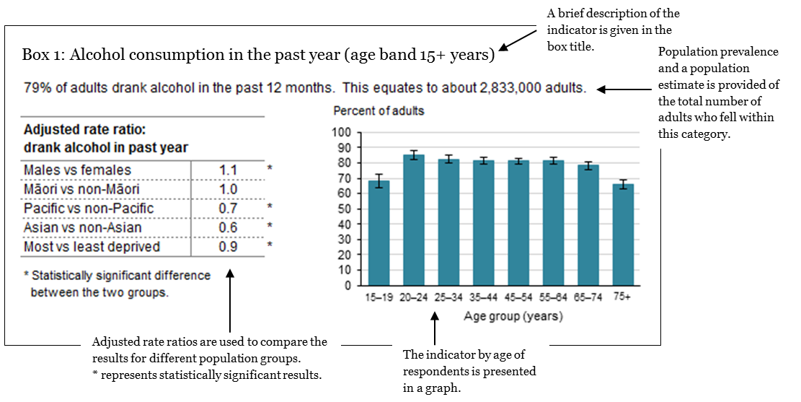

Please refer to the ‘Methods’ section for more information.

# Patterns of alcohol consumption

## Background

The majority of New Zealanders drink alcohol. Most tend to drink responsibly and in moderation, but some do not. To continue to inform the public health response to alcohol misuse, we need to know how we are currently drinking, the harms we are experiencing, and what we are doing to reduce those harms.

Key findings

* Seventy-nine percent of adults aged 15+ years had consumed alcohol in the past 12 months. Ninety-six percent of past-year drinkers (drinkers) typically drank alcohol in their home or in another’s home.
* One-quarter of adults who have ever drunk alcohol describe themselves as a ‘social drinker’.
* One third of drinkers drank alcohol regularly, at least three to four times a week.
* Half of drinkers had drunk to intoxication at least once in the past 12 months. Eight percent reported drinking to intoxication at least weekly.
* One in six drinkers who drove in the past year had driven while feeling under the influence of alcohol.
* One-quarter of drinkers had used a drug substance while drinking alcohol in the past year. Tobacco and cannabis accounted for the majority of concurrent use.
* Drinkers experienced a range of harms as a result of their own drinking. Harm to physical health was the harm most commonly reported.
* Violent harms were the most commonly reported harm resulting from someone else’s drinking.
* Seventy percent of drinkers made a point of eating always or most of the time when they drank alcohol.

## Alcohol use

In 2012/13 alcohol was the most commonly used recreational psychoactive substance in New Zealand. The majority of people consumed alcohol at least weekly.

### General use

Box 1: Alcohol consumption in the past year (age band 15+ years)

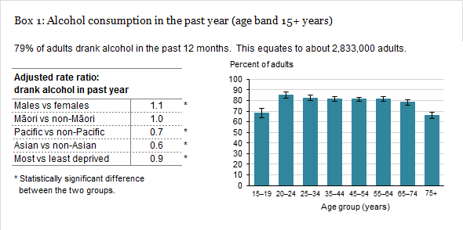

Adults were asked if they had consumed an alcoholic drink in the past 12 months.

#### Males are more likely to have drunk alcohol in the past year

Seventy-nine percent of adults aged 15+ years had drunk alcohol in the past 12 months. This equates to around 2,833,000 adults. Eighty-four percent of males compared with 76% of females reported having done so. Males were 1.1 times more likely to have drunk alcohol in the past year, after adjusting for age differences (Box 1).

Eighty-five percent of European/Other and 80% Māori compared with 56% of Pacific and 54% of Asians reported having drunk alcohol in the past 12 months. Pacific people were 0.7 times less likely, and Asians 0.6 times less likely, than non-Pacific and non-Asian adults to have drunk alcohol in the past year, after adjusting for age and sex differences.

A greater percentage of people living in the least deprived areas (84%) reported having drunk alcohol in the past year compared to those living in the most deprived areas (71%). People living in the most deprived areas were 0.9 times less likely to have drunk alcohol in the past year compared to those living in the least deprived areas, after adjusting for age, sex and ethnic differences (Box 1).

#### Half of 15–17-year-olds drank alcohol in the past year

The prevalence of past-year drinking is explored here by the age of the drinker at the time they were surveyed. This analysis was conducted for 15–17-year-olds to explore the prevalence of past-year drinking when aged under the minimum legal purchase age of 18 years.

Fifty-six percent of 15–17-year-olds had drunk alcohol in the past year (Figure 1). This equates to around 101,000 drinkers aged 15–17 years in 2012/13. Fifty-seven percent of males and 55% of females reported having done so.

Figure 1: Percentage of adults who had drunk alcohol in the past year, by age group and sex, 2012/13

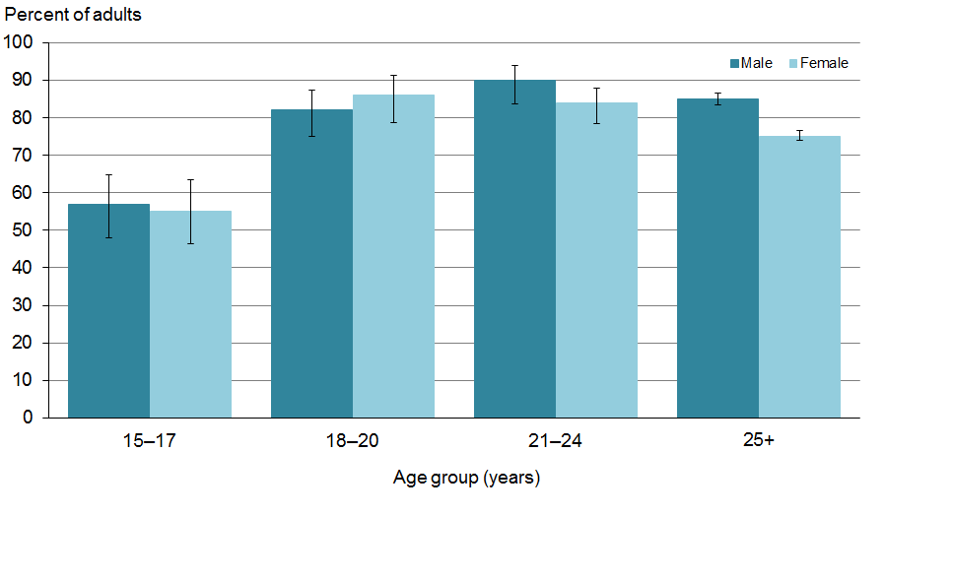

Source: 2012/13 New Zealand Health Survey

#### Alcohol is mostly consumed at home

In the home or another’s home (96%) was the most frequently reported place for drinking on a typical occasion, in the past 12 months. Drinking in public settings (74%), such as pubs, night clubs or workplaces, was less frequently reported.

### Initiation of alcohol use

Box 2: Age at which adults first drank alcohol (age band 15+ years)



Early initiation into drinking alcohol is a risk factor for alcohol-related harm in young people, and for heavy drinking and alcohol dependence in adulthood (Girling et al 2006, Cagney et al 2007, Ministry of Health 2009, Fergusson et al 2011).

Adults who had ever drunk alcohol were asked how old they were the first time they tried an alcoholic drink. For this analysis it should be noted that there may be some recall error when remembering the age when people first started drinking alcohol, as older people may not remember exactly when they first started drinking.

#### Male adults more likely to report drinking before age 15 years

Among the total population of adults who had ever drunk alcohol, 27% recalled having first drunk alcohol before age 15 years. Among them, 32% of males and 23% of females reported doing so. When adjusted for age, males were 1.4 times more likely than females to recall drinking before age 15 years. In the age group 15–19 years, 60% of females and 59% of males reported having started drinking alcohol before age 15 years (Box 2).

#### Māori adults more likely to report starting to drink before age 15 years

Forty-three percent of Māori and 29% of European/Other adults who had ever drunk alcohol recalled starting to drink before age 15 years compared with 18% of Pacific and 12% of Asian adults. When adjusted for age and sex, Māori were 1.5 times more likely to have recalled starting to drink before age 15 years than non-Māori (Box 2). The majority of first-time alcohol drinking occurs within the 15–19 years age group, with slightly more European/Others reporting having done so (Figure 2).

Figure 2: Age at which adults first start to drink, by ethnic group, 2012/13

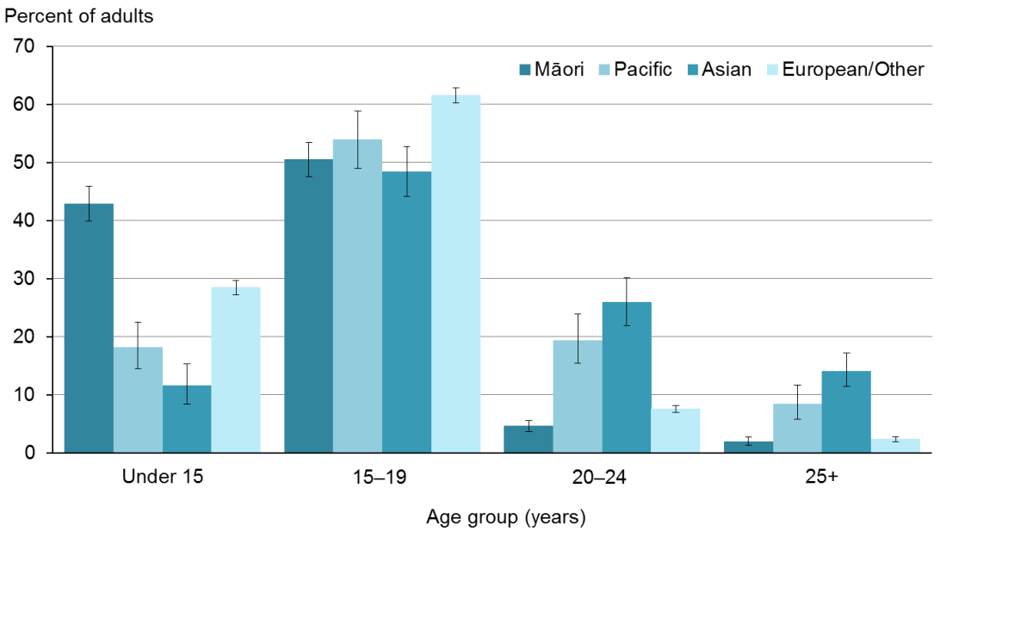

Source: 2012/13 New Zealand Health Survey

#### Four out of ten adults aged 15–17 years in 2012/13 reported first drinking alcohol before age 15 years

The age at which adults who had ever drunk alcohol reported they first started drinking is explored here by the age of the adult at the time of the survey. This analysis was conducted for 15–17-year-olds to explore the prevalence of starting to drink when under the minimum legal purchase age of 18 years. For this analysis it is assumed that the impact of recall error is negligible.

Forty-two percent of adults aged 15–17 years in 2012/13 had first drunk alcohol before age 15 years. Thirty-seven percent of adults who had ever drunk alcohol aged 18–20 years in 2012/13 had first drunk before age 15 years (Figure 3).

Figure 3: Percentage of adults who reported drinking alcohol before age 15 years, by age group and sex, 2012/13

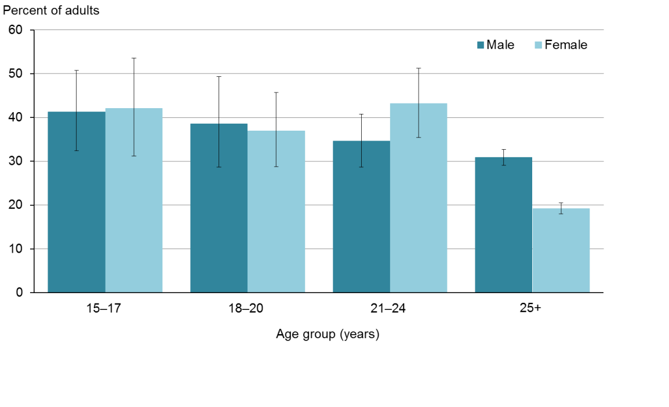

Source: 2012/13 New Zealand Health Survey

#### Starting to drink before age 15 years varied by ethnic group

Among adults who had ever drunk alcohol aged 15–17 years in 2012/13, 50% of Māori compared with 46% of Asian, 41% of European/Other and 39% of Pacific adults reported having started drinking before age 15 years (Figure 4). Among adults who had ever drunk alcohol aged 18–20 years in 2012/13, 53% of Māori and 40% European/Other drinkers compared with 25% of Pacific and 9.9% of Asian adults reported having started drinking before age 15 years (Figure 4).

Figure 4: Percentage of adults who reported drinking alcohol before age 15 years, by ethnic group and age, 2012/13

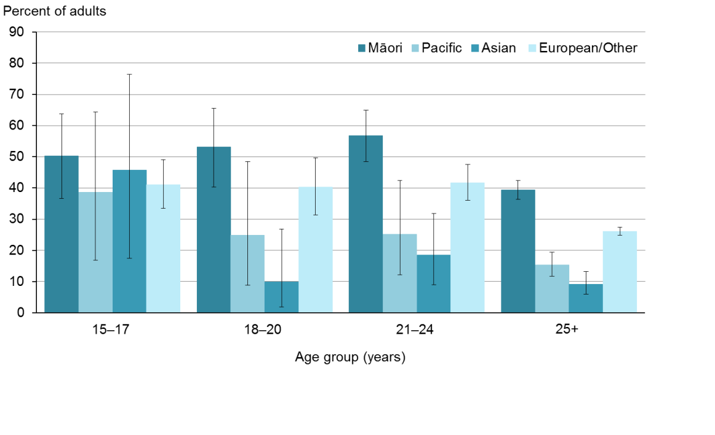

Source: 2012/13 New Zealand Health Survey

### Types of alcohol consumed

Box 3: Types of alcohol consumed by drinkers on a typical occasion (age band 15+ years)

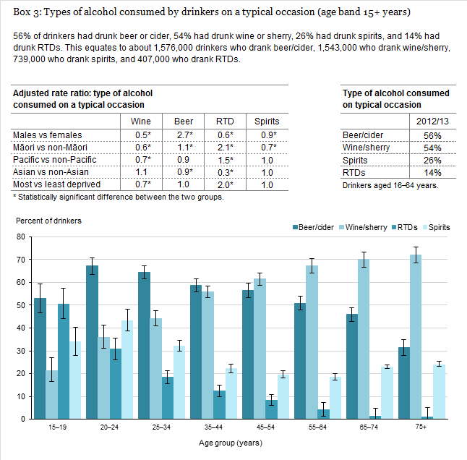

According to Statistics New Zealand, the types of alcohol available for consumption in New Zealand are slowly changing (Statistics New Zealand 2013). Over the last decade, beer accounts for a decreasing proportion of the total volume of alcoholic beverages available for consumption, while wine, spirits and spirit-based drinks (including RTDs – ready-to-drinks) account for more (Statistics New Zealand 2013). Drinkers were asked about the types of alcoholic drinks they consumed on a typical occasion in the last 12 months (multiple responses were possible).

#### Older drinkers report typically drinking wine

The consumption of different types of alcohol by drinkers aged 15+ years varied across age groups. Younger drinkers reported typically drinking beer, RTDs and spirits, whereas older adults reported typically drinking wine/sherry (Box 3).

#### Females report typically drinking wine, RTDs, and spirits

Males and females aged 15+ years typically drank different types of alcohol (Figure 5); 80% of males and 30% of females typically consumed beer or cider, compared to the 38% of males and 71% of females who typically drank wine or sherry. More females reported typically drinking RTDs and spirits than males.

After adjusting for age differences, males were 0.6 times less likely to typically drink RTDs and 0.9 times less likely to typically drink spirits than females. Similarly, males were 0.5 times less likely to drink wine or sherry than females. Males were 2.7 times more likely to typically drink beer than females, after adjusting for age differences (Box 3).

Figure 5: Percentage of drinkers who consumed specified types of alcohol on a typical occasion in the past 12 months, by sex

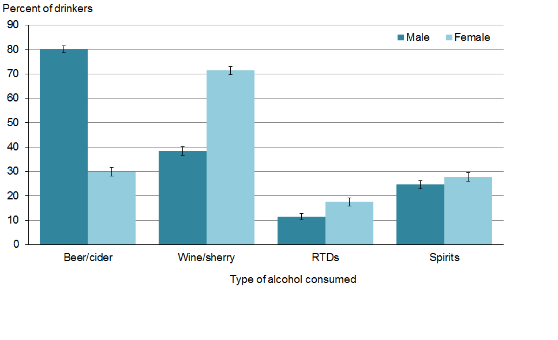

Source: 2012/13 New Zealand Health Survey

#### Consumption of different types of alcohol varied by ethnic group

The consumption of specified types of alcohol by drinkers on a typical occasion differs across ethnic groups. The percentage of drinkers within ethnic groups who drank specified types of alcohol on a typical occasion are as follows:

* Beer or cider was reported to be consumed by 61% of Māori and 58% of Asian drinkers compared with 57% of Pacific and 55% of European/Other drinkers.
* Wine or sherry was reported to be consumed by 59% of European/Other and 49% of Asian drinkers compared with 31% of Pacific and 30% of Māori drinkers.
* RTDs were reported to be consumed by 33% of Māori and 27% of Pacific drinkers compared with 13% of European/Other and 5.6% of Asian drinkers.
* Spirits were reported to be consumed by 28% of Asian, 28% of Pacific and 27% of European/Other drinkers compared with 21% of Māori drinkers (Figure 6).

Māori were 2.1 times more likely, and Pacific people 1.5 times more likely to drink RTDs on a typical occasion compared to non-Māori and non-Pacific people, after adjusting for age and sex differences (Box 3).

Figure 6: Percentage of drinkers who consumed specified types of alcohol on a typical occasion in the past 12 months, by ethnic group

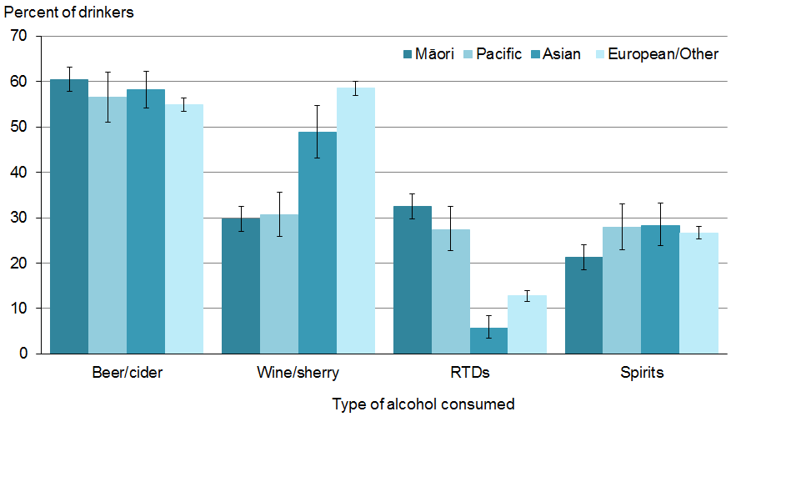

Source: 2012/13 New Zealand Health Survey

### Type of drinker

Adults who had ever drunk alcohol were asked what category of drinker best described their current drinking behaviour at the time they were surveyed.

#### One-quarter of adults describe themselves as ‘social drinkers’

Around one-fifth of adults who had ever drunk alcohol and aged 15+ years in 2012/13 described themselves as non-drinkers (22%). This equates to around 770,000 adults. The majority of adults, however, described themselves as occasional (24%), light (22%) or social drinkers (26%). A greater percentage of younger adults than older adults described themselves as social and occasional drinkers. Older adults described themselves as light drinkers.

#### Heavy and binge drinking is most prevalent among younger adults

Heavy drinking is alcohol consumption that is consistently risky, while binge drinking is a pattern of heavy drinking that occurs in an extended period set aside for the purpose.

A small percentage described themselves as heavy (1.9%) or binge drinkers (1.3%). This equates to around 115,000 drinkers in total. Consistent risky drinking or heavy drinking with intervening periods of abstinence is known to be harmful. More males than females describe themselves as a heavy drinker (2.8% of males compared with 1.0% of females) and as binge drinkers (1.6% of males compared with 1.1% of females). Males were 2.8 times more likely than females to describe themselves as heavy drinkers, after adjusting for age differences. A greater percentage of youth and young adults reported heavy and binge drinking, a trend reducing sharply with age.

Three-and-a-half percent of Māori adults compared with 1.9% of European/Other, 1.2% of Pacific and 0.8% of Asian adults described themselves as a heavy drinker. Similarly, 3.1% of Māori adults compared with 1.4% of European/Other, 1.4% of Pacific and 0.1% of Asian adults self-described themselves as a binge drinker. Māori were 1.4 times more likely to describe themselves as heavy drinkers compared to non-Māori. Asians were 0.7 times less likely to describe themselves as heavy drinkers than non-Asians, when adjusted for age and sex differences.

### Frequency of alcohol consumption

The frequency of alcohol use and the amount of alcohol consumed are important factors in the health effects of alcohol use. In New Zealand, both factors differ across population groups (Pega et al 2010, Fergusson et al 2011, Huckle et al 2011, Ministry of Health 2012, Clark et al 2013, Huckle et al 2013, Rankine et al 2013, Ministry of Health 2013a).

Drinkers were asked about the frequency of their use of alcohol in the last 12 months. Drinking frequency was categorised as high, medium or low frequency. High frequency was drinking at least three to four times a week, medium frequency was drinking once or twice a week, and low frequency was drinking less than once or twice a week.

#### Males more likely to drink with high frequency

Thirty-one percent of drinkers aged 15+ years drank alcohol with a high frequency. This equates to around 872,000 drinkers. Twenty-eight percent drank alcohol with a medium frequency, and 41% drank alcohol with a low frequency. Males drank more frequently than females (Figure 7). Males were 0.7 times less likely than females to consume alcohol with low frequency, after adjusting for age differences. Males were 1.2 times more likely to drink with medium frequency, and were 1.4 times more likely than females to drink with high frequency (at least three to four times a week), after adjusting for age differences.

Figure 7: Percentage of drinkers who consumed alcohol, by frequency of alcohol consumption and sex

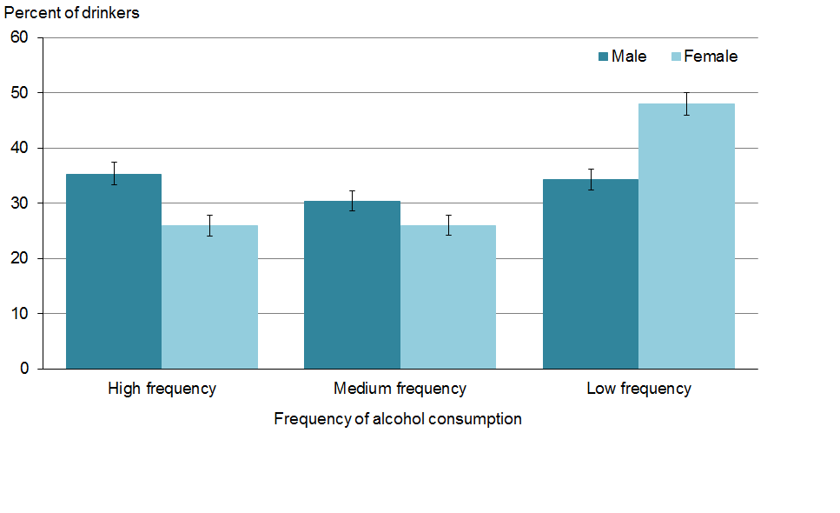

Source: 2012/13 New Zealand Health Survey.

Note: Drinking frequency for general alcohol use is categorised into high frequency: at least 3–4 times a week; medium frequency: once or twice a week; and low frequency: less than once or twice a week.

#### Older drinkers are drinking with high frequency

The prevalence of drinkers who drink with high frequency increased with age for both sexes (Figure 8). Of note, more than half of males aged over 75 years who drank alcohol, did so with high frequency (Figure 8).

Figure 8: Percentage of drinkers who consume alcohol with high frequency, by age group and sex

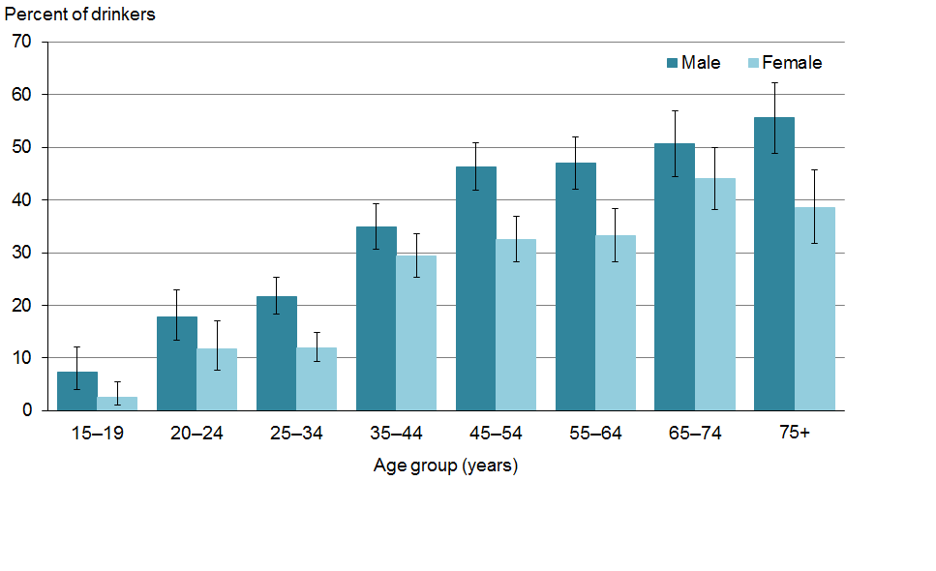

Source: 2012/13 New Zealand Health Survey

Note: High frequency drinking for general alcohol use is categorised as at least 3–4 times a week.

#### European/Other drinkers report drinking with high frequency

The percentage of European/Other drinkers (35%) who drink alcohol with high frequency was markedly greater than for other ethnic groups: Māori (17%), Asian (11%) and Pacific people (8.7%) (Figure 9). Māori were 0.7 times less likely than non-Māori to have drunk alcohol with high frequency, after adjusting for age and sex differences. Both Pacific people and Asians were 0.4 times less likely than non-Pacific people and non-Asians to have drunk alcohol with high frequency.

Figure 9: Percentage of drinkers who reported drinking with high frequency, by ethnic group

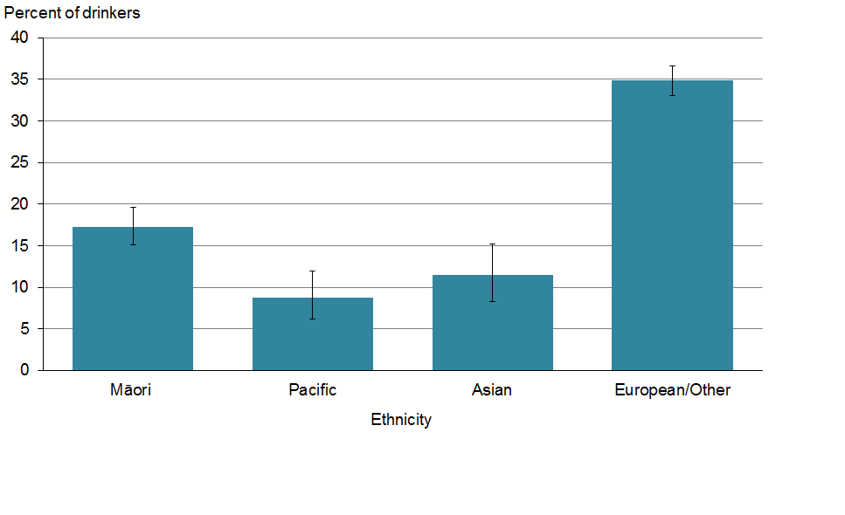

Source: 2012/13 New Zealand Health Survey

Note: High-frequency drinking for general alcohol use is categorised as at least 3–4 times a week.

#### High-frequency drinking decreases as deprivation increases

The proportion of drinkers who drank with high frequency decreased as deprivation increased (Figure 10). Drinkers living in the most deprived areas were 0.7 times less likely to be high-frequency drinkers than drinkers who lived in the least deprived areas, after adjusting for age, sex and ethnic differences.

Figure 10: Percentage of drinkers who reported drinking with high frequency, by deprivation

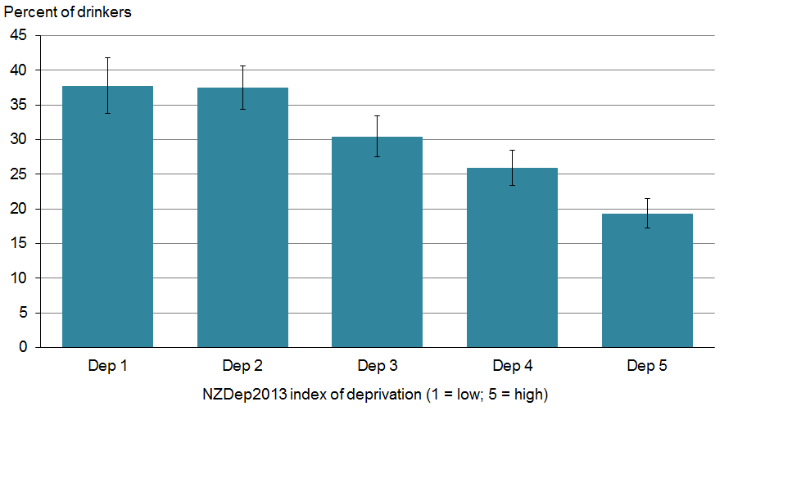

Source: 2012/13 New Zealand Health Survey

Note: High-frequency drinking for general alcohol use is categorised as at least 3–4 times a week.

### Drinking to intoxication in the past year

Drinking to intoxication and chronic high levels of alcohol consumption (heavy or excessive use) is related to poorer general health outcomes (Fuller 2011, O’Keefe et al 2014), risk-taking behaviour and increased experience of harms (WHO 2007, Slack et al 2009, Poulsen et al 2012, Research New Zealand 2012, Wilkins et al 2012, Connor 2013, Ministry of Health 2013c).

Drinkers were asked how frequently they drank to intoxication (drinking enough to feel drunk) in the last 12 months.

Box 4: Drinkers who drank to intoxication at least once in the past year (age band 15+ years)

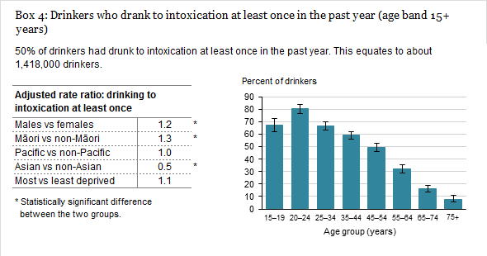

#### Half of drinkers had drunk to intoxication at least once in past year

Fifty percent of drinkers had drunk to intoxication at least once in the past year. This equates to around 1,418,000 drinkers. Fifty-five percent of males and 45% of females reported drinking to intoxication at least once in the past year. Males were 1.2 times more likely than females to drink to intoxication, after adjusting for age differences (Box 4).

Drinking to intoxication was prevalent among youth and younger adults, a trend decreasing with increasing age (Box 4).

Sixty-nine percent of Māori and 58% of Pacific drinkers compared with 50% of European/Others and 34% of Asians reported drinking to intoxication in the past year. Māori drinkers were 1.3 times more likely to drink to intoxication than non-Māori, while Asians were 0.5 times less likely to do so compared with non-Asians, after adjusting for age and sex differences (Box 4).

### Drinking to intoxication with high frequency

Box 5: Drinkers who drank to intoxication with high frequency (age band 15+ years)

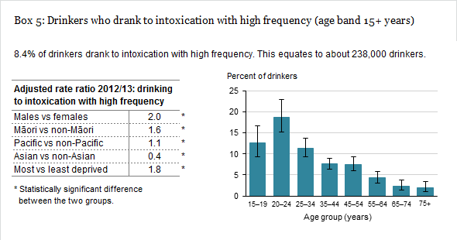

Drinkers were asked how frequently they drank to intoxication (drinking enough to feel drunk) in the last 12 months. Frequency of intoxication drinking was categorised into low frequency (less than once a month), medium frequency (at least once a month) and high frequency (at least once a week).

#### Males, young adults and Māori drinkers report drinking to intoxication with high frequency

In the past year 8.4% of drinkers had drunk to intoxication with high frequency. This equates to around 238,000 drinkers (Box 5). Eleven percent had drunk to intoxication with medium frequency, and 30% had drunk to intoxication with low frequency. After age 24 years, drinking to intoxication with high frequency decreased with increasing age (Box 5).

Eleven percent of males and 5.5% of females reported having drunk to intoxication with high frequency. Males were twice as likely as females to drink to intoxication with high frequency, after adjusting for age differences (Box 5).

Fourteen percent of Māori and 12% of Pacific drinkers compared with 8.0% of European/Others and 4.2% of Asians drinkers reported drinking to intoxication with high frequency. Māori drinkers were 1.6 times more likely to drink to intoxication with high frequency compared to non-Māori, while Asians were 0.4 times less likely than non-Asians to do so, after adjusting for age and sex differences (Box 5).

Drinkers living in areas of high deprivation were 1.8 times more likely to drink to intoxication with high frequency than people living in areas of low deprivation, after adjusting for sex, age and ethnicity differences (Box 5). Taken together with the frequency of drinking data (Figure 10), people living in the most deprived areas drink alcohol less frequently but become intoxicated more often (Figure 11).

Figure 11: Percentage of drinkers who drank to intoxication with high frequency in the past year, by deprivation

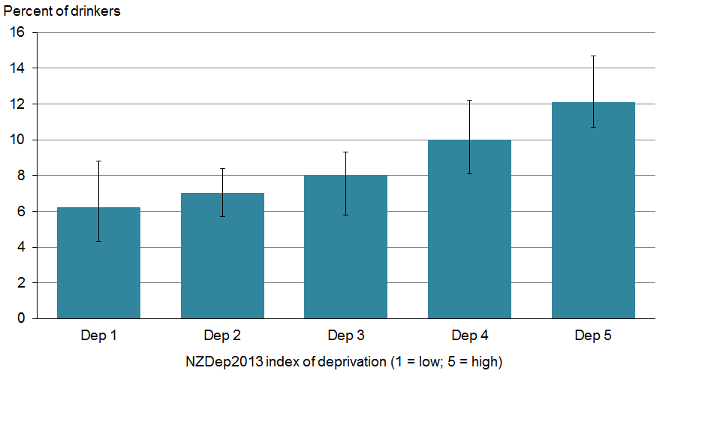

Source: 2012/13 New Zealand Health Survey.

Note: high frequency drinking to intoxication = at least once a week.

### Summary of past-year alcohol consumption

Key findings (Table 1)

* Around 80% of adults aged between 15–74 years reported drinking alcohol at least once in the past year.
* Eighty-five percent of European/Other and 80% of Māori adults reported having drunk alcohol at least once in the past year compared with 54% of Asian and 56% Pacific adults.
* Fifty percent of drinkers aged 15+ years had drunk to intoxication at least once in the past 12 months.
* Fifty-eight percent of drinkers living in areas of high deprivation reported having drunk to intoxication at least once in the past 12 months compared with 46% of drinkers living in areas of low deprivation.
* Drinking to intoxication with high frequency was more prevalent among younger age groups (15–34 years).
* Twelve percent of drinkers living in areas of high deprivation reported drinking to intoxication with high frequency compared with 6.2% of those living in areas of low deprivation.

Table 1: Percentage of adults who drank in the past year and drinkers who drank to intoxication, by sex, age, ethnic group and deprivation

|  |  |  |  |  |  |  |  |  |  |
| --- | --- | --- | --- | --- | --- | --- | --- | --- | --- |
|  | | **Percent of adults who drank alcohol in past 12 months** | | **Percent of drinkers who drank to intoxication at least once in past 12 months** | | | **Percent of drinkers who drank to intoxication with high frequency in past 12 months** | | |
| **Sex** | |  | |  | | |  | | |
| Females | | 76 | | 45 | | 5.5 | | |
| Males | | 84 | | 55 | | 11 | | |
| Total | | 79 | | 50 | | 8.4 | | |
| **Age (years)** | |  | |  | | |  | | |
| 15–24 | | 77 | | 75 | | 16 | | |
| 25–34 | | 83 | | 67 | | 11 | | |
| 35–44 | | 82 | | 59 | | 7.6 | | |
| 45–54 | | 82 | | 49 | | 7.5 | | |
| 55–64 | | 82 | | 32 | | 4.3 | | |
| 65–74 | | 79 | | 16 | | 2.4 | | |
| 75+ | | 66 | | 7.8 | | 2.0 | | |
| **Ethnic group** | |  | |  | | |  | | |
| Māori | | 80 | | 69 | | 14 | | |
| Pacific | | 56 | | 58 | | 12 | | |
| Asian | | 54 | | 34 | | 4.2 | | |
| European/Other | | 85 | | 50 | | 8.0 | | |
| **Deprivation 2013** | |  | |  | | |  | | | |
| 1 (Low) | | 84 | | 46 | | 6.2 | | |
| 2 | | 84 | | 47 | | 6.9 | | |
| 3 | | 81 | | 50 | | 8.0 | | |
| 4 | | 76 | | 51 | | 9.8 | | |
| 5 (High) | | 71 | | 58 | | 12 | | |

Source: 2012/13 New Zealand Health Survey.

Note: High frequency of intoxication drinking was categorised as: at least once a week.

Data for low and medium frequency of intoxication drinking can be found within accompanying web-tables.

### Hazardous drinking

#### Around one in seven adults reported hazardous drinking

Hazardous drinking is an established drinking pattern that carries a risk of harming the drinker’s physical or mental health, or having harmful social effects on the drinker or others. The Ministry of Health reported on hazardous drinking in the NZHS 2012/13 annual update (Ministry of Health 2013 b). Below is a summary of those findings.

* Fifteen percent of adults reported drinking alcohol at a level that was hazardous to their health. Hazardous drinking levels were much higher in men (22%) than in women (9.0%).
* Hazardous drinking rates were highest in young people, with one in four adults aged 15–24 years drinking at levels that were hazardous to their health. Hazardous drinking rates were also high in adults aged 25–34 years (24%).
* Almost one third of Māori adults (31%) reported drinking at hazardous levels. Māori adults were twice as likely to drink at hazardous levels than non-Māori, after adjusting for age and sex differences.
* Adults living in the most deprived areas were 1.5 times more likely to be hazardous drinkers than those living in the least deprived areas, after adjusting for age, sex and ethnic differences.

## Risky behaviours

Risky behaviours are defined as behaviours proven to be associated with increased susceptibility to a specific injury, disease or ill health. Drinkers were asked whether they had driven a car or another motor vehicle, worked, or operated machinery while under the influence of alcohol.

#### Male drinkers are more likely to engage in risky behaviours

Seventeen percent of drinkers aged 15+ years who had driven a car or another motor vehicle, 6.8% who had worked, and 3.3% who had operated machinery during the last 12 months reported doing so at least once while under the influence of alcohol.

#### Younger adults are engaging in risky behaviours

The prevalence of risky behaviours decreased with increasing age. Those aged 44 years or younger show a higher prevalence of risky behaviour than older age groups (Figure 12).

Figure 12: Percentage of drinkers who engaged in risky behaviour while under the influence of alcohol, by age

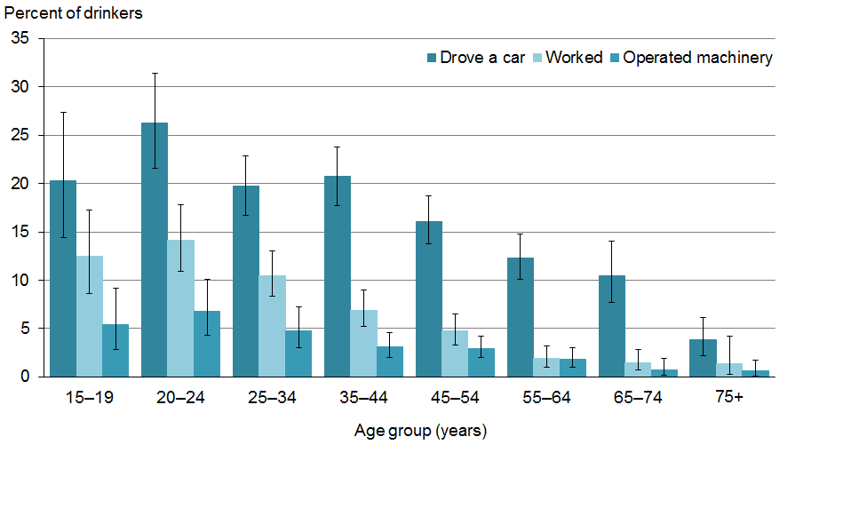

Source: 2012/13 New Zealand Health Survey.

### Drink driving

Box 6: Drinkers who drove a car or another motor vehicle while under the influence of alcohol (age band 15+ years who drove in past year)



Drink driving is a well-documented risk factor for injury and death (Ministry of Transport 2011, Poulsen et al 2012, Clark et al 2013). Drinkers were asked if in the last 12 months they had driven a car or another motor vehicle while feeling under the influence of alcohol.

#### Male drinkers more likely to drive under the influence of alcohol

Seventeen percent of drinkers aged 15+ years who drove in the past year had driven at least once while feeling under the influence of alcohol. This equates to around 416,000 drinkers. Twenty-one percent of males and 12% of females reported having done so. Males were 1.7 times more likely than females to have driven while feeling under the influence of alcohol in the past year, after adjusting for age differences (Box 6).

Overall, having driven while feeling under the influence of alcohol peaked for drinkers aged 20–24 years and thereafter decreased with increasing age. The pattern was the same for males and females, although the rates were lower for females (Box 6). This pattern may be associated with the high rates of hazardous drinking (Ministry of Health 2013a, Ministry of Health 2013b) and high frequency of drinking to intoxication among males in this age band (Box 5).

Twenty-four percent of Māori and 23% of Pacific drinkers compared with 16% of European/Others and 15% of Asians reported having driven while feeling under the influence of alcohol in the past year. Māori were 1.3 times more likely to have done so compared to non-Māori, after adjusting for age and sex differences.

#### Drinkers in high-deprivation areas are less likely to report drinking and driving

A similar percentage of drinkers living in high-deprivation (18%) neighbourhoods as those living in low-deprivation (17%) neighbourhoods reported having driven while feeling under the influence of alcohol in the past year. People living in the most deprived areas were 0.8 times less likely to have driven while feeling under the influence of alcohol than people living in the least deprived areas, after adjustment for sex, age and ethnic differences.

### Working while under the influence of alcohol

Box 7: Drinkers who worked while under the influence of alcohol (age band 15+ years)



Drinkers were asked if in the last 12 months they had worked while under the influence of alcohol.

#### Males and Māori were more likely to have worked under the influence of alcohol (aged 15+ years)

In the past year 6.8% of drinkers who had worked reported working at least once while under the influence of alcohol. This equates to around 165,000 drinkers (Box 7). Eight-point-eight percent of males and 4.6% of females reported having done so.

The prevalence of working while feeling under the influence of alcohol decreased with increasing age. Males were 1.9 times more likely than females to have worked when under the influence of alcohol, after adjusting for age differences (Box 7).

Thirteen percent of Pacific and 12% of Māori drinkers who had worked in the past year reported working at least once when under the influence of alcohol compared with 6.5% of European/Other and 4.7 % of Asian drinkers in the past year. When adjusted for age and sex, Māori were 1.5 times more likely than non-Māori to have worked under the influence of alcohol. Pacific people were also 1.5 times more likely than non-Pacific people to have worked under the influence of alcohol. However, this was not found to be statistically significant (Box 7).

### Operating machinery after drinking

Box 8: Drinkers who operated machinery while under the influence of alcohol (age band 15+ years)



Drinkers were asked if in the last 12 months they had operated machinery while under the influence of alcohol.

#### Males and Māori more likely to have operated machinery under the influence of alcohol (aged 15+ years)

In the past year 3.3% of drinkers who had operated machineryreporteddoing soat least once while under the influence of alcohol. This equates to around 65,000 drinkers. Four-point-three percent of males and 2.0% of females reported having operated machinery at least once while feeling under the influence of alcohol. The prevalence of operating machinery while feeling under the influence of alcohol decreased with increasing age (Box 8). Males were twice as likely as females to have done so, after adjustment for age differences (Box 8).

Six-point-three percent of Māori and 3.9% of Pacific drinkers compared with 3.0% of European/Other and 2.5% of Asian drinkers who had operated machinery reported doing so at least once when under the influence of alcohol. Māori were 1.8 times more likely than non-Māori to operate machinery under the influence of alcohol, after adjustment for sex and age differences (Box 8).

Between areas of low and high deprivation there were no statistically significant differences for operating machinery while under the influence of alcohol (Box 8).

## Drinking and drug use

The combination of drinking and using drugs has been associated with increased susceptibility to a specific injury, disease or ill health.

A leading risk factor for health loss is substance use (tobacco, alcohol and illicit drugs) (Ministry of Health 2013c). Alcohol is often consumed with other drugs (poly-drug), which tends to increase the risks of harmful effects (Davey 2000, EMCDDA 2009, Seitz et al 2009, Wilson et al 2012). The use of alcohol or tobacco in adolescence is also among key risk factors for later illicit drug use and dependence (Fergusson et al 2011).

Drinkers were asked if in the last 12 months they had used a drug (legal or illicit) with alcohol on at least one occasion. Drinkers were asked to specify which drugs they had used concurrently, meaning drinkers could specify more than one drug type. This section includes the use of drugs of pharmaceutical origin but that are not necessarily pharmaceuticals prescribed to respondents.

#### One-quarter of drinkers used a drug (including tobacco) while drinking in the past year (age band 15+ years)

The majority (74%) of drinkers aged 15+ years drank alcohol without the use of an illicit or legal drug or tobacco. Around one in four (26%) drinkers had, on at least one occasion, used a drug substance (including tobacco) at the same time as drinking alcohol (Table 3). This equates to around 744,000 drinkers. Twenty-nine percent of males and 24% of females had used a drug substance (including tobacco) while drinking. Overall, concurrent drug use decreased with increasing age. Concurrent use was most frequent among the 15–34 years age group. Males were 1.2 times more likely than females to have used a drug (including tobacco) while drinking alcohol, after adjusted for age differences.

Fifty-one percent of Māori and 40% of Pacific drinkers reported using a drug (including tobacco) while drinking alcohol in the past year compared with 24% of European/Other and 19% of Asian drinkers. Māori drinkers were 1.9 times more likely than non-Māori drinkers, and Pacific drinkers were 1.3 more likely than non-Pacific drinkers, to report using a drug (including tobacco) while drinking alcohol, after adjusting for age and sex differences.

#### Drinkers in high deprivation areas were more likely to drink and use a drug

A marked difference in prevalence of using a drug (including tobacco) while drinking alcohol was found between areas of low and high deprivation (Figure 13). Drinkers living in the most deprived areas were 2.3 times more likely to report using any drug (including tobacco) while drinking alcohol than those living in the least deprived areas, after adjusting for age, sex and ethnic differences.

Figure 13: Percentage of drinkers who consumed any drug (including tobacco) while drinking alcohol, by deprivation

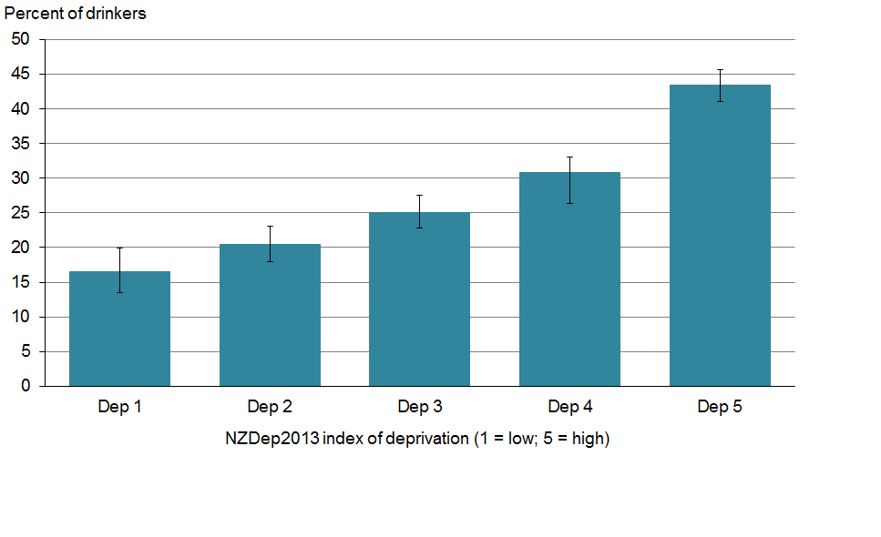

Source: 2012/13 New Zealand Health Survey.

#### A range of drug types are used along with alcohol

Drinkers consumed a range of drug types while drinking alcohol at least once in the past year. Tobacco (22%) and cannabis (9.5%) were the most frequently reported drugs used concurrently with alcohol. For tobacco this equates to around 614,000 drinkers and for cannabis about 270,000 drinkers.

Drinkers consumed a number of other drug types with alcohol, but at much lower rates. The most common among them were ecstasy (2.3%), opioids (1.1%), amphetamines (0.9%) and the previously legal range of party pills (1.1%) (Table 2). This equates to around 65,000 drinkers using ecstasy, about 32,000 drinkers using opioids, about 24,000 drinkers using amphetamines, and about 32,000 drinkers using legal party pills at the same time as drinking alcohol, at least once in the past year (Table 2).

Drinkers consumed other drug types concurrently with alcohol, but at lower rates. These included hallucinogens (0.7%), stimulants (0.4%), sedatives (0.3%), cocaine (0.3%) and heroin or ‘homebake’ (0.1%). In total this equates to around 53,000 drinkers using other drug types along with alcohol at least once in the past year (Table 2).

Table 2: Percentage of drinkers who used a drug substance (including tobacco) together with alcohol in the past 12 months

|  |  |
| --- | --- |
| **Drug use type** | **Percent** |
| Used a drug – including tobacco | 26 |
| Used a drug – excluding tobacco | 11 |
| Tobacco | 22 |
| Cannabis | 9.5 |
| Ecstasy | 2.3 |
| Amphetamines | 0.9 |
| Legal party pills | 1.1 |
| Stimulants | 0.4 |
| Opioids | 1.1 |
| Sedatives | 0.3 |
| Hallucinogens | 0.7 |
| Cocaine | 0.3 |
| Heroin/homebake | 0.1 |

Note: More than one response was possible.

### Concurrent tobacco use

#### Māori and Pacific drinkers are more likely to use tobacco while drinking

Twenty-three percent of male drinkers and 21% of female drinkers reported tobacco use while drinking alcohol. Males were 1.1 times more likely than females to have used tobacco while drinking alcohol, after adjusting for age differences. Overall, concurrent tobacco use decreased with increasing age. The use of tobacco with alcohol was most frequent among drinkers aged 15–34 years, and among 35–54-year-olds.

Forty-four percent of Māori and 36% of Pacific drinkers compared with 19% of European/Other and 17% of Asian drinkers reported smoking and drinking. Māori were twice as likely as non-Māori, and Pacific drinkers 1.4 times more likely than non-Pacific drinkers, to have smoked while drinking, after adjusting for age and sex differences. While Asian drinkers were 0.6 times less likely than non-Asians to have done so, after adjusting for age and sex differences.

#### Drinkers who smoke tobacco have higher rates of hazardous drinking

The Ministry of Health recently reported on the relationship between tobacco use and harmful drinking. The findings include a well-established relationship between smoking and alcohol consumption. In particular, higher levels of alcohol use are associated with higher levels of smoking, and hazardous drinking patterns are elevated among smokers (Ministry of Health 2014).

Overall, in 2012/13, 40% of smokers who had drunk alcohol in the last year had a hazardous drinking pattern. Across all age groups, hazardous drinking patterns were higher in smokers than in non-smokers. This was particularly so for youth and younger adults (aged  
25–34 years), with over half in each group having a hazardous drinking pattern. Smokers living in the most deprived areas were more likely to report hazardous drinking patterns than smokers living in the least deprived areas (Ministry of Health 2014).

### Concurrent illicit drug use

#### One in ten drinkers used an illicit drug substance while drinking in the past year

When tobacco is excluded from all reported poly-drug use, 11% of drinkers had, on at least one occasion, used an illicit drug substance at the same time as drinking alcohol (Table 3).

Patterns of illicit drug use in drinkers vary by sex, age and ethnicity. These differences are most apparent across genders, with a greater proportion of males than females using illicit drugs while drinking. Fourteen percent males and 8.6% of females had used any illicit drug substance while drinking. Males were 1.5 times more likely than females to have used an illicit drug while drinking alcohol, after adjusting for age differences. Overall, concurrent illicit drug use decreased with increasing age. Use was most frequent among the 15–34 years age band.

Twenty-five percent of Māori drinkers, 11% of Pacific, 11% of European/Other and 4.5% of Asian drinkers reported using an illicit drug while drinking alcohol in the past year. A greater percentage of drinkers living in the most deprived areas reported concurrent illicit drug use than drinkers living in the least deprived areas. However, after adjustment these differences among ethnic groups and deprivation were not found to be significant.

### Concurrent cannabis use

Box 9: Drinkers who smoked cannabis while drinking alcohol (age band 15+ years)



#### Male drinkers more likely to use cannabis while drinking

Fourteen percent of male drinkers and 8.6% of female drinkers used an illicit drug substance while drinking. This gender difference reflects a higher prevalence of cannabis use among males: more males (12%) than females (7.2%) used cannabis while drinking alcohol. Overall, drinking with concurrent cannabis use decreased with increasing age. The use of cannabis with alcohol was most frequent among drinkers aged 15–24 years. Males were 1.6 times more likely than females to have used cannabis while drinking alcohol, after adjusting for age differences (Box 9).

Twenty-three percent of Māori drinkers, 10% of Pacific and 9.0% of European/Other drinkers reported using cannabis while drinking alcohol, compared with 3.5% of Asian drinkers. These differences were not found to be statistically significant, after adjusting for age and sex differences.

### Concurrent tobacco and cannabis use

#### Tobacco and cannabis use differs across areas of deprivation

There are differences in the reported prevalence of drug use across areas of deprivation (Figure 14). These differences are most prominent for the use of tobacco and cannabis. In direct comparisons between the most deprived and the least deprived areas, 37% and 16% of past-year drinkers living in the most deprived areas had used tobacco and cannabis, respectively, compared to 13% and 5.1% of people living in the least deprived areas (Figure 14).

When adjusted for age, sex and ethnicity, drinkers living in the most deprived areas were 2.6 times more likely to have smoked tobacco while drinking than those living in the least deprived areas. This difference was found to be statistically significant. Drinkers living in the most deprived areas were 1.9 times more likely to use cannabis while drinking than those living in the least deprived areas. However, this difference for concurrent cannabis use was not found to be significant (Box 9).

A higher rate of tobacco and cannabis use among drinkers living in areas of high deprivation reflects the patterns of tobacco use and hazardous drinking derived from the 2012/13 New Zealand Health Survey (Ministry of Health 2014), and patterns of drinking to intoxication with high frequency (Figure 11).

Figure 14: Percentage of drinkers who used cannabis and/or tobacco while drinking alcohol, by deprivation

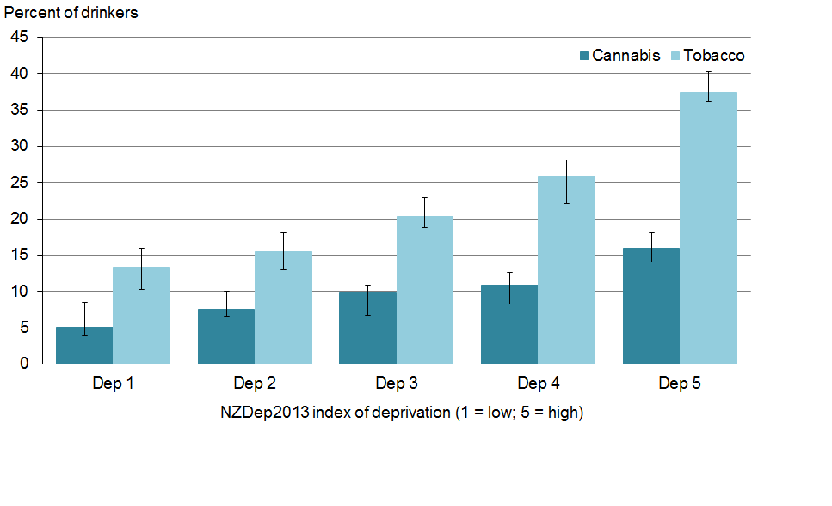

Source: 2012/13 New Zealand Health Survey.

## Harms from drinking

There is a range of alcohol-related harms. These can be caused and experienced by the drinker alone, or experienced as a result of another’s misuse of alcohol. Males and females experience harm in different ways, and males tend to experience harm more often. The prevalence of specific harms differs for different ages (WHO 2007, Ministry of Health 2009, Law Commission 2010, Research New Zealand 2012, Clark et al 2013, Connor 2013, Huckle et al 2013, Ministry of Health 2013c).

### Harms from own drinking

Alcohol misuse produces a range of harmful effects for the drinker. Drinkers were asked questions about harmful experiences they had had as a result of drinking alcohol.

### Harms from own drinking: physical and mental harms

Box 10: Drinkers who experience physical and mental harms from drinking (age band 15+ years)



Drinkers were asked if there were times that their alcohol use had a harmful effect on their physical health or mental health, or if they had had any injuries due to their alcohol use.

For more information on alcohol-related injury see: *Alcohol-related Injury: An evidence-based literature review* (Research New Zealand 2012).

#### Males are more likely to experience harm to their health from drinking

Harm to physical health (8.0%) was the most commonly reported harmful effect of own alcohol use in the past 12 months. This equates to around 228,000 drinkers. Nine-point-one percent of male drinkers reported experiencing harmful effects to physical health compared with 6.9% of female drinkers. Males were 1.3 times more likely than females to experience harmful effects to physical health from their drinking, after adjusting for age differences.

Compared to physical health, fewer drinkers experienced a harmful effect to mental health (4.6%), or experienced injuries (3.6%), as a result of their drinking. This equates to around 131,000 drinkers experiencing mental health harms and 101,000 drinkers experiencing an injury as a result of drinking. Five percent of male drinkers reported experiencing mental health harm from their drinking compared with 4.3% female drinkers. Similarly, 4.2% of male drinkers reported experiencing injuries compared with 2.9% of female drinkers. Males were 1.4 times more likely than females to experience injuries from drinking, after adjusting for age differences (Box 10).

#### Younger drinkers report experiencing harm to their health from drinking

Alcohol-related harm to physical health and alcohol-related injuries were most frequently reported by youth (aged 15–24 years) and younger adults (aged 25–34 years). Reported harms decreased with increasing age (Box 10). The harmful effect on mental health was similar for youth and young adults, and then gradually decreases with increasing age.

Fifteen percent of Māori and 10% of Pacific drinkers compared with 7.5% of European/Others and 7.1% of Asian drinkers reported a harmful effect to their physical health as a result of their drinking.

#### Drinkers living in the most deprived areas report alcohol-related harm

The prevalence of physical and mental health harms from own drinking were higher for drinkers who live in the most deprived areas compared with those living in the least deprived areas (Figure 15). In particular, a greater percentage of drinkers living in the most deprived areas (6.2%) than those living in the least deprived areas (2.4%) reported injuries as a result of their drinking. Drinkers living in the most deprived areas were 2.1 times more likely to experience an injury than drinkers living in the least deprived areas, after adjusting for age, sex and ethnic differences (Box 10). However, this difference was not found to be statistically significant.

Figure 15: Percentage of drinkers who reported experiencing specific harms in the past 12 months as a result of their own alcohol use, least versus most deprived areas

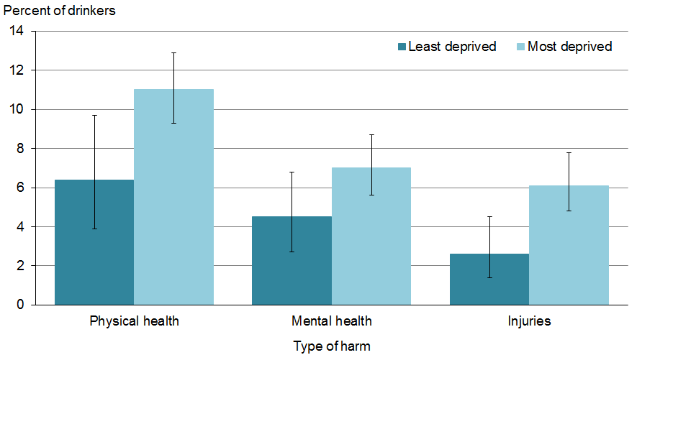

Source: 2012/13 New Zealand Health Survey.

Note: NZDep2013 index of deprivation; least deprived = quintile 1; most deprived= quintile 5.

### Harms from own drinking: social harms

Box 11: Drinkers who experience social harms from drinking (age band 15+ years)



Drinkers were asked if there were times that alcohol use had had a harmful effect on their friendship and social life, or home life, or if they had had legal problems due to their alcohol use.

#### Youth experience harms to friendships and social life from their drinking

Harm to friendships and social life was the most commonly reported social harm for drinkers (5.3%). This equates to around 149,000 drinkers. Six-point-one percent of male drinkers reported experiencing harmful effects to friendships or social life compared with 4.3% of female drinkers. Males were 1.2 times more likely than females to experience harmful effects to friendships and social life from their drinking, after adjusting for age differences. The effect of alcohol use on friendships and social life was most frequently reported by youth (15–24 years) and younger adults (25–34 years). The experience of all alcohol-related social harms decreased with increasing age.

Harm to home life from own drinking was reported by 4.7% of drinkers. This equates to around 134,000 drinkers. Five-point-nine percent of male drinkers reported experiencing harmful effects to home life compared with 3.5% of female drinkers. Males were 1.4 times more likely than females to experience harmful effects on their home life from their drinking, after adjusting for age differences.

#### Social harms are more prevalent among drinkers living in the most deprived areas

The prevalence of all alcohol-related social harms was increased for those who live in the most deprived areas (Figure 16). A greater percentage of drinkers living in the most deprived areas reported experiencing a harmful effect on friendships and social life, home life and legal issues than drinkers living in the least deprived areas.

Drinkers living in the most deprived areas were 1.4 times more likely to experience a harmful effect on home life than drinkers living in the least deprived areas, after adjusting for age, sex and ethnicity differences (Box 11). However, for other social harms (to friendships and social life and legal issues) differences were not statistically significant.

Figure 16: Percentage of drinkers who reported experiencing specific harms in the past 12 months as a result of their own alcohol use, least versus most deprived areas

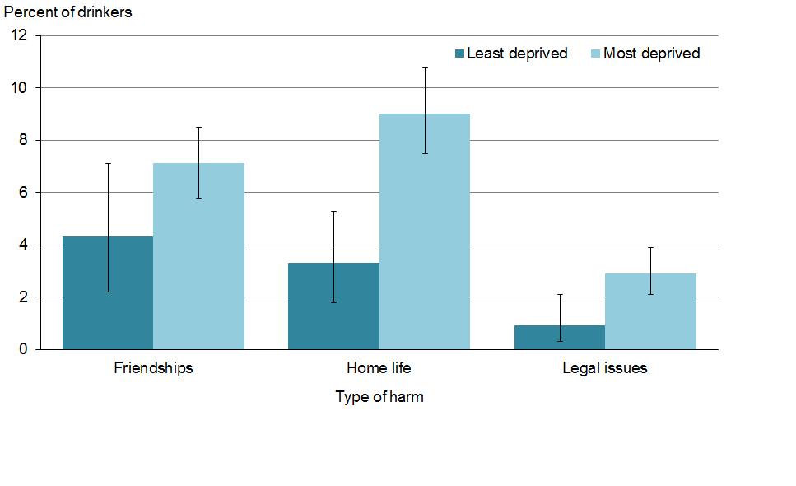

Source: 2012/13 New Zealand Health Survey.

Note: NZDep2013 index of deprivation; least deprived = quintile 1; most deprived= quintile 5.

### Harms from own drinking: productivity and economic harms

Box 12: Past-year drinkers who experienced productivity harms from drinking (age band 15+ years)



Drinkers were asked if there were times that alcohol use had had a harmful effect on their work, studies, employment opportunities or financial position, or if they had been absent from work or school due to their alcohol use.

#### Males drinkers more likely to experience financial harm from their drinking

Harm to financial position was the most commonly reported alcohol-related economic harm for drinkers (5.8%). This equates to around 165,000 drinkers. Six-point-nine percent of male drinkers reported experiencing a harmful effect to their financial position compared with 4.7% of female drinkers. Males were 1.4 times more likely than females to have their financial position affected, after adjusting for age differences (Box 12). Overall, alcohol-related productivity and economic harms gradually decreased with increasing age. The negative effect of alcohol use on financial position was most frequently reported by youth (15–24 years) and younger (25–34 years) drinkers (Box 12).

Fourteen percent of Māori and 9.1% of Pacific drinkers compared with 5.2% of European/Others and 3.9% of Asian drinkers reported a harmful effect to their financial position as a result of their drinking.

#### Drinkers living in the most deprived areas report alcohol-related productivity harms

The prevalence of harms was greater for those living in the most deprived areas (Figure 17). However, the difference in prevalence of alcohol-related productivity and economic harm between drinkers living in the most and least deprived areas was not statistically significant, after adjusting for age, sex and ethnicity differences (Box 12).

Figure 17: Percentage of drinkers who reported experiencing specific harms in the past 12 months as a result of their own alcohol use, least versus most deprived areas

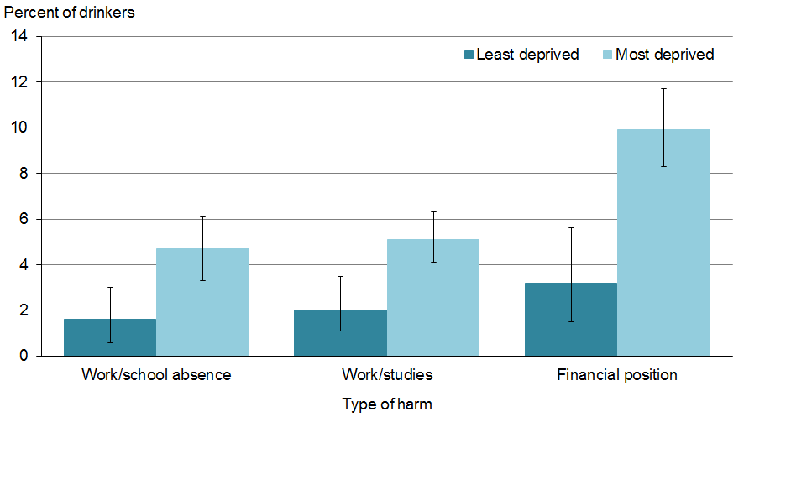

Source: 2012/13 New Zealand Health Survey.

Note: NZDep2013 index of deprivation; least deprived = quintile 1, most deprived= quintile 5.

### Harms from others drinking

Box 13: Adults’ experience of harms from others’ drinking (age band 15+ years)



Alcohol-related harms that are experienced as a result of someone else’s drinking comprise a range of health and social impacts. Impacts include fetal alcohol spectrum disorder, a large proportion of criminal offences, stranger violence and familial violence, family and interpersonal problems, and alcohol-related vehicle crashes (WHO 2007, McLean et al 2009, Slack et al 2009, Ministry of Transport 2011, Boden et al 2012, Connor et al 2012, Ministry of Social Development 2012, Poulsen et al 2012, Research New Zealand 2012, Huckle et al 2013, Families Commission 2014).

Adults were asked questions about harmful experiences they had had as a result of other people’s drinking. These included harms to social life, home life, financial position, being driven by a drunk driver, and violent harms (ie, verbal abuse, physical harm, and being made to feel scared or fearful).

#### A range of harms are experienced by adults as a result of other people’s drinking

Violent harms were the most prominent harm reported (15%) the result of someone else’s drinking among adults aged 15+ years. This equates to around 533,000 adults. Effects on friendship and social life (8.4%), home life (5.3%) and financial position (2.3%) were also reported by adults as a result of others’ alcohol use. This equates to around 573,000 adults experiencing these harms. A greater percentage of female adults than male adults reported harmful effects from other people’s drinking on friendships and social life (10% compared with 6.8%), to home life (6.7% compared with 3.9%) and to financial position (3.0% compared with 1.6%). Seven percent of male and 5.2% of female adults reported having been driven by a drunk driver.

Males were significantly less likely than females to report a harmful effect from other people’s drinking on friendship and social life, on home life, and on financial position, after adjusting for age differences.

#### Youth and young adults report being driven by a drink driver

Being driven by a drunk driver was reported by 6.1% of adults. This equates to around 217,000 adults reporting being a passenger in a car driven by a driver under the influence of alcohol in the past year. Seven percent of male and 5.2% of female adults reported having been a passenger. Males were 1.3 times more likely to report having been a passenger in a car driven by a driver under the influence of alcohol in the past year, after adjusting for age differences.

Among all adults, a greater percentage of youth (15–24 years) and younger adults (25–34 years) reported being driven by a drunk driver.

#### Violent harms are the most frequently reported harms caused by other people’s drinking

Seventeen percent of male and 13% of female adults reported experiencing a violent harm of some kind. Among all adults, a greater percentage of youth (15–24 years) and younger adults (25–34 years) report experiencing a violent harm from other people’s drinking (Box 13).

The violent harms reported as the result of someone else’s drinking include being made to feel scared or fearful, physical harm and verbal abuse. Fifteen percent of male and 11% of female adults reported suffering verbal abuse. This equates to around 259,000 males and 200,000 females. Physical harm was reported by 3.2% of male and 2.8% of female adults, which equates to about 56,000 cases of physical harm to male and 51,000 to female adults as the result of another’s drinking. In contrast, 6.8% of female and 4.4% of male adults reported being made scared or fearful as the result of another person’s drinking.

#### Adults living in the most deprived areas were more likely to experience a violent harm

Violent harms were reported by more adults who live in the most deprived areas (Figure 18). Adults living in the most deprived areas were 1.4 times more likely to experience any violent harm as a result of other people’s drinking than adults living in the least deprived areas, after adjusting for age, sex and ethnicity differences (Box 13).

Figure 18: Percentage of adults experiencing any violent harm as a result of other people’s drinking in the past 12 months, by deprivation

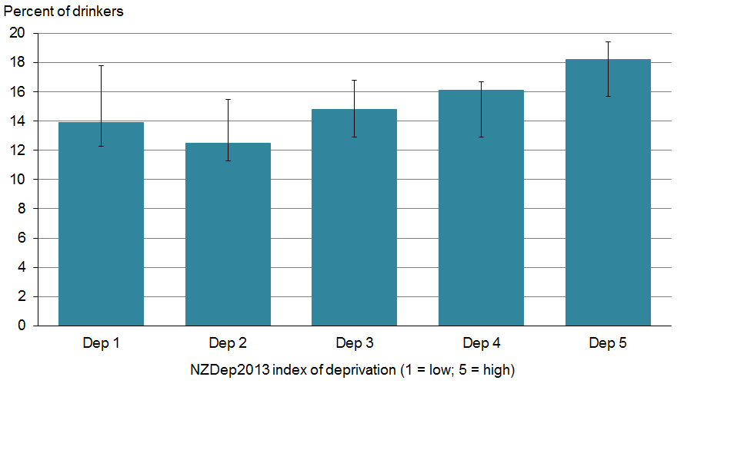

Source: 2012/13 New Zealand Health Survey.

## Moderating behaviours

Moderating behaviours to reduce the harmful effects of alcohol consumption can be used while drinking. Drinkers were asked if they had moderated their drinking behaviours in the past 12 months; for example, by making a point of eating while consuming alcohol, by alternating between alcoholic and non-alcoholic drinks, or by only drinking low-alcohol drinks.

#### Drinkers most commonly ate food to reduce the effects of alcohol

The most common moderating behaviour used by drinkers was to make a point of eating while drinking (70%) “always” or “most of the time”. This equates to around 1,990,000 drinkers. Seventy-six percent of female and 65% of male drinkers reported eating while drinking “always” or “most of the time”. Males were 0.9 times less likely to eat while drinking “always” or “most of the time”, after adjusting for age differences.

Seventy-one percent of Asian 71% and 72% European/Others drinkers compared with 57% of Māori and 51% of Pacific drinkers reported eating while drinking “always” or “most of the time”. Conversely, 18% of Pacific people and 14% of Māori reported never making a point of eating while drinking. Māori and Pacific people were 0.8 times less likely than non-Māori and Non-Pacific people to eat while drinking “always” or “most of the time”, after adjusting for age and sex differences.

People living in areas of high deprivation were 0.8 times less likely than those living in areas of low deprivation to eat while drinking “always” or “most of the time”, after adjusting for age, sex and ethnic differences.

#### Reducing the effects of alcohol by limit the number of drinks varied by ethnic group

The second most prevalent method of reducing the harmful effects of alcohol was to limit the number of drinks consumed in a session (65%). This equates to around 1,840,000 drinkers. Sixty-eight percent of female and 62% of male drinkers reported having done so “always” or “most of the time”. Males were 0.9 times less likely than females to limit their number of drinks “always” or “most of the time”, after adjusting for age differences.

As was found for eating, 74% of Asian and 67% of European/Others drinkers compared with 50% of Pacific and 45% of Māori drinkers reported limiting the number of drinks consumed “always” or “most of the time”. Asians were 1.2 times more likely than non-Asians to limit the number of drinks they consumed in one session “always” or “most of the time”, after adjusting for age and sex differences. While Māori drinkers were 0.7 times less likely than non-Māori drinkers, and Pacific drinkers 0.9 times less likely than non-Pacific drinkers, to limit the number of drinks they consumed in one session “always” or “most of the time”, after adjusting for age and sex differences. Drinkers living in areas of high deprivation were 0.9 times less likely than drinkers living in areas of low deprivation to limit the number of drinks they consumed in one session “always” or “most of the time”, after adjusting for age, sex and ethnicity differences.

## Help-seeking behaviours

#### A small group of drinkers received help for their alcohol use

Drinkers were asked if in their lifetime they had ever received help to reduce their level of alcohol use.

Help for reducing alcohol consumption is available from a number of sources. Only a small percentage of drinkers (4.4%) reported having received help to reduce the level of alcohol use at some stage during their lifetime. This equates to around 124,000 adults. Of those who had ever received help, 1.1% received help from a general practitioner (GP). One-point-five percent of male and 0.7% of female drinkers received help from a GP. When adjusted for age, males were 2.1 times more likely than female drinkers to approach a GP for help. Pacific drinkers were 1.6 times more likely to seek help from a GP than non-Pacific drinkers, and Māori drinkers were 1.3 times more likely than non-Māori drinkers to do so, after adjusting for age and sex differences.

#### Half of help sought by drinkers was from a GP

Drinkers were asked whether they had received help to reduce their level of use in the last 12 months, and who they had received help from.

Of those drinkers who had ever received help, 56% received help in the past 12 months. This equates to around 69,000 people. The majority of those who received help in the past year used a combination of sources for help. About half (52%) of help-seekers approached a GP. Sixty-three percent of females and 47% of males sought help from a GP.

#### Few drinkers who sought help did not receive it

Drinkers were asked if in the last 12 months they had wanted help but not received it.

A minority of drinkers had wanted help (1.0%) to reduce their alcohol use in the past 12 months but did not receive help. Fewer male drinkers (1.4%) than female drinkers (0.7%) reported having not received help when they wanted it.

# Summary of changes from 2007/08

Whereas the 2012/13 NZHS includes adults aged 15 years and over, the 2007/08 alcohol and drug use survey was limited to adults aged 16–64 years. To enable comparisons over time only statistically significant changes in the patterns of alcohol consumption by adults aged 16–64 years are reported in this section.

### General use

#### Fewer adults are drinking

Fewer adults consumed alcohol in 2012/13 (82%) than in 2007/08 (85%). This decline was observed for both males (from 88% to 85%) and females (from 82% to 78%).

### Initiation of alcohol use

#### Fewer adults reported starting drinking alcohol as teenagers

Fewer adults reported first drinking alcohol before age 15 years in 2012/13 (30%) than in 2007/08 (32%). This decline was observed for females (from 27% to 26%) but not for males.

### Types of alcohol consumed

#### The types of alcohol typically consumed changed over time

The type of alcohol typically consumed by drinkers in 2012/13 diffed from that described in the 2007/08 alcohol report. The changes in the percentage of drinkers typically drinking different types of alcohol were as follows:

* Spirits consumption decreased from 49 percent in 2007/08, to 27 percent in 2012/13.
* Wine or sherry consumption decreased from 69 percent in 2007/08, to 52 percent in 2012/13.
* Beer or cider consumption decreased from 66 percent in 2007/08, to 59 percent in 2012/13.
* Ready-to-drink drinks (RTDs) consumption decreased from 22 percent in 2007/08, to 17 percent in 2012/13.

### Frequency of alcohol use

#### A third of drinkers had drunk alcohol regularly

The percentage of drinkers who drank alcohol with high, medium or low frequency in the past 12 months has changed since 2007/08 (Table 3). More drinkers drank with a low frequency in 2012/13 (42%) than in 2007/08 (39%), and fewer drinkers drank with medium frequency in 2012/13 (30%) than in 2007/08 (32%).

Table 3: Frequency of drinking among drinkers aged 16–64 years

|  |  |  |
| --- | --- | --- |
| **Frequency of drinking** | **Percent 2007/08** | **Percent 2012/13** |
| High frequency (at least 3–4 times a week) | 29 | 28 |
| Medium frequency (once or twice a week) | 32 | 30 |
| Low frequency (less than once or twice a week) | 39 | 42 |

Source: 2007/08 and 2012/13 New Zealand Health Surveys.

Note: Drinking frequency for general alcohol use is categorised into high frequency: at least 3–4 times a week; medium frequency: once or twice a week; and low frequency: less than once or twice a week.

### Drinking to intoxication

#### Fewer drinkers drank to intoxication

Fewer drinkers reported drinking to intoxication at least once in 2012/13 (57%) compared with 2007/08 (59%). This decline in intoxication was observed for females (from 55% to 52%), but not for males.

### Risky behaviours

#### Fewer drinkers reported working under the influence of alcohol

Fewer drinkers reported having worked in the past 12 months while feeling under the influence of alcohol in 2012/13 (7.6%) than in 2007/08 (11%). This decline was observed for both males (from 15% to 9.8%) and females (from 7.6% to 5.1%).

### Concurrent tobacco use

#### Fewer drinkers smoked tobacco while drinking

Tobacco remains the most commonly reported drug used while drinking alcohol. However, fewer drinkers aged 16–64 years reported having smoked tobacco while drinking in 2012/13 (25%) compared with 2007/08 (30%).

### Harms from own drinking

#### Drinking injuries have decreased

Fewer drinkers experienced an injury due to their alcohol use in 2012/13 (4.1%) compared with 2007/08 (5.5%). This decline was observed for both males (from 6.2% to 4.8%) and females (from 4.7% to 3.4%).

#### Effects on friendships and social life, and home life, have decreased

Fewer drinkers experienced harms to their friendship or social life as a result of their drinking in 2012/13 (6.2%) compared with 2007/08 (7.8%). This decline was observed for males (from 9.6% to 7.2%) but not for females.

The impact of alcohol on home life also reduced over this time. Fewer drinkers reported that their drinking harmed their home life in 2012/13 (5.5%) compared with 2007/08 (6.2%). The decline was observed for females (from 5.3% to 4.1%), but not for males.

#### Fewer drinkers were absent from work

Fewer drinkers were absent from work or study as a result of their drinking in 2012/13 (3.8%) compared with 2007/08 (6.6%). This decrease was observed for both males (from 7.4% to 4.7%) and females (from 5.8% to 2.9%).

### Harms from others drinking

#### Harms caused by other people’s drinking have decreased over time

Fewer adults reported an effect of others’ alcohol use on their financial position in 2012/13 (2.7%) compared with 2007/08 (3.6%). This decline was observed for females (from 4.4% to 3.5%), but not for males.

Similarly, there was a decrease in the percentage of adults reporting an impact of others’ alcohol use on their friendships or social life in 2012/13 (9.7%) compared with 2007/08 (16%). This decline was observed for males (from 14% to 7.7%) and females (from 18 % to 12%).

Fewer adults reported harmful effects of others’ alcohol use on their home life in 2012/13 (6.1%) compared with in 2007/08 (8.5%). This decline was observed for males (from 6.2% to 4.5%) and females (from 11% to 7.7%).

### Moderating behaviours

#### Moderating behaviours have decreased over time

Fewer drinkers reported moderating their drinking “always” or “most of the time” by limiting the number of drinks they consumed during a drinking session, in 2012/13 (63%) compared with 2007/08 (79%). The decline in moderating behaviours was observed for females (from 77% to 66%) and males (from 80% to 59%).

# Alcohol use by pregnant women

## Background

The Ministry of Health continue to advise women to drink no alcohol leading up to and during pregnancy (Ministry of Health 2010).

The consequences of drinking alcohol during pregnancy include the risk of miscarriage and stillbirth, and the risk of a baby being born with fetal alcohol spectrum disorder (FASD). FASD encompasses a range of lifelong effects (WHO 2000, Sellman et al 2009, Ministry of Health 2010), including cranial, facial, limb and cardiovascular defects, and numerous debilitating long-term effects, such as brain damage, growth restriction, developmental delay, and cognitive, social, emotional and behavioural problems (WHO 2000, Ministry of Health 2010). New Zealand research suggests an incidence of FASD in 3 per 1000 live births per year. This equates to approximately 170 babies being born with FASD in New Zealand every year (circa 2007) (Elliott et al 2008).

Alcohol consumption during pregnancy occurs under different circumstances. Some women choose to drink when they are aware of their pregnancy. Other women consume alcohol unaware that they are pregnant; in such cases, alcohol consumption might continue until a pregnancy is recognised or confirmed (Sellman et al 2009, Huckle et al 2013).

This section draws on survey responses from women aged 15–54 years who were pregnant in the past 12 months.

Key findings

* About one in five women who were pregnant in the last 12 months drank alcohol at some point during their most recent pregnancy.
* Most women who were pregnant in the last 12 months altered their drinking behaviour leading up to and during pregnancy: one in three stopped drinking before pregnancy, and one in two stopped drinking when aware of their pregnancy. However, one in six continued to drink during their most recent pregnancy.
* More than two-thirds of the women who were pregnant in the last 12 months and who had ever drunk alcohol received advice not to drink during pregnancy. Half of those were advised by a GP.
* Seventy-eight percent of women who were pregnant in the last 12 months and who drank during pregnancy reported past-year risky drinking.

## Alcohol use by pregnant women

Women who had been pregnant in the last 12 months were asked if they had consumed alcohol at any time during their most recent pregnancy. The pregnancy and alcohol use section was answered by 565 women aged 15–54 years who were pregnant within the past 12 months.

#### Younger women were more likely to drink alcohol during pregnancy

In 2012/13 about one in five women (19%) who had been pregnant in the last 12 months drank alcohol at some time during their most recent pregnancy. Twenty-eight percent of women aged 15–24 years compared with 17% of women aged 25–34 years and 13% of women aged 35–54 years reported having consumed alcohol during their most recent pregnancy (Figure 19).

Figure 19: Percentage of pregnant women who reported having drunk alcohol at any time during their most recent pregnancy, by age

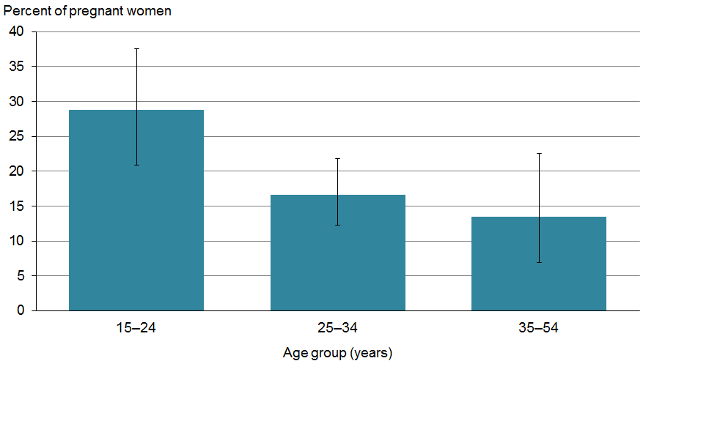

Source: 2012/13 New Zealand Health Survey.

Twenty percent of European/Others women compared with 10% of Pacific or 4.3% of Asian women who were pregnant in the past 12 months reported having consumed alcohol during their most recent pregnancy. The highest rates for drinking during pregnancy were for Māori women. One-third (34%) of Māori women who were pregnant in the past 12 months reported drinking alcohol at some time during their most recent pregnancy (Figure 20). Māori women were twice as likely as non-Māori women to have drunk during their most recent pregnancy, after adjusting for age differences.

Figure 20: Percentage of pregnant women who reported having drunk alcohol at any time during their most recent pregnancy, by ethnic group

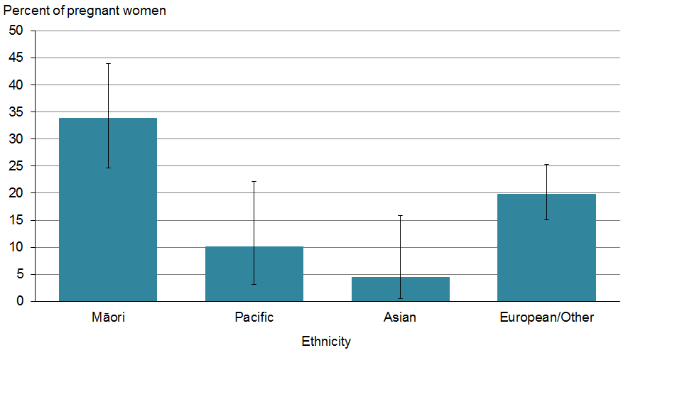

Source: 2012/13 New Zealand Health Survey.

#### Women altered their drinking behaviour leading up to and during pregnancy

The level of harm to the fetus from drinking during pregnancy is related to the amount of alcohol consumed, the frequency of consumption and the timing of the exposure (Elliott et al 2008, Ministry of Health 2010, Sawada-Feldman et al 2012). Women were therefore asked about their pattern of alcohol consumption leading up to, and during, pregnancy.

A third of all women who had been pregnant in the last 12 months (31%) reported that they stopped drinking before becoming pregnant. The majority of women who had been pregnant in the last 12 months (55%), however, reported that they stopped drinking as soon as they learned of the pregnancy (Table 4).

About 15% of women who had been pregnant in the last 12 months continued to drink while they were pregnant (Table 4). Of this group, the majority (8.5%) stated that they reduced their drinking while pregnant. A smaller number of women who had been pregnant in the last 12 months continued to drink with a similar pattern (4.2%). Some eventually stopped drinking (2.5%) while pregnant, although a minority increased their drinking during pregnancy (0.2%) (Table 4). Māori women were 3.4 times more likely than non-Māori women to reduce their drinking while pregnant, and 4.4 times more likely to eventually stop drinking while pregnant, after adjusting for age differences.

Table 4: Reported alcohol consumption behaviours by women who were pregnant in the past year

|  |  |
| --- | --- |
| **Behaviour** | **Percent** |
| Stopped drinking before pregnancy | 31 |
| Stopped drinking as soon as learned of pregnancy | 55 |
| Eventually stopped drinking while pregnant | 2.5 |
| Reduced drinking while pregnant | 8.5 |
| Did not change drinking pattern during pregnancy | 4.2 |
| Increased drinking while pregnant | 0.2 |

Source: 2012/13 New Zealand Health Survey.

Note: Prevalence estimates are rounded to one decimal place if less than 10% and to whole numbers if more than 10%. Total prevalence does not equal 100%.

#### Most women who drank during pregnancy also reported past-year risky drinking

Risky drinking is defined for women as drinking more than four standard drinks on one drinking occasion. An established pattern of risky drinking may be difficult to change leading up to or during pregnancy. Damage to the fetus is more likely to occur when a woman has an established pattern of drinking where high amounts of alcohol are consumed (WHO 2000, Ministry of Health 2010, Sawada-Feldman et al 2012). In unplanned pregnancies, women who regularly drink in a risky way will be at greater risk of causing harm to the fetus (Maier et al 2001), because there is a greater chance that pre-pregnancy alcohol consumption levels continue until the pregnancy is recognised (Sellman et al 2009, Huckle et al 2013).

This analysis was conducted in order to illustrate past-year alcohol consumption behaviours among women who drank alcohol at any time during their most recent pregnancy. It should be noted that the rates for past-year risky drinking among women who drank during pregnancy do not necessarily equate to pregnant women drinking in a risky way during that pregnancy.

Among women who had been pregnant in the last 12 months and who reported drinking alcohol during their most recent pregnancy, 78% also reported risky drinking in the past year. Of the women who drank alcohol during their most recent pregnancy and drank in a risky way in the past year, 11% reported risky drinking with high frequency (at least weekly), 16% reported risky drinking with medium frequency (at least once a month), while the majority (51%) reported risky drinking with low frequency (at least once a year). Of women who reported drinking alcohol during their most recent pregnancy, 89% of those aged 15–24 years and 73% of those aged 25–34 years also reported past-year risky drinking. The sample size for 35–54-year-olds was low, so the data was suppressed and not reported.

## Advised not to drink

Pregnant women who had ever drunk alcohol were asked if anyone, during their most recent pregnancy, had advised them not to drink.

#### Of pregnant women who had ever drunk alcohol most were advised not to drink

More than two-thirds (68%) of pregnant women who had ever drunk alcohol received advice not to drink during pregnancy. Seventy-one percent of pregnant women aged 15–24 years reported being advised not to drink compared with 66% of 25–34-years-olds and 67% of 35–54-year-olds. Sixty-nine percent of Pacific and 69% of European/Others compared with 66% of Māori and 53% of Asian women who were pregnant in the past 12 months reported having received advice not to drink during pregnancy.

#### Most pregnant women who had ever drunk alcohol were advised not to drink by their GP

About half (49%) of those who received advice to not drink while pregnant were advised by a GP. Fifty-five percent of women aged 25–34 years compared with 50% of 15–24 year-old and 39% of 35–54 year-old women who were pregnant in the past 12 months reported having been advised by a GP not to drink during their last pregnancy.

Of those who were advised not to drink by someone other than a GP, this advice was received from another health professional (ie, nurse, midwife, obstetrician), a spouse or partner, relative or friend. Fifty-three percent of European/Others pregnant women compared with 49% of Māori and 46% of Pacific women who were pregnant in the past 12 months reported having received advice from another health professional (ie, nurse, midwife, obstetrician), a spouse or partner, relative or friend. The sample size for Asian women who were pregnant in the past 12 months was low, so data was suppressed and not reported.

#### Most pregnant women who drank during pregnancy were advised not to drink

The majority of women who were pregnant in the past 12 months and drank during their most recent pregnancy received advice not to drink during pregnancy (71%). Among them, 78% of women aged 15–24 years compared with 70% of women aged 25–34 years reported being advised not to drink. The sample size for 35–54-year-olds was low, so data was suppressed and not reported.

# Alcohol availability and use: a geospatial analysis

## Background

Geospatial analysis helps explore relationships between health data and geography. In the context of alcohol use, geospatial analysis can tell us more about the association between alcohol availability and alcohol use.

Greater alcohol outlet density has been associated with increased alcohol consumption. The relationships between drinking behaviour and density of alcohol outlets are complex and depend on a range of factors, such as local drinking patterns, demographic differences in the population (eg, age and ethnicity), and neighbourhood characteristics (such as transport networks and public facilities) (Livingston et al 2007, Connor et al 2010, Cameron et al 2012, Cameron et al 2013).

Previous research demonstrates a positive relationship between alcohol outlet density (clustering) and increased local levels of alcohol consumption (WHO 2007, Connor et al 2010); between alcohol outlet density and relative social deprivation; and between social deprivation and a shorter distance to the nearest alcohol outlet, particularly in urban areas (Pearce et al 2008, Hay et al 2009, Cameron et al 2013). Further to this, people living in the most deprived areas are more likely to be hazardous drinkers than those living in the least deprived areas (Ministry of Health 2013a, Ministry of Health 2013b).

This analysis explores the relationship between the density of alcohol outlets in urban environments and alcohol use. For more information, see the ‘Methods’ section of this report.

Key findings

* Alcohol outlets are within a short driving distance for most New Zealanders.
* Eighty-five percent of adults living in urban areas live within two minutes’ drive of any alcohol outlet, while two in three live within two minutes’ drive of an off-licence outlet.
* Off-licence alcohol outlet density is greatest in the most deprived areas.
* Higher levels of hazardous drinking occur in the most deprived areas.
* Hazardous drinkers living within the most deprived urban areas are more likely to live within two minutes’ drive of multiple off-licence alcohol outlets.

## Alcohol availability

#### Alcohol outlets are within a short driving distance for most New Zealanders

Seventy-eight percent of New Zealanders aged 15+ years live within two minutes’ drive of an alcohol outlet (approximately 1.5 km). The majority of New Zealanders live in an urban environment (Statistics New Zealand 2008), where 85% live within two minutes’ drive of an alcohol outlet: 66% live within two minutes of an alcohol on-licence (bars, clubs, restaurants and cafés), and 67% live within two minutes of an off-licence alcohol outlet (bottle stores and supermarkets).

More adults who live in the most deprived areas live close to (within 2 minutes’ drive) alcohol outlets than those living in the least deprived areas, and the density of alcohol outlets is greater in areas of greater deprivation (Figure 21).

Figure 21: Percentage of adults aged 15+ years living in urban environments across New Zealand that are within two minutes’ drive of 0, 1–2 or 3+ alcohol outlets (on- and off-licence), by deprivation

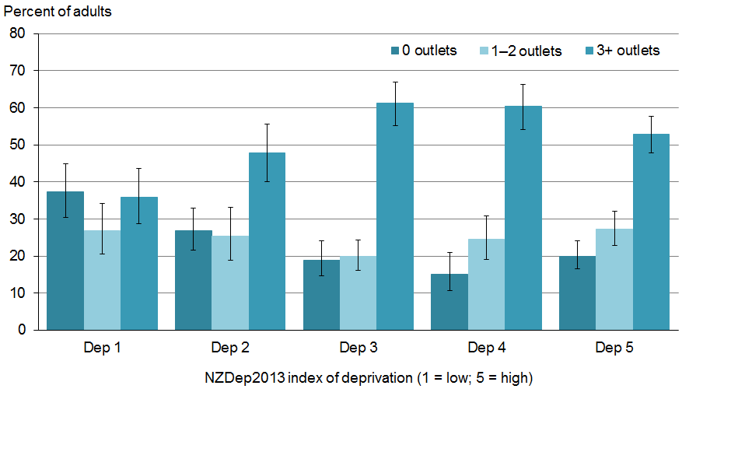

Source: 2011/12 and 2012/13 New Zealand Health Survey; Ministry of Justice alcohol outlet licences database 2013.

#### Off-licence density is greatest in the most deprived areas

The vast majority of adults in New Zealand drink alcohol in a private setting (refer to the above section ‘Patterns of alcohol use’). Alcohol drunk in private settings is purchased from off-licences such as bottle stores and supermarkets. Supermarkets, in particular, contribute around 30% of all beer and 60% of all wine sales in New Zealand (Law Commission 2010).

Twenty-six percent of adults who live in the most deprived areas have no off-licences within two minutes of their homes compared with 55% of adults who live in the least deprived areas (Figure 22). More adults who live in the most deprived areas (37%) have one to two off-licences within two minutes’ drive of their homes compared with adults who live in the least deprived areas (31%) (Figure 22). More adults living in high deprivation areas (37%) have three or more off-licences within 2 minutes’ drive compared with adults who live in the least deprived areas (14%) (Figure 22).

Figure 22: Percentage of adults aged 15+ years living in urban environments who are within two minutes’ drive of 0, 1–2 or 3+ off-licence alcohol outlets, by deprivation

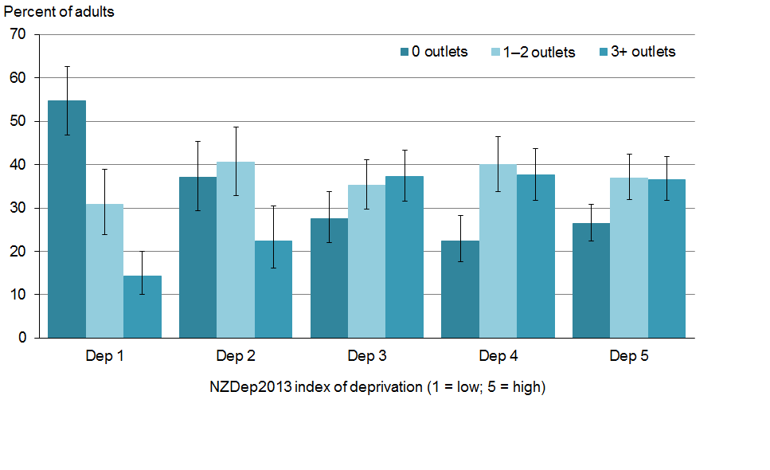

Source: 2011/12 and 2012/13 New Zealand Health Surveys; Ministry of Justice alcohol outlet licences database 2013.

## Hazardous drinking

Hazardous drinking refers to an established drinking pattern that carries a risk of harming the drinker’s physical or mental health, or of having harmful social effects on the drinker or others. Around 15% of New Zealand adults aged 15+ years report a hazardous drinking pattern, as measured by the AUDIT tool (Ministry of Health 2013a, Ministry of Health 2013b).

#### Higher levels of hazardous drinking occur in the most deprived areas

Hazardous drinking increases with increasing deprivation: 12% of the adult population living in urban environments within the least deprived areas are hazardous drinkers, whereas 19% of adults living in urban environments within the most deprived areas are hazardous drinkers.

#### More hazardous drinkers living in the most deprived urban areas live within two minutes’ drive of multiple off-licences

Of the adult population aged 15+ years who are hazardous drinkers (hereafter known as hazardous drinkers), 21% live in the most deprived urban areas with no off-licence alcohol outlets within two minutes’ drive; this is compared with 10% of those living in the least deprived urban areas (Figure 23).

Almost 20 percent of hazardous drinkers who live in the most deprived urban areas live within two minutes’ drive of 1–2 off-licence alcohol outlets; this compares with 10% of those who live in the least deprived urban areas (Figure 23). Hazardous drinkers living in the most deprived urban areas were 1.4 times more likely to live within two minutes’ drive of 1–2 off-licence outlets than those living in the least deprived urban areas, after adjusting for age, sex and ethnic differences.

Living in urban areas of low deprivation and within two minutes’ drive of 3+ off-licence outlets may influence rates of hazardous drinking. Twenty-four percent of those who live in the least deprived areas live within two minutes’ drive of 3+ off-licence alcohol outlets. In comparison, 18% of hazardous drinkers who live in the most deprived urban areas live within two minutes’ drive of 3+ off-licence alcohol outlets (Figure 23). Unpublished data suggests that the larger proportion of hazardous drinkers living in urban areas of low deprivation and within two minutes’ drive of 3+ off-licence outlets is most likely the result of more hazardous drinkers living within the inner city of major urban centres.

Figure 23: Percentage of the adult population aged 15+ years living in urban environments who are hazardous drinkers, by deprivation and proximity to off-licence alcohol outlets (within two minutes’ drive of 0, 1–2 or 3+ outlets)

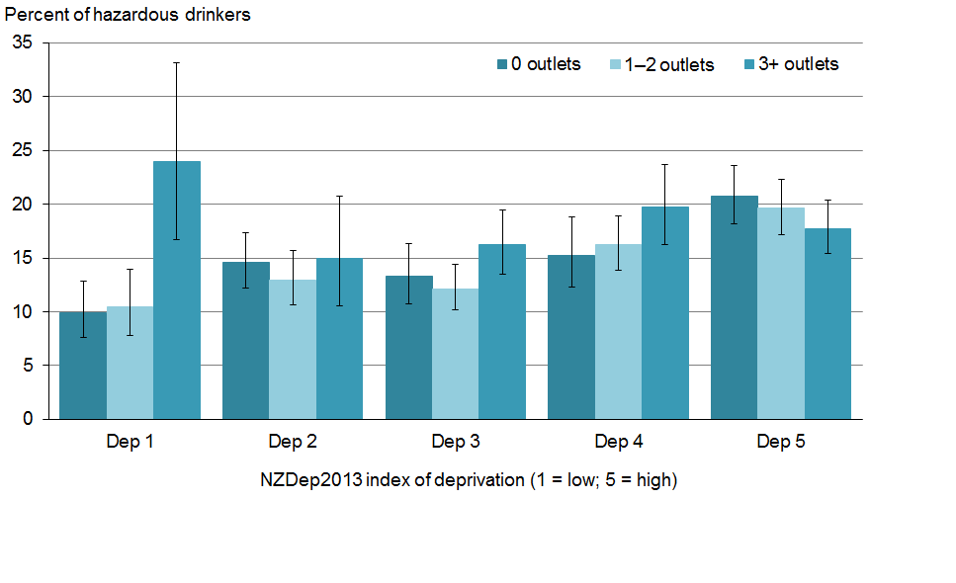

Source: 2011/12 and 2012/13 New Zealand Health Surveys; Ministry of Justice alcohol outlet licences database 2013.

# Methods

## 2012/13 NZHS methodology

### Overview of the survey methodology

The NZHS collects a wealth of information on the health and wellbeing of New Zealanders. Every year it includes a core set of questions, which help us to identify key issues and monitor trends. Every five years the survey includes an additional module which focuses specifically on alcohol and drug use.

The full survey methodology report is available online: [www.health.govt.nz/publication/new-zealand-health-survey-methodology-report-2012-13](http://www.health.govt.nz/publication/new-zealand-health-survey-methodology-report-2012-13)

The New Zealand Health and Disability Multi-Region Ethics Committee granted approval for the 2012/13 NZHS (MEC/10/10/103) in 2011.

### Survey population and sample design

The current survey covers the usually resident population of all ages living in permanent dwellings, aged-care facilities and student accommodation, which was approximately 3.6 million adults aged 15 years and over.

The NZHS has a multi-stage, stratified, probability-proportional-to-size (PPS) sampling design, with increased sampling of some ethnic groups (Māori, Pacific people and Asians), primarily through a ‘screened’ sample. The survey is designed to yield an annual sample size of approximately 13,000 adults.

### Data collection

The NZHS field work is contracted out to a specialist survey provider, CBG Health Research Ltd (CBG). Data for the 2012/13 NZHS was collected by CBG using professional social research interviewers using a combination of face-to-face and self-complete surveying methods. Interviews were conducted in the adults’ homes using the Survey System computer-assisted personal interview (CAPI) software and show cards when appropriate or necessary.

The alcohol component of the module collects information on the broad topics of alcohol use. The full questionnaire is available online: [www.health.govt.nz/publication/new-zealand-health-survey-content-guide-and-questionnaires-2012-13](http://www.health.govt.nz/publication/new-zealand-health-survey-content-guide-and-questionnaires-2012-13).

### Response and coverage rates of survey

Of those invited to participate in the 2012/13 survey, 80% of adults (13,000) and 85% of parents/care givers (representing 4000 children) agreed to be interviewed. All results have been weighted in order to be representative of New Zealand’s estimated resident population.

## Alcohol report analysis methodology

### What has been analysed and reported

This report provides results from 2012/13 for adults aged 15 years and over. This is done to account for all youths (aged 15–24 years) and because New Zealand has an ageing population who are also drinking.

General data in this report has been presented for the total adult population aged 15+ years, analysed by sex (male and female) and, where possible, age group, ethnic group (European/Other, Māori, Pacific peoples and Asian), and neighbourhood deprivation (NZDep2013). Unadjusted (crude) rates have been presented for estimates of the prevalence of alcohol-related factors in the total population, and by age group, sex and ethnic group. Total response ethnicity is reported. Population estimates have been given for some analyses, reflecting the estimated number of people in the total population aged 15+ years.

Ninety-five percent confidence intervals have been used to quantify the sample errors. Rate ratios have been used to compare different population groups, to determine how many times larger or smaller the rate is for a group of interest.

### Comparison between NZHS 2007/08 and 2012/13

The 2007/08 NZHS surveyed adults aged 16–64 years, whereas the 2012/13 NZHS surveyed adults aged 15 years and over. A subset of the 2012/13 data has been drawn to compare findings.

### Sample size

The participant sample size was low for some questions, leading to the number of data points being small for the corresponding items. This can affect the reliability of results and therefore data has only been presented when the sample size on the denominator was at least 30 people. When the denominator was below 30 people, the data has been presented in an aggregated form, or the results have been suppressed.

### Socioeconomic deprivation

Analyses in this report have used neighbourhood socioeconomic deprivation, as measured by NZDep2013, as a factor. In this analysis we have grouped meshblocks (residential areas broken into small geographical areas) into five quintiles, each representing a fifth of the population. Quintile 1 represents the least deprived areas and quintile 5 the most deprived areas. More information is available online at: [www.health.govt.nz/publication/nzdep2013-index-deprivation](http://www.health.govt.nz/publication/nzdep2013-index-deprivation).

### Alcohol use by women during pregnancy

The pregnancy and alcohol use section was answered by women aged 15–54 years who were pregnant within the past 12 months. A total of 565 women responded. For some questions the participant sample size was low and could have affected the reliability of results. In these circumstances data was suppressed and not reported.

### Geospatial analysis: distance travelled to alcohol outlets

In this analysis, alcohol outlet licence data for New Zealand was mapped to the current NZDep2013 meshblocks. The Ministry of Justice alcohol outlet licensing dataset was used to confirm and then map the specific location of (i) off-licence (eg, supermarkets and bottle stores) and (ii) on-licence (eg, restaurants, cafes, pubs and bars) alcohol outlets. The Ministry of Justice licensing data set was geocoded, removing duplications within meshblocks. The geocoding rate was at a sufficiently high level to give acceptable confidence.

The distance to alcohol outlets was measured within a meshblock by taking the meshblock centroid (centre point) and calculating the driving distance from the centroid to alcohol outlets. This analytical approach details distance by road network to alcohol outlet rather than by linear measurement. An average drive time of two minutes (which is equivalent to approximately a 20‑minute walk, and a distance of 1.5 km) has been used as the minimum data point for all calculations of alcohol outlet density. This distance was selected in order to align with previous New Zealand research (Connor et al 2010).

### Geospatial analysis: hazardous drinking

Hazardous drinking represents an established pattern of drinking that carries a high risk of future damage to physical or mental health but may not yet have had significant adverse effects. The data set used in the geospatial analysis for hazardous drinking (an AUDIT score of 8 or more) was pooled data from the 20011/12 and 2012/13 NZHS core. Pooling the data provided a larger sample size and greater accuracy.

The 2011/12 and 2012/13 NZHS asked people aged 15 years and over whether they had had a drink containing alcohol in the past year. People who had consumed alcohol in the past year were then asked the 10-question Alcohol Use Disorders Identification Test (AUDIT), developed by the World Health Organization (Babor et al 2001). The AUDIT includes questions about alcohol use, including the volume and frequency of alcohol consumed, alcohol-related problems and abnormal drinking behaviour.

# References

Ayuka F, Barnett R, Pearce J. 2014. Neighbourhood availability of alcohol outlets and hazardous alcohol consumption in New Zealand. *Health & Place* 29(0): 186–99.

Babor T, Higgins-Biddle J, Saunders J, et al. 2001. *The Alcohol Use Disorders Identification Test: Guidelines for use in primary care*. Geneva: World Health Organization.

Boden J, Fergusson D, Horwood L. 2012. Alcohol misuse and violent behavior: Findings from a 30‑year longitudinal study. *Drug & Alcohol Dependence* 122(1–2): 135–41.

Cagney P, Palmer S. 2007. *The Sale and Supply of Alcohol to Under-18-year-olds in New Zealand: A systematic overview of international and New Zealand literature (final report)*. Wellington: Research New Zealand for the Review of the Sale and Supply of Liquor to Minors Working Group.

Cameron M, Cochrane W, Gordon C, et al. 2013. *The Locally-specific Impacts of Alcohol Outlet Density in the North Island of New Zealand, 2006–2011.* Research report commissioned by the Health Promotion Agency. Wellington: Health Promotion Agency.

Cameron M, Cochrane W, McNeill K, et al. 2012. *A Spatial Econometric Analysis of Selected Impacts of Liquor Outlet Density in Manukau City: The impacts of liquor outlets in Manukau City Report No. 4*. Wellington: Alcohol Advisory Council of New Zealand.

Clark T, Fleming T, Bullen P, et al. 2013. *Youth’12 Overview: The health and wellbeing of New Zealand secondary school students in 2012*. Auckland: The University of Auckland.

Connor J, Casswell S. 2012. Alcohol-related harm to others in New Zealand: evidence of the burden and gaps in knowledge. *New Zealand Medical Journal* 125(1360): 11–27.

Connor J, Kydd R, Rehm J, et al. 2013. *Alcohol-attributable Burden of Disease and Injury in New Zealand: 2004 and 2007.* Research report commissioned by the Health Promotion Agency. Wellington: Health Promotion Agency.

Connor J, Kypri K, Bell M, et al. 2010. Alcohol outlet density, levels of drinking and alcohol-related harm in New Zealand: A national study. *Journal of Epidemiology and Community Health* 65: 841–6.

Davey J. 2000. Gender differences and adolescent risks. *Social Policy Journal of New Zealand* (14): 1–20.

Elliott L, Coleman K, Suebwongpat A, et al. 2008. *Fetal Alcohol Spectrum Disorders (FASD): Systematic reviews of prevention, diagnosis and management*. HSAC Report 2008. Christchurch: Health Services Assessment Collaboration (HSAC), University of Canterbury,1–535.

EMCDDA. 2009. Polydrug use: patterns and responses. *Selected Issue 2009*. Luxembourg: European Monitoring Centre for Drugs and Drug Addiction, 1–34.

Families Commission. 2014. *Submission by the Families Commission to the Ministry of Health on the National Drug Policy*. Wellington: New Zealand Families Commission, 1–3.

Fergusson D, Boden J. 2011. Alcohol use in adolescence. In P Gluckman, H Hayne (eds) *Improving the Transition: Reducing social and psychological morbidity during adolescence*. Wellington: Office of the Prime Minister’s Science Advisory Committee,217–37.

Fergusson D, Boden J. 2011. Cannabis use in adolescence. In P Gluckman, H Hayne (eds) *Improving the Transition: Reducing social and psychological morbidity during adolescence*. Wellington: Office of the Prime Minister’s Science Advisory Committee, 257–71.

Fuller T. 2011. Moderate alcohol consumption and the risk of mortality. *Demography* 48(3):  
1105–25.

Girling M, Huakau J, Casswell S, et al. 2006. Families and heavy drinking: impacts on children’s wellbeing. *Blue Skies Report*. Wellington: Centre for Social and Health Outcomes Research and Evaluation and Te Ropu Whariki, Massey University, 6.

Hay G, Whingham P, Kypri K, et al. 2009. Neighbourhood deprivation and access to alcohol outlets: a national study. *Health and Place* 15(4): 1086–93.

Huckle T, Yeh L, Lin J, et al. 2013. *Trends in Alcohol Consumption and Alcohol-related Harms among Females in New Zealand: A research report commissioned by the Health Promotion Agency*. Wellington: Health Promotion Agency.

Huckle T, You R, Casswell S. 2011. Increases in quantities consumed in drinking accasions in New Zealand 1995–2004. *Drug and Alcohol Review* 30(4): 366–71.

Law Commission. 2010. *Alcohol in our Lives: Curbing the harm – a report on the review of the regulatory framework for the sale and supply of liquor*. Law Commission Report No. 114. New Zealand: Law Commission.

Livingston M, Chikritzhs T, Room R. 2007. Changing the density of alcohol outlets to reduce alcohol-related problems. *Drug and Alcohol Review* 26: 557–66.

Maier S, West J. 2001. Patterns and alcohol-related birth defects. *Alcohol Research & Health* 25(3): 168–74.

McLean R, Connor J. 2009. Alcohol and injury: A survey in primary care settings. *NZMJ* 122(1303): 21–8.

Ministry of Health. 2009. *Alcohol Use in New Zealand: Key results of the 2007/08 New Zealand Alcohol and Drug Use Survey*. Wellington: Ministry of Health.

Ministry of Health. 2010. *Alcohol and Pregnancy: A practical guide for health professionals*. Wellington: Ministry of Health.

Ministry of Health. 2012. *The Health of New Zealand Adults 2011/12: Key findings of the New Zealand Health Survey*. Wellington: Ministry of Health.

Ministry of Health. 2013a. *Hazardous Drinking in 2011/12: Findings from the New Zealand Health Survey*. Wellington: Ministry of Health.

Ministry of Health. 2013b. *New Zealand Health Survey: Annual update of key findings 2012/13*. Wellington: Ministry of Health, 1–61.

Ministry of Health. 2013c. *Health Loss in New Zealand: A report from the New Zealand Burden of Diseases, Injuries and Risk Factors Study, 2006–2016*. Wellington: Ministry of Health.

Ministry of Health. 2014. *Tobacco Use 2012/13: New Zealand Health Survey*. Wellington: Ministry of Health.

Ministry of Social Development. 2012. The white paper for vulnerable children. *The White Paper for Vulnerable Children*. Wellington: Ministry of Social Development, II: 1–190.

Ministry of Transport. 2011. Blood alcohol levels for fatally injured drivers. *Motor Vehicle Crashes in New Zealand*. Wellington: Ministry of Transport, 127–38.

O’Keefe J, Bhatti S, Bajwa A, et al. 2014. Alcohol and cardiovascular health: the dose makes the poison ... or the remedy. *Mayo Clinic Proceedings* 89(3): 382–93.

Pearce J, Day P, Witten K. 2008. Neighbourhood provision of food and alcohol retailing and social deprivation in urban New Zealand. *Urban Policy and Research* 26(2): 213–27.

Pega F, MacEwan E. 2010. *Takatāpui, Lesbian, Gay, and Bisexual Scoping Exercise*. A research report commissioned by the Alcohol Advisory Council of New Zealand. Wellington: ALAC.

Poulsen H, Moar R, Troncoso C. 2012. The incidence of alcohol and other drugs in drivers killed in New Zealand road crashes 2004–2009. *Forensic Science International* 223(1–3): 364–70.

Rankine R, Gregory A, Tonks A, et al. 2013. *Women and Alcohol in Aotearoa/New Zealand (Te waipiro me ngā wāhine i Aotearoa)*. Wellington: Alcohol Healthwatch and Women’s Health Action, 1–200.

Research New Zealand. 2012. *Alcohol-related Injury: An evidence-based literature review*. Wellington: ACC.

Sawada-Feldman H, Lyons-Jones K, Lindsay S. 2012. Prenatal alcohol exposure patterns and alcohol-related birth defects and growth deficiencies: a prospective study. *Alcoholism: Clinical and Experimental Research* 36(4): 670–6.

Seitz H, Cho C. 2009. Contribution of alcohol and tobacco use in gastrointestinal cancer development. *Methods Molecular Biology* 217–41.

Sellman D, Connor J. 2009. In utero brain damage from alcohol: a preventable tragedy. *New Zealand Medical Journal* 122(1306): 6–8.

Slack A, Nana G, Webster M, et al. 2009. *Costs of Harmful Alcohol and Other Drug Use*. Wellington: Business and Economic Research Limited (BERL) 1–175.

Statistics New Zealand. 2008. *New Zealand: An urban/rural profile update – people*. Wellington: Staistics New Zealand.

Statistics New Zealand. 2013. *Alcohol Available for Consumption: Year ended September 2013*. Wellington: Statistics New Zealand.

WHO. 2000. *International Guide for Monitoring Alcohol Consumption and Related Harm*. Geneva: World Health Organization: Department of Mental Health and Substance Dependence: Non‑communicable Diseases and Mental Health Cluster.

WHO. 2007. WHO expert committee on problems related to alcohol consumption. *WHO Technical Report Series*. Geneva: World Health Organization 1–57.

Wilkins C, Sweetsur P, Moewaka Barnes H, et al. 2012. *New Zealand Arrestee Drug Use Monitoring (NZ-ADUM) – 2011 Results*. Auckland: SHORE and Whariki Research Centre, School of Public Health, Massey University, 1–223.

Wilson N, Weerasekera D, Kahler C, et al. 2012. Hazardous patterns of alcohol use are relatively common in smokers: ITC Project (New Zealand). *NZMJ* 125(1348): 34–41.