’Ala Mo’ui Progress Report
June 2015

Citation: Ministry of Health. 2015. ’Ala Mo’ui Progress Report June 2015.
Wellington: Ministry of Health.
Published in September 2015
by the Ministry of Health
PO Box 5013, Wellington 6145, New Zealand
ISBN 978-0-478-44875-7 (online)
HP 6251
This document is available at www.health.govt.nz

This work is licensed under the Creative Commons Attribution 4.0 International licence. In essence, you are free to: share ie, copy and redistribute the material in any medium or format; adapt ie, remix, transform and build upon the material. You must give appropriate credit, provide a link to the licence and indicate if changes were made.

Contents
Executive summary vii
Whole-of-system measures 1
Life expectancy 1
Health expectancy 1
Ambulatory sensitive hospital admission rates 1
Priority outcome 1 – Systems and services meet the needs of Pacific peoples 5
Priority outcome 2 – More services are delivered locally in the community and in primary care 39
Priority outcome 3 – Pacific peoples are better supported to be healthy 48
Priority outcome 4 – Pacific ʼāiga, kāiga, magafaoa, kōpū tangata, vuvale, fāmili experience improved broader determinants of health 55
References 61
Appendix 62

List of tables
Table 1: ’Ala Mo’ui indicators where performance for Pacific peoples has achieved equity (equal or greater than the total New Zealand population) as at 30 June 2015 viii
Table 2: ’Ala Mo’ui indicators where there is a large disparity between performance for Pacific peoples and total New Zealand population, as at 30 June 2015 viii
Table 3: DHBs that have achieved the national target for four-year-olds who received a B4 School Check (as at March 2015) ix
Table 4: ’Ala Mo'ui performance indicators to 30 June 2015 x
Table 5: Outcome one performance indicators where performance for Pacific is still below the total New Zealand population as at 30 June 2015 4
Table 6: DHB ‘Rising to the Challenge’ activities delivered 5
Table 7: DHB activities delivered to improve services offering Pacific peoples better help for smokers to quit 27
Table 8: DHB work towards offering Pacific peoples more heart and diabetes checks 28
Table 9: Performance against priority outcome 2 indicators as at 30 June 2015 38
Table 10: Performance against priority outcome four indicators as at 30 June 2015 54
Table A1: Forecast Pacific peoples population for 2014/15 by DHB 62

List of figures
Figure 1: ASH rates per 100,000 (0–74-year-olds), Pacific peoples population and total New Zealand population, 2001–2014 2
Figure 2: ASH rates per 100,000 (0–74-year-olds), Pacific peoples, by priority DHBs, 2001–2014 3
Figure 3: Access rate to DHB mental health services, Pacific peoples population and total New Zealand population, 2005/2006–2014/2015 6
Figure 4: Access rate to DHB mental health services, Pacific peoples, by priority DHBs, 2005/2006–2014/2015 7
Figure 5: Access to DHB alcohol and drug services, Pacific peoples population and total New Zealand population, 2012/2013–2014/2015 8
Figure 6: Access to DHB alcohol and drug services, Pacific peoples, by priority DHBs, 2012/2013–2014/2015 9
Figure 7: Percentage of newborn infants enrolled with a general practice by three months, Pacific peoples population and total New Zealand population,
2013–2015 11
Figure 8: Percentage of newborn infants enrolled with a general practice by three months of age, Pacific peoples, by priority DHBs, 2013–2015 12
Figure 9: Percentage of infants who received all WCTO core contacts in their first year of life, Pacific peoples population and total New Zealand population,
2013–2015 13
Figure 10: Percentage of infants who received all WCTO core contacts in their first year of life, Pacific peoples, by priority DHBs, 2013–2015 14
Figure 11: Percentage of four-year-olds who received a B4SC, Pacific peoples population and total New Zealand population, 2013–2015 15
Figure 12: Percentage of four-year-olds who received a B4SC, Pacific peoples, by priority DHBs, 2013–2015 16
Figure 13: Percentage of infants exclusively or fully breastfed at three months, Pacific peoples population and total New Zealand population, 2013–2015 17
Figure 14: Percentage of infants exclusively or fully breastfed at three months, Pacific peoples, by priority DHBs, 2013–2015 18
Figure 15: Percentage of children with BMI >99.4th percentile referred to a GP or specialist services, Pacific peoples population and total New Zealand population, 2013–2015 19
Figure 16: Percentage of children with BMI >99.4th percentile referred to a GP or specialist services, Pacific peoples, by priority DHBs, 2013–2015 20
Figure 17: Percentage of children under five years old enrolled in DHB-funded dental services, Pacific peoples population and total New Zealand population, 2007–2013 21
Figure 18: Percentage of children under five years old enrolled in DHB-funded dental services, Pacific peoples, by priority DHBs, 2007–2013 22
Figure 19: Percentage of children caries-free at age five, Pacific peoples population and total New Zealand population, 2007–2013 23
Figure 20: Percentage of children caries-free at age five, Pacific peoples, by priority DHBs, 2007–2013 24
Figure 21: Mean rate of DMFT at year eight, Pacific peoples population and total New Zealand population, 2007–2013 25
Figure 22: Mean rate of DMFT at year eight, Pacific peoples, by priority DHBs,
2007–2013 26
Figure 23: Percentage of smokers offered brief advice and support to quit in primary health care, Pacific peoples population and total New Zealand population, 2013–2015 29
Figure 24: Percentage of smokers offered brief advice and support to quit in primary health care, Pacific peoples, by priority DHBs, 2013–2015 30
Figure 25: Percentage of eligible adults who had cardiovascular risk assessed, Pacific peoples population and total New Zealand population, 2013–2015 31
Figure 26: Percentage of eligible adults who had cardiovascular risk assessed, Pacific peoples, by priority DHBs, 2013–2015 32
Figure 27: Percentage of children who are obese (BMI >/= Cole cut-offs), Pacific peoples population and total New Zealand population, 2006–2014 34
Figure 28: Percentage of children who are obese (BMI >/= Cole cut-offs), Pacific peoples, by priority DHBs, 2006–2014 35
Figure 29: Percentage of enrolled women aged 25–69 years who received a cervical smear in the past three years, Pacific peoples population and total New Zealand population, 2013–2015 36
Figure 30: Percentage of enrolled women aged 25–69 years who received a cervical smear in the past three years, Pacific peoples, by priority DHBs, 2013–2015 37
Figure 31: GP utilisation rate (average visits per person per year), Pacific peoples population and total New Zealand population, 2008–2014 41
Figure 32: GP utilisation rate (average visits per person), Pacific peoples by priority DHBs, 2008–2014 42
Figure 33: Nurse utilisation rate (average visits per person), Pacific peoples population and total New Zealand population, 2008–2014 43
Figure 34: Nurse utilisation rate (average visits per person), Pacific peoples, by priority DHBs, 2008–2014 44
Figure 35: Total GP and nurse utilisation rate (average visits per person), Pacific peoples population and total New Zealand population, 2008–2014 45
Figure 36: Total GP and nurse utilisation rate (average visits per person), Pacific peoples, by priority DHBs, 2008–2014 46
Figure 37: Estimated percentage of people with diabetes, Pacific peoples population and total New Zealand population, 2010–2014 52
Figure 38: Estimated percentage of people with diabetes, Pacific peoples, by priority DHBs, 2010–2014 53
Figure 39: Rheumatic fever hospitalisation rates, Pacific peoples, 2011–2014 56
Figure 40: Immunisation coverage (percent) at six months of age (three-month reporting), Pacific peoples population and total New Zealand population, 2013–2015 59
Figure 41: Immunisation coverage (percent) at six months of age (three-month reporting), Pacific peoples, by priority DHBs, 2013–2015 60

Executive summary
’Ala Mo’ui: Pathways to Pacific Health and Wellbeing 2014–2018 is a four-year plan that provides an outcomes framework for delivering high-quality health services to Pacific peoples. The outcomes and actions in ’Ala Mo’ui contribute to the Government’s long-term outcomes for health: all New Zealanders, including Pacific peoples, will lead healthier and more independent lives; high-quality health services will be delivered in a timely and accessible manner; and the future sustainability of the health and disability sector will be assured.

The long term vision of ’Ala Mo’ui is:
Pacific ’āiga, kāiga, magafaoa, kōpū tangata, vuvale and fāmili experience equitable health outcomes and lead independent lives.

Its four priority outcome areas are:
1. Systems and services meet the needs of Pacific peoples
2. More services are delivered locally in the community and in primary care
3. Pacific peoples are better supported to be healthy
4. Pacific peoples experience improved determinants of health.

To achieve this vision and these outcomes, ’Ala Mo’ui sets out 13 actions, which sit across the four priority outcome areas. Associated with these actions are 21 quantitative indicator measures, chosen to cover areas where performance has lagged in the past. The Ministry of Health monitors the 21 indicators and measures performance against set national targets (where applicable) and the total New Zealand population. The Ministry also provides indicator reporting on each of the eight district health boards (DHBs) in which over 90 percent of Pacific peoples reside. For the purposes of this document, these DHBs are considered the ‘Pacific priority DHBs’; they are (in order of highest numbers of Pacific peoples): Counties Manukau, Auckland, Waitemata, Capital & Coast, Canterbury, Hutt Valley, Waikato and Hawke’s Bay. (See Appendix 1 for Pacific population numbers and percentages for each of the 20 DHBs.) Population figures in this report are based on Statistics New Zealand population projections, which use Census 2013 figures. The total New Zealand population in 2014 and 2015 was 4,532,340. The total Pacific peoples population was 302,788.

National level progress to 30 June 2015
At a national level, good progress has been made in achieving equity for Pacific peoples in four of the 21 quantitative indicators, as Table 1 illustrates.

Table 1: ’Ala Mo’ui indicators where performance for Pacific peoples has achieved equity (equal or greater than the total New Zealand population) as at 30 June 2015
Indicator | Total Pacific peoples population | Total New Zealand population
Nurse utilisation rate  (average number of visits per person per year) | 0.74 | 0.64
GP utilisation rate  (average number of visits per person per year) | 2.98 | 2.93
Children with a BMI greater than the 99.4th percentile referred to a GP or specialist services | 99% | 86%
Eligible adults who had cardiovascular disease risk assessment in the last five years | 88% | 87%

The figures in this table represent a significant achievement. However, the improvement is not reflected in ambulatory sensitive hospital admission (ASH) rates for 0–74-year-olds. These rates measure the numbers of hospitalisations due to medical conditions that could have been avoided by the provision of adequate primary health care. The rate for Pacific peoples remains two times higher than that for the total New Zealand population: 3,900 per 100,000 in 2014, compared to the total New Zealand rate of 1,936 per 100,000.

In order to reduce Pacific peoples’ ASH rates and the gap in health equity between Pacific peoples and the total New Zealand population, certain indicators require prioritisation and improvement, as Table 2 demonstrates.

Table 2: ’Ala Mo’ui indicators where there is a large disparity between performance for Pacific peoples and total New Zealand population, as at 30 June 2015
Indicator | Total Pacific peoples population | Total New Zealand population | National target
Infants who received all WCTO core contacts in their first year of life | 63% | 76% | 86%
Four-year-olds who received a B4SC | 83% | 93% | 90%
Children who were caries-free at age five | 36% | 57% | 65%
Mean rate of DMFT for children at year eight | 1.6 | 1.1 | No target
Children aged 2–14 years who are obese | 25% | 11% | No target
Enrolled women aged 20–69 years who received a cervical smear in the past three years | 68% | 79% | 80%
Rheumatic fever hospitalisation rate per 100,000 | 26.8 | 3.4 | 1.4/100,000  8/100,000  (Pacific target)

District health board level progress to 30 June 2015
At a DHB level, the priority DHBs have achieved positive progress towards equity and/or national targets for a number of indicators, as outlined below.

Table 3: DHBs that have achieved the national target for four-year-olds who received a B4 School Check (as at March 2015)
DHB | Pacific peoples population | Total New Zealand population | National target
Canterbury | 98% | 93% | 90%
Hawke’s Bay | 96% | 93% | 90%
Hutt Valley | 100% | 93% | 90%
Waitemata | 92% | 93% | 90%

The following grid provides a full list of the 20 ’Ala Mo’ui performance indicators and an overview of DHBs’ achievement, as at 30 June 2015. Data for rheumatic fever rates is not reported by DHB, due to small numbers.

Table 4: ’Ala Mo'ui performance indicators to 30 June 2015
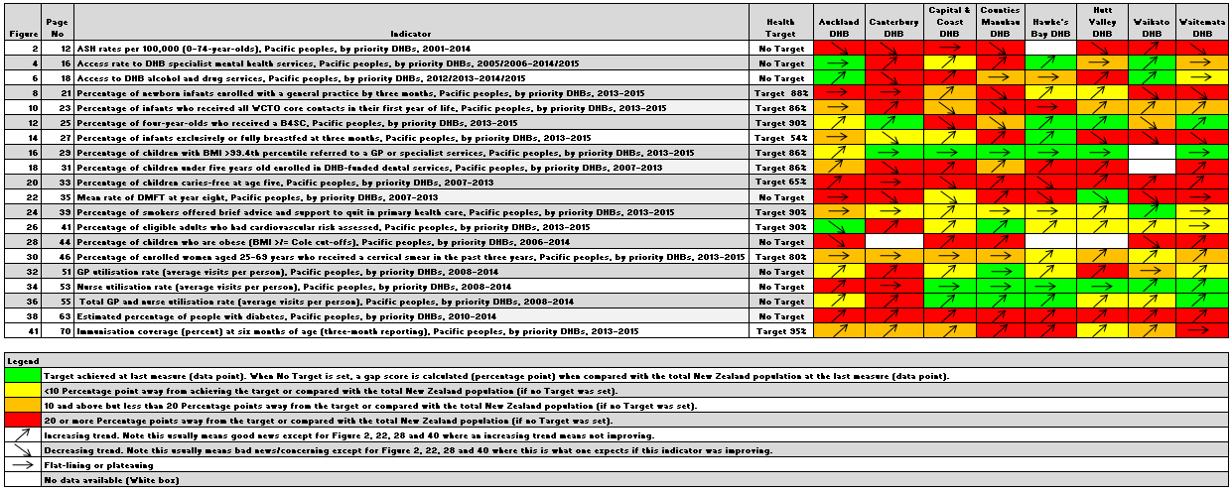

Whole-of-system measures
’Ala Mo’ui aims to make a positive impact on three particular whole-of-system indicators in the long term:
- Life expectancy – the number of years a person can expect to live (Ministry of Health 2012b)
- Health expectancy – the number of years a person can expect to live free of functional limitation needing assistance (Ministry of Health 2012b)
- Ambulatory Sensitive Hospital admissions – ASH rates refers to hospitalisations due to medical conditions that could be avoided by the provision of adequate primary health care (Ministry of Health 2012b).

Life expectancy
Life expectancy at birth continues to improve for Pacific peoples. However, Pacific peoples still have shorter life expectancy compared with the total New Zealand population. Based on death rates in New Zealand in 2012–2014, life expectancy was 78.7 years for Pacific females and 74.5 years for Pacific males in that time period, compared with 83.2 years for females and 79.5 years for males in the total New Zealand population (Statistics New Zealand 2015).

Health expectancy
In 2006, the gap in health expectancy for Pacific males compared with males in the total population was 4.4 years. The gap for Pacific females compared with the females in the total population was 5.3 years.

The health expectancy indicator has not been updated since 2006.

Ambulatory sensitive hospital admission rates
The rate of ambulatory-sensitive hospital admissions (ASH) is often used as a measure of the effectiveness of the interface between primary and secondary health care. ASH rates are a health system indicator. The assumption is that better management of chronic conditions such as diabetes and cardiovascular disease within local communities has the potential to reduce the number of avoidable hospital admissions (and to moderate demand on hospital resources). Diagnosis information on hospitalisations sent to the national dataset is analysed quarterly to provide avoidable ambulatory sensitive hospitalisations. Figure 1 presents ASH rates between 2001 and 2014.

Figure 1: ASH rates per 100,000 (0–74-year-olds), Pacific peoples population and total New Zealand population, 2001–2014
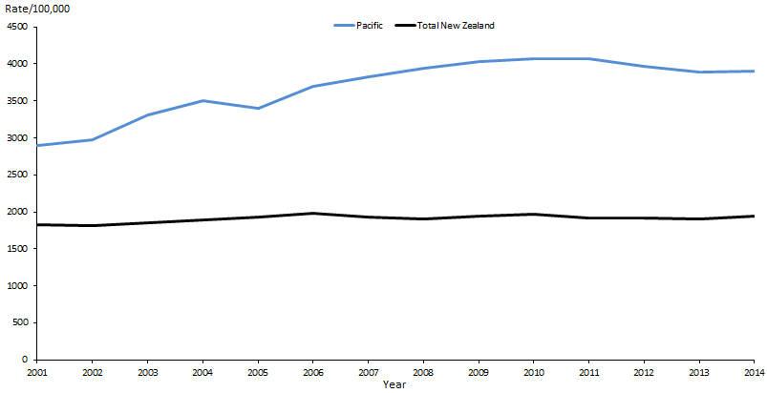

Figure 1 shows that the ASH rate per 100,000 for the Pacific population 0–74 years of age plateaued between 2012 and 2014; however it remains almost two times higher than the total population figure.

Note: The ASH rate per 100,000 is age-standardised to adjust for any differences that may arise due to the differences in age structure of the two populations. In order to provide data back to 2001, Statistics New Zealand population projections had to be used in place of primary health organisation (PHO) populations.

Figure 2: ASH rates per 100,000 (0–74-year-olds), Pacific peoples, by priority DHBs, 2001–2014
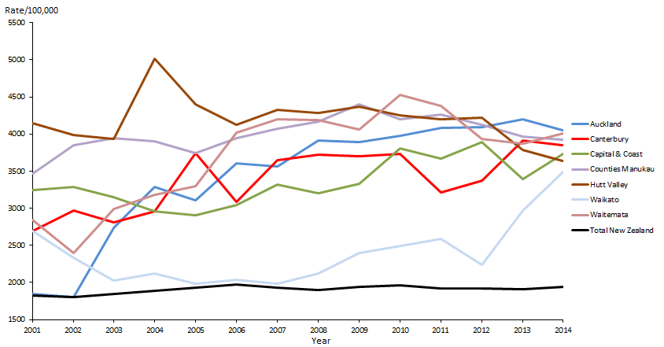
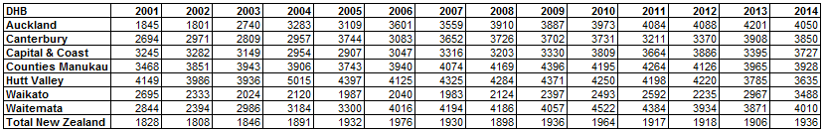

Note: The numbers for Hawke’s Bay DHB were too small to report on.

Figure 2 shows that over the years there have been no material changes in ASH rates within any of the DHBs. This reflects the fact that Pacific populations continue to face substantial unmet health needs.

Waikato DHB’s ASH rates appear to be vastly lower than those of the other DHBs prior to 2012. This suggests issues with ethnicity data collection.

Priority outcome 1 –
Systems and services meet the needs of Pacific peoples
The following presents a brief summary of performance indicators results in priority outcome one for this reporting period.
Within this priority outcome, good progress had been made in achieving equity in two indicators (in comparison with the total population rate) as at 30 June 2015:
1. percentage of children with BMI >99.4th percentile referred to a general practitioner (GP) or specialist services: Pacific peoples’ coverage was 99%; total population coverage was 86%
2. percentage of eligible adults who had had cardiovascular risk assessments: Pacific people’s coverage was 88%; total population coverage was 87%.
For all the other indicators, Pacific rates or percentages were below those of the total population, as Table 5 shows.
Table 5: Outcome one performance indicators where performance for Pacific is still below the total New Zealand population as at 30 June 2015
Indicator | Pacific | Total population
Access rate to mental health services | 2.9% | 3.5%
Access rate to alcohol and drug services | 0.9% | 1.0%
Newborn infants enrolled with a GP by three months of age | 60% | 65%
Infants who received all WCTO core contacts in their first year of life | 63% | 76%
Four-year-olds who received a B4SC | 83% | 93%
Infants exclusively or fully breastfed at three months | 46% | 55%
Children enrolled in DHB-funded dental services | 68% | 73%
Mean rate of DMFT for children at year eight | 1.6 | 1.1
Children caries-free at age five | 36% | 57%
Smokers offered brief advice and support to quit in primary health care | 83% | 90%
Children aged 2–14 years who are obese | 25% | 11%
Enrolled women aged 25–69 years who received a cervical smear in the past three years | 68% | 79%
Note: The data collected for each indicator varies; for example, some data reflects 2015 coverage,
and other data is from 2013 or 2014.

Priority outcome 1 – Systems and services meet the needs of Pacific peoples
Action 1 | DHBs will implement the actions focused on Pacific peoples in Rising to the Challenge: The Mental Health and Addiction Service Development Plan 2012–2017 (Ministry of Health 2012a) in order to build more responsive services for Pacific peoples who are severely affected by mental illness or addiction.

Action commentary
Four DHBs – Capital & Coast, Counties Manukau, Hutt Valley and Waitemata – are delivering on actions under Rising to the Challenge that directly impact on Pacific peoples, as follows.

Table 6: DHB ‘Rising to the Challenge’ activities delivered
DHB | Activities as at June 2015
Capital & Coast and Hutt Valley | Capital & Coast continues to lead the development of a new integrated mental health, addictions and intellectual disability service across three DHBs (Capital & Coast, Hutt Valley and Wairarapa). This will entail an acute adult model of care pathway with a particular focus on improving access for Pacific and Māori populations. Planning has commenced on this model of care.
Counties Manukau | Counties Manukau developed and implemented a mental health first aid training package to increase mental health literacy on depression, drug and alcohol issues for Pacific communities. The DHB is also administering cultural capability training for all its staff, to ensure that staff are competent and comfortable to engage Pacific, Māori and other priority groups. It has been working with Pacific and Asian advisors to upgrade this programme.
Waitemata | Waitemata DHB has set benchmarks for access and readmission rates for Pacific, Māori and Asian populations, and for reducing late access to services. The DHB aims to increase the focus of its mental health partnership with Whānau House on Whānau Ora. In addition it is actively engaging with Pacific and Māori people in service planning through family advisor forums and a real-time feedback project.

Rising to the Challenge does not prioritise actions, or prescribe the sequence in which they are to be implemented. Each year during the annual planning process, the Ministry of Health asks each DHB to articulate which of the Plan’s actions it has implemented and proposes to implement.

Indicator 1a | Improving the health status of Pacific people with severe mental illness through improved access rates

Performance: There is no target set for this indicator.

Note: The Pacific peoples’ access rate is the percentage of total Pacific unique clients seen. The total New Zealand access rate is the percentage of total unique clients seen (all ethnicities included). Both rates include all age groups.

Figure 3: Access rate to DHB mental health services, Pacific peoples population and total New Zealand population, 2005/2006–2014/2015
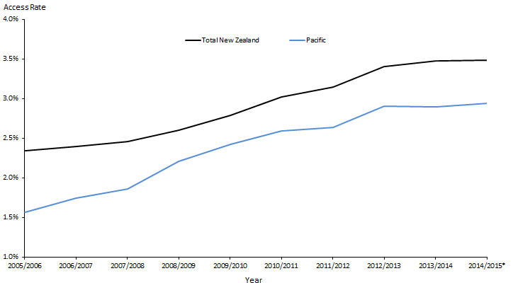

Figure 3 shows that Pacific access to mental health services has been improving over the years, parallel to the total New Zealand population. However, there continues to be a difference between the Pacific access rate to mental health services and that of the total population.

* Data is the most recent available, from the second quarter of the 2014/2015 financial year.

Figure 4: Access rate to DHB mental health services, Pacific peoples, by priority DHBs, 2005/2006–2014/2015
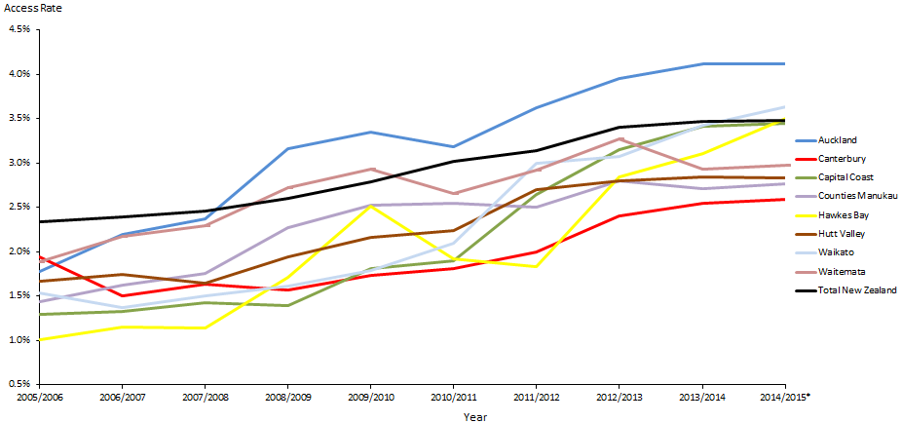
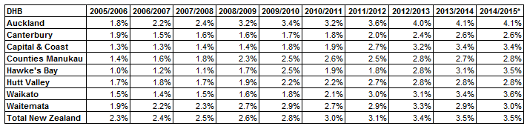

* Data is the most recent available, from the second quarter of the 2014/2015 financial year.

Figure 4 shows that, overall, DHBs are making good progress; Pacific people’s access rates to specialist mental health and addiction services have been increasing over the years.

Auckland DHB’s access rates for Pacific peoples have been higher than those of all other DHBs and the total New Zealand population since 2007/2008, and continues to improve.

Indicator 1b | Improving the health status of Pacific people with alcohol and drug addiction through improved access rates to alcohol and drug services

Performance: There is no target set for this indicator.

Note: The Pacific peoples’ access rate is the percentage of total Pacific unique clients seen. The total New Zealand access rate is the percentage of total unique clients seen (all ethnicities included). Both rates include all age groups.

Figure 5: Access to DHB alcohol and drug services, Pacific peoples population and total New Zealand population, 2012/2013–2014/2015
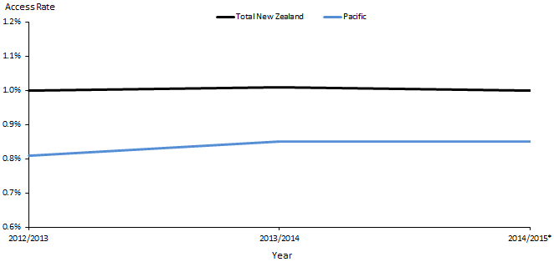
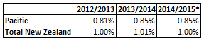

* Data is the most recent available, from the second quarter of the 2014/2015 financial year.

Figure 5 shows that Pacific people’s access to alcohol and drug services has been improving since 2012. It is still lower (by 10 percentage points) than that of the total New Zealand population, though the disparity between the two population groups appears to be narrowing.

Figure 6: Access to DHB alcohol and drug services, Pacific peoples, by priority DHBs, 2012/2013–2014/2015
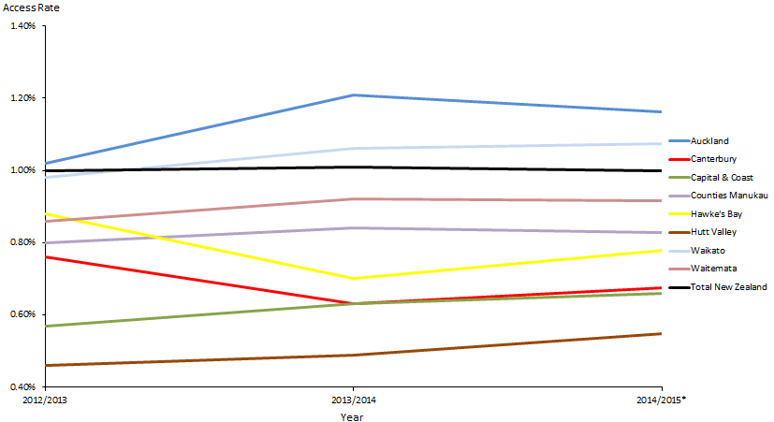
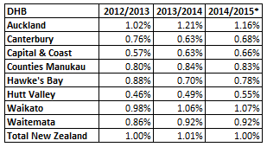

* Data is the most recent available, from the second quarter of the 2014/2015 financial year.

Figure 6 shows that Auckland and Waikato DHBs have improved access to alcohol and drug services among their Pacific peoples populations.

Action 2 | Universal maternity and child health services will engage in a more timely manner with Pacific families

Action commentary
In the six months from January 2015 to June 2015, the Ministry has continued to deliver on activities in efforts to improve timely access to universal maternity and child health services for Pacific families. Achievements in this time period have included the following.
- The Ministry published the fourth Well Child/Tamariki Ora (WCTO) Quality Indicators report (Ministry of Health 2015b). The report provides disaggregated data by ethnicity (on 24 of 27 indicators); 10 of 27 indicators focus on improving timely child health service access. The report shows Pacific access rates and outcomes over a wide range of areas, including newborn enrolments with a general practice; referrals from lead maternity carers to WCTO providers and participation in early childhood education.
- The Ministry completed the 2014 Maternity Consumer Survey, and will publish results in the coming months. This survey collates feedback from 3,801 women who gave birth in 2013 and 2014, including 185 Pacific women. The survey found that 77 percent of all women were ‘satisfied’ or ‘very satisfied’ with the overall maternity care they received. Pacific women were more likely to report being ‘satisfied’ or ‘very satisfied’ with labour and birth care, hospital care and postnatal care than women of other ethnicities. The survey showed differences by ethnicity in whom women contact when they first suspect they are pregnant and when they make this first contact, indicating a number of areas for improvement within DHBs and maternity service providers.
- Through their annual plans, all 20 DHBs committed to ensuring that their pregnancy and parenting education services (eg, antenatal classes) focused on meeting the needs of first-time parents and groups with high needs, including young/teenage parents, Pacific parents, Māori parents and parents with limited comprehension of English. The DHBs have committed to provide these services to 30 percent of the population within each of these priority groups by end of 2015/16.
- The Ministry completed a project with the Health Promotion Agency to support families currently not accessing the B4 School Checks (B4SCs) to access the service, with a specific focus on Pacific peoples, Māori and low-income families. As a result of this work, changes are being made to the way DHBs and providers communicate with their populations about the B4SC. A national promotion campaign targeting Pacific peoples’ and Māori families is under way.

Note: The eight action indicator measures discussed on pages 11-17 are WCTO indicators. Data on these indicators is drawn from various sources. It should be noted that, while primary maternity and WCTO services are intended to be universal, they are not universally accessed. The data reported for these indicators only accounts for about 85 percent of the total New Zealand population. On average around 4000 babies each year do not receive any WCTO services; about 15 percent of these are Pacific babies. Consequently the indicator results for these indicators are not an accurate and complete indication of performance for the total Pacific peoples population.

Indicator 2a | Increased percentage of Pacific infants who are enrolled with a general practice by three months

Performance: A new target of 98 percent was set at 1 January 2015. Prior to this, the target was 88 percent.

Figure 7: Percentage of newborn infants enrolled with a general practice by three months, Pacific peoples population and total New Zealand population, 2013–2015
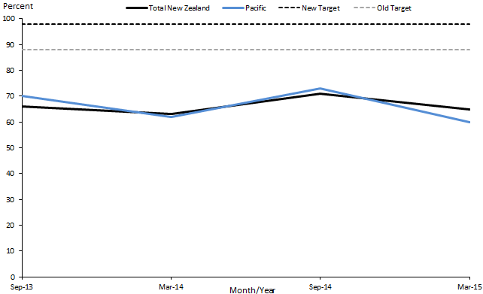
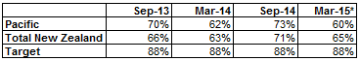

* The time period for the March 2015 data is 20 August to 19 November 2014.

Figure 7 shows that rates for neither the Pacific peoples nor the total New Zealand populations have reached either the old or the new target. Enrolments for the Pacific peoples and total New Zealand populations as at March 2015 had decreased by 13 and 6 percent respectively.

Figure 8: Percentage of newborn infants enrolled with a general practice by three months of age, Pacific peoples, by priority DHBs, 2013–2015
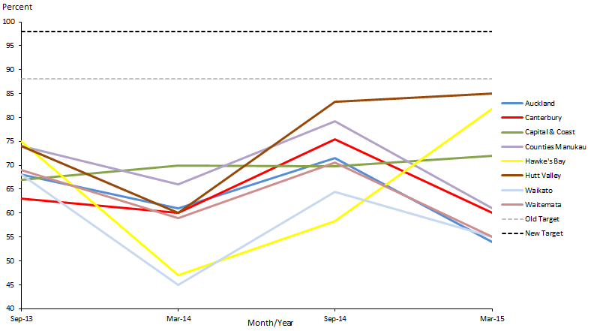
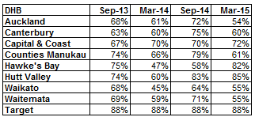

Figure 8 shows that in Hutt Valley, Hawke’s Bay and Capital & Coast DHBs, percentages of newborn enrolments have increased since March 2014. Rates in the other six DHBs decreased.

Note: Both Figures 7 and 8 show a pattern of a decrease in the September quarters and increase in the March quarters. This pattern is a seasonal effect, due to reporting for newborn enrolments being recorded prior to the Christmas and New Year’s period, during which providers have two fewer weeks to process enrolments.

The Ministry is focusing on improving the timeliness of enrolments and is working with Primary Health Organisations (PHOs) to identify ways to do this. One method currently in place is the use of newborn enrolment champions, who help PHOs work together to share ideas for improving coverage.

Indicator 2b | Increased percentage of Pacific infants who received all five WCTO core contracts in their first year of life

Performance: A new target of 95 percent was set at 1 January 2015. Prior to this, the target was 86 percent.

Figure 9: Percentage of infants who received all WCTO core contacts in their first year of life, Pacific peoples population and total New Zealand population, 2013–2015
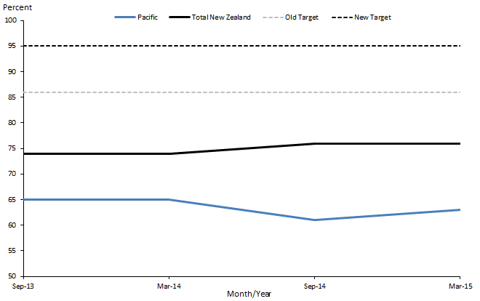
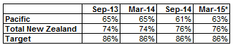

* The time period for the March 2015 data is July–December 2014.

Figure 9 shows that rates for neither the Pacific peoples nor the total New Zealand populations reached either the old or the new target, and that the disparity between the Pacific peoples and the total New Zealand population is widening. This implies that the models and approaches currently being used to deliver WCTO services are not working for Pacific peoples.

Figure 10: Percentage of infants who received all WCTO core contacts in their first year of life, Pacific peoples, by priority DHBs, 2013–2015
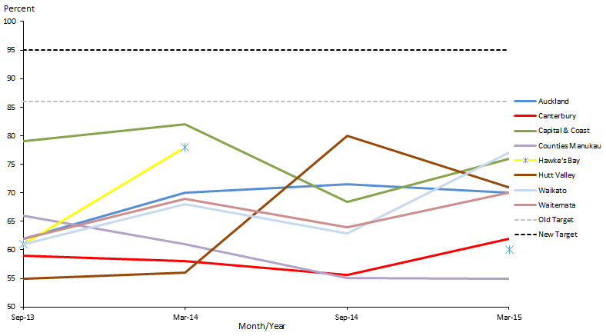
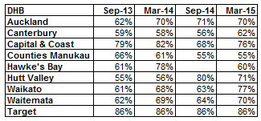

* The time period for the March 2015 data is July–December 2014.

Note: Where numbers recorded were less than 20, the data has not been reported, due to the high likelihood of identification.

Figure 10 shows that, since September 2014, Capital & Coast, Waikato, Waitemata and Canterbury DHBs have been making positive progress towards the target. Counties Manukau DHB currently has the lowest percentage for this measure. The March 2015 data shows that only one in two (55 percent) of Pacific infants received all WCTO core contacts in their first year of life in Counties Manukau.

Indicator 2c | Increased percentage of Pacific children who receive B4SC

Performance: The target for this indicator is 90 percent.

Figure 11: Percentage of four-year-olds who received a B4SC, Pacific peoples population and total New Zealand population, 2013–2015
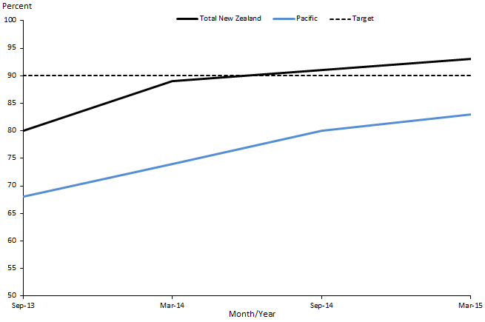
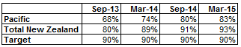

* The time period for the March 2015 data is July 2014 to January 2015.

Figure 11 shows that the percentages for both the Pacific peoples and total New Zealand populations have been improving; there have been increases of 15 and 13 percent respectively since September 2013. This can be attributed to increased pressure on DHBs from the Ministry and incentivised payments for achieving the 90 percent target.

Figure 12: Percentage of four-year-olds who received a B4SC, Pacific peoples, by priority DHBs, 2013–2015
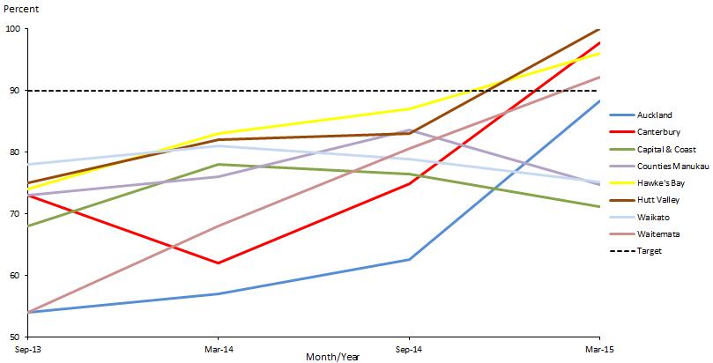
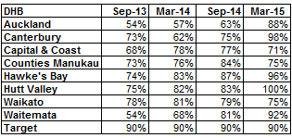

* The time period for the March 2015 data is July 2014 to January 2015.

Figure 12 shows that Hutt Valley, Canterbury, Hawke’s Bay and Waitemata DHBs have recently achieved the national target of 90 percent.

Indicator 2d | Increased percentage of Pacific infants who are exclusively or fully breastfed up to three months

Performance:. A new target of 60 percent was set at 1 January 2015. Prior to this, the target was 54 percent.

Figure 13: Percentage of infants exclusively or fully breastfed at three months, Pacific peoples population and total New Zealand population, 2013–2015
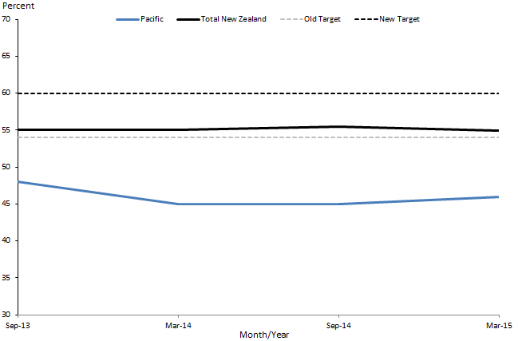
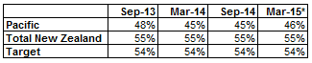

* The time period for the March 2015 data is July–December 2014.

Figure 13 shows no improvement since September 2013 for the total New Zealand population and decreases for the Pacific population in the percentage of infants exclusively or fully breastfed at three months.

Note: There has been little or no increase in breastfeeding rates for the total New Zealand population for the past ten years; among Pacific infants the rate has remained consistently lower.

Figure 14: Percentage of infants exclusively or fully breastfed at three months, Pacific peoples, by priority DHBs, 2013–2015
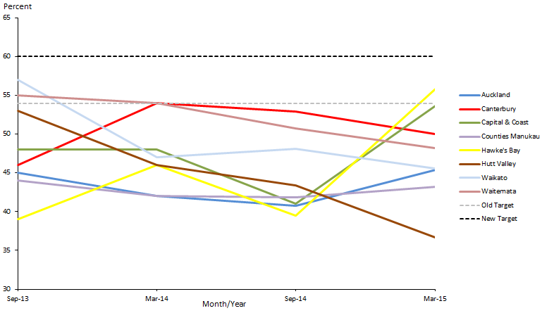
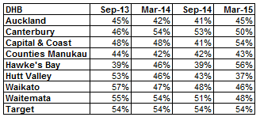

* The time period for the March 2015 data is July–December 2014.

Figure 14 shows that as at March 2015, Hawke’s Bay and Capital & Coast DHBs had achieved the national target of 54 percent. Hutt Valley DHB’s breastfeeding rate has been decreasing steadily since 2013; by March 2015, approximately only one in three Pacific infants were exclusively or fully breastfed in the Hutt Valley population.

Indicator 2e | Increased percentage of Pacific children with BMI >99.4th percentile are referred to GP or specialist services

Performance: A new target of 95 percent was set at 1 January 2015. Prior to this, the target was 86 percent.

Figure 15: Percentage of children with BMI >99.4th percentile referred to a GP or specialist services, Pacific peoples population and total New Zealand population, 2013–2015
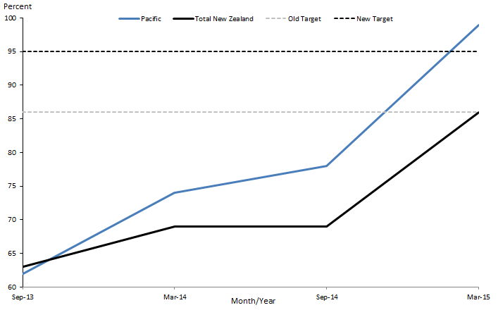
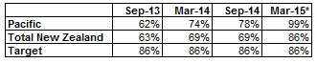

* The time period for the March 2015 data is July - December 2014.

Figure 15 shows that the target was achieved and exceeded for the Pacific population in the last quarter to March 2015. The sharp improvements for both population groups visible in the March 2014 and March 2015 data can be attributed to increased pressure from the Ministry on DHBs towards the end of the year to reach the target.

Figure 16: Percentage of children with BMI >99.4th percentile referred to a GP or specialist services, Pacific peoples, by priority DHBs, 2013–2015
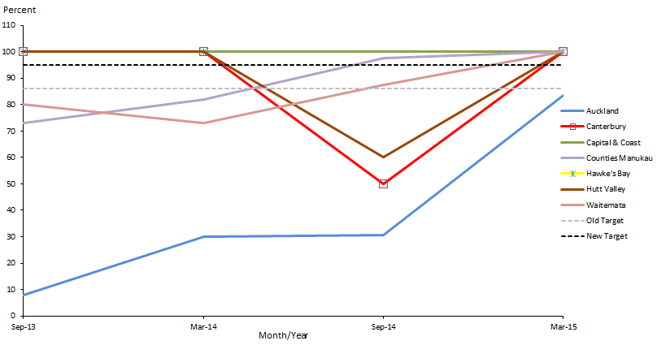
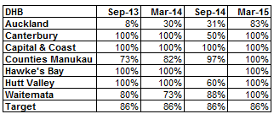

* The time period for the March 2015 data is 1 July – 31 December 2014.

Note: Data is unavailable for the September 2014 quarter for Hawke’s Bay DHB and for all quarters for Waikato DHB because there were no reported Pacific children with BMI >99.4th percentile in those populations and time periods.

Figure 16 shows that six DHBs (Canterbury, Capital & Coast, Counties Manukau, Hawke’s Bay, Hutt Valley and Waitemata) achieved the target by March 2015. Auckland DHB showed excellent progress after September 2014; its percentages increased from 8 percent to 83 percent between then and March 2015.

Indicator 2f | Increased percentage of Pacific children in preschool who are enrolled with the Community Oral Health Service

Performance: A new target of 95 percent was set at 1 January 2015. Prior to that, the target was 86 percent.

The latest data for this indicator is from December 2013. The 2014 data is not yet available.

Figure 17: Percentage of children under five years old enrolled in DHB-funded dental services, Pacific peoples population and total New Zealand population, 2007–2013
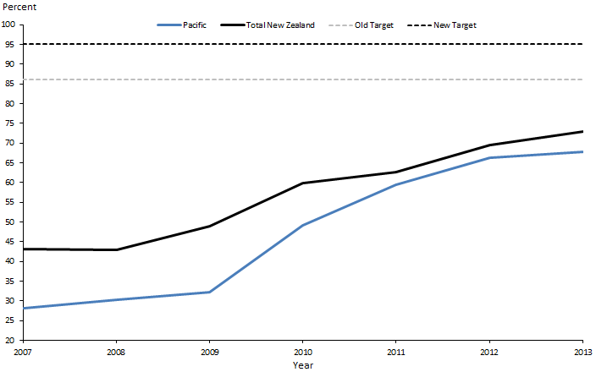
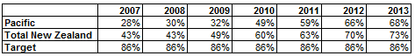

Figure 17 shows that percentages for this indicator in both the Pacific peoples population and the total New Zealand population are improving, and the disparity between the two population groups gradually narrowing.

The improvement for both population groups visible from 2009 correlates to significant Government investment in the last six years into the infrastructure, model of care and capacity of child and adolescent oral health services. Since 2008, the Government has provided $116 million of capital funding for new fixed clinics and mobile clinics, and an additional $32 million per annum for operational funding for staff. The new Community Oral Health Service infrastructure is almost fully in place. The service operates from 170 fixed clinics (seven more will open by June 2016) and 169 mobile clinics, at 1263 sites around the country.

Figure 18: Percentage of children under five years old enrolled in DHB-funded dental services, Pacific peoples, by priority DHBs, 2007–2013
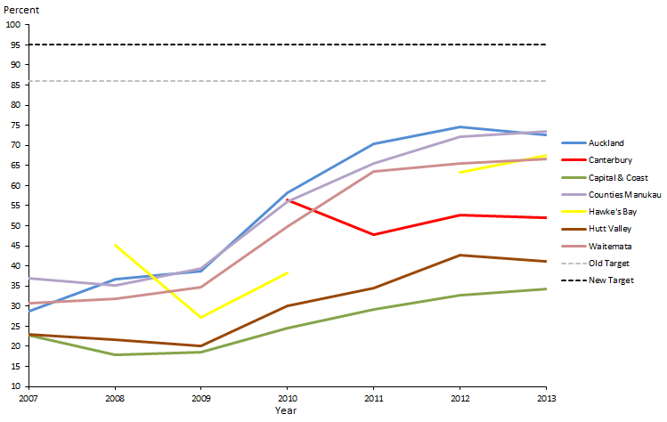
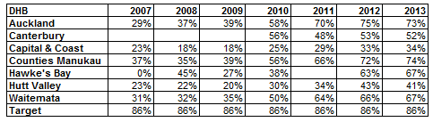

Figure 18 shows that none of the DHBs had achieved the national target by 2013. Rates in Auckland, Counties Manukau and Waitemata DHBs improved but then appeared to plateau. This reflects the plateau in the Pacific total rate apparent in Figure 17.

Note: Canterbury DHB did not report data by ethnicity for this indicator prior to 2010, Hawke’s Bay DHB reported no data for the 2011 year and Waikato DHB does not report data by ethnicity for this indicator.

Indicator 2g | Increased number of Pacific children caries-free at age five, and rates of DMFT at year eight at least equivalent to the total population

Performance: The target for Pacific children caries-free at age five is 65 percent. There is no target for rates of DMFT at year eight.

The latest data for this indicator is from December 2013.

Figure 19: Percentage of children caries-free at age five, Pacific peoples population and total New Zealand population, 2007–2013
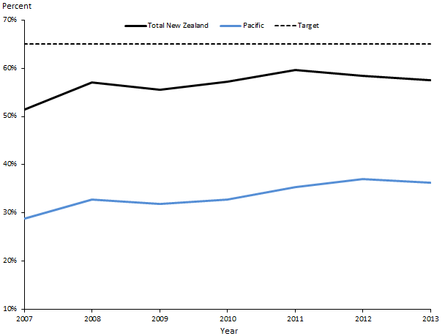
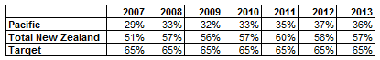

Figure 19 shows that the caries-free rate for this age group in both the Pacific peoples and total New Zealand population has remained largely the same over the recent years, and so has the significant disparity between the two population groups. The Ministry of Health anticipates that improvements in rates of preschool enrolments in DHB-funded dental services (see Figure 17) will in time be reflected in the percentage of children who are caries-free at age five.

Figure 20: Percentage of children caries-free at age five, Pacific peoples, by priority DHBs, 2007–2013
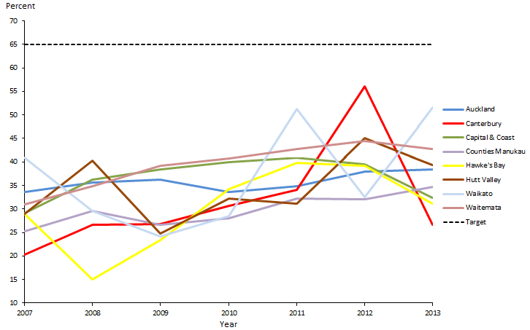
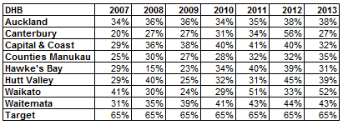

Figure 20 shows that DHBs have made little progress towards the target. The sharp fluctuations in the graph are due to the small numbers involved, especially in the smaller DHBs. This is why the trends in percentages for Auckland, Counties Manukau and Waitemata DHBs appear to be smoother.

Figure 21: Mean rate of DMFT at year eight, Pacific peoples population and total New Zealand population, 2007–2013
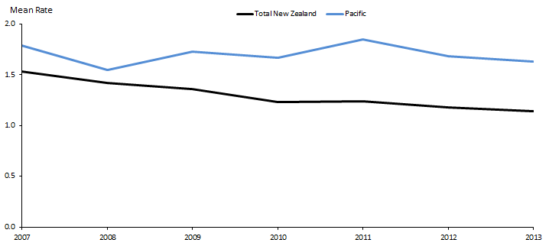
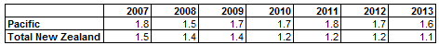

Note: The latest data for this indicator is from 2013. There is no set national target.

The mean rate is the average rate per child. For example, the 2013 figure of 1.6 can be interpreted as indicating that, on average, a Pacific child in year eight will have approximately 1.6 decayed, missing or filled teeth. Therefore, the lower this figure is, the better.

Figure 21 shows that the mean rate for this indicator is decreasing; that is, improving. However, the disparity between the Pacific peoples and the total New Zealand population is widening.

The Ministry of Health anticipates that improvements in enrolments of preschool children in DHB-funded dental services (see Figure 17) will be reflected in the mean rate of DMFT for year eight children, for both the Pacific peoples and total New Zealand population.

Figure 22: Mean rate of DMFT at year eight, Pacific peoples, by priority DHBs, 2007–2013
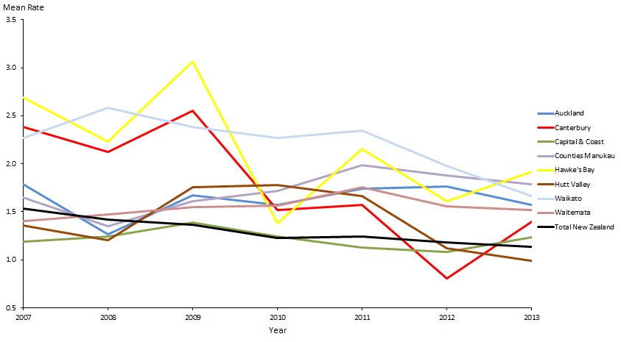
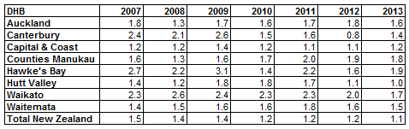

Figure 22 shows that overall the mean rate of DMFT for Pacific children in all DHBs has been decreasing. Hutt Valley DHB now has a rate lower than the New Zealand total population, and Capital & Coast DHB’s rate is almost on par with the total New Zealand population. The sharp fluctuations are due to the small numbers involved.

Action 3 | DHBs will improve performance against achieving health targets for Pacific peoples.

Action commentary
The Government’s ‘better help for smokers to quit’ and ‘more heart and diabetes checks’ health targets apply to the whole New Zealand population. This action focuses on their achievement for Pacific peoples in particular.

Cardiovascular disease (CVD) is the leading cause of death in New Zealand; it accounts for 40 percent of deaths annually. Cardiovascular conditions are the leading cause of morbidity in New Zealand, and disproportionately affect Pacific peoples.

This section reports on DHBs’ activities relevant to this action for the six months to 30 June 2015.

Better help for smokers to quit
The Ministry has been working closely with DHBs to ensure that providers offer advice and smoking cessation support to Pacific peoples in health care settings, as Table 7 sets out.

Table 7: DHB activities delivered to improve services offering Pacific peoples better help for smokers to quit
DHB | Work towards achieving the target as at June 2015
Auckland and Waitemata | There are high rates of smoking among the populations of Pacific peoples in both Auckland and Waitemata DHBs. Both DHBs are among the top performers for the ‘better help for smokers to quit’ health target. The DHBs and their PHOs have invested in many best-practice strategies to ensure that the majority of smokers, including Pacific smokers, receive brief advice and cessation support to quit in primary care.  Recently, the DHBs have been refreshing the smoking cessation training they provide to health professionals, to increase the number of patients that make supported quit attempts, particularly to Māori and Pacific patients.
Canterbury | Canterbury DHB has made significant improvements towards achieving the target.  All PHOs continue to provide cessation programmes; two of the three PHOs have revised and enhanced their cessation programmes extensively. Pacific communities are one of the key audiences for these services.  Canterbury has integrated delivery of this target and the ‘more heart and diabetes checks’ target. This approach has proven to be effective in reaching Pacific and Māori communities.  The Pacific Trust Canterbury quit service, funded by the Ministry, is contracted to provide cessation services to 180 people annually in Canterbury.
Capital & Coast and Hutt Valley | Capital & Coast and Hutt Valley DHBs have made significant improvements towards achieving the target. Examples of recent work include:  - systematically ensuring tobacco control is included as a key activity in all DHB health documents, including Pacific health plans  - supporting clinical and community leadership in tobacco control through the Pacific health unit  - continuing to collect target results by ethnicity  - promoting smoking cessation services to increase awareness among Pacific communities.  Pacific Health Services provides a local quitting service targeted at Pacific peoples. It provides face-to-face counselling sessions, free nicotine replacement therapy and quit checks at four weeks and three months.

The Ministry is in the process of re-tendering and realigning all face-to-face stop smoking services (including Pacific, Māori and pregnancy stop smoking services) and all the health promotion and advocacy services for tobacco control (services) that the Ministry purchases. This is necessary to ensure that services are better focused on high-needs populations. The Ministry may apply a population-based funding formula to maximise targeting of resources to those with the greatest needs.

More heart and diabetes checks
The Ministry has been working closely with DHBs to ensure early detection of diabetes in Pacific peoples. Table 8 sets out some of the work that has taken place in the last six months.

Table 8: DHB work towards offering Pacific peoples more heart and diabetes checks
DHB | Work towards achieving the target as at June 2015
Auckland | Auckland DHB, together with Waitemata DHB continues to provide the Pacific population in the region with education on self-management. The programme is delivered by The Fono, a health and social services agency for Pacific peoples.  Seventy-three Pacific people commenced self-management education programme in quarter two; the majority have now had their diabetes annual review and five-year cardiovascular and diabetes risk assessment.
Canterbury | Canterbury DHB’s Diabetes Consumer Group includes Pacific representation. The group provides accessible ‘Conversation Map’ education sessions for up to 10 people supported by a trained facilitator. The conversation map is a large printed map that focuses on various topics related to diabetes and diabetes management. Participants address the topics they consider most relevant to their own life and experiences with diabetes.
Capital & Coast | Capital & Coast DHB has allocated additional nursing time for recalls for Pacific peoples, to ensure that these patients receive appropriate medicines and appropriate referrals to podiatry, renal and ophthalmology services.
Counties Manukau | Counties Manukau DHB’s Diabetes Projects Trust aims to improve the provision of care to diabetes patients through audit services and tailored support for practice staff. The trust’s service is specifically targeted towards practices with high numbers of Pacific patients, as well as those with high diabetes prevalence.
Waitemata | Waitemata DHB has contracted retinal screening and education programmes for Pacific peoples under the Ministry of Health’s Diabetes Care Improvement Package. It also runs the self-management education service alongside Auckland DHB (see above).

Indicator 3a | Increased number of Pacific peoples who smoke are offered brief advice and support to quit smoking in primary health care

Performance: The target for this indicator is 90 percent.

Figure 23: Percentage of smokers offered brief advice and support to quit in primary health care, Pacific peoples population and total New Zealand population, 2013–2015
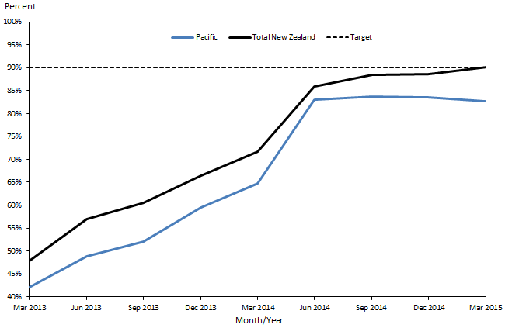

Figure 23 shows that percentages for this indicator have been increasing since March 2013 for both the Pacific and total New Zealand populations. However, as rates for both population groups get closer to achieving the target, they start to plateau.

Figure 24: Percentage of smokers offered brief advice and support to quit in primary health care, Pacific peoples, by priority DHBs, 2013–2015
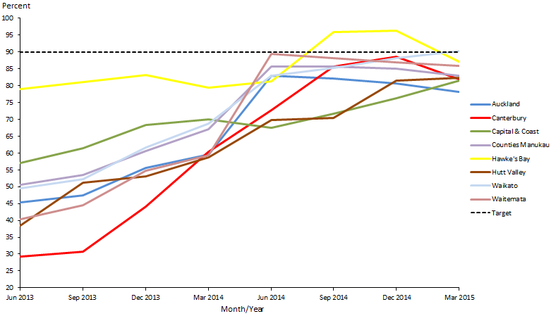
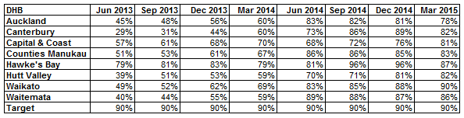

Figure 24 shows that percentages for this indicator in priority DHBs have been improving steadily since June 2013. Waikato DHB had achieved the target as at March 2015. Overall, results begin to plateau as DHBs get closer to achieving the target.

There are a number of Pacific smoking cessation providers across the country. The DHBs and PHOs with significant populations of Pacific peoples have established strong relationships and clinical referral pathways to these providers.

Note: Figures 23 and 24 show a sharp increase in percentages from the March 2014 to June 2014 period. This is probably due to extra pressure on DHBs to achieve the target by the end of quarter four.

Indicator 3b | Improve management of diabetes by increasing ‘more heart and diabetes checks’

Performance: The target for this indicator is 90 percent.

Figure 25: Percentage of eligible adults who had cardiovascular risk assessed, Pacific peoples population and total New Zealand population, 2013–2015
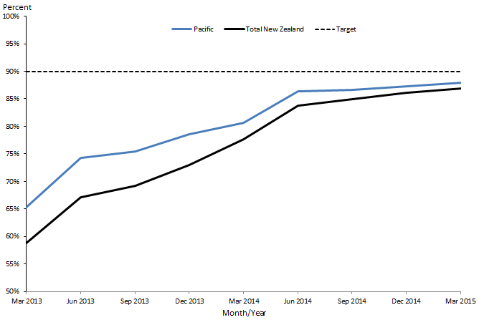
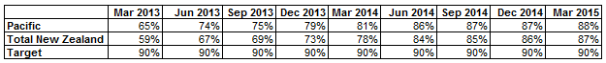

Figure 25 shows that the percentage of eligible adults who had their cardiovascular risk assessed has been improving over the years for both the Pacific and total New Zealand populations. Moreover, the disparity between the groups is narrowing.

Figure 26: Percentage of eligible adults who had cardiovascular risk assessed, Pacific peoples, by priority DHBs, 2013–2015
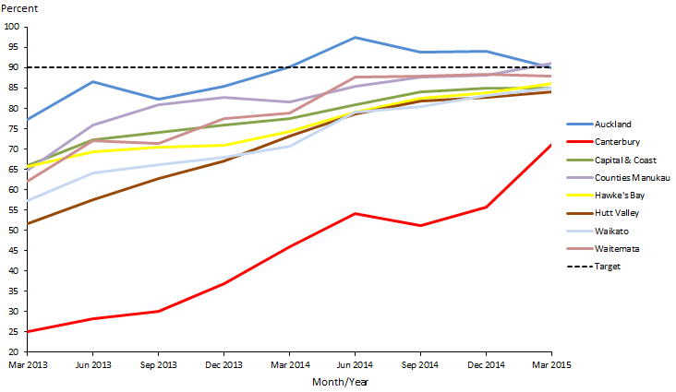
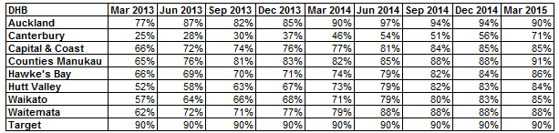

Figure 26 shows that generally the DHBs are making positive progress in terms of this indicator.

Auckland and Counties Manukau DHBs had achieved the target by March 2015. Auckland DHB recently completed its second workplace staff CVD risk assessment project, which focused on Pacific and high-risk staff across three sites. The project assessed over 100 Pacific staff. Counties Manukau DHB actively targets Pacific and high-risk populations by using specific practice queries and recall systems, including queries on patients who are turning 35 within the next three months, and appointment scanners to identify patients booked for a consultation that day so that providers can offer CVD assessment opportunistically. Both DHBs are using innovative ways of reaching the last few hard-to-reach patients (eg, outreach services and after-hours clinics, and using community health workers to transport patients).

Canterbury DHB initially did not agree to the CVD risk assessments, and only began to work towards achieving the national target in mid-2014.

Note: In early 2014, the Ministry developed and launched the General Practice Toolkit to help providers offer more heart and diabetes checks and better help for smokers to quit. Overall improvements for both these indicators may be attributed to the release of this toolkit and provider efforts.

Action 4 | DHBs will support the Pacific Whānau Ora Commissioning Agency.

Action commentary
In their 2015/2016 annual plans, all priority DHBs have committed to working with Whānau Ora commissioning agencies. The Auckland, Counties Manukau and Waitemata DHBs’ annual plans make specific reference to working with Pasifika Futures (the Pasifika Whānau Ora Commissioning Agency) to ensure effective integration between Whānau Ora and DHB-funded family support services, and to quarterly meetings.

The Ministry has invested in Pacific health collectives, networks and a number of Pacific providers through the Pacific Provider Workforce Development Fund. Providers have reported that, as a result, they are better placed to deliver on their contracts with Pasifika Futures.

Currently Pasifika Futures mainly works directly with contracted community providers. However, the agency is looking to begin working closer with DHBs.

One of the health outcomes Pasifika Futures’ aims to achieve in the next three to five years is for ‘Pacific peoples to be physically active and make healthy eating choices’.

Indicator 4a | District Health Board annual plans report on extent of support for the Pacific Whānau Ora Commissioning Agency

Refer to action commentary above.

Indicator 4b | Decrease the number of Pacific children aged 2–14 years who are obese

Performance: There is no target for this indicator.

Figure 27: Percentage of children who are obese (BMI >/= Cole cut-offs), Pacific peoples population and total New Zealand population, 2006–2014
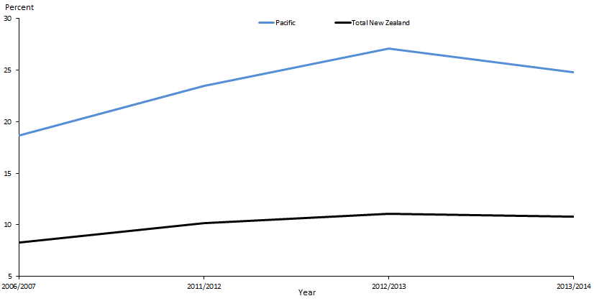
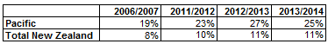

Figure 27 shows that the obesity trajectory of the total New Zealand population of children between the age of two and 14 years appears to be increasing. Compared to all other children in New Zealand, Pacific children have the highest rates of obesity; one in four Pacific children is obese, compared to one in 10 children for the total New Zealand population.

Figure 28: Percentage of children who are obese (BMI >/= Cole cut-offs), Pacific peoples, by priority DHBs, 2006–2014
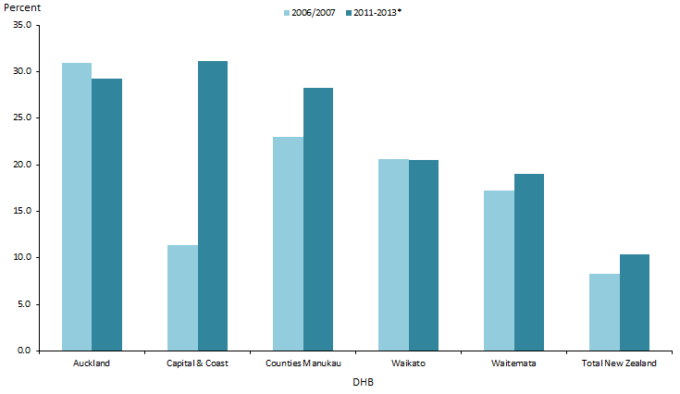
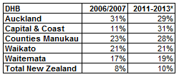

Note: Due to small numbers, we were unable to obtain enough samples for this indicator from all the DHBs. We pooled data from three previous New Zealand Health Surveys (2011/2012–2013/2014) to provide data for Pacific peoples for the five DHBs represented here. The sample sizes for Pacific children in the New Zealand Health Surveys were small. Small samples can affect both the reliability and the confidentiality of results. Data has only been presented when there were at least 30 people in the denominator (that is, the population group being analysed). We have taken care to ensure that no participant can be identified in the results.

Figure 28 shows that Auckland DHB was the only DHB to have shown some improvement over the time period: a slight decrease. The percentage within Waikato DHB has remained the same at 21 percent, while the percentages in other DHBs have all shown increases. The most noticeable increase was within Capital & Coast DHB, where the percentage of children who were obese increased by 20 percent.

Action 5 | DHBs, PHOs and other providers will maximise coverage and participation of Pacific peoples in the national screening programmes.

Action commentary
During January–June 2015, the National Cervical Screening Programme negotiated with four DHBs (Northland, Tairawhiti, Whanganui and MidCentral) to provide additional funding to reduce barriers for Pacific women to have a cervical smear. Note that none of these are a Pacific priority DHB.

The National Screening Unit is investigating options for future purchasing of outreach services to support Pacific women’s participation in the screening programme.

The National Screening Unit has implemented a system of monthly data matching within PHOs, so that they can identify who to screen and when, in order to increase cervical screening coverage rates and achieve better outcomes for Pacific women.

Indicator 5 | Increase percentage of enrolled Pacific women aged 25–69 years old to receive a cervical smear in the past three years to at least equal to the rate of the total population

Performance: The target for this indicator is 80 percent.

Figure 29: Percentage of enrolled women aged 25–69 years who received a cervical smear in the past three years, Pacific peoples population and total New Zealand population, 2013–2015
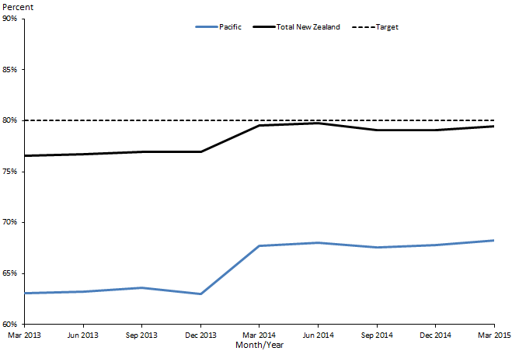
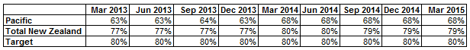

Note: The age range for cervical screening eligibility was 20–69 years prior to 2014, and then changed to 25–69 years in January 2014. This change aligns with international best practice, and allows for international comparison of screening programme performance.

Figure 29 shows that apart from the increase between December 2013 and March 2014, due possibly to the change in the age range, progress in rates of uptake of cervical smears appears to have plateaued for both the Pacific and the total New Zealand population.
Figure 30: Percentage of enrolled women aged 25–69 years who received a cervical smear in the past three years, Pacific peoples, by priority DHBs, 2013–2015
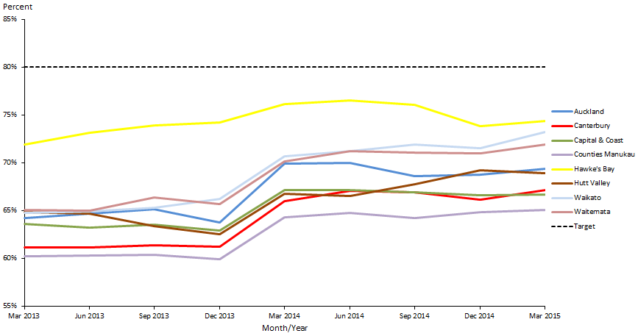
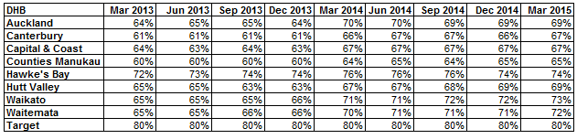

Figure 30 shows that, overall, all the DHBs are making good progress. Hawke’s Bay is performing above the other DHBs: in March 2015, 74 percent of its enrolled Pacific women aged 25–69 had received a cervical smear in the last three years.

Hawke’s Bay DHB has performed consistently well in this measure over the years. This is perhaps due to its targeted approach: the DHB identified that its Pacific population was concentrated in a small number of GP practices, and so began to work with these practices to identify women eligible to be screened.

Priority outcome 2 –
More services are delivered locally in the community and in primary care
The following presents a brief summary of performance indicators results in priority outcome two for this reporting period.
The four national Pacific collectives are making good progress towards this priority outcome, through collaborations with their respective DHB alliances.
The only indicator with a quantitative measure in this priority outcome section for which the rates have reached equity (that is, the rate for Pacific peoples has met or exceeded the total population rate), if not the target, is increased utilisation rates of primary health care, as Table 9 shows.
Table 9: Performance against priority outcome 2 indicators as at 30 June 2015
Indicator | Pacific rate | Total New Zealand rate
GP utilisation | 2.98 | 2.93
Nurse utilisation | 0.75 | 0.64
Total GP and nurse | 3.74 | 3.58
The latest results to 2014 show that Pacific peoples’ rate of primary care utilisation (for both GPs and nurses) has increased over the years, and is now higher than that of the total New Zealand population. However, this increase has not improved Pacific people’s ASH rate, which has been increasing steadily over the years and remains much higher than that of the total New Zealand population. The assumption is that increased access to primary health care lead to improved health outcomes and a reduction in ASH rates. However, this is not the case for Pacific peoples.

Priority outcome 2 – More services are delivered locally in the community and in primary care
Action 1 | The four Pacific health collectives will be part of relevant DHB alliances.

Nationally, there are four Pacific health collectives, each with memberships of three to 12 Pacific providers who deliver a range of primary care, community-based health care and social services. They are based in Auckland (led by Alliance Health + Trust), Aere Tai (Midlands – led by K’aute Pacific Services), Wellington (led by Taeaomanino Trust) and the South Island (led by Pacific Trust Canterbury). All of the collective members use Ministry of Health funds to strengthen funding capability, infrastructure, IT frameworks, and policies and systems, to provide improved health services to the Pacific peoples they serve.

Action commentary
The Auckland Region Pacific Provider Network, Tangata o le Moana, has been working closely with the Pacific health divisions of Counties Manukau, Auckland and Waitemata DHBs. In May this year, all three DHBs met with Tangata o le Moana providers. There, DHB representatives signalled to Tangata o le Moana that they were interested in the demonstration projects currently under development within the network. Through Tangata o le Moana members, providers maintain several alliance arrangements. For example, Alliance Health + is engaged in the District Alliance for Counties Manukau DHB, and there is a Rheumatic Fever Rapid Response Alliance within Auckland DHB.

K’aute Pasifika maintains a close working relationship with Waikato DHB, and is member of a number of the DHB’s working groups, including the Rheumatic Fever Stakeholder Group, the Sore Throat Management Steering Group, the Immunisation Stakeholder Group and the Children’s Action team.

The Wellington collective has established a strong working relationship with Capital & Coast and Hutt Valley DHBs and holds regular monthly meetings with both.

The Pacific Trust Canterbury works closely with Canterbury DHB, and also holds various primary health care, social services and education contracts that support improving Pacific peoples’ wellbeing in the Canterbury region. The Pacific Trust Canterbury is part of the Pacific Reference Group, a forum which has representatives from Canterbury DHB, Pegasus PHO, the Ministry of Pacific Island Affairs and the youth community. The forum is chaired by Canterbury DHB and administered by the Pacific manager for Pegasus PHO.
Indicator 1 | Monitor the number of Pacific collectives/networks involved in DHB alliances through collective and network monitoring reports

Refer to action commentary above.

Action 2 | The new Integrated Performance and Incentive Framework (IPIF) will facilitate improved health outcomes for Pacific peoples.

Action commentary
IPIF has been established to support the health system to address equity, safety, quality, access and cost of services. It is a quality and performance improvement programme that will reward good performance and will be developed and implemented over several years.

The five system-level measures that commenced in 2014 have been confirmed for the 2015/2016 year. They are:
- more heart and diabetes checks (target = 90% of the relevant enrolled population)
- better help for smokers to quit (target = 90%)
- increased immunisation rates at eight months old (target = 95%)
- increased immunisation rates at two years old (target = 95%)
- increased cervical screening coverage (target = 80%).

To demonstrate their commitment to high standards of care, PHOs are carrying out self-assessments.

In addition, the Ministry and the Health Quality & Safety Commission are introducing patient experience measures for primary care using online surveys. The information gathered in this way will be used to improve the quality and safety of services, and define one of the IPIF’s measures of patient care.

The IPIF continues to have an equity focus; all measures will include ethnicity breakdowns.

Indicator 2a | Equity in all system measures for Pacific peoples (ie, healthy start measures, healthy child measures and healthy adult measures)

Refer to action commentary above, and to Figures 24, 25 and 30.

Indicator 2b | Increased utilisation rates of primary health care providers in the eight priority DHBs

Performance: There is no target set for this indicator.

Figure 31: GP utilisation rate (average visits per person per year), Pacific peoples population and total New Zealand population, 2008–2014
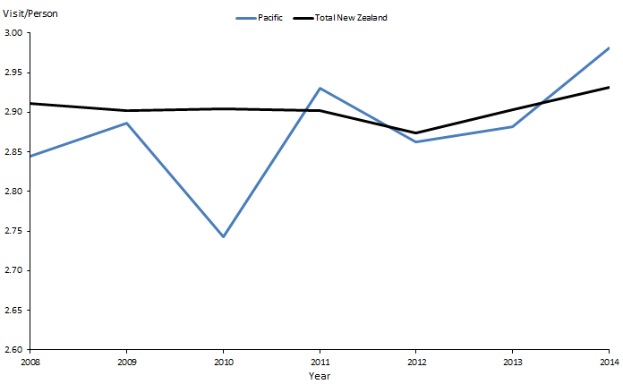
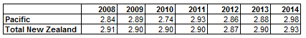

Figure 31 shows that in 2014, Pacific peoples were more likely to have accessed their GPs than the total New Zealand population.

Figure 32: GP utilisation rate (average visits per person), Pacific peoples by priority DHBs, 2008–2014
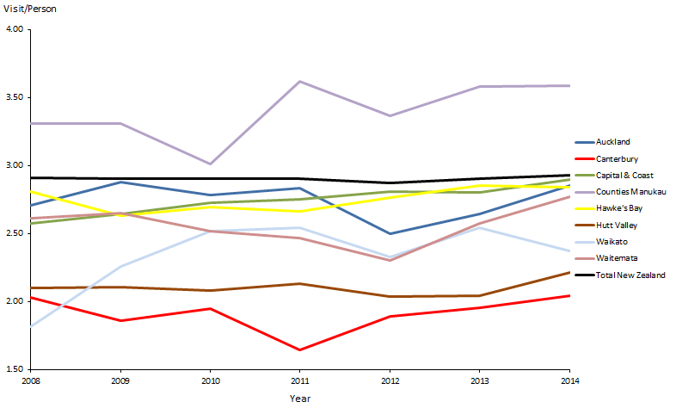
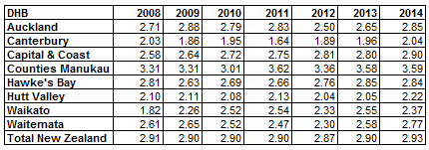

Figure 32 shows that Counties Manukau, the DHB with the largest number of enrolled Pacific peoples, had an average of 3.59 of visits per person per year in 2014 , compared with the total New Zealand average of 2.93. The other three DHBs with large Pacific enrolments – Auckland, Waitemata and Capital & Coast – are all producing improved figures for this indicator.

Low GP utilisation rates are likely due to a cost barrier.

Figure 33: Nurse utilisation rate (average visits per person), Pacific peoples population and total New Zealand population, 2008–2014
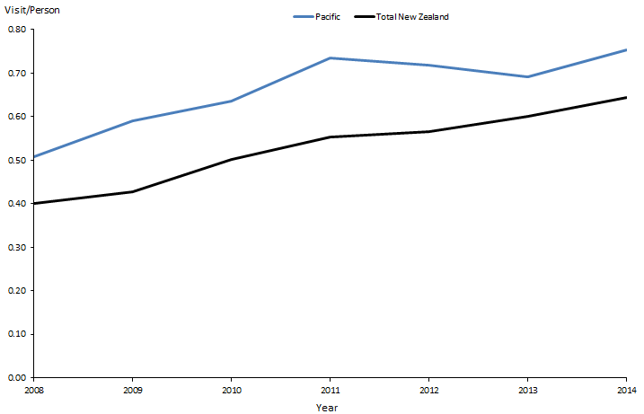
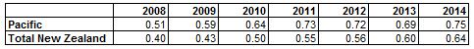

Figure 33 shows that in general, rates of utilisation of primary health nursing services are higher for Pacific peoples.

Figure 34: Nurse utilisation rate (average visits per person), Pacific peoples, by priority DHBs, 2008–2014
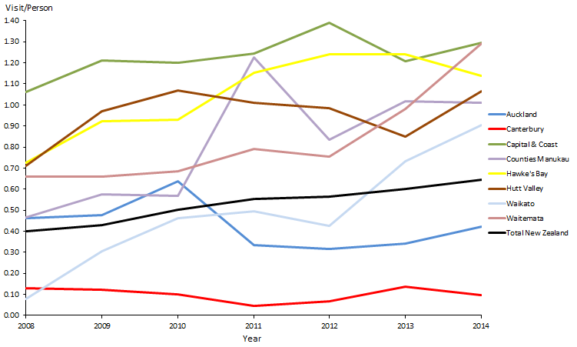
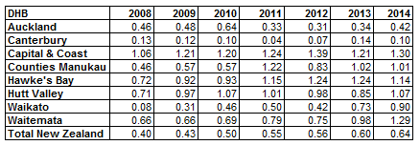

Figure 34 shows that in Capital & Coast, Counties Manukau, Hawke’s Bay, Hutt Valley, Waikato and Waitemata DHBs, nurse utilisation rates were higher compared with the total New Zealand population.

Figure 35: Total GP and nurse utilisation rate (average visits per person), Pacific peoples population and total New Zealand population, 2008–2014
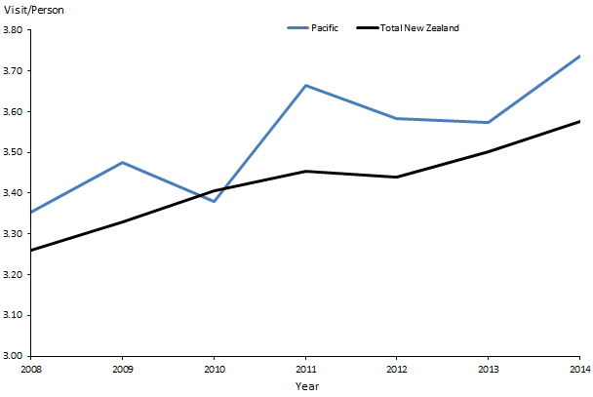
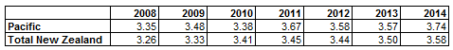

Figure 35 shows that the total rates for GP and nurse utilisation have been improving since 2008 for both the Pacific peoples and total New Zealand populations. The Pacific population rates have been consistently higher than those of the total New Zealand population since 2008, except in 2010.

Figure 36: Total GP and nurse utilisation rate (average visits per person), Pacific peoples, by priority DHBs, 2008–2014
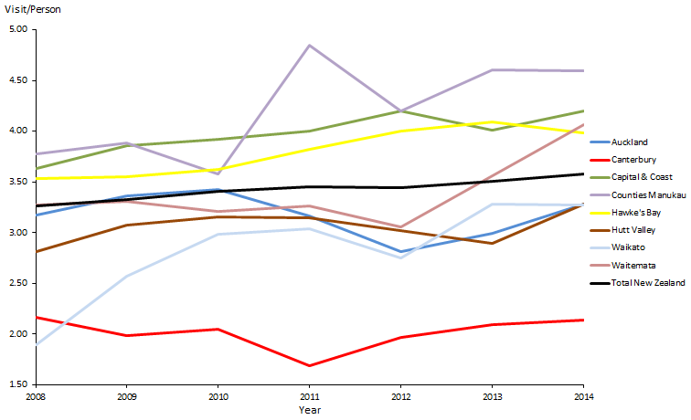
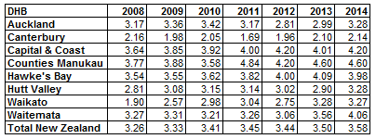

Figure 36 shows that in Capital & Coast, Counties Manukau, Hawke’s Bay and Waitemata DHBs, access rates for primary care among Pacific peoples were generally higher than they were in the total New Zealand population.

Though total GP and nurse utilisation rates have been consistently higher for the Pacific population than the total New Zealand population, this is not reflected in the Pacific ASH rates, and in overall health outcomes for Pacific peoples.

A 2012 study on primary care for Pacific peoples found that barriers to accessing primary care services included transport problems and the cost of health care (Pacific Perspectives 2012). The study also found that Pacific patients experienced difficulties in making appointments to see their GPs, and some – especially older people – had anxiety or a lack of confidence in communicating with doctors. Language barriers, a lack of interpreter resources and cultural insensitivity by GPs and staff all contributed to the communication problems experienced by Pacific patients when accessing primary care services. Where cost is not an issue and Pacific patients do access primary care services, lack of cultural competence in the delivery of health services for Pacific peoples and language barriers between health service providers and Pacific peoples could be a reason for the numerous GP and nurse visits by Pacific patients.

Priority outcome 3 –
Pacific peoples are better supported to be healthy
The following presents a brief summary of performance indicators results and activities delivered in priority outcome three for this reporting period.
The only indicator with a quantitative measure in this priority outcome section for which the rates have reached equity (that is, the rate for Pacific peoples has met or exceeded the total population rate) is that stating that 90 percent of the eligible population will have had their CVD risk assessed in the last five years. In 2014 this was achieved for 87 percent of the eligible Pacific peoples population, and 86 percent of the eligible total New Zealand population.
Good progress is being made in improving health literacy for Pacific peoples. The Ministry has released a health literacy framework and a review guide (Ministry of Health 2015a), which promotes ways in which the health sector can address health literacy issues.
In the case of rheumatic fever, the Ministry has undertaken extensive work to ensure health literacy is not a barrier to understanding the key prevention messages. Work also continues on how to most effectively disseminate key messages in the B4SC programme. The Ministry of Pacific Island Affairs’ Pacific Analysis Framework (PAF) training is continuing; the Ministry has recently consulted with other Government agencies to update the demographic data and language of the tool, and to make it more user-friendly.
Priority needs to be given to the indicator requiring a reduction in the percentage of Pacific children aged 2–14 years who are obese, which currently stands at 25 percent (compared with 11 percent of children in the total New Zealand population).

Priority outcome 3 – Pacific peoples are better supported to be healthy
Action 1 | Improve the healthy literacy of Pacific peoples so that they can make healthy choices and gain better access to the health and disability system, by supporting research on effective approaches to strengthen health literacy.

Action commentary
On 15 May 2015, the Ministry released a health literacy framework and review guide on its website, and disseminated hard copies to DHBs, PHOs and other health organisations.

The health literacy framework sets out the ways people in the health sector can address health literacy issues. Focusing on different levels of the sector (system level, organisation level and the health workforce level), it suggests particular actions to be taken, with the ultimate aim of supporting individuals and whānau to make informed decisions about their health.

The review guide provides advice on how health organisations such as DHBs and PHOs can prepare for and undertake a review on health literacy aspects of their services, and take action accordingly.

The review guide has been piloted in three health organisations: Counties Manukau oral health services, Capital & Coast DHB’s outpatient services, and diabetes health services within a PHO in Northland.

The review guide is supported by web-based materials including instructional videos (showcasing participants from the three pilot organisations) that help explain the guide.

Performance: The Ministry will conduct a qualitative survey to measure the health literacy of Pacific peoples, and will continue to monitor the impact of the actions and activities being delivered.

Action 2 | Ensure that health programmes work for people with low levels of health literacy and raise health literacy awareness.

Performance: See performance notes for Action 1 above.

Rheumatic fever
The Ministry has taken steps to ensure the Rheumatic Fever Prevention Programme (RFPP) is well received by Pacific peoples, including the following.
- Pacific providers have engaged with more than 26,000 Pacific families in Auckland and Wellington since 2013, in their homes and at community events, to raise awareness of rheumatic fever and inform people about preventative actions.
- Eleven community groups have each accessed up to $25,000 through the Pacific Community Innovations Fund, to run local events in Wellington (four) and Auckland (seven) to further raise awareness. These activities began in December 2014 and will run until October 2015.
- The 2015 Rheumatic Fever Awareness Campaign was launched on 28 April, and involves television, radio and online advertising. It is aimed at Pacific and Māori parents and caregivers of children and young people aged 4–19 years. Pacific peoples and health providers were important stakeholders in the focus group testing process for the campaign. Pacific providers have worked closely with the Health Promotion Agency to deliver the campaign for the Ministry. The campaign includes radio advertising in English, Samoan and Tongan, on Pacific stations and mainstream stations popular with Pacific listeners. A radio feature is being developed to specifically target Samoan and Tongan audiences, in those languages. It will be broadcast in July 2015.
- The Ministry continues to deliver a campaign aimed at Pacific and Māori youth aged 13–19 years in partnership with the Ministry of Youth Development. This has involved raising awareness of rheumatic fever in schools, at community events and at festivals. Thirty youth ambassadors have been trained to deliver rheumatic fever prevention messages to their peers. Some of these ambassadors were at the Te Matatini National Kapa Haka Festival in Christchurch on 4–8 March 2015 and at Polyfest 2015, held in Auckland on 18–21 March. ‘Dramatic Fever’ interactive performance workshops, created and developed by youth theatre group the Phoenix Trust, have been delivered to 48 schools in Auckland and Northland. These hour-long shows used youth-specific language and ideas to deliver their message.

B4 School Checks
The Ministry has refreshed the messages being provided in its B4SCs. It has developed new promotional material and tools, with a focus on increasing the participation of Māori and Pacific families. Tools and materials now include:
- videos of Pacific families talking about the B4SC
- new web content
- print material for parents/caregivers and the early education sector, including translations in Te Reo, Samoan and Tongan
- short-term targeted media activity over April 2015 (on radio, through outdoor advertisements and on Facebook) in regions with proportionally higher Māori and Pacific families and families living in high-deprivation areas.

Families who were less likely to access the B4SC (including Pacific and Māori, and families living in high deprivation areas) were involved in developing the material, to gain an understanding of barriers to accessing the B4SC.
Action 3 | Strengthen the practice of health literacy in the health workforce through cultural competency education (PAF training, Ministry of Pacific Island Affairs).

Action commentary
The Ministry of Pacific Island Affairs’ PAF is a tool for incorporating Pacific perspectives into the policy processes of Government agencies. In 2014, the Ministry of Pacific Island Affairs began work to review and refresh this tool. To date, the review has included consultation with Government agencies, including non-Pacific policy practitioners (the key target audience for the PAF). The Ministry of Pacific Island Affairs has updated the PAF with more up-to-date demographic data, updated the language to reflect today’s public service and restructured the PAF to make it more user-friendly.

Further work will include ensuring the PAF:
- is underpinned by a Pacific strengths-based approach to policy development
- captures the evolving diversity and values of Pacific peoples
- incorporates Pacific models, methodologies and approaches of engagement.

Sitting alongside the PAF is a companion document, the Pacific Engagement Guidelines, which the Ministry of Pacific Island Affairs is also reviewing and updating.

The Ministry of Pacific Island Affairs is also developing a PAF training package for agencies. It expects to complete this work and deliver five training workshops to key partner agencies (including the Ministry of Health) by June 2016.

Performance: The Ministry of Health will conduct a qualitative survey to measure health literacy of Pacific peoples in New Zealand, and will continue to monitor the impact of the actions and activities being delivered.

Action 4 | Work with lead providers of the Healthy Families New Zealand Initiative to implement programmes that enable Pacific families and communities to live healthier lives.

Action commentary
The Healthy Families New Zealand is a large-scale initiative that brings community leadership together in a united effort for better health. It aims to improve people’s health where they live, learn, work and play, in order to prevent chronic disease.

The concept of local leadership is at the core of the project. Lead providers for the initiative have recruited their managers and confirming their partnerships. The providers began working on an implementation road map in the first quarter of 2015. The Healthy Families New Zealand communities are now well established.

Each of the communities has established a governance group made up of local leaders with strong spheres of influence across multiple sectors and settings, including leaders from local government, iwi, the health sector, the education sector, business and the community.

Approximately one-third of the anticipated seventy-five full-time employees in the Healthy Families project have been recruited (a manager, settings coordinator, and partnerships and engagements coordinators have been appointed in each location). It is expected that the full workforce will be in employment by the end of September 2015. Of the funding designated for the workforce, 80 percent is for establishing a workforce across the locations, and 20 percent for an ‘action budget’ to seed sustainable change at scale.

Healthy Families New Zealand aims to improve people’s health where they live, learn, work and play. It does so according to a ‘settings framework’ that is one of its core elements. The framework will be used to support evidence-based action in education and workplace settings, and the Healthy Families New Zealand workforce will use it in their engagement with these settings.

The lead provider for Healthy Families Spreydon-Heathcote is the Pacific Trust Canterbury. The lead provider for Healthy Families Manukau and Healthy Families Manurewa-Papakura is Auckland Council, in partnership with Alliance Health +.

Pacific leaders are active on the governance groups for many of the other seven Healthy Families communities.

Indicator 4a | Decrease the number of Pacific children aged 2–14 years who are obese

Performance: There is no target set for this indicator.

Refer to Figures 27 and 28.

Indicator 4b | Improve management of diabetes by providing ‘more heart and diabetes checks’

Performance: The target for this indicator is 90 percent.

Refer to Figures 25 and 26.

Figure 37: Estimated percentage of people with diabetes, Pacific peoples population and total New Zealand population, 2010–2014
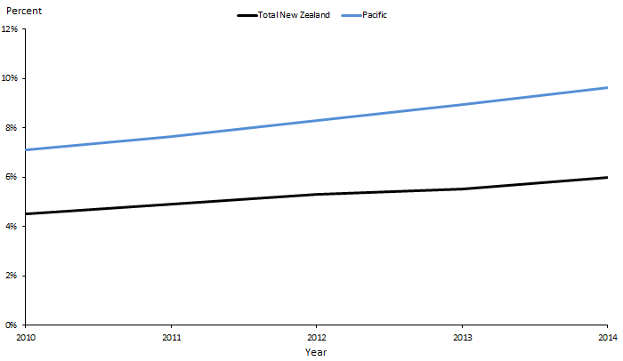
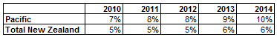

Note: This indicator is only reported on annually.

Figure 37 shows that the estimated percentage of people with diabetes in both the Pacific peoples and the total New Zealand populations is increasing. The Pacific peoples figure is increasing more rapidly than that of the total New Zealand population.

Figure 38: Estimated percentage of people with diabetes, Pacific peoples, by priority DHBs, 2010–2014
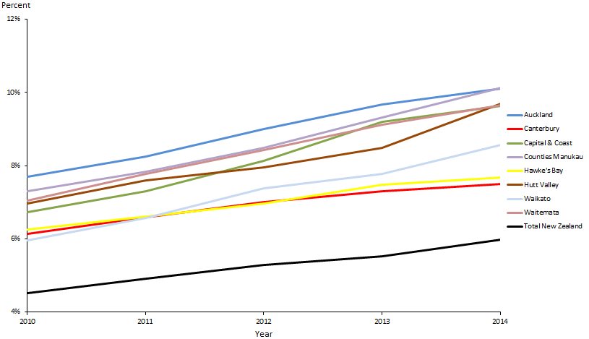
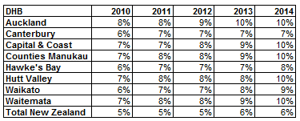

Figure 38 shows that, overall, the estimated percentage of Pacific peoples who have diabetes across the DHBs increased between 2010 and 2014.

Priority outcome 4 –
Pacific peoples experience improved broader determinants of health
There are two quantitative indicators in this priority outcome; rates for neither of those two have reached equity with rates for the total New Zealand population. However, progress has been made in terms of both.
There has been a small reduction in the rate of rheumatic fever hospitalisations among Pacific peoples, and the rate of childhood immunisations at six months of age among Pacific peoples is only 3 percent away from the rate for the total population (at March 2015).
Table 10: Performance against priority outcome four indicators as at 30 June 2015
Indicator | Pacific | Total New Zealand population | Target
Reduce Pacific rheumatic fever hospitalisation rates by June 2017 | 26.8 per 100,000 | 3.4 per 100,000 | 8 per 100,000 (Pacific)
Increase infant immunisation rates at six months of age | 76% coverage | 79% coverage | 95% coverage
The Ministry is reviewing funding and contracting arrangements to support service access and integration in primary maternity and WCTO services.
It has supported implementation of four children’s teams currently operating in Whangarei, Rotorua, Horowhenua/Ōtaki and Marlborough, and an additional six that will go live in 2015/2016 in Hamilton, Tairawhiti, Eastern Bay of Plenty, Whanganui, Christchurch and South Auckland. DHBs will lead the health sector’s implementation of these teams at a local level.
The Ministries of Health, Education and Social Development and Te Puni Kōkiri are working together to develop a whole-of-government response to children and young people with conduct problems.

Priority outcome 4 – Pacific ʼāiga, kāiga, magafaoa, kōpū tangata, vuvale, fāmili experience improved broader determinants of health
Action 1 | The health and disability sector will work across government to decrease overcrowding in Pacific homes and increase access to healthy housing.

Action commentary
Through the RFFP, the Ministry is administering Healthy Homes Initiatives (HHIs) across the 11 DHBs in which there is a high incidence of rheumatic fever. This new service systematically identifies families with children at risk of rheumatic fever who are living in crowded households, and facilitates access to a range of interventions.

The Auckland-wide Healthy Homes Initiative (AWHI) service was the first HHI to be launched; it has been operational since December 2013. In its first 16 months, the AWHI had assessed more than 1200 vulnerable families in Auckland, and over 650 changes had been made in their homes as a result.

Healthy Homes Initiatives enabled housing assistance for up to 3500 families in 2015/16. Where families are current Housing New Zealand Corporation tenants, household crowding may swiftly be addressed through capital interventions. Interventions for private tenants are more challenging – there are few levers with which to influence landlord behaviour, and tenants are often fearful of rising rents should the quality of their rented house improve.

Cross-agency action on reducing household crowding has resulted in the Ministryand the Ministries of Social Development, Business, Innovation and Employment and Housing New Zealand working closely together. The resulting partnerships also include the private and philanthropic sectors.

Indicator 1 | Reduction in Pacific rheumatic fever hospitalisation rates by June 2017

Performance: The national target for this indicator is 1.4 per 100,000. The Pacific target for this indicator is 8 per 100,000 by June 2017. The Pacific target is, phased over the years.

Figure 39: Rheumatic fever hospitalisation rates, Pacific peoples, 2011–2014
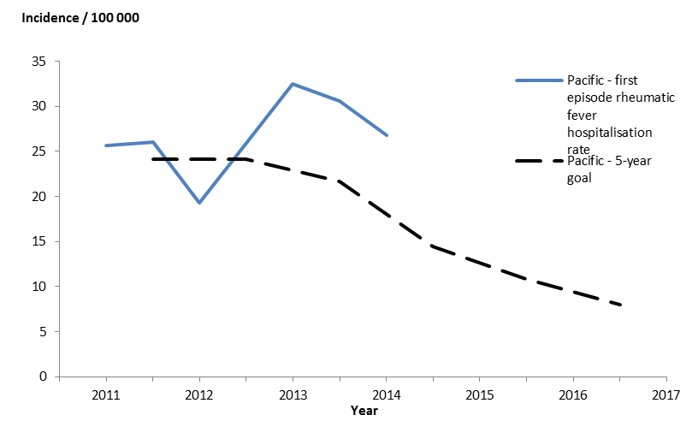
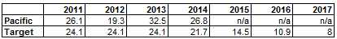

Figure 39 shows a sharp increase in rheumatic fever hospitalisation rates for the Pacific peoples population between 2012 and 2013. There are three possible explanations for this increase:
- Increased awareness of rheumatic fever among both the public and health professionals may have led to an increased number of children and young people presenting to health services with rheumatic fever symptoms and an increased number of health professionals investigating and diagnosing rheumatic fever.
- The increase may be due to the natural variation of rheumatic fever cases year on year, due to the small numbers involved.
- There may have been a true increase in the number of children and young people developing rheumatic fever.

Note: We have not reported on this indicator by DHB, as the numbers per 100,000 are very small.

Action 2 | The Ministry of Health will work in partnership with the Ministries of Social Development; Business, Innovation and Employment; and Education and with the New Zealand Police on the following Better Public Service priorities, targeting vulnerable children:  - increase participation in early childhood education  - increase infant immunisation rates  - reduce the incidence of rheumatic fever  - reduce the number of assaults on children.

Action commentary
The health sector supports a range of initiatives that contribute to reducing assaults on children; for example:
- primary maternity and WCTO services
- the Children’s Action Plan and the Vulnerable Children Act 2014
- the cross-agency conduct problems project.

Primary maternity and WCTO services
In the context of improving outcomes for vulnerable children, the health sector plays a vital role. Primary maternity and WCTO services contribute to reducing assaults on children through early assessment and intervention. These services have high and wide reach; access rates are currently over 90 percent. Midwives and WCTO nurses often deliver their services in the home; they can identify parenting problems early and provide advice and support to parents before they reach crisis point. They can also refer the family to other support services (such as the children’s teams). These services are relationship-based, and delivered at a time when families and whānau are receptive to information and advice, which contributes to their effectiveness.

The Ministry has undertaken work with the sector to improve primary maternity and WCTO services within current settings, and is now considering the role of funding and contracting arrangements in supporting service access and integration. It expects that any changes as a result of this work will improve the reach of these services into vulnerable population groups. This will further enhance the importance of these services in addressing complex health and social problems like child maltreatment and family violence.

The Children’s Action Plan and the Vulnerable Children Act 2014
The health sector contributes to reducing assaults on children by assisting with implementing the Children’s Action Plan and the Vulnerable Children Act 2014.

The Ministry has supported implementation of a total of ten children’s teams, as outlined above and has provided funding to all 10 DHBs involved. Funding of $0.7 million each was provided to the two DHBs with demonstration sites (Lakes and Northland) over two years ($0.35 million each in 2013/14 and 2014/15). Negotiations are under way with those two DHBs for ‘transition funding’ to be provided for the 2015/16 financial year. The remaining eight sites are also receiving funding from the Ministry, totalling $2.177 million, to support establishment and start-up costs.

The Ministry is working with DHBs and other health sector providers to implement the workforce programme and requirements of the Vulnerable Children Act. Part 2 of the Act requires government-funded providers of children’s services to have child protection policies in place that support the identification of, and response to, suspected abuse or neglect. DHBs already have such policies in place, and are varying funding agreements to require contracted providers of children’s services to develop and adopt similar policies. Many large national contracts have been varied to include this requirement, including those for primary care, disability services and the national WCTO agreement.

Part 3 of the Act requires state sector agencies, and organisations funded by the state sector, to ensure safety checks of their paid children’s workers are done to the regulatory standard, with criminal penalties for non-compliance. Many health employers, including DHBs, already undertake the recommended practices. However, the new requirements will increase the consistency of recruitment practice across the children’s workforce and within the health sector. The Ministry has ensured that the wider health sector is ready to comply with the new requirements which came into force on 1 July 2015.

The cross-agency conduct problems project
The Ministries of Health, Education and Social Development and Te Puni Kōkiri are working together to develop a whole-of-government response to children and young people with conduct problems. Clinical interventions for children with conduct disorders offer an important opportunity to prevent a burden of poor health and social maladjustment in adulthood, that can included criminal and violent offending. The costs of intervention are often low compared to the potential benefits. Even when treatment costs are high and success rates low, it is still cost-effective to intervene.

A small cross-agency group is working to scope the project to galvanise collective impact to address conduct problems, particularly for Māori, and align this initiative with other government activities.

Indicator 2 | Increase infant immunisation rates

Performance: The target for this indicator is 95 percent.

Figure 40: Immunisation coverage (percent) at six months of age (three-month reporting), Pacific peoples population and total New Zealand population, 2013–2015
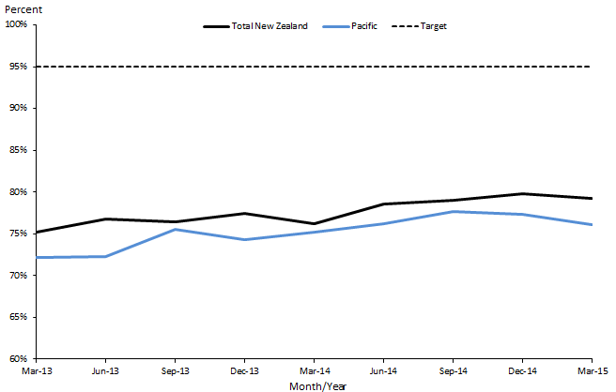
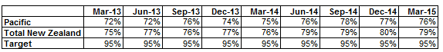

Figure 40 shows minimal increases in the percentages for both the Pacific peoples and total New Zealand population groups in immunisation coverage at six months of age.

Figure 41: Immunisation coverage (percent) at six months of age (three-month reporting), Pacific peoples, by priority DHBs, 2013–2015
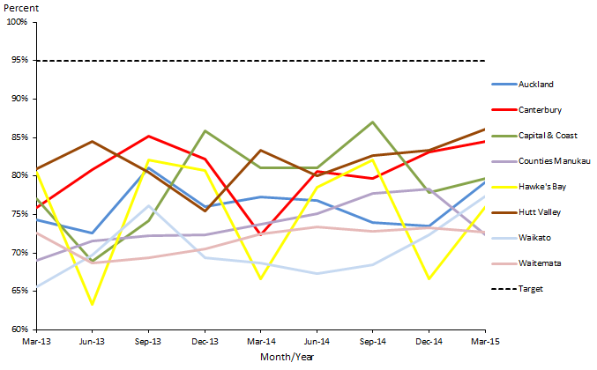
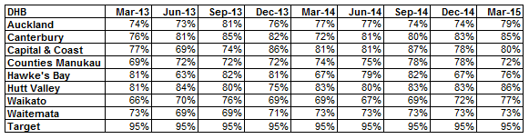

Figure 41 shows that most DHBs are making positive progress. However, Counties Manukau and Waitemata DHB immunisation coverage dropped in the March 2015 quarter.

Note: Immunisation coverage was chosen to be monitored in ’Ala Mo’ui at six months (as opposed to eight or 12 months) as this is the age at which coverage for Pacific is the lowest. Immunisation coverage for Pacific at eight months of age is 95 percent, compared to 93 percent for the total New Zealand population. At 12 months, Pacific coverage is 98 percent, compared to 95 percent for the total New Zealand population.

References
Ministry of Health. 2012a. Rising to the Challenge: The Mental Health and Addictions Service Development Plan 2012-2017. Wellington: Ministry of Health.
Ministry of Health. 2012b. Tupu Ola Moui: Pacific Health Chart Book 2012. Wellington: Ministry of Health.
Ministry of Health. 2015a. A Framework for Health Literacy. Wellington: Ministry of Health.
Ministry of Health. 2015b. Indicators for the Well Child / Tamariki Ora Quality Improvement Framework – March 2015. Wellington: Ministry of Health.
Pacific Perspectives. 2012. Primary Care for Pacific Peoples: A Pacific and health systems approach. Report to the Health Research Council and the Ministry of Health. Wellington: Pacific Perspectives.
Statistics New Zealand. 2015. New Zealand Period Life Tables: 2012–14. URL: www.stats.govt.nz/browse_for_stats/health/life_expectancy/NZLifeTables_HOTP12-14.aspx (accessed 28 August 2015).

Appendix
Table A1: Forecast Pacific peoples population for 2014/15 by DHB
DHB | Population | Percentage
Counties Manukau | 121,935 | 40.3%
Auckland | 51,945 | 17.2%
Waitemata | 41,900 | 13.8%
Capital & Coast | 22,150 | 7.3%
Canterbury | 12,415 | 4.1%
Hutt Valley | 12,370 | 4.1%
Waikato | 9780 | 3.2%
Hawke’s Bay | 5210 | 1.7%
Southern | 4885 | 1.6%
MidCentral | 4620 | 1.5%
Bay of Plenty | 3215 | 1.1%
Northland | 2895 | 1.0%
Lakes | 2605 | 0.9%
Nelson Marlborough | 1973 | 0.7%
Taranaki | 1220 | 0.4%
Whanganui | 1090 | 0.4%
Tairawhiti | 990 | 0.3%
Wairarapa | 788 | 0.3%
South Canterbury | 513 | 0.2%
West Coast | 290 | 0.1%
Total | 302,789 | 100%
Note: Percentages have been rounded.

The first progress report on ̛Ala Mo’ui tracked and monitored 23 indicator measures. The two indicator measures no longer being monitored and tracked are ‘Pacific caries-free at year eight’ and ‘Pacific decayed missing, or filled teeth (dmft) rates at age five’. The Ministry has decided that the two indicator measures ‘Pacific caries-free at age five’ and ‘Pacific (DMFT) rates at year eight’ suffice for monitoring oral health outcomes for Pacific children.
Some indicator measures lack targets as none have been set nationally and there has been no identified optimal number or percentage to reach.
Hawke’s Bay DHB has been included to make a total of eight Pacific priority DHBs.
Ambulatory sensitive hospital admission rates are often used as a measure of the effectiveness of the interface between primary and secondary health care. They are a health system indicator. The assumption is that better management of chronic conditions such as diabetes and cardiovascular disease within local communities can reduce the number of avoidable hospital admissions (and moderate demand on hospital resources).
Whānau House is operated by Te Whānau o Waipareira Trust and offers families ‘wrap-around’ integrated services (health, social, justice and education) tailored to their needs.
Six of Pasifika Futures’ core commissioning funded agencies have been supported through the Ministry’s Pacific Provider Workforce Development Fund: Pacific Trust Canterbury, Aere Tai Collective, The Fono, Taeaomanino Trust, The Pacific Islands Safety and Prevention Trust and South Seas Healthcare Trust.
Cole cut-offs are BMI for overweight and obesity by gender and age.
Alliance Health + is the only Pacific PHO. Its enrolled population was approximately 90,000 as at 30 June 2014. Its performance against aggregate health targets in 2014 was in the top quartile of PHOs nationally.

