’Ala Mo’ui Progress Report
June 2016

Citation: Ministry of Health. 2016. ’Ala Mo’ui Progress Report: June 2016.
Wellington: Ministry of Health.
Published in August 2016
by the Ministry of Health
PO Box 5013, Wellington 6140, New Zealand
ISBN 978-0-947515-56-0 (online)
HP 6475
This document is available at health.govt.nz
This work is licensed under the Creative Commons Attribution 4.0 International licence. In essence, you are free to: share ie, copy and redistribute the material in any medium or format; adapt ie, remix, transform and build upon the material. You must give appropriate credit, provide a link to the licence and indicate if changes were made.

Contents
Executive summary vii
Whole-of-system measures 1
Priority outcome 1 – Systems and services meet the needs of Pacific peoples 7
Priority outcome 2 – More services are delivered locally in the community and in primary care 44
Priority outcome 3 – Pacific peoples are better supported to be healthy 55
Priority outcome 4 – Pacific peoples experience improved broader determinants of health 61
References 67
Appendix 68

List of Tables
Table 1: ’Ala Mo’ui indicators where performance for Pacific peoples has achieved equity, as at 30 June 2016 viii
Table 2: ’Ala Mo’ui indicators where there is a disparity in equity between Pacific peoples and the set target, as at 30 June 2016 viii
Table 3: ’Ala Mo’ui indicators where there is a disparity in equity between Pacific peoples and the total New Zealand population, as at 30 June 2016 ix
Table 4: ’Ala Mo’ui performance indicators progress for the priority DHBs, as at 30 June 2016 x
Table 5: Priority outcome 1 performance indicators where equity is a concern for Pacific peoples, as at 30 June 2016 6
Table 6: DHB ‘Rising to the Challenge’ actions delivered, as at 30 June 2016 8
Table 7: DHB activities delivered to improve services offering Pacific peoples better help for smokers to quit, as at 30 June 2016 31
Table 8: DHB work towards offering Pacific peoples more heart and diabetes checks, as at 30 June 2016 32
Table 9: Performance against priority outcome 2 indicators, as at 31 December 2015 43
Table 10: Performance against priority outcome 4 indicators, as at 30 June 2016 60
Table A1: Projected Pacific peoples population for 2015/16 by DHB based on the 2013 Census 68

List of Figures
Figure 1a: ASH rates per 100,000 (0–4-year-olds), Pacific peoples population and total New Zealand population, 2002–2015 2
Figure 1b: ASH rates per 100,000 (0–4-year-olds), Pacific peoples, by priority district health boards (DHBs), 2002–2015 3
Figure 1c: ASH rates per 100,000 (45–64-year-olds), Pacific peoples population and total New Zealand population, 2002–2015 4
Figure 1d: ASH rates per 100,000 (45–64-year-olds), Pacific peoples, by priority district health boards (DHBs), 2002–2015 5
Figure 2: Access rate to DHB mental health services, Pacific peoples population and total New Zealand population, 2005/06–2014/15 9
Figure 3: Access rate to DHB mental health services, Pacific peoples, by priority DHBs, 2005/06–2014/15 10
Figure 4: Access to DHB alcohol and drug services, Pacific peoples population and total New Zealand population, 2012/13–2014/15 11
Figure 5: Access to DHB alcohol and drug services, Pacific peoples, by priority DHBs, 2012/13–2014/15 12
Figure 6: Percentage of newborn infants enrolled with a general practice by three months of age, Pacific peoples population and total New Zealand population, 2013–2016 14
Figure 7: Percentage of newborn infants enrolled with a general practice by three months of age, Pacific peoples, by priority DHBs, 2013–2016 15
Figure 8: Percentage of infants who received all WCTO core contacts in their first year of life, Pacific peoples population and total New Zealand population, 2013–2016 16
Figure 9: Percentage of infants who received all WCTO core contacts in their first year of life, Pacific peoples, by priority DHBs, 2013–2016 17
Figure 10: Percentage of four-year-olds who received a B4SC, Pacific peoples population and total New Zealand population, 2013–2016 18
Figure 11: Percentage of four-year-olds who received a B4SC, Pacific peoples, by priority DHBs, 2013–2016 19
Figure 12: Percentage of infants exclusively or fully breastfed at three months of age, Pacific peoples population and total New Zealand population, 2013–2016 20
Figure 13: Percentage of infants exclusively or fully breastfed at three months of age, Pacific peoples, by priority DHBs, 2013–2016 21
Figure 14: Percentage of children with BMI >99.4th percentile referred to a GP or specialist services, Pacific peoples population and total New Zealand population, 2013–2016 22
Figure 15: Percentage of children with BMI >99.4th percentile referred to a GP or specialist services, Pacific peoples, by priority DHBs, 2013–2016 23
Figure 16: Percentage of children under five years old enrolled in the Community Oral Health Service, Pacific peoples population and total New Zealand population, 2007–2015 24
Figure 17: Percentage of children under five years old enrolled in the Community Oral Health Service, Pacific peoples, by priority DHBs, 2007–2015 25
Figure 18: Percentage of children caries-free at age five, Pacific peoples population and total New Zealand population, 2007–2014 26
Figure 19: Percentage of children caries-free at age five, Pacific peoples, by priority DHBs, 2007–2014 27
Figure 20: Mean rate of DMFT at school year eight, Pacific peoples population and total New Zealand population, 2007–2014 28
Figure 21: Mean rate of DMFT at school year eight, Pacific peoples, by priority DHBs, 2007–2014 29
Figure 22: Percentage of smokers offered brief advice and support to quit in primary health care, Pacific peoples population and total New Zealand population, 2013–2016 33
Figure 23: Percentage of smokers offered brief advice and support to quit in primary health care, Pacific peoples, by priority DHBs, 2013–2016 34
Figure 24: Percentage of eligible adults who had cardiovascular risk assessed, Pacific peoples population and total New Zealand population, 2013–2016 35
Figure 25: Percentage of eligible adults who had cardiovascular risk assessed, Pacific peoples, by priority DHBs, 2013–2016 36
Figure 26: Percentage of children who are obese (BMI >/= Cole cut-offs), Pacific peoples population and total New Zealand population, 2006–2015 38
Figure 27: Percentage of children who are obese (BMI >/= Cole cut-offs), Pacific peoples, by priority DHBs, 2006–2015 39
Figure 28: Percentage of enrolled women aged 25–69 years who received a cervical smear in the past three years, Pacific peoples population and total New Zealand population, 2013–2016 41
Figure 29: Percentage of enrolled women aged 25–69 years who received a cervical smear in the past three years, Pacific peoples, by priority DHBs, 2013–2016 42
Figure 30: GP utilisation rate (average visits per person per year), Pacific peoples population and total New Zealand population, 2008–2016 48
Figure 31: GP utilisation rate (average visits per person), Pacific peoples, by priority DHBs, 2008–2016 49
Figure 32: Nurse utilisation rate (average visits per person), Pacific peoples population and total New Zealand population, 2008–2016 50
Figure 33: Nurse utilisation rate (average visits per person), Pacific peoples, by priority DHBs, 2008–2016 51
Figure 34: Total GP and nurse utilisation rate (average visits per person), Pacific peoples population and total New Zealand population, 2008–2016 52
Figure 35: Total GP and nurse utilisation rate (average visits per person), Pacific peoples, by priority DHBs, 2008–2016 53
Figure 36: Estimated percentage of people with diabetes, Pacific peoples population and total New Zealand population, 2010–2015 58
Figure 37: Estimated percentage of people with diabetes, Pacific peoples, by priority DHBs, 2010–2015 59
Figure 38: Rheumatic fever hospitalisation rates, Pacific peoples, 2011–2015 63
Figure 39: Immunisation coverage (percent) at eight months of age (three-month reporting), Pacific peoples population and total New Zealand population, 2013–2016 65
Figure 40: Immunisation coverage (percent) at eight months of age (three-month reporting), Pacific peoples, by priority DHBs, 2013–2016 66

Executive summary
’Ala Mo’ui: Pathways to Pacific Health and Wellbeing 2014–2018 (’Ala Mo’ui) is a four-year plan that provides an outcomes framework for delivering high-quality health services to Pacific peoples. The outcomes and actions in ’Ala Mo’ui contribute to the Government’s long-term outcomes for health: all New Zealanders, including Pacific peoples, will lead healthier and more independent lives; high-quality health services will be delivered in a timely and accessible manner; and the future sustainability of the health and disability sector will be assured (Ministry of Health 2014).

The long term vision of ’Ala Mo’ui is:
Pacific ’āiga, kāiga, magafaoa, kōpū tangata, vuvale and fāmili experience equitable health outcomes and lead independent lives.

Its four priority outcome areas are:
1. Systems and services meet the needs of Pacific peoples.
2. More services are delivered locally in the community and in primary care.
3. Pacific peoples are better supported to be healthy.
4. Pacific peoples experience improved broader determinants of health.

Indicators used in ’Ala Mo’ui
’Ala Mo’ui sets out 13 actions, which sit across four priority outcome areas to achieve its long-term vision and outcomes. Associated with these actions are 21 indicators. The aim of the indicators is to monitor and promote quality improvement across the health and disability sector without creating any additional reporting burden. The indicators are a subset of measures drawn from existing data collections and reporting mechanisms; for example, the Well Child/ Tamariki Ora (WCTO) Quality Improvement Framework, the health targets and the Better Public Services targets. The Ministry will review the indicators on a regular basis as the sector performance improves.

Monitoring and reporting
The Ministry of Health (through ’Ala Mo’ui) will monitor the 21 indicators and measure performance against set national targets or the total New Zealand population across eight district health boards (DHBs) where 90 percent of Pacific peoples reside. The eight DHBs that are considered the ‘Pacific priority DHBs’ are (in order of highest numbers of Pacific peoples) Counties Manukau, Auckland, Waitemata, Capital & Coast, Canterbury, Hutt Valley, Waikato and Hawke’s Bay. See the Appendix for Pacific peoples population numbers and percentages for each of the 20 DHBs. Population figures in this report are based on Statistics New Zealand population projections, which use Census 2013 figures as a base. The total New Zealand population in 2015 and 2016 was 4,638,750. The total Pacific peoples population was 299,190. All indicators will be reported by DHBs and published online on a six-monthly basis.

National level progress to 30 June 2016
At a national level, there has been progress made in achieving equity for Pacific peoples in seven of the 21 indicators (Table 1). For the purpose of this report, equity is defined as equal to or greater than the total New Zealand population.

Table 1: ’Ala Mo’ui indicators where performance for Pacific peoples has achieved equity, as at 30 June 2016
Indicator | Pacific peoples | Total New Zealand | National target
Percentage of four-year-olds who received a Before School Check (B4SC), Pacific peoples | 90.4% | 91.9% | 90%
Percentage of children with body mass index (BMI) >99.4th percentile referred to a GP or specialist services | 95.8% | 89.0% | 95%
Immunisation coverage (percentage) at eight months of age (three-month reporting) | 95.6% | 93.5% | 95%
Access to DHB alcohol and drug services | 1.15% | 1.00% | No target
Percentage of eligible adults who had cardiovascular risk assessed | 89.8% | 90.3% | 90%
General practitioner (GP) utilisation rate  (average number of visits per person per year) | 3.08 | 2.99 | No target
Nurse utilisation rate  (average number of visits per person per year) | 0.77 | 0.72 | No target
Total GP and nurse utilisation rate (average visits per person) | 3.85 | 3.71 | No target

The ‘Percentage of eligible adults who had cardiovascular risk assessed’ for Pacific is 89.8 percent rounded to 90 percent. The last three indicators on Table 1 show Pacific peoples’ access to GP services is high and has maintained the achieved status over the 18 months since June 2015.

Table 2: ’Ala Mo’ui indicators where there is a disparity in equity between Pacific peoples and the set target, as at 30 June 2016
Indicator | Pacific peoples | National target
Percentage of newborn infants enrolled with a general practice by three months of age | 64.9% | 98%
Infants who received all WCTO core contacts in their first year of life | 58.6% | 95%
Percentage of infants exclusively or fully breastfed at three months of age | 46.1% | 60%
Percentage of children under five years old enrolled in DHB-funded dental services | 75.6% | 95%
Children who were caries-free at age five | 35.3% | 65%
Percentage of smokers offered brief advice and support to quit in primary health care | 85.7% | 90%
Percentage of enrolled women aged 25–69 years who received a cervical smear in the past three years | 76.2% | 80%
Rheumatic fever hospitalisation rate per 100,000 | 16.6 | 8*
* The 8 per 100,000 rate target for Pacific peoples is based on a two-thirds reduction from baseline rate (2009/2010–2011/2012) as per the target for the total population.
Table 3: ’Ala Mo’ui indicators where there is a disparity in equity between Pacific peoples and the total New Zealand population, as at 30 June 2016
Indicator | Pacific  peoples | Total  New Zealand
Ambulatory sensitive hospitalisation (ASH) rate per 100,000 (0–4-year-olds) | 12,312 | 6,537
Ambulatory sensitive hospitalisation (ASH) rate per 100,000 (45–64-year-olds) | 8,318 | 3,655
Access rate to DHB mental health services | 3.04% | 3.48%
Mean rate of DMFT for children at school year eight | 1.5 | 1.0
Children aged 2–14 years who are obese | 29.7% | 10.8%
Estimated percentage of people with diabetes | 10.5% | 6.0%

District health boards progress to 30 June 2016
Table 4 shows the summary of all the indicators monitored in ’Ala Mo’ui across the eight priority DHBs. The DHBs are arranged from the biggest population on the left to the smallest population on the right. The arrows indicate the trend of progress over time. Rheumatic fever data was not presented because there were not enough numbers (new cases) in a number of DHBs to successfully estimate the rheumatic fever hospitalisation rate with confidence.

Overall, DHBs with big Pacific populations, led by Counties Manukau, Auckland and Waitemata have all improved their number of achieved targets over the last 18 months. Capital & Coast, Waikato and Hawke’s Bay DHBs have relatively smaller Pacific populations, and have all maintained their number of achieved targets over the last 18 months.

Pacific children are doing well with Before School Checks (B4SC). Nine out of ten (90.4 percent) are checked. Nine of ten (95.8 percent) Pacific children extremely obese children identified in the B4SC are referred to GPs or specialist services. Nine out of ten (95.6 percent) Pacific infants at eight months are being immunised.

Pacific peoples are accessing alcohol and drug services. Pacific peoples are accessing GPs and Nurses. At the general practice, nine out of ten (89.8 percent) Pacific peoples’ cardiovascular and diabetes risks are being assessed.

Table 4: ’Ala Mo’ui performance indicators progress for the priority DHBs, as at 30 June 2016
Indicator no. | Counties Manukau DHB |  |  | Auckland  DHB |  |  | Waitemata  DHB |  |  | Capital & Coast  DHB |  |  | Canterbury  DHB |  |  | Hutt Valley  DHB |  |  | Waikato  DHB |  |  | Hawke’s Bay  DHB
 | Jun-15 | Dec-15 | Jun-16 | Jun-15 | Dec-15 | Jun-16 | Jun-15 | Dec-15 | Jun-16 | Jun-15 | Dec-15 | Jun-16 | Jun-15 | Dec-15 | Jun-16 | Jun-15 | Dec-15 | Jun-16 | Jun-15 | Dec-15 | Jun-16 | Jun-15 | Dec-15 | Jun-16
1
2
3
4
5
6
7
8
9
10
11
12
13
14
15
16
17
18
19
20

Indicator no. | Figure no. | Page  no. | Indicator (timeline) | Health target
1 | 1b | 3 | ASH rates per 100,000 in 0–4-year-olds (2002–2015) | No target
1 | 1d | 4 | ASH rates per 100,000 in 45–64-year-olds (2002–2015) | No target
2 | 3 | 9 | Access rate to DHB specialist mental health services (2005/2006–2014/2015) | No target
3 | 5 | 11 | Access to DHB alcohol and drug services (2012/2013–2014/2015) | No target
4 | 7 | 14 | Percentage of newborn infants enrolled with a general practice by three months (2013–2016) | 98%
5 | 9 | 16 | Percentage of infants who received all WCTO core contacts in their first year of life (2013–2016) | 95%
6 | 11 | 18 | Percentage of four-year-olds who received a B4SC (2013–2016) | 90%
7 | 13 | 20 | Percentage of infants exclusively or fully breastfed at three months (2013–2016) | 60%
8 | 15 | 22 | Percentage of children with BMI >99.4th percentile referred to a GP or specialist services (2013–2016) | 95%
9 | 17 | 24 | Percentage of children under five years old enrolled in DHB-funded dental services (2007–2014) | 95%
10 | 19 | 26 | Percentage of children caries-free at age five (2007–2014) | 65%
11 | 21 | 27 | Mean rate of DMFT at school year eight (2007–2014) | No target
12 | 23 | 32 | Percentage of smokers offered brief advice and support to quit in primary health care (2013–2016) | 90%
13 | 25 | 34 | Percentage of eligible adults who had cardiovascular risk assessed (2013–2016) | 90%
14 | 27 | 37 | Percentage of children who are obese (2006–2015) | No target
15 | 29 | 40 | Percentage of enrolled women aged 25–69 years who received a cervical smear in the past three years (2013–2016) | 80%
16 | 31 | 46 | GP utilisation rate (average visits per person) (2008–2016) | No target
17 | 33 | 48 | Nurse utilisation rate in average visits per person (2008–2016) | No target
18 | 35 | 50 | Total GP and nurse utilisation rate in average visits per person (2008–2016) | No target
19 | 37 | 55 | Estimated percentage of people with diabetes (2010–2015) | No target
20 | 40 | 61 | Percentage of immunisation coverage at eight months of age for three-month reporting (2013–2016) | 95%

Legend
Target achieved at last measure (data point). When ‘no target’ is set, a gap score is calculated (percent) when compared with the total New Zealand population at the last measure (data point).
<10 percent away from achieving the target or compared with the total New Zealand population (if ‘no target’ was set).
10 and above but less than 20 percent away from the target or compared with the total New Zealand population (if ‘no target’ was set).
20 or more percent away from the target or compared with the total New Zealand population (if ‘no target’ was set).
An increasing trend means improvement except for Figures 1b, 1d, 21, 27 and 37 where an increasing trend means not improving.
A decreasing trend means no improvement except for Figures 1b, 1d, 21, 27 and 37 where a decreasing trend means improving.
Flat-lining or plateauing.
No data available (white box).

Whole-of-system measures
’Ala Mo’ui aims to make a positive impact on three particular whole-of-system indicators in the long term:
- Life expectancy – the number of years a person can expect to live (Ministry of Health 2015b)
- Health expectancy – in the form of independent life expectancy, is the number of years a person can expect to live free of functional limitation needing assistance (Ministry of Health 2015b)
- Ambulatory sensitive hospitalisation (ASH) rates – ASH rates refers to hospitalisations due to medical conditions that could be avoided by the provision of adequate primary health care (Ministry of Health 2012b).

Life expectancy
Life expectancy at birth continues to improve for Pacific peoples. However, Pacific peoples still have shorter life expectancy compared with the total New Zealand population. Based on death rates in New Zealand in 2012–2014, life expectancy was 78.7 years for Pacific females and 74.5 years for Pacific males, compared with 83.2 years for females and 79.5 years for males in the total New Zealand population (Statistics New Zealand 2015).

Health expectancy
In 2006, the gap in health expectancy for Pacific males compared with males in the total population was 4.4 years. The gap for Pacific females compared with the females in the total population was 5.3 years.

Health expectancy at birth for New Zealand women has increased steadily for all females since 1996 to 2013, from 66.4 to 66.5. Health expectancy at birth for New Zealand men over the same period has also increased, from 63.8 to 65.2 (Ministry of Health 2015b).

The health expectancy indicator has not been updated since 2006 for Pacific peoples.

Ambulatory sensitive hospitalisation rates
ASH rates are often used as a measure of the effectiveness of the interface between primary and secondary health care. ASH rates are a health system indicator. The assumption is that better management of chronic conditions such as diabetes and cardiovascular disease within local communities has the potential to reduce the number of avoidable hospital admissions (and to moderate demand on hospital resources). Diagnosis information on hospitalisations sent to the national data set is analysed quarterly to provide avoidable ambulatory sensitive hospitalisations.

The Ministry initiated a review of the methodology used to calculate ASH rates towards the end of 2014. As a result of the review, the Ministry has changed the previous ASH definition to differentiate ‘Child ASH’ from ‘Adult ASH’. The rationale is that clinical conditions for ‘Child ASH’ differ from those for ‘Adult ASH’. Combining the two to create a single measure adds no utility to ASH. The Ministry is now reporting Child ASH (0–4-year-olds) and Adult ASH
(45–64-year-olds) rates. (Refer: http://nsfl.health.govt.nz/accountability/performance-and-monitoring/performance-measures/performance-measures-201516)

Figure 1a: ASH rates per 100,000 (0–4-year-olds), Pacific peoples population and total New Zealand population, 2002–2015
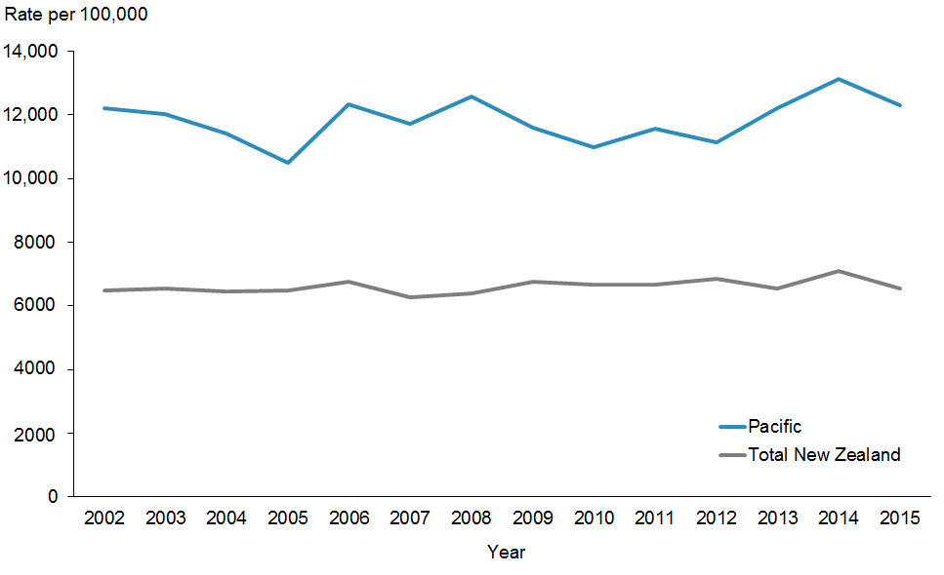
 | 2002 | 2003 | 2004 | 2005 | 2006 | 2007 | 2008 | 2009 | 2010 | 2011 | 2012 | 2013 | 2014 | 2015
Pacific | 12,225 | 12,033 | 11,424 | 10,507 | 12,331 | 11,723 | 12,585 | 11,615 | 10,980 | 11,577 | 11,127 | 12,200 | 13,140 | 12,312
Total New Zealand | 6475 | 6532 | 6452 | 6488 | 6753 | 6276 | 6394 | 6756 | 6656 | 6681 | 6852 | 6541 | 7096 | 6537

Figure 1a presents ASH rates between 2002 and 2015. ASH rates have been increasing steadily since 2012 and peaked in 2014 for Pacific children (0–4-year-olds). However, from 2014 to 2015 there has been a decrease. In contrast, the ASH rates for total New Zealand children has been stable in recent years but also peaked in 2014 and decreased in 2015. This decrease is partly explained by the fact that from July 2014, the immunisation schedule included a vaccine for Rotavirus (RotaTeq) at six weeks, three months and five months. Rotavirus was one of the main causes of admissions to hospitals with gastroenteritis/ dehydration for Pacific children. Gastroenteritis/dehydration is in the top five contributors to ASH rates in this age group.

Figure 1b: ASH rates per 100,000 (0–4-year-olds), Pacific peoples, by priority district health boards (DHBs), 2002–2015
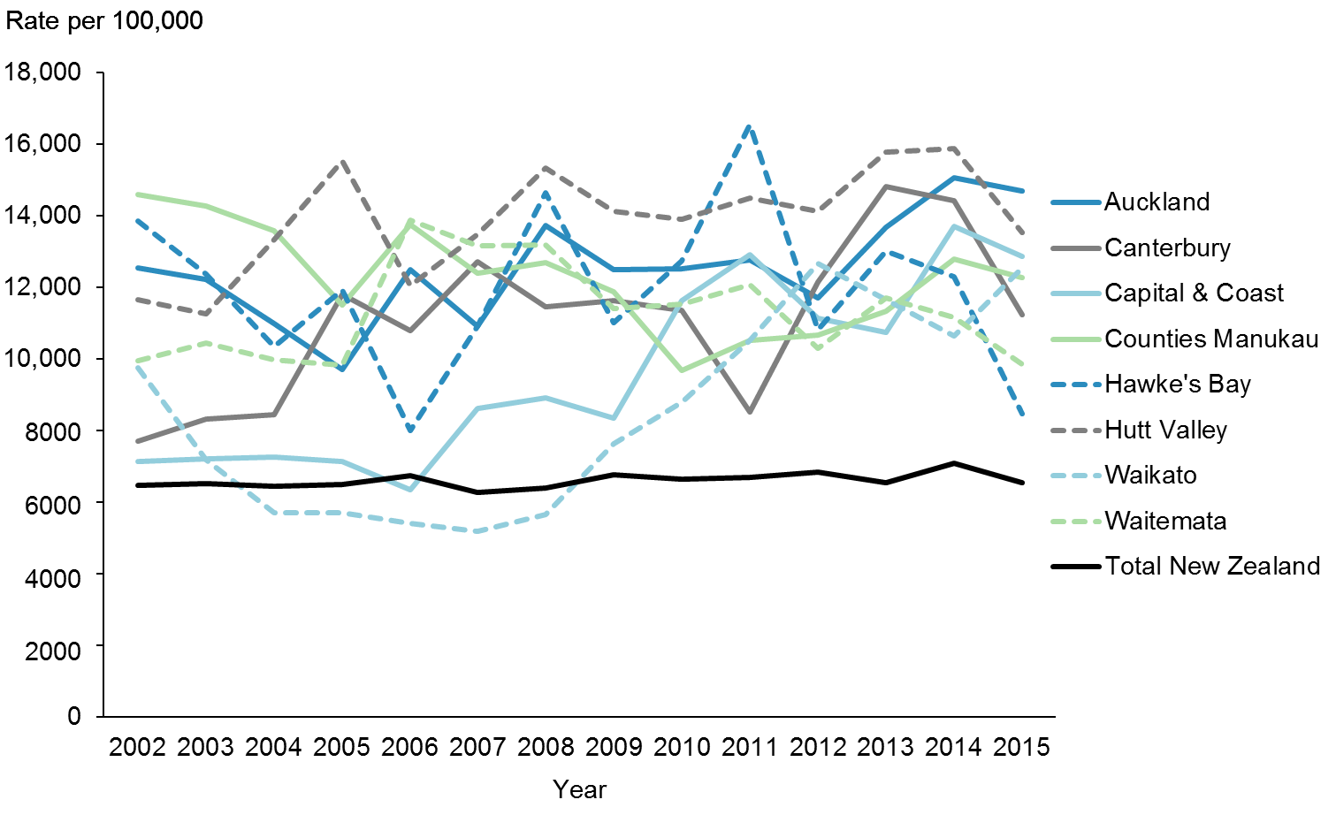
 | 2002 | 2003 | 2004 | 2005 | 2006 | 2007 | 2008 | 2009 | 2010 | 2011 | 2012 | 2013 | 2014 | 2015
Auckland | 12,542 | 12,233 | 10,997 | 9695 | 12,500 | 10,921 | 13,725 | 12,509 | 12,525 | 12,768 | 11,711 | 13,679 | 15,069 | 14,705
Canterbury | 7717 | 8333 | 8447 | 11,810 | 10,804 | 12,712 | 11,452 | 11,628 | 11,357 | 8521 | 12,153 | 14,812 | 14,429 | 11,241
Capital & Coast | 7137 | 7210 | 7273 | 7130 | 6346 | 8612 | 8905 | 8341 | 11,643 | 12,911 | 11,137 | 10,754 | 13,700 | 12,878
Counties Manukau | 14,590 | 14,286 | 13,580 | 11,521 | 13,769 | 12,392 | 12,696 | 11,892 | 9688 | 10,534 | 10,674 | 11,349 | 12,804 | 12,278
Hawke's Bay | 13,846 | 12,364 | 10,357 | 11,930 | 8000 | 10,909 | 14,655 | 11,017 | 12,742 | 16,557 | 10,806 | 13,016 | 12,308 | 8462
Hutt Valley | 11,667 | 11,273 | 13,333 | 15,526 | 12,051 | 13,475 | 15,328 | 14,141 | 13,906 | 14,496 | 14,141 | 15,780 | 15,888 | 13,524
Waikato | 9747 | 7179 | 5696 | 5696 | 5412 | 5181 | 5663 | 7640 | 8791 | 10,521 | 12,673 | 11,667 | 10,656 | 12,540
Waitemata | 9949 | 10,437 | 9977 | 9822 | 13,872 | 13,177 | 13,187 | 11,410 | 11,535 | 12,082 | 10,302 | 11,718 | 11,171 | 9853
Total New Zealand | 6475 | 6532 | 6452 | 6488 | 6753 | 6276 | 6394 | 6756 | 6656 | 6681 | 6852 | 6541 | 7096 | 6537

Figure 1b shows the ASH rates between 2002 and 2015 by priority DHBs. Seven of the eight priority DHBs showed a decreased in 2014 and 2015 except for Waikato DHB. Hawke’s Bay showed the biggest reduction over the same period.

Figure 1c: ASH rates per 100,000 (45–64-year-olds), Pacific peoples population and total New Zealand population, 2002–2015
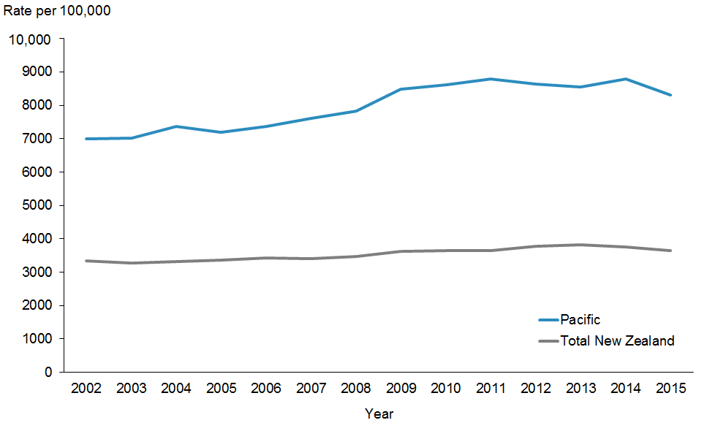
 | 2002 | 2003 | 2004 | 2005 | 2006 | 2007 | 2008 | 2009 | 2010 | 2011 | 2012 | 2013 | 2014 | 2015
Pacific | 7002 | 7006 | 7364 | 7182 | 7373 | 7600 | 7837 | 8486 | 8613 | 8786 | 8626 | 8552 | 8796 | 8318
Total New Zealand | 3340 | 3268 | 3314 | 3358 | 3429 | 3404 | 3481 | 3623 | 3640 | 3636 | 3772 | 3818 | 3764 | 3655

Figure 1c presents ASH rates between 2002 and 2015 for Pacific and Total New Zealand adults (45–64-year-olds). ASH rates have been increasing for both populations and peaked in 2014.

Figure 1d: ASH rates per 100,000 (45–64-year-olds), Pacific peoples, by priority district health boards (DHBs), 2002–2015
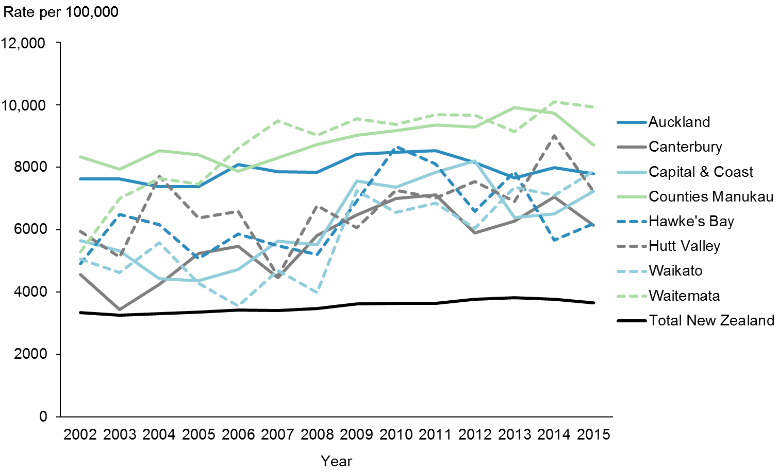
 | 2002 | 2003 | 2004 | 2005 | 2006 | 2007 | 2008 | 2009 | 2010 | 2011 | 2012 | 2013 | 2014 | 2015
Auckland | 7630 | 7623 | 7381 | 7372 | 8082 | 7862 | 7841 | 8413 | 8488 | 8537 | 8151 | 7660 | 7989 | 7786
Canterbury | 4561 | 3448 | 4250 | 5238 | 5461 | 4465 | 5818 | 6474 | 6995 | 7120 | 5897 | 6281 | 7044 | 6143
Capital & Coast | 5643 | 5317 | 4421 | 4355 | 4731 | 5623 | 5516 | 7560 | 7358 | 7845 | 8206 | 6383 | 6501 | 7230
Counties Manukau | 8336 | 7945 | 8534 | 8398 | 7869 | 8306 | 8730 | 9024 | 9180 | 9360 | 9283 | 9918 | 9727 | 8712
Hawke's Bay | 4912 | 6491 | 6154 | 5070 | 5857 | 5479 | 5200 | 6923 | 8659 | 8095 | 6591 | 7857 | 5657 | 6190
Hutt Valley | 5948 | 5125 | 7711 | 6374 | 6592 | 4516 | 6771 | 6061 | 7268 | 7014 | 7534 | 6898 | 9013 | 7225
Waikato | 5047 | 4630 | 5575 | 4274 | 3548 | 4688 | 3985 | 7246 | 6552 | 6842 | 6038 | 7360 | 7097 | 7868
Waitemata | 5289 | 7002 | 7648 | 7461 | 8615 | 9491 | 9031 | 9552 | 9366 | 9684 | 9666 | 9133 | 10092 | 9936
Total New Zealand | 3340 | 3268 | 3314 | 3358 | 3429 | 3404 | 3481 | 3623 | 3640 | 3636 | 3772 | 3818 | 3764 | 3655

Figure 1d shows the ASH rates between 2002 and 2015 by priority DHBs. In general as seen in the 0–4 age group, the 45–64 age group trend has been increasing, but in recent years the trend has changed with DHBs showing either a plateauing or decreasing trend.

Priority outcome 1 –
Systems and services meet the needs of Pacific peoples
The following presents a brief summary of performance indicator results in priority outcome 1 for this reporting period.
Within this priority outcome, some progress had been made in achieving equity or the set target in four indicators as at 30 June 2016:
1. Percentage of four-year-olds who received a Before School Check (B4SC) where Pacific children achieved 90.4 percent compared with 91.9 percent for the total population and a target set at 90.0 percent.
2. Percentage of children with body mass index (BMI) >99.4th percentile referred to a GP or specialist services where Pacific children achieved 95.8 percent compared with 89.0 percent for the total population and a target set at 95.0 percent.
3. Access rate to alcohol and drug services where Pacific peoples had 1.15 percent compared with 1.00 percent for the total population.
4. Percentage of eligible adults who had had cardiovascular risk assessments where Pacific peoples achieved 89.8 percent compared with 90.3 percent for the total population and a target of 90 percent.
For all the other indicators under priority outcome 1, Pacific rates or percentages did not achieve either equity or the target set.
Table 5: Priority outcome 1 performance indicators where equity is a concern for Pacific peoples, as at 30 June 2016
Indicator | Pacific | Total population | Target
Access rate to mental health services | 3.14% | 3.48% | No target
Newborn infants enrolled with a general practice by three months of age | 64.9% | 67.2% | 98%
Infants who received all Well Child/Tamariki Ora (WCTO) core contacts in their first year of life | 58.6% | 72.0% | 95%
Infants exclusively or fully breastfed at three months of age | 46.1% | 55.2% | 60%
Children enrolled in DHB-funded dental services | 75.6% | 81.1% | 95%
Children caries-free at age five | 35.3% | 58.6% | 65%
Mean rate of decayed, missing, or filled teeth (DMFT) for children at school year eight | 1.53 | 1.02 | No target
Smokers offered brief advice and support to quit in primary health care | 85.7% | 86.0% | 90%
Prevalence of children aged 2–14 years who are obese | 29.7% | 10.8% | No target
Enrolled women aged 25–69 years who received a cervical smear in the past three years | 76.2% | 76.6% | 80%

Priority outcome 1 – Systems and services meet the needs of Pacific peoples
Action 1 | DHBs will implement the actions focused on Pacific peoples in Rising to the Challenge: The Mental Health and Addiction Service Development Plan 2012–2017 in order to build more responsive services for Pacific peoples who are severely affected by mental illness or addiction.

Action commentary
Rising to the Challenge: The Mental Health and Addiction Service Development Plan
2012–2017 was released in 2012 (Ministry of Health 2012a). This was further impetus for mental health and addiction services to increase national consistency in access, service quality and outcomes for people who use services, for their families and whānau, and for communities. It sets a service development pathway with clear actions to be achieved over the five-year period, to achieve the most effective outcomes for those who most need them and make the best use of public money.

Table 6: DHB ‘Rising to the Challenge’ actions delivered, as at 30 June 2016
DHB | Actions
Counties Manukau | Counties Manukau DHB developed and implemented a mental health first aid training package to increase mental health literacy on depression and drug and alcohol issues for Pacific communities. The DHB has mandatory cultural capability training for all its staff to ensure that staff are competent and comfortable to engage Pacific, Māori and other priority groups. It has been working with Pacific and Asian advisors to upgrade this programme.
Auckland | Auckland DHB continues with its mental health programme through Lotofale, which provides Pacific clients and their families with the best possible standards of cultural-clinical care and choices, ensuring their cultural needs are met. The addiction services are carried out via TUPU. TUPU is a mobile Pacific Island alcohol and other drug and gambling service which provides services across the Auckland region (covering the three Auckland DHBs).
Waitemata | Pacific Mental Health & Addictions Services (Takanga A Fohe) is responsible for the management and leadership of Waitemata DHB’s Pacific mental health and addictions services. These services are carried out via Malaga a le Pasifika (Pacific Islands Liaison Team) and TUPU. Both services have Pacific staff with cultural knowledge including clinical staff. In addition, there is Isa Lei, which is a Pacific Island community mental health service that provides cultural-clinical care coordination to Pacific mental health consumers and their families. The DHB aims to increase the focus of its mental health partnership with Whānau House on Whānau Ora. All clients that go through Pacific mental health services have six-monthly cardiovascular risk assessments.
Hutt Valley | Hutt Valley has been working hard to reduce their number of Did Not Attend (DNA). In the April 2015 to December 2015 period, Pacific DNAs dropped by 22 percent.
Capital & Coast | Capital & Coast DHB continues to lead the development of a new integrated mental health, addictions and intellectual disability service across three DHBs (Capital & Coast, Hutt Valley and Wairarapa). This will entail an acute adult model of care pathway with a focus on improving access for Pacific and Māori populations. Capital & Coast DHB also opened New Zealand’s first forensic inpatient mental health secure service providing services for up to 10 clients, who have offended and have complex mental health (or mental health and alcohol or drug) issues. Ratonga Rua Hospital provides a weekly GP and health nurse services. Weight gain due to medication is an issue.

Rising to the Challenge does not prioritise actions, nor does it prescribe the sequence in which they are to be implemented. Each year during the annual planning process, the Ministry of Health requires each DHB to articulate which of the Plan’s actions it proposes to implement. All eight priority DHBs are expected to deliver on actions under Rising to the Challenge that directly impact on Pacific peoples.

The three Auckland DHBs (Auckland, Waitemata and Counties Manukau) share some services for Pacific peoples. In the mental health service space, Auckland DHB has Lotofale, Waitemata DHB has Takanga a Fohe and Counties Manukau DHB has Faleola. All three DHBs share addiction services through TUPU. These DHBs are benefiting from this and it is evident in their performance in access rates for both mental health care and alcohol and drug services for Pacific peoples.

Indicator 1a | Improving the health status of Pacific people with severe mental illness through improved access rates

Performance: There is no target set for this indicator.

Note for Figures 2 to 5: The data is sourced from the Programme for the Integration of Mental Health Data (PRIMHD) data set, which is the national system for collecting information on services activity and outcomes data for individuals using mental health and addiction services. The Pacific peoples’ access rate is the percentage of total Pacific unique clients seen divided by the projected population from Statistics New Zealand. The total New Zealand access rate is the percentage of total unique clients seen (all ethnicities included) divided by the total projected population of New Zealand. Both rates include all age groups.

Figure 2: Access rate to DHB mental health services, Pacific peoples population and total New Zealand population, 2005/06–2014/15
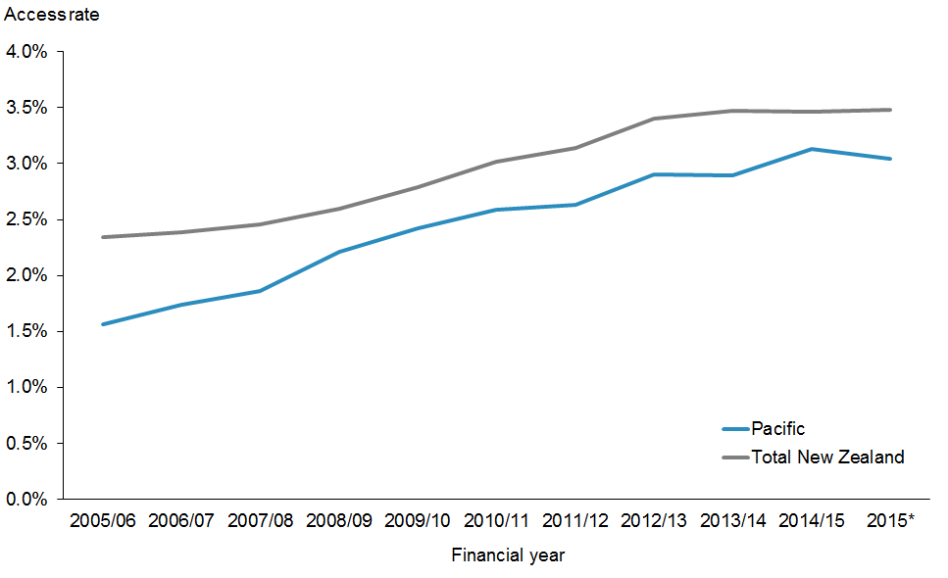
 | 2005/06 | 2006/07 | 2007/08 | 2008/09 | 2009/10 | 2010/11 | 2011/12 | 2012/13 | 2013/14 | 2014/15 | 2015*
Pacific | 1.56% | 1.74% | 1.86% | 2.21% | 2.42% | 2.59% | 2.63% | 2.90% | 2.89% | 3.13% | 3.04%
Total New Zealand | 2.34% | 2.39% | 2.46% | 2.60% | 2.79% | 3.02% | 3.14% | 3.40% | 3.47% | 3.46% | 3.48%
* Annual access rate.

Figure 2 shows that Pacific peoples’ access to mental health services has been improving over the years. The gap between Pacific peoples’ access and that of the total population is closing, although in the last measure it may be widening. Note though the last measure is an annual rate instead of the financial year rates that has been plotted in the past.

Figure 3: Access rate to DHB mental health services, Pacific peoples, by priority DHBs, 2005/06–2014/15
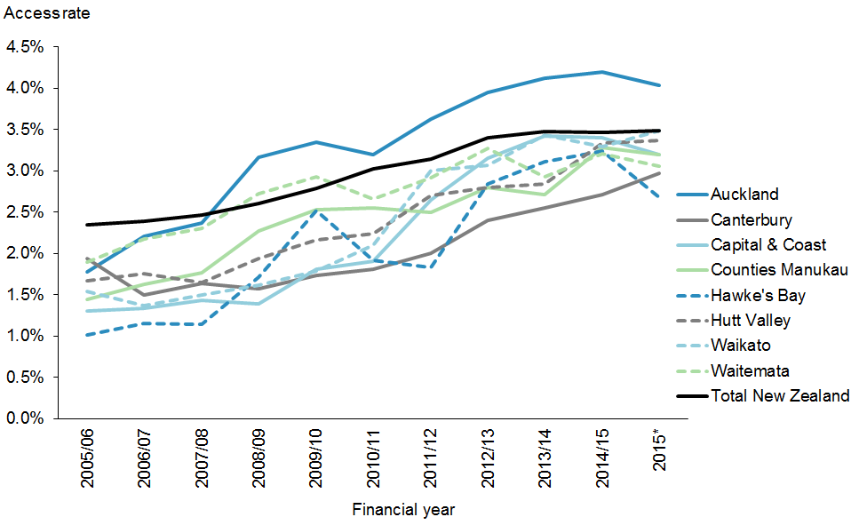
 | 2005/06 | 2006/07 | 2007/08 | 2008/09 | 2009/10 | 2010/11 | 2011/12 | 2012/13 | 2013/14 | 2014/15 | 2015*
Auckland | 1.78% | 2.20% | 2.37% | 3.16% | 3.35% | 3.19% | 3.62% | 3.95% | 4.12% | 4.20% | 4.03%
Canterbury | 1.94% | 1.50% | 1.64% | 1.57% | 1.73% | 1.81% | 2.00% | 2.40% | 2.55% | 2.71% | 2.97%
Capital & Coast | 1.30% | 1.33% | 1.43% | 1.39% | 1.81% | 1.90% | 2.65% | 3.15% | 3.42% | 3.40% | 3.19%
Counties Manukau | 1.44% | 1.62% | 1.76% | 2.27% | 2.53% | 2.55% | 2.50% | 2.80% | 2.71% | 3.28% | 3.19%
Hawke’s Bay | 1.01% | 1.15% | 1.14% | 1.71% | 2.52% | 1.92% | 1.83% | 2.84% | 3.11% | 3.24% | 2.68%
Hutt Valley | 1.67% | 1.75% | 1.65% | 1.94% | 2.16% | 2.24% | 2.70% | 2.80% | 2.84% | 3.33% | 3.37%
Waikato | 1.54% | 1.37% | 1.50% | 1.61% | 1.79% | 2.10% | 3.00% | 3.07% | 3.43% | 3.29% | 3.48%
Waitemata | 1.89% | 2.17% | 2.30% | 2.72% | 2.93% | 2.66% | 2.92% | 3.27% | 2.93% | 3.21% | 3.06%
Total New Zealand | 2.34% | 2.39% | 2.46% | 2.60% | 2.79% | 3.02% | 3.14% | 3.40% | 3.47% | 3.46% | 3.48%
* These are annual access rates.

Figure 3 shows the access rates to DHB mental health services for Pacific peoples in the eight priority DHBs. Most DHBs are making progress towards achieving equity. Auckland DHB access rates for Pacific peoples have consistently been higher than the other DHBs and that of the total New Zealand population since 2007/2008. Waikato DHB has now achieved equity for Pacific. Capital & Coast, Hutt Valley and Counties Manukau, are all less than 10 percent away from achieving equity with the total New Zealand population. Waitemata DHBs are not far. Hawke’s Bay and The three Auckland DHBs with high Pacific enrolment have TUPU which is a Pacific service. Capital & Coast DHB has Vaka O Le Pasifika, which is part of Te Korowai-Whāriki, the mental health service for Māori and Pacific peoples.

Indicator 1b | Improving the health status of Pacific people with alcohol and drug addiction through improved access rates to alcohol and drug services

Performance: There is no target set for this indicator.

Note: The data is sourced from the PRIMHD data set.

Figure 4: Access to DHB alcohol and drug services, Pacific peoples population and total New Zealand population, 2012/13–2014/15
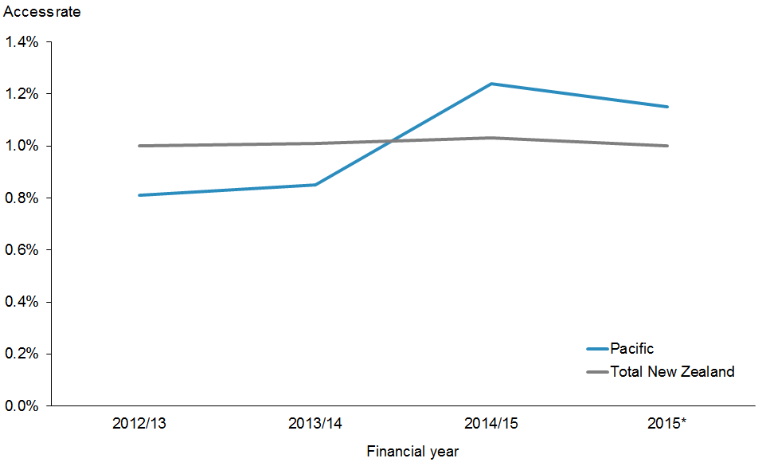
 | 2012/13 | 2013/14 | 2014/15 | 2015*
Pacific | 0.81% | 0.85% | 1.24% | 1.15%
Total New Zealand | 1.00% | 1.01% | 1.03% | 1.00%
* Annual access rate.

Figure 4 shows access to DHB alcohol and drug services for Pacific peoples and the total New Zealand population. Pacific peoples’ access to alcohol and drug services has been increasing steadily. It has now surpassed that of the total New Zealand population and had maintained this. The high access rates in the three Auckland DHBs plus Waikato DHB contribute to this, as they serve more than two-thirds of the total Pacific population (refer to Figure 5).

Figure 5: Access to DHB alcohol and drug services, Pacific peoples, by priority DHBs, 2012/13–2014/15
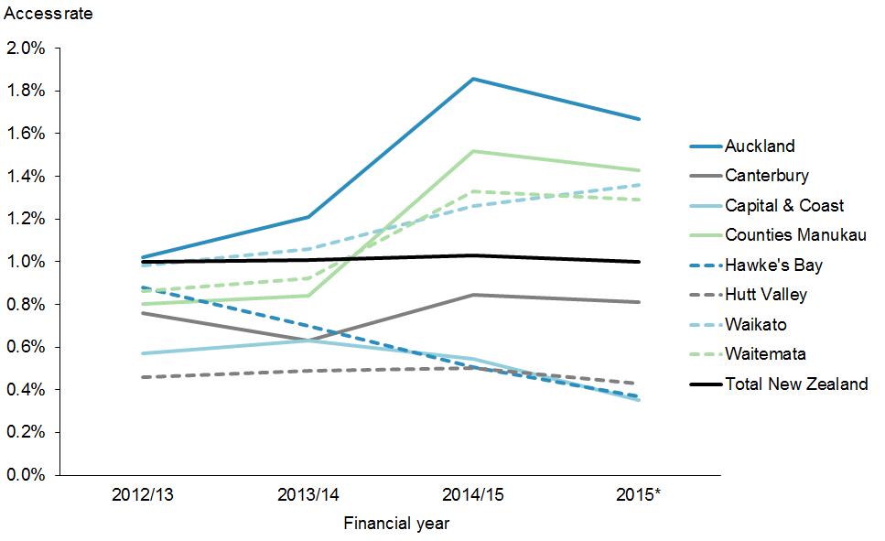
 | 2012/13 | 2013/14 | 2014/15 | 2015*
Auckland | 1.02% | 1.21% | 1.86% | 1.67%
Canterbury | 0.76% | 0.63% | 0.85% | 0.81%
Capital & Coast | 0.57% | 0.63% | 0.54% | 0.35%
Counties Manukau | 0.80% | 0.84% | 1.52% | 1.43%
Hawke's Bay | 0.88% | 0.70% | 0.51% | 0.37%
Hutt Valley | 0.46% | 0.49% | 0.50% | 0.43%
Waikato | 0.98% | 1.06% | 1.26% | 1.36%
Waitemata | 0.86% | 0.92% | 1.33% | 1.29%
Total New Zealand | 1.00% | 1.01% | 1.03% | 1.00%
* Annual access rate.

Figure 5 shows that Auckland, Counties Manukau, Waitemata and Waikato DHBs have improved access to alcohol and drug services among their Pacific populations. The access rates in these four DHBs have remained higher than the national access rate. The sharing of Pacific services via TUPU appears to improve access for Pacific clients and their families in the Auckland region.

Action 2 | Universal maternity and child health services will engage in a more timely manner with Pacific families.

Action commentary

Ministry of Health
In the six months from December 2015 to June 2016, the Ministry of Health has continued to deliver on activities in efforts to improve timely access to universal maternity and child health services for Pacific families. Achievements in this time period have included the following:
- The Ministry announced funding for DHBs in October 2015 aimed at improving the rate of enrolment in Well Child/Tamariki Ora (WCTO) programmes.
- The New Zealand maternity sector continues to improve maternity services. The National Maternity Monitoring Group Annual Report 2015, released in December 2015 (Ministry of Health 2015d), showed 25 percent of Pacific women were registered with a lead maternity carer in their first trimester compared with seventy percent of European or Other women. Overall during the whole pregnancy term, 65 percent of Pacific women were registered with a lead maternity carer compared with 90 percent of European or Other women.
- A new health target will be implemented from 1 July 2016 where ‘by December 2017, 95 percent of obese children identified in the Before School Check (B4SC) programme will be referred to a health professional for clinical assessment and family based nutrition, activity and lifestyle interventions’ (Ministry of Health 2016).
- The Ministry released the Electronic Oral Health Records (EOHR) Programme which will provide a national platform of information, processes and technology to support the needs of consumers and clinicians of DHB provided oral health services. This will enable oral health services to support New Zealanders to live well, stay well, and get well.

National Child Health Information Platform
Over the last two years, Midland Health Network (MHN) has been working with Orion and Waikato DHB to implement a national child health information platform (NCHIP). This is an information solution designed to ensure children receive preventative health services or ‘milestones’, such as immunisation, before school checks, and screening. It provides an executive level view of the child’s milestones which is available to general practice staff, Well Child providers, other providers and DHB staff. MHN provide a child health coordination centre to utilise the system to proactively follow-up and track children who fall behind their checks or who do not enrol in services. NCHIP is planned to roll out to the four northern DHBs.

The Northern Regional Child Health Steering Group is responsible for setting priorities in its annual plan for the four Northern DHBs (Counties Manukau, Auckland, Waitemata and Northland). This group is planning to establish and integrated enrolment system for the region.

Note: Priority outcome 1 indicators 2a–2g are from the WCTO Quality Improvement Framework. Data on these indicators is drawn from various sources. Targets for these indicators reflect national targets set by other monitoring frameworks and processes, including health targets, DHB non-financial performance monitoring and the Government’s Better Public Services targets. The targets are staged to reflect that improvements will be made over time. The final and new targets were then set to be achieved by June 2016. To support equity, the target for each indicator is the same across all ethnic groups, deprivation quintiles and DHB regions. The WCTO Quality Improvement Framework is reported six-monthly in March and September of each year.

Indicator 2a | Increased percentage of Pacific infants who are enrolled with a general practice by three months of age

Performance: The target was set at 98 percent to be achieved by June 2016.

Figure 6: Percentage of newborn infants enrolled with a general practice by three months of age, Pacific peoples population and total New Zealand population, 2013–2016
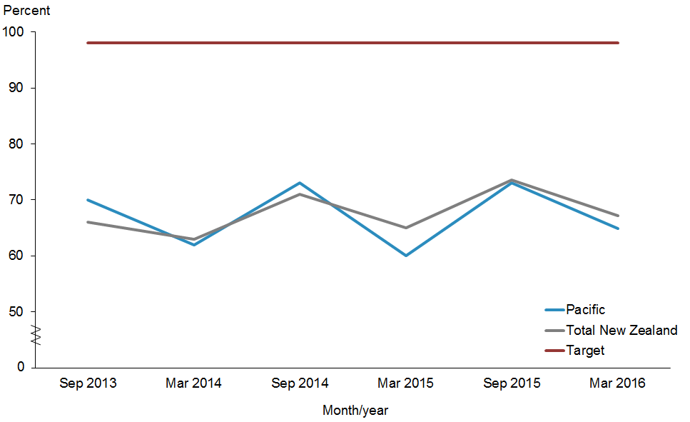
 | Sep 2013 | Mar 2014 | Sep 2014 | Mar 2015 | Sep 2015 | Mar 2016
Pacific | 70.0% | 62.0% | 73.0% | 60.0% | 73.1% | 64.9%
Total New Zealand | 66.0% | 63.0% | 71.0% | 65.0% | 73.5% | 67.2%
Target | 98.0% | 98.0% | 98.0% | 98.0% | 98.0% | 98.0%

Notes for Figures 6 and 7:
- Time period: births between 20 August 2015 and 19 November 2015.
- Numerator: enrolments of infants under three months of age with a general practice.
- Denominator: births reported to the National Immunisation Register.
- Rates greater than 100 percent for ethnic subgroups is likely due to variation in ethnicity reporting in different systems.
- Both Figures 6 and 7 show a pattern of decrease in the September quarters and increase in the March quarters. This pattern is a seasonal effect, due to reporting for newborn enrolments being recorded prior to the Christmas and New Year’s period, during which providers have two fewer weeks to process enrolments.

Figure 6 shows that the enrolment rate of infants under three months of age with a general practice for the Pacific population is very similar to the rate for the total New Zealand population in the same period. Pacific enrolment has improved slightly compared with March 2015.

Figure 7: Percentage of newborn infants enrolled with a general practice by three months of age, Pacific peoples, by priority DHBs, 2013–2016
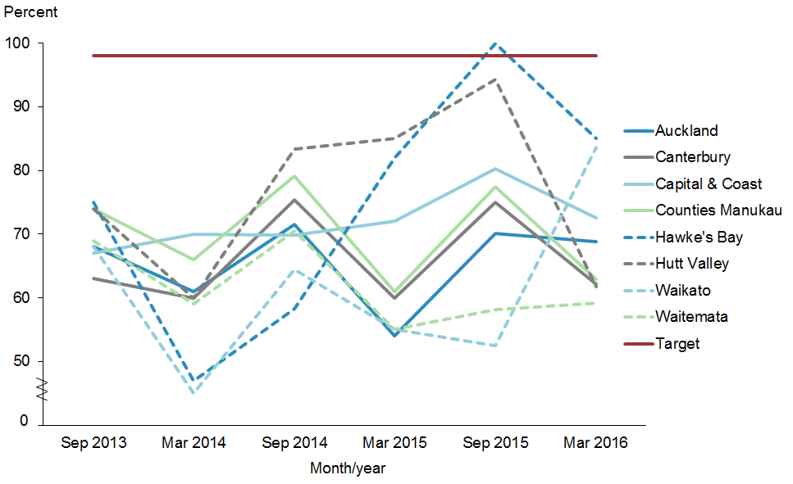
 | Sep 2013 | Mar 2014 | Sep 2014 | Mar 2015 | Sep 2015 | Mar 2016
Auckland | 68.0% | 61.0% | 71.5% | 54.0% | 70.1% | 68.9%
Canterbury | 63.0% | 60.0% | 75.4% | 60.0% | 75.0% | 62.1%
Capital & Coast | 67.0% | 70.0% | 69.8% | 72.0% | 80.3% | 72.6%
Counties Manukau | 74.0% | 66.0% | 79.1% | 61.0% | 77.5% | 62.9%
Hawke's Bay | 75.0% | 47.0% | 58.3% | 82.0% | 100.0% | 85.0%
Hutt Valley | 74.0% | 60.0% | 83.3% | 85.0% | 94.3% | 61.7%
Waikato | 68.0% | 45.0% | 64.4% | 55.0% | 52.5% | 83.7%
Waitemata | 69.0% | 59.0% | 70.5% | 55.0% | 58.2% | 59.2%
Target | 98.0% | 98.0% | 98.0% | 98.0% | 98.0% | 98.0%

Figure 7 shows that Hawke’s Bay DHB which achieved the target in the December progress has not achieved the target this time. Waikato is the only DHB that does not seem to be affected by seasonal effect for this progress report. It is possible that the pilot of NCHIP could be contributing to this mentioned above.

Indicator 2b | Increased percentage of Pacific infants who received all five WCTO core contracts in their first year of life

Performance: The target was set at 95 percent to be achieved by June 2016.

Figure 8: Percentage of infants who received all WCTO core contacts in their first year of life, Pacific peoples population and total New Zealand population, 2013–2016
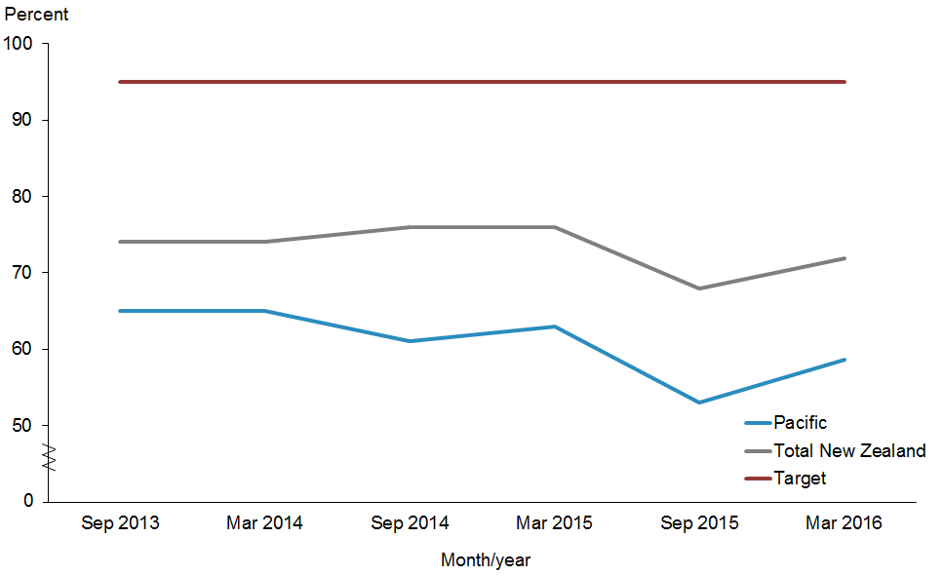
 | Sep 2013 | Mar 2014 | Sep 2014 | Mar 2015 | Sep 2015 | Mar 2016
Pacific peoples | 65.0% | 65.0% | 61.0% | 63.0% | 53.0% | 58.6%
Total New Zealand | 74.0% | 74.0% | 76.0% | 76.0% | 68.0% | 72.0%
Target | 95.0% | 95.0% | 95.0% | 95.0% | 95.0% | 95.0%

Notes for Figures 8 and 9:
- Time period: children reaching the age band for core contact 6 between July 2015 and December 2015.
- Hawke’s Bay DHB had fewer than 20 children in that population in September 2014.
- From this report onwards, the data source for this indicator includes reporting from all WCTO providers. Prior to this report, data presented for this indicator was sourced from Plunket alone. This means results for this indicator for the period January–June 2015 are not directly comparable with results from earlier periods.
- Numerator: number of infants where contact was able to be made by six weeks of age and who received all five contacts (source: WCTO National Health Index (NHI) data set).
- Denominator: number of infants where contact was able to be made by six weeks of age who reached the age band for core contact 6 (13 months, 4 weeks, 1 day) (source: WCTO NHI data set).

Figure 8 shows the percentages of infants who received all WCTO core contacts in their first year of life for the Pacific population and the total New Zealand population. Both percentages dropped in the December 2015 progress report but have improved. However, the gap between Pacific peoples and the total New Zealand population remains. Currently we are only reaching 72 percent of all infants and only around 59 percent (58.6%) of Pacific infants.

Figure 9: Percentage of infants who received all WCTO core contacts in their first year of life, Pacific peoples, by priority DHBs, 2013–2016
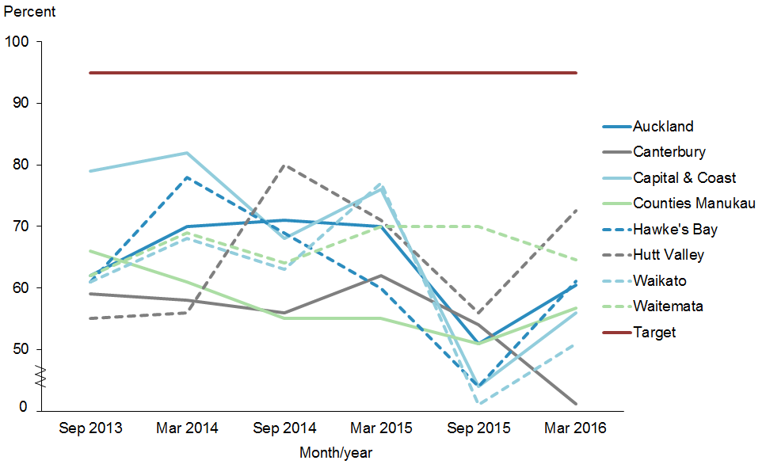
 | Sep 2013 | Mar 2014 | Sep 2014 | Mar 2015 | Sep 2015 | Mar 2016
Auckland | 62.0% | 70.0% | 71.0% | 70.0% | 51.0% | 60.5%
Canterbury | 59.0% | 58.0% | 56.0% | 62.0% | 54.0% | 41.1%
Capital & Coast | 79.0% | 82.0% | 68.0% | 76.0% | 44.0% | 55.9%
Counties Manukau | 66.0% | 61.0% | 55.0% | 55.0% | 51.0% | 56.7%
Hawke's Bay | 61.0% | 78.0% | - | 60.0% | 44.0% | 61.1%
Hutt Valley | 55.0% | 56.0% | 80.0% | 71.0% | 56.0% | 72.5%
Waikato | 61.0% | 68.0% | 63.0% | 77.0% | 41.0% | 50.9%
Waitemata | 62.0% | 69.0% | 64.0% | 70.0% | 70.0% | 64.6%
Target | 95.0% | 95.0% | 95.0% | 95.0% | 95.0% | 95.0%

Figure 9 shows the percentages of infants who received all WCTO core contacts in their first year of life for Pacific peoples in the eight priority DHBs. Since the December 2015 update, Waitemata and Canterbury DHBs continues to be affected by the change of data source noted above where the rest of the DHBs have improved. There is no Pacific specific WCTO provider at Waitemata DHB, although a Pacific nurse is often used by Pacific mothers at Te Puna Hauora. Hutt Valley DHB leads this group. The WCTO service has recently been reviewed and providers have new targets set for 2016/2017.

Indicator 2c | Increased percentage of Pacific children who receive B4SC

Performance: The target of this indicator was set at 90 percent to be achieved by June 2016.

Figure 10: Percentage of four-year-olds who received a B4SC, Pacific peoples population and total New Zealand population, 2013–2016
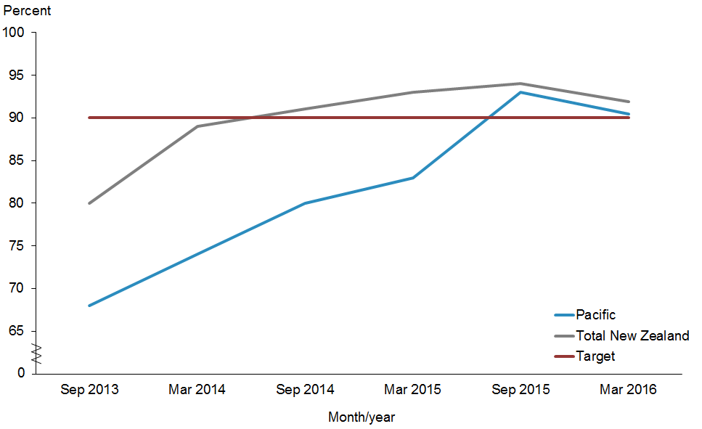
 | Sep 2013 | Mar 2014 | Sep 2014 | Mar 2015 | Sep 2015 | Mar 2016
Pacific | 68.0% | 74.0% | 80.0% | 83.0% | 93.0% | 90.4%
Total New Zealand | 80.0% | 89.0% | 91.0% | 93.0% | 94.0% | 91.9%
Target | 90.0% | 90.0% | 90.0% | 90.0% | 90.0% | 90.0%

Notes for Figures 10 and 11:
- Time period: checks between July 2015 to December 2015.
- DHB is DHB of service.
- Numerator: number of completed B4SCs (source: B4 School Check).
- Denominator: number of children eligible for a B4SC (source: PHO).
- Rates of greater than 100 percent for ethnic subgroups is likely due to variation in ethnicity reporting in different systems.

Figure 10 shows that the 90 percent target was maintained for Pacific children and the total New Zealand population.

Figure 11: Percentage of four-year-olds who received a B4SC, Pacific peoples, by priority DHBs, 2013–2016
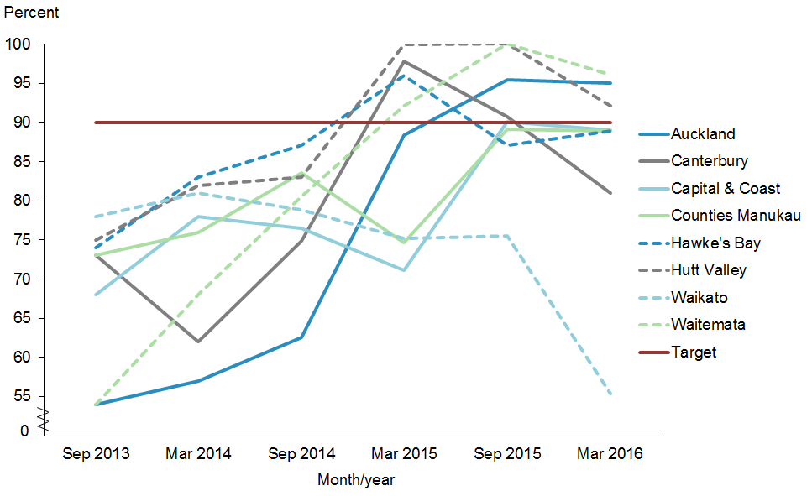
 | Sep 2013 | Mar 2014 | Sep 2014 | Mar 2015 | Sep 2015 | Mar 2016
Auckland | 54.0% | 57.0% | 62.6% | 88.4% | 95.4% | 95.0%
Canterbury | 73.0% | 62.0% | 74.9% | 97.8% | 90.7% | 81.0%
Capital & Coast | 68.0% | 78.0% | 76.5% | 71.1% | 90.1% | 89.1%
Counties Manukau | 73.0% | 76.0% | 83.6% | 74.7% | 89.1% | 88.9%
Hawke's Bay | 74.0% | 83.0% | 87.1% | 96.0% | 87.1% | 88.9%
Hutt Valley | 75.0% | 82.0% | 83.0% | 100.0% | 100.0% | 92.2%
Waikato | 78.0% | 81.0% | 78.8% | 75.2% | 75.5% | 55.3%
Waitemata | 54.0% | 68.0% | 80.6% | 92.2% | 100.0% | 96.1%
Target | 90.0% | 90.0% | 90.0% | 90.0% | 90.0% | 90.0%

Figure 11 shows that three out of the eight priority DHBs have achieved the target of 90 percent. These were Auckland, Hutt Valley, and Waitemata DHBs. Capital & Coast (89.1%), Counties Manukau (88.9%) and Hawke’s Bay (88.9%) DHBs are close. Of concern are Waikato and Canterbury DHBs.

Indicator 2d | Increased percentage of Pacific infants who are exclusively or fully breastfed at three months of age

Performance: The target was set at 60 percent to be achieved by June 2016.

Figure 12: Percentage of infants exclusively or fully breastfed at three months of age, Pacific peoples population and total New Zealand population, 2013–2016
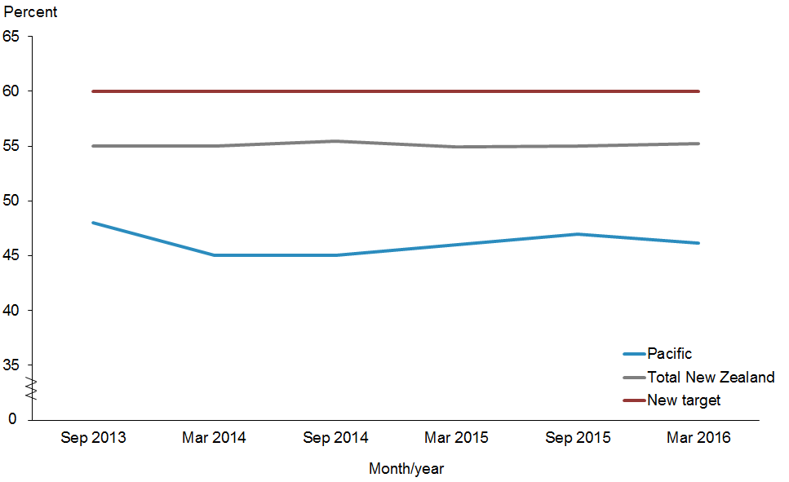
 | Sep 2013 | Mar 2014 | Sep 2014 | Mar 2015 | Sep 2015 | Mar 2016
Pacific | 48.0% | 45.0% | 45.0% | 46.0% | 47.0% | 46.1%
Total New Zealand | 55.0% | 55.0% | 55.5% | 54.9% | 55.0% | 55.2%
Target | 60.0% | 60.0% | 60.0% | 60.0% | 60.0% | 60.0%

Notes for Figures 12 and 13:
- Time period: infants aged three months between 1 July 2015 t0 31 December 2015.
- Results for this indicator for this period are not directly comparable with results from earlier periods because of the inclusion of data from Tamariki Ora providers in addition to Plunket data.
- Numerator: breastfeeding at three months of age = exclusive or fully (source: WCTO NHI data set).
- Denominator: breastfeeding at three months of age = not null (source: WCTO NHI data set).

Figure 12 shows there has not been much improvement in this indicator since the December 2015 progress report. Of concern is the recent decrease in Pacific percentage which has further increased the gap between the two populations. In 2016/17 the Ministry of Health will be updating the National Breastfeeding Strategy to improve rates across the entire population and reduce inequity gaps.

Figure 13: Percentage of infants exclusively or fully breastfed at three months of age, Pacific peoples, by priority DHBs, 2013–2016
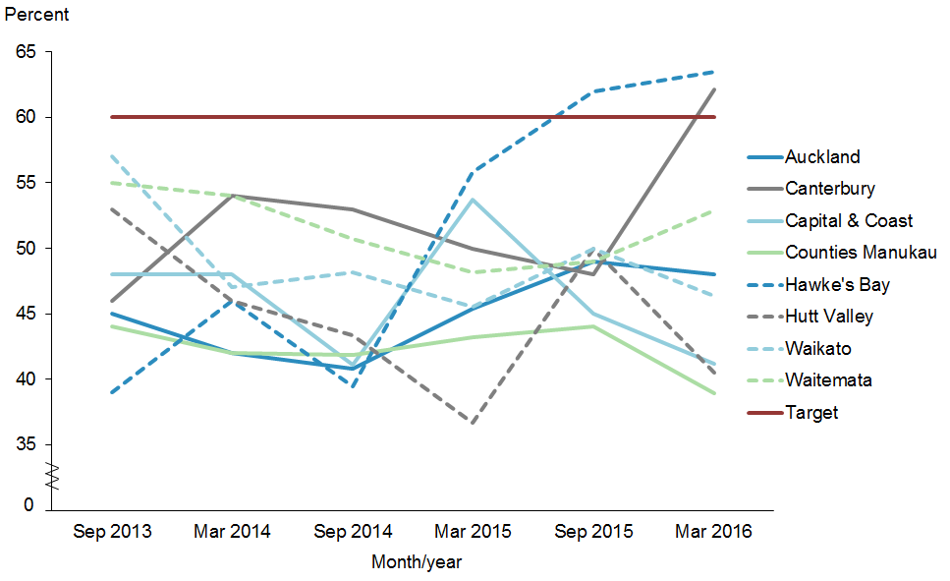
 | Sep 2013 | Mar 2014 | Sep 2014 | Mar 2015 | Sep 2015 | Mar 2016
Auckland | 45.0% | 42.0% | 40.8% | 45.4% | 49.0% | 48.0%
Canterbury | 46.0% | 54.0% | 52.9% | 50.0% | 48.0% | 62.1%
Capital & Coast | 48.0% | 48.0% | 41.1% | 53.7% | 45.0% | 41.2%
Counties Manukau | 44.0% | 42.0% | 41.8% | 43.2% | 44.0% | 39.0%
Hawke's Bay | 39.0% | 46.0% | 39.5% | 55.8% | 62.0% | 63.5%
Hutt Valley | 53.0% | 46.0% | 43.4% | 36.7% | 50.0% | 40.5%
Waikato | 57.0% | 47.0% | 48.1% | 45.5% | 50.0% | 46.3%
Waitemata | 55.0% | 54.0% | 50.7% | 48.2% | 49.0% | 52.9%
Target | 60.0% | 60.0% | 60.0% | 60.0% | 60.0% | 60.0%

Figure 13 shows the percentages of infants exclusively or fully breastfed at three months of age for Pacific peoples in the eight priority DHBs. Hawke’s Bay and Canterbury achieved the target of 60 percent. Waitemata DHB has improved since the last update. The recently published WCTO Quality Improvement Framework report showed that women who live in high-deprivation areas were least likely to breast feed (Ministry of Health 2016).

Indicator 2e | Increased percentage of Pacific children with BMI >99.4th percentile are referred to GP or specialist services

Performance: The target was set at 95 percent to be achieved by June 2016. For this progress report the definition has changed to be in line with the new child obesity Health target starting on 1 July 2016. Instead of screening at the 99.4th percentile, it is now at the 98th percentile. The target remains as referring 95 percent of these children to GPs or specialist services. Please refer to notes below.

Figure 14: Percentage of children with BMI >99.4th percentile referred to a GP or specialist services, Pacific peoples population and total New Zealand population,
2013–2016
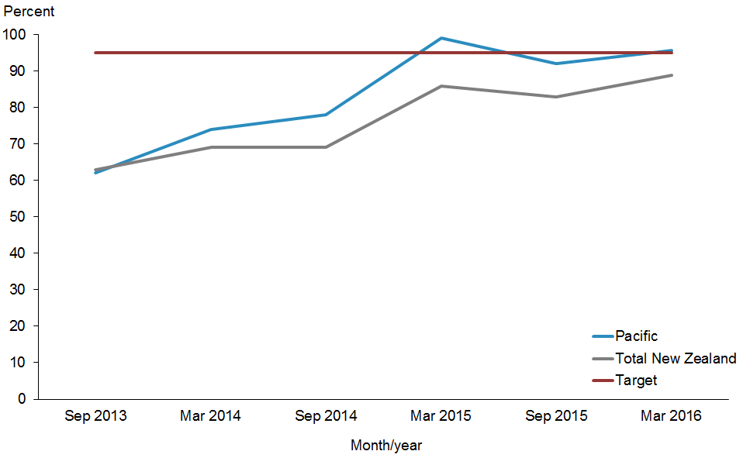
 | Sep 2013 | Mar 2014 | Sep 2014 | Mar 2015 | Sep 2015 | Mar 2016
Pacific | 62.0% | 74.0% | 78.0% | 99.0% | 92.0% | 95.8%
Total New Zealand | 63.0% | 69.0% | 69.0% | 86.0% | 83.0% | 89.0%
Target | 95.0% | 95.0% | 95.0% | 95.0% | 95.0% | 95.0%

Notes for Figures 14 and 15:
- Time period: children receiving a B4SC between 1 July 2015 and 31 December 2015.
- Hawke’s Bay DHB had fewer than 20 children in that population in September 2014.
- Waikato DHB is now reporting on this target.
- Numerator: number of children with a BMI greater than the 99.4th percentile referred (source: B4 School Check).
- Denominator: number of children with a BMI greater than the 99.4th percentile (excluding those already under care) (source: B4 School Check).
- Caution should be used with interpreting these graphs because of the small numbers involved.
- The data for this progress report cannot be compared with previous data due to the change in definition.

Figure 14 shows that the target of referring kids that were identified as extremely obese at the 99.4th percentile was achieved for Pacific peoples. Note this target will change in the future to the new Ministry of Health childhood obesity target that will be implemented from 1 July 2016, announced in the ‘Childhood Obesity Plan’ (refer to the ‘Action Commentary’ section above).

Figure 15: Percentage of children with BMI >99.4th percentile referred to a GP or specialist services, Pacific peoples, by priority DHBs, 2013–2016
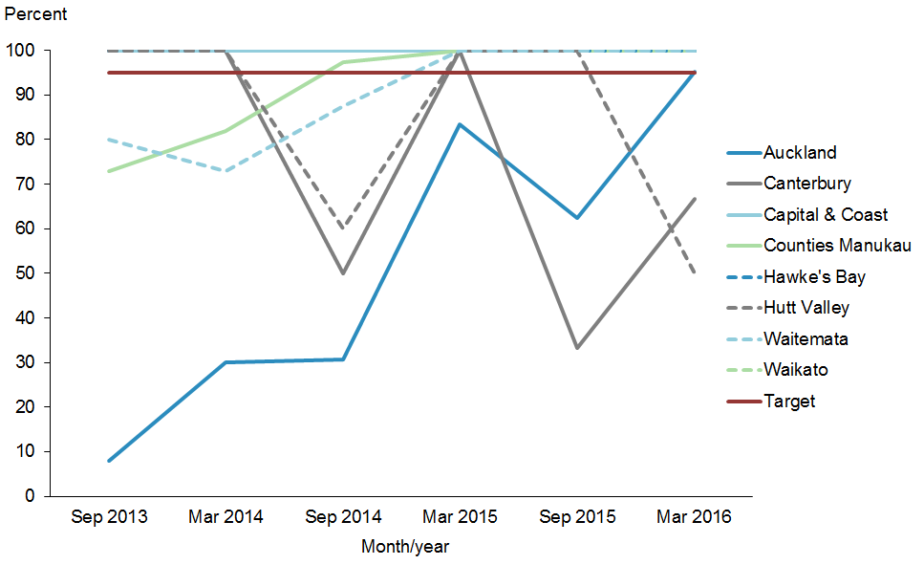
 | Sep 2013 | Mar 2014 | Sep 2014 | Mar 2015 | Sep 2015 | Mar 2016
Auckland | 8.0% | 30.0% | 30.8% | 83.3% | 62.5% | 95.2%
Canterbury | 100.0% | 100.0% | 50.0% | 100.0% | 33.3% | 66.7%
Capital & Coast | 100.0% | 100.0% | 100.0% | 100.0% | 100.0% | 100.0%
Counties Manukau | 73.0% | 82.0% | 97.4% | 100.0% | 100.0% | 100.0%
Hawke's Bay | 100.0% | 100.0% | - | 100.0% | 100.0% | 100.0%
Hutt Valley | 100.0% | 100.0% | 60.0% | 100.0% | 100.0% | 50.0%
Waikato | 80.0% | 73.0% | 87.5% | 100.0% | 100.0% | 100.0%
Waitemata | - | - | - | - | - | 100.0%
Target | 95.0% | 95.0% | 95.0% | 95.0% | 95.0% | 95.0%

Note: Data was unavailable for the September 2014 quarter for Hawke’s Bay DHB because there were no reported Pacific children with BMI >99.4th percentile in their populations in those time periods.

Figure 15 six out of the eight priority DHBs for Pacific peoples have achieved this target.

Indicator 2f | Increased percentage of Pacific children in preschool who are enrolled with the Community Oral Health Service

Performance: The target was of 95 percent to be achieved by June 2016.

Figure 16: Percentage of children under five years old enrolled in the Community Oral Health Service, Pacific peoples population and total New Zealand population, 2007–2015
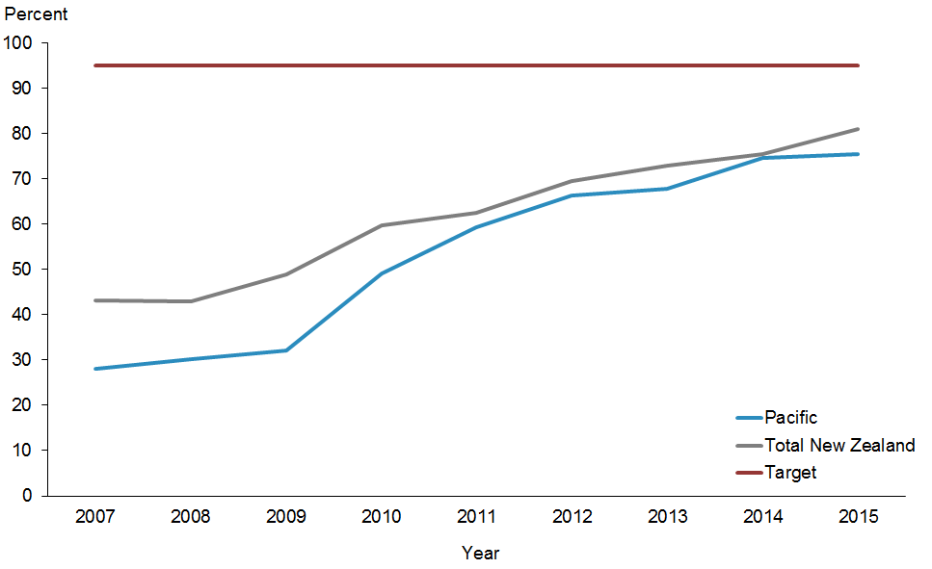
 | 2007 | 2008 | 2009 | 2010 | 2011 | 2012 | 2013 | 2014 | 2015
Pacific | 28.1% | 30.2% | 32.2% | 49.1% | 59.4% | 66.3% | 67.8% | 74.7% | 75.6%
Total New Zealand | 43.2% | 43.0% | 48.9% | 59.8% | 62.6% | 69.5% | 72.9% | 75.6% | 81.1%
Target | 95.0% | 95.0% | 95.0% | 95.0% | 95.0% | 95.0% | 95.0% | 95.0% | 95.0%

Notes for Figures 16 and 17:
- Time period: 2015.
- Canterbury DHB did not report data by ethnicity for this indicator prior to 2010. Fewer children were examined in Canterbury in 2014 than in 2013 due to the unavailability of mobile dental units during school term 2. Hawke’s Bay DHB reported no data by ethnicity for the 2007 and 2011 year and Waikato DHB does not report data by ethnicity for this indicator.
- Numerator: number of children aged under five years enrolled with the Community Oral Health Service (source: DHBs reporting).
- Denominator: number of children aged under five years (source: Statistics New Zealand population projections based on Census 2013).

Figure 16 shows an improvement in the enrolment of Pacific under five children in Community Oral Health Services for 2015, but the gap has grown compared with 2014.

Figure 17: Percentage of children under five years old enrolled in the Community Oral Health Service, Pacific peoples, by priority DHBs, 2007–2015
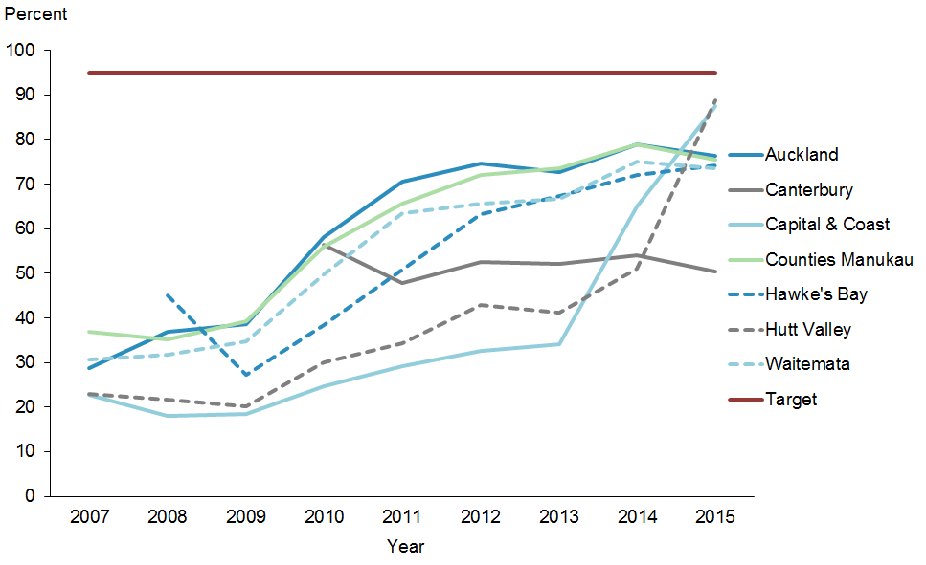
 | 2007 | 2008 | 2009 | 2010 | 2011 | 2012 | 2013 | 2014 | 2015
Auckland | 28.6% | 36.8% | 38.6% | 58.2% | 70.5% | 74.6% | 72.6% | 79.0% | 76.4%
Canterbury | - | - | - | 56.4% | 47.8% | 52.6% | 52.1% | 54.0% | 50.5%
Capital & Coast | 22.7% | 17.9% | 18.4% | 24.6% | 29.2% | 32.7% | 34.2% | 65.0% | 87.4%
Counties Manukau | 36.9% | 35.3% | 39.3% | 56.0% | 65.6% | 72.1% | 73.5% | 79.0% | 75.5%
Hawke's Bay | - | 45.1% | 27.1% | 38.3% | - | 63.3% | 67.4% | 72.0% | 74.2%
Hutt Valley | 22.9% | 21.6% | 20.1% | 30.0% | 34.4% | 42.8% | 41.1% | 51.0% | 88.8%
Waitemata | 30.8% | 31.8% | 34.7% | 49.8% | 63.5% | 65.6% | 66.6% | 75.0% | 73.6%
Target | 95.0% | 95.0% | 95.0% | 95.0% | 95.0% | 95.0% | 95.0% | 95.0% | 95.0%

Figure 17 shows a general improvement in the enrolment of Pacific under five children in Community Oral Health Services in most of the priority DHBs. Hutt Valley and Capital & Coast DHBs are the two that are leading. Both DHBs utilise the national newborn enrolment service to improve enrolment for pre-schoolers. There are early interventions through Kohanga Reo and Pacific Language nests.

Indicator 2g | Increased number of Pacific children caries-free at age five, and rates of decayed, missing, or filled teeth (DMFT) at school year eight at least equivalent to the total population

Performance: The target of this indicator was set at 65 percent to be achieved by June 2016.

Figure 18: Percentage of children caries-free at age five, Pacific peoples population and total New Zealand population, 2007–2014
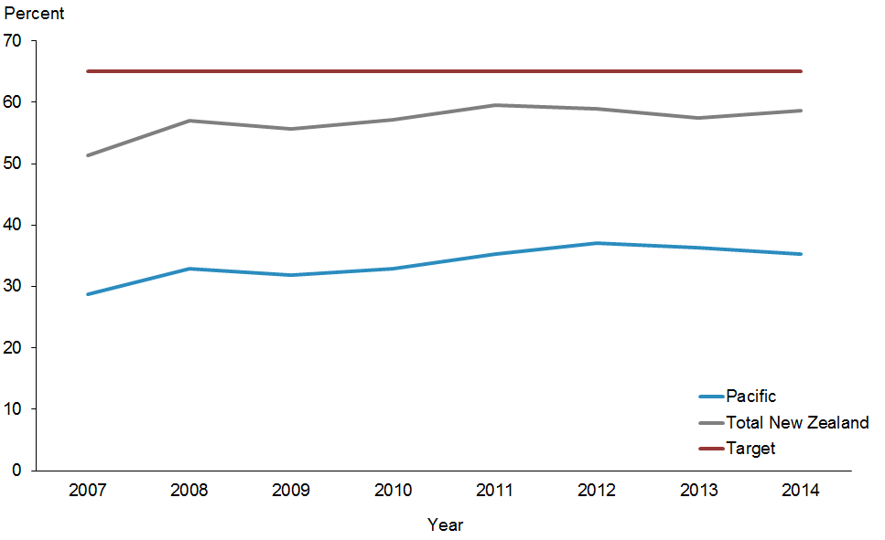
 | 2007 | 2008 | 2009 | 2010 | 2011 | 2012 | 2013 | 2014
Pacific | 28.8% | 32.8% | 31.9% | 32.8% | 35.3% | 37.0% | 36.3% | 35.3%
Total New Zealand | 51.4% | 57.0% | 55.6% | 57.2% | 59.6% | 58.9% | 57.5% | 58.6%
Target | 65.0% | 65.0% | 65.0% | 65.0% | 65.0% | 65.0% | 65.0% | 65.0%

Notes for Figures 18 and 19:
- Time period: children aged five examined between 1 January 2014 and 31 December 2014.
- Numerator: number of five-year-old children caries-free (source: DHB reporting).
- Denominator: number of five-year-old children examined by the Community Oral Health Service with oral health services (source: DHB reporting).

Figure 18 shows no change from the December 2015 Progress Report.

Figure 19: Percentage of children caries-free at age five, Pacific peoples, by priority DHBs, 2007–2014
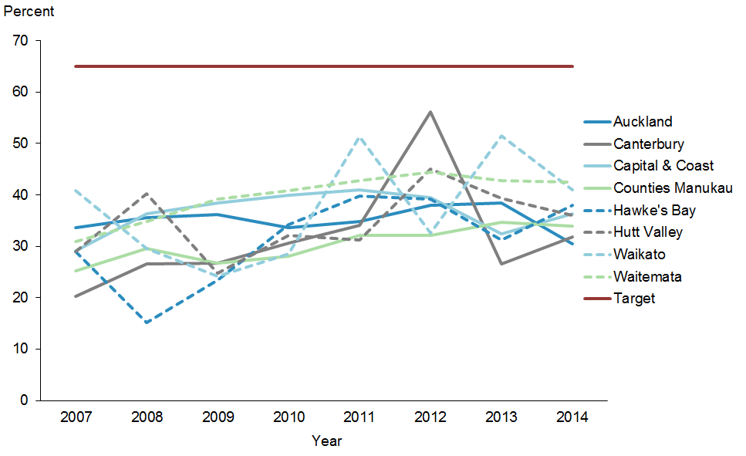
 | 2007 | 2008 | 2009 | 2010 | 2011 | 2012 | 2013 | 2014
Auckland | 33.6% | 35.6% | 36.2% | 33.6% | 34.8% | 38.0% | 38.4% | 30.5%
Canterbury | 20.3% | 26.6% | 26.8% | 30.7% | 34.1% | 56.1% | 26.6% | 31.8%
Capital & Coast | 29.1% | 36.3% | 38.5% | 39.9% | 41.0% | 39.6% | 32.4% | 36.4%
Counties Manukau | 25.2% | 29.6% | 26.7% | 28.1% | 32.2% | 32.1% | 34.7% | 34.0%
Hawke's Bay | 29.0% | 15.1% | 23.4% | 34.2% | 39.8% | 39.2% | 31.2% | 38.0%
Hutt Valley | 29.0% | 40.2% | 24.7% | 32.2% | 31.2% | 45.0% | 39.4% | 36.1%
Waikato | 40.9% | 29.6% | 24.1% | 28.6% | 51.3% | 32.6% | 51.5% | 40.9%
Waitemata | 30.9% | 34.8% | 39.1% | 40.8% | 42.8% | 44.4% | 42.8% | 42.5%
Target | 65.0% | 65.0% | 65.0% | 65.0% | 65.0% | 65.0% | 65.0% | 65.0%

Figure 19 shows no change from the December 2015 Progress Report.

Figure 20: Mean rate of DMFT at school year eight, Pacific peoples population and total New Zealand population, 2007–2014
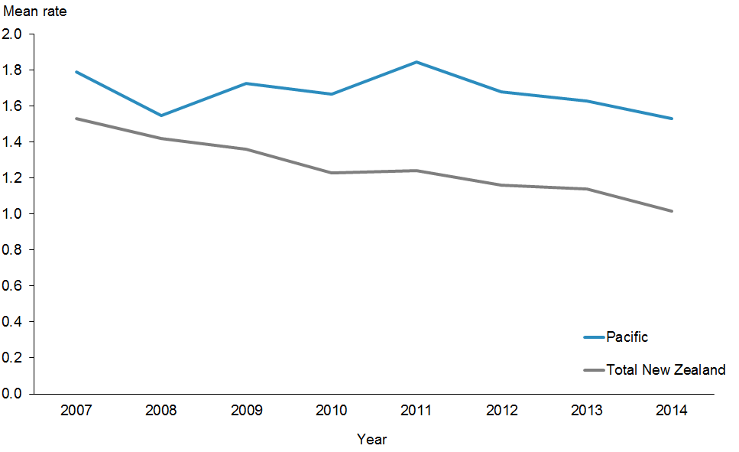
 | 2007 | 2008 | 2009 | 2010 | 2011 | 2012 | 2013 | 2014
Pacific | 1.79 | 1.55 | 1.73 | 1.67 | 1.85 | 1.68 | 1.63 | 1.53
Total New Zealand | 1.53 | 1.42 | 1.36 | 1.23 | 1.24 | 1.16 | 1.14 | 1.02

Note: The latest data for this indicator is from 2014. There is no set national target.

Figure 20 shows no change from the December 2015 Progress Report.

Figure 21: Mean rate of DMFT at school year eight, Pacific peoples, by priority DHBs, 2007–2014
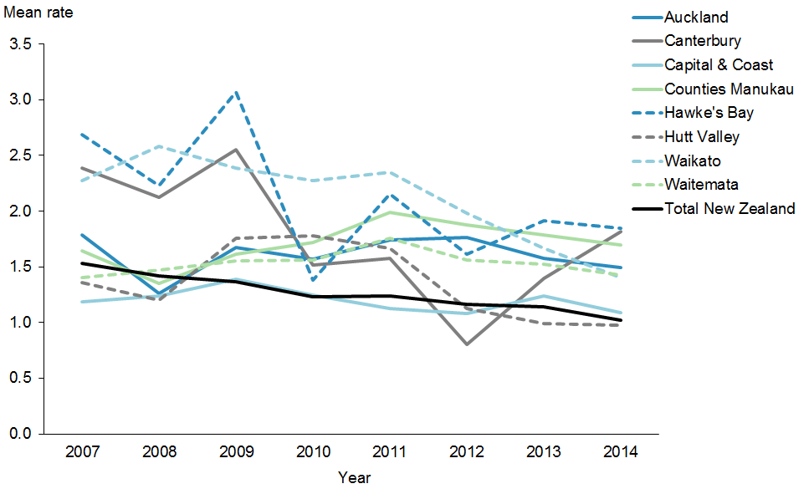
 | 2007 | 2008 | 2009 | 2010 | 2011 | 2012 | 2013 | 2014
Auckland | 1.79 | 1.26 | 1.67 | 1.57 | 1.74 | 1.76 | 1.57 | 1.49
Canterbury | 2.38 | 2.12 | 2.55 | 1.52 | 1.57 | 0.81 | 1.39 | 1.82
Capital & Coast | 1.19 | 1.24 | 1.39 | 1.25 | 1.13 | 1.08 | 1.24 | 1.09
Counties Manukau | 1.65 | 1.35 | 1.61 | 1.72 | 1.99 | 1.88 | 1.79 | 1.69
Hawke's Bay | 2.69 | 2.23 | 3.07 | 1.38 | 2.16 | 1.61 | 1.92 | 1.85
Hutt Valley | 1.36 | 1.20 | 1.76 | 1.78 | 1.67 | 1.12 | 0.99 | 0.98
Waikato | 2.27 | 2.58 | 2.38 | 2.27 | 2.35 | 1.98 | 1.66 | 1.40
Waitemata | 1.40 | 1.47 | 1.55 | 1.56 | 1.76 | 1.56 | 1.52 | 1.43
Target | 1.53 | 1.42 | 1.36 | 1.23 | 1.24 | 1.16 | 1.14 | 1.02

Figure 21 shows no change from the December 2015 Progress Report.

Action 3 | DHBs will improve performance against achieving health targets for Pacific peoples.

Action commentary
The ‘better help for smokers to quit’ and ‘more heart and diabetes checks’ are two of three health targets that are monitored in ’Ala Mo’ui.

Better help for smokers to quit
The target is 90 percent of PHO-enrolled patients who smoke have been offered help to quit smoking by a health care practitioner in the last 15 months. From quarter one 2015/2016, the target shifted its focus to the entire enrolled population of people who smoke and not only those seen in primary care. It also covers advice provided over 15 months, instead of 12 months.

The Ministry continues to work closely with DHBs to ensure that providers offer advice and smoking cessation support to Pacific peoples in health care settings. Table 7 sets out the DHBs’ activities for this health target.

Realignment of tobacco control services
In 2013 the Ministry commissioned a review, conducted by SHORE/Whariki Research at Massey University, to determine whether changes were needed to achieve the Smokefree Aotearoa 2025 goal. The review indicated that it is unlikely the goal will be achieved if we continue with a business as usual approach.

A 2014 study published in the New Zealand Medical Journal also clearly indicated that more needs to be done, particularly among priority populations, to achieve the 2025 goal.

The Ministry’s own analysis and feedback from stakeholders confirms the view that while ongoing Government legislative levers such as taxation have a role to play, cessation and advocacy services are critical in supporting smokers to quit and ensuring public participation in the services.

There have also been significant changes in the tobacco control environment over the past 15 years and since many contracts were put in place.

We now need to realign services to ensure that they:
- make the most of their contribution to a comprehensive set of tobacco control measures designed to reduce smoking rates in order to achieve the Smokefree Aotearoa 2025 goal
- build on the findings and opportunities outlined in the Review of Tobacco Control Services 2014
- achieve the relevant expectations outlined in the New Zealand Guidelines for Helping People to Stop Smoking, 2014.

The tobacco control services realignment will take place over 15 months, from April 2015 to June 2016. The Ministry has run an engagement and procurement processes to design and purchase a suite of new tobacco control services. New services will commence from 1 July 2016 and will include health promotion/leadership and advocacy along with smoking cessation treatment services.

Table 7: DHB activities delivered to improve services offering Pacific peoples better help for smokers to quit, as at 30 June 2016
DHB | Activities
Auckland and Waitemata | There are high rates of smoking among Pacific populations in both Auckland and Waitemata DHBs. Both DHBs are among the top performers for the ‘better help for smokers to quit’ health target. The DHBs and their PHOs have invested in many best-practice strategies to ensure that the majority of smokers, including Pacific smokers, receive brief advice and cessation support to quit in primary care.  Recently, the DHBs have been refreshing the smoking cessation training they provide to health professionals, to increase the number of patients that make supported quit attempts, particularly to Māori and Pacific patients.
Canterbury | Canterbury DHB has made significant improvements towards achieving the target.  All PHOs continue to provide cessation programmes; two of the three PHOs have revised and enhanced their cessation programmes extensively. Pacific communities are one of the key audiences for these services.  Canterbury DHB has integrated delivery of this target and the ‘more heart and diabetes checks’ target. This approach has proven to be effective in reaching Pacific and Māori communities.
Capital & Coast and Hutt Valley | Capital & Coast and Hutt Valley DHBs have made significant improvements towards achieving the target. Examples of recent work include:  - systematically ensuring tobacco control is included as a key activity in all DHB health documents, including Pacific health plans  - supporting clinical and community leadership in tobacco control through the Pacific health unit  - continuing to collect target results by ethnicity  - promoting smoking cessation services to increase awareness among Pacific communities.  Pacific Health Services provides a local quitting service targeted at Pacific peoples. It provides face-to-face counselling sessions, free nicotine replacement therapy, and quit checks at four weeks and three months.

More heart and diabetes checks
Cardiovascular disease (CVD) is the leading cause of death in New Zealand; it accounts for 30 percent of deaths annually. Cardiovascular conditions are the leading cause of morbidity in New Zealand, and disproportionately affect Pacific peoples. This health target is that 90 percent of the eligible population will have had their cardiovascular risk assessed in the last five years.

The Ministry continues to work closely with DHBs to ensure early detection of both heart disease and diabetes in Pacific peoples. In addition, the Ministry is focusing on CVD risk factor management for those with high risk. This is increasingly being rolled into long term conditions work programme. The Ministry is also partnering with the Heart Foundation to improve outcome.

This indicator however will cease being a Health Target from July 2016. The risk for Pacific people is that as their five year risk reassessment window come to an end, some may miss their reassessment for a number of reasons. It is important that the emphasis on assessing CVD risk assessment is maintained. The Ministry is able to maintain this through the DHB accountability process as well as through Integrated Performance Indicator Framework (IPIF) contributory measures. The Ministry is working through an evaluation of this health target’s implementation. In addition, CVD guideline update is underway. There are potentially significant implications for CVD risk assessments and treatment thresholds for risk factor management.

Table 8: DHB work towards offering Pacific peoples more heart and diabetes checks, as at 30 June 2016
DHB | Activities
Waitemata | Both PHOs continue to work with their practices to help them identify and screen high risk populations as well as providing assistance with active recalling and flagging patients for opportunistic assessments.
Canterbury | Over the last 12 months significant increases in the total delivery of Cardiovascular Risk Assessments (CVRA), have been made across all ethnic population groups. More Heart & Diabetes Checks by ethnicity. In addition to the activities listed above, the following initiatives that target the high-needs populations’ include:  - PHOs are supporting practices to systematically contact and recall eligible patients who are yet to receive a CVRA risk assessment;  - By providing general practice with lists of their enrolled population discharged from hospital with a clinical risk of >20%, Canterbury DHB is helping engage high-risk patients with their general practice team for follow-up and ongoing management.
Capital & Coast | Reducing the equity gap of CVRA coverage between total and high need populations has been a focus this quarter. A patient incentivised initiative was piloted in two practices to help improve CVRA coverage within their respective practices. The focus was on high need populations as both practices had low CVRA coverage for this group at the beginning of the quarter. Initial discussion with key practice staff was undertaken and an implementation plan agreed. Improvement of CVRA coverage was monitored via a weekly CVRA report. Resources provided to the practices for the pilot initiative included sample invitation letters and SMS texts, vouchers and ongoing support to the team over the quarter. Preliminary feedback from practices is that there was a mixed response to the free CVRA screening invitation however both practices improved their overall CVRA coverage from 79%–90% (19 CVRA’s completed) and 85% to 91% (18 CVRAs completed) respectively. A ‘Virtual CVRA’ report was developed which showed eligible patients with relevant blood results and BP readings within the last five years, due CVRA and where CVRA was not recorded. Proviso for the use of results up to five years old, as per CVRA Update 2013 was communicated out to practices via the weekly mailout.
Counties Manukau | Counties Manukau DHB continues with its Diabetes Projects Trust which aims to improve the provision of care to diabetes patients through audited services and tailored support for practice staff. The Trust’s service is still targeted towards practices with high numbers of Pacific patients, as well as those with high diabetes prevalence. Counties Manukau DHB actively targets Pacific and high-risk populations by using specific practice queries and recall systems, including queries on patients who are turning 35 years old within the next three months, and appointment scanners to identify patients booked for a consultation that day so that providers can offer CVRA opportunistically. Both DHBs are using innovative ways of reaching the last few hard-to-reach patients, including:  - creation of regular monthly reports on Māori and Pacific peoples who have not yet had a CVRA or who need to be recalled, including reports for Māori and Pacific men turning 35 years old and Māori and Pacific females turning 45 years old within the next three months  - funding cardiovascular risk assessments for high-needs patients  - funding practice-based phlebotomy and point-of-care testing  - assessment of the barriers to accessing/receiving a risk assessment and implementation of initiatives to resolve these issues including offering weekend and after-hours clinics  - outreach initiatives and use of marae-based clinics  - utilising Test Safe data to complete virtual assessments and ensuring recalls are put in place for those patients with a moderate to high risk.

Indicator 3a | Increased number of Pacific peoples who smoke are offered brief advice and support to quit smoking in primary health care

Performance: The target for this indicator is 90 percent.

Figure 22: Percentage of smokers offered brief advice and support to quit in primary health care, Pacific peoples population and total New Zealand population, 2013–2016
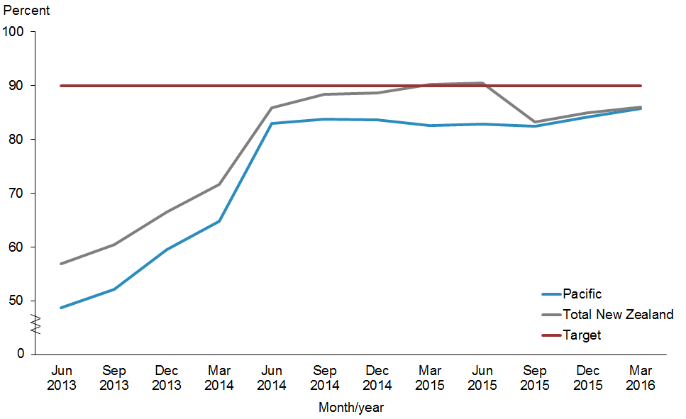
 | Jun 2013 | Sep 2013 | Dec 2013 | Mar 2014 | Jun 2014 | Sep 2014 | Dec 2014 | Mar 2015 | Jun 2015 | Sep 2015 | Dec 2015 | Mar 2016
Pacific | 48.8% | 52.1% | 59.6% | 64.8% | 83.0% | 83.8% | 83.6% | 82.6% | 82.8% | 82.4% | 84.2% | 85.7%
Total New Zealand | 56.9% | 60.5% | 66.5% | 71.6% | 85.8% | 88.4% | 88.6% | 90.2% | 90.5% | 83.2% | 85.0% | 86.0%
Target | 90.0% | 90.0% | 90.0% | 90.0% | 90.0% | 90.0% | 90.0% | 90.0% | 90.0% | 90.0% | 90.0% | 90.0%

Figure 22 shows that both populations are beginning to recover from the definition change in early 2015 and are both improving towards the target.

Figure 23: Percentage of smokers offered brief advice and support to quit in primary health care, Pacific peoples, by priority DHBs, 2013–2016
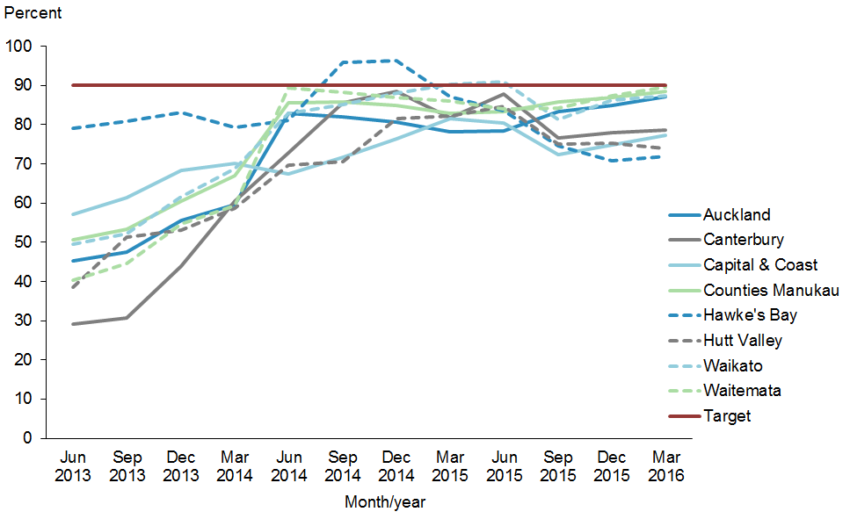
 | Jun 2013 | Sep 2013 | Dec 2013 | Mar 2014 | Jun 2014 | Sep 2014 | Dec 2014 | Mar 2015 | Jun 2015 | Sep 2015 | Dec 2015 | Mar 2016
Auckland | 45.3% | 47.5% | 55.5% | 59.6% | 82.9% | 82.1% | 80.6% | 78.2% | 78.3% | 83.4% | 84.9% | 87.2%
Canterbury | 29.2% | 30.7% | 44.0% | 60.4% | 72.8% | 85.7% | 88.5% | 81.8% | 87.9% | 76.6% | 78.0% | 78.7%
Capital & Coast | 57.1% | 61.5% | 68.2% | 70.0% | 67.5% | 71.8% | 76.3% | 81.5% | 80.5% | 72.4% | 74.8% | 77.2%
Counties Manukau | 50.7% | 53.4% | 60.5% | 67.0% | 85.6% | 85.7% | 85.0% | 82.9% | 83.3% | 85.8% | 87.0% | 88.4%
Hawke's Bay | 79.0% | 81.0% | 83.1% | 79.4% | 81.2% | 95.9% | 96.3% | 87.1% | 83.7% | 74.6% | 70.7% | 71.9%
Hutt Valley | 38.5% | 51.3% | 53.1% | 58.8% | 69.8% | 70.5% | 81.5% | 82.3% | 84.7% | 75.0% | 75.3% | 73.9%
Waikato | 49.5% | 52.3% | 61.7% | 68.8% | 82.9% | 85.2% | 88.1% | 90.2% | 91.0% | 81.3% | 86.3% | 87.4%
Waitemata | 40.4% | 44.5% | 54.7% | 59.3% | 89.4% | 88.3% | 86.9% | 85.9% | 84.1% | 84.1% | 87.3% | 89.7%
Target | 90.0% | 90.0% | 90.0% | 90.0% | 90.0% | 90.0% | 90.0% | 90.0% | 90.0% | 90.0% | 90.0% | 90.0%

Figure 23 shows that Waitemata DHB has achieved this target. Counties Manukau, Auckland and Waikato DHBs are not far. Canterbury, Capital & Coast, Hutt Valley and Hawke’s Bay are also improving.

Indicator 3b | Improve management of diabetes by increasing ‘more heart and diabetes checks’

Performance: The target for this indicator is 90 percent.

Figure 24: Percentage of eligible adults who had cardiovascular risk assessed, Pacific peoples population and total New Zealand population, 2013–2016
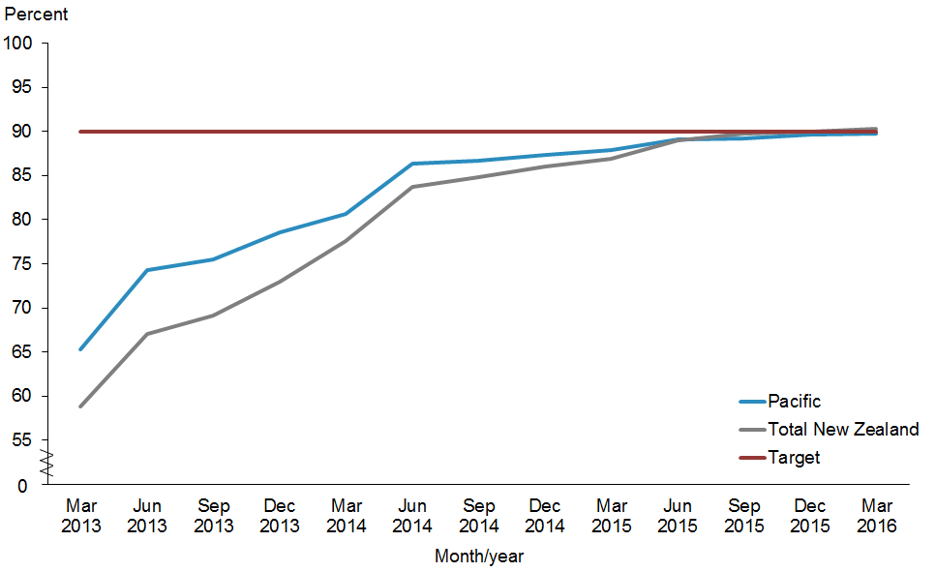
 | Mar 2013 | Jun 2013 | Sep 2013 | Dec 2013 | Mar 2014 | Jun 2014 | Sep 2014 | Dec 2014 | Mar 2015 | Jun 2015 | Sep 2015 | Dec 2015 | Mar 2016
Pacific | 65.3% | 74.3% | 75.5% | 78.5% | 80.7% | 86.4% | 86.7% | 87.3% | 87.9% | 89.1% | 89.2% | 89.6% | 89.8%
Total New Zealand | 58.8% | 67.1% | 69.1% | 73.0% | 77.6% | 83.7% | 84.9% | 86.1% | 86.9% | 89.0% | 89.8% | 90.0% | 90.3%
Target | 90.0% | 90.0% | 90.0% | 90.0% | 90.0% | 90.0% | 90.0% | 90.0% | 90.0% | 90.0% | 90.0% | 90.0% | 90.0%

Figure 24 shows that both the Pacific population and the total New Zealand population have achieved this target.

Figure 25: Percentage of eligible adults who had cardiovascular risk assessed, Pacific peoples, by priority DHBs, 2013–2016
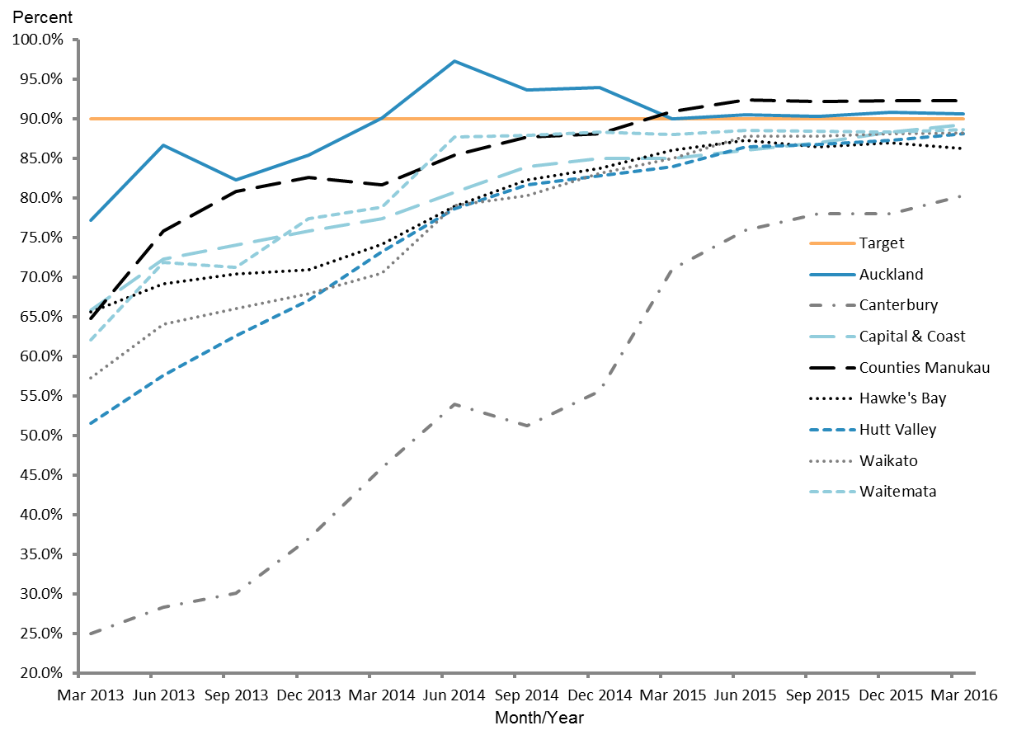
 | Mar 2013 | Jun 2013 | Sep 2013 | Dec 2013 | Mar 2014 | Jun 2014 | Sep 2014 | Dec 2014 | Mar 2015 | Jun 2015 | Sep 2015 | Dec 2015 | Mar 2016
Auckland | 77.2% | 86.6% | 82.3% | 85.5% | 90.1% | 97.3% | 93.7% | 94.0% | 90.0% | 90.5% | 90.3% | 90.8% | 90.6%
Canterbury | 25.0% | 28.3% | 30.1% | 37.0% | 45.9% | 54.0% | 51.2% | 55.6% | 71.0% | 75.9% | 78.1% | 78.0% | 80.3%
Capital & Coast | 65.9% | 72.3% | 74.1% | 75.9% | 77.4% | 80.8% | 84.0% | 85.0% | 85.0% | 86.1% | 87.0% | 88.3% | 89.3%
Counties Manukau | 64.8% | 75.9% | 80.9% | 82.6% | 81.6% | 85.4% | 87.8% | 88.1% | 91.0% | 92.4% | 92.2% | 92.3% | 92.3%
Hawke's Bay | 65.6% | 69.2% | 70.4% | 71.0% | 74.2% | 79.0% | 82.4% | 83.8% | 86.0% | 87.3% | 86.5% | 87.0% | 86.3%
Hutt Valley | 51.6% | 57.6% | 62.6% | 67.1% | 73.3% | 78.7% | 81.7% | 82.8% | 84.0% | 86.5% | 86.7% | 87.3% | 88.1%
Waikato | 57.3% | 64.0% | 66.1% | 67.9% | 70.6% | 79.1% | 80.4% | 83.1% | 85.0% | 87.8% | 87.8% | 88.1% | 88.2%
Waitemata | 62.0% | 71.9% | 71.3% | 77.4% | 78.9% | 87.8% | 87.9% | 88.4% | 88.0% | 88.5% | 88.5% | 88.3% | 88.7%
Target | 90.0% | 90.0% | 90.0% | 90.0% | 90.0% | 90.0% | 90.0% | 90.0% | 90.0% | 90.0% | 90.0% | 90.0% | 90.0%

Figure 25 shows that all DHBs are making positive progress and are converging around the target of 90 percent. Auckland DHB and Counties Manukau DHB have achieved the target and have maintained this achieved status from the last update. In addition, contributing to the overall Pacific population achieving this target are other DHBs with relatively big Pacific populations, for example Waitemata, Capital & Coast, Waikato, Hutt Valley and Hawke’s Bay. Canterbury DHB is also making progress.

Action 4 | DHBs will support the Pacific Whānau Ora Commissioning Agency.

Action commentary
In their 2015/2016 annual plans, all priority DHBs have committed to working with Whānau Ora commissioning agencies. The annual plans of Auckland, Counties Manukau and Waitemata DHB make specific reference to working with Pasifika Futures (the Pacific Whānau Ora Commissioning Agency) to ensure effective integration between Whānau Ora and DHB-funded family support services, and to quarterly meetings.

The Ministry has invested in Pacific health collectives, networks and eligible Pacific health providers through the Pacific Provider Workforce Development Fund. Providers have reported that they are better placed to deliver on their contracts with Pasifika Futures as a result.

Currently Pasifika Futures mainly works directly with contracted community providers. However, the agency is looking to begin working closer with DHBs.

One of the health outcomes Pasifika Futures aims to achieve in the next three to five years is for ‘Pacific peoples to be physically active and make healthy eating choices’.

Indicator 4a | DHB annual plans report on extent of support for the Pacific Whānau Ora Commissioning Agency

Counties Manukau DHB
Counties Manukau DHB has embedded a Fanau Ola (Pacific Whānau Ora) approach in its work in the hospital and through the integrated Pacific provider contracts. This is linked to Counties Manukau DHB’s Health Accelerating Pacific Health Gain Plan 2017. There are a number of actions and measures set (Counties Manukau Health, Annual Plan 2015/2016).

Auckland DHB
Auckland DHB will work with Pasifika Futures to ensure effective integration between Whānau Ora and Auckland DHB-funded family support services and will continue to identify outcomes for Pacific families. Auckland DHB will establish a Whānau Ora network in Tāmaki. Services and programmes to improve outcomes for Māori and Pacific children, including immunisations, healthy lifestyles initiatives and PHO enrolment, have been prioritised. Auckland DHB will continue to implement the objectives described in the Pacific Health Action Plan.

Waitemata DHB
Waitemata DHB will continue to implement the objectives described in the Pacific Health Action Plan, work with Pasifika Futures to ensure effective integration between Whānau Ora and Waitemata DHB-funded family support services, and identify outcomes for families at quarterly meetings with West Fono Health Trust (the Pacific Whānau Ora provider for the DHB).

Indicator 4b | Decrease the number of Pacific children aged 2–14 years who are obese

Performance: There is no target set for this indicator.

Figure 26: Percentage of children who are obese (BMI >/= Cole cut-offs), Pacific peoples population and total New Zealand population, 2006–2015
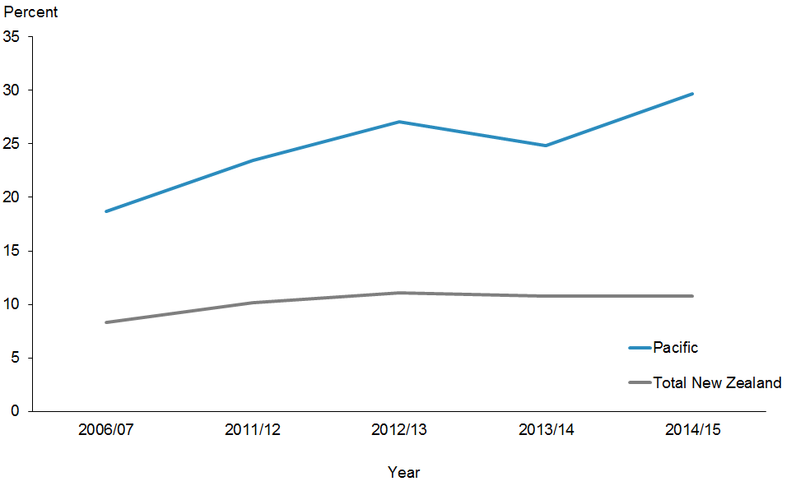
 | 2006/07 | 2011/12 | 2012/13 | 2013/14 | 2014/15
Pacific | 18.7% | 23.5% | 27.1% | 24.8% | 29.7%
Total New Zealand | 8.3% | 10.2% | 11.1% | 10.8% | 10.8%

Figure 26 shows percentage of Pacific children who are obese between 2006 and 2015 continues to increase compared with the total New Zealand population which shows a plateauing trend.

Figure 27: Percentage of children who are obese (BMI >/= Cole cut-offs), Pacific peoples, by priority DHBs, 2006–2015
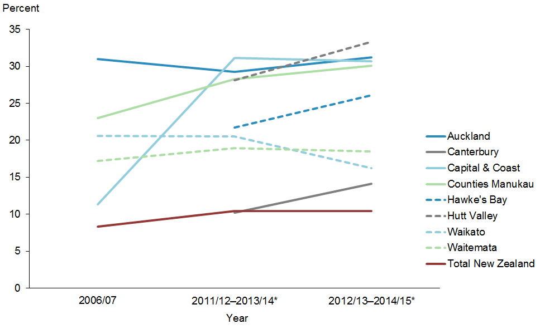
 | 2006/07 | 2011/12–2013/14* | 2012/13–2014/15*
Auckland | 31.0% | 29.3% | 31.2%
Canterbury |  | 10.2% | 14.1%
Capital & Coast | 11.4% | 31.1% | 30.7%
Counties Manukau | 23.0% | 28.3% | 30.1%
Hawke's Bay |  | 21.7% | 26.1%
Hutt Valley |  | 28.1% | 33.3%
Waikato | 20.6% | 20.5% | 16.2%
Waitemata | 17.2% | 19.0% | 18.5%
Target | 8.3% | 10.4% | 10.4%
* These are data pooled from three consecutive New Zealand Health surveys.

Note: Data for some DHBs with small samples (<30) are suppressed. These are crude rates. There is no set national target. For the first time we have data for Canterbury, Hawke’s Bay and Hutt Valley.

Figure 27 shows the percentage of Pacific children who are obese by priority DHBs. Waikato DHB is showing a decreasing trend. Waitemata, Auckland and Capital & Coast DHBs are plateauing.

Action 5 | DHBs, PHOs and other providers will maximise coverage and participation of Pacific peoples in the national screening programmes.

Action commentary
National Cervical Screening Programme
PHOs now have access to the electronic PHO Cervical Screening Data Match Report via the secure file transfer protocol (EFT account). The report produces an excel spreadsheet able to be sent to practices with information on the screening status of all women enrolled with their PHO.

This is an exciting new development that will assist practices with recalling women. Fields in the report include NHI, date of birth, the date of the women’s last screen and where it was taken, the next due date, and the important clinical management indicators, for example if the last smear was negative, or low or high grade. Information on ethnicity and deprivation quintile is also available.

Practices can choose to use any or all of this report, however it is particularly useful as a spreadsheet to filter and identify the following:
- women screened elsewhere
- women with a low or high grade smear who are overdue (able to be sorted by the most overdue)
- women in the practice not yet been enrolled in the National Cervical Screening Programme (NCSP)
- targeted follow-up of women missing out (eg, by ethnicity and deprivation).

From time to time the Practice Management System may have an incorrect recall date, and this report can be helpful to identify this.

Indicator 5 | Increase percentage of enrolled Pacific women aged 25–69 years old to receive a cervical smear in the past three years to at least equal to the rate of the total population

Performance: The target for this indicator is 80 percent.

Figure 28: Percentage of enrolled women aged 25–69 years who received a cervical smear in the past three years, Pacific peoples population and total New Zealand population, 2013–2016
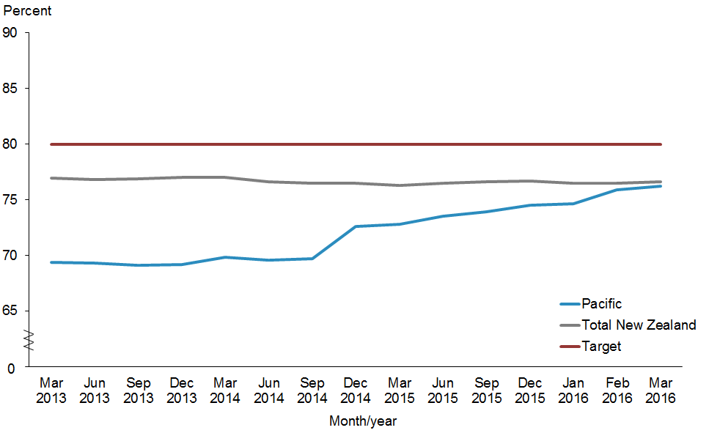
 | Mar 2013 | Jun 2013 | Sep 2013 | Dec 2013 | Mar 2014 | Jun 2014 | Sep 2014 | Dec 2014 | Mar 2015 | Jun 2015 | Sep 2015 | Dec 2015 | Jan 2016 | Feb 2016 | Mar 2016
Pacific | 69.4% | 69.3% | 69.1% | 69.2% | 69.8% | 69.6% | 69.7% | 72.6% | 72.8% | 73.5% | 73.9% | 74.5% | 74.6% | 75.9% | 76.2%
Total New  Zealand | 76.9% | 76.8% | 76.9% | 77.0% | 77.0% | 76.6% | 76.5% | 76.5% | 76.3% | 76.5% | 76.6% | 76.7% | 76.5% | 76.5% | 76.6%
Target | 80.0% | 80.0% | 80.0% | 80.0% | 80.0% | 80.0% | 80.0% | 80.0% | 80.0% | 80.0% | 80.0% | 80.0% | 80.0% | 80.0% | 80.0%

Notes for Figures 29 and 30:
- The age range for the cervical screening eligibility monitoring target was 20–69 years prior to 2014, and then changed to 25–69 years in January 2014. This change aligns with international best practice, and allows for international comparison of screening programme performance.
- Data was obtained from the NCSP.
- These percentages may not be the same as the ones in previous ’Ala Mo’ui Progress Reports.

Figure 28 shows continuous improvement in the cervical screening percentages for Pacific women from the last update in December 2015. The inclusion of cervical screening as a target in IPIF in primary care has increased PHO engagement and interest in increasing cervical screening coverage. However, it would be important going forward to continue monitoring this indicator now that IPIF has changed into System Level Measures (page 45).

Figure 29: Percentage of enrolled women aged 25–69 years who received a cervical smear in the past three years, Pacific peoples, by priority DHBs, 2013–2016
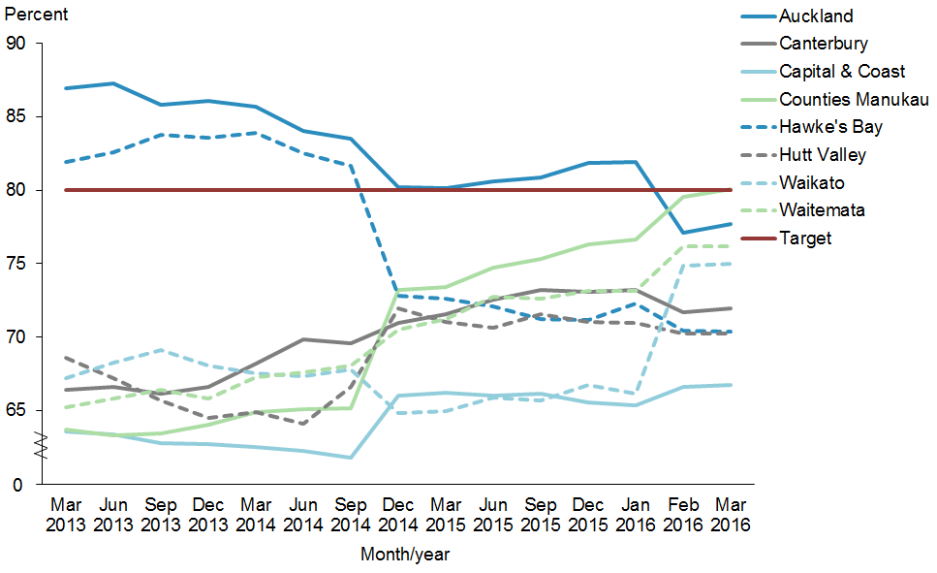
 | Mar 2013 | Jun 2013 | Sep 2013 | Dec 2013 | Mar 2014 | Jun 2014 | Sep 2014 | Dec 2014 | Mar 2015 | Jun 2015 | Sep 2015 | Dec 2015 | Jan 2016 | Feb 2016 | Mar 2016
Auckland | 86.9% | 87.2% | 85.8% | 86.1% | 85.7% | 84.0% | 83.5% | 80.2% | 80.1% | 80.6% | 80.9% | 81.9% | 81.9% | 77.1% | 77.7%
Canterbury | 66.4% | 66.6% | 66.1% | 66.6% | 68.2% | 69.8% | 69.6% | 71.0% | 71.6% | 72.6% | 73.2% | 73.1% | 73.2% | 71.7% | 72.0%
Capital & Coast | 63.6% | 63.4% | 62.8% | 62.7% | 62.5% | 62.2% | 61.8% | 66.0% | 66.2% | 66.0% | 66.1% | 65.5% | 65.4% | 66.6% | 66.7%
Counties Manukau | 63.7% | 63.3% | 63.4% | 64.0% | 64.9% | 65.1% | 65.1% | 73.2% | 73.4% | 74.7% | 75.3% | 76.3% | 76.7% | 79.5% | 80.1%
Hawke's Bay | 81.9% | 82.6% | 83.8% | 83.6% | 83.9% | 82.5% | 81.7% | 72.8% | 72.6% | 72.1% | 71.2% | 71.2% | 72.3% | 70.4% | 70.4%
Hutt Valley | 68.6% | 67.2% | 65.7% | 64.5% | 64.9% | 64.1% | 66.6% | 72.0% | 71.0% | 70.6% | 71.5% | 71.0% | 71.0% | 70.2% | 70.3%
Waikato | 67.2% | 68.3% | 69.1% | 68.0% | 67.5% | 67.3% | 67.8% | 64.8% | 65.0% | 65.9% | 65.7% | 66.7% | 66.2% | 74.8% | 75.0%
Waitemata | 65.2% | 65.8% | 66.4% | 65.8% | 67.2% | 67.6% | 68.1% | 70.5% | 71.2% | 72.7% | 72.6% | 73.1% | 73.1% | 76.2% | 76.2%
Target | 80.0% | 80.0% | 80.0% | 80.0% | 80.0% | 80.0% | 80.0% | 80.0% | 80.0% | 80.0% | 80.0% | 80.0% | 80.0% | 80.0% | 80.0%

Figure 29 show that Counties Manukau DHB has achieved the target. Waikato and Waitemata DHBs have been improving recently and are not far from the target. Auckland (77.7 percent) and Hawke’s Bay DHBs (70.4 percent) have achieved this target (80 percent) in the past but have not in this progress report.

Priority outcome 2 –
More services are delivered locally in the community and in primary care
The following presents a brief summary of performance indicator results in priority outcome 2 for this reporting period.
Table 9: Performance against priority outcome 2 indicators, as at 31 December 2015
Indicator | Pacific rate | Total New Zealand rate
GP utilisation | 3.08 | 2.99
Nurse utilisation | 0.77 | 0.72
Total GP and nurse | 3.85 | 3.71
The latest results to June 2016 show that Pacific peoples’ rate of primary care utilisation (for both GPs and nurses) has increased over the years, and continues to be higher than that of the total New Zealand population. There is an assumption that increased access to primary health care leads to improved health outcomes and a reduction in ASH rates. Both Child ASH
(0–4 years) and Adult ASH (45–64 years) rates reported in this report are starting to show an improvement (page 2 to page 4).
Other policies that have contributed to this are:
1. The introduction of the Very Low Cost Access (VLCA) scheme has helped achieve equity for Pacific peoples’ GP utilisation in New Zealand. The VLCA scheme was introduced in October 2006. This is a voluntary scheme that general practices can opt out of at any time if they find it is no longer appropriate for them. From October 2009, eligibility for the VLCA payment was limited to PHOs and contracted general practices with an enrolled population of 50 percent or more high-needs patients (defined as Māori, Pacific or New Zealand Deprivation Index quintile 5).
2. Zero fees for under-13s which started in July 2015. The zero fees scheme applies to a standard daytime visit to a GP or nurse at the child’s regular practice (where they are enrolled) or an after-hours visit to a participating clinic. It also applies to injuries covered by ACC. Ninety-six percent of general practices with enrolled children aged
6–12 have opted in to the zero fees for under-13s scheme, and 98 per cent of practices with enrolled under-sixes offer zero fee visits.

Priority outcome 2 – More services are delivered locally in the community and in primary care
Action 1 | The four Pacific health collectives will be part of relevant DHB alliances.

Nationally, there are four Pacific health collectives, each with memberships of three to 12 Pacific providers who deliver a range of primary care, community-based health care and social services. They are based in Auckland (led by Alliance Health Plus Trust), Midlands (led by K’aute Pacific Services), Wellington (led by the Central Pacific Collective) and the South Island (led by Pacific Trust Canterbury). All of the collective members use Ministry of Health funds to strengthen funding capability, infrastructure, IT frameworks, and policies and systems to provide improved health services to the Pacific peoples they serve.

Action commentary
The Auckland Region Pacific Provider Network, Tangata o le Moana, has been working closely with the Pacific health divisions of Counties Manukau, Auckland and Waitemata DHBs. In May 2015, all three DHBs met with Tangata o le Moana providers. There, DHB representatives signalled to Tangata o le Moana that they were interested in the demonstration projects currently under development within the network. Through Tangata o le Moana members, providers maintain several alliance arrangements. For example, Alliance Health Plus is engaged in the District Alliance for Counties Manukau DHB, and there is a Rheumatic Fever Rapid Response Alliance within Auckland DHB.

K’aute Pasifika maintains a close working relationship with Waikato DHB, and is member of a number of the DHB’s working groups, including the Rheumatic Fever Stakeholder Group, the Sore Throat Management Steering Group, the Immunisation Stakeholder Group and the Children’s Action team.

In Wellington, the Pacific Health and Wellbeing Collective has established a strong working relationship with Capital & Coast and Hutt Valley DHBs and holds regular monthly meetings with both.

Pacific Trust Canterbury works closely with Canterbury DHB, and also holds various primary health care, social services and education contracts that support improving Pacific peoples’ wellbeing in the Canterbury region. Pacific Trust Canterbury is part of the Pacific Reference Group, a forum which has representatives from Canterbury DHB, Pegasus PHO, the Ministry for Pacific Peoples and the youth community. The forum is chaired by Canterbury DHB and administered by the Pacific manager for Pegasus PHO.

Indicator 1 | Monitor the number of Pacific collectives/networks involved in DHB alliances through collective and network monitoring reports

Refer to ‘Action Commentary’ above.

Action 2 | The new Integrated Performance and Incentive Framework (IPIF) will facilitate improved health outcomes for Pacific peoples.

Action commentary

IPIF and System Level Measures
The IPIF began in 2012 through the establishment of the Expert Advisory Group. The aim of IPIF was to drive stronger integration across the health system, improve quality and ensure long term system sustainability. IPIF was implemented in 2014 with primary care financial incentives directly linked to performance against the primary care National Health Targets (Better help for smokers to quit, Immunisation and More Heart and Diabetes Checks) and the cervical screening coverage.

The development of the overall IPIF framework was paused during the refresh of the New Zealand Health Strategy (the Strategy). In May 2015 the Minister of Health decided not to introduce new performance measures in 2015/16 as he wanted more aspirational measures developed that looked at the performance of the system rather than just primary care. The Minister also wanted to change the focus from looking at outputs and processes to outcomes. The refresh of the Strategy provided the opportunity for this work and has built the case to extend and evolve the IPIF concept of System Level Measures.

New Zealand Health Strategy and System Level Measures
One of the five themes of the Strategy is value and high performance, which places an emphasis on measuring the performance of the whole system as well as its component parts. The Strategy recommends the development of an outcomes-based approach to performance measurement that will guide the delivery of constantly improving health services.

The Ministry of Health has been working closely with the sector to co-develop a suite of System Level Measures that provide a system wide view of performance. These measures have evolved from an initial list of over 100. The new measures engage the health sector more broadly (professions, settings and health conditions) than the previous measures.

The performance of individual clinicians and/or provider organisations, through health activities and processes, are measured by contributory measures. These individual groups must work as one team to improve system level performance. The System Level Measures for introduction in 2016/17 also resonate with the care closer to home, people powered and smart system themes of the Strategy.

The System Level Measures to be introduced rely on the contribution of a wider group of providers. In 2016/17, the focus is on the contributions and performance of DHBs and PHOs.

The contribution of the wider groups will be seen over the next 18 months as the Ministry and the DHBs include System Level Measures in a wider range of contracts.

System level measures for 2016/2017
The four new system level measures to be implemented from 1 July 2016 are:
1. ambulatory sensitive hospitalisation (ASH) rates per 100,000 for 0–4 year olds (ie, Keeping children out of the hospital)
2. acute hospital bed days per capita (ie, using health resources effectively)
3. patient experience of care (ie, person-centred care)
4. amenable mortality rates (ie, prevention and early detection).

The following two system level measures will be developed during 2016/17 including definitions and identification of data sets:
5. number of babies who live in a smoke-free household at six weeks post natal (ie, Healthy start)
6. youth access to and utilisation of youth appropriate health services (ie, Teens make good choices about their health and wellbeing).

System level measures have nationally consistent definitions and will be reported nationally. Contributory measures will have nationally consistent definitions and data sets, but will be selected locally and will not need to be reported nationally.

More information about system level and contributory measures is available from the Health Quality Measures Library (www.hqmnz.org.nz). A measures guidance document explaining the concept of system level and contributory measures and how they can be selected and used will also be available on this site.

Proposed approach to financial incentives for 2016/17
A proposed approach to financial incentives has been shared with the PHO Services Agreement Amendment Protocol Group (PSAAP) in April 2016. A working group of PHO and DHB representatives will work with the Ministry to draft the new schedule of the PHO Services Agreement that will be discussed at the May PSAAP meeting.

The proposed approach to financial incentives acknowledges the sector’s preference for capacity and capability funding to ensure the appropriate improvement infrastructure is in place.

The proposed approach includes:
- two capacity and capability payments and one ‘at risk’ performance payment to be paid to primary health organisations (PHOs):
- 25 percent capacity and capability payment up front in quarter one
- 50 percent capacity and capability payment in quarter two once the Ministry approves the district alliance’s Improvement Plan
- 25 percent performance payment in quarter one 2017/18 based on quarter four 2016/17 performance
- for the 25 percent performance payment, PHOs will be incentivised for the following three system level measures and the two primary care national health targets:
- ASH rates for 0–4 year olds
- acute hospital bed days per capita
- patient experience of care
- better help for smokers to quit
- increased immunisation for eight-month-olds.

The incentives for PHOs and general practices are paid out of the $23 million PHO performance funding pool. The incentives payments will be made to the PHOs through their contracted DHB as per current processes.

Indicator 2a | Equity in all system measures for Pacific peoples (ie, healthy start measures, healthy child measures and healthy adult measures)

Refer to ‘Action Commentary’ above, and to Figures 23, 25 and 31.

Indicator 2b | Increased utilisation rates of primary health care providers in the eight priority DHBs

Performance: There is no target set for this indicator.

Figure 30: GP utilisation rate (average visits per person per year), Pacific peoples population and total New Zealand population, 2008–2016
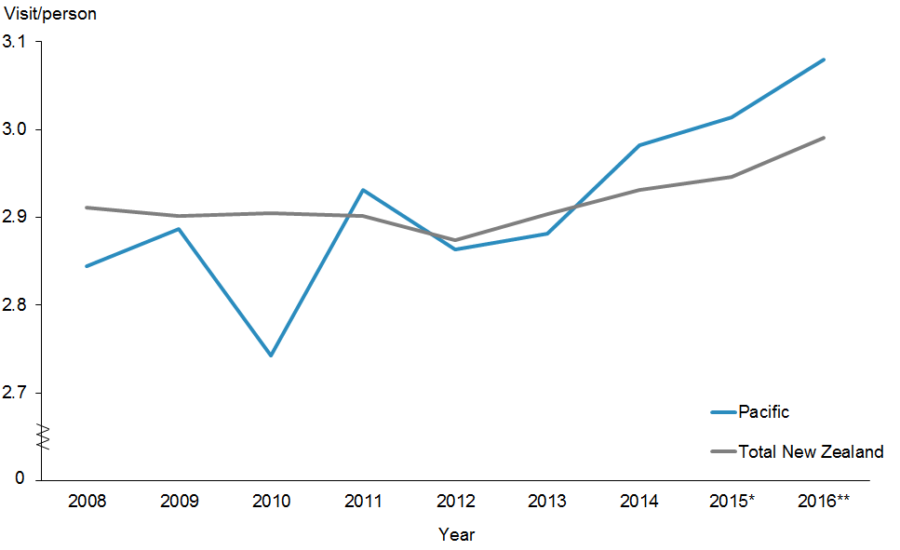
 | 2008 | 2009 | 2010 | 2011 | 2012 | 2013 | 2014 | 2015* | 2016**
Pacific | 2.84 | 2.89 | 2.74 | 2.93 | 2.86 | 2.88 | 2.98 | 3.01 | 3.08
Total New Zealand | 2.91 | 2.90 | 2.90 | 2.90 | 2.87 | 2.90 | 2.93 | 2.95 | 2.99
* Financial year 2014/2015
** Quarter 3, 2015/2016

Figure 30 shows that Pacific peoples were more likely to have accessed their GPs than the total New Zealand population.

Figure 31: GP utilisation rate (average visits per person), Pacific peoples, by priority DHBs, 2008–2016
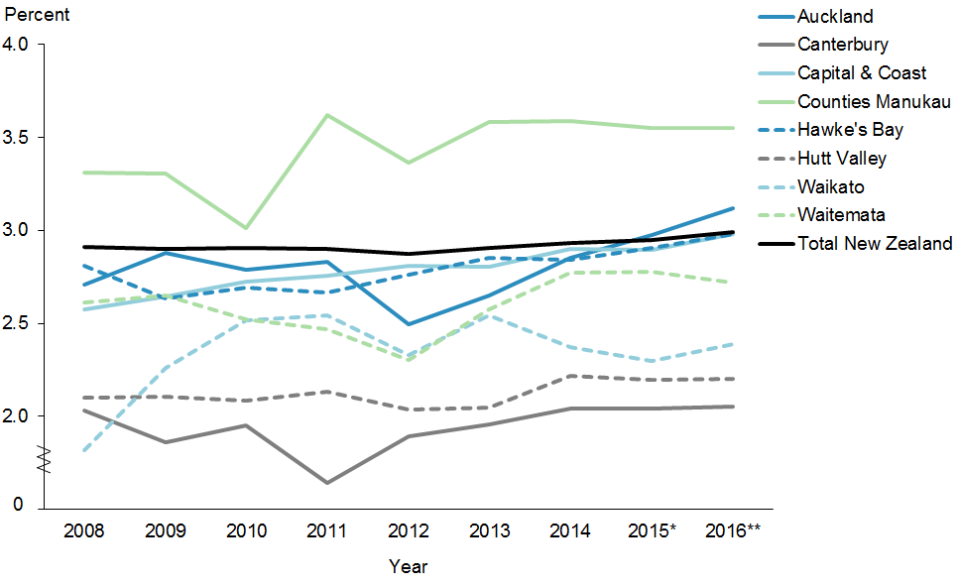
 | 2008 | 2009 | 2010 | 2011 | 2012 | 2013 | 2014 | 2015* | 2016**
Auckland | 2.71 | 2.88 | 2.79 | 2.83 | 2.50 | 2.65 | 2.85 | 2.97 | 3.12
Canterbury | 2.03 | 1.86 | 1.95 | 1.64 | 1.89 | 1.96 | 2.04 | 2.04 | 2.05
Capital & Coast | 2.58 | 2.64 | 2.72 | 2.75 | 2.81 | 2.80 | 2.90 | 2.90 | 2.98
Counties Manukau | 3.31 | 3.31 | 3.01 | 3.62 | 3.36 | 3.58 | 3.59 | 3.55 | 3.55
Hawke's Bay | 2.81 | 2.63 | 2.69 | 2.66 | 2.76 | 2.85 | 2.84 | 2.91 | 2.98
Hutt Valley | 2.10 | 2.11 | 2.08 | 2.13 | 2.04 | 2.05 | 2.22 | 2.20 | 2.20
Waikato | 1.82 | 2.26 | 2.52 | 2.54 | 2.33 | 2.55 | 2.37 | 2.30 | 2.39
Waitemata | 2.61 | 2.65 | 2.52 | 2.47 | 2.30 | 2.58 | 2.77 | 2.78 | 2.72
Target | 2.91 | 2.90 | 2.90 | 2.90 | 2.87 | 2.90 | 2.93 | 2.95 | 2.99
* Financial year 2014/2015
** Quarter 3, 2015/2016

Figure 31 shows that Counties Manukau, Auckland, Capital & Coast, and Hawke’s Bay DHBs have improved access to GPs for Pacific peoples. These four DHBs have closed the equity gap.

Figure 32: Nurse utilisation rate (average visits per person), Pacific peoples population and total New Zealand population, 2008–2016
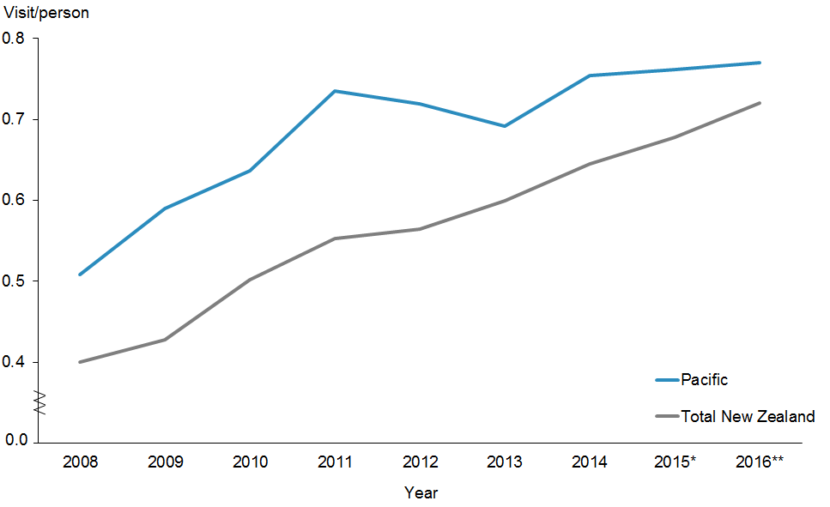
 | 2008 | 2009 | 2010 | 2011 | 2012 | 2013 | 2014 | 2015* | 2016**
Pacific | 0.51 | 0.59 | 0.64 | 0.73 | 0.72 | 0.69 | 0.75 | 0.76 | 0.77
Total New Zealand | 0.40 | 0.43 | 0.50 | 0.55 | 0.56 | 0.60 | 0.64 | 0.68 | 0.72
* Financial year 2014/2015
** Quarter 3, 2015/2016

Figure 32 shows that the rates of utilisation of primary health nursing services is consistently higher for Pacific peoples compared with the total New Zealand population.

Figure 33: Nurse utilisation rate (average visits per person), Pacific peoples, by priority DHBs, 2008–2016
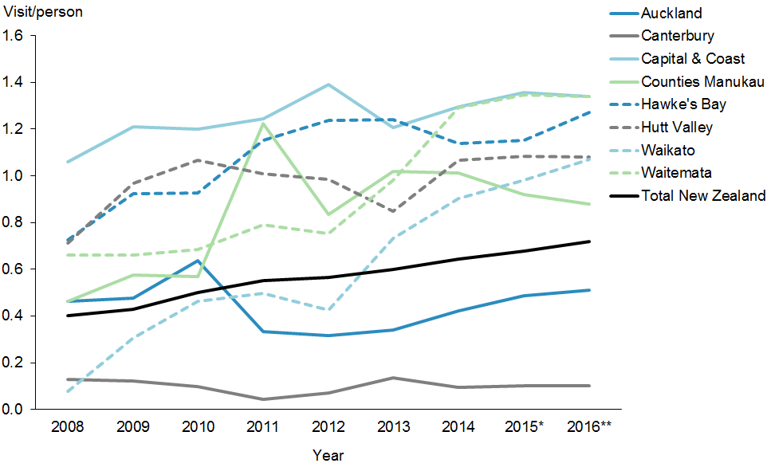
 | 2008 | 2009 | 2010 | 2011 | 2012 | 2013 | 2014 | 2015* | 2016**
Auckland | 0.46 | 0.48 | 0.64 | 0.33 | 0.31 | 0.34 | 0.42 | 0.49 | 0.51
Canterbury | 0.13 | 0.12 | 0.10 | 0.04 | 0.07 | 0.14 | 0.10 | 0.10 | 0.10
Capital & Coast | 1.06 | 1.21 | 1.20 | 1.24 | 1.39 | 1.21 | 1.30 | 1.36 | 1.34
Counties Manukau | 0.46 | 0.57 | 0.57 | 1.22 | 0.83 | 1.02 | 1.01 | 0.92 | 0.88
Hawke's Bay | 0.72 | 0.92 | 0.93 | 1.15 | 1.24 | 1.24 | 1.14 | 1.15 | 1.27
Hutt Valley | 0.71 | 0.97 | 1.07 | 1.01 | 0.98 | 0.85 | 1.07 | 1.08 | 1.08
Waikato | 0.08 | 0.31 | 0.46 | 0.50 | 0.42 | 0.73 | 0.90 | 0.98 | 1.07
Waitemata | 0.66 | 0.66 | 0.69 | 0.79 | 0.75 | 0.98 | 1.29 | 1.35 | 1.34
Target | 0.40 | 0.43 | 0.50 | 0.55 | 0.56 | 0.60 | 0.64 | 0.68 | 0.72
* Financial year 2014/2015
** Quarter 3, 2015/2016

Figure 33 shows that Capital & Coast and Waitemata DHBs had the highest nurse utilisation rate by Pacific peoples, followed by Hawke’s Bay, Hutt Valley, Waikato and Counties Manukau DHBs. All six DHBs above showed the access rates to see nurses for Pacific peoples were higher than for the total New Zealand population.

Figure 34: Total GP and nurse utilisation rate (average visits per person), Pacific peoples population and total New Zealand population, 2008–2016
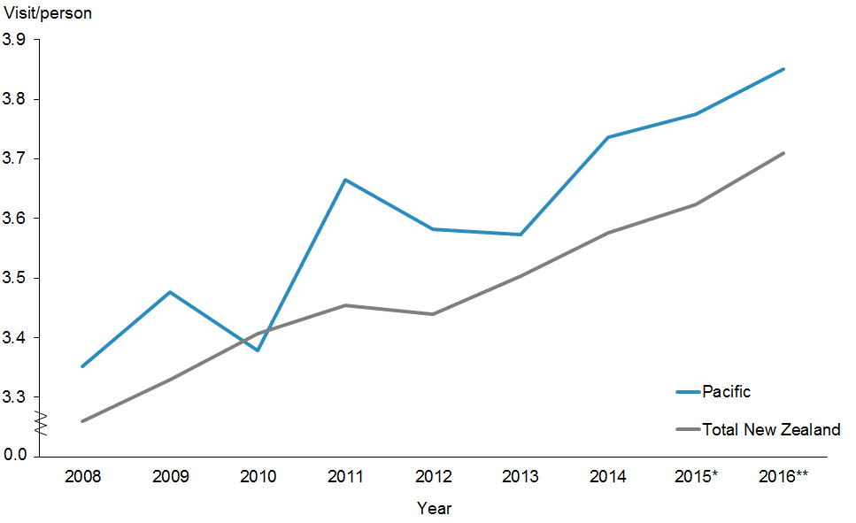
 | 2008 | 2009 | 2010 | 2011 | 2012 | 2013 | 2014 | 2015* | 2016**
Pacific | 3.35 | 3.48 | 3.38 | 3.67 | 3.58 | 3.57 | 3.74 | 3.77 | 3.85
Total New Zealand | 3.26 | 3.33 | 3.41 | 3.45 | 3.44 | 3.50 | 3.58 | 3.62 | 3.71
* Financial year 2014/2015
** Quarter 3, 2015/2016

Figure 34 shows that the rates for both populations have been improving. The Pacific population rates have been consistently higher than those of the total New Zealand population. These results suggest that Pacific peoples are accessing both GPs and nurses more on average than the total New Zealand population.

Figure 35: Total GP and nurse utilisation rate (average visits per person), Pacific peoples, by priority DHBs, 2008–2016
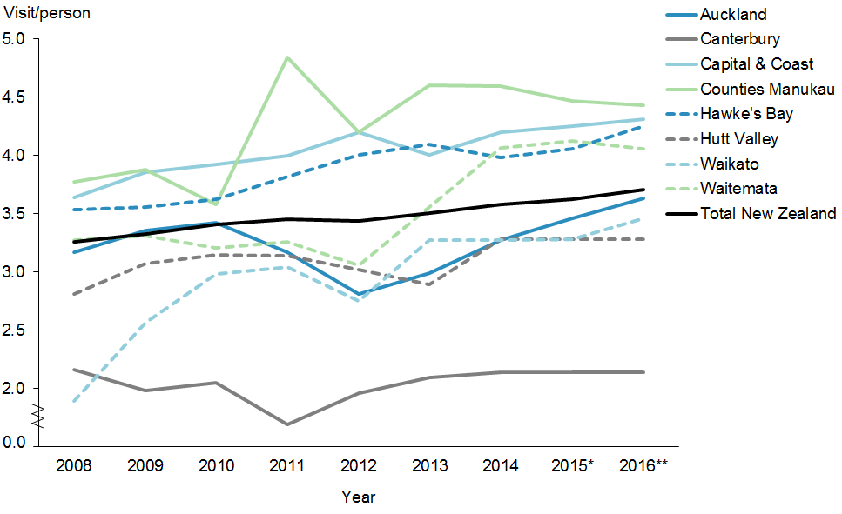
 | 2008 | 2009 | 2010 | 2011 | 2012 | 2013 | 2014 | 2015* | 2016**
Auckland | 3.17 | 3.36 | 3.42 | 3.17 | 2.81 | 2.99 | 3.28 | 3.46 | 3.63
Canterbury | 2.16 | 1.98 | 2.05 | 1.69 | 1.96 | 2.10 | 2.14 | 2.14 | 2.14
Capital & Coast | 3.64 | 3.85 | 3.92 | 4.00 | 4.20 | 4.01 | 4.20 | 4.25 | 4.31
Counties Manukau | 3.77 | 3.88 | 3.58 | 4.84 | 4.20 | 4.60 | 4.60 | 4.47 | 4.43
Hawke's Bay | 3.54 | 3.55 | 3.62 | 3.82 | 4.00 | 4.09 | 3.98 | 4.06 | 4.25
Hutt Valley | 2.81 | 3.08 | 3.15 | 3.14 | 3.02 | 2.90 | 3.28 | 3.28 | 3.28
Waikato | 1.90 | 2.57 | 2.98 | 3.04 | 2.75 | 3.28 | 3.27 | 3.28 | 3.46
Waitemata | 3.27 | 3.31 | 3.21 | 3.26 | 3.06 | 3.56 | 4.06 | 4.12 | 4.06
Target | 3.26 | 3.33 | 3.41 | 3.45 | 3.44 | 3.50 | 3.58 | 3.62 | 3.71
* Financial year 2014/2015
** Quarter 3, 2015/2016

Figure 35 shows the total GP and nurse utilisation rates (average visits per person) for the Pacific population and the total New Zealand population. The access rates for Pacific peoples in Counties Manukau, Capital & Coast, Waitemata and Hawke’s Bay DHBs were generally higher than for the total New Zealand population.

Priority outcome 3 –
Pacific peoples are better supported to be healthy
The following presents a brief summary of performance indicator results and activities delivered in priority outcome 3 for this reporting period.
There are three actions to ensure that Pacific peoples are better supported to be healthy in this priority outcome.
1. Improve the health literacy of Pacific peoples so that they make healthy choices.
2. Decrease the number of Pacific children (aged 2–14 years) who are obese.
3. Improve the management of diabetes by increasing ‘More heart and diabetes checks’.
Improve the health literacy
Improving health literacy for Pacific peoples is crucial in improving their health. The Ministry has released the health literacy framework and a review guide (Ministry of Health 2015a). These documents promote ways in which the health sector can address health literacy issues. The next phase was putting action plans in place. A number of DHBs have chosen areas where they piloted their action plans. For example, Counties Manukau DHB has chosen an action plan for oral health.
Decrease the number of obese Pacific children
In October 2015, the Government announced a package of initiatives to prevent and manage obesity in children and young people up to 18 years of age. The package has three focus areas, made up of 22 initiatives, which are either new or an expansion of existing initiatives:
- targeted interventions for those who are obese
- increased support for those at risk of becoming obese
- broad approaches to make healthier choices easier for all New Zealanders.
The focus is on food, the environment and being active at each life stage, starting during pregnancy and early childhood. The package brings together initiatives across government agencies, the private sector, communities, schools, and families and whānau.
Improve the management of diabetes by increasing ‘More heart and diabetes checks’
The Ministry released Living Well with Diabetes: A Plan for People at High Risk of or Living with Diabetes 2015–2020 in October 2015. The Ministry continues to identify those at risk of developing diabetes sooner and improve the quality of services for people already living with diabetes.

Priority outcome 3 – Pacific peoples are better supported to be healthy
Action 1 | Improve the health literacy of Pacific peoples so they can make healthy choices and gain better access to the health and disability system, by supporting research on effective approaches to strengthen health literacy.

Performance: The Ministry will conduct a qualitative survey to measure the health literacy of Pacific peoples in New Zealand, and will continue to monitor the impact of the actions and activities being delivered.

Action 2 | Ensure that health programmes work for people with low levels of health literacy, and raise health literacy awareness.

Performance: See performance notes for Action 1 above.

Rheumatic fever
The Ministry continues to increase awareness of rheumatic fever, what causes it and how to prevent it. The Pacific Engagement Service has engaged more than 41,000 Auckland and Wellington Pacific families through home visits and community events. The rheumatic fever awareness campaign will run until the end of August – it includes TV, radio and online advertising as well as community initiatives for example the Mama’s House Sing Off.

The Mama’s House Sing Off competition is one of a few innovation projects under the Pacific Engagement Strategy (PES) led by Alliance Health Plus (AH+). It started off small but in March 2016, 12 south and central Auckland church choirs competed in the sing-off raising awareness about preventing rheumatic fever.

Action 3 | Strengthen the practice of health literacy in the health workforce through cultural competency education (Pacific Analysis Framework training, Ministry for Pacific Peoples).

Action commentary

Ministry for Pacific Peoples
The Pacific Analysis Framework (PAF) is a tool for incorporating Pacific perspectives into the policy processes of Government agencies. In 2014, the Ministry of Pacific Island Affairs (now the Ministry for Pacific Peoples) began work to review and refresh this tool. To date, the review has included consultation with Government agencies, including non-Pacific policy practitioners (the key target audience for the PAF). The Ministry for Pacific Peoples has updated the PAF with more up-to-date demographic data, updated the language to reflect today’s public service and restructured the PAF to make it more user-friendly. Sitting alongside the PAF is a companion document, the Pacific Engagement Guidelines, which the Ministry for Pacific Peoples is also reviewing and updating.

As new work priorities have emerged for the Ministry for Pacific Peoples policy team, the Ministry for Pacific Peoples has deferred the roll-out of the revised PAF until the 2016/17 financial year.

Ministry of Health
Rising to the Challenge: The Mental Health and Addiction Service Development Plan
2012–2017 provides a strong vision to guide the mental health and addiction sector, as well as clear direction to planners, funders and providers of mental health and addiction services on Government priority areas for service development over the next five years. The plan has eight priority actions for the next five years to make better use of current resources for Pacific peoples. The first action is to fund mental health literacy programmes in Pacific and vulnerable communities. These evidence-informed, culturally appropriate programmes are aimed at increasing awareness of how to recognise and respond to mental health and addiction issues for communities that have a high prevalence of mental health and addiction issues, or a low rate of using health services, or that are experiencing disparities in health outcomes. Where possible, these programmes will be linked to wider health literacy programmes.

Action 4 | Work with lead providers of the Healthy Families New Zealand Initiative to implement programmes that enable Pacific families and communities to live healthier lives.

Action commentary
Healthy Families New Zealand (HFNZ) is a large-scale initiative that brings community leadership together in a united effort for better health. It aims to improve people’s health where they live, learn, work and play, in order to prevent chronic disease.

HFNZ is the Government’s flagship prevention platform – a key part of the Government’s wider approach to helping New Zealanders live healthy, active lives. HFNZ is challenging communities to think differently about the underlying causes of poor health, and to make changes – in our schools, workplaces, sports clubs, marae and other key community settings – that will help people make healthier choices.

Led by the Ministry of Health, the initiative will focus on 10 locations in New Zealand in the first instance. It has the potential to impact the lives of over a million New Zealanders. In each location, a skilled prevention workforce will work with local leaders to create healthy change. The Government has allocated $40 million over four years to support HFNZ.

The HFNZ teams will work collaboratively with local leaders and organisations to identify, design and implement changes to help people make healthier choices and live healthier lives. This will involve working with early childhood education, schools, workplaces, food outlets, sports clubs, marae, businesses, places of worship, local governments, health professionals and more to create healthier environments for all.

Pacific Trust Canterbury is the lead provider for Healthy Families Spreydon-Heathcote. The lead provider for Healthy Families Manukau and Healthy Families Manurewa-Papakura is the Auckland Council, in partnership with Alliance Health Plus Trust. Pacific leaders are active on the governance groups for many of the other seven Healthy Families communities.

Indicator 4a | Decrease the number of Pacific children aged 2–14 years who are obese

Performance: There is no target set for this indicator. Refer to Figures 26 and 27.

Indicator 4b | Improve management of diabetes by providing ‘more heart and diabetes checks’

Performance: The target for this indicator is 90 percent. Refer to Figures 24 and 25.

Action commentary
Diabetes is a priority long-term condition affecting an estimated 257,000 New Zealanders. In 2014 the number of people with diabetes grew by nearly 40 people per day. In 2015, the Ministry released Living Well with Diabetes: A Health Care Plan for People at High Risk of or Living with Diabetes 2015–2020 (Ministry of Health 2015c).

The plan’s overarching objectives are to:
- reduce the personal burden of disease for people with diabetes by providing integrated services along with the tools and support that people need to manage their health
- provide consistent and sustainable services across the country that improve health outcomes and equity for all New Zealanders, and better use of health information
- reduce the cost of diabetes on the public health system and the broader societal impact in the longer term.

Figure 36: Estimated percentage of people with diabetes, Pacific peoples population and total New Zealand population, 2010–2015
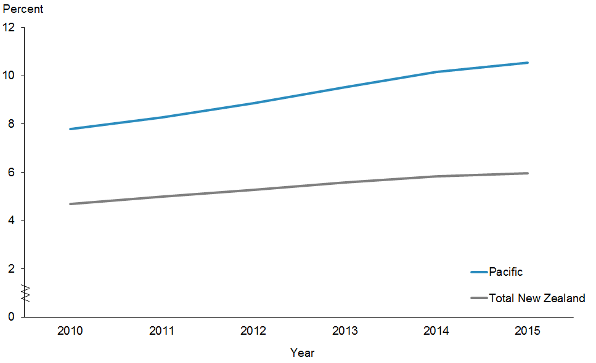
 | 2010 | 2011 | 2012 | 2013 | 2014 | 2015
Pacific | 7.8% | 8.3% | 8.9% | 9.5% | 10.2% | 10.5%
Total New Zealand | 4.7% | 5.0% | 5.3% | 5.6% | 5.8% | 6.0%

Note: This indicator is reported annually.
Figure 36 shows the estimated percentage of Pacific people with diabetes continues to increase at a faster rate than the total New Zealand population.

Figure 37: Estimated percentage of people with diabetes, Pacific peoples, by priority DHBs, 2010–2015
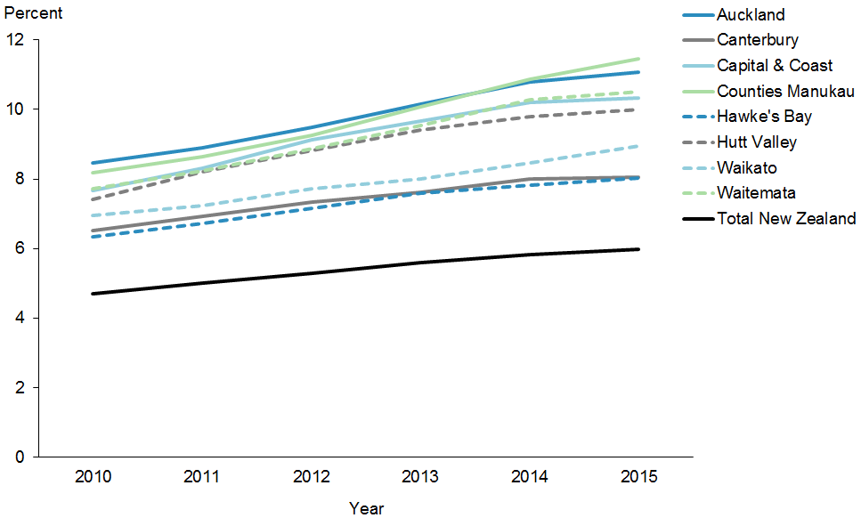
 | 2010 | 2011 | 2012 | 2013 | 2014 | 2015
Auckland | 8.5% | 8.9% | 9.5% | 10.2% | 10.8% | 11.1%
Canterbury | 6.5% | 6.9% | 7.3% | 7.6% | 8.0% | 8.0%
Capital & Coast | 7.7% | 8.3% | 9.1% | 9.7% | 10.2% | 10.3%
Counties Manukau | 8.2% | 8.6% | 9.3% | 10.1% | 10.9% | 11.5%
Hawke's Bay | 6.3% | 6.7% | 7.1% | 7.6% | 7.8% | 8.0%
Hutt Valley | 7.4% | 8.2% | 8.8% | 9.4% | 9.8% | 10.0%
Waikato | 6.9% | 7.2% | 7.7% | 8.0% | 8.5% | 8.9%
Waitemata | 7.7% | 8.2% | 8.9% | 9.5% | 10.3% | 10.5%
Target | 4.7% | 5.0% | 5.3% | 5.6% | 5.8% | 6.0%

Figure 37 shows the estimated percentage of Pacific people with diabetes in the eight priority DHBs. There was no change from the December 2015 progress report. All eight priority DHBs were increasing in prevalence.

Priority outcome 4 –
Pacific peoples experience improved broader determinants of health
There are two quantitative indicators in this priority outcome; rates for neither of those two have reached equity with rates for the total New Zealand population. However, progress has been made in terms of both.
There has been a 25 percent reduction in the rate of rheumatic fever hospitalisations among Pacific peoples from the previous progress reports, and the rate of childhood immunisations at eight months of age among Pacific peoples has achieved the target of 95 percent (at June 2016).
Table 10: Performance against priority outcome 4 indicators, as at 30 June 2016
Indicator | Pacific | Total New Zealand population | Target
Reduce Pacific rheumatic fever hospitalisation rates by June 2017 | 16.6 per 100,000 | 2.1 per 100,000 | 8 per 100,000 (Pacific)
Increase infant immunisation rates at eight months of age | 95.6% coverage | 93.5% coverage | 95% coverage

Priority outcome 4 – Pacific peoples experience improved broader determinants of health
Action 1 | The health and disability sector will work across government to decrease overcrowding in Pacific homes and increase access to healthy housing.

Action commentary

Healthy Homes Initiatives
Through the Rheumatic Fever Prevention Programme, the Ministry is administering Healthy Homes Initiatives (HHIs) across the 11 DHBs in which there is a high incidence of rheumatic fever. HHIs systematically identify families with children at risk of getting rheumatic fever who are living in crowded households and facilitate access to a range of interventions to reduce that crowding.

The Government has announced earlier in 2016 its investment of $36 million to ensure more New Zealand families live in warmer, drier and healthier homes. The investment includes:
- $18 million of operating funding over two years to extend the Warm Up New Zealand programme to insulate rental houses occupied by low-income tenants, particularly those with high health needs.
- $18 million over four years to expand the Healthy Homes Initiative to reduce preventable illnesses among young children (newborns to 5-year olds) who are living in cold, damp and unhealthy homes.

Rheumatic fever
The Ministry continues with its Rheumatic Fever Prevention Programme. The programme has three main strategies to reduce rheumatic fever rates throughout New Zealand, and a number of initiatives for each. They are:
1. increase awareness of rheumatic fever, what causes it and how to prevent it
2. reduce household crowding and therefore reduce household transmission of strep throat bacteria within households
3. improve access to timely and effective treatment for strep throat infections in priority communities.

A range of initiatives have been put in place to tackle rheumatic fever:
- More than 50,000 high risk young people have accessed sore throat drop-in services.
- There are over 300 drop-in clinics in Northland, Auckland, Counties Manukau, Waitemata, Waikato, Rotorua, Tairawhiti, Porirua and the Hutt Valley.
- Children are also being assessed and treated for sore throats through school-based services in around 200 North Island schools.
- Healthy Homes Initiatives in all high incidence areas are offering packages of housing-related interventions to more than 3000 families each year.
- A Pacific Engagement Service has engaged more than 41,000 Auckland and Wellington Pacific families through home visits and community events to raise awareness of rheumatic fever and what they can do to prevent it. The rheumatic fever awareness campaign will run until the end of August – it includes TV, radio and online advertising.

Indicator 1 | Reduction in Pacific rheumatic fever hospitalisation rates by June 2017

Performance: The national target for this indicator is 1.4 per 100,000. The Pacific target for this indicator is 8 per 100,000 by June 2017. This target is based on the two-thirds reduction from baseline rate (2009/2010–2011/2012) as per the target for the total New Zealand population.

Figure 38: Rheumatic fever hospitalisation rates, Pacific peoples, 2011–2015
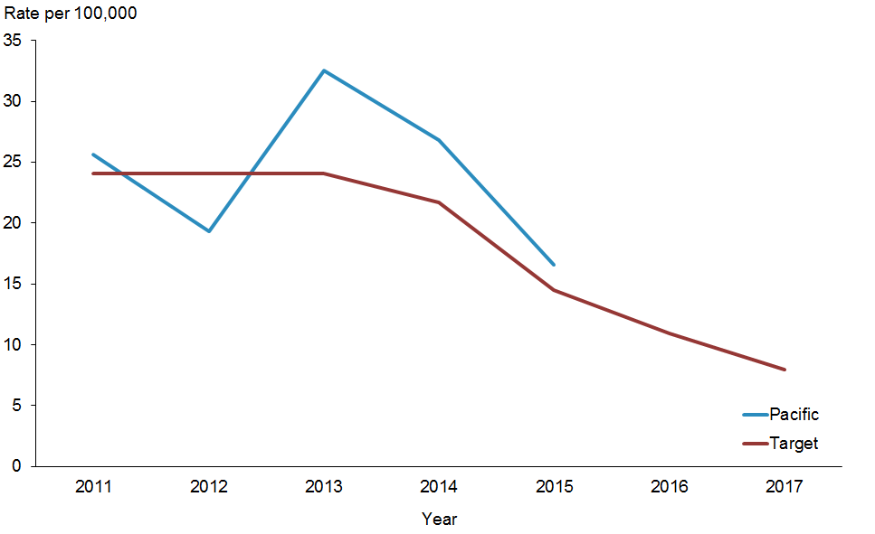
 | 2011 | 2012 | 2013 | 2014 | 2015 | 2016 | 2017
Pacific | 25.6 | 19.3 | 32.5 | 26.8 | 16.6
Total New Zealand | 24.1 | 24.1 | 24.1 | 21.7 | 14.5 | 10.9 | 8

Figure 38 shows that rheumatic fever hospitalisation rates for Pacific peoples have been declining steadily over the years. The decline between 2014 and 2015 has been statistically significant.

Note: We have not reported on this indicator by DHB, as the numbers of new cases for some DHBs are very small.

Action 2 | The Ministry of Health will work in partnership with the Ministry of Social Development; Ministry of Business, Innovation and Employment; Ministry of Education; and New Zealand Police on the following Better Public Services priorities, targeting vulnerable children:  - increase participation in early childhood education  - increase infant immunisation rates  - reduce the incidence of rheumatic fever  - reduce the number of assaults on children.

Action commentary

Prior early childhood education participation
The Ministry of Education March 2016 figures for Prior Participation in Early Childhood Education for Pacific children is 92.5 percent, compared with 96.6 percent for total New Zealand children. The target is 98.0 percent by 2016.

Increase infant immunisation rates
The Ministry of Health and DHBs are continuing to push hard to achieve the target of 95 percent immunisation coverage at eight months of age. In this progress report, Pacific has achieved the Health Target at 95.6 percent compared with 93.5 percent for the total New Zealand population. This is a great achievement for Pacific peoples.

Reducing the incidence of rheumatic fever
In December 2015, the Ministry of Health rheumatic fever campaign evaluation came back positive. The independent evaluation by Allen + Clarke Policy and Regulatory Specialists Ltd describes the rheumatic fever campaign as ‘efficient, effective and relevant’. The campaign exceeded the expected level of reach amongst the target Māori and Pasifika audience, with about 95 percent having seen or heard the campaign. They also had a good understanding of the issue, and the campaign was promoting positive health behaviour and discussions. Other prevention activities in high-incidence areas include targeted sore throat drop-in clinics, school-based services, HHIs, and Pacific engagement services. The combination effect of these initiatives is making a difference. Rheumatic fever rates are trending down. Rheumatic fever hospitalisation has dropped. In 2015, 98 people were hospitalised for the first time with rheumatic fever in compared with 177 hospitalisations in 2012 which is a 45 percent reduction. Pacific numbers also dropped by 27 percent over the same period.

Indicator 2 | Increase infant immunisation rates

Performance: The target for this indicator is 95 percent.

Figure 39: Immunisation coverage (percent) at eight months of age (three-month reporting), Pacific peoples population and total New Zealand population, 2013–2016
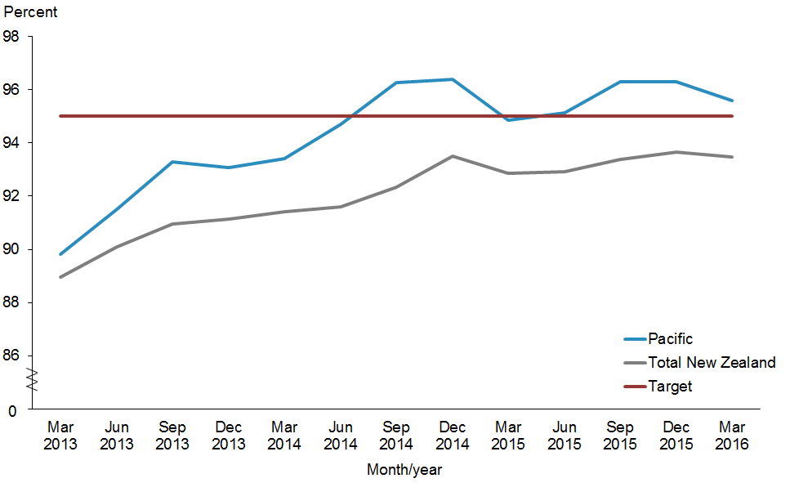
 | Mar 2013 | Jun 2013 | Sep 2013 | Dec 2013 | Mar 2014 | Jun 2014 | Sep 2014 | Dec 2014 | Mar 2015 | Jun 2015 | Sep 2015 | Dec 2015 | Mar 2016
Pacific | 89.8% | 91.5% | 93.3% | 93.1% | 93.4% | 94.7% | 96.3% | 96.4% | 94.9% | 95.1% | 96.3% | 96.3% | 95.6%
Total New  Zealand | 88.9% | 90.1% | 91.0% | 91.1% | 91.4% | 91.6% | 92.4% | 93.5% | 92.9% | 92.9% | 93.4% | 93.7% | 93.5%
Target | 95.0% | 95.0% | 95.0% | 95.0% | 95.0% | 95.0% | 95.0% | 95.0% | 95.0% | 95.0% | 95.0% | 95.0% | 95.0%

Note: This is the first time the eight-months immunisation coverage has been used to be in-line with the Health Target. Previous ’Ala Mo’ui Progress Reports have used the six-months immunisation coverage.

Figure 39 shows that Pacific immunisation coverage at eight months of age has achieved the target. Pacific people have achieved this target compared with the total New Zealand population.

Figure 40: Immunisation coverage (percent) at eight months of age (three-month reporting), Pacific peoples, by priority DHBs, 2013–2016
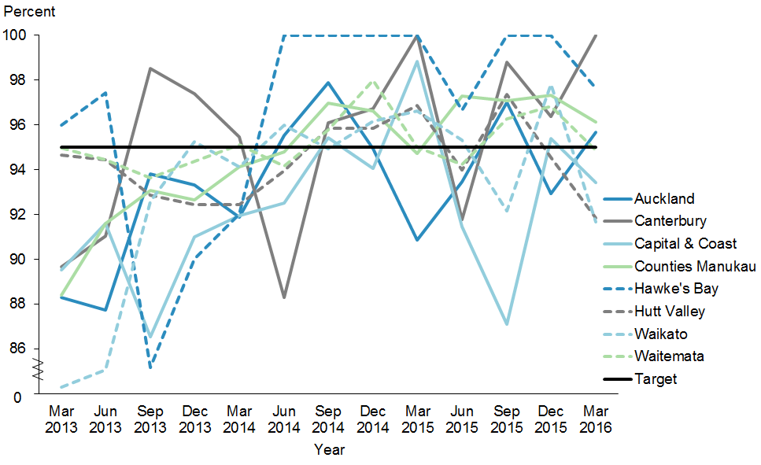
 | Mar 2013 | Jun 2013 | Sep 2013 | Dec 2013 | Mar 2014 | Jun 2014 | Sep 2014 | Dec 2014 | Mar 2015 | Jun 2015 | Sep 2015 | Dec 2015 | Mar 2016
Auckland | 88.3% | 87.7% | 93.8% | 93.3% | 91.9% | 95.5% | 97.9% | 94.9% | 90.9% | 93.5% | 97.0% | 92.9% | 95.7%
Canterbury | 89.7% | 91.0% | 98.5% | 97.4% | 95.5% | 88.3% | 96.1% | 96.7% | 100% | 91.8% | 98.8% | 96.4% | 100%
Capital & Coast | 89.5% | 91.6% | 86.5% | 91.0% | 92.0% | 92.5% | 95.4% | 94.1% | 98.8% | 91.5% | 87.1% | 95.4% | 93.4%
Counties Manukau | 88.4% | 91.6% | 93.1% | 92.7% | 94.1% | 94.8% | 97.0% | 96.6% | 94.7% | 97.3% | 97.1% | 97.3% | 96.1%
Hawke's Bay | 96.0% | 97.4% | 85.2% | 90.0% | 92.0% | 100% | 100% | 100% | 100% | 96.7% | 100% | 100% | 97.6%
Hutt Valley | 94.6% | 94.4% | 92.9% | 92.5% | 92.5% | 93.9% | 95.8% | 95.8% | 96.9% | 94.0% | 97.4% | 94.5% | 91.8%
Waikato | 84.3% | 85.1% | 92.6% | 95.2% | 94.1% | 96.0% | 94.9% | 96.2% | 96.6% | 95.3% | 92.2% | 97.8% | 91.7%
Waitemata | 95.0% | 94.4% | 93.6% | 94.4% | 95.1% | 94.2% | 95.8% | 98.0% | 95.0% | 94.2% | 96.3% | 96.8% | 94.9%
Target | 95.0% | 95.0% | 95.0% | 95.0% | 95.0% | 95.0% | 95.0% | 95.0% | 95.0% | 95.0% | 95.0% | 95.0% | 95.0%

Figure 40 shows that Auckland, Canterbury, Counties Manukau, Hawke’s Bay and Waitemata DHBs have achieved the target. The other three DHBs are not far away from achieving this target.

References
Bennett J, Chisholm E, Hansen R, et al. 2014. Results from a Rental Housing Warrant of Fitness Pre-Test. Wellington: University of Otago.
Counties Manukau Health. 2016. Counties Manukau District Health Board Annual Plan 2015/2016. Auckland: Counties Manukau Health.
Ministry of Health. 2012a. Rising to the Challenge: The Mental Health and Addictions Service Development Plan 2012–2017. Wellington: Ministry of Health.
Ministry of Health. 2012b. Tupu Ola Moui: Pacific Health Chart Book 2012. Wellington: Ministry of Health.
Ministry of Health. 2014. ’Ala Mo’ui: Pathways to Pacific Health and Wellbeing 2014–2018. Wellington: Ministry of Health.
Ministry of Health. 2015a. A Framework for Health Literacy. Wellington: Ministry of Health.
Ministry of Health. 2015b. Independent Life Expectancy in New Zealand 2013. Wellington: Ministry of Health.
Ministry of Health. 2015c. Living Well with Diabetes: A health care plan for people at high risk of or living with diabetes 2015–2020. Wellington: Ministry of Health.
Ministry of Health. 2015d. National Maternity Monitoring Group Annual Report 2015. Wellington: Ministry of Health.
Ministry of Health. 2016. Indicators for the Well Child/Tamariki Ora Quality Improvement Framework – September 2015. Wellington: Ministry of Health.
Statistics New Zealand. 2015. New Zealand Period Life Tables: 2012–14. URL: www.stats.govt.nz/browse_for_stats/health/life_expectancy/NZLifeTables_HOTP12-14.aspx (accessed 28 August 2015).
Tan J, Ward G, Thompson L. 2015. Report of the Parliamentary Review Committee regarding the New Zealand Cervical Screening Programme. Wellington: Ministry of Health.

Appendix
Table A1: Projected Pacific peoples population for 2015/16 by DHB based on the 2013 Census
DHB | Population | Percentage
Counties Manukau | 111,910 | 37.4%
Auckland | 53,870 | 18.0%
Waitemata | 41,430 | 13.8%
Capital & Coast | 21,410 | 7.2%
Canterbury | 12,910 | 4.3%
Hutt Valley | 11,420 | 3.8%
Waikato | 11,290 | 3.8%
Hawke’s Bay | 6010 | 2.0%
Southern | 6000 | 2.0%
MidCentral | 5060 | 1.7%
Bay of Plenty | 3890 | 1.3%
Northland | 3300 | 1.1%
Lakes | 2480 | 0.8%
Nelson Marlborough | 2330 | 0.8%
Taranaki | 1535 | 0.5%
Whanganui | 1330 | 0.4%
Tairāwhiti | 1185 | 0.4%
Wairarapa | 875 | 0.3%
South Canterbury | 590 | 0.2%
West Coast | 365 | 0.1%
Total | 299,190 | 100%
Note: Percentages have been rounded. The eight priority DHBs are in bold.

The first progress report on ’Ala Mo’ui tracked and monitored 23 indicator measures. The two indicator measures no longer being monitored and tracked are ‘Pacific caries-free at year eight’ and ‘Pacific decayed, missing, or filled teeth (DMFT) rates at age five’. The Ministry has decided that the two indicator measures ‘Pacific caries-free at age five’ and ‘Pacific DMFT rates at school year eight’ suffice for monitoring oral health outcomes for Pacific children.
Nine out of the total of 21 indicators that are monitored in ’Ala Mo’ui currently do not have set national targets. The difference between the Pacific population and the total New Zealand population is used as a measure of equity.
Whānau House is operated by Te Whānau o Waipareira Trust and offers families ‘wrap-around’ integrated services (health, social, justice and education) tailored to their needs.
Cole cut-offs are BMI for overweight and obesity by gender and age.
Alliance Health Plus is the only Pacific PHO. Its enrolled population was approximately 90,000 as at 30 June 2014. Its performance against aggregate health targets in 2014 was in the top quartile of PHOs nationally.

