’Ala Mo’ui Progress Report

December 2015

Citation: Ministry of Health. 2016. *’Ala Mo’ui Progress Report: December 2015*. Wellington: Ministry of Health.

Published in April 2016  
by the Ministry of Health  
PO Box 5013, Wellington 6145, New Zealand

ISBN 978-0-947491-94-9 (online)  
HP 6251

This document is available at health.govt.nz



### CCBY This work is licensed under the Creative Commons Attribution 4.0 International licence. In essence, you are free to: share ie, copy and redistribute the material in any medium or format; adapt ie, remix, transform and build upon the material. You must give appropriate credit, provide a link to the licence and indicate if changes were made.

Contents

Executive summary vii

Whole-of-system measures 1

Life expectancy 1

Health expectancy 1

Ambulatory sensitive hospitalisation rates 1

Priority outcome 1 – Systems and services meet the needs of Pacific peoples 5

Priority outcome 2 – More services are delivered locally in the community and in primary care 41

Priority outcome 3 – Pacific peoples are better supported to be healthy 50

Priority outcome 4 – Pacific peoples experience improved broader determinants of health 55

References 61

Appendix 62

List of tables

Table 1: *’Ala Mo’ui* indicators where performance for Pacific peoples has achieved equity, as at 31 December 2015 viii

Table 2: *’Ala Mo’ui* indicators where there is a disparity in equity between Pacific peoples and the set target, as at 31 December 2015 viii

Table 3: *’Ala Mo’ui* indicators where there is a disparity in equity between Pacific peoples and the total New Zealand population, as at 31 December 2015 ix

Table 4: *’Ala Mo’ui* performance indicators progress for the priority DHBs, as at 31 December 2015 x

Table 5: Priority outcome 1 performance indicators where equity is a concern for Pacific peoples, as at 31 December 2015 4

Table 6: DHB ‘Rising to the Challenge’ actions delivered, as at 31 December 2015 5

Table 7: DHB activities delivered to improve services offering Pacific peoples better help for smokers to quit, as at 31 December 2015 27

Table 8: DHB work towards offering Pacific peoples more heart and diabetes checks, as at 31 December 2015 28

Table 9: Performance against priority outcome 2 indicators, as at 31 December 2015 40

Table 10: Performance against priority outcome 4 indicators, as at 31 December 2015 54

Table A1: Projected Pacific peoples population for 2015/16 by DHB based on the 2013 Census 62

List of figures

Figure 1: ASH rates per 100,000 (0–74-year-olds), Pacific peoples population and total New Zealand population, 2001–2014 2

Figure 2: ASH rates per 100,000 (0–74-year-olds), Pacific peoples, by priority district health boards (DHBs), 2001–2014 3

Figure 3: Access rate to DHB mental health services, Pacific peoples population and total New Zealand population, 2005/2006–2014/2015 6

Figure 4: Access rate to DHB mental health services, Pacific peoples, by priority DHBs, 2005/2006–2014/2015 7

Figure 5: Access to DHB alcohol and drug services, Pacific peoples population and total New Zealand population, 2012/2013–2014/2015 8

Figure 6: Access to DHB alcohol and drug services, Pacific peoples, by priority DHBs, 2012/2013–2014/2015 9

Figure 7: Percentage of newborn infants enrolled with a general practice by three months of age, Pacific peoples population and total New Zealand population, 2013–2015 11

Figure 8: Percentage of newborn infants enrolled with a general practice by three months of age, Pacific peoples, by priority DHBs, 2013–2015 12

Figure 9: Percentage of infants who received all WCTO core contacts in their first year of life, Pacific peoples population and total New Zealand population, 2013–2015 13

Figure 10: Percentage of infants who received all WCTO core contacts in their first year of life, Pacific peoples, by priority DHBs, 2013–2015 14

Figure 11: Percentage of four-year-olds who received a B4SC, Pacific peoples population and total New Zealand population, 2013–2015 15

Figure 12: Percentage of four-year-olds who received a B4SC, Pacific peoples, by priority DHBs, 2013–2015 16

Figure 13: Percentage of infants exclusively or fully breastfed at three months of age, Pacific peoples population and total New Zealand population, 2013–2015 17

Figure 14: Percentage of infants exclusively or fully breastfed at three months of age, Pacific peoples, by priority DHBs, 2013–2015 18

Figure 15: Percentage of children with BMI >99.4th percentile referred to a GP or specialist services, Pacific peoples population and total New Zealand population, 2013–2015 19

Figure 16: Percentage of children with BMI >99.4th percentile referred to a GP or specialist services, Pacific peoples, by priority DHBs, 2013–2015 20

Figure 17: Percentage of children under five years old enrolled in the Community Oral Health Service, Pacific peoples population and total New Zealand population, 2007–2014 21

Figure 18: Percentage of children under five years old enrolled in the Community Oral Health Service, Pacific peoples, by priority DHBs, 2007–2014 22

Figure 19: Percentage of children caries-free at age five, Pacific peoples population and total New Zealand population, 2007–2014 23

Figure 20: Percentage of children caries-free at age five, Pacific peoples, by priority DHBs, 2007–2014 24

Figure 21: Mean rate of DMFT at school year eight, Pacific peoples population and total New Zealand population, 2007–2014 25

Figure 22: Mean rate of DMFT at school year eight, Pacific peoples, by priority DHBs, 2007–2014 26

Figure 23: Percentage of smokers offered brief advice and support to quit in primary health care, Pacific peoples population and total New Zealand population, 2013–2015 30

Figure 24: Percentage of smokers offered brief advice and support to quit in primary health care, Pacific peoples, by priority DHBs, 2013–2015 31

Figure 25: Percentage of eligible adults who had cardiovascular risk assessed, Pacific peoples population and total New Zealand population, 2013–2015 32

Figure 26: Percentage of eligible adults who had cardiovascular risk assessed, Pacific peoples, by priority DHBs, 2013–2015 33

Figure 27: Percentage of children who are obese (BMI >/= Cole cut-offs), Pacific peoples population and total New Zealand population, 2006–2014 35

Figure 28: Percentage of children who are obese (BMI >/= Cole cut-offs), Pacific peoples, by priority DHBs, 2006–2014 36

Figure 29: Percentage of enrolled women aged 25–69 years who received a cervical smear in the past three years, Pacific peoples population and total New Zealand population, 2013–2015 38

Figure 30: Percentage of enrolled women aged 25–69 years who received a cervical smear in the past three years, Pacific peoples, by priority DHBs, 2013–2015 39

Figure 31: GP utilisation rate (average visits per person per year), Pacific peoples population and total New Zealand population, 2008–2015 43

Figure 32: GP utilisation rate (average visits per person), Pacific peoples, by priority DHBs, 2008–2015 44

Figure 33: Nurse utilisation rate (average visits per person), Pacific peoples population and total New Zealand population, 2008–2015 45

Figure 34: Nurse utilisation rate (average visits per person), Pacific peoples, by priority DHBs, 2008–2015 46

Figure 35: Total GP and nurse utilisation rate (average visits per person), Pacific peoples population and total New Zealand population, 2008–2015 47

Figure 36: Total GP and nurse utilisation rate (average visits per person), Pacific peoples, by priority DHBs, 2008–2015 48

Figure 37: Estimated percentage of people with diabetes, Pacific peoples population and total New Zealand population, 2010–2014 53

Figure 38: Estimated percentage of people with diabetes, Pacific peoples, by priority DHBs, 2010–2014 54

Figure 39: Rheumatic fever hospitalisation rates, Pacific peoples, 2011–2015 56

Figure 40: Immunisation coverage (percent) at six months of age (three-month reporting), Pacific peoples population and total New Zealand population, 2013–2015 59

Figure 41: Immunisation coverage (percent) at six months of age (three-month reporting), Pacific peoples, by priority DHBs, 2013–2015 60

# Executive summary

*’Ala Mo’ui: Pathways to Pacific Health and Wellbeing 2014–2018* (*’Ala Mo’ui*) is a four-year plan that provides an outcomes framework for delivering high-quality health services to Pacific peoples. The outcomes and actions in *’Ala Mo’ui* contribute to the Government’s long-term outcomes for health: all New Zealanders, including Pacific peoples, will lead healthier and more independent lives; high-quality health services will be delivered in a timely and accessible manner; and the future sustainability of the health and disability sector will be assured (Ministry of Health 2014).

The long term vision of *’Ala Mo’ui* is:

Pacific ’āiga, kāiga, magafaoa, kōpū tangata, vuvale and fāmili experience equitable health outcomes and lead independent lives.

Its four priority outcome areas are:

1. Systems and services meet the needs of Pacific peoples.

2. More services are delivered locally in the community and in primary care.

3. Pacific peoples are better supported to be healthy.

4. Pacific peoples experience improved broader determinants of health.

### Indicators used in *’Ala Mo’ui*

*’Ala Mo’ui* sets out 13 actions, which sit across four priority outcome areas to achieve its long-term vision and outcomes. Associated with these actions are 21[1] indicators. The aim of the indicators is to monitor and promote quality improvement across the health and disability sector without creating any additional reporting burden. The indicators are a subset of measures drawn from existing data collections and reporting mechanisms; for example, the Well Child/ Tamariki Ora (WCTO) Quality Improvement Framework, the health targets and the Better Public Services targets. The Ministry will review the indicators on a regular basis as the sector performance improves.

### Monitoring and reporting

The Ministry of Health (through *’Ala Mo’ui*) will monitor the 21 indicators and measure performance against set national targets[2] or the total New Zealand population across eight district health boards (DHBs) where 90 percent of Pacific peoples reside. The eight DHBs that are considered the ‘Pacific priority DHBs’ are (in order of highest numbers of Pacific peoples) Counties Manukau, Auckland, Waitemata, Capital & Coast, Canterbury, Hutt Valley, Waikato and Hawke’s Bay. See the Appendix for Pacific peoples population numbers and percentages for each of the 20 DHBs. Population figures in this report are based on Statistics New Zealand population projections, which use Census 2013 figures as a base. The total New Zealand population in 2015 and 2016 was 4,638,750. The total Pacific peoples population was 299,190. All indicators will be reported by DHBs and published online on a six-monthly basis.

### National level progress to 31 December 2015

At a national level, progress has been made in achieving equity for Pacific peoples in five of the 21 indicators (Table 1).

The definition of equity for the purpose of this report is equal to or greater than the total New Zealand population if no national target has been set or has achieved the national target set for that particular indicator.

Table 1: *’Ala Mo’ui* indicators where performance for Pacific peoples has achieved equity, as at 31 December 2015

|  |  |  |  |
| --- | --- | --- | --- |
| **Indicator** | **Pacific peoples** | **Total New Zealand** | **National target** |
| Access to DHB alcohol and drug services | 1.24% | 1.03% | No target |
| Percentage of four-year-olds who received a Before School Check (B4SC), Pacific peoples | 93% | 94% | 90% |
| General practitioner (GP) utilisation rate (average number of visits per person per year) | 3.01 | 2.95 | No target |
| Nurse utilisation rate (average number of visits per person per year) | 0.76 | 0.68 | No target |
| Total GP and nurse utilisation rate (average visits per person) | 3.77 | 3.62 | No target |

The last three indicators on Table 1 show Pacific peoples’ access to GP services is high and has maintained the achieved status over the six months since June 2015.

Table 2: *’Ala Mo’ui* indicators where there is a disparity in equity between Pacific peoples and the set target, as at 31 December 2015

|  |  |  |
| --- | --- | --- |
| **Indicator** | **Pacific peoples** | **National target** |
| Percentage of newborn infants enrolled with a general practice by three months of age | 73.0% | 98.0% |
| Infants who received all WCTO core contacts in their first year of life | 53.0% | 95.0% |
| Percentage of infants exclusively or fully breastfed at three months of age | 47.0% | 60.0% |
| Percentage of children with body mass index (BMI) >99.4th percentile referred to a GP or specialist services | 92.0% | 95.0% |
| Percentage of children under five years old enrolled in DHB-funded dental services | 74.7% | 95.0% |
| Children who were caries-free at age five | 35.3% | 65.0% |
| Percentage of smokers offered brief advice and support to quit in primary health care | 82.4% | 90.0% |
| Percentage of eligible adults who had cardiovascular risk assessed | 89.2% | 90.0% |
| Percentage of enrolled women aged 25–69 years who received a cervical smear in the past three years | 73.9% | 80.0% |
| Immunisation coverage (percentage) at six months of age (three-month reporting) | 78.7% | 95.0% |
| Rheumatic fever hospitalisation rate per 100,000 | 22.1 | 8.0* |

* The 8 per 100,000 rate target for Pacific peoples is based on a two-thirds reduction from baseline rate (2009/2010–2011/2012) as per the target for the total population.

Table 3: *’Ala Mo’ui* indicators where there is a disparity in equity between Pacific peoples and the total New Zealand population, as at 31 December 2015

|  |  |  |
| --- | --- | --- |
| **Indicator** | **Pacific peoples** | **Total New Zealand** |
| Ambulatory sensitive hospitalisation (ASH) rate per 100,000 | 3,900 | 1,936 |
| Access rate to DHB mental health services | 3.14% | 3.48% |
| Mean rate of DMFT for children at school year eight | 1.5 | 1.0 |
| Children aged 2–14 years who are obese | 25.0% | 11.0% |
| Estimated percentage of people with diabetes | 9.6% | 6.0% |

### District health boards progress to 31 December 2015

Table 4 shows the summary of all the indicators monitored in *’Ala Mo’ui* across the eight priority DHBs. The DHBs are arranged from the biggest population on the left to the smallest population on the right. The arrows indicate the trend of progress over time. Rheumatic fever data was not presented because there were not enough numbers (new cases) in a number of DHBs to successfully estimate the rheumatic fever hospitalisation rate with confidence.

Other indicators that were not presented in Table 4 for this progress report were ‘ASH rates per 100,000’ (0–74-year-olds), ‘Percentage of children who are obese’ and the ‘Estimated percentage of people with diabetes’. These three indicators will be updated as data becomes available.

The exclusion of the ASH rates from this progress report was due to a change in definition (refer to page 1). Data for the ‘Percentage of children who are obese’ was not available in time for this progress report, as well as data for the ‘Estimated percentage of people with diabetes’, which is reported annually.

Table 4: *’Ala Mo’ui* performance indicators progress for the priority DHBs, as at 31 December 2015



# Whole-of-system measures

*’Ala Mo’ui* aims to make a positive impact on three particular whole-of-system indicators in the long term:

* **Life expectancy** – the number of years a person can expect to live (Ministry of Health 2015b)
* **Health expectancy** – in the form of independent life expectancy, is the number of years a person can expect to live free of functional limitation needing assistance (Ministry of Health 2015b)
* **Ambulatory sensitive hospitalisation (ASH)** **rates** – ASH rates refers to hospitalisations due to medical conditions that could be avoided by the provision of adequate primary health care (Ministry of Health 2012b).

## Life expectancy

Life expectancy at birth continues to improve for Pacific peoples. However, Pacific peoples still have shorter life expectancy compared with the total New Zealand population. Based on death rates in New Zealand in 2012–20f14, life expectancy was 78.7 years for Pacific females and 74.5 years for Pacific males, compared with 83.2 years for females and 79.5 years for males in the total New Zealand population (Statistics New Zealand 2015).

## Health expectancy

In 2006, the gap in health expectancy for Pacific males compared with males in the total population was 4.4 years. The gap for Pacific females compared with the females in the total population was 5.3 years.

Health expectancy at birth for New Zealand women has increased steadily for all females since 1996 to 2013, from 66.4 to 66.5. Health expectancy at birth for New Zealand men over the same period has also increased, from 63.8 to 65.2 (Ministry of Health 2015b).

The health expectancy indicator has not been updated since 2006 for Pacific peoples.

## Ambulatory sensitive hospitalisation rates

ASH rates are often used as a measure of the effectiveness of the interface between primary and secondary health care. ASH rates are a health system indicator. The assumption is that better management of chronic conditions such as diabetes and cardiovascular disease within local communities has the potential to reduce the number of avoidable hospital admissions (and to moderate demand on hospital resources). Diagnosis information on hospitalisations sent to the national data set is analysed quarterly to provide avoidable ambulatory sensitive hospitalisations.

The Ministry initiated a review of the methodology used to calculate ASH rates towards the end of 2014. As a result of the review, the Ministry is changing the previous ASH definition to differentiate ‘Child ASH’ from ‘Adult ASH’. The rationale is that clinical conditions for ‘Child ASH’ differ from those for ‘Adult ASH’. Combining the two to create a single measure adds no utility to ASH. The Ministry will now be reporting Child ASH (0–4-year-olds) and Adult ASH (45–64-year-olds) rates. (Refer: <http://nsfl.health.govt.nz/accountability/performance-and-monitoring/performance-measures/performance-measures-201516>)

**Note**: ASH rates are not updated for this report. The next report will have the two new rates (Child and Adult).

Figure : ASH rates per 100,000 (0–74-year-olds), Pacific peoples population and total New Zealand population, 2001–2014

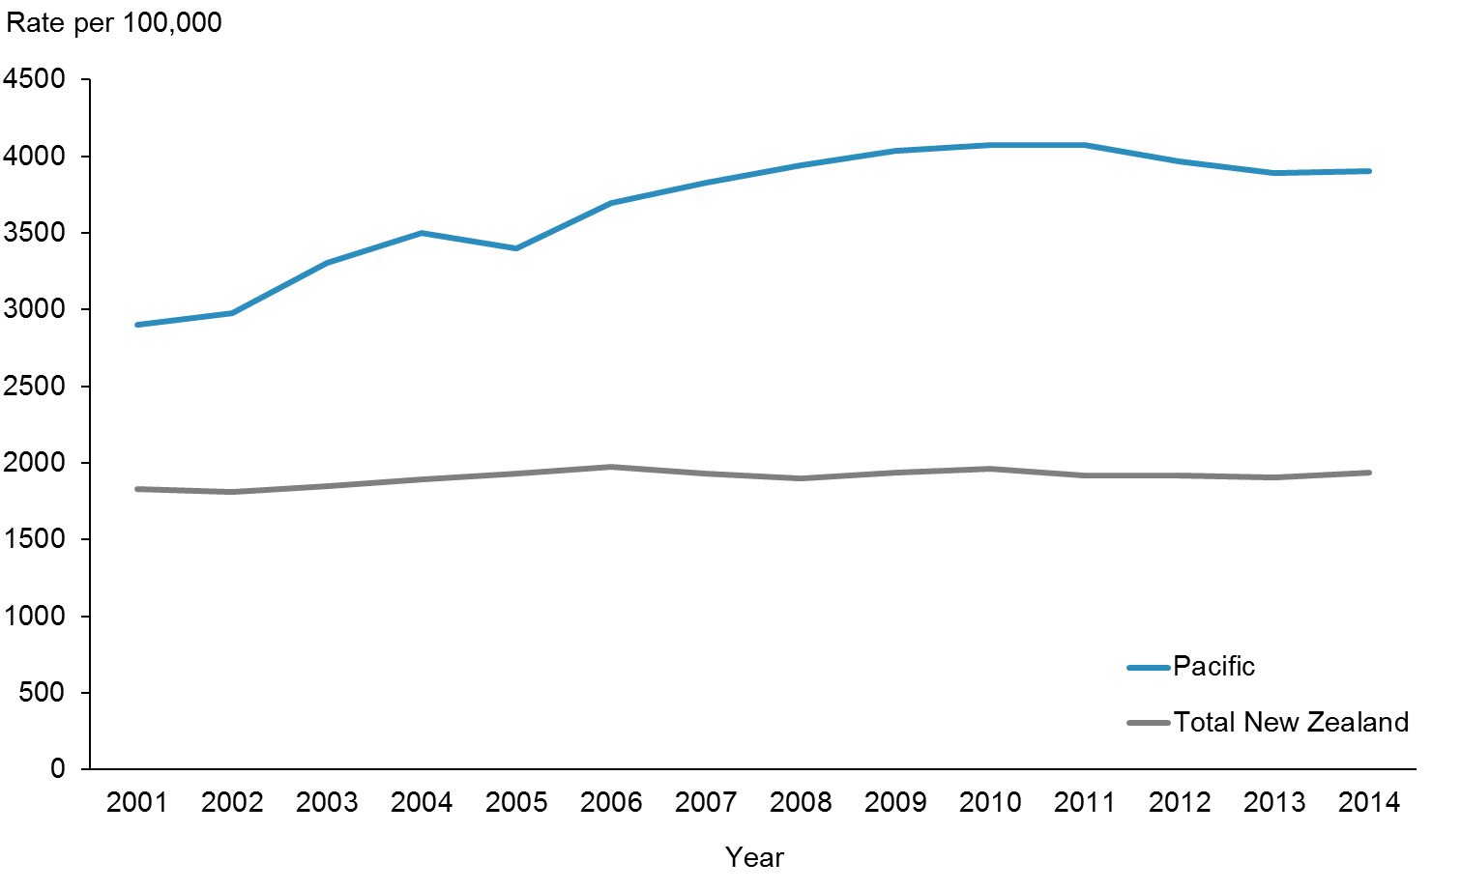

|  |  |  |  |  |  |  |  |  |  |  |  |  |  |  |
| --- | --- | --- | --- | --- | --- | --- | --- | --- | --- | --- | --- | --- | --- | --- |
|  | **2001** | **2002** | **2003** | **2004** | **2005** | **2006** | **2007** | **2008** | **2009** | **2010** | **2011** | **2012** | **2013** | **2014** |
| Pacific | 2898 | 2975 | 3307 | 3503 | 3399 | 3697 | 3827 | 3938 | 4033 | 4072 | 4070 | 3964 | 3894 | 3900 |
| Total New Zealand | 1828 | 1808 | 1846 | 1891 | 1932 | 1976 | 1930 | 1898 | 1936 | 1964 | 1917 | 1918 | 1906 | 1936 |

Figure 1 presents ASH rates between 2001 and 2014 (previously reported in the June 2015 progress report). There was no change since the June 2015 progress report.

Figure : ASH rates per 100,000 (0–74-year-olds), Pacific peoples, by priority district health boards (DHBs), 2001–2014

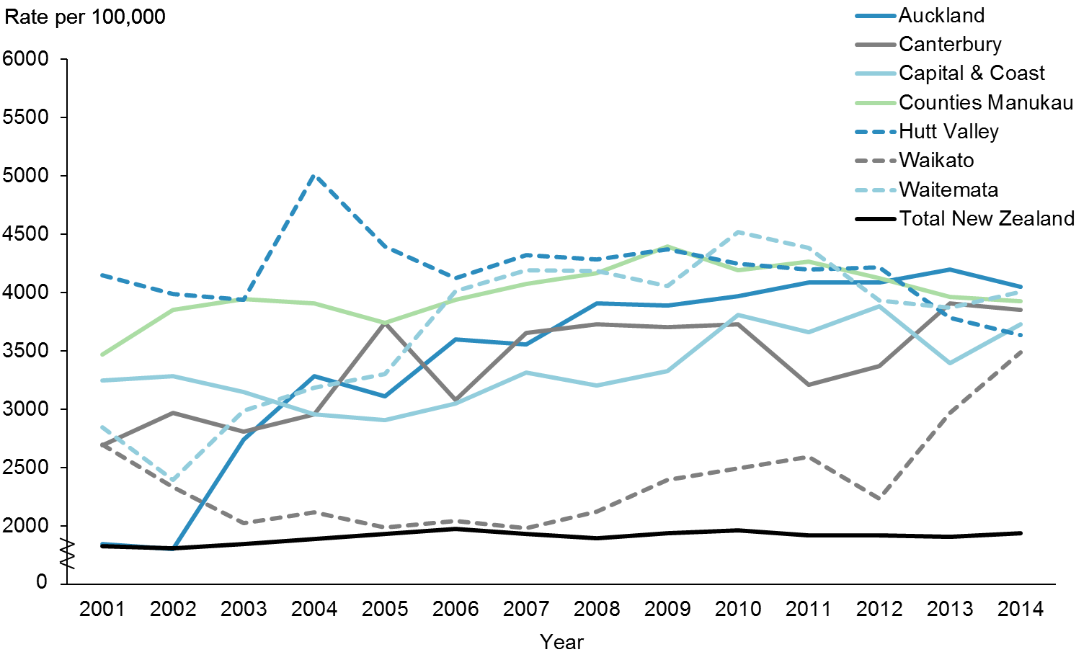

|  |  |  |  |  |  |  |  |  |  |  |  |  |  |  |
| --- | --- | --- | --- | --- | --- | --- | --- | --- | --- | --- | --- | --- | --- | --- |
|  | **2001** | **2002** | **2003** | **2004** | **2005** | **2006** | **2007** | **2008** | **2009** | **2010** | **2011** | **2012** | **2013** | **2014** |
| Auckland | 1845 | 1801 | 2740 | 3283 | 3109 | 3601 | 3559 | 3910 | 3887 | 3973 | 4084 | 4088 | 4201 | 4050 |
| Canterbury | 2694 | 2971 | 2809 | 2957 | 3744 | 3083 | 3652 | 3726 | 3702 | 3731 | 3211 | 3370 | 3908 | 3850 |
| Capital & Coast | 3245 | 3282 | 3149 | 2954 | 2907 | 3047 | 3316 | 3203 | 3330 | 3809 | 3664 | 3886 | 3395 | 3727 |
| Counties Manukau | 3468 | 3851 | 3943 | 3906 | 3743 | 3940 | 4074 | 4169 | 4396 | 4195 | 4264 | 4126 | 3965 | 3928 |
| Hutt Valley | 4149 | 3986 | 3936 | 5015 | 4397 | 4125 | 4325 | 4284 | 4371 | 4250 | 4198 | 4220 | 3785 | 3635 |
| Waikato | 2695 | 2333 | 2024 | 2120 | 1987 | 2040 | 1983 | 2124 | 2397 | 2493 | 2592 | 2235 | 2967 | 3488 |
| Waitemata | 2844 | 2394 | 2986 | 3184 | 3300 | 4016 | 4194 | 4186 | 4057 | 4522 | 4384 | 3934 | 3871 | 4010 |
| Total New Zealand | 1828 | 1808 | 1846 | 1891 | 1932 | 1976 | 1930 | 1898 | 1936 | 1964 | 1917 | 1918 | 1906 | 1936 |

Figure 2 shows the ASH rates between 2001 and 2014 by priority DHBs. The numbers for Hawke’s Bay DHB were too small to report on. There was no change since the June 2015 progress report.

|  |  |  |  |  |  |  |  |  |  |  |  |  |  |  |  |  |  |  |  |  |  |  |  |  |  |  |  |  |  |  |  |  |  |  |  |  |  |  |  |  |  |  |  |  |  |  |  |  |  |  |  |  |
| --- | --- | --- | --- | --- | --- | --- | --- | --- | --- | --- | --- | --- | --- | --- | --- | --- | --- | --- | --- | --- | --- | --- | --- | --- | --- | --- | --- | --- | --- | --- | --- | --- | --- | --- | --- | --- | --- | --- | --- | --- | --- | --- | --- | --- | --- | --- | --- | --- | --- | --- | --- | --- |
| **Priority outcome 1 – Systems and services meet the needs of Pacific peoples**  The following presents a brief summary of performance indicator results in priority outcome 1 for this reporting period.  Within this priority outcome, some progress had been made in achieving equity or the set target in two indicators as at 31 December 2015:  1. access rate to alcohol and drug services where Pacific peoples had 1.24 percent compared with 1.03 percent for the total population  2. percentage of four-year-olds who received a Before School Check (B4SC) where Pacific children achieved 93 percent compared with 94 percent for the total population and a target set at 90 percent.  For all the other indicators under priority outcome 1, Pacific rates or percentages did not achieve either equity or the target set.  Table 5: Priority outcome 1 performance indicators where equity is a concern for Pacific peoples, as at 31 December 2015   |  |  |  |  | | --- | --- | --- | --- | | **Indicator** | **Pacific** | **Total population** | **Target** | | Access rate to mental health services | 3.14% | 3.48% | No target | | Newborn infants enrolled with a general practice by three months of age | 73.0% | 74.0% | 98.0% | | Infants who received all Well Child/Tamariki Ora (WCTO) core contacts in their first year of life | 53.0% | 68.0% | 95.0% | | Infants exclusively or fully breastfed at three months of age | 47.0% | 55.0% | 60.0% | | Percentage of children with body mass index (BMI) >99.4th percentile referred to a general practitioner (GP) or specialist services | 92.0% | 83.0% | 95.0% | | Children enrolled in DHB-funded dental services | 74.7% | 75.6% | 95.0% | | Children caries-free at age five | 35.3% | 58.6% | 65.0% | | Mean rate of decayed, missing, or filled teeth (DMFT) for children at school year eight | 1.53 | 1.02 | No target | | Smokers offered brief advice and support to quit in primary health care | 82.4% | 83.2% | 90.0% | | Percentage of eligible adults who had had cardiovascular risk assessments | 89.2% | 89.8% | 90.0% | | Children aged 2–14 years who are obese | 25% | 11% | No target | | Enrolled women aged 25–69 years who received a cervical smear in the past three years | 73.9% | 76.6% | 80.0% | |

# Priority outcome 1 – Systems and services meet the needs of Pacific peoples

|  |  |
| --- | --- |
| **Action 1** | **DHBs will implement the actions focused on Pacific peoples in *Rising to the Challenge: The Mental Health and Addiction Service Development Plan 2012–2017* in order to build more responsive services for Pacific peoples who are severely affected by mental illness or addiction.** |

### Action commentary

*Rising to the Challenge: The Mental Health and Addiction Service Development Plan  
2012–2017* was released in 2012 (Ministry of Health 2012a). This was further impetus for mental health and addiction services to increase national consistency in access, service quality and outcomes for people who use services, for their families and whānau, and for communities. It sets a service development pathway with clear actions to be achieved over the five-year period, so that all New Zealanders can be confident that publicly funded health services are working in ways that achieve the most effective outcomes for those who most need them and that make the best use of public money.

Table 6: DHB ‘Rising to the Challenge’ actions delivered, as at 31 December 2015

|  |  |
| --- | --- |
| **DHB** | **Actions** |
| Capital & Coast and Hutt Valley | Capital & Coast DHB continues to lead the development of a new integrated mental health, addictions and intellectual disability service across three DHBs (Capital & Coast, Hutt Valley and Wairarapa). This will entail an acute adult model of care pathway with a focus on improving access for Pacific and Māori populations. Planning has commenced on this model of care. |
| Counties Manukau | Counties Manukau DHB developed and implemented a mental health first aid training package to increase mental health literacy on depression and drug and alcohol issues for Pacific communities. The DHB has mandatory cultural capability training for all its staff to ensure that staff are competent and comfortable to engage Pacific, Māori and other priority groups. It has been working with Pacific and Asian advisors to upgrade this programme. |
| Auckland | Auckland DHB continues with its mental health programme through Lotofale, which provides Pacific clients and their families with the best possible standards of cultural-clinical care and choices, ensuring their cultural needs are met. The addiction services are carried out via TUPU. TUPU is a mobile Pacific Island alcohol and other drug and gambling service which provides services across the Auckland region (covering the three Auckland DHBs). |
| Waitemata | Pacific Mental Health & Addictions Services (Takanga A Fohe) is responsible for the management and leadership of Waitemata DHB’s Pacific mental health and addictions services. These services are carried out via Malaga a le Pasifika (Pacific Islands Liaison Team) and TUPU. Both services have Pacific staff with cultural knowledge including clinical staff. In addition, there is Isa Lei, which is a Pacific Island community mental health service that provides cultural-clinical care coordination to Pacific mental health consumers and their families. The DHB aims to increase the focus of its mental health partnership with Whānau House[3] on Whānau Ora. |

*Rising to the Challenge* does not prioritise actions, nor does it prescribe the sequence in which they are to be implemented. Each year during the annual planning process, the Ministry of Health requires each DHB to articulate which of the Plan’s actions it proposes to implement. All eight priority DHBs are expected to deliver on actions under *Rising to the Challenge* that directly impact on Pacific peoples.

The three Auckland DHBs (Auckland, Waitemata and Counties Manukau) share some services for Pacific peoples. In the mental health service space, Auckland DHB has Lotofale, Waitemata DHB has Takanga a Fohe and Counties Manukau DHB has Faleola. All three DHBs share addiction services through TUPU. These DHBs are benefiting from this and it is evident in their performance in access rates for both mental health care and alcohol and drug services for Pacific peoples.

|  |  |
| --- | --- |
| **Indicator 1a** | **Improving the health status of Pacific people with severe mental illness through improved access rates** |

**Performance:** There is no target set for this indicator.

**Note for Figures 3 to 6**: The data is sourced from the Programme for the Integration of Mental Health Data (PRIMHD) data set, which is the national system for collecting information on services activity and outcomes data for individuals using mental health and addiction services.

Figure : Access rate to DHB mental health services, Pacific peoples population and total New Zealand population, 2005/2006–2014/2015

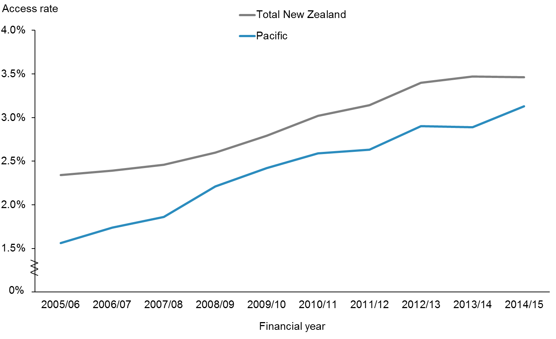

|  |  |  |  |  |  |  |  |  |  |  |
| --- | --- | --- | --- | --- | --- | --- | --- | --- | --- | --- |
|  | **2005/06** | **2006/07** | **2007/08** | **2008/09** | **2009/10** | **2010/11** | **2011/12** | **2012/13** | **2013/14** | **2014/15** |
| Pacific | 1.56% | 1.74% | 1.86% | 2.21% | 2.42% | 2.59% | 2.63% | 2.90% | 2.89% | 3.13% |
| Total New Zealand | 2.34% | 2.39% | 2.46% | 2.60% | 2.79% | 3.02% | 3.14% | 3.40% | 3.47% | 3.46% |

Figure 3 shows that Pacific peoples’ access to mental health services has been improving over the years. The gap between Pacific peoples’ access and that of the total population is closing.

Figure : Access rate to DHB mental health services, Pacific peoples, by priority DHBs, 2005/2006–2014/2015

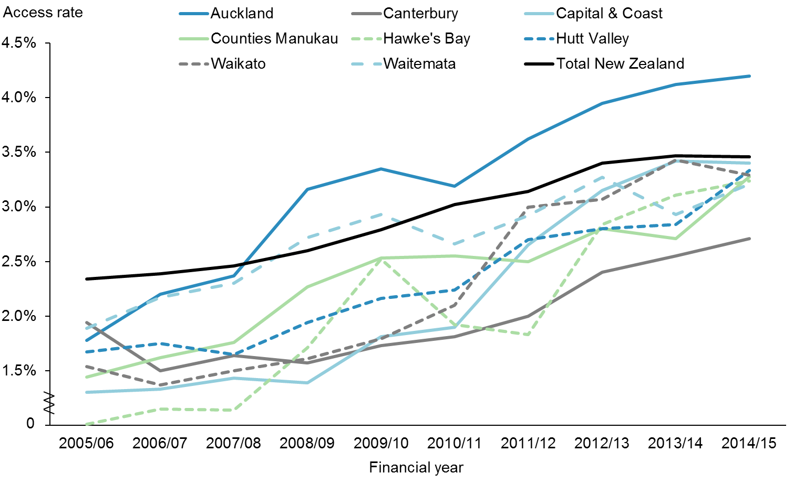

|  |  |  |  |  |  |  |  |  |  |  |
| --- | --- | --- | --- | --- | --- | --- | --- | --- | --- | --- |
|  | **2005/06** | **2006/07** | **2007/08** | **2008/09** | **2009/10** | **2010/11** | **2011/12** | **2012/13** | **2013/14** | **2014/15** |
| Auckland | 1.78% | 2.20% | 2.37% | 3.16% | 3.35% | 3.19% | 3.62% | 3.95% | 4.12% | 4.20% |
| Canterbury | 1.94% | 1.50% | 1.64% | 1.57% | 1.73% | 1.81% | 2.00% | 2.40% | 2.55% | 2.71% |
| Capital & Coast | 1.30% | 1.33% | 1.43% | 1.39% | 1.81% | 1.90% | 2.65% | 3.15% | 3.42% | 3.40% |
| Counties Manukau | 1.44% | 1.62% | 1.76% | 2.27% | 2.53% | 2.55% | 2.50% | 2.80% | 2.71% | 3.28% |
| Hawke's Bay | 1.01% | 1.15% | 1.14% | 1.71% | 2.52% | 1.92% | 1.83% | 2.84% | 3.11% | 3.24% |
| Hutt Valley | 1.67% | 1.75% | 1.65% | 1.94% | 2.16% | 2.24% | 2.70% | 2.80% | 2.84% | 3.33% |
| Waikato | 1.54% | 1.37% | 1.50% | 1.61% | 1.79% | 2.10% | 3.00% | 3.07% | 3.43% | 3.29% |
| Waitemata | 1.89% | 2.17% | 2.30% | 2.72% | 2.93% | 2.66% | 2.92% | 3.27% | 2.93% | 3.21% |
| Total New Zealand | 2.34% | 2.39% | 2.46% | 2.60% | 2.79% | 3.02% | 3.14% | 3.40% | 3.47% | 3.46% |

Figure 4 shows the access rates to DHB mental health services for Pacific peoples in the eight priority DHBs. Most DHBs are making progress towards achieving equity. Auckland DHB access rates for Pacific peoples have consistently been higher than the other DHBs and that of the total New Zealand population since 2007/2008. Capital & Coast, Hutt Valley, Waikato, Counties Manukau, Hawke’s Bay, and Waitemata DHBs are all less than 10 percent away from achieving equity with the total New Zealand population. The three Auckland DHBs with high Pacific enrolment have Pacific services. Capital & Coast DHB has Vaka O Le Pasifika, which is part of Te Korowai-Whāriki, the mental health service for Māori and Pacific peoples.

|  |  |
| --- | --- |
| **Indicator 1b** | **Improving the health status of Pacific people with alcohol and drug addiction through improved access rates to alcohol and drug services** |

**Performance:** There is no target set for this indicator.

**Note**: The data is sourced from the PRIMHD data set.

Figure : Access to DHB alcohol and drug services, Pacific peoples population and total New Zealand population, 2012/2013–2014/2015

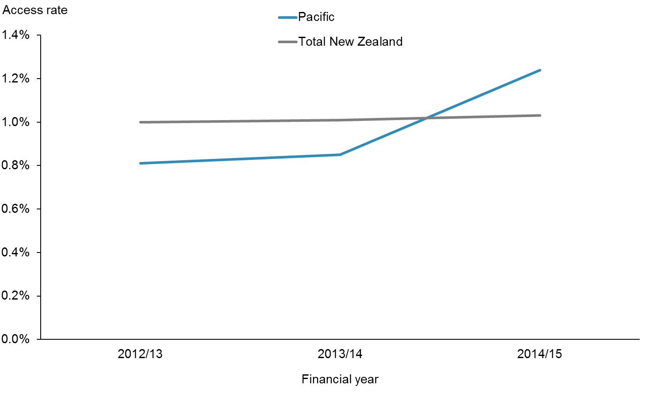

|  |  |  |  |
| --- | --- | --- | --- |
|  | **2012/13** | **2013/14** | **2014/15** |
| Pacific | 0.81% | 0.85% | 1.24% |
| Total New Zealand | 1.00% | 1.01% | 1.03% |

Figure 5 shows access to DHB alcohol and drug services for Pacific peoples and the total New Zealand population. Pacific peoples’ access to alcohol and drug services has been increasing steadily. It has now surpassed that of the total New Zealand population. The high access rates in the three Auckland DHBs contributes to this as they enrol two-thirds of the total Pacific population (refer to Figure 6).

Figure : Access to DHB alcohol and drug services, Pacific peoples, by priority DHBs, 2012/2013–2014/2015

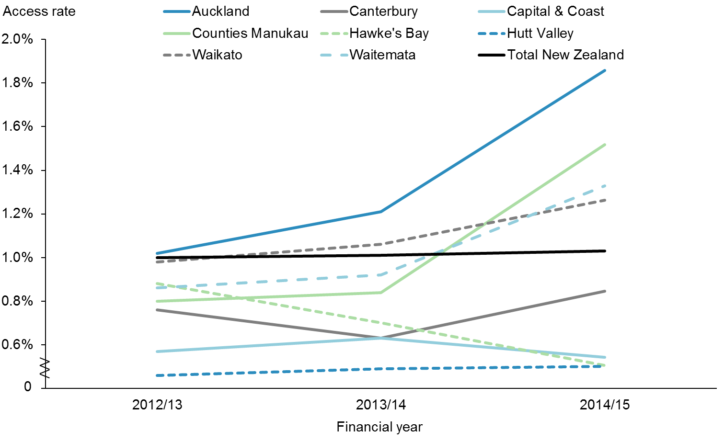

|  |  |  |  |
| --- | --- | --- | --- |
|  | **2012/13** | **2013/14** | **2014/15** |
| Auckland | 1.02% | 1.21% | 1.86% |
| Canterbury | 0.76% | 0.63% | 0.85% |
| Capital & Coast | 0.57% | 0.63% | 0.54% |
| Counties Manukau | 0.80% | 0.84% | 1.52% |
| Hawke's Bay | 0.88% | 0.70% | 0.51% |
| Hutt Valley | 0.46% | 0.49% | 0.50% |
| Waikato | 0.98% | 1.06% | 1.26% |
| Waitemata | 0.86% | 0.92% | 1.33% |
| Total New Zealand | 1.00% | 1.01% | 1.03% |

Figure 6 shows that Auckland, Counties Manukau, Waitemata and Waikato DHBs have improved access to alcohol and drug services among their Pacific populations. Their access rates have surpassed the national access rate. Both Auckland and Waikato DHBs have maintained the ‘Achieved’ status since the first progress report. The sharing of Pacific services via TUPU appears to improve access for Pacific clients and their families in the Auckland region.

|  |  |
| --- | --- |
| **Action 2** | **Universal maternity and child health services will engage in a more timely manner with Pacific families.** |

### Action commentary

In the six months from June 2015 to December 2015, the Ministry of Health has continued to deliver on activities in efforts to improve timely access to universal maternity and child health services for Pacific families. Achievements in this time period have included the following:

* The Ministry announced funding for DHBs in October 2015 aimed at improving the rate of enrolment in Well Child/Tamariki Ora (WCTO) programmes.
* The Ministry has published the fifth WCTO Quality Indicators report (Ministry of Health 2016). The report showed that eight of the total of 27 indicators are at least 98 percent achieved across all ethnic groups. Pacific children have achieved 10 out of the 25 indicators that had ethnic breakdown.
* The New Zealand maternity sector continues to improve maternity services. The *National Maternity Monitoring Group Annual Report* 2015, released in December 2015 (Ministry of Health 2015d), showed one out of four Pacific women were registered with a lead maternity carer in their first trimester compared with seven out of ten European or Other women. Overall during the whole pregnancy term, two out of three Pacific pregnant women were registered with a lead maternity carer compared with about nine out ten European or Other women.
* In October 2015 the Government announced the ‘Childhood Obesity Plan’, which is a package of initiatives to prevent and manage obesity in children and young people up to 18 years of age. The package has three focus areas, made up of 22 initiatives, which are either new or an expansion of existing initiatives. The three focus areas are:
* targeted interventions for those who are obese
* increased support for those at risk of becoming obese
* broad approaches to make healthier choices easier for all New Zealanders. The focus is on food, the environment and being active at each life stage, starting during pregnancy and early childhood. The package brings together initiatives across government agencies, the private sector, communities, schools, families and whānau.
* A new health target will be implemented from 1 July 2016 where ‘by December 2017, 95 percent of obese children identified in the Before School Check (B4SC) programme will be referred to a health professional for clinical assessment and family based nutrition, activity and lifestyle interventions’ (Ministry of Health 2016).
* The Ministry continues its investment into the infrastructure, model of care and capacity of child and adolescent oral health services. Since 2008, the Government has provided $116 million of capital funding for new fixed clinics and mobile clinics, and an additional $32 million per annum for operational funding for staff. The new Community Oral Health Service infrastructure is almost fully in place. The service operates from 170 fixed clinics (seven more will open by June 2016) and 169 mobile clinics, at 1263 sites around the country. The three Auckland DHBs offer shared oral health services through the Auckland Regional Dental Service, which provides free dental care for children in the Auckland region aged  
  0–17 years (until their 18th birthday).

**Note:** Priority outcome 1 indicators 2a–2g are from the WCTO Quality Improvement Framework. Data on these indicators is drawn from various sources. Targets for these indicators reflect national targets set by other monitoring frameworks and processes, including health targets, DHB non-financial performance monitoring and the Government’s Better Public Services targets. The targets are staged to reflect that improvements will be made over time. The interim/old targets to be achieved by December 2014 were set at 90 percent of the three-year target for the WCTO Quality Improvement Framework. The final/new targets were then set to be achieved by June 2016. To support equity, the target for each indicator is the same across all ethnic groups, deprivation quintiles and DHB regions. The WCTO Quality Improvement Framework is reported six-monthly in March and September of each year.

|  |  |
| --- | --- |
| **Indicator 2a** | **Increased percentage of Pacific infants who are enrolled with a general practice by three months of age** |

**Performance:** The interim/old target of 88 percent was set to be achieved by December 2014. This was set at 90 percent of the final/new target of 98 percent, which was set to be achieved by June 2016.

Figure : Percentage of newborn infants enrolled with a general practice by three months of age, Pacific peoples population and total New Zealand population, 2013–2015

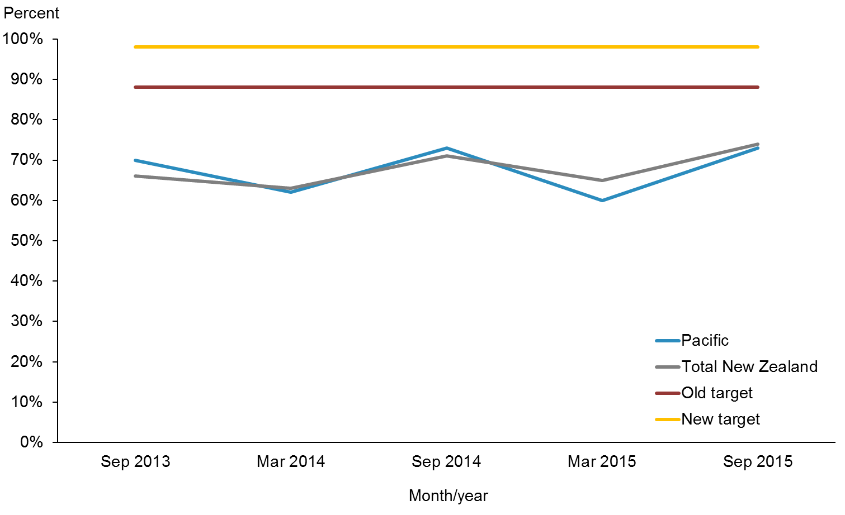

|  |  |  |  |  |  |
| --- | --- | --- | --- | --- | --- |
|  | **Sep-13** | **Mar-14** | **Sep-14** | **Mar-15** | **Sep-15** |
| Pacific | 70.0% | 62.0% | 73.0% | 60.0% | 73.0% |
| Total New Zealand | 66.0% | 63.0% | 71.0% | 65.0% | 74.0% |
| Old target | 88.0% | 88.0% | 88.0% |  |  |
| New target |  |  |  | 98.0% | 98.0% |

**Notes for Figures 7 and 8:**

* Time period: births between 20 February 2015 and 19 May 2015.
* Numerator: enrolments of infants under three months of age with a general practice.
* Denominator: births reported to the National Immunisation Register.
* Rates greater than 100 percent for ethnic subgroups is likely due to variation in ethnicity reporting in different systems.

Figure 7 shows that the enrolment rate of infants under three months of age with a general practice for the Pacific population is very similar to the rate for the total New Zealand population in the same period.

Both Figures 7and 8show a pattern of decrease in the September quarters and increase in the March quarters. This pattern is a seasonal effect, due to reporting for newborn enrolments being recorded prior to the Christmas and New Year’s period, during which providers have two fewer weeks to process enrolments. The Ministry is focused on improving the timeliness of enrolments and is working with GPs to identify ways to do this. Currently, newborn enrolment champions help GPs in primary health organisations (PHOs) work together to share ideas for improving enrolment.

Figure : Percentage of newborn infants enrolled with a general practice by three months of age, Pacific peoples, by priority DHBs, 2013–2015

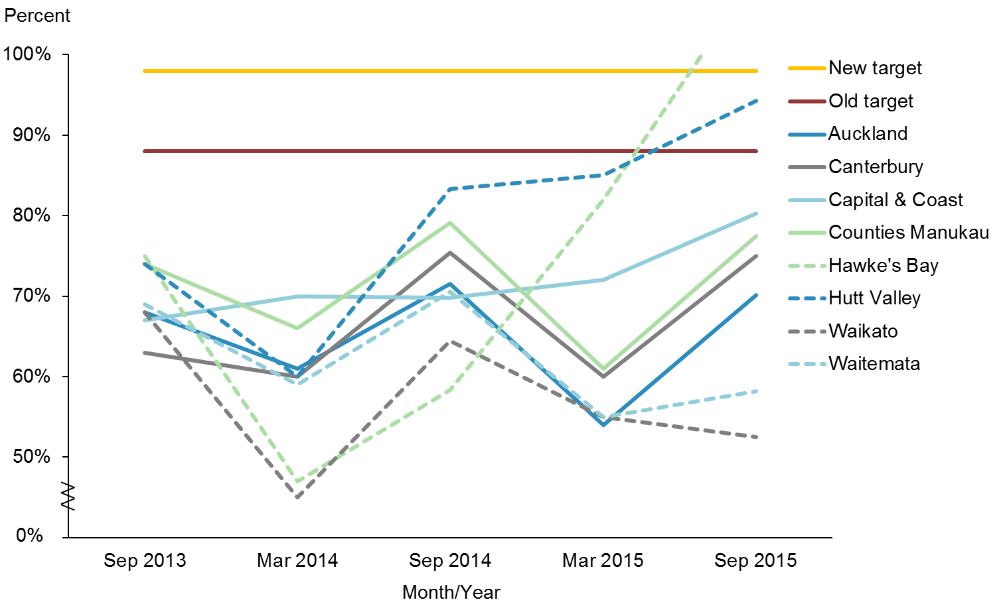

|  |  |  |  |  |  |
| --- | --- | --- | --- | --- | --- |
|  | **Sep-13** | **Mar-14** | **Sep-14** | **Mar-15** | **Sep-15** |
| Auckland | 68.0% | 61.0% | 71.5% | 54.0% | 70.1% |
| Canterbury | 63.0% | 60.0% | 75.4% | 60.0% | 75.0% |
| Capital & Coast | 67.0% | 70.0% | 69.8% | 72.0% | 80.3% |
| Counties Manukau | 74.0% | 66.0% | 79.1% | 61.0% | 77.5% |
| Hawke's Bay | 75.0% | 47.0% | 58.3% | 82.0% | 110.0% |
| Hutt Valley | 74.0% | 60.0% | 83.3% | 85.0% | 94.3% |
| Waikato | 68.0% | 45.0% | 64.4% | 55.0% | 52.5% |
| Waitemata | 69.0% | 59.0% | 70.5% | 55.0% | 58.2% |
| Old target | 88.0% | 88.0% | 88.0% |  |  |
| New target |  |  |  | 98.0% | 98.0% |

Figure 8 shows that Hawke’s Bay DHB has achieved the target in this update (110 percent). The denominator used to calculate these percentages are births reported to the National Immunisation Register. The numerator is enrolments of infants under three months of age with a PHO. Hawke’s Bay DHB had 32 enrolled in the PHOs and 29 registered births in the National Immunisation Register. Hawke’s Bay DHB’s improvement in enrolment has been driven by GP facilitators (Champions) performing monthly auditing of practices for new births. A card is sent out to parents/guardians identified through the birth code with an invitation to join the practice and have a six-week immunisation. Hutt Valley DHB is also making noticeable progress in this indicator. Hutt Valley DHB is about four percentage points away from achieving the target of 98 percent. Capital & Coast DHB is also improving. The new enrolment scheme implemented by these two DHBs may explain the increase in newborn enrolments.

|  |  |
| --- | --- |
| **Indicator 2b** | **Increased percentage of Pacific infants who received all five WCTO core contracts in their first year of life** |

**Performance:** The interim/old target of 86 percent was set to be achieved by December 2014. This was set at 90 percent of the final/new target of 95 percent, which was set to be achieved by June 2016.

Figure : Percentage of infants who received all WCTO core contacts in their first year of life, Pacific peoples population and total New Zealand population, 2013–2015

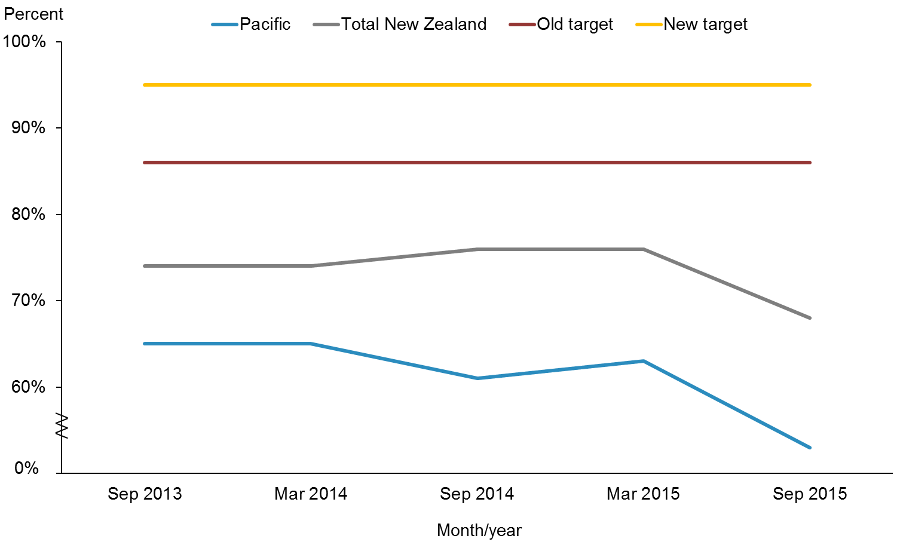

|  |  |  |  |  |  |
| --- | --- | --- | --- | --- | --- |
|  | **Sep-13** | **Mar-14** | **Sep-14** | **Mar-15** | **Sep-15** |
| Pacific | 65.0% | 65.0% | 61.0% | 63.0% | 53.0% |
| Total New Zealand | 74.0% | 74.0% | 76.0% | 76.0% | 68.0% |
| Old target | 86.0% | 86.0% | 86.0% |  |  |
| New target |  |  |  | 95.0% | 95.0% |

**Notes for Figures 9 and 10:**

* Time period: children reaching the age band for core contact 6 between January 2015 and June 2015.
* Hawke’s Bay DHB had fewer than 20 children in that population in September 2014.
* From this report onwards, the data source for this indicator includes reporting from all WCTO providers. Prior to this report, data presented for this indicator was sourced from Plunket alone. This means results for this indicator for the period January–June 2015 are not directly comparable with results from earlier periods.
* Numerator: number of infants where contact was able to be made by six weeks of age and who received all five contacts (source: WCTO National Health Index (NHI) data set).
* Denominator: number of infants where contact was able to be made by six weeks of age who reached the age band for core contact 6 (13 months, 4 weeks, 1 day) (source: WCTO NHI data set).

Figure 9 shows the percentages of infants who received all WCTO core contacts in their first year of life for the Pacific population and the total New Zealand population. Both percentages have dropped, and the gap between Pacific peoples and the total New Zealand population remains. This is not the result of lower performance; instead, it reflects a more accurate picture of performance the data now allows. Currently we are only reaching two-thirds of all infants and only around half of Māori, Pacific peoples, and children living in high-deprivation areas. The Ministry is working to build collective responsibility for the WCTO programme across all providers. DHBs and all WCTO providers are to actively collaborate to increase coverage, in particular for our higher-needs populations (Ministry of Health 2016).

Figure : Percentage of infants who received all WCTO core contacts in their first year of life, Pacific peoples, by priority DHBs, 2013–2015

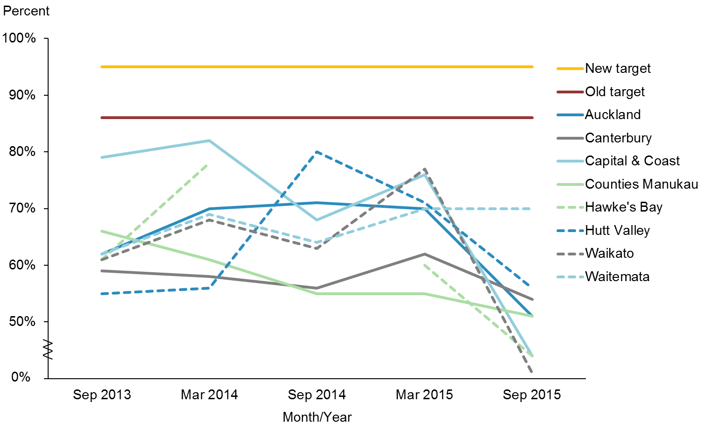

|  |  |  |  |  |  |
| --- | --- | --- | --- | --- | --- |
|  | **Sep-13** | **Mar-14** | **Sep-14** | **Mar-15** | **Sep-15** |
| Auckland | 62.0% | 70.0% | 71.0% | 70.0% | 51.0% |
| Canterbury | 59.0% | 58.0% | 56.0% | 62.0% | 54.0% |
| Capital & Coast | 79.0% | 82.0% | 68.0% | 76.0% | 44.0% |
| Counties Manukau | 66.0% | 61.0% | 55.0% | 55.0% | 51.0% |
| Hawke's Bay | 61.0% | 78.0% |  | 60.0% | 44.0% |
| Hutt Valley | 55.0% | 56.0% | 80.0% | 71.0% | 56.0% |
| Waikato | 61.0% | 68.0% | 63.0% | 77.0% | 41.0% |
| Waitemata | 62.0% | 69.0% | 64.0% | 70.0% | 70.0% |
| Old target | 86.0% | 86.0% | 86.0% |  |  |
| New target |  |  |  | 95.0% | 95.0% |

Figure 10 shows the percentages of infants who received all WCTO core contacts in their first year of life for Pacific peoples in the eight priority DHBs. Since the June 2015 update, Waitemata DHB has maintained its percentage. The other seven priority DHBs have been affected by the change of data source noted above.

|  |  |
| --- | --- |
| **Indicator 2c** | **Increased percentage of Pacific children who receive B4SC** |

**Performance:** The target of this indicator was set at 90 percent to be achieved by June 2016.

Figure : Percentage of four-year-olds who received a B4SC, Pacific peoples population and total New Zealand population, 2013–2015

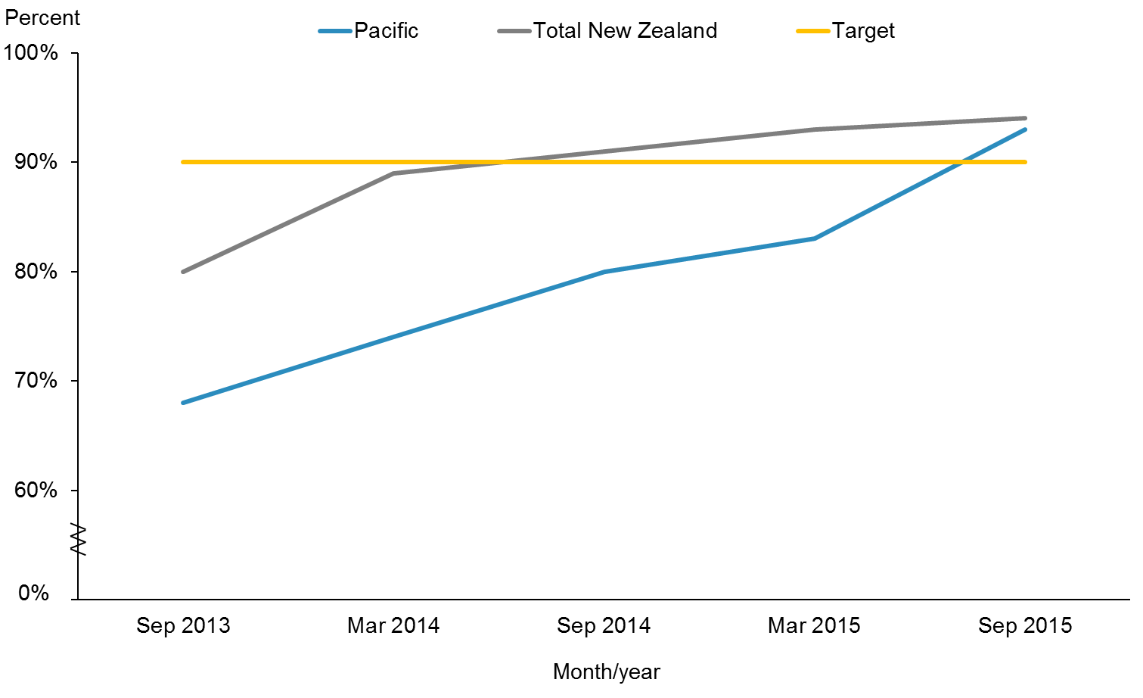

|  |  |  |  |  |  |
| --- | --- | --- | --- | --- | --- |
|  | **Sep-13** | **Mar-14** | **Sep-14** | **Mar-15** | **Sep-15** |
| Pacific | 68.0% | 74.0% | 80.0% | 83.0% | 93.0% |
| Total New Zealand | 80.0% | 89.0% | 91.0% | 93.0% | 94.0% |
| Target | 90.0% | 90.0% | 90.0% | 90.0% | 90.0% |

**Notes for Figures 11 and 12:**

* Time period: checks between January 2015 to June 2015.
* DHB is DHB of service.
* Numerator: number of completed B4SCs (source: B4 School Check).
* Denominator: number of children eligible for a B4SC (source: PHO).
* Rates of greater than 100 percent for ethnic subgroups is likely due to variation in ethnicity reporting in different systems.

Figure 11 shows that the 90 percent target was achieved in this update for Pacific children, and the ‘achieved target’ status has been maintained for children in the total New Zealand population.

Figure : Percentage of four-year-olds who received a B4SC, Pacific peoples, by priority DHBs, 2013–2015

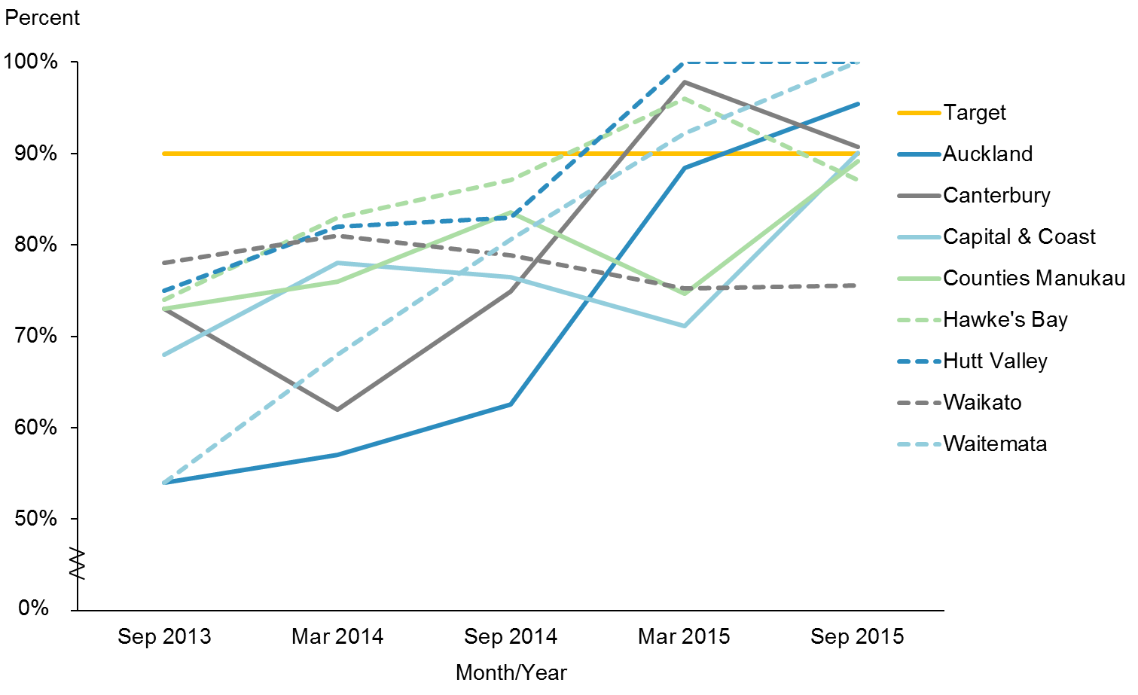

|  |  |  |  |  |  |
| --- | --- | --- | --- | --- | --- |
|  | **Sep-13** | **Mar-14** | **Sep-14** | **Mar-15** | **Sep-15** |
| Auckland | 54.0% | 57.0% | 62.6% | 88.4% | 95.4% |
| Canterbury | 73.0% | 62.0% | 74.9% | 97.8% | 90.7% |
| Capital & Coast | 68.0% | 78.0% | 76.5% | 71.1% | 90.1% |
| Counties Manukau | 73.0% | 76.0% | 83.6% | 74.7% | 89.1% |
| Hawke's Bay | 74.0% | 83.0% | 87.1% | 96.0% | 87.1% |
| Hutt Valley | 75.0% | 82.0% | 83.0% | 100.0% | 100.0% |
| Waikato | 78.0% | 81.0% | 78.8% | 75.2% | 75.5% |
| Waitemata | 54.0% | 68.0% | 80.6% | 92.2% | 100.0% |
| Target | 90.0% | 90.0% | 90.0% | 90.0% | 90.0% |

Figure 12 shows that five out of the eight priority DHBs have achieved the target of 90 percent. These were Auckland, Canterbury, Capital & Coast, Hutt Valley, and Waitemata DHBs. Capital & Coast DHB and Auckland DHB both achieved the target in this progress report compared with the previous progress report. Over the years, Auckland and Waitemata DHBs have significantly increased their coverage of B4SC rates for Pacific children (54 percent for both DHBs in September 2013 to 95 and 100 percent respectively). Counties Manukau DHB has also made progress and is on its way to achieving the national target. Hawke’s Bay DHB was not able to maintain its achieved status for this update; however, we are working with very small numbers here. Waikato DHB is aware of the need to improve.

|  |  |
| --- | --- |
| **Indicator 2d** | **Increased percentage of Pacific infants who are exclusively or fully breastfed at three months of age** |

**Performance:** The interim/old target of 54 percent was set to be achieved by December 2014. This target was set at 90 percent of the final/new target of 60 percent, which was set to be achieved by June 2016.

Figure : Percentage of infants exclusively or fully breastfed at three months of age, Pacific peoples population and total New Zealand population, 2013–2015

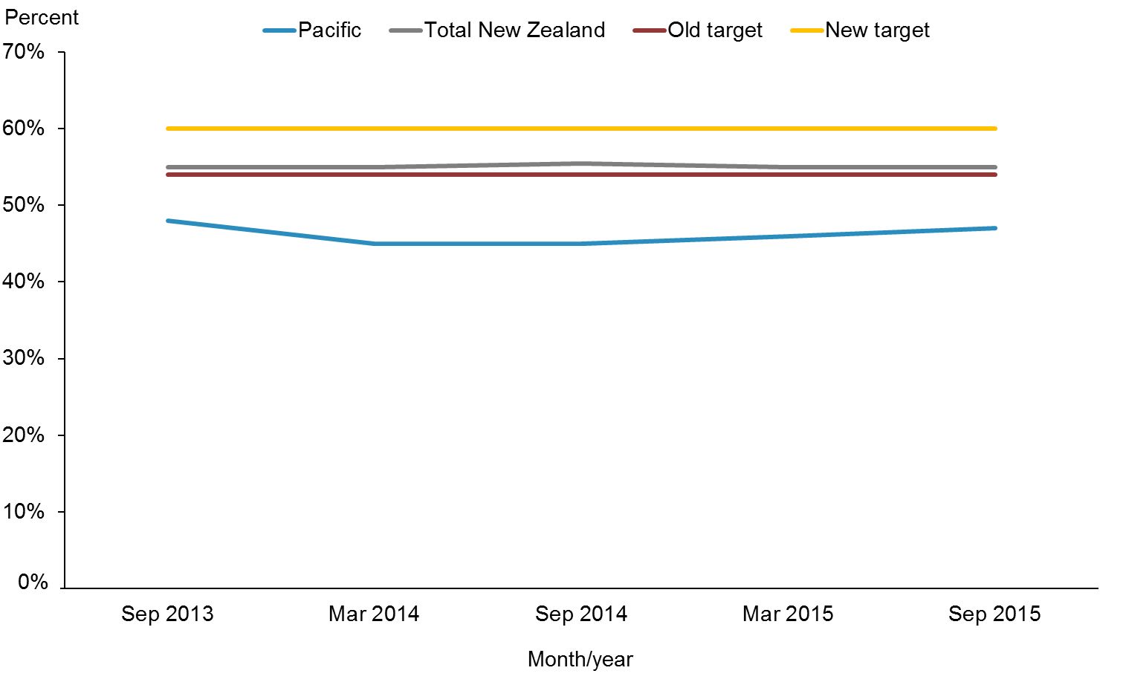

|  |  |  |  |  |  |
| --- | --- | --- | --- | --- | --- |
|  | **Sep-13** | **Mar-14** | **Sep-14** | **Mar-15** | **Sep-15** |
| Pacific | 48.0% | 45.0% | 45.0% | 46.0% | 47.0% |
| Total New Zealand | 55.0% | 55.0% | 55.5% | 54.9% | 55.0% |
| Old target | 54.0% | 54.0% | 54.0% |  |  |
| New target |  |  |  | 60.0% | 60.0% |

**Notes for Figures 13 and 14:**

* Time period: infants aged three months between 1 January 2015 t0 30 June 2015.
* Results for this indicator for this period are not directly comparable with results from earlier periods because of the inclusion of data from Tamariki Ora providers in addition to Plunket data.
* Numerator: breastfeeding at three months of age = exclusive or fully (source: WCTO NHI data set).
* Denominator: breastfeeding at three months of age = not null (source: WCTO NHI data set).

Figure 13 shows that there was not much progress in either population since September 2014. In 2016/17 the Ministry of Health will be updating the National Breastfeeding Strategy to improve rates across the entire population and reduce inequity gaps.

Figure : Percentage of infants exclusively or fully breastfed at three months of age, Pacific peoples, by priority DHBs, 2013–2015

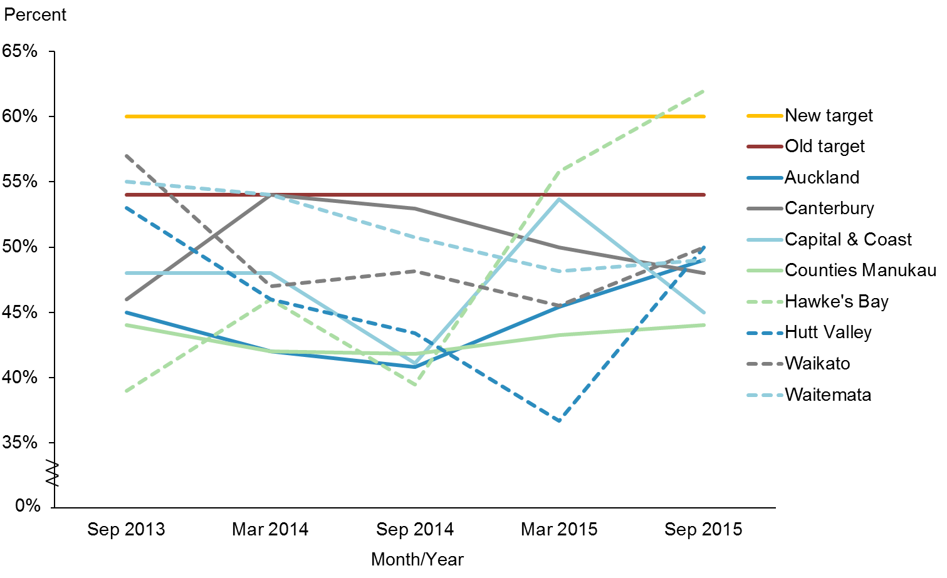

|  |  |  |  |  |  |
| --- | --- | --- | --- | --- | --- |
|  | **Sep-13** | **Mar-14** | **Sep-14** | **Mar-15** | **Sep-15** |
| Auckland | 45.0% | 42.0% | 40.8% | 45.4% | 49.0% |
| Canterbury | 46.0% | 54.0% | 52.9% | 50.0% | 48.0% |
| Capital & Coast | 48.0% | 48.0% | 41.1% | 53.7% | 45.0% |
| Counties Manukau | 44.0% | 42.0% | 41.8% | 43.2% | 44.0% |
| Hawke's Bay | 39.0% | 46.0% | 39.5% | 55.8% | 62.0% |
| Hutt Valley | 53.0% | 46.0% | 43.4% | 36.7% | 50.0% |
| Waikato | 57.0% | 47.0% | 48.1% | 45.5% | 50.0% |
| Waitemata | 55.0% | 54.0% | 50.7% | 48.2% | 49.0% |
| Old target | 54.0% | 54.0% | 54.0% |  |  |
| New target |  |  |  | 60.0% | 60.0% |

Figure 14shows the percentages of infants exclusively or fully breastfed at three months of age for Pacific peoples in the eight priority DHBs. Hawke’s Bay was the only DHB that had achieved the target of 60 percent. Hutt Valley DHB has significantly improved since the last update. The recently published WCTO Quality Improvement Framework report showed that women that live in high-deprivation areas were least likely to breast feed (Ministry of Health 2016).

|  |  |
| --- | --- |
| **Indicator 2e** | **Increased percentage of Pacific children with BMI >99.4th percentile are referred to GP or specialist services** |

**Performance:** The interim/old target of 86 percent was set to be achieved by December 2014. This was set at 90 percent of the final/new target of 95 percent, which was set to be achieved by June 2016.

Figure : Percentage of children with BMI >99.4th percentile referred to a GP or specialist services, Pacific peoples population and total New Zealand population, 2013–2015

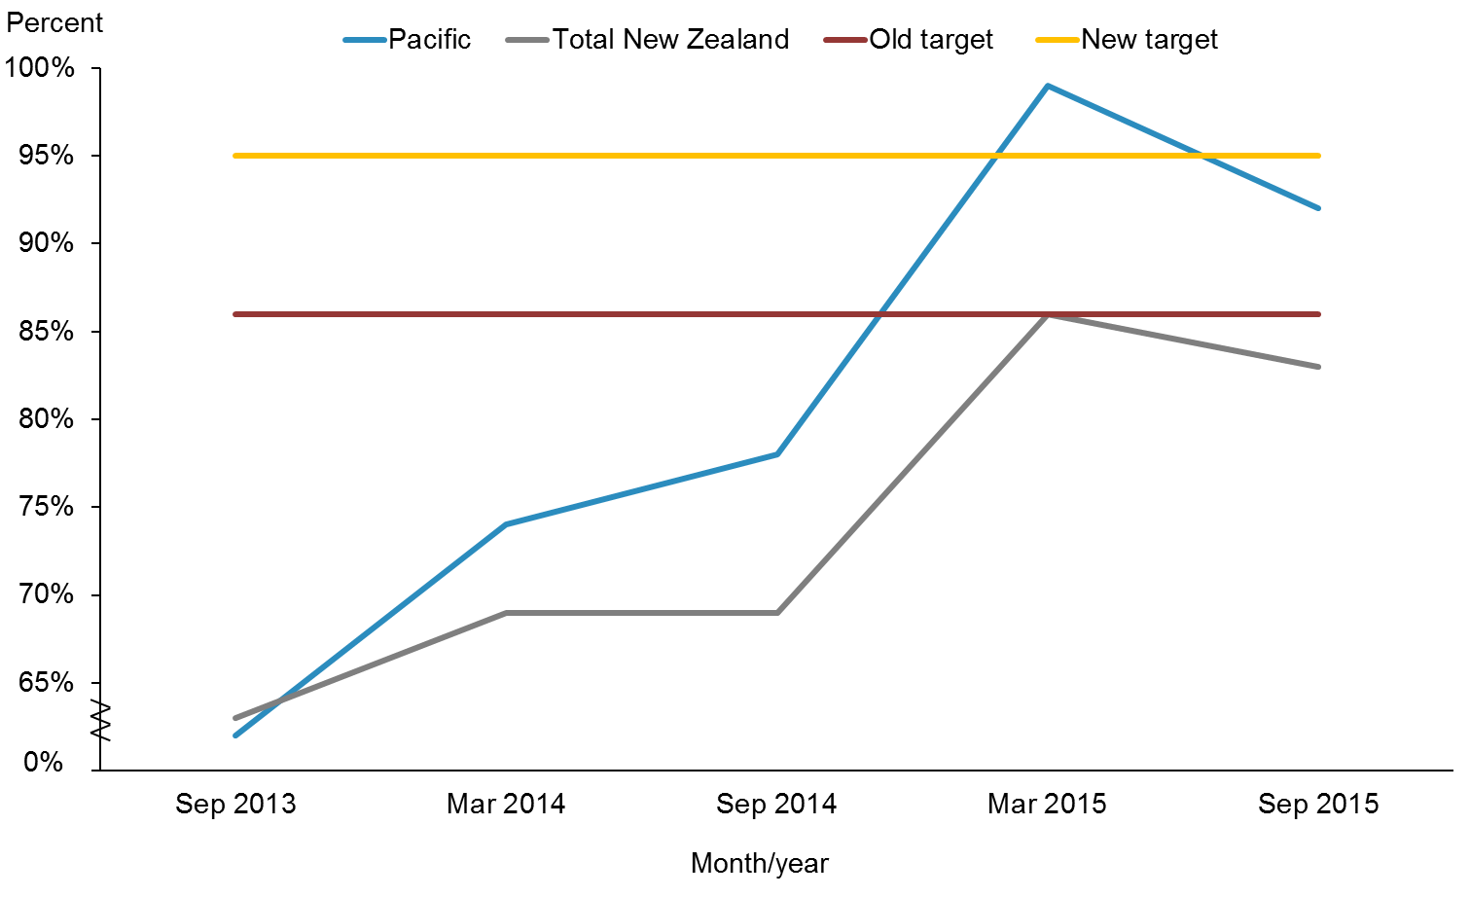

|  |  |  |  |  |  |
| --- | --- | --- | --- | --- | --- |
|  | **Sep-13** | **Mar-14** | **Sep-14** | **Mar-15** | **Sep-15** |
| Pacific | 62.0% | 74.0% | 78.0% | 99.0% | 92.0% |
| Total New Zealand | 63.0% | 69.0% | 69.0% | 86.0% | 83.0% |
| Old target | 86.0% | 86.0% | 86.0% |  |  |
| New target |  |  |  | 95.0% | 95.0% |

**Notes for Figures 15 and 16:**

* Time period: children receiving a B4SC between 1 January 2015 and 30 June 2015.
* Hawke’s Bay DHB had fewer than 20 children in that population in September 2014.
* Numerator: number of children with a BMI greater than the 99.4th percentile referred (source: B4 School Check).
* Denominator: number of children with a BMI greater than the 99.4th percentile (excluding those already under care) (source: B4 School Check).
* Caution should be used with interpreting these graphs because of the small numbers involved.

Figure 15 shows that the target was achieved for both populations in the June 2015 progress report, but now both have dropped below the target of 95 percent. A new health target will be implemented from 1 July 2016, announced in the ‘Childhood Obesity Plan’ (refer to the ‘Action Commentary’ section above).

Figure : Percentage of children with BMI >99.4th percentile referred to a GP or specialist services, Pacific peoples, by priority DHBs, 2013–2015

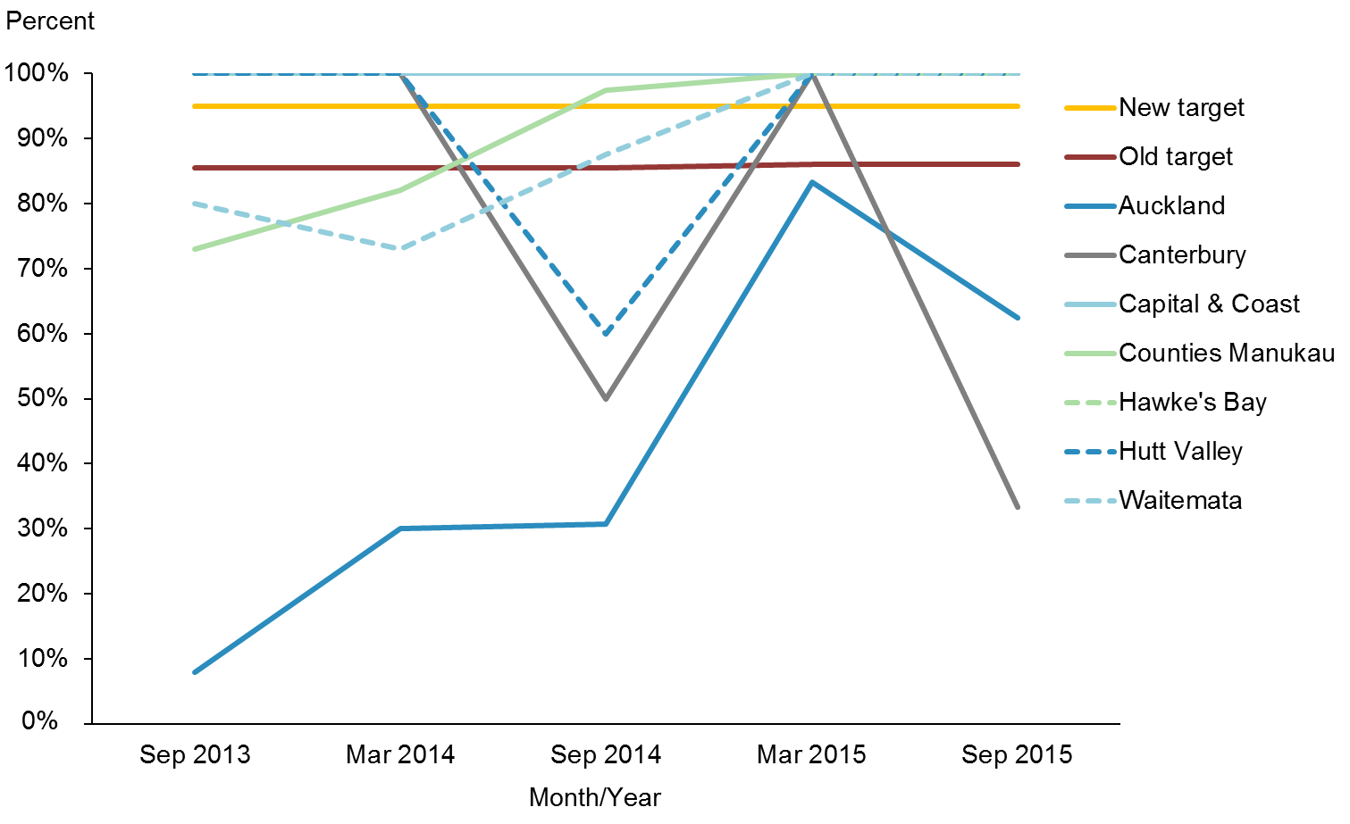

|  |  |  |  |  |  |
| --- | --- | --- | --- | --- | --- |
|  | **Sep-13** | **Mar-14** | **Sep-14** | **Mar-15** | **Sep-15** |
| Auckland | 8.0% | 30.0% | 30.8% | 83.3% | 62.5% |
| Canterbury | 100.0% | 100.0% | 50.0% | 100.0% | 33.3% |
| Capital & Coast | 100.0% | 100.0% | 100.0% | 100.0% | 100.0% |
| Counties Manukau | 73.0% | 82.0% | 97.4% | 100.0% | 100.0% |
| Hawke's Bay | 100.0% | 100.0% |  | 100.0% | 100.0% |
| Hutt Valley | 100.0% | 100.0% | 60.0% | 100.0% | 100.0% |
| Waitemata | 80.0% | 73.0% | 87.5% | 100.0% | 100.0% |
| Old target | 86.0% | 86.0% | 86.0% |  |  |
| New target |  |  |  | 95.0% | 95.0% |

**Note**: Data is unavailable for the September 2014 quarter for Hawke’s Bay DHB and for all quarters for Waikato DHB because there were no reported Pacific children with BMI >99.4th percentile in those populations and time periods.

Figure 16 shows that Capital & Coast, Counties Manukau, Hawke’s Bay, Hutt Valley and Waitemata DHBs achieved the target in this progress report. Canterbury DHB achieved this target in the June 2015 update but has dropped significantly. Auckland DHB has also dropped from the June 2015 update. These significant drops are due to very small numbers (Ministry of Health 2016).

|  |  |
| --- | --- |
| **Indicator 2f** | **Increased percentage of Pacific children in preschool who are enrolled with the Community Oral Health Service** |

**Performance:** The interim/old target of 86 percent was set to be achieved by December 2014. This was set at 90 percent of the final/new target of 95 percent, which was set to be achieved by June 2016.

Figure : Percentage of children under five years old enrolled in the Community Oral Health Service, Pacific peoples population and total New Zealand population, 2007–2014

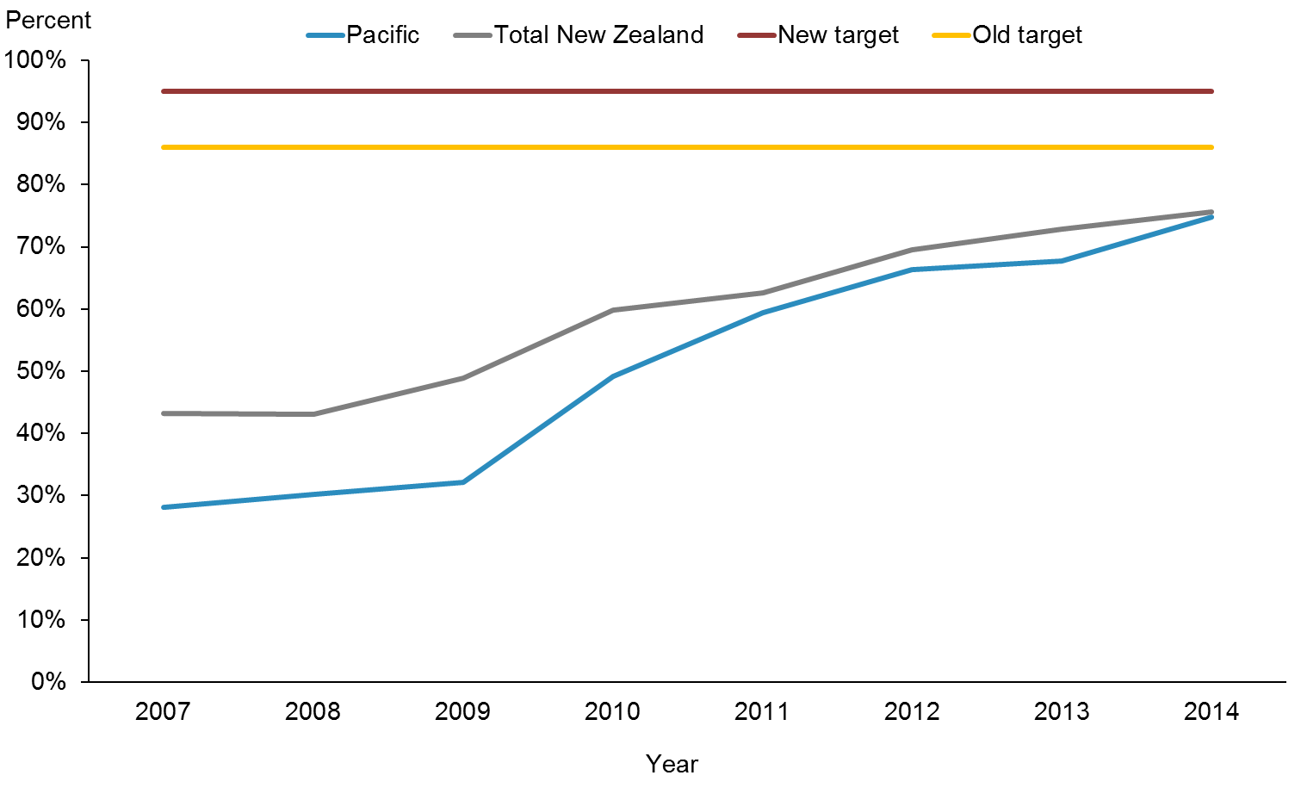

|  |  |  |  |  |  |  |  |  |
| --- | --- | --- | --- | --- | --- | --- | --- | --- |
|  | **2007** | **2008** | **2009** | **2010** | **2011** | **2012** | **2013** | **2014** |
| Pacific | 28.1% | 30.2% | 32.2% | 49.1% | 59.4% | 66.3% | 67.8% | 74.7% |
| Total New Zealand | 43.2% | 43.0% | 48.9% | 59.8% | 62.6% | 69.5% | 72.9% | 75.6% |
| Old target | 86.0% | 86.0% | 86.0% | 86.0% | 86.0% | 86.0% | 86.0% | 86.0% |
| New target | 95.0% | 95.0% | 95.0% | 95.0% | 95.0% | 95.0% | 95.0% | 95.0% |

**Notes for Figures 17 and 18:**

* Time period: 2014.
* Canterbury DHB did not report data by ethnicity for this indicator prior to 2010. Fewer children were examined in Canterbury in 2014 than in 2013 due to the unavailability of mobile dental units during school term 2. Hawke’s Bay DHB reported no data by ethnicity for the 2007 and 2011 year and Waikato DHB does not report data by ethnicity for this indicator.
* Numerator: number of children aged under five years enrolled with the Community Oral Health Service (source: DHBs reporting).
* Denominator: number of children aged under five years (source: Statistics New Zealand population projections based on Census 2013).

Figure 17 shows that results for this indicator in both the Pacific population and the total New Zealand population continue to improve, and the equity gap between the two population groups has closed.

Figure : Percentage of children under five years old enrolled in the Community Oral Health Service, Pacific peoples, by priority DHBs, 2007–2014

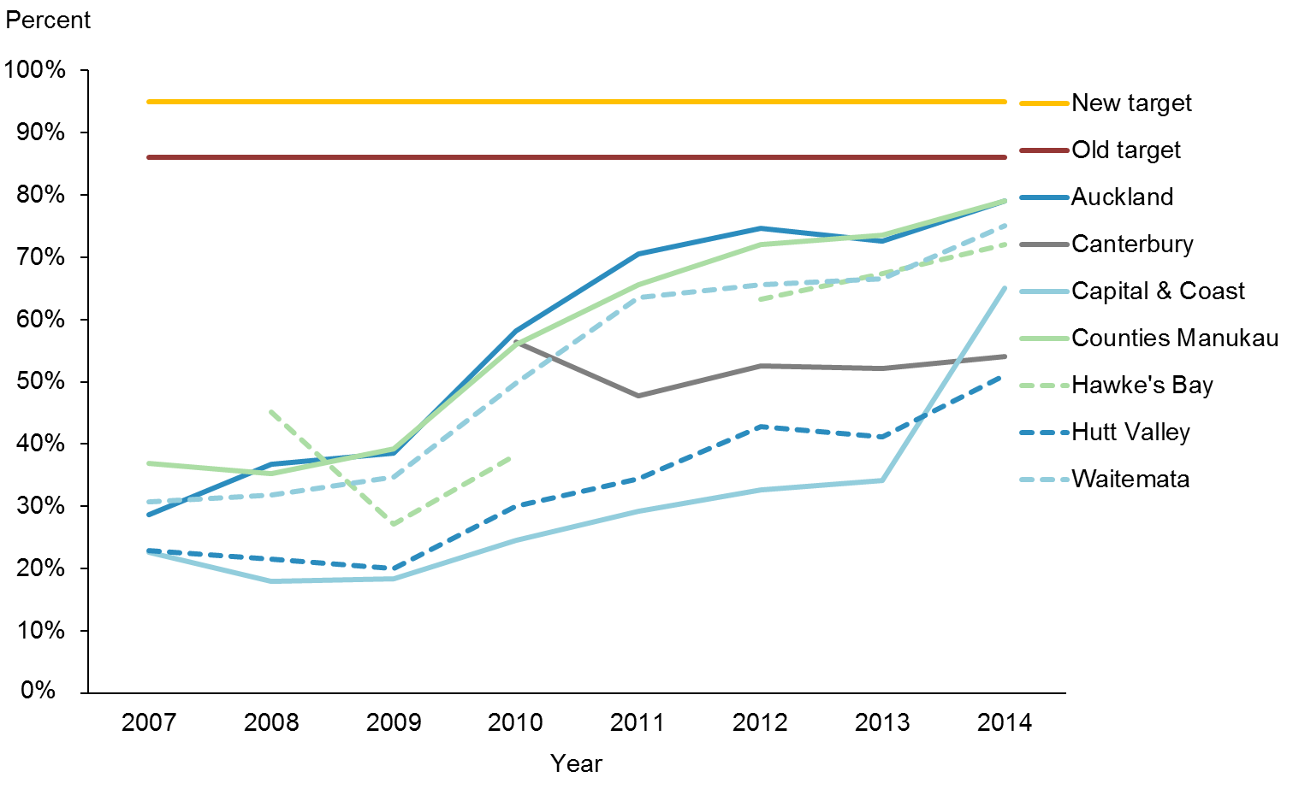

|  |  |  |  |  |  |  |  |  |
| --- | --- | --- | --- | --- | --- | --- | --- | --- |
|  | **2007** | **2008** | **2009** | **2010** | **2011** | **2012** | **2013** | **2014** |
| Auckland | 28.6% | 36.8% | 38.6% | 58.2% | 70.5% | 74.6% | 72.6% | 79.0% |
| Canterbury |  |  |  | 56.4% | 47.8% | 52.6% | 52.1% | 54.0% |
| Capital & Coast | 22.7% | 17.9% | 18.4% | 24.6% | 29.2% | 32.7% | 34.2% | 65.0% |
| Counties Manukau | 36.9% | 35.3% | 39.3% | 56.0% | 65.6% | 72.1% | 73.5% | 79.0% |
| Hawke's Bay |  | 45.1% | 27.1% | 38.3% |  | 63.3% | 67.4% | 72.0% |
| Hutt Valley | 22.9% | 21.6% | 20.1% | 30.0% | 34.4% | 42.8% | 41.1% | 51.0% |
| Waitemata | 30.8% | 31.8% | 34.7% | 49.8% | 63.5% | 65.6% | 66.6% | 75.0% |
| Old target | 86.0% | 86.0% | 86.0% | 86.0% | 86.0% | 86.0% | 86.0% | 86.0% |
| New target | 95.0% | 95.0% | 95.0% | 95.0% | 95.0% | 95.0% | 95.0% | 95.0% |

Figure 18 shows that all of the eight priority DHBs are making progress. The three Auckland DHBs offer shared oral health services through the Auckland Regional Dental Service, which provides free dental care for children in the Auckland region aged 0–17 years. Pacific children’s enrolment for this region is improving as a result of this. Hawke’s Bay DHB has improved as well, and Capital & Coast DHB has shifted substantially since the last update.

|  |  |
| --- | --- |
| **Indicator 2g** | **Increased number of Pacific children caries-free at age five, and rates of DMFT at school year eight at least equivalent to the total population** |

**Performance:** The target of this indicator was set at 65 percent to be achieved by June 2016.

Figure : Percentage of children caries-free at age five, Pacific peoples population and total New Zealand population, 2007–2014

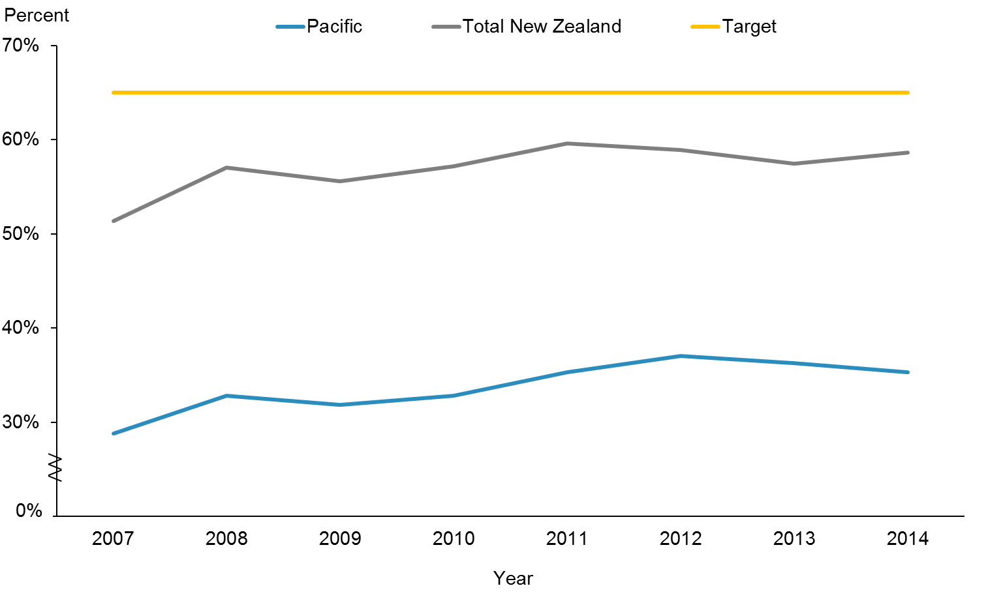

|  |  |  |  |  |  |  |  |  |
| --- | --- | --- | --- | --- | --- | --- | --- | --- |
|  | **2007** | **2008** | **2009** | **2010** | **2011** | **2012** | **2013** | **2014** |
| Pacific | 28.8% | 32.8% | 31.9% | 32.8% | 35.3% | 37.0% | 36.3% | 35.3% |
| Total New Zealand | 51.4% | 57.0% | 55.6% | 57.2% | 59.6% | 58.9% | 57.5% | 58.6% |
| Target | 65.0% | 65.0% | 65.0% | 65.0% | 65.0% | 65.0% | 65.0% | 65.0% |

**Notes for Figures 19 and 20:**

* Time period: children aged five examined between 1 January 2014 and 31 December 2014.
* Numerator: number of five-year-old children caries-free (source: DHB reporting).
* Denominator: number of five-year-old children examined by the Community Oral Health Service with oral health services (source: DHB reporting).

Figure 19 shows that the percentages have moved slowly over the years, but the disparity between the two population groups remains largely unchanged.

Figure : Percentage of children caries-free at age five, Pacific peoples, by priority DHBs, 2007–2014

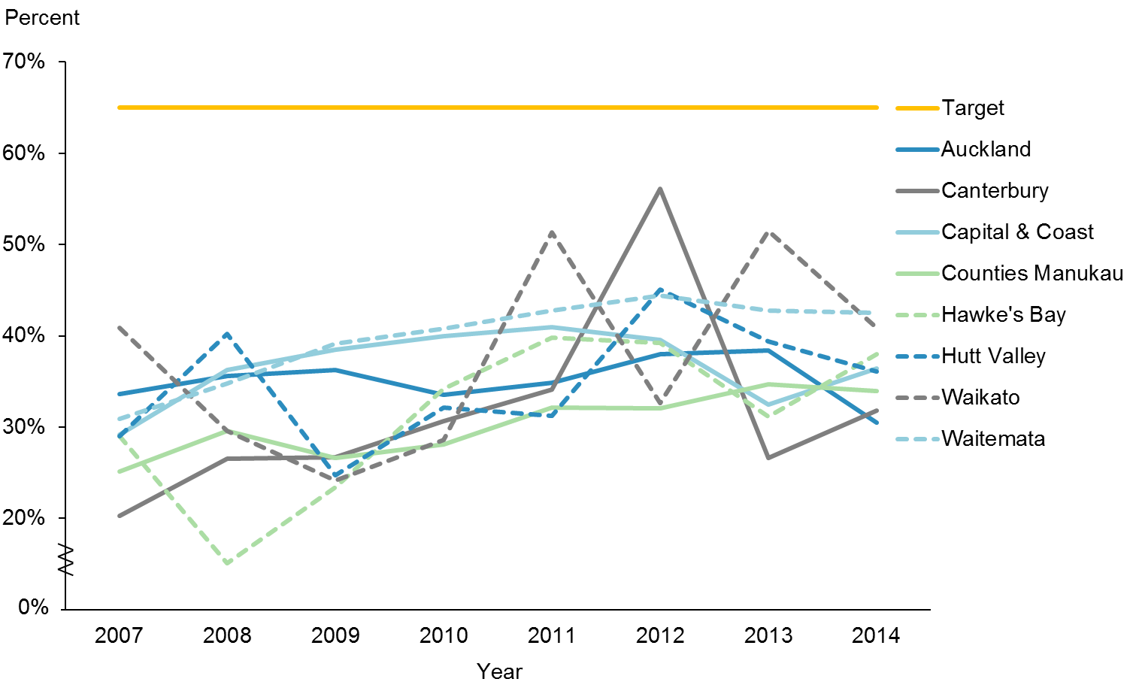

|  |  |  |  |  |  |  |  |  |
| --- | --- | --- | --- | --- | --- | --- | --- | --- |
|  | **2007** | **2008** | **2009** | **2010** | **2011** | **2012** | **2013** | **2014** |
| Auckland | 33.6% | 35.6% | 36.2% | 33.6% | 34.8% | 38.0% | 38.4% | 30.5% |
| Canterbury | 20.3% | 26.6% | 26.8% | 30.7% | 34.1% | 56.1% | 26.6% | 31.8% |
| Capital & Coast | 29.1% | 36.3% | 38.5% | 39.9% | 41.0% | 39.6% | 32.4% | 36.4% |
| Counties Manukau | 25.2% | 29.6% | 26.7% | 28.1% | 32.2% | 32.1% | 34.7% | 34.0% |
| Hawke's Bay | 29.0% | 15.1% | 23.4% | 34.2% | 39.8% | 39.2% | 31.2% | 38.0% |
| Hutt Valley | 29.0% | 40.2% | 24.7% | 32.2% | 31.2% | 45.0% | 39.4% | 36.1% |
| Waikato | 40.9% | 29.6% | 24.1% | 28.6% | 51.3% | 32.6% | 51.5% | 40.9% |
| Waitemata | 30.9% | 34.8% | 39.1% | 40.8% | 42.8% | 44.4% | 42.8% | 42.5% |
| Target | 65.0% | 65.0% | 65.0% | 65.0% | 65.0% | 65.0% | 65.0% | 65.0% |

Figure 20shows that less than half of the DHBs have made some progress towards the target. Lower numbers of children were examined in Canterbury in 2014 due to the unavailability of mobile dental units during part of the year.

Figure : Mean rate of DMFT at school year eight, Pacific peoples population and total New Zealand population, 2007–2014

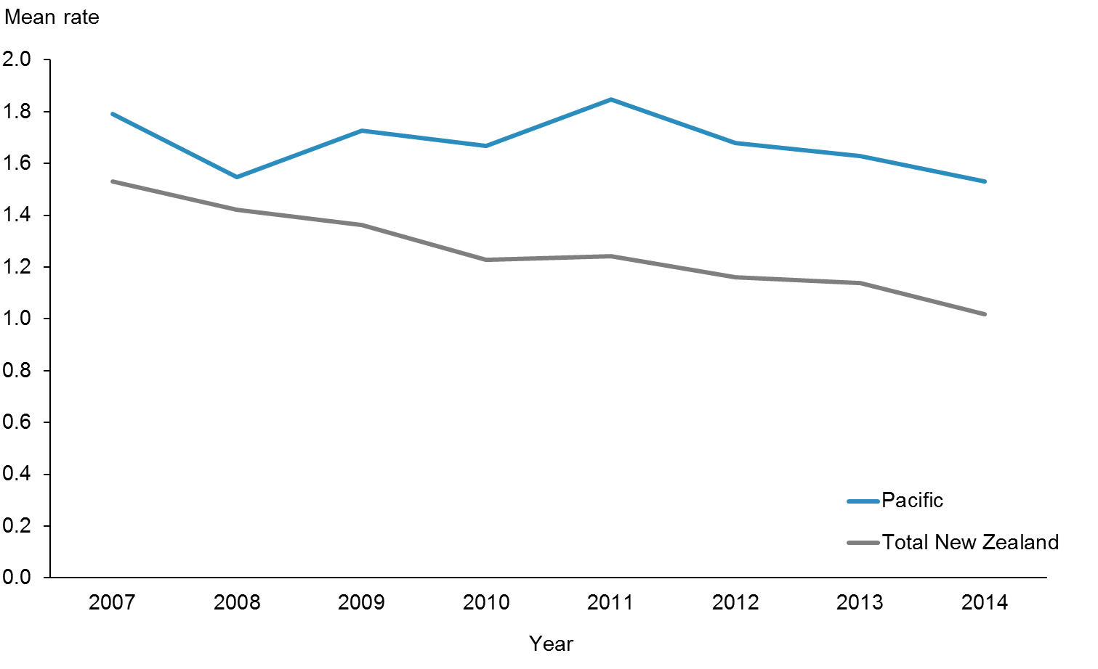

|  |  |  |  |  |  |  |  |  |
| --- | --- | --- | --- | --- | --- | --- | --- | --- |
|  | **2007** | **2008** | **2009** | **2010** | **2011** | **2012** | **2013** | **2014** |
| Pacific | 1.79 | 1.55 | 1.73 | 1.67 | 1.85 | 1.68 | 1.63 | 1.53 |
| Total New Zealand | 1.53 | 1.42 | 1.36 | 1.23 | 1.24 | 1.16 | 1.14 | 1.02 |

**Note:** The latest data for this indicator is from 2014. There is no set national target.

Figure 21 shows that the mean rate of DMFT is decreasing (improving) for school year eight children in both the Pacific population and in the total New Zealand population. However, the equity gap between Pacific peoples and the total New Zealand population has not closed.

Figure : Mean rate of DMFT at school year eight, Pacific peoples, by priority DHBs, 2007–2014

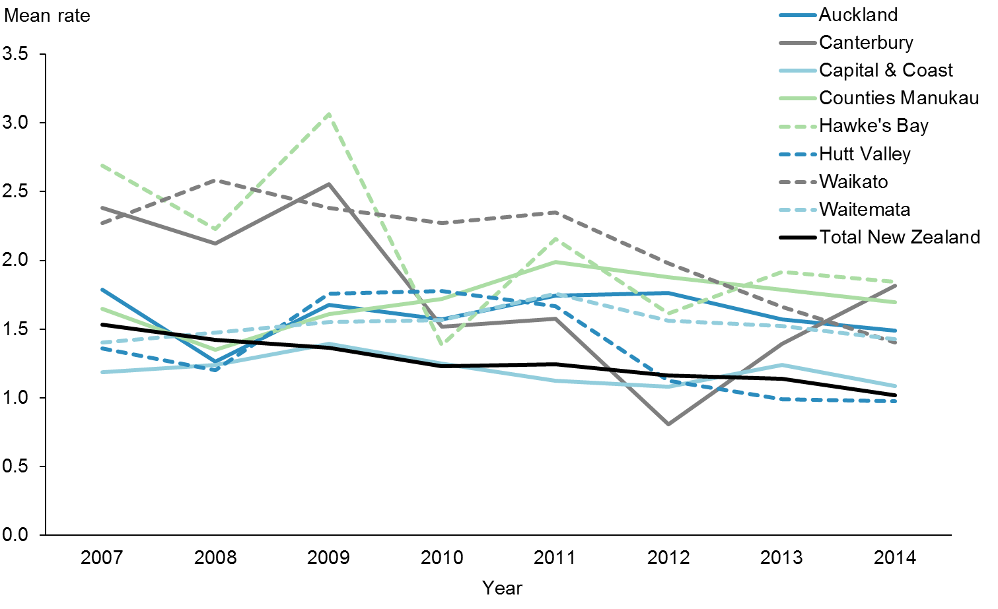

|  |  |  |  |  |  |  |  |  |
| --- | --- | --- | --- | --- | --- | --- | --- | --- |
|  | **2007** | **2008** | **2009** | **2010** | **2011** | **2012** | **2013** | **2014** |
| Auckland | 1.79 | 1.26 | 1.67 | 1.57 | 1.74 | 1.76 | 1.57 | 1.49 |
| Canterbury | 2.38 | 2.12 | 2.55 | 1.52 | 1.57 | 0.81 | 1.39 | 1.82 |
| Capital & Coast | 1.19 | 1.24 | 1.39 | 1.25 | 1.13 | 1.08 | 1.24 | 1.09 |
| Counties Manukau | 1.65 | 1.35 | 1.61 | 1.72 | 1.99 | 1.88 | 1.79 | 1.69 |
| Hawke's Bay | 2.69 | 2.23 | 3.07 | 1.38 | 2.16 | 1.61 | 1.92 | 1.85 |
| Hutt Valley | 1.36 | 1.20 | 1.76 | 1.78 | 1.67 | 1.12 | 0.99 | 0.98 |
| Waikato | 2.27 | 2.58 | 2.38 | 2.27 | 2.35 | 1.98 | 1.66 | 1.40 |
| Waitemata | 1.40 | 1.47 | 1.55 | 1.56 | 1.76 | 1.56 | 1.52 | 1.43 |
| Total New Zealand | 1.53 | 1.42 | 1.36 | 1.23 | 1.24 | 1.16 | 1.14 | 1.02 |

Figure 22 shows the mean rates of DMFT at school year eight for Pacific peoples in the eight priority DHBs. Hutt Valley DHB has a rate lower than the total New Zealand population, and the Capital & Coast DHB rate is almost on par with the total New Zealand population. The sharp fluctuations in DHBs like Hawke’s Bay and Canterbury are due to the small numbers.

|  |  |
| --- | --- |
| **Action 3** | **DHBs will improve performance against achieving health targets for Pacific peoples.** |

### Action commentary

The ‘better help for smokers to quit’ and ‘more heart and diabetes checks’ are two of three health targets that are monitored in ’*Ala Mo*’*ui*.

#### Better help for smokers to quit

The target is 90 percent of PHO-enrolled patients who smoke have been offered help to quit smoking by a health care practitioner in the last 15 months. From quarter one 2015/2016, the target shifted its focus to the entire enrolled population of people who smoke and not only those seen in primary care. It also covers advice provided over 15 months, instead of 12 months.

The Ministry continues to work closely with DHBs to ensure that providers offer advice and smoking cessation support to Pacific peoples in health care settings. Table 7 sets out the DHBs’ activities for this health target.

Table 7: DHB activities delivered to improve services offering Pacific peoples better help for smokers to quit, as at 31 December 2015

|  |  |
| --- | --- |
| **DHB** | **Activities** |
| Auckland and Waitemata | There are high rates of smoking among the populations of Pacific peoples in both Auckland and Waitemata DHBs. Both DHBs are among the top performers for the ‘better help for smokers to quit’ health target. The DHBs and their PHOs have invested in many best-practice strategies to ensure that the majority of smokers, including Pacific smokers, receive brief advice and cessation support to quit in primary care.  Recently, the DHBs have been refreshing the smoking cessation training they provide to health professionals, to increase the number of patients that make supported quit attempts, particularly to Māori and Pacific patients. |
| Canterbury | Canterbury DHB has made significant improvements towards achieving the target.  All PHOs continue to provide cessation programmes; two of the three PHOs have revised and enhanced their cessation programmes extensively. Pacific communities are one of the key audiences for these services.  Canterbury DHB has integrated delivery of this target and the ‘more heart and diabetes checks’ target. This approach has proven to be effective in reaching Pacific and Māori communities. |
| Capital & Coast and Hutt Valley | Capital & Coast and Hutt Valley DHBs have made significant improvements towards achieving the target. Examples of recent work include:   * systematically ensuring tobacco control is included as a key activity in all DHB health documents, including Pacific health plans * supporting clinical and community leadership in tobacco control through the Pacific health unit * continuing to collect target results by ethnicity * promoting smoking cessation services to increase awareness among Pacific communities.   Pacific Health Services provides a local quitting service targeted at Pacific peoples. It provides face-to-face counselling sessions, free nicotine replacement therapy, and quit checks at four weeks and three months. |

#### More heart and diabetes checks

Cardiovascular disease (CVD) is the leading cause of death in New Zealand; it accounts for 30 percent of deaths annually. Cardiovascular conditions are the leading cause of morbidity in New Zealand, and disproportionately affect Pacific peoples. This health target is that 90 percent of the eligible population will have had their cardiovascular risk assessed in the last five years.

The Ministry continues to work closely with DHBs to ensure early detection of both heart disease and diabetes in Pacific peoples.

This section reports on DHBs’ activities relevant to this action for the six months to 31 December 2015. Table 8 sets out the DHBs activities for this health target.

Table 8: DHB work towards offering Pacific peoples more heart and diabetes checks, as at 31 December 2015

| **DHB** | **Activities** |
| --- | --- |
| Auckland and Waitemata | Auckland DHB continue to provide the Pacific population in the region with education on self-management. The programme is delivered by The Fono, a health and social services agency for Pacific peoples.  Seventy-three Pacific people began a self-management education programme in quarter two; the majority have now had their diabetes annual review and five-year cardiovascular and diabetes risk assessment.  Auckland DHB recently completed its second workplace staff cardiovascular risk assessment (CVRA) project, which focused on Pacific and high-risk staff across three sites. The project assessed over 100 Pacific staff. |
| Canterbury | A range of activities continue to support Canterbury DHB’s progress towards the target. Over the last 12 months significant increases in the total delivery of CVRA have been made across all ethnic population groups.  In addition, the following initiatives that target Māori, Pacific and high-risk populations include:   * PHOs are supporting practices to systematically contact and recall eligible patients who are yet to receive a CVRA. * By providing general practices with lists of their enrolled population discharged from hospital with a clinical risk of >20%, Canterbury DHB is helping engage high-risk patients with their general practice team for follow-up and ongoing management. |
| Capital & Coast | Capital & Coast DHB has allocated additional nursing time for recalls for Pacific peoples to ensure that these patients receive appropriate medicines and appropriate referrals to podiatry, renal and ophthalmology services.  Reducing the equity gap of CVRA coverage between total and high-need populations has been a focus. A patient-incentivised initiative was piloted in two practices to help improve CVRA coverage within their respective practices. The focus was on high-need populations as both practices had low CVRA coverage for this group at the beginning of the quarter. Initial discussion with key practice staff was undertaken and an implementation plan agreed. Improvement of CVRA coverage was monitored via a weekly CVRA report. Resources provided to the practices for the pilot initiative included sample invitation letters and SMS texts, vouchers and ongoing support to the team over the quarter. Preliminary feedback from practices is that both practices improved their overall CVRA coverage from 79% to 90% and 85% to 91%, respectively.  In addition, a ‘Virtual CVRA’ report was developed, which showed eligible patients with relevant blood results and blood pressure readings within the last five years due CVRA, and where CVRA was not recorded. Proviso for the use of results up to five years old, as per *Cardiovascular Disease Risk Assessment: Updated 2013*, was communicated out to practices via the weekly mail-out. Preliminary data indicates that 44 practices achieved this indicator in this quarter. |
| Counties Manukau | Counties Manukau DHB’s Diabetes Projects Trust aims to improve the provision of care to diabetes patients through audited services and tailored support for practice staff. The trust’s service is specifically targeted towards practices with high numbers of Pacific patients, as well as those with high diabetes prevalence.  Counties Manukau DHB actively targets Pacific and high-risk populations by using specific practice queries and recall systems, including queries on patients who are turning 35 years old within the next three months, and appointment scanners to identify patients booked for a consultation that day so that providers can offer CVRA opportunistically. Both DHBs are using innovative ways of reaching the last few hard-to-reach patients, including:   * creation of regular monthly reports on Māori and Pacific peoples who have not yet had a CVRA or who need to be recalled, including reports for Māori and Pacific men turning 35 years old and Māori and Pacific females turning 45 years old within the next three months * funding cardiovascular risk assessments for high-needs patients * funding practice-based phlebotomy and point-of-care testing * assessment of the barriers to accessing/receiving a risk assessment and implementation of initiatives to resolve these issues including offering weekend and after-hours clinics * outreach initiatives and use of marae-based clinics * utilising Test Safe data to complete virtual assessments and ensuring recalls are put in place for those patients with a moderate to high risk. |
| Waitemata | Waitemata DHB has contracted retinal screening and education programmes for Pacific peoples under the Ministry of Health’s Diabetes Care Improvement Package. It also runs the self-management education service alongside Auckland DHB (see above).  Both PHOs continue to work with their practices to help them identify and screen high-risk populations as well as providing assistance with active recalling and flagging patients for opportunistic assessments.  The Budget 2013 funding has been passed on to the PHOs, which has enabled the PHOs and practices to achieve the CVD health target and maintain the achievement. |

|  |  |
| --- | --- |
| **Indicator 3a** | **Increased number of Pacific peoples who smoke are offered brief advice and support to quit smoking in primary health care** |

**Performance:** The target for this indicator is 90 percent.

Figure : Percentage of smokers offered brief advice and support to quit in primary health care, Pacific peoples population and total New Zealand population, 2013–2015

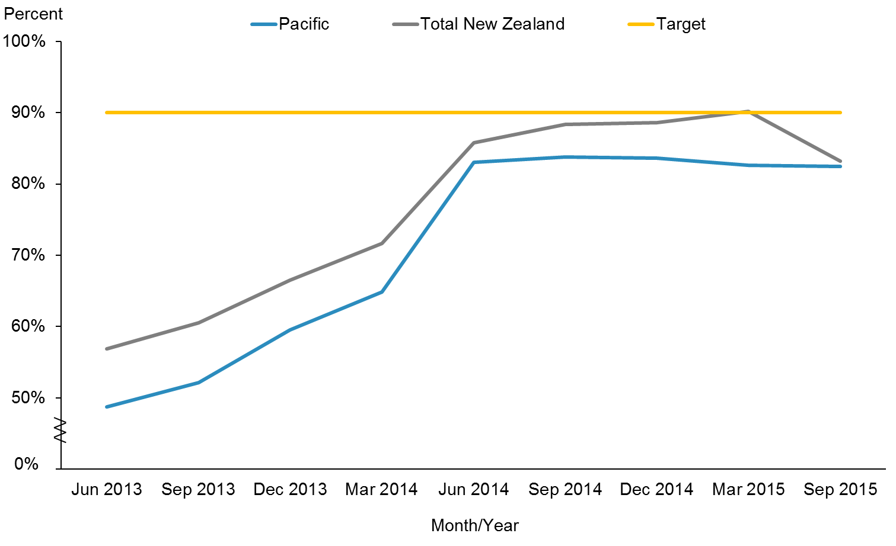

|  |  |  |  |  |  |  |  |  |  |
| --- | --- | --- | --- | --- | --- | --- | --- | --- | --- |
|  | **Jun 2013** | **Sep 2013** | **Dec 2013** | **Mar 2014** | **Jun 2014** | **Sep 2014** | **Dec 2014** | **Mar 2015** | **Sep 2015** |
| Pacific | 48.8% | 52.1% | 59.6% | 64.8% | 83.0% | 83.8% | 83.6% | 82.6% | 82.4% |
| Total New Zealand | 56.9% | 60.5% | 66.5% | 71.6% | 85.8% | 88.4% | 88.6% | 90.2% | 83.2% |
| Target | 90.0% | 90.0% | 90.0% | 90.0% | 90.0% | 90.0% | 90.0% | 90.0% | 90.0% |

Figure 23 shows that since 2013 there has been an increase in the percentage of smokers offered brief advice and support to quit in primary health care. However, from June 2014, both rates have slowed. In March 2015, there was a marked decrease for the total New Zealand population compared with the Pacific population. This marked shift can be explained by the target shift in focus to the entire enrolled population of people who smoke, which means the denominator has increased.

Figure : Percentage of smokers offered brief advice and support to quit in primary health care, Pacific peoples, by priority DHBs, 2013–2015

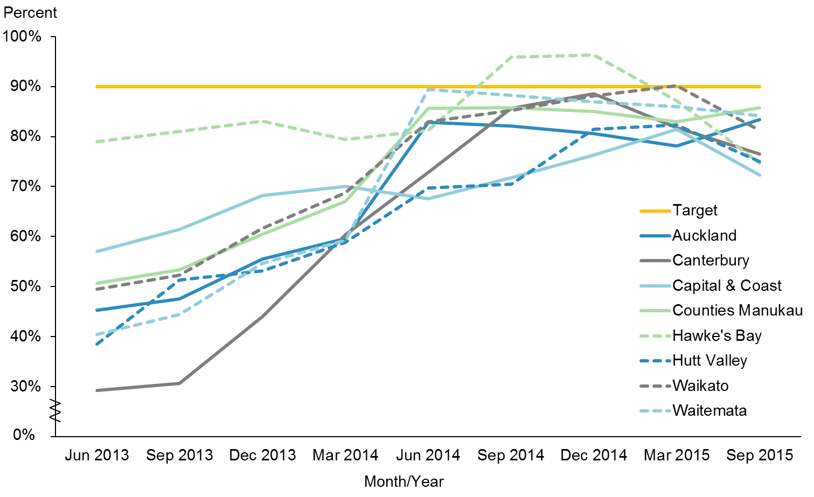

|  |  |  |  |  |  |  |  |  |  |
| --- | --- | --- | --- | --- | --- | --- | --- | --- | --- |
|  | **Jun 2013** | **Sep 2013** | **Dec 2013** | **Mar 2014** | **Jun 2014** | **Sep 2014** | **Dec 2014** | **Mar 2015** | **Sep 2015** |
| Auckland | 45.3% | 47.5% | 55.5% | 59.6% | 82.9% | 82.1% | 80.6% | 78.2% | 83.4% |
| Canterbury | 29.2% | 30.7% | 44.0% | 60.4% | 72.8% | 85.7% | 88.5% | 81.8% | 76.6% |
| Capital & Coast | 57.1% | 61.5% | 68.2% | 70.0% | 67.5% | 71.8% | 76.3% | 81.5% | 72.4% |
| Counties Manukau | 50.7% | 53.4% | 60.5% | 67.0% | 85.6% | 85.7% | 85.0% | 82.9% | 85.8% |
| Hawke's Bay | 79.0% | 81.0% | 83.1% | 79.4% | 81.2% | 95.9% | 96.3% | 87.1% | 74.6% |
| Hutt Valley | 38.5% | 51.3% | 53.1% | 58.8% | 69.8% | 70.5% | 81.5% | 82.3% | 75.0% |
| Waikato | 49.5% | 52.3% | 61.7% | 68.8% | 82.9% | 85.2% | 88.1% | 90.2% | 81.3% |
| Waitemata | 40.4% | 44.5% | 54.7% | 59.3% | 89.4% | 88.3% | 86.9% | 85.9% | 84.1% |
| Target | 90.0% | 90.0% | 90.0% | 90.0% | 90.0% | 90.0% | 90.0% | 90.0% | 90.0% |

Figure 24 shows that Counties Manukau DHB and Auckland DHB have rebounded and are heading up after the downturn in March 2015. The other six DHBs were affected by the target shift to focus on the entire enrolled population of people who smoke, which means the denominator has increased.

|  |  |
| --- | --- |
| **Indicator 3b** | **Improve management of diabetes by increasing ‘more heart and diabetes checks’** |

**Performance:** The target for this indicator is 90 percent.

Figure : Percentage of eligible adults who had cardiovascular risk assessed, Pacific peoples population and total New Zealand population, 2013–2015

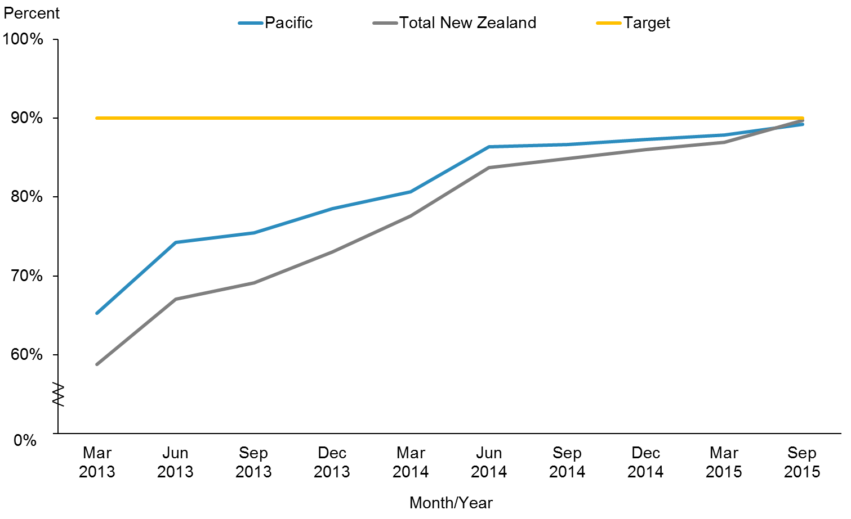

|  |  |  |  |  |  |  |  |  |  |  |
| --- | --- | --- | --- | --- | --- | --- | --- | --- | --- | --- |
|  | **Mar 2013** | **Jun 2013** | **Sep 2013** | **Dec 2013** | **Mar 2014** | **Jun 2014** | **Sep 2014** | **Dec 2014** | **Mar 2015** | **Sep 2015** |
| Pacific | 65.3% | 74.3% | 75.5% | 78.5% | 80.7% | 86.4% | 86.7% | 87.3% | 87.9% | 89.2% |
| Total New Zealand | 58.8% | 67.1% | 69.1% | 73.0% | 77.6% | 83.7% | 84.9% | 86.1% | 86.9% | 89.8% |
| Target | 90.0% | 90.0% | 90.0% | 90.0% | 90.0% | 90.0% | 90.0% | 90.0% | 90.0% | 90.0% |

Figure 25 shows that both the Pacific population and the total New Zealand population continue to improve. The target of 90 percent is close to being achieved for the Pacific population (89.2%) and the total New Zealand population (89.8%). The disparity between the populations is diminishing.

Figure : Percentage of eligible adults who had cardiovascular risk assessed, Pacific peoples, by priority DHBs, 2013–2015

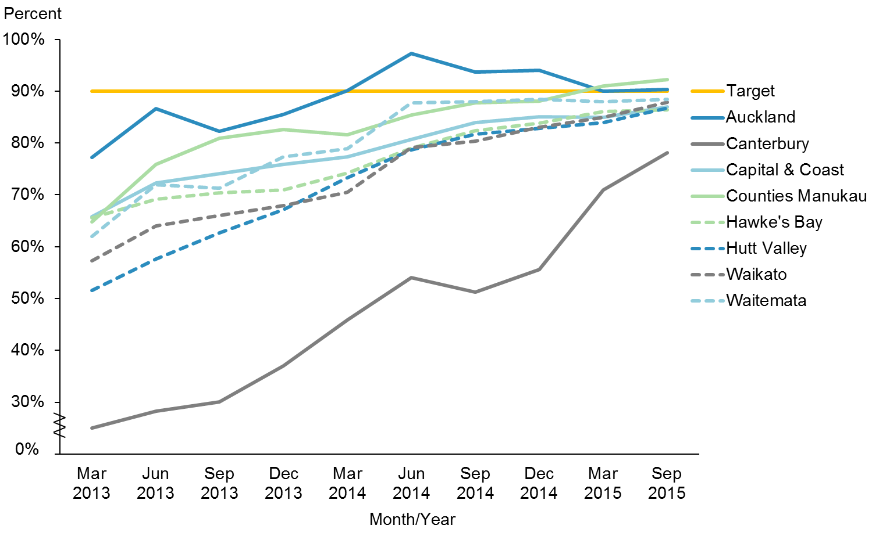

|  |  |  |  |  |  |  |  |  |  |  |
| --- | --- | --- | --- | --- | --- | --- | --- | --- | --- | --- |
|  | **Mar 2013** | **Jun 2013** | **Sep 2013** | **Dec 2013** | **Mar 2014** | **Jun 2014** | **Sep 2014** | **Dec 2014** | **Mar 2015** | **Sep 2015** |
| Auckland | 77.2% | 86.6% | 82.3% | 85.5% | 90.1% | 97.3% | 93.7% | 94.0% | 90.0% | 90.3% |
| Canterbury | 25.0% | 28.3% | 30.1% | 37.0% | 45.9% | 54.0% | 51.2% | 55.6% | 71.0% | 78.1% |
| Capital & Coast | 65.9% | 72.3% | 74.1% | 75.9% | 77.4% | 80.8% | 84.0% | 85.0% | 85.0% | 87.0% |
| Counties Manukau | 64.8% | 75.9% | 80.9% | 82.6% | 81.6% | 85.4% | 87.8% | 88.1% | 91.0% | 92.2% |
| Hawke's Bay | 65.6% | 69.2% | 70.4% | 71.0% | 74.2% | 79.0% | 82.4% | 83.8% | 86.0% | 86.5% |
| Hutt Valley | 51.6% | 57.6% | 62.6% | 67.1% | 73.3% | 78.7% | 81.7% | 82.8% | 84.0% | 86.7% |
| Waikato | 57.3% | 64.0% | 66.1% | 67.9% | 70.6% | 79.1% | 80.4% | 83.1% | 85.0% | 87.8% |
| Waitemata | 62.0% | 71.9% | 71.3% | 77.4% | 78.9% | 87.8% | 87.9% | 88.4% | 88.0% | 88.5% |
| Target | 90.0% | 90.0% | 90.0% | 90.0% | 90.0% | 90.0% | 90.0% | 90.0% | 90.0% | 90.0% |

Figure 26 shows that all DHBs are making positive progress and are converging around the target of 90 percent. Auckland DHB and Counties Manukau DHB have achieved the target and maintained this achieved status in the last update. Canterbury DHB is also making progress. In the June 2015 update they have progressed from about 20 percentage points away from the target to 13 percentage points away.

|  |  |
| --- | --- |
| **Action 4** | **DHBs will support the Pacific Whānau Ora Commissioning Agency.** |

### Action commentary

In their 2015/2016 annual plans, all priority DHBs have committed to working with Whānau Ora commissioning agencies. The Auckland, Counties Manukau and Waitemata DHBs’ annual plans make specific reference to working with Pasifika Futures (the Pacific Whānau Ora Commissioning Agency) to ensure effective integration between Whānau Ora and DHB-funded family support services, and to quarterly meetings.

The Ministry has invested in Pacific health collectives, networks and eligible Pacific health providers through the Pacific Provider Workforce Development Fund. Providers have reported that, as a result, they are better placed to deliver on their contracts with Pasifika Futures.

Currently Pasifika Futures mainly works directly with contracted community providers. However, the agency is looking to begin working closer with DHBs.

One of the health outcomes Pasifika Futures aims to achieve in the next three to five years is for ‘Pacific peoples to be physically active and make healthy eating choices’.

|  |  |
| --- | --- |
| **Indicator 4a** | **DHB annual plans report on extent of support for the Pacific Whānau Ora Commissioning Agency** |

#### Counties Manukau DHB

Counties Manukau DHB has embedded a Fanau Ola (Pacific Whānau Ora) approach in its work in the hospital and through the integrated Pacific provider contracts. This is linked to Counties Manukau DHB’s Health Accelerating Pacific Health Gain Plan 2017. There are a number of ‘Actions’ and ‘Measures’ set (Counties Manukau Health, Annual Plan 2015/2016).

#### Auckland DHB

Auckland DHB will work with Pasifika Futures to ensure effective integration between Whānau Ora and Auckland DHB-funded family support services and will continue to identify outcomes for Pacific families. Auckland DHB will establish a Whānau Ora network in Tāmaki. Services and programmes to improve outcomes for Māori and Pacific children, including immunisations, healthy lifestyles initiatives and PHO enrolment, have been prioritised. Auckland DHB will continue to implement the objectives described in the Pacific Health Action Plan.

#### Waitemata DHB

Waitemata DHB will continue to implement the objectives described in the Pacific Health Action Plan, work with Pasifika Futures to ensure effective integration between Whānau Ora and Waitemata DHB-funded family support services, and identify outcomes for families at quarterly meetings with West Fono Health Trust (the Pacific Whānau Ora provider for the DHB).

|  |  |
| --- | --- |
| **Indicator 4b** | **Decrease the number of Pacific children aged 2–14 years who are obese** |

**Performance:** There is no target set for this indicator.

Figure : Percentage of children who are obese (BMI >/= Cole cut-offs),[4] Pacific peoples population and total New Zealand population, 2006–2014

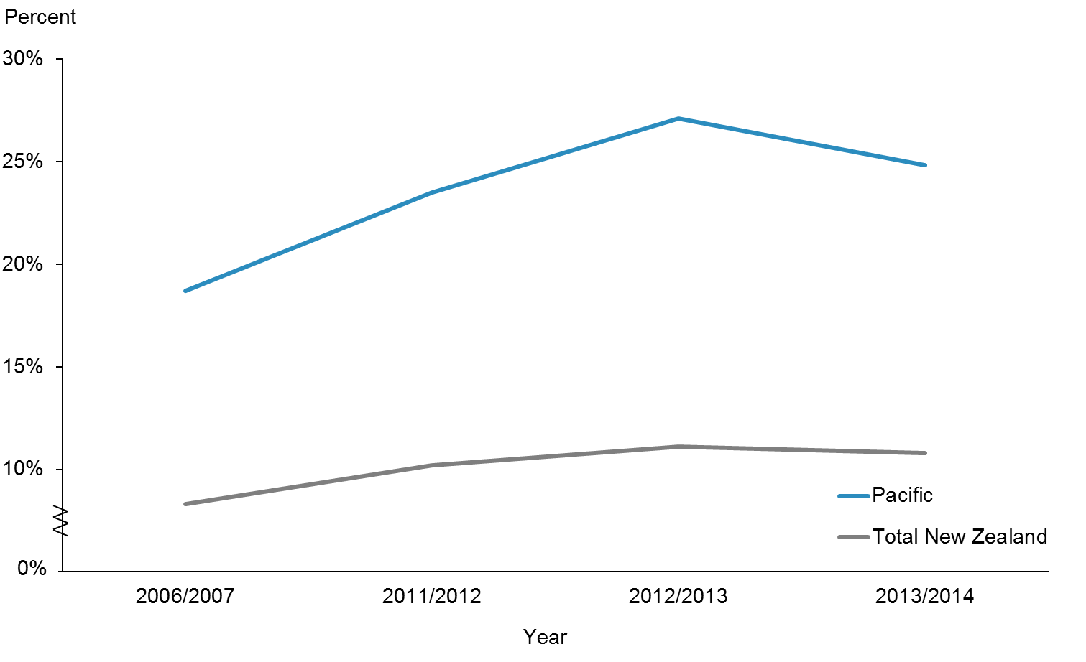

|  |  |  |  |  |
| --- | --- | --- | --- | --- |
|  | **2006/2007** | **2011/2012** | **2012/2013** | **2013/2014** |
| Pacific | 18.7% | 23.5% | 27.1% | 24.8% |
| Total New Zealand | 8.3% | 10.2% | 11.1% | 10.8% |

Figure 27 shows obesity rates for children between 2006 and 2014. There was no change from the June 2015 progress report.

Figure : Percentage of children who are obese (BMI >/= Cole cut-offs), Pacific peoples, by priority DHBs, 2006–2014

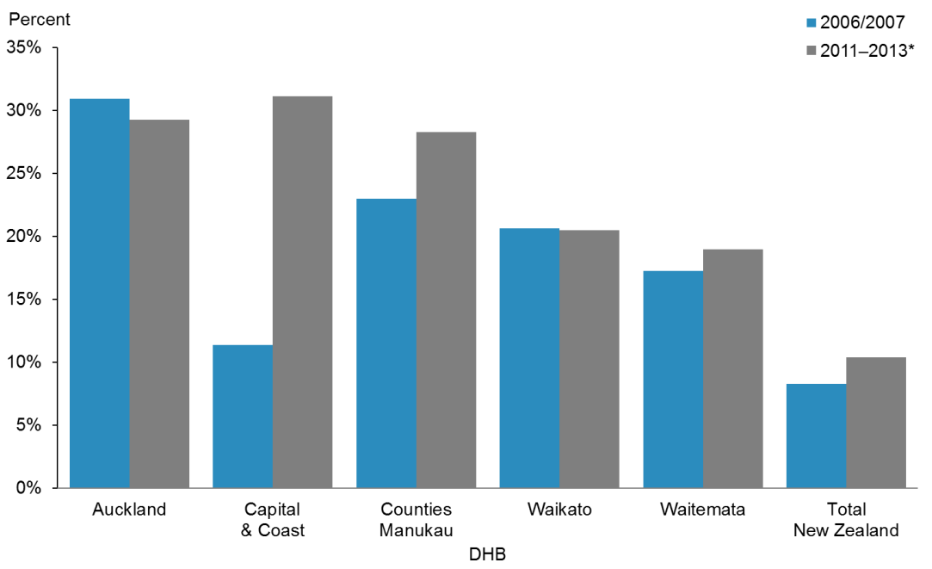

|  |  |  |
| --- | --- | --- |
|  | **2006/2007** | **2011-2013\*** |
| Auckland | 31.0% | 29.3% |
| Capital & Coast | 11.4% | 31.1% |
| Counties Manukau | 23.0% | 28.3% |
| Waikato | 20.6% | 20.5% |
| Waitemata | 17.2% | 19.0% |
| Total New Zealand | 8.3% | 10.4% |

* This is data pooled from three consecutive surveys 2011/2012, 2012/2013 and 2013/2014.

**Note:** The latest data for this indicator from the 2014/2015 was not available in time for this report.There is no set national target.

Figure 28 shows obesity rates for Pacific children by priority DHBs. There was no change from the June 2015 progress report.

|  |  |
| --- | --- |
| **Action 5** | **DHBs, PHOs and other providers will maximise coverage and participation of Pacific peoples in the national screening programmes.** |

### Action commentary

The Report of the Parliamentary Review Committee regarding the New Zealand Cervical Screening Programme June 2015 was released online in July 2015 (Tan et al 2015). Age‑standardised cervical cancer incidence rates have been decreasing since they peaked in 2009 at about 15 new cases to about 8 cases per 100,000 in 2012. For all women in New Zealand, the incidence rate was about 6 per 100,000 compared with about 8 per 100,000 for Pacific women. Between 1998 and 2010 cervical cancer mortality has declined from 3.2 to 1.7 per 100,000 for women of all ethnicities, but not so for Pacific women. The age-standardised cervical cancer mortality rate for Pacific women is the highest in New Zealand at 9 deaths per 100,000. Pacific women are least likely to have follow-up after a high-grade cytology report compared with all women in New Zealand. After three months, 1 in 4 (24.4%) Pacific women are not followed up compared with 1 in 10 (10.0%) for the total population. After six months, 1 in 6 (16.3%) Pacific women are not followed up compared with 1 in 20 (6.7%) for total population.

Some of the recommendations to improve equity in this report are listed below.

#### Coverage, participation, equity and access

Clear strategies are needed to ensure that access to free smears is appropriately targeted to the women in highest need. To improve coverage for high-priority women, the cost of smears must not be a barrier. Cultural competency is vitally important and ongoing education is needed to ensure that smear takers are attuned to cultural sensitivities. The National Screening Unit has undertaken an open tender for future purchasing of outreach services to support Pacific women’s participation in the screening programme.

#### Monitoring and evaluation

The proportion of women who did not have a follow-up test reported within 90 days after a high-grade cytological abnormality varied significantly across DHBs and by ethnicity. The National Screening Unit is investigating the barriers to attendances that are preventing timely investigations and treatment, and will develop strategies to improve outcomes for these women.

#### Organisational and structural issues

The NCSP must address the variable achievement of the target rate of 80 percent for Māori, Pacific and Asian women by producing Action Plans for each of the priority groups that can demonstrate progressive reduction in disparities for each of these groups.

#### Ethnicity data

The National Screening Unit, NCSP portfolio managers and DHB managers need to collaborate with independent service providers and PHOs (general practices) regarding data sharing between the agencies to identify unscreened women in the regions. The NCSP should ensure that DHBs provide Action Plans for each of the priority groups. In particular, DHBs should develop an annual Pacific Action Plan and an annual Asian Action Plan to address inequities and disparities in cervical screening for each of these priority groups. The NCSP is encouraging PHOs to proactively refer women to independent service providers where women are overdue for screening and have not responded to general practice recalls for screening.

|  |  |
| --- | --- |
| **Indicator 5** | **Increase percentage of enrolled Pacific women aged 25–69 years old to receive a cervical smear in the past three years to at least equal to the rate of the total population** |

**Performance:** The target for this indicator is 80 percent.

Figure : Percentage of enrolled women aged 25–69 years who received a cervical smear in the past three years, Pacific peoples population and total New Zealand population, 2013–2015

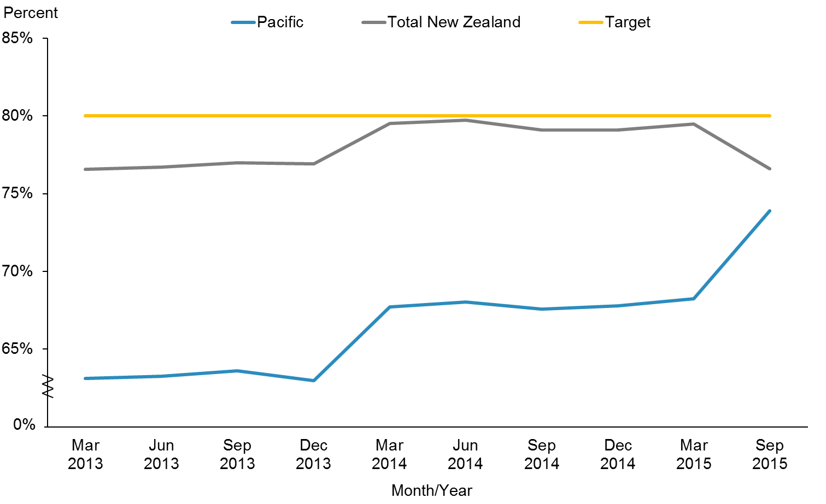

|  |  |  |  |  |  |  |  |  |  |  |
| --- | --- | --- | --- | --- | --- | --- | --- | --- | --- | --- |
|  | **Mar 2013** | **Jun 2013** | **Sep 2013** | **Dec 2013** | **Mar 2014** | **Jun 2014** | **Sep 2014** | **Dec 2014** | **Mar 2015** | **Sep 2015** |
| Pacific | 63.1% | 63.2% | 63.6% | 63.0% | 67.7% | 68.0% | 67.6% | 67.8% | 68.2% | 73.9% |
| Total New Zealand | 76.6% | 76.7% | 77.0% | 76.9% | 79.5% | 79.7% | 79.1% | 79.1% | 79.5% | 76.6% |
| Target | 80.0% | 80.0% | 80.0% | 80.0% | 80.0% | 80.0% | 80.0% | 80.0% | 80.0% | 80.0% |

**Notes for Figures 29 and 30:**

* The age range for the cervical screening eligibility monitoring target was 20–69 years prior to 2014, and then changed to 25–69 years in January 2014. This change aligns with international best practice, and allows for international comparison of screening programme performance.
* These percentages are calculated using the PHO population as the denominator.
* These percentages may not be the same as the ones reported online by the NCSP that uses the Population Projections provided by Statistics New Zealand based on Census 2013.

Figure 29 shows there has been improvement in the cervical screening percentages for Pacific women from the last update in June 2015. The inclusion of cervical screening as a target in the Integrated Performance Indicator Framework (IPIF) in primary care has increased PHO engagement and interest in increasing cervical screening coverage.

Figure : Percentage of enrolled women aged 25–69 years who received a cervical smear in the past three years, Pacific peoples, by priority DHBs, 2013–2015

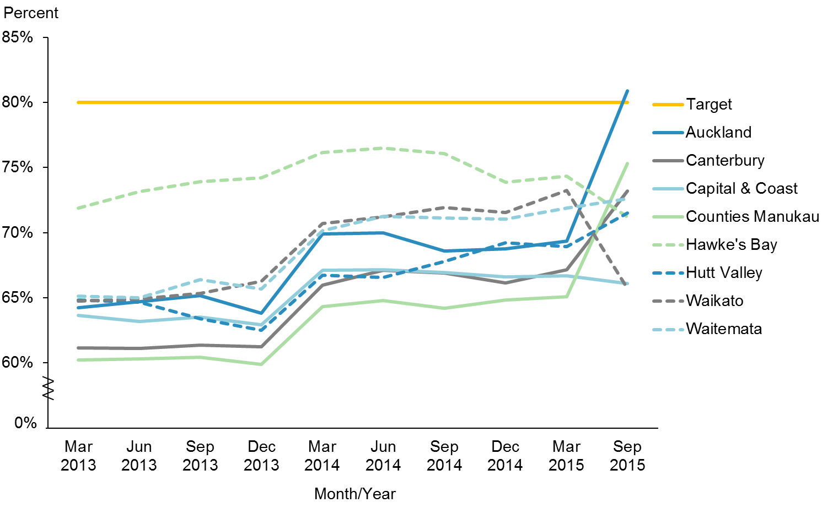

|  |  |  |  |  |  |  |  |  |  |  |
| --- | --- | --- | --- | --- | --- | --- | --- | --- | --- | --- |
|  | **Mar 2013** | **Jun 2013** | **Sep 2013** | **Dec 2013** | **Mar 2014** | **Jun 2014** | **Sep 2014** | **Dec 2014** | **Mar 2015** | **Sep 2015** |
| Auckland | 64.2% | 64.7% | 65.2% | 63.8% | 69.9% | 70.0% | 68.6% | 68.8% | 69.4% | 80.9% |
| Canterbury | 61.1% | 61.1% | 61.4% | 61.2% | 66.0% | 67.1% | 66.9% | 66.1% | 67.1% | 73.2% |
| Capital & Coast | 63.6% | 63.2% | 63.5% | 62.9% | 67.1% | 67.2% | 67.0% | 66.6% | 66.7% | 66.1% |
| Counties Manukau | 60.2% | 60.3% | 60.4% | 59.9% | 64.3% | 64.8% | 64.2% | 64.9% | 65.1% | 75.3% |
| Hawke's Bay | 71.9% | 73.1% | 73.9% | 74.2% | 76.2% | 76.5% | 76.1% | 73.9% | 74.4% | 71.2% |
| Hutt Valley | 64.8% | 64.7% | 63.4% | 62.5% | 66.8% | 66.6% | 67.8% | 69.2% | 68.9% | 71.5% |
| Waikato | 64.7% | 64.9% | 65.3% | 66.3% | 70.7% | 71.2% | 71.9% | 71.6% | 73.3% | 65.7% |
| Waitemata | 65.1% | 65.0% | 66.4% | 65.7% | 70.2% | 71.3% | 71.1% | 71.0% | 71.9% | 72.6% |
| Target | 80.0% | 80.0% | 80.0% | 80.0% | 80.0% | 80.0% | 80.0% | 80.0% | 80.0% | 80.0% |

Figure 30 shows that overall, the priority DHBs are making good progress towards achieving the 80 percent target. Auckland DHB has achieved the goal in this update, which is the first time any of the priority DHBs have achieved this target. Counties Manukau DHB and Canterbury DHB are making progress. Waikato DHB has had a 10 percentage point drop since the June 2015 progress report. It is very likely this is due to an under-count in the denominator for Waikato DHB, which uses PHO population, compared with the NCSP, which uses all eligible women between 25 and 69 years old obtained from Statistics New Zealand population projection figures. For example, the March 2015 figure for Waikato DHB is 73.3 percent (reported above), compared with the NCSP figure of 65.0 percent of the same period.

|  |  |  |  |  |  |  |  |  |  |  |  |  |
| --- | --- | --- | --- | --- | --- | --- | --- | --- | --- | --- | --- | --- |
| **Priority outcome 2 – More services are delivered locally in the community and in primary care**  The following presents a brief summary of performance indicator results in priority outcome 2 for this reporting period.  The four national Pacific collectives are making good progress towards this priority outcome, through collaborations with their respective DHB alliances.  The only indicator with a quantitative measure in this priority outcome section for which the rates have reached equity (that is, the rate for Pacific peoples has met or exceeded the total population rate), if not the target, is increased utilisation rates of primary health care, as Table 9 shows.  Table 9: Performance against priority outcome 2 indicators, as at 31 December 2015   |  |  |  | | --- | --- | --- | | **Indicator** | **Pacific rate** | **Total New Zealand rate** | | GP utilisation | 3.01 | 2.95 | | Nurse utilisation | 0.76 | 0.68 | | Total GP and nurse | 3.77 | 3.62 |   The latest results to December 2015 show that Pacific peoples’ rate of primary care utilisation (for both GPs and nurses) has increased over the years, and is now higher than that of the total New Zealand population. There is an assumption that increased access to primary health care leads to improved health outcomes and a reduction in ASH rates. We are unable to update the ASH rates for this progress report. ASH rates will be reported differently in the next progress report update (June 2016) as Child ASH (0–4 years) and Adult ASH (45–64 years). |

# Priority outcome 2 – More services are delivered locally in the community and in primary care

|  |  |
| --- | --- |
| **Action 1** | **The four Pacific health collectives will be part of relevant DHB alliances.** |

Nationally, there are four Pacific health collectives, each with memberships of three to 12 Pacific providers who deliver a range of primary care, community-based health care and social services. They are based in Auckland (led by Alliance Health Plus Trust),[5] Midlands (led by K’aute Pacific Services), Wellington (led by the Central Pacific Collective) and the South Island (led by Pacific Trust Canterbury). All of the collective members use Ministry of Health funds to strengthen funding capability, infrastructure, IT frameworks, and policies and systems to provide improved health services to the Pacific peoples they serve.

### Action commentary

The Auckland Region Pacific Provider Network, Tangata o le Moana, has been working closely with the Pacific health divisions of Counties Manukau, Auckland and Waitemata DHBs. In May 2015, all three DHBs met with Tangata o le Moana providers. There, DHB representatives signalled to Tangata o le Moana that they were interested in the demonstration projects currently under development within the network. Through Tangata o le Moana members, providers maintain several alliance arrangements. For example, Alliance Health Plus is engaged in the District Alliance for Counties Manukau DHB, and there is a Rheumatic Fever Rapid Response Alliance within Auckland DHB.

K’aute Pasifika maintains a close working relationship with Waikato DHB, and is member of a number of the DHB’s working groups, including the Rheumatic Fever Stakeholder Group, the Sore Throat Management Steering Group, the Immunisation Stakeholder Group and the Children’s Action team.

In Wellington, the Pacific Health and Wellbeing Collective has established a strong working relationship with Capital & Coast and Hutt Valley DHBs and holds regular monthly meetings with both.

Pacific Trust Canterbury works closely with Canterbury DHB, and also holds various primary health care, social services and education contracts that support improving Pacific peoples’ wellbeing in the Canterbury region. Pacific Trust Canterbury is part of the Pacific Reference Group, a forum which has representatives from Canterbury DHB, Pegasus PHO, the Ministry for Pacific Peoples and the youth community. The forum is chaired by Canterbury DHB and administered by the Pacific manager for Pegasus PHO.

|  |  |
| --- | --- |
| **Indicator 1** | **Monitor the number of Pacific collectives/networks involved in DHB alliances through collective and network monitoring reports** |

Refer to ‘Action Commentary’ above.

|  |  |
| --- | --- |
| **Action 2** | **The new Integrated Performance and Incentive Framework (IPIF) will facilitate improved health outcomes for Pacific peoples.** |

### Action commentary

IPIF has been established to support the health system to address equity, safety, quality, access and cost of services. It is a quality and performance improvement programme that will reward good performance and will be developed and implemented over several years.

The five system-level measures that commenced in 2014 have been confirmed for the 2015/2016 year. They are:

* more heart and diabetes checks (target = 90% of the relevant enrolled population)
* better help for smokers to quit (target = 90%)
* increased immunisation rates at eight months old (target = 95%)
* increased immunisation rates at two years old (target = 95%)
* increased cervical screening coverage (target = 80%).

To demonstrate their commitment to high standards of care, PHOs are carrying out self-assessments.

In addition, the Ministry and the Health Quality & Safety Commission are introducing patient experience measures for primary care using online surveys. The information gathered in this way will be used to improve the quality and safety of services, and define one of the IPIF’s measures of patient care.

The IPIF continues to have an equity focus; all measures will include ethnicity breakdowns.

|  |  |
| --- | --- |
| **Indicator 2a** | **Equity in all system measures for Pacific peoples (ie, healthy start measures, healthy child measures and healthy adult measures)** |

Refer to ‘Action Commentary’ above, and to Figures 24, 25 and 30.

|  |  |
| --- | --- |
| **Indicator 2b** | **Increased utilisation rates of primary health care providers in the eight priority DHBs** |

**Performance:** There is no target set for this indicator.

Figure : GP utilisation rate (average visits per person per year), Pacific peoples population and total New Zealand population, 2008–2015

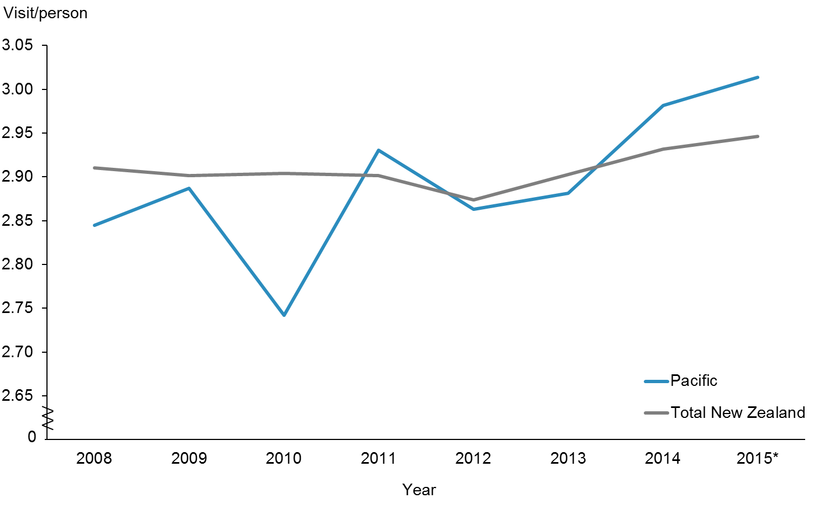

|  |  |  |  |  |  |  |  |  |
| --- | --- | --- | --- | --- | --- | --- | --- | --- |
|  | **2008** | **2009** | **2010** | **2011** | **2012** | **2013** | **2014** | **2015\*** |
| Pacific | 2.84 | 2.89 | 2.74 | 2.93 | 2.86 | 2.88 | 2.98 | 3.01 |
| Total New Zealand | 2.91 | 2.90 | 2.90 | 2.90 | 2.87 | 2.90 | 2.93 | 2.95 |

* Financial year 2014/2015

Figure 31 shows that Pacific peoples were more likely to have accessed their GPs than the total New Zealand population. The introduction of the Very Low Cost Access (VLCA) scheme has helped achieve equity for Pacific peoples’ GP utilisation in New Zealand. The VLCA scheme was introduced in October 2006. This is a voluntary scheme that general practices can opt out of at any time if they find it is no longer appropriate for them. From October 2009, eligibility for the VLCA payment was limited to PHOs and contracted general practices with an enrolled population of 50 percent or more high-needs patients (defined as Māori, Pacific or New Zealand Deprivation Index quintile 5).

Figure : GP utilisation rate (average visits per person), Pacific peoples, by priority DHBs, 2008–2015

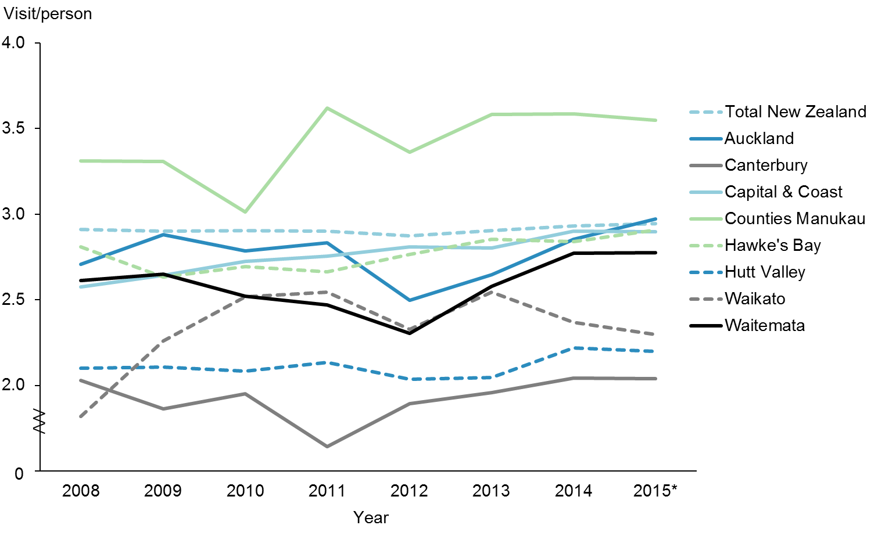

|  |  |  |  |  |  |  |  |  |
| --- | --- | --- | --- | --- | --- | --- | --- | --- |
|  | **2008** | **2009** | **2010** | **2011** | **2012** | **2013** | **2014** | **2015\*** |
| Auckland | 2.71 | 2.88 | 2.79 | 2.83 | 2.50 | 2.65 | 2.85 | 2.97 |
| Canterbury | 2.03 | 1.86 | 1.95 | 1.64 | 1.89 | 1.96 | 2.04 | 2.04 |
| Capital & Coast | 2.58 | 2.64 | 2.72 | 2.75 | 2.81 | 2.80 | 2.90 | 2.90 |
| Counties Manukau | 3.31 | 3.31 | 3.01 | 3.62 | 3.36 | 3.58 | 3.59 | 3.55 |
| Hawke's Bay | 2.81 | 2.63 | 2.69 | 2.66 | 2.76 | 2.85 | 2.84 | 2.91 |
| Hutt Valley | 2.10 | 2.11 | 2.08 | 2.13 | 2.04 | 2.05 | 2.22 | 2.20 |
| Waikato | 1.82 | 2.26 | 2.52 | 2.54 | 2.33 | 2.55 | 2.37 | 2.30 |
| Waitemata | 2.61 | 2.65 | 2.52 | 2.47 | 2.30 | 2.58 | 2.77 | 2.78 |
| Total New Zealand | 2.91 | 2.90 | 2.90 | 2.90 | 2.87 | 2.90 | 2.93 | 2.95 |

* Financial year 2014/2015

Figure 32 shows that Counties Manukau, the DHB with the largest enrolled Pacific population, had the highest average visit per person, followed by Auckland. They were the only two DHBs that had achieved equity. Other DHBs (Hawke’s Bay, Capital & Coast and Waitemata) have also been improving and are not far away from achieving equity.

Figure : Nurse utilisation rate (average visits per person), Pacific peoples population and total New Zealand population, 2008–2015

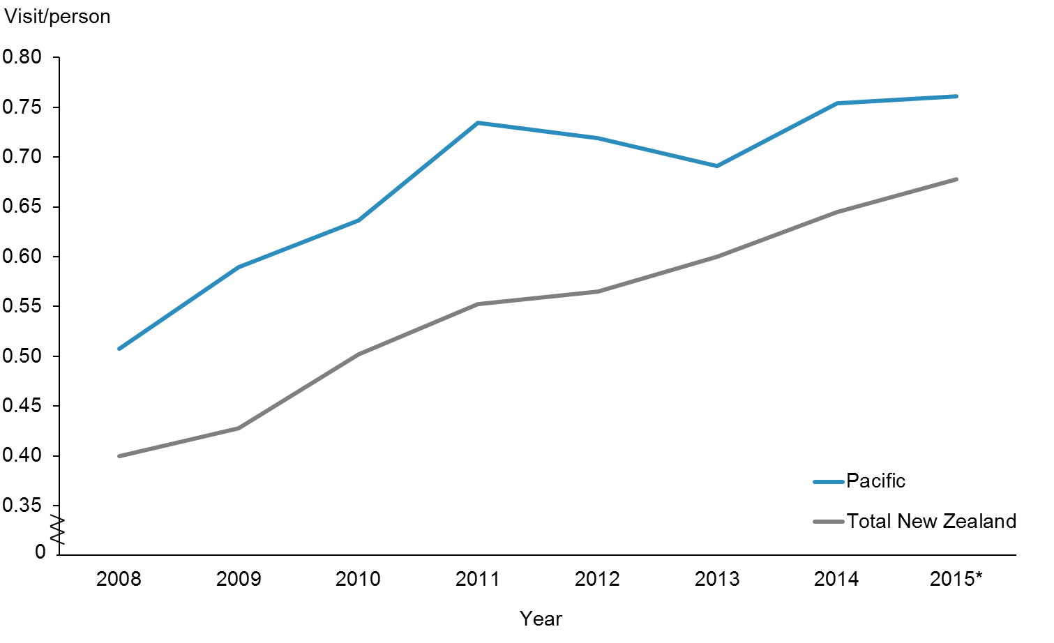

|  |  |  |  |  |  |  |  |  |
| --- | --- | --- | --- | --- | --- | --- | --- | --- |
|  | **2008** | **2009** | **2010** | **2011** | **2012** | **2013** | **2014** | **2015\*** |
| Pacific | 0.51 | 0.59 | 0.64 | 0.73 | 0.72 | 0.69 | 0.75 | 0.76 |
| Total New Zealand | 0.40 | 0.43 | 0.50 | 0.55 | 0.56 | 0.60 | 0.64 | 0.68 |

* Financial year 2014/2015

Figure 33 shows that the rates of utilisation of primary health nursing services were higher for Pacific peoples compared with the total New Zealand population. The rates dropped from 2011 until 2013, then increased again. This could be explained by the additional funding (to the VLCA scheme) available during 2013 and 2014 to fund graduate nurses to work in VLCA practices for one year.

Figure : Nurse utilisation rate (average visits per person), Pacific peoples, by priority DHBs, 2008–2015

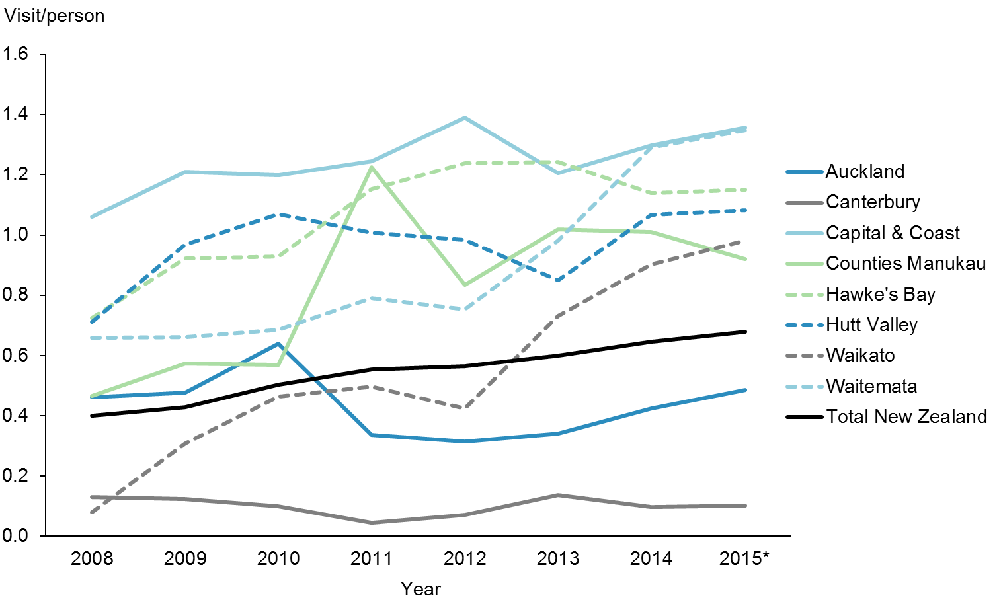

|  |  |  |  |  |  |  |  |  |
| --- | --- | --- | --- | --- | --- | --- | --- | --- |
|  | **2008** | **2009** | **2010** | **2011** | **2012** | **2013** | **2014** | **2015\*** |
| Auckland | 0.46 | 0.48 | 0.64 | 0.33 | 0.31 | 0.34 | 0.42 | 0.49 |
| Canterbury | 0.13 | 0.12 | 0.10 | 0.04 | 0.07 | 0.14 | 0.10 | 0.10 |
| Capital & Coast | 1.06 | 1.21 | 1.20 | 1.24 | 1.39 | 1.21 | 1.30 | 1.36 |
| Counties Manukau | 0.46 | 0.57 | 0.57 | 1.22 | 0.83 | 1.02 | 1.01 | 0.92 |
| Hawke's Bay | 0.72 | 0.92 | 0.93 | 1.15 | 1.24 | 1.24 | 1.14 | 1.15 |
| Hutt Valley | 0.71 | 0.97 | 1.07 | 1.01 | 0.98 | 0.85 | 1.07 | 1.08 |
| Waikato | 0.08 | 0.31 | 0.46 | 0.50 | 0.42 | 0.73 | 0.90 | 0.98 |
| Waitemata | 0.66 | 0.66 | 0.69 | 0.79 | 0.75 | 0.98 | 1.29 | 1.35 |
| Total New Zealand | 0.40 | 0.43 | 0.50 | 0.55 | 0.56 | 0.60 | 0.64 | 0.68 |

* Financial year 2014/2015

Figure 34 shows that Capital & Coast DHB had the highest nurse utilisation rate by Pacific peoples, followed by Waitemata, Hawke’s Bay, Hutt Valley, Waikato and Counties Manukau DHBs. In all six of these six DHBs the rates for Pacific peoples were higher than for the total New Zealand population.

Figure : Total GP and nurse utilisation rate (average visits per person), Pacific peoples population and total New Zealand population, 2008–2015

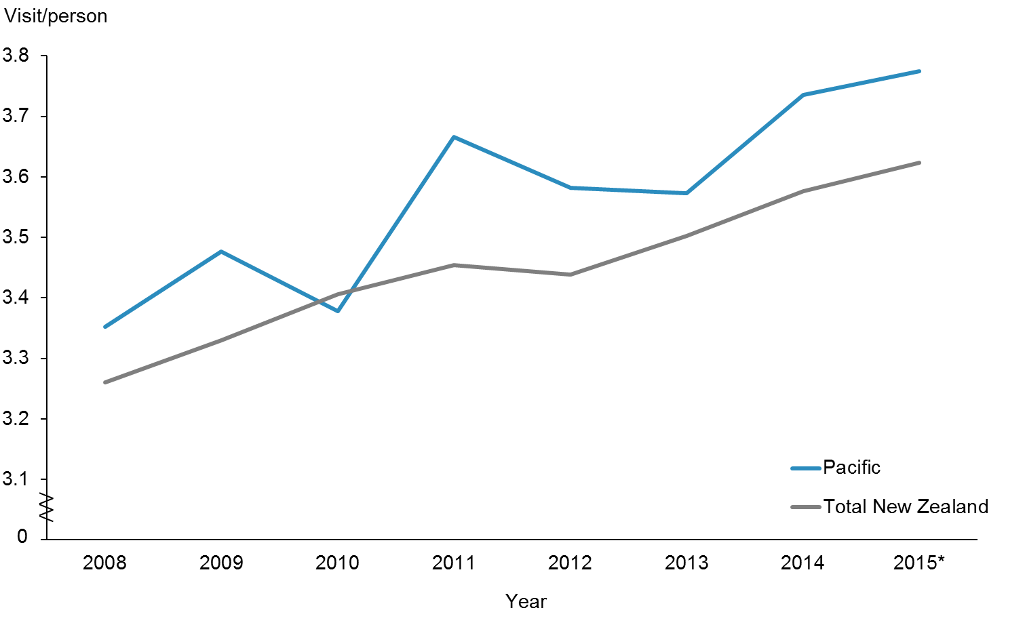

|  |  |  |  |  |  |  |  |  |
| --- | --- | --- | --- | --- | --- | --- | --- | --- |
|  | **2008** | **2009** | **2010** | **2011** | **2012** | **2013** | **2014** | **2015\*** |
| Pacific | 3.35 | 3.48 | 3.38 | 3.67 | 3.58 | 3.57 | 3.74 | 3.77 |
| Total New Zealand | 3.26 | 3.33 | 3.41 | 3.45 | 3.44 | 3.50 | 3.58 | 3.62 |

* Financial year 2014/2015

Figure 35 shows that the rates for both populations have been improving. The Pacific population rates have been consistently higher than those of the total New Zealand population. These results suggest that Pacific peoples are accessing both GPs and nurses more on average than the total New Zealand population. That said, the access rates are inconsistent when compared with the high ASH rates for Pacific peoples compared with the total New Zealand population.

Figure : Total GP and nurse utilisation rate (average visits per person), Pacific peoples, by priority DHBs, 2008–2015

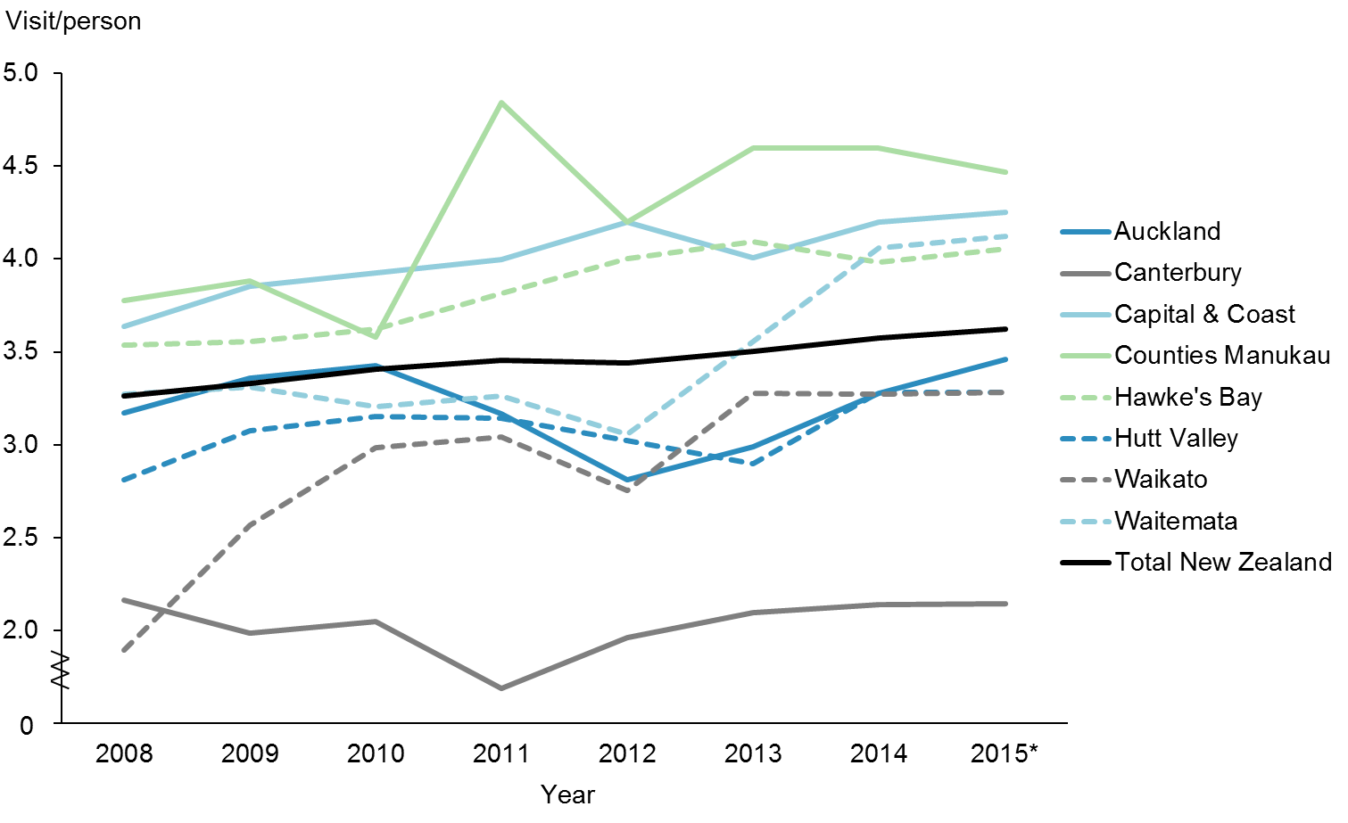

|  |  |  |  |  |  |  |  |  |
| --- | --- | --- | --- | --- | --- | --- | --- | --- |
|  | **2008** | **2009** | **2010** | **2011** | **2012** | **2013** | **2014** | **2015\*** |
| Auckland | 3.17 | 3.36 | 3.42 | 3.17 | 2.81 | 2.99 | 3.28 | 3.46 |
| Canterbury | 2.16 | 1.98 | 2.05 | 1.69 | 1.96 | 2.10 | 2.14 | 2.14 |
| Capital & Coast | 3.64 | 3.85 | 3.92 | 4.00 | 4.20 | 4.01 | 4.20 | 4.25 |
| Counties Manukau | 3.77 | 3.88 | 3.58 | 4.84 | 4.20 | 4.60 | 4.60 | 4.47 |
| Hawke's Bay | 3.54 | 3.55 | 3.62 | 3.82 | 4.00 | 4.09 | 3.98 | 4.06 |
| Hutt Valley | 2.81 | 3.08 | 3.15 | 3.14 | 3.02 | 2.90 | 3.28 | 3.28 |
| Waikato | 1.90 | 2.57 | 2.98 | 3.04 | 2.75 | 3.28 | 3.27 | 3.28 |
| Waitemata | 3.27 | 3.31 | 3.21 | 3.26 | 3.06 | 3.56 | 4.06 | 4.12 |
| Total New Zealand | 3.26 | 3.33 | 3.41 | 3.45 | 3.44 | 3.50 | 3.58 | 3.62 |

* Financial year 2014/2015

Figure 36 shows the total GP and nurse utilisation rates (average visits per person) for the Pacific population and the total New Zealand population. The access rates for Pacific peoples in Counties Manukau, Capital & Coast, Waitemata and Hawke’s Bay DHBs were generally higher than for the total New Zealand population.

|  |
| --- |
| **Priority outcome 3 – Pacific peoples are better supported to be healthy**  The following presents a brief summary of performance indicator results and activities delivered in priority outcome 3 for this reporting period.  There are three actions to ensure that Pacific peoples are better supported to be healthy in this priority outcome.  1. Improve the health literacy of Pacific peoples so that they make healthy choices.  2. Decrease the number of Pacific children (aged 2–14 years) who are obese.  3. Improve the management of diabetes by increasing ‘More heart and diabetes checks’.  **Improve the health literacy**  Improving health literacy for Pacific peoples is crucial in improving their health. The Ministry has released the health literacy framework and a review guide (Ministry of Health 2015a). These documents promote ways in which the health sector can address health literacy issues. The next phase was putting Action Plans in place. A number of DHBs have chosen areas where they piloted their Action Plans. For example, Counties Manukau DHB has chosen an Action Plan for oral health.  **Decrease the number of obese Pacific children**  In October 2015 the Government announced a package of initiatives to prevent and manage obesity in children and young people up to 18 years of age. The package has three focus areas, made up of 22 initiatives, which are either new or an expansion of existing initiatives:   * targeted interventions for those who are obese * increased support for those at risk of becoming obese * broad approaches to make healthier choices easier for all New Zealanders.   The focus is on food, the environment and being active at each life stage, starting during pregnancy and early childhood. The package brings together initiatives across government agencies, the private sector, communities, schools, and families and whānau.  **Improve the management of diabetes by increasing ‘More heart and diabetes checks’**  The Ministry released *Living Well with Diabetes: A Plan for People at High Risk of or Living with Diabetes 2015–2020* in October 2015. The Ministry continues to identify those at risk of developing diabetes sooner and improve the quality of services for people already living with diabetes. |

# Priority outcome 3 – Pacific peoples are better supported to be healthy

|  |  |
| --- | --- |
| **Action 1** | **Improve the health literacy of Pacific peoples so they can make healthy choices and gain better access to the health and disability system, by supporting research on effective approaches to strengthen health literacy.** |

**Performance:** The Ministry will conduct a qualitative survey to measure the health literacy of Pacific peoples in New Zealand, and will continue to monitor the impact of the actions and activities being delivered.

|  |  |
| --- | --- |
| **Action 2** | **Ensure that health programmes work for people with low levels of health literacy, and raise health literacy awareness.** |

**Performance:** See performance notes for Action 1 above.

### Rheumatic fever

The Rheumatic Fever Prevention Programme has three main strategies to reduce rheumatic fever rates throughout New Zealand, and a number of initiatives for each. They are:

1) increase awareness of rheumatic fever, what causes it and how to prevent it

2) reduce household crowding and therefore reduce household transmission of strep throat bacteria within households

3) improve access to timely and effective treatment for strep throat infections in priority communities.

#### Increase awareness of rheumatic fever, what causes it and how to prevent it

**Awareness Campaign:** The 2015 Rheumatic Fever Awareness Campaign was launched on 28 April 2015 and ran until the end of August 2015 across a range of marketing channels. It was built on the 2014 Winter Rheumatic Fever Awareness Campaign which ran from May to August 2014, and again targeted Māori and Pacific parents and caregivers of at-risk Māori and Pacific children and young people. Another awareness campaign aimed at Māori and Pacific youth aged 13–19 years was rolled out, initially in Auckland and Northland. It includes youth ambassadors, social media, theatre in schools, development of short films on prevention, and involvement in a range of youth events. The campaign is jointly designed and delivered by the Ministry of Health, the Ministry of Youth Development and the Ministry for Pacific Peoples.

**Pacific engagement service:** A Pacific engagement service in Auckland and Wellington which provides face-to-face awareness raising and education for Pacific families on the importance of getting sore throats checked and the link between strep throat and rheumatic fever. It is delivered by existing Pacific health providers already making health visits to homes and in community sessions.

**Community Innovations Fund:** In 2014/15, one-off funding was provided through the Pacific Community Innovations Fund to support Pacific community groups to create and put into action their own ideas to improve awareness and help to reduce rheumatic fever.

**Online learning:** A new rheumatic fever e-learning course is now available at Learnonline.health.nz. The course is free and is aimed at primary care nurses, public health nurses and community health workers who work with families whose children are at risk of developing rheumatic fever.

### B4 School Checks

The Ministry has refreshed the messages being provided in its B4SCs. It has developed new promotional material and tools, with a focus on increasing the participation of Māori and Pacific families. Tools and materials now include:

* videos of Pacific families talking about the importance of B4SC
* new web content
* print material for parents/caregivers and the early education sector, including translations in te reo Māori, Samoan and Tongan
* short-term targeted media activity over April 2015 (on radio, through outdoor advertisements and on Facebook) in regions with proportionally higher Māori and Pacific families and families living in high-deprivation areas. Families who were less likely to access the B4SC (including Pacific and Māori, and families living in high deprivation areas) were involved in developing the material, to gain an understanding of barriers to accessing the B4SC.
* a toolkit for providers to support their promotional activity.

|  |  |
| --- | --- |
| **Action 3** | **Strengthen the practice of health literacy in the health workforce through cultural competency education (Pacific Analysis Framework training, Ministry for Pacific Peoples).** |

### Action commentary

#### Ministry for Pacific Peoples

The Pacific Analysis Framework (PAF) is a tool for incorporating Pacific perspectives into the policy processes of Government agencies. In 2014, the Ministry of Pacific Island Affairs (now the Ministry for Pacific Peoples) began work to review and refresh this tool. To date, the review has included consultation with Government agencies, including non-Pacific policy practitioners (the key target audience for the PAF). The Ministry for Pacific Peoples has updated the PAF with more up-to-date demographic data, updated the language to reflect today’s public service and restructured the PAF to make it more user-friendly. Sitting alongside the PAF is a companion document, the Pacific Engagement Guidelines, which the Ministry for Pacific Peoples is also reviewing and updating.

As new work priorities have emerged for the Ministry for Pacific Peoples policy team, the Ministry for Pacific Peoples has deferred the roll-out of the revised PAF until the 2016/17 financial year.

#### Ministry of Health

*Rising to the Challenge: The Mental Health and Addiction Service Development Plan  
2012–2017* provides a strong vision to guide the mental health and addiction sector, as well as clear direction to planners, funders and providers of mental health and addiction services on Government priority areas for service development over the next five years. The plan has eight priority actions for the next five years to make better use of current resources for Pacific peoples. The first action is to fund mental health literacy programmes in Pacific and vulnerable communities. These evidence-informed, culturally appropriate programmes are aimed at increasing awareness of how to recognise and respond to mental health and addiction issues for communities that have a high prevalence of mental health and addiction issues, or a low rate of using health services, or that are experiencing disparities in health outcomes. Where possible, these programmes will be linked to wider health literacy programmes.

|  |  |
| --- | --- |
| **Action 4** | **Work with lead providers of the Healthy Families New Zealand Initiative to implement programmes that enable Pacific families and communities to live healthier lives.** |

### Action commentary

Healthy Families New Zealand (HFNZ) is a large-scale initiative that brings community leadership together in a united effort for better health. It aims to improve people’s health where they live, learn, work and play, in order to prevent chronic disease.

HFNZ is the Government’s flagship prevention platform – a key part of the Government’s wider approach to helping New Zealanders live healthy, active lives. HFNZ is challenging communities to think differently about the underlying causes of poor health, and to make changes – in our schools, workplaces, sports clubs, marae and other key community settings – that will help people make healthier choices.

Led by the Ministry of Health, the initiative will focus on 10 locations in New Zealand in the first instance. It has the potential to impact the lives of over a million New Zealanders. In each location, a skilled prevention workforce will work with local leaders to create healthy change. The Government has allocated $40 million over four years to support HFNZ.

The HFNZ teams will work collaboratively with local leaders and organisations to identify, design and implement changes to help people make healthier choices and live healthier lives. This will involve working with early childhood education, schools, workplaces, food outlets, sports clubs, marae, businesses, places of worship, local governments, health professionals and more to create healthier environments for all.

Pacific Trust Canterbury is the lead provider for Healthy Families Spreydon-Heathcote. The lead provider for Healthy Families Manukau and Healthy Families Manurewa-Papakura is the Auckland Council, in partnership with Alliance Health Plus Trust. Pacific leaders are active on the governance groups for many of the other seven Healthy Families communities.

|  |  |
| --- | --- |
| **Indicator 4a** | **Decrease the number of Pacific children aged 2–14 years who are obese** |

**Performance:** There is no target set for this indicator. Refer to Figures 27 and 28.

|  |  |
| --- | --- |
| **Indicator 4b** | **Improve management of diabetes by providing ‘more heart and diabetes checks’** |

**Performance:** The target for this indicator is 90 percent. Refer to Figures 25 and 26.

### Action commentary

Diabetes is a priority long-term condition affecting an estimated 257,000 New Zealanders. In 2014 the number of people with diabetes grew by nearly 40 people per day. In 2015, the Ministry released *Living Well with Diabetes: A Health Care Plan for People at High Risk of or Living with Diabetes 2015–2020* (Ministry of Health 2015c).

The plan’s overarching objectives are to:

* reduce the personal burden of disease for people with diabetes by providing integrated services along with the tools and support that people need to manage their health
* provide consistent and sustainable services across the country that improve health outcomes and equity for all New Zealanders, and better use of health information
* reduce the cost of diabetes on the public health system and the broader societal impact in the longer term.

Figure : Estimated percentage of people with diabetes, Pacific peoples population and total New Zealand population, 2010–2014

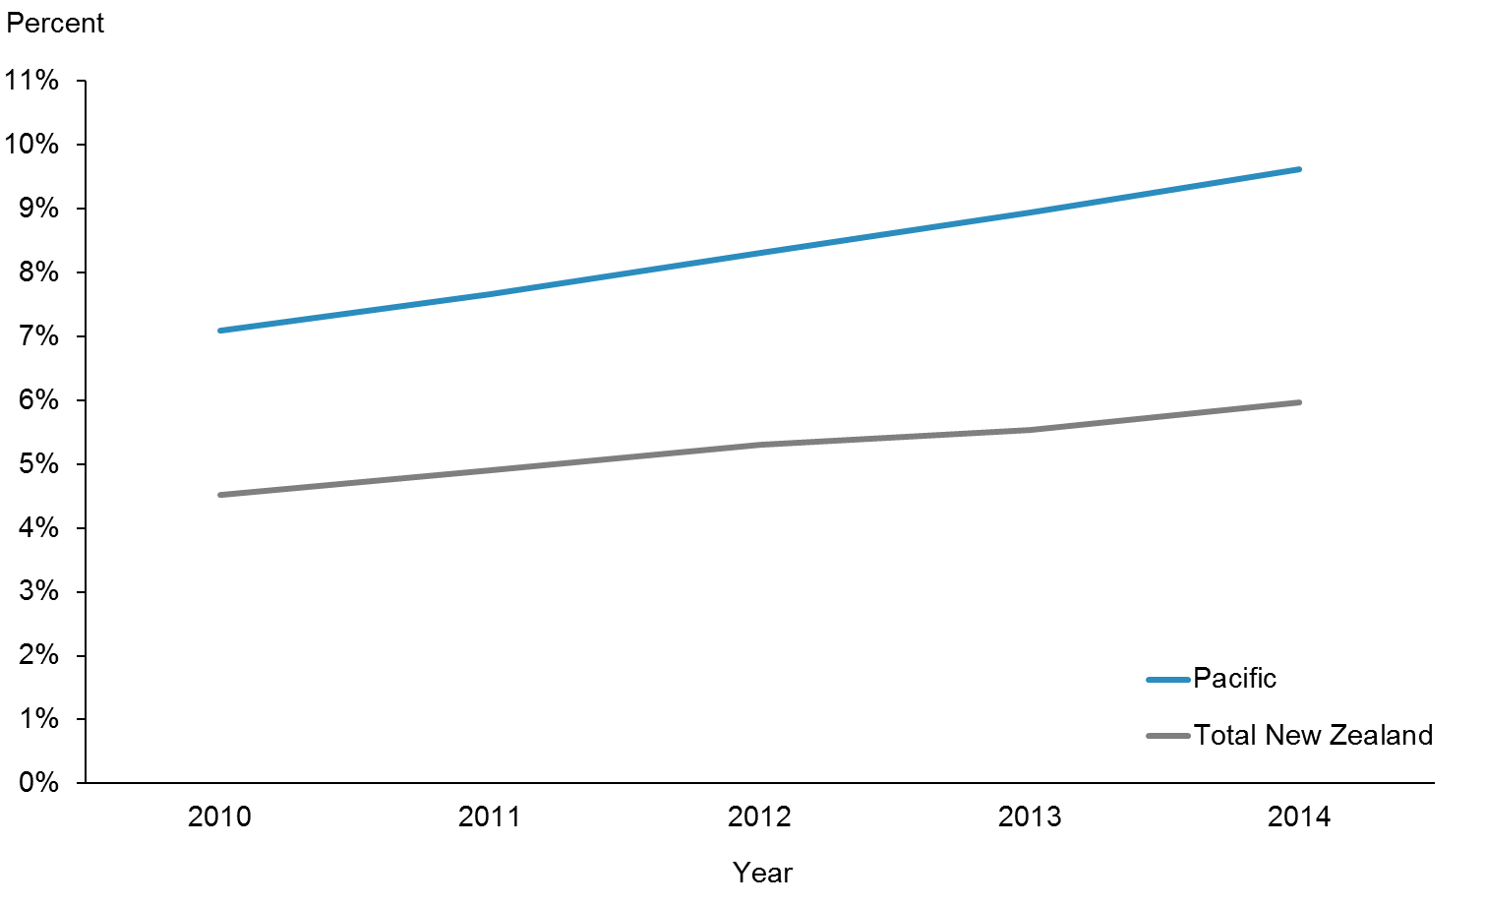

|  |  |  |  |  |  |
| --- | --- | --- | --- | --- | --- |
|  | **2010** | **2011** | **2012** | **2013** | **2014** |
| Pacific | 7.1% | 7.7% | 8.3% | 8.9% | 9.6% |
| Total New Zealand | 4.5% | 4.9% | 5.3% | 5.5% | 6.0% |

**Note**: This indicator is only reported on annually. There was no change from the June 2015 progress report.

Figure : Estimated percentage of people with diabetes, Pacific peoples, by priority DHBs, 2010–2014

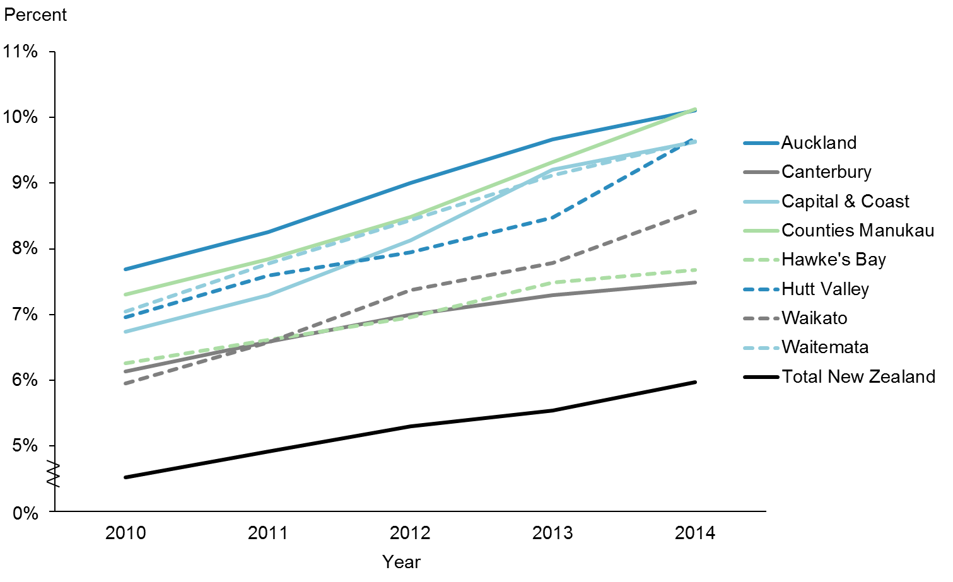

|  |  |  |  |  |  |
| --- | --- | --- | --- | --- | --- |
|  | **2010** | **2011** | **2012** | **2013** | **2014** |
| Auckland | 7.7% | 8.3% | 9.0% | 9.7% | 10.1% |
| Canterbury | 6.1% | 6.6% | 7.0% | 7.3% | 7.5% |
| Capital & Coast | 6.7% | 7.3% | 8.1% | 9.2% | 9.6% |
| Counties Manukau | 7.3% | 7.8% | 8.5% | 9.3% | 10.1% |
| Hawke's Bay | 6.3% | 6.6% | 7.0% | 7.5% | 7.7% |
| Hutt Valley | 7.0% | 7.6% | 7.9% | 8.5% | 9.7% |
| Waikato | 5.9% | 6.6% | 7.4% | 7.8% | 8.6% |
| Waitemata | 7.0% | 7.8% | 8.4% | 9.1% | 9.6% |
| Total New Zealand | 4.5% | 4.9% | 5.3% | 5.5% | 6.0% |

Figure 38 shows the estimated percentage of Pacific people with diabetes in the eight priority DHBs. There was no change from the June 2015 progress report.

|  |  |  |  |  |  |  |  |  |  |  |  |  |  |  |  |  |
| --- | --- | --- | --- | --- | --- | --- | --- | --- | --- | --- | --- | --- | --- | --- | --- | --- |
| **Priority outcome 4 – Pacific peoples experience improved broader determinants of health**  There are two quantitative indicators in this priority outcome; rates for neither of those two have reached equity with rates for the total New Zealand population. However, progress has been made in terms of both.  There has been a small reduction in the rate of rheumatic fever hospitalisations among Pacific peoples, and the rate of childhood immunisations at six months of age among Pacific peoples is only 3 percent away from the rate for the total population (at March 2015).  Table 10: Performance against priority outcome 4 indicators, as at 31 December 2015   |  |  |  |  | | --- | --- | --- | --- | | **Indicator** | **Pacific** | **Total New Zealand population** | **Target** | | Reduce Pacific rheumatic fever hospitalisation rates by June 2017 | 22.1 per 100,000 | 3.0 per 100,000 | 8 per 100,000 (Pacific) | | Increase infant immunisation rates at six months of age | 78.7% coverage | 80.6% coverage | 95% coverage | |  | | | | |

# Priority outcome 4 – Pacific peoples experience improved broader determinants of health

|  |  |
| --- | --- |
| **Action 1** | **The health and disability sector will work across government to decrease overcrowding in Pacific homes and increase access to healthy housing.** |

### Action commentary

#### Healthy Homes Initiatives

Through the Rheumatic Fever Prevention Programme, the Ministry is administering Healthy Homes Initiatives (HHIs) across the 11 DHBs in which there is a high incidence of rheumatic fever. HHIs systematically identify families with children at risk of getting rheumatic fever who are living in crowded households and facilitate access to a range of interventions to reduce that crowding. The first of these initiatives was in Auckland and services have been expanded to Northland, Waikato, Wellington, Lakes, Bay of Plenty, Hawke’s Bay and Tairāwhiti DHB regions. HHIs enabled housing assistance for up to 3500 families in 2015/16. Where families are current Housing New Zealand Corporation tenants, household crowding may swiftly be addressed through capital interventions. Interventions for private tenants are more challenging – there are few levers with which to influence landlord behaviour, and tenants are often fearful of rising rents should the quality of their rented house improve.

The Auckland-Wide Healthy Homes Initiative service was the first HHI to be launched; it has been operational since December 2013. In its first 16 months, the Auckland-Wide Healthy Homes Initiative had assessed more than 1200 vulnerable families in Auckland, and over 650 changes had been made in their homes as a result.

#### Cross-agency action

Reducing household crowding has resulted in the Ministry of Health; the Ministry of Social Development; the Ministry of Business, Innovation and Employment; and Housing New Zealand working closely together. The resulting partnerships also include the private and philanthropic sectors.

#### Social housing fast track scheme

This Ministry of Social Development administered programme addresses the impact that poor housing and crowded conditions have on the rate of rheumatic fever. The scheme aims to give families with children at risk of rheumatic fever priority for appropriately sized state homes.

#### Rental housing Warrant of Fitness field tests through city councils

The rental housing Warrant of Fitness project is based on over a decade of publicly funded housing research and was developed by the University of Otago Wellington and the New Zealand Green Building Council in collaboration with five councils (Auckland, Tauranga, Wellington, Christchurch and Dunedin) and the Accident Compensation Corporation. Councils were interested in developing a WOF tool that will assist in improving the quality of the rental housing stock, which would result in improved health outcomes and a reduction in household injuries. A WOF for housing would provide a minimum standard for rental dwellings or be an information tool for tenants and landlords to understand the performance of a dwelling. The current regulations for rental housing quality have not been amended since 1947. Of the 144 houses that were assessed in the project, eight (6%) passed the Warrant of Fitness (Bennett et al 2014).

The Government announced the Residential Tenancies Act in 2015. This will help to make rental homes warmer, drier and safer with new regulations to take effect next year making it compulsory for landlords to insulate their properties and provide smoke alarms.

|  |  |
| --- | --- |
| **Indicator 1** | **Reduction in Pacific rheumatic fever hospitalisation rates by June 2017** |

**Performance:** The national target for this indicator is 1.4 per 100,000. The Pacific target for this indicator is 8 per 100,000 by June 2017. This target is based on the two-thirds reduction from baseline rate (2009/2010–2011/2012) as per the target for the total New Zealand population.

Figure : Rheumatic fever hospitalisation rates, Pacific peoples, 2011–2015

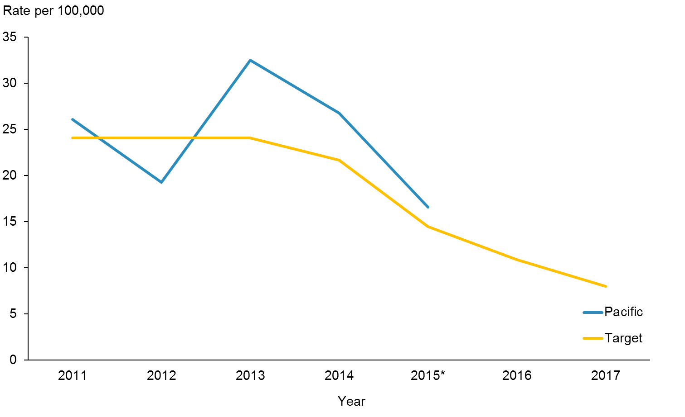

|  |  |  |  |  |  |
| --- | --- | --- | --- | --- | --- |
|  | **2011** | **2012** | **2013** | **2014** | **2015\*** |
| Pacific | 26.1 | 19.3 | 32.5 | 26.8 | 16.6 |
| Target | 24.1 | 24.1 | 24.1 | 21.7 | 14.5 |

Figure 39 shows that rheumatic fever hospitalisation rates for Pacific peoples have been declining steadily over the years. The decline between 2014 and 2015 has been statistically significant. Overall, there has been a decline of 27 percent for Pacific peoples compared with 45 percent for the total New Zealand population from baseline. Both declines were statistically significant.

**Note**: We have not reported on this indicator by DHB, as the numbers of new cases for some DHBs are very small.

|  |  |
| --- | --- |
| **Action 2** | **The Ministry of Health will work in partnership with the Ministry of Social Development; Ministry of Business, Innovation and Employment; Ministry of Education; and New Zealand Police on the following Better Public Services priorities, targeting vulnerable children:**   * **increase participation in early childhood education** * **increase infant immunisation rates** * **reduce the incidence of rheumatic fever** * **reduce the number of assaults on children.** |

### Action commentary

#### Prior early childhood education participation

The prior early childhood education (ECE) participation rate is defined as:

(number who had regularly attended ECE ÷ (number who had regularly attended ECE + number who had not regularly attended ECE)) × 100

The number of students with unknown prior ECE attendance has been excluded (from both the numerator and denominator) when calculating participation rates. The most recent rate for Pacific children is 91.7 percent compared with 96.3 percent for total New Zealand children. The target is 98.0 percent by 2016. To help achieve this target, the Ministry of Education has several participation initiatives that make it easier for families to find an ECE service they like that meets their needs. It has also set up the Early Learning Taskforce. The Taskforce works with communities to help more children participate in early learning. The Ministry of Education focuses on making ECE participation easier. Two examples of participation initiatives are Engaging Priority Families (which is mainly Māori, Pacific and high-deprivation families) and Targeted Assistance for Provision.

#### Increase infant immunisation rates

The Ministry of Health and DHBs are continuing to push hard to achieve the target of 95 percent immunisation coverage at eight months of age later this year. In September 2015, the immunisation coverage at six months of age for Pacific peoples was at 78.7 percent compared with 80.6 percent for the total New Zealand population. On the other hand, the immunisation coverage at eight months of age for Pacific peoples was 96.3 percent compared with 93.4 percent for the total New Zealand population.

#### Reducing the incidence of rheumatic fever

In December 2015, the Ministry of Health rheumatic fever campaign evaluation came back positive. The independent evaluation by Allen + Clarke Policy and Regulatory Specialists Ltd describes the rheumatic fever campaign as ‘efficient, effective and relevant’. The campaign exceeded the expected level of reach amongst the target Māori and Pasifika audience, with about 95 percent having seen or heard the campaign. They also had a good understanding of the issue, and the campaign was promoting positive health behaviour and discussions. Other prevention activities in high-incidence areas include targeted sore throat drop-in clinics, school-based services, HHIs, and Pacific engagement services. The combination effect of these initiatives is making a difference. Rheumatic fever rates are trending down.

#### Reducing the number of assaults on children

The Children’s Action Plan contributes to the Government’s Better Public Services under the result area Supporting Vulnerable Children. The plan implements initiatives to reduce the number of assaults on children. The Ministry of Health continues to collaborate with other agencies (Ministry of Social Development; Ministry of Education; Ministry of Justice; Ministry of Business, Innovation, and Employment (Housing); New Zealand Police; and Te Puni Kōkiri) to deliver the actions. This is the Ministry of Health’s response to actions outlined in the Government’s White Paper for Vulnerable Children, which include:

* better screening of children for vulnerability
* fully assessing the needs of vulnerable children
* better enabling frontline workers and communities to communicate concerns about children
* making services more focused on results.

Meeting this target means bringing the projected number of approximately 4000 children expected to experience substantiated physical abuse down to less than 3000 by June 2017, which is a reduction of approximately 25 percent in projected numbers. In the 12 months to September 2015, 3011 children experienced substantiated physical abuse. This was a 3.2 percent decrease on the year to September 2014 (3110).

The overall trend is that substantiated findings of physical abuse of children appear to be stabilising and even slightly declining. The proportions of the total by ethnic group have remained fairly stable over the past five years. The breakdown of these proportions is:

* Māori – 49 percent
* NZ European – 26 percent
* Pasifika – 19 percent
* Asian – 4 percent
* Other ethnic groups – 3 percent.

|  |  |
| --- | --- |
| **Indicator 2** | **Increase infant immunisation rates** |

**Performance**: The target for this indicator is 95 percent.

Figure : Immunisation coverage (percent) at six months of age (three-month reporting), Pacific peoples population and total New Zealand population, 2013–2015

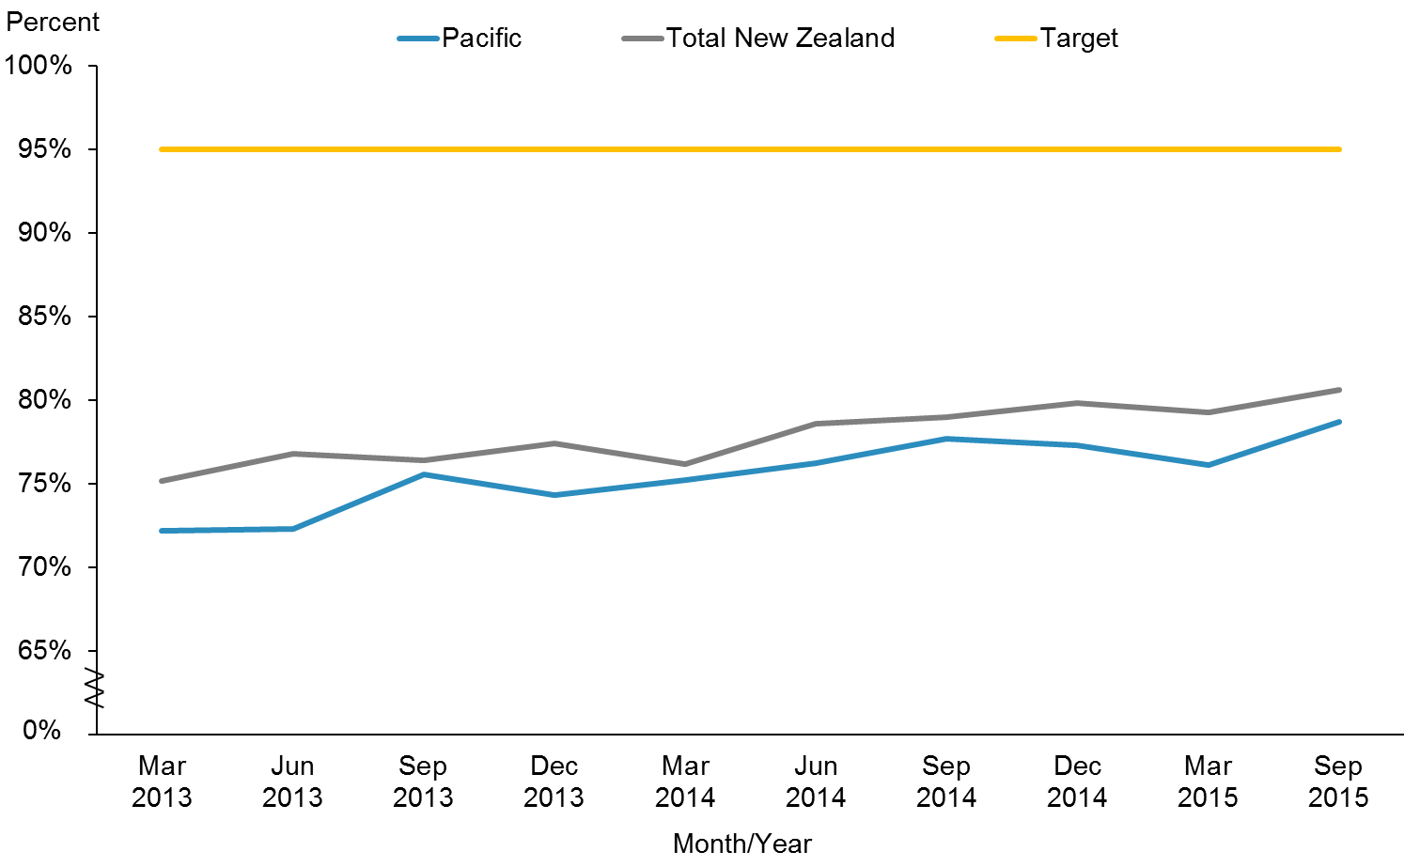

|  |  |  |  |  |  |  |  |  |  |  |
| --- | --- | --- | --- | --- | --- | --- | --- | --- | --- | --- |
|  | **Mar 2013** | **Jun 2013** | **Sep 2013** | **Dec 2013** | **Mar 2014** | **Jun 2014** | **Sep 2014** | **Dec 2014** | **Mar 2015** | **Sep 2015** |
| Pacific | 72.2% | 72.3% | 75.6% | 74.3% | 75.2% | 76.2% | 77.7% | 77.3% | 76.1% | 78.7% |
| Total New Zealand | 75.1% | 76.8% | 76.4% | 77.4% | 76.2% | 78.6% | 79.0% | 79.8% | 79.3% | 80.6% |
| Target | 95.0% | 95.0% | 95.0% | 95.0% | 95.0% | 95.0% | 95.0% | 95.0% | 95.0% | 95.0% |

Figure 40 shows that immunisation coverage at six months of age is increasing in both the Pacific population and the total New Zealand population. However, neither population is close to achieving the target of 95 percent coverage at this stage.

Figure : Immunisation coverage (percent) at six months of age (three-month reporting), Pacific peoples, by priority DHBs, 2013–2015

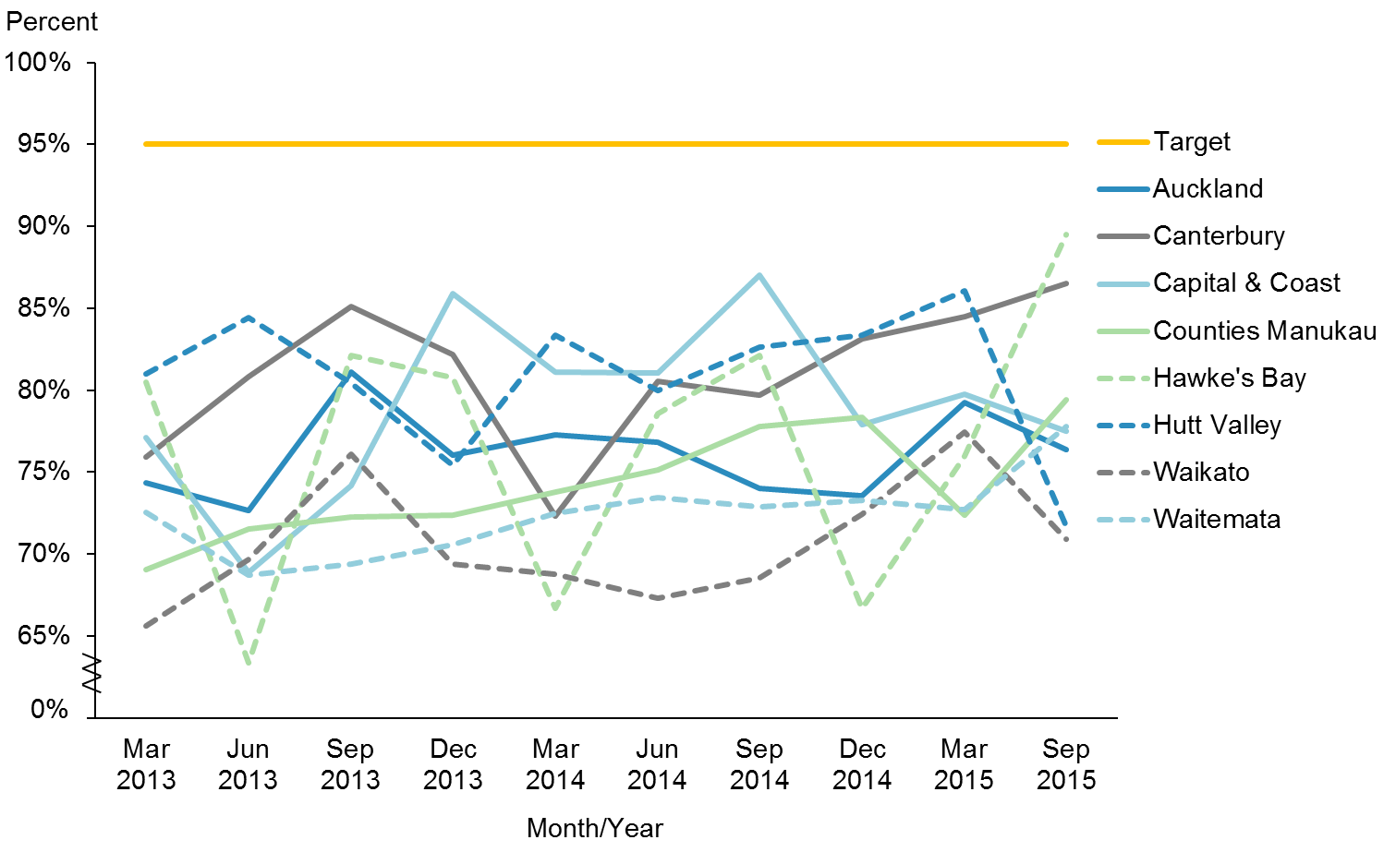

|  |  |  |  |  |  |  |  |  |  |  |
| --- | --- | --- | --- | --- | --- | --- | --- | --- | --- | --- |
|  | **Mar 2013** | **Jun 2013** | **Sep 2013** | **Dec 2013** | **Mar 2014** | **Jun 2014** | **Sep 2014** | **Dec 2014** | **Mar 2015** | **Sep 2015** |
| Auckland | 74.4% | 72.6% | 81.1% | 76.0% | 77.3% | 76.8% | 74.0% | 73.5% | 79.2% | 76.4% |
| Canterbury | 75.9% | 80.8% | 85.1% | 82.2% | 72.3% | 80.6% | 79.7% | 83.1% | 84.5% | 86.5% |
| Capital & Coast | 77.1% | 68.9% | 74.2% | 85.9% | 81.1% | 81.0% | 87.0% | 77.9% | 79.7% | 77.5% |
| Counties Manukau | 69.1% | 71.5% | 72.3% | 72.3% | 73.8% | 75.1% | 77.8% | 78.3% | 72.4% | 79.4% |
| Hawke's Bay | 80.5% | 63.3% | 82.1% | 80.8% | 66.7% | 78.6% | 82.1% | 66.7% | 76.0% | 89.5% |
| Hutt Valley | 81.0% | 84.4% | 80.4% | 75.4% | 83.3% | 80.0% | 82.6% | 83.3% | 86.0% | 71.7% |
| Waikato | 65.6% | 69.7% | 76.1% | 69.4% | 68.8% | 67.3% | 68.5% | 72.4% | 77.4% | 70.9% |
| Waitemata | 72.6% | 68.7% | 69.4% | 70.6% | 72.5% | 73.4% | 72.9% | 73.3% | 72.7% | 77.8% |
| Target | 95.0% | 95.0% | 95.0% | 95.0% | 95.0% | 95.0% | 95.0% | 95.0% | 95.0% | 95.0% |

Figure 41 shows that most of the priority DHBs are making progress. Hawke’s Bay and Canterbury are the two leading DHBs towards achieving this target.

**Note**: Immunisation coverage was chosen to be monitored in *’Ala Mo’ui* at six months of age (as opposed to eight or 12 months) as this is the age at which coverage for Pacific infants is the lowest. Immunisation coverage for Pacific infants at eight months of age is 96.3 percent, compared to 93.4 percent for the total New Zealand population. Six out of the eight priority DHBs achieved this target over the same period. Immunisation coverage at eight months of age is a Government target. The eight priority DHBs are supporting a shift to monitor the immunisation coverage at eight months of age instead of six months. In the next update, *’Ala Mo’ui* will be shifting to monitoring the immunisation coverage at eight months of age to be in line with the health target.

# References

Bennett J, Chisholm E, Hansen R, Howden-Chapman P. 2014. *Results from a Rental Housing Warrant of Fitness Pre-Test*. Wellington: University of Otago.

Counties Manukau Health. 2016. *Counties Manukau District Health Board Annual Plan 2015/2016*. Auckland: Counties Manukau Health.

Ministry of Health. 2012a. *Rising to the Challenge: The Mental Health and Addictions Service Development Plan 2012–2017.* Wellington: Ministry of Health.

Ministry of Health. 2012b. *Tupu Ola Moui: Pacific Health Chart Book 2012.* Wellington: Ministry of Health.

Ministry of Health. 2014. *’Ala Mo’ui: Pathways to Pacific Health and Wellbeing 2014–2018*. Wellington: Ministry of Health.

Ministry of Health. 2015a. *A Framework for Health Literacy.* Wellington: Ministry of Health.

Ministry of Health. 2015b. *Independent Life Expectancy in New Zealand 2013*. Wellington: Ministry of Health.

Ministry of Health. 2015c. *Living Well with Diabetes: A health care plan for people at high risk of or living with diabetes 2015–2020*. Wellington: Ministry of Health.

Ministry of Health. 2015d. *National Maternity Monitoring Group Annual Report 2015*. Wellington: Ministry of Health.

Ministry of Health. 2016. *Indicators for the Well Child/Tamariki Ora Quality Improvement Framework – September 2015.* Wellington: Ministry of Health.

Statistics New Zealand. 2015. *New Zealand Period Life Tables: 2012–14*. URL: [www.stats.govt.nz/browse_for_stats/health/life_expectancy/NZLifeTables_HOTP12-14.aspx](http://www.stats.govt.nz/browse_for_stats/health/life_expectancy/NZLifeTables_HOTP12-14.aspx) (accessed 28 August 2015).

Tan J, Ward G, Thompson L. 2015. *Report of the Parliamentary Review Committee regarding the New Zealand Cervical Screening Programme*. Wellington: Ministry of Health.

# Appendix

Table A1: Projected Pacific peoples population for 2015/16 by DHB based on the 2013 Census

|  |  |  |
| --- | --- | --- |
| **DHB** | **Population** | **Percentage** |
| **Counties Manukau** | **111,910** | **37.4%** |
| **Auckland** | **53,870** | **18.0%** |
| **Waitemata** | **41,430** | **13.8%** |
| **Capital & Coast** | **21,410** | **7.2%** |
| **Canterbury** | **12,910** | **4.3%** |
| **Hutt Valley** | **11,420** | **3.8%** |
| **Waikato** | **11,290** | **3.8%** |
| **Hawke’s Bay** | **6,010** | **2.0%** |
| Southern | 6,000 | 2.0% |
| MidCentral | 5,060 | 1.7% |
| Bay of Plenty | 3,890 | 1.3% |
| Northland | 3,300 | 1.1% |
| Lakes | 2,480 | 0.8% |
| Nelson Marlborough | 2,330 | 0.8% |
| Taranaki | 1,535 | 0.5% |
| Whanganui | 1,330 | 0.4% |
| Tairāwhiti | 1,185 | 0.4% |
| Wairarapa | 875 | 0.3% |
| South Canterbury | 590 | 0.2% |
| West Coast | 365 | 0.1% |
| Total | 299,190 | 100% |

Note: Percentages have been rounded. The eight priority DHBs are in bold.

1. The first progress report on *’Ala Mo’ui* tracked and monitored 23 indicator measures. The two indicator measures no longer being monitored and tracked are ‘Pacific caries-free at year eight’ and ‘Pacific decayed, missing, or filled teeth (DMFT) rates at age five’. The Ministry has decided that the two indicator measures ‘Pacific caries-free at age five’ and ‘Pacific DMFT rates at school year eight’ suffice for monitoring oral health outcomes for Pacific children.
2. Nine out of the total of 21 indicators that are monitored in *’Ala Mo’ui* currently do not have set national targets. The difference between the Pacific population and the total New Zealand population is used as a measure of equity.
3. Whānau House is operated by Te Whānau o Waipareira Trust and offers families ‘wrap-around’ integrated services (health, social, justice and education) tailored to their needs.
4. Cole cut-offs are BMI for overweight and obesity by gender and age.
5. Alliance Health Plus is the only Pacific PHO. Its enrolled population was approximately 90,000 as at 30 June 2014. Its performance against aggregate health targets in 2014 was in the top quartile of PHOs nationally.