Adults’ Dietary Habits
Findings from the 2018/19 and 2019/20 New Zealand Health Survey
2022

Acknowledgements
The dietary habits module of the New Zealand Health Survey was developed by the Ministry of Health Health Survey team. The survey was conducted by CBG Health Research Ltd with the support of many survey participants.
This report was written by James Greenwell and Megan Grant with input and review from many of their colleagues including Steven Johnston and Shari Mason.
Citation: Ministry of Health. 2022. Adults’ Dietary Habits – Findings from the 2018/19 and 2019/20 New Zealand Health Survey. Wellington: Ministry of Health.
Published in October 2022 by the Ministry of Health
PO Box 5013, Wellington 6140, New Zealand
ISBN 978-1-99-110065-8 (online)
HP 8512
This document is available at health.govt.nz
This work is licensed under the Creative Commons Attribution 4.0 International licence. In essence, you are free to: share ie, copy and redistribute the material in any medium or format; adapt ie, remix, transform and build upon the material. You must give appropriate credit, provide a link to the licence and indicate if changes were made.

Contents
Summary 1
Key findings 3
Background 4
Measuring dietary habits in the New Zealand Health Survey 5
Vegetables and fruit 7
Vegetable and fruit (combined indicator) 7
Vegetables 10
Fruit 11
Dietary exclusions 12
Processed meat 13
Red meat 16
Cutting the fat from red meat 18
Removing meat fat 19
Fish and other seafood 20
Takeaways 23
Legumes 26
Sweet baked items including biscuits 28
Confectionery 31
Cordial 33
Fruit juice 36
Fizzy drink 39
Nuts and seeds 42
Types of spread used 45
Fat for cooking 48
Bread type 50
Milk 52
Weight perception 54
Weight management 57
Trying to lose weight 57
Implications for policy 59
Interpretation notes 60
Statistical significance 60
Confidence intervals 60
Comparing population subgroups 60
Pooled data 60
Gender 61
Ethnicity 61
NZDep 61
Overweight/obese 61
References 62
Additional information 63

List of Tables
Table 1: Prevalence of meeting the combined vegetable and fruit indicator by sex and age group 8
Table 2: Characteristics of adults meeting the combined vegetable and fruit indicator 9
Table 3: Characteristics of adults meeting the vegetable recommendation 10
Table 4: Characteristics of adults meeting the fruit recommendation 11
Table 5: Prevalence of specific dietary exclusions 12
Table 6: Prevalence of eating processed meat 14
Table 7: Prevalence of eating processed meat by sex 14
Table 8: Characteristics of adults who frequently ate processed meat 15
Table 9: Frequency of eating red meat 16
Table 10: Frequency of red meat consumption by sex 16
Table 11: Characteristics of adults who frequently ate red meat 17
Table 12: Frequency of removing fat from red meat 18
Table 13: Characteristics of adults who infrequently removed fat from red meat 18
Table 14: Frequency of eating seafood 20
Table 15: Frequency of eating seafood by sex 20
Table 16: Characteristics of adults who ate seafood infrequently 21
Table 17: Frequency of eating takeaways 23
Table 18: Frequency of eating takeaways by sex 23
Table 19: Characteristics of adults who frequently ate takeaways 24
Table 20: Frequency of eating legumes 25
Table 21: Frequency of eating legumes by sex 25
Table 22: Characteristics of adults who ate legumes infrequently 26
Table 23: Frequency of eating biscuits 28
Table 24: Frequency of eating biscuits by sex 28
Table 25: Characteristics of adults who ate biscuits frequently 29
Table 26: Frequency of eating confectionery 30
Table 27: Frequency of eating confectionery by sex 30
Table 28: Characteristics of adults who frequently ate confectionery 31
Table 29: Frequency of drinking cordial 33
Table 30: Frequency of drinking cordial by sex 33
Table 31: Characteristics of adults who drank cordial frequently 34
Table 32: Frequency of drinking fruit juice 36
Table 33: Frequency of drinking fruit juice by sex 36
Table 34: Characteristics of adults who drank fruit juice frequently 37
Table 35: Frequency of drinking fizzy drinks 39
Table 36: Frequency of drinking fizzy drinks by sex 39
Table 37:Characteristics of adults who drank fizzy drink frequently 40
Table 38: Frequency of eating nuts and seeds 42
Table 39: Frequency of eating nuts and seeds by sex 42
Table 40: Characteristics of adults who ate nuts and seeds infrequently 43
Table 41: Prevalence of use of butter as a spread 44
Table 42: Prevalence of use of butter as a spread by age and sex 45
Table 43: Prevalence of use of each type of spread 46
Table 44: Characteristics of adults who used butter as a spread 46
Table 45: Prevalence of use of cooking fat by type 47
Table 46: Characteristics of adults who used saturated fat for cooking 48
Table 47: Prevalence of bread consumption by type 49
Table 48: Characteristics of adults who ate white bread 50
Table 49: Prevalence of milk use by type 51
Table 50: Characteristics of adults who used standard milk 52
Table 51: Prevalence of types of perceptions of weight 53
Table 52: Prevalence of types of perceptions of weight by sex 53
Table 53: Characteristics of adults who perceived themselves as overweight 55
Table 54: Characteristics of adultstrying to lose weight 57

Summary
Consuming healthy food and drink and avoiding unhealthy options contributes to good health and reduces the likelihood of developing non-communicable diseases such as cardiovascular disease, obesity, type 2 diabetes and some cancers (Forouzanfar et al 2015). Dietary habits are linked with nutrient intake, nutritional status and health conditions. Dietary habits can act as protective factors for chronic diseases, whereas high intakes of some foods or food components are risk factors.

The results of the New Zealand Health Survey since 2006/07 have consistently shown that around half of adults did not meet the recommended intake for vegetables and fruit over time. Obesity has also become more prevalent over time.

Findings of the most recent nutrition survey in 2008/09 and the dietary habits questionnaire (DHQ) results in this report show the distribution of healthy and unhealthy eating patterns across gender, age, ethnic and socioeconomic groups in adults is inequitable.

In general, women reported following healthier dietary patterns more often than men. Examples of their healthier dietary patterns include eating the recommended number of servings of vegetables and fruit, eating processed meat and red meat less often and cutting the fat from red meat more often. Women were also less likely to drink cordial, fruit juice and fizzy drink.

Māori adults ate more red meat and processed meat than other groups. Māori women were less likely to meet vegetable and fruit recommendations than non- Māori women. Māori adults were also more likely to use butter as a spread and saturated fat for cooking, as well as to choose white bread and standard milk rather than whole grain bread and reduced-fat milk. Both Māori and Pacific populations were less likely to trim the fat from their red meat and more likely to consume takeaways and fizzy drinks.

More Pacific adults perceived they were overweight and were trying to lose weight.
Adults who were living in areas of high deprivation were less likely to meet recommendations for vegetable and fruit intake. They were more likely to consume less healthy foods and drinks.

Protective dietary patterns such as eating the recommended number of servings of vegetables and fruit, eating takeaways infrequently and cutting fat off red meat
were more common in older adults. Conversely, some unhealthy dietary patterns like drinking fizzy drinks, eating processed meat and often having takeaways were most prevalent in young adults.

This report indicates some New Zealanders’ patterns of food and drink consumption meet the evidence-based recommendations in the Eating and Activity Guidelines for New Zealand Adults (EAGs) (Ministry of Health 2020). However, the analysis shows some populations were less represented in healthy food and drink patterns and
over-represented in the less healthy dietary patterns.

The current survey analysis provides us with a picture of dietary habits before the pandemic. The interaction between eating patterns and the COVID-19 pandemic in New Zealand is not yet understood. The COVID-19 pandemic brought an early end to the second year of the DHQ survey, with the DHQ module in the field winding up when the first national lockdown began in March 2020. This analysis will be useful for comparison with dietary habits after the pandemic, which the next national nutrition survey will capture.

Comparisons of habits over time have not been possible because of changes in questions since the last survey. Analysis and discussion of the DHQ responses leave important questions unanswered and highlight where we should address them in the next national nutrition survey. The goal of this report is to inform planning and funding decisions within the health sector so that providers can target services and interventions to reduce inequities.

Key findings
- Overall, 32.8 percent of adults met the recommendation for combined vegetable and fruit intake. Women (38.4 percent) were more likely to meet the recommendation than men (27.0 percent).
- New Zealand adults generally did not make exclusions from their diet. The food groups/ ingredients they were most likely to exclude were seafood and red meat.
- Nearly half of all women (48.2 percent) and men (48.4 percent) ate processed meat once or twice a week.
- Men and women had similar patterns of eating red meat. However, men were more likely to eat three or more servings a week (53.9 percent) compared with women (46.6 percent). Men were also more likely to eat meat fat (58.4 percent) compared with women (44.5 percent).
- Just over a quarter of adults (26.5 percent) never or infrequently ate seafood while nearly three quarters (73.2 percent) ate seafood at least once a week.
- Over half (57.3 percent) of adults never ate takeaways or ate them less than once a week.
- About half (52.0 percent) of adults ate legumes at least once a week
- While 41.2 percent of adults ate biscuits, cakes, slices, muffins, sweet pastries or muesli bars at least three times a week, 30.0 percent infrequently or never ate them.
- Over half (59.1 percent) of adults ate confectionery at least once a week.
- Most of the adult population (88.6 percent) used unsaturated fats for cooking.
- Almost half of adults surveyed ate light grain bread with the other half split evenly between eating white bread and heavy grain bread.
- Most adults used standard milk until the age of 65 years and over, when similar percentages chose standard and reduced-fat varieties.
- Around two-thirds of adults (65.9 percent) reported never or infrequently drinking fruit juice.
- More than three out of four reported never or infrequently drinking cordial. Around 74.5 percent of women reported never or infrequently drinking fizzy drink compared with 60.4 percent of men.
- Use of butter as a spread was highest among Māori adults (51.3 percent) compared with other ethnic groups, followed by European/other (44.7 percent), Pacific (43.2 percent) and Asian (38.4 percent) adults.
- Most adults ate nuts and seeds at least once a week, while 27.8 percent never or infrequently ate them.
- More than two in five adults (42.7 percent) considered they were overweight.
- Overall, nearly half (46.6 percent) of women and around one in three men (34.9 percent) reported trying to lose weight.

Background
Having optimal nutrition in adulthood is related to keeping good health and reducing the burden of diet-related non-communicable diseases such as cardiovascular disease, hypertension, obesity, type 2 diabetes and some cancers.

Having a less healthy diet is an important modifiable risk factor for morbidity and mortality (Forouzanfar et al 2015) and is linked with an increased risk of developing chronic disease later in life. In 2015, 21 percent of total global deaths were attributed to these risks, which include diets low in fruit, whole grains and vegetables, and diets high in red meat and sugar-sweetened beverages.

The results of the DHQ analysis are presented with the survey questions and within the context of the EAGs.

Measuring dietary habits in the New Zealand Health Survey
Adults completed the DHQ as part of the New Zealand Health Survey in years 2018/19 and 2019/20, where each survey year began on 1 July. Some indicators were reported in the annual New Zealand Health Survey Data Explorer publication but are not comparable with this report because results in this report have been pooled from consecutive surveys.

The analysis describes dietary habits in New Zealand before the COVID-19 pandemic. The 2019/20 survey was halted early at the time of the first lockdown response to the COVID-19 pandemic in March 2020.

The analysis examines patterns of healthy eating patterns such as eating vegetables and fruit, choosing whole grain and lower-fat options of core foods, avoiding high-fat takeaways and limiting sugary drinks. It compares such patterns across characteristics such as age groups, sex, ethnicity (total response), level of deprivation.

The analyses presented in this report are only a small proportion of those that could be undertaken, and in many ways raise more questions than they answer. A team of Ministry technical experts prioritised areas to feature in the report. Interpretation of more complex results is difficult currently without an ongoing survey collection to establish a baseline. The Ministry of Health also encourages researchers to use data sets from the previous adult nutrition survey (2008/09 NZANS) to explore topics of interest.

During the development of this project, decisions had to be made to focus on some of the variation or similarities at the expense of other areas. Bona fide researchers can access the full data sets (see link below).

To access the survey questions and answer card prompts, go to the Ministry of Health website https://www.health.govt.nz/publication/2008-09-new-zealand- adult-nutrition-survey-data-tables

Note that this report uses unadjusted prevalence and total response ethnicity in reporting results.

To find out more
You can find the latest dietary habits results from the survey, including data tables in the Data Explorer, at https://www.health.govt.nz/publication/annual-update-key-results-2020-21-new-zealand-health-survey

How to access survey microdata

Confidentialised unit record files of Ministry of Health population surveys are potentially available to bona fide public-good researchers, government agencies and non- governmental organisations – subject to certain terms and conditions.

Statistics New Zealand (Stats NZ) manages researcher access to these data sets.

Please go to Confidentialised unit record files on the Stats NZ website http://www.stats.govt.nz/integrated-data/apply-to-use-microdata-for-research/confidentialised-unit-record-files-curfs/ to view the eligibility criteria, the protocol for applying for access and the application form to access microdata.

Vegetables and fruit

Vegetable and fruit (combined indicator)
Low vegetable and fruit consumption is associated with increased risk of developing some cancers, type 2 diabetes, cardiovascular disease and obesity. The EAGs current during the time of the DHQ survey recommended adults eat at least three servings of vegetables and at least two servings of fruit each day. This analysis used the recommendation as the combined vegetable and fruit indicator
‘at least three servings of vegetables and two servings of fruit daily’.

The description of vegetables included fresh, frozen and canned vegetables, but not vegetable juices. The description of fruit included fresh, frozen, canned or stewed fruit and specifically did not include fruit juice or dried fruit.

Overall, 32.8 percent of adults met the recommendation for combined vegetable and fruit intake. Women (38.4 percent) were more likely to meet the recommendation than men (27.0 percent) (Table 1). Well over half of adults did not meet the recommended intake for vegetables and fruit; this figure has changed little since 2006/07 (Ministry of Health 2019).

The youngest age group (15–24 years) were least likely to meet the combined recommendation (27.3 percent). In contrast, in the oldest age group (75 years and over), 42.6 percent met the combined recommendation (Table 1).

This analysis used the indicator of 3+2 servings a day
Table 1: Prevalence of meeting the combined vegetable and fruit indicator by sex and age group
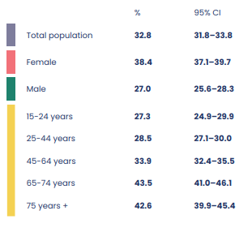

More than one in three European/other adults (35.9 percent), over one in four Māori adults (28.2 percent) and one in four Pacific adults (25.6 percent) met the
combined recommendation. One in five Asian adults (21.3 percent) met the combined recommendation (Table 2).

Only 25.3 percent of adults living in areas of high deprivation met the recommended combined vegetable and fruit indicator (Table 2).

Table 2: Characteristics of adults meeting the combined vegetable and fruit indicator
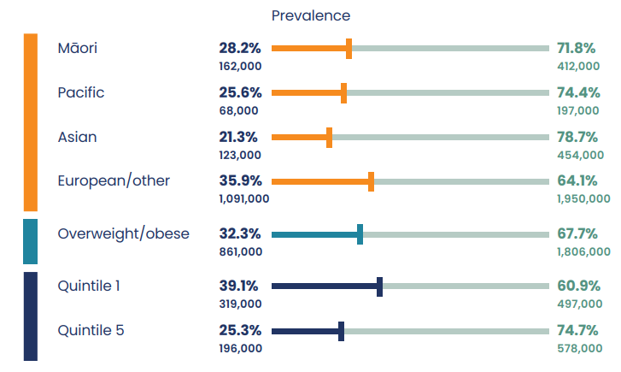

Vegetables
Overall, 53.6 percent of adults ate the recommended number of servings of vegetables per day (which was three or more servings of vegetables a day at the time of the survey).

The proportion of adults meeting the recommendation increased with age. Overall, more women (59.3 percent) than men (47.7 percent) met the recommendation.
More Māori (51.3 percent) and European/other (58.4 percent) adults met the vegetable serving recommendation than Pacific (41.8 percent) or Asian (33.9 percent) adults.

Only 46.5 percent of adults living in areas of high deprivation met the recommended vegetable intake compared with 58.4 percent of those living in areas of low deprivation (Table 3).

This analysis used the indicator of 3+ servings a day.
Table 3: Characteristics of adults meeting the vegetable recommendation
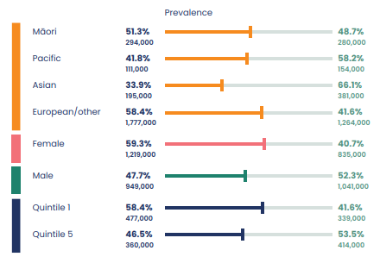

Fruit
Overall, 51.2 percent of adults met the recommendation to eat two or more servings of fruit each day.

The proportion of adults meeting this recommendation increased with age. More Pacific (47.4 percent) and Asian (46.9 percent) adults met the fruit recommendation than the adults in these groups who met the vegetable recommendation. By comparison, more European/other (52.8 percent) and fewer Māori (44.8 percent) adults ate the recommended number of servings.

Adults living in the most deprived quintile (43.5 percent) were less likely to meet the fruit guidelines than adults living in the least deprived quintile (58.4 percent) (Table 4).

This analysis used the indicator of 2+ fruit servings a day
Table 4: Characteristics of adults meeting the fruit recommendation
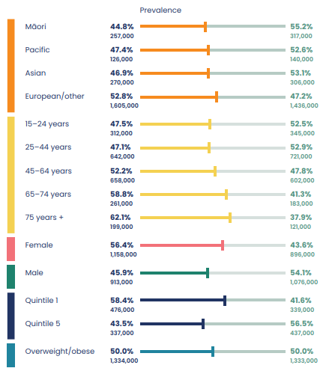

Dietary exclusions
Respondents were asked whether they completely excluded any of a list of specific food groups or food components from their diet. The DHQ defines ‘completely exclude’ as ‘never eat the item on its own, or as part of a prepared dish’.

Options on the list were red meat (eg, beef, pork, mutton, lamb, goat, venison), chicken or poultry (eg, turkey, duck), fish or other seafood, eggs, dairy products (eg, milk, cheese), gluten sources (eg, wheat, barley) and nuts.

Results indicated that most New Zealand adults did not make exclusions from their diet. The food groups/ingredients they were most likely to exclude were seafood and red meat (Table 5).

The survey did not ask respondents’ reasons for specific dietary exclusions; however, common reasons for dietary exclusion include health, cultural or religious practices. Data collected from this question is also used to identify plant-based dietary patterns, which will be reported separately.

Table 5: Prevalence of specific dietary exclusions
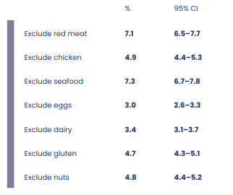

Processed meat
The EAGs recommend adults limit their processed meat intake. Eating processed meat results in an increased intake of saturated fat and salt and is linked to a higher risk of colorectal cancer. These results show that more than two-thirds of adults were eating processed meat at least weekly (Table 6), which may increase health risks.

Respondents were asked how often they ate processed meat products such as ham, bacon, sausages, luncheon, smoked chicken, canned corned beef, pastrami or salami.

Nearly half of all women (48.2 percent) and men (48.4 percent) ate processed meat once or twice a week. Frequent intake (three or more times a week) was more common in men (34.9 percent) than women (20.9 percent). More women (30.9 percent) than men (16.7 percent) never or infrequently consumed processed meat (Table 7).

Those aged from 15–24 years were more likely than other age groups to eat processed meat three or more times a week. Māori adults were most likely
(35.6 percent) and Asian adults least likely (22.8 percent) to eat processed meat three or more times a week. Those living in the most socioeconomically deprived quintile areas were more likely than those living in the least deprived quintile to eat processed meat three or more times a week (Table 8).

Table 6: Prevalence of eating processed meat
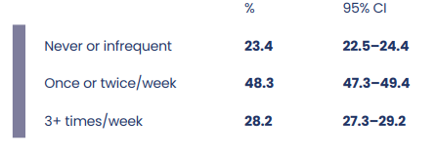

Table 7: Prevalence of eating processed meat by sex
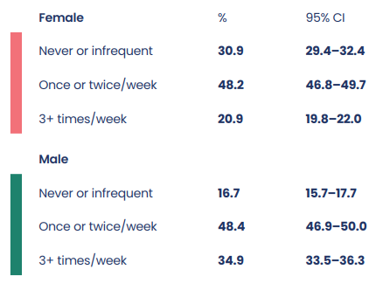

This analysis used the indicator of 3+ a week
Table 8: Characteristics of adults who frequently ate processed meat
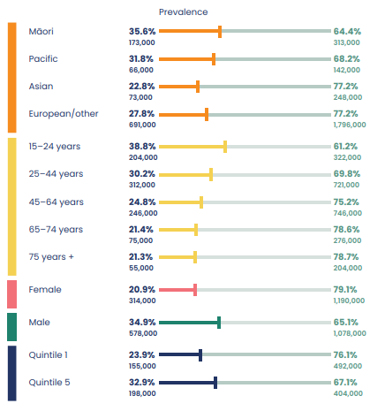

Red meat
The EAGs recommend eating red meat no more than three times a week. High red meat consumption is linked to a greater risk of some non-communicable diseases. About half of all adults were eating above this limit (Table 9).

Respondents were asked whether they ate red meat, such as beef, pork, mutton, lamb, goat or venison. Processed meat products, such as ham, bacon, sausages, luncheon, smoked chicken, canned corned beef, pastrami or salami were excluded.

Men and women had similar red meat consumption patterns. However, more men (53.9 percent) than women (46.6 percent) ate three or more servings a week. More women (9.0 percent) than men (5.5 percent) never or infrequently ate red meat (Table 10).

Among those who ate red meat three or more times a week, differences by age, ethnicity and deprivation were small (Table 11).

Table 9: Frequency of eating red meat
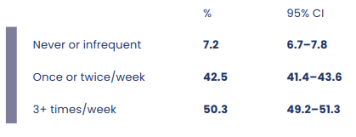
Table 10: Frequency of red meat consumption by sex
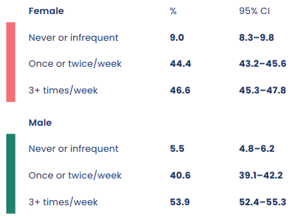
This analysis used the indicator of 3+ a week
Table 11: Characteristics of adults who frequently ate red meat
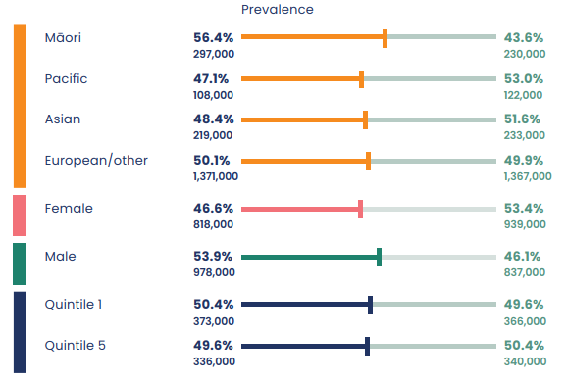

Cutting the fat from red meat
Respondents who ate red meat were asked how often they removed excess fat from red meat before cooking or eating it. The EAGs recommend choosing meat with little visible fat or removing fat before cooking it. Meat fat is a source of saturated fat and eating it is linked with a higher risk of cardiovascular disease.

Among those who ate red meat, fewer women (44.5 percent) than men (58.4 percent) ate meat fat. The differences were also greater between women and men by age group. The prevalence for always eating fat decreased for both groups as age increased; however, women were more likely than men to infrequently or never eat meat fat in all age groups except those 75 years and older.

Māori (66.8 percent) and Pacific (66.6 percent) adults were more likely to eat meat fat than Asian (47.9 percent) or European/other (49.6 percent) adults. Those living in the most socioeconomically deprived quintile were more likely to eat meat fat (60.5 percent) than those living in the least deprived quintile (45.9 percent) (Table 13).

Removing meat fat
Table 12: Frequency of removing fat from red meat
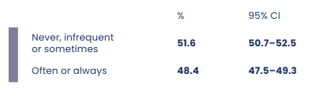

This analysis used the indicator of never, infrequent or sometimes (remove meat fat)
Table 13: Characteristics of adults who infrequently removed fat from red meat
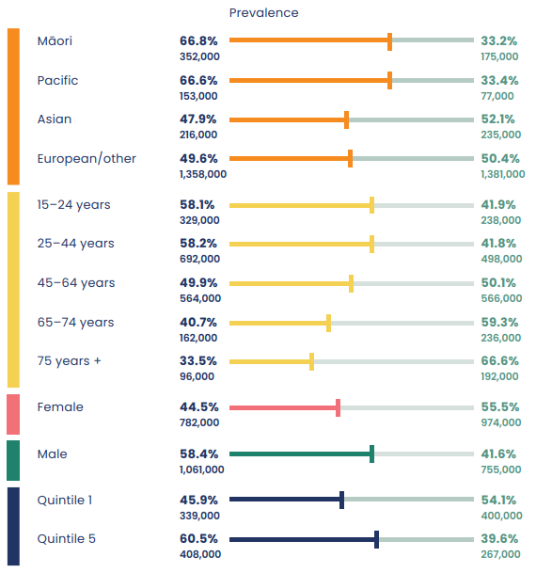

Fish and other seafood
Respondents were asked how often they ate fish or other seafood, including canned seafood, but excluding deep-fried fish and other seafood that is deep-fried.

The EAGs recommend eating some seafood. Seafood is a source of iodine and some fish types (oily fish such as salmon, tuna and mackerel) are good sources
of omega-3 fatty acids, which are linked to a lower risk of heart disease and stroke. Nearly three-quarters of New Zealand adults ate seafood at least once a week (Table 14).

Men and women had similar consumption patterns for seafood across all age groups. Among adults generally, a little under 20 percent ate seafood three or more times a week. However, the prevalence of adults who ate seafood once or twice weekly differed markedly by age, increasing from around 45 percent in those aged 15–24 years to around 60 percent in the 75 plus age group.

Those aged 15–24 years were the most likely to eat seafood infrequently (37.1 percent). Only one in five adults over the age of 65 years never or infrequently ate seafood.

About one in four adults living in the least deprived quintile (24.5 percent) ate little or no seafood while more adults living in the most deprived quintile (27.4 percent) ate seafood infrequently. Māori and European/other adults were more likely to eat seafood infrequently compared with Pacific or Asian adults (Table 16). This same finding of ethnic differences is also reported for children. It is possible that the use of traditional seafood recipes in Pacific and Asian cultures relates to this difference.

Table 14: Frequency of eating seafood
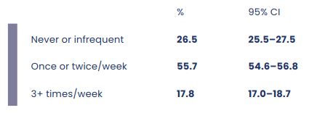

Table 15: Frequency of eating seafood by sex
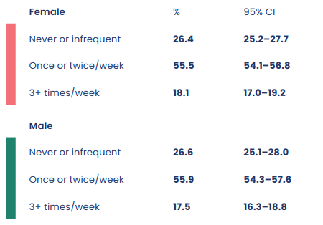

This analysis used the indicator of never or infrequent
Table 16: Characteristics of adults who ate seafood infrequently
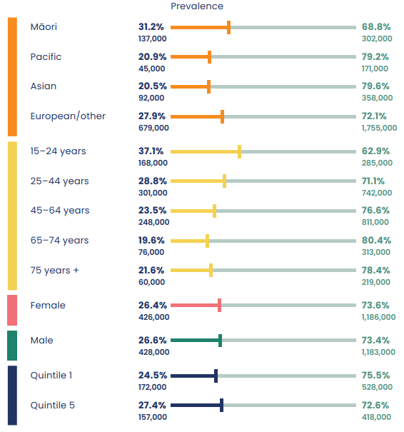

Takeaways
Respondents were asked how often they ate takeaways. The survey question specified takeaways were ‘fish and chips, burgers, fried chicken and pizza, hot dogs, chicken nuggets and deep-fried food’, but excluded ‘other takeaway foods such as sushi, wraps, or curries’.

The EAGs recommend replacing takeaways higher in fat and salt with options lower in fat and salt. A relatively low number of adults ate takeaways often (Table 17) but frequent takeaway consumption was correlated with the most deprived quintile and with young adults.

Many women (63.8 percent) and men (50.6 percent) never or infrequently ate takeaways (Table 18). At least three-quarters of men and women aged 65 years or older never or infrequently ate takeaways. Across age groups, more men than women tended to eat takeaways frequently (three or more times a week); the differences were most significant in those aged 25–44 years. Across adults generally, frequent takeaway consumption was most common among those aged 15–24 years (17.9 percent).

Nearly one in five Pacific adults (19.3 percent) ate takeaways frequently. Fewer Māori (14.3 percent), Asian (8.5 percent) and European/other (5.3 percent) adults frequently ate takeaways. A higher proportion of those living in the most deprived quintile ate takeaways frequently (12.2 percent) compared with those living in the least deprived quintile (3.8 percent) (Table 19).

Table 17: Frequency of eating takeaways
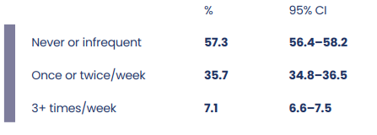

Table 18: Frequency of eating takeaways by sex
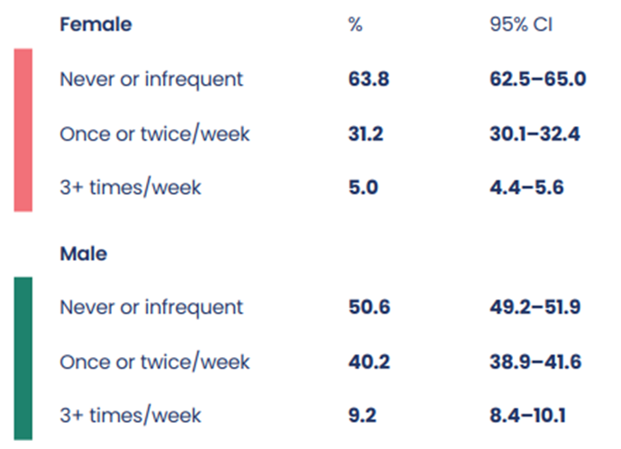

This analysis used the indicator of 3+ times per week
Table 19: Characteristics of adults who frequently ate takeaways
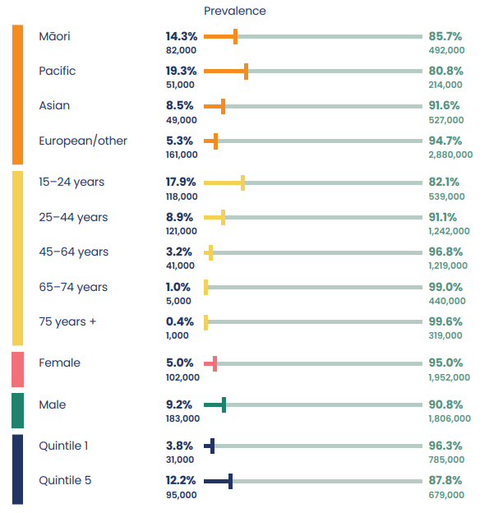

Legumes
The survey described legumes as lentils, chickpeas, kidney beans and baked beans. It also included foods that contain legumes such as hummus and soups. Legumes are rich in nutrients and high in fibre as well as a source of protein. The EAGs include them as healthy protein-rich food options.

Nearly half of all adults ate few or no legumes (Table 20). Pacific (55.3 percent) and Māori (54.0 percent) adults were more likely to eat few or no legumes compared with Asian (43.1 percent) and European/other (47.6 percent) adults. More adults living in the most deprived quintile ate legumes infrequently (52.9 percent) compared with those living in the least deprived quintile (43.9 percent) (Table 22).

Table 20: Frequency of eating legumes
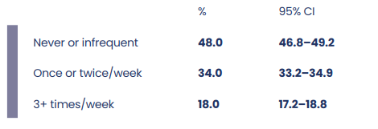

Table 21: Frequency of eating legumes by sex
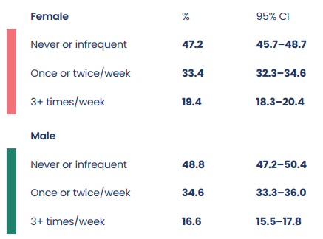

This analysis used the indicator of never or infrequent
Table 22: Characteristics of adults who ate legumes infrequently
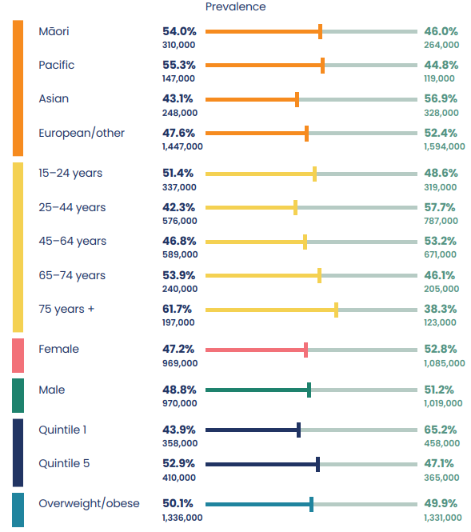

Sweet baked items including biscuits
The dietary habits question about biscuit consumption includes cakes, slices, muffins, sweet pastries and muesli bars (including nut bars) in the biscuit definition.

The EAGs recommend replacing foods high in refined grains, sugar and fat, such as sweet biscuits and cake, with fresh fruit or vegetables and low-fat dip.

More than a third (41.2 percent) of adults ate biscuits three or more times a week (Table 23). Men (43.0 percent) were slightly more likely than women (39.5 percent) to eat biscuits three or more times a week (Table 24).

The greatest differences in biscuit consumption occurred across age groups. The prevalence of adults eating biscuits at least three times a week began to increase among those aged 45–64 years (45.9 percent) and was highest among adults aged 75 years and over (62.8 percent). Frequent biscuit consumption was most common in European/other adults (44.8 percent) and least common in Asian adults (30.7 percent), while 35.7 percent of Māori adults and 31.9 percent of Pacific adults ate biscuits three or more times a week (Table 25).

Table 23: Frequency of eating biscuits
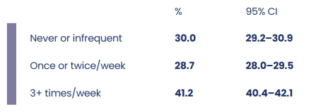

Table 24: Frequency of eating biscuits by sex
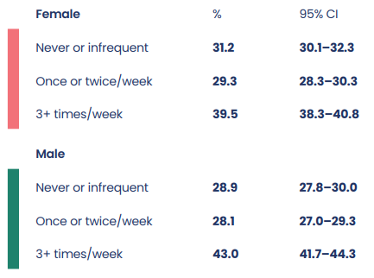

This analysis used the indicator of 3+ times per week
Table 25: Characteristics of adults who ate biscuits frequently
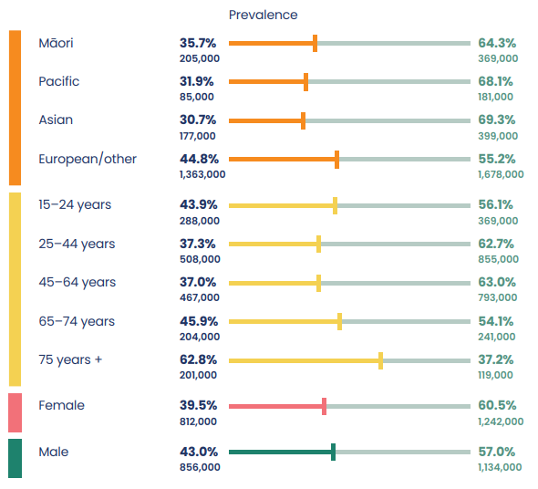

Confectionery
Respondents were asked how often they ate lollies, sweets, chocolate or confectionery.

The EAGs recommend replacing chocolate or sweets with fruit- or vegetable-based snacks.

Around 41 percent of adults reported never or infrequently eating confectionery, 30.2 percent reported eating confectionery once or twice a week and 28.9 percent reported eating confectionery at least three times a week (Table 26).

Both young adults and older adults were the most frequent consumers of confectionery. Frequent consumption was lowest among those aged 45–75 years.

Among those eating confectionery at least three times per week, European/other (31.0 percent) and Māori (28.8 percent) adults had the highest prevalence (Table 28).

Table 26: Frequency of eating confectionery
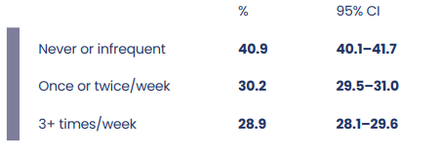

Table 27: Frequency of eating confectionery by sex
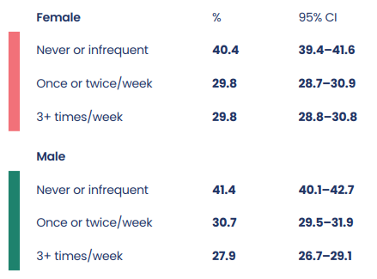
This analysis used the indicator of 3+ times a week
Table 28: Characteristics of adults who frequently ate confectionery
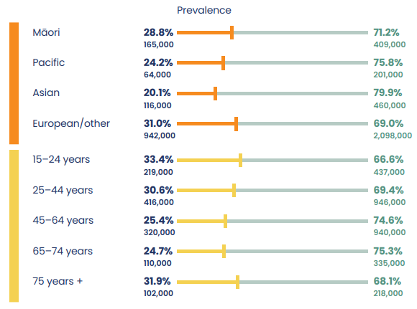

Cordial
Respondents were asked how often they had a drink made from cordial, concentrate or powder (excluding diet or reduced-sugar varieties).

The EAGs recommend drinking plain water, plain milk or diet drinks, rather than sugary drinks such as cordial. About one in five adults reported drinking cordial at least weekly (Table 29). The prevalence was higher among those living in the most deprived quintile and also among Māori and Pacific adults.

Māori adults and Pacific adults and adults in the youngest age group (15–24 years) were more likely than other groups to drink cordial frequently. Men were more likely than women to drink cordial frequently (Table 30). Overweight or obese adults, and adults living in the most deprived quintile also drank cordial more frequently than other groups.

More than three out of four adults (81.9%) reported never or infrequently drinking cordial. While variations in drinking patterns between women and men and between age groups were significant, they were not as great as differences in consumption across ethnic groups and levels of deprivation.

Among adults reporting cordial consumption three or more times per week, the prevalence was 18.1 percent for Māori and 17.7 percent for Pacific adults. By comparison, 9.7 percent of European/other adults and 4.8 percent of Asian adults were in this category.

In the analysis by deprivation, 7.6 percent of adults living in the least deprived quintile drank cordial three or more times a week. That prevalence more than doubled to 16.1 percent among those living in the most deprived quintile (Table 31).

Table 29: Frequency of drinking cordial
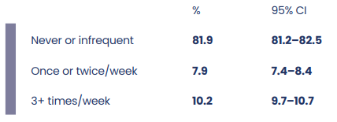

Table 30: Frequency of drinking cordial by sex
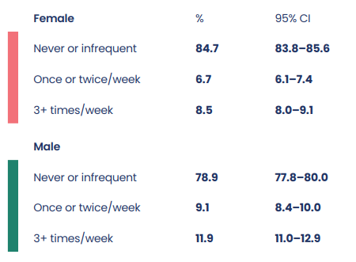

This analysis used the indicator of 3+ times a week
Table 31: Characteristics of adults who drank cordial frequently
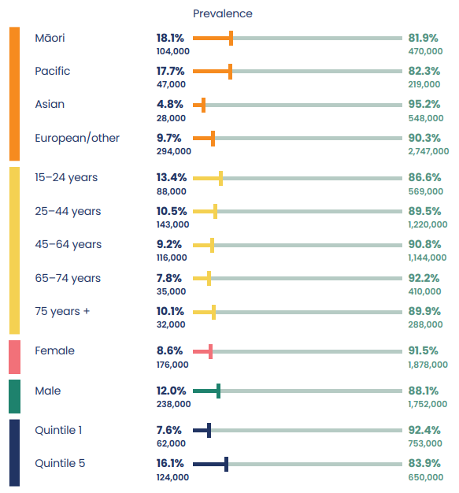

Fruit juice
Respondents were asked how often they drank fruit juice, including freshly squeezed varieties and packaged juice, but this question excluded drinks made from cordial, concentrate or powder.

The EAGs recommend drinking plain water and eating fresh fruit rather than drinking fruit juice.

Asian adults were most likely (22.4 percent) and European/other adults were least likely (15.3 percent) to drink fruit juice frequently. The youngest and the oldest age groups were the most likely to drink fruit juice frequently, along with men and overweight or obese adults. Adults living in the most deprived quintile were more likely than those adults living in the least deprived quintile to drink fruit juice often (Table 34).

Most adults (65.9 percent) reported never or infrequently drinking fruit juice, while less than a fifth (16.8 percent) reported drinking fruit juice at least three times a week (Table 32). More men (19.8 percent) than women (13.9 percent) drank fruit juice three or more times a week (Table 33).

Table 32: Frequency of drinking fruit juice
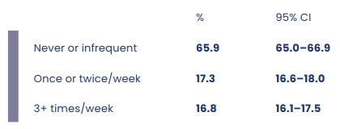

Table 33: Frequency of drinking fruit juice by sex
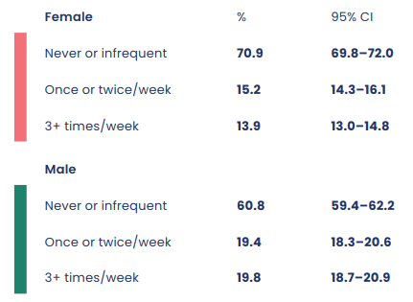

This analysis used the indicator of 3+ times a week
Table 34: Characteristics of adults who drank fruit juice frequently
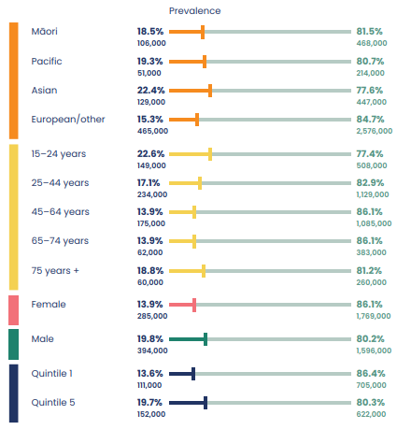

Fizzy drink
Respondents were asked how often they drank soft drinks, fizzy drinks, sports drinks or energy drinks and were prompted to include their use of these as mixers in alcoholic drinks. The question excluded diet and reduced-sugar varieties.

The EAGs recommend drinking plain water or diet drinks rather than sugary drinks such as fizzy drink.

Nearly a third of adults reported drinking fizzy drinks at least weekly (Table 35).

Around 74.5 percent of women reported never or infrequently drinking fizzy drinks compared with 60.4 percent of men. Among those drinking fizzy drinks at least three times a week, the prevalence among men was 20.8 percent and among women was 11.9 percent. As adults got older, the rate of infrequently drinking fizzy drinks increased (Table 36). Among those reporting consumption at least three times per week, however, men had a higher prevalence than women in all age groups except those aged 75 years and older.

Among ethnic groups, Pacific (29.6 percent) and Māori (27.7 percent) adults had the highest rates of drinking fizzy drink at least three times per week.

Drinking fizzy drinks frequently was more common in the youngest age group (15–24 years) (30.0 percent). The prevalence dropped to 6.3 percent in the oldest group (75 years and older).

Among the least deprived quintile of adults, 11.3 percent drank fizzy drink three or more times a week. In contrast, around one in four adults (24.4 percent) in the most deprived quintile drank fizzy drinks this frequently (Table 37).

Table 35: Frequency of drinking fizzy drinks
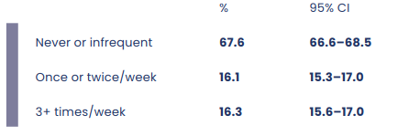

Table 36: Frequency of drinking fizzy drinks by sex
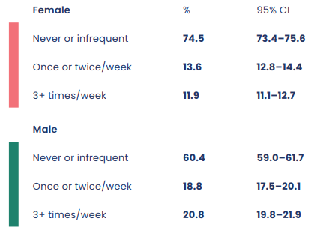

This analysis used the indicator of 3+ times a week
Table 37: Characteristics of adults who drank fizzy drink frequently
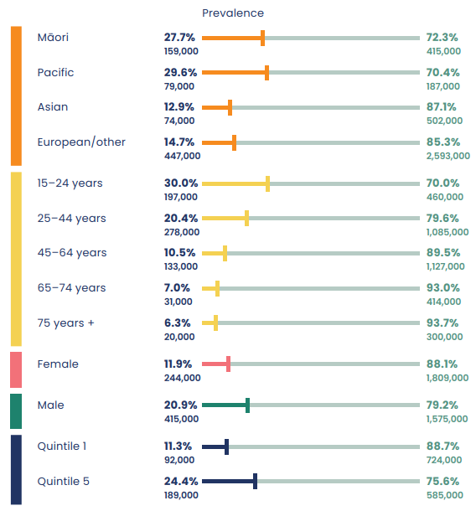

Nuts and seeds
Respondents were asked how often they ate nuts or seeds. The question included roasted nuts and butters made from nuts (eg, peanut butter) or from seeds but excluded hazelnut spreads, and nuts in cereals, snack bars, salads and smoothies.

The EAGs recommend including some nuts and seeds as part of a dietary pattern. Eating some nuts and seeds provides protein as well as fibre and unsaturated fats.

Māori and Pacific men, overweight or obese adults, and adults living in the most deprived quintile had the lowest nut consumption. Adults aged 25–44 years and 45–64 years were the most likely to eat nuts.

Almost half of adults (46.9 percent) reported eating nuts at least three times per week. Around 27.8 percent reported they never or infrequently ate nuts and the remaining 25.3 percent reported eating nuts once or twice per week (Table 38).

More than a third of Māori (33.8 percent) and Pacific (38.6 percent) adults never or infrequently ate nuts. By comparison, 28.6 percent of Asian adults and a quarter (25.8 percent) of European/other adults were in this category.

Across age groups, low nut consumption was most common in those aged 75 years or older (40.9 percent).

Adults living in the most deprived quintile were more likely to never or infrequently eat nuts (37.2 percent) than adults living in the least deprived quintile (20.1 percent) (Table 40).

Table 38: Frequency of eating nuts and seeds
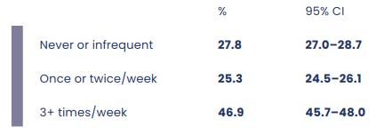

Table 39: Frequency of eating nuts and seeds by sex
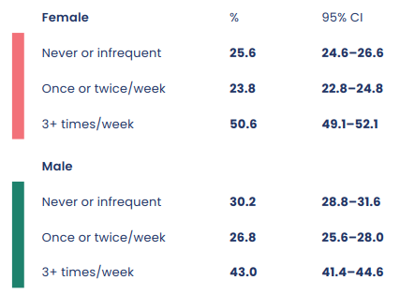

This analysis used the indicator of never or infrequent
Table 40: Characteristics of adults who ate nuts and seeds infrequently
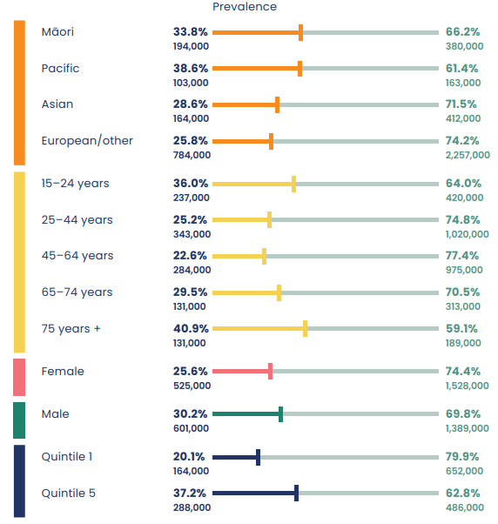

Types of spread used
Respondents were asked what type of butter, margarine or plant oil spread they used. The question described butter alternatives as including butter and plant oil blends, full-fat margarine and plant oil spreads, reduced-fat margarines and plant oil spreads, and plant sterol spreads.

The EAGs recommend replacing butter with margarine or other plant based spreads.

Māori and European/other adults were more likely to use butter spreads. The older age groups (65 years and over) along with those living in the most deprived quintile were less likely to use butter spreads.

Butter spread use differed by ethnicity, age and deprivation. Across age groups, patterns of use of butter and non-butter spread were similar in younger age groups. However, use of butter was lower among older age groups: 41.3 percent of those aged 65–74 years and 38.2 percent of those aged 75 years and older used butter as a spread.

Among ethnic groups, the prevalence of butter use was highest among Māori adults (51.3 percent), followed by European/other (44.7 percent), Pacific (43.2 percent) and Asian (38.4 percent) adults.

Butter use was over eight percent higher among those living in the least deprived quintile (48.3 percent) than among those living in the most deprived quintile (39.9 percent) (Table 44). Butter is usually a more expensive spread option than some margarines.

This analysis excludes those who reported using no spread.

Table 41: Prevalence of use of butter as a spread
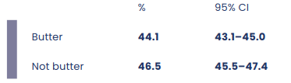

Table 42: Prevalence of use of butter as a spread by age and sex
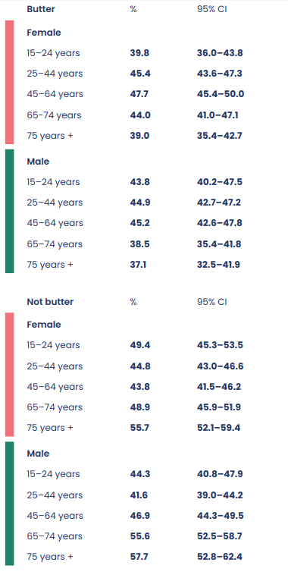

Table 43: Prevalence of use of each type of spread
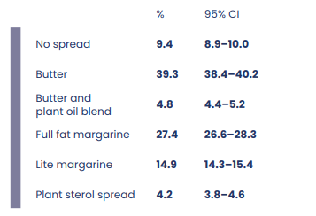

This analysis used the indicator of butter use
Table 44: Characteristics of adults who used butter as a spread
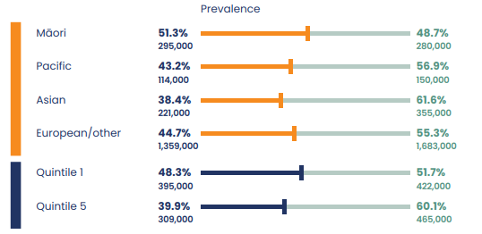

Fat for cooking
Respondents were asked what type of oil or fat they used most often when cooking. Options were olive, coconut, other plant or vegetable oil, butter, butter oil blend, margarine, dripping or lard.

The EAGs recommend replacing saturated fats (such as lard or dripping) with unsaturated fats (such as vegetable oil) for cooking. The types of fat that people use affect their risk of developing cardiovascular disease.

Most of the adult population (88.6 percent) used unsaturated fats for cooking (Table 45). The patterns for use of saturated and unsaturated cooking fat between men and women did not vary significantly. The main variations were across ethnicity and age.

Use of saturated cooking fats was highest among Māori adults at around one in ten (10.0 percent) followed by Pacific adults (7.8 percent).

Those aged 25–44 years (7.4 percent) used saturated cooking fats more than other age groups (Table 46).

Table 45: Prevalence of use of cooking fat by type
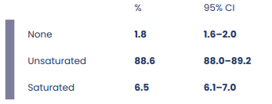

This analysis used the indicator of saturated fat
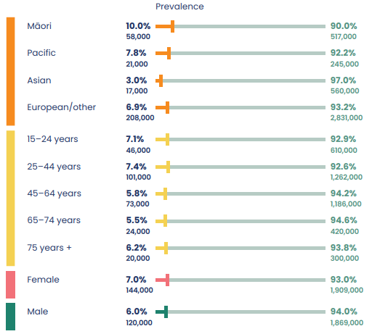
Table 46: Characteristics of adults who used saturated fat for cooking

Bread type
Respondents were asked what type of bread, toast or rolls they ate most. The bread options in the question were white, light grain and heavy grain. Gluten-free and organic breads were included in each of these three options.

The EAGs for adults recommend replacing white bread with higher-fibre or whole grain varieties. White bread is lower in fibre and generally higher in sodium than the alternatives.

The prevalence of eating white bread differed by deprivation, age and ethnicity.

Almost half of adults surveyed ate light grain bread, while the other half was split evenly between the options of white bread and heavy grain bread (Table 47).

Across age groups, the prevalence of eating white bread was highest in the youngest age group (15–24 years) (37.9 percent) and lowest in the group aged 65–74 years (16.1 percent).

Over a quarter of men (27.7 percent) ate white bread compared with just over one in five women (21.9 percent).

Only one in five European/other adults (20.2 percent) ate white bread, compared with 43.8 percent of Pacific adults and 39.6 percent of Māori adults.

The prevalence of white bread consumption is twice as high among adults living in the most deprived quintile (39.2 percent) compared with those in the least deprived quintile (17.5 percent) (Table 48). White bread is usually a lower-cost option than other types of bread.

Table 47: Prevalence of bread consumption by type
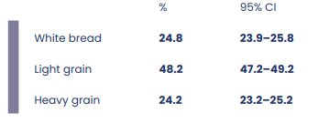

This analysis used the indicator of white bread
Table 48: Characteristics of adults who ate white bread
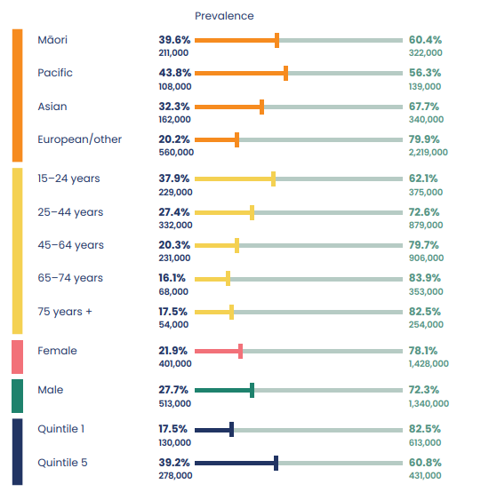

Milk
Respondents were asked what type of milk they used most from the following list: whole or standard, reduced-fat, skim or trim, raw, plant-based (such as soy, rice, almond, coconut) or other animals’ milk (such as sheep or goat). The question included powdered milk but excluded flavoured milk.

The EAGs recommend replacing full-fat (standard) milk with low and reduced- fat milks. Low-fat milks contain less energy and less saturated fat than full-fat or standard milk.

Most adults used standard milk until the age of 65 years and over when adults became more evenly split between the choices of standard and reduced-fat varieties. Māori, Pacific and Asian adults, adults under 45 years, men, and those living in the most deprived areas were more likely to choose standard milk.

About two in three Māori (65.4 percent), Pacific (66.1 percent) and Asian (62.3 percent) adults used standard milk, compared with nearly one in two European/ other adults (47.5 percent).

While 43.1 percent of adults living in the least deprived quintile used standard milk, the prevalence increased to 65.0 percent of those in the most deprived quintile (Table 50). Standard milk is usually a lower-cost option than reduced- or low-fat milk.

The main difference in the type of milk used by age and sex was for plant-based and standard milk. In the youngest age group (15–24 years), 19.6 percent of women reported using plant-based milk compared with only 4.0 percent of men.

Table 49: Prevalence of milk use by type
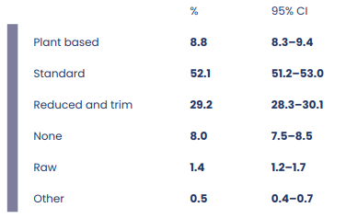

This analysis used the indicator of standard milk
Table 50: Characteristics of adults who used standard milk
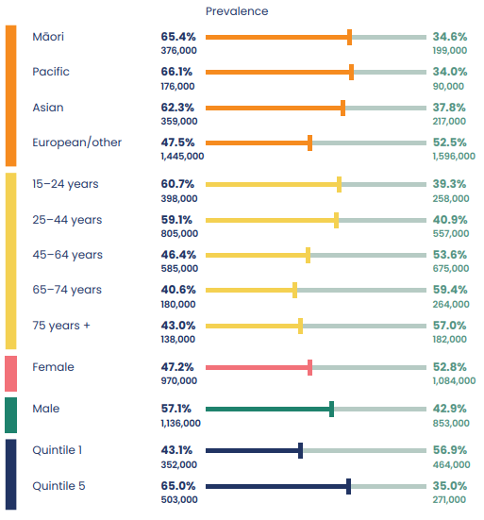

Weight perception
Respondents were asked how they viewed their weight on a scale of one (very underweight) to five (very overweight).

Measurements of weight among adults showed 66.0 percent were overweight or obese (meaning they had a body mass index (BMI) of 25 or higher).

The responses to weight perception varied by age, sex and ethnicity.

Adults in the youngest age group (15–24 years) were more likely than other age groups to perceive their weight as neutral (neither overweight nor underweight) (63.3 percent). The neutral perception was lowest in those aged 45–64 years (44.6 percent) before increasing again in the oldest age group (62.8 percent).

Table 51: Prevalence of types of perceptions of weight
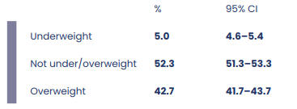

Table 52: Prevalence of types of perceptions of weight by sex
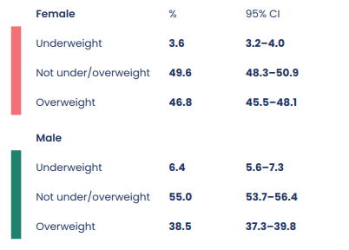

A higher prevalence of men (6.4 percent) than women (3.6 percent) perceived themselves as underweight. Conversely, women (46.8 percent) in general were
more likely than men (38.5 percent) to perceive themselves as overweight (Table 52).
This trend remained consistent by age in all but the oldest age group (75 years and older).

Just over one in every two adults aged 45–64 years (52.3 percent) perceived they were overweight. Among those aged 65–74 years, half of women (50.1 percent) and 41.4 percent of men perceived themselves as overweight.

Pacific (53.1 percent) and Māori (50.2 percent) adults were most likely to perceive they were overweight. This perception was least common among Asian adults (32.5 percent).

Adults living in the least deprived quintile were less likely to perceive themselves as overweight (39.6 percent) compared with those living in the most deprived quintile (46.4 percent) (Table 53).

Nearly two-thirds (60.7 percent) of overweight or obese adults perceived themselves as being overweight.

The indicator overweight was selected for this analysis
Table 53: Characteristics of adults who perceived themselves as overweight
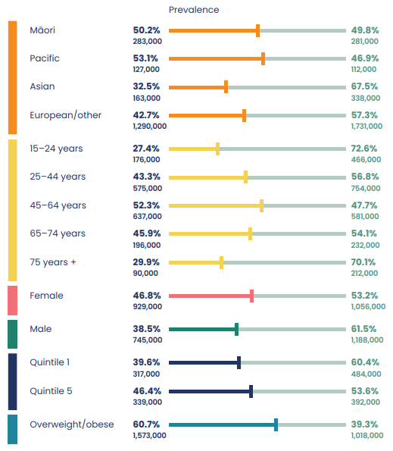

Weight management
Weight perception and weight management are complex interactions that relate to an individual’s experience of the food environment, as well as personal attributes such as level of deprivation, age, sex and cultural norms.

Respondents were asked if they were currently trying to lose weight, stay the same weight or gain weight, or not trying to do anything about their weight.

The proportion of men and women reporting that they were either maintaining weight or not doing anything about their weight was similar across all age groups.

A higher prevalence of adults in the oldest age group (over 75 years) reported they were doing nothing about their weight.

Trying to lose weight
The largest difference between men and women was among those trying to lose weight. In the youngest age group (15–24 years), nearly half of women (47.7 percent) compared with about a quarter of men (26.0 percent) were trying to lose weight.

Overall, nearly half (46.6 percent) of women and around one in three men (34.9 percent) reported they were trying to lose weight.

Just over half of overweight or obese (BMI of 25 or higher) adults (53.7 percent) were trying to lose weight.

Pacific (55.3 percent) and Māori (45.7 percent) adults were more likely than other groups to report they were trying to lose weight. By comparison, 39.5 percent of European/other adults and 40.9 percent of Asian adults were trying to lose weight.

At least a third of those younger than 75 years reported they were trying to lose weight. This prevalence was higher for those aged 25–44 years (46.3 percent) and 45–64 years (45.9 percent) (Table 54).

This analysis used the indicator of lose weight
Table 54: Characteristics of adults trying to lose weight
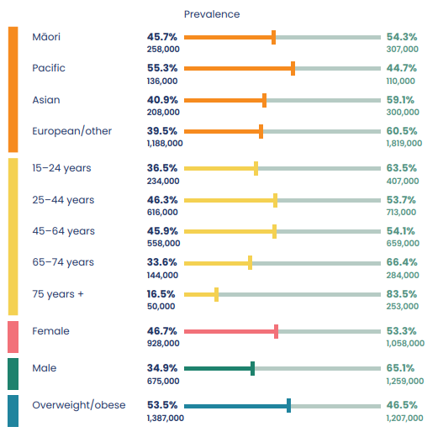

Implications for policy
By analysing the dietary habits survey data, we have been able to measure the unequal distribution of healthy and unhealthy dietary practices within subgroups of the New Zealand population. This analysis will inform future food-related policy designed to address current inequity in food and drink intake and related health outcomes.

Work is under way to influence food choices by encouraging reformulation of less healthy foods to healthier alternatives, limiting advertising of less healthy options and improving access to fruit and vegetables. While providing information does not necessarily translate to change in behaviour, front-of-pack labelling (with understandable nutrition information) is another practice to be encouraged.

Interpretation notes
This section provides some key information to help interpret the survey results presented in this report. For more details about the survey methodology, see the Methodology Report 2019/20 (Ministry of Health 2020b).

Statistical significance
Unless otherwise specified, the results discussed in this report only refer to differences that were statistically significant at the five percent level (ie, those with a p-value of less than 0.05). ‘Statistically significant’ means that the difference between the sample groups is likely to reflect real differences in the population groups, rather than being due to chance. A statistically significant difference does not necessarily mean the difference between the population groups is meaningful.

Confidence intervals
We use 95 percent confidence intervals to show the statistical precision of the estimates. Wider confidence intervals indicate less precise estimates than narrow intervals, which may be caused by higher variation and/or smaller numbers in a sample. Confidence intervals generally agree with statistical significance. When confidence intervals for two estimates do not overlap, the difference between the estimates is statistically significant. However, the opposite may not always be true.

Comparing population subgroups
Analyses that make ethnic comparisons often adjust the data for age to make different groups more comparable, but this report did not take this approach. Age adjusting rates is a way to make fairer comparisons between groups with different age distributions. For example, Māori have a younger population than non-Māori. Younger people may have a lower rate of a particular disease, so it could appear that Māori had a lower rate than non-Māori for that disease, just because they were younger.

Pooled data
Combining two years of data (2018/19 and 2019/20) increases the sample size, so that more reliable results can be provided for subgroups in the population (eg, based on age, ethnicity and neighbourhood deprivation).

The 2019/20 survey was conducted before the COVID-19 pandemic. It is important to note that data was collected for three-quarters of the survey year only. On 19 March 2020 the interviewing for the New Zealand Health Survey was suspended to reduce any risks of transmitting COVID-19 between interviewers and respondents.

Gender
Gender is self-defined by respondents in the survey. For some people, their gender is not the same as their biological sex at birth. Respondents were asked if they were male or female, and while what these options meant was open to the respondent’s interpretation, gender-diverse options (eg, ‘gender non-conforming’ or ‘other’) were not available. The Ministry of Health acknowledges the need to improve data collection in this area and is implementing the Statistical standard for gender, sex, and variations of sex characteristics in the 2022/23 New Zealand Health Survey (Stats NZ 2021).

Ethnicity
Adults who reported more than one ethnic group were counted once in each group they reported. This means that the total number of responses for all ethnic groups can be greater than the total number of adults who stated their ethnicities.

NZDep
The survey uses the New Zealand Index of Deprivation 2013 (NZDep2013) to measure neighbourhood deprivation. The survey groups neighbourhoods into five quintiles: the label ‘quintile 1’ applies to neighbourhoods with the lowest levels of deprivation, and ‘quintile 5’ to those with the highest.

Overweight/obese
Weight and height were measured (by interviewers and entered directly into laptop computers), not self-reported.

Body mass index (BMI) was calculated by dividing weight in kilograms by height in metres squared (kg/m²). For adults aged 18 years and over, the following BMI categories were used:
- underweight: BMI < 18.50
- healthy weight: BMI 18.50–24.99
- overweight: BMI 25.00–29.99
- obese: BMI ≥ 30.0.

References
Forouzanfar MH, Alexander L, Anderson HR, et al. 2015. Global, regional, and national comparative risk assessment of 79 behavioural, environmental and occupational, and metabolic risks or clusters of risks in 188 countries, 1990–2013: a systematic analysis for the Global Burden of Disease Study 2013. Lancet 386(10010): 2287–323. DOI: 10.1016/ S0140-6736(15)00128-2 (accessed 16 May 2022).
Hirvonen K, Bai Y, Headey D, Masters WA, Affordability of the EAT–Lancet reference diet: a global analysis, The Lancet Global Health, Volume 8, Issue 1,2020, Pages e59-e66, ISSN 2214-109X, doi.org/10.1016/S2214-109X(19)30447-4 (accessed 31 May 2022).
Ministry of Health. 2019. Wai 2575 Māori Health Trends Report. Wellington: Ministry of Health.
Ministry of Health. 2020a. Eating and Activity Guidelines for New Zealand Adults: Updated 2020. Wellington: Ministry of Health.
Ministry of Health. 2020b. Methodology Report 2019/20: New Zealand Health Survey. Wellington: Ministry of Health.
Stats NZ. 2021. Statistical standard for gender, sex, and variations of sex characteristics. URL: http://www.stats.govt.nz/methods/statistical-standard-for-gender-sex-and-variations-of-sex-characteristics (accessed 19 May 2022).

Additional information
Ministry of Health. 2016. Sample Design from 2015/16: New Zealand Health Survey. Wellington: Ministry of Health.
Ministry of Health. 2019. Wai 2575 Māori Health Trends Report. Wellington: Ministry of Health.
Ministry of Health. 2020. Content Guide 2019/20: New Zealand Health Survey. Wellington: Ministry of Health.
Questionnaires for the New Zealand Health Survey 2019/20 (Ministry of Health).
Questionnaires for the New Zealand Health Survey 2018/19 (Ministry of Health).

1 This analysis examines socioeconomic deprivation as defined by the New Zealand Deprivation Index 2013. It groups areas in New Zealand into fifths, or quintiles, based on their level of deprivation. See the interpretation notes for more detail.
2 Butter includes butter and butter and plant oil blend. Not butter includes all other spreads.

