Abortion Services Aotearoa New Zealand
Annual Report
2021

Citation: Ministry of Health. 2021. Abortion Services Aotearoa New Zealand: Annual report. Wellington: Ministry of Health.
Published in October 2021 by the Ministry of Health
PO Box 5013, Wellington 6140, New Zealand
ISBN 978-1-99-100761-2 (online)
HP 7877
This document is available at health.govt.nz
This work is licensed under the Creative Commons Attribution 4.0 International licence. In essence, you are free to: share ie, copy and redistribute the material in any medium or format; adapt ie, remix, transform and build upon the material. You must give appropriate credit, provide a link to the licence and indicate if changes were made.

Contents
Introduction 1
The Ministry of Health’s values and our vision for abortion services 1
The Abortion Legislation Act changes to service provision 3
Ministry of Health Abortion Services work programme 4
Standards and clinical guidance 5
Abortion (Information Collection) Regulations 5
Abortion workforce training 6
National Telehealth Service 6
Contraception, Sterilisation, and Abortion (Safe Areas) Amendment Bill 7
Abortion statistics 2020 8
Data summary 8
Key facts 8
1 Abortion numbers, rates, and ratios 10
2 Abortions by facility and region 12
3 Age of patient 15
4 Previous live births 17
5 Previous abortions 18
6 Ethnic group 19
7 Duration of pregnancy 21
8 Procedure 22
9 Complications 23
10 Contraception 24
Methodology 27
Data definitions 28
References 29
Related legislation 30

List of Tables
Table 2.1: Number of abortions by residency status of patient, 2020 14
Table 3.1: Number of abortions by age for those under 16 years, 2020 16
Table 5.1: Number of abortions by age and number of previous abortions, 2020 18
Table 7.1: Number of abortions by age group and duration of pregnancy, 2020 21
Table 8.1: Number of abortions by procedure and duration of pregnancy, 2020 22
Table 9.1: Number and percentage of abortions by complication, 2020 23
Table 10.1: Number and percentage of abortions by type of contraception used at time of conception, 2020 24
Table 10.2: Number of abortions by age group and contraception use at time of conception, 2020 24
Table 10.3: Contraception provided at the time of the abortion by type, 2020 26

List of Figures
Figure 1: Key legislative and Ministry milestones, 24 March 2020 to 24 September 2021 2
Figure 2: Key milestones for Ministry ALR and Abortion Services teams, 24 March 2020 to 24 September 2021 4
Figure 1.1: Number of abortions by year, 2010–2020 10
Figure 1.2: Abortion ratio, 2010–2020 11
Figure 1.3: General abortion rate, 2010–2020 11
Figure 2.1: Number of abortions by facility 12
Figure 2.2: Number of abortions by residence of patient (DHB of domicile), 2019 and 2020 13
Figure 3.1: Number of abortions by age group, 2010–2020 15
Figure 3.2: Percentage of abortions by age group, 2020 16
Figure 4.1: Number of abortions by previous live births, 2010–2020 17
Figure 5.1: Number of abortions by number of previous abortions, 2010–2020 18
Figure 6.1: Number of abortions by total response ethnicity, 2020 19
Figure 6.2: Number of abortions by ethnic group, 2010–2020 20
Figure 7.1: Percentage of abortions by duration of pregnancy, 2010–2020 21
Figure 8.1: Number of abortions by procedure, 2016–2020 22
Figure 10.1: Percentage of abortions where contraception was not used at the time of conception by age group, 2020 25

Introduction
On 24 March 2020, responsibility for abortion services in Aotearoa moved from the Abortion Supervisory Committee to Manatū Hauora (Ministry of Health).
This report provides information on key legislative changes and the Ministry of Health’s work, along with data on abortion services provided in the 2020 calendar year.
Before the passing of the Abortion Legislation Act 2020 in March last year, the Abortion Supervisory Committee (ASC) had oversight of abortion services, set standards of care and was responsible for annual reporting on abortion-related information. As part of the legislative changes, the ASC was disestablished on 24 March 2020 (ASC 2020).

The Ministry of Health (the Ministry) is now responsible for publishing an annual report to inform the sector about the progress of its Abortion Services work programme. The Ministry is aware that annual reporting supports the sector with service planning and research activities.

This 2021 annual report is similar in content to what the ASC reported in previous years. Future annual reports will have a greater focus on equity of abortion service provision, as further work is completed in this area. In addition, data collection for future reports will look different because new data information collection regulations applied from 24 September 2021. This report contains more information about those regulations.

The Ministry of Health’s values and our vision for abortion services
As kaitiaki of the health and disability system in Aotearoa New Zealand, the Ministry aims to create a fair, accessible, effective and sustainable system that people trust. The Ministry’s values help guide and inform how we deliver on our purpose as kaitiaki. They underpin how we work together with the health and disability sector and communities to achieve pae ora – healthy futures for all New Zealanders.

Our values are:
- manaakitanga – we show care, inclusion, respect, support, trust and kindness to each other
- kaitiakitanga – we preserve and maintain an environment that enables the Ministry and our people to thrive
- whakapono – we have trust and faith in each other to do the right thing
- kōkiri ngātahi – we connect and work together collectively towards a common purpose.

The Ministry Abortion Law Reform (ALR) team was stood up to support and implement immediate changes required as part of the Abortion Legislation Act 2020 during the legislative transition period, as well as to scope up further work required. In October 2020, the Abortion Services team was established to implement the Abortion Services work programme. This work programme aims to achieve the Ministry’s vision of accessible, equitable and high-quality abortion services. This report gives further details of the Ministry Abortion Services work programme.

Figure 1: Key legislative and Ministry milestones, 24 March 2020 to 24 September 2021
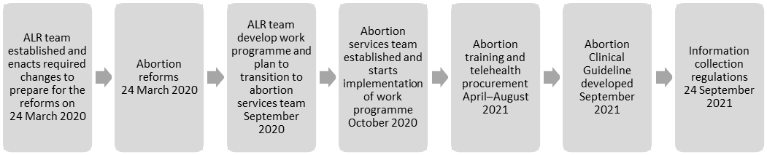
Note: ALR = Abortion Law Reform.

The Ministry vision for abortion services: Accessible, equitable and high-quality abortion services
Once we have implemented the Abortion Legislation Act changes, the health and disability system can expect to see:
- local access to first-trimester abortion services for all regions of Aotearoa New Zealand
- improved abortion service choice and access. Those considering abortion experience greater choice and timely access to services, with barriers and delays removed
- equitable services that are more patient centred and focused more strongly on the requirements of rangatahi, Māori, Pacific peoples and disabled people considering abortion
- a well-supported abortion workforce that has clear clinical guidance and training as a framework for patient-centred and equitable service provision.

The Abortion Legislation Act changes to service provision
The Abortion Legislation Act 2020 came into effect on 24 March 2020. This law change was the outcome of a long reform process that began in February 2018 with the Law Commission’s review of abortion laws. The Law Commission published its briefing paper, Alternative approaches to abortion law, on 26 October 2018.

The Abortion Legislation Bill was a Government Bill in the name of Hon Andrew Little, Minister of Justice. The writing of the Bill was informed by the Law Commission’s briefing paper. The Bill was introduced to Parliament on 5 August 2019 and had its first reading on 8 August 2019.

After the Bill passed the first reading, a Select Committee was established for six months. During this time the Committee received 25,781 written submissions from organisations and individuals. In addition, it held eight oral hearings, during which it heard from 138 submitters. The second reading of the Bill was on 3 March 2020, and the third reading was on 18 March 2020.

The Abortion Legislation Act 2020 primarily amended the Contraception, Sterilisation and Abortion Act 1977 and the Crimes Act 1961, as well as making minor amendments to several other Acts. The intention of the Abortion Legislation Act was to amend the law to decriminalise abortion, better align the regulation of abortion services with other health services and modernise the legal framework for abortion.

The key changes of the law reforms were:
- decriminalising abortion when performed by health practitioners, allowing a wider range of registered health practitioners to perform abortions, subject to their scope of practice (ie, medical, midwifery or nursing)
- allowing self-referral to an abortion service
- removing the statutory criteria to access an abortion. A health practitioner may perform an abortion before 20 weeks gestation. After 20 weeks gestation, a health practitioner may only perform an abortion if they reasonably believe the abortion is clinically appropriate in the circumstances
- removing the requirement for premises providing abortion services to be licensed. Abortions can now occur in a range of settings, including primary care
- requiring counselling to be available to anyone considering abortion, without making counselling mandatory
- requiring health practitioners who conscientiously object to abortion provision to tell the person of their objection and how to access details of their closest abortion provider.

Ministry of Health Abortion Services work programme
The Ministry’s Abortion Services work programme has several workstreams, which aim to improve equity, access and choice for people seeking abortion services in Aotearoa. These workstreams are:
- stakeholder engagement and communication
- standards, regulations, clinical guideline, policy and research
- availability of medicines and medical devices
- service design and implementation (care pathways, models of care)
- support for current workforce and enabling avenues for future workforce
- consumer information
- data collection and reporting
- funding and accountability
- law and ethics.

Figure 2 outlines key milestones for the Ministry ALR and Abortion Services teams and related legislative changes. Later sections expand on some of these.

Figure 2: Key milestones for Ministry ALR and Abortion Services teams, 24 March 2020 to 24 September 2021
24 March to 30 September 2020 |  | 1 October to 31 March 2021 |  | 1 April to 24 September 2021
- Established Ministry communication channels (ALR mailbox, abortion services webpages and 0800 number) used to provide information on the Act to the public and health sector  - Established a sector working group for the health and disability standard review  - Engaged with Pharmac on process to increase funding for abortion medicines  - Designed the organisation structure for the Ministry Abortion Services team  - DHB service delivery survey questions sent to DHBs to better understand current state, desired future state, gaps, and opportunities |  | - Abortion Services team established  - Abortion Services work programme further developed  - Stakeholder engagement commenced  - Procurement process for service improvement, innovation and training initiated  - Business case for telehealth services completed  - Abortion services data collection requirements reviewed with stakeholders  - Clinical guidelines working group established |  | - Service information updated on Ministry website to have more consumer focus  - Procurement for service improvement, innovation and training completed and national training contract awarded  - Procurement process for national telehealth service completed  - New abortion information collection regulations legislation implemented requirements with stakeholders  - Ngā Paerewa (health and disability standard) published  - Abortion Clinical Guideline developed  - Community restrictions to abortion medicines lifted by Pharmac
Note: Act = Abortion Legislation Act 2020; ALR = Abortion Law Reform; DHB = district health board.

Standards and clinical guidance
Abortion service provision, like other health services, is underpinned by clinical guidance and national standards to support consistent, high-quality provision of care. Interim Standards for Abortion Services in New Zealand were published on the Ministry of Health website in April 2020. These have now been replaced by Ngā Paerewa Health and Disability Services Standard 8134:2021 (Ngā Paerewa) and the New Zealand Aotearoa Abortion Clinical Guideline (Ministry of Health 2021).

The New Zealand Aotearoa Abortion Clinical Guideline provides best clinical practice advice for health care practitioners who provide abortion services in New Zealand. It has been developed with a working group of representatives from professional colleges and councils, abortion providers, and academics and is available on the Ministry of Health website.

Ngā Paerewa, which we developed with the health sector, sets out the minimum requirements for care and support within services specified in the Health and Disability Services (Safety) Act 2001. It focuses on the patient and whānau experience of health services and is designed for abortion services in hospital settings to use. Abortion services provided in primary and community care settings will not be audited against Ngā Paerewa but may wish to use Ngā Paerewa as a best practice guide.

The Ministry of Health will use Ngā Paerewa as a reference standard when periodically reviewing whether access to abortion services is timely and equitable nationwide and we will report on our findings in future annual reports. The next annual report will provide further information about the implementation of the guideline.

Abortion (Information Collection) Regulations
On 24 September 2021 new abortion notification (abortion service reporting) and annual reporting requirements came into force. All providers of abortion services must submit abortion notifications to the Ministry of Health within one month of the procedure. They are also required to report annually on abortion services and abortion counselling services they provided in the preceding calendar year; for example, they must report on services they provided in 2021 by 31 March 2022.

The changes have been introduced to meet requirements for the Director-General of Health to collect, collate, analyse and publish information about the provision of abortion services and counselling services in relation to, or in connection with, the provision of abortion services. This information will also help to identify whether access to abortion and to abortion counselling is timely and equitable, and whether there is any evidence of anyone seeking an abortion solely for the purpose of choosing the sex of the fetus.

Abortion workforce training
In 2021 the Ministry Abortion Services team ran two separate procurement processes aimed at improving abortion access. The first was a registration of interest for abortion service improvement, innovation and training proposals. The focus was on developing and delivering accessible abortion services for rangatahi, Māori, Pacific peoples and disabled people as these groups typically experience the greatest inequity in abortion access.

This procurement process resulted in a contract with the New Zealand College of Sexual and Reproductive Health to develop a national training package. That package will include: a revised early medical abortion (EMA) training module; a new vacuum aspiration training module; a triage and communication skills training module; and an abortion point-of-care ultrasound (POCUS) training module. Training for vacuum aspiration and POCUS includes both theory and practical training and assessment.

Māori models Te Whare Tapa Whā and Te Pōwhiri will provide the training framework. The training content will be determined through hui with abortion health sector experts along with rangatahi, Māori, Pacific and disabled consumer representatives and through a co-design research project on what ‘good’ abortion service looks like.

The new suite of abortion training will provide nationally available, culturally safe training that supports the abortion workforce to meet service expectations of rangatahi, Māori, Pacific and disabled service users. It is aligned with the Abortion Clinical Guideline and relevant care standards. The training will be available towards the end of 2022 to all health practitioners in scope to provide abortion. In 2022 we will also give the health sector further details on how health practitioners can access the training.

National Telehealth Service
The second procurement process completed by the Abortion Services team was for a National Abortion Telehealth Service.

Having a publicly funded telehealth service available to everyone in New Zealand who needs EMA services will help to improve access to early abortion at a national level. The National Abortion Telehealth Service will improve service access and equity of access. People who are expected to benefit most are those in regions without locally available EMA services.

The National Abortion Telehealth Service will roll out in phases. The first phase will provide nationally available consumer information, support and service referral; the second will provide telehealth abortion counselling and clinical follow-up after EMA; and the third will provide EMA abortion via telemedicine.

Phases one and two are intended to remove barriers to primary and community care providers, including independent practitioners, wanting to provide abortion services.

We will provide an update on the contract holder and timeline for the phased rollout of the National Abortion Telehealth Service towards the end of 2021.

Contraception, Sterilisation, and Abortion (Safe Areas) Amendment Bill
In July 2020 the Contraception, Sterilisation, and Abortion (Safe Areas) Amendment Bill was introduced in Parliament as a private member’s Bill. The Bill would allow safe areas to be established around abortion provider premises, to protect the safety and privacy of those accessing abortion services. The extent of a safe area would be decided on a case-by-case basis, up to a maximum of 150 metres from the premises. A person engaging in any prohibited behaviour in a safe area would be liable on conviction to a fine of up to $1,000.

Although the wording of the Bill may change between the First Reading and Second Reading, at the time of publication of this report, prohibited behaviour is defined in the Bill as:
- intimidating, interfering with, or obstructing a protected person –
- with the intention of frustrating the purpose for which the protected person is in the safe area; or
- in a manner that an ordinary reasonable person would know would cause emotional distress to a protected person:
- communicating with, or visually recording, a person in a manner that an ordinary reasonable person would know would cause emotional distress to a protected person.

A protected person is defined in the Bill as a person who is in a safe area for the purpose of:
- accessing abortion services
- providing, or assisting with providing, abortion services
- seeking advice or information about abortion services
- providing, or assisting with providing, advice or information about abortion services.

Abortion statistics 2020

Data summary
The source of the abortion data included in this report is abortion notifications from all abortions performed in Aotearoa New Zealand for the calendar year 2020. Abortions performed before 24 March 2020 were reported to the ASC and collated by Tatauranga Aotearoa Statistics New Zealand; abortions performed from 24 March 2020 onwards are reported to and collated by the Data and Digital team at the Ministry of Health. The Ministry Data and Digital team combined the Statistics New Zealand and Ministry data for 2020 to enable reporting on the complete year.

The data provides an overview of abortion numbers, rates and ratios, as well as further breakdown and analysis to gain a more detailed understanding of trends in relation to factors such as age, ethnicity, region, duration of pregnancy, procedures, complications and contraception. This supports analysis of national abortion service provision. We use insights from the data to inform the Ministry Abortion Services work programme and will use the data in future to evaluate the success of initiatives such as the National Abortion Telehealth Service.

Key facts
- 13,246 abortions were performed in New Zealand in 2020, up from 12,857 in the previous year.
- The general abortion rate was 13 abortions per 1,000 women aged 15–44 years, down slightly from 13.2 per 1,000 in 2019.
- 18.6% of known pregnancies ended in an abortion in 2020, compared with 17.7% in 2019 (this percentage excludes miscarried pregnancies).
- The data indicates that abortion numbers have levelled off in New Zealand since 2014.
- Two facilities started providing abortion services for the first time in 2020: Timaru Hospital and the Family Planning Clinic in Whangārei.
- The mean age of those having an abortion in 2020 was 28 years.
- 40% of all abortions were for those aged 30 years and over, up from 34 percent in 2015.
- Most abortions in 2020 (64%) were a first abortion, the same as in 2019.
- 21.7% of all abortions were for those identifying as Māori in 2020, a decrease from 23.1% in 2019.
- 8% of all abortions were for those identifying as Pacific peoples in 2020, a decrease from 9.8% in 2019.
- In 2020, 45% of abortions were accessed before eight weeks’ gestation, compared with only 27% in 2019.
- The rate of early medical abortion increased significantly: 36% (4,774) had an EMA up to nine weeks’ gestation in 2020 compared with only 22% in 2019.
- Conversely surgical abortion decreased substantially, accounting for 59% (7,802) of total abortions compared with 72% in 2019.
- Provision of contraception at the time of the abortion procedure fell in 2020. This may be because contraception provision was limited during Alert Levels 3 and 4 lockdown in response to the COVID-19 pandemic, and EMA and telehealth abortion provision increased, requiring patients to attend a separate contraception appointment after the abortion.

Abortion numbers, rates, and ratios
The number of abortions performed in 2020 (13,246) increased slightly compared with the number performed in 2019 (12,948) (Figure 1.1). The ratio was 186 abortions per 1,000 known pregnancies in 2020, up from 177 per 1,000 known pregnancies in 2019 (Figure 1.2). The general abortion rate in 2020 shows that 0.13% of women aged 15–44 years sought an abortion (Figure 1.3). This continues the downward trend in the general abortion rate of recent years.

Overall, the total number of abortions and abortion ratio have remained consistent over the last seven years, indicating that abortions in New Zealand have levelled off.

Figure 1.1: Number of abortions by year, 2010–2020
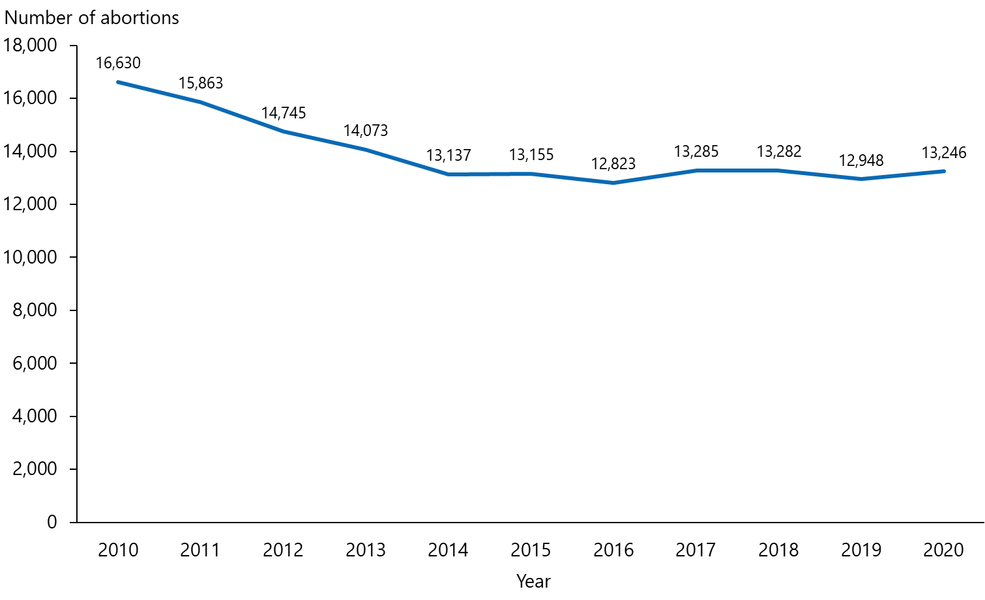

Figure 1.2: Abortion ratio, 2010–2020
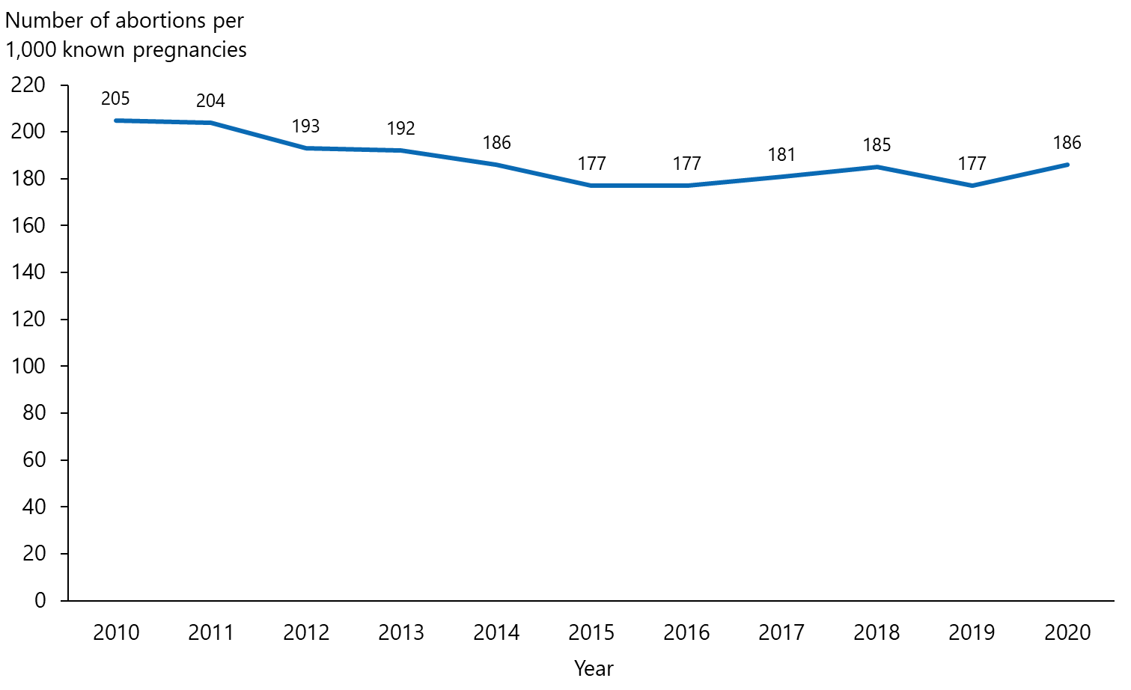
Note: Known pregnancies include live births, stillbirths and abortions combined, but do not include miscarriages.

Figure 1.3: General abortion rate, 2010–2020
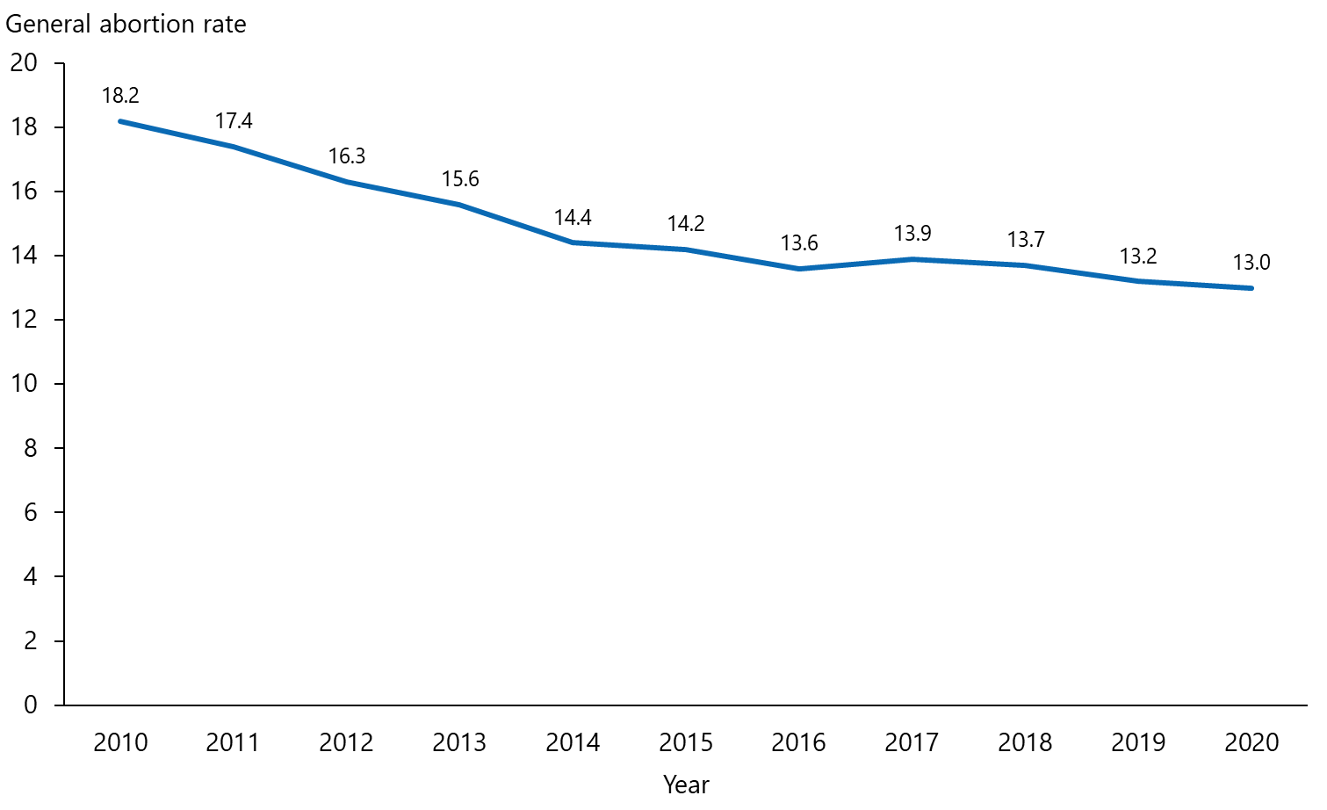
Note: The general abortion rate is the number of abortions per 1,000 of the mean estimated population of women aged 15–44 years. For 2020 data, the denominator is the estimated number of women in New Zealand aged 15–44 years, mean year ended 31 December 2020.

Abortions by facility and region

Number of abortions by facility
In 2020, 25 separate facilities provided abortions (Figure 2.1). Two facilities started providing abortions in that year: Timaru Hospital, which provides first- and second-trimester abortion services; and the Family Planning Clinic in Whangārei, which provides a first trimester EMA service.

In most cases, each facility provided abortion care to a similar number of patients in 2020 compared with 2019. The Ministry expects that work over the next year will enable more health practitioners practising in primary and community health care settings to provide abortion services. Over time this may result in a shift away from abortion provision in hospital settings.

Visit abortion provider locations on the Ministry of Health website for up-to-date information on abortion providers.

Figure 2.1: Number of abortions by facility
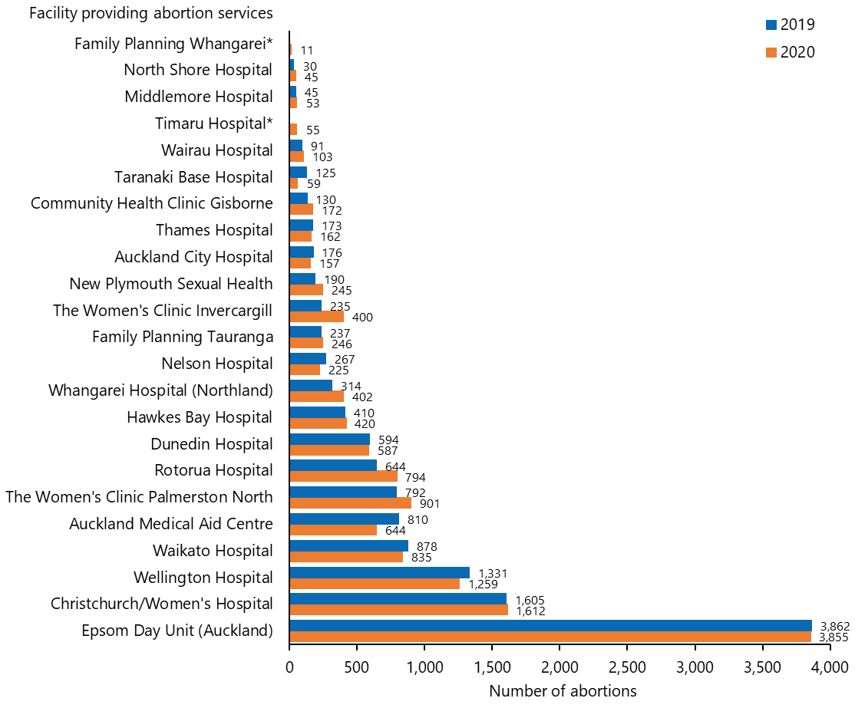
Notes:
* New services started 2020.
** Christchurch hospitals represent Christchurch Women’s Hospital and Christchurch Hospital.
Hutt and Palmerston North hospitals are not represented in this figure because of the low number of abortions they performed (a combined total of four) in 2020.

Abortions by residence of patient (DHB of domicile)
In most cases, a similar number of patients from each DHB region were provided abortion care in 2020 compared with 2019 (Figure 2.2). Modest increases occurred for patients from Whanganui, Northland, Bay of Plenty, Southern, Waikato and Canterbury DHBs; and modest decreases occurred for patients from Taranaki, MidCentral, Auckland and Counties Manukau DHBs. It is positive to note that overall access to abortion services did not decrease during the response to the COVID-19 pandemic in that year. Please note that the data in Figure 2.2 represents where the patient lived in 2020, not where the abortion took place. For example, in the West Coast DHB region, no local abortion service is available so most pregnant people travel to Canterbury DHB for abortion care.

Figure 2.2: Number of abortions by residence of patient (DHB of domicile), 2019 and 2020
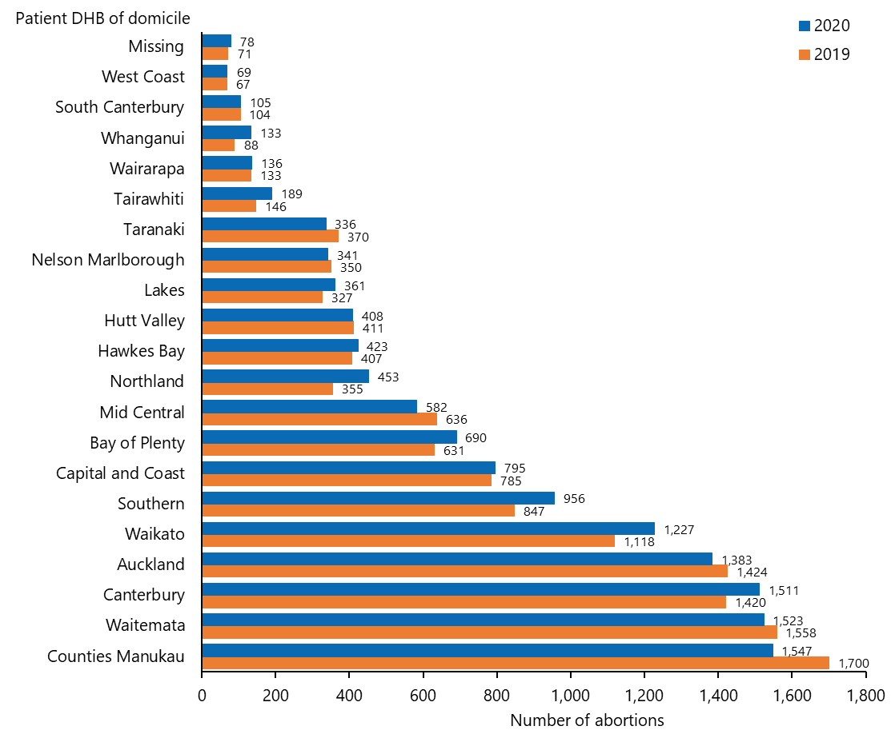

Abortions by residency status of patient
In 2020, approximately 90% of abortion services in Aotearoa New Zealand were provided to New Zealand residents (Table 2.1). This was not significantly different from 2019, despite the border restrictions due to COVID-19. Note that residency status is not the same as area of residence.

Table 2.1: Number of abortions by residency status of patient, 2020
Residency status | Number
New Zealand resident | 11,845
Non-resident | 1,383
Not stated | 18
Total | 13,246

Age of patient

Number of abortions by age group
For most age groups, the number of abortions increased slightly in 2020 compared with 2019 (Figure 3.1). The mean age of those having abortions was 28 years. The group aged 25–29 years continues to have the most abortions, accounting for 26.3% of all abortions in 2020 (Figure 3.2). The greatest increase was seen for those aged 30–34 years. The trend of increasing numbers of abortions in those over 30 years continued in 2020, up 1% from 2019 and 6% from 2015.

Figure 3.1: Number of abortions by age group, 2010–2020
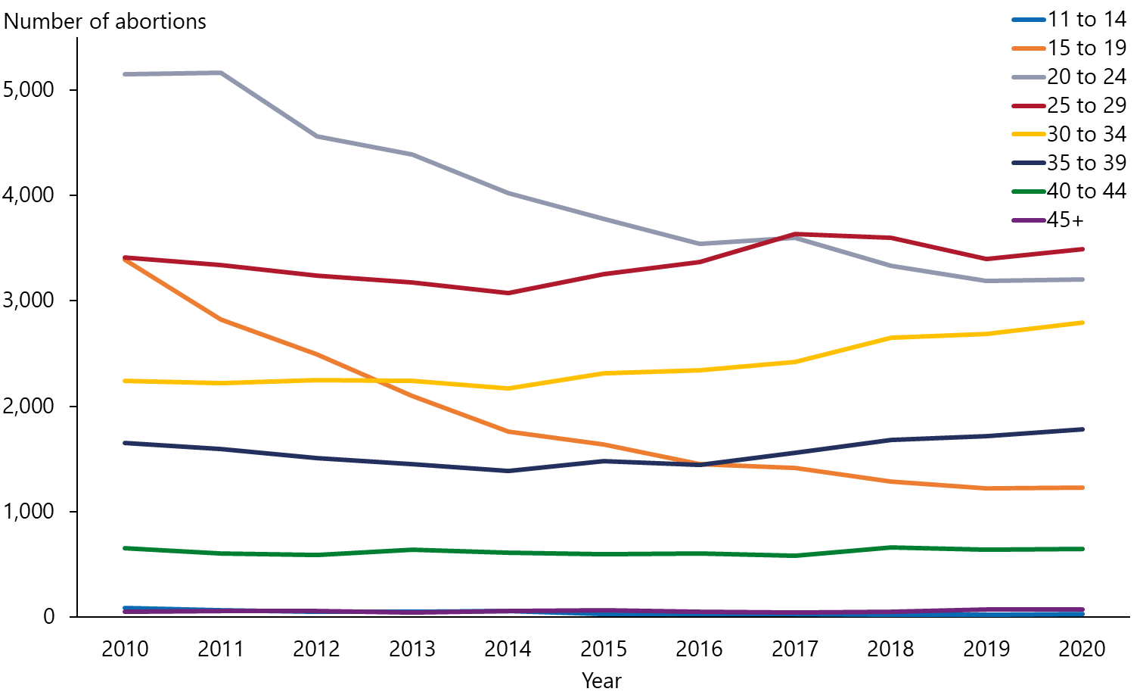

Age group | 2011 | 2012 | 2013 | 2014 | 2015 | 2016 | 2017 | 2018 | 2019 | 2020
11 to 14 | 68 | 51 | 48 | 57 | 32 | 27 | 30 | 22 | 23 | 26
15 to 19 | 2,822 | 2,489 | 2,096 | 1,758 | 1,635 | 1,451 | 1,414 | 1,289 | 1,219 | 1,227
20 to 24 | 5,160 | 4,560 | 4,386 | 4,024 | 3,777 | 3,537 | 3,599 | 3,334 | 3,191 | 3,204
25 to 29 | 3,340 | 3,240 | 3,174 | 3,075 | 3,256 | 3,368 | 3,632 | 3,598 | 3,397 | 3,488
30 to 34 | 2,220 | 2,248 | 2,237 | 2,172 | 2,309 | 2,343 | 2,419 | 2,650 | 2,686 | 2,795
35 to 39 | 1,593 | 1,506 | 1,451 | 1,384 | 1,483 | 1,443 | 1,562 | 1,679 | 1,720 | 1,784
40 to 44 | 605 | 590 | 637 | 611 | 598 | 602 | 584 | 660 | 642 | 649
45+ | 55 | 61 | 44 | 56 | 65 | 52 | 45 | 50 | 70 | 70
Note: Data on age was missing for three patients in 2020 so they have been excluded from the analysis.

Figure 3.2: Percentage of abortions by age group, 2020
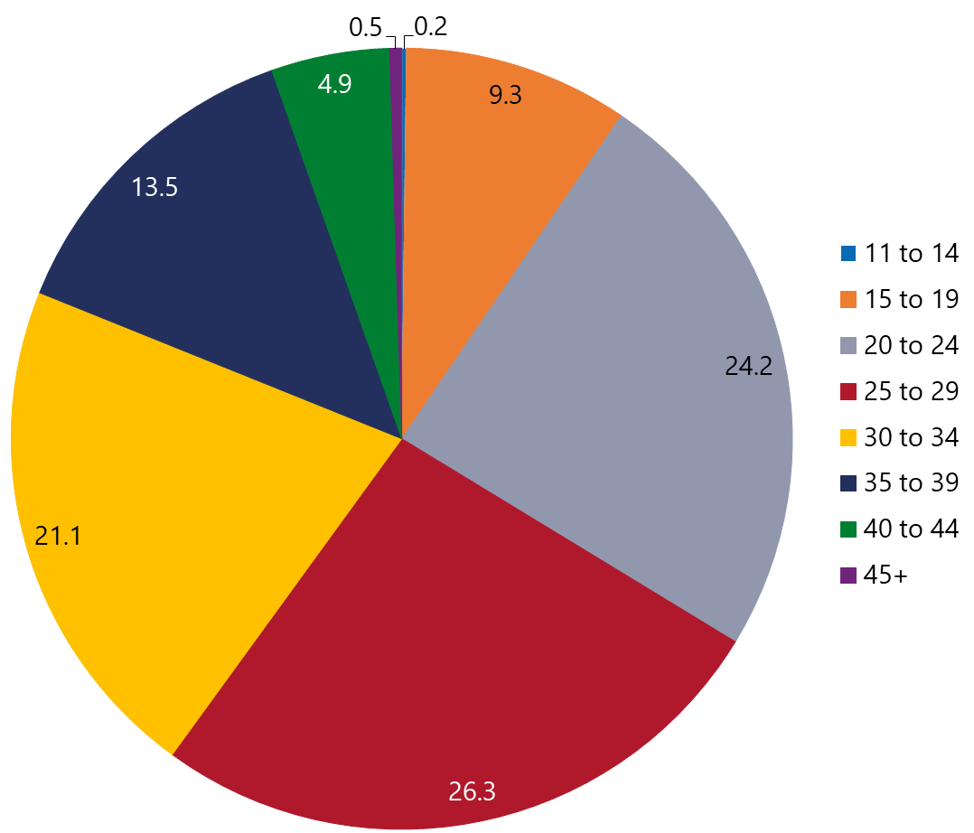

Abortions in those under 16 years
The number of abortions in those aged under 16 years in 2020 remains low (Table 3.1) and was very similar to the number in 2019.

Table 3.1: Number of abortions by age for those under 16 years, 2020
Age (years) | Number
11 | –
12 | ≤5
13 | ≤5
14 | 19
15 | 55
Note: Specific counts equal to or less than five have not been released to protect confidentiality.

Previous live births
In 2020, a total of 5,445 (41%) of those having an abortion had no previous live birth (Table 4.1). Numbers and proportions of abortion by previous live birth were like those observed in 2019. The numbers of abortions by previous live birth have also remained consistent over the last seven years (Figure 4.1), following the same trend noted for general abortion rates.

Table 4.1: Number of abortions by age group and previous live births, 2020
Age group (years) | Total | Number of previous live births
 |  | 0 | 1 | 2 | 3 | 4 | 5 | 6 | 7+
All ages | 13,246 | 5,445 | 2,810 | 2,966 | 1,255 | 486 | 170 | 71 | 43
11–14 | 26 | 26 | 0 | 0 | 0 | 0 | 0 | 0 | 0
15–19 | 1,227 | 1,056 | 150 | 20 | 1 | 0 | 0 | 0 | 0
20–24 | 3,204 | 2,000 | 703 | 375 | 100 | 24 | 2 | 0 | 0
25–29 | 3,488 | 1,439 | 808 | 737 | 338 | 112 | 42 | 6 | 6
30–34 | 2,795 | 631 | 661 | 844 | 404 | 159 | 57 | 26 | 13
35–39 | 1,784 | 228 | 368 | 698 | 282 | 120 | 50 | 25 | 13
40–44 | 649 | 59 | 102 | 259 | 121 | 68 | 18 | 12 | 10
45 and over | 70 | 4 | 17 | 33 | 9 | 3 | 1 | 2 | 1
Missing | 3 | 2 | 1 | 0 | 0 | 0 | 0 | 0 | 0

Figure 4.1: Number of abortions by previous live births, 2010–2020
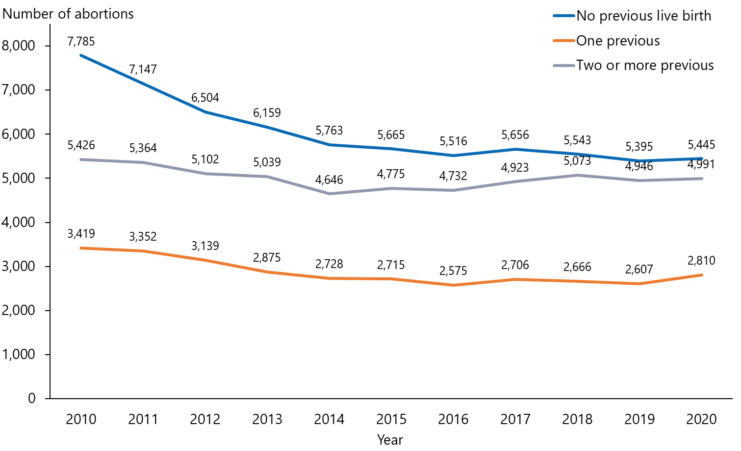

Previous abortions
In 2020, 64% of abortions were the person’s first abortion. This is consistent with trends in recent years (Figure 5.1). Those in older age groups tended to be more likely to have had one or more previous abortions (Table 5.1).

Table 5.1: Number of abortions by age and number of previous abortions, 2020
Age group (years) | Number of previous abortions
 | Total | 0 | 1 | 2 | 3 | 4 | 5 | 6 or more
All ages | 13,246 | 8,505 | 3,099 | 1,093 | 335 | 116 | 54 | 44
Under 15 | 26 | 26 | 0 | 0 | 0 | 0 | 0 | 0
15–19 | 1,227 | 1,132 | 83 | 9 | 2 | 0 | 0 | 1
20–24 | 3,204 | 2,371 | 657 | 140 | 28 | 5 | 2 | 1
25–29 | 3,488 | 2,134 | 906 | 301 | 90 | 28 | 15 | 14
30–34 | 2,795 | 1,538 | 762 | 319 | 113 | 34 | 16 | 13
35–39 | 1,784 | 946 | 491 | 222 | 69 | 30 | 14 | 12
40–44 | 649 | 315 | 186 | 91 | 31 | 17 | 6 | 3
45 and over | 70 | 40 | 14 | 11 | 2 | 2 | 1 | 0
Missing | 3 | 3 | 0 | 0 | 0 | 0 | 0 | 0

Figure 5.1: Number of abortions by number of previous abortions, 2010–2020
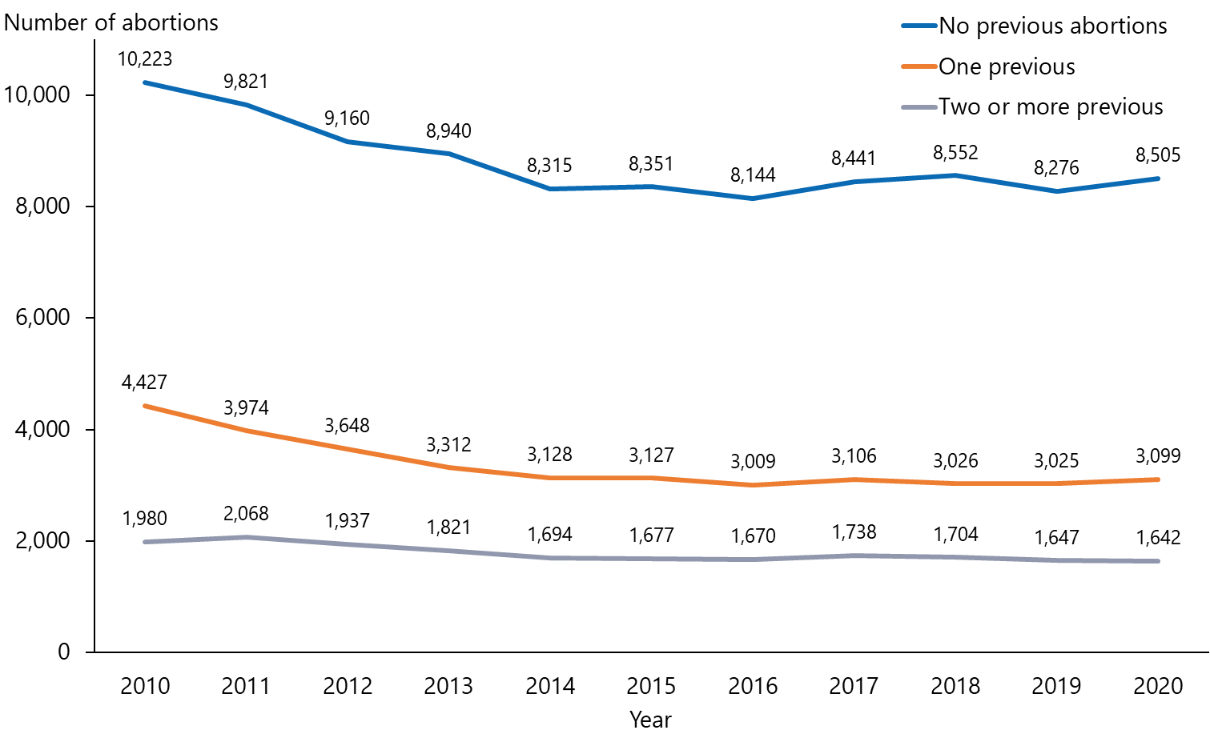

Ethnic group
Among the patients who had an abortion in 2020, the percentages of those identifying as New Zealand European (54.2%) or Asian (21.6%) were like those in the previous year. However, the percentages decreased for those identifying as Māori or Pacific peoples in 2020 (Figure 6.1). Specifically, in 2020:
- 21.7% (2,875) of those having an abortion identified as Māori, compared with 23.1% in 2019
- 8% (1,053) of those having an abortion identified as Pacific, compared with 9.8% in 2019 (Figure 6.2).

Reasons for the reduction in Māori and Pacific abortions in 2020 are not known. This requires close monitoring to ensure Māori or Pacific are not experiencing barriers to accessing abortion services.

Figure 6.1: Number of abortions by total response ethnicity, 2020
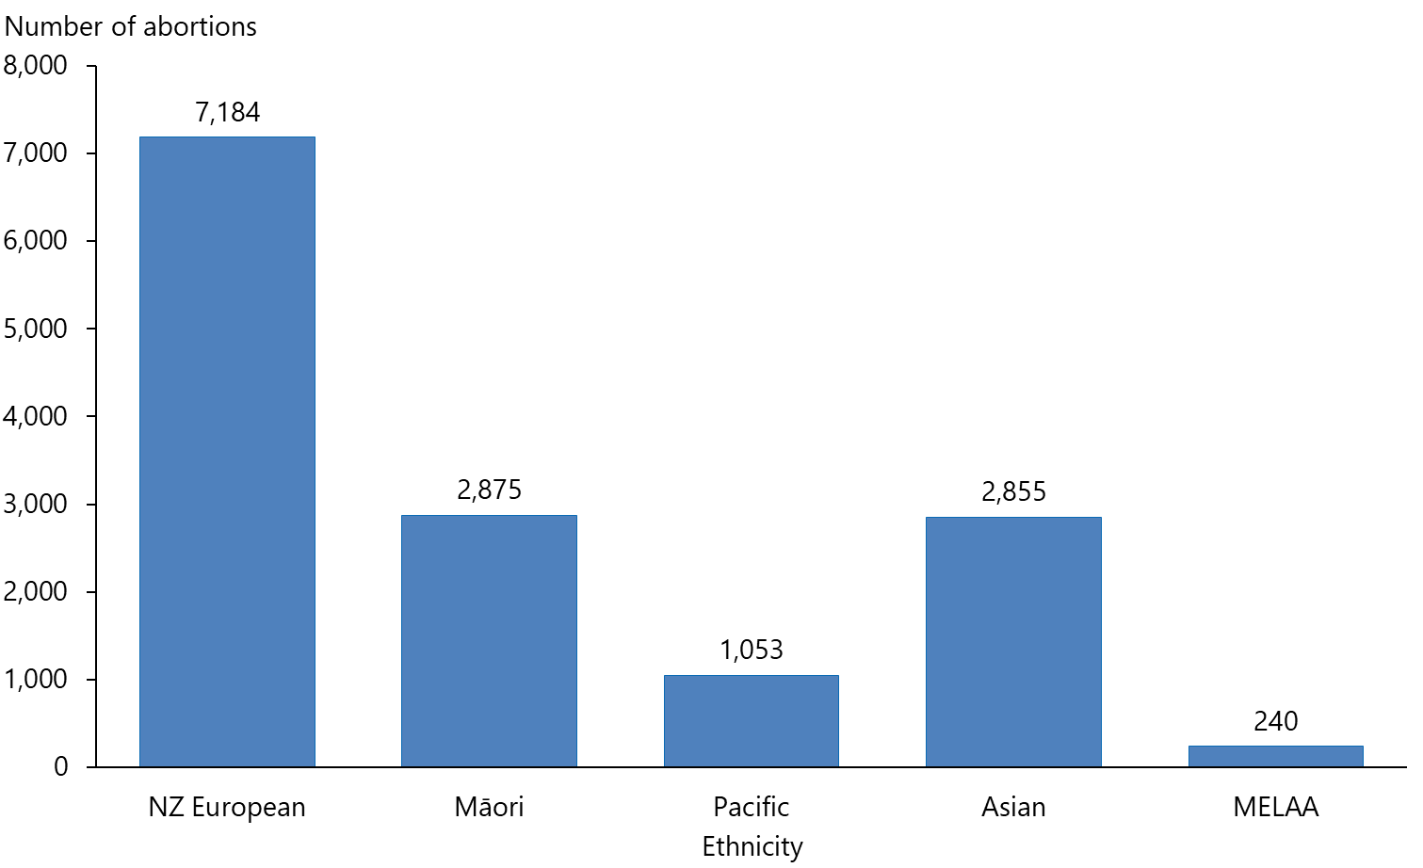
Note: Each abortion has been included in every ethnic group that a person stated that they identified with. For this reason, some abortions are counted more than once. The figure does not show the data for the ‘other’ ethnic group (number less than 5) and the 41 people whose ethnic group was not stated.
MELAA = Middle Eastern, Latin American and African.

Figure 6.2: Number of abortions by ethnic group, 2010–2020
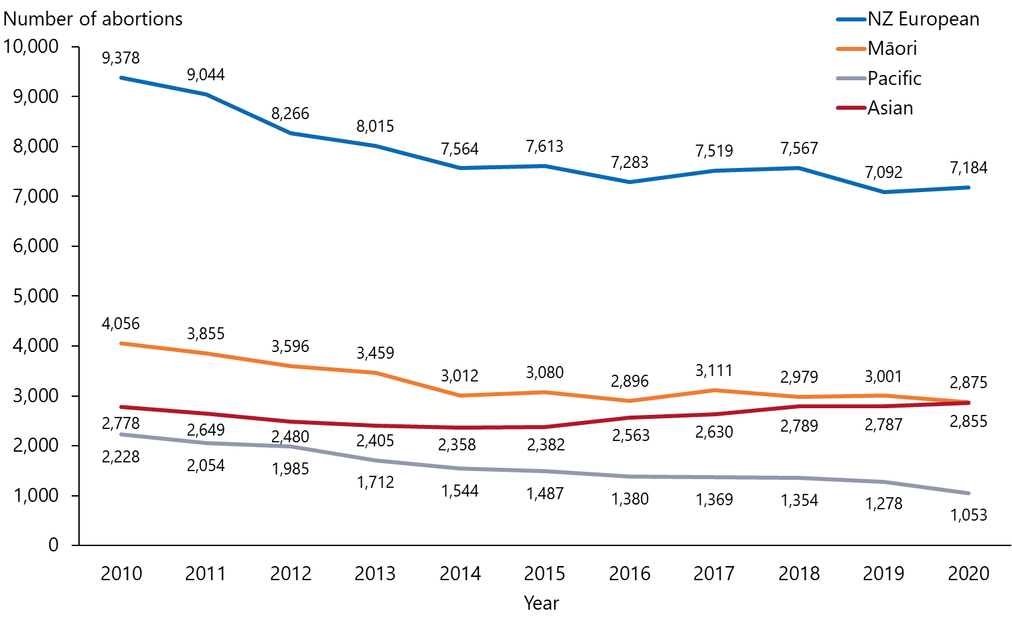

Duration of pregnancy
In 2020, 45% of abortions (5,965 abortions) were accessed before eight weeks’ gestation, compared with only 27% of patients in 2019 (Table 7.1 and Figure 7.1). Rangatahi aged under 20 years tended to access abortion slightly later than other age groups. Only 39% of those aged under 20 years accessed abortion before eight weeks; however, this is a significant improvement compared with 2019 when only 24% accessed abortion in that timeframe. While this may be an early indication that changes such as self-referral are improving access, we will continue to monitor trends over the coming years and hope to see continued earlier access to abortion.

Table 7.1: Number of abortions by age group and duration of pregnancy, 2020
Age (years) | Duration of pregnancy (weeks)
 | Total | Under 8 | 8–12 | 13–16 | 17–20 | 21 and over | Missing
All ages | 13,246 | 5,965 | 6,272 | 698 | 208 | 102 | 1
Under 20 | 1,253 | 489 | 661 | 82 | 16 | 5 | 0
20–24 | 3,204 | 1,456 | 1,561 | 133 | 45 | 9 | 0
25–29 | 3,488 | 1,624 | 1,629 | 164 | 52 | 18 | 1
30–34 | 2,795 | 1,293 | 1,242 | 170 | 48 | 42 | 0
35–39 | 1,784 | 762 | 862 | 103 | 34 | 23 | 0
40–44 | 649 | 302 | 288 | 45 | 12 | 2 | 0
45 and over | 70 | 36 | 29 | 1 | 1 | 3 | 0
Missing | 3 | 3 | 0 | 0 | 0 | 0 | 0

Figure 7.1: Percentage of abortions by duration of pregnancy, 2010–2020
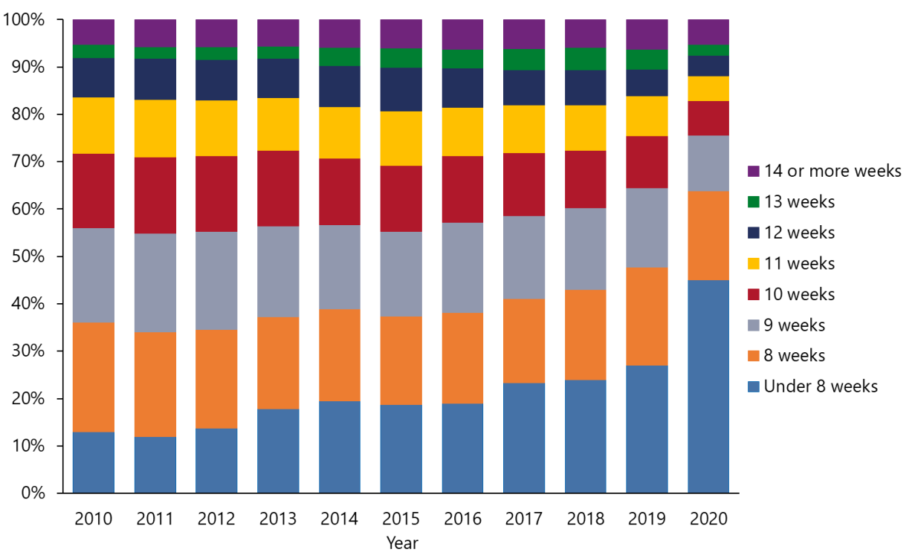

Procedure
In line with the finding that more patients accessed abortion earlier, 2020 also saw a large increase in early medical abortion. In total, 36% (4,774) of patients had an EMA up to nine weeks’ gestation in 2020 (Table 8.1), compared with only 22% in 2019.
Surgical abortion decreased in 2020, accounting for 59% (7,802) of total abortions compared with 72% in 2019.

Later medical abortion decreased slightly in 2020, accounting for 4% of total abortions, compared with 6% in 2019 (Figure 8.1).

Table 8.1: Number of abortions by procedure and duration of pregnancy, 2020
Procedure | Under 9 weeks | 9th week and over | Unknown | Total
Total | 8,455 | 4,790 | 1 | 13,246
Surgical | 3624 | 4178 | 0 | 7,802
Medical only (no surgery) | 4774 | 567 | 1 | 5,342
Failed medical only followed by surgical | 37 | 28 | 0 | 65
Failed surgical followed by medical | 4 | 1 | 0 | 5
Other | 0 | 2 | 0 | 2
Missing | 16 | 14 | 0 | 30

Figure 8.1: Number of abortions by procedure, 2016–2020
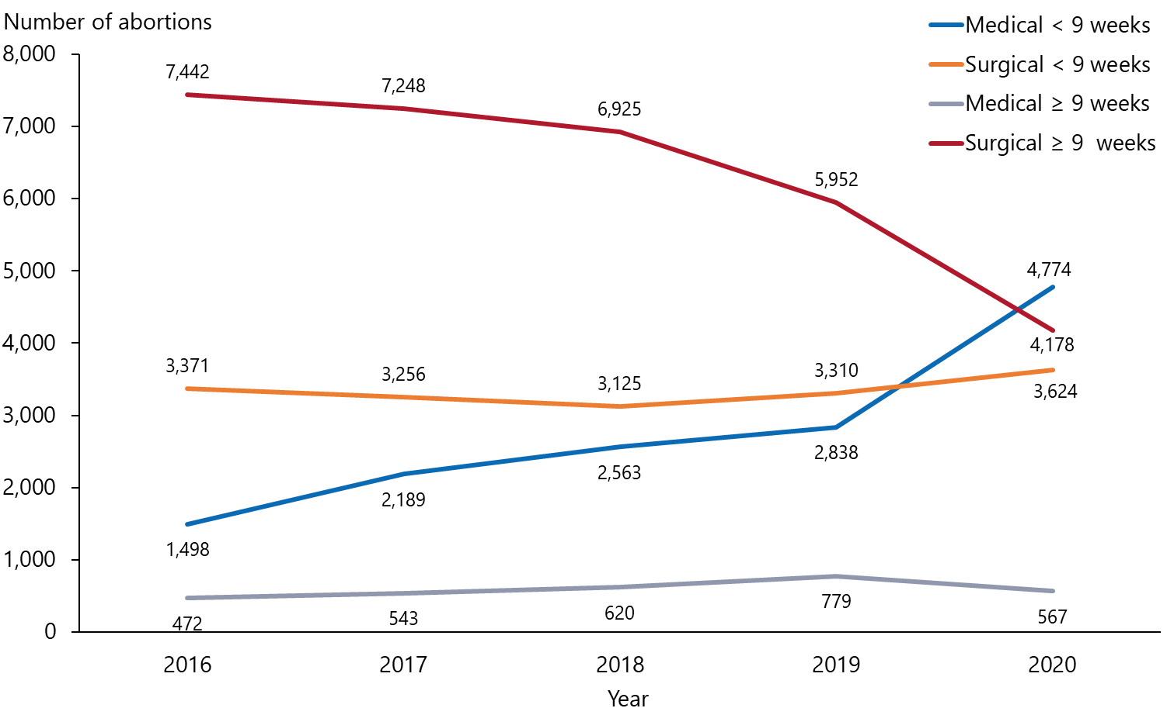

Complications
Abortion is a relatively safe procedure, as the data reflects: 99% of abortions in 2020 did not result in any complications prior to patient discharge (Table 9.1). The most frequent complications were retained placenta/products of pregnancy (0.6%) and haemorrhage (0.3%). The rate of retained placenta/products of pregnancy in 2020 was slightly above that in 2019 and 2018 (both had a rate of 0.2%), which is likely to be due to the increase in medical procedures and drop in surgical procedures in 2020.

Table 9.1: Number and percentage of abortions by complication, 2020
Reported complication* | Number | Percentage
Total | 13,246 | 100.0
None | 13,110 | 99.0
Haemorrhage (500 mL or more) | 41 | 0.3
Retained placenta/products | 75 | 0.6
Haemorrhage and retained placenta/products | 9 | >0.1
Other | 11 | >0.1
Note: * Reported complications before discharge from abortion provider.

Contraception

Contraception used at the time of conception
Reported contraception use at the time of conception in 2020 was similar to previous years for both contraception type (Table 10.1) and whether or not contraception was used by age (Table 10.2 and Figure 10.1).

Table 10.1: Number and percentage of abortions by type of contraception used at time of conception, 2020
Type of contraception used | Number | Percentage
Total | 13,350 | 100%
None | 8,648 | 64.8%
Condoms | 2,495 | 18.7%
Combined oral contraceptive | 982 | 7.4%
Progesterone-only contraceptive | 416 | 3.1%
Natural family planning | 254 | 1.9%
Emergency contraception | 223 | 1.7%
IUCD | 146 | 1.1%
Depo provera injection | 119 | 0.9%
Unknown | 28 | 0.2%
Other* | 20 | 0.1%
Subdermal implant | 19 | 0.1%
Note: 105 of the 13,246 patients were reported to be using more than one contraception type at the time of conception so these patients are counted more than once.
* ‘Other’ category includes other, patient sterilisation and partner sterilisation responses.

Table 10.2: Number of abortions by age group and contraception use at time of conception, 2020
Age group (years) | Total | No contraception used | Contraception used | Unknown
All ages | 13,246 | 8,645 | 4,598 | 3
Under 20 | 1,253 | 850 | 403 | 0
20–24 | 3,204 | 2,110 | 1,094 | 0
25–29 | 3,488 | 2,224 | 1,264 | 0
30–34 | 2,795 | 1,818 | 977 | 0
35–39 | 1,784 | 1,164 | 620 | 0
40 and over | 719 | 479 | 240 | 0
Missing | 3 | – | – | 3
Figure 10.1: Percentage of abortions where contraception was not used at the time of conception by age group, 2020
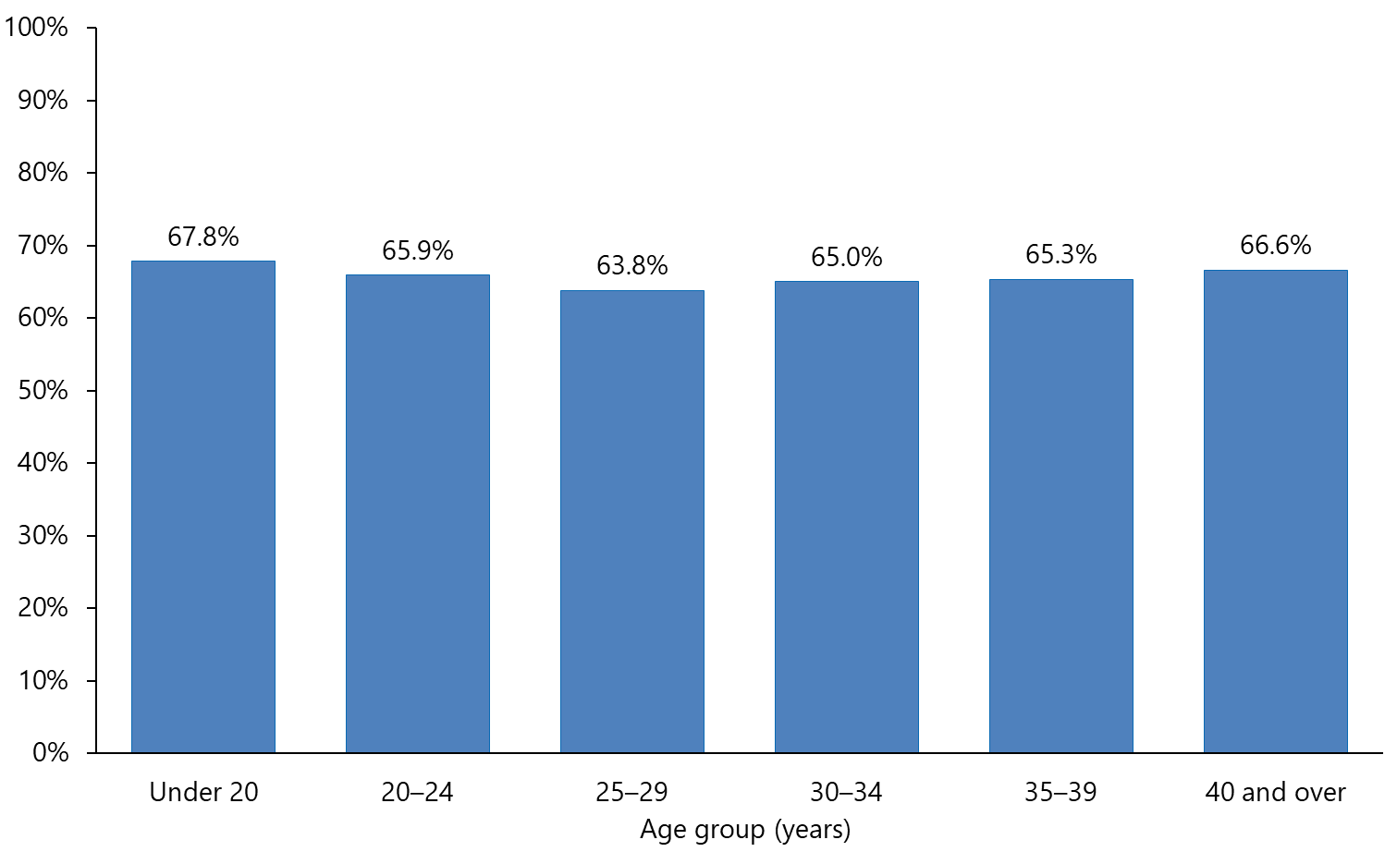

Contraception provided at the time of the abortion procedure
Marked differences were noted in contraception provided at the time of the abortion procedure in 2020 compared with 2019.

In 2020, 24.1% of patients were not provided contraception at the time of the abortion procedure (Table 10.3), compared with only 12.6% in 2019. Reductions were evident across most contraception types.

One reason for the changes seen in 2020 may be that provision of contraception fell during the COVID-19 Alert Levels 3 and 4 in that year, when more abortions were delivered virtually via telehealth. An additional reason may be related to the finding that more patients had EMA and fewer had a surgical abortion, because EMA requires more patients to attend a follow-up appointment for contraception but this is not necessary for surgical procedures so they may be more likely to receive contraception at the time of the abortion.

The abortion notification form was modified in September 2021 to include an option to record when patients are booked for a follow-up contraception appointment, so it captures this information. We will continue to monitor contraception provision at the time of abortion to ensure contraception is provided to those who are using abortion services when they require contraception to prevent future pregnancy.

Table 10.3: Contraception provided at the time of the abortion by type, 2020
Type of contraception provided | Number | Percentage
Total | 13,477 | 100%
None* | 3,243 | 24.1%
IUCD insertion | 4,174 | 31.0%
Combined oral contraceptives | 1,896 | 14.1%
Condoms | 1,688 | 12.5%
Subdermal implant insertion | 1,028 | 7.6%
Depo provera injection | 756 | 5.6%
Progesterone-only contraceptives | 536 | 4.0%
Emergency contraceptive pill | 110 | 0.8%
Other** | 40 | 0.3%
Natural family planning advice | 6 | 0.0%
Note: 230 of the 13,246 patients were provided more than one contraceptive type so these patients are counted more than once.
* ‘None’ category includes none, declined, patient already has contraception and all ‘patient referred to GP, Family Planning or contraceptive clinic’ responses.
** ‘Other’ category includes other, patient sterilisation and partner sterilisation responses.

Methodology
For every abortion carried out in New Zealand, as approved under the Contraception, Sterilisation and Abortion Act 1977, the provider must complete an electronic notification of abortion within one month of the abortion.

Providers send their forms to the Ministry of Health, which collates the data. The Ministry relies on providers submitting accurate data. Any clear errors or omissions on abortion notifications are referred to providers for correction.

Abortion data included in this annual report covers the period 1 January to 31 December 2020.

Data definitions
Abortion population: All abortions notified to the Ministry of Health by abortion providers in New Zealand.
Abortion ratio: The proportion of pregnancies terminated by abortions. The standard for abortion ratios used was the number of induced abortions per 1,000 known pregnancies (live births, stillbirths and abortions combined). Tatauranga Aotearoa Statistics New Zealand uses this same standard.
General abortion rate: Total abortions per 1,000 women aged 15–44 years based on Tatauranga Aotearoa Statistics New Zealand’s population estimates, mean year ended 31 December 2020, Census 2018 base.

References
ASC. 2020. Report of the Abortion Supervisory Committee 2020. Wellington: Abortion Supervisory Committee. URL: https://www.justice.govt.nz/assets/Documents/Publications/ASC-Annual-Report-2020.pdf (accessed 5 September 2021).
Ministry of Health. 2021. New Zealand Aotearoa Abortion Clinical Guideline. Wellington: Ministry of Health.
Statistics New Zealand. 2020. Abortion statistics. Retrieved from https://www.stats.govt.nz/topics/abortions (accessed 5 September 2021).

Related legislation
Contraception, Sterilisation and Abortion Act 1977. Retrieved from https://www.legislation.govt.nz/act/public/1977/0112/latest/DLM17680.html (accessed 5 September 2021).
Contraception, Sterilisation and Abortion (Safe Areas) Amendment Bill 310-1 (2020). Retrieved from Contraception, Sterilisation, and Abortion (Safe Areas) Amendment Bill 310-1 (2020), Members Bill – New Zealand Legislation (accessed 5 September 2021).
Crimes Act 1961. Retrieved from https://www.legislation.govt.nz/act/public/1961/0043/latest/DLM327382.html (accessed 5 September 2021).

