Ratonga Whakatahe i Aotearoa

Abortion Services Aotearoa New Zealand
Pūrongo ā-Tau | Annual Report
2023

Citation: Ministry of Health. 2023. Abortion Services Aotearoa New Zealand: Annual Report. Wellington: Ministry of Health.
Published in October 2023 by the Ministry of Health
PO Box 5013, Wellington 6140, New Zealand
ISBN 978-1-991075-61-1 (online)
HP 9051
This document is available at health.govt.nz
This work is licensed under the Creative Commons Attribution 4.0 International licence. In essence, you are free to: share ie, copy and redistribute the material in any medium or format; adapt ie, remix, transform and build upon the material. You must give appropriate credit, provide a link to the licence and indicate if changes were made.

Kupu takamua | Foreword
I am pleased to present the third Abortion Services Aotearoa New Zealand: Annual Report.

This report highlights some real improvements to accessibility and equity, in line with both the 2020 law reform and the 2022 health reforms.

One key indicator is the growth of the abortion workforce, which has doubled when compared to the previous year and which includes greater representation of Māori and Pacific health practitioners. This has been supported by more facilities providing abortion services, increased accessibility through the endorsement of midwifery abortion services, and telehealth services for early medical abortion (EMA).

These changes have contributed to better outcomes for people seeking abortion services, as shown by the increase in the proportion of EMA procedures performed, and a decrease in average gestation at the time of abortion. Additionally, average drive times to access in-person abortion services have also decreased.

These are all key indicators of more accessible and equitable service provision. Recommendations from the Royal College of Obstetricians and Gynaecologists (2022) have emphasised the importance of local and early abortion service provision, as earlier terminations of pregnancies are associated with fewer complications. The earlier in pregnancy an abortion is performed, the safer it is.

The report shows positive signs that abortion service access has improved across most ethnic groups, including Māori and Pacific peoples. However, barriers continue to exist and disproportionately impact Māori and Pacific peoples. Eliminating health disparities will be an ongoing focus for Manatū Hauora | the Ministry of Health.

In March 2022, an amendment to the Contraception, Sterilisation, and Abortion Act 1977 was made to enable the creation of Safe Areas around abortion service providers. Safe Areas aim to protect the safety, wellbeing, privacy and dignity of people accessing or providing abortion services. I am really pleased with how this work has progressed and that we are at the stage of establishing and enforcing Safe Areas at abortion service providers around the country; 11 Safe Areas had been established by October 2023.

We aim to increase geographic coverage, with abortion care provided in most districts. In 2022, I am particularly pleased to see that there is now service provision on the West Coast of the South Island. I am aware that people living in this district have often had to travel to Christchurch for abortion care.

I am heartened by the continued progress in equitable service provision for a health service.

Ngā mihi maioha

Dr Diana Sarfati
Te Tumu Whakarae mō te Hauora
Director-General of Health

Kupu takamua | Foreword
Nōku te whiwhi ki te whakaatu i tēnei pūrongo tuatoru o Abortion Services Aotearoa New Zealand: Pūrongo ā-Tau.

Ka whakamiramiratia e tēnei pūrongo ētahi whakapainga tūturu ki te āheinga me te tautika, e hāngai ana ki te whakahounga ture 2020 me ngā whakahounga hauora 2022.

Ko tētahi tohu matua ko te tipuranga o te kāhui kaimahi whakatahe, otirā i rearua mai i te tau o mua, ā, kua nui ake te kitea o ngā kaimahi kanohi Māori, Pasifika hoki. Kua tautokona tēnei e ētahi atu whare e whakarato ana i ngā ratonga whakatahe, te pikinga o te āheinga mā roto i te whakamanatanga o ngā ratonga whakawhānau whakatahe, me ngā ratonga hauora ā-waea mō te whakatahe wawe (EMA).

I āwhina ēnei panoni i ngā whakapainga pai ake mā te hunga e rapu ana i ngā ratonga whakatahe, otirā i kitea i roto i te pikinga o ngā āhuatanga EMA i whakahaeretia, ā, me te hekenga o te toharite wā kukune i te wā o te whakatahe. Tuia ki tēnei, kua heke hoki te wā toharite o te hautū waka e āhei atu ai ki ngā ratonga whakatahe ā-tinana.

He tohu matua hoki ēnei o te whakaratonga āhei ake, tautika ake hoki. I miramira ngā tūtohu a te Royal College of Obstetricians and Gynaecologists (2022) i te whaitake o te whakaratonga o ngā ratonga whakatahe paetata, wawe hoki, i te mea ka iti ake ngā āhuatanga tuatini i te whakakorenga wawe o ngā hapūtanga. Ko te wawe atu o te whakahaere whakatahe, te haumaru atu.

E whakaatu ana te pūrongo i ngā tohu pai o te pikinga o te āheinga ki ngā ratonga whakatahe puta noa i ngā mātāwaka katoa, tae atu ki te Māori me ngā iwi o Te Moana-nui-a-Kiwa. Engari, arā tonu ngā tauārai e pā pāhikahika ana ki te Māori me ngā iwi o Te Moana-nui-a-Kiwa. Ka noho tonu te whakakore i ngā manarite-kore o te hauora hei aronga matua mā Te Manatū Hauora.

I te marama o Māehe 2022, i whakahoutia tētahi wāhanga o te Contraception, Sterilisation, and Abortion Act 1977 kia pai ai te hanga i ngā Wāhi Haumaru huri noa i ngā kaiwhakarato ratonga whakatahe. Ko te tikanga o ngā Wāhi Haumaru, he tiaki i te haumaru, te oranga, te tūmataiti me te mana o te tangata e whakauru ana ki ngā ratonga whakatahe. E tino harikoa ana ahau ki ngā kokenga mahi nei, ā, kua tae mātou ki te wāhanga o te whakatū me te whakamana i ngā Wāhi Haumaru i ngā kaiwhakarato ratonga whakatahe puta noa i te motu, otirā 11 ngā Wāhi Haumaru i whakatūria i te taenga ki te Ōketopa 2023.

E whai ana mātou ki te whakapiki i te horapatanga ā-whenua, otirā e whakaratoa ana ngā ratonga whakatahe i te nuinga o ngā rohe. I te tau 2022, e koa ana ahau ki te kite i te whakatūtanga o te ratonga nei ki Te Tai Poutini o Te Waipounamu. E mōhio ana ahau he rite tonu te haere o nga tāngata e noho ana i tēnei takiwā ki Ōtautahi mō ngā ratonga whakatahe.

E manawanui ana ahau i te kokenga whakamua tonu o te whakaratonga tautika o tētahi ratonga hauora.

Ngā mihi maioha

Dr Diana Sarfati
Te Tumu Whakarae mō te Hauora
Director-General of Health

Ngā ihirangi | Contents
Kupu takamua | Foreword iii
Kupu takamua | Foreword v
Kupu arataki | Introduction 1
Ngā meka matua | Key facts 1
Ngā ratonga whakatahe tomopai, whakatuarite, aro ki te tangata, kounga hoki | Accessible, equitable, person-centred, and high-quality abortion services 3
Whakahoutanga pūnaha hauora | Health system reforms 4
Te whakaū i Te Tiriti o Waitangi | Embedding Te Tiriti o Waitangi 5
Te hoahoa mō te mana ōrite | Designing for equity 5
Te whakatinanatanga o DECIDE | Implementation of DECIDE 6
Ngā paerewa me te waeture | Standards and regulation 6
Rongoā whakatahe | Abortion medication 9
Whakangungu whakatahe ā-motu wāhanga tuatahi | First-trimester national abortion training 9
Tatauranga whakatahe | Abortion statistics 2022 10
Wāhanga 1. Ngā tatauranga whakatahe ahuwhānui | Section 1: General abortion statistics 10
Wāhanga 2. Te aronga ki te Māori | Section 2: Responsiveness to Māori 17
Wāhanga 3. Ngā tukanga whakatahe | Section 3: Types of abortion procedures 20
Wāhanga 4. Te whakatahe i roto i te ara whakaputa uri | Section 4: Abortion within the reproductive journey 24
Wāhanga 5. Te āheinga ki te whakatahe me ngā ārai hapūtanga | Section 5: Abortion and access to contraception 26
Wāhanga 6. Te āheinga ā-matawhenua ki te whakatahe | Section 6: Geographical access to abortion 34
Wāhanga 7. Ngā uauatanga i pūrongotia i te wā o te whakatahe | Section 7: Complications at time of abortion 39
Wāhanga 8. Ngā kaimahi whakatahe | Section 8: Abortion workforce 42
Wāhanga 9. Tohuora whakatahe | Section 9: Abortion counselling 44
Wāhanga 10. Ngā pātai whakatahe me te whakatahe kāore i oti noa | Section 10: Abortion enquiries and non-completed abortion 45
Ngā kōrero mō te whakarōpūtanga mātāwaka i whakamahia i tēnei pūrongo | Notes on ethnicity classifications used in this report 47
Ngā kōrero raraunga ahuwhānui | General data notes 48
Ngā kupu matua | Key terms 49

List of Figures
Figure 1-1: Number of abortions procedures by year, 2012–2022 11
Figure 1-2: Number of abortion procedures per 1,000 females aged 15–44 years (general abortion rate), 2012–2022 12
Figure 1-3: Number of abortion procedures per 1,000 known pregnancies (abortion ratio), 2012–2022 12
Figure 1-4: Number of abortion procedures by age group, 2012–2022 13
Figure 1-5: Total number of abortion procedures by prioritised ethnicity, 2022 13
Figure 1-6: Number of abortion procedures by ethnicity, 2020–2022 14
Figure 1-7: Percentage of abortion procedures by age and ethnicity, 2022 14
Figure 1-8: Average gestation at time of abortion procedure by ethnicity, 2020–2022 15
Figure 1-9: Number of abortion procedures by level of socioeconomic deprivation, 2022 16
Figure 1-10: Average gestation at time of abortion by level of socioeconomic deprivation, 2022 16
Figure 2-1: Abortion rate by district of domicile, Māori versus non-Māori, non-Pacific, 2022 18
Figure 2-2: Number of abortion procedures by age group, Māori versus non-Māori, non-Pacific, 2022 19
Figure 2-3: Number and percentage of abortion procedures by type of procedure, Māori versus non-Māori, non-Pacific, 2022 19
Figure 3-1: Number of abortion procedures by procedure type, 2017–2022 21
Figure 3-2: Number of abortion procedures by procedure type and district of domicile, 2022 22
Figure 3-3: Number of abortion procedures by district of service, 2020–2022 22
Figure 4-1: Abortion procedures and number of previous live births by ethnicity, 2022 25
Figure 4-2: Abortion procedures and number of previous abortions by ethnicity, 2022 25
Figure 5-1: Percentage of people provided with contraception at time of abortion, all contraception types, 2022 28
Figure 5-2: Percentage of people receiving long-acting reversible contraception by procedure type, 2022 30
Figure 5-3: Percentage of people receiving long-acting reversible contraception by district of domicile, 2022 31
Figure 5-4: Number and percentage of people recieving long-acting reversible contraception by ethnicity, 2022 33
Figure 6-1: Geospatial analysis – patient drive time to services by facility, 2022 36
Figure 6-2: Percentage of patients travelling to other districts for abortion procedures, 2022 38
Figure 6-3: Average gestation by district of domicile, 2022 38

List of Tables
Table 1-1: Number of abortion procedures by patient residency status, 2022 15
Table 3-1: Number of abortion procedures by district of service, 2020–2022 23
Table 5-1: Type of contraception used at time of conception, 2022 28
Table 5-2: Contraception provided at time of abortion by type, number, and percentage of total abortion, 2022 29
Table 5-3: No contraception provided by category, number, and percentage of total abortion, 2022 29
Table 5-4: Bookings/referrals and information provision by category, number, and percentage of total abortion, 2022 30
Table 5-5: Number of people receiving long-acting reversible contraception by procedure type, 2022 31
Table 5-6: Number and percentage of people receiving long-acting reversible contraception after an abortion procedure by district of domicile, 2022 32
Table 7-1: Number and percentage of complications at the time of abortion by type of complication, 2022 40
Table 7-2: Number of complications at the time of abortion by procedure type, 2022 40
Table 7-3: Number and percentage of complications at the time of abortion by age group, 2022 41
Table 8-1: National abortion workforce (medical, nursing and midwifery) by region and registered profession, 2022 43
Table 8-2: National abortion workforce (medical, nursing and midwifery) by region and ethnicity, 2022 43
Table 8-3: National abortion workforce (medical, nursing and midwifery) by region and gender, 2022 43

Kupu arataki | Introduction
This report provides information on the role of Manatū Hauora | the Ministry of Health under the Pae Ora (Healthy Futures) Act 2022 in the context of abortion services, and what effect the recent health and disability system changes will have in this area.

Following the Government’s recent announcement of a major transformation of Aotearoa New Zealand’s health and disability system, on 1 July 2022, 3 new entities were established under the Pae Ora (Healthy Futures) Act. This included Te Whatu Ora | Health New Zealand as the national organisation to lead and coordinate delivery of health services across the country and Te Aka Whai Ora | Māori Health Authority, which works in partnership with Te Whatu Ora and Manatū Hauora to ensure that the health system recognises and responds to Māori health needs. The transformation strengthened the role of Manatū Hauora as chief steward of the health and disability system.

This report also gives updates on the work programme in the area of abortion services between October 2022 and September 2023, and data on abortion services provided in the 2022 calendar year.

This is the third annual report on abortion services Manatū Hauora has published. The Contraception, Sterilisation, and Abortion Act 1977 requires the Director-General of Health to collect, collate, analyse, and publish information about the provision of abortion services, as well as on the provision of counselling in relation to these services. This report includes information presented in the same format as it was presented in last year’s report, which includes detailed reporting on timely and equitable service access by ethnicity, socioeconomic area (decile), district, and age.

Ngā meka matua | Key facts
- In total, providers reported 14,164 abortion procedures in 2022. This number presents a 6.8% increase in abortions when compared to 2021 (total abortions: 13,257). These changes may reflect the increased accessibility of in-person first-trimester abortions, as well as the availability of a national telehealth early medical abortion (EMA) service. This is performed at up to and including 10 weeks or 70 days of gestation; it was introduced in the final two months of 2022.
- The general abortion rate and number of abortions per 1,000 pregnancies increased slightly but remained consistent with the minor fluctuations in abortion trends observed over the preceding decade.
- Consistent with the overall population trend, the number of abortion procedures for European/other, Māori, and Pacific peoples increased slightly in 2022 compared with 2021.
- As observed in 2021, Māori accessed abortions at a higher rate, measured as the number of abortions per 1,000 females aged 15–44, than non-Māori, non-Pacific people in most districts of Aotearoa New Zealand. Where higher rates were observed, the extent of the difference in varied, ranging from a 4% increase to more than double (for Māori compared to non-Māori, non-Pacific people).
- Gestation is an important indicator of access to services – earlier gestation at the time of abortion indicates fewer barriers to accessing service. Continuing the pattern observed in recent years, average gestation at the time of abortion decreased across most ethnic groups in 2022.
- In 2022, the average gestation for non-Māori, non-Pacific peoples was the lowest, at 7 weeks and 5 days, compared with 8 weeks and 3 days for Māori and 9 weeks for Pacific peoples. This reflects an average decrease in gestation of 1 day compared to 2021. The one exception to this trend was observed within the Asian group, where average gestation remained stable at just under 8 weeks.
- The trend of an increasing rate of EMA and decreasing rate of surgical abortion continued. Compared to 2021, the rate of EMA in 2022 increased by 7% to 50.6% of total abortion procedures, and surgical abortion decreased by 6% to 47.8% of total abortion procedures. 2022 represents the first year in which a greater number of EMA, rather than surgical abortions, was performed.
- The average decrease in surgical abortions and increase in EMA was observed in both Māori and non-Māori, non-Pacific groups. However, as in 2021, Māori accessed surgical abortions at a higher rate compared to non-Māori, non-Pacific peoples.
- Assessments of regional patterns demonstrated that rates of EMA increased for individuals living across most districts in 2022 compared to 2021. Specifically, the proportion of EMA rather than surgical abortions increased for individuals living in all but 3 districts.
- EMA was accessed at a greater rate than surgical abortion for individuals living across 11 districts in 2022, compared to only 8 districts in 2021.
- Similar to 2021, those living within the most socioeconomically deprived decile (decile 10) accessed abortion services a week later, on average, than those living in the least deprived decile (decile 1). We measure socioeconomic deprivation using the New Zealand Index of Deprivation 2013 (NZDep2013), which is based on nine census variables. Each decile represents approximately 10% of area in Aotearoa New Zealand.
- On average, drive times related to in-person abortion services decreased in 2022 compared to 2021. Specifically, there was an 8% decrease in both Māori and non-Māori, non-Pacific individuals living further than a 30-minute drive from an abortion service compared to 2021.
- Individuals living in the 3 most socioeconomically deprived deciles live, on average, a further drive time from an abortion service than those living in the 3 least socioeconomically deprived deciles. Analysis by ethnicity demonstrated that the impact of socioeconomic decile on drive time was disproportionately greater for Māori compared to non-Māori, non-Pacific peoples.
- As in 2021, individuals who had to travel for abortion services because they lived in a district with no local first-trimester abortion service tended to have a later gestation at the time of the abortion procedure.
- Individuals who had an EMA (rather than surgical abortion) were less likely to be provided with long-acting reversible contraception (LARC) at the time of their abortion. However, this group saw an increased rate in LARC provision compared to 2021. In 2022, 17.7% of those having an EMA were provided with LARC at the time of their procedure, compared with 12.6% of those in 2021. LARC provision also increased among those seeking a surgical abortion; 57.7% of those receiving a surgical abortion accessed LARC at the time of their abortion in 2022, compared to 53.6% in 2021.
- In 2022, 1.6% of total abortion procedures reported were associated with a complication at the time of the abortion. This is similar to the rate of complications observed in 2021 (1.3%).
- The national workforce involved in providing abortion services doubled in 2022 (total: 348) compared to 2021 (total: 162). This increase was observed across all 4 Te Whatu Ora regions. This is reflected in the increase in abortion facilities, the endorsement of EMA training for midwives, and the inclusion of new access to EMA through the national abortion telehealth service – DECIDE.
- The number of Māori and Pacific health practitioners increased in 2022. In 2022, 7.2% of abortion health practitioners were Māori, compared to only 4.3% of the abortion workforce in 2021. While this figure remains far lower than the percentage of Māori service users (25.6%), the increase reflects a positive shift in the overall availability of Māori health practitioners.

Ngā ratonga whakatahe tomopai, whakatuarite, aro ki te tangata, kounga hoki | Accessible, equitable, person-centred, and high-quality abortion services
The Manatū Hauora vision for abortion services in Aotearoa New Zealand is that abortion services are accessible, equitable, person-centred, and of high quality. This means that there is a focus on efficient care pathways, equitable access to services, culturally appropriate and safe services, choice of service, and access to post-abortion contraception.

Over the past year, Manatū Hauora has worked towards this vision by:
- improving data collection and reporting – this work continues from last year and there will be reporting on improvements in future reports
- implementing and establishing Safe Areas in Regulations – to protect the safety, wellbeing, privacy, and dignity of people who are accessing, or providing, abortion services
- embedding quality improvement processes – by applying a greater regulatory focus on abortion services and ensuring that services continue to work towards the Manatū Hauora vision
- commissioning consumer health research – Manatū Hauora has been working towards the vision of equitable and culturally responsive access by commissioning and collaborating in the development of research relating to the experiences of diverse groups accessing abortion services.

Whakahoutanga pūnaha hauora | Health system reforms
On 1 July 2022, our health system was transformed with the aim of achieving pae ora (healthy futures) for all New Zealanders.

The 3 health agencies Manatū Hauora, Te Whatu Ora | Health New Zealand and Te Aka Whai Ora | Māori Health Authority are working together to protect, promote and improve the health of all New Zealanders. Together they are also working to achieve equity in health outcomes across Aotearoa New Zealand, including through elimination of health disparities for Māori. This includes abortion health services.

In March 2023, the abortion services programme was shared across Manatū Hauora and Te Whatu Ora. Manatū Hauora continues to focus on strategy, policy, data, and regulation. Commissioning, workforce, and service planning now sit with Te Whatu Ora and Te Aka Whai Ora. The abortion services work will intersect with Whaikaha | Ministry of Disabled People, and the agencies will work to ensure that links are established and maintained.

The transformed health system has embedding Te Tiriti o Waitangi across the health sector at its heart. A health system that honours Te Tiriti will uphold the rights of Māori, including tāngata whaikaha Māori (Māori with disabilities), and give effect to the principles of the Pae Ora (Healthy Futures) Act. The abortion work programme, and this report, is intentional in focusing on Māori access and equitable service provision.

The health system as a whole has a refreshed focus on achieving equitable health and wellbeing outcomes for Māori, as well as for other priority groups such as Pacific peoples, the rainbow community, disabled people, and those living in greater socioeconomic deprivation or rural areas who have been under-served by health systems in the past. Notably, Māori may be included within more than one of these other priority groups. It is also important to recognise how intersectionality – where a person belongs to more than one of these groups – can expose someone to overlapping forms of discrimination and disadvantage.

With a focus on these equitable health and wellbeing outcomes, Manatū Hauora commissioned research to develop a greater understanding of the unique experiences in accessing abortion services for individuals identifying within the diverse groups referenced above. This work commenced at the end of 2022 and is ongoing. We will apply insights derived from this research to inform future recommendations on the design and delivery of accessible and appropriate abortion services in Aotearoa New Zealand, with the goal of achieving equitable outcomes.

Te whakaū i Te Tiriti o Waitangi | Embedding Te Tiriti o Waitangi
Manatū Hauora requires the health and disability system, including abortion services and providers, to embed Te Tiriti o Waitangi into their processes and service delivery. Manatū Hauora expects to see the agencies and providers responsible for abortion services taking meaningful actions aimed at eliminating health disparities for Māori in Aotearoa New Zealand.

Over the past year, Manatū Hauora has worked in partnership with Te Apārangi | Māori Partnership Alliance, included Te Tiriti guidance in key documents, and examined its Māori data approaches. Activities and achievements include.
- Te Apārangi was established to work in partnership with teams at Manatū Hauora to provide expert Māori advice, framed by Te Tiriti o Waitangi. In 2022, Te Apārangi included abortion services within its scope to further support the programme to achieve the goals of accessible, equitable, person-centred, and high-quality abortion services across Aotearoa New Zealand. For more information about Te Apārangi, see the Manatū Hauora website (health.govt.nz).
- Manatū Hauora has set an expectation that agencies and providers will engage with iwi. For example, applications for Safe Areas include a recommendation to inform local iwi of the application.
- As it did last year, this Annual Report contains a range of indicators reported by ethnicity, as well as a specific section comparing the experiences of Māori with those of non-Māori, non-Pacific people.

As part of its commitment to identifying and addressing issues faced by Māori in accessing abortion services, including tāngata whaikaha Māori, Manatū Hauora has collaborated with health consumer research groups to gain direct feedback from a Māori-centred perspective. This research commenced in 2022 and is ongoing. We will provide insights deriving from this research in the upcoming periodic review, and will apply them to inform future recommendations developed by Manatū Hauora. Insights will likewise reflect on the cultural responsivity of abortion services in Aotearoa New Zealand, as well as on how effectively the system and services are embedding Te Tiriti.

Te hoahoa mō te mana ōrite | Designing for equity
The Manatū Hauora vision for abortion services focuses on services meeting the needs of rangatahi (youth), Māori, Pacific peoples, disabled people, rainbow and transgender communities, ethnic minorities, and those living in rural areas and areas of the highest deprivation (as groups experiencing the greatest inequity of access). Manatū Hauora regulates and monitors equitable access to abortion services through abortion service reporting.

From October 2022 to September 2023, Manatū Hauora focused on the following activities:
- roll-out of the telemedicine component of the DECIDE service from 1 November 2022, to improve timely and equitable access to abortion; as of March 2023, the contract for DECIDE services has been managed by Te Whatu Ora
- continued implementation of the Contraception Sterilisation, and Abortion (Information Collection) Regulations 2021, and review of the data and what it tells us about accessibility of services.
- implementation and establishment of Safe Areas for abortion providers and consumers; 6 providers had Safe Areas established during this period, and a further 5 will be enforceable by October 2023. Work on further applications is under way.

Te whakatinanatanga o DECIDE | Implementation of DECIDE
The final phase of the national abortion telehealth service – DECIDE was launched on 1 November 2022. This service provides EMA by telemedicine. This report incorporates data for the 2 months (November and December) in which DECIDE provided services in 2022.

The EMA service from DECIDE includes consultation, abortion counselling (if requested), and provision of abortion medications and aftercare (including contraception post-abortion) for those who meet all clinical requirements. This service complements in-person abortion services available across Aotearoa New Zealand.

Te Whatu Ora is now responsible for the DECIDE contract. However, Manatū Hauora will continue to report on service use for this, and all, service providers. Future reports will include more detailed analyses of the impact of DECIDE services, following a full year of service provision.

Ngā paerewa me te waeture | Standards and regulation
Manatū Hauora has retained oversight over regulation of abortion services, and will increase its focus on ensuring services are accessible, equitable, and safe. Aotearoa New Zealand’s health system is founded on collaboration. The role of Manatū Hauora includes monitoring the performance and outcomes our health system achieves. We will continue to work with Te Whatu Ora to identify key areas of potential improvement and act accordingly.

Manatū Hauora is also working to identify areas where we can improve regulation or monitoring across abortion services. The following subsections set out our main areas of focus.

Paerewa mō te Tumu Kōrero Whakatahe I Aotearoa | Standard for Abortion Counselling Aotearoa New Zealand
The Standard for Abortion Counselling Aotearoa New Zealand was developed and published in 2022, and abortion-related counselling must now be in line with the new standard. There will be further focus on this in next year’s annual report.

Ngā waeture kohi raraunga whakatahe | Abortion data collection regulations
The Contraception Sterilisation, and Abortion (Information Collection) Regulations 2021 (the Regulations) are part of the CSA Act. They set out the new abortion notification and annual reporting requirements for abortion providers, to better monitor timely and equitable access to services. The process of implementing these regulations and reviewing of the data collection has highlighted potential ways in which we can improve our data collection.

Manatū Hauora and Te Whatu Ora will continue to work together to identify potential improvements based on engagement with service providers, service users and wider health sector stakeholders, including Māori data experts. Recommendations from this work will be included in the first periodic review and report due to Parliament by March 2025. This report is outlined in section 17 of the Contraception, Sterilisation, and Abortion Act 1977, which sets an obligation for the Director-General to review and report on and provide recommendations relating to the timeliness and equity of abortion service provision at 5-year intervals.

Ngā Wāhi Haumaru | Safe Areas
Manatū Hauora has completed 2 rounds of Safe Area applications (on 25 August and 5 October 2023) and opened the third round in August 2023. There are now 11 service providers with Safe Areas, accounting for about one-third of all current abortion service providers. Details of these Safe Areas are found on the Manatū Hauora website.

The aim of Safe Areas is to protect the safety, wellbeing, privacy, and dignity of people accessing or providing abortion services. Providers can apply to have a Safe Area, and decisions about their applications are made on a case-by-case basis. Safe Areas are regulated under the Contraception, Sterilisation, and Abortion Act 1977.

Certain behaviours that may be considered distressing to a person accessing or providing abortion services or attempting to stop a person from accessing or providing these services are prohibited within a Safe Area.
A Safe Area can encompass up to 150 metres around any premises where abortion services are provided; for example, a hospital or general practice. A Safe Area can include both the building in which the abortion services are provided and the land surrounding the building.

Under the Manatū Hauora process to create a safe area, providers apply for a Safe Area to be established, Manatū Hauora assesses the application in consultation with the New Zealand Police and the Ministry of Justice, and then Manatū Hauora passes on a recommendation to the Minister of Health. The ultimate decision on whether the Safe Area should be approved sits with Cabinet.

Ngā kaiwhakarite ā-pūnaha | System enablers
Responsible authorities are part of the system that ensures services are of good quality and that practitioners can access further training and support. They play a key role in enabling more practitioners to choose to provide abortion, which gives people greater choice of, and access to, abortion services.

Since last year, Te Tatau o te Whare Kahu | Midwifery Council has confirmed that abortion care sits within the main scope of midwifery and has endorsed EMA training for midwives.

The other system enablers are Te Kaunihera Tapuhi o Aotearoa | Nursing Council of New Zealand, Te Pou Whakamana Kaimatū o Aotearoa | Pharmacy Council and Te Kaunihera Rata o Aotearoa | Medical Council of New Zealand. Below we list some key activities of each of these to date.

Te Kaunihera Tapuhi o Aotearoa | Nursing Council of New Zealand:
- has confirmed that abortion is in scope for nurses
- has confirmed that nurse prescribers and nurse practitioners are permitted to prescribe for early medical abortion
- has endorsed the New Zealand Aotearoa Abortion Clinical Guideline 2021, which provides best practice clinical guidance for health professionals on abortion care in the Aotearoa New Zealand context

Te Pou Whakamana Kaimatū o Aotearoa | Pharmacy Council:
- has confirmed that abortion is in scope for pharmacists

Te Kaunihera Rata o Aotearoa | Medical Council of New Zealand:
- has confirmed that abortion is already within several scopes under the Medical Council

Manatū Hauora is interested in how these organisations meet their Te Tiriti obligations and their accountabilities in the context of equity. It will consider these areas in future reports as part of its regulatory role.

Rongoā whakatahe | Abortion medication
Since November 2022, abortion medications are available via a prescription that can be collected at a local pharmacy. Manatū Hauora has partnered with Healthpoint to maintain a list of pharmacies willing to dispense abortion medication. Health practitioners prescribing these medications can access this list through a secure site and thereby ensure that a person goes to the correct pharmacy the first time.

Whakangungu whakatahe ā-motu wāhanga tuatahi | First-trimester national abortion training
The first-trimester national abortion training package was launched in November 2022. The training was developed by the New Zealand College of Sexual and Reproductive Health and is accessible via the BPAC (Best Practice Advocacy Centre New Zealand) website: https://bpac.org.nz/

The training is aimed at a wide range of health professionals for whom abortion is in the scope of their role (including medical, nursing, midwifery, and pharmacist prescribers) planning to provide first-trimester abortion services in a range of settings, including primary care and community-based services.

The training is also suitable for those currently providing abortion services who may be looking to refresh their knowledge, build their cultural competency or further develop their skill set in areas such as of point-of-care ultrasound or early surgical abortion care.

Te Whatu Ora is now responsible for the ongoing support for this training.

Tatauranga whakatahe | Abortion statistics 2022

Ngā tatauranga whakatahe ahuwhānui | Section 1: General abortion statistics
The number of abortions performed in 2022 (14,164) was 6.8% higher than the number performed in 2021 (13,257) (Figure 1-1). Similarly, the abortion rate (14 abortions per 1,000 females aged 15–44 years) (Figure 1-2) and ratio of abortion (193 per 1,000 known pregnancies) (Figure 1-3) were slightly higher in 2022 compared to 2021. This increase in abortion rate was observed across almost all ages, excluding people under the age of 15 and aged 40 and above (Figure 1-4). Overall, abortion rates and ratios have remained reasonably stable over the past decade.

A summary by ethnicity shows that Māori accessed approximately a quarter (26%), Pacific peoples 9%, Asian people 17%, and European/other group close to half (48%) of all abortion procedures (Figure 1-5) in 2022. Abortion rates increased slightly among European/other, Māori, and Pacific peoples in 2022 compared with 2021 (Figure 1-6).

Māori and Pacific peoples generally accessed abortion at younger ages. Among those accessing abortions, around 70% of Māori and Pacific peoples were under 30 years of age, compared with just over 60% of the European/other group and 40% of the Asian group (Figure 1-7).

Gestation is an important indicator of access to services; earlier gestation at the time of abortion signals fewer barriers to accessing service. On average, length of gestation decreased in 2022 compared to 2021 for all groups, excluding the Asian group, for which there was no change (Figure 1-8). Figure 1-8 shows that, on average, Māori and Pacific peoples accessed abortion procedures at later gestations compared with the non-Māori, non-Pacific groups.
The current findings suggest that service access has improved for most ethnic groups, but that barriers continue to exist and disproportionately affect Māori and Pacific peoples. To ensure that Māori and Pacific groups can access abortion equitably, it is important for services to consider their specific needs. For this purpose, Manatū Hauora commissioned various health consumer research projects commencing in 2022 and 2023 with a focus on identifying aspects of equitable, safe, and accessible abortion services from diverse perspectives following the law change in 2020. Outcomes and insights derived from this research programme will be provided in later reports.

In 2022, non-residents and cases where residency status was not stated accounted for 6.5% (917) of all abortion procedures, compared with 7.4% (984) in 2021 (Table 1-1). This reflects a slight overall decrease in both number and percentage of abortions accessed by non-residents or where residency status is unknown.

Figure 1-9 shows that those accessing abortions were more likely to be living in the more socioeconomically deprived deciles (deciles 7–10). As in 2021, those living in the most deprived decile (decile 10) accessed abortion when gestation was on average a week later than those living in the least deprived decile (decile 1) (Figure 1-10).

Figure 1-1: Number of abortions procedures by year, 2012–2022
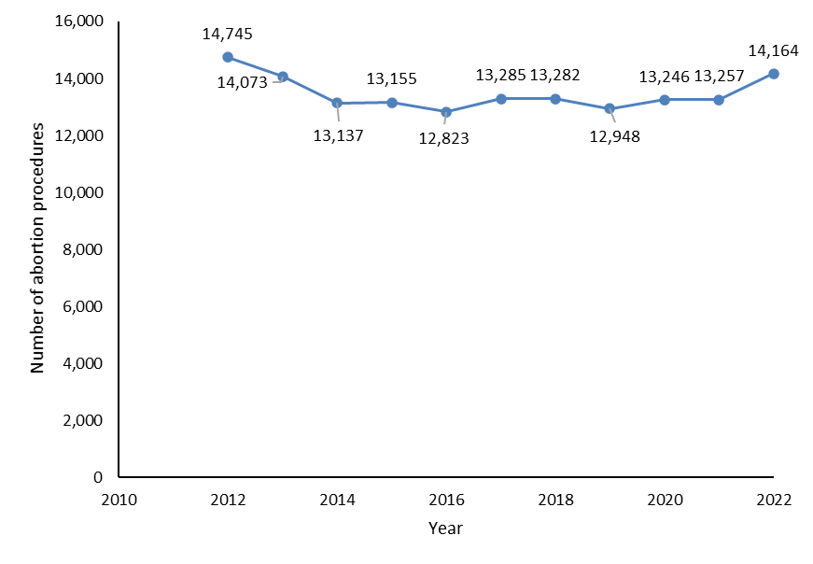

Figure 1-2: Number of abortion procedures per 1,000 females aged 15–44 years (general abortion rate), 2012–2022
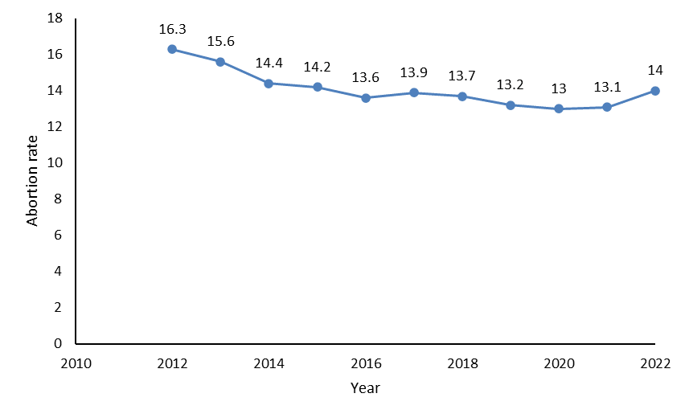
Figure 1-3: Number of abortion procedures per 1,000 known pregnancies (abortion ratio), 2012–2022
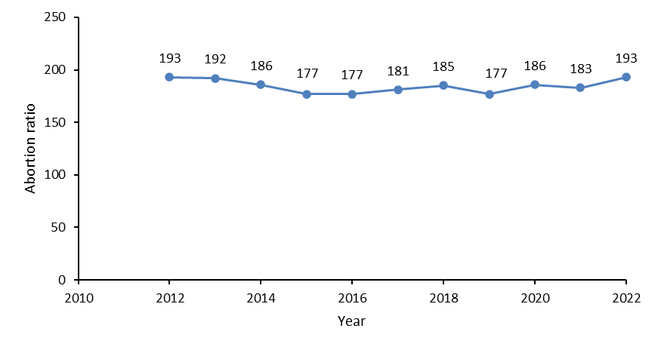

Figure 1-4: Number of abortion procedures by age group, 2012–2022
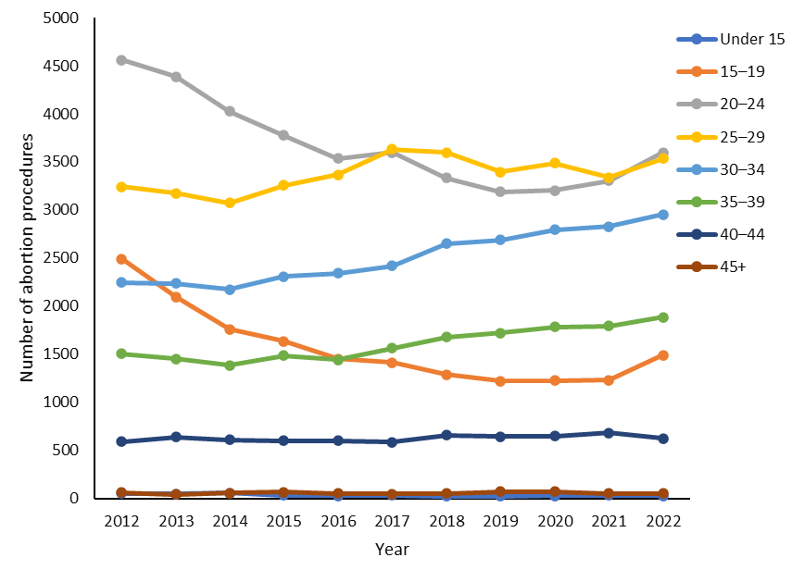

Figure 1-5: Total number of abortion procedures by prioritised ethnicity, 2022
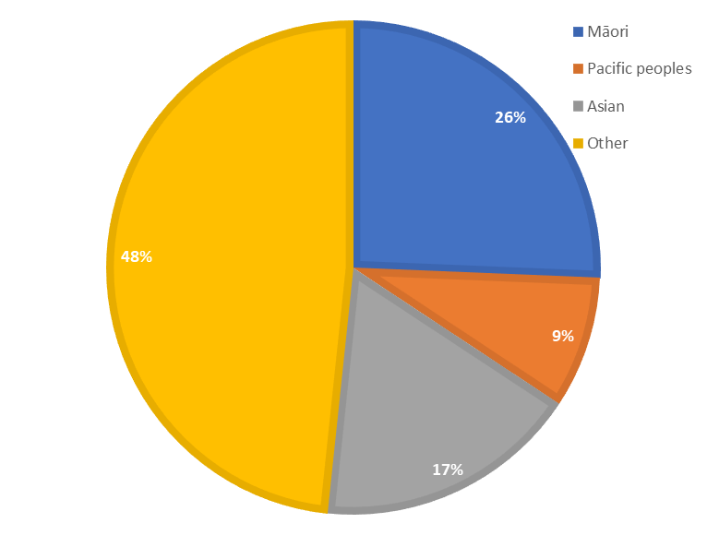

Figure 1-6: Number of abortion procedures by ethnicity, 2020–2022
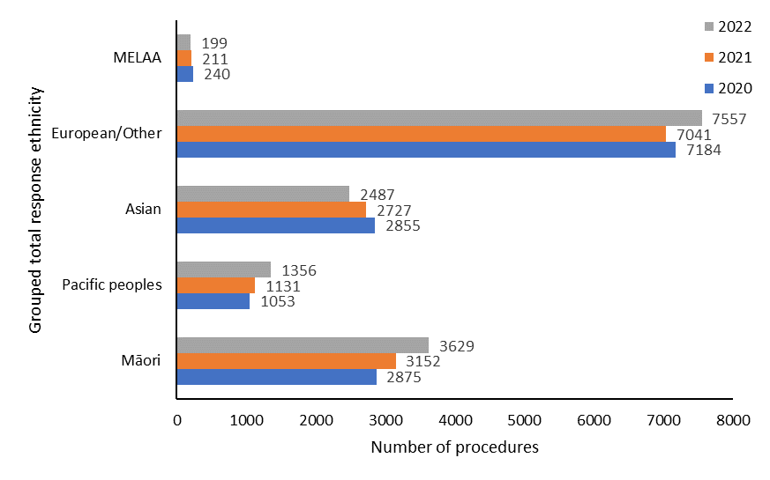
Note: MELAA = Middle Eastern, Latin American, and African.

Figure 1-7: Percentage of abortion procedures by age and ethnicity, 2022
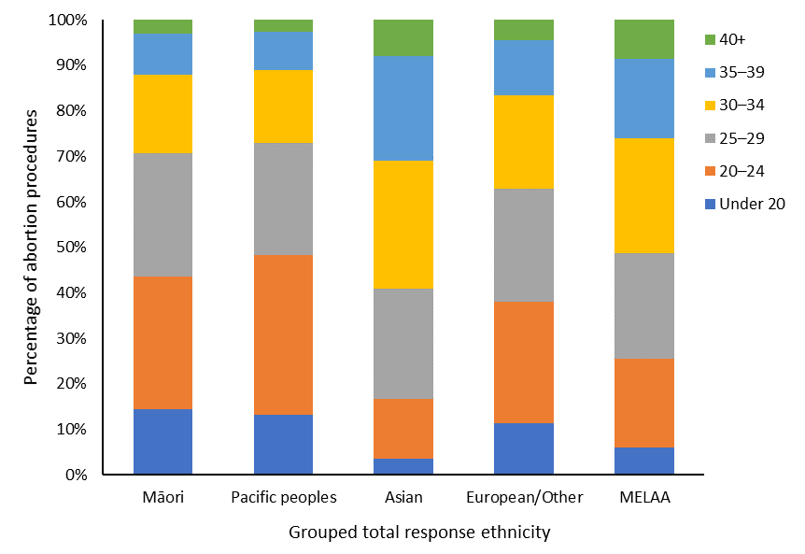
Note: MELAA = Middle Eastern, Latin American, and African.

Figure 1-8: Average gestation at time of abortion procedure by ethnicity, 2020–2022
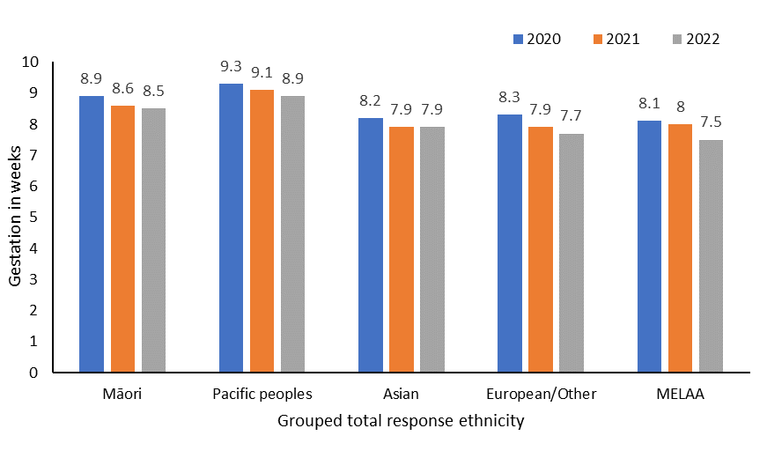
Note: MELAA = Middle Eastern, Latin American, and African.

Table 1-1: Number of abortion procedures by patient residency status, 2022
Residency status | Number
Resident | 12,247
Non-resident | 621
Not stated | 296
Total | 14,164

Figure 1-9: Number of abortion procedures by level of socioeconomic deprivation, 2022
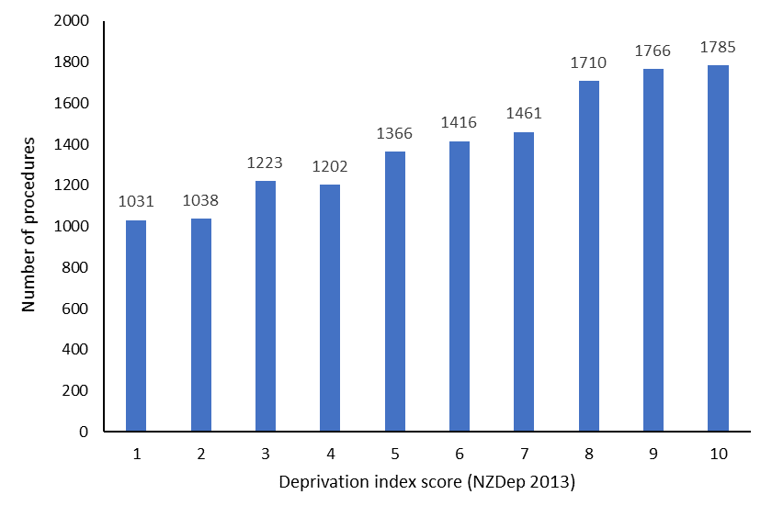

Figure 1-10: Average gestation at time of abortion by level of socioeconomic deprivation, 2022
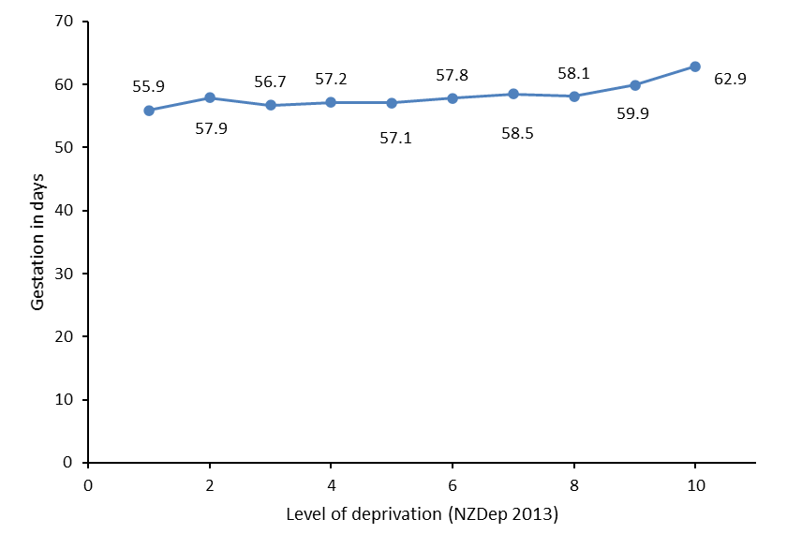

Te aronga ki te Māori | Section 2: Responsiveness to Māori
This section highlights differences between Māori and non-Māori, non-Pacific people in accessing abortions related to where they live, their age, and the type of abortion procedure performed. Sections 3 to 8 give more information on the performance of abortion services for Māori.

As part of its commitment to the principals of equity, and with the intention of achieving equitable abortion health outcomes, Manatū Hauora monitors and reports on population-level trends. To further the goal of equity, Manatū Hauora has also commissioned a multidisciplinary health consumer research project into the experiences of wāhine Māori and Pacific women accessing abortion services. This work commenced in 2022 and will be used to inform and support Manatū Hauora in the design and delivery of accessible, responsive, and wāhine-centred abortion services. Further, in partnership with Te Aka Whai Ora, Manatū Hauora (including Te Pou Māori | the Māori Health directorate) will develop Māori equity goals that will be reported on in subsequent annual reports and for the 5-year review.

In 2022, Māori were accessing abortions at higher rates (per 1,000 females aged 15–44) than non-Māori, non-Pacific people in most districts of Aotearoa New Zealand (Figure 2-1). However, the extent of this difference varied. In some districts, Māori accessed abortion services at a greater than double rate compared to non-Māori, non-Pacific people. In others, the increase in abortion rates was as low as 4%.

Notably, in 2021, abortion rates were 20% higher for non-Māori, non-Pacific people in Counties Manukau. In the same district in 2022, Māori accessed abortions at a 4% higher rate than non-Māori, non-Pacific people. This area has a high proportion of Māori and, historically, no local access to first-trimester abortion services. While the difference in results from 2021 is relatively low, reflecting a change of 2.7 individuals per 1,000 females aged 15–44, the current finding may suggest that the new availability of EMA through the national telehealth EMA service is reducing barriers to access, including the need to travel to Auckland for first-trimester abortions.

There was no change in the age-related trends of people accessing abortion from what was reported in 2021 when comparing Māori and non-Māori, non-Pacific groups. Specifically, Māori tended to have abortions at a younger age than the non-Māori, non-Pacific group. The mean age for Māori to access abortion was 26 years, compared with 29 years for the non-Māori, non-Pacific group. Across all age groups, the peak for Māori accessing abortion occurred earlier (at 20–24 years) than for non-Māori, non-Pacific people (at 25–29 years) (Figure 2-2).

In 2022, 55% of Māori accessing abortion had a surgical abortion procedure, compared with 44% of the non-Māori, non-Pacific group (Figure 2-3). There was an overall decrease in surgical abortions of approximately 6% for both groups compared to 2021. This decrease in surgical abortions may be due to the greater number of locally based first-trimester in-person services, as well as the availability of the national telehealth EMA service delivered by DECIDE.

It is important to note that the DECIDE service only became available from November 2022, and so the greater impact of this increased accessibility cannot yet be determined. Future reports will provide details relating to the impact of this national telehealth EMA service on population and regional trends, when a full year’s data becomes available.

Figure 2-1: Abortion rate by district of domicile, Māori versus non-Māori, non-Pacific, 2022
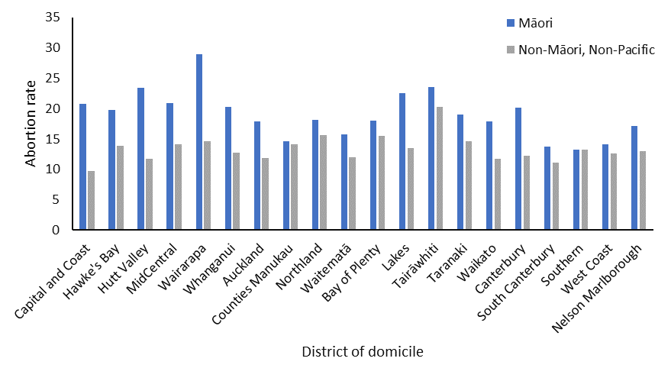
* Note: Abortion rate is calculated as number of abortion procedures per 1,000 females aged 15–44. A person is classified as Māori if one of their recorded ethnicities was Māori. All people not identifying with either a Māori or a Pacific ethnicity are classified as non-Māori, non-Pacific.

Figure 2-2: Number of abortion procedures by age group, Māori versus non-Māori, non-Pacific, 2022
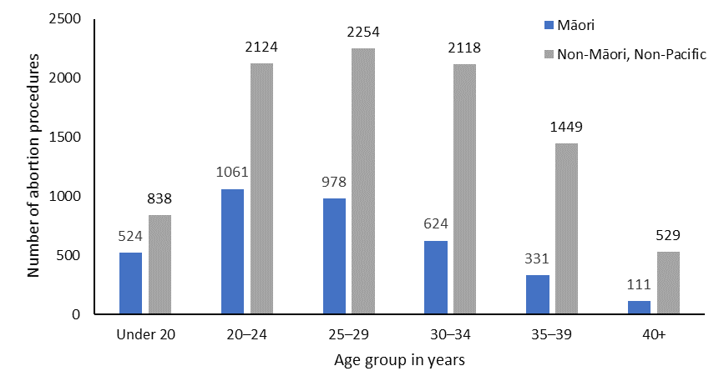

Figure 2-3: Number and percentage of abortion procedures by type of procedure, Māori versus non-Māori, non-Pacific, 2022
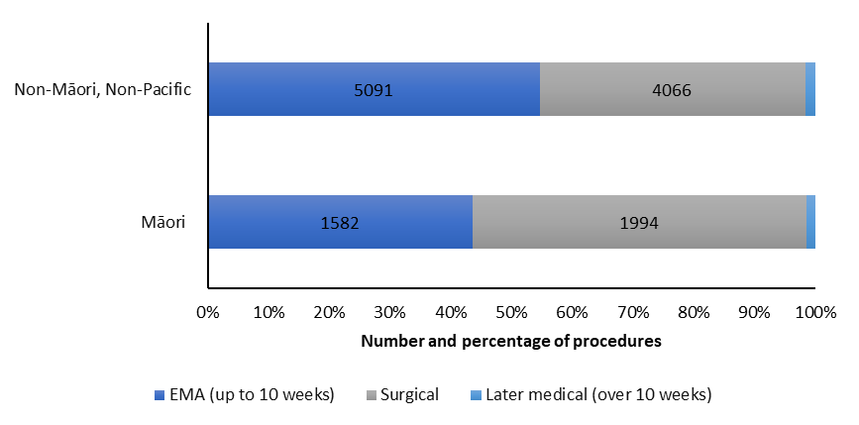

Ngā tukanga whakatahe | Section 3: Types of abortion procedures
The trend of increasing EMAs and decreasing surgical abortions observed in recent years continues. Compared to 2021, the proportion of EMAs (performed up to 10 weeks gestation) increased by 7%, and the proportion of surgical abortions decreased by 6%. In total, of all abortion procedures in 2022, 50.6% (7,171) were EMAs, compared with 43.8% (5,811) reported in 2021. In total, 47.8% (6,764) of all abortion procedures were surgical in 2022, compared with 53.8% (7,133) in 2021. Notably, 2022 was the first year in which EMAs outnumbered surgical abortions. Later medical abortion accounted for just 1.6% of all abortions. This number has remained reasonably static since 2017 (Figure 3-1).

Analysis of abortion services accessed based on district of domicile shows an overall decrease in the percentage of surgical abortions for individuals living in almost all districts in 2022, compared to 2021. In 2022, the proportion of surgical abortions increased among people living in only 3 districts. Specifically, compared to 2021, there was a 5% increase in surgical abortions in Lakes (totalling 53.9% in 2022) and a 2% increase in both the Taranaki (totalling 12.6% in 2022) and Southern (totalling 37.8% in 2022) districts. Among the 17 districts where the rate of surgical abortion decreased, this decrease ranged from 2% to 40%. Finally, base rates of EMA were greater than rates of surgical abortion for people living across 11 districts in 2022, compared to only 8 districts in 2021 (Figure 3-2).

In 2022, notably, 50.8% of those living in the West Coast who accessed an abortion had a surgical abortion, compared with 90.9% of those living in that district in 2021. This difference may reflect the new accessibility of locally based first-trimester in-person services in this district, as well as the availability of national telehealth EMA services delivered by DECIDE.

Considering abortion procedures by district of service shows small increases in abortion service provision in 12 of the 17 districts reported. The largest service decrease occurred in Southern and the largest service increase in Auckland (Figure 3-3 and Table 3-1). Additionally, 3.6% of abortions (515) were accessed through the national telehealth service delivered by DECIDE.

Taken together, these changes demonstrate an average increase in the number and rate of EMA service provision, and a decrease in surgical abortions nationally as well as across most districts in Aotearoa New Zealand. Future reporting will include greater detail on regional outcomes, particularly as they relate to observed increases in the availability of first-trimester services, like DECIDE.

Figure 3-1: Number of abortion procedures by procedure type, 2017–2022
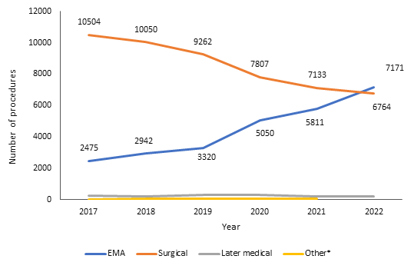
Note: * ‘Other’ abortion types (2017-2021) include failed abortion, a secondary abortion following a failed abortion, and reports where a procedure type was missing. From 2022, complications relating to failed abortion procedures are reported within Table 7.2. EMA = early medical abortion.
Figure 3-2: Number of abortion procedures by procedure type and district of domicile, 2022
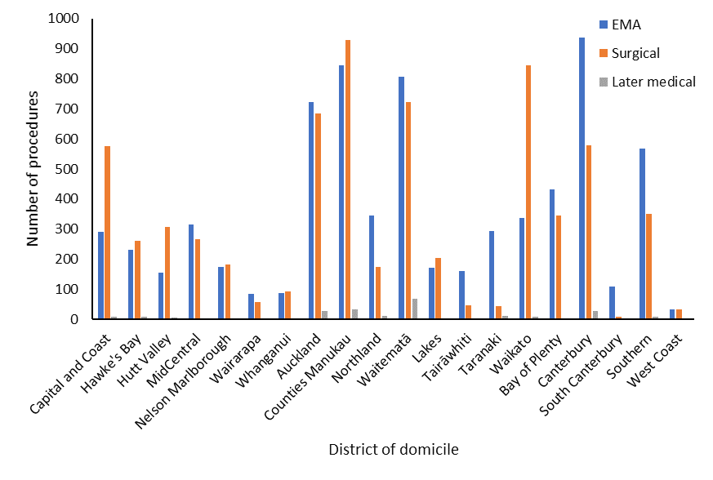
Note: EMA = early medical abortion.
Figure 3-3: Number of abortion procedures by district of service, 2020–2022
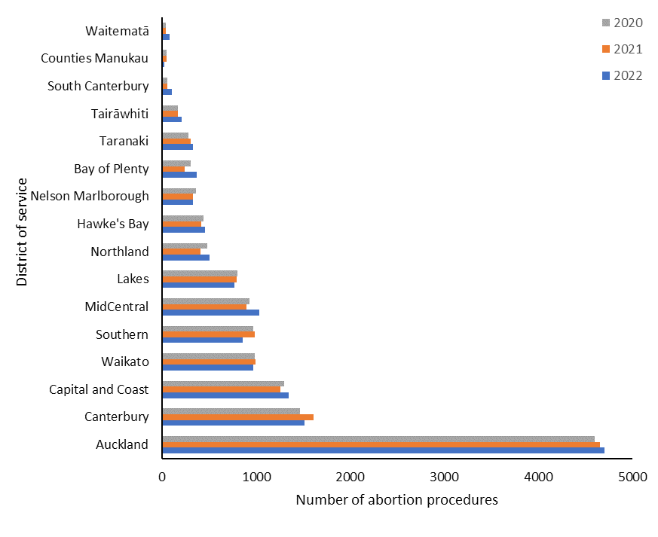

Table 3-1: Number of abortion procedures by district of service, 2020–2022
District | 2020 | 2021 | 2022
Auckland | 4,656 | 4,597 | 4,702
Canterbury | 1,612 | 1,470 | 1,515
Capital and Coast | 1,259 | 1,297 | 1,345
Waikato | 997 | 989 | 975
Southern | 987 | 969 | 857
MidCentral | 902 | 932 | 1,038
Lakes | 794 | 802 | 775
Northland | 413 | 480 | 503
Hawke’s Bay | 420 | 446 | 459
Nelson Marlborough | 328 | 364 | 329
Bay of Plenty | 246 | 305 | 373
Taranaki | 304 | 283 | 327
Tairāwhiti | 172 | 167 | 213
South Canterbury | 55 | 57 | 110
Counties Manukau | 53 | 53 | 30
Waitematā | 45 | 40 | 80
West Coast | S | S | 17
Note: Excludes 515 abortions accessed through DECIDE. At the end of this period that service had only been delivered for two months, and inclusion of these figures would not accurately reflect the district-level distribution of service provision. Future reports will address trends relating to this service in greater detail. These figures exclude abortion procedures in Hutt Valley district (for 2020, 2021, and 2022) and the West Coast (for 2020 and 2021) due to very low numbers.

Te whakatahe i roto i te ara whakaputa uri | Section 4: Abortion within the reproductive journey
Overall, the proportion of people with no previous live births who had an abortion was similar in 2022 (43%) compared to 2021 (42%). Summarising this data by ethnicity shows that 30.9% of Māori accessing abortion had had no previous live births, compared with 43.4% of Pacific peoples, 39% of Asian people, and 49.3% of the European/other group (Figure 4-1).

The proportion of people overall who had their first abortion in 2022 (64%) was consistent with the equivalent figure in 2021 (63%). By ethnicity, 57.7% of Māori accessing abortion had had no previous abortions, compared with 66.3% of Pacific peoples, 68.4% of Asian people, and 64.3% of the European/other group (Figure 4-2).

Figure 4-1: Abortion procedures and number of previous live births by ethnicity, 2022
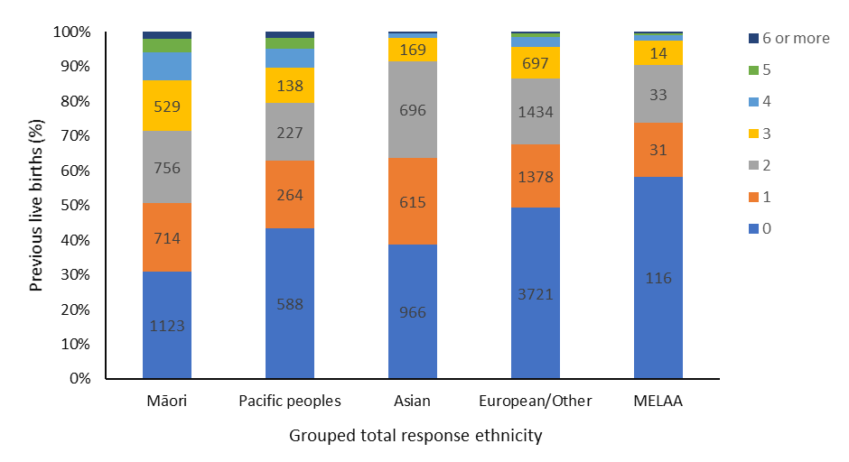
Note: MELAA = Middle Eastern, Latin American, and African.
Figure 4-2: Abortion procedures and number of previous abortions by ethnicity, 2022
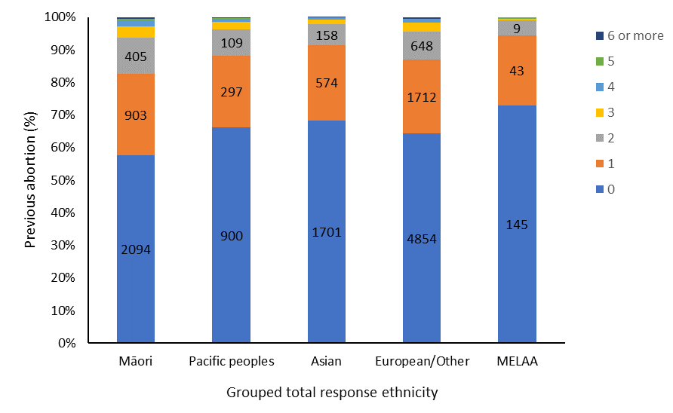
Note: MELAA = Middle Eastern, Latin American, and African.

Wāhanga 5. Te āheinga ki te whakatahe me ngā ārai hapūtanga | Section 5: Abortion and access to contraception
Of those who had an abortion in 2022, 61.8% had not been using any contraception. A small percentage (0.5%) of these individuals indicated that this had been a planned pregnancy. 18.5% of people reported using condoms as their sole form of contraception, and a further 9.5% of people reported having taken oral contraceptive birth control (combined or progesterone-only) at the time they became pregnant.

Providers are given an option to report both contraception provided at the time of abortion, as well as instances in which an individual has booked or has been referred for a post-abortion follow up contraception appointment. As observed in 2021, 72.6% of people who had an abortion in 2022 were provided with some form of contraception. 8.6% of individuals who received an abortion had booked or been referred for a post-abortion contraception appointment or had been provided information about fertility awareness methods, compared to 4.4% in 2021. In the majority of instances in which a follow-up contraceptive appointment had been booked, the type of contraception sought was not reported.

The remaining 18.7% of individuals who accessed an abortion in 2022 were not provided with any contraception (or it was not known whether they were provided with contraception). This latter group included people planning another pregnancy, those reporting already having contraception, and those choosing to follow up with another provider, as well as those who did not attend a follow-up contraception appointment.

Long-acting reversible contraception (LARC) is a form of contraception which is highly effective at preventing pregnancy and lasts for several years, while being easily reversible. Examples of LARC include the intra-uterine system (IUS) and subdermal implant contraceptive devices. Analysis shows that of those who had an EMA in 2022, 17.7% were provided with LARC at the time of the abortion, reflecting a 5% increase compared to 2021. A further 3.0% were booked to access LARC at a follow-up appointment.

Similar to 2021, approximately one-third (33.9%) of those having EMA were not provided with any form of contraception and had not booked a follow-up appointment at the time of abortion (33.4% in 2021).

In comparison, over half (57.7%) of those who had surgical abortion were provided with LARC at the time of the abortion, reflecting a 4% increase compared to 2021. The relative increase of LARC provision for individuals accessing surgical rather than early medical abortions is likely due to differences in these procedures. Specifically, insertion of a LARC IUS into the uterus cannot occur at the time of a medical abortion; it requires a follow-up appointment. Of those having surgical abortion, only 13.8% had not been provided any form of contraception and had not been booked for a follow-up contraception appointment. This was a similar result to that observed in 2021 (12.1%).

Analysis of LARC provision by patient domicile shows that those living in Tairāwhiti, West Coast, Greater Wellington, and Lakes had the highest percentage of LARC provision at the time of abortion. Those in Taranaki, Wairarapa, Northland, and South Canterbury had the lowest percentage of LARC provision at the time of abortion. High rates of LARC provision generally aligns with districts with high rates of surgical abortion provision, and low LARC rates of provision aligns with districts with high rates EMA provision. The one exception to this trend was noted in Tairāwhiti, which had high rates of both EMA and LARC.

The data shows that, excluding condoms, LARC IUS was the most commonly provided contraceptive device post-abortion, and was provided at almost double the rate of subdermal contraceptive implants. Notably, subdermal implants can be provided immediately after a medical abortion, and do not require a follow up appointment. Health practitioners holding current practising certificates are able to complete training to perform LARC procedures, including IUS insertion and subdermal implant insertion and removal, providing they meet the criteria outlined in Long-acting Reversible Contraception: Health practitioner training principles and standards 2022.

As almost all abortion providers reported providing both subdermal implants and LARC IUS, training of practitioners and the availability of subdermal implants do not appear to be the reason for the low uptake. The low uptake of subdermal implants (12.7%) compared to LARC IUS (21.6%) may be due to people not choosing to have this form of contraception. The preference for LARC IUS over subdermal implants is also reflected in the data on the type of follow-up contraception appointments people booked.

Analysis of LARC provision by ethnicity shows that Māori and Pacific people had the highest rates of LARC provision at the time of abortion in 2022. This is consistent with the data showing that Māori and Pacific people had more surgical abortion procedures than other ethnic groups (see Section 2).

Table 5-1: Type of contraception used at time of conception, 2022
Contraception used | Number | Percentage  (%)
None* | 8,755 | 61.8
Condoms | 2,616 | 18.5
Combined oral contraceptive pill | 807 | 5.7
Unknown | 501 | 3.5
Progesterone-only oral contraception | 487 | 3.4
Fertility awareness method | 275 | 1.9
Emergency contraceptive pill | 226 | 1.6
Copper intra-uterine device contraception | 101 | 0.7
Progesterone-only depot injection | 84 | 0.6
Condoms and emergency contraception | 57 | 0.4
Condoms and fertility awareness method | 53 | 0.4
Intra-uterine contraceptive device with hormones | 44 | 0.3
Subdermal contraceptive implant | 34 | 0.2
Oral contraceptive pill with condoms | 22 | 0.2
Partner sterilisation | 18 | 0.1
Oral contraceptive pill not further defined | 17 | 0.1
Oral contraceptive pill with emergency contraception | 11 | 0.1
Other** | 56 | 0.40
Total | 14,164 | 100
Note: * ‘None’ includes 41 cases reported as a planned pregnancy.
** ‘Other’ includes all categories with fewer than 10 reported cases.
Figure 5-1: Percentage of people provided with contraception at time of abortion, all contraception types, 2022
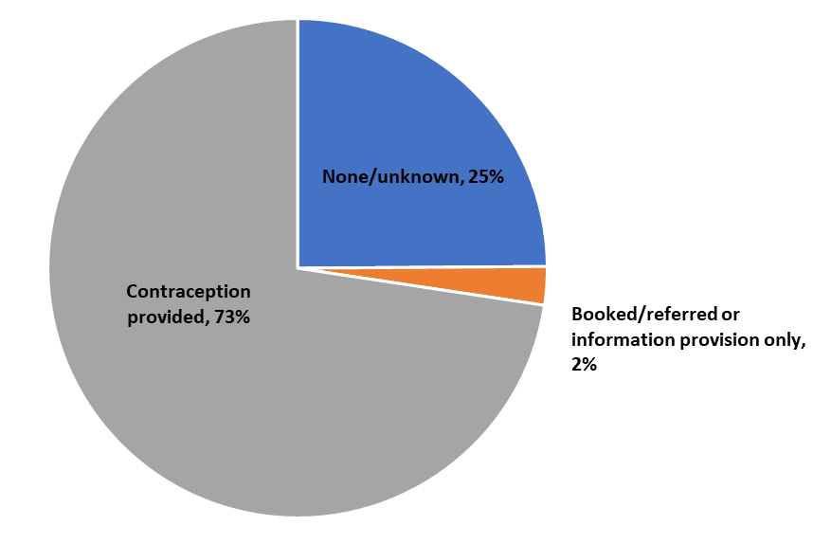
Table 5-2: Contraception provided at time of abortion by type, number, and percentage of total abortion, 2022
Contraception provided | Number | Percentage of  total abortion (%)
Condoms | 2,223 | 15.7
Intra-uterine contraceptive device with hormones | 2,195 | 15.5
Subdermal contraceptive implant | 1,791 | 12.6
Combined oral contraceptive pill | 1,756 | 12.4
Copper intra-uterine device contraception | 817 | 5.8
Progesterone only oral contraceptive pill | 663 | 4.7
LARC not further defined | 321 | 2.3
Condoms and emergency contraceptive pill | 219 | 1.5
Condoms and progesterone only contraceptive pill | 96 | 0.7
Condoms and combined oral contraceptive pill | 48 | 0.3
Intra-uterine contraceptive device not further defined | 38 | 0.3
Condoms and partner booked for sterilisation | 31 | 0.2
Emergency contraceptive pill | 24 | 0.2
Other and LARC | 16 | 0.1
Condoms and intra-uterine contraceptive device | 13 | 0.1
Condoms and subdermal contraceptive implant | 13 | 0.1
Condoms and booked/referred for LARC (IUS) | 12 | 0.1
Other* | 12 | 0.1
Total | 10,288 | 72.6
Note: * ‘Other’ includes all categories with fewer than 10 reported cases. IUS = intra-uterine system; LARC = long-acting reversible contraception.

Table 5-3: No contraception provided by category, number, and percentage of total abortion, 2022
Category | Number | Percentage of total abortion (%)
None, patient declined contraception | 1,723 | 12.2
None, patient to follow up with GP or other provider | 493 | 3.5
None* | 270 | 1.9
None, patient already had contraception | 168 | 1.2
Total | 2,654 | 18.7
* ‘None’ includes 39 cases reported as a planned pregnancy.

Table 5-4: Bookings/referrals and information provision by category, number, and percentage of total abortion, 2022
Booked/referred category or information provision | Number | Percentage of total abortion (%)
Follow-up booked, not further defined | 870 | 6.1
Booked/referred for LARC (IUS) | 88 | 0.6
Booked/referred for LARC, not further defined | 83 | 0.6
Booked/referred for partner sterilisation | 71 | 0.5
Booked/referred for LARC (implant) | 45 | 0.3
Fertility awareness methods information | 38 | 0.3
Booked/referred for sterilisation | 23 | 0.2
Other* | 4 | 0.0
Total | 1,222 | 8.6
Note: * ‘Other’ includes all categories with fewer than 10 reported cases. NFD = not further defined; IUS = intra-uterine system; LARC = long-acting reversible contraception.

Figure 5-2: Percentage of people receiving long-acting reversible contraception by procedure type, 2022
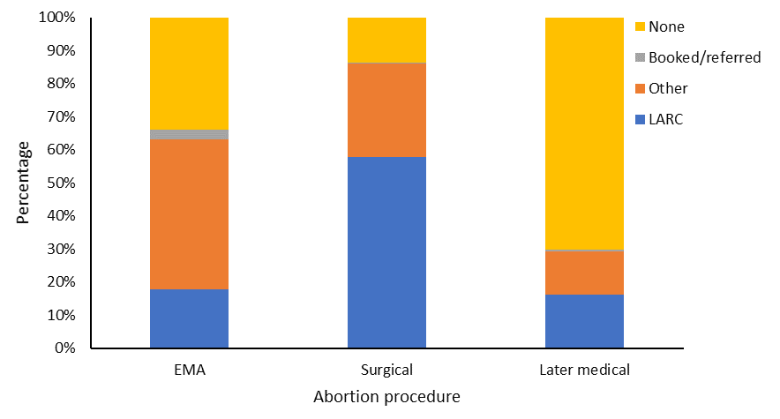
Note: EMA = early medical abortion; LARC = long-acting reversible contraception.

Table 5-5: Number of people receiving long-acting reversible contraception by procedure type, 2022
Procedure | LARC | Other | Booked/referred | None | Total
EMA | 1,266 | 3,256 | 218 | 2,431 | 7,171
Surgical | 3,901 | 1,922 | 9 | 932 | 6,764
Later medical | 37 | 30 | 1 | 161 | 229
Total | 5,204 | 5,208 | 228 | 3,524 | 14,164
Note: EMA = early medical abortion; LARC = long-acting reversible contraception.

Figure 5-3: Percentage of people receiving long-acting reversible contraception by district of domicile, 2022
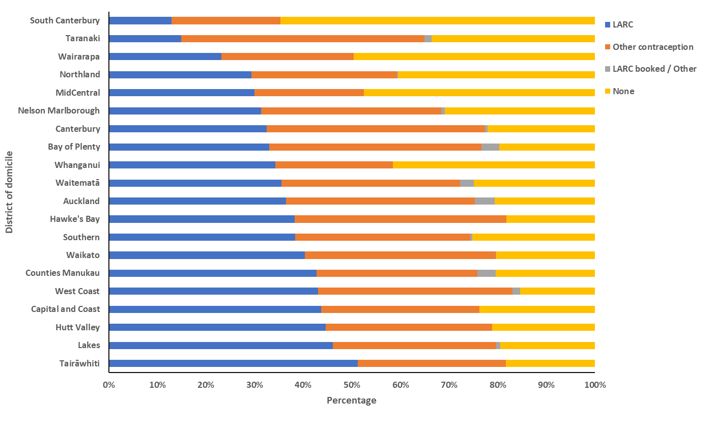
Note: LARC = long-acting reversible contraception.

Table 5-6: Number and percentage of people receiving long-acting reversible contraception after an abortion procedure by district of domicile, 2022
District of domicile | LARC | Other  contraception | LARC booked/  referred | None | Number | Percentage (%)
Tairāwhiti | 106 | 63 | 0 | 38 | 207 | 51.2
Lakes | 175 | 128 | 3 | 74 | 380 | 46.1
Hutt Valley | 209 | 160 | 0 | 99 | 468 | 44.7
Capital and Coast | 383 | 286 | 0 | 208 | 877 | 43.7
West Coast | 28 | 26 | 1 | 10 | 65 | 43.1
Counties Manukau | 773 | 598 | 68 | 369 | 1808 | 42.8
Waikato | 480 | 468 | 1 | 242 | 1191 | 40.3
Southern | 356 | 334 | 4 | 234 | 928 | 38.4
Hawke’s Bay | 191 | 218 | 0 | 91 | 500 | 38.2
Auckland | 523 | 556 | 59 | 296 | 1434 | 36.5
Waitematā | 567 | 586 | 46 | 397 | 1596 | 35.5
Whanganui | 61 | 43 | 0 | 74 | 178 | 34.3
Bay of Plenty | 256 | 339 | 28 | 153 | 776 | 33.0
Canterbury | 502 | 695 | 8 | 341 | 1546 | 32.5
Nelson Marlborough | 113 | 133 | 3 | 111 | 360 | 31.4
MidCentral | 175 | 131 | 0 | 277 | 584 | 30.0
Northland | 156 | 159 | 1 | 215 | 531 | 29.4
Wairarapa | 34 | 40 | 0 | 73 | 147 | 23.1
Taranaki | 52 | 174 | 5 | 117 | 348 | 14.9
South Canterbury | 15 | 26 | 0 | 75 | 116 | 12.9
Note: Excludes those records missing a meshblock code. LARC = long-acting reversible contraception. Hutt Valley is included here as a unique district, as this area represented a distinct district until July 2022.

Figure 5-4: Number and percentage of people recieving long-acting reversible contraception by ethnicity, 2022
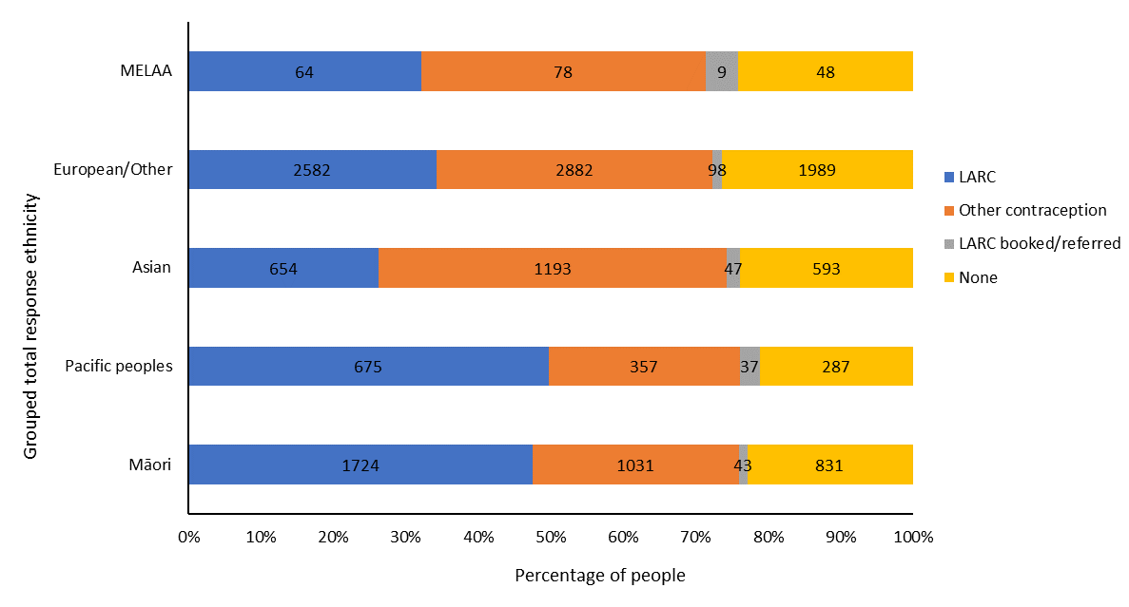
Note: Excludes those records missing ethnicity data. LARC = long-acting reversible contraception; MELAA = Middle Eastern, Latin American and African.

Wāhanga 6. Te āheinga ā-matawhenua ki te whakatahe | Section 6: Geographical access to abortion
Figure 6-1 shows data on drive time to abortion services across Aotearoa New Zealand in 2022. A greater number of locally based in-person abortion services became available in 2022 compared to 2021, resulting in an overall decrease in drive time for both Māori and non-Māori, non-Pacific females. Specifically, 46,892 (27%) of the Māori female population (aged 15–44 years) lived more than a 30-minute drive from an abortion service, compared with 136,389 (16%) of the non-Māori female population of the same age. This reflects an 8% decrease for both Māori and non-Māori, non-Pacific groups living further than a 30-minute drive from an abortion service compared to 2021. Additionally, 5,016 (3%) of Māori females aged 15–44 and 7,170 (1%) of non-Māori females aged 15–44 lived more than a 90-minute drive from an abortion service in 2022, reflecting a 2% decrease for both groups compared to 2021.

These overall decreases in drive times demonstrate a move towards greater accessibility to local in-person abortion services in Aotearoa New Zealand. However, the greater average drive time that remains for Māori compared to non-Māori demonstrates that Māori are still experiencing greater barriers to accessing in-person abortion services.

Being a long distance from an abortion service can present a disproportionate burden for those living in the most socioeconomically deprived areas, as these individuals are more likely to have less (or no) access to a car. In 2022, 18% of females aged 15–44 living in the 3 least socioeconomically deprived areas were more than a 30-minute drive from an abortion service, compared to 20% of those in the 3 most socioeconomically deprived areas. Notably, barriers relating to drive time and socioeconomic status have the potential to affect a high proportion of those seeking abortion services. In 2022, 37.2% of abortions were accessed by individuals living in the 3 most socioeconomically deprived areas (see Figure 1-9). In comparison, only 23.3% of abortions were accessed by individuals living in the 3 least socioeconomically deprived areas.

Barriers relating to socioeconomic status and drive time have been shown to have a disproportionate impact on Māori females accessing abortion services. In 2022, 21% of Māori females aged 15–44 living in the 3 least socioeconomically deprived areas were more than a 30-minute drive from an abortion service, compared to 31% of those in the 3 most socioeconomically deprived areas.

Because not all districts of Aotearoa New Zealand have access to any local first-trimester abortion services, people living in certain districts must travel to another district for in-person abortion services (Figure 6-2). In 2022, all those requiring a first-trimester abortion who lived in Waitematā, Counties Manukau, Hutt Valley, Whanganui and Wairarapa had to travel out of district for in-person first-trimester abortion services. Note that Hutt Valley is included as a distinct district in the present reporting. Although this district became incorporated with Capital and Coast in July 2022, it was a unique district for the first 6 months of 2022.

Having to travel out of district appears to affect timely service access, as people living in districts without local first-trimester services had, on average, later gestations at the time of their abortion procedure in 2022 (Figure 6-3). In districts with local first-trimester services but where people access abortion later (for example, Waikato, Hawke’s Bay and Auckland), there may be longer service wait times, due to limited service capacity or additional service access barriers.

Figure 6-1: Geospatial analysis – patient drive time to services by facility, 2022

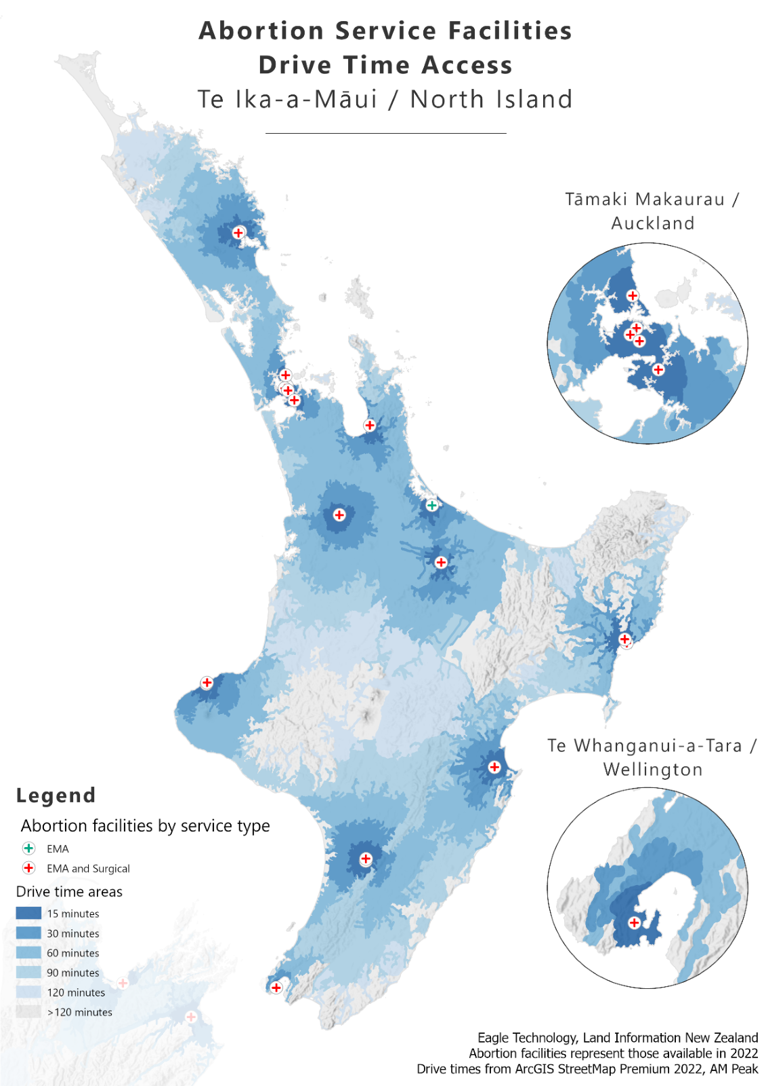
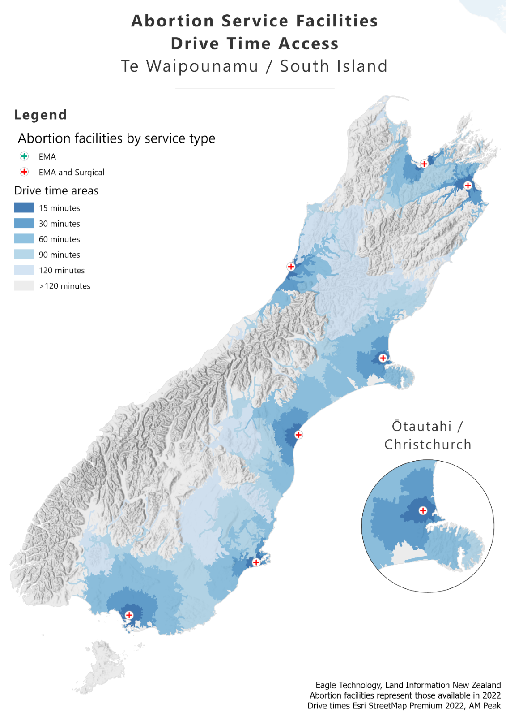

Figure 6-2: Percentage of patients travelling to other districts for abortion procedures, 2022
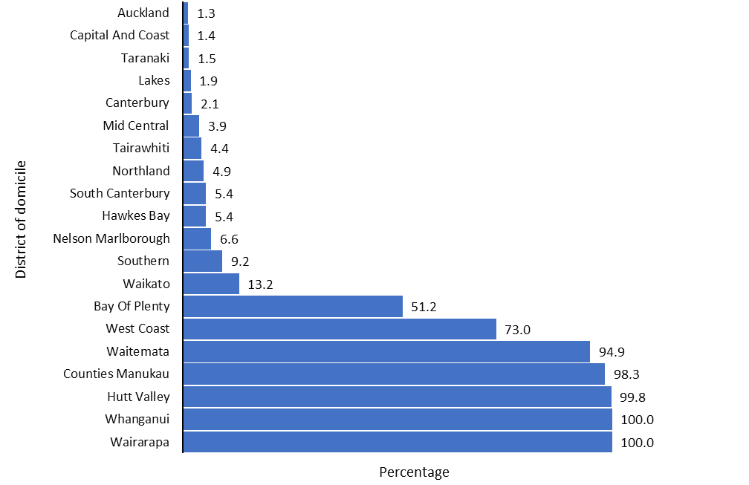

Note: Total values exclude individuals accessing EMA via DECIDE telehealth services. Also excludes those records missing a meshblock code.
Figure 6-3: Average gestation by district of domicile, 2022
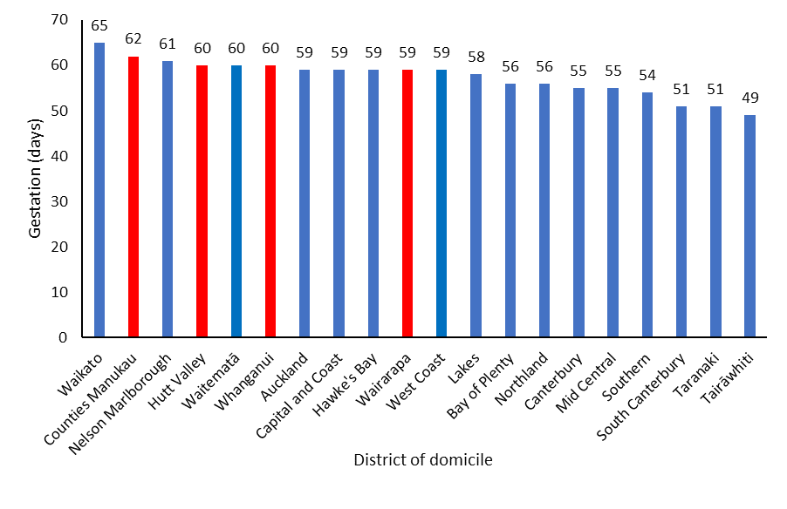
Note: Red = District had no local in-person, first-trimester abortion services in 2022. Blue = District had local in-person, first-trimester abortion services in 2022.

Wāhanga 7. Ngā uauatanga i pūrongotia i te wā o te whakatahe | Section 7: Complications at time of abortion
In 2022, services reported that 221 abortion procedures were associated with a complication at the time of the abortion (1.6% of all abortion procedures; see Table 7-1). This was consistent with the data reported in 2021, in which 1.3% of all abortions were associated with a complication. By type of abortion procedure, 131 (1.8%) EMA, 55 (0.8%) surgical procedures and 35 (15%) later medical procedures were associated with a complication. The most commonly reported complications included a retained placenta or products following a medical abortion and retained products or haemorrhage following surgical abortion (Table 7-2).

A small proportion of cases (57, or 0.4%) were reported as ‘lost to follow-up’ across 6 services in 2022. ‘Lost to follow-up' cases represent those where the person did not attend a booked follow-up appointment or, in the case of EMA, could not be contacted to confirm the abortion had been completed. In 2022, all cases ‘lost to follow-up’ reflected abortions accessed as EMA. Now that EMA is more accessible, it will be important to monitor reported complications and cases where individuals are lost to follow-up. In 2022, Māori represented 42% (24) of all lost to follow-up cases.

Table 7-3 shows that the rate of complications was unrelated to age in 2022.

Table 7-1: Number and percentage of complications at the time of abortion by type of complication, 2022
Complication type | Number | Percentage (%)
None | 13,886 | 98.4
Retained placenta/products | 104 | 0.7
Haemorrhage | 32 | 0.2
Infection | 20 | 0.1
Haemorrhage and retained placenta/products | 18 | 0.1
Reaction to medication; eg, drowsiness, nausea, dizziness | 12 | 0.1
Pain | 11 | 0.1
Retained placenta/products and infection | 11 | 0.1
Perforation of uterus | 6 | 0.0
Failed abortion | 4 | 0.0
Other | 3 | 0.0
Total | 14,107 | 100.0
Note: In 57 cases, the person was lost to follow-up; the outcome is therefore unknown.

Table 7-2: Number of complications at the time of abortion by procedure type, 2022
Complication type | EMA | Surgical | Later medical | Total
None | 6,983 | 6,709 | 194 | 13,886
Retained placenta/products | 70 | 18 | 16 | 104
Infection | 18 | 2 | 0 | 20
Haemorrhage | 10 | 15 | 7 | 32
Retained placenta/products and infection | 9 | 2 | 0 | 11
Pain | 8 | 3 | 0 | 11
Reaction to medication; eg, drowsiness, nausea, dizziness | 7 | 5 | 0 | 12
Haemorrhage and retained placenta/products | 4 | 4 | 10 | 18
Failed abortion | 3 | 1 | 0 | 4
Other | 2 | 1 | 0 | 3
Perforation of uterus | 0 | 4 | 2 | 6
Total reported | 7,114 | 6,764 | 229 | 14,107
Lost to follow-up | 57 | 0 | 0 | 57
Note: EMA = early medical abortion.

Table 7-3: Number and percentage of complications at the time of abortion by age group, 2022
Age group (years) | Number of  abortions | Number of complications | Percentage (%) of complications
<20 | 1,516 | 25 | 1.6
20–24 | 3,599 | 44 | 1.2
25–29 | 3,537 | 62 | 1.8
30–34 | 2,951 | 46 | 1.6
35–39 | 1,886 | 35 | 1.9
40+ | 675 | 9 | 1.3

Wāhanga 8. Ngā kaimahi whakatahe | Section 8: Abortion workforce
Across Aotearoa New Zealand, the abortion workforce doubled in 2022 (total: 348) compared to 2021 (total: 162). In 2022, the abortion workforce consisted of 103 (29.6%) medical staff, 219 (62.9%) nurses, and 26 (7.5%) midwives (Table 8-1). The majority of the workforce were of European descent or another ethnicity (66.4%) and approximately one-fifth (20.4%) were Asian. The number of Māori abortion service practitioners increased from 7 in 2021 to 25 in 2022, reflecting 7.2% of the workforce. Likewise, there was an increase in Pacific abortion service practitioners from 5 in 2021 to 17 in 2022. Pacific abortion service providers comprised 4.9% of the workforce in 2022. The majority of the workforce (86.5%) was female. As in 2021, the Northern area (Auckland metro district and Northland) had the most ethnically diverse workforce (Table 8-3).

As the majority (over 95%) of the workforce is non-Māori, but Māori represent almost a quarter of service users, it is vitally important that the workforce is culturally safe for Māori. Moreover, given the diversity of those accessing abortion services in Aotearoa New Zealand, we must ensure that the workforce is responsive to the needs of diverse cultures, and that abortion service facilities are culturally safe for everyone. Abortion service providers have acted with proactive engagement to cultural competency training. In 2022, 66% of abortions were accessed across 13 locations in which at least one abortion service provider had undergone some form of cultural competence training within the prior year.

Encouraging cultural diversity in the workforce and supporting the development of cultural competency among abortion service providers continues to be a priority for Manatū Hauora. Insights resulting from health consumer research projects commissioned by Manatū Hauora commencing in 2022 will help to inform guidelines and recommendations in the upcoming 5-year review. Ngā Paerewa Health and Disability Services Standard NZS 8134:2021 outlines the expected standard for workforce cultural competency. The national first-trimester abortion training has cultural competency at its core and is freely available to health practitioners.

Table 8-1: National abortion workforce (medical, nursing and midwifery) by region and registered profession, 2022
Region | Medical | Nursing | Midwifery | Total by region
Central | 27 | 30 | 1 | 58
Northern | 37 | 97 | 22 | 156
Te Manawa Taki | 13 | 43 | 3 | 59
Te Waipounamu | 24 | 34 | 0 | 58
Nationwide* | 2 | 15 | 0 | 17
Total by profession | 103 | 219 | 26 | 348
*DECIDE telehealth services

Table 8-2: National abortion workforce (medical, nursing and midwifery) by region and ethnicity, 2022
Region | Māori | Pacific peoples | Asian | Other | Not disclosed | Total by region
Central | 8 | 0 | 4 | 46 | 0 | 58
Northern | 8 | 12 | 60 | 76 | 0 | 156
Te Manawa Taki | 2 | 5 | 4 | 47 | 1 | 59
Te Waipounamu | 4 | 0 | 3 | 48 | 3 | 58
Nationwide* | 3 | 0 | 0 | 14 | 0 | 17
Total by ethnicity | 25 | 17 | 71 | 231 | 4 | 348
*DECIDE telehealth services

Table 8-3: National abortion workforce (medical, nursing and midwifery) by region and gender, 2022
Region | Female | Male | Gender diverse | Not disclosed | Total by region
Central | 44 | 14 | 0 | 0 | 58
Northern | 142 | 14 | 0 | 0 | 156
Te Manawa Taki | 54 | 5 | 0 | 0 | 59
Te Waipounamu | 48 | 4 | 3 | 3 | 58
Nationwide* | 13 | 2 | 0 | 2 | 17
Total by gender | 301 | 39 | 3 | 5 | 348
*DECIDE telehealth services

Wāhanga 9. Tohuora whakatahe | Section 9: Abortion counselling
Following changes to the Contraception, Sterilisation, and Abortion Act 1977, Manatū Hauora is responsible for services relating to abortion counselling. The Act states that abortion counselling is not mandatory for a person accessing abortion services. However, health providers must advise those seeking an abortion about the availability of counselling services. The Standard for Abortion Counselling in Aotearoa New Zealand (2022), referenced in the ‘Standards and regulations’ section of this report, outlines the purpose and scope of abortion counselling in Aotearoa New Zealand.

People should be supported by abortion counsellors to explore their emotions, thoughts, and feelings around their abortion. As the Standard explains, abortion counselling provides therapeutic support to people who are considering having, or have had, an abortion. The standard is grounded in Te Tiriti and health equity practice and sets out what Manatū Hauora expects of those delivering abortion-related counselling.

In 2022, 21 of 31 abortion service facilities provided in-house abortion counselling. All of these facilities offered both pre- and post-abortion counselling that were generally accessible both in-person and virtually. In 2022, 2,764 (20%) of those accessing an abortion chose to also access pre-abortion counselling services. In the majority of these cases (2,392), the person accessing pre-abortion counselling did so within the same location as the abortion service provider.

Manatū Hauora is continuing to work with providers within its regulatory role to monitor abortion counselling services. The following principles guide abortion counsellors and will be a focus of the Manatū Hauora ongoing role of monitoring abortion counselling services:
- Give effect to Crown obligations under Te Tiriti o Waitangi, considering the interests and needs of Māori.
- Be objective, impartial and non-judgemental.
- Ensure counselling services are accessible, equitable and high quality.
- Offer timely, person-specific and tailored support.
- Screen for and acknowledge trauma and follow a trauma-informed approach in such circumstances.

Further information will be provided in future reports.

Wāhanga 10. Ngā pātai whakatahe me te whakatahe kāore i oti noa | Section 10: Abortion enquiries and non-completed abortion
Not all cases where an individual engages with an initial consultation regarding abortion services will result in a termination of pregnancy. In some cases, a termination of pregnancy does not follow an initial consultation as further medical testing indicates that a pregnancy has not occurred, or that a prior pregnancy resulted in a miscarriage. In other instances, people seeking an abortion may choose to access initial consultation services at one location and then undergo an abortion procedure at another location. Some people initially considering an abortion may decide to continue the pregnancy to term.

In 2022, 20 services reported that at least one patient did not proceed to termination following initial consultation. Three services reported that more than 100 patients did not proceed to termination at their facility. The average consultation time for each case where a person accessing an initial consultation did not to proceed to termination at the same location was 1 hour and 14 minutes (with a range of 30 minutes to 3 hours).

Abortion service providers may refuse to administer an abortion procedure. This was reported by 10 locations in 2022. The primary consideration reported for refusal to provide termination services was length of gestation. This included instances where the facility only provided first-trimester abortions. Refusal and referral also occurred in instances where medical considerations required medical treatment outside the scope of services available at the original location.

During 2022, 6 services reported instances in which they refused to provide an abortion for a viable, ongoing pregnancy and made no referral to another service. These services reported between one and seven such refusals. Reasons services gave for these refusals were generally that the pregnancy was of later gestation and services decided either that an abortion was not clinically appropriate or that they were not able to provide the abortion due to limited service availability.

Three services reported receiving an enquiry for an abortion during 2022 where sex selection was addressed as a consideration. Additionally, three services noted that it is hard to determine whether sex selection is the reason for the abortion as people did not ask for an abortion solely because they prefer a particular fetal sex.

Ngā kōrero mō te whakarōpūtanga mātāwaka i whakamahia i tēnei pūrongo | Notes on ethnicity classifications used in this report
Prioritised ethnicity. Data collection that uses prioritised ethnicity allocates each person to a single ethnic group, in priority order. Ethnicity is recorded in the following prioritised order: Māori, Pacific, Asian, and European/other. For example, if a person’s recorded ethnicities include both Māori and New Zealand European, this person is classified as Māori.

Total response ethnicity. Data collection that uses total response ethnicity reports each person within all groups they have identified with. This report uses the following ethnicity categories: Māori; Pacific peoples; Asian; Middle Eastern, Latin American, and African (MELAA); and European/other. A person belonging to more than one ethnic group is counted once in each group. For example, a person of Samoan, Tongan and German ethnicity would be counted once in the category of Pacific peoples and once in the category of European/other.

Māori compared with non-Māori, non-Pacific. Data collection that compares Māori with non-Māori, non-Pacific allocates each person, other than Pacific people, to a single ethnic group, either Māori or non-Māori, non-Pacific, based on the ethnic groups they identify with. A person is classified as Māori if one of their recorded ethnicities is Māori. All people not identifying with either a Māori or a Pacific ethnicity are classified as non-Māori, non-Pacific and represent a comparator or reference group. As Pacific peoples experience inequity, they are not included in the comparator group.

Ngā kōrero raraunga ahuwhānui | General data notes
Data in this report comes from abortion notification reporting and annual abortion provider reports. The statistics presented are for the 2022 calendar year, along with some data from previous years for comparison and to show trends.

For comparisons of Māori and non-Māori, non-Pacific, and where prioritised ethnicity has been used, the population data used as the denominator to calculate rates comes from Stats NZ, and was accessed by Manatū Hauora in July 2023. This data consists of population summaries for females resident in Aotearoa New Zealand as of 31 December 2022 by prioritised ethnic group, age, and sex. National data collection using the current statistical standard for sex typically asks individuals to self-report whether they are male or female.

The general abortion rate is the number of abortions per 1,000 of the mean estimated population of females aged 15–44 years. The mean estimated population of females aged 15–44 years comes from the Stats NZ estimated resident population for the mean year ended 31 December 2022. This information was downloaded from the Stats NZ Infoshare website in July 2023.

Drive time estimates used the total female population aged 15–44 years from the Health Service User (HSU) population data set 2022. This is a count of the number of people who used health services between 1 January and 31 December 2022. It was used as the denominator because Stats NZ does not produce population estimates at this granular level, and the HSU can be used to calculate population estimates by small area units, age, and sex.

We used the New Zealand Index of Deprivation 2013 (NZDep2013) to determine the deprivation decile linked to each abortion procedure using the meshblock data of the person accessing the service.

The abortion statistics in this report represent all abortion procedures reported to Manatū Hauora as occurring in the 2022 calendar year and received by 1 August 2023.

Ngā kupu matua | Key terms
Central (region). Te Whatu Ora region representing Capital and Coast, Hawke’s Bay, Hutt Valley, MidCentral, Nelson Marlborough, Wairarapa and Whanganui districts.

Decile. Each decile represents approximately 10% of area in Aotearoa New Zealand. ‘Decile 1’ is a label for the 10% of areas in Aotearoa New Zealand with the lowest level of socioeconomic deprivation on the New Zealand Index of Deprivation 2013 (NZDep2013). ‘Decile 10’ is a label for the 10% of areas with the highest level of deprivation on NZDep2013.

District. Te Whatu Ora districts reflect the 20 former district health boards. These are incorporated into Te Whatu Ora’s four regional divisions, ensuring continuity of services in the health system. In July 2022, the Hutt Valley and Capital and Coast districts became incorporated as the Capital, Coast and Hutt Valley district. This report retains the Hutt Valley as a distinct district to reflect its role within the first 6 months of 2022.

District of domicile. The district where a person has a fixed or legal address or permanent residence.

District of service. The district where a person accessed an abortion service. This may be the same as the district of domicile, or another district if the person travelled outside of the district for the abortion.

EMA. Early medical abortion. All medical abortion reported at up to and including 10 weeks’ gestation has been classified as EMA in this report.

HSU. Health Service User. The HSU population data set estimates the population of Aotearoa New Zealand using health data. It contains all those who enrolled or received health services, including vaccination services, in a 12-month period.

LARC. Long-acting reversible contraception. This form of contraception is highly effective at preventing pregnancy and will last for several years. Additionally, this form of contraception is easily reversible—if a person wants to get pregnant or stop using it, it can be removed at any time. Examples include the intra-uterine system and subdermal implants.

Meshblock. A defined geographic area that is the smallest geographic unit for which Stats NZ reports statistical data, represented by a seven-digit code. In this report, meshblock is based on a health care user’s address at the time of service provision. It has been required for abortion notification reporting since 24 September 2021.

New Zealand Index of Deprivation 2013 (NZDep 2013). Calculates an area’s level of socioeconomic deprivation based on the following Census variables for the population living in that area: lack of internet access, receiving a means-tested benefit, income below an income threshold, 18–64 years unemployed, 18–64 years without any qualifications, people not living in their own home, people under 65 years living in single-parent families, people living in households below a bedroom occupancy threshold, people with no access to a car.

Northern (region). Te Whatu Ora region representing Auckland, Counties Manukau, Northland and Waitematā districts.

Te Manawa Taki (region). Te Whatu Ora region representing Lakes, Tairāwhiti, Taranaki, Waikato and Bay of Plenty districts.

Te Waipounamu (region). Te Whatu Ora region representing Canterbury, South Canterbury, Southern and West Coast districts.

Royal College of Obstetricians and Gynaecologists. 2022. Best Practice in Abortion Care. URL: www.rcog.org.uk/guidance/browse-all-guidance/best-practice-papers/best-practice-in-abortion-care-best-practice-paper (accessed 16 October 2023).
Royal College of Obstetricians and Gynaecologists. 2022. Best Practice in Abortion Care. URL: www.rcog.org.uk/guidance/browse-all-guidance/best-practice-papers/best-practice-in-abortion-care-best-practice-paper (accessed 16 October 2023).
The term ‘female’ is used when referring to self-reported population level trends retrieved from national databases.

