Ratonga Whakatahe i Aotearoa

Abortion Services Aotearoa New Zealand
Pūrongo ā-Tau | Annual Report
2022

Citation: Ministry of Health. 2022. Abortion Services Aotearoa New Zealand: Annual Report 2022. Wellington: Ministry of Health.
Published in October 2022 by the Ministry of Health
PO Box 5013, Wellington 6140, New Zealand
ISBN 978-1-99-110086-3 (online)
HP 8622
This document is available at health.govt.nz
This work is licensed under the Creative Commons Attribution 4.0 International licence. In essence, you are free to: share ie, copy and redistribute the material in any medium or format; adapt ie, remix, transform and build upon the material. You must give appropriate credit, provide a link to the licence and indicate if changes were made.

Kupu takamua | Foreword
It is my pleasure to present the Abortion Services Aotearoa New Zealand: Annual Report for 2022.

I would like to acknowledge the many people working across the abortion services sector. Thank you for your dedication, expertise, and care.

It is incredibly humbling to see the important work providers and the teams within Manatū Hauora (the Ministry of Health) are undertaking.

We’ve seen real positive changes for abortion care over the past year. Improvements and innovations have resulted in a better care pathway and increased access in more locations. The introduction of the national abortion telehealth service DECIDE has helped people to make informed and supported decisions, while the introduction of the standard for abortion counselling has supported practitioners to provide culturally safe abortion counselling services.

This report provides a chance to reflect on how this mahi improves health outcomes and the wellbeing of people across Aotearoa.

Through the introduction of the Information Collection Regulations in September 2021, we can now report on abortion service provision with a greater focus on consumer access to services. This is incredibly important as we consider not only what is working well, but where we can do better, such as by ensuring abortion services reach our priority populations.

As such, I am pleased that Te Apārangi – Māori Partnership Alliance has agreed to provide guidance, direction, and recommendations to Manatū Hauora to embed Te Tiriti o Waitangi across our abortion services planning, processes and services delivery.

We’ve come a long way in abortion services in Aotearoa, but plenty is yet to be done.

We are entering a new era of healthcare, with the health system reforms presenting a once-in-a-lifetime opportunity to put equity front and centre. The reforms reinforce Manatū Hauora’s commitment to eliminating health disparities and ensuring everyone in Aotearoa can access safe, high-quality health care.

Ngā mihi maioha

Dr Diana Sarfati
Te Tumu Whakarae mō te Hauora
Director-General of Health

Ngā ihirangi | Contents
Kupu takamua | Foreword iii
Kupu arataki | Introduction 1
Ngā ratonga whakatahe tomopai, whakatuarite, aro ki te tangata, kounga hoki | Accessible, equitable, person-centred, and high-quality abortion services 1
Whakahoutanga pūnaha hauora | Health system reforms 2
Te whakaū i Te Tiriti o Waitangi | Embedding Te Tiriti o Waitangi 3
Te hoahoa mō te mana ōrite | Designing for equity 4
Te whakatinanatanga o DECIDE | Implementation of DECIDE 5
Ngā paerewa me te waeture | Standards and regulation 6
Rongoā whakatahe | Abortion medication 8
Whakangungu whakatahe ā-motu wāhanga tuatahi | First-trimester national abortion training 9
Tatauranga whakatahe | Abortion statistics 2021 10
Ngā meka matua | Key facts 10
Wāhanga 1. Ngā tatauranga whakatahe ahuwhānui | Section 1: General abortion statistics 12
Wāhanga 2. Te aronga ki te Māori | Section 2: Responsiveness to Māori 19
Wāhanga 3. Ngā tukanga whakatahe | Section 3: Types of abortion procedures 22
Wāhanga 4. Te whakatahe i roto i te ara whakaputa uri | Section 4: Abortion within the reproductive journey 25
Wāhanga 5. Te āheinga ki te whakatahe me ngā ārai hapūtanga | Section 5: Abortion and access to contraception 27
Wāhanga 6. Te āheinga ā-matawhenua ki te whakatahe | Section 6: Geographical access to abortion 34
Wāhanga 7. Ngā uauatanga i pūrongotia i te wā o te whakatahe | Section 7: Complications at time of abortion 38
Wāhanga 8. Ngā kaimahi whakatahe | Section 8: Abortion workforce 41
Wāhanga 9. Ngā pātai whakatahe me te whakatahe kāore i oti noa | Section 9: Abortion enquiries and non-completed abortion 43
Ngā kōrero mō te whakarōpūtanga mātāwaka i whakamahia i tēnei pūrongo | Notes on ethnicity classification used in this report 44
Ngā kōrero raraunga ahuwhānui | General data notes 45
Ngā kupu matua | Key terms 46

List of Figures
Figure 1-1: Number of abortions procedures by year, 2012–2021 13
Figure 1-2: Number of abortion procedures per 1,000 women aged 15–44 years (general abortion rate), 2012–2021 14
Figure 1-3: Number of abortion procedures per 1,000 known pregnancies (abortion ratio), 2012–2021 14
Figure 1-4: Number of abortion procedures by age group, 2012–2021 15
Figure 1-5: Total number of abortion procedures by ethnicity, 2021 15
Figure 1-6: Number of abortion procedures by ethnicity, 2020 and 2021 16
Figure 1-7: Percentage of abortion procedures by age and ethnicity, 2021 16
Figure 1-8: Average gestation at time of abortion procedure by ethnicity, 2020 and 2021 17
Figure 1-9: Number of abortion procedures by level of socioeconomic deprivation, 2021 18
Figure 1-10: Average gestation at time of abortion by level of socioeconomic deprivation, 2021 18
Figure 2-1: Abortion rate by region of domicile, Māori versus non-Māori, non-Pacific, 2021 20
Figure 2-2: Number of abortion procedures by age group, Māori versus non-Māori, non-Pacific, 2021 20
Figure 2-3: Number and percentage of abortion procedures by type of procedure, Māori versus non-Māori, non-Pacific, 2021 21
Figure 3-1: Number of abortion procedures by procedure type, 2017–2021 23
Figure 3-2: Number of abortion procedures by procedure type and region of domicile, 2021 23
Figure 3-3: Number of abortion procedures by region of service, 2020 and 2021 24
Figure 4-1: Abortion procedures and number of previous live births by ethnicity, 2021 25
Figure 4-2: Abortion procedures and number of previous abortions by ethnicity, 2021 26
Figure 5-1: Percentage of people provided with contraception at time of abortion, all contraception types, 2021 29
Figure 5-2: Percentage of people receiving LARC contraception provision by procedure type, 2021 31
Figure 5-3: Percentage of people provided with LARC by region of domicile, 2021 32
Figure 5-4: Number and percentage of people provided with LARC contraception by ethnicity, 2021 33
Figure 6-1: Geospatial analysis – patient drive time to services by facility, 2021 35
Figure 6-2: Percentage of patients travelling to other regions for abortion procedures, 2021 37
Figure 6-3: Average gestation by region of domicile, 2021 37
Figure 7-1: Percentage of complications at the time of abortion by age group, 2021 40

List of Tables
Table 1-1: Number of abortion procedures by patient residency status, 2021 17
Table 3-1: Number of abortion procedures by region of service, 2020 and 2021 24
Table 5-1: Types of contraception used at time of conception, 2021 28
Table 5-2: Contraception provided at time of abortion by type, number, and percentage of total abortion 2021 29
Table 5-3: No contraception provided by reason, number, and percentage of total abortion, 2021 30
Table 5-4: Bookings/referrals by and information provision by type, number, and percentage of total abortion, 2021 31
Table 5-5: Number of people receiving LARC contraception provision by procedure type, 2021 31
Table 5-6: Number and percentage of people receiving LARC provision after an abortion procedure by region of domicile, 2021 32
Table 7-1: Number and percentage of complications at the time of abortion by type of complication, 2021 38
Table 7-2: Number of complications at the time of abortion by procedure type, 2021 39
Table 7-3: Number and percentage of complications at the time of abortion by age group, 2021 40
Table 8-1: National abortion workforce (medical, nursing and midwifery) by region and registered profession, 2021 42
Table 8-2: National abortion workforce (medical, nursing and midwifery) by region and ethnicity, 2021 42
Table 8-3: National abortion workforce (medical, nursing and midwifery) by region and gender, 2021 42

Kupu arataki | Introduction
This report provides information on the health system reforms, the role of Manatū Hauora (the Ministry of Health) in the new system and what the changes mean for abortion services. It also gives updates on the work programme throughout the past year (between October 2021 and September 2022) and data on abortion services provided in the 2021 calendar year.

This is the second annual report on abortion services Manatū Hauora has published. The Contraception, Sterilisation, and Abortion Act 1977 requires Manatū Hauora to report on the goal of timely and equitable abortion care and abortion as a health service. This report includes information presented in a similar format to last year, but with more detailed reporting on timely and equitable service access by ethnicity, socioeconomic area (decile), region and age.

Ngā ratonga whakatahe tomopai, whakatuarite, aro ki te tangata, kounga hoki | Accessible, equitable, person-centred, and high-quality abortion services

Manatū Hauora’s vision for abortion services in Aotearoa New Zealand is that they are accessible, equitable, person-centred and of high quality. This means that there is a focus on efficient care pathways, equitable access to services, culturally appropriate and safe services, choice of service, and access to post-abortion contraception.

Over the past year, Manatū Hauora has worked towards this vision by:
- introducing DECIDE (national abortion telehealth service) – to improve access to information and advice
- introducing the Standard for Abortion Counselling Aotearoa New Zealand – to support the provision of high-quality counselling services that are culturally safe
- improving data collection and reporting – to support better service planning and monitoring of timely and equitable access to abortion services. This work continues into the next reporting period
- improving access to funded early medical abortion (EMA) medicines – for those in community and primary care settings to support patient choice and early abortion access
- implementing Safe Areas – to protect the safety, wellbeing, privacy and dignity of people who are accessing, or providing, abortion services
- integrating Ngā Paerewa Health and Disability Services Standard NZS 8134:2021 (Ngā Paerewa) – recognising abortion as part of health and disability services, we have integrated Ngā Paerewa into the clinical guideline, the counselling standard and the reporting of data from providers
- partnering with Te Apārangi – Māori Partnership Alliance – to gain expert Māori health advice, framed by Te Tiriti o Waitangi, to guide the work programme.

Whakahoutanga pūnaha hauora | Health system reforms
On 1 July 2022 our health system was transformed with the aim of achieving pae ora (healthy futures) for all New Zealanders. The reform has created Te Whatu Ora | Health New Zealand, a new entity combining the 20 district health boards; Te Aka Whai Ora | Māori Health Authority; a new Public Health Agency within Manatū Hauora; and Whaikaha, a new Ministry of Disabled People.

The reforms have strengthened the role of Manatū Hauora as chief system steward while moving some of its previous functions to Te Whatu Ora and Te Aka Whai Ora. Manatū Hauora is focused on policy, strategy, and regulation. Te Whatu Ora is now responsible for planning and commissioning services and undertaking the functions of the previous 20 district health boards, which removes duplication of effort and enables planning at both national and local levels.

Te Aka Whai Ora works with Manatū Hauora on national strategies, monitoring, and policy advice to ensure they improve hauora Māori. Te Aka Whai Ora also operates alongside Te Whatu Ora, including in co-commissioning community health services, and kaupapa Māori services.

The three health agencies are working together to protect, promote and improve the health of all New Zealanders. Together they are also working to achieve equity in health outcomes across Aotearoa, including elimination of health disparities for Māori.

Whaikaha | Ministry of Disabled People is a new ministry, set up to improve support for those living with a disability. The work it will do in partnership with the community and Māori will transform the lives of many New Zealanders.

The abortion services programme extends across Manatū Hauora and Te Whatu Ora. Manatū Hauora continues to focus on strategy, policy, data, and regulation while commissioning, workforce and service planning now sit with Te Whatu Ora and Te Aka Whai Ora. The abortion services work will intersect with Whaikaha and will ensure that links are established and maintained.

The transformed health system has embedding Te Tiriti o Waitangi across the health sector at its heart. A health system that honours Te Tiriti will uphold the rights of Māori, including tāngata whaikaha Māori (Māori with disabilities), and give effect to the principles of the Pae Ora (Healthy Futures) Act 2022.

The health system has a refreshed focus on health equity to achieve equitable health and wellbeing outcomes for Māori, as well as for other priority groups such as Pacific peoples, disabled people and those living in greater socioeconomic deprivation or rural areas who have been under-served by health systems in the past. Notably Māori may be included within more than one of these other priority groups. It is also important to recognise how intersectionality – where a person belongs to more than one of these groups – can expose someone to overlapping forms of discrimination and disadvantage.

Ngā Paerewa describes pae ora for Māori as meaning that Māori flourish and thrive in an environment that enables good health and wellbeing.

The transformation through the health system reforms will achieve five key changes or ‘shifts’ in what the system delivers.
- The health system will uphold Te Tiriti o Waitangi.
- People and whānau will received the support they need to stay well and connected to their communities.
- High-quality specialist and emergency care will be allocated equitably and accessible to all when it is needed.
- Digital services and technology will provide more care in people’s homes and communities.
- Our health workforce will be valued and well trained, with enough skilled people to meet future health needs.

Te whakaū i Te Tiriti o Waitangi | Embedding Te Tiriti o Waitangi

Manatū Hauora requires the health and disability system, including abortion services and providers, to embed Te Tiriti o Waitangi into their processes and service delivery. Manatū Hauora expects to see the agencies and providers responsible for abortion services taking meaningful actions aimed at eliminating health disparities for Māori in Aotearoa.

Over the past year, Manatū Hauora has established a partnership with Te Apārangi – Māori Partnership Alliance, included Te Tiriti guidance in key documents and examined its Māori data approaches. Activities and achievements included the following.

- Te Apārangi was established to work in partnership with teams at Manatū Hauora to provide expert Māori advice, framed by Te Tiriti o Waitangi. Te Apārangi has agreed to include abortion services within its scope to further support the programme achieve the goals of accessible, equitable, person-centred, and high-quality abortion services across Aotearoa. For more information about Te Apārangi, see Manatū Hauora’s website (health.govt.nz).
- Manatū Hauora has set an expectation that agencies and providers will engage with iwi. For example, applications for Safe Areas include the expectation to inform iwi.
- This Annual Report contains a range of indicators reported by ethnicity, as well as a specific section comparing the experiences of Māori with those of non-Māori, non-Pacific people.
- Manatū Hauora has incorporated Te Tiriti o Waitangi principles into the Counselling Standard to support practitioners to provide services that recognise and support Māori models of care and Ngā Paerewa. This follows Te Tiriti o Waitangi principles being incorporated into the clinical guidelines 2021.

As the system regulator, Manatū Hauora will assess in future annual reports how well the system and services are embedding Te Tiriti. It will also examine whether services are addressing issues for Māori, including tāngata whaikaha Māori, with meaningful actions.

Te hoahoa mō te mana ōrite | Designing for equity

Manatū Hauora’s vision for abortion services focuses on services meeting the needs of rangatahi (youth), Māori, Pacific peoples, disabled people, transgender, ethnic minorities, and those living in rural areas and areas of the highest deprivation (as groups experiencing the greatest inequity of access) to support equity access for all people in Aotearoa. Manatū Hauora regulates and monitors equitable access to abortion services through abortion service reporting. Te Whatu Ora is accountable for abortion service provision and equitable service access.

In the period October 2021 to September 2022, Manatū Hauora focused on the following activities.
- Implementation of the DECIDE service, providing consumer-focused information on abortion and abortion services via a website and free phone number (0800 DECIDE) to connect people to services. These services will include (from 1 November 2022) the option of telemedicine where appropriate, to improve timely and equitable access to abortion.
- Support for practitioners to provide culturally safe abortion counselling services by introducing the standard for abortion counselling.
- Implementation of the Information Collection Regulations and reviewed the new data, including in terms of the quality and completeness of data being reported to Manatū Hauora. This work includes reviewing and working to improve abortion reporting and how it captures data on access for all groups. Improving data quality is particularly important for priority populations (including Māori, Pacific peoples, youth, those living rurally or in areas of high deprivation) as a way of increasing understanding of their needs. It is necessary to capture data from a range of sources, including service users and their whānau, and align the data with best-practice data protocols and standards, such as the 2017 Ethnicity Data protocol.
- Implementation of Safe Areas work programme. Through this programme, providers can apply for a Safe Area around their premises. Once granted, Safe Areas will allow people accessing the service, and health practitioners, to have safe access free from intimidation.

Te whakatinanatanga o DECIDE | Implementation of DECIDE
Phase one of the DECIDE service launched in April 2022. It includes a freephone number (0800 DECIDE) and website with consumer-focused abortion information such as about services. Phase two, launched in July 2022, includes virtual abortion counselling and 24/7 clinical support post-abortion. The final phase, EMA by phone (telemedicine), is due to launch on 1 November this year.

From 1 November people will be able to access the full telehealth EMA service from DECIDE. This service includes consultation, abortion counselling (if required), provision of abortion medications and aftercare, including contraception post-abortion, if people choose this option and meet all of the clinical requirements. This service will complement in-person abortion services available across Aotearoa.

Since the initial launch in April 2022, the DECIDE website has drawn a high level of interest and use. Between the launch on 26 April and the end of August 2022, the website had received 72,980 page views from 15,641 individual users. The ‘find a provider’ page is the most visited page, followed by the pages on Auckland-based providers and types of abortion procedure.

Ngā paerewa me te waeture | Standards and regulation

Paerewa mō te Tumu Kōrero Whakatahe i Aotearoa | Standard for Abortion Counselling Aotearoa New Zealand
This year Manatū Hauora published the Standard for Abortion Counselling Aotearoa New Zealand (the standard). Abortion counselling is not mandatory. However, people seeking abortion must be made aware that counselling is available. Abortion-related counselling must be in line with the new standard.

The standard is firmly grounded in Te Tiriti and health equity practice. It identifies what Manatū Hauora expects of those delivering abortion-related counselling. It outlines what abortion counselling is, who can provide abortion counselling and its principles. The standard sets out how it connects with Ngā Paerewa and describes the rights of people receiving abortion counselling. Ngā Paerewa reflects the shift towards person- and whanau-centred health and disability services.

Ngā waeture kohi raraunga whakatahe | Abortion data collection regulations
The Information Collection Regulations (as part of the Contraception, Sterilisation, and Abortion Act 1977) came into force on 24 September 2021. The new regulations aim to capture data that provides greater insight into the accessibility and equity of abortion (and sterilisation) services in New Zealand in line with Ngā Paerewa.

As part of the regulations, providers must now submit an annual report to Manatū Hauora in addition to their abortion notification reporting. In March 2022 providers submitted their reports to Manatū Hauora for the first time. Provider reports included service costs, the size and ethnicity of its workforce, its cultural safety training, interpreting services, counselling provision, the number of cases where it refused to provide an abortion and whether anyone had approached its service for the sole purpose of a sex-selection abortion.

The implementation of the regulations and review of the data collected have highlighted potential ways of improving what and how data is collected. Manatū Hauora and Te Whatu Ora have agreed to work together to develop a picture of improvements that could be made based on engagement with service providers, service users and wider health sector stakeholders, including Māori data experts. Recommendations from this work will be included in the first periodic review and report due to Parliament by March 2025.

Ngā Wāhi Haumaru | Safe Areas
The Contraception, Sterilisation, and Abortion (Safe Areas) Amendment Act was passed in March 2022, allowing a Safe Area to be created around an abortion service provider’s premises. The aim of Safe Areas is to protect the safety, wellbeing, privacy, and dignity of people who are accessing or providing abortion services.

Providers can apply to have a Safe Area and decisions about their applications will be made on a case-by-case basis. Safe Areas will be listed as regulations under the Contraception, Sterilisation, and Abortion Act 1977.

Certain behaviours that may be considered distressing to a person accessing or providing abortion services or attempting to stop a person from accessing or providing these services are prohibited within a Safe Area.

A Safe Area can cover up to 150 metres around any premises where abortion services are provided, for example, a hospital or general practice. A Safe Area can include both the building in which the abortion services are provided and the land surrounding the building.

Since March 2022, Manatū Hauora has developed an application process to ensure a smooth transition between the different phases. The process moves from providers applying, to Manatū Hauora assessing applications in consultation with NZ Police and Ministry of Justice and then passing on their recommendations to the Minister of Health to progress though government processes.

The first round of applications opened on 5 July and closed on 15 August. Six applications were submitted in this first round. All applications from that round are now being reviewed.
A second round for applications will be open from 31 October to 16 December 2022. Further application rounds will be notified on the Manatū Hauora website.

Ngā kaiwhakarite ā-pūnaha | System enablers
Professional organisations and councils are part of the system that ensures services are of good quality and that practitioners can access further training and support. They play a key role in enabling more practitioners to choose to provide abortion, which gives people greater choice of and access to abortion services.

Manatū Hauora has been meeting with national professional organisations and councils to ensure that their support of practitioners is aligned with the direction of abortion services. This discussion has produced some promising developments. Manatū Hauora is interested in how the organisations and councils meet their Te Tiriti obligations and their accountabilities around equity. It will consider these areas in future annual reports as part of its regulatory role. Below we list some key achievements of each of these professional organisations and councils to date.

Te Tatau o te Whare Kahu | Midwifery Council:
- is developing a separate scope of practice for midwives wanting to provide abortion care
- has endorsed the New Zealand Aotearoa Abortion Clinical Guideline.

Te Kaunihera Tapuhi o Aotearoa | Nursing Council of New Zealand:
- has confirmed that abortion is in scope for nurses
- has confirmed nurse prescribers and nurse practitioners are permitted to prescribe for early medical abortion
- has endorsed the New Zealand Aotearoa Abortion Clinical Guideline.

Te Pou Whakamana Kaimatū o Aotearoa | Pharmacy Council:
- has confirmed that abortion is in scope for pharmacists.

Te Kaunihera Rata o Aotearoa | Medical Council of New Zealand:
- has confirmed that abortion is already within several scopes under the Medical Council.

Te Whare Tohu Rata o Aotearoa | The Royal New Zealand College of General Practitioners:
- has confirmed that abortion is in scope for general practitioners.

The Royal Australian and New Zealand College of Obstetricians and Gynaecologists:
- has confirmed that abortion is in scope for obstetricians and gynaecologists
- has endorsed the New Zealand Aotearoa Abortion Clinical Guideline
- is progressing work to develop an advanced training module for second-trimester surgical abortion.

Rongoā whakatahe | Abortion medication
Manatū Hauora has been working with the Pharmaceutical Management Agency Ltd (Pharmac) since 2021 to improve access to funded abortion medicines for early medical abortion. In August 2021 Pharmac removed community restrictions on Mifepristone through a practitioner’s supply order.

In August 2022, Pharmac decided to fund Mifepristone on prescription (effective from 1 November 2022). This will enable better access and choice for patients. Patients accessing telemedicine EMA will be able to choose whether to have the medication couriered to them or to pick it up from their local community pharmacist. Primary care practitioners will no longer have to hold a stock of EMA medicines as they will be able to provide prescriptions. For some patients, especially those in rural or remote areas, these changes will allow quicker and more convenient access to abortion medicines.

Whakangungu whakatahe ā-motu wāhanga tuatahi | First-trimester national abortion training
The launch of the national abortion training package is now planned for November 2022. First Trimester abortion training has been developed by the New Zealand College of Sexual and Reproductive Health and will be accessible via the BPAC (Best Practice Advocacy Centre New Zealand) website.

The training is aimed at a wide range Health Professionals with abortion in scope of their role (includes medical, nursing, midwifery, and pharmacist prescribers) planning to provide first trimester abortion services in a range of settings, including primary care and community-based services.

The training is also suitable for those currently providing abortion services who may be looking to refresh their knowledge, build their cultural competency or further develop their skill set in areas such as of point of care ultrasound or early surgical abortion care.

The training is available for free at least until June 2023 and those completing the training will gain a certificate confirming they have completed nationally recognised abortion training developed specifically for the context of Aotearoa New Zealand.

The training modules on offer will be:
- module 1: Consultation – communication and decision-making (core module).
- module 2: Early medical abortion.
- module 3: Early surgical abortion (Note: Practitioners need to complete both theory and practical competency training).
- module 4: Point-of-care ultrasound in first-trimester abortion (Note: Practitioners need to complete both theory and practical competency training).

Tatauranga whakatahe | Abortion statistics 2021

Ngā meka matua | Key facts
- In total, providers reported 13,257 abortion procedures in 2021. As the number of abortion procedures has remained consistent for the past few years, it appears that the 2020 abortion law reform has not resulted in more abortion procedures during 2020 or 2021.
- The number of abortion procedures for Māori and Pacific peoples increased slightly in 2021 compared with 2020, while numbers for all other groups reduced slightly.
- Māori access abortion at a higher rate than non-Māori, non-Pacific people in most regions of Aotearoa.
- The average gestation at the time of abortion decreased for all ethnic groups in 2021 compared with 2020.
- Gestation is an important indicator of access to services: earlier gestation at the time of abortion indicates people face fewer barriers to accessing service. In 2021 the average gestation for non-Māori, non-Pacific was 7 weeks and 6 days, compared with 8 weeks and 4 days for Māori and 9 weeks and 1 day for Pacific peoples.
- Those living in the most socioeconomically deprived areas (decile 10) accessed abortion services over a week later, on average, than those living in the least deprived areas (decile 1) in 2021.
- The trend of increasing EMA and decreasing surgical abortion continues. In 2021 EMA increased by 5% to 43.8% of total abortion procedures, and surgical abortion decreased by 5% to 53.5% of total abortion procedures compared with 2020.
- Overall Māori accessed 10% more surgical abortions than non-Māori, non-Pacific peoples in 2021.
- Some regions differ substantially in which procedures they tend to access. Among those who used abortion services, 90.9% of people on the West Coast had a surgical abortion in 2021 compared with just 10.2% of those in Taranaki. These differences appear to reflect differences in surgical and medical service provision, and practical considerations related to out-of-region travel for services.
- People who had an EMA are less likely to be provided long-acting reversible contraception (LARC) at the time of the abortion. In 2021 only 12.6% of those having an EMA were provided with LARC at the time of the procedure compared with 53.6% of those having a surgical abortion. With EMA increasing it is important to ensure those providing EMA services are either trained LARC or have a clear LARC referral pathway to support access for those choosing LARC.
- Where people had to travel for abortion services because they lived in a region with no local first-trimester abortion service in 2021, they tended to have a later gestation at the time of the abortion procedure.
- In 2021, 1.2% of total abortion procedures reported were associated with a complication at the time of the abortion.
- The majority of the workforce are females of European or other ethnicity. Only 4.3% of the abortion workforce are Māori, lower than the percentage in the general population and far lower than the 24% of Māori service users.

Ngā tatauranga whakatahe ahuwhānui | Section 1: General abortion statistics
The number of abortions performed in 2021 (13,257) was very similar to the number performed in 2020 (13,246) (Figure 1-1). The abortion rate (13.1 abortions per 1,000 women aged 15–44 years) (Figure 1-2) ratio of abortion (183 per 1,000 known pregnancies) (Figure 1-3) and ages of those having abortion (Figure 1-4) are also very similar to last year. Total abortion numbers, rates and ratios have remained stable over the past 8 years.

A breakdown by ethnicity shows that Māori accessed almost a quarter (24%), Pacific peoples 8%, Asian 20% and the European/other group close to half (48%) of all abortion procedures ( Figure 1-5). Māori and Pacific peoples accessed slightly more abortion procedures in 2021 compared with 2020 (Figure 1-6).

Māori and Pacific peoples generally access abortion at younger ages. Within each ethnic group, among those accessing abortions, around 70% of Māori and Pacific peoples were under 30 years of age, compared with just over 60% of the European/other group and 40% of the Asian group (Figure 1-7).

Figure 1-8 shows that, on average, Māori and Pacific peoples accessed abortion procedures at later gestations compared with non-Māori, non-Pacific ethnicities. These finding highlights service access barriers continue to exist and disproportionately impact Māori and Pacific peoples.

To achieve equitable access so that rangatahi Māori and Pacific youth can access abortion as early as other groups, it is important for services to consider their specific needs.

In 2021 non-residents accounted for 7% (972) of all abortion procedures compared with 10% (1,383) of all abortion procedures in 2020 (Table 1-1). This drop is likely to reflect the COVID-19 border and travel restrictions in Aotearoa during 2021.

Figure 1-9 shows that those accessing abortions were more likely to be living in the more socioeconomically deprived areas (deciles 7–10). Those living in the most deprived areas (decile 10) accessed abortion when gestation was on average over a week later than those living in the least deprived areas (decile 1) (Figure 1-10).

As access to first-trimester abortion improves through becoming available in more local and primary care services and also through telehealth EMA, it will be important to monitor any access changes for those living rurally and those living in the most deprived areas.

Figure 1-1: Number of abortions procedures by year, 2012–2021
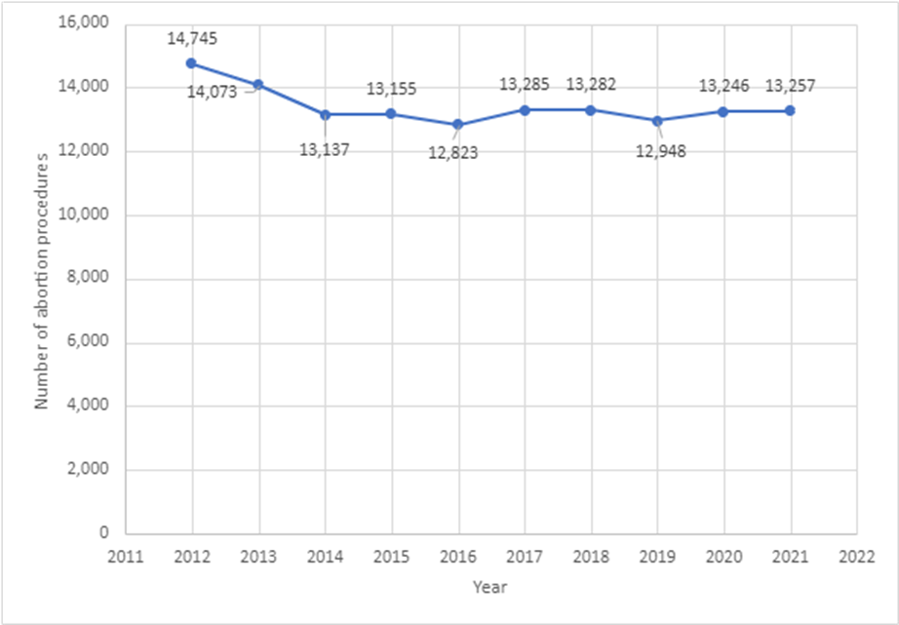

Figure 1-2: Number of abortion procedures per 1,000 women aged 15–44 years (general abortion rate), 2012–2021
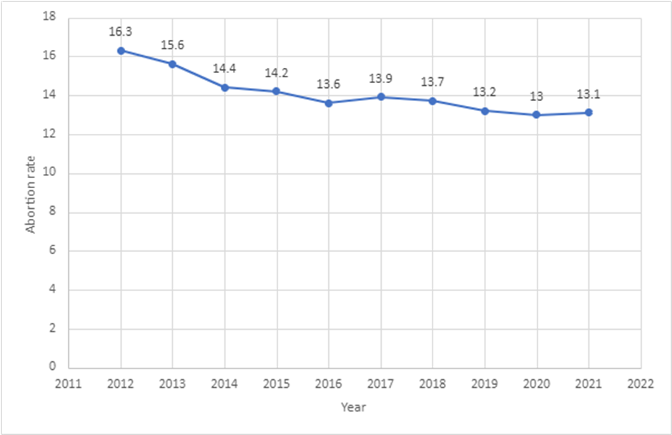
Figure 1-3: Number of abortion procedures per 1,000 known pregnancies (abortion ratio), 2012–2021
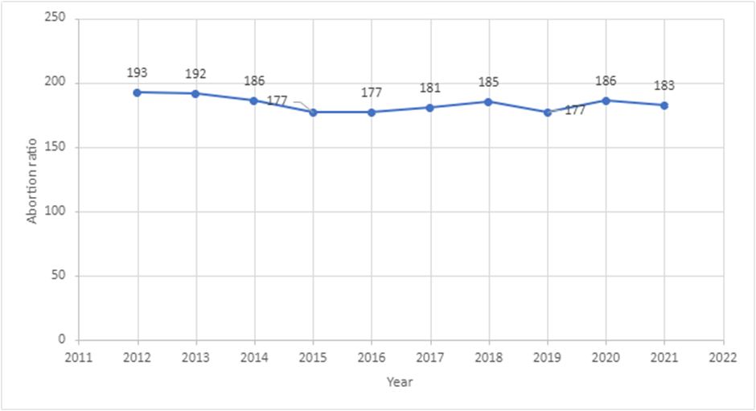

Figure 1-4: Number of abortion procedures by age group, 2012–2021
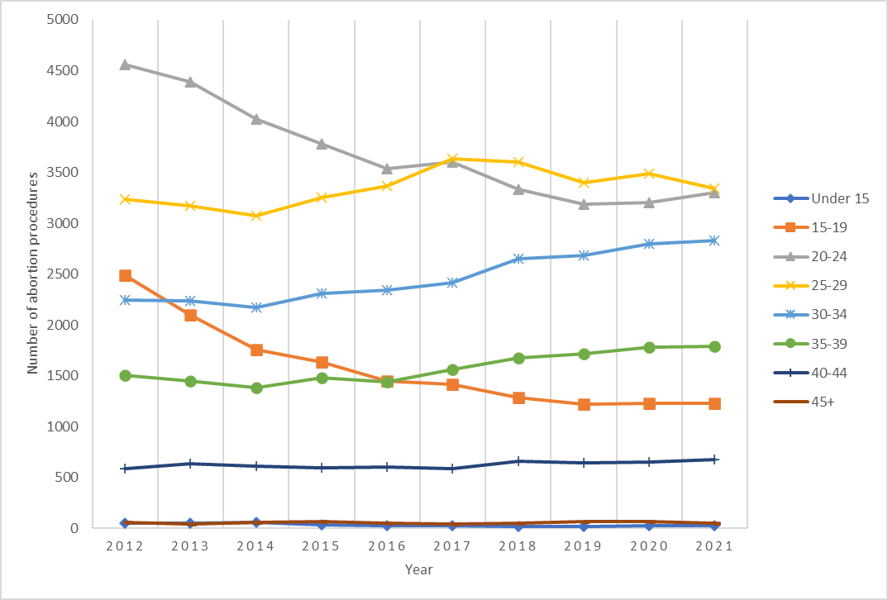

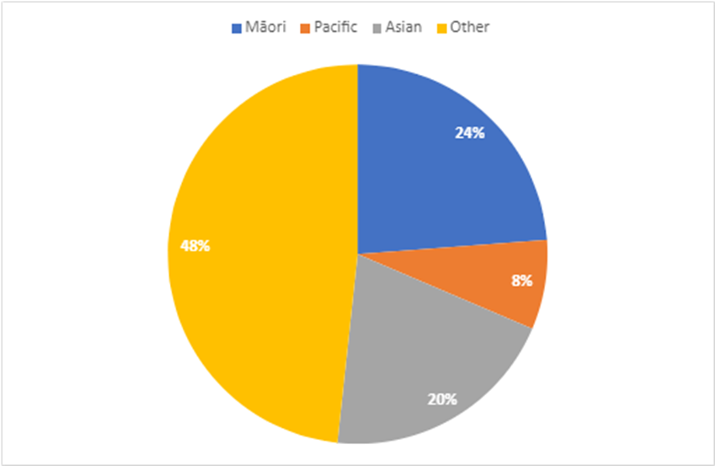
Figure 1-5: Total number of abortion procedures by ethnicity, 2021

Figure 1-6: Number of abortion procedures by ethnicity, 2020 and 2021
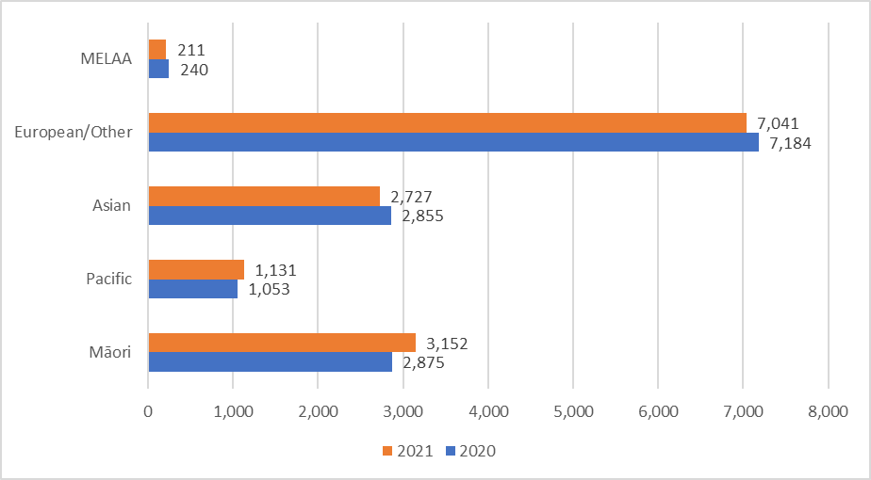
Note: MELAA = Middle Eastern, Latin American, and African.

Figure 1-7: Percentage of abortion procedures by age and ethnicity, 2021
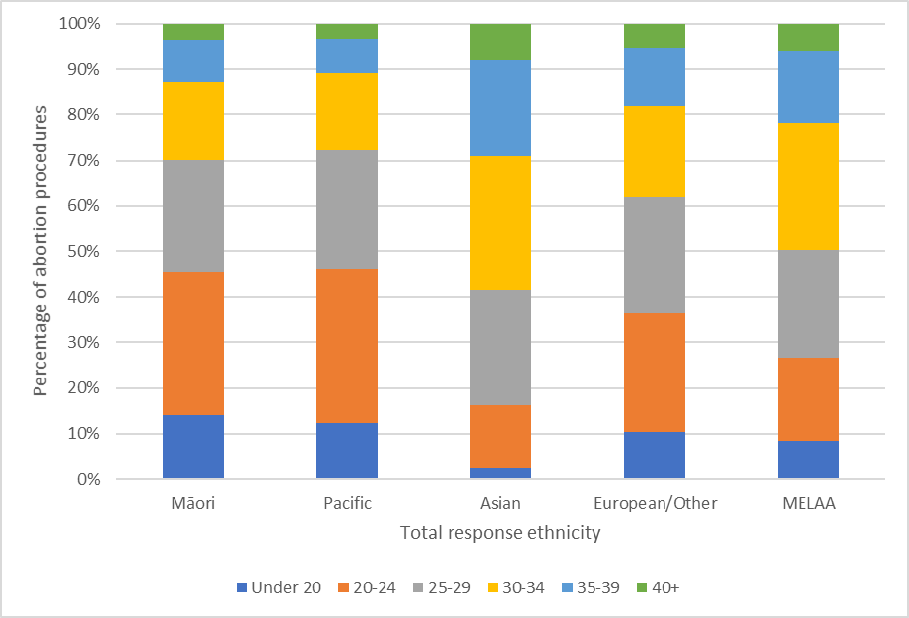
Note: MELAA = Middle Eastern, Latin American, and African.

Figure 1-8: Average gestation at time of abortion procedure by ethnicity, 2020 and 2021
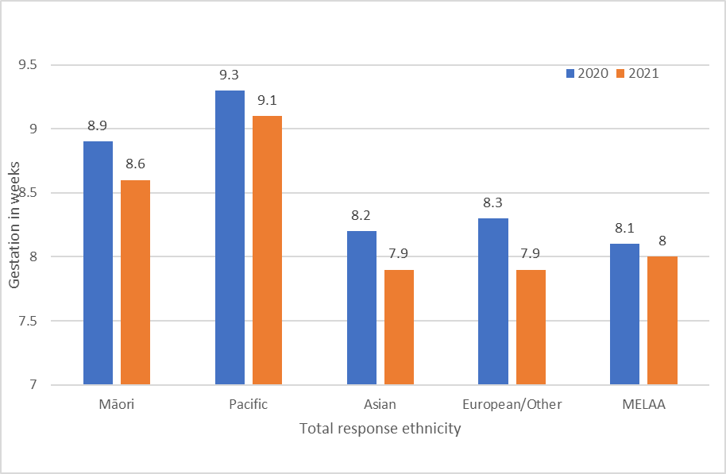
Note: MELAA = Middle Eastern, Latin American, and African.

Table 1-1: Number of abortion procedures by patient residency status, 2021
Residency status | Number
Resident | 12,273
Non-resident | 972
Not stated | 12
Total abortion | 13,257

Figure 1-9: Number of abortion procedures by level of socioeconomic deprivation, 2021
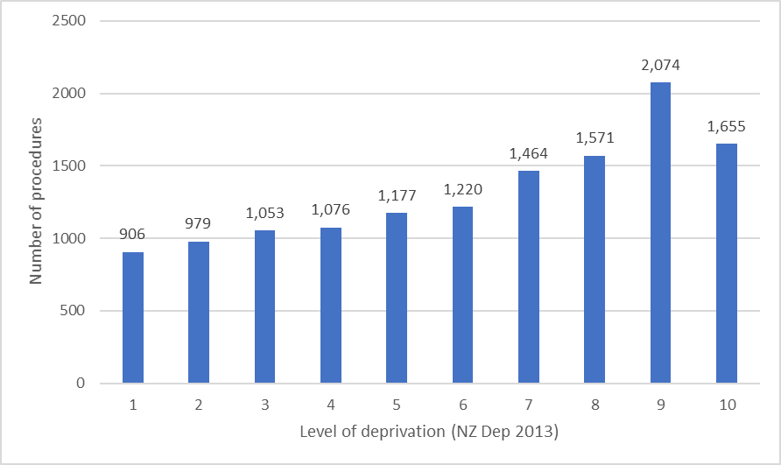

Figure 1-10: Average gestation at time of abortion by level of socioeconomic deprivation, 2021
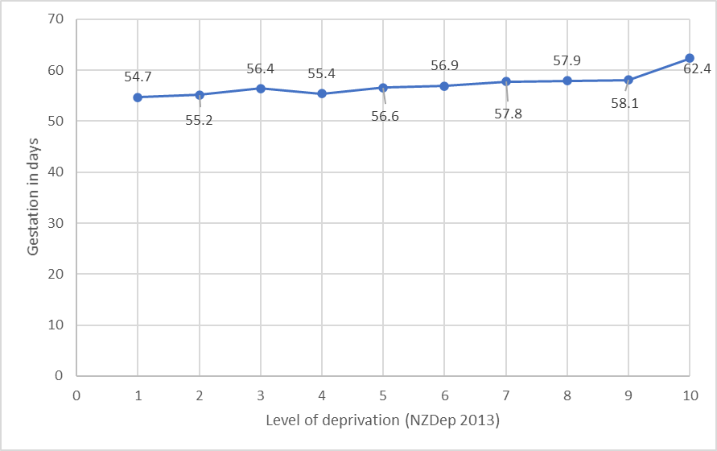

Te aronga ki te Māori | Section 2: Responsiveness to Māori

This section highlights differences between Māori and non-Māori, non-Pacific people in accessing abortions related to where they live, their age and type of abortion procedure. Sections 3 to 8 give more information on the performance of abortion services for Māori. Future annual reports will expand the ‘Responsiveness to Māori’ section to improve monitoring of progress for Māori, and to ensure that all parts of our services are responsive to Māori.

Our intention is to achieve equitable abortion health outcomes for Māori by monitoring progress and following up on actions abortion services take to improve equity. In partnership with Te Apārangi and Te Aka Whai Ora, Manatū Hauora will develop Māori equity goals that we can report on in subsequent annual reports and for the 5-year review.

In 2021, Māori were accessing abortion at higher rates than non-Māori, non-Pacific people in most regions of Aotearoa (Figure 2-1). However, abortion rates were lower for Māori in Counties Manukau, an area where a high proportion of Māori live and where no first-trimester abortion services are available. The data may be indicating that the requirement to travel to Auckland for abortion services has disproportionately impacted Māori access.

Māori tend to have abortions at a younger age than the non-Māori, non-Pacific group. In 2021, the mean age for Māori to access abortion was 26 years, compared with 29 years for the non-Māori, non-Pacific group. Across all age groups, the peak for Māori accessing abortion occurred earlier (at 20–24 years) than for non-Māori, non-Pacific people (25–29 years) (Figure 2-2).

In 2021, 61% of Māori had a surgical abortion procedure compared with 50% of the non- Māori, non-Pacific group (Figure 2-3). The finding that Māori are accessing abortion services at a later gestation on average may explain some of this difference, as EMA is only available up to 9-or 10-week gestation. It will be important to monitor trends now that DECIDE is delivering the national telehealth EMA service and as more locally based first-trimester in-person services become available.
Figure 2-1: Abortion rate by region of domicile, Māori versus non-Māori, non-Pacific, 2021
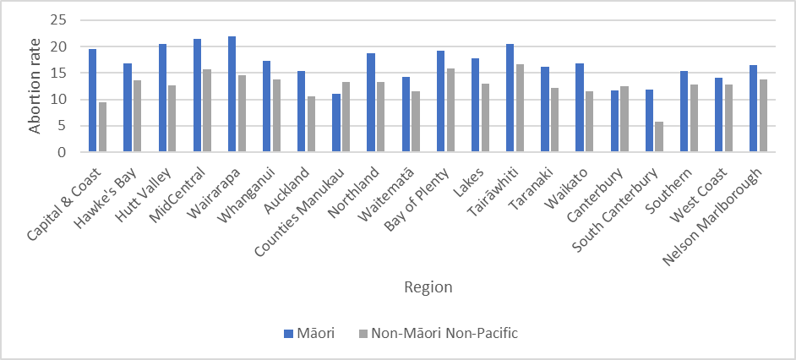

Figure 2-2: Number of abortion procedures by age group, Māori versus non-Māori, non-Pacific, 2021
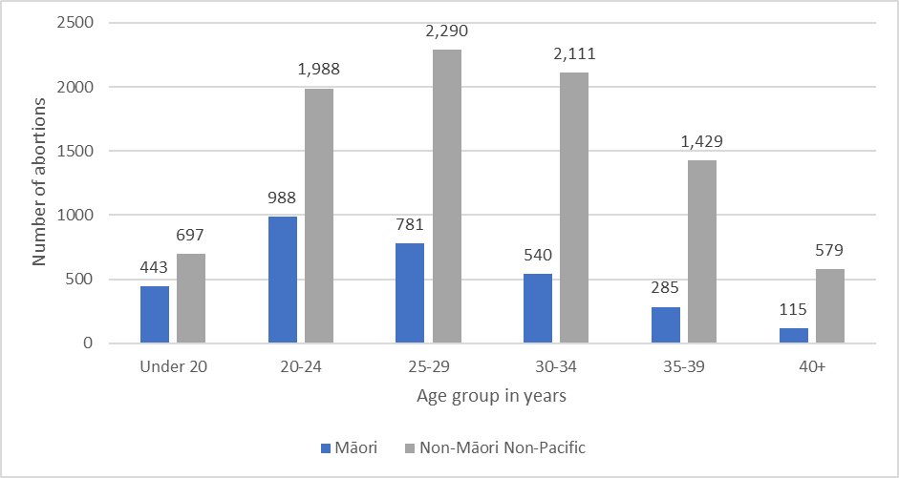

Figure 2-3: Number and percentage of abortion procedures by type of procedure, Māori versus non-Māori, non-Pacific, 2021
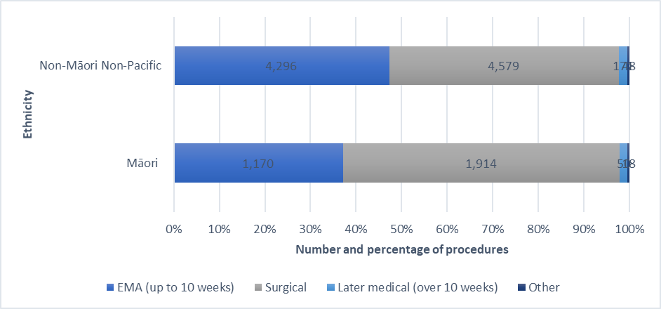

Ngā tukanga whakatahe | Section 3: Types of abortion procedures
The trend of increasing EMAs and decreasing surgical abortions continues. In 2021 EMAs (performed up to 10 weeks’ gestation) increased by 5%, and surgical abortion decreased by 5% compared with the previous year. In total, 43.8% (5,811) of all abortion procedures were EMAs in 2021, compared with 38.1% (5,049) in 2020. In total 53.5% (7,133) of all abortion procedures were surgical in 2021, compared with 58.9% (7,807) in 2020. Later medical abortion accounted for just 1.8% of all abortions, with numbers remaining static since 2017 (Figure 3-1).

Analysis of people accessing abortion services based on the region where they live shows some significant differences. In 2021, 90.9% of those living in the West Coast and 74.1% of those living in the greater Wellington region who accessed an abortion had a surgical abortion, compared with only 10.2% of people living in Taranaki and 12.7% of people living in South Canterbury who had an abortion (Figure 3-2).

These differences may reflect differences in how services are set up in different regions and what services are available. Those having to travel significant distances for services face practical considerations that influence their decisions. For example, a first-trimester surgical procedure typically takes 15–20 minutes compared with several hours for an EMA. So West Coast patients who must travel the considerable distance to Canterbury for an abortion may be more likely to choose a surgical abortion so they can return home the same day rather than stay overnight in Christchurch.

Looking at abortion procedures by region of service shows that similar numbers of procedures were performed in 2021 compared with 2020. The largest service decrease occurred in Canterbury and the largest service increase in the Bay of Plenty (Figure 3-3 and Table 3-1).

Figure 3-1: Number of abortion procedures by procedure type, 2017–2021
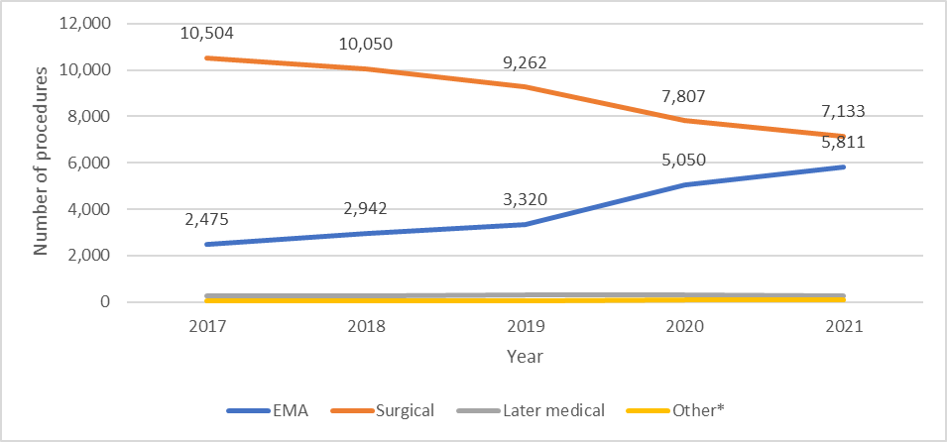
Note: * Other abortion types include failed abortion, a secondary abortion following a failed abortion, and reports with procedure type missing. EMA = early medical abortion.

Figure 3-2: Number of abortion procedures by procedure type and region of domicile, 2021
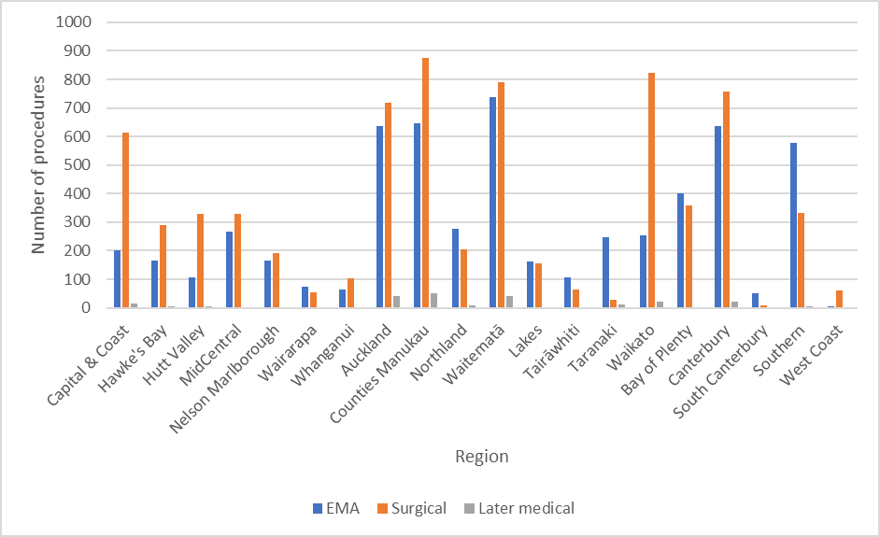
Note: EMA = early medical abortion.

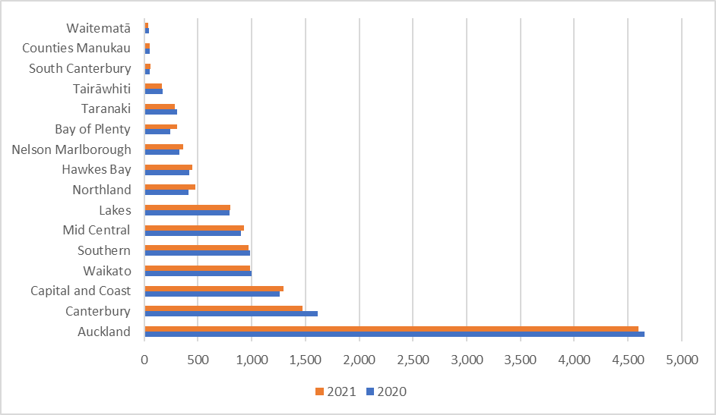
Figure 3-3: Number of abortion procedures by region of service, 2020 and 2021

Table 3-1: Number of abortion procedures by region of service, 2020 and 2021
Region | 2020 | 2021
Auckland | 4,656 | 4,597
Canterbury | 1,612 | 1,470
Capital & Coast | 1,259 | 1,297
Waikato | 997 | 989
Southern | 987 | 969
MidCentral | 902 | 932
Lakes | 794 | 802
Northland | 413 | 480
Hawke’s Bay | 420 | 446
Nelson Marlborough | 328 | 364
Bay of Plenty | 246 | 305
Taranaki | 304 | 283
Tairāwhiti | 172 | 167
South Canterbury | 55 | 57
Counties Manukau | 53 | 53
Waitematā | 45 | 40

Te whakatahe i roto i te ara whakaputa uri | Section 4: Abortion within the reproductive journey
Overall, the number of people with no previous live birth who had an abortion was similar in 2021 to previous years. Breaking down this data by ethnicity shows that 30.9% of Māori accessing abortion had no previous live birth compared with 40.3% of Pacific peoples, 38% of Asian people and 47.9% of the European/other group (Figure 4-1).

The number of people overall who had their first abortion in 2021 was also consistent with previous years. An analysis by ethnicity shows that 57.2% of Māori accessing abortion had no previous abortion, compared with 66.6% of Pacific peoples, 68.6% of Asian people and 62.3% of the European/other group (Figure 4-2).

Figure 4-1: Abortion procedures and number of previous live births by ethnicity, 2021
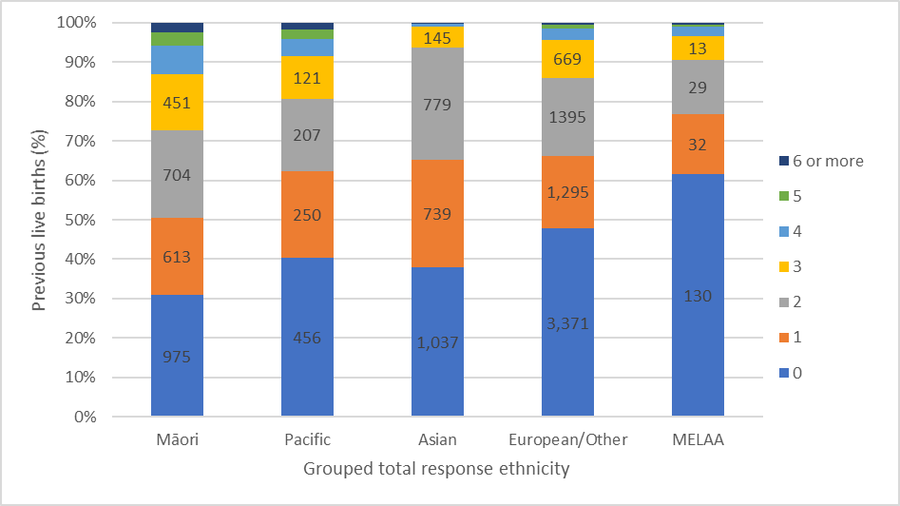
Note: MELAA = Middle Eastern, Latin American, and African.
Figure 4-2: Abortion procedures and number of previous abortions by ethnicity, 2021
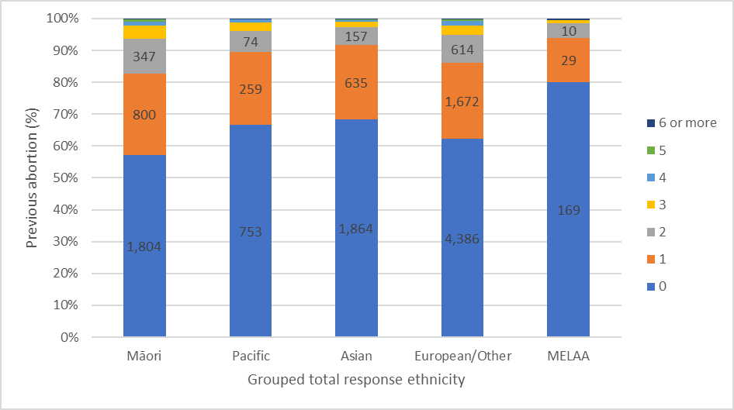
Note: MELAA = Middle Eastern, Latin American, and African.

Te āheinga ki te whakatahe me ngā ārai hapūtanga | Section 5: Abortion and access to contraception
Of those having an abortion in 2021, 64.8% had not been using any contraception, with a small percentage (0.3%) of these reporting not using contraception due to planning a pregnancy. 17.9% of people reported using condoms as contraception, with a further 6.8% of people taking the combined oral contraceptive pill at the time they became pregnant.

This year providers were given greater choice for reporting contraception provision. This included an option for providers to report when they had booked a follow up contraception appointment for a person, to better capture post-abortion contraception behaviours especially as EMA procedures increase resulting in more follow up appointments being required for some types of contraceptives.

Using this updated reporting 73% of people having an abortion were provided some form of contraception at the time of the abortion, with a further 2% being booked or referred for a post-abortion follow up contraception appointment or provided information about fertility awareness methods. The remaining 25% were not provided any contraception (or contraception provision was unknown). This latter group included people planning another pregnancy, those already with contraception, and those choosing to see another provider for contraception, as well as people not attending a follow up contraception appointment.

Many health sector providers and researchers have expressed concern that the increase in EMA provision has resulted in a decrease in Long-Acting Reversible Contraception (LARC) provision at the time of abortion, and consequently this could result in an increase in further unintended pregnancies. This is because although LARC is one of the most effective forms of contraception, insertion of LARC intra-uterine system (IUS) into the uterus cannot occur at the time of an EMA abortion and requires a follow up appointment. LARC IUS can be provided at the time of a first trimester surgical abortion. LARC includes IUS such as Mirena as well as subdermal implants such as Jadelle.

Analysis shows that of those having EMA in 2021 only 12.6% were provided LARC at the time of the abortion, with a further 9.4% booked for LARC at a follow up appointment. One third (33.4%) of those having EMA were not provided any form of contraception or booked for a follow up appointment.

In comparison, over half (53.6%) of those having surgical abortion were provided LARC at the time of the abortion, with only 12.1% not provided any form of contraception or booked for a follow up appointment.

Analysis of LARC provision by region shows that those in the West Coast, Greater Wellington and Lakes, have the highest percentage of LARC provision at the time of abortion. Those in Taranaki, Wairarapa and Northland, have the lowest percentage of LARC provision at the time of abortion. High LARC provision aligns with regions of high surgical provision, and low LARC provision aligns with regions with high EMA provision.

The data shows that LARC IUS is provided in most cases where LARC is provided post-abortion. As almost all abortion providers reported providing both subdermal implants and LARC IUS in 2021, training/availability of subdermal implants does not appear to be the reason for the low uptake. The low uptake of subdermal implants may be due to people not wishing to have this form of contraception rather than lack of provider ability to provide it.

Analysis of LARC provision by ethnicity shows that Māori and Pacific people have the highest LARC provision at the time of abortion. This is consistent with the data showing Māori and Pacific people had more surgical abortion procedures than other ethnic groups (see Section 2 for Māori data).

Table 5-1: Types of contraception used at time of conception, 2021
Contraception used | Number | Percentage  (%)
None** | 8,597 | 64.8
Condoms | 2,371 | 17.9
Combined oral contraceptive pill | 908 | 6.8
Progesterone-only contraception, not further defined | 307 | 2.3
Fertility awareness methods | 203 | 1.5
Emergency contraception, not further defined | 142 | 1.1
Progesterone-only oral contraceptive pill | 131 | 1
Progesterone-only depot injection | 91 | 0.7
Unknown | 71 | 0.5
Intra-uterine contraceptive device without hormones | 68 | 0.5
Emergency contraceptive pill | 60 | 0.5
Emergency contraception, not further defined, and condoms | 56 | 0.4
Intra-uterine contraceptive device with hormones | 40 | 0.3
Condoms and fertility awareness methods | 38 | 0.3
Other | 27 | 0.2
Subdermal contraceptive implant | 26 | 0.2
Copper intra-uterine device contraception | 25 | 0.2
Condoms and emergency contraceptive pill | 20 | 0.2
Condoms and combined oral contraceptive pill | 15 | 0.1
Other* | 61 | 0.5
Total | 13,257 | 100
Note: * ‘Other’ includes all categories with fewer than 10 reported cases.
** ‘None’ includes 29 cases reported as a planned pregnancy.

Figure 5-1: Percentage of people provided with contraception at time of abortion, all contraception types, 2021
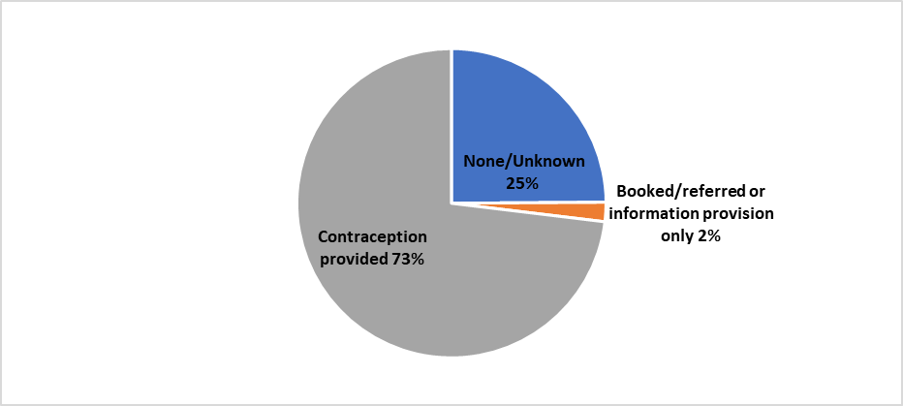

Table 5-2: Contraception provided at time of abortion by type, number, and percentage of total abortion 2021
Contraception provided at time of abortion | Number | Percentage of total abortion (%)
Intra-uterine contraceptive device, not further defined | 2,131 | 16.1
Condoms | 1,769 | 13.3
Combined oral contraceptive pill | 1,694 | 12.8
Intra-uterine contraceptive device with hormones | 1,141 | 8.6
Subdermal contraceptive implant | 1,038 | 7.8
Progesterone-only depot injection | 739 | 5.6
Progesterone-only oral contraception, not further defined | 392 | 3
Copper intra-uterine device contraception | 224 | 1.7
Progesterone-only oral contraceptive pill | 186 | 1.4
Combined oral contraceptive pill and condoms | 48 | 0.4
LARC, not further defined | 42 | 0.3
Condoms and emergency contraceptive pill | 35 | 0.3
Condoms and booked/referred partner sterilisation | 33 | 0.2
Partner sterilisation | 28 | 0.2
Condoms and booked/referred for LARC (IUS) | 26 | 0.2
Condoms and progesterone-only oral contraceptive pill | 21 | 0.2
Intra-uterine contraceptive device, not further defined, and condoms | 21 | 0.2
Condoms and progesterone-only contraception, not further defined | 18 | 0.1
Condoms and booked/referred for sterilisation | 14 | 0.1
Condoms and booked/referred progesterone-only depot injection | 11 | 0.1
Emergency contraceptive pill | 10 | 0.1
Other* | 68 | 0.5
Total contraception provided | 9,689 | 73.2
Note: * ‘Other’ includes all categories with fewer than 10 reported cases. IUS = intra-uterine system; LARC = long-acting reversible contraception.

Table 5-3: No contraception provided by reason, number, and percentage of total abortion, 2021
No contraception provided at time of abortion or unknown | Number | Percentage of total abortion (%)
None** | 2,389 | 18
None, declined contraception | 358 | 2.7
None, follow-up booked | 312 | 2.4
None to follow up with GP or other provider | 139 | 1
None patient already had contraception | 80 | 0.6
None did not attend follow up contraception appointment | 16 | 0.1
Other* | 7 | 0
Total none/unknown | 3,301 | 24.8
Note: * ‘Other’ includes all categories with fewer than 10 reported cases.
** ‘None’ includes 27 cases reported as a planned pregnancy.

Table 5-4: Bookings/referrals by and information provision by type, number, and percentage of total abortion, 2021
Booked/referred or information provision only at time of abortion | Number | Percentage of total abortion (%)
Booked/referred for LARC (IUS) | 127 | 1
Booked/referred for LARC, not further defined | 72 | 0.5
Booked/referred for sterilisation | 20 | 0.2
Fertility awareness methods information | 16 | 0.1
Booked/referred for LARC (implant) | 13 | 0.1
Other* | 19 | 0.1
Total booked/referred or information provision only | 267 | 2
Note: * ‘Other’ includes all categories with fewer than 10 reported cases. IUS = intra-uterine system; LARC = long-acting reversible contraception.

Figure 5-2: Percentage of people receiving LARC contraception provision by procedure type, 2021
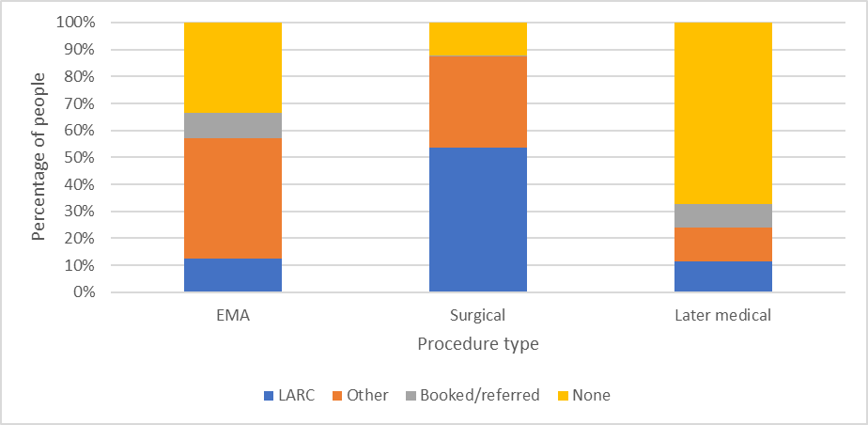
Note: EMA = early medical abortion; LARC = long-acting reversible contraception.

Table 5-5: Number of people receiving LARC contraception provision by procedure type, 2021
Procedure* | LARC | Other | Booked/referred | None | Total
EMA | 734 | 2,591 | 546 | 1,940 | 5811
Surgical | 3,820 | 2,411 | 36 | 866 | 7133
Later medical | 28 | 30 | 21 | 163 | 242
Total | 4,582 | 5,032 | 603 | 2,969 | 13,186
Note: * Excludes ‘other’ procedure type. EMA = early medical abortion; LARC = long-acting reversible contraception.

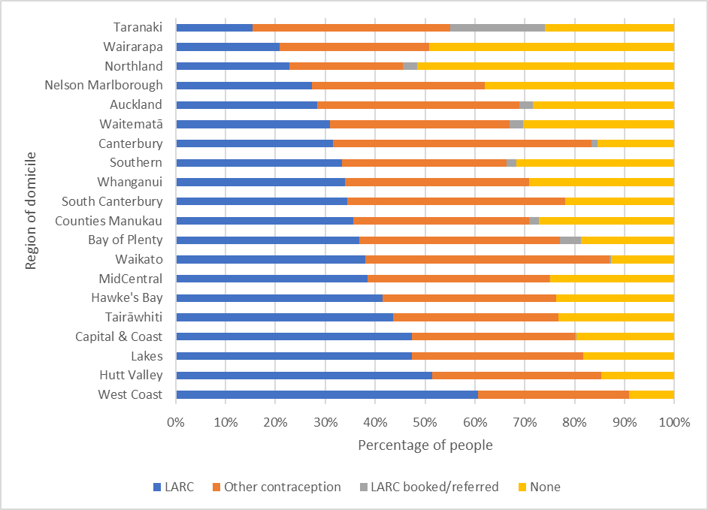
Figure 5-3: Percentage of people provided with LARC by region of domicile, 2021
Note: LARC = long-acting reversible contraception.

Table 5-6: Number and percentage of people receiving LARC provision after an abortion procedure by region of domicile, 2021
Region of domicile | LARC | Other  contraception | LARC booked/  referred | None | Number | Percentage (%)
West Coast | 40 | 20 | 0 | 6 | 66 | 60.6
Hutt Valley | 227 | 150 | 0 | 65 | 442 | 51.4
Lakes | 156 | 113 | 0 | 60 | 329 | 47.4
Capital & Coast | 394 | 272 | 2 | 164 | 832 | 47.4
Tairāwhiti | 75 | 57 | 0 | 40 | 172 | 43.6
Hawke’s Bay | 191 | 161 | 0 | 109 | 461 | 41.4
MidCentral | 232 | 219 | 1 | 150 | 602 | 38.5
Waikato | 421 | 544 | 3 | 141 | 1,109 | 38.0
Bay of Plenty | 283 | 310 | 32 | 144 | 769 | 36.8
Counties Manukau | 562 | 557 | 32 | 428 | 1,579 | 35.6
South Canterbury | 22 | 28 | 0 | 14 | 64 | 34.4
Whanganui | 57 | 62 | 0 | 49 | 168 | 33.9
Southern | 309 | 306 | 18 | 294 | 927 | 33.3
Canterbury | 446 | 736 | 16 | 219 | 1,417 | 31.5
Waitematā | 487 | 567 | 43 | 479 | 1,576 | 30.9
Auckland | 397 | 568 | 37 | 398 | 1,400 | 28.4
Nelson Marlborough | 98 | 124 | 0 | 136 | 358 | 27.4
Northland | 112 | 111 | 14 | 253 | 490 | 22.9
Wairarapa | 27 | 39 | 0 | 64 | 130 | 20.8
Taranaki | 44 | 113 | 54 | 74 | 285 | 15.4
Note: Excludes those whose records were missing a domicile code. LARC = long-acting reversible contraception.

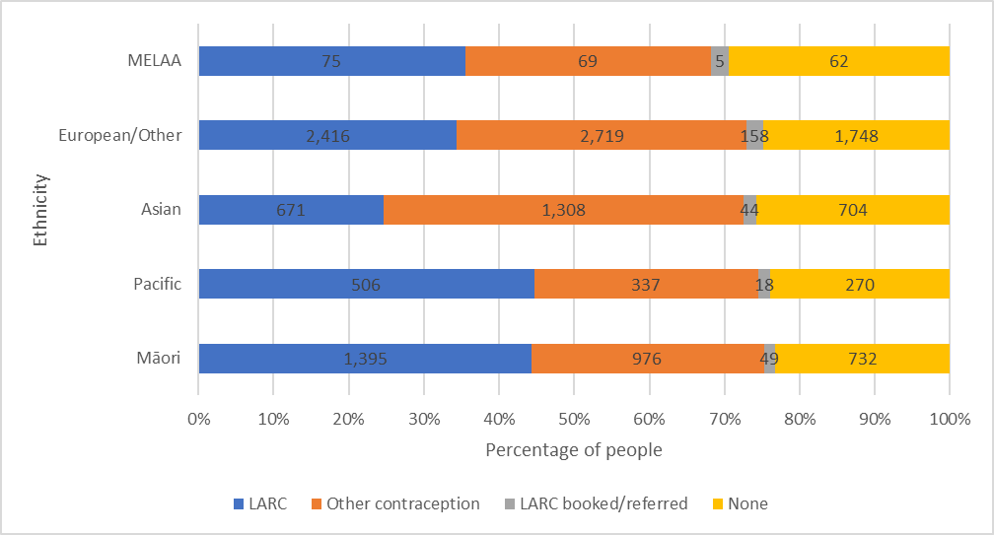
Figure 5-4: Number and percentage of people provided with LARC contraception by ethnicity, 2021
Note: Excludes those whose records were missing ethnicity. LARC = long-acting reversible contraception; MELAA = Middle Eastern, Latin American and African.

Te āheinga ā-matawhenua ki te whakatahe | Section 6: Geographical access to abortion
Figure 6-1 shows the drive time to abortion services across New Zealand in 2021. In that year 59,527 (35%) of the Māori female population (aged 15–44 years) lived more than a 30-minute drive from an abortion service compared with 208,317 (24%) of the non-Māori female population. Another 8,591 (5%) of Māori females and 27,491 (3%) of non-Māori females lived more than a 90-minute drive from an abortion service.

A disproportionate number of people requiring abortion services live in the most socioeconomically deprived areas and so are likely to have less (or no) access to a car. Being a long distance from an abortion service can prove a significant access barrier for some.

Because not all regions of Aotearoa have local first-trimester abortion services, people living in these regions must travel to another region for services. In 2021, all those requiring a first trimester abortion who lived in Waitematā, Counties Manukau, West Coast, Hutt Valley, Whanganui and Wairarapa had to travel out of region for in-person first-trimester abortion services. In addition, all those in the Bay of Plenty requiring a surgical abortion in 2021 (61%) had to travel outside of their region for this service (Figure 6-2).

Having to travel out of region appears to impact timely service access, as people living in regions without local first-trimester services had some of the latest average gestations at the time of the abortion procedure in 2021 (Figure 6-3). Regions with local first-trimester services but where people access abortion later (Waikato, Hawke’s Bay and Auckland) may have longer service wait times due to limited service capacity or additional service access barriers.
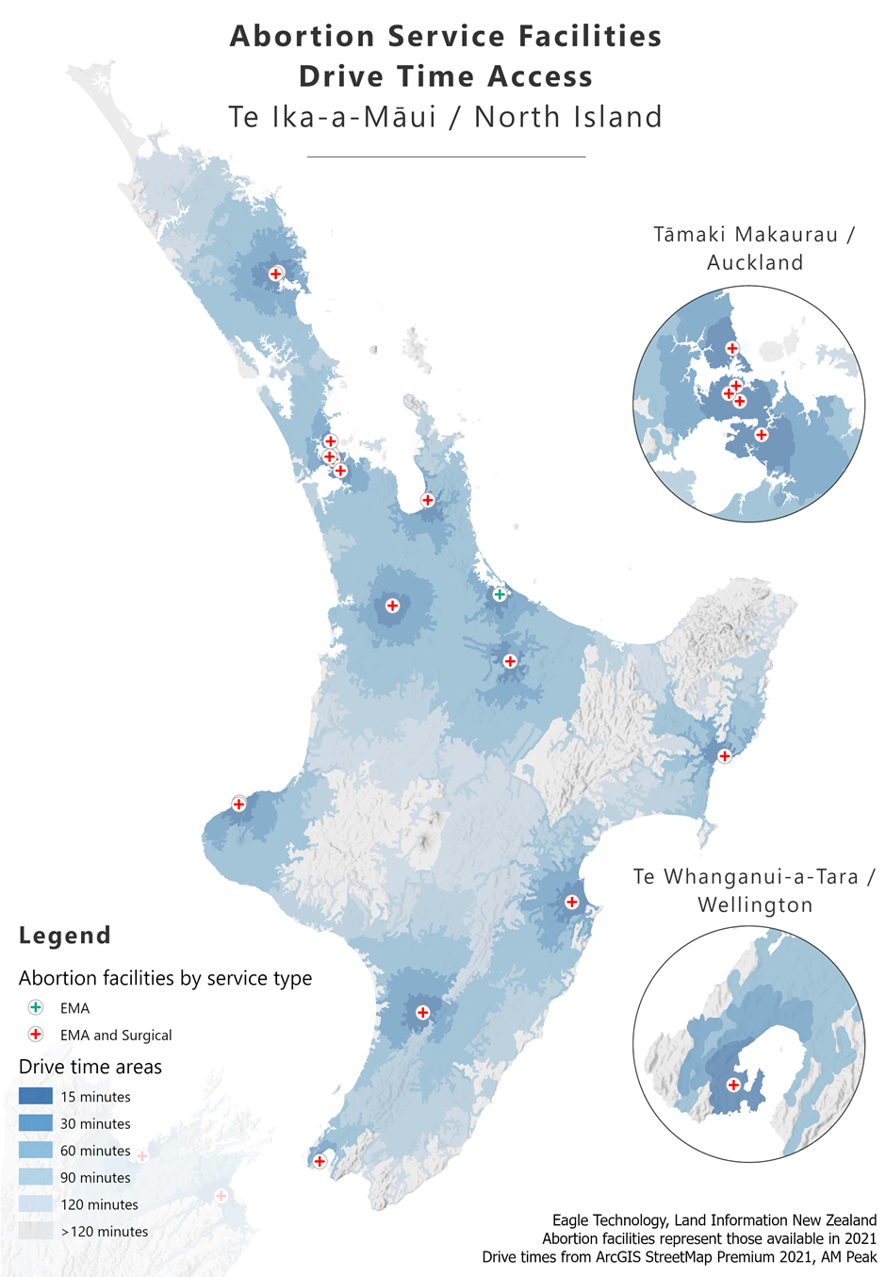
Figure 6-1: Geospatial analysis – patient drive time to services by facility, 2021

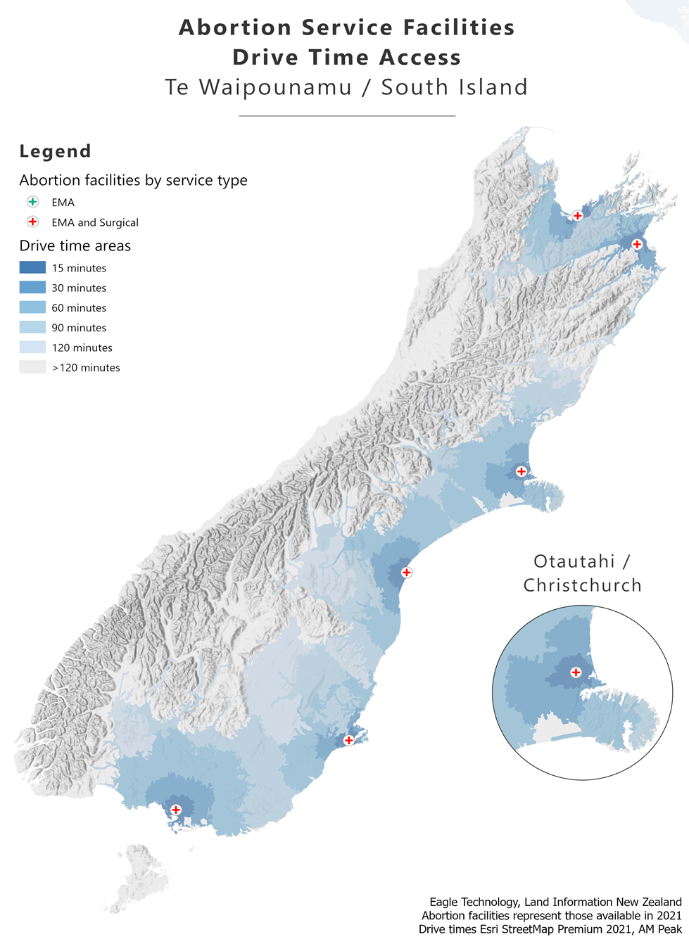

Figure 6-2: Percentage of patients travelling to other regions for abortion procedures, 2021
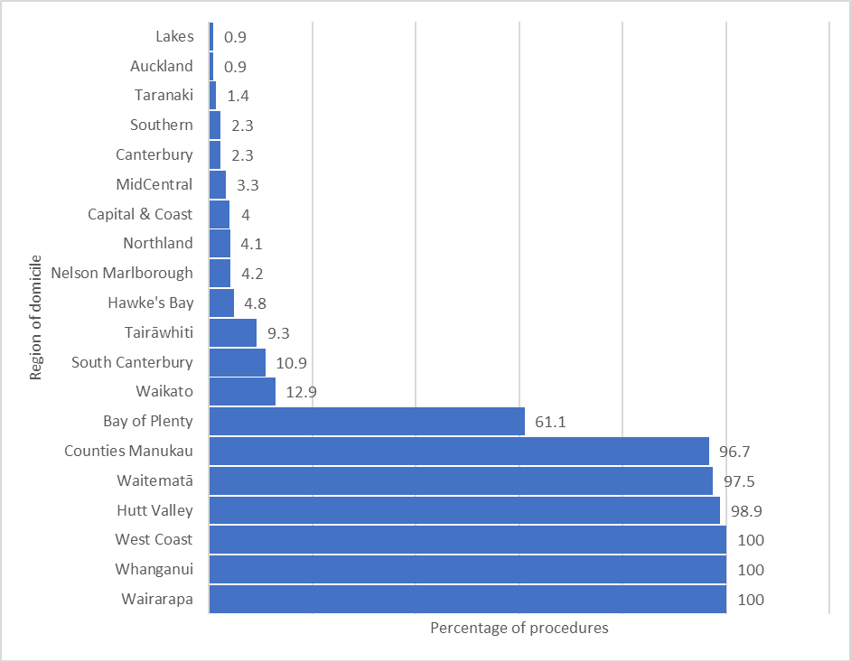
Note: Includes those having EMA via telehealth. Excludes those whose records were missing a domicile code.

Figure 6-3: Average gestation by region of domicile, 2021
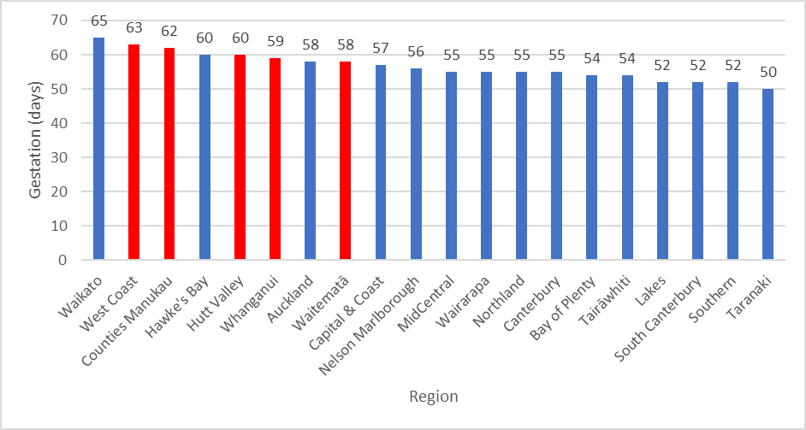
Note: Red = region had no local in-person, first-trimester abortion services in 2021. Blue = Region had local in-person, first-trimester abortion services in 2021.

Ngā uauatanga i pūrongotia i te wā o te whakatahe | Section 7: Complications at time of abortion
In 2021, services reported 161 (1.2%) of all abortion procedures were associated with a complication at the time of the abortion (Table 7-1). By type of abortion procedure, 76 (1.3%) EMA, 37 (0.5%) surgical procedures, and 34 (14%) later medical procedures were associated with a complication. The most commonly reported complication was having a retained placenta or products for medical abortion, and haemorrhage for surgical abortion (Table 7-2).

A small proportion of cases (34) were reported as ‘lost to follow-up’ across five services in 2021. This number is higher than 2020 when only 19 cases were reported as lost to follow-up. Lost to follow-up cases represent those where the person did not attend a booked follow-up appointment or, in the case of EMA, could not be contacted to confirm the abortion had been completed. Māori represented 58.8% (20) of all lost to follow-up cases.

Figure 7-1 and Table 7-3 show that the rate of complications increases with age. Those who had an abortion at over 40 years of age experienced the most complications in 2021.

Table 7-1: Number and percentage of complications at the time of abortion by type of complication, 2021
Complication type | Number | Percentage (%)
None | 13,062 | 98.8
Retained placenta/products | 79 | 0.6
Haemorrhage | 29 | 0.2
Haemorrhage and retained products | 9 | 0.1
Pain | 9 | 0.1
Failed abortion | 5 | 0.0
Perforation of uterus | 4 | 0.0
Cervical tear | 2 | 0.0
Infection | 2 | 0.0
Retained placenta/products and other | 1 | 0.0
Retained placenta/products and infection | 1 | 0.0
Vaginal laceration | 1 | 0.0
Other | 19 | 0.1
Total | 13,223 | 100.0
Note: In 34 cases, the person was lost to follow-up, so the outcome is unknown.

Table 7-2: Number of complications at the time of abortion by procedure type, 2021
Complication type | EMA | Surgical | Later medical | Other | Total
None | 5,704 | 7,094 | 208 | 56 | 13,062
Retained placenta/products | 44 | 6 | 18 | 11 | 79
Haemorrhage | 6 | 13 | 8 | 2 | 29
Haemorrhage and retained products | 1 | 0 | 7 | 1 | 9
Pain | 6 | 3 | 0 | 0 | 9
Failed abortion | 4 | 1 | 0 | 0 | 5
Perforation of uterus | 0 | 4 | 0 | 0 | 4
Cervical tear | 0 | 2 | 0 | 0 | 2
Infection | 2 |  | 0 | 0 | 2
Retained placenta/products and other | 0 | 1 | 0 | 0 | 1
Retained placenta/products and infection | 1 | 0 | 0 | 0 | 1
Vaginal laceration | 0 | 0 | 1 | 0 | 1
Other | 12 | 7 | 0 | 0 | 19
Total reported | 5,780 | 7131 | 242 | 70 | 13,223
Lost to follow-up | 31 | 2 | 0 | 1 | 34
Note: EMA = early medical abortion.

Figure 7-1: Percentage of complications at the time of abortion by age group, 2021
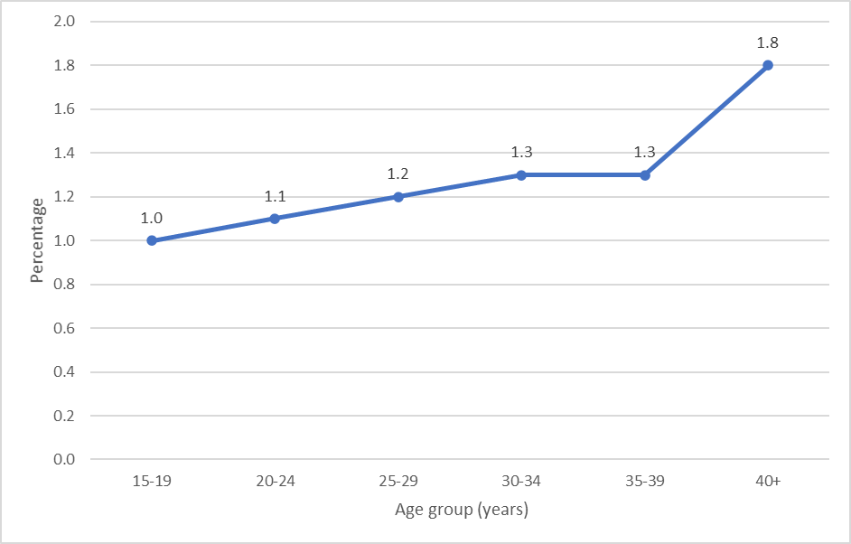

Table 7-3: Number and percentage of complications at the time of abortion by age group, 2021
Age group (years) | Number of  abortions | Number of complications | Percentage (%) of complications
15–19 | 1,232 | 12 | 1.0
20–24 | 3,303 | 36 | 1.1
25–29 | 3,339 | 41 | 1.2
30–34 | 2,829 | 36 | 1.3
35–39 | 1,792 | 23 | 1.3
40+ | 732 | 13 | 1.8
Note: Excludes those whose records were missing age.

Ngā kaimahi whakatahe | Section 8: Abortion workforce
Across Aotearoa, the abortion workforce consisted of 63 (38.9%) medical staff and 99 (61.1%) nurses in 2021 (Table 8-1). The majority of the workforce, 109 (67.2%) were of European or other ethnicity and almost one-quarter, 38 (23.5%) were Asian, while only 7 (4.3%) were Māori and 5 (3.1%) were Pacific peoples. The vast majority of the workforce 140 (86.4%) was female. The Northern region (Auckland metro region and Northland) had the most ethnically diverse workforce (Table 8-3).

About 40 social workers and 5 counsellors were associated with abortion services and providing in-house abortion counselling. All offered both pre- and post-abortion counselling, which was generally available both in-person and virtually. Now that abortion counselling is no longer mandatory, it will be important to monitor demand for abortion counselling, as well as how this impacts workforce numbers and wait times for services. We will report on these trends further next year.

As the majority (over 95%) of the workforce is non-Māori but Māori represent almost a quarter of service users, it is vitally important that the workforce is culturally safe for Māori, as well as people of other cultures using abortion services.

Reporting on cultural competency training in 2021 highlighted that in seven services no staff had any cultural competency training during the year. Other services reported at least one staff member had some form of cultural competency training, ranging from a single webinar to a more extensive training.

As well as encouraging the workforce to undertake cultural competency training, abortion service providers should consider active recruitment strategies targeting Māori health practitioners (medical, nursing and midwifery) and other minority ethnicities to increase the cultural diversity of their workforce. Ngā Paerewa, published by Manatū Hauora in 2021, outlines the expected standard for workforce cultural competency. The national first-trimester abortion training that Manatū Hauora supports and funds has cultural competency at its core and is freely available to health practitioners.

Table 8-1: National abortion workforce (medical, nursing and midwifery) by region and registered profession, 2021
Region | Medical | Nursing | Midwifery | Total by region
Central | 10 | 6 | 0 | 16
Northern | 24 | 60 | Unknown* | 84
Te Manawa Taki | 11 | 13 | 2 | 26
Te Waipounamu | 14 | 9 | 0 | 23
Region unclear | 4 | 9 |  | 13
Total by profession | 63 | 97 | 2 | 162
*Number of this workforce reported as unknown

Table 8-2: National abortion workforce (medical, nursing and midwifery) by region and ethnicity, 2021
Region | Māori | Pacific | Asian | Other | Not disclosed | Total by region
Central | 1 | 0 | 0 | 15 | 0 | 16
Northern | 4 | 5 | 35 | 40 | 0 | 84
Te Manawa Taki | 1 | 0 | 2 | 23 | 0 | 26
Te Waipounamu | 0 | 0 | 1 | 19 | 3 | 23
Region unclear | 1 | 0 | 0 | 12 | 0 | 13
Total by ethnicity | 7 | 5 | 38 | 109 | 3 | 162

Table 8-3: National abortion workforce (medical, nursing and midwifery) by region and gender, 2021
Region | Female | Male | Gender diverse | Not disclosed | Total by region
Central | 11 | 5 | 0 | 0 | 16
Northern | 76 | 8 | 0 | 0 | 84
Te Manawa Taki | 24 | 2 | 0 | 0 | 26
Te Waipounamu | 19 | 0 | 3 | 1 | 23
Region unclear | 10 | 3 | 0 | 0 | 13
Total by gender | 140 | 18 | 3 | 1 | 162

Ngā pātai whakatahe me te whakatahe kāore i oti noa | Section 9: Abortion enquiries and non-completed abortion
2021 was the first-year services were asked to report on cases where a person changed their mind and decided not to proceed with the abortion at some stage following an initial consultation. Some services did not capture this data because the new regulations only came into effect on 24 September 2021. Fifteen services did report that at least one patient chose not to proceed, with three services reporting more than 100 patients choosing not to proceed during 2021. The average consultation time spent on each case where a person chose not to proceed was 1 hour and 9 minutes (range of 20 minutes to 2.5 hours).

2021 was the first year that services were asked to report on the number of cases where they refused to provide an abortion. Some services did not capture this data for the year. Among those that reported on this area, the main reason for refusing services was that they were not able to provide the service required. This was either because the person presented at a later gestation of pregnancy than the service provided abortion for, or the person required a surgical service when the service only provided EMA.

During 2021 seven services reported that they refused to provide an abortion for a viable, ongoing pregnancy and made no referral to another service. Of the seven services, there were between one and nine service refusals reported. Reasons services gave for these refusals generally were that the pregnancy was of later gestation and services either decided an abortion was not clinically appropriate or were not able to provide the abortion due to limited-service availability.

Five services reported receiving enquiries for sex-selection abortion during 2021. Three services noted it is hard to determine if sex selection is the reason for the abortion as people did not ask for an abortion solely because they prefer a particular fetal sex.

Ngā kōrero mō te whakarōpūtanga mātāwaka i whakamahia i tēnei pūrongo | Notes on ethnicity classification used in this report
Prioritised ethnicity. Each person is allocated to a single ethnic group. If their record lists more than one ethnicity, the person is classified as Māori if one of their recorded ethnicities was Māori (for example, a person identifying as both Māori and New Zealand European is counted as Māori). Ethnicity is recorded in the following order: Māori Pacific, Asian and European/other.

Total response ethnicity. Each person is reported within all groups they have identified with. This report uses the following categories: Māori; Pacific peoples; Asian; Middle Eastern, Latin American and African (MELAA); and European/other. A person belonging to more than one ethnic group is counted once in each group. For example, a person of Samoan, Tongan and German ethnicity would be counted once in the category of Pacific peoples and once in the category of European/other.

Māori compared with non-Māori, non-Pacific. Each person, other than Pacific peoples, is allocated to a single ethnic group: either Māori or non-Māori, non-Pacific based on the ethnic groups they identify with. A person is classified as Māori if one of their recorded ethnicities was Māori. All people not identifying with either a Māori or a Pacific ethnicity are classified as non-Māori, non-Pacific and represent a comparator or reference group. As Pacific peoples experience inequity, they are not included in the comparator group.

Ngā kōrero raraunga ahuwhānui | General data notes
Data in this report comes from abortion notification reporting and annual abortion provider reports. The statistics presented are for the 2021 calendar year, along with some data from previous years for comparison and to show trends.

For comparisons of Māori and non-Māori, non-Pacific, and where prioritised ethnicity has been used, the population data used as the denominator to calculate rates comes from Stats NZ, which it provided to Manatū Hauora in July 2021. This data consists of population projections for women resident in New Zealand as of 30 June 2021 by prioritised ethnic group, age and gender, which is the breakdown we needed for our analysis.

The general abortion rate is the number of abortions per 1,000 of the mean estimated population of women aged 15–44 years. The mean estimated population of women aged 15–44 years comes from the Stats NZ estimated resident population for the mean year ended 31 December 2021. This information was downloaded from the Stats NZ Info share website in August 2022.

Drive time estimates used the total female population aged 15–44 years from the Health Service Utilisation (HSU) population data set 2021. The HSU 2021 is a count of the number of people who used health services between 1 January and 31 December 2021. It was used as the denominator because Stats NZ does not produce population estimates at this granular level, and the HSU can be used to calculate population estimates by small area units, age and gender.

The New Zealand Index of Deprivation 2013 (NZDep2013) was used to determine the deprivation decile linked to each abortion procedure using the mesh block or domicile code data of the person accessing the service. The decile is for the area where the person lives rather than for that individual specifically.

The 2020 procedure data in this report contain some slight differences from the 2021 Annual Abortion Report. These occur because updates from providers allowed us to reclassify a small number of abortions from missing procedures to medical or surgical procedures.

Note the abortion statistics represent all abortion procedures reported to Manatū Hauora as occurring in the 2021 calendar year and received by 30 June 2022. In most cases they represent completed abortions; however, this report also includes 5 cases of failed abortions in 2021.

Ngā kupu matua | Key terms
Central (region). Te Whatu Ora region representing Capital & Coast, Hawke’s Bay, Hutt Valley, MidCentral, Nelson Marlborough, Wairarapa and Whanganui regions.

Decile. Decile 1 represents the 10% of areas in Aotearoa with the lowest level of socioeconomic deprivation on the New Zealand Index of Deprivation 2013. Decile 10 represents the 10% of areas with the highest level of deprivation on NZDep2013.

Domicile code. A 4-digit code representing a geographical unit based on the health care user’s address at the time of service provision. It was required for abortion notification reporting up to 23 September 2021.

EMA. Early medical abortion. All medical abortion reported up to and including 10 weeks’ gestation has been classified as EMA in this report.

HSU. Health Service Utilisation population data set estimates the population of Aotearoa using health data. It contains all those who enrolled or received health services, including vaccination services, in a 12-month period.

LARC. Long-acting reversible contraception.

Meshblock. A 7-digit code representing a geographic unit based on the health care user’s address at the time of service provision. It has been required for abortion notification reporting from 24 September 2021.

New Zealand Index of Deprivation 2013 (NZ Dep 2013). Calculates an area’s level of socioeconomic deprivation based on the following Census variables for the population living in that area: lack of internet access, receiving a means-tested benefit, income below an income threshold, 18–64 years unemployed, 18–64 years without any qualifications, people not living in their own home, people under 65 years living in single-parent families, people living in households below a bedroom occupancy threshold, people with no access to a car.

Northern (region). Te Whatu Ora region representing Auckland, Counties Manukau, Northland and Waitematā regions.

Region of domicile. The region where the person has a fixed or legal address or permanent residence.

Region of service. The region where the person accessed the abortion service. This may be the same as the region of domicile, or another region if the person travelled outside of the region for the abortion.

Te Manawa Taki (region). Te Whatu Ora region representing Lakes, Tairāwhiti, Taranaki, Waikato and Bay of Plenty regions.

Te Waipounamu (region). Te Whatu Ora region representing Canterbury, South Canterbury, Southern and West Coast regions.

