Ao Mai te Rā

The Anti-Racism Kaupapa
Whiria te Muka Tangata:
Weaving a New Future
July 2022

Acknowledgements
Kaituhi:
Sacha McMeeking
Dr Eruera Tarena
Adrienne Anderson
Luc Shorter
Dr Madi Williams
Citation: McMeeking S, Tarena E, Williams M et al. 2023. Whiria te Muka Tangata: Weaving a New Future. Wellington: Ministry of Health.
Published in February 2023 by the Ministry of Health
PO Box 5013, Wellington 6140, New Zealand
HP 8711
This document is available at health.govt.nz
This work is licensed under the Creative Commons Attribution 4.0 International licence. In essence, you are free to: share ie, copy and redistribute the material in any medium or format; adapt ie, remix, transform and build upon the material. You must give appropriate credit, provide a link to the licence and indicate if changes were made.

Contents
Whiria te Muka Tangata: | Weaving A New Future 1
Ngā Whiri: The Threads 2
Kawa 2
Tikanga 3
Ritenga 4
Putanga 4
Mahi Raranga: The Weaving Process 6
Whakarite: Preparation 6
Whakahoahoa: Designing 11
Te Aho Tapu: Starting 13
What's Next? 14
Appendix A - The Tools 15

Whiria te Muka Tangata: | Weaving A New Future
Over many generations, racism has been woven into the tapestry of our nation. It has been here for so long it can be a struggle to see the patterns of racism in our structures, systems and practices. However, racism and inequity are not inevitable. Working together, we can weave a new reality for ourselves and those who come after us – one in which our shared values, policies and practices honour and respect the dignity of all people – mana tangata.

Whiria te Muka Tangata is a product of the first phase of Ao Mai te Rā: the Anti-Racism Kaupapa (Ao Mai te Rā). It is part design, part tool-kit and part guidance manual for organisations who wish to weave a mana tangata future. Whiria Te Muka Tangata is an anti-racism maturity model for organisations who wish to weave a new future. It describes the pattern of that future; all the essential components that will be necessary to identify racism and strategise for change. It provides a structured way for organisations to evaluate existing progress and improvement over time. That preparatory work supports a thoughtful design process and provides markers for where an organisation can make a new start.

Thinking of a mana tangata future as a woven pattern reinforces a few underlying truths. The first is that each of the constituent threads is part of a whole. It is only when they are brought together and combined by skilful hands that a picture emerges. The interlocking nature of how that happens reflects the dependencies between the threads – and how they support one another. Finally, each thread is itself a product of numerous strands. Individually, they are easily broken but when rolled together with others they become incredibly strong. So it is with each individual strand discussed later in this document - it is their combined strength that we draw on as we imagine a new future and strategise for change.

Ngā Whiri: The Threads
Grounded in mātauranga Māori, the whiri or four threads to Whiria te Muka Tangata are:

Kawa, Tikanga, Ritenga, Putanga

This section describes each thread and its constituent aho or strands.

Kawa
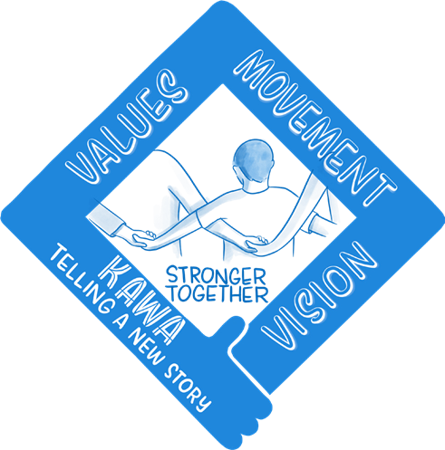
The first whiri/thread is about creating a new story and building a belief in what an anti-racist health system makes possible. Teams must believe that each and every person - regardless of their ethnicity - deserves to be treated with respect and receive high-quality health services that support them to live, thrive and flourish on their own terms.

Creating a new story of who we are as a nation opens our hearts and minds to care for one another in a way that embraces our shared humanity. Placing Te Tiriti o Waitangi (Te Tiriti) at the heart of our national identity unites those divided by history and fosters the aroha and respect needed to grow strong, connected and inclusive communities. Building a new narrative shifts mindsets and invites us to be part of shaping a better future where we are stronger together. The two aho/ strands within this thread are:.
- Leadership
Leaders are the weavers-in-chief for organisations seeking to create a new future. These leaders are visionaries and champions of anti-racism. They embrace vulnerability, they are eager to be held accountable and to bring their people and partners together to create a shared future.
- Narrative
Leaders need to be able to paint a picture of what it could look like and why we should all want it – a narrative that is at once honest about how we got to where we are, and aspirational about what is possible.

Tikanga
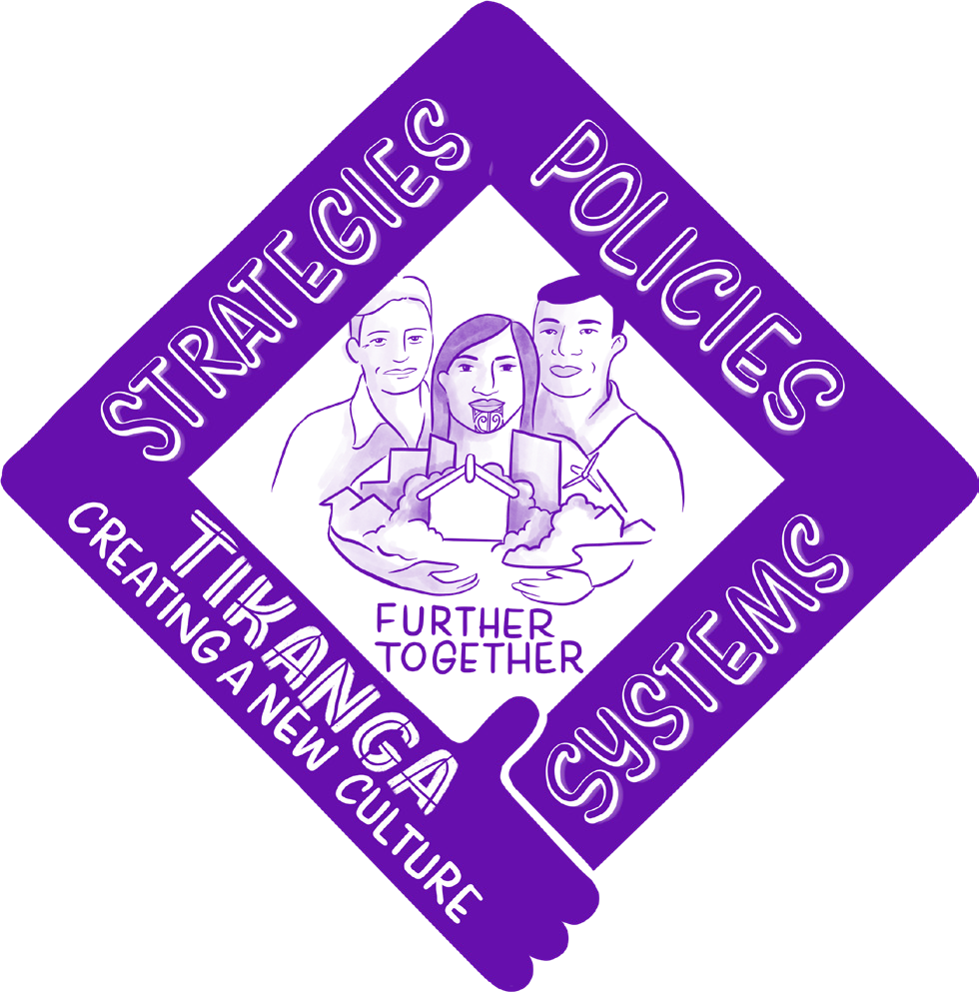
The second whiri/thread is about creating the right conditions – a culture - that will promote the development of a future that is fair and equitable for all people. Teams must have transparent systems, strategies and policies that promote decision making conducive to good health and wellbeing.

Creating a new culture helps us to redesign our organisations so everyone’s needs can be met. We can create policies that tailor solutions for the different needs of all our communities so we all gain and life becomes fairer for all. We will get more value out of the money we spend and there will be more to go around. Creating a new culture centred on trust ensures our institutions will achieve more for us all. The four aho/strands within this thread include:
- Vision, Strategy & Goals
Organisations must have a clearly-articulated anti-racism strategy that is integrated into its overarching business strategy with defined accountabilities and responsibilities.
- Power & Commitment
Organisations need to consider how they redistribute power and enable shared decision-making. This requires a new approach to power-sharing, high-trust partnerships and commitment of sufficient resources.
- HR Policies
Organisations can make an impactful change in their HR policies, to ensure increased diversity at all levels and foster cultural change through clear and transparent behavioural expectations. Recruitment, promotion, incentives and disciplinary policies all have a contribution to make.
- Service Design
In order for everyone to be treated with dignity for who they are, design principles related to service access, content and delivery method need to be consistent with mana tangata.
.

Ritenga
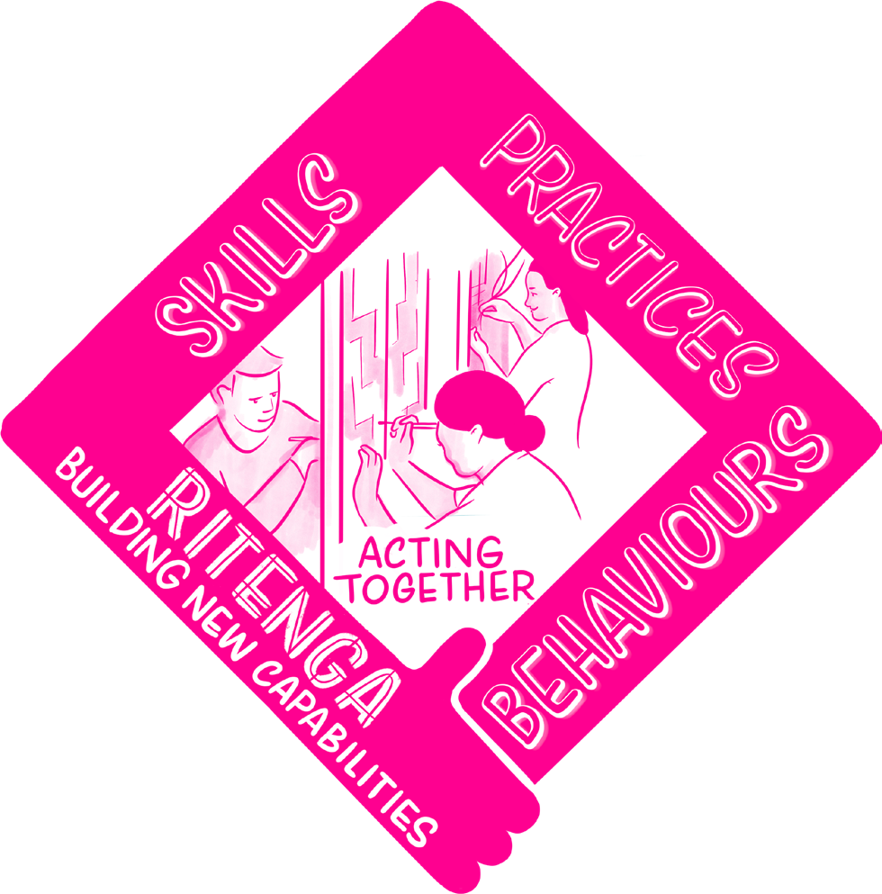
The third whiri/thread relates to ensuring that team capability, behaviours and practices are aligned with the vision of mana tangata and an anti-racist health system. Believing in anti-racism, supporting it and operating in an environment that nurtures it means that teams need to develop the capability to know how to do it.

Creating new capabilities helps us transform our practice. We need to ensure people have the skills to embed anti-racism into their everyday actions and behaviours. Building anti-racist practices centred on dignity and understanding creates a space where everyone gets what they need. The two aho/strands within this thread include:
- Training
In addition to believing in mana tangata and working in an environment that promotes it, all team trainings need to have it embedded as an essential concept.
- Practice
A set of defined practices that guide ways of being, speaking, and working should be developed so behaviours are consistent with what anti-racist practice looks like in a health service setting.

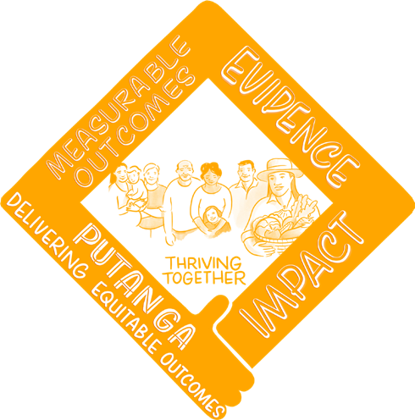
Putanga
The fourth whiri/thread relates to how organisations can assess, track and monitor progress towards an anti-racist health service that is consistent with the vision of mana tangata. On any journey, it is useful to know how far we have come, whether we are still tracking in the right direction and how far there is to go. A clear picture of that should foster a sense of urgency about accelerating progress, determination to make good choices, and confidence from what has already been achieved.

We need data and evidence to identify racist policies and practices so we can remove them. We need to connect those who haven’t experienced racism with those that have so they understand the toxic impact it has. Finally, we need to build and share evidence of what works to support anti-racism movements to grow and spread. The two aho/strands within this thread include.
- Data Collection
A coherent, robust data collection approach that goes beyond compliance and centres mana tangata outcomes will provide high-quality foundations for monitoring progress.
- Monitoring, Reporting & Auditing
Ongoing monitoring, reporting and auditing of progress and practice performance is an important part of ensuring the pattern being created is the one intended, how much work has been completed, and how much more there is yet to do.
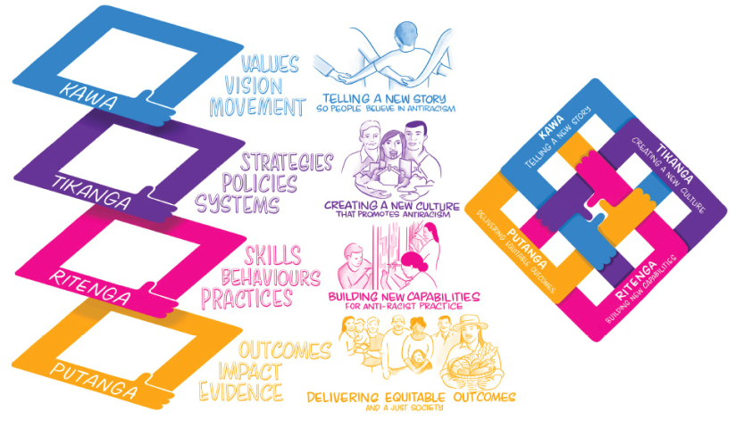

Mahi Raranga: The Weaving Process
With the four whiri/threads in front of us and an understanding of their constituent aho/strands, we can begin the process of weaving a new future. There are three parts covered by Whiria te Muka Tangata.

Preparation
This is where we evaluate our materials and check our tools. Understanding where our organisations are today in terms of equity and mana tangata is the starting point.

Designing
Once we know our current state, we can assess it against our desired future and begin to design a bespoke strategy for getting there. This is both in terms of what actions we need to take and how to give our work its own energy and self-sustaining momentum - how to build a movement.

Starting
A crucial part of any weaving effort is getting the start right. It takes preparation, a picture of the finished pattern in mind and the confidence to cast on and make the first weave.

Whakarite: Preparation
Prior to commencing the work of weaving a new future for an organisation, some preparation is required. As with hāro, the process of stripping the flax to expose the muka fibres, organisations need to look inside and understand their current state. Whiria te Muka Tangata provides the framework and there are three levels of assessment:
- the organisation
- existing initiatives
- existing programme/portfolio

Taken together, these assessments will leave you with a picture of:
- where your organisation is now in terms of mana tangata;
- what you are already doing to make change; and
- the areas of Whiria te Muka Tangata where you are most active and those that will need more attention to drive your organisation forward.

Organisational Assessment
The first level of assessment is at the organisational level. For each of the whiri/threads, aho/strands and underlying whenu/components, an assessment should be completed by a group of staff members and trusted partners. The group needs to be curated to ensure diversity in terms of level, function, ethnicity and other factors. An excerpt of a preliminary scoring rubric is included below:
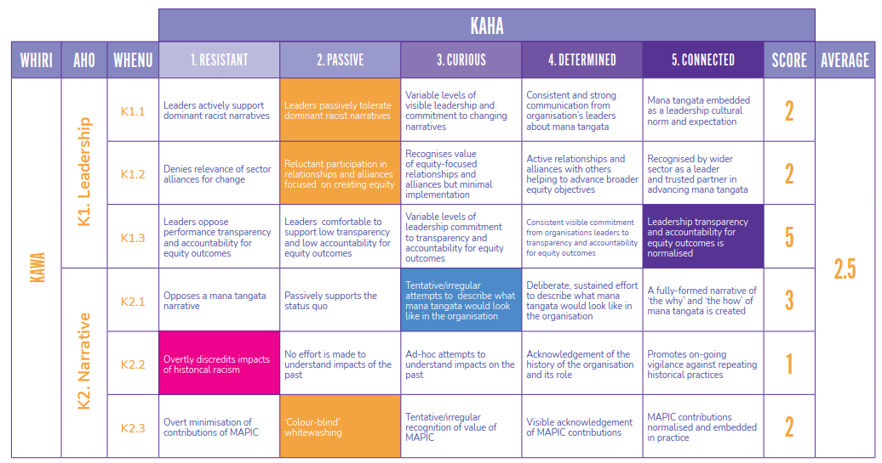

Once complete, the tool provides a visual representation of the result. The results from different individuals, levels, functions, or ethnic backgrounds can then be compared to identify any significant differences. This will create a space for conversation and exploring those differences together, preparing the ground for the work ahead.

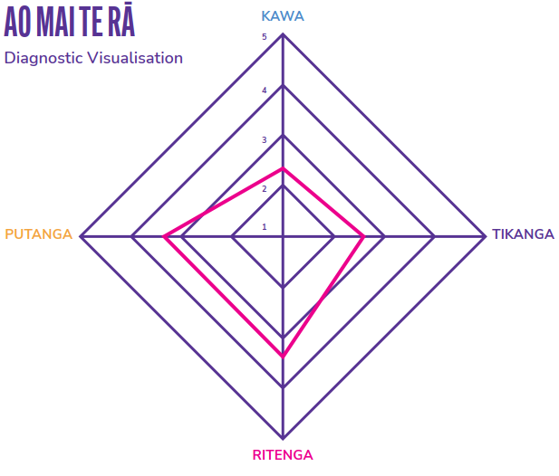

The intention is that building a collective understanding (even with differences within that) of areas where the organisation is weak and where it is strong, will serve the next stage of the process – design.

The average of all scores will provide an overall progress rating for the organisation. This then translates into a definition on the following maturity model:
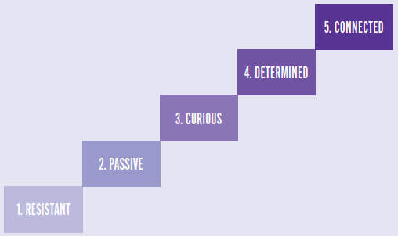

- The organisation is actively resistant to tackling systemic racism and to values, policies, and practices that advance mana tangata.
- The organisation is passive about systemic racism, only making change where it is a compliance requirement.
- The organisation recognises there is a need for mana tangata but its efforts are patchy and not well coordinated or resourced.
- The organisation actively buys in to mana tangata and is making positive changes in a way that is concerted, joined-up and well resourced.
- Mana tangata is embedded into the leadership, culture and practices of the organisation as business-as-usual.

The reality is nuanced and organisations will sit in between these definitions, rather than neatly on a single one. Different departments will be at different places. However, this maturity model provides a high-level view of where an organisation is and its next logical step.

Existing Initiatives Assessment
Many organisations already have initiatives focused on advancing equity objectives. There is no need to abandon work already underway, in preparing for weaving a new future. However, it is useful to consider the work underway through the rubric of Whiria te Muka Tangata. Which of the aho/strands are connected to the initiatives? To what extent do they positively impact the whiri/ threads in the model?

For example, an organisation might have an initiative to recruit more Māori and Pasifika peoples into their organisation. What other components of that initiative relate to other parts of Whiria te Muka Tangata? Are there any aho/strands absent from the design that could be included? How is it positioned in company material? Is
it described purely as an equity initiative or are the strengths and potential contributions of participants highlighted as beneficial to the organisation’s mission?

The whiri/threads and aho/strands of Whiria te Muka Tangata provide you with a framework to conduct this assessment. In addition to that, three further tools are provided to assist organisations to analyse the design of initiatives (or aspects of them) to work out:
- which are focused on quick-wins, which are more slow-burn, and how they might be phased;
- which concentrate more on protecting people from the harms resulting from the absence of mana tangata, and those looking to realising mana tangata; and
- which look to foster intrinsic motivation and those that provide extrinsic motivation.

Guidance on these tools can be found in Appendix A.

Existing Programme/ Portfolio Assessment
Once all existing initiatives have been evaluated, the final component of the preparation process is to gain an overall understanding of what kind of coverage all the existing initiatives have of the Whiria te Muka Tangata model as a whole. Which of the threads (Kawa, Tikanga, Ritenga, Putanga) have a lot of initiatives? When compared to the organisational assessment, are there weak whiri/threads or aho/strands that are not receiving sufficient attention?

The outputs from the other tools (organisational diagnostic) provided in this toolkit will also assist organisations in striking the right balance across the portfolio as a whole between:
- slower change and immediate benefits;
- ensuring that sufficient focus is placed on longer-term investments while also remembering to look after those existing in an environment today that is not an expression of mana tangata and its associated harms; and
- people buying into mana tangata for themselves and receiving signals from the organisation that this is the way it’s going and the need to be on board with it.

Whakahoahoa: Designing
The preparation process provides you with a clear picture of:
- your organisation’s current state;
- initiatives your organisation is currently implementing; and
- how the portfolio of initiatives as a whole is advancing Whiria te Muka Tangata.

Together, this information will help inform the design of your new pattern of mana tangata – a new strategy for the future.

Strategy
In addition to an evaluation framework, Whiria te Muka Tangata is a theory of change. A high-level representation with some example interventions is visualised on the right.

This can be used as the starting point for both designing your mana tangata strategy and mapping your initiatives - both existing and future - and for identifying priorities/phasing.

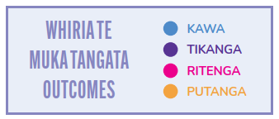

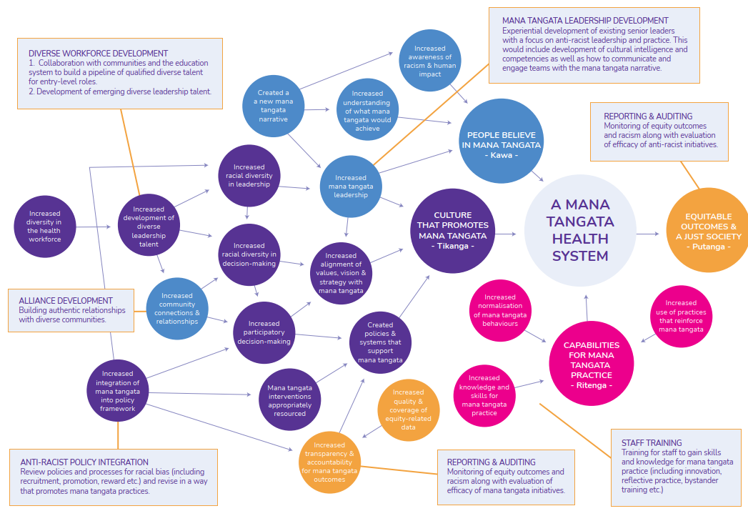

Te Aho Tapu: Starting
The first line of any weaving effort is crucially significant. It sets the basis of every weft and weave that is to come later, it is the foundation on which the final pattern is built. In the context of Whiria te Muka Tangata, this means ensuring that the order in which the threads and strands are brought together is consistent with your intended design or strategy.

As all organisations are different, there is no magic formula for how this should roll out. It takes time to order things and confidence to make a start.

Building A Movement
Weaving a new future takes ongoing leadership and a vision that people want to support. However, the desired end-state of Whiria te Muka Tangata is one where that future is self- sustaining, driven by an inherent desire from within the organisation. The introduction of different strands of the model at different stages in an organisation’s development can be helpful in building momentum, as set out on the right.

For example, moving an organisation from Resistant (1) to Passive (2) can be facilitated by strengthened monitoring and reporting of equity outcomes. A culture of active resistance will struggle to survive in an environment of increased transparency and accountability. A wider set of the aho/strands are required in taking the next step to Curious (3) and then on to Determined (4). The fifth and final stage of the Whiria te Muka Tangata maturity model is called Connected.(5) This is because, in addition to continuing to develop all of the aho/strands of the model, reaching this stage will require a state of deep, ongoing, authentic users, staff, communities, and with the organisation's values and purpose. It is that connection that will hold the mana tangata pattern firmly in place by being a source of diverse thinking, innovation, achievement, standards and accountability.

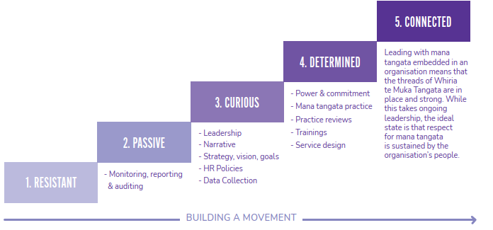

What's Next?
Whiria te Muka Tangata is a product of the first phase of Ao Mai te Rā. The next stage is to provide further assistance through more detailed implementation guides for specific interventions that will advance the kaupapa.

For example:
- What are examples and features of HR policies that foster a mana tangata culture?
- What are some specific practices that align with mana tangata?
- What is a good process for beginning a power- sharing shift?

That work is expected to commence in the near future.

In the meantime, it is hoped that Whiria te Muka Tangata as it stands supports organisations to commence work on moving to a mana tangata future.

It is an ambitious task but we have many reasons to be hopeful. Although racism can be found worked into the tapestry of our nation and its institutions, we have it within us to conceive a new pattern that honours the dignity of all people - to take the whiri in our hands and begin to weave.
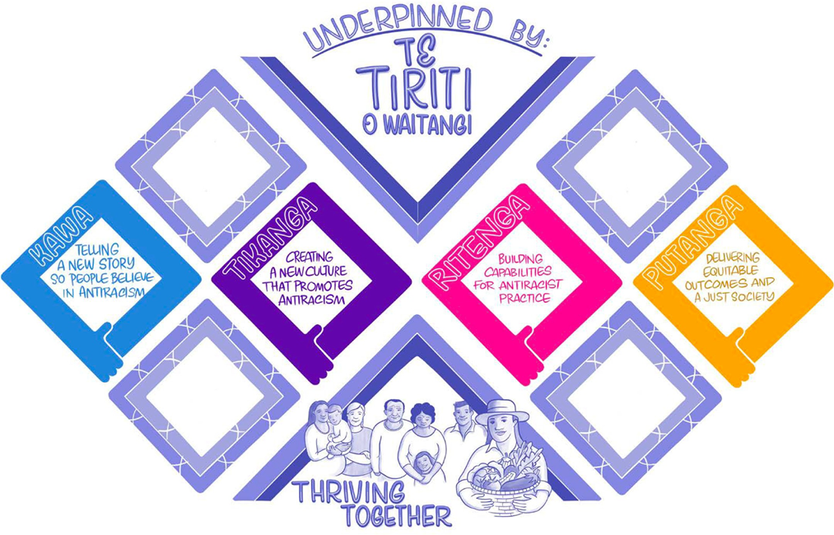

Appendix A - The Tools

Time to Impact
The Time-to-Impact tool is designed to provide visibility on how the organisation is investing in interventions that are likely to have a short versus long-term arc to achieving impact. The tool does not propose that there is any desired balance of short versus long-term interventions. That will depend on the nature of the organisation. Our view is that to maintain momentum behind any transformational effort, there will need to be simultaneous time horizons pursued.

We map the time to impact arc across the different aho/strands below. We note that as a conceptual model, we have only mapped a few levers aho/strands for indicative purposes.

The graph endeavours to convey the following insights:
- Leadership - that leadership can generate impact across all time horizons, but doing so requires ongoing, intentional leadership toward anti-racism.
- Organisational goals - goal setting that includes anti-racist aspirations will likely have an immediate short-term impact mobilising the organisation, but that the uplift will plateau in time, necessitating that there is a cycle of creating, reviewing and resetting anti- racist goals to achieve long-term impact.
- Diversity recruitment - that the early stages of ‘diversity hiring’ will have modest impact in the short-term, but as a critical mass of ‘diversity hires’ is achieved, there will likely be significant transformation of organisational culture, systems and processes as those hires become more widely represented across the organisation and ascend to leadership roles.
- Training - the direct impact of training is likely to be short-term, recognising that training may be the ‘door’ that enables other interventions to be identified and pursued.
- Monitoring and auditing - it is likely that it will take time to assemble an effective body of evidence and for the organisation to learn how to conduct effective equity audits. Accordingly, the impact is set in the early medium-term to allow for these learnings, and with a dotted line to represent that it will take a number of cycles for the impact to be realised, and that the ultimate impact may be that auditing is a catalyst for other interventions, such as equity driven innovation.

We consider that this type of mapping for all interventions, generating visibility of alignment across the whole portfolio, will enable organisations to make more considered decisions about what new anti-racism initiative to invest in. We believe this type of tool is important because we have observed organisations to have unsound expectations of the time horizon in which impact will be realised, as well as unreflectively weighting their investment at one end of the time horizon.
Weighting investment in short-term gains can carry the risk of being unsustainable and relapsing. Whereas, weighting investment in initiatives with long-term impact can unnecessarily heighten the exposure of people at risk of the harms of racism. Ultimately, we believe there is value in using time horizon for impact as a factor for ‘balancing the portfolio’ of anti-racism initiatives.

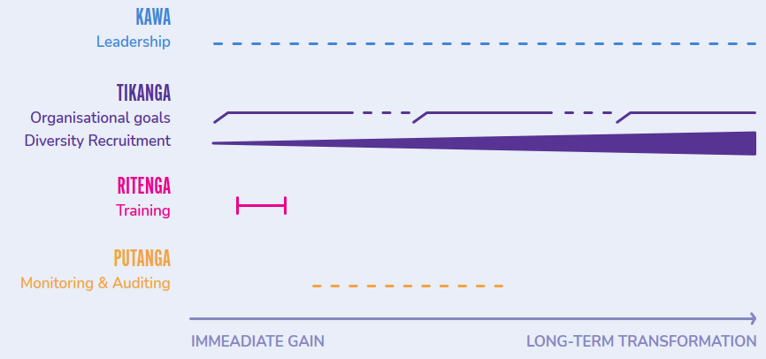
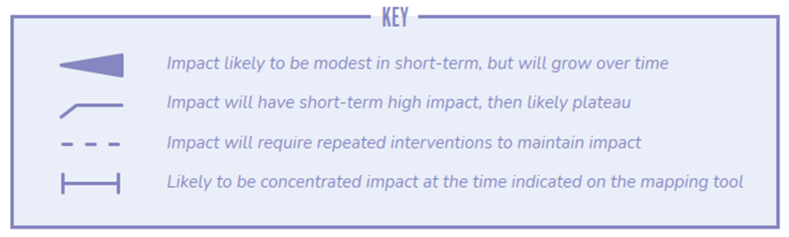

Protective - Corrective
Looking at the purpose and operation of anti- racism initiatives enables categorisation into two types:
- Protective - aho/strands which principally aim to insulate people exposed to racism from some of the harms of racism; and
- Corrective - levers that principally aim to shift organisations and society to a less racist and ultimately anti-racist future.

We consider that there is value for an organisation is seeing the portfolio effect of their anti-racism initiatives on a spectrum of protective to corrective, recognising that some interventions will achieve both aims. We believe there is a common pattern of over-weighting protective factors. Irrespective of good intentions, protective factors can only make the experience ‘less bad’ for those exposed to racism. To generate systemic change it is necessary to progress corrective approaches in parallel, even though they may be slower and more complex.

We map the aho/strands below on a spectrum of protective to corrective. We note that as a conceptual model, we have only mapped a few aho/stands for indicative purposes.

The graph endeavours to convey the following insights:
- Leadership - that leadership is primarily a corrective aho/strand that can mobilise systemic change, and that a secondary impact can be increasing an internal sense of resilience in those exposed to racism, as a result of increased trust in leadership and/or sense of being valued.
- Organisational goals - goal setting is also primarily a corrective tool that can change the direction of the organisation, as well as provide the impetus for other aho/strands, for example allocation of resourcing.
- Diversity recruitment - in the early stages of ‘diversity hiring’, those hired may have high exposure to racism, but that as the number of ‘diversity hires’ grows, a cohort dynamic will create enhanced individual and collective resilience. As described above, a secondary impact of a critical mass can also transform organisational culture, systems and processes as those hires become more widely represented across the organisation and ascend to leadership roles.
- Training - the direct impact of training is corrective. Done well, participants are likely to have a new understanding of racism, and the journey toward an anti-racist future. It is possible for training to have a secondary impact of making collegial relationships more comfortable for those exposed to racism (noting that it can also have the reverse result on occasion).
- Monitoring and auditing - is primarily a tool that increases visibility and the wider corrective impact is as a ‘door’ to exploring other interventions.

We consider that across all investment in anti-racism, there is value in organisations exploring the optimal balance of protective factors that provide immediate ‘insulation’ value to those exposed to racism, while also pursuing corrective factors genuinely capable of generating the systems change needed to realise an anti-racist future.

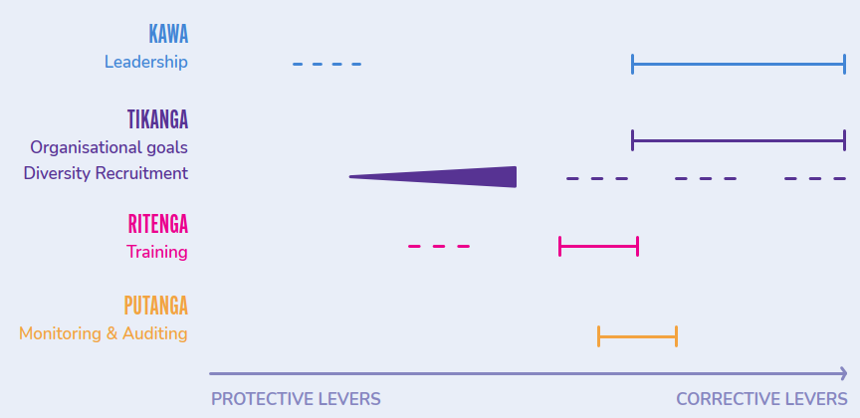
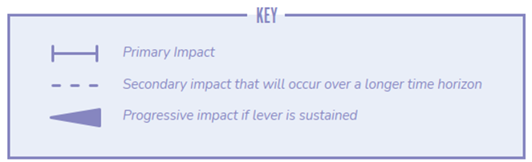

Motivation
The motivation tool is designed to provide visibility on the type of motivation that is generated by different aho/strands. We distinguish between two types of motivation:
- Intrinsic motivation - in psychology literature, intrinsic motivation is a deep form driven by an internal drive that emanates from a sense of ownership and autonomy over the change sought. Intrinsic motivation is considered to be more durable and effective for achieving complex change. Behaviour change theorists argue that intrinsic motivation can be triggered through positive feelings (love and aspiration) as well as a sense of autonomy.
- Extrinsic motivation - in psychology literature, extrinsic motivation is geared by external motivators (such as compliance). Extrinsic motivation is considered to be less durable and effective in sustaining complex change.

We consider that the type of motivation triggered by different change levers is important to the efficacy of anti-racist change programmes. Too much reliance on extrinsic motivation will result in short-term change that is likely to be less ‘sticky’ than change which is driven by a deeper sense of internal drive and autonomous action.

We map the aho/strands below on a spectrum of intrinsic to extrinsic. We note that as a conceptual model, we have only mapped a few aho/strands of change for indicative purposes.

The graph endeavours to convey the following insights:
- Leadership - leadership can generate motivation, depending on the leadership style. There is a strong body of evidence that values driven leadership that empowers people to take actions is more likely to generate intrinsic motivation.
- Organisational goals - it is common for goals to be directive for most of the organisation, and therefore more like a coercive measure that generates extrinsic motivation. However, some organisations have highly participatory goal setting processes, which could generate intrinsic motivation.
- Diversity recruitment - has the potential to generate intrinsic motivation for anti-racism if there is belief in the value of diversity hiring (noting that belief is largely reliant on leadership). In the absence of that belief, it can at best result in extrinsic motivation and at worst, create resentment that hinders the journey to anti-racism.
- Training - the most likely impact of training is extrinsic motivation, however, if it is delivered in a way that triggers empathy it has the potential to catalyse deep intrinsic motivation.
- Monitoring and auditing - auditing is primarily a ‘stick’ mechanism. This means it generates extrinsic motivation but can be partnered with other levers that trigger intrinsic motivation.

We believe this type of mapping can provide visibility on the balance of ‘carrot and stick’ aho/ strands, with a directional encouragement to ensure that the implementation of levers that could trigger either motivation, is intentionally geared
to the motivation best suited to the organisation’s context and needs at the time.

In combination, we believe that these three tools will support a comprehensive portfolio assessment of the collective impact of all the levers of change, as well as providing insight into how future efforts could best be directed to achieve optimal impact

