Ao Mai te Rā

The Anti-Racism Kaupapa
Whiria te Muka Tangata. Anti-Racism Systems Change
A Preliminary Model for the Aotearoa New Zealand Health System
October 2022

Citation: McMeeking S, Tarena E, Williams M et al. 2023. Whiria te Muka Tangata: Anti-Racism Systems Change. A Preliminary Model for the Aotearoa New Zealand Health System. Wellington: Ministry of Health.
Published in February 2023 by the Ministry of Health
PO Box 5013, Wellington 6140, New Zealand
HP 8710
This document is available at health.govt.nz
This work is licensed under the Creative Commons Attribution 4.0 International licence. In essence, you are free to: share ie, copy and redistribute the material in any medium or format; adapt ie, remix, transform and build upon the material. You must give appropriate credit, provide a link to the licence and indicate if changes were made.

Contents
Kupu Whakataki | Introduction 1
Overview of Whiria Te Muka 2
Kawa Telling a New Story 3
Tikanga Creating a New Culture 4
Ritenga Building New Capabilities 5
Putanga Delivering Equitable Outcomes 6
Interactions between the layers 7
Terms within Whiria te Muka 8
Implementing Whiria Te Muka 14
Whakarite Preparation 15
Whakahoahoa Designing 22
Te Aho Tapu Starting 27
Kupu Whakamutunga | Conclusion 28
Appendix A - Scoring Rubric 29
References 32

Kupu Whakataki | Introduction
This paper outlines a preliminary anti-racism systems change model for the Aotearoa New Zealand health system. The overarching question this paper seeks to answer is ‘what would a maturity model for anti-racism in the health system look like in Aotearoa?’.

To reach this point, the papers draws on insights and recommendations outlined in three discrete components of research conducted as part of phase one of Ao Mai te Rā: the Anti-Racism Kaupapa.

This includes:
- The definitions for racism and anti- racism drawn from the stage one Literature Review ‘Evolution of Racism and Anti-Racism. Lessons for the Aotearoa New Zealand health system’.
- The key levers for change drawn from the stage two Literature Review ‘Best Practices Approaches to Addressing Racism. Lessons for the Aotearoa New Zealand health system.’
- A model that draws on the concept of maturity as a basis for diagnosis, and integrates systems thinking and critical theory as mechanisms for anti-racism transformation. These insights are drawn from the stage three Literature Review ‘Anti-Racism Maturity Models. Lessons for the Aotearoa New Zealand health system’

Whiria te Muka is a preliminary systems change model developed to support the transformation of the Aotearoa health system towards an anti-racist future. An overview of the model is summarised in a companion document [Summary Paper – Whiria te Muka. A preliminary model for the Aotearoa New Zealand health system].

This paper provides detail on a preliminary model that is designed to give us an organisational and systems view of anti- racism action in health and an evolutionary pathway of how we might achieve the vision mana tangata – where everyone who enters the health system, regardless of culture, background, identity, or race, is valued, respected and honoured for who they are.

It’s important to note that Whiria te Muka is a preliminary model, there are some elements of the model that are yet to be developed and all aspects of the model require testing and iteration within the health system.

Overview of Whiria Te Muka
Systems change is growing in global prominence as a way to address complex, intractable problems. The key features of systems change include:
- complex problems, where there are multiple factors contributing to the existence of a problem with visible and invisible inter-relationships;
- the ability to examine, observe and understand the interaction of the multiple contributing factors, which means taking a system level view; and
- synchronised action, where tangible, meaningful and durable change will only be achieved if multiple levers are synchronised to create a solution ‘collage’.

Taking a systems view requires us to move away from expectations that solutions can be mechanistic and linear: plugging gaps with well-intended micro-solutions will paper over the complexity of causation without producing real change. Designing a collage of solutions requires nuanced thinking about the network effect of multiple simultaneous or sequenced interventions, combined with strategic imagination that unlocks the potential of novel and/or non-linear style interventions.

Whiria Te Muka is a mātauranga Māori anchored approach to systems change that builds on the work of the late Professor Mānuka Henare. Professor Henare’s foundational work was developed for the Royal Commission on Social Policy, and recommended that effective public policy should align across four dimensions: kawa, tikanga, ritenga and āhuatanga.

Professor Henare used traditional Ngā Puhi concepts to describe a philosophical ideal of a good life. In this example, the kawa dimension is derived from Io Matua Kore, the supreme being, with kawa being a reverence for life. The tikanga dimension represents the forms of appropriate behaviour that reinforce kawa and the prime values that determine what we do, think and feel. Outside of the tribal confines of mapped relationships, the kawa-tikanga-ritenga-āhuatanga framework displays a type of holistic relationality through the ethical intentions of a value system. Professor Henare describes it as a matrix for ethical pluralism where values inform relationships, which continue to describe the good life and indicate the ultimate purpose of activity. Professor Henare’s description of ethics as a spiral constitutes a way of connecting humanity and the environment in a relationship of respect and reciprocity, as opposed to a hierarchical system.

Whiria Te Muka extends Professor Henare’s model in a way we hope and believe honours his work and intellectual leadership. The extensions aim to order and reflect the inter-relationships between the causal factors for a complex problem, as well as to map existing interventions and possible solutions. The key adaptations made to Professor Henare’s model are:
- substituting Āhuatanga with Putanga. We do this because we consider that Āhuatanga can be interpreted narrowly to capture ‘process outcomes’ rather than substantive impact outcomes; and
- augmenting each of the layers within the model with a detailed itinerary of levers for change. Levers for change are the types of action that can be taken to create change.

The key levers for change draw from the companion document - the stage two Literature Review ‘Best practices Approaches to Addressing Racism. Lessons for the Aotearoa New Zealand health system’. The adaptations to Professor Henare’s model into Whiria te Muka is depicted and described below:

Kawa Telling a New Story
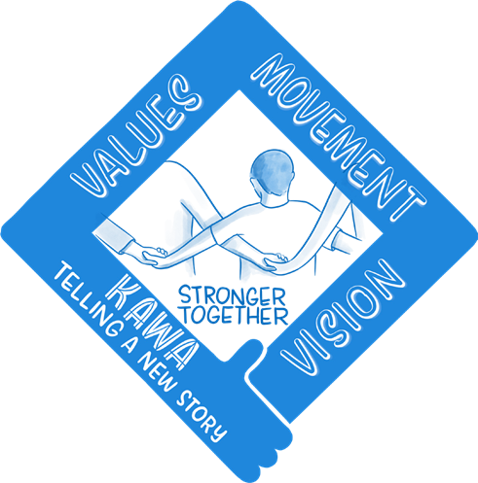
Professor Henare defines Kawa as the moral imperative, which reflects the paradigm framing for what is conceived as ‘good’ or ‘valued’. In simpler terms, Kawa encompasses the values and beliefs that shape what we believe as good, right or just.

Within Whiria Te Muka, Kawa encompasses the cognitive frames, mental models, values, and beliefs that contribute to a given problem. The two key levers which can support change within the Kawa dimension are:
- Leadership – leaders are champions for change, they can influence cognitive frames/mental models, by embedding and modelling new values and beliefs that support a new direction of travel.
- Narrative – narrative stories are a recognised tool to influence cognitive frames/mental models, how we frame and talk about an issue can change how people think and act, and nudge the evolution of societal beliefs.

These levers provide a directional coherence that can help people make sense of the desired change as well as inculcate motivation and build momentum.

Tikanga Creating a New Culture
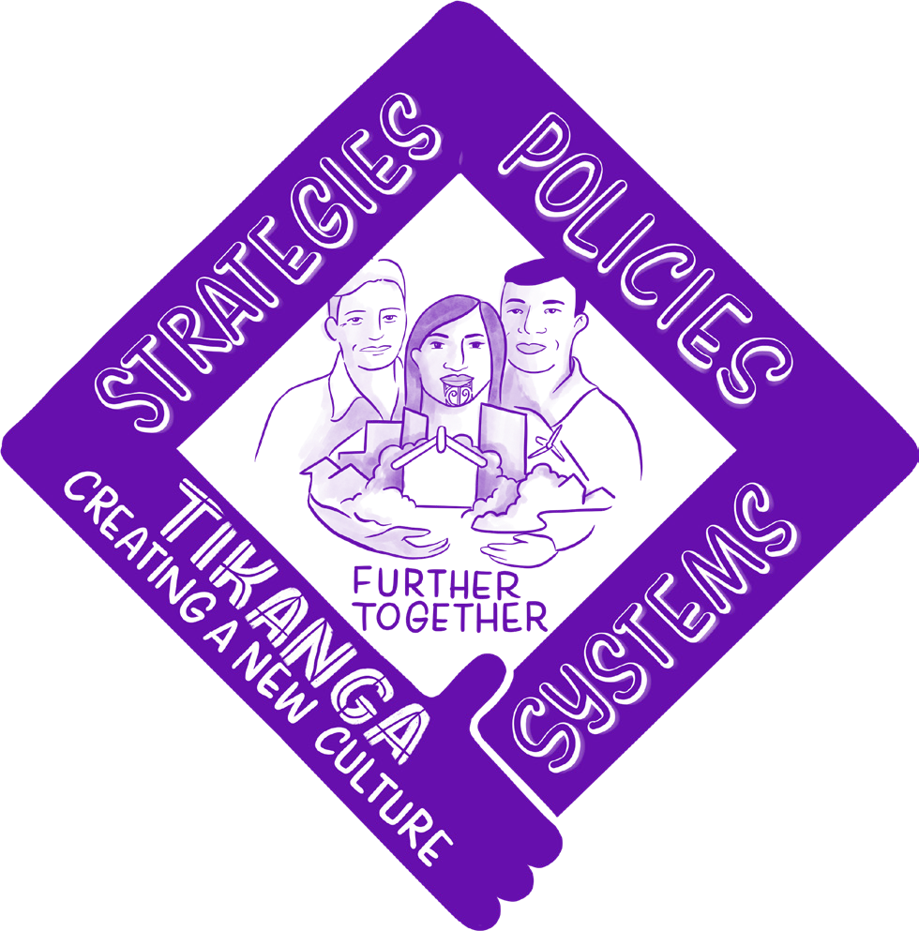
Professor Henare defines tikanga as principles and ethics. Within Whiria Te Muka, Tikanga encompasses the mechanisms that specify or determine what is considered ‘right’ within an organisation, with specific regard to its systems, strategies and policies.

There are four key levers which can support change within the Tikanga dimension:
- Organisational Strategy and Goals - organisations must have a clearly articulated anti-racism strategy that is integrated into its overarching business strategy with defined accountabilities and responsibilities.
- Power and Commitment - organisations need to consider how they redistribute power and enable shared decision-making. This requires a new approach to power-sharing, high- trust partnerships and commitment of sufficient resources.
- Human Resource (HR) Policies - organisations can make an impactful change in their HR policies, to ensure increased diversity at all levels and foster cultural change through clear and transparent behavioural expectations. Recruitment, promotion, incentives and disciplinary policies all have a contribution to make.
- Products, Services and Design - relates to the who, what, why, where and how a product or service is delivered by an organisation.

Each of these levers act as mechanisms to promulgate the intangible values and
beliefs of an organisation. It is through the tikanga dimension that the kawa dimension is enacted.

Ritenga Building New Capabilities
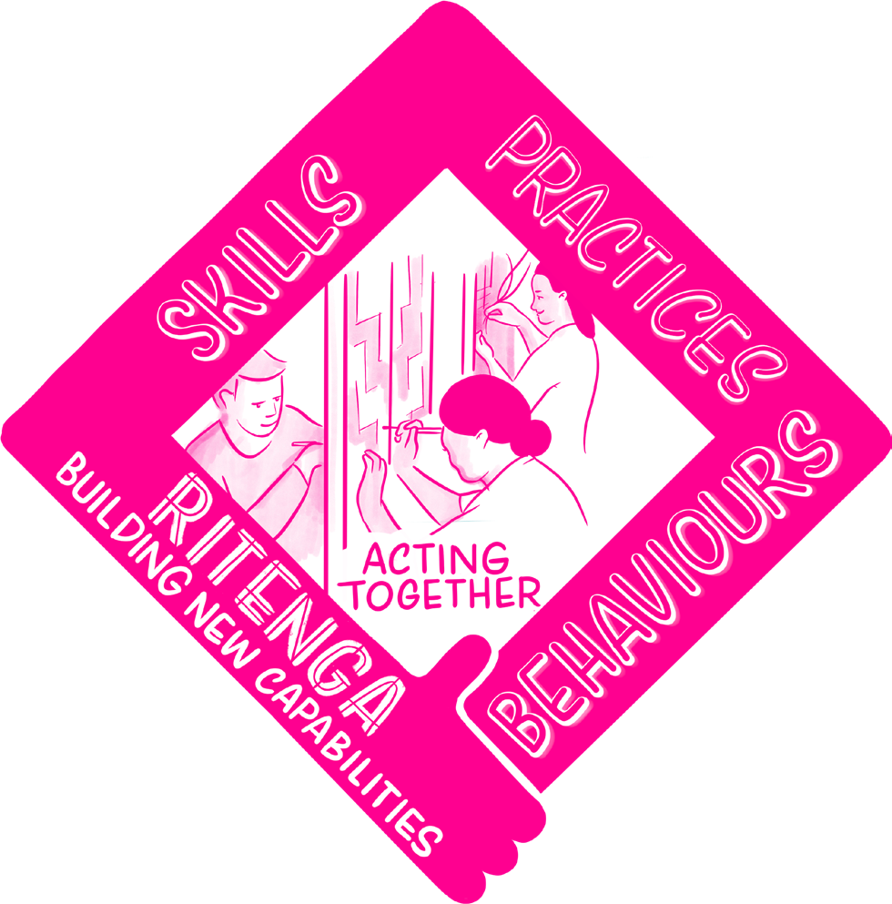
Professor Henare defines ritenga as behaviour and enactment. This definition has been maintained within Whiria Te Muka.

Ritenga is premised on building and creating habits (the things we do subconsciously, outside of our awareness) which tacitly reflect what is valued or considered good within an organisation. By corollary, if a habit is disrupted in some way, space is created to seed the desired change, and, where new habits are created, they can foster the formation of new cognitive frames/mental models as people act themselves into a new understanding or new way of thinking.

There are two key levers which can support change within the Ritenga dimension:
- Training - training and knowledge initiatives rely on the rationale that if people ‘know differently, they will act differently’, however, they can also be used to seed or promote narratives supporting the desired change or elicit empathy that supports a motivation to create change.
- Practice - a set of defined practices that guide ways of being, speaking and working should be developed so behaviours are consistent with what anti-racist practice looks like in a health service setting. Practices are a soft way of encouraging people or organisations to question things that are taken for granted, and by creating that visibility, can lead to changes in what is done or decided.

It is recognised that while the levers within Ritenga are useful, on their own they have notable limitations, and are best deployed amongst a suite of companion levers to maintain habits that are conducive to anti- racism praxis in the long-term.

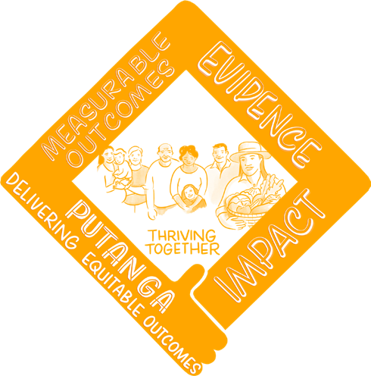
Putanga Delivering Equitable Outcomes
Putanga is an adaptation we have made to Professor Henare’s model. Putanga
replaces Āhuatanga. Putanga is interpreted as substantive indicators that demonstrate of the desired change towards equitable outcomes.

The two key levers identified which can support change within the Putanga dimension:
- Data Collection - a coherent, robust data collection approach that increases the visibility of underrepresented groups (particularly groups with historically suppressed data records), and includes equity specific metrics and indicators, that provide high-quality foundations for monitoring progress.
- Monitoring, Reporting & Auditing - ongoing analysis of progress and practice performance is an important part of ensuring the pattern being created is the one intended, how much work has been completed, and how much more is yet to do.

Each of these levers help us to uncover the visible, tangible impacts and consequences of racial/ethnic health inequity – and provides a basis from which organisations can track progress and monitor for change over time.

Interactions between the layers
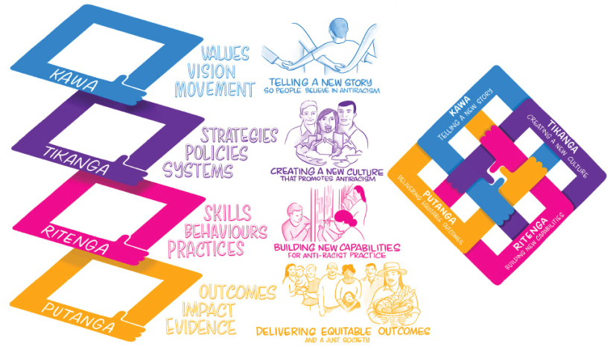

Whiria Te Muka is premised on interaction between all the dimensions – Kawa, Tikanga, Ritenga, Putanga – and in all directions. Any given problem will be caused by a complex network of interactions across the dimensions, and any effective solution will require the development of mutually reinforcing actions across all levels.

There are two key types of interactions to be mindful of:
- Pull factors promote new cognitive frames and mental models, intersecting with existing values and beliefs, to inspire and catalyse motivation and action toward the desired change. Within the context of Whiria te Muka, ‘pull factors’ operate within the kawa layer and the relevant levers for change are leadership and visioning.
- Push factors create momentum toward the desired change. Within the context of Whiria te Muka, they are the activation or enactment of change that operates across tikanga, ritenga and putanga.

To create change, it is considered necessary to have a combination of pulling people and organisations toward the new cognitive frame, as well as creating impetus for change by pushing people toward having the opportunity to ‘act themselves into’ the change sought which creates a momentum or velocity behind the desired change.

Momentum in Whiria te Muka is critical: without a constant sense of movement, the health system will lapse back into the status quo that causes/embeds the problem of racial/ethnic health inequity. Any strategy or plan for change should carefully design intentional interaction between push and pull factors to be mutually reinforcing and consistently sustain, or build, the momentum toward change.

Terms within Whiria te Muka
Whiria te Muka draws upon the metaphor of weaving to explain the change process. Racism has been woven into the tapestry of our nation. It has been here for so long it can be a struggle to see the patterns of racism in our structures, systems,
and practices.

However, racism and inequity are not inevitable. Working together, we can weave a new reality. The process for transformation starts with un-weaving the threads so we can see the pattern and un- learn old ways of thinking and doing before re-weaving a new anti-racist pattern.

Whiria te Muka draws upon the following weaving terms:
- Whiri are the cords/rope used to describe the dimensions within the framework (e.g. kawa, tikanga, ritenga, putanga)
- Aho are the key threads within each whiri that have been identified as key levers for change
- Whenu are the key strands within each aho that have been identified as the micro-levers for change.

Each whiri is part of a whole; it’s only when they are brought together by skillful hands that a woven picture emerges. The interlocking nature of each aho represents the dependencies between each the key levers. Individually the whiri and aho are easily broken. When woven together they become incredibly strong.

The table below summarises the component parts of Whiria te Muka, with an additional section that identifies how the levers and micro-levers could be applied in a health system setting.

Whiri  (Dimension) | Aho  (Lever for Change) | Whenu  (Micro-Levers) | Practical application in a health system setting
KAWA | Leadership | K1.1 Championing Mana Tangata  K1.2 Building relationships and alliances  K1.3 Modelling transparency and accountability | - Championing mana tangata includes:  - Clear and consistent position that anti-racism/ equity transformation is an organizational priority  - Clear and consistent position that organization will honour Te Tiriti  - Building internal will & commitment at all levels of leadership; top, middle & bottom  - Building relationships and alliances includes external advocacy & movement building for change that contributes to leadership by creating visible accountability.  - Modelling transparency and accountability reflects a core principle of leadership to role model desired behaviour.
 | Narrative | K2.1 Developing the Mana Tangata story  K2.2 Promoting accountability for history  K2.3 Promoting strengths and capabilities of ‘the other’ | - Developing the Mana Tangata story:  - Leading with a strong positive vision anchored in Te Tiriti  - Building a shared understanding of racism & anti-racism  - New narrative reflects equality of paradigms (ie Western, Māori, Pacific and other knowledge systems are accorded equal respect and visibility)  - Promoting accountability for history:  - Sharing stories of the lived experiences of racism & their impacts  - Sharing stories of organisational contributions to racism  - Promoting strengths and capabilities of ‘the other’ is important for reframing expectations to a ‘strengths based foundation, including sharing positive stories & concrete examples of successes by under-served groups
TIKANGA | Organisational Strategy and Goals | T1.1 Developing and adopting a Mana Tangata strategy  T1.2 Integrating Mana Tangata into overarching strategy  T1.3 Driving accountability for achieving Mana Tangata goals | - Developing and adopting a Mana Tangata strategy:  - Organisation has an anti-racism strategy with clear positioning statement  - Integrating Mana Tangata into overarching strategy  - Organisation integrates anti-racism into overarching strategy  - Values, purpose, leadership, ownership, planning, performance, & accountability structures aligned to anti-racist strategy  - Organisational policy recognizes and values creating space for under-served groups to have sphere of autonomy over delivery on their aspirations  - Contracting arrangements with under-served groups to deliver on their aspirations is based on high-trust, multi-year delivery and flexibility to evolve the delivery  - Driving accountability for achieving Mana Tangata goals embeds meaningful community partnerships that provide for community accountability
 | Power and Commitment | T2.1 Governance-level power-sharing  T2.2 High-trust contracting for service delivery  T2.2 Mana Tangata strategy and goals have sufficient budget and resource | The practical application of these micro-levers identified by practitioners include:  - Key decision making fora have structures or protocols in place to ensure under-served groups have effective voice and shared responsibilities for decision making  - Organisation has pervasive participation of under- served groups across decision making loci  - Shared power influences budget allocation  - Shared power influences organisational strategy and priorities  - Anti-racism goals and strategies have budget allocation  - Expenditure (including commissioning) prioritises equitable outcomes  - Expenditure is assessed for fairness and proportionality against interest groups and equity outcomes  - Equity/anti-racism goals and strategies have organisational capacity and expert capability for delivery
 | Human Resource (HR) Policies | T3.1 Diversity  T3.2 Diversity promotion  T3.3 Rewards and incentives  T3.4 Disciplinary | - Diversity:  - Increase critical mass of diversity hires  - Embed anti-racism into job descriptors & recruitment processes  - There are appropriate spaces for practices by under-served groups to occur  - There is encouragement and practical allowance for ‘diversity hires’ to provide mutual support (wānanga, talanoa etc)  - Diversity Promotion:  - Increase advancement to leadership positions  - Rewards and incentives:  - Staff performance management system integrates ‘cultural competency’ and anti- racism, including as a factor for promotion or other reward  - Staff performance management system includes formal success factors related to anti- racism/mana tangata  - Organisation uses financial or other rewards to incentivise desired priority behaviour changes aligned to anti-racism/ mana tangata at individual and sub-unit level  - Disciplinary:  - Racism is integrated into disciplinary code to create zero tolerance culture  - Visibility of responses to allegations of inconsistent conduct
 | Products, Services and Design | T4.1 Access  T4.2 Content  T4.3 Delivery method | - Organisation recognises that mainstream products/ services/ access channels may embed inequity  - Organisation encourages development of tailored products/ services/ access channels that respond to needs, interests and aspirations of underserved groups (eg By Māori for Māori)  - Organisation can identify innovations that achieve enhanced equity  - Organisation prioritises achieving equity as an objective of innovation  - Equity driven innovation is pervasive across the organisation
RITENGA | Training | R1.1 Mana Tangata in training | - Anti-racism training is mandatory with organisation  - Wānanga to unpack history & impacts of racism and how it manifests in organizational systems  - Wānanga to unpack positive benefits of anti- racism  - Equip people with the skills & language to call out racism  - Building cultural/reo competency  - Build anti-racism into workforce training provision
 | Practice | R2.1 Mana Tangata practice | - Organisation uses reflective practice tools to understand where they are on the continuum of racism & chart their journey towards anti-racism  - There is a broad understanding of the assumptions and ‘taken for granted’ elements of the organisation that contribute to disadvantage (ie the organisation has seen the ‘train tracks’ that embed the status quo)  - Organisation uses reflective practice tools to question assumptions and ‘taken for granted’ processes that embed racism (ie habitual triggers to see the ‘train tracks’)  - Reflective practices are embedded into organisational processes, including investment proposals (business cases) and decision making on strategic issues (ie formal tools eg HEAT, CTA etc)  - Reflective practices are habitual in initiative planning and debriefing  - Creating safe spaces to call out racism  - Incorporating anti-racism into everyday meetings & routines  - Leaders role model anti-racist practice  - Anti-racist/ equity seeking behaviour is incentivized and celebrated across the organization  - Habitual practice reflects an ethic of service to communities and under-served groups  - Habitual practice places priority on relationships and the va  - Tools and resources to embed anti-racism into habitual practice (eg nudges, information material)
PUTANGA | Data Collection | P1.1 Mana Tangata data collection | - Te Tiriti partners work together to determine priorities & data measures  - Set quantifiable & data-driven goals & outcomes for anti-racism  - Design data accountability, monitoring & reporting tools focused on equity  - Balance quantitative data with qualitative information and stories of lived experience  - Share insights with iwi & grow Māori data literacy to inform on the ground activities
 | Monitoring, Reporting and Auditing | P2.1 Practice reviews P2.2 Monitoring | - Practice reviews  - Take structured ‘pulse checks’ on racism across the system  - Evaluate and provide feedback loops for emerging anti-racist practices  - Shine the light on successes  - Monitoring  - Periodic service reviews are implemented across the organisation on achieving equity and anti-racism priorities and practices  - Implementation gaps revealed in periodic service reviews are visible and followed through on  - Organisation engages in equity auditing  - Embed measures within existing reporting mechanisms  - Outcomes of monitoring and accountability processes are shared with communities (ie community accountability)

Implementing Whiria Te Muka
With the four whiri (dimensions) in front of us and an understanding of their constituent aho (key levers for change) we can begin the process of weaving a new future. There are three process steps in applying Whiria te Muka Tangata:

Whakarite  Preparation  This is where we evaluate our materials and check our tools. Understanding where our organisations are today in terms of anti-racism and mana tangata is the starting point. | Whakahoahoa  Designing  Once we know our current state, we can assess it against our desired future and begin to design a bespoke strategy for getting there. This is both in terms of what actions we need to take and how to give our work its own energy and self-sustaining momentum towards building a movement. | Te Aho Tapu  Starting  A crucial part of any weaving effort is getting the start right. It takes preparation, a picture of the finished pattern in mind and the confidence to cast on and make the  first weave.
Key steps to implementing Whiria te Muka
- Stocktake existing anti- racism initiatives  - Sensemake the portfolio effect of the existing anti-racism initiatives through analysing the cumulative impact and potential gaps  - Score the organisation on the spectrum of progress toward anti-racism using a benchmarking framework | - Strategise how to accelerate progress by developing a sequenced suite of interventions aligned to a theory of change | - Start acting through:  - Designing and prioritising solutions  - Prototyping solutions  - Evaluating impact

Whakarite Preparation

Stocktake » Sensemake » Score
The first three proposed steps in the preparatory phase are designed to ensure organisations have a clear and comprehensive understanding of their current work, impact and location on the journey toward anti-racism. Collectively, they form a critical foundation for sound anti-racist practice that can be built upon over time.

Stocktake
The purpose of the stocktake is to consolidate all existing anti-racism and equity related initiatives. The rationale is that it is common for organisations to lack visibility of all the relevant work which can compromise their ability to make informed decisions about what’s working well and what could or should be prioritised for future work.

This stocktake should be organised according to the Whiria te Muka framework, consolidating initiatives against the whiri and the aho within Whiria te Muka.

When the stocktake is completed, an organisation/institution should be able to answer the following questions:
- What are we currently doing to address racism, racial health inequity, and further anti-racism?
- Are there obvious gaps in what we are doing?
- Are there obvious points of duplication in what we are doing?

Sensemake
The analysis phase involves looking at the individual and cumulative effect of anti-racism and equity-related initiatives. The rationale for this phase is similar to that of the stocktake: to gain a big picture understanding of what is already occurring, but more importantly, to assess the efficacy of what is occurring from a cumulative vantage point. It is likely that existing initiatives are well intended and will have a logical genesis. However, we also know that what we are doing is not yet remedying the persistent presence and consequences of racism. The purpose of the analysis phase is to delve into the complexity of what is occurring and create an open, transparent analysis of impact.

The goal of the analysis phase is for an organisation to answer the following questions:
- Are we doing the right things?
- Are we doing the right mix of things?
- Are we doing the right mix of things in the right amount?

To support the analysis being incisive, we recommend that organisations use two approaches to analysing their current portfolio of work.
The first analysis we suggest organisations do is consider the relative balance of different types of levers they are using, both against the whiri as well as understanding the principal impact of the levers they are using. We class the type of impact levers make into four key categories:
- Directional lever – creates coherence for the desired future state by creating a sense of meaning, purpose, clarity and tangibility. This is critical to individual and organisational ‘sensemaking’.
- Enabling lever – creates organisational preparedness for change.
- Protective lever – creates protections for those exposed to the harms of the current state by creating a critical mass.
- Deep change lever – rewires how the current state creates harm, replacing it with change seeking ways of delivering the core business.

This type of analysis can produce a simple pie graph that is revealing of tacit organisational philosophies and priorities. For example, one organisation intentionally left unnamed had the following relative investment in these types of levers:

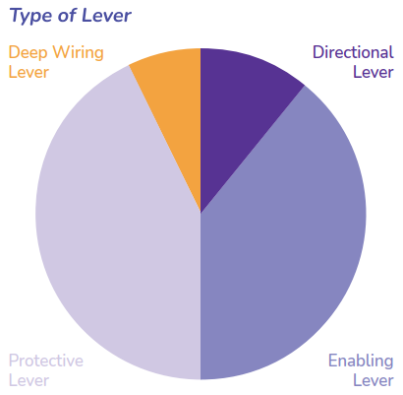

For this organisation, there is a clear priority placed on preparing to change and protecting under-served groups from the harms of the status quo, with comparably light investment in direct and deep rewiring of the core business elements that create the harms of the status quo.

We believe this type of analysis will help organisations to consider how their
approaches to advancing anti-racism tacitly embed assumptions and/or embed the train tracks that maintain the status quo. For example, protective approaches may be necessary in the short-term to insulate under-served communities from potential injury but can also distract the organisation from addressing the underlying causative factors of racism.

We group the levers for change into these classifications as follows:

Directional levers | Leadership  Narrative  Organisational strategy and goals
Enabling levers  (preparatory work) | Budgets and resourcing  Power and commitment  HR policies  Training Practice  Data Collection  Monitoring, reporting and auditing
Protective levers | Power and commitment*  HR policies*  Practice*  *To the extent that the initiatives within these levers have a protective impact for under- served groups
Deep wiring levers | Service/Product Design

Completing this analysis requires inspecting the impact of the initiatives under each lever to quantify the volume of initiatives under each of the four categories, which could either be a simple numeric approach or according to assigned budget.

The second analytical component is assessing each of the initiatives against four factors which provide insight into the efficacy of the portfolio of work. The proposed factors are:
- Impact – the extent of transformation achieved by individual initiatives is helpful for prioritising investment, recognising that small steps (or lower impact) can be necessary to build into higher impact initiatives. It is important to distinguish between the meaningfulness of an initiative to those involved in it and the impact. An initiative can have high meaning, such as the ability for an under-served group to come together for mutual social support. However, the impact might only be moderate, in that the group coming together provides short-term support to those exposed to racism, without contributing tangible systemic change. Equally an initiative might have low emotional resonance, but high impact, for example, an equity dashboard or budget evaluation tool.
- Time to impact – there is a need for interventions that achieve impact across all time horizons. However, without considering the interaction between initiatives organisations can unknowingly over-invest in a particular time horizon.
- Scale and reach – the reach of initiatives is relevant to the normalisation of the desired future state. Broader scale initiatives are necessary to achieve normalisation, but smaller scale initiatives have an important role in building momentum as well as fostering innovation. Like the other factors for assessment, considering scale aims to be revelatory for organisations and prompt discussion on the optimal balance across different levels of scale.
- Strategic significance – some initiatives may have symbolic importance that is an important contribution, independent of any of the other factors for assessment.

These factors are well suited to a range of graphic representations that allow an organisation to see the cumulative impact and the inter-relationship between their full suite of initiatives.

In combination, the two stages of analysis are likely to be revelatory for organisations to understand the impact, efficacy and tacit priorities informing their current approach to anti-racism. These insights provide a solid foundation for the next phase of applying Whiria te Muka.

Score
The scoring phase of Whiria te Muka to benchmark the organisation by assessing an organisation’s performance on their journey toward anti-racism. Drawing on insights from the stocktake and analysis phases, as well as wider insights into the organisation, performance is scored against each of the whiri and aho within Whiria te Muka, across a spectrum of kaha (or maturity level). The spectrum is plotted below:

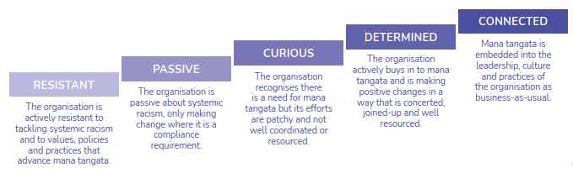

The goal of benchmarking is for an organisation to achieve an honest, full and potentially challenging understanding of their current place on the journey towards anti-racism. The value for an organisation is that it creates a point in time reference for the organisation to track future progress. It is also a mechanism to build a culture of
accountability for, and momentum toward, anti-racism.

A preliminary scoring rubric has been developed and is appended in full in Appendix A. Indicative visual representations are included in Figures 1-3 below.
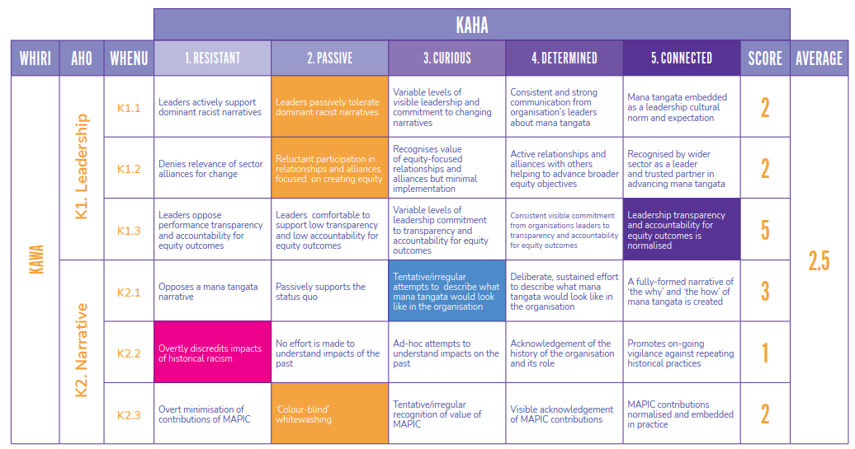
In many cases, an organisation may not fit perfectly into a singular kaha (or maturity level). Each level is nuanced and complex, and this rubric is an illustrative pathway for organisations, it is not comprehensive. We should expect the competencies within each kaha to evolve as our understanding and practical application of each whiri and aho matures over time.

The process for benchmarking could involve a range of participatory processes, such as using a representative panel to complete the assessment, a range of survey-based assessments and/or elements of peer review. We propose to further test the calibration of the scoring rubric and the benchmarking processes in the next phase of Ao Mai te Rā.

The scoring rubric also produces visual depictions that simplify the organisations results - outlining their strengths, weaknesses, and areas for future investment. Indicative graphics are depicted in Figures 1 and 2. These images depict the relative strength of an organisation’s level of kaha for each of the whiri, aho or whenu. The closer the line is to the centre of the graphic, the weaker the level of kaha is assessed to be that the closer the line is to the outer edges of the graphic, the stronger the level of progression.

Figure 1: High level view of whiri
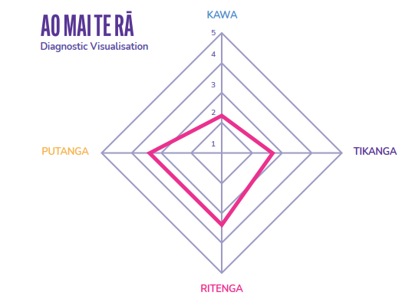

Figure 2: Mid-range view of aho
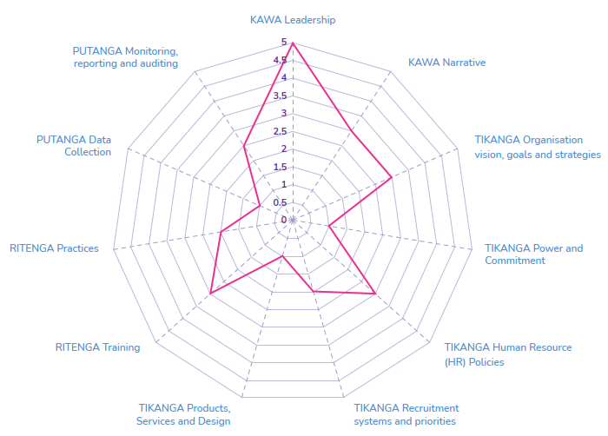

Figure 3: Detailed View of whenu (excerpt for legibility)
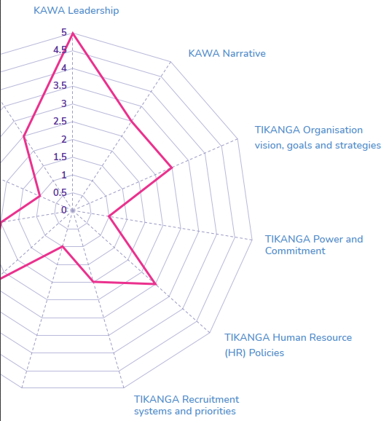

These visuals serve as a simple representation of the relative strengths and weaknesses across the full range of change interventions needed to progress anti-racism, contributing to the honest reflection objective of the scoring stage, effective communication across the organisation and forming a shared starting point for approaching what to do next.

Whakahoahoa Designing

The design phase involves an organisation creating a strategy or plan for progressing anti-racism. The preparation process provides you with a clear picture of:
- your organisation’s current state;
- initiatives your organisation is currently implementing; and
- how the portfolio of initiatives as a whole is advancing Whiria te Muka Tangata.
Together, this information will help inform the design of your new pattern– a new strategy for the future.

Movement Building
We consider that organisations should approach their planning as intentionally constructing a movement within their organisations that aims to cultivate a tipping point of normalising anti-racism. As discussed above, Whiria te Muka supports movement building through intentional sequencing of pull and push factors to create a virtuous cycle of a drive toward a clear end state supported by an ongoing velocity of action.

Some preliminary thinking on how organisations could curate the interaction between their levers for change is set out on the follows. We emphasise that the proposed ordering of proposed levers is a first attempt to build an approach and requires further testing and is likely to become more robust in the next phase of Ao Mai te Rā.

Passive | Curious | Determined | Connected
Pull Factors  What’s needed: catalyse & cohere shared aspiration for change | Pull Factors  What’s needed: cohere a collective with a sense of shared meaning in equity | Pull Factors  What’s needed: grow reach of vision/ narrative for change to broaden ‘membership’ | Pull Factors  What’s needed: consistently reinforce the normality of equity
How to do that  Courageous and provocative leadership to create an organisational commitment to change. | How to do that  Visible leadership promoting positive benefits of equity to build shared organisational values and commitment to change. | How to do that  Vocal leadership promoting positive benefits to grow distributed leadership. | How to do that  Leadership advocacy extends beyond the organisation to the wider community
Examples – Kawa levers  - A senior leader (management or governance) championing the change  - Establish a cross- disciplinary leadership group  - Formalise a call to action  - Define key messages | Examples – Kawa levers  - Leadership clearly communicate expectations of how anti-racism will manifest across the organisation  - The new aspirational narrative is consistently repeated internally  - Inform the community | Examples – Kawa levers  - The narrative increasingly uses data insights and lived experience to communicate impacts | Examples – Kawa levers  - New vision, values and narrative are now normalised  - Build external alliances to amplify movement
Push Factors  What’s needed: initial velocity that builds hope in the change, early learning opportunities and track record of progress | Push Factors  What’s needed: sustained action with growing number of participants that means more people ‘act into’ the change with tangible track record growing | Push Factors  What’s needed: sustained action that builds sense of inevitability for the change (more pervasive) as well as tackling more complex action | Push Factors:  What’s needed: pervasive action
How to do that  Short-term, bite-sized and tangible initiatives to create a sense of momentum, hope and confidence. | How to do that  Maintain, strengthen and extend initial projects to build clusters of activity and widen active participation in the change.  Increased transparency and accountability increases support base and widens participation. | How to do that  Solidifying, aligning and integrating the use of all levers for change so they reinforce each other.  Extend efforts into experimentation and innovation to impact deeper & wider. | How to do that  Practices are close to normalised and the goal is to build a strong community of practice to ensure it is pervasive and durable.
Examples – Tikanga levers  - Strategy related to change (1st generation goal setting)  - Diverse recruitment  Examples – Ritenga levers:  - Change related training  - Stocktake of current initiatives  Examples – Putanga levers:  - Identifying outcomes indicators  - Pilot tailored initiative (new programme/ service/ access channel)  - Collect stories of lived experiences to understand issues and impacts | Examples – Tikanga levers  - New/ amended organisational policies relevant to change  - Integrate change related content into wider organisational strategy and goals  - Create organisational structure with responsibility for change (eg equity unit)  - Strengthen applicable HR policies and practices  Examples – Ritenga levers:  - Expand change related training  - Create reflective practices that support wider visibility of change aspiration  Examples – Putanga levers:  - Expand pilot initiatives  - Collate equity data  - Establish baseline data  - Build equity data framework/reporting | Examples – Tikanga levers  - Cross organisational responsibilities for change embedded in performance expectations  - Increased transparency and allocation of budget to support change  - Align/ realign policy goals  Examples – Ritenga levers:  - Build community of practice across organisation  - Renew reflective practice tools to support deeper approach to change  Examples – Putanga levers:  - Publicly release equity scorecards | Examples – Tikanga levers:  - Change embedded in all organisational policies and processes  - Diverse leadership across organisation  Examples – Ritenga levers:  - Change embedded in habitual practice across organisation  Examples – Putanga levers:  - Visibility embedded in organisational data processes  - Pervasive equity driven innovation

The Movement Model we propose is not drawn directly from literature, but the thinking behind it has theoretical roots in a number of disciplines, including:
- Social movement theory
- Sensemaking theory
- Behaviour change approaches
- Motivation as considered within psychology

Social Movement Theory
Social movement theory is concerned with understanding the formation of social movements, as a form of social mobilisation that results in collective action. Within this literature, vision and leadership are positioned as critical to the formation of a movement and there is extensive exploration of the mechanisms by which leadership and vision can successfully mobilise people.

One of the key insights concerns the process and importance of ‘framing’. ‘Framing’ means to create or shape meaning for people. Within a movement, framing is critical to focusing people on collective level action, creating the impetus and membership of a movement, by creating a shared lens for people to understand the purpose or meaning. In a transformative sense, framing is the mechanism by which people change the meaning they ascribe to different things or people. For example, effective framing efforts can help people move from perceiving a particular group of people within prejudicial stereotypes to a perception that recognises their full humanity. In a practical sense, framing typically occurs through leaders that use narrative and vision, however other forms of symbolism are also effective (for example the raised hand that became synonymous with the Black Panthers).

The literature is very clear that effective framing takes repetition and consistency, particularly where the goal of framing is to replace a pre-existing frame. In our context, the pre-existing frame carries the imprint of racism, and the goal of an anti- racism movement is to generate a new frame that creates meaning and momentum behind anti-racism. In the literature, there are a number of stages to promulgate
a new frame, such as an equity frame. These stages are called ‘laminations’. The first lamination is called keying which is about creating a new frame for people that provides a tangible sense of meaning and purpose. The second lamination is termed ‘frame breaks’. These are about transitioning people from the frames that they hold to the new frame that has been ‘keyed’.

Throughout all stages, the critical element is continually ‘relaminating’ the new frame with consistency.

These insights into framing, keying and laminating substantiate our explicit focus on ‘Pull Factors’, to build shared understanding and mobilise action.

Sensemaking
Organisational theory suggests that for any new, complex or challenging phenomenon (such as a change process toward greater equity) that people/organisations need support to ‘sensemaking’. We use ‘sensemaking’ in the way referred to by Karl Weick, as a process that involves people giving meaning to collective experiences. The process of sensemaking is generally considered to have three elements: cognitive, emotional and physical. The cognitive elements are having a mental model or frame to understand the ‘new thing’. The emotional elements are about feelings associated with the change and the physical are enactment or other practical ways to embody the cognitive and emotional elements. The latter are sometimes referred to as ‘acting into’
sensemaking: the act of doing can be a way we make sense of a particular change.

We have drawn on sensemaking in the way the pull and push factors interact. The pull factors are framing levers within Kawa that support cognitive sensemaking directly. The push factors are about acting into sensemaking through practical things to do. Both push and pull factors can be designed to provide the emotional element to sensemaking.

We apply sensemaking within this model as a guide to designing mutually reinforcing interaction across push and pull factors. The supporting tools encourage organisations to focus on both coherence in the pull factors while sustaining momentum through sequenced enactment opportunities (push factors).

Behaviour Change
Behaviour change is particularly concerned with how to create both individual and collective change. The field is still cohering, so there is arguably no-one theory, but there is agreement on the complexity of shifting human behaviour requiring a nuanced approach to both catalysing and sustaining change. The need to intentionally trigger and sustain change has informed our approach to the relationship between push and pull factors, as well as the focus placed on momentum and velocity. We have also drawn from the levers for change discussed in behaviour change work, with consideration of the distinctive role of different types of levers in creating change. Many commentators distinguish between coercing, incentivising and influencing change, and suggest that each will have a different effect in terms of the durability of change triggered. It is also recommended that the suitability of these types of levers is considered in the human and wider context. We have drawn on this body of work to build out our compilation of levers for change, as well as consider the likely suitability of different types of levers at different phases in the movement model.

Motivation
Psychology distinguishes between different types of motivation. Intrinsic motivation
is a deep form driven by an internal drive that emanates from a sense of ownership and autonomy over the change sought. Intrinsic motivation is considered to be more durable and effective for achieving complex change. Extrinsic motivation in contrast is geared by external motivators (such as compliance). Extrinsic motivation is considered to be less durable and effective in sustaining complex change.

We consider that the type of motivation triggered by different change levers is important to assess in strategising about the movement pathway. Too much reliance on extrinsic motivation will result in short- term change that is likely to be less ‘sticky’ than change which is driven by a deeper sense of internal drive and autonomous action.

Te Aho Tapu Starting
The first line of any weaving effort is crucially significant. It sets the basis of every aho (weft) and whenu (warp) that is to come later, it is the foundation on which the final pattern is built. In the context of Whiria te Muka Tangata, this means ensuring that the order in which the threads and strands are brought together is consistent with your intended design or strategy.

Whiria te Muka draws upon a Social Labs methodology in which people from within the organisation and those that have experience of the issues collaboratively design solutions. These solutions are experimental, systemic and numerous as the idea is not to place a large bet on a single solution but many smaller bets on multiple interventions.

As all organisations are different, there is no magic formula for how this should roll out. It takes time to order things and have the confidence to make a start. Weaving a new future takes ongoing leadership and a vision that people want to support. However, the desired end-state of Whiria te Muka Tangata is one where that future is self-sustaining and driven by an inherent desire from within the organisation. The introduction of different aho (levers for change) within the model at different stages in an organisation’s development can be helpful in building momentum.

Kupu Whakamutunga | Conclusion
The information in this document is preliminary and needs further testing, iteration and insight during the next phase of Ao Mai te Rā. This document provides a practical sense of how Whiria te Muka could be deployed within health organisations, so that we can deepen the dialogue we are able to have in the next phase of Ao Mai te Rā. We also plan to prototype Whiria te Muka in two to three organisations, which we are confident will be powerful learning opportunities to drive changes in Whiria te Muka.

Appendix A - Scoring Rubric
The scoring rubric below is designed to support organisations to benchmark their progress towards anti-racism. The rubric is in preliminary form and we look forward to evolving it with the sector in the next phase of Ao Mai Te Rā.

WHIRA | AHO | WHENU | 1  RESISTANT  Overt Racism | 2  PASSIVE  Covert Racism | 3  CURIOUS  Seeking Mana Tangata | 4  DETERMINED  Mana Tangata Valued | 5  CONNECTED  Mana Tangata Embedded
KAWA | K1. Leadership | K1.1 Championing Mana Tangata | Leaders actively support dominant racist narratives | Leaders passively tolerate dominant racist narratives | Variable levels of visible leadership and commitment to changing racist narratives | Consistent and strong communication from organisation's leaders about Mana Tangata | Mana Tangata embedded as a leadership cultural norm and expectation
 |  | K1.2 Building relationships and alliances | Denies relevance of sector alliances for change | Reluctant participant in relationships and alliances focused on creating equity | Recognises value of equity- focused relationships and alliances but minimal implementation | Active relationships and alliances with others helping to advance broader equity objectives | Recognised by wider sector as a leader and trusted partner in advancing Mana Tangata
 |  | K1.3 Modelling transparency and accountability | Leaders oppose performance transparency and accountability for equity outcomes | Leaders comfortable to support low transparency and low accountability for equity outcomes | Variable levels of leadership commitment to transparency and accountability for equity outcomes | Consistent visible commitment from organisation's leaders to transparency and accountability for equity outcomes | Leadership transparency and accountability for equity outcomes is normalised
 | K2. Narrative | K2.1 Developing the Mana Tangata story | Opposes a Mana Tangata narrative | Passively supports the status quo | Tentative/irregular attempts to describe what Mana Tangata would look like in the organisation | Deliberate, sustained effort to describe what Mana Tangata would look like in the organisation | A fully-formed narrative of 'the why' and 'the how' of Mana Tangata is created
 |  | K2.2 Promoting accountability for history | Overtly discredits impacts of historical racism | No effort is made to understand impacts of the past | Ad-hoc attempts to understand impacts of the past | Acknowledgement of the history of the organisation and its role | Promotes ongoing vigilance against repeating historical practices
 |  | K2.3 Promoting strengths and capabilities of 'the other' | Overt minimisation of contributions of MAPIC | Colour-blind' whitewashing | Tentative/irregular recognition of value of MAPIC | Visible acknowledgement of MAPIC contributions | MAPIC contributions normalised and embedded in practice
TIKANGA | T1. Organisational Strategy & Goals | T1.1 Developing and adopting a Mana Tangata strategy | No Mana Tangata strategy and current approach creates inequities | No Mana Tangata strategy and current approach passively sustains current inequities | Current Mana Tangata strategy is narrow, incomplete and/or inconsistently applied | Current Mana Tangata strategy is complete but inconsistently applied | Current Mana Tangata strategy is fully- formed, supported by and embedded in the organisation
 |  | T1.2 Integrating Mana Tangata into overarching strategy | Overarching strategy creates inequities | Overarching strategy ignores equity and sustains inequities | Overarching strategy references equity but in narrow, contained ways | Overarching strategy is aligned with Mana Tangata | Overarching strategy embeds and visibly prioritises the Mana Tangata strategy
 |  | T1.3 Driving accountability for achieving Mana Tangata goals | Organisation resists data- gathering and/or monitoring equity goals and outcomes | Organisation uses inconsistent data-gathering, data sets and/or methods for equity reporting | Organisation has a consistent equity reporting approach but reporting is irregular | Organisation has robust regular reporting on Mana Tangata strategy with clear accountabilities is growing a Mana Tangata culture | Commitment to the Mana Tangata strategy and accountability sustains a Mana Tangata culture
 | T2. Power & Commitment | T2.1 Governance-level power-sharing | Deliberate exclusion from decision-making | Token representation in decision-making | Board members and processes aligning to Mana Tangata vision | Structural changes to governance for more inclusive decision-making | Te Tiriti governance
 |  | T2.2 High-trust contracting for service delivery | Contract for service delivery to MAPIC is with mainstream providers | Under-funded, high- compliance for MAPIC providers responsible for MAPIC service delivery | Initial efforts to understand and implement equitable operating environment for MAPIC providers | Equitable compliance expectations and funding for MAPIC providers | Reduced compliance, high- trust MAPIC contracting normalised
 |  | T2.2 Mana Tangata strategy and goals have sufficient budget and resource | Deliberate under-funding and resourcing equity strategy | Failure to prioritise funding and resourcing of equity strategy | Minimal funding for Mana Tangata strategy | Mana Tangata strategy mostly well-funded and resourced | Funding and resourcing of Mana Tangata strategy enables its full implementation
 | T3. HR Policies | T3.1 Diversity | Recruitment processes are discriminatory against MAPIC applicants | Recruitment processes disadvantage MAPIC | Recruitment processes designed to ensure MAPIC are not disadvantaged | Recruitment processes are designed to increase the number of MAPIC applicants | Recruitment processes ensure equitable number of MAPIC applications and appointments
 |  | T3.2 Diversity promotion | Promotion processes are discriminatory against MAPIC | Promotion processes disadvantage MAPIC | Promotion processes are designed to ensure MAPIC are not disadvantaged | MAPIC are promoted at equitable rates to non- MAPIC | MAPIC are found at equitable rates at all levels in the organisation
 |  | T3.3 Rewards and incentives | Reward system enables racism because of "blindness" | Reward system allows racism because rewards tied to factors that disadvantage MAPIC | Reward system supports dialogue about interpersonal conduct but does not carry financial implications | Some incentives for positive interpersonal conduct | Incentive framework embeds positive interpersonal conduct and delivery against equity outcomes
 |  | T3.4 Disciplinary | Organisation actively fosters/tolerates racism | Racist discourse goes underground in the organisation | Racism and/or discriminatory conduct is specifically referenced as misconduct/serious misconduct but enforcement is patchy | Sanctions for racism and/or discriminatory conduct are applied consistently | Organisational culture discourages racist discourse and practice with broad support for sanctions where necessary
 | T4. Service Design | T4.1 Access | Service access criteria actively disadvantage MAPIC | Service access criteria are not consciously reviewed to eliminate disadvantage | Efforts to review service access criteria have commenced | Access criteria have been reviewed and changed in order to ensure MAPIC are not disadvantaged | MAPIC have equitable access to services
 |  | T4.2 Content | Service content is consciously designed from a Eurocentric worldview | Service content is not consciously reviewed for exclusionary elements | Efforts to review service content elements for appropriateness for MAPIC have commenced | Service content has been reviewed in order to ensure MAPIC are not excluded or disadvantaged | Service content is appropriate for MAPIC
 |  | T4.3 Delivery method | Service delivery methods actively disadvantage MAPIC | Service delivery methods are not consciously reviewed for characteristics that may exclude MAPIC | Efforts to review service delivery methods for MPAIC accessibility have commenced | Service delivery methods have been reviewed in order to ensure MAPIC are not excluded or disadvantaged | Service delivery methods are inclusive and accessible for MAPIC
RITENGA | R1. Training | R1.1 Mana Tangata in training | Training offerings deliberately exclude equity/ anti-racism/Mana Tangata elements | Training offerings not reviewed for equity/anti- racism/Mana Tangata elements | Efforts to review training offerings with a view to strengthening equity/anti-racism/Mana Tangata elements | Training offerings have been reviewed and equity/ anti-racism/Mana Tangata elements have been added/ strengthened | All training offerings embed Mana Tangata throughout as an essential concept
 | R2. Practice | R2.1 Mana Tangata practice | Opposition to practices that support Mana Tangata | No coherent set of practices that support Mana Tangata | Efforts to define a set of practices that support Mana Tangata has commenced | A coherent set of practices to support Mana Tangata has been defined and has begun to be used | A defined, coherent set of Mana Tangata practices is embedded in organisational operations
 | P1. Data Collection | P1.1 Mana Tangata data collection | Organisation is resistant to capturing equity related data | Organisation ignores equity related data in organisational processes | Equity related data is collected but it lacks consistency and/or reliability | Equity data collection is robust but limited to compliance | Equity data collection is prioritised in both business-as-usual and service innovations with consideration of desired Mana Tangata outcomes
PUTANGA | P2. Monitoring, Reporting & Auditing | P2.1 Practice reviews | Organisation is resistant to regular reviews of practice to ensure consistency with Mana Tangata principles | Organisation does not prioritise reviews of practice to ensure consistency with Mana Tangata principles | Tentative/irregular reviews of practice are conducted | Practice reviews with a focus on Mana Tangata principles are reviewed on a regular basis, with lessons shared widely | Practice reviews with a focus on Mana Tangata principles are normalised and embedded as business- as-usual with lessons leading to identifiable service improvements
 |  | P2.2 Monitoring | Organisation is resistant to monitoring the efficacy of services in terms of equity outcomes | Organisation does not prioritise or resource monitoring the efficacy of services in terms of equity outcomes | Organisation limits monitoring of equity outcomes of services to where it is required for compliance and does not routinely use monitoring to inform ongoing Mana Tangata efforts | Equity monitoring goes beyond what is required and is used to guide organisational priorities, resourcing and decision- making. | Equity monitoring is embedded in the organisation's operations, with lessons learnt shared widely and used to inform service improvements and innovation.

References
Coker, R, Atun, R, & McKee, M 2008, Health Systems and the Challenge of Communicable Diseases: Experiences from Europe and Latin America, McGraw-Hill Education, Berkshire. Available from: ProQuest Ebook Central.
Foster-Fishman, P.G. and Behrens, T.R., 2007. Systems change reborn: Rethinking our theories, methods, and efforts in human services reform and community-based change. American journal of community psychology, 39(3), pp.191-196.,;
Gahan, P. and Pekarek, A., 2013. Social movement theory, collective action frames and union theory: A critique and extension. British Journal of Industrial Relations, 51(4), pp.754-776
Gray, B., Purdy, J.M. and Ansari, S., 2015. From interactions to institutions: Microprocesses of framing and mechanisms for the structuring of institutional fields. Academy of management review, 40(1), pp.115-143.
Hassan, Z., 2014. The social labs revolution: A new approach to solving our most complex challenges. Berrett-Koehler Publishers.
Henare, M., 1988. Nga tikanga me nga ritenga o te ao Maori: Standards and foundations of Maori society. Report of the Royal Commission on Social Policy, Wellington.,
Levesque, J.F. and Sutherland, K., 2017. What role does performance information play in securing improvement in healthcare? A conceptual framework for levers of change. BMJ open, 7(8)
Michie, S., Van Stralen, M.M. and West, R., 2011. The behaviour change wheel: a new method for characterising and designing behaviour change interventions. Implementation science, 6(1), pp.1-12.
Michie, S., Atkins, L. and West, R., 2014. The behaviour change wheel. A guide to designing interventions. 1st ed. Great Britain: Silverback Publishing, pp.1003-1010.
Morris, A., 2000. Reflections on social movement theory: Criticisms and proposals. Contemporary sociology, 29(3), pp.445-454.
Nulman, E. & Schlembach, R. 2018, “Advances in social movement theory since the global financial crisis”, European journal of social theory, vol. 21, no. 3, pp. 376-390.
Reinecke, J. and Ansari, S., 2021. Microfoundations of framing: The interactional production of collective action frames in the occupy movement. Academy of Management Journal, 64(2), pp.378-408
Ryan, R.M. and Deci, E.L., 2000. Intrinsic and extrinsic motivations: Classic definitions and new directions. Contemporary educational psychology, 25(1), pp.54-67.,
Sage., Holt, R. and Cornelissen, J., 2014. Sensemaking revisited. Management Learning, 45(5), pp.525-539

This, A., 2000. WITH A LEVER
Vallerand, R.J., 1997. Toward a hierarchical model of intrinsic and extrinsic motivation. In Advances in experimental social psychology (Vol. 29, pp. 271-360)
Weick, K.E., 1995. Sensemaking in organizations (Vol. 3).
Williams, L.R.T. and Henare, M., 2009. The double spiral and ways of knowing. Mai Review, 3, pp.1-9.

Henare, M., 1988. Nga tikanga me nga ritenga o te ao Maori: Standards and foundations of Maori society. Report of the Royal Commission on Social Policy Wellington.
Henare, M., 1988. Nga tikanga me nga ritenga o te ao Maori: Standards and foundations of Maori society. Report of the Royal Commission on Social Policy, Wellington., Williams, L.R.T. and Henare, M., 2009. The double spiral and ways of knowing. Mai Review, 3, pp.1-9.
Williams, L.R.T. and Henare, M., 2009. The double spiral and ways of knowing. Mai Review, 3, pp.1-9.
Nulman, E. & Schlembach, R. 2018, “Advances in social movement theory since the global financial crisis”, European journal of social theory, vol. 21, no. 3, pp. 376-390.
Morris, A., 2000. Reflections on social movement theory: Criticisms and proposals. Contemporary sociology, 29(3), pp.445-454.
Reinecke, J. and Ansari, S., 2021. Microfoundations of framing: The interactional production of collective action frames in the occupy movement. Academy of Management Journal, 64(2), pp.378-408; Gray, B., Purdy, J.M. and Ansari, S., 2015. From interactions to institutions: Microprocesses of framing and mechanisms for the structuring of institutional fields. Academy of management review, 40(1), pp.115-143.
Gahan, P. and Pekarek, A., 2013. Social movement theory, collective action frames and union theory: A critique and extension. British Journal of Industrial Relations, 51(4), pp.754-776., Morris, A., 2000. Reflections on social movement theory: Criticisms and proposals. Contemporary sociology, 29(3), pp.445-454.
Reinecke, J. and Ansari, S., 2021. Microfoundations of framing: The interactional production of collective action frames in the occupy movement. Academy of Management Journal, 64(2), pp.378-408; Gray, B., Purdy, J.M. and Ansari, S., 2015. From interactions to institutions: Microprocesses of framing and mechanisms for the structuring of institutional fields. Academy of management review, 40(1), pp.115-143.
Coker, R, Atun, R, & McKee, M 2008, Health Systems and the Challenge of Communicable Diseases: Experiences from Europe and Latin America, McGraw-Hill Education, Berkshire. Available from: ProQuest Ebook Central.
Weick, K.E., 1995. Sensemaking in organizations (Vol. 3). Sage., Holt, R. and Cornelissen, J., 2014. Sensemaking revisited. Management Learning, 45(5), pp.525-539.
Ibid
Ibid
13 Michie, S., Atkins, L. and West, R., 2014. The behaviour change wheel. A guide to designing interventions. 1st ed. Great Britain: Silverback Publishing, pp.1003-1010., Michie, S., Van Stralen, M.M. and West, R., 2011. The behaviour change wheel: a new method for characterising and designing behaviour change interventions. Implementation science, 6(1), pp.1-12.
Ibid
Ibid
Ryan, R.M. and Deci, E.L., 2000. Intrinsic and extrinsic motivations: Classic definitions and new directions. Contemporary educational psychology, 25(1), pp.54-67., Vallerand, R.J., 1997. Toward a hierarchical model of intrinsic and extrinsic motivation. In Advances in experimental social psychology (Vol. 29, pp. 271-360). Academic Press.
Levesque, J.F. and Sutherland, K., 2017. What role does performance information play in securing improvement in healthcare? A conceptual framework for levers of change. BMJ open, 7(8), p.e014825. Foster-Fishman, P.G. and Behrens, T.R., 2007. Systems change reborn: Rethinking our theories, methods, and efforts in human services reform and community-based change. American journal of community psychology, 39(3), pp.191-196.,; This, A., 2000. WITH A LEVER.
Ryan, R.M. and Deci, E.L., 2000. Intrinsic and extrinsic motivations: Classic definitions and new directions. Contemporary educational psychology, 25(1), pp.54-67., Vallerand, R.J., 1997. Toward a hierarchical model of intrinsic and extrinsic motivation. In Advances in experimental social psychology (Vol. 29, pp. 271-360). Academic Press.
Hassan, Z., 2014. The social labs revolution: A new approach to solving our most complex challenges. Berrett-Koehler Publishers.

