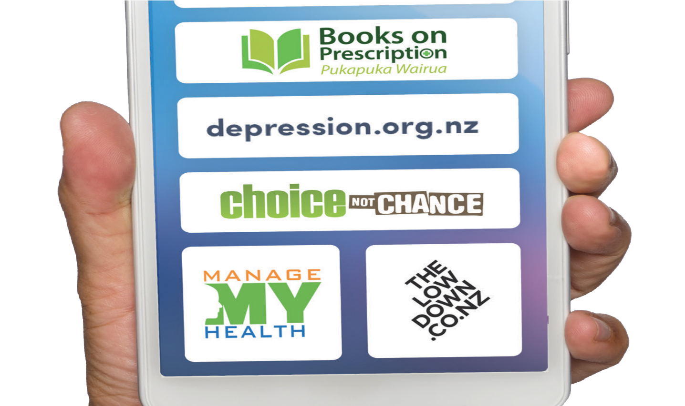

Sponsored Data pilot:
project review
NOVEMBER 2019

Ministry of Health PO Box 5013
Wellington 6140
Ph (04) 496 2000
Email info@health.govt.nz
www.health.govt.nz

WellSouth Primary Health Network Level 1, 333 Princes St
Dunedin 9016
Ph (03) 477 1163
Email info@wellsouth.org.nz
www.wellsouth.nz

Health Promotion Agency/Te Hiringa Hauora PO Box 2142
Wellington 6140 Aotearoa New Zealand Ph (04) 917 0060
Email enquiries@hpa.org.nz
www.hpa.org.nz

November 2019

Contents
Executive Summary 3
Background 4
Findings 6
Appendix 1 11

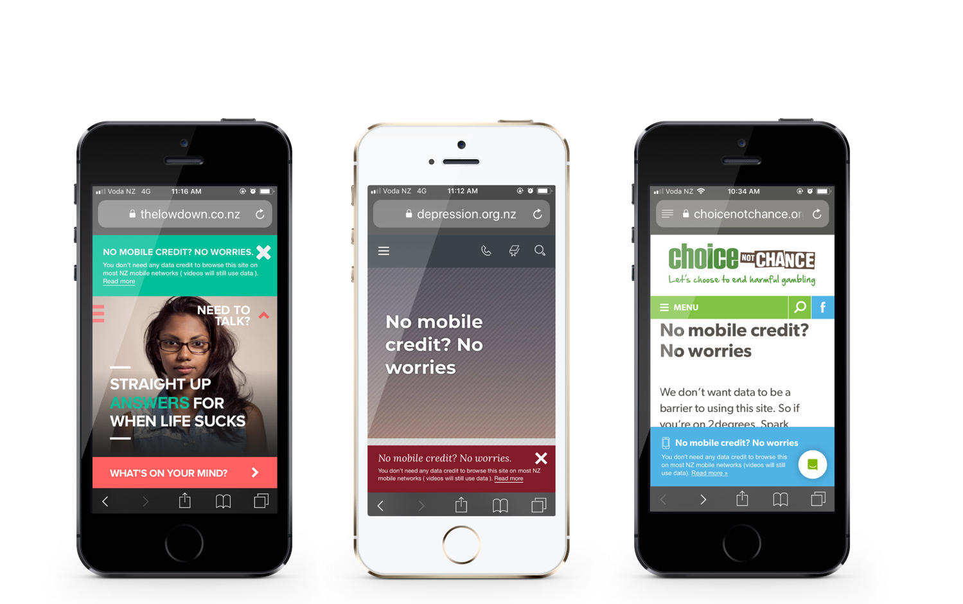
Document Purpose
The Sponsored Data pilot project (“the project”) set out three deliverables:
- A set of learnings and pilot results
- Ministry of Health and/or agency business case(s)
- A documented pilot commercial framework.
This report is deliverable 1, and contributes to deliverables 2 and 3.

Executive Summary

The Sponsored Data pilot project tested the provision of free to the consumer mobile phone data for some online health resources, in order to evaluate the value and impact of removing the cost of data for consumers to these resources.

The project was a joint initiative of the Ministry
of Health, WellSouth Primary Health Organisation, and Health Promotion Agency, working with three telecommunication companies – Spark (including the Skinny brand), Vodafone, and 2degrees.
The project provided free to the consumer mobile access for the period 1 May to 31 October 2019 to four websites:
  - Depression.org.nz
  - Thelowdown.co.nz
  - Choicenotchance.org.nz
  - Booksonprescription.co.nz and two patient portals:
  - ConnectMed (used by 23 practices)
  - ManageMyHealth (used by 18 practices).
Overall, the project has shown that people with no data (and therefore no other way to access the websites from a mobile network) did in fact access the project websites: two of the three Health Promotion Agency websites (depression.org.nz and thelowdown.co.nz) and WellSouth’s Books on Prescription website showed that a large number of people with no mobile data accessed the sites. In the case of Books on Prescription, there was significant access by new users. Patient portal user access by users with sponsored data could not be determined.
There was direct feedback by general practices and NGOs that data cost and availability is a fundamental access barrier, particularly for those experiencing the most inequity.
A number of technical and commercial lessons were learnt, chiefly how to ensure websites and infrastructure are optimised for the specific technical requirements of sponsored data, and that there can be significant cost to purchasing agencies and telecommunication providers above the cost of data.
While there are a number of limitations to the findings presented here – including that users may still have accessed the sites in the absence of sponsored data, as well as a lack of consumer feedback and the unavailability of some website analytics – the view of the health agencies is the project has demonstrated there is clear demand for free to the consumer access to key health information, particularly from New Zealanders who experience the most inequity. As such, the key finding is that it is reasonable to further pursue the provision of such free to the consumer access.

Background

The Sponsored Data pilot project (“the project”) tested the provision of free to the consumer mobile phone data for some online health resources, in order to evaluate the value and impact of removing the cost of data for consumers to these resources.

Sponsored data involves subsidising mobile data traffic to a limited set of sites by an interested party (the third party). The third party carries the cost of the end consumers’ use of the destination site. With subsidised data usage, the mobile carrier can zero- rate consumers’ use of that data so it does not draw down on their mobile plan.
The rationale for the project was to help improve digital inclusion, recognising that those who do not, or cannot, access and use digital health services are most often those with the highest health needs. There are a number of core elements for improving digital inclusion; the target for this project was to improve access by improving affordability 1.
Consideration has also to be given to ensuring that as valuable services – such as patient portals – become available or go online, people without access to mobile data will not be excluded from accessing them. Such exclusion would clearly not improve health equity.
The project was a joint initiative of the Ministry
of Health (the Ministry), WellSouth Primary Health Organisation (WellSouth), and Health Promotion Agency (HPA), led by the Ministry’s Digital Strategy and Investment team. The Ministry, HPA and WellSouth were exploring free or sponsored data options simultaneously, and all parties saw merit in joining forces to conduct a pilot in which resources were shared and learnings applied to the wider health sector.
These agencies worked with three telecommunication companies – Spark (including the Skinny brand), Vodafone and 2degrees – that provided the sponsored data and technical assistance to the project. For the telecommunication companies, sponsored data has a number of business advantages derived from improved consumer and enterprise engagement with sponsored mobile services.
The project provided free to the consumer mobile access, for the period 1 May to 31 October 2019, to four websites:
- Depression.org.nz
- Thelowdown.co.nz
- Choicenotchance.org.nz
- Booksonprescription.co.nz and two patient portals:
- ConnectMed (used by 23 practices)
- ManageMyHealth (used by 18 practices).

- For example, see https://www.digital.govt.nz/digital-government/digital-transformation/digital-inclusion/digital-inclusion-blueprint/.

Project timing
The project timing was as follows:

Promotion of the project
Promotion of the project began in May 2019 across Otago and Southland, the area covered by WellSouth.
Project stage | Timing
Discovery and planning | August to October 2018
Vendor partner discussions, advice, approvals and agreement | October 2018 to  February 2019
Implementation: availability of sponsored data | 1 May to  31 October 2019
Evaluation, learnings documentation and project close | November 2019

Information about the project was distributed twice via email channels to 84 general practices, high schools, youth services, Māori and Pasifika support agencies, health sector NGOs, and community agencies. A poster for the project was created and sent out via email. This was supported by flyers which were posted or delivered to these organisations.
The project was also promoted via the 30 clinicians in the WellSouth Brief Intervention Mental Health Service, and the clinical outreach team including refugee support and cross-cultural navigators. The promotional material was also added to the WellSouth website and Facebook page.
The project was promoted on the three HPA websites (Choice Not Chance, Depression and The Lowdown) as “No credit, no worries” via a popup banner. A page with further details about the project was clicked on by 1,651 people on the Depression site and 359 on The Lowdown site between June and September 2019.

Findings

The objectives of the project set out in the Project Brief were:
  - Conduct a limited “zero-rated data” pilot over a three month period to better evaluate the value and impact of removing data costs.
  - Assess and validate that data cost and availability is a fundamental barrier for many accessing digital health information/services, particularly for those experiencing the most inequity.
  - Continue engagement with Government Chief Information Officer (GCIO) and create a set of learnings on how this initiative, or business model could be applied more broadly, or fit within all of government.
  - Enable those New Zealanders, who experience the most inequity, and/or multiple access barriers to health information and services, to better access and use digital health services.
The project was able to collect some of the information needed to fulfil these objectives, via website analytics, feedback from the participating agencies, the telecommunications companies, and health and social service providers. Some of this serves as a useful proxy for helping understand the key objective, largely showing that people with no data (and therefore no other way to access the websites from a mobile network) did in fact access the project websites.

Objective 1: value and impact
The project can show a positive impact on usage.
Two of the three Health Promotion Agency websites2 (depression.org.nz and thelowdown.co.nz) and WellSouth’s Books on Prescription website showed that a large number of people with no mobile data accessed the sites. In the case of Books on Prescription, there was significant access by new users.
It is assumed that these are people who without sponsored data would not have been able to access the sites. Therefore their use represents a positive impact.
FREE MOBILE

AVAILABLE ON

- The project was not able to measure Choice not Chance users due to the complex design of the site’s analytics.

Table 1: Depression.org.nz – sponsored data users

Month | June | July | August | September
Total number of sponsored data users | 5,562 | 4,795 | 5,158 | 4,981
Total NZ users | 57,580 | 39,526 | 42,692 | 43,760
Percentage of NZ users accessing via sponsored data | 9.7% | 12.1% | 12.1% | 11.4%

Table 2: thelowdown.co.nz – sponsored data users

Month | June | July | August | September
Total number of sponsored data users | 734 | 472 | 400 | 440
Total NZ users | 12,415 | 9,253 | 11,247 | 11,006
Percentage of NZ users accessing via sponsored data | 5.9% | 5.1% | 3.6% | 4.0%

Table 3: Books on Prescription – sponsored data users

 | Users | Sessions | Page Views | Comment
May | 15 | 18 | 49 | 88.2% new users, 11.8% returning
June | 60 | 60 | 67 | 98% new users, 2% returning
July | 92 | 92 | 97 | 100% new users
August | 89 | 89 | 92 | 100% new users

Patient portal user access by users with sponsored data could not be determined because:
- ConnectMed reporting accessible to WellSouth could not identify if mobile users had data or not and could not provide data specific to the 23 WellSouth practices
- ManageMyHealth did not provide data to WellSouth.
Impact on patients and consumers can best be assessed by the clear feedback from general practices and NGOs that the project was of value. For example:
“This project is something that some of the patients have commented on as being very helpful. To the point where we have put the poster on our website too.
It would be great to see it continued. Thank you”

SOUTH CITY MEDICAL PRACTICE, INVERCARGILL
47% of patients are high needs3

- High needs refers to patients enrolled in a general practice who are Māori OR Pasifika OR NZDep5 (the most deprived quintile).

There was very limited direct feedback from
patients or consumers, though some excellent
feedback from general practitioners about patient
experience. For example:

“One of my patients I enrolled for Manage.
My Health was in debt with us and so only
allowed to book over the phone to make
she was aware she needed to pay first.
Even with this in place she would often
book and not attend. I got her enrolled
for Manage My Health and yes she booked
her own appointments but interestingly
she also cancelled them well in time for others
to use the slot. This has meant her taking better
control over her health. She orders her script
through Manage My Health appropriately, which
she was unable to do before as she had no phone
money left to order by phone. Hence medication compliance has improved and so has her health condition. All because of empowering her to use
Manage My Health and giving her access to free
data to use the system.”

GP, MORNINGTON HEALTH CENTRE, DUNEDIN
21% of patients are high needs

Objective 2: assess and
validate cost and availability
as a barrier

The project has demonstrated data cost and
availability is a fundamental access barrier, particularly
for those experiencing the most inequity. There was
clear feedback from general practices and NGOs in
this regard:

“For our mainly low income patients, having free
access to health information and their patient
portal is a great improvement. The feedback we've
had so far is really positive, and as we add more
and more patients to the patient portal, it's only
going to become more important.”

TE KAIKA CAVERSHAM HEALTH
48% of patients are high needs

“It was a great initiative. Young people appreciated
it. We continued to put the flyers in our waiting
area and we noticed people were taking them.
"Even from an organisation perspective, we
can say this project is great as people can
access health resources even though they
do not have credit.”

SOUTHLAND YOUTH ONE-STOP SHOP

WellSouth also received feedback from others aware
of but not involved in the project:

“This is a wonderful initiative and would be a
significant benefit to our patients. We support
many Māori, Pacific whānau with complex needs
and data can be a barrier to accessing the care
and information they need. We would love to see
this initiative expanded to cover all health websites
and rolled out nationally.”

TURUKI HEALTH CARE, AUCKLAND
97% of patients are high needs

Objective 3: learnings
The learnings of the project can be broken down into three elements: technical, financial and consumer engagement. This section includes feedback from the participating agencies and the three telecommunications companies. Limitations on these learnings are set out below.

Technical
The key finding was that not all existing websites will be suitable for sponsored data: existing websites and applications need to be reviewed to ensure they meet the special technical requirements of sponsored data architectures. In some cases it will be preferable to develop a new website or app that is compliant with the sponsored data platforms. For example, if third party integrations such as video streaming are left in place, users would be directed to sites outside the sponsored data IP ranges. This may result in data charges for users or the sponsored data sites not loading.
To the extent possible, such technical decisions should design for the user experience remaining the same in terms of performance.
It is also important to establish baseline data before implementing a sponsored data initiative in order to contribute to evaluation.
These technical arrangements can be complex. As such, there may be a requirement for consulting resources from the telecommunications companies to support sponsored data initiatives.
In regard to patient portals, there was not granular enough information to draw any conclusions in regard to whether sponsored data made any difference to users.
The HPA’s technical learnings are detailed in Appendix 1, and these could form the basis of a user guide to assist organisations with these technical requirements.

Financial
A number of financial learnings are clear:
  - There is a cost in communicating to users, whether on the sponsored sites or in promoting the service.
  - The actual mobile data has a cost (which may go up significantly if the sites are heavily used), and confirming who meets this cost is important.
  - Agency and telecommunications firms experience employee time cost.
  - There is a cost to all parties in ensuring technical requirements are met.
  - There are potential costs if additional technical features are required, for example RealMe login or more specific patient portal information.
a. Specifically, if better information is required regarding patient portal access, then some analysis is required to determine the cost to create this.
This consideration of cost needs to be balanced against the clear evidence that the cost and therefore unavailability of mobile data is a barrier to access, particularly for those experiencing the most inequity.

Consumer engagement
There was very limited direct feedback from patients or consumers. Consequently, any new sponsored data initiative will require work to ensure that their feedback on value and impact is captured.
The main learning is that communication with consumers should be very clear on the details of how sponsored data operates. For the most part, this is not difficult to set out, but it does require some decisions about how future approaches operate – for example, the behaviour of banner information ads on sponsored data sites.

Engagement applies to not only explaining how a sponsored data initiative operates, but also explaining to new website and patient portal users that access when they have no data is covered in such an initiative. Given the positive impact of patient portals on consumers’ health experience, effective communication with target users of sponsored data will be an important component of driving uptake with such users.
It is also important to acknowledge that technical and health literacy may be different in target consumer groups, and that communication should be designed around this.

Limits on findings
- Website usage by sponsored data users does not prove that users would not have otherwise accessed the sites.
- Technical issues restricted the collection of sufficiently granular patient portal information to make meaningful assessments of use.
- A consumer survey was not carried out, despite this being planned, as the cost was prohibitive.
- There was limited in-depth qualitative feedback from health service providers about their patients’ or consumers’ experience.

Objective 4: enable better access and use
Enabling those New Zealanders who experience the most inequity and/or multiple access barriers to health information and services to better access and use digital health services is a process beyond the remit of this project.
However, the learnings gleaned from this project do demonstrate that there is demand for free to the consumer access to key health information, as shown by actual usage and provider feedback.
The view of the health agencies involved in this project is that it is reasonable to further investigate the provision of such free to the consumer access, so long as this includes a business case focussed on clear business drivers.
Feedback from the agencies and telecommunications companies is that such a process is best carried out by purchasing agencies working within the Department of Internal Affairs Telecommunications as a Service (TaaS) arrangements.

Appendix 1

HPA: Sponsored Data Pilot – lessons learned, considerations and recommendations.

Technical requirements/considerations
Not all digital services may be suited to implementing the sponsored mobile data service. Considerations include:
  - Infrastructure (hosting/third party).
  - Data analytics (e.g. Choice not Chance being a single page application, so website analytics were unavailable).
  - Specific qualifying criteria.
  - Ability for websites to provide alternative functions, for example: display default fonts if using web fonts, provide transcripts if using YouTube/Vimeo videos.
  - Possible code revisions and updates are required to ensure websites work properly, if third party libraries are not loaded before going live. This is very hard to test before going live.

Technical lessons learned:
  - Third party integration is common on most websites and sponsored data cannot be applied to these third party products. These products:
    - usually include: fonts, images and videos
    - can also be a part of some other features like campaign management tools (Google remarketing, Facebook retargeting, Hotjar), form verification (captcha), survey popup (Survey Gizmo, Surveymonkey), and form subscription (newsletter).
  - Using a proxy solution to redirect Google Analytics is a very efficient way to track users without mobile data, and this is not very complex to achieve.
  - Some websites with complex tracking codes using Google Tag Manager can lead to conflicting JavaScript codes if using a proxy solution to redirect Google Analytics.
- After going live with the sponsored data service, web developers need to monitor the performance of the website to investigate any issues. Many issues were found after going live with the pilot, even though we had conducted thorough testing with a simulated environment.
- Websites with a lot of traffic (more than 10k page views per day) could lead to inaccuracies in reported numbers as it requires more resource from a proxy server.

Technical tips:
- User profiling related data in Google Analytics, should be regarded as relative rather than absolute.
- In Google Analytics, returning users only start to be counted from when a view is first set up.
- Honeypot: solution to fix slow performance if websites have captcha verification feature
https://dev.to/felipperegazio/how-to-create-a-simple-honeypot-to-protect-your-web-forms- from-spammers--25n8.
- Move fonts/js/css to local as much as possible to make website run faster.
- Video streaming platforms like YouTube
and Vimeo are a good solution to fix the issue of video integration. We have investigated https://clipbucket.com/, it worked well and is reasonably priced.

Financial considerations for agencies to consume the zero rated service:
- Cost to ensure technical requirements are met.
- Cost of communication to users e.g. development costs to implement website banners, marketing or other promotions, collection of user feedback (website survey).
- Cost of the actual mobile data:
- Cost of data for a website may go up significantly once it is promoted/marketed
- It is not free data, it is free for the consumer, but will be paid for by agencies implementing the service. The data was sponsored by the telecommunication companies during the pilot.
- Cost in terms of resources for managing the service, i.e. review, reporting and monitoring of data etc.
- Other specific requirements that may apply to websites which were not in scope for this pilot e.g. RealMe login.
User communication and user experience The ‘No credit, no worries’ banner behaviour implemented on the HPA websites was for it to pop-up the first time the (sponsored data) consumer accessed the site. The banner included a link to further information about how the sponsored data service works.
Recommendations:
- Implementation of a banner pop-up to inform users of the sponsored data service. Provide access (e.g. link) to further information about the service from the banner
- Provide clear communications as to how sponsored data works:
- Only users in NZ can access (includes non-New Zealanders)
- Applies to mobile data only
- Specify which telecommunication providers offer the service (and which do not)
- Specify what users need to do in order to access the service e.g. keep mobile data setting turned on.
- The user experience should remain the same in terms of performance, download etc., however, for some features like video there may be a data cost, so alternatives such as video transcripts or streaming platforms may need to be implemented.
- Pop-up surveys for qualitative customer feedback through using 3rd parties, like SurveyGizmo, Surveymonkey, cannot be targeted for sponsored data customers only, which is why we could not collect qualitative feedback during the pilot. There may be a technical solution to enable a survey to specifically target sponsored data users, but this would obviously incur additional expenditure.
- Privacy – tracking for analytics purposes should be in line with agencies privacy policies.

Analytics
Our Choice not Chance website analytics was implemented using a complex tracking code and there was a conflict with the sponsored data tracking solution, therefore, we could not measure sponsored data users.
What can be measured?
  - GB of all per site – this should be measured by hosting providers. Some hosting providers like Umbrellar or AWS can provide traffic per site. However, this may not be accurate as it includes all traffic to the server, not just the web traffic.
  - Traffic per user – this was calculated based on the total traffic divided by the total number of users, so the final number is not precise.
Communications
HPA did not do any external marketing/promotion for the Sponsored Data pilot project. It was only promoted on the participating websites through the ‘No credit, no worries’ pop-up banner.

