Ao Mai te Rā

The Anti-Racism Kaupapa
Anti-Racism Maturity Models
Lessons for the Aotearoa New Zealand Health System
Stage Three Literature Review
September 2022

Citation: Williams M. 2023. Anti-Racism Maturity Models - Lessons for the Aotearoa New Zealand Health System (Stage Three Literature Review). Wellington: Ministry of Health.
Published in February 2023 by the Ministry of Health
PO Box 5013, Wellington 6140, New Zealand
HP 8708
This document is available at health.govt.nz
This work is licensed under the Creative Commons Attribution 4.0 International licence. In essence, you are free to: share ie, copy and redistribute the material in any medium or format; adapt ie, remix, transform and build upon the material. You must give appropriate credit, provide a link to the licence and indicate if changes were made.

Context for this work
Ao Mai te Rā: the Anti-Racism Kaupapa (Ao Mai te Rā) is a Manatū Hauora (Ministry of Health) initiative to support the way the health system understands, reacts and responds to racism in the Aotearoa New Zealand health system.

Phase one of Ao Mai te Rā comprises three literature reviews that can be read individually or as an integrated portfolio of work. This is the third literature review in the portfolio.

Collectively the three literature reviews have been used to inform the major outputs for phase one. This review was completed by researchers from the University of Canterbury and Tokona Te Raki – Māori Futures Collective.

Kaituhi:
Dr Madi Williams

Kaiwhakahaere:
Dr Eruera Tarena
Sacha McMeeking

Kaiārahi/Expert Advisory Group:
Garrick Cooper
Dr Yvonne Crichton-Hill
Dr Matthew Scobie

Tokona Te Raki:
Adrienne Anderson
Contents
Context for this work iii
Introduction 1
Progression Maturity Models (PMM) 2
Capability Maturity Models (CMM) 3
Hybrid Maturity Models (HMM) 5
Benefits and Limitations of Maturity Models 6
Alternative Approaches 9
Equity Audits 9
Organisational Capacity Assessment Tools (OCAT) 10
Racial Equity Impact Assessments 12
Section Conclusion 13
Critical Theories of Change 15
Systems Change, Levers and Deep Equity 15
Critical Race Theory (CRT) 19
Critical Anti-Racist Theory (CART) 20
Section Conclusion 21
Examples of Models and Approaches 23
Diversity and Inclusion Models 24
Korn Ferry Diversity and Inclusion Maturity Model 2.0 24
Aotearoa Inclusivity Matrix 27
Australian HR Institute’s (AHRI) Diversity and Inclusion Maturity Model 28
The Deloitte Diversity and Inclusion Model 29
Racial Justice and Equity Models 32
Beloved Community's Equity Audit 32
The Equity-Driven Systems Change (ESC) Model 33
Disruptive Equity Education Project (DEEP) Theory of Change 36
Health Equity Assessment Tool (HEAT) 38
Organisational Capacity Assessment Tool Examples 41
Building Organisational Capacity for Health Equity Action: A Practical Assessment Tool for Public Health 41
Anti-Racism Maturity Models 45
Justice T.R.E.E.E. Model 45
The QuakeLab Maturity Model 47
Critical Policy Analysis Models 49
Discussion 52
Kupu whakamutunga | Conclusion 55
References 56

List of Figures
Figure 1: Nader Mehravari, Progression Model 3
Figure 2: Nader Mehravari, Capability Maturity Model 4
Figure 3: Five Maturity Levels. Adapted from Humphrey [1989] in Bill Curtis et al. [2009]. 4
Figure 4: Nader Mehravari,Hybrid Maturity Model 5
Figure 5: Four Stages of Organisational Development 11
Figure 6: Korn Ferry Diversity and Inclusion Maturity Model 2.0 25
Figure 7: The Diversity and Inclusion Model Sequence 26
Figure 8: Client Example of the Diversity and Inclusion Model 26
Figure 9: Leadership Component in the Aotearoa Inclusivity Matrix 27
Figure 10: AHRI's Diversity and Inclusion Maturity Model 28
Figure 11: The Deloitte Diversity and Inclusion Model 29
Figure 12: Deloitte's Six Personas of Strategic Change Applied to Diversity and Inclusion 30
Figure 13: The Deloitte Diversity and Inclusion Maturity Model (formatting adapted) 31
Figure 14: Beloved Community Equity Audit Score Bands 33
Figure 15: Equity-Driven Systems Change (ESC) Model 35
Figure 16: Five Stages of Equity-Driven Systems Change (ESC) Model 36
Figure 17: DEEP's Taxonomy of Disruption 37
Figure 18: Intervention Framework to Improve Health and Reduce Inequalities 40
Figure 19: Building Organisational Capacity for Health Equity Action Conceptual Framework 42
Figure 20: Individual Spidergram Model 43
Figure 21: Organisational Spidergram Model - Applied Exemplar 43
Figure 22: The Justice T.R.E.E.E Model 45
Figure 23: Justice T.R.E.E.E. Model 46
Figure 24: QuakeLab Inclusion Maturity Model 49
Figure 25: Critical Tiriti Analysis Indicators, as applied in the Primary Health Strategy 51

“Kotahi karihi nāna ko te wao tapu nui a Tāne”
- Te Wharehuia Milroy

THE CREATION OF THE FORESTS OF TĀNE COMES FROM ONE KERNEL.

Growth, maturity and development takes time and must be nurtured.
Planting a seed today to reap the harvest tomorrow.

Introduction
The purpose of this literature review is to explore and examine the key features and characteristics of anti-racism maturity models.

The overarching question it seeks to answer is: What would a maturity model for
anti-racism in health look like, that will help us get a system view of our current state and where we need to be in future?

To reach this point, this review discusses what maturity models consist of, the different types, and the benefits of each. Primary criticisms and alternative approaches to maturity models are also discussed to provide a balanced exploration and to draw out best practice insights.

This review concludes by offering critical recommendations on the key features and characteristics of an anti-racism maturity model for New Zealand (Aotearoa).

What is a maturity model?
A maturity model is a tool that assists people and organisations in understanding their performance in particular areas and in encouraging and mapping a path for progress. They provide a scale of levels (including characteristics, patterns, indicators) against which their practices can be measured. When the organisation demonstrates the necessary indicators, ‘capabilities’ for each level, it has reached that level of maturity.1 Maturity models originated in the information technology discipline in the 1980s but have since been applied to various fields. They are also sometimes referred to as “stages-of-growth models, stage models, or stage theories.” They are generally quite simple, with four to five levels or stages that indicate maturity in a given area.

Having measurable transition states between the levels enables an organisation to use the stages to:
- define its current state
- determine its future, more “mature” state
- identify the attributes it must attain to reach that future state (Caralli, Knight, Montgomery (2012).

They are premised on the idea of “predictable patterns” that “evolve in a stage-by-stage manner along an anticipated, desired, or logical maturation path.” This is the genesis of the core critique of maturity models, which will be explored further on.
The three key benefits of a maturity model were identified as:
- Measuring for auditing and benchmarking;
- Measuring of progress assessment against objectives; and
- An understanding of strengths, weaknesses and opportunities.

Maturity models allow strengths and weaknesses to be assessed and benchmarked and provide insight into key areas for improvement and levers for change.

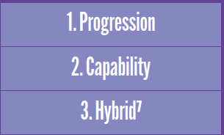

Progression Maturity Models (PMM)
Progression Maturity Models (PMM) involve measuring improvement in relation to
an attribute. The model focuses on the attribute or task rather than a specific measure of maturity.

An example of a PMM, is the progression from crawling to running, as depicted in the model below.

Figure 1: Nader Mehravari, Progression Model
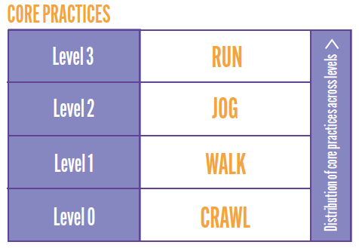

Benefits and Limitations
Progression models are a simple way of measuring practices, patterns, or attributes and are comprehensible, making them easy to use. However, their simplicity is also
a weakness as they “do not measure capability or process maturity,” making them
of limited use. They are also limited in their sustainability as they do not measure the capability of an organisation to sustain the practice in question during challenging times, ie resilience.

Capability Maturity Models (CMM)
Capability models measure capabilities on a range of “characteristics, indicators, attributes, or patterns,” in other words, “processes.” Inherent to CMMs is the aim of improvement.

These models are also referred to as “process models.” These are different from progression models because they examine the maturity of the culture and “the degree to which the capabilities are embedded (or “institutionalized”) in the culture.” They are more complex than progression models and are premised on the idea that “Institutionalization is cumulative.”
Figure 2: Nader Mehravari, Capability Maturity Model
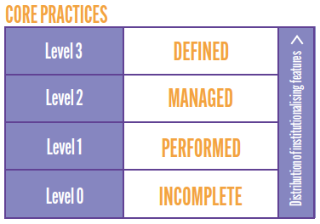

An example of a CMM is the embedding of management practices as depicted in the model below.

Figure 3: Five Maturity Levels. Adapted from Humphrey [1989] in Bill Curtis et al. [2009].
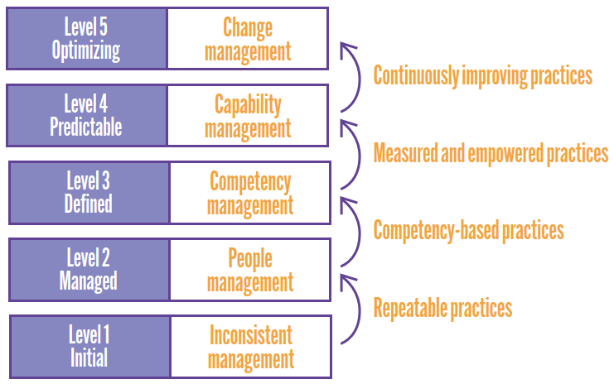

Benefits and Limitations
CMMs are beneficial in that they enable the thorough measurement of the core capabilities and competencies of a group or organisation. The level to which
the capabilities are embedded and institutionalised is what determines an organisation’s “ability to retain core competencies under times of stress.” Some of the limitations of CMMs are that they can be complicated to understand and therefore use, and they have a high implementation cost. Another limitation that was identified in the literature was that maturity does not always transfer to results. This means they can give a “false sense of achievement” to organisations. CMMs, unlike PMMs, measure the capability and resilience of an organisation and embed the competencies so they are sustainable during challenging times.

Hybrid Maturity Models (HMM)
Hybrid Maturity Models (HMM) as the name suggests, combine the progression and capability approaches. An HMM “reflects transitions between levels that are similar to a capability model (ie that describe capability maturity) but architecturally use the characteristics, indicators, attributes, or patterns of a progression model.” These models measure how capabilities have been institutionalised within an easy-to- use progression model framework. An example of an HMM is depicted below.

Figure 4: Nader Mehravari,Hybrid Maturity Model
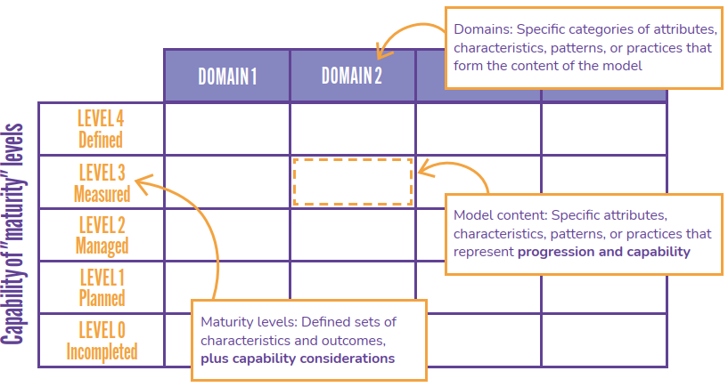

Benefits and Limitations
HMMs are the most beneficial of the maturity models as they take the best of the PMM and CMMs. They enable the measurement of “core competencies as well as approximation of capability.” Capability measurement is important as this indicates an organisation’s resilience in the presence of disruption and stress.”

HMMs can be easily adapted as needed and are low-cost to employ. There are limitations; because they are a hybrid, they are not as comprehensive or rigorous as a CMM in terms of measuring maturity. Some have argued that the way HMMs combine “attributes with institutionalizing features at each level can be arbitrary.”

Benefits and Limitations of Maturity Models
Maturity models (MMs) help provide a structured roadmap for improvement and the monitoring and analysis of progress. They can be used as a practical tool to show people and organisations what they need to do to progress. Laying out a progression pathway helps people and organisations to start their journey of change. They can also be used to collect information and data on where an organisation is currently in a particular area. This information can support organisations identify areas for growth as well as benchmark their performance against comparable organisations.

Benchmarking is one of the key benefits of a MM. They enable organisations to measure and benchmark their maturity and performance. Organisations can assess where their starting point is and then strategically plan how to progress. The framework of a maturity model also means organisations can compare their performance to other similar groups, which can drive organisation improvement and change. The MM can also be used to track the progress of an organisation over time and see where improvements have been made. In order to achieve this, they establish a shared language regarding an area for improvement, which provides a “consistent way of thinking and communicating about a domain.”

Although there are many benefits of a MM, there are also weaknesses that need to be taken into account. While there is not a lack of literature on maturity models generally, there is a lack of literature and evidence around the correlation between maturity and improvement. There is certainly a need for further research into the impacts of maturity models in different spheres. There was also discussion on the assumptions made in MM, such as assumptions around the order of the maturity process, which can be inaccurate and “do not hold true universally.” Related to this is the limitation that MM can become “step-by-step recipes” which do not take into account the complexities and different paths that can be taken. It has been argued that they are too simplistic and imply that there is only one path to a particular goal. In response to these criticisms, it has been proposed that “maturity models should
not focus on a sequence of levels toward a predefined ‘end state’, but on factors driving evolution and change.” They then need to be flexible, adaptable and customised to the specific context of each organisation.

Another crucial criticism of maturity models is that they can often be descriptive rather than prescriptive. This can be mitigated by ensuring they encompass prescriptive points too, but is an important risk to be aware of. A descriptive MM is useful for gaining an “as-is” picture of the current state; it serves as a “diagnostic tool.” Whereas a prescriptive MM also “indicates how to identify desirable maturity level” as well as offering “guidelines on improvement measures.” The literature suggests that these guidelines should be “Specific and detailed courses of action.”

Taking these benefits and limitations into account, for a maturity model to be most beneficial, it needs to:
- Be prescriptive rather than simply descriptive;
- Provide a roadmap for sustainable change;
- Identify levers for change at each level; and
- Identify multiple potential paths towards a goal.

In other words, MMs should not be used simply for assessment and objective benchmarking. The key questions organisations need to ask when implementing an MM are:
- What does this indicate our strengths and weaknesses are?
- What levers of change do we need to prioritise?

A related point was made by J. L. King and K.L. Kramer, who argued that MMs need to refocus on the factors that influence and drive change rather than a prescribed set of levels leading to an end goal. They were identified in the literature as helpful when there is a need to “monitor and measure progress, particularly in the presence of change” and as a “roadmap from a current state to a desired state.” The map needs to identify the current state of an organisation but then also give directions to the next stages of development. Maturity is not linear, and there is not a single path towards it. Similarly, the stages should not be linear, and there should be multiple paths to achieving the identified goals. Any MM must take these factors into account.

“E koekoe te tūī, e ketekete te kākā, e kūkū te kererū”

THE TŪĪ SQUAWKS, THE KĀKĀ CHATTERS, THE KERERŪ COOS.

Everyone has a unique perspective and has a right to be heard. Working together and understanding differences can enable new pathways to be created. The symphony of the collective is more harmonious than the individual.

Alternative Approaches
Maturity models are not the only tool that can be used to benchmark capabilities and provide a pathway for improvement in a given area. This section explores a broad range of alternative approaches that have been used in the health sector to benchmark, measure and support capacity and capability development.

These include:
- Equity audits,
- Organisational capacity assessment tools, and
- Racial equity impact assessments.

Equity Audits
An alternative approach to maturity models are equity audits. Equity audits focus on policies, programs and practice that directly or indirectly impact a person relative to their race, ethnicity, gender, national origins, colour, disability or other socioculturally significant factors. An example of an equity audit is depicted to the right:

What is an Equity Audit?
An Example.
Service: providing shoes.
Equality: everyone gets a pair of shoes.
Equity: everyone gets shoes that fit.
Equity Audit: determining
(1) who “everyone” is,
(2) what constitutes “shoes,” and
(3) creating decision-making processes for how “fit” is identified and evaluated.

Benefits and Limitations
Equity audits are a useful tool for gaining a robust understanding of equity at a point in time for an organisation. However, the limitation then is that they only capture a particular point in time. The process is labour and resource-intensive, and this can reduce buy-in from those involved. Equity audits, in their rigour, create a massive amount of data, and this has “tended to overwhelm decision makers.” This makes it hard to implement changes from the results. There have been more simplified versions developed by scholars such as Linda Skrla to enhance their “usability” and applicability. As was noted by Skrla, “Although extremely detailed examinations of practices of schools and districts can be highly useful in some circumstances… they are not very useful in more practical, day-to-day leadership contexts. In our experience, few school leaders will have time or motivation to read through a several hundred-page document and then use the results well in planning school change.”

Equity audits are also not equipped for driving sustained change. While they are beneficial for gaining an understanding of the existing situation, they are not sufficiently focused on deep, sustained transformation. Equity audits do not engage with multiple levers of change and therefore are not suitable for creating sustained transformation in the anti-racism space. What is needed is a “deep equity” approach that sees the whole system and pulls multiple levers of change. This is discussed in-depth in the systems thinking section.

Organisational Capacity Assessment Tools (OCAT)

Organisational Capacity Assessment Tools are intended to measure an organisation’s ability to achieve its aims. They were developed in the Non-Governmental Organisations (NGO) space as a “framework to prompt organized thinking about an organisation’s trajectory.” They have been used to assist organisations in understanding their capacity for equity action in a systematic manner.

The key aims of OCATs are to:
- “Provide a framework that facilitates individual reflections about an organization’s trajectory”;
- “Help stakeholders identify shared concerns and priority actions”; and
- Provide a “common language to discuss difficult organizational issues and focus the conversation on the questions within a tool rather than opinions of specific individuals.”

There is a wide range of OCATs available because they have been adapted to specific circumstances and areas. Specific examples of OCAT are given in the examples section of this review. An effective OCAT is one that “supports an efficient process for understanding an organization’s strengths and weaknesses, and identifies capacity
areas needing attention.” The tools range from simplistic to comprehensive. The comprehensive tools look at a range of capacity areas and help paint an overall picture of an organisation’s capacity. The following figure, from William Booth and Robert Morin’s 1996 model, gives four categories of NGO's development:

Figure 5: Four Stages of Organisational Development
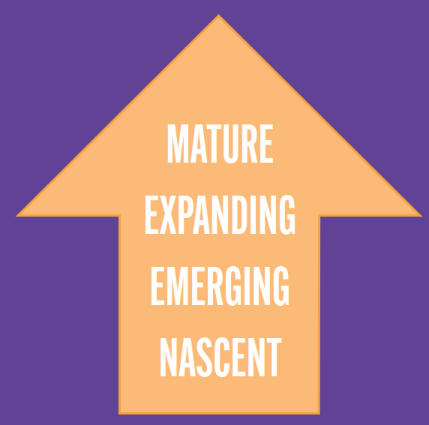

Benefits and Limitations
The benefits of OCATs are that they provide a way for an organisation to determine a pathway for improvement 'collectively'. They are useful in providing a focal point to centre the conversation and aggregate individual concerns and perspectives into a 'collective' organisational story. OCATs are adaptable and can be applied to a range of
situations, making them customisable to the needs of an organisation.

However, the OCAT process can be time-consuming and resource-intensive. This was identified by groups who used comprehensive OCATs and "were frustrated by the time it took to understand and answer the questions". They are intensive by nature and can often stifle the enthusiasm and energy needed to discuss and implement the results and drive change.

Another limitation is that power dynamics within an organisation can impact what people share if there is an internal person facilitating the OCAT.

They are generally not about sustained transformation as they are primarily directed at measuring current capacity and areas for improvement.

Racial Equity Impact Assessments
An alternative approach to maturity models are Racial Equity Impact Assessments (REIA). These assessments take a systematic approach to understanding “how different racial and ethnic groups will likely be affected by a proposed action or decision.” They are used to identify and mitigate or minimise any negative consequences that could result from decisions around policies and practices within an institution. REIA have been described as “a vital tool for preventing institutional racism and for identifying new options to remedy long- standing inequities.” This is because these assessments acknowledge and consciously try to prevent the “routine, often invisible” reproduction of racial inequities.

These tools are similar to risk assessments and are used to inform the decision-making process. REIA fit with the definition of anti-racism given in the first stage of the literature review on anti-racism as being a conscious choice requiring action. These assessments acknowledge that “When racial equity is not consciously addressed, racial inequality is often unconsciously replicated.” A key example of a REIA is the Health Equity Assessment Tool (HEAT) developed for te Manatū Hauora | the Ministry of Health in 2003-2004. This will be further outlined in the examples of approaches section.

Some key examples of questions that guide these assessments are:
- “Which racial/ethnic groups may be most affected by and concerned with the issues related to this proposal?”
- “Have stakeholders from different racial/ ethnic groups— especially those most adversely affected—been informed, meaningfully involved and authentically represented in the development of this proposal? Who’s missing and how can they be engaged?”
- “Which racial/ethnic groups are currently most advantaged and most disadvantaged by the issues this proposal seeks to address? How are they affected differently? What quantitative and qualitative evidence of inequality exists? What evidence is missing or needed?”
- “What factors may be producing and perpetuating racial inequities associated with this issue? How did the inequities arise? Are they expanding or narrowing? Does the proposal address root causes? If not, how could it?”
- “Is the proposal realistic, adequately funded, with mechanisms to ensure successful implementation and enforcement. Are there provisions to ensure ongoing data collection, public reporting, stakeholder participation and public accountability?”

Benefits and Limitations
REIA are beneficial in their systematic approach and the centering of race/ethnicity and health equity. They can be usefully applied to policy and practice decisions to identify and prevent any possible negative impacts. They are helpful in that they ask for the root cause of the inequities, but this requires significant unpacking in each specific context. There needs to be more acknowledgment of societal, institutional and individual levels and systems change to be effective in the anti-racism space.

The alternative approaches tend to capture a snapshot in time and focus on single or few levers for change. For anti-racism and equity, multiple levers for change are needed to enact deep transformation on a systematic level.

Section Conclusion
What has emerged from this review of the literature is that while no approach is
perfect, a maturity model is highly effective because it encompasses a wider range of levers and dimensions of change. The alternative approaches, such as equity audits, are useful for a specific purpose but only act as narrow levers and do not take into account the bigger picture. As will be detailed in the following section, any model for change needs to see the 'wholes' to create deep transformation. Racism is a systemic issue and needs to be addressed at all levels; interpersonal, institutional and internalised.

“E ngaki ana a mua, e tōtō mai ana a muri”

FIRST CLEAR THE WEEDS, THEN PLANT

The conventional way of thinking has led us to where we are.
We must make space for new and innovative approaches to designing
solutions to a persistent and pervasive problem.

Critical Theories of Change
This section outlines the key critical theories of change that are necessary to include in a model aiming to create deep and sustainable transformation in the anti-racism space.

Theories of change are a crucial facet of transformation. They are able to “limit or facilitate the development, direction and substance of ideas, while empowering or constraining the creative capacity of their users."

A vital point regarding these theories is that they all see the importance of wholes and the intersectional nature of oppression.

The main points discussed in this section are systems change thinking, levers of change, and the importance of Deep Equity, CRT, and CART.

A maturity model for the health system, needs to be grounded in systems thinking and deep equity to facilitate sustainable, measurable progress in the system as
a whole.

For an anti-racism model, it also needs to engage with Critical Race Theory and its offshoot Critical Anti-Racist Theory. The combination of these ensures that the resulting maturity model will effectively be able to measure and scaffold sustainable, long-term change in the anti-racism space.

Systems Change, Levers and Deep Equity

Systems Change
What is clear from the literature is that systems change approaches are effective at creating change in the anti-racism space. Systems change is “the process of shifting narratives, relationships, and power in order to foster equity and self-determination.”
It is underpinned by systems thinking which Peter Senge, systems change theorist, describes as “a discipline for seeing wholes. It is a framework for seeing interrelationships rather than things, for seeing patterns of change rather than static ‘snapshots’”. Systems thinking recognises "complex systems as dynamic, constantly changing and governed by history and feedback".

It was identified in the literature as particularly useful in the health system context because of how it does not focus “on the individual components” and requires keeping “the whole system in mind when designing and evaluating health systems strengthening innovations.” In essence, systems change thinking "is [a] more holistic perpsective to complex problems in complex systems."

Power is a crucial component that needs to be addressed to affect change at the systems level. A recent briefing paper developed by Stop Institutional Racism on the forthcoming National Action Plan Against Racism states that, “An analysis of power needs to be at the forefront to transform structures, systems, policies, hearts and minds.” For change creation, there is a need “to confront and map the racism within organisations, systems and sectors and co-create iterative solutions with those who are targeted by racism.” The briefing paper recommended that there is a need to: “Invest in demonstration interventions where organisations undertake systems change-based anti-racism programmes, where the organisation is committed to sharing their learnings and supporting others. Upholding Te Tiriti o Waitangi and restoring power to Māori. Develop tools to support organisations as they map and disrupt racism. Invest in training change-agents in system change- based anti-racism programmes.”

For systems change to be sustainable, there needs to be deep “[transformation] of the underlying power dynamics, narratives, and histories that built these structures and enable them to thrive”. An important aspect affecting this level of systems change is deep equity.

Levers for Change
The stage two literature review for Ao Mai te Rā identifies and discusses the levers for change that are crucial to achieving complex systems change. They are areas of work, policies, or practices that have “the potential to deliver wide-ranging positive change.” Systems change occurs through activating levers that then “trigger shifts across system components” and at different levels. They are most successful at affecting change when they have multiple “connections within the system.”

Therefore when identifying potential levers, there needs to be close attention paid to the connections and interactions between parts of the system. Levers can include such things as:
- Organisational policy change;
- Shifting members;
- Strengthening and expanding relationships;
- New or different resources;
- Changing practices; and
- Changing members’ mental models.

A useful way to identify and frame levers for change is through examining the system as a whole:
- norms, including attitudes, values, and beliefs;
- resources, including the human, social, and economic capital available within the system;
- regulations, including policies and procedures; and
- operations, particularly power/decision- making processes and structures.

These levers are important to consider across all levels or areas of a system. Recent research into fostering older adults with disabilities participation in health found that health equity could be improved by health providers “activating levers for change” at “multiple levels to foster effective change.” These levers and levels were identified as “systems (eg healthcare, academic sector), organizations (eg homecare, community associations), emerging services (eg social participation opportunities), practitioners (eg community psychologists, occupational therapists, public health agents), and service users.”

Levers for change necessitates some discussion of extrinsic and intrinsic motivation. Extrinsic motivation is generated by external factors influencing change such as “directives, policies and economic or structural forces emanating from outside their direct control.” While intrinsic motivation emerges from “self- awareness, self-reflection or tailored and specific feedback about performance – with subsequent catalysis of action or response.” Intrinsic motivation is more powerful and drives sustainable change that people have bought into rather than been coerced or forced into.

This is referred to in the literature as shifting mental models or mindsets. This is crucial because mental models influence decision- making and action. This means that “even if system members have developed the new capacities needed to implement a new program or practice, they are unlikely to implement or sustain these changes if the shifts do not cohere with their worldviews about how things should be done.” One way that norms can be altered and intrinsic motivation can be sparked is through narrative. Systems transmit norms, and this has been described as “a blessing and a curse” because these norms can be conducive to, or limiting of, change. If anti-racism and equity are “institutionalised” just as racism and inequity have been, then the norms will be transmitted and more likely to create sustainable change. This is one of the primary ways CRT seeks to create change.

Deep Equity
Deep equity examines how the social construction of identity, power and privilege impacts our individual and collective experiences. It necessitates an understanding of, and engaging with, power and privilege - and how it operates within the system. A vital component of deep equity is the acknowledgment of context and history and how it has created and maintained inequity. Change Elemental argue that deep equity is "inseparable" from systems change.

One of the main critiques of systems change literature is that it "has been largely written by people of privilege (mostly White, of Western European decent, with advanced degrees, and mostly men)". The majority of system change literature does not offer "any deep or extended exploration of how White dominant culture shapes the formation, use, and impact of these ideas and principles. Race, racism and colonialism are occasionally, but still very rarely and briefly, mentioned in anecdotes from most systems change interventions or in systems archetypes and maps".

Deep equity is an essential component of complex systems change. It has even been suggested that systems change pursued without deep equity is "dangerous and can cause harm, and in fact leaves some of the critical elements of systems, unchanged."

Critical Race Theory (CRT)
Critical Race Theory (CRT) examines systems, institutions and power through the lens of race and racism. CRT argues that race and racism are social constructs that are upheld by dominant values and beliefs and re-engrained in systems and structures (ie legal frameworks, policies, etc.) It argues that the impact of racism is not happenstance but purposeful and deliberate - resulting in outcomes that benefit one group over another. This standpoint shifts our focus and understanding of racism from an act that only 'bad' people commit, to a network or system that deliberately disadvantages one group in favour of another.

CRT uses counter-narratives or stories "as a means to speak against the dominant narrative" that is "often accepted without question". Counter-narratives help raise
awareness and empathy. For instance, "they contextualize the social determinants of health and help advantaged groups envision and sympathize with the harsh realities of disadvantage contexts".

CRT has been used in the United States of America to critique the myth that society "is fundamentally fair and meritocratic and there has always been continual racial progress".

The five key tenets of CRT are:
- critical analysis of race, racism and power are central to any theorising or intervention
- challenging dominant ideas of objectivity, meritocracy, colour-blindness, race neutrality and equal opportunity
- the pursuit of social justice and transformation
- centralizing marginalised voices and naming realities
- using trans-disciplinary approaches to challenge dogma and orthodoxies.

CRT needs to be used 'pragmatically' in a way that acknowledges the nature of
race as a social construct . . . but not to the point where it is trivialised and rendered unimportant". Focusing on race does not create a “hierarchy of oppressions”; rather, it shows how oppressions intersect and is a way of ensuring that the race aspect is not ignored as it has been in the past.

CRT scholars have argued for intersectional understandings of oppression and “strategies to challenge the relationship between men and women, capital and labour, rather than an abstract focus on racism.”

CRT’s goals of social justice and transformation are of vital importance for anti-racism. CRT offers critiques and aims to “positively disrupt and transform racialized power relations.”¹⁰⁵ One such critique is of the “liberal incrementalism of the Left,” which has attempted to change “the legal system, and state sponsored racial equality,” these attempts have been “unsatisfactory and slow.”

Theory, while necessary, cannot affect deep, transformational change on its own. There also needs to be “sufficient conditions” to enable anti-racism. This means that there needs to be “a shift from a rhetorical commitment to change to one actually committed to the performance of proposed change." In other words, theory needs to be followed through by actions. CRT provides the framework for anti-racist change through “a vocabulary and narrative that facilitates a critical approach to anti-racism.”

Critical Anti-Racist Theory (CART)
A related theory to CRT is Critical Anti- Racist Theory (CART). Like CRT, CART is interested in the intersectionality of oppression based on “race, class, gender, sexuality, ability, and religion.” It recognises that these are influenced by the historical context and forces such as colonialism, capitalism, imperialism and xenophobia. It proposes that “critical anti- racism practice must root the understanding of racism in histories” of these forces. The literature noted that the theory-practice gap needs to be avoided as this limits the “transformative potential” of CART. Action is a crucial component of any anti-racist goals.

CRT pushes back against the dominant myth of meritocracy. It proposes that just because race “has proven to be scientifically invalid” does not mean it has “gone away.” In CART, there is an emphasis on lived experience, and it argues that the “reality of race emerges from the everydayness of racism and not the other way around. In other words, it is racism that has made race real.”

Historical context is a key component of CART, and it is argued that “We cannot understand racism without a link to the history of colonialism and European imperial expansion.” This is applicable in the Aotearoa context. This is heavily interlinked with resource distribution, and CART “calls on us to challenge the dominant claims of ownership and rights to place and property.” It not only encompasses race but “[places] Indigeneity in anti-racism calls for historicizing the colonial epoch in terms of who took up what spaces and resources, how, and why.” CART is a useful theory in this context because it recognises that any theory and practice must “acknowledge the specificities and connections of oppressions of Indigenous peoples and other racialized bodies in any struggles against racism.”

It is also useful because it recognises and accounts for the complexity of intersecting oppressions. Therefore, CART is a theory of ‘wholes’ and looking at the bigger picture. It acknowledges that oppression needs to “be fought on multiple grounds including individual and collective actions,” rather than focusing on one level. Although there are different forms of oppression, CART also accounts for the commonality between them, they all “work within structures, they are intended to establish material advantage and disadvantage, and they make invidious distinctions of self/Other.” This does not create a hierarchy of oppression and acknowledges that “oppressions are not equal in their consequences and intensities.” This is crucial because, as discussed in the stage one literature review, there are differences in intensity of oppression, and impacts can be felt more strongly by various people and groups.

Section Conclusion
The critical theories discussed in this section outline a set of criteria or desirable characteristics for maturity models aimed at making change in the anti-racism space. Most importantly, they outline the need to examine the whole picture and not zero in on one specific lever for change. As outlined in the stage one and stage two literature
reviews, racism is a systemic issue and therefore must be addressed at a systems level using multiple levers of change simultaneously. These points are important to keep in mind when examining the range of models and approaches discussed in the following section.

“Nā tō rourou, nā tōku rourou, ka ora ai te iwi”

THROUGH YOUR CONTRIBUTION AND MINE,
THE PEOPLE WILL THRIVE

When different peoples or groups collaborate and combine efforts,
all things can be achieved. Drawing on existing models, approaches and
research, we can learn from each other about what works best for our communities. This allows us to take practical steps with due diligence,
and do what is right, with integrity and with compassion.

Examples of Models and Approaches
This section explores twelve examples of how a systems change maturity model can be applied and used. While these examples are largely focused on 'individual change' there are some key aspects in each example that would be beneficial for anti-racism systems change.

Theme 1 - Diversity and Inclusion
- Korn Ferry Diversity and Inclusion Maturity Model 2.0
- Aotearoa Inclusivity Matrix
- Australian HR Institute Diversity and Inclusion Model
- The Deloitte Diversity and Inclusion Model

Theme 2 - Racial Justice and Equity Models
- Beloved Community Equity Audit
- Equity Driven Systems Change Model
- Disruptive Equity Education Project
- Health Equity Assessment Tool

Theme 3 - Organisational Capacity
- Organisational Capacity Assessment Test

Theme 4 - Anti-Racism
- Justice T.R.E.E.E. Model
- QuakeLab Maturity Model
- Critical Te Tiriti Analysis Model

Diversity and Inclusion Models

Korn Ferry Diversity and Inclusion Maturity Model 2.0
Korn Ferry is an organisational consulting firm that developed the Diversity and Inclusion Maturity Model (the D&I model) The D&I model offers a simple yet comprehensive snapshot of how mature an organisation is in both:
- Behavioural inclusion which focuses on individuals and their behaviours regarding diversity and inclusion
- Structural inclusion which focuses on the systems and processes and how equitable they are.

The D&I model measures maturity across five dimensions:
- Compliance
- Awareness
- Talent integration
- Operations integration
- Market integration

Progress against each dimension is captured across four sequences or stages which are illustrated on the next page. Each sequence has clearly defined anchors that are the same across each dimension to allow granular measurement of outcomes to targeted recommendations.

Within each of these five dimensions are two levels – behavioural and structural. The behavioural level is focused on individuals and their behaviours regarding diversity and inclusion. The second is structural, and is focused on the systems and processes and how equitable they are.

Figure 6: Korn Ferry Diversity and Inclusion Maturity Model 2.0
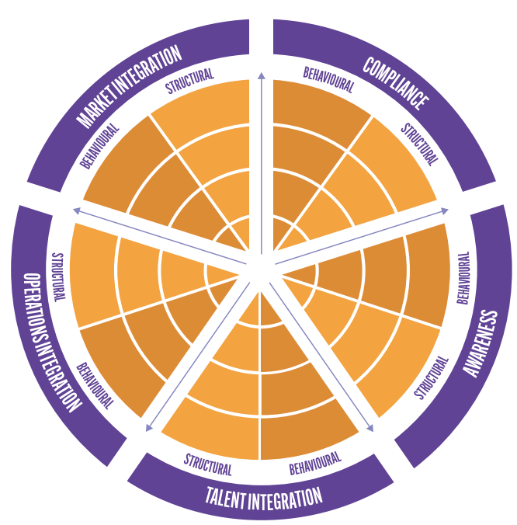

There are four levels within this model which are illustrated below.

Figure 7: The Diversity and Inclusion Model Sequence
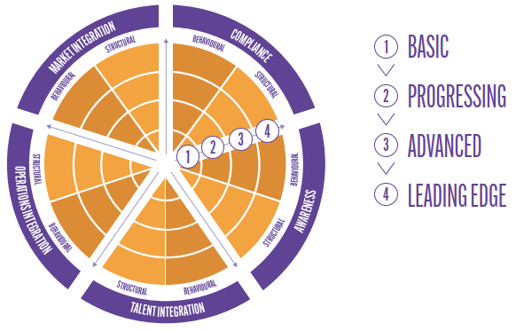
Figure 8: Client Example of the Diversity and Inclusion Model
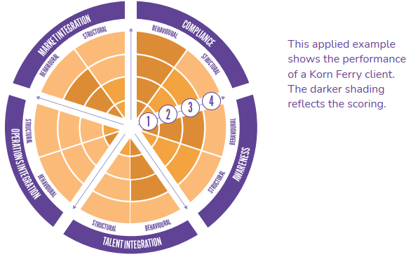

The first iteration of the model was linear, but the developers realised that while linear is useful for capturing a “snapshot of the current and desired states” it is not as useful for moving organisations forward. This is because “gaps are within multiple dimensions rather than neatly 100% resolved one dimension at a time and in a particular order.” The non-linear nature of this model is helpful, in particular how it acknowledges both behavioural and structural elements. The Korn-Ferry model operates on the institutional and individual levels but is limited in that it does not extend to the societal level or engage with aspirations and freedoms.

Aotearoa Inclusivity Matrix
The Aotearoa Inclusivity Matrix is a tool that was developed specifically for workplaces in Aotearoa to “identify the maturity of their diversity, equity and inclusion measures across seven components.” It is intended to help organisations understand their starting point, the areas for development and to help develop a plan moving forward. The levels are starter, emerging, developer, integrated and advanced.

The key components being measured are:
- Leadership
- Diversity infrastructure
- Diverse recruitment
- Inclusive career development
- Bi-culturalism
- Inclusive collaboration
- Social impact.

The first component of leadership is shown on the next page to illustrate how this matrix works.

Figure 9: Leadership Component in the Aotearoa Inclusivity Matrix
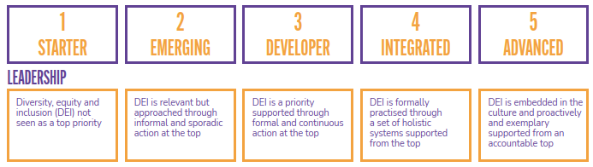

There are also indicators along the side to help apply the matrix to the workplace.
For leadership, these were identified as: “Rationale for diversity and inclusion; organisational values; location and type of accountability; visible commitment and participation in initiatives; the ability and willingness to role model expected
behaviours; the overall strategic approach to diversity management.”¹³¹

The matrix allows organisations to benchmark their performance in terms of diversity and inclusivity against others in their field, as well as establishing a national standard. It also enables organisations to identify key gaps and levers for change in their existing practices. Furthermore, it then assists organisations in planning to improve on these.

As with many of these ‘Diversity and Inclusion’ models, the Aotearoa Inclusivity Matrix is not sufficient for anti-racism. It is narrowly focused on increasing diversity in the workplace and assumes that this will decrease racism. In other words, it only pulls one lever of change. It is a diversity model, but this is not the same as an anti-racism one.

Australian HR Institute’s (AHRI) Diversity and Inclusion Maturity Model
The Australian HR Institute (AHRI) developed a simple diversity and inclusion maturity model with three levels. The first level is focused on compliance with legal diversity and inclusion frameworks. This level establishes the groundwork for further development and is an essential and compulsory element. The second level centres on mindsets and behaviour change. The third level focuses on engrained diversity and inclusion practices.

Crucially, at level three it is expected that "D&I is a function that is owned by everyone, across all employee brackets.” The need to embed D&I is important, but overall this
is a very simplistic model and one without a lot of supporting literature. It is unclear how it seeks to achieve the aims.

Figure 10: AHRI's Diversity and Inclusion Maturity Model
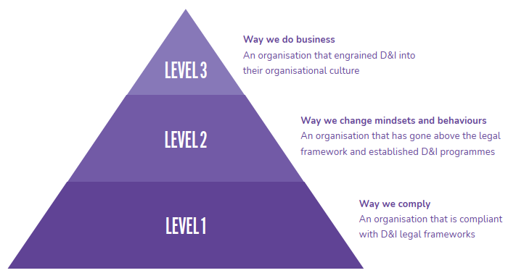

The Deloitte Diversity and Inclusion Model
Deloitte has developed a diversity and inclusion maturity model, which identified that the “most effective way to achieve significant gains is through leadership ownership, strategic measurement, and a culture of accountability for inclusion that is driven from top to bottom.” Another key component of the model is the acknowledgement that for an organisation to begin maturing, discussing issues of “diversity and inclusion as a critical component” of their strategy is important. This fits with the Critical Race Theory approach around counter-narratives and the importance of challenging dominant narratives.

The science of their approach is summarised in the following figure:

Figure 11: The Deloitte Diversity and Inclusion Model
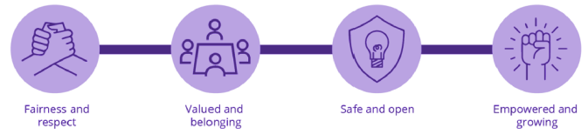

Deloitte also identified eight core truths regarding diversity and inclusion maturity:
- Diversity of thinking is the new frontier;
- Diversity without inclusion is not enough;
- Inclusive leaders cast a long shadow;
- Middle managers matter;
- Rewire the system to rewire the behaviours;
- Tangible goals make ambition real;
- Match the inside and outside; and
- Perform a cultural reset, not a tick-the- box program.

These truths were developed in response to current practices, which Deloitte argued are “heavily weighted toward diversity metrics, events, and training.” This model has a focus on reshaping and resetting cultures and behaviours to bring about sustainable change. An important aspect is leadership and ownership of change.

Another component of the model is the “personas of strategic change.” There are six personas that depict different levels of maturity.

Figure 12: Deloitte's Six Personas of Strategic Change Applied to Diversity and Inclusion
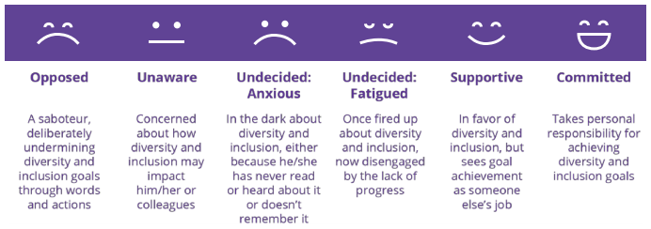

The Deloitte Diversity & Inclusion Maturity model is depicted below:

Figure 13: The Deloitte Diversity and Inclusion Maturity Model (formatting adapted)
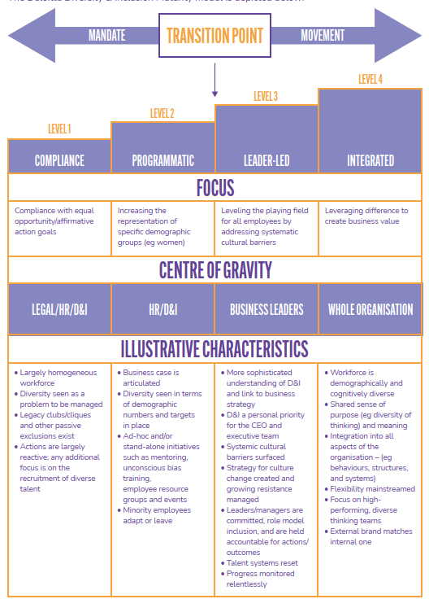

Racial Justice and Equity Models

Beloved Community's Equity Audit
The Beloved Community's Equity Audit (the Audit) supports organisations to assess their diversity, equity and inclusion practices and policies. The Audit is based on three foundational standards - Diversity, Equity and Inclusion - and includes a series of thirteen sub-standards. There are a range of questions or indicators which are used to measure the organisation’s capability in each standard. The Audit can be undertaken across multiple teams within an organization.

An example of the framework and key questions is outlined below.

Diversity
To what extent does any given population group within or associated with your organisation reflect your regional demographics?
D1: Awareness - To what extent is a diverse population aware that your organisation exists?
D2: Application - To what extent does a diverse population apply to participate in or associate with your organisation?
D3: Selection - To what extent does your organisation select a diverse population to participate in, or associate with, your organisation?
D4: Participation - To what extent does a diverse population self-select in to participate or associate with your organisation once they have been selected by you?

Equity
To what extent are the outcomes from any stakeholder or function predictable by participants’ demographics?
E1: Audits & Access - To what extent has your organisation established internal audit procedures for your various functions?
E2: Assignment - To what extent does an individual’s demographics or identities predict their assignment within your organisation?
E3: Advancement - To what extent does an individual’s demographics or identities predict their advancement within your organisation?
E4: Financial - To what extent does your organisation invest or distribute equitable financial resources across demographics and identities?
E5: Performance Outcomes - To what extent are actual performance outcomes predictable by demographics or identities?

Inclusion
To what extent do our diverse populations feel comfortable, respected, and empowered within your organisation? To what extent are diverse community perspectives included in decision-making?
I1: Language - To what extent does your organisation use inclusive language in every medium of communication?
I2: Shared Voice, Shared Power - To what extent does an individual, regardless of demographics or identities, have actual shared voice and shared power? To what extent do you create a space for all identities to advocate for themselves (shared voice) and to participate in decision-making for themselves and their community (shared power)?
I3: Belonging - To what extent does an individual, regardless of demographics or identities, report a strong sense of belonging within your organisation?
I4: Cultural Relevance - To what extent does an individual, regardless of demographics or identities, have access to culturally relevant communications and celebrations within your organisation?
The questions are given a score, and the scores are then turned into a percentage. The scores are then placed in the five “score bands” as depicted below.

Figure 14: Beloved Community Equity Audit Score Bands
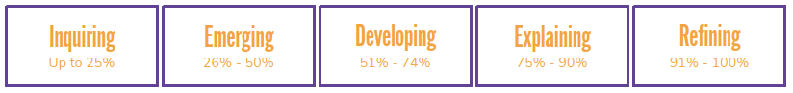

The Equity-Driven Systems Change (ESC) Model
The Equity-Driven Systems Change (ESC) Model was developed by California Tomorrow in 2009. It was developed “to support colleges in thinking systemically about how to address issues of equity at their institutions.” A systematic approach to equity requires an equity-driven process. An equity-driven process is one that is “participatory, data-driven, and produces measurable results over time.” Furthermore, it “values and promotes shifts in thinking, planning, and acting towards a more collaborative, culturally responsive, student-centered, and reflective institution.”

California Tomorrow proposed that there needs to be deep commitment and “buy-in” from all areas of the institution. To this end, they outlined ten key requirements that need to be in place (or in development) prior to applying the model.
- Leadership – Organisational change on issues of diversity, inclusion and equity depends upon a clear institutional commitment by top-level leaders—presidents, chancellors, vice presidents, and trustees—to the equity-driven change process.
- Dialogue among people of diverse backgrounds and experiences is needed to construct the fullest possible understanding of diversity, inclusion and equity dynamics in a college and community.
- Vision and Values – Clarifying and articulating an institution’s shared vision and values— particularly developing a shared language around key concepts—is essential to organisational change processes.
- Attention to Context – Realigning community colleges to meet the needs of a diverse student body is a context-specific process. There is no single model of an inclusive and equitable organisation, and no single recipe for incorporating equity goals.
- Use of Data – Colleges make better choices when they base their decisions on both quantitative and qualitative data and develop systems and structures for ongoing use of data across the institution.
- Assessment and Planning – Aligning community colleges’ programmes and services with diversity, inclusion and equity values takes more than expanded awareness and a clear vision. It also requires assessing organisational practices and developing concrete plans for change.
- Taking Action – Once plans have been made, community colleges must put them into practice. Successful implementation depends on the availability of sufficient human and financial resources.
- Personal and Organisational Learning – Organisational change requires individual change, as well. The reflection and learning at the heart of such change is supported by the development of learning communities with safe and open spaces for dialogue on difficult issues related to race, class, and other dimensions of equity.
- Peer Support – Individuals and organisations engaged in changing their practices benefit from ongoing support, an opportunity to share experiences, and the feedback and critique of their peers.
- Technical Assistance – Technical support and assistance such as training, coaching, or process design and facilitation help build an organisation’s capacity to sustain change.
The model itself puts the students at the centre and focuses on structural change across the four levels of an institution. It illustrates the “interdependence of structural and cultural approaches to change.”

Figure 15: Equity-Driven Systems Change (ESC) Model
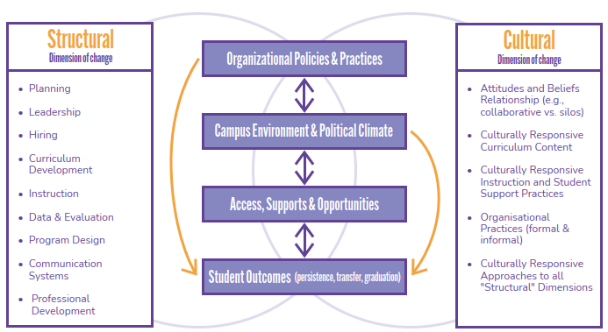

The structural dimensions of change focus on two key strands:
- Examining an institution’s formal systems, processes, and roles; analysing quantitative inputs and outcomes; and
- Including attention to differentiated outcomes, uncovered by reviewing data disaggregated by race, income, and other key factors on course completion, graduation, transfer, etc.

The cultural dimension of change depicted in the model attempts to discover “why particular patterns are seen in the structural dimension.” Within the cultural dimension, there are two key strands: organisational culture and culturally responsive practice.

The centre block of the ESC Model has four key levels with a range of practices and factors going into each:
- Organisational Policies & Practices including: Leadership; Teaching & Learning (curriculum and instructional practices); Budgeting & Planning; Approach to Reflection; Data & Evaluation; and Human Resources.
- Campus Environment & Political Climate including: Campus Climate, Culture, Values, Norms & History; Community & Political Context; Communications Systems (bottom-up, top-down, and horizontal); Facilities Management; and Engagement with Student Groups.
- Access, Supports & Opportunities including: Outreach; Orientation; Admissions; Academic Counselling, Supports & Advising; Equipment, Technology & Infrastructure; and Financial Aid.
- Student Outcomes including: Course Completion; Advancement from Developmental Education Courses; Persistence; Graduation; and Transfer.

The model also has a process model broken down into five key stages, which are useful to illustrate its overall aims:

Figure 16: Five Stages of Equity-Driven Systems Change (ESC) Model
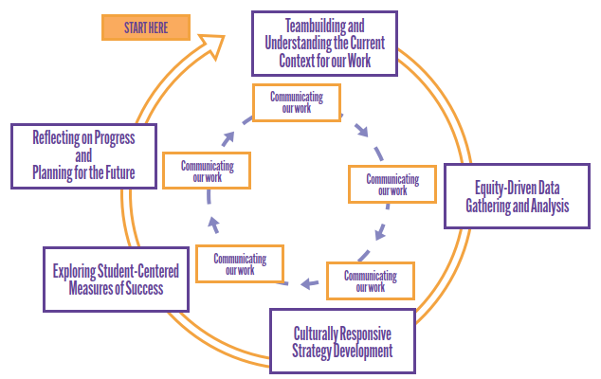

Disruptive Equity Education Project (DEEP) Theory of Change
The Disruptive Equity Education Project (DEEP) is focused on “changing mindsets around equity and dismantling systemic oppression and racism.” There are nine guiding principles of the DEEP approach:

- Equity is a process NOT a product.
- Impact is measured by shifts in mindset and behaviour.
- Systemic disruption requires large, observable change.
- Equity work is generational.
- The single-most important starting place is self.
- Equity requires strategic technical & adaptive solutions.
- Disruption with love & grace.
- Real, meaningful change in communities comes from the inside out.
- We live in a constant state of racial smog.

From these guiding principles, DEEP developed a theory of change known as DEEP’s Taxonomy of Disruption.

Figure 17: DEEP's Taxonomy of Disruption
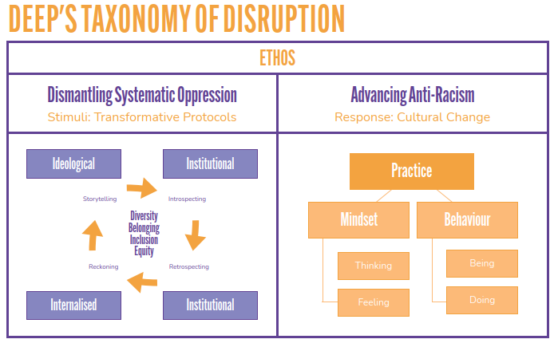

This theory of change has some key steps. The first part is labelled the “Reckoning,” and this stage is described as “the window versus the mirror. [A majority of people] are ready to externalize the situation [by] looking out ‘the window’ of race and equity. It is only when you hold up the ‘mirror’ that they are [confronted] with their own assumptions and biases.” The next step is focused on “Narratives.” In this stage, people use a storytelling framework to explain their “experiences of inequity,” they are assisted with this, and these are then shared as a group to build shared understanding. The third step is “Inner Work,” and this was described as the “deepest” part as people need to “unpack their assumptions and biases.” The fourth stage is on “Critical Race Theories,” which are used to give people a framework to “make sense of inequity as it exists today.” In this stage, there are discussions around how to apply their learning to the community to create sustainable change. The fifth step on “Transformative Culture” is for organisations and groups to create their own equity mission statement. And then the final step is about “Building Capacity” of people to continue teaching others, ensuring the theory of change is sustainable and ongoing.

Health Equity Assessment Tool (HEAT)
The Health Equity Assessment Tool (HEAT) was developed by a group of academics, adapting it from a tool originating in Wales for Te Manatū Hauora ( the Ministry of Health). It was first used in 2003-2004 and further developed over the following
years. Its objective is to “promote equity in health in New Zealand,” and to this end, it uses ten key questions that are used to evaluate “policy, programme or service interventions for their current or future impact on health inequalities.”

These questions are:
- What inequalities exist in relation to the health issue under consideration?
- Who is most advantaged and how?
- How did the inequalities occur? What are the mechanisms by which the inequalities were created, maintained or increased?
- Where/how will you intervene to tackle this issue?
- How will you improve Māori health outcomes and reduce health inequalities experienced by Māori?
- How could this intervention affect health inequalities?
- Who will benefit most?
- What might the unintended consequences be?
- What will you do to make sure the intervention does reduce inequalities?
- How will you know if inequalities have been reduced?

These questions are intended to allow for flexibility in the sense that they can all be asked or certain ones selected for particular purposes. It is focused on the decision- making process and intervening at that stage to prevent health inequities.¹⁶² There is both qualitative and quantitative research required to utilise HEAT to evidence the answers to the ten questions.

HEAT also employs an intervention model which looks at “four levels: structural, intermediary pathways, health and disability service, and impact.” During workshops on HEAT, there were some key findings regarding inequalities in the health system. The following levers for change were identified: in order to institutionalise ideas, there needs to be “further training of staff, politicians and providers,” “inequalities objectives” need to be built “into key strategic and policy documents,” and “Māori models of health in policy-making” need to be used to “better meet the needs of Māori.” The levers for change on a structural level were identified as “increased Māori participation and partnership in decision-making through shared leadership in policy-making and increased Māori representation in DHBs (District Health Boards) at the political, executive and workforce levels; strengthening DHB relationships with iwi (tribes) e.g. through memoranda of understanding; and funding and supporting services provided ‘by Māori for Māori.’”

There was also a range of levers regarding institutional processes: “incorporating a strong focus on health inequalities in DHB needs assessment templates; ensuring all DHB patients receive their full benefit entitlement; ensuring a strategic and systematic approach to intersectoral work; and encouraging integral and ongoing community involvement in the work of the institution.” The need to include formal means of addressing inequalities was also identified, such as all evaluations being required to assess the effect on inequalities. Barriers to change in the health system regarding inequalities were also identified as: “lack of leadership across the sector, strong vested interests for the status quo and lack of knowledge about effective interventions.” Some methods to overcome these barriers and support change were identified as “good information, strong relationships between the health sector and other sectors of society, and appropriate accountability and monitoring mechanisms.”

Figure 18: Intervention Framework to Improve Health and Reduce Inequalities
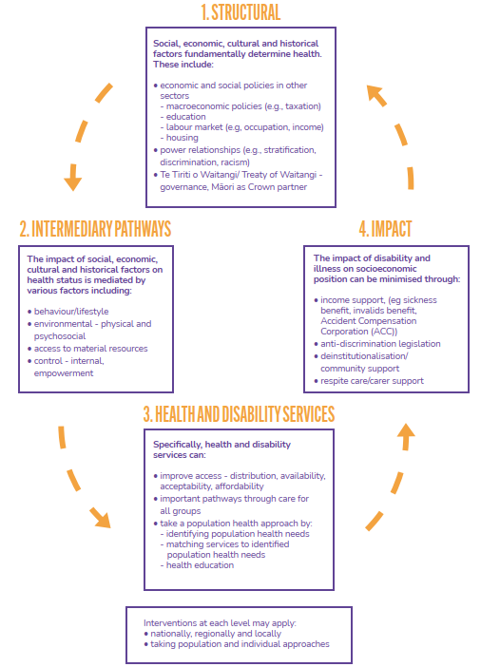

Organisational Capacity Assessment Tool Examples

Building Organisational Capacity for Health Equity Action: A Practical Assessment Tool for Public Health

Building Organisational Capacity for Health Equity Action is a practical assessment
tool for public health that has been used by Lambton Public Health in Ontario, Canada. The aim and purpose of the tool is to facilitate “learning, sharing and
reflection on what’s needed to enable action for health equity” across the organisation. It uses seven elements of equity action to measure capacity and identify areas for development:
- Leadership and commitment
- Formal systems
- Informal systems
- Resources
- Accountability
- Partnerships
- Governance.

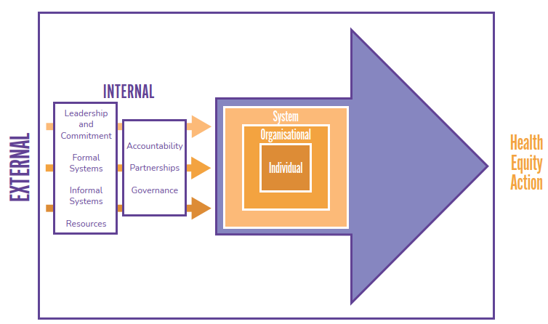
Figure 19: Building Organisational Capacity for Health Equity Action Conceptual Framework

These seven elements are included in three checklists – one for each key level for change: the individual, organisation, and systems level. These checklists evaluate
the equity action across the seven identified elements of health equity and give:
- a description, definition or example of the capacity element being assessed;
- a rating scale with responses ranging from strongly agree to strongly disagree; and
- evidence for future review and comparison.

For each key level for change (individual, organisation or systems), the findings are applied differently. For the individual level, the results are employed to “strengthen public health professionals’ daily practice.” Then on the organisation level, they are used to “strengthen processes and structures for embedding health equity.” And finally, on the systems level, they are used to “strengthen organizational policies, modes of governance and decision-making systems.” An example of an indicator used on the organisation level checklists is “I am able to communicate health equity issues to the board of health in a clear, concise manner.” The results from the checklists are then plotted on a spidergram model as shown in Figures 20 and 21.

Figure 20: Individual Spidergram Model
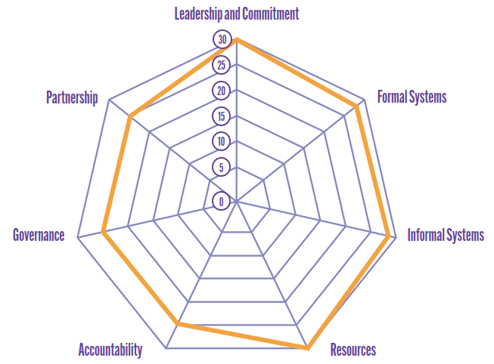

Figure 21: Organisational Spidergram Model - Applied Exemplar
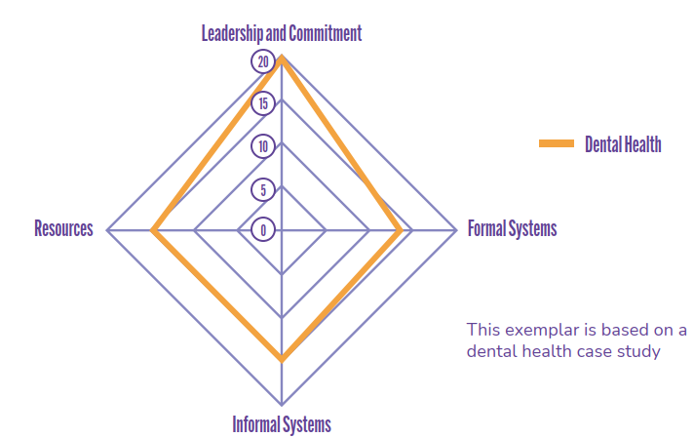

Some of the key insights from organisations applying this model:

- the need for practical, concrete examples in the tool that are relevant to the daily practice of the organisation;
- discussion helped shift views of those who were not meaningfully engaged initially;
- leadership support and buy-in is crucial;
- a core team is helpful for guiding the project;
- strengths-based approach to the assessment necessary;
- continuing support throughout required to all involved; and
- the governance body needs to be engaged.

This model is one of the more thorough ones in the literature as it acknowledges the different levels of change. It looks at the institutional, individual and systems levels, but there is limited engagement with the human elements of systems change, such as building capabilities. There is also a gap in terms of the societal level, which is crucial.

Anti-Racism Maturity Models

Justice T.R.E.E.E. Model
The Justice T.R.E.E.E. Model is an anti- racism model developed by Tiffany Galvin Green and Megan Wilson-Reitz at John Carroll University. The acronym stands for “Tackling Racism: Educate, Engage, and Effect Change.” This model takes a systemic approach to the issue of racial

justice rather than a linear, step-by-step approach. It employs the analogy of the growth stages of a tree from seed, to sapling, to tree, to a forest. This analogy, combined with the acronym, provides clear and powerful imagery.

Figure 22: The Justice T.R.E.E.E Model
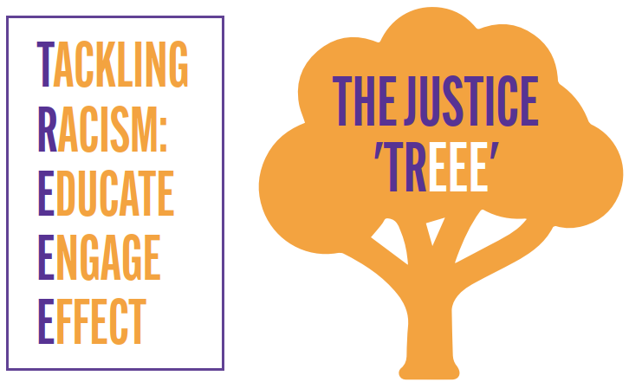

Figure 23: Justice T.R.E.E.E. Model
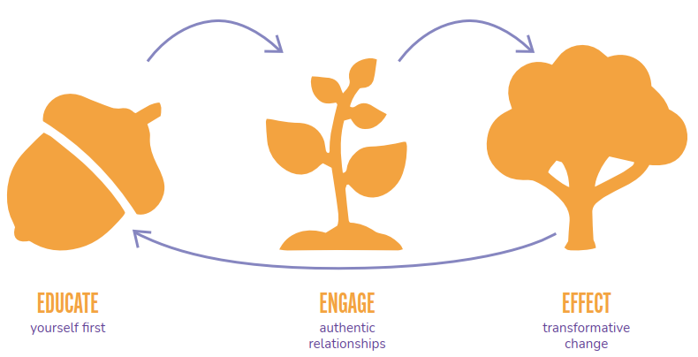

The Justice T.R.E.E.E. Model describes the growth progression of an oak tree - from an acorn to a sapling to a tree.

The Acorn (educate - starting with yourself)
This stage is when the acorn is “working hard to soak up the nutrients needed to push through its shell and begin putting down roots.” This translates to a person or organisation beginning to gain knowledge and understanding through education to enable growth.

The Sapling (engage - authentic relationships)
The next stage describes the sapling as being “fragile” and “wholly dependent upon the elements in its environment for survival.” This stage is where the
organisation is “engaging in difficult conversations” in order to grow and sustain relationships and change.

The Tree (effect - transformative change)
Following this is the tree stage where the tree is grounded and can begin to “effect change in its environment, providing shelter, shade and roots for others to grow.” Furthermore, it drops acorns which creates an ongoing cycle of growth for others and creates a forest.

Seed Stage (Educate)
- Approach information and education with a growth mindset
- Acknowledge and understand ‘colour blindness’ is really blindness to racism
- Lived experience and education are both important but not the same
- Personal responsibility for educating oneself and
- Acknowledge that the dialogue about racism has been ongoing for a long time – whether or not one has been involved until now.

Sapling Stage (Engage)
- Listen more than speak in engaging on difficult topics
- Embrace any discomfort and be purposeful and conscious of how you engage;
- Know when to call someone in and call someone out
- Defensiveness is not conducive to growth
- Apologise when mistakes are made and
- Be in it for the growth not the rewards.

Tree Stage (Effect Change)
- Find your place and role in the pursuit of change
- Recognise and utilise your power and privilege to effect change;
- Be an advocate – speak up and out
- Be an accomplice not just an ally (ally is a support role and accomplice entails deconstructing systems)
- Be a good follower – participation, accountability and support and
- Make space and ensure representation.

This model is focused on the individual level and the idea that the individual will then influence others. The “individual grows by increasingly subsuming itself into a network of interconnected organisms at multiple levels, learning to contribute to the growth of the whole, and depending on the whole to grow as well.”¹⁸³ An anti-racist forest or ecosystem of sorts. It proposes that anti- racism is “an organic and systemic process of community growth” rather than “a linear road map to a destination.” However, it is not entirely individualistic in orientation, and the designers of the model state that they created it “as a corrective to the more mechanistic models that treat anti-racism as a linear, individual path.” While it does see anti-racism “as a complex, perpetually evolving process of constant growth,” it is focused on the individual’s role in creating the forest of anti-racism, rather than seeing it as a system.

The QuakeLab Maturity Model
The QuakeLab Inclusion Maturity Model (QuakeLab model) emerges from the Canadian context from QuakeLab, which is a self-described “full-stack inclusion agency.” They used design thinking frameworks to develop it in response to existing models which focus “solely on diversity and recruitment.” This approach is limiting and means that the focus stays on recruitment, and there are no further steps taken. The typical models have around five levels, often centering on recruitment, for example:
- Industry and/or government compliance
- Recruiting a diverse team
- Creating a welcoming environment and culture
- Addressing systemic barriers
- Marketing and integration (ie focus externally).

The QuakeLab Model developers described these models as focusing “on low bearing fruit and minimum effort and resources,” which is not conducive to long-term, sustainable change. Therefore, their model identifies that a focus on diversity is the “bare minimum,” and there needs to also be a “rigorous investigation into historical systems of oppression” as well. The proposed model has four levels.
- Level 1 – Internal Assessment and Action
Data collection and thorough (consistent) assessment of the organisation
- Level 2 – Embedding Action and looking externally
Responding to the identified patterns and bringing in external support (eg groups working on “transformative social change”)
- Level 3 – Innovative Inclusion
“Actively and consistently” using “innovative, new methods of work steeped in anti-racism, feminism, anti-oppressive, anti-capitalist, and pro-Indigenous ways of knowing and working.”
- Level 4 – Dismantle and Redesign the Systems
Collaboration, consultation with the community, and integration of insights. Transparent processes and procedures are necessary.

Figure 24: QuakeLab Inclusion Maturity Model
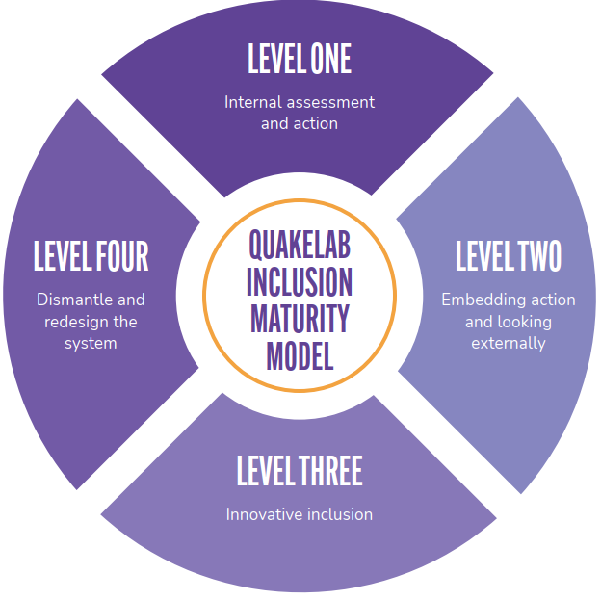

The four levels are intended to integrate inclusion into overall strategy but also “into processes, culture, and systems for real, measurable change.”

Critical Policy Analysis Models

Critical Te Tiriti Analysis (CTA)
An interesting and slightly different example of an approach to change has recently been developed in the Aotearoa context, known as Critical Te Tiriti Analysis (CTA). This approach was developed by Heather Came, D. O’Sullivan, and T. McCreanor following evidence given in the Waitangi Tribunal Health Services and Outcomes Inquiry (Wai 2575). It is adapted from Critical Policy Analysis (CPA) methods and was described by the developers as “a useful tool that will clarify and inform the efforts of Crown agencies to become compliant with Te Tiriti.”

The aim of CTA is to “disrupt the potential connection between policy-making and discriminatory or otherwise inequitable outcomes.” It necessitates working with the “five elements of Te Tiriti – the Preamble, the three written articles and the fourth oral article.” Thus far, it has been used in a variety of “Crown policy documents and has informed evaluation design, curriculum review, and policy development.”

CTA uses an evaluative approach to review policy against Te Tiriti, using five key steps:
- Orientation – does the policy address Māori health as a Crown responsibility, in ways that Māori prefer? Does it reflect rangatiratanga, Māori citizenship and healthy equity?
- Close reading – deeper reading in relation to all elements of Te Tiriti: preamble, kāwanatanga, rangatiratanga, ōritetanga, and wairuatanga.
- Making a determination against a set of indicators – five indicators to be ranked against (outlined on the next page).
- Suggestions for strengthening practice – positive and negative critique to enable reproduction of what works and improvement on what does not.
- Māori final word – engagement with Māori perspectives, through leadership, critique, peer review and engagement.

Set of Indicators
- Indicator 1 (Preamble) – Elements showing that Te Tiriti is central and Māori are equal or lead parties in the policy processes.
- Indicator 2 (Article 1) – Mechanisms to ensure equitable Māori participation and/or leadership in setting priorities, resourcing, implementing and evaluating the policy.
- Indicator 3 (Article 2) – Evidence of Māori values influencing and holding authority in the policy processes.
- Indicator 4 (Article 3) – Evidence of Māori exercising their citizenship as Māori in the policy.
- Indicator 5 (Wairuatanga) – Acknowledgement of the importance of wairua, rongoā and wellness in the policy.

An example of how this can be applied was through a CTA of the Primary Health Strategy. The figure below shows how the indicators can be used in the evaluation.

Figure 25: Critical Tiriti Analysis Indicators, as applied in the Primary Health Strategy
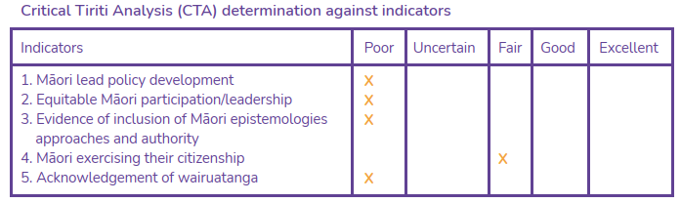

CTA is a useful tool for analysing policy and is particularly useful for Māori. However, it is not an anti-racism systems change model as it is limited in terms of its applicability for other population groups or ethnic communities, and it does not engage with all necessary levels and levers of systems change. This is not to say it is not useful, just that it has slightly different, more specific aims than the aim of this project.

“Titiro atu ki te taumata o te moana . . . tākiri ko te ata.”

- Te Ruki Kawiti

LOOK BEYOND TO THE CONFIGURATIONS ON THE HORIZON...
THE BREAKING OF A NEW DAWN

Eradicating racial health inequity requires a systemic approach that targets
and replaces racist ideas, policies and practices. The scale of this challenge
can seem overwhelming but we have a strong foundation to work from
and fertile grounds to create a future where everyone, regardless of race,
ethnicity or culture, can thrive.

Discussion
The existing models surveyed for this review have been developed in a range of contexts, and while none is fully applicable to anti- racism, there are some useful components contained throughout. Accompanied by the systems change and critical theories literature, some of these components can be combined to build a more applicable model. A number of the models have useful components, but not all are appropriate for Ao Mai te Rā: the Anti-Racism Kaupapa.

From the preceding analysis, some key points can be drawn. The first point to make is that many of the maturity models contain useful elements, but none are a complete toolbox of levers needed for change in terms of anti-racism. A maturity model alone is not sufficient for anti-racist change; it must be grounded by a theory of change as well as take into account critical approaches including Critical Race Theory and Critical Anti-Racism Theory. The stronger models are the ones underpinned by a theory of change, such as the DEEP model, and that engage with the transformation at a systems level, such as the Equity-Driven Systems Change Model. Additionally, the resulting maturity model needs to pull multiple levers of change simultaneously for maximum effect.

The existing models contain varying levels of opacity regarding how and why the levers work to affect change. There is a seemingly limitless list of levers, but what is important is understanding how they work, and this is where the literature is less clear. For example, power was consistently invoked in the literature as a critical component of systems change and equity initiatives. There is a clear need for shared voice and power to bring about sustainable and effective change. Despite this, there was a lack of substantial literature around its application. Most models focus on the individual level without engaging sufficiently with power.

The models employ a range of levers, including:
- Narrative
- Leadership
- Organisational vision, goals and strategy
- Budgets and resourcing
- Diversity recruitment and leadership
- Disciplinary processes and accountability
- Formal decision-making tools
- Reflective practices
- Training and knowledge
- Habitual practices
- Evaluation of organisational shifts
- Monitoring and auditing

These levers can be classified under some broad categories—compliance-based measures such as training and knowledge and diversity recruitment. There were levers that focused on reflective practices and turning inward to change behaviours and habitual practices. Organisational levers were a major focus. These include budgets and resourcing, leadership, formal decision-making, organisational vision, and monitoring and auditing.

A considerable number of the models, and indeed the literature more generally, focus on individual and organisational levers. This is likely due to a significant amount of the literature emerging from the practitioner market. That is, from people and businesses who are hired by an organisation to assist or run their change process. This context guides the focus of the models around organisational changes. There seems to be a dominant assumption that individual levers such as diversity training will have flow-on effects to the organisational level and beyond. The Justice T.R.E.E.E. Model is a good example of this; the individuals are seen to create the forest. There is certainly a gap in the literature and existing models in terms of a full suite of levers at all levels, including societal.

Monitoring and auditing were a common feature of many models, particularly equity audits. Equity audits are used to identify practices and processes within an institution that contribute to inequities. These are useful in that they establish a starting point and assess the current state, and they identify key areas for intervention. However, they are resource-intensive and time- consuming and result in masses of data. Therefore, while monitoring and auditing is useful, it needs to be done in such a way that it does not put people off.

It needs to be a lever for change but not the only one.

One of the most common approaches to creating change and enhancing equity in organisations is diverse recruitment. This can be seen in the number of models that focus on diversity and inclusion. It is important to note that focusing on diverse employee numbers is only one lever for change and a limited one. The purpose of diverse recruitment is to grow organisational capabilities through diversity in order to shift organisational values. It works on the idea that through growing a diverse workforce, more diverse thinking will be present and allow for deeper dialogue to occur. It remains focused on the individual level and so needs to be one of many levers rather than the primary one. For it to be effective, there also need to be adequate career development processes to enable people to progress in the organisation and into leadership roles. This needs to be embedded in the processes and structure of an organisation for sustainable change.

Some additional levers have been identified throughout this analysis that were discussed in the literature but not adequately engaged within the existing models. Counter- narratives are an essential component of change that was identified, often associated with CRT, narratives were identified in some models on a limited level, such as individual narratives, but can be employed on a wider level for greater impact. There is also a need for more equity-driven innovation to be addressed in the models, as this is an important lever for change.

There was a surprising lack of discussion of rewards and promotions as a lever for change, although this may be taken for granted and therefore not explicitly discussed in each model. A further gap is around equity data reporting and the need for better data systems to ensure the data is being reported accurately and effectively. There was some mention in the literature and models, but none adequately engaged with this crucial lever. Another gap was around tailored products and services and the need for more responsive channels for these. This was identified as a lever but was not included in the examples of models.

Kupu whakamutunga | Conclusion
The purpose of this literature review was to outline and analyse existing anti-racism maturity models to synthesise key best practice insights. In addition, critical theories and systems change literature has been employed to provide commentary and insight into best practice. This also necessitated some discussion of other approaches such as equity audits to give an in-depth analysis of existing approaches to anti-racist change.

In summary, an anti-racism maturity model must be built for the specific context it will be applied to. It needs to identify a range of levers at each level and pull these simultaneously. There needs to be more focus on the factors that influence and drive change as opposed to a prescribed set of levels to progress through to an end goal.

The maturity model should be grounded in a theory of change and systems thinking in order to see and transform the whole. This also requires the inclusion of deep equity and acknowledgement of the historical circumstances that have influenced contemporary circumstances to facilitate anti-racist transformation. Furthermore, it needs to offer counter-narratives and enhance intrinsic motivation to ensure buy-in that ensures sustainable change.

This is the third and final literature review for phase one of Ao Mai te Rā. The recommendations from this literature review will be used to inform the development of a preliminary anti-racism systems change model for the Aotearoa health system.

References
“A Guide to Using Organizational Capacity Assessment Tools.” Informing Change, Prepared for William & Flora Hewlett Foundation, 2017.
“About DEEP.” Disruptive Equity Education Project. https://digdeepforequity.org/about/ “About Us.” Korn Ferry. https://www.kornferry.com/about-us
“About Us.” QuakeLab. https://quakelab.ca/about-us
“AHRI’s Diversity & Inclusion Maturity Model.” Australian HR Institute, nd. https://www.ahri.com.au/media/4908/ahri_dimaturityguide.pdf
“Briefing Paper on the Forthcoming National Action Plan Against Racism.” STIR: Stop Institutional Racism, NZ Public Health Association and Auckland University of Technology, 2021.
“Diving Deep.” Harvard Graduate School of Education, 2017. https://www.gse.harvard.edu/news/17/06/diving-deep
“Equity Audit User Guide.” Beloved Community. https://www.wearebeloved.org/equity-audit “Influencing Complex Systems Change.” Change Elemental. https://changeelemental.org/influencing-complex-systems-change/
“Learning Together: A guide to assessment tools for organizational health equity capacity.” National Collaborating Centre for Determinants of Health, 2020. https://substanceuse.ca/learning-together-guide-assessment-tools-organizational-health-equity-capacity
“Levers of Change.” Food Systems Summit. United Nations, 2021. https://www.un.org/hi/node/122994
“New Deloitte Research Identifies Keys to Creating Fair and Inclusive Organizations. ”Bersin by Deloitte, https://www.prnewswire.com/news-releases/new-deloitte-research-identifies-keys-to-creating-fair-and-inclusive-organizations-300455164.html
“Systems Change with an Equity Lens Community Interventions that Shift Power and Center Race.” Building Movement Project and Management Assistance Group. https://www.youtube.com/watch?v=DbzeciuPSfM
“The Aotearoa Inclusivity Matrix.” Diversity Works. 2021. https://diversityworksnz.org.nz/news-resources/aotearoa-inclusivity-matrix/
“The Deloitte Diversity And Inclusion Model.” Triangle Diversity Equity & Inclusivity Alliance, November 10, 2020. http://www.triangledei.org/blog/the-deloitte-diversity-and-inclusion-model
“The Korn Ferry Diversity and Inclusion Maturity Model: A new understanding.” Korn Ferry. 2020.
“The QuakeLab Inclusion Maturity Model.” 2020. https://quakelab.ca/blog/quakelab-inclusion-maturity-model
“Your guide to using the Aotearoa Inclusivity Matrix.” Diversity Works. 2021.
Adam, Taghreed and Don De Savigny. “Systems Thinking for Strengthening Health Systems in LMICs: Need for a Paradigm Shift.” Health Policy and Planning 27, no. 4 (2012): iv1-iv3.
Ahmed, Sarah. “The Nonperformativity of Antiracism.” Meridians: Feminism, Race, Transnationalism 19 (2020): 196-218.
Amiot, Michelle N., Jennifer Mayer-Glenn and Laurence Parker. “Applied critical race theory: educational leadership actions for student equity.” Race Ethnicity and Education 23, no. 2 (2020): 200-220.
Booth, William and Robert Morin. Assessing Organizational Capacity Through Participatory Monitoring and Evaluation Handbook. Prepared for the Pact Ethiopian NGO Sector Enhancement Initiative, first edition, 1996.
Bourke, Juliet and Bernadette Dillon. “The diversity and inclusion revolution.” Deloitte Review, Issue 22 (2018): 83-95.
Came, Heather, D. O’Sullivan, and T. McCreanor. “Introducing critical Tiriti policy analysis through a retrospective review of the New Zealand Primary Health Care Strategy.” Ethnicities 20, no. 3 (2020): 434-456.
Caralli, Richard, Mark Knight, and Austin Montgomery. “Maturity Models 101: A Primer for Applying Maturity Models to Smart Grid Security, Resilience, and Interoperability. Software Engineering Institute, Carnegie Mellon, 2012. https://resources.sei.cmu.edu/library/asset-view.cfm?assetid=58916
Cox, Kate, Stephen Jolly, Simon van der Staaij, and Christian van Stolk. Understanding the Drivers of Organisational Capacity. California and Cambridge: Rand and Saatchi Institute, 2018.
Curtis, Bill, Bill Hefley, and Sally Miller. “People Capability Maturity Model (P-CMM) Version 2.0, Second Edition.” Technical Report, Software Engineering Institute, 2009. https://www.researchgate.net/publication/235082540_People_Capability_Maturity_Model_P-CMM_Version_20_Second_Edition
De Bruin, Tonia and Ronald Freeze. “Understanding the Main Phases of Developing a Maturity Assessment Model.” Paper presented at the 16th Australasian Conference on Information Systems, Sydney, 2005. https://www.researchgate.net/publication/27482282_Understanding_the_Main_Phases_of_Developing_a_Maturity_Assessment_Model
Dei, George J. Sefa. “Chapter One: Reframing Critical Anti-Racist Theory (CART) for Contemporary Times.” Counterpoints 445 (2013): 1-14.
Foster-Fishman, Pennie G. and Teresa R. Behrens. “Systems change reborn: rethinking our theories, methods, and efforts in human services reform and community-based change.” Am J Community Psychol 39 (2007): 191-296.
Foster-Fishman, Pennie G., Brenda Nowell, Huilan Yang. “Putting the system back into systems change: a framework for understanding and changing organizational and community systems.” Am J Community Psychol 39 (2007): 197-215.
Galvin, Tiffany and Megan Wilson-Reitz. “How to get started in racial equity work: Plant a Justice T.R.E.E.E.” Ignatian Solidarity Network. https://ignatiansolidarity.net/blog/2020/08/03/racial-equity-work-justice-treee/
Gazmuri, Singhashri (Kica), Sheryl Petty, and Ed Porter. The Equity-Driven Systems Change (ESC) Model: A Toolkit for Improving Institutional Practice and Student Outcomes. California Tomorrow, 2010. https://skylinecollege.edu/seeed/assets/resources/ESC-Tool kit.pdf
Gillies, Alan and John Howard. “Managing change in process and people: Combining a maturity model with a competency-based approach.” Total Quality Management & Business Excellence 14, no. 7 (2003): 779-787.
Gomes, Jorge, Mário Romão, and Mário Caldeira. “Linking Benefits to Maturity Models.” Paper presented at the 15th IAMB Conference, Lisbon, Portugal, 2013. https://www.researchgate.net/publication/259619901_Linking_Benefits_to_Maturity_Models
Groenke, Susan L. “Seeing, Inquiring, Witnessing: Using the Equity Audit in Practitioner Inquiry to Rethink Inequity in Public Schools.” English Education 43, no.1 (2020), 83-96.
https://www.researchgate.net/publication/221409904_What_makes_a_useful_maturity_model_A_framework_of_general_design_principles_for_maturity_models_and_its_demonstration_in_business_process_management
Hylton, Kevin. “How a turn to critical race theory can contribute to our understanding of ‘race’, racism and anti-racism in sport.” International Review for the Sociology of Sport 45, no. 3 (2010): 333-354.
Keleher, Terry. “An Introduction to Racial Equity Assessment Tools.” Race Forward, 2014. https://racc.org/wp-content/uploads/2015/12/An-Introduction-to-Racial-Equity-Assessment-Tools.pdf
Keleher, Terry. “Racial Equity Impact Assessment.” Race Forward, 2009. https://www.raceforward.org/sites/default/files/RacialJusticeImpactAssessment_v5.pdf
Kohlegger, Michael, Ronald Maier, and Stefan Thalmann. “Understanding maturity models: Results of a Structured Content Analysis.” Paper presented at I-KNOW '09 and 1-SEMANTICS '09, 2-4 September 2009, Austria. https://www.researchgate.net/publication/290265437_Understanding_maturity_models_results_of_a_structured_content_analysis
Lambton Public Health. Building Organizational Capacity for Health Equity Action: A Framework and Assessment Tool for Public Health. Point Edward: Author, 2017.
Lasater, Kara, Ed Bengston, and Waheeb S. Albiladi. “Data use for equity?: How data practices incite deficit thinking in schools.” Studies in Educational Evaluation 69 (2021): 1-10.
Levesque, Jean-Frederic and Kim Sutherland. “What role does performance information play in securing improvement in healthcare? A conceptual framework for levers of change.” BMJ Open 7 (2017): 1-9.
MAEC. “Equity Audit.” 2021. https://maec.org/resource/equity-audit-materials/
Maier, A.M., J. Moultrie, and P.J. Clarkson. “Developing maturity grids for assessing organisational capabilities: Practitioner guidance.” Paper presented at the 4th International Conference on Management Consulting, Academic Management (MCD), Vienna, Austria, 2009. https://www.researchgate.net/publication/292732883_Developing_maturity_grids_for_assessing_organizational_capabilities_Practitioner_guide
Mehravari, Nader. “Everything You Always Wanted to Know About Maturity Models.” CERT Operational Resilience: Manage, Protect, and Sustain, Carnegie Mellon University, 2013. https://resources.sei.cmu.edu/asset_files/webinar/2014_018_101_293863.pdf
Milton, Nick. “The benefits and limitations of KM change and maturity models.” 25 November 2019. http://www.nickmilton.com/2019/11/the-benefits-and-limitations-of-km.html
Mullaly, Mark. “If maturity is the answer, then exactly what was the question?” International Journal of Managing Projects in Business 7, no. 2 (2014): 169-185.
Proença, Diogo and José Borbinha, “Maturity Model Architect: A Tool for Maturity Assessment Support.” Paper presented at the 20th IEEE Conference on Business Informatics, 2018. https://www.researchgate.net/publication/327409112_Maturity_Model_Architect_A_Tool_for_Maturity_Assessment_Support
Röglinger, Maximilian and Jens Pöppelbuß, “What makes a useful maturity model? A framework for general design principles for maturity models and its demonstration in business process management.” Paper presented at the 19th European Conference on Information Systems, Helsinki, Finland, June, 2011.
Senge, P. The Fifth Discipline: The Art and Practice of the Learning Organization. London: Century Business, 1990.
Signal, Louise, Jennifer Martin, Papaarangi Reid, Christopher Carroll, Philippa Howden- Chapman, Vera Keefe Ormsby, Ruth Richards, Bridget Robson, and Teresa Wall. “Tackling health inequalities: moving theory to action,” International Journal for Equity in Health 6, no. 12 (2007): 1-6.
Signal, L., J. Martin, F. Cram, and B. Robson. The Health Equity Assessment Tool: A user’s guide. Wellington: Ministry of Health, 2008.
Skrla, Linda, Kathryn Bell McKenzie, and James Joseph Scheurich. Using Equity Audits to Create Equitable and Excellent Schools. ProQuest Ebook Central, 2009.
Systems Change & Deep Equity: Pathways Toward Sustainable Impact, Beyond “Eureka!” Unawareness & Unwitting Harm. An Interview with Sheryl Petty and Mark Leach. Change Elemental, 2020.
Turcotte, Pier-Luc, Annie Carrier, and Melanie Levasseur. “Levers for Change and Unexpected Outcomes of a Participatory Research Partnership: Toward Fostering Older adults’ Social Participation to Promote Health Equity.” Am J Community Psychol 66 (2020): 417-426.
Williams, David R. and Lisa A. Cooper. “Reducing Racial Inequities in Health: Using What We Already Know to Take Action.” International Journal of Environmental Research and Public Health 16 (2019): 1-26.
Yuan, Alda. “With a lever a DIY guide to institutional change for racial equity.” 2021. https://www.racialequitytools.org/resources/plan/change-process/organization-change

Caralli, Knight, and Montgomery, “Maturity Models 101,” 3
Ibid p.4
Maximilian Röglinger and Jens Pöppelbuß, “What makes a useful maturity model? A framework for general design principles for maturity models and its demonstration in business process management,” paper presented at the 19th European Conference on Information Systems, Helsinki, Finland, June, 2011.
Röglinger and Pöppelbuß, “What makes a useful maturity model?”, np
Proença and Borbinha, “Maturity Model Architect,” 1.
Jorge Gomes, Mário Romão, and Mário Caldeira, “Linking Benefits to Maturity Models,” Paper presented at the 15th IAMB Conference, Lisbon, Portugal, 2013, 2.
Caralli, Knight, and Montgomery, “Maturity Models 101,” 7.
Ibid
Nader Mehravari, “Everything You Always Wanted to Know About Maturity Models,” CERT Operational Resilience: Manage, Protect, and Sustain, Carnegie Mellon University, 2013.
Caralli, Knight, and Montgomery, “Maturity Models 101,” 8.
Ibid p.7
Mehravari, “Everything You Always Wanted to Know About Maturity Models.”
Caralli, Knight, and Montgomery, “Maturity Models 101,” 7.
Alan Gillies and John Howard, “Managing change in process and people: Combining a maturity model with a competency-based approach,” Total Quality Management & Business Excellence 14, no. 7 (2003): 779.
Caralli, Knight, and Montgomery, “Maturity Models 101,” 7.
Ibid
Mehravari, “Everything You Always Wanted to Know About Maturity Models.”
Curtis, Bill, Bill Hefley, and Sally Miller. “People Capability Maturity Model (P-CMM) Version 2.0, Second Edition.” Technical Report, Software Engineering Institute, 2009.
Mehravari, “Everything You Always Wanted to Know About Maturity Models.”
Ibid
Ibid
Ibid
Ibid
Ibid
Caralli, Knight, and Montgomery, “Maturity Models 101,” 8.
Ibid
Mehravari, “Everything You Always Wanted to Know About Maturity Models.”
Ibid
Ibid
Caralli, Knight, and Montgomery, “Maturity Models 101,” 6.
Ibid
Ibid
Gomes, et al., “Linking Benefits to Maturity Models,” 2.
Nick Milton, “The benefits and limitations of KM change and maturity models,” 25 November 2019, http://www.nickmilton.com/2019/11/the- benefits-and-limitations-of-km.html
Gomes, et al., “Linking Benefits to Maturity Models,” 4.
Röglinger and Pöppelbuß, “What makes a useful maturity model?”, n.p.
J. L. King and K.L. Kraemer, “Evolution and organizational information systems: an assessment of Nolan's stage model,” Communications of the ACM, 27 (5), (1984): 466-475. Referenced in Röglinger and Pöppelbuß, “What makes a useful maturity model?”, np.
Röglinger and Pöppelbuß, “What makes a useful maturity model?”, np
Michael Kohlegger, Ronald Maier, and Stefan Thalmann, “Understanding maturity models: Results of a Structured Content Analysis,” Proceedings of I-KNOW ’09 and 1-SEMANTICS ’09, 2-4 September 2009, Austria, 59.
Röglinger and Pöppelbuß, “What makes a useful maturity model?”, np.
Ibid
A.M. Maier, J. Moultrie, and P.J. Clarkson, “Developing maturity grids for assessing organisational capabilities: Practitioner guidance, 4th International Conference on Management Consulting, Academic Management (MCD), Vienna, Austria, 2009, 21.
J.L. King and K.L. Kraemer referenced in Gomes, et al., “Linking Benefits to Maturity Models,” 4.
Mehravari, “Everything You Always Wanted to Know About Maturity Models.”
MAEC, “Equity Audit,” 2021, 1, https://maec.org/resource/equity-audit-materials/
Skrla, et al., Using Equity Audits, 23.
Ibid
MAEC, “Equity Audit,” 1.
Ibid
Ibid
Kate Cox, Stephen Jolly, Simon van der Staaij, and Christian van Stolk, Understanding the Drivers of Organisational Capacity, (California and Cambridge: Rand and Saatchi Institute, 2018), 7.
“A Guide to Using Organizational Capacity Assessment Tools,” Informing Change, Prepared for William & Flora Hewlett Foundation, 2017, 3.
“Learning Together: A guide to assessment tools for organizational health equity capacity,” National Collaborating Centre for Health, 2020, 3 https://substanceuse.ca/learning-together-guide-assessment-tools-organizational-health-equity-capacity
“A Guide to Using Organizational Capacity Assessment Tools,” 2.
Ibid p.3
“A Guide to Using Organizational Capacity Assessment Tools,” 3.
Ibid p.14
William Booth and Robert Morin, Assessing Organizational Capacity Through Participatory Monitoring andEvaluation Handbook, Prepared for the Pact Ethiopian NGO Sector Enhancement Initiative,first edition, 1996, 3-4.
Ibid p.14
William Booth and Robert Morin, Assessing Organizational Capacity Through Participatory Monitoring and Evaluation Handbook, Prepared for the Pact Ethiopian NGO Sector Enhancement Initiative, first edition, 1996, 3-4.
“A Guide to Using Organizational Capacity Assessment Tools,” 9.
Terry Keleher, “Racial Equity Impact Assessment,” Race Forward, 2009, https://www.raceforward.org/sites/default/files/RacialJusticeImpactAssessment_v5.pdf
Keleher, “Racial Equity Impact Assessment.” 79Ibid.
Ibid
Ibid
Ibid
Ibid
L. Signal, J. Martin, F. Cram, and B. Robson, The Health Equity Assessment Tool: A user’s guide (Wellington: Ministry of Health, 2008).
Terry Keleher, “An Introduction to Racial Equity Assessment Tools,” Race Forward, 2014.
Kevin Hylton, “How a turn to critical race theory can contribute to our understanding of ‘race’, racism and anti-racism in sport,” International Review for the Sociology of Sport 45, no. 3 (2010): 337
“Briefing Paper on the Forthcoming National Action Plan Against Racism,” STIR: Stop Institutional Racism, NZ Public Health Association and Auckland University of Technology, 2021, np.
“Systems Change with an Equity Lens Community Interventions that Shift Power and Center Race,” Building Movement Project and Manage- ment Assistance Group, https://www.youtube.com/watch?v=DbzeciuPSfM
P. Senge, The Fifth Discipline: The Art and Practice of the Learning Organization (London: Century Business, 1990), 23.
Taghreed Adam and Don de Savigny, “Systems thinking for strengthening health systems in LMICs: need for a paradigm shift,” Health Policy and Planning, 27, no. 4 (2012): iv1.
Adam and de Savigny, “Systems thinking for strengthening health systems in LMICs,” iv1.
“Briefing Paper on the Forthcoming National Action Plan Against Racism,” np.
Ibid
Pennie G. Foster-Fishman and Teresa R. Behrens, “Systems change reborn: rethinking our theories, methods, and efforts in human services reform and community-based change,” Am J Community Psychol 39 (2007): 194.
Foster-Fishman and Behrens, “Systems change reborn,” 195.
Hylton, “How a turn to critical race theory can contribute to our understanding of ‘race’, racism and anti-racism in sport,” 338
“Influencing Complex Systems Change,” Change Elemental, https://changeelemental.org/influencing-complex-systems-change/
Foster-Fishman and Behrens, “Systems change reborn,” 195.
Ibid
Ibid p.194-95
Pennie G. Foster-Fishman, Brenda Nowell, Huilan Yang, “Putting the system back into systems change: a framework for understanding and changing organizational and community systems,” Am J Community Psychol 39 (2007): 205.
Foster-Fishman, et al., “Putting the system back into systems change,” 205.
Pier-Luc Turcotte, Annie Carrier, and Melanie Levasseur, “Levers for Change and Unexpected Outcomes of a Participatory Research Partnership: Toward Fostering Older adults’ Social Participation to Promote Health Equity,” Am J Community Psychol 66 (2020): 418.
Turcotte, et al., “Levers for Change and Unexpected Outcomes of a Participatory Research Partnership,” 418.
Jean-Frederic Levesque and Kim Sutherland, “What role does performance information play in securing improvement in healthcare? A conceptual framework for levers of change,” BMJ Open 7 (2017): 3.
Foster-Fishman and Behrens, “Systems change reborn,” 195.
Ibid
Alda Yuan, “With a lever a DIY guide to institutional change for racial equity,” 2021, 6 https://www.racialequitytools.org/resources/plan/change-process/organization-change
Ibid p.6
Systems Change & Deep Equity: Pathways Toward Sustainable Impact, Beyond “Eureka!,” Unawareness & Unwitting Harm, An Interview with Sheryl Petty and Mark Leach (Change Elemental, 2020), 5.
Ibid p.3-4
Ibid p.66
Ibid p.35
Ibid p.4
Michelle N. Amiot, Jennifer Mayer-Glenn and Laurence Parker, “Applied critical race theory: educational leadership actions for student equity,” Race Ethnicity and Education 23, no. 2 (2020): 204.
David R. Williams and Lisa A. Cooper, “Reducing Racial Inequities in Health: Using What We Already Know to Take Action,” International Journal of Environmental Research and Public Health 16 (2019): 13.
Amiot et al., “Applied critical race theory,” 204
Ibid p.339 Hylton, “How a turn to critical race theory can contribute to our understanding of ‘race’, racism and anti-racism in sport,” 338.
Ibid p.339
Ibid p.340 ' Hylton, “How a turn to critical race theory can contribute to our understanding of ‘race’, racism and anti-racism in sport,” 340
Hylton, “How a turn to critical race theory can contribute to our understanding of ‘race’, racism and anti-racism in sport,” 340 106Ibid., 339
Ibid., 339
Sarah Ahmed, “The Nonperformativity of Antiracism,” Meridians: Feminism, Race, Transnationalism vol. 19, supplement (2020): 196-197
Hylton, “How a turn to critical race theory can contribute to our understanding of ‘race’, racism and anti-racism in sport,” 336.
George J. Sefa Dei, “Chapter One: Reframing Critical Anti-Racist Theory (CART) for Contemporary Times,” Counterpoints, vol. 445 (2013): 3. 110
Dei, “Chapter One: Reframing Critical Anti-Racist Theory,” 3.
Ibid
Ibid p.12
Ibid p.11
Ibid p.4
Ibid p.3-4
Ibid p.4
Ibid p.8
Ibid
Ibid
Ibid p.4
Ibid
Ibid
Annabel Ahuriri-Driscoll, Madi Williams and Ulamila Vakalalabure-Wragg “Ao Mai Te Ra The Anti-Racism Kaupapa- Evolution of Racism and Anti-Racism. Lessons for the Aotearoa New Zealand Health System (2022) https://www.health.govt.nz/system/files/documents/publications/ao-mai-te-ra-the-anti-racism-kaupapa-state-one-literature-review-aug22.pdf
Ibid p.3
Annabel Ahuriri-Driscoll, Madi Williams and Ulamila Vakalalabure-Wragg “Ao Mai Te Ra The Anti-Racism Kaupapa- Evolution of Racism and Anti-Racism. Lessons for the Aotearoa New Zealand Health System Stage One Literature Review (2022) https://www.health.govt.nz/system/files/documents/publications/ao-mai-te-ra-the-anti-racism-kaupapa-state-one-literature-review-aug22.pdf Madi Williams and Sacha McMeeking Ao Mai Te Ra The Anti-Racism Kaupapa-Best Practice Approaches to Addressing Racism Lessons for the Aotearoa New Zealand Health System Stage Two Literature Review (2022)
“The Korn Ferry Diversity and Inclusion Maturity Model: A new understanding,” Korn Ferry, 2020.
Ibid.
Ibid.
Ibid.
“The Aotearoa Inclusivity Matrix,” Diversity Works, 2021
“The Aotearoa Inclusivity Matrix.”
“Your guide to using the Aotearoa Inclusivity Matrix,” Diversity Works, 2021.
“AHRI’s Diversity & Inclusion Maturity Model,” Australian HR Institute, nd, 1-6.
“AHRI’s Diversity & Inclusion Maturity Model,” 5.
John Bersin quoted in “New Deloitte Research Identifies Keys to Creating Fair and Inclusive Organizations,” Bersin by Deloitte, https://www.prnewswire.com/news-releases/new-deloitte-research-identifies-keys-to-creating-fair-and-inclusive-organizations-300455164.html
“The Deloitte Diversity And Inclusion Model,” Triangle Diversity Equity & Inclusivity Alliance, November 10, 2020, http://www.triangledei.org/blog/the-deloitte-diversity-and-inclusion-model
Amiot et al., “Applied critical race theory,” 204.
Juliet Bourke and Bernadette Dillon, “The diversity and inclusion revolution,” Deloitte Review, Issue 22 (2018): 84.
Bourke and Dillon, “The diversity and inclusion revolution,” 95.
Ibid.
“Equity Audit User Guide,” Beloved Community, 5.
Ibid
Ibid., 16.
Singhashri (Kica) Gazmuri, Sheryl Petty, and Ed Porter, “The Equity-Driven Systems Change (ESC) Model: A Toolkit for Improving Institutional Practice and Student Outcomes,” California Tomorrow, 2010, 4.
Gazmuri, et al., “The Equity-Driven Systems Change (ESC) Model,” 4.
Ibid.
Ibid., 4-5.
Ibid., 5.
Ibid.
Ibid.
Ibid., 6.
“About DEEP,” Disruptive Equity Education Project.
Ibid.
“Diving Deep,” Harvard Graduate School of Education, 2017.
Ibid.
Ibid.
Ibid.
Ibid.
Signal et al., The Health Equity Assessment Tool, 33.
Ibid.
Ibid., 1.
Ibid., 6. Louise Signal, Jennifer Martin, Papaarangi Reid, Christopher Carroll, Philippa Howden-Chapman, Vera Keefe Ormsby, Ruth Richards, Bridget Robson, and Teresa Wall, “Tackling health inequalities: moving theory to action,” International Journal for Equity in Health 6, no. 12 (2007): 4.
Signal et al., “Tackling health inequalities,” 4.
Ibid.
Ibid.
Ibid.
Ibid.
Ibid.
Ibid.
"Learning Together: A guide to assessment tools for organizational health equity capacity.” National Collaborating Centre for Determinants of Health, 2020" 7.
Ibid.
Lambton Public Health, Building Organizational Capacity for Health Equity Action: A Framework and Assessment Tool for Public Health (Point Edward: Author, 2017), 1.
Building Organizational Capacity for Health Equity Action, 11.
Ibid.,18.
Ibid., 12.
Ibid., 24.
“A Guide to Using Organizational Capacity Assessment Tools,” 7-8.
Tiffany Galvin and Megan Wilson-Reitz, “How to get started in racial equity work: Plant a Justice T.R.E.E.E.,” Ignatian Solidarity Network.
Ibid.
Ibid.
Ibid.
Ibid.
Ibid.
Ibid.
Ibid.
Ibid.
“About Us,” QuakeLab.
“The QuakeLab Inclusion Maturity Model,” 2020.
Ibid.
Ibid.
“About Us,” QuakeLab.
Heather Came, D. O’Sullivan, and T. McCreanor, “Introducing critical Tiriti policy analysis through a retrospective review of the New Zealand Primary Health Care Strategy,” Ethnicities 20, no. 3 (2020).
“Briefing Paper on the Forthcoming National Action Plan Against Racism,” 25.
Came, O’Sullivan, and McCreanor, “Introducing critical Tiriti policy analysis,” 439.
“Briefing Paper on the Forthcoming National Action Plan Against Racism,” 25.
Ibid.
Ibid.
Came, O’Sullivan, and McCreanor, “Introducing critical Tiriti policy analysis,” 442.
Kara Lasater, Ed Bengston, and Waheeb S. Albiladi, “Data use for equity?: How data practices incite deficit thinking in schools,” Studies in Educational Evaluation 69 (2021): 1-10.

