Greenhouse Gas Emissions for the 2022/23 Financial Year
Report and inventory
2024

Acknowledgements
Prepared by: Manager Property and Facilities
Approved by: General Manager Operations
The General Manager Operations in the Corporate Services Directorate is responsible for this report. For any inquiries on the GHG emissions report and inventory, please email sustainability@health.govt.nz.
Verification status: reasonable for all categories.
Citation: Ministry of Health. 2024. Greenhouse Gas Emissions for the 2022/23 Financial Year: Report and inventory. Wellington: Ministry of Health.
Published in April 2024 by the Ministry of Health
PO Box 5013, Wellington 6140, New Zealand
ISBN 978-1-991075-68-0 (online)
HP 9065
This document is available at health.govt.nz
This work is licensed under the Creative Commons Attribution 4.0 International licence. In essence, you are free to: share ie, copy and redistribute the material in any medium or format; adapt ie, remix, transform and build upon the material. You must give appropriate credit, provide a link to the licence and indicate if changes were made.

Contents
Introduction 1
Our commitment 2
Statement of intent 2
Organisation description 3
Base year selection 3
Organisational and operational boundaries included for this reporting period 4
Operational boundaries excluded from the inventory 6
Organisational restructure: Establishment of Health New Zealand Te Whatu Ora 7
GHG emissions sources included 7
GHG emissions sources excluded 8
Data collection and uncertainties 10
Greenhouse gas emissions report summary 12
Calculations and results 13
Variances from base year 14
Conclusion 15
Reduction plan 15
Appendix A: Manatū Hauora Greenhouse Gas Emissions Inventory 16
Appendix B: Manatū Hauora 2022/23 Audit Certification 17

List of Figures
Figure 1: Operational boundaries 5
Figure 2: Summary of GHG emission sources included in the inventory, by category 8
Figure 3: GHG emissions by category 13
Figure 4: GHG emissions by source 13

List of Tables
Table 1: Brief description of properties included in operational boundaries 5
Table 2 Brief description of properties excluded from operational boundaries 6
Table 3: Emissions source exclusions 9
Table 4: Details of GHG emissions sources included 10
Table 5: GHG emissions summary 12
Table 6: Emissions variances from base year 14

Introduction
This document provides the financial year 2022/23 (1 July 2022 to 30 June 2023) report and inventory for the greenhouse gas (GHG) emissions of the Ministry of Health – Manatū Hauora (the Ministry).
The inventory has been prepared in accordance with the requirements of:
- the Carbon Neutral Government Programme (CNGP)
- the GHG Protocol
- International Standard ISO 14064-1:2018 and with guidance from:
- the Ministry for the Environment – Manatū mō te Taiao (Ministry for the Environment)
- the Ministry of Business, Innovation and Employment – Hīkana Whakatutuki.
The inventory report (Appendix A) and any GHG assertions have been verified by a third-party verifier. Its assurance statement is attached to this report and inventory (Appendix B).

Our commitment
The GHG inventory forms part of the Ministry’s commitment to measure and manage our emissions in support of the Carbon Neutral Government Programme (CNGP). This report and inventory will guide our sustainability work programme and inform our Emissions Reduction Plan 2023/24.

Statement of intent
We aim to:
- achieve carbon neutrality by 2025
- measure, manage, verify and report on our emissions annually
- reduce our emissions and implement an Emissions Reduction Plan by the end of 2025 with a 1.5°C target reduction pathway
- optimise our vehicle fleet to electric vehicles or hybrids where practicable
- build or lease energy-efficient buildings with ratings no less than 4 stars (or for new builds, 5 stars) for government office accommodation over 2,000 m2
- offset remaining emissions where it is impractical to reduce them.

Organisation description
The Ministry of Health – Manatū Hauora is chief steward (kaitiaki) of the health and disability system and has overall responsibility for the management and development of that system.
As kaitiaki of the health and disability system, the Ministry has a stewardship role and responsibility to sustain, nurture, grow and develop the system. It steers improvements that help New Zealanders live longer, healthier and more independent lives.
The Ministry funds an array of national services (including disability support services and public health services) and provides clinical and sector leadership.
The Ministry ensures that the health and disability system is delivering on the Government’s priorities, and that health sector organisations are well governed and soundly managed from a financial perspective.
To do this, the Ministry:
- advises the government
- funds, monitors and drives the performance improvements of health sector Crown entities, including Health New Zealand – Te Whatu Ora (Te Whatu Ora)
- supports the planning and accountability functions of health sector Crown entities, including Te Whatu Ora
- regulates the sector and ensures legislative requirements are being met.
The Ministry is made up of directorates and business units, each with its own functions and areas of responsibility.
The property portfolio under the operational control of the Ministry operates across New Zealand from Auckland through to Christchurch in various property types.

Base year selection
In determining the base year, the Ministry of Health has consulted with the Ministry for the Environment and other government agencies and agreed that due to the variabilities that the COVID-19 pandemic presented, the base year should fall before March 2020. For this reason, the base year for the Ministry’s GHG emissions reports is 1 March 2019 to 29 February 2020.
Where it was impractical to source data for the base year period, data from an alternative time period (as close to the base year as possible) was sourced to best represent ‘business as usual’ for those specific emissions sources as noted in the inventory.

Organisational and operational boundaries included for this reporting period
‘Organisational boundaries’ refer to the legal composition of an organisation and determine whether the Ministry has direct control over the sources of its emissions.
The organisational boundaries at the time of the base year (1 March 2019 to 29 February 2020) were set with reference to the methodology described in the GHG Protocol standard.
The GHG Protocol allows for two approaches to consolidate GHG emissions: the equity share (financial) approach and the control (operational) approach. For the purposes of the Ministry’s reporting, the control approach has been used to account for emissions.
For the purposes of carbon emission reporting to CNGP, it has been agreed that Cancer Control Agency – Te Aho o Te Kahu is included in the Ministry’s organisational boundaries.
Figure 1 represents the structure of the operational boundaries defined in the GHG emissions inventory, which includes all owned and leased properties directly under the operational control of the Ministry, or co-located premises where noted. Error! Reference source not found.Table 1 briefly describes those properties.
Figure 1: Operational boundaries
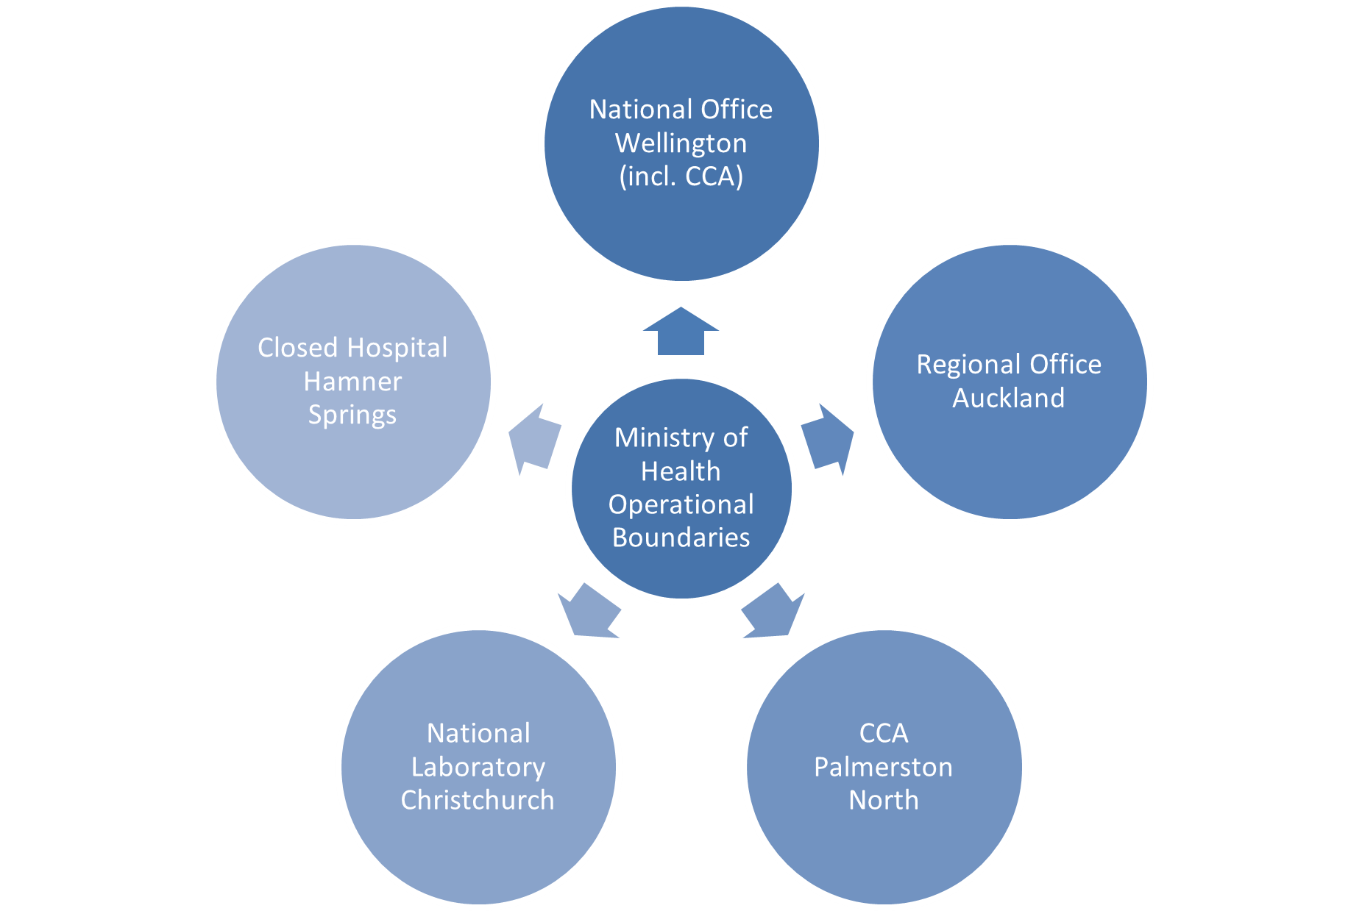

Table 1: Brief description of properties included in operational boundaries
Property | Address | Description
National Office | Wellington | Head office responsible for oversight and operational management of property portfolio. This site also includes Cancer Control Agency | Te Aho o Te Kahu staff accommodated within this location.
Regional Office | Auckland | Regional Ministry office
National Laboratory | Christchurch | National laboratory
Closed Hospital | Hanmer Springs | Closed hospital, minor maintenance conducted at this site
CCA Office | Palmerston North | Cancer Control Agency | Te Aho o Te Kahu

Operational boundaries excluded from the inventory
Table 2 describes the properties that have been leased recently or have produced no emissions (within the financial year 2022/23). They are not relevant to the base year from which this report and GHG emissions inventory are consolidated. For transparency, this provides an overview of the current state of the property portfolio and potential for inclusion in future GHG reports and inventories.
Some properties do not sit under the operational control of the Ministry (for example, co-located tenancies). However, if their emissions data can be sourced, future GHG emissions reports will note the relevant portion of their emissions outputs in line with their associated categories. If this is not achievable, each lead agency will report their emissions inclusive of their co-located tenants.
Table 2 Brief description of properties excluded from operational boundaries
Property | Address | Description
Hamilton | 16 Clarence Street | Cancer Control Agency | Te Aho o Te Kahu (CCA): Not under operational control; however, the agency agreement sits with the Ministry. Due to the small number of staff (4–5), this site has been excluded from this report.
Christchurch | 32 Oxford Street | CCA (The Loft): Not under operational control and has no influence over the operation of this building. Due to the small number of staff (4–5), this site has been excluded from the inventory.
Invercargill | 194 Dee St | Closed Hospital: Minor maintenance conducted as required; however, no emissions produced in base year where data could practically be sourced. No operational or energy use activity occurs at this site.
Hamilton | 87 Alexandra Street | Small number of staff housed – about 8, which is assumed minor. Not under operational control as the lease agreement is per seat. The Ministry has no influence over the operation of this building.

Organisational restructure: Establishment of Health New Zealand – Te Whatu Ora
This financial year, the Ministry has been restructured and a new separate agency, Health New Zealand Te Whatu Ora, has been created. As a result, a number of functions that the Ministry previously held are now within the mandate of Te Whatu Ora. For this reason, a number of staff, facilities and operations have been transferred to Te Whatu Ora.

GHG emissions sources included
The GHG emissions sources included in this inventory were identified with reference to the methodology described in the GHG Protocol and International Standard ISO14064-1:2018.

The emissions sources are also referenced in the Ministry for the Environment’s Measuring Emissions: 2023 Quick Guide. This guide specifies the various types of emissions the organisation would typically report on, depending on what type of organisation it is and its operational functions.

As adapted from the GHG Protocol, the emissions were classified under the following categories:
- Direct GHG emissions (Category 1): emissions from sources that are owned or controlled by the agency
- Indirect GHG emissions from imported energy (Category 2): emissions from the generation of purchased electricity, heat and steam consumed by the agency
- Indirect GHG emissions from transportation (Category 3): emissions that occur as a consequence of the agency’s activities but from sources not owned or controlled by the agency
- Indirect GHG emissions from products an organisation uses (Category 4): emissions that occur as a consequence of the agency’s activities but from sources not owned or controlled by the agency.

Figure 2 lists the actual emissions sources relevant to the Ministry’s operational boundaries that have been identified and included in the GHG emissions inventory under each category.

Figure 2: Summary of GHG emission sources included in the inventory, by category
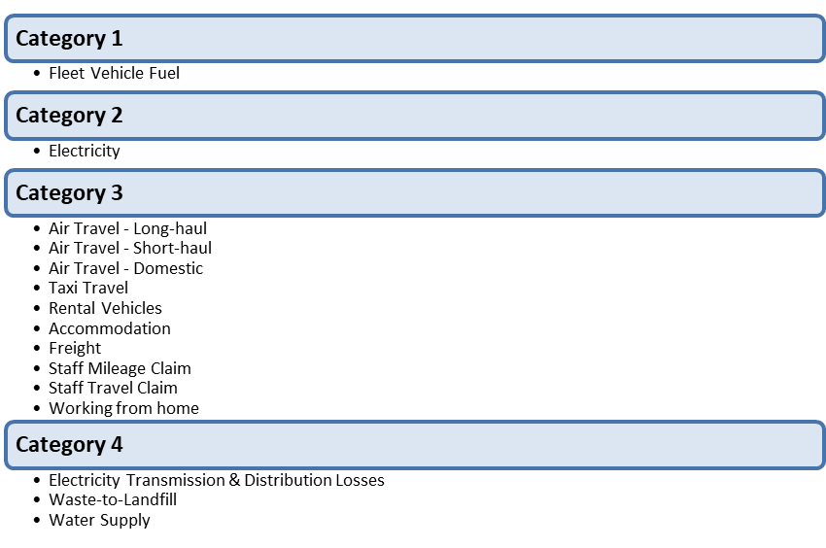

GHG emissions sources excluded
Table 3 identifies the emissions sources for the financial year 1 July 2022 to 30 June 2023 that have been excluded from the operational boundaries (as identified in Figure 1).
Where a property is considered to be outside of the Ministry’s operational control, the emissions sources may be de minimis (too trivial or minor to be worthy of consideration) and will be reported as an exclusion. For example, this applies to the small co-located tenancies shown in Table 2.
Various factors may be involved in the decision to exclude an emissions source relevant to the Ministry’s organisation boundaries for the 2022/23 year. These include but are not limited to :
- the type of lease agreement in place
- the practicality of sourcing the emissions
- total occupied space
- the number of full-time equivalent staff (FTE) in the premises
- an emissions source that is less than 1% of the total emissions within that source and not greater than 5% of the total emissions.

Table 3: Emissions source exclusions
Property | Address | Reason | Source
Categories 2 and 4 | 87 Alexandra Street, Hamilton | The site is out of the Ministry’s operational control; it is unpractical to source data as it would require apportioning building data for only 8 desks occupied by the Ministry. This site is part of Te Whatu Ora and will be reported in its emissions. | Electricity  Waste to landfill  Water supply  Wastewater
Categories 2 and 4 | 32 Oxford Street, Christchurch  16 Clarence St, Hamilton | Cancer Control Agency |Te Aho o Te Kahu (CCA): Not under operational control and has no influence over the operation of this building. There are low number of staff (4–5) at this site and form part of Te Whatu Ora emissions inventory. | Electricity  Waste to landfill  Water supply  Wastewater
Category 4 | All sites | Data for the base year had been sourced for the largest building and extrapolated on a square-metre basis for all other site and was found to be de minimis. | Water supply
Category 4 | All sites | Has water supply that was de minimis. Wastewater has also been considered de minimis. | Wastewater

Data collection and uncertainties
Table 4 provides an overview and an explanation of any uncertainties or assumptions. The calculation methodology has been used for quantifying the emissions inventory using emissions source activity data, multiplied by the emissions factors. For further detail of how the data was sourced, see the GHG inventory (Appendix A). All emissions factors have been sourced from guidance provided by the Ministry for the Environment, specifically through the Ministry for the Environment Measuring Emissions: A guide for organisations: 2023 detailed guide – 2023 Emission Factors Workbook.
Table 4: Details of GHG emissions sources included
Business unit | Activity | Categories | Data source | Data unit | Uncertainty (description)
All | Fleet fuel | Category 1 | Fuel card monthly summary and monthly fuel invoices | Litre | The Fleet card summary is cross-checked with fuel card invoices for accuracy and completeness. As a result, the amount of uncertainty is limited.
All | Purchased electricity | Category 2 | Smart Power report, and Smart Power sourced the consumption for one site recharged by the Accident Compensation Corporation that was not in its system. | kWh | Smart Power receives, verifies and pays all energy bills on behalf of the Ministry, using a strong internal quality assurance process. As a result, the amount of uncertainty is limited.
All | Electricity transmission and distribution losses | Category 4 | As above | kWh | As above
All | Air travel | Category 3 | Tandem, reconciliation report | Passenger km (pkm) | Tandem reconcile and process all the Ministry’s invoices for flights, accommodation and rental cars and can only charge back against an approved booking. Therefore all data would have been approved in the report. As a result, the amount of uncertainty is limited.
All | Accommodations | Category 3 | Tandem, reconciliation report | Room/night
All | Rental vehicles | Category 3 | Tandem, reconciliation reports | km
All | Taxi travel | Category 3 | Taxi charge summary report | km | It is assumed the report is complete and accurate. Kilometres are used for consistency across the inventory, and default emissions factors are used. The amount of uncertainty is moderate.
All t | Freight | Category 3 | CourierPost emission report | Tonne-km (tkm) and other | It is assumed the report is complete and accurate, especially because Toitū audited and certified CourierPost’s calculation. As a result, the amount of uncertainty is limited.
All | Freight | Category 3 | Kiwi Express | km | It is assumed the report is complete and accurate. Kiwi Express could not provide accurate weight but provided accurate type of vehicle used and km. Therefore road freight for light vehicle emissions factors have been used. As a result, the amount of uncertainty is moderate.
All | Working from home | Category 3 | Attendance record from security record for the head office and other Wellington office, and FTE and assumptions provided by the Ministry | Employee per day | As the Ministry has no formal ways to measure the number of employees working from home per day, the amount of uncertainty is reasonable.
All | Use private car | Category 3 | Staff expenses financial report | km | Estimated assumption is based on national vehicle ownership data to determine the split between petrol (91%) and diesel (9%) for light passenger vehicles. Inland Revenue conversion rate from $ to km was used. Default emissions factors were used. As a result, the amount of uncertainty is moderate.
All | Air travel | Category 3 | Staff expenses financial report | pkm | A number of assumptions have to be made as the expenses claim report was not detailed enough. As a result, the amount of uncertainty is reasonable.
All | Taxi | Category 3 | Staff expenses financial report | $
All | Accommodation | Category 3 | Staff expenses financial report | Room/night
All | Waste to landfill | Category 4 | Waste Management customer sales transaction report | kg | It is assumed the report is complete and accurate, especially because Toitū audited Waste Management’s process. Emissions factors with gas recovery have been used because waste in all Ministry sites includes landfill with gas recovery. As a result, the amount of uncertainty is limited.

Greenhouse gas emissions report summary
Table 5 shows the Ministry’s total emissions for the period 1 July 2022 to 30 June 2023. With the exception of the final column, the amounts are expressed as kilograms of carbon dioxide equivalent (kg CO₂-e). For a complete and quantified breakdown of this information, see the GHG inventory (Appendix A).
Table 5: GHG emissions summary
Category | CO₂ | CH₄ | N2O | HFCs | PFCs | SF₆ | Total t-CO₂-e
Category 1: Direct | 7.14 | 0.07 | 0.18 | 0.00 | 0.00 | 0.00 | 7.388
Category 2: Direct | 103.69 | 2.79 | 0.23 | 0.00 | 0.00 | 0.00 | 106.704
Category 3: Indirect | 738.89 | 2.78 | 8.02 | 0.00 | 0.00 | 0.00 | 749.691
Category 4: Indirect | 12.02 | 43.88 | 0.03 | 0.00 | 0.00 | 0.00 | 55.933
Total |  |  |  |  |  |  | 919.716
Note: CO₂ = carbon dioxide; CH₄ = methane; N₂O = nitrous oxide; HFCs = hydrofluorocarbons; PFCs = perfluorinated compounds; SF₆ = sulfur hexafluoride; t-CO₂-e = metric tonnes in carbon dioxide equivalent.

Calculations and results
Figure 2 provides the totals of the Ministry’s emissions in each category.
Figure 2: GHG emissions by category
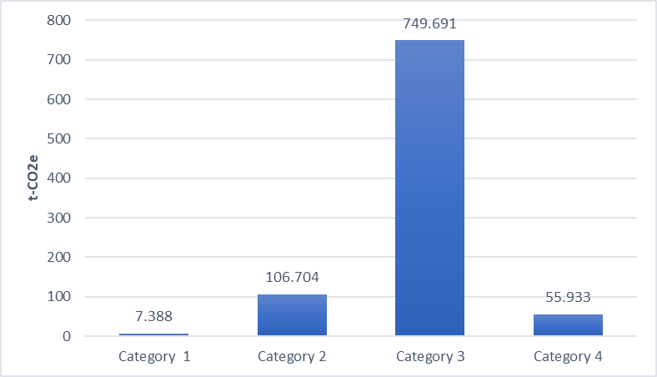

Figure 3 provides the totals of the Ministry’s emissions for each source.
Figure 3: GHG emissions by source
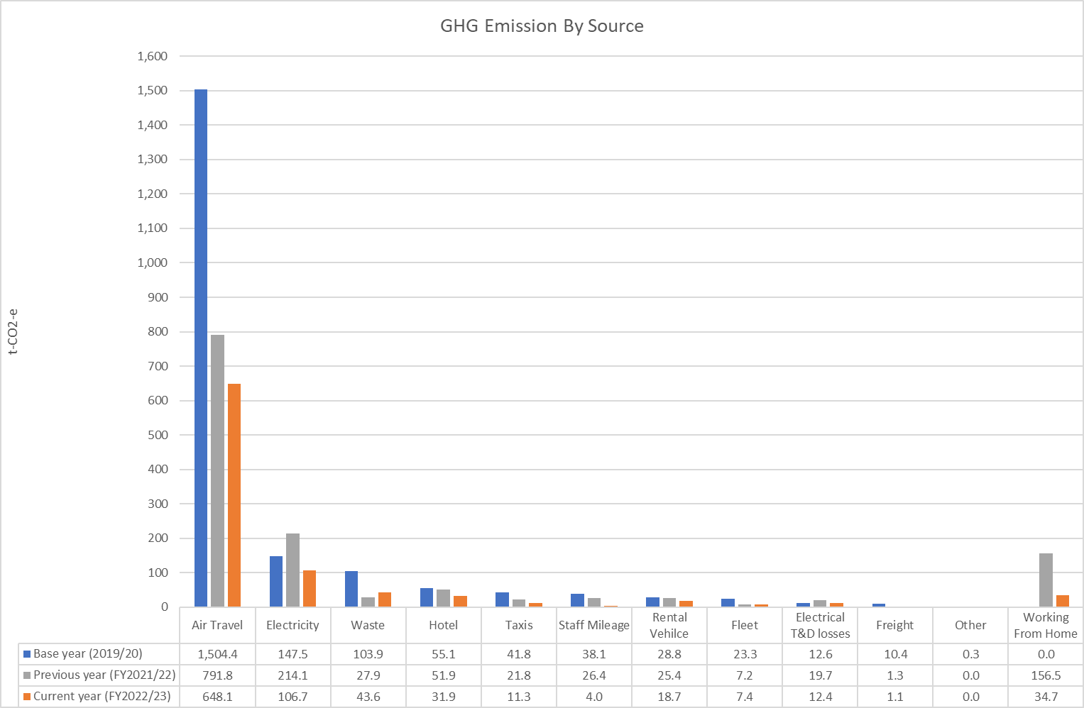

Variances from base year
This report concludes that, for the financial year 1 July 2022 to 30 June 2023, the Ministry’s highest emissions source is air travel.
Table 6: Emissions variances from base year
Emissions source | 2022/23 emissions  (t-CO₂e) | Emissions variance from base year  (t-CO₂e) | % variance from base year
Working from home | 34.7 | 34.7 | 100%
Freight | 1.1 | –9.3 | –90%
Fleet | 7.4 | –15.9 | –68%
Electricity transmission and distribution losses | 12.4 | –0.3 | –2%
Rental vehicles | 18.7 | –10.0 | –35%
Taxis | 11.3 | –30.5 | –73%
Use of private cars | 4.0 | –34.1 | –90%
Waste to landfill | 43.6 | –60.4 | –58%
Accommodation | 31.9 | –23.3 | –42%
Electricity | 106.7 | –40.8 | –28%
Air travel | 648.1 | –856.4 | –57%
Total | 919.7 | –1,046.5 | –53%

Conclusion
The operational boundary changes resulting from the creation of Te Whatu Ora are the main factor contributing to the large reduction in emissions.

It is also important to note that the Ministry has also been actively working toward strengthening its travel policy, decarbonising its fleet and improving the accuracy of its carbon reporting, all of which also contributed to this large reduction.

Reduction plan
This report provides a framework for the Ministry to measure, verify and report on our emissions annually. The Ministry is currently developing a reductions plan with a 1.5°C target reduction pathway. Some of the planned initiatives are to:
- improve internal process to ensure accuracy and completeness of reporting
- continue to engage with suppliers to improve reporting
- investigate potential for reducing electrical sources emissions, including improved renewable sourced electricity generation
- continue working on fleet decarbonisation.

Travel-based sources were responsible for 78% of the Ministry’s total carbon emissions for 2022/23, with over 70% of the total emissions being air travel. It is therefore the area of air travel reductions that the Ministry must focus on in order to achieve its reduction goals.

Appendix A: Manatū Hauora Greenhouse Gas Emissions Inventory
See attached.

Appendix B: Manatū Hauora 2022/23 Audit Certification
See attached.

New Zealand Government. 2020. Public sector to be carbon neutral by 2025. Releases. URL: www.beehive.govt.nz/release/public-sector-be-carbon-neutral-2025 (accessed 6 December 2023).
Greenhouse Gas Protocol. About Us. URL: https://ghgprotocol.org/about-us.
International Organization for Standardization. 2018. ISO 14064-1:2018: Greenhouse Gases – Part 1: Specification with guidance at the organization level for quantification and reporting of greenhouse gas emissions and removals.. URL: www.iso.org/standard/66453.html (accessed 6 December 2023).
In line with the Government’s policy for reducing emissions – see New Zealand Government Procurement. Reducing government fleet emissions. URL: www.procurement.govt.nz/broader-outcomes/reducing-emissions-and-waste/reducing-gqovernment-fleet-emissions (accessed 6 December 2023)
Greenhouse Gas Protocol. and. The Public Sector GHG Accounting and Reporting Standard, Provisional draft. URL: ghgprotocol.org/sites/default/files/standards_supporting/provisional-draft.pdf (accessed 6 December 2023).
Ministry for the Environment. 2023. 2023 Emission Factors Workbook. Measuring Emissions: A guide for organisations 2023 – 2023 detailed guide. URL: environment.govt.nz/publications/measuring-emissions-a-guide-for-organisations-2023-detailed-guide (accessed 15 January 2024).

