Designated Auditing Agency Handbook
Manatū Hauora (Ministry of Health) Auditor Handbook (revised 2023)
For Ngā paerewa Health and disability services standard NZS 8134:2021

Ministry of Health requirements for auditing and audit reporting for certification under the Health and Disability Services (Safety) Act 2001.
Citation: Ministry of Health. 2023. Designated Auditing Agency Handbook: Ministry of Health Auditor Handbook (revised 2023). Wellington: Ministry of Health.
Published in December 2023 by the Ministry of Health
PO Box 5013, Wellington 6140, New Zealand
ISBN 978-1-991075-62-8 (online)
HP 9056
This document is available at health.govt.nz
This work is licensed under the Creative Commons Attribution 4.0 International licence. In essence, you are free to: share ie, copy and redistribute the material in any medium or format; adapt ie, remix, transform and build upon the material. You must give appropriate credit, provide a link to the licence and indicate if changes were made.

Contents
1 Introduction 1
1.1 Keeping the handbook updated online 1
1.2 Key associated documents 1
1.3 References 3
2 Definitions within this document 5
3 Auditing principles 10
4 Designated auditing agency responsibilities 11
5 Code of conduct for DAA auditors 17
6 Audit teams 19
6.1 Audit team requirements 19
6.2 Lead auditor/team leader 22
6.3 Role of audit team members 24
6.4 Auditors with clinical expertise 24
6.5 Technical experts 24
6.6 Consumer auditors 25
7 Certification audit process 27
7.1 Two-stage audit process for certification audit 27
7.2 Audit duration 28
7.3 Criteria Application Framework audit approach 28
8 Types of audits 30
8.1 Provisional audit 30
8.2 Partial provisional audit 31
8.3 Certification audit 33
8.4 Ngā Paerewa surveillance audit 35
9 General requirements for the audit process 37
9.1 Combining audits 37
9.2 Auditing against conditions on a certificate 37
9.3 Include relevant information 38
9.4 Evidence-based auditing 39
9.5 Analysis of audit evidence 47
9.6 Ratings 48
9.7 Corrective actions 49
9.8 Transition to Ngā Paerewa 50
10 Audit reporting 51
10.1 Audit report writing guideline 52
10.2 Documented evidence 52
10.3 Reporting of critical and high risks 54
10.4 Submission of the Ministry of Health audit report 54
10.5 Incomplete or inadequate reports 56
11 Published audit information 57
11.1 Published summaries 57
11.2 Publication of full audit reports 59
11.3 Exception process 59
11.4 Publication of addendums 59
12 Progress reporting 60
12.1 Procedure – all services where progress is required to be monitored by a DAA 60
13 Unannounced surveillance audits 62
14 Aged residential care (rest home and hospital geriatric) – specific audit process requirements 63
14.1 Funder involvement in aged residential care audits 63
14.2 Document review 64
14.3 Safe and appropriate environment checklist 64
14.4 On-site audit 65
14.5 Sampling 65
14.6 Progress reporting procedure – for aged residential care services 66
14.7 Public hospital owned/ operated aged care services 66
14.8 interRAI requirements 66
14.9 Auditing for hospital – medical (non-acute) certification 69
14.10 Hospital and rest home level care in Occupational Right Agreement units 69
14.11 Charges 70
14.12 Auditor guidance specific to dementia services 70
14.13 Auditor guidance specific to young disabled people 72
15 Public hospitals – specific audit process requirements 74
15.1 Certification audits 74
15.2 Certification sampling 76
15.3 Using self-assessments 80
15.4 Daily meetings 81
15.5 Audit reporting 81
15.6 Progress reporting 81
15.7 Surveillance audits 81
15.8 Surveillance sampling 82
15.9 Validating self-assessments including individual tracers completed by public hospitals 85
15.10 Daily meetings 85
15.11 Audit reporting 85
15.12 Published summary 85
15.13 Progress reporting 86
16 Residential disability – specific audit process requirements 87
16.1 Interpretation 87
16.2 Audit preparation 87
16.3 Sampling plans 87
16.4 Certification audit sampling 89
16.5 Surveillance audits 90
16.6 Surveillance monitoring 90
17 Residential disability – psychiatric 92
17.1 Audit preparation 92
17.2 On-site audit 93
17.3 Progress reporting procedure 94
17.4 Unannounced surveillance audits 94
18 Fertility services 95
18.1 Key personnel in fertility services 95
18.2 Audit preparation 96
18.3 Sampling plans 97
18.4 Closure of a fertility service 97
Appendix 1 : Criteria Application Framework: Certification audits 98
Appendix 2 : Surveillance audits 108
Appendix 3 : Provisional audit – the interview with the prospective provider 111
Appendix 4 : Role description – lead auditor, public hospital audits 113
Introduction 113
Functions 113
Working with the audit team 114
Stage one of the audit 114
Stage two of the audit 114
Qualifications and experience 114
Appendix 5 : Role description – technical expert assessor, public hospital audits 116
Introduction 116
Functions 116
Stage one of the audit 116
Stage two of the audit 116
Qualifications and experience 117
Attributes 118
Training 118
Conflict of interest 118
Appendix 6 : Role description – quality auditor, public hospital audits 119
Introduction 119
Functions 119
Working with technical expert assessors 119
Stage one of the audit 120
Stage two of the audit 120
Qualifications and experience 121
Appendix 7 : Guidance for auditing residential disability services 123
Infection prevention and control auditing guidance 124
Appendix 8 : Audit Framework 125

Introduction
The key purpose of this handbook is to state Manatū Hauora - the Ministry of Health’s (the Ministry’s) requirements of designated auditing agencies (DAAs) for auditing and audit reporting for certification of health care services under the Health and Disability Services (Safety) Act 2001 (the Act).

This version of the Designated Auditing Agency Handbook replaces all prior versions. This handbook will be updated periodically and, where necessary, in collaboration with Te Apārangi, the Ministry’s Māori Partnership Alliance Group, DAAs and Te Whatu Ora.

Sector Guidance is available on the Ministry website to support compliance with Ngā paerewa Health and disability services standard NZS 8134:2021 (Ngā Paerewa) This will be reviewed and updated at regular intervals through a formal feedback process including stakeholders.

If there is any doubt as to any interpretation or requirement specified within this handbook, DAAs shall request written guidance from HealthCERT (a business unit within the Ministry) in advance of any action.

Keeping the handbook updated online
This handbook will be updated periodically online to keep it accurate. To get the latest version, please access or download the online handbook at www.health.govt.nz/publication/designated-auditing-agency-handbook.

Key associated documents
DAAs should be familiar with all Acts, regulations, codes, and guidelines relevant to the service being audited and the auditing best practice. Key documents are listed below.

Legislation and regulation
      - Code of Health and Disability Services Consumers’ Rights 1996 and the Health and Disability Services (Safety) Act 2001.
      - Ngā Paerewa Health and Disability Services Standard NZS 8134:2021 (Ngā Paerewa): https://www.standards.govt.nz/shop/nzs-81342021/.
      - Age-Related Residential Care (ARRC) and Age-Related Residential Hospital Specialised Services (ARHSS) service agreements: https://www.tewhatuora.govt.nz/for-the-health-sector/aged-residential-care/te-whatu-ora-aged-residential-care-provider-agreements/.
      - Contracts for disability support services funded by Whaikaha - Ministry of Disabled People: https://www.whaikaha.govt.nz/for-service-providers/contracts-and-service-specifications/.
      - Mental health and addiction service specifications: https://www.tewhatuora.govt.nz/our-health-system/nationwide-service-framework-library/about-nationwide-service-specifications/mental-health-and-addiction-service-specifications/.
      - Cloud computing and health information – available at: https://www.tewhatuora.govt.nz/our-health-system/digital-health.
      - Health and Safety at Work Act 2015.

Good practice standards and guidance
      - Ministry of Health, Sector Guidance for Ngā Paerewa Health and Disability Services Standard (NZS 8134:2021) available at https://www.health.govt.nz/our-work/regulation-health-and-disability-system/certification-health-care-services/services-standard/resources-nga-paerewa-health-and-disability-services-standard/sector-guidance-nga-paerewa-health-and-disability-services-standard-nzs-81342021.
      - Ministry of Health, Audit Report Writing Guide, Revised November 2014. Available at: https://www.health.govt.nz/publication/audit-report-writing-guide.
      - Ministry of Health, Provider Regulation Monitoring System (PRMS), log on and user guides available at https://providerregulation.health.govt.nz/oprans/.
      - Ministry of Health, Provider Regulation Monitoring System (PRMS), support link quick user guide for public hospitals available at https://www.health.govt.nz/our-work/regulation-health-and-disability-system/certification-health-care-services/information-designated-auditing-agencies/submission-audit-report-forms.
      - United Nations Convention on Rights of Persons with Disabilities – information on New Zealand’s involvement and how it is being implemented. Available at: https://www.odi.govt.nz/united-nations-convention-on-the-rights-of-persons-with-disabilities/.
      - Ministry of Health, Disability Services. Available at: https://www.health.govt.nz/our-work/disability-services.
      - The Chief Ombudsman’s aged care monitoring programme under the United Nation’s Optional Protocol to the Convention against Torture (OPCAT) at: https://www.ombudsman.parliament.nz/what-ombudsman-can-help/aged-care-monitoring.
      - Guidance for territorial authorities and verifiers working under the Food Act 2014. Available at: https://www.mpi.govt.nz/food-safety/food-act-2014/information-for-regulators-and-verifiers/practice-notes/.
      - Ministry of Health. 2018. Heat Health Plans: Guidelines. Wellington: Ministry of Health.
      - In-service safety inspection and testing of electrical equipment. Australian and New Zealand Standard AS/NZS 3760:2010.
      - Management programs for medical equipment. Australian and New Zealand Standard AS/NZS3551:2012.

Accreditation
      - AS/NZS ISO 19011:2019 – Guidelines for auditing management systems.
      - IAF MD1:2018 IAF Mandatory Document for the Audit and Certification of a Management System Operated by a Multi-Site Organization.
      - IAF MD2: 2017 – International Accreditation Forum Mandatory Document for the Transfer of Accredited Certification of Management Systems.
      - IAF MD5: 2019 – International Accreditation Forum Mandatory Document for Duration of Quality Management Systems and Environmental Management Systems Audits.
      - AS/NZS ISO/IEC 17021-1:2015 Conformity assessment – Requirements for bodies providing audit and certification of management systems.
      - AS/NZS ISO/IEC 17065:2012 Conformity assessment – Requirements for bodies certifying products, processes, and services.
      - Guidelines and Standards for External Evaluation Organisations, 5th Edition Version 1.0, September 2018 – International Society for Quality in Health Care.

Note: Cited publications are current at the time of publishing this DAA Handbook. Publications do not constitute requirements in the DAA Handbook. Refer to the most recent publication.

References
Forms and templates referenced in this handbook that are available on the HealthCERT website are:
- declaration forms
- provider self-assessment forms and templates
- provider document review templates
- environmental check template

Referenced requirements in this handbook that are available within the Provider Monitoring and Regulation System (PRMS) are:
- auditor register
- audit reporting templates
- corrective action monitoring.

Definitions within this document
Term | Definition
Age Related Residential Care Services Agreement (ARRC) | Services provided in accordance with an Agreement held with a public hospital to include 24-hour provision of hotel services and personal care, in the following categories:  - Continuing care (hospital care), (being ‘hospital care as defined in section 4 of the Health and Disability Services (Safety) Act 2001  - Specialist Dementia Services  - Rest Home Care in both cases being ‘rest home care’ as defined in section 6(2) of the Health and Disability Services (Safety) Act 2001.
Aged Residential Hospital Specialised Services Agreement (ARHSS) | Aged residential hospital specialised services, provided in accordance with an Agreement held with a public hospital to provide 24-hour provision of hotel services and personal care, in the category of psychogeriatric care.  Psychogeriatric care is a form of hospital care as defined in section 4 of the Health and Disability Services (Safety) Act 2001.
Annual service provider declaration | A declaration by a provider (other than public hospitals) to the DAA in any calendar year in which a certification or surveillance audit has not occurred.
Assisted Reproductive Technology Service (ART) | Assisted reproductive technology includes medical procedures used primarily to address infertility. Assisted reproduction often involves procedures such as in vitro fertilisation, intracytoplasmic sperm injection, cryopreservation of gametes (sperm and eggs) or embryos, and/or the use of fertility medication.
Audit | A systematic, independent, objective, and documented evaluation or review of the provision of the services and level of compliance of the extent to which health care providers meet a standard and processes, based on a particular audit.
Audit reporting template | A Ministry of Health document supplied electronically to DAAs to be completed and submitted by them as a record of the audit outcome.
Auditor with clinical expertise | An auditor holding a qualification in quality auditing that meets HealthCERT minimum requirements (eg, New Zealand Qualifications Authority (NZQA) Unit Standard 8086 – demonstrate knowledge required for quality auditing or equivalent as recognised by the Ministry) and have a demonstrated ability to comply with the requirements of AS/NZS ISO 19011. In addition, holds a current annual practising certificate in a health professional field and has proven expertise and recent experience pertinent to the service being audited.  Note: This is the minimum requirement where specific requirements are not additionally set out by service type within this handbook.
Client | Organisation being audited. NB: Also known as a provider.
Complex care in a public hospital setting | Patients that have received clinical care from intensive care, high dependency, coronary care, interventional radiology, and acute assessment units until transfer to a ward.
Consumer/kiritaki | A person who uses or receives a health or disability service.
Consumer auditor | A full member of the audit team who either is a service user of the type of service being audited (eg, residential physical or psychiatric) or is a family member or primary carer of such a person. Where a provider is certified for multiple services, someone who reflects the primary nature of the service is acceptable as a consumer auditor.
Corroboration/verification of evidence | The process an auditor follows to confirm their conclusions, which should involve triangulation of evidence wherever possible.
Criteria Application Framework | An audit that focuses on Ngā paerewa Health and disability services standard NZD 8134:2021 and specified criteria that are applicable to the service type being audited. All specified criteria are rated. All subsections have evidence of conformity and non-conformity reported. Criteria have evidence reported where there is non-conformity or continuous improvement (ie, fully attained ratings do not have evidence reported at criterion level).
Critical risk | A risk requiring immediate corrective actions, including documentation and sign-off by an auditor within 24 hours and notification in writing to the Ministry, in the interests of consumer safety.
Current clinical expertise | A health professional who holds a relevant annual practising certificate and can demonstrate practical experience within the past two years and professional development in the service relevant to the audit and if a:  - registered nurse or allied health professional, has been assessed as competent within an approved professional development programme at level 3 equivalent or higher, where level 2 is competent in a programme of either 4 or 5 levels  - registered medical practitioner, holds membership as a fellow of the relevant college and meets the requirements of the continuing medical education activities and assessments of competence as required by the college.
DAA annual self-declaration | Declaration that internal audit, appeals process, policy on managing conflicts of interest, auditor register, and auditor qualifications validation are current and comply with Ministry requirements.  DAAs are required to complete the form and submit to the Ministry prior to 29 of January annually.
Designated auditing agency (DAA) | An auditing agency for the time being designated under section 32(1) of the Health and Disability Services (Safety) Act 2001.
Director-General | The chief executive of the Ministry of Health.
Doctor | A person registered by the Medical Council of New Zealand to practise medicine in New Zealand.
Episode of care | A period between defined intervals (eg, from admission to discharge, or for the duration of specific management of an illness).
Executive summary | A preview of the main points from the audit report. It is written in plain English and contains enough information for a reader to familiarise themselves with the content of the full report. It should not contain information about anything that has occurred subsequent to the audit.
Evidence-based approach | The rational method for reaching reliable and reproducible audit conclusions in a systematic audit process. This may include sampling of a subset of a population, in order to provide a representative depiction from which it is possible to confidently generalise conclusions.
Fertility service | A service providing clinical care for the management of fertility related issues which may include the use of ART services.
Health care services | Health and disability services including hospital care, rest home care, residential disability care, fertility services, or other specified health (including mental health) or disability services.
HealthCERT | The business unit of the Ministry of Health responsible for the administration of the Health and Disability Services (Safety) Act 2001.
Hospital care | As defined in the Health and Disability Services (Safety) Act 2001:  Children’s health services, geriatric services, maternity services, medical services, mental health services or surgical services (or a combination of two or more of those services), where the services are provided:  - in premises held out by the person providing or intending to provide them as being capable of accommodating two or more of the people for whom the services are provided for continuous periods of 24 hours or longer  - in consideration of payment (whether made or to be made, and whether by the Crown, the people for whom the services are provided or any other person).
IAF | International Accreditation Forum.
Incidental sampling | A sample based on the collection of evidence from whomever or whatever comes along (eg, through informal talks with consumers on a tour of the facility). Incidental sampling can supplement other information collected throughout the audit process.
Issue | A deviation from a known standard.
Lead auditor/team leader | The person holding a qualification in auditing assigned to managing the audit team and audit process and responsible for authorising the final audit report before it is submitted to the Ministry of Health. The lead auditor holds a qualification in auditing that enables them to undertake the team leader role (eg, NZQA 8084; conduct a quality audit for compliance with quality standards or equivalent as recognised by the Ministry and have a demonstrated ability to comply with the requirements of AS/NZS ISO 19011). Note that ‘team leader’ is the equivalent term for ‘lead auditor’ in AS/NZS ISO 19011.
Ministry | Ministry of Health.
Whaikaha – Ministry of Disabled People | Part of the Ministry of Health, responsible for the planning and funding of disability services.
Multi-site | Structure of an organisation that has a central location at which certain activities are planned, controlled, or managed and a network of local offices, branches, and services (sites) at which such activities are carried out.
Multi-site audit | A process carried out under a written, pre-negotiated agreement between a multi-site provider (two or more sites) of residential disability care and HealthCERT, which establishes that an agreed percentage or number of the provider’s premises/sites will be audited.  The methodology for determining the number of facilities to be audited is based on IAF MD 1:2018 where there is not a requirement to submit a multi-site audit plan to the Ministry prior to the audit.
Observed audits undertaken by HealthCERT | Process in which an official from the Ministry observes an audit being conducted by a DAA for the purposes of determining competence of the audit team or implementation of audit processes.
Peer reviewer | A lead auditor with a relevant qualification and expertise in Ngā Paerewa Health and Disability Services Standard (NZS 8134:2021), acting as an independent expert who is not a member of the audit team and whose function is to critically review the audit report to ensure that audit activities conducted were technically adequate, properly documented and satisfy established quality requirements.
Problem | A deviation from a known standard.
Provider surveillance declaration | A declaration completed by a residential disability provider as a condition of certification. The declaration is made following an internal assessment of progress towards completing corrective action requirements arising from a certification audit and any relevant reports that followed a developmental evaluation prior to the mid-point of certification.
Resident | A person who uses/receives a health or disability service in a residential setting. Otherwise known as a consumer.
Residential disability care | As defined in the Health and Disability Services (Safety) Act 2001: Residential care provided in any premises (including aged care premises) for five or more people with an intellectual, physical, psychiatric, or sensory disability (or a combination of two or more such disabilities) to help them function independently.
Residential disability – psychiatric | A subset of residential disability care where residential mental health and/or addiction services are provided.
Rest home care | As defined in the Health and Disability Services (Safety) Act 2001:  - are residential care services provided for the care or support, or to promote the independence, of people who are frail (whether because of their age or for some other reason)  - neither include, nor are provided together with, geriatric services  - are provided for three or more people unrelated by blood or marriage (or a relationship in the nature of marriage) to the person providing the services  - are provided in premises held by the person providing the services as being principally a residence for people who are frail because of their age  - are provided in consideration of payment (whether made or to be made, and whether by the Crown, the people for whom the services are provided, or any other person)  - may include dementia care services.
Reconfiguration of certified services | This pertains to any change in the provider’s certified services. (eg, addition/ removal of a service, change in bed numbers, building an extension to an existing facility).  HealthCERT review reconfiguration applications and determine the need for an audit.
Site visit | A visit by an auditor to a provider, to audit an applicable standard, or part of a standard. This includes verifying the implementation at each site of generic policies, procedures, and systems. For a certification audit, a site visit is stage two of the audit.
The Standard (HDSS) | Health and Disability Services Standard NZS 8134 and any amendments or additional standards in accordance with the Health and Disability Services (Safety) Act 2001.
Systems tracer | Looks at one system or programme sampling across multiple consumers. Systems-based tracer methodology can be applied to programmes such as medication management or the deteriorating patient.
Technical expert | A person who provides specific knowledge or expertise to the audit team but does not act as an auditor in that team. See also ‘Consumer auditor’.
Technical expert assessor | A senior clinician with relevant specialist knowledge of public hospital systems and current practice working as an expert in delivery of services who is nominated by a public hospital to be on the Ministry register of technical expert assessors.
Individual tracer methodology | An individual tracer follows the actual care experience of the consumer who is receiving care and treatment at the time of the audit. Selection of a tracer should include a consumer who is receiving complex care and treatment as their experience shows how the provider’s systems and processes support the care they receive.
Transition plan | A plan that is developed where a provider is purchasing a health or disability service (or reconfiguring their services). The plan includes how information about the change in ownership is being communicated, how risks are identified and managed, and how any intended changes to the service are to be implemented (eg, staffing changes, changes to policies and procedures).
Triangulation of evidence | A process of drawing information from three sources (interviews, observations, and documentation) in order to gather reliable evidence.
Witnessed audit assessments undertaken by DAAs | Process in which an individual is assigned by the DAA to assess the competence, skills, knowledge, and ability of an audit team member through observation of the auditor conducting an audit in accordance with audit process requirements. The observer shall hold qualifications equivalent to or greater than the auditor being observed. The observer shall use established criteria to evaluate the auditor under observation and complete a report that is then used to inform a performance review of the auditor.

Auditing principles
The Ministry of Health requires auditors to follow the principles of ethical conduct, fair presentation, due professional care and support, independence, and an evidence-based approach as outlined in AS/NZS ISO 19011. In addition, the following principles apply.
      - Consumer focus: Care, support and services meet the needs and preferences of consumers consistent with currently accepted practice.
Auditors shall use their technical and clinical expertise to collect audit evidence directly from consumers, whānau and providers and include a review of care and support received, considering both the episode of care and individual components of care.
      - Outcomes focus: The context for service provision shall be considered, acknowledging that outcomes can be achieved through various inputs, processes, and outputs.
Audit evidence shall reflect the inputs, activities and outputs that contribute to outcomes, giving due consideration to contractual requirements in the case of any government-funded services that also rely on Ngā Paerewa as a means of measuring or monitoring the standard of services, care, and support.
      - Systems and process focus: Effective systems and processes are implemented to support the delivery of services and care.
Auditors will determine through the collection of audit evidence that the standard of service, care and support delivery are not dependent on any one person, but rather on the systems and processes present.
      - Openness and transparency: Information is effectively communicated throughout the audit process.
Auditors ensure stakeholders involved in the audit process are fully informed.

Designated auditing agency responsibilities
Each DAA shall meet the requirements listed below.

Legislative
      - Meet all requirements of designation as outlined in the Act and in the Gazette notice.
      - Comply with relevant legislation, including but not being limited to the:
        - Health and Disability Commissioner Act 1994
        - Health and Disability Services (Safety) Act 2001
        - The Health and Safety at Work Act (2015)
        - Health Practitioners Competence Assurance Act 2003
        - New Zealand Public Health and Disability Act 2000
        - Privacy Act 2020
        - Health Information Privacy Code 2020
        - Social Security Act (Long-term residential care) Amendment Act 2004.

Third-party accreditation
      - Hold third-party accreditation with either the Joint Accreditation System of Australia and New Zealand (JAS-ANZ), or the International Society for Quality in Health Care External Evaluation Association (IEEA) (or the Reproductive Technology Accreditation Committee (RTAC) for auditing fertility services) and meet all costs associated with this accreditation.
      - Provide to the Ministry upon receipt, all reports and requirements generated by its third-party accreditation body, together with associated action plans that are a result of third-party accreditation activities.
      - Notify HealthCERT immediately of any application made for third-party accreditation, or any suspension or conditions imposed by a third-party accreditation body.
      - Ensure that the third-party accreditation body undertakes a surveillance audit at the mid-point of the accreditation period or at more frequent intervals, as determined by the third-party accreditation body. A written request to HealthCERT is required from the DAA or the third-party accreditor if an audit cannot be undertaken for any reason.

Client management
      - Follow IAF MD2:2017 for the transfer of clients where the client has previously received services from another DAA.
      - Where a provider changes DAA, all documentation pertaining to the provider’s certification is required to be transferred to the chosen DAA by the existing DAA.
      - Ensure clients of the DAA are aware that the Ministry of Health or a recognised third-party accrediting body (JAS-ANZ or IEEA as applicable) may accompany DAA auditors on any audit as part of their observation audit or witnessed audit, performance monitoring process, accreditation, or designation/re-designation process.
      - Ensure all information obtained or created during the performance of certification activities is maintained confidentially.

Auditors
      - Employ or contract with competent auditors who have gained the New Zealand Qualifications Authority (NZQA) Unit Standard 8086 (demonstrate knowledge required for quality auditing) qualification (or equivalent as recognised by the Ministry) in auditing quality management systems (QMS) and have a demonstrated ability to comply with the requirements of AS/NZS ISO 19011.
      - Lead auditors (team leaders) demonstrate competence through successful completion of NZQA Unit Standard 8084 (conduct a quality audit for compliance with quality standards) qualification (or equivalent as recognised by the Ministry). This course supports skills required of lead auditors such as audit planning/ preparation; technical aspects including triangulating evidence, undertaking opening and closing meetings; interpersonal aspects relating to communication with providers and audit team members; and providing a peer reviewed audit report.
      - Determine competence of auditors and technical experts in accordance with AS/NZS ISO/IEC 17021-1:2015.
      - Ensure auditors employed or contracted by the DAA comply with the code of conduct as outlined in section 5.
      - DAAs will ensure auditors employed or contracted by them use Workbooks or onsite audit tools to gather consistent field notes which align with Ngā Paerewa.
      - Ensure auditors employed or contracted by the DAA can demonstrate continual professional development through regular participation in audits and completion of at least eight hours per calendar year of professional development education and training relevant to their area of audit.
      - DAAs shall provide opportunities for employed or contracted auditors to undertake equity and Te Tiriti learning.
      - Ensure that requirements for continual professional development are consistent with AS/NZS ISO 19011.
      - Ensure that auditors with clinical expertise include, within their professional development, activities that keep them up to date with current QMS auditing and best practices for service delivery. Such professional development shall cover but is not limited to knowledge of:
        - all legislation and regulations relevant to the service setting (for example, auditors undertaking residential care auditing require knowledge of enduring power of attorney in the context of personal care and welfare, and how this should be approached within a residential care setting)
        - the current management of commonly occurring medical conditions relevant to the service setting
        - current care best practice relevant to the service setting.
      - Complete and document an annual performance review of all employed and contracted auditors which shall at a minimum include a witnessed audit assessment undertaken and documented by the DAA of their staff and contractors. A performance review report or witnessed audit assessment of an employee or contractor undertaken by a different DAA, does not meet this requirement. NB: All DAAs have organisation specific systems, processes and requirements of their auditors.
      - Ensure that the auditor undertaking a witnessed audit assessment or contributing to a performance appraisal is additional to the audit team and does not participate in the audit process. The person undertaking the witnessed audit does not need to be present for the full audit. Ensure a witnessed audit assessment of a lead auditor includes at a minimum the opening meeting, audit of organisational management, quality management, end of day meeting with audit team, preparation for the closing meeting, and the closing meeting itself. For the purpose of a witnessed audit assessment the lead auditor shall be competent in section 2 of Ngā Paerewa (Workforce and Structure).
      - Ensure auditors undertake performance-based monitoring. A DAA may move to two-yearly performance reviews or witnessed audit assessments if the following criteria are met.
- Two successful witnessed audit assessments have been undertaken by a DAA with no major non-conformities raised of the auditor.
- Professional development log is maintained annually and meets the requirements.
- Training is completed as required to meet the requirements of the DAA Handbook.
- No substantiated complaints relating to the auditor’s performance received from stakeholders, the DAA, or through monitoring undertaken by the Ministry.
- The auditor has not been required by the Ministry to amend and/or re-submit an audit report, in response to the standard of reporting (including insufficient information).
- Auditors can only be considered for eligibility for performance-based monitoring after two consecutive years where the above criteria are met.
      - Ensure newly qualified auditors work in a trainee capacity for a provisional period of no fewer than four audits where they are fully supervised by an experienced auditor. Auditors shall not work independently until such time as they have been assessed as competent at the completion of the four trainee audits.
      - Ensure auditors with lead auditor or team leader qualifications (NZQA Unit Standard 8084 or equivalent as recognised by the Ministry) are assessed as competent to work in the capacity of a lead auditor by the DAA following a witnessed assessment audit. This assessment shall be completed at the fourth certification audit and shall demonstrate competency before they undertake this role. A minimum of four observed certification audits totalling a minimum of eight on-site days are required before they undertake this role.
      - Where an auditor works for more than one DAA, the auditor is required to disclose to the DAAs that they are contracted and/or employed by, any areas for improvement resulting from Ministry of Health observed audits.
      - Disseminate all relevant Ministry updates to auditors employed or contracted.
      - As part of their monitoring processes or internal audit programme resubmission of audit reports are monitored and evaluated by the DAA for training purposes.

Audit teams
      - Ensure the audit team comprises a lead auditor, competent auditors, auditors with clinical or technical expertise and consumer auditors, as appropriate to the service. Auditors shall be on the DAA auditor register and be approved by the Ministry to audit for specific service types. Minimum requirements are outlined in section 6.

Provider Regulation and Monitoring System
      - Access the Provider Regulation and Monitoring System (PRMS) via a connection to the New Zealand Health Network (connected health).
      - Securely manage user-specific log-in and passwords to the PRMS.
      - Use the PRMS to download provider-specific audit reporting templates that are then used to complete audits.
      - Use the PRMS to upload completed audit reports.
      - Use the PRMS to report progress on corrective actions arising from audits where the DAA is responsible for progress reporting.
      - Complete the prescribed form in the PRMS that maintains an up-to-date auditor register of auditors and clinical/technical experts who undertake audits on behalf of the DAA. Upload any supporting documentation (for example, CVs) to the PRMS as required. An auditor is not to undertake an audit on behalf of a DAA if they have not been entered onto the Ministry auditor register. An auditor and clinical/technical expert can only undertake an audit role in their area of speciality or in accordance with their respective qualification as specified in PRMS and the DAA Handbook auditor competency requirements.
      - Maintain the auditor register within the PRMS ensuring all professional development activities have been recorded into the PRMS upon their completion. The first entry could be a reference to the organisation’s own record. APC expiry and performance review dates are mandatory.

Reporting requirements
      - Ensure the Ministry holds an up-to-date copy of their specific policies and procedures for auditing against Ngā Paerewa and recruiting or contracting with audit team members.
      - Provide the Ministry with an annual audit schedule updated quarterly, commencing 29 January each year and provide an update of this schedule on a quarterly basis.
      - Provide to the Ministry, 20 working days prior to a scheduled audit, an audit sampling plan and timetable for all audits where multi-site sampling occurs, to be approved by HealthCERT as per the specified sampling methodology requirements in section 9.4 of this handbook. NB: This includes all residential disability organisations with multiple sites (ie, two or more sites) for surveillance and certification audits. The requirements for public hospital audit sampling plans and timetables are the same with the exception of the submission date to the Ministry for approval.
      - Complete the prescribed annual self-declaration using the prescribed form on the HealthCERT website and submit before 29 January each year. Provide all supporting documents that may be subsequently requested by the Ministry of Health.
      - Ensure all audit reports have been reviewed by the lead auditor/team leader and have undergone a peer reviewer before they are submitted to the Ministry of Health. The peer review process shall include but is not limited to:
        - proofreading the report
        - ensuring the report is factual and accurate and meets standards for reporting audit evidence (see section 10)
        - ensuring the audit activities conducted were technically adequate and properly documented
        - ensuring the report follows the guidelines set out in the Ministry of Health’s Audit Report Writing Guide.
      - Notify the Ministry of any client who has not satisfactorily completed an annual service provider declaration, using the prescribed form available on the HealthCERT website to enable the Ministry to determine whether an additional surveillance audit is required.
      - Comply with any benchmarking requirements, including those concerning publication of results.
      - Meet all time requirements for submission of information/reports as outlined in this DAA Handbook.

Managing conflicts of interest
      - Establish a system or process in safeguarding impartiality, consistent with a process for managing conflicts of interest as per AS/NZS ISO/IEC 17021-1.
      - Ensure all auditors complete a conflict-of-interest declaration before every audit.
      - Have established processes to specifically manage conflicts of interest at an organisational level – noting that:
        - a DAA shall not provide any consulting services to an organisation that is also a client receiving auditing services
        - individual auditors shall not provide auditing services where they have provided consultancy or educational services within the last two years to the same client
        - a DAA may arrange and participate in training courses provided that these courses relate to quality assurance, management systems or auditing. They shall provide only generic information and advice that is freely available in the public domain and includes a range of options or approaches the client could then act on. A DAA shall not provide specific advice to any client or provide a particular system for implementation for a client receiving auditing services from the DAA
        - providing internal, ongoing professional development training to auditors employed or contracted by the DAA is a legitimate DAA activity and does not pose a conflict of interest.
      - Ensure there is rotation of auditors whereby at least 50 percent of the members of the full audit team for the re-certification audit differ from the team members who undertook the prior certification or re-certification audit of any particular premise.

Code of conduct for DAA auditors
Under the code of conduct, an auditor is required to:
      - act professionally and accurately, and report findings in a consistent and unbiased manner and in accordance with Ministry requirements
      - undertake audits in accordance with Ministry requirements, procedures, and guidelines, and with AS/NZS ISO 19011. Ministry requirements are to supersede any other requirements
      - strive to increase the competence and prestige of auditors by continuing to develop their own auditing skills
      - not misrepresent their own or any other individual’s qualifications, competence, or experience, nor undertake auditing work beyond the scope of their own qualifications
      - disclose to the DAA any current or prior working or personal relationships that may be seen as a conflict of interest or that may influence their judgement
      - not enter into any activity that may be in conflict with the best interests of the Ministry or the DAA, or that would prevent the performance of their duties in an objective manner
      - adhere to the requirement of the Health and Disability Services (Safety) Act 2001, the Privacy Act 2020 and the Health and Disability Commissioner’s (HDC) Code of Health and Disability Services Consumers’ Rights and all other relevant legislation, regulations, guidelines, codes and best practice standards
      - not promote or represent any business interests or any entity with which they have an interest or may have an interest while conducting audits
      - not accept any inducement, commission or gift or any other benefit from any interested party while conducting audits
      - not communicate false, erroneous or misleading information that may compromise the integrity of any audit
      - not act in any way that would prejudice the reputation of the Ministry or the DAA
      - cooperate fully with any inquiry in the event of a complaint about their performance as an auditor, or any alleged breach of this code
      - make clear to providers that the decision about certification status rests solely with the Director-General of Health and that the DAA is not able to make comment or support an appeal concerning the determination made regarding certification
      - accept that providers have the freedom to select and change their DAA, and not to place any undue influence on providers when they are making a decision in this respect
      - refrain from making any comments on any auditors or DAA, including Ministry or public hospital auditors
      - respect consumers’ rights during any interaction especially when assessing vulnerable populations such as those in disability or mental health services.

Audit teams

Audit team requirements
The requirements for every DAA audit team are outlined below.
      - The composition of the audit team shall reflect the characteristics of the service and the people receiving services – for example, in terms of cultural background and service type.
      - Every audit team shall include a qualified and experienced lead auditor/team leader who meets the definitions in section 2 for a lead auditor.
      - Where audits require technical expertise, the level of expertise shall meet the definitions in section 2 for an auditor with current clinical expertise or technical expert or technical expert assessor. Clinical/technical experts shall have recognised health qualifications and experience in the health field or services area to be audited. Note: One person may be both the lead auditor and a clinical/technical expert.
      - Minimum audit team requirements by service kind are outlined below.
Service kind | Specific service level expertise required
Fertility Services | Auditor with clinical expertise or technical expert shall have current in-depth fertility services knowledge with an in-depth understanding of RTAC code. A person with technical expertise relevant to ART must be included if ART Services are included in the audit.
Hospital care | Qualified lead auditor/team leader shall meet the role description in Appendix 4 and, if auditing a public hospital, be approved by the Ministry to be a lead auditor in public hospitals.  Auditor shall meet the specific role description if auditing a public hospital (see Appendix 6).
Hospital care – children’s health services | Auditor with clinical expertise or technical expert shall have current paediatric experience including management of children with complex presentations.
Hospital care – medical services | Auditor with clinical expertise or technical expert shall have current medical care experience, or in the case of a hospice current experience.
Hospital care – surgical services | Auditor with clinical expertise or technical expert shall have current surgical care experience.
Hospital care – maternity services | Auditor with clinical expertise or technical expert shall have current midwifery or obstetric care experience.
Hospital care –mental health and addictions services | Auditor with clinical expertise or technical expert shall have current acute inpatient mental health and addictions experience.
Hospital care – geriatric services | Auditors shall be conversant with the relevant contracts held between the funder and provider of services.  Auditor with clinical expertise or technical expert shall have current experience in at least one of the following: medical care, rehabilitation nursing, gerontology or psychogeriatric care.
Hospital care – geriatric services (continued) | Where an auditor with clinical experience does not meet the minimum requirements (see definition of this role in section 2), an exception can be applied if the person is:  - not currently practising but has held a clinical role working in aged residential care or gerontology less than five years ago at an advanced/senior level (ie, level 4 or above on a Professional Development and Recognition Programme (PDRP) or equivalent)  - currently practising in aged residential care or gerontology with less than two years’ experience in this field but was previously working as an advanced/senior practitioner (ie, level 3 or above on a PDRP or equivalent).  - an auditor who has been approved by the Ministry to audit in geriatric services and rest home, having provided evidence that they:  - have three or more years’ experience auditing this type of service, and  - are a registered nurse with at least two years’ clinical experience in medical or gerontological nursing, and  - hold an annual practising certificate, and  - have completed one-third of the New Zealand Nursing Council’s required professional development hours to maintain an annual practising certificate that are specific to aged care, comprising recognised short courses, seminars, conferences, online learning, internet-based courses or degree courses.
Rest home care | Auditors shall be conversant with the relevant contracts held between the funder and provider of services.  Auditor with clinical expertise or technical expert shall have current experience in at least one of the following: medical care, rehabilitation nursing, gerontology or psychogeriatric care. Where dementia services are being audited, specific dementia care or psychogeriatric expertise is required. Where a contract for five or more residents is held and YPD services are being audited specific expertise in this area is required.  Where an auditor with clinical experience does not meet the minimum requirements (see definition of this role in section 2), an exception can be applied as for hospital care – geriatric services above.
Residential disability care – intellectual, physical or sensory | Auditor or technical expert with demonstrated knowledge and understanding of the UN Convention on the Rights of Persons with Disabilities 2008 and the NZ Disability Action Plan; and current experience of disability services relevant to the sub-category (ie, intellectual, physical or sensory).  Note: this requirement also applies where residential disability care is provided in an aged residential care service or hospital level services and a contract to provide services for five more YPD residents is held.
Residential disability care – psychiatric (mental health and addictions) care | Auditors shall be conversant with the relevant contracts held between the funder and provider of services.  Auditor with clinical expertise or technical expert shall have current experience of mental health and additions services.
Residential disability care – psychiatric (mental health and addictions) care (continued) | Where an auditor with clinical experience does not meet the minimum requirements (see definition of this role in section 2), an exception can be applied if the person is:  - not currently practising but has held a senior clinical role working in mental health and addictions services less than five years ago at an advanced/senior practitioner level (ie, level 4 or above on a PDRP or equivalent)  - currently practising in mental health and addictions services with less than two years’ experience in this field but was previously working as an advanced/senior practitioner (ie, level 3 or above on a PDRP or equivalent)  - an auditor who has been approved by the Ministry to audit in hospital – mental health services and residential disability – psychiatric, having provided evidence that they:  - have three or more years’ experience auditing this type of service  - are a health professional qualified to work in mental health and addictions services with at least two years’ clinical experience in mental health services or another services that has mental health clients  - hold an annual practising certificate  - have completed one-third of the professional development hours to maintain an annual practising certificate that are specific to mental health and addictions services, comprising recognised short courses, seminars, conferences, online learning, internet-based courses or degree courses.  Also refer 9.4.2 (stratified sampling) and 14.13 (auditor guidance specific to young disabled people).
Mental health services – drug or alcohol services | Auditor with clinical expertise or technical expert shall have current experience of alcohol or drug rehabilitation services or acute mental health services.
      - For hospital care of any kind and rest home care of any kind, Ngā Paerewa section 3, section 5 and section 6 shall be audited either by an auditor with clinical expertise or by an auditor with either a technical expert or technical expert assessor.
      - For hospital care – mental health and addictions services and residential disability care of any kind, including where it is provided as a dual service, certification audits shall include a consumer auditor. See section 6.6 for the responsibilities of the consumer auditor.
      - Note that where a mental health consumer has been assessed to receive rest home level care, the audit team shall meet the requirements for rest home care.
      - The audit team shall have a working knowledge of current contracts held by the provider to ensure the relevance of contracted requirements are considered as part of the certification audit process. Auditors shall be familiar with and use cultural safety resources to underpin their audit practice. Clinical auditors are required to observe cultural safety set by their responsible authorities, such as https://www.mcnz.org.nz/our-standards/current-standards/cultural-safety/ and https://www.hqsc.govt.nz/our-programmes/patient-safety-day/previous-psw-campaigns/psw-2019/cultural-safety-and-cultural-competence/.
      - The DAA shall uphold the principles of Te Tiriti o Waitangi and embed them during the audit process.

Lead auditor/team leader
The lead auditor/team leader shall coordinate the audit. While their roles and responsibilities are not limited to the following, the lead auditor/team leader shall:
      - confirm the membership of the audit team is appropriate to the type of audit being conducted
      - ensure each team member has completed a conflict-of-interest declaration
      - ensure the audit is conducted in accordance with DAA policies and procedures and consistent with AS/NZS ISO 19011
      - for all announced audits, including those where multi-site sampling is required and for all public hospital audits, ensure an audit plan, including a sampling plan and timetable has been developed prior to the audit and the client has received a copy. Also note the requirement to submit to HealthCERT for approval, audit sampling plans and timetables where multi-site sampling is required and for all public hospital audits
      - confirm audit arrangements with clients, as specified by AS/NZS ISO 19011, where an audit is announced
      - review provider information, such as:
        - document review
        - last certification audit
        - any surveillance or other (for example, partial provisional) audit event since the last certification audit
        - progress reports
        - developmental evaluations or other assessments undertaken by third parties
        - accreditation or audits undertaken by third parties
        - any information requested for review by HealthCERT
      - contact the funder/s (public hospital /Whaikaha – Ministry of Disabled People) if an audited client holds a contract to deliver services for that funder. This contact will include but is not limited to:
        - notifying the funder of the intended date of the audit
        - asking the funder to provide the DAA with any relevant information that may contribute to the audit process
        - determining with the funder the level of involvement it would like to have in the audit (for example, witnessing the audit) with provider agreement.
Where there are issues in respect of one or more of the certified facilities, it may be necessary to include them in the sampling plan (if applicable).
Residential disability, intellectual disability, physical disability and sensory services contracts are held by Whaikaha – Ministry of Disabled People; mental health services contracts and hospice contracts are held by public hospitals.
      - chair opening and closing meetings with the client, maintaining a record of these
      - ensure the opening and closing meetings conform with the requirements of AS/NZS ISO/IEC 17021-1/17065 and AS/NZS ISO 19011, and include a discussion with the client about the audit objectives
      - ensure substantiation and validation of information gathered by the audit team that is then used as audit evidence
      - ensure the service provider receives a written copy of the audit findings and corrective action required at the closing meeting
      - where a service holds a service contract with a public hospital and/or Disability Services, forward a copy of the corrective actions report generated on site to the public hospital and/or Disability Services within 24 hours if there are any high-risk findings
      - ensure the service provider has obtained verbal consent from consumers for the audit team to interview consumers
      - notify the Ministry in writing within 24 hours about the progress of the audit where a high or critical risk has been identified at the time of the audit
      - coordinate the audit team and be a resource to the team (see AS/NZS ISO 19011), for example in helping to validate information collected
      - be the central point of contact for the client throughout the audit, liaising with them as appropriate to ensure openness and transparency throughout (see AS/NZS ISO 19011)
      - review the full audit report prior to peer review of the report, and any changes following peer review, and before submission to the Ministry
      - provide any auditor performance feedback to the DAA.

Role of audit team members
The role of audit team members shall include but is not limited to:
      - working as a team and as a group of individuals who maintain good communication with the lead auditor/team leader and with others as specified by AS/NZS ISO 19011
      - conducting the audit according to the principles and requirements set out in this handbook and AS/NZS ISO 19011
      - undertaking audit activities and tasks as assigned to them, as specified in AS/NZS ISO 19011
      - working to timeframes, as specified in AS/NZS ISO 19011
      - supporting other auditors as necessary, as specified in AS/NZS ISO 19011
      - accurately reporting evidence and ensuring that documents are proofread before submitting them to the lead auditor or team leader
      - providing feedback to the DAA as applicable.

Auditors with clinical expertise
A qualified quality auditor with clinical expertise can audit those parts of Ngā Paerewa that require a level of expertise in the service provision area being audited. Where an auditor is acting as an auditor with clinical expertise, the auditor shall hold a current annual practising certificate and meet the specific competency requirements as set out in section 6.1 above.

Technical experts
A technical expert is a competent health professional with an annual practising certificate or equivalent who has demonstrated knowledge, skills and experience in the service area being audited but does not necessarily hold an auditing qualification and does not act as an auditor within the audit team. For example, when auditing a birthing unit, the DAA shall have available to it as a resource, a technical expert who currently works or has recently worked for that service type. The technical expert shall attend audits of the following services:
- forensic services
- forensic intellectual disability services
- alcohol and other drugs addiction services
- maternity services with birthing units
- private surgical hospitals
- hospices.

In all other cases the technical expert can provide advice remotely.

A technical expert shall:
      - have demonstrated knowledge and skills related to and recent experience of working within the service area being audited
      - be competent to reach an informed opinion on the appropriateness of the services being offered in the service being audited
      - be able to identify trends in relation to service delivery
      - where they are not a qualified quality auditor and are not completing the Ministry audit reporting template, complete a report that forms part of the audit evidence
      - complete a conflict-of-interest declaration.

Consumer auditors
A consumer auditor, when used, is expected to:
      - be involved in the planning and preparation of methods of service user participation in the audit and in evaluating the need for independent support for service users
      - participate as a full audit team member
      - focus on the experience of people who use the services
      - be included in key meetings with the organisation, management, staff and consumers
      - facilitate meetings and interviews with service users and consumer groups
      - interview service users independently and work under the direction of the lead auditor/team leader when completing any other aspects of the audit
      - be engaged under the normal principles of employment related to term of appointment, contract, remuneration, job description and adherence to codes of conduct such as those on confidentiality, non-disclosure protocols and conflict-of-interest declarations, in the same way that those principles apply to all other team members
      - be trained in auditing principles, the use of the approved standards and audit tools as a member of the audit team
      - have the following knowledge, skills and attributes:
- knows the legislative and regulatory requirements for the service being audited
- understands continuous improvement concepts, methodologies and planning processes
- understands quality management systems
- is able to communicate effectively in writing or orally or to use alternative communication systems with all parties involved in the audit process.

For all certification audits of residential disability (psychiatric)) including alcohol and drug services, intellectual, physical or sensory) care, and hospital mental health services the audit team shall comprise a minimum of two members: a lead auditor/technical expert (combined role) and a consumer auditor; or a lead auditor/consumer auditor (combined role) and a technical expert. The auditor completing the continuum cannot also be the consumer auditor unless the auditor can demonstrate that they meet the requirements of both roles.

Surveillance audits do not require a consumer auditor but will still require the audit team to include a lead auditor/technical expert. For larger services requiring more than one auditor with technical expertise, a consumer auditor shall be used for a surveillance audit.

The consumer auditor shall be a full participant, visit each site subject to audit and be fully involved in the audit (including audits for which HealthCERT has approved a sampling plan) and subsequent audit reporting. Involvement of consumer auditors shall be traceable in the audit report submitted to HealthCERT.

The Health Information Privacy Code 2020 states that the disclosure of a person’s private health information is permitted only to the extent necessary for the particular purpose.

The consumer auditor shall review clinical information relevant to their role. They may view personal plans, for example:
- support/activity/goal plans
- consent forms
- information about services

in conjunction with service user interviews.

Certification audit process

Two-stage audit process for certification audit
All certification audits will include a two-stage initial audit. The first stage of the audit will incorporate off-site activities, including a document review of:
- policies and procedures (covering, for example, management systems and clinical systems)
- prior certification and relevant contractual audits (where supplied by a public hospital or Disability Services).

The purpose of this review is to allow the DAA to collect sufficient verifiable information to contribute to the second stage of the audit. The DAA is required to provide written feedback to the provider to allow them to remedy any minor non-conformities prior to the on-site audit.

Documents requested for review as part of stage one can be supplied or accessed electronically.

DAAs may store information in the cloud as long as they can demonstrate that they comply with the Ministry’s “cloud computing and health information” requirements, and the associated requirements of the Office of the Privacy Commissioner and the Government Chief Information Officer. Implementation of these requirements will be monitored through third party accreditation.

Stage one may include activities in addition to a document review that are consistent with AS/NZS ISO/IEC 17021-1/17065.

Where an audit is a certification audit undertaken by a particular DAA, the DAA will provide its client (the service provider) with a findings report of the stage one results at least one week before starting stage two of the audit. The content of the findings report will include whether documents required for the review were present and, if so, whether they displayed sufficient content to represent current accepted practice consistent with requirements of Ngā Paerewa.

When conducting a provisional audit, the DAA will document whether the policies reviewed are those of the current provider or the potential provider (ie, the prospective owner). Where the potential provider intends to implement their own policies or staffing, rather than following the approach of the current provider, a transition plan and implementation timetable are required.
If a large number of non-conformities are identified in stage one, the DAA will contact the Ministry to discuss appropriate timing for the next stage of the audit.

Audit duration
The time required to conduct an on-site audit shall be determined considering the following aspects (as applicable):
      - the fact that an auditor day is a minimum of eight hours
      - the size and complexity of the service being audited, including geographic spread between regional and outreach services from the primary service
      - results of prior audits
      - multi-site considerations
      - requirements to meet the standards of auditing practice required of the DAA
      - use of technical experts and technical expert assessors
      - the requirement that time on site comprises at least 50 percent of the estimated total audit time.

The DAA shall submit an audit plan to the Ministry of Health for approval no less than 20 working days and no more than three months before an audit where the DAA plans to use one auditor for one day (or less), for audit of aged residential care services. This excludes partial provisional audits.

For guidance on aspects of audit duration not covered in this handbook, see IAF MD5 International Accreditation Forum Mandatory Document for Duration of Quality Management Systems and Environmental Management Systems Audits.

Criteria Application Framework audit approach
The DAA audits all applicable criteria as per the Ngā Paerewa Criteria Application Framework for each service type for all certification audits. See Appendices 1 and 2 for a full list of Ngā Paerewa criteria that shall be audited.

The audit approach requires audit evidence to be collected and triangulated to reflect the intent of each Ngā Paerewa subsection and associated applicable criteria (ie, the sum of the parts rather than each part in isolation).
      - Each subsection shall be apportioned a level of attainment and associated risk rating. The risk rating attributed to a subsection shall take into consideration applicable criteria and levels of attainment and risk apportioned to them. This means that a risk rating apportioned at a subsection level may be higher or lower than that of any one individual criterion. A subsection cannot be awarded as fully attained (FA) if there is a criterion that has been awarded a partial attainment (PA).
      - To award a continuous improvement (CI) rating to a subsection or criterion, the auditor shall collect evidence that clearly demonstrates the interpretation for this level of attainment as set out in Appendix 8 audit framework (also refer 9.6.6 Ratings).
      - A CI at subsection level should only be considered where a substantive number of criteria contained within the subsection are rated as CI and all other criteria rated FA (also refer 9.6.6).

Types of audits

Provisional audit
Definition | A provisional audit is undertaken to establish:  - a prospective provider’s preparedness to provide a health and disability service, and  - the level of conformity of the existing provider’s service that is under offer to the prospective provider.
Applies to | The audit applies to:  - a prospective provider applying for certification of an existing service.
Scope | The audit should include an:  - interview with the prospective provider (or contact person) to establish their preparedness to deliver a health and disability service (see Appendix 3 – audit report should include interview guidance and subsection/criteria evidence should be reported on)  - audit of the current facility against all applicable criteria in Ngā Paerewa.  In the instance whereby an activity is planned but not completed a PA should be awarded. Examples of this could be planned training or recruitment. A risk rating with a minimum of low is to be used for provisional and or partial provisional audits.
Provider roles and responsibilities | The prospective provider shall:  - submit an application, signed declaration and prescribed fee to HealthCERT  - provide evidence that the company/business entity was incorporated under the Companies Act 1993 (eg, a certificate of incorporation) to HealthCERT  - engage a DAA to undertake the provisional audit.
DAA roles and responsibilities | The DAA shall:  - notify the relevant funder, at least 10 working days prior to audit, of the intention to audit where the provider holds or has applied to hold a contract for services. NB: this relates to audits of aged residential care services and residential disability – psychiatric services mainly funded by public hospitals  - NB: this relates to all services to be audited notify Whaikaha – Ministry of Disabled People, at least 20 days before the audit of the intention to audit where the provider holds or has applied to hold a contract for residential disability services  - submit the audit report to HealthCERT within 20 working days of the audit (refer to 10.4.1)  - ensure the provider and prospective provider receives a copy of the final audit report.
Outcome | A certificate is issued for a period of one year.  A surveillance (announced or unannounced) audit may be required.  Note: The current provider will be forwarded the corrective action report after the audit. The current provider is responsible for any corrective actions identified at the provisional audit until the settlement or transfer to the new provider has occurred.

Partial provisional audit
Definition | A partial provisional audit is undertaken to establish the level of preparedness of a provider (certified or prospective) to provide a new or reconfigured health and disability service.
Applies to | The audit applies to a:  - certified provider applying to add a new kind of service to an existing certificate (eg, certified rest home adding a hospital)  - certified provider applying to change the configuration of existing services (eg, adding dementia services in a rest home that has previously not had dementia care or increasing the number of beds within an existing service type)  - uncertified provider or prospective provider applying for certification of a new premise (eg, adding a new building as an extension to an existing site or for a building that is not currently providing health and disability services on a new site). Note: It is recommended that providers liaise directly with HealthCERT prior to engaging a DAA as an audit may not be required or HealthCERT may approve a combined audit where other audit activity is imminent. If a partial provisional audit is combined with an unannounced surveillance audit, the latter audit shall still be unannounced.
Scope | The audit should include an:  - interview with the provider (or contact person)  - audit against the following:  - Ngā Paerewa: Subsection 2.1 – Governance  - Ngā Paerewa: Subsection 2.3 – Service Management  - Ngā Paerewa: Subsection 2.4 – Health Care and Support Workers  - Ngā Paerewa: Subsection 3.4 – My Medication  - Ngā Paerewa: Subsection 3.5 – Nutrition to support wellbeing  - Ngā Paerewa: Subsection 4.1 – The Facility Ngā Paerewa: Subsection 4.2 – Security of People and Workforce  - Ngā Paerewa: Section 5 – Infection Prevention and Antimicrobial Stewardship (AMS) including:  - Subsection 5.1 – Governance  - Subsection 5.2 – The Infection Prevention Programme and Implementation  - Subsection 5.3 – AMS Programme and Implementation Subsection 5.4 – Surveillance of Health Care-Associated Infections (HAI)  - Ngā Paerewa: Subsection 5.5 – Environment  - Ngā Paerewa: Subsection 3.3 – Individualised Activities when adding dementia and/or specialist hospital services  - Ngā Paerewa: Subsection 6.1 – Criteria 6.1.5 (restraint approval and processes) when adding dementia and/or specialist hospital services  - for existing providers, any criterion in Ngā Paerewa: Section 3 – Pathways to Wellbeing that was partially attained in their most recent audit.  In the instance whereby an activity is planned but not completed a PA should be awarded. Examples of this could be planned training or recruitment. A risk rating with a minimum of low is to be used for provisional and or partial provisional audits.
The following subsections shall be rated as fully attained prior to occupation:
- Ngā Paerewa: Subsection 4.1 – The Facility:
- Criterion 4.1.1 – Certificate of Public Use and appropriate equipment
- Criterion 4.1.2 – the audit evidences that the physical environment minimises harm to residents
- Criterion 4.1.4 – amenities are in place
- Ngā Paerewa: Subsection 4.2 – Security of People and Workforce – Criteria 4.2.1 – Approved Fire Evacuation Plan. Where a change to the current plan is required, the provider can evidence that an application has been lodged with the New Zealand Fire Service. In addition, a plan is in place to undertake a trial evacuation at the time of audit
Ngā Paerewa: Subsection 4.2 – Security of People and Workforce – Criteria 4.2.5 – an appropriate ‘call system’ is in place
- Ngā Paerewa: Subsection 2.3 – Service Management; Criteria 2.3.1 – a documented process that addresses staffing implications and staff recruitment (where required) is, at a minimum, under way at the time of audit.
Provider roles and responsibilities | The provider shall:  - notify the Ministry of any planned reconfiguration or increase in capacity before implementation  - submit an application, signed declaration, prescribed fee and self-assessment (refer to the relevant forms on the HealthCERT website where applicable) to HealthCERT  - where HealthCERT has determined an audit is required, engage a DAA to undertake the partial provisional audit.  Note: where a new premise is involved in the partial provisional audit process the timing of the audit steps shall allow for an assessment of the new building as close to the completion of the build as possible. This is to allow the auditors to accurately assess the provider’s preparedness to provide the new or reconfigured service in the new building and support a planned occupancy. The public hospital may delay an audit if the construction is still substantially under way.
DAA roles and responsibilities | The DAA shall:  - not undertake a partial provisional audit without documented approval from HealthCERT  - notify the relevant funder, at least 10 days prior to audit, of the intention to audit where the provider holds or has applied to hold a contract for services. Note: the public hospital may delay the audit if the construction of a new building is still substantially underway. NB: this relates to audits of aged residential care services and residential disability – psychiatric services mainly funded by public hospitals  - notify Whaikaha – Ministry of Disabled People, at least 20 days before the audit, of the intention to audit where the provider holds or has applied to hold a contract for disability services. NB: this relates to audits of residential disability providers that are mainly funded by Disability Services  - rate criteria where planned activities are not yet completed as PA low  - submit the audit report at least eight working days prior to the date the provider intends to commence service delivery  - when requested, provide any additional documentation, including where relevant a copy of a current building warrant of fitness (or a certificate of public use in respect of a new site) or written advice from the relevant local authority confirming one is not required for a service currently certified; and a copy of the New Zealand Fire Service’s approval of an evacuation scheme or the Fire Service’s notification that a scheme will not be approved until after occupation  - ensure the provider receives a copy of the final audit report.
Outcome | Additional service type/reconfiguration: The new or reconfigured service/site will be added to the current certificate (the period of certification will remain unchanged).  Newly certified provider/new build: A certificate will be issued for one year. Surveillance audit may be required (unannounced for aged care and residential disability – mental health and AOD services).  Schedule: A new or amended schedule will be developed in response to the findings with progress reporting requirements.
Note specific to Occupational Rights Agreements | A certified provider with Occupational Rights Agreement (ORA) units may request a reconfiguration to provide rest home or hospital-level services in the units. However, such a ‘change in use’ of parts of a facility may mean that the provider no longer meets the Fire Department requirements and so does not have approval for its fire evacuation plan. If this change of use has happened since the Building Warrant of Fitness (BWOF) was issued, that BWOF will not show that the local authority has acknowledged the ‘change of use’ and granted an exemption or indicated the possible need for a new BWOF to be issued.  In such cases, therefore, the provider needs to ensure that the local authority has assessed the pre-existing BWOF and has granted an exemption until a new BWOF is issued. During a partial provisional audit, auditors then check that a current BWOF is in place and that a fire evacuation scheme has been approved before the provider can use the apartments/studios for hospital or rest home levels of service.  Providers are obliged to comply with legislation (Ngā Paerewa: Subsection 4.1 – The Facility; Criteria 4.1.1. Legislation relevant to reconfiguring ORA units includes the Building Act 2004 and the requirements of regulation 3 of the Building Regulations 2002 (ie, the Building Code in Schedule 1).

Certification audit
Definition | A certification audit is undertaken to determine if a provider is meeting the relevant service standards.
Applies to | The audit applies to:  - all providers providing a health or disability service required to be certified under the Act.
Scope | The audit should meet all relevant requirements of Ngā Paerewa: using the Criteria Application Framework.  See Appendix 1 for the Criteria Application Framework and Ngā Paerewa for full information: https://www.standards.govt.nz/shop/nzs-81342021/.
Provider roles and responsibilities | A certified provider shall:  - ensure that the certification remains current  - submit an application, signed declaration and prescribed fee to HealthCERT.
DAA roles and responsibilities | The DAA shall:  - notify the relevant funder, at least 20 days prior to audit, of the intention to audit where the provider holds or has applied to hold a contract for services. NB: this relates to audits of aged residential care services, residential disability – psychiatric services, and fertility services mainly funded by public hospitals  - notify Whaikaha – Ministry of Disabled People, at least 20 days before the audit, of the intention to audit where the provider holds or has applied to hold a contract for disability services. NB: this relates to audits of residential disability providers mainly funded by Disability Services  - where the relevant public hospital or Whaikaha – Ministry of Disabled People specifies contractually related issues to be considered at audit, notify the provider of this requirement seven working days prior to audit  - undertake the audit no more than three months prior to the expiry of the provider’s certificate, unless it has HealthCERT’s prior agreement to a different arrangement  - submit the audit report whichever is the earlier time of: within 20 working days of the last site visit undertaken; or no less than 20 working days prior to the expiration date on the provider’s certificate (refer to 10.4.1)  - provide any additional documentation and evidence, including where relevant a copy of a current building warrant of fitness or written advice from the relevant local authority confirming one is not required for a service currently certified; and a copy of the New Zealand Fire Service’s approval of an evacuation scheme  - ensure the provider receives a copy of the final audit report.  Note: For residential disability providers, the audit team shall witness medication administration and meal preparation/management and document this in the audit report.
Outcome | A period of certification for up to five years may be provided (section 29(1) of the Act).  All providers are required to have one surveillance audit at the mid-point of this period unless:  - an additional surveillance audit is required as a result of information disclosed in the provider surveillance declaration  - significant shortfalls are identified following an inspection or issues-based audit  - a condition of certification is the submission of a mid-point surveillance declaration (eg, residential disability – intellectual, physical, sensory).  In the case of fertility services an annual surveillance audit is undertaken.  NB: All residential disability services that have a service type of mental health and/or addiction services either as a stand-alone service type or as a combination of any other service type are required to have a mid-point unannounced surveillance audit.
Annual declaration | Providers shall submit an annual declaration to their DAA by the end of each calendar year (ie, 31 December) for every year in which they have not had any audits (refer to the HealthCERT website for the relevant form).

Ngā Paerewa surveillance audit
Definition | A surveillance audit is undertaken part-way through a service provider’s period of certification to assure the Ministry that the provider continues to meet all relevant sections.  The focus of the audit is on service delivery and review of criteria not fully attained at the previous audit.  All surveillance audits carried out as part of aged care residential audits and residential disability – psychiatric shall be unannounced; they are termed spot audits.
Applies to | The audit applies to:  - affected providers providing a health or disability service that is certified under the Act.
Scope | The audit should meet all relevant requirements of the Ngā Paerewa using the Criteria Application Framework.  See Appendix 2 for the list of surveillance criteria for Ngā Paerewa that are required for surveillance audits.
DAA roles and responsibilities | The DAA shall:  - notify the Ministry of the intended date of the unannounced surveillance audit at least three months prior to the audit (as part of provision of quarterly notifications to the Ministry of upcoming unannounced surveillance audits)  - notify the relevant funder, at least 20 days prior to audit, of the intention to audit where the provider holds or has applied to hold a contract for services. NB: this relates to aged residential care services and residential disability – psychiatric services mainly funded by public hospitals  - notify Whaikaha – Ministry of Disabled People, at least 20 days before the audit, of the intention to audit where the provider holds or has applied to hold a contract for disability services  - where the relevant public hospital or Ministry’s Disability Services, specifies contractually related issues to be considered at audit, notify the provider of this requirement seven working days prior to audit (unless it is an unannounced surveillance)  - when requested, provide any additional documentation and evidence, including where relevant a copy of a current building warrant of fitness or written advice from the relevant local authority confirming one is not required for a service currently certified; and a copy of the New Zealand Fire Service’s approval of an evacuation scheme  - ensure the provider receives a copy of the final audit report.
DAA roles and responsibilities (continued) | Audit activity  - Undertake an unannounced surveillance audit where this is a condition of certification.  - For announced audits, conduct a surveillance no more than six weeks prior to the date on the schedule, unless it has the Ministry of Health’s approval for a different timeframe.  - For unannounced audits, undertake the audit unannounced within three months on either side of the surveillance audit due date.  - Submit the audit report electronically within 20 working days of completing the audit.  - Widen the scope of the surveillance audit to include any aspect of the Ngā Paerewa if any areas of non-conformity (actual or potential) have been identified as a result of the audit process (eg, as a result of observation while conducting a tour of the service or in the review of clinical files, or in interviews with staff, consumers or whānau).
Outcome | The period of certification does not change. However, a new or amended schedule may be issued in response to the audit result.  Note: A provider proposing a reconfiguration of services at the time of a surveillance audit may also be required to undergo a partial provisional audit.

General requirements for the audit process
The following audit requirements apply to all service types. For information on a specific service type, refer to the relevant section on that service type in addition to this section.

Combining audits
A combined audit involves completing two audits (eg, certification and partial provisional audit or surveillance and partial provisional audit) at the same time.

A provisional audit cannot be combined with any other audit because the provisional audit is commissioned by the prospective provider whereas any other audit is commissioned by the current provider.

When completing two audits at the same time, the DAA can submit one audit report that covers both of them. The report shall have:
      - the ‘type of audit’ field completed correctly – enter partial provisional into this field first
      - evidence that clearly describes each audit under subheadings for the relevant criteria
      - specific information relating to each audit type included in the general overview section of the report template
      - findings and corrective actions clearly related to the relevant audit type.

Note: Where services have changed (for example, through an increase in capacity or reconfiguration) and are being verified as part of a routine audit, the DAA can just include information about the changes in the general overview section of the report template.

Auditing against conditions on a certificate

Ministry inspection
Where a service has conditions added to its certificate as a result of a Ministry inspection, the Ministry requires the service provider to submit evidence as part of monitoring requirements directly to the Ministry or to the public hospital for aged care providers. The Ministry notifies the DAA of any conditions added to a certificate applying to any of its clients, and the DAA shall audit against these conditions at the next conducted audit.

Requirements from previous non-conformities
When conducting an on-site audit, the DAA shall audit all conditions on the existing certificate. Where a condition has been generated as a result of a corrective action from the prior audit under HDSS, the DAA shall audit the related Ngā Paerewa criterion and the completion of the corrective action. This requirement also applies to any conditions that the DAA has monitored through progress reporting. All HDSS corrective actions will be removed from the conditions of certification following an audit under Ngā Paerewa.

For example, a partial attainment was made at the prior certification audit again against HDSS NZS8134: 2008 criterion 1.3.4.2, the DAA shall audit the full requirements of Ngā Paerewa criterion 3.2.1 at the surveillance audit.

Include relevant information
When conducting audits against Ngā Paerewa, the DAA shall include all relevant information. This includes (but is not limited to) HDC complaints, police investigations, coroner’s inquests, issues-based audits and any other notifications (eg, public health).

HDC complaints
When HealthCERT requests the DAA to follow up aspects of a HDC complaint at audit, the DAA is asked to follow up against a number of subsections/criteria. The DAA is to provide the overall evidence relating to the complaint against Subsection 1.8.

Where there are no issues relating to the complaint identified at the time of the audit, the DAA is to state this in the report against subsection 1.8. For example, Subsection 1.8: Manatū Hauora requested follow up against aspects of a complaint that included timeliness of service delivery. There were no identified issues in respect of this complaint.

If there are findings that relate to aspects requested for follow up, the DAA is to state this in the report against subsection 1.8 and link this to the relevant criterion. For example, Manatū Hauora requested follow up against aspects of a complaint that included timeliness of service delivery. This audit has identified issues with timeliness of services delivery (link 3.2.1)

Evidence-based auditing
When conducting audits against Ngā Paerewa, the DAA shall consider all consumers’ experiences of services as an important part of the triangulation of evidence. Principles of sampling apply to the review of documents as well as to interviews and observations.

Sample size
Designated auditing agencies shall ensure an adequate sample size for all audits as follows. The formulae are to be applied to each service type of a certified provider.
      - The minimum sample of clinical files and consumer interviews shall be the square root of the number of consumers (rounded to the upper whole number) for all certification audits and 0.6 times the square root of the number of consumers for surveillance audits. Alternatively, where the sampling formula for any type of audit produces a number less than five, a minimum of five consumers shall be interviewed and their corresponding clinical files reviewed. Whānau shall be included in the minimum sampling requirements for consumer interviews. Note: Relative and consumer interviews are to be stratified in the audit evidence.
      - At least one tracer for each service kind shall be undertaken to review a consumer’s care experience using tracer methodology, for example, rest home, dementia, hospital mental health of older persons and residential disability care. See section 9.4.5 for additional information.
      - Auditors shall interview every consumer, staff member or relative who specifically requests to be interviewed.
      - In determining the minimum number of medication records to be reviewed as part of the audit, DAAs shall review double the number of consumer files reviewed with the exception of:
        - public hospital audit sampling numbers, which remain the same as the number of clinical files, as per the square root methodology. See public hospital-specific audit processes in section 15 for sampling requirements in public hospitals.
        - Residential mental health and addiction, and disability services – review all medication charts, up to a maximum of double the number of consumer files.
      - Where an auditor finds a non-conformity within the minimum sample, sample sizes shall be widened in order to verify whether the case is one of system or process failure, or a one-off anomaly. Document in the audit report the widening of sample sizes, the outcome and the rationale for awarding a partial attainment or not.
      - Auditors shall not allow the service to pre-select samples for them. This requirement applies to samples of staff, consumers and clinical files.
      - DAAs are required to submit a multi-site audit plan for auditing of multi-site providers to HealthCERT for approval for all service types. DAAs shall sample in such a manner that it includes each site, specialty or subspecialty. The sample shall represent a minimum of 10 percent of data available in each group.
      - Personnel (staff, management, contractors, visiting health professionals and advocates) shall be interviewed as part of the audit process, as follows.
        - In determining the minimum number of staff to be interviewed in addition to management, consumers and visiting health professionals, apply the square root rule.
        - The sample shall represent all shifts and roles of staff, which may mean the sample is larger than that produced by the square root rule. (Note that this requirement may be achieved by interviewing staff working on a day or afternoon shift who also work night shifts as part of rotating duties or relief duties.)
        - Where possible, interview at least one medical clinician from each service in all audited hospitals. Where auditing maternity services ensure at least one lead maternity carer (LMC) is interviewed and ideally included in a tracer.
        - Ask any visiting advocates present on the day of audit (eg, Age Concern, Grey Power or HDC advocates) whether they wish to be interviewed. Where there is a regular consumer advocate associated with a service, an auditor shall formally ask this person whether they wish to be interviewed (either on site or via a telephone interview prior to the audit).
      - All audits shall include reference to any satisfaction survey (or equivalent) of consumers, whānau and/or staff undertaken by the provider, or on behalf of the provider or funder, since the last certification or surveillance audit. In referencing surveys, the audit team shall include results and actions taken in response to survey results.

An example showing the calculation for sampling for tracers, file reviews, consumer interviews and medication file reviews is shown below:
Occupied beds | Rest home | Dementia | Hospital | Psychogeriatric
143 | 66 | 15 | 62 | 0
Tracer | 1 | 1 | 1 | 0
File review and consumer interviews: 12 (SQRT 143) (sample across each service type).
Medication file review: 24 – except for public hospital audits (sample across each service type).

Stratified sampling
Auditors shall identify relevant subgroups as part of their sampling methodology in order to consider the different characteristics of the population that the audited service is catering for.

Examples of relevant subgroups for a provider may include consumers:
      - with a particular presentation – for example, impaired cognitive function, behavioural symptoms or a medical condition requiring a specific treatment
      - receiving specific care – for example, wound care, end-of-life care, respite care
      - people under 65 years of age receiving YPD services in an aged care environment. Note where there are young people funded by DSS at a facility, irrespective of the certified service type, ensure this sub-group is included in the sample. (Also refer 6.1 Audit team requirements and 14.13 Auditor guidance specific to young disabled people.)

Examples of staff subgroups are:
      - registered nursing staff
      - health care assistants/support workers
      - administrative staff
      - full-time staff
      - part-time or casual staff
      - staff who work night shifts
      - direct staff
      - supervisory staff
      - management staff.

Note: Stratification (including sampling numbers) of residents, families, staff and files is reported in Ngā Paerewa: Subsection 3.2 – My Pathway to Wellbeing.

Random sampling
Random selection of consumers, staff or documents (where any individual or document is as likely to be chosen as the next) reduces the likelihood of bias and allows for accurate generalisation of audit results. In every audit, DAAs shall randomly select a number of clinical files through random sampling in addition to stratified sampling.

On site, auditors are expected to choose consumers and staff for interview as randomly as possible.

Incidental sampling
In incidental sampling, an auditor selects the sample based on the collection of evidence from whomever or whatever comes along (eg, through informal talks with consumers on a tour of the facility). Auditors shall not use incidental sampling as the principal form of evidence collection, although the use of incidental sampling can supplement other information collected throughout the audit process.

Individual tracer methodology
An individual tracer follows the actual care experience of the consumer who is receiving care or treatment at the time of the audit. Selection of a tracer should include a consumer who is receiving complex care and treatment as their experience shows how the provider’s systems and processes support the care they receive.

Complex care may encompass multidisciplinary interventions but does not need to be extreme.

Individual tracer methodology requires an auditor to review both chronology and the quality of assessment, care/support and service provision. The consumer record is used as a roadmap to move through the service and follows the experience of the consumer allowing an audit of the continuum of care matched to a consumer’s experience of service provision.

Individual tracer methodology changes the focus from written policies and procedures, examined in isolation, to the delivery of care. It enables a form of observation and assessment in which the auditor looks for trends that might point to potential issues at the system level within an organisation. The organisation also has a good opportunity to share examples of current practice.

Auditors shall get individuals’ verbal consent for their participation where possible.

Individuals shall be current residents or patients who have recently been or are receiving multiple or complex services. In choosing someone receiving more complex care, they are likely to have received services that test the systems and processes of the organisation including transfers within services or between services.

Individual tracer methodology shall involve a review of the consumer file, observation of care, observation of the medication process, observation of the environment and equipment use, review of competencies of staff and interviews with as many people as possible, including but not limited to the consumer and the staff (nursing, medical, support) who have been directly involved in the delivery of services to the consumer.

Each individual tracer should commence in the area where the patient or resident is currently located (particularly for public hospitals), with sampling extended beyond that individual tracer based on the findings from that tracer to other related health service received by the consumer in their current episode of care. This is to look at multiple systems and processes in relation to the individual.

Individual tracer samples shall be reported in Ngā Paerewa subsection 3.2 and evidenced throughout Ngā Paerewa to demonstrate triangulation of evidence. An individual tracer is required for each service type at provisional, surveillance or certification audits.

As part of birthing unit tracers, the clinical auditor shall contact the Lead Maternity Carer of the tracer for interview.

Note: No identifiable information about an individual shall be included in the tracer description in the audit report.

The following are two examples of how tracer methodology might be used.
      - If a consumer in a residential service has recently experienced a chest infection, the audit would include review of the assessment undertaken when the consumer became unwell, medical care prescribed and delivered, short-term care planning and documentation of the delivery of care in progress records and on observation charts, along with a record of the care experience as recounted by the consumer (and/or their whānau) and staff. Findings are also then matched to relevant policies and procedures.
      - An audit tracing a consumer requiring wound care would include a review of the wound assessment process, care plan, progress of wound healing, liaison between health professionals (for example, wound care nurse and doctor) and management of the consumer’s diet, and an interview with the consumer and staff. Findings are also then matched to wound care policies and procedures.

Suitable samples for review of a consumer’s care experience include but are not limited to a consumer:
      - who has been involved in an incident or accident
      - who has experienced a recent illness where pain or a complication was a feature
      - in a residential service requiring public hospital admission following a change in their condition
      - receiving palliative care
      - receiving care other than an aged care service type within an aged care setting (for example, respite, palliative or residential disability physical care)
      - is or has recently been involved in an activity or work programme within a residential disability service.

Systems-based tracer methodology
A systems-based tracer is used to audit a process, programme or system across an organisation to determine how well it functions in relation to relevant Ngā Paerewa subsections across an organisation/facility. The process for undertaking systems-based tracers is similar irrespective of the system being audited. Examples of systems-based tracers include infection prevention and microbial stewardship, and medication management.

To complete a systems-based tracer, the auditor will look at a sample of consumers’ care experience to determine how well the system and processes used within the system have responded. Systems-based tracer methodology can be applied to programmes such as falls management or the deteriorating patient.

A key difference between a systems-based tracer and individual tracer is that the individual tracer looks at multiple systems and processes in relation to the individual and then extends sampling beyond that individual tracer based on the findings from that tracer. The systems-based tracer looks at one system or programme sampling across multiple consumers.
The process for undertaking systems-based tracers requires:
- a review of relevant documentation such as policies, procedures, internal audits, incident reports, complaints, dashboard reporting and individual tracer results
- an interview or small focus group discussion with staff that are involved in management and delivery of the programme or system. This usually includes direct care staff
- audit of a sample of current consumer records, observation and informal interviews across the organisation which can be used to test the implementation of the process or programme within the system
- analysis that results in the determination of the relevance, reliability, sufficiency and validity of evidence gathered to form audit findings
- audit findings that create clear linkages to relevant Standards
- providing feedback on the findings and analysis to senior and middle management staff.

Audits that include systems-based tracers are currently required in public hospital audits.

Refer to section 15.2.2 for more information about public hospital systems-based tracers including reporting requirements.

Interviewing
Auditors shall use interviews to:
      - gather new audit evidence
      - corroborate audit evidence.

Interviewing of staff, consumers and whānau shall not take place solely in groups. In such a situation an individual may not disclose his or her true opinions, due to the lack of confidentiality.

Interviewing of staff shall include staff directly providing services. It shall not be isolated to management or staff employed in a team leader or management capacity.

Auditors shall apply sampling methodology to interviewing as described in section 9.4.1 above. Note that they should make the sample of a sufficient size to ensure their conclusions are representative of the service they are auditing.

Auditors shall use interviewing to corroborate information such as how processes work and their effectiveness. The DAA shall ensure that, when interviewing, auditors:
      - obtain permission from interviewee(s) prior to conducting the interview
      - conduct interviews in an appropriate environment that provides for adequate privacy
      - reduce barriers to effective communication (for example, do not use jargon, and take into account hearing impairments or specific cultural requirements)
      - introduce themselves to the interviewee(s) before beginning the interview
      - explain the purpose of the interview to the interviewee
      - explain that the interview is confidential and that what the interviewee says will not be referenced in a way that could identify them
      - seek permission to take notes
      - start the interview using a standard set of questions
      - use a balance of open and closed questions
      - validate their understanding by summarising information or reflecting it back to the interviewee
      - end the interview by allowing the interviewee to ask any questions or make comments that may not have been covered within the interview.

Whānau
Certification and re-certification audits shall gather information from a sample of whānau, through either an interview or a survey conducted by the DAA. The DAA shall ensure:
      - whānau are interviewed individually or as a family, either in person or in a telephone interview
      - focus group interviewing represents no more than 10 percent of the sample of consumers and whānau
      - where a DAA undertakes a survey of whānau, the survey is posted or emailed to all whānau at least two weeks prior to a certification or re-certification audit. If posted, the survey shall include a pre-paid envelope for the return of the survey.

Unannounced surveillance audits shall include incidental sampling of whānau. This means that DAAs shall ask whānau visiting the service on the day or days of the surveillance audit if they are willing to be interviewed as part of the audit process. Note that if a sufficient sample has been obtained, not all whānau need be asked.

Where whānau are not interviewed as part of the audit process, the audit report shall clearly state the reason why whānau have not been interviewed.

Collection of audit evidence
DAAs will develop auditor workbooks, auditor work documents such as checklists, audit sampling plans and forms for recording information such as supporting evidence, audit findings and records of meetings and interviews to support a consistent standard of collection of information that will form audit evidence.

AS/NZS ISO 19011 defines audit evidence as ‘records, statements of fact or other information which are relevant to the audit criteria and verifiable’.

Auditors shall collect evidence using appropriate sampling methods, including but not limited to interviews, documentation and observations.

Auditors shall consider the sufficiency and relevance of the information gathered prior to making audit findings. They shall not use one-off events and unsubstantiated information as the sole basis for an audit finding but shall use such data as a prompt to collect more information in order to corroborate or repudiate the initial information. Where there are two or more non-conformities identified that do not meet a criterion, widening the sample size is required to determine the rating. Documentation of the rationale for a FA in the audit report is required.

Where an auditor determines that an isolated event posed a serious risk of harm or potential harm to a consumer, they are required to determine that the service in question has remedied the situation and the risk of reoccurrence is negligible, or to further substantiate the risk and make an appropriate audit finding (see section 10.3 on reporting critical and high risks) and agree on an action plan.

Auditors are required to triangulate evidence from at least three sources where possible and at a minimum corroborate each piece of evidence they cite, to increase the reliability of their findings. The corroboration process shall include substantiation from at least two sources.

Auditors shall strive to triangulate evidence as part of the corroboration process. Triangulation requires evidence to be gathered from three sources, by using the following three strategies.
      - Interview consumers, whānau, personnel (managers, staff members), other health professionals (for example, a doctor, a clinical specialist, an allied health professional, Needs Assessment and Service Coordination organisation) and advocates (for example, Age Concern, Grey Power, HDC).
      - Review documents including but not limited to:
        - plans, policies, procedures, manuals and work instructions (for example, a service’s quality and risk management plan, annual plan, clinical policies and procedures, cleaning procedures and infection control manual)
        - information for consumers and other stakeholders (for example, pamphlets or admission brochures)
        - clinical records (for example, nursing, medical, allied health, medicines, wound care, completed assessments, progress, complaints, incident and accident records)
        - other records (for example, personnel records, staff training records or minutes of meetings, consumer, relative and staff satisfaction surveys, complaints)
        - reports (for example, incident reports, quality assurance or self-assessment reports)
        - forms (for example, data collection forms used as assessment tools).
      - Observe the process. Observation allows the auditor to review practices in the service on the day of audit, including (but not limited to) assessing elements of the living environment and physical environment; reviewing practices such as activity programmes and the presentation, sufficiency and appropriateness of meals; and identifying any support required by consumers.

The only exception to the requirement for more than one source of evidence is an auditor’s sighting of the building warrant of fitness and current operative evacuation scheme approved by the New Zealand Fire Service.

Requirements for electrical testing
Electrical testing needs to be part of a residential facility’s safety activities. The Electricity Act 1992, the Health and Safety at Work Act (2015) and Occupational Safety and Health regulations put the duty of care on both the employer and the employee to ensure the safety of all people using the facility, as with any other work premises.

Testing shall be in accordance with Australian and New Zealand Standard AS/NZS 3760 or, for medical equipment, AS/NZS 3551. Standard AS/NZS 3760 specifies the frequency of testing required according to these circumstances.

Include a sample of provider and resident owned equipment when auditing for electrical safety.

Analysis of audit evidence
Auditors shall discuss findings with the whole audit team and evaluate evidence objectively to reach conclusions that determine the extent to which requirements have been fulfilled. This includes the evaluation of information collected to identify information that supports conformity and information that does not.

When undertaking an analysis of evidence, the audit team shall determine:
      - whether evidence supports the achievement of criteria (sufficiency)
      - whether evidence has identified deficiencies in systems, policies or processes
      - whether evidence has identified deficiencies in the implementation of systems and processes
      - trends within evidence
      - causes of identified deficiencies, to allow auditors to determine the best Ngā Paerewa subsection or criterion to evidence the non-conformity against and to assist providers to develop and agree on a corrective action plan
      - risks and consequences of issues identified (using the HDSS risk matrix in Appendix 8 of the DAA handbook).

Reported evidence shall include a narrative that reflects the relationship between:
- evidence collected specific to the Ngā Paerewa subsection or criteria
- evaluation of that evidence
- how criteria have contributed to the level of achievement awarded to the Ngā Paerewa subsection.

Conclusions shall be fair, balanced and free of bias.

Ratings
The audit report shall reflect findings and ratings at the time of the audit. This will ensure that appropriate criteria will be further monitored at subsequent audits. Levels of attainment at criterion and subsection level are defined in Appendix 8 under ‘Audit Framework’.

Auditors shall ensure that they:
      - record in the report an explanation of the reason for any criterion being ‘not applicable’ to the service being audited
      - document audit evidence for each criterion and subsection in a way that meets the reporting requirements set out in this handbook
      - do not rate as ‘fully attained’ (FA) any criterion that contains a corrective action planned for a future date. If the client advises the DAA that it has completed a corrective action before the DAA has completed the audit or submitted the report, the grading remains ‘partially attained’ (PA) or ‘unattained’ (UA), and the risk rating shall remain as it was determined at the time of the on-site audit. The report may reflect that action has been taken, and the impact of this action on the risk level may be contained in the report commentary
      - include audit evidence for any (CI) ratings that demonstrates all of the following:
        - achievement beyond the expected full attainment
        - a review process has occurred, including analysis and reporting of findings
        - evidence of action taken based on findings and improvement to service provision
        - consumer safety or consumer satisfaction has been measured as a result of the review process
        - A CI is considered to be an improvement that is system wide affecting or relating to a group, or system as a whole instead of its individual residents/consumers or parts.
A CI may be awarded at any audit provided the above conditions (a-e) continue to be demonstrated together with the relevant interpretation of attainment levels of the Ngā Paerewa Audit Framework outlined in Appendix 8 of the DAA handbook. This may occur at subsequent or consecutive audits (see also 7.3 Criteria Application Framework audit approach).
      - When a CI has been awarded at a previous audit, the auditor shall ensure the above criteria (a–e) continue to be demonstrated in order to award a CI rating.
      - Award a rating for each criterion that reflects the lowest level of attainment achieved where multiple service categories are being audited for a single service provider or where multiple wards or service areas provide the same service. For example, if:
        - one medical ward achieves a PA for the same criterion for which another medical ward at the same provider achieves a FA, the rating awarded for this criterion shall be a PA
        - a rest home service achieves a PA for the same criterion for which the hospital service at the same provider achieves a FA, the rating awarded for this criterion shall be a PA.

Only the following Ngā Paerewa attainment ratings may be changed within the period between the end of the on-site audit and the submission of the report:
      - Ngā Paerewa subsection 4.1 – The Facility; criterion 4.1.1 where this relates to building warrant of fitness or code of conformity
      - Ngā Paerewa subsection 4.2 – Security of People and Workforce; criterion 4.2.1 New Zealand Fire Service approval of an evacuation scheme, or written approval of an exemption.

Corrective actions
Audit teams shall generate a corrective action request for each audit finding resulting in a PA or UA rating. Audit conclusions resulting in corrective action requests shall:
      - clearly define the extent of the issue (description, level of attainment and risk rating)
      - provide a rationale for the finding
      - describe expected outcomes
      - describe actions to be taken that have been developed by the service provider and approved by the DAA (or alternatively, developed by the DAA and agreed by the service provider) in a corrective action plan. Corrective action planning shall be undertaken in consultation with a public hospital portfolio manager or the Ministry’s Disability Services, if required actions directly influence a service contract held with a public hospital or the Ministry
      - define timeframes for these actions
      - define the method and frequency of reporting to be made against progress.

The service provider is responsible for developing the action plan and implementing the corrective actions. Where a condition on a service provider’s certification schedule requires a written progress report to be submitted, the entity responsible for monitoring the provider’s progress against corrective actions is stated. A DAA may also undertake on-site auditing to verify progress/completion. (For details on requirements for progress reporting, see section 12.)

Transition to Ngā Paerewa
A non-punitive approach was used to support service providers transition to Ngā Paerewa. The approach included the following guidelines:
      - Mapped criteria were audited as usual, and attainment aligned with existing audit practices.
      - Partially mapped criteria had a grace period for all audits undertaken between 28 February 2022 and 28 February 2023.
      - Unmapped/new criteria had a grace period for all audits undertaken between 28 February 2022 and 28 August 2023.
      - During the grace period, DAAs audited the provider’s action and progress towards achieving the criteria requirements for new and partially mapped criteria. On the audit report, DAAs selected ‘FA’ as ‘Attainment and Risk’ if the provider met the full requirement, or ‘Not Applicable’ as ‘Attainment and Risk’ and made comments in the ‘Evidence’ area about actions providers were taking, or plan to take to meet the full requirement.

For subsections 3, 4, and 6 where there would have been findings under the previous standards (replaced by Ngā Paerewa), a ‘Recommendation Relating to Existing Clinical Requirement’ was documented and clearly mapped to the previous standard where this was a clinical requirement. At the next audit, recommendation(s) from previous audit are followed up following the same process as for corrective actions (any ongoing findings are treated as a finding).

Audit reporting
The purpose of a DAA undertaking an audit is to provide the Director-General of Health (the Director-General) with an audit report to allow the Director-General to determine if the provider meets the required standards.

Audit reports submitted to the Ministry shall use the Ministry audit reporting template and present evidence that is competent, sufficient, relevant and reliable.

In order for evidence to be:
      - valid, it shall:
        - be collected by appropriately skilled and experienced members of the audit team (that is, technical experts, qualified lead auditors and auditors with clinical expertise matched to the service being audited, as appropriate)
        - be derived from an adequate sampling methodology (see section 9.4)
        - demonstrate corroboration of evidence, triangulated wherever possible, from a variety of reliable sources
        - include evidence from documented records and interviews with stakeholders that can be substantiated
      - sufficient, it shall:
        - provide detailed information with relevant and quantified examples
      - relevant, it shall:
        - demonstrate the relationship between actual and expected outcomes
        - be consistent
      - reliable, it shall:
        - report attainment ratings against each Ngā Paerewa subsection and criterion not rated fully attained or where there is a continuous improvement
        - report risk ratings against each Ngā Paerewa subsection and criterion within the scope of the audit
        - be proofread, peer reviewed, and endorsed by the lead auditor, before it is submitted to the Ministry.

10.1 Audit report writing guideline
The Audit Report Writing Guide, a Ministry guideline for DAAs on preparing audit reports, is available online at: www.health.govt.nz/publication/audit-report-writing-guide.

Documented evidence
The following are minimum requirements when documenting evidence.
      - Evidence is reported against attainment ratings for all Ngā Paerewa at subsection level and for any criterion that is not rated fully attained, as per the Ngā Paerewa Criteria Application Framework.
      - Evidence is reported against risk ratings (as specified by Ngā Paerewa and the Audit Framework as specified in Appendix 8 of the DAA Handbook).
      - Evidence reported as unattained, partially attained, or with continuous improvement shall be reported at criterion level against the most relevant criterion. This evidence does not need to be repeated at the subsection level. It is referred to in the subsection level reporting along with the impact of this evidence on the subsection itself.
      - Fully attained (FA) criteria do not need to have evidence reported at criterion level. FA shall be populated against the criterion.
      - Audit evidence shall not be repeated across subsections and criteria. Place evidence where it is most relevant. Auditors shall refrain from issuing non-conformities across multiple criteria or subsections that identify the same issue based on the same evidence as this overstates evidence.
      - All tracer reporting should follow the same format when reporting at the subsection level. This requires three paragraphs of two sentences each:
- why the person or issue within the system was selected.
- the severity and frequency of the potential issue or reason for focus
- how and where the evidence was obtained
- findings of conformance and non-conformance with any cross referencing to any other subsections or criteria.
Individual tracer evidence shall be reported against Ngā Paerewa subsection 3.2 – My Pathway to Wellbeing and evidenced throughout Ngā Paerewa to demonstrate triangulation of evidence. Field notes should be taken whilst auditing a tracer journey, to help in documenting information that then forms evidence. The evidence reported shall reflect the analysis of this information and relationship of any tracer findings to the service which is then supported by supplementary sampling. This is a necessary step to ensure auditors can state what relevance the tracer findings have at both an individual and aggregated level. Note there should not be detailed reporting of tracer cases that could lead to the identification of the individual. Tracers are used as an example where no detail about the person is required in the report itself.
      - Evidence is quantified (how representative the evidence is, eg, x sampled out of total x or general statement of sample size) and the source of the evidence is stated (eg, in a sample of consumers interviewed).
      - Evidence sources are referenced and do not include any self-assessments that have not been verified or undertaken by an authorised third party.
      - Evidence clearly distinguishes differing service kinds and service areas (for example, a dementia unit within a rest home or an acute medical unit within a medical service) where evidence has been collected.
      - Against Ngā Paerewa: subsection 2.1 – Governance, report the breakdown of the population on the day of the audit, namely: Rest Home, Hospital, Dementia, Psychogeriatric and under 65 in each service, and the respective contracts they sit under, eg, ARRC, MH, LTS-CH, YPD and so on. If the facility has boarders, please state the number.
      - Against Ngā Paerewa: subsection 2.4 – Health Care and Support Workers, provide a breakdown of the number of staff who are enrolled, have commenced and completed the required training in the dementia and psychogeriatric unit(s) (reference to E4.5 f ARRC and D17.11 (i–ii) ARHSS agreements)
      - Against Ngā Paerewa: subsection 1.8 I have the right to complain, provide a breakdown of the number of complaints received by external agencies (eg, the HDC, public hospital) since the last audit of the services and report on the progress made on the recommendations and or corrective actions associated with each complaint.
      - Where an activity that demonstrates conformance to a subsection or criteria is planned but is not completed, a PA should be awarded. Examples of this could be planned training or recruitment.
      - Against Ngā Paerewa: subsection 4.2: Security of People and Workforce, the environment should meet the Ministry of Civil Defence and Emergency Management recommendations for the region, to ensure the facility has appropriately stocked quantities of water and food.
      - Evidence of the involvement of consumer auditors where part of an audit team is traceable in the audit report. This requires the activities undertaken by the consumer auditor to be documented. For example, the consumer auditor interviewed XX residents.
      - Evidence is written in the past tense unless the statement will hold true after completion of the audit in which case it can be written in present tense. Evidence does not include statements of intent.
      - The lead auditor/team leader reviews reports, and they are peer reviewed before they are submitted to the Ministry.

Reporting of critical and high risks
The lead auditor/team leader or DAA shall report verbally to a HealthCERT Advisor at the time of the audit to inform HealthCERT of the finding and the provider’s mitigation plan to reduce a critical or high risk prior to leaving the audit site. The lead auditor/team leader or DAA shall report the risk and mitigation plan to HealthCERT and the funder (eg, public hospital, Disability Services) in writing, within 24 hours of the audit’s completion, for any services where the level of risk is assessed as critical or high at criterion level, according to the Ngā Paerewa risk matrix in Appendix 8 of the DAA Handbook. Notifications are emailed to HealthCERT on certification@health.govt.nz.

Where a service holds a contract with a public hospital and a DAA identifies critical or high-risk issues, the DAA shall ensure the public hospital is aware of the proposed corrective actions required to address risks by forwarding a copy of the corrective actions report to the public hospital within 24 hours of the on-site audit’s completion.

Submission of the Ministry of Health audit report
Every audit report shall be submitted electronically to HealthCERT within the Ministry of Health and, in the case of service providers who hold contracts with a public hospital, copied to the relevant public hospital (unless the public hospital states otherwise).

Before submitting the audit report to the Ministry, the DAA shall ensure that:
      - the service provider has had an opportunity to comment on the draft report. The DAA shall clearly document any disagreement between the DAA and provider on the content
      - every mandatory field has been completed (including the executive summary)
      - finding statements and corrective action requests are completed and appropriate to the level of attainment and risk determined
      - the report has been reviewed by the lead auditor/team leader and a peer reviewer, and endorsed by the lead auditor/team leader following peer review
      - the report is complete
      - the report has been received by the service audited.

Timeframes
Certification audit reports are to be submitted whichever is the earlier time of: within 20 working days of the last site visit undertaken; or no less than 20 working days before the certificate expiry date. All other audit reports are to be submitted within 20 working days of the last site visit undertaken.

In the case of public hospital audits no less than 20 working days before the certification expiry date, or 22 working days of the last site visit undertaken.

Any request for an exemption from these timeframes shall be negotiated directly with HealthCERT on a case-by-case basis.

In the case of multi-site providers, the total number of audits shall be completed within 20 working days (or such other time agreed with the Ministry in advance, and in writing) of the first audit.

Supporting documents
If the content of the audit reporting template is inadequate or incomplete and Ministry advisors need to seek further clarification, HealthCERT will ask the DAA to submit the required evidence. The DAA shall submit this evidence within two working days, in one of the following ways.
      - Upload an amended audit report against the relevant audit case in PRMS; please also send an email to certification@health.govt.nz to advise that this has been submitted.
      - Email the required clarification or additional information to certification@health.govt.nz or the HealthCERT advisor requesting the information.

Additional evidence that may be required and shall be provided on request includes but is not limited to:
      - document reviews
      - audit plans and correspondence between the DAA and provider relevant to the audit
      - conflict-of-interest declarations for each member of the audit team
      - opening and closing meeting records
      - audit field notes, tools, checklists or workbooks completed by individual auditors
      - interview records
      - auditor notes
      - reports written by technical experts or technical expert assessors
      - surveys undertaken by the DAA in respect of the audit.

Incomplete or inadequate reports
If audit reports present conflicting, incomplete or insufficient supporting evidence, the DAA will be notified and the report returned via PRMS to the DAA for correction and re-submission.

HealthCERT advisors review and check the accuracy of the resubmitted audit report. If any alteration to the audit content is needed, the DAA is contacted and is then responsible for making changes, in consultation with the provider. The timeframe for re-submitting an audit report will be determined on a case-by-case basis but will not be longer than five working days from request.

Where the Ministry has to repeatedly request additional evidence or clarification, or the re-submission of reports, and the DAA has been provided with ample opportunities to rectify the issues but has failed to, the Ministry will treat this as a performance issue and notify the appropriate third-party accrediting body.

Published audit information

Published summaries
The intent of publishing audit information is to provide:
- consumers and their whānau with information about a service with which they can make more informed choices among care options
- the wider public with a snapshot of how a health care provider is performing in relation to the Ngā Paerewa.

The same principles apply to all summaries for publication.

Published audit summaries will be generated by the PRMS. Information for publication will be extracted electronically from the completed audit reporting template. This includes:
- the premise name (or registered address), service type, public hospital (where applicable), DAA and certification period
- the executive summary
- finding statements
- corrective action requests
- timeframes for completing corrective action requests.

Published summaries are consumer focused. As the majority of information is extracted from the executive summary, the DAA shall ensure it:
- reviews the current published certification summary on the website when completing a general overview for a surveillance audit. This will ensure information is not repeated (for example, capacity where there are no changes)
- is consistent with the intent of the summary
- considers the reader – for many readers, this report is their first introduction to the provider
- keeps within the set word limits
- follows the Ministry of Health’s Audit Report Writing Guide.

The general overview, as the section published for all audit types, shall:
- be grouped in ‘themes’ where possible – for example, ‘care planning, documentation and policy development’ rather than ‘eight partial attainments were identified’

- be written in plain language, without technical terms and abbreviations such as ‘Medico Douglas’ or ‘tertiary-level ACC WSMP’
- give individualised information on the provider – for example, ‘The service has completed a number of building renovations since the previous audit ...’
- summarise the improvements – for example, ‘Improvements made since the last audit include embedding policies and procedures and educating staff on them, and implementing a varied activities programme’
- summarise the shortfalls – for example, ‘The audit found one area that requires improvement, related to the safe labelling and storage of chemicals’
- the shortfalls and improvements are summarised in the general overview only and should not be repeated in subsequent sections
- provide a factual narrative – for example, ‘Visual inspection of the facility provided evidence that the facility is clean, adequately heated/ventilated and is well maintained’. Avoid vague or value-laden statements such as ‘meandering streams’, ‘picturesque rural views’ or ‘well-respected’ facility.

The table below sets out the word limit and the information that is to be published for each type of audit.
Audit type and word limit | What is published
Certification  Maximum of 1400 words | The full executive summary (ie, all sections of the executive summary), the Ministry of Health’s conformity summary (ie, ‘traffic lights’)  Finding statements  Corrective action requests and timeframes to remedy  Progress as corrective actions are amended in the PRMS Corrective Action Monitoring
Surveillance  Maximum of 200 words | General overview section  The Ministry of Health’s conformity summary (ie, ‘traffic lights’)  The overview should comment on changes since the last audit that specifically address areas of non-conformity  Aspects of bed capacity already recorded on website summary at certification need not be repeated in the general overview  Finding statements  Corrective action requests and timeframes to remedy  Progress as corrective actions are amended in the PRMS Corrective Action Monitoring
Provisional  Maximum of 200 words | General overview section  This overview should comment on the current level of conformity and the prospective provider’s level of preparedness
Partial provisional  Maximum of 200 words | General overview section  This overview should comment on the intent of this audit (ie, addition of service or new location), the current level of conformity and, if this audit concerns a new unoccupied site, the prospective provider’s level of preparedness; or if the focus is on a reconfiguration or increased capacity, the areas of non-conformity are identified
Note: Not all providers currently have published audit summaries.

Publication of full audit reports
Full audit reports for aged care services are published on the Ministry’s website.

Exception process
If the provider does not wish to have the new summary published, the Ministry will contact the provider directly and discuss their specific concerns. If a satisfactory agreement cannot be reached and the Ministry considers the summary to be factual, the Ministry will give 15 working days’ notice of its intention to publish the summary.

If the provider takes action to prevent the publication of the summary, the Ministry will publish a statement to the effect that the provider has requested a summary not be published.

Publication of addendums
An addendum is an addition to the certification information that is published on the Ministry’s website.

A summary of any audit or inspection conducted by either Te Whatu Ora (or its representative agency) or the Ministry that has resulted in audit findings substantiating a complaint about the health service provider that has been received.

An addendum will be published in chronological order so that the most recent information is readily retrievable.

Addendum information will remain published (that is, will remain online) for seven years.

Progress reporting
Written progress reports apply to any certified provider whose schedule contains a condition for progress reporting or monitoring.

Procedure – all services where progress is required to be monitored by a DAA
Where a condition on a certified provider’s schedule requires ‘a written progress report to be submitted to the Director-General of Health by a designated auditing agency’, the responsibility for monitoring the provider’s progress lies with the DAA.

The DAA shall ensure the Director-General receives the written progress report by the date specified on the provider’s schedule. It shall then assess the progress report to determine if any non-conformity has been corrected since the last audit.

The DAA shall provide to the Ministry on request: all progress reports written by the provider; the documented review of progress by the DAA; and correspondence between the provider and DAA.

The DAA is required to complete the PRMS Corrective Action Monitoring (CAM) case to report to the Ministry on a service provider’s progress against all criteria that were not fully attained at audit.

The DAA is required to use the PRMS ‘Review by Ministry’ notification in the CAM case to report:
      - that a service provider is making inadequate progress, irrespective of the risk rating as it appears in the audit report
      - all criteria and subsections audited as high or critical risk
      - a service provider’s progress against subsections or criteria rated unattained, regardless of the associated risk rating.

DAAs should attach supporting information when requesting a review by the Ministry.

If a review is not required, then the DAA may choose ‘Reporting Complete’.

DAAs shall report new information received from providers into the PRMS within five working days of receiving it.

Where the Ministry becomes aware of a particular issue with a provider (for example, a consumer complaint or public hospital or HDC Office concerns) and the issue relates to criteria identified within a scheduled progress report, it may contact the DAA for information.

Unannounced surveillance audits
Surveillance audits can be announced or unannounced (spot) depending on the requirements on the schedule to the certificate.

Where a surveillance audit is announced, the DAA undertaking the audit notifies the provider ahead of the audit and agrees a date to undertake the audit. The DAA will also liaise with the provider when developing the audit plan and audit schedule.

Where the surveillance audit is an unannounced (spot) audit, the DAA will not contact the provider prior to the audit.

If the manager of a service to be audited (or their deputy or other designated temporary manager) is not present on the day of audit and the auditors are unable to access all necessary documentation to verify information, the auditors shall determine the relevant criteria partially attained.

In the following instances the auditor shall contact the manager the next day and obtain the information that the auditor needs to make a determination where:
      - an up-to-date complaints register does not contain all complaints because the manager is holding a separate file on a current complaint under investigation for confidentiality reasons (Ngā Paerewa: subsection 1.8 – I have the right to complain).
      - records held in human resources files that are not accessible to staff working on the day of the audit (Ngā Paerewa: subsection 2.4 – Health Care and Support Workers).

If the usual health professional or clinical manager responsible for a clinical service is not available on the day of an unannounced audit, the auditor shall arrange and conduct a phone interview with that person in order to obtain sufficient evidence before determining achievement of criteria relevant to the role of the health professional or clinical manager.

Aged residential care (rest home and hospital geriatric) – specific audit process requirements
Note: The requirements below are in addition to the general requirements outlined in section 9.

Ngā Paerewa Health and Disability Service Standard audits are integrated with audits under the Age-Related Residential Care (ARRC) services agreement and/or Aged Residential Hospital Specialised Services (ARHSS) services agreement.

Any other service kind being concurrently provided at an aged residential care service, for example physical disability shall be audited clearly distinguishing the service kind in sampling and reporting.

Funder involvement in aged residential care audits
At least 20 days prior to each audit, the DAA is required to contact the relevant public hospital or Health of Older Persons Portfolio Manager and DSS where applicable (funder), in accordance with the process below. The funder will provide any relevant information to the DAA to support its audit planning. Additionally, the funder will notify the DAA if it wishes a funder representative to attend all or part of the audit. The DAA shall get agreement from the provider where the funder wishes to attend any part of the audit.

When notifying the funder of an upcoming audit, please include the:
- premise name
- names of the audit team members
- date of audit
- type of audit.

After a DAA has undertaken an audit, its audit report will not be considered final until the funders and the Ministry (HealthCERT) have reviewed the report for completeness. If the funder or HealthCERT requests follow-up on a specific issue relating to a provider (prior to the audit), the DAA shall address this issue clearly in the body of the audit report. The DAA shall submit the audit report within the required timeframes (see details for each type of audit in section 8) to HealthCERT via the PRMS.

Note: The funder will view the report via the PRMS.

Document review
The DAA shall complete a document review before every on-site certification audit. The auditors should use the review to help them to prepare for the audit, reducing the need to review policies and procedures while on site. The review should assist the provider in preparing for the audit and allow it the opportunity to make minor corrections or improvements to policies and procedures if required.
      - The DAA shall request documents required for the review at least 30 working days before the scheduled on-site audit. The list of documents requested shall match the document review reporting template available on the Ministry website.
      - The lead auditor or second auditor appointed to the team performing the on-site audit shall complete the document review.
      - The DAA shall send the report to the provider using the document review reporting template (available on the Ministry website) at least 20 working days prior to the scheduled on-site audit.
      - The provider may use information from the document review report to make changes to policies and procedures often associated with minor non-conformity.
      - Any documents that a provider changes between the document review and on-site audit shall be reviewed by the auditors at the on-site audit.

Safe and appropriate environment checklist
Providers should be encouraged to complete a safe and appropriate environment checklist as part of their preparation for a certification audit. Auditors should refer to the provider’s completed checklist at the on-site audit.
      - The DAA shall ensure the provider receives a copy of the safe and appropriate environment checklist available on the Ministry website at least 20 working days before the scheduled on-site audit, together with instructions for its completion.
      - When completed, the audit team shall request a copy of the checklist and refer to it while completing the on-site audit.

On-site audit
      - Auditors shall refer to the document review completed before the on-site audit so that they do not request documents for review when they have already been reviewed, which is unnecessary unless a point of clarification or verification is required.
      - Auditors shall request and refer to the safe and appropriate environmental checklist where a provider has completed one in preparation for the on-site audit. Auditors should use this checklist to help them audit subsections within Ngā Paerewa section 4: Person Centred and Safe Environment Use of this checklist does not negate the need for a tour of the service.
      - When on site, auditors shall refer to section 14.10 Occupational Right Agreement (ORA).

Sampling
Where possible, interview at least one general practitioner (or a nurse practitioner) providing services to the consumers of the audited services in all audited aged residential care services.

Auditors shall undertake a minimum of one tracer for each service type. In addition, where there is a dementia care or psychogeriatric care service, or physical disability, they shall undertake a tracer for each of these services that applies.

In determining sample size, auditors shall consider each service type (see section 9.4).

Progress reporting procedure – for aged residential care services
Where a condition on a certified provider’s schedule requires a written progress report to be submitted to the Director-General of Health by the public hospital funder, the responsibility for monitoring the provider’s progress lies with the public hospital.

Note: The DAA shall still determine the corrective actions required, identify risk levels and set timeframes for action within the audit process. The public hospital will request and approve the corrective action plan and monitor progress against the corrective action plan, including entering progress information into the PRMS.

Public hospital owned/ operated aged care services
Where a public hospital owns an aged care facility or a multi-service facility that includes aged care service provision, a general overview of the aged care service is required for publication. The DAA shall audit these services in accordance with the integrated audit process for those services holding a contract with a public hospital to provide aged residential care services and it shall ensure the information relevant to the aged care service is recorded separately from the other services. Use headings within each Ngā Paerewa subsection and criterion of the audit report and ensure equivalent audit evidence is reported for the aged residential care service as it would be otherwise reported if audited with its own certificate.

Where the aged residential care service is audited separately from the public hospital provider audit, the DAA will monitor progress unless otherwise specified as a condition on the certificate schedule.

interRAI requirements
From 1 July 2015, aged residential care facilities were required to use the interRAI Long Term Care Facilities (LTCF) assessment to inform their care planning of ARRC agreement funded residents. Auditors undertaking certification and surveillance audits against the Ngā Paerewa should consider how the interRAI LTCF is being used to inform assessment and care planning.

Registered nurses (RNs)* are required to meet requirements annually to maintain their competency with interRAI.
* Enrolled Nurses are eligible to be trained to use the LTCF assessment to support an interRAI competent RN. The EN must use their own log on to assess and mark complete the sections that they have been delegated by the RN and the RN ‘signs off’ the overall assessment in the software using their log on.
The following reports and the care plan will assist auditors in determining how an interRAI LTCF assessment has been completed and used to inform care planning. These are:
- Assessment Summary report is a stand-alone report (page 1 of 1) which reflects the Clinical Assessment Protocols (CAPs) that were triggered in the assessment and why the CAPs triggered for that person
- LTCF Minimum Data Set (MDS)/Assessment
- MDS Comments
- Client Summary Report – triggered CAPs and Outcome Scores
- Care Plan.

As part of the interRAI system, there is resident level and integrated reporting available. The Residents Listing Assessments Due report and Wound Management Report may provide useful information to inform audits. Other reports such as the interRAI CAP trending by resident report and the weight and BMI by resident report may also be useful to identify change in resident status.

For further clarification of what is required to be written in both the MDS comments and in the Assessment Summary section of the interRAI assessment please see National Standards available on the interRAI website.

For further clarification of outcome measures from the interRAI LTCF assessment please see the interRAI website.

Auditing requirements
The following areas should be considered when auditing the following Ngā Paerewa subsections.
Standard | interRAI area of relevance
Ngā Paerewa: subsection 2.2 –  Quality and Risk | Policies and procedures updated to include appropriate reference to interRAI LTCF.  Also review any integrated reporting used by the facility that helps inform quality improvement.
Ngā Paerewa: subsection 2.4 –  Health Care and Support Workers | Sufficient number of RNs interRAI competent (meeting the annual requirements for maintaining competency).
Ngā Paerewa: subsection 2.5 –  Information | Information is accurately entered into the comments in the assessment on Momentum (the interRAI software programme). This includes entering other assessment results that have been clinically indicated in the comments section in the Minimum Data Set (MDS). The Assessment Summary will indicate the clinical decisions regarding the inclusion of CAPs and Outcome scores and other identified needs that will be addressed in the care plan.
Ngā Paerewa subsection 3.2 –  My Pathway to Wellbeing (Assessment) | The first interRAI LTCF assessment must be completed within 21 days of admission.  Following routine six monthly LTCF interRAI assessment the resident’s care plan should be updated.  Reassessment and subsequent change in care plan is required when a resident has had a significant change is status, especially where this leads to a revised funding level.  The interRAI LTCF is used as the primary assessment with other assessments being undertaken as clinically indicated from the assessment (or as per the aged residential care facilities policies).  The assessment information is referenced to the identified Assessment Reference Date (ARD) and the related look back periods as per the interRAI assessment process. Reference to interviews with the resident, their family and other health professionals and review of relevant documentation is included in the comments in the assessment.  The Assessment Summary will include a summary of the clinical concerns from the triggered CAPs and/or clinical reason for including a non-triggered CAP in the care plan. Relevant outcome scores will be included to support decision making for goals and interventions in the care plan. A clinical rationale will be provided for not including a triggered CAP.  Cultural, sexuality and spiritual needs are recorded in the comments section of the LTCF assessment and their need to be care planned, identified in the Assessment Summary.  The interRAI LTCF assessment results are discussed with the resident or person entitled to act on behalf of the resident, as recorded on the care plan or in resident progress notes.
Ngā Paerewa subsection 3.2 –  My Pathway to Wellbeing (Planning) | The interRAI Assessment, Assessment Summary which includes triggered CAPs, Outcome Scores and the needs identified by the Registered Nurses clinical judgement informs the care plan.  The following reports have been reviewed by the RN as part of the planning process:  - Assessment Summary  - MDS Comments  - Client Summary Report (CAPs and Outcome Scores)  - Previous Care Plan.
Ngā Paerewa subsection 3.2 –  My Pathway to Wellbeing (Evaluation) | Reassessments are completed using the interRAI LTCF within the last six months.  All significant health status change reassessments have been completed using interRAI LTCF.  Review any resident level trending reports that have been used to inform the evaluation and reassessment process.

Under the Ministry’s COVID-19 response framework for aged residential care providers, some interRAI assessment requirements were waived. Where a provider has not met the usual interRAI assessment requirement due to the waiver under COVID-19 Advice for Aged Residential Care providers, the provider will not receive a Partial Attainment under the relevant subsection/criterion. The audit report should document this.

Auditing for hospital – medical (non-acute) certification
When auditing for hospital – medical (non-acute) certification within an aged residential care facility, the audit team will consider the following Ngā Paerewa subsections.
- Ngā Paerewa subsection 2.2: Quality and Risk: The service develops policies and procedures that are aligned with current good practice.
- Ngā Paerewa subsection 2.4 – Health Care and Support Workers: Appropriate service providers are appointed to safely meet the needs of consumers.
- Ngā Paerewa subsection 2.3 – Service Management; Criterion 2.3.1: A clearly documented and implemented process determines service provider levels and skill mixes in order to deliver services safely.
- Ngā Paerewa subsection 3.2 – My Pathway to Wellbeing: Each stage of service provision (assessment, planning, provision, evaluation, review and exit) is undertaken by suitably qualified and/or experienced service providers who are competent to perform the function.
- Ngā Paerewa subsection 3.2 – My Pathway to Wellbeing): Appropriate links are developed and maintained with other services and organisations that are working with consumers and their families.
- Ngā Paerewa subsection 3.4 – My Medication: Policies and procedures clearly document the service provider’s responsibilities in relation to each stage of medicine management; and medicine management information is recorded to a level of detail and communicated to consumers at a frequency and detail to comply with legislation and guidelines.

These requirements are to be met for all types of audit where the addition of hospital – medical (non-acute) will result on the aged residential care facility’s certificate.

Hospital and rest home level care in Occupational Right Agreement units
Where an aged residential care service includes hospital or rest home level services with Occupational Rights Agreements (ORAs), the audit report shall include specific reference to ORA services. Reporting shall include how services with ORA meet the relevant criterion of the Age-Related Residential Care (ARRC) services agreement and include commentary in the following Ngā Paerewa subsections and criteria:
- Ngā Paerewa subsection 2.4 – Health Care and Support Workers; criterion 2.4.2
- Ngā Paerewa subsection 2.3 – Service Management; criterion 2.3.1; 2.3.2
- Ngā Paerewa subsection 4.2 Security of People and Workforce – criterion 4.2.3; 4.2.4.

Note: The audit should include determining each resident’s needs are being met within the environment in which they live. Auditors should focus on the safety of residents who may be receiving rest home level care and hospital-level care in ORA units. Consider the following potential issues:
- safety of a resident isolated from the care unit or in a separate building without 24-hour care staff
- sufficiency of staffing to meet the needs of all residents and in accordance with the ARRC agreement
- registered nurse availability across the service including ORA units
- include review of resident/s file in the overall sample size to determine compliance with relevant standards.

Note: If CCTV monitoring is used, it should not replace staff in a hospital care ORA environment.

Notifying public hospitals
When undertaking an audit to verify that ORA units are suitable for aged care services, the DAA needs to notify the relevant public hospital. The public hospital can then give feedback to the DAA and Ministry about any relevant concerns.

Charges
There are instances where providers charge subsidised residents extra for services that are additional to services covered by the Age-Related Residential Care (ARRC) services agreement. Auditors should check these service charges comply with clauses A13, A14 and D13 of the ARRC agreement and any attachments to the agreement specific to ORA and reporting as appropriate under Ngā Paerewa subsection 1.7: I am informed and able to make choices; and Ngā Paerewa subsection 3.1: Entry and declining entry.

Further information is available at: https://www.tewhatuora.govt.nz/assets/Our-health-system/Claims-provider-payments-and-entitlements/Aged-Residential-Care/Provider-Agreements/ARRC-Agreement-2022-23-effective-1-Sept-2022-FINAL-for-website.pdf

Auditor guidance specific to dementia services
When auditing aged residential services against Ngā Paerewa the audit team shall consider the purpose of Specialist dementia services and consider the safe environment and therapeutic care needs of residents with dementia. See www.health.govt.nz/publication/new-zealand-framework-dementia-care.

Consumer rights
Ngā Paerewa subsection 1.7: I am informed and able to make choices; criterion 1.7.6 and 1.7.7: All residents have an Enduring Power of Attorney that has been enacted, where an EPOA is not in place the provider is supporting actions to have one appointed.

Organisational management
Ngā Paerewa subsection 2.1 – Governance: The service organisation philosophy and strategic plan reflect a person/family-centred approach to all services.

Ngā Paerewa subsection 2.4 – Health Care and Support Workers: All staff have completed dementia training as set out in E4.5 f ARRC and D17.11 (i–ii) ARHSS agreements timeframe to complete unit standards.

Continuum of service delivery
Ngā Paerewa subsection 3.1: Entry and declining entry: Specialist referral to the service is confirmed; EPOA has consented for the resident to be admitted.

Ngā Paerewa subsection 3.2 – My Pathway to Wellbeing: Resident files reviewed for behaviour management plans including triggers and interventions for behaviours.

Ngā Paerewa subsection 3.3 – Individualised activities: A holistic 24/7 approach to activities is available and includes aspects of the resident’s life and past routines.

Ngā Paerewa subsection 3.5 – Nutrition to support wellbeing: Nutritional needs are met and include the availability of snack food available 24/7.

Safe and appropriate environment
Ngā Paerewa subsection 4.1: The Facility: The environment design should provide safe areas that encourage purposeful walking; this includes easy access to a safe outdoor area.

Ngā Paerewa subsection 4.2: Security of People and Workforce: The services emergency plan considers the special needs of people with dementia in an emergency.

Ngā Paerewa subsection 4.2: Security of People and Workforce: The environment should meet the Ministry of Civil Defence and Emergency Management recommendations for the region, to ensure the facility has appropriately stocked quantities of water and food.

Auditor guidance specific to young disabled people
Although important to all people receiving health and disability service, when auditing aged residential services against Ngā Paerewa that include physical disability services subject to certification, the audit team should pay particular attention to the following. Also refer 6.1 (audit team requirements) and 9.4.2 (stratified sampling).

Where a facility does not have residential disability (eg, intellectual, physical, sensory, psychiatric) as a certified service type, and there are five or more residents with this service type on day of audit, the DAA is to complete an additional tracer for this service type and document this in the audit report. The DAA is to determine whether the facility usually has five or more disability residents, and if so, advise the provider to contact HealthCERT or submit an application to HealthCERT to add this service type to their certificate.

Consumer rights
Ngā Paerewa subsection 1.4: I am treated with respect: Young people with disabilities are able to maintain their personal, gender, sexual, cultural, religious and spiritual identity.

Ngā Paerewa subsection 1.6: Effective communication occurs: Language and communication needs, and use of alternative information and communication methods are available and used where applicable.

Ngā Paerewa subsection 3.2: My pathway to Wellbeing: The service is responsive to young people with disabilities accessing the community, resources, facilities and mainstream supports such as education, public transport and primary health care services in the community. The service promotes access to family and friends.

Organisational management
Ngā Paerewa subsection 2.1 – Governance: The service organisation philosophy and strategic plan reflect a person/family centred approach.

Ngā Paerewa subsection 2.4 – Health Care and Support Workers: All staff participate in continuing education relevant to physical disability and young people with physical disabilities.

Quality and risk management systems
Ngā Paerewa 2.2 Quality and Risk: Young people with disabilities have input into quality improvements to the service. Satisfaction with choices, decision making, access to technology, aids, equipment and services contribute to quality data collected by the service.

Continuum of service delivery
Ngā Paerewa subsection 3.1 – Entry and declining entry: Assessment confirming the appropriate level of care and Needs Assessment and Service Coordination organisation (NASC) authorisation is held on file.

Ngā Paerewa subsection 3.2 – My Pathway to Wellbeing: Support plans are person centred, developed with the person and includes wellbeing, community participation, meeting physical needs and health needs where the service has a role to play.

Ngā Paerewa subsection 3.3 – Individualised activities: Young people with disabilities are able to participate in a range of education, recreation, leisure, cultural and community events consistent with their interests and preferences.

Ngā Paerewa subsection 3.4 – My Medication: The service facilitates young people with disabilities wishing to self-medicate.

Safe and appropriate environment
Ngā Paerewa subsection 4.1: The Facility: Sufficient equipment is available (personal equipment is not used for other residents). The facility is accessible to meet the mobility and equipment needs of people receiving services.

Ngā Paerewa subsection 4.1: The Facility: The facility includes places where young people with disabilities can find privacy within communal spaces. There is consideration of compatibility with residents.

Ngā Paerewa subsection 4.2: Security of People and Workforce: The services emergency plan considers the special needs of young people with disabilities in an emergency.

Public hospitals – specific audit process requirements
Note: The requirements below are in addition to the general requirements outlined in section 9. Certification requirements are described separately to surveillance requirements. Requirements that are the same for certification as surveillance are more fully described in the certification section.

The audit framework for public hospitals is under review and will be published at a later date.

Certification audits

Self-assessment
The public hospital self-assessment process is designed to reduce the audit activity required at the on-site audit and take into full consideration internal and external audit activities, benchmarking and quality monitoring that occurs in public hospitals. For example, it is not necessary to re-audit a kitchen or laundry service that has been externally audited and for which a third party is managing corrective actions.

At least 50 days before an audit the DAA shall request the public hospital to complete a self-assessment using the self-assessment template (available from the Ministry website). The public hospital has 30 days (4 weeks) to complete the self-assessment.

At least 20 working days before an audit, the DAA shall receive the completed self-assessment from the public hospital for review. The lead auditor, and/or other auditors delegated by the lead auditor that are part of the on-site audit team, shall undertake the review.

At least 10 working days before a certification audit, the DAA shall arrange to view public hospital policies and procedures.

At least five working days before the audit, the DAA shall provide the public hospital with a brief report that comments on the self-assessment and review of policies and procedures.

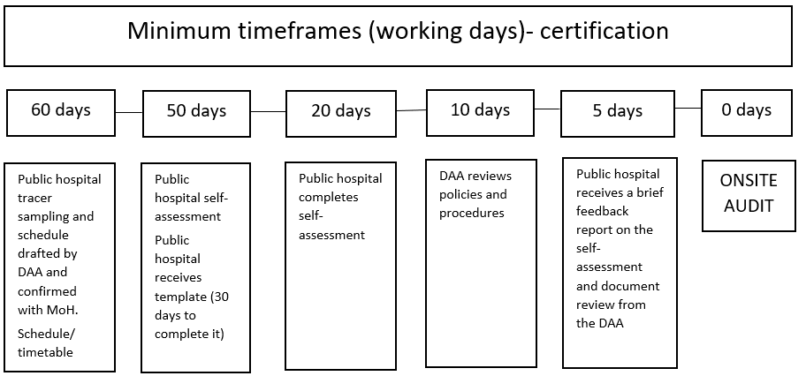

Scheduling
The DAA must submit timetable and sampling plan for an audit to the Ministry no later than 60 working days before an audit. The sampling plan shall include a list of speciality and clinical areas, bed numbers in wards and units where services are provided 24/7 across the public hospital. The timetable shall include individual and system-based tracer numbers.

HealthCERT will give approval when the DAA has met all requirements for the timetable, audit team and sampling plan.

Timetable
The timetable should include the names of auditors and technical expert assessors that will be present at the audit. The DAA has a responsibility to update HealthCERT in relation to any changes to the audit timetable, particularly where they involve a change in team membership, start time, completion time or site changes. Note that changes to an approved timetable will require re-approval by HealthCERT.

The timetable is to be sufficiently detailed to provide a clear understanding of:
- start and finish times for each day
- auditor team meetings
- time (and auditor/s) allocated to each service, including auditor activity to be completed – for example, ‘staff interviews (3), file review (2), medication chart review (4)’
- sampling plan information including the ward/service area where individual tracers are commencing
- travel time between sites if relevant
- scheduled interviews with key personnel such as Chief Operating Officer (or Chief Executive Officer), Director of Nursing, Chief Medical Officer, After Hours Manager
- any technical experts and/or technical expert assessors involved, including which auditor they are working with
- any trainee auditor involved and the auditor supporting them. The provider is notified (and agrees to) trainee auditors attending the audit. There shall be no more than one trainee auditor on any audit, unless approved by the public hospital and HealthCERT on a case-by-case basis. The public hospital is not to incur any additional cost in having a trainee auditor participate in an audit.

Auditor selection
The DAA shall ensure that in addition to requirements set out in section 6, the audit team members meet the role description requirements for the lead auditor in Appendix 4 and auditor in Appendix 6.

Technical expert assessor selection
Technical expert assessors (TEAs)will be part of the audit team for public hospital certification audits. The technical expert assessors will undertake tracers in their clinical specialty area. Technical expert assessors shall work within the role description for a technical expert assessor (see Appendix 5).

The auditors and technical expert assessors will work as part of the audit team. The Ministry will aim to allocate technical expert assessors to audits from its register of technical expert assessors 20 working days prior to the audit.

The DAA shall notify the respective public hospital of the Technical Expert Team.

Note: Once allocated to an audit, the DAA is responsible for arranging all travel, accommodation and other disbursements for technical expert assessors. Technical expert assessors are paid by their current employer and no costs other than disbursements can be passed on to the public hospital being audited.

Certification sampling

Sampling plan
The DAA shall base each sampling plan on resourced bed numbers and staffing levels as determined by the provider. It is acknowledged actual sample sizes may show marginal variance, auditors will need to recalculate them on day one of the audit based on actual patient numbers.

Contracted staff shall be included in sample size where outsourced services are evidenced (eg, Spotless Catering) and there is no current independent audit report available for that service.

The methodology to determine the sample size is as follows:
- clinical files: tracer files and in addition a minimum of the square root of the total number of inpatients in that clinical area/ward. Note that where a sample is widened in response to non-conformities, the sampling is in addition to the minimum sampling requirement
- medication charts numbers: tracer files and clinical file samples (NB: not double the number of clinical files as is the case for all other service types)
- individual and system tracer: sampling requirements have been developed for each public hospital. The tracer requirements are available from HealthCERT
- staff interviews: staff identified within the tracer samples plus clinical leaders and service managers within each clinical and non-clinical service necessary to obtain and triangulate evidence
- patient and relative interviews: within the context of the tracers identified and additional incidental sampling within wards and departments which should at a minimum equate to 0.6 square root of the total sample of clinical files.

Sampling methodology
Sampling shall be stratified across the public hospital within service types. Ensure the sample includes wards/service areas that were not audited at the last certification audit or surveillance audit where possible. Consider geographical localities/facilities within the public hospital certified premises. Over several audits, the majority of wards and service areas for each service type will have had an individual tracer completed (eg, if a public hospital has three surgical wards, each ward will have been selected at least once for an individual patient surgical tracer over the course of subsequent certification and surveillance audits on a rotational or risk basis).

The sampling plan submitted to HealthCERT for approval shall include, in addition to the bed number list, the following:
- the number of individual tracers per service type according to the HealthCERT public hospital sampling numbers template per public hospital
- the specific service area/ward an individual tracer will be commenced
- the number of available beds and calculated square root in the selected tracer ward/area to inform the number of incidental samplings to be completed in addition to the tracer in the ward/service area. See 15.2.3: Incidental sampling. (NB: This may require adjustment to occupied number of beds on audit day if different)
- the number of clinical files to be sampled
- the number of medication charts to be sampled
- the number of consumer/family interviews to be conducted
- the number of staff to be interviewed, the mix of staff who will be interviewed for the individual tracer service type (eg, physio for AT&R, RNs, medical officer, etc)
- a potential area to follow the individual tracer to in the afternoon to continue evidencing the patient journey (eg, ED for child health tracer; ICU for surgical patient).

When stratifying large services, it is acceptable for auditors to take a ‘sensible’ approach to maximise the effectiveness of auditor time on site. (For example, where it is apparent there are like services, such as two general surgical wards, the audit can be undertaken in full in one ward.) However, auditors are to visit tertiary and secondary clinical services and/or regional services and clearly delineate them on the sampling plan provided to HealthCERT.

Tracer sampling
Sampling includes individual tracers and systems-based tracers.
      - Individual tracers shall concentrate on the journey of a consumer through the hospital system with a particular focus on risk points (eg, handovers and transfer of care between units).
      - A minimum of one individual tracer per service type is required.
      - Auditors and technical expert assessors should jointly choose individual tracers following a brief tour of a clinical area in discussion with the clinical team or unit manager. The team leader, or unit manager on the auditor’s behalf, shall gain consent before the tracer begins. Verbal consent is acceptable.
      - Auditors shall choose individual tracers that represent complexity in either the consumer’s clinical presentation or their journey through a hospital system. Examples of consumers suited to this methodology are a:
- patient with limited mobility who uses oxygen or has cognitive impairment
- patient who has had multiple hospital admissions
- surgical patient whose recovery included a stay in the intensive care or a high dependency unit
- medical patient who has been transferred from a cardiac care unit
- child who has been admitted from the emergency department, is nearing discharge and will receive specialist district nursing services upon discharge
- baby that has been through both maternity and neonatal services.
It is important to coordinate tracer selection with the lead auditor to avoid overlap of visits to various services or units as much as possible.
In public hospitals with multiple sites, individual tracers shall include patients who move between locations and services.
See section 9.4.5 for additional information on individual tracer methodology.
      - Two systems-based tracers will be completed at the certification audit.
        - Medication management: Auditors look at a sample of consumers who are receiving a high-risk medicine, or for which close monitoring is needed, or evaluate the introduction of a new medication or medication practice, for example, pain relief. This will include reviewing staff education specific to the medication, patient education, medication management processes, evaluation of the continuity of the process (prescribing, dispensing, administration and monitoring) and evaluation of medication reconciliation across the continuum. The tracer should begin with an interview with at least one member of pharmacy/medication committee. Interviews as part of the tracer process should include ward staff (doctors, nurses, educators, patient and pharmacist).
The completion of this tracer should take no more than half an auditor day to complete. Report findings from the medication management tracer in Ngā Paerewa subsection 3.4 – My Medication.
        - Infection prevention and control: Auditors choose a high-risk consumer group or an outbreak event as the basis for reviewing the planning, implementation and evaluation of the infection prevention and control programme. The tracer should begin with an interview with at least one member of the infection control committee and review of desktop information before moving to the relevant clinical areas.
The completion of this tracer should take no more than half an auditor day to complete. Report findings from the infection prevention and control tracer in Ngā Paerewa subsection 5.2 – The infection prevention programme and implementation or Ngā Paerewa subsection 5.4 – Surveillance of health care associated infection (as appropriate).

Incidental sampling
Incidental sampling is required to ensure sufficient information is gathered to form audit evidence and ensure the audit is reliable.
      - Take the square root of the number of patients in a clinical area where an individual tracer has been scheduled to occur (as per the sampling plan) to create an additional sample.
      - Sampling should commence in the clinical area where the tracer is being undertaken and applied to other clinical areas based on that patient’s journey. This means that auditors will work across multiple clinical areas throughout the individual tracer audit process.
      - Incidental sampling of files shall include informed consent, observation records, progress notes and medication charts.
      - Incidental sampling shall also include patient and relative interviews to determine their satisfaction with services and the public hospital’s conformity with consumer rights standards. Auditors shall use several approaches to gain patient, family and whānau perspectives. The approaches shall include in-depth interviews related to the tracer, informal interviews with patients, family and whānau (in addition to tracers), interviews with staff who hold positions specific to patient or family and whānau liaison, and review of satisfaction survey results and complaint information.
      - An interview with the general practitioner liaison staff member, should also be undertaken to gather information about entry and exit from services (including discharge planning and transfer of information).
Note: Incidental sampling can be undertaken consecutively with individual patient tracers and systems-based tracers. Auditors shall conduct additional sampling throughout the audit process to ensure conformity with Ngā Paerewa. This includes but is not limited to the review of information held at ward level, service level and organisational level, such as quality monitoring records, minutes of meetings, patient satisfaction survey results and complaints information, staff training opportunities, orientation to clinical areas and staffing/roster issues.
      - Where issues arise in tracers or incidental sampling as described above, auditors should take a wider sample specific to the particular issue to establish whether the finding is a single incident or a systemic issue. Auditors should ensure their sample is sufficient and that this is in addition to the planned and documented incidental sampling as approved by HealthCERT in the sampling plan.

Staff interviews
Auditors shall record the exact number of staff interviews by designation in their field notes; for example, ‘Medicine – Senior Medial Officer x2; Charge Nurse Manager x5’.

Where group discussions are part of auditors’ introduction to the service, these do not contribute to the tally of the total number of staff interviewed; instead, they are to be recorded within evidence against a subsection.

The following do not constitute interviews in terms of sampling requirements:
- informal conversations
- clarification of file layout and process
- database familiarisation with staff.

Using self-assessments
When reviewing the self-assessment, the DAA will determine what information provided requires validation. Independent reports and third-party audits do not require validation.

Where validation of the self-assessment is required, the DAA should take a sampling approach considering:
- information submitted with the self-assessment that provides evidence to support narrative conclusions in the report
- reviewing information submitted with the self-assessment to determine whether it is sufficient to demonstrate conformance
- interviewing the quality manager or delegated person responsible for completion and submission of the self-assessment
- on-site auditing of areas identified in the self-assessment as being partially attained or not attained
- on-site auditing of areas identified in the self-assessment as having insufficient supporting evidence where an interview with the quality manager has not clarified concerns
- on-site auditing of a small sample from the self-assessment to determine validity of findings where it has not been possible to validate this by reviewing supporting evidence.

Note that on-site sampling can be included within incidental sampling undertaken with tracer activity.

Daily meetings
The lead auditor shall hold a daily meeting with a public hospital representative, at which they offer a concise summary of audit activities undertaken to date. The lead auditor shall make general comments on significant issues arising, note any specific positive findings and emphasise trends that could lead to partial attainment ratings. The lead auditor shall give the public hospital the opportunity to provide information that may have been missed and schedule time for more extensive discussion or review and review the agenda for the day ahead.

Prior to the briefing meeting, the lead auditor shall ensure the audit team has had an opportunity to discuss their findings to date. This discussion can cover whether issues identified that are likely to be systemic or isolated.

Audit reporting
The draft audit report will be peer reviewed and proof-read before it is given to the public hospital. The DAA shall give public hospitals at least 10 working days to complete their review of the draft audit report. Refer to section 11.1 for guidance. Corrections should include corrections of fact as well as requests for change where audit evidence is inaccurate.

Progress reporting
Public hospitals are responsible for managing progress monitoring in conjunction with the Ministry. There is no requirement for DAAs to participate in this process.

Surveillance audits

Public hospital self-assessment
The self-assessment for surveillance audit will include an update to the self-assessment completed for the certification audit.

Public hospitals have the option of undertaking individual tracers in the lead up to the surveillance audit. Where this occurs tracer results are also reported as part of the self-assessment process. Only any new or changed policies and procedures should be reviewed. Note that viewing may be arranged via remote access to the public hospital server.

At least five working days before the audit, the DAA shall provide the public hospital with a brief report that comments on the self-assessment and review of policies and procedures.

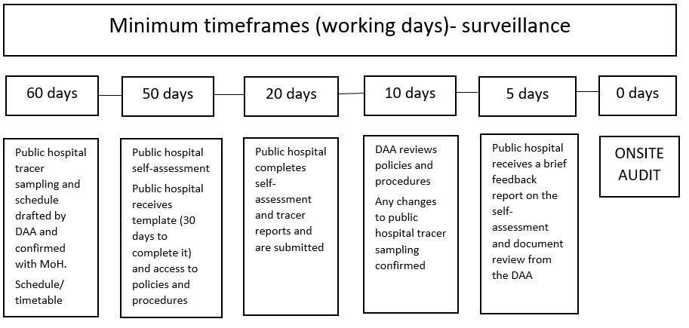

Scheduling
As for certification audits. In addition, the DAA should request the CAMS report from HealthCERT.

Timetable
As for certification audits.

Auditor selection
As for certification audits.

Technical expert assessor selection
The Ministry will decide on a case-by-case basis whether one or more technical experts are required for a surveillance audit. Where required, the process is the same as for certification audits.

Surveillance sampling

Sampling plans
As for certification audits.

Tracer sampling
The extent of the requirement of the DAA to undertake individual tracers is dependent on the public hospitals decision to complete individual tracers as part of its self-assessment process.

For each public hospital surveillance audit, the DAA will always undertake one maternity tracer and one mental health tracer (dependent on these service types being within the scope of the audit).

Where a public hospital has not completed individual tracers as part of its self-assessment, one individual tracer for each service type will be undertaken by the DAA.

Where a public hospital has completed individual tracers, the DAA will not complete individual tracers for the service types that the public hospital has completed individual tracers unless approved by HealthCERT.

NB: The public hospital’s decision to complete their own individual tracers, own a portion of their own tracers shall be reflected clearly in the audit timetable with time specified for the DAA to verify the public hospital individual tracer outcomes.

The individual tracer process is the same as for certification audits, with the exception of the DAA verifying the outcome of the public hospital’s individual tracers in medical, surgical, child health and health of older person where applicable. See 15.9.
      - Four systems-based tracers shall be completed at surveillance audits.
        - Medication management: As for certification audits.
        - Infection prevention and control: As for certification audits.
        - Deteriorating patients: Auditors review the system used by the public hospital to recognise and respond to clinical deterioration in acute care settings. This will include an interview or focus group meeting with the patient at risk team (or equivalent) and gathering information about the early warning system (or equivalent), how it is implemented including weekends and after hours; and how it is monitored. Documents to be reviewed include incident reporting, internal audits or other quality monitoring. In addition to sampling across the organisation, it is recommended that a sample of patients to review as part of the audit is obtained through patients identified as being at risk from the afterhours report, patients in the High Dependency Unit, patients discharged from the High Dependency Unit, patients in Intensive Care Unit, patients discharged from the Intensive Care Unit, patients admitted to the Medical or Surgical Assessment Units as this will ensure the sample will include patients who have deteriorated or are at high risk of deterioration. In addition to the review of clinical files, the systems-based tracer activity includes interview of patients or whānau (where possible), educators and direct care staff (doctors, nurses, allied health professionals).
Note:
- The system for management of the deteriorating patient should include adults and paediatrics; and any satellite/regional hospitals.
- The completion of this tracer should have one auditor day assigned.
- It is not necessary to go to the emergency department to complete this tracer.
Report findings from the deteriorating patient tracer in Ngā Paerewa subsection 3.2 – My Pathway to Wellbeing; and additionally in other subsections and criteria as relevant.
        - Falls prevention: Auditors review the falls prevention programme used by the public hospital. This will include consideration of governance structures and systems for the prevention and management of falls and how patients are screened or assessed, and strategies implemented including patient education and disclosure (treatment injury).
        - Review of documents includes incident reporting, risk assessments, education, reporting and monitoring consistent with Health Quality and Safety Commission guidelines and requirements. Audit activities in a sample of wards and units should include implementation of risk assessment and care planning processes and observation of the environment essential in preventing falls. In addition to the review of clinical files and observation in clinical areas, the systems-based tracer activity includes interview of patients or whānau (where possible), educators and direct care staff (doctors, nurses, allied health professionals).
The completion of this tracer should take no more than half an auditor day to complete.
Report findings from the falls prevention tracer in Ngā Paerewa subsection 3.2 – My Pathway to Wellbeing; and additionally in other subsections and criteria as relevant.

Note that the system-based tracer sampling is part of the timetable which shall be approved by HealthCERT.

Incidental sampling
As for certification audits. If applying a square root rule for determining the size of the incidental sample, auditors may apply 0.6 the square root if this will result in a sufficient sample.

Staff interviews
As for certification audits.

Validating self-assessments including individual tracers completed by public hospitals
As for certification audits.

In addition, the validation of individual tracers undertaken by public hospital public hospitals shall include:
- review of the individual tracer report to ensure it includes all required fields of the template
- on-site review of the actions taken in response to the individual tracer where it has identified opportunities for improvement
- on-site interview of a sample of staff that either undertook or participated in the tracer process.

Note that where the DAA determines an individual tracer cannot reliably be used to supplement on-site audit activities following its review of the individual tracer report, the DAA will provide notification of this to HealthCERT and the public hospital prior to completing the on-site audit. HealthCERT will review the individual tracer information provided and will either work with the public hospital to ensure another tracer is undertaken prior to the audit or approve additional individual tracers to be undertaken on-site by the DAA.

Daily meetings
As for certification audits.

Audit reporting
As for certification audits.

Published summary
The executive summary is published for all audits undertaken at public hospitals. Every attempt is made to discuss changes to the content to the summary during processing of the audit report. Where changes are agreed subsequent to processing the report, the Ministry will send a finalised version to the DAA.

Progress reporting
As for certification audits.

Residential disability – specific audit process requirements
This section applies to residential disability services (ie, physical, intellectual and sensory) excluding residential disability – psychiatric. For residential disability – psychiatric, see section 17 and Appendix 7.

Note: The requirements below are in addition to the general requirements outlined in section 9.

Interpretation
Guidance has been developed for auditors to ensure they take into consideration the service type, scope and complexity when auditing residential disability services. See Appendix 7 for this guidance.

Audit preparation

Contacting Whaikaha – Ministry of Disabled People
At least 20 days prior to each audit, the DAA shall contact Whaikaha – Ministry of Disabled People who will provide any relevant information where there are known issues to the DAA to support its audit planning.

If the funder or HealthCERT requests follow-up on a specific issue relating to a provider (prior to the audit), the DAA shall address this issue clearly in the body of the audit report. The DAA shall submit the audit report within the required timeframes (see details for each type of audit in section 8) to HealthCERT via PRMS.

Sampling plans
A sampling plan in respect of certification against Ngā Paerewa primarily focuses on certified homes/facilities.

Sampling – multiple sites
A multi-site provider with three or more sites will be eligible for site sampling where the provider demonstrates a centralised management structure that includes:
      - system documentation and systems changes
      - management review
      - complaints
      - evaluation of corrective actions
      - internal audit and self-assessment planning and evaluation of results.
      - service user assessment.

Developing the sampling plan
The DAA develops the sampling plan in consultation with the provider and HealthCERT, who will liaise with the Whaikaha – Ministry of Disabled People Quality team to ensure the sample is appropriate. Where psychiatric services form part of the provider’s certified services, HealthCERT will also consult the relevant public hospital portfolio manager.

The DAA shall forward its proposed sampling plan to HealthCERT no less than 20 working days and no more than three months before the audit. HealthCERT shall approve the sampling plan with the DAA in writing. Where the provider changes the configuration or location of premises after the sample has been agreed, it may be necessary to audit these premises in addition to the agreed sample.

The DAA notifies the provider of the facilities to be audited only when sending the audit plan to the provider. The DAA may discuss the following with the provider:
- the number of facilities for audit
- the number of facilities for a site visit as part of the audit process
- the methodology – see below.

The total number of audits shall be completed within 20 working days (or as agreed in writing with the Ministry) and submitted within 20 working days of the last audit.

Specific requirements are that:
- where multiple sites are included within one certificate, the period of certification will be based on the lowest level of achievement obtained by the provider for any one site
- for ‘respite only’ services, the audit team shall conduct the audit while residents are in attendance.

Certification audit sampling
This methodology is to be applied where three or more premises are certified on the provider’s schedule.

The calculation is based on service type (for example intellectual, physical, youth, adult services) and service complexity (for example behaviours that challenge or use behaviour of concern).

Service type and complexity
When developing a sampling plan:
      - identify number of homes by service type – eg, intellectual, physical, youth, older adult, RIDSAS
      - if all homes are considered to be the same service type cluster by service complexity and variance within the service type – eg, behaviours that challenge or use behaviour of concern, residents are working or not
      - also separate those homes that have significant variations in the size of the service and number of service users – eg, homes of five residents, 30 bed homes/facilities.

Apply the square root rule (y=√x) to each resulting cluster, and then chose the homes based on:
      - where issues related to service delivery have been identified
      - geographical location – for example, grouped within public hospital localities or similar (eg, regional management structure of a national organisation)
      - ensure the sample includes homes that were not audited at the last certification audit or were not visited as part of a developmental evaluation within the last certification period.

Sampling – interviews and record review
Sample sizes for interviews and record reviews are managed as set out in section 9. In the case of disability services, an auditor may interview the Needs Assessment and Service Coordination organisation (NASC).

The DAA shall also record the number of interviews and records to be reviewed, in the sampling plan it submits to HealthCERT before the on-site audit.

Note: For residential disability houses subject to certification with five or fewer residents, all files are sampled.

Surveillance audits
Providers who offer combined services – eg, aged residential care and residential disability (Ministry funded) and/or residential disability (psychiatric) and residential disability (Ministry funded) are subject to surveillance audit requirements.

Residential disability providers who offer intellectual, physical or sensory services are not automatically subject to an on-site surveillance audit unless this is a condition of certification.

Where HealthCERT identifies the need for an on-site surveillance audit, and specifies a future date, the DAA will undertake an on-site visit within 30 working days of that date.

Sampling methodology – surveillance audits
For surveillance audits, the same methodology is applied as per the certification method and then applying (0.6(y = √x)) rounded to the upper whole number.

Surveillance monitoring
Residential disability providers who offer intellectual, physical or sensory services and do not have an on-site surveillance audit as a condition of certification are subject to the surveillance monitoring and reporting requirements described below.

Provider responsibilities for surveillance monitoring
The provider is responsible for meeting all conditions of certification. This includes submitting a provider surveillance declaration to the DAA (this form can be downloaded from the Ministry’s website) by the mid-point of surveillance together with a copy of a corrective action progress report and most recent developmental evaluation report.

Note: The provider is responsible for ensuring the developmental evaluator has received a copy of the certification audit report and any onward progress monitoring.

Ministry of Health Disability Services
The process that links the DSS Developmental Evaluation (DE) process with the certification process is summarised below.
      - Where a provider’s schedule requires submission of a surveillance declaration at the midpoint of the certification period, relevant information from a recent Developmental Evaluation (DE) is included with the submission.
      - At the midpoint DE, corrective actions from the certification audit are followed up by the evaluators who determine whether requirements have been met. A DE summary report references the status of corrective actions from the certification audit.
      - The provider sends the DE summary report to the DAA which is used to inform the surveillance declaration. The summary report is also published on the Ministry of Health’s website: https://www.health.govt.nz/our-work/disability-services/contracting-and-working-disability-support-services/audit-and-evaluation-disability-service-providers/developmental-evaluation-disability-support-services.
      - The DAA submits the surveillance declaration for review by HealthCERT. This results in either:
        - notification to the provider that its surveillance declaration has been received and any conditions on their schedule have been met
        - an amended schedule is issued with additional progress reporting requirements. An amended schedule is generally issued when the findings from the earlier certification audit continue to be unmet.
Any requirements resulting from the midpoint DE (that are not related to the certification findings) are followed up by the DE evaluator who reports to Disability Services.

DAA responsibilities for surveillance monitoring
The DAA is responsible for:
      - ensuring the provider submits all necessary information to the DAA on the dates due. This shall include the DE report where one is available and any progress reports
      - reviewing the submitted declaration and associated information
      - contacting the developmental evaluator if more information is required following discussion with the provider, review of the developmental evaluation report and any progress reports
      - submitting a surveillance report to PRMS within 20 working days of receiving the provider surveillance declaration
      - providing HealthCERT with additional information, including all documents and the declaration the provider submitted to the DAA, if HealthCERT requests it. Note HealthCERT is likely to make this request where the DAA recommends an on-site surveillance audit.

Residential disability – psychiatric
This section applies to residential disability – psychiatric and any community-based mental health providers subject to certification requirements.

Note: The requirements below are in addition to the general requirements outlined in section 9.

Integrated audits
DAAs/auditors need to contact the funder pre audit and identify any changes to the current tier service specifications for that provider including any regional specific tier three service specs, and integrate these specifications within the Ngā Paerewa audit.

Visit https: //www.tewhatuora.govt.nz/our-health-system/nationwide-service-framework-library/about-nationwide-service-specifications/mental-health-and-addiction-service-specifications/ for specific information.

Audit preparation

Contacting the public hospital
At least 20 days prior to each audit, the DAA shall contact the relevant public hospital or Mental Health Portfolio Manager in accordance with the process below. The public hospital will provide any relevant information to the DAA to support its audit planning. Additionally, the public hospital will notify the DAA if it wishes a public hospital representative to attend all or part of the audit. The DAA shall get agreement from the provider where the public hospital wishes to attend any part of the audit.

When notifying the public hospital of an upcoming audit, please include the:
- premise name
- names of the audit team members
- date of audit
- type of audit.

After the DAA has undertaken an audit, its audit report will not be considered final until the public hospital and the Ministry (HealthCERT) have reviewed the report for completeness. If the public hospital or HealthCERT requests follow-up on a specific issue relating to a provider (prior to the audit), the DAA shall address this issue clearly in the body of the audit report. The DAA shall submit the audit report within the required timeframe (see details of each type of audit in section 8) to HealthCERT via the PRMS.

Note: The public hospital will view the report via the PRMS.

Preparation to include relevant service specifications
The DAA shall include relevant service specifications from the Nationwide Service Framework and any public hospital provider specific specifications in audit tools it develops to ensure capture of contractually relevant requirements within the integrated audit process.

Sampling plan
Follow the sampling plan requirements as set out for residential disability services in section 16.

On-site audit
Within the integrated audit process, the DAA shall audit the following areas within the Tier 1 Mental Health and Addiction Services Service Specification and related Tier 2 and Tier 3 Service Specifications which include residential services:
- services will be responsive
- Māori Health
- Pacific Health
- key inputs
- service links.

Note: Audit reporting templates will not have cross-references which means the DAA auditors need to be explicit within their reporting as to contractual aspects.

Relapse prevention
When auditing residential disability – psychiatric services against Ngā Paerewa subsection 3.2: My Pathway to Wellbeing: criterion 3.2.3, note that in the case of people who have been consumers of mental health and/or addiction services for two years or more, the Ministry focuses on relapse prevention planning through public hospital accountability processes. As such, it requires DAAs to pay particular attention to relapse prevention planning in their audits. A relapse prevention plan is defined by the Ministry as follows:
- Relapse prevention plans identify early relapse warning signs of clients. The plan identifies what the client can do for themselves and what the service will do to support the client. Ideally, each plan will be developed with involvement of clinicians, consumer and their significant others. The plan represents an agreement and ownership between parties. Each plan will have varying degrees of complexity depending on the individual. Each client will know of (and ideally have a copy of) their plan.

Progress reporting procedure
Where a condition on a certified provider’s schedule requires a written progress report to be submitted to the Director-General of Health by your public hospital funder, the responsibility for monitoring the provider’s progress lies with the public hospital.

Note: The DAA shall still determine the corrective actions required, identify risk levels and set timeframes for action within the audit process. The public hospital will request and approve the corrective action plan and monitor progress against the corrective action plan including entering progress information into the PRMS CAMs.

Unannounced surveillance audits
As in some residential disability (psychiatric) services it may be more likely that a full service will be away on a day trip or holiday, the DAA should ask providers to submit to it, at least three months prior to the notice period, any dates that create a direct conflict within the six-month window in which an unannounced surveillance audit may take place.

Note: For multi-site providers with a head office or regional office, the unannounced audit should commence at that site.

Fertility services
The following information includes excerpts from the previous SNZ HB 8181:2007 Fertility Services Auditor Workbook, that remain relevant to auditing fertility services under Ngā Paerewa. The requirements below are in addition to the general requirements outlined in section 9.

Note: All fertility services require a certification audit every three years, and a surveillance audit annually.

Key personnel in fertility services

Medical Director
The Medical Director is responsible for the clinical management within the Organisations/ART Unit. The Medical Director must:
- be a recognised specialist gynaecologist or physician
- have at least five years’ experience in that role; or
- demonstrate substantial similar experience in the governance of an ART Unit and the management of patients with infertility; or
- hold a Certificate of Reproductive Endocrinology and Infertility (CREI)
- have membership or eligibility for membership of the FSANZ
- have evidence of Fellowship of the Royal Australian and New Zealand College of Obstetrics and Gynaecology (RANZCOG) and demonstrate continuing medical education in the field of reproductive endocrinology and infertility.

For non-CREI holding Medical Directors, at least 50 percent of the minimum required CME points in their College-mandated CME programmes must be obtained in the area of reproductive medicine and infertility.

Scientific Director
The Scientific Director is responsible for the scientific management within the ART Unit. The Scientific Director must:
- have experience in the management of clinical embryology or clinical andrology laboratory as appropriate to services offered
- have a minimum of four full-time equivalent years of ART clinical laboratory experience in an RTAC-accredited clinic (or equivalent) and two full-time equivalent years of experience in a managerial and/or supervisory role
- have experience in the management of clinical embryology or clinical andrology laboratory as appropriate to services offered
- have a doctorate from an accredited institution in reproductive biology, or a Master’s degree with expertise and/or specialised training in the physiology of reproduction, cell biology and biochemistry
- be registered as a clinical Embryologist with the New Zealand Medical Science Council
- be eligible for membership of the Fertility Society of Australia and New Zealand (FSANZ) and Scientists in Reproductive Technology (SIRT – a sub-group of FSANZ) is required.

Nurse Manager
The Nurse Manager must:
- be a Registered Nurse and/or Registered Midwife with experience and training in infertility nursing
- be registered to practice in New Zealand
- have a minimum of three years’ experience in the management of patients with infertility
- demonstrate continuing nursing education in the field of infertility
- be eligible for membership of the FSANZ and Fertility Nurses of Australasia (FNA – a sub-group of FSANZ).

Counselling Manager
The Unit Counselling Manager/Senior Counsellor is responsible for the counselling management within the ART Unit. The Counselling Manager/Senior Counsellor must:
- be a full member OR be eligible for full membership of the Australian and New Zealand Infertility Counsellors Association (ANZICA)
- have a minimum of two years’ experience in the management of patients with infertility
- have evidence of a minimum of 10-hours of engagement in ongoing professional development in the field of ART and infertility counselling over 12 months.

Audit preparation

Information from service
Audits of ART services require advance provision of names and qualification of key personnel and procedures provided by the clinic. A selection of file codes for patient documents related to the use of donor material or surrogacy are also required as described in the RTAC Scheme clause 7.4.10.

Contacting the funder
At least 20 days prior to each audit, the DAA shall contact the relevant funder in accordance with the process below. The funder will provide any relevant information to the DAA to support its audit planning. Additionally, the funder will notify the DAA if it wishes a representative to attend all or part of the audit. The DAA shall get agreement from the provider where the funder wishes to attend any part of the audit.

When notifying the funder of an upcoming audit, please include the:
- premise name
- names of the audit team members
- date of audit
- type of audit.

After the DAA has undertaken an audit, its audit report will not be considered final until the funder and the Ministry (HealthCERT) have reviewed the report for completeness. If the funder or HealthCERT requests follow-up on a specific issue relating to a provider (prior to the audit), the DAA shall address this issue clearly in the body of the audit report. The DAA shall submit the audit report within the required timeframe (see details of each type of audit in section 8) to HealthCERT via the PRMS.

Sampling plans

Sampling – interviews and record review
- The sampling methodology for certification audits and surveillance audits is the same and is designed to meet RTAC requirements.
- The sample selected should include three representative records (where available) for the donor and recipient of each category of donated material (sperm, eggs, and embryos) and surrogacy, as well as 10 representative pregnancies.
- Interviews for Ngā Paerewa audits are in addition to RTAC sampling, and between four and six Interviews should be used to ensure sufficient sampling is completed.

Closure of a fertility service
On closure of a fertility service, the integrity of information and stored gametes and embryos must be maintained.

Policies and procedures should be in place to ensure gametes and embryos can be transferred to another certified fertility service. Records shall be transferred to the Registrar-General of Births, Deaths and Marriages on closure.

- : Criteria Application Framework: Certification audits
The information in Appendix 1 is a copy of Table 2 – Criteria application framework on pages 15–23 from NZS 8134:2021.

Copyright in NZS 8134:2021 is owned by the Crown and administered by the New Zealand Standards Executive. Reproduced with permission from Standards New Zealand, on behalf of New Zealand Standards Executive, under copyright licence LN001437.

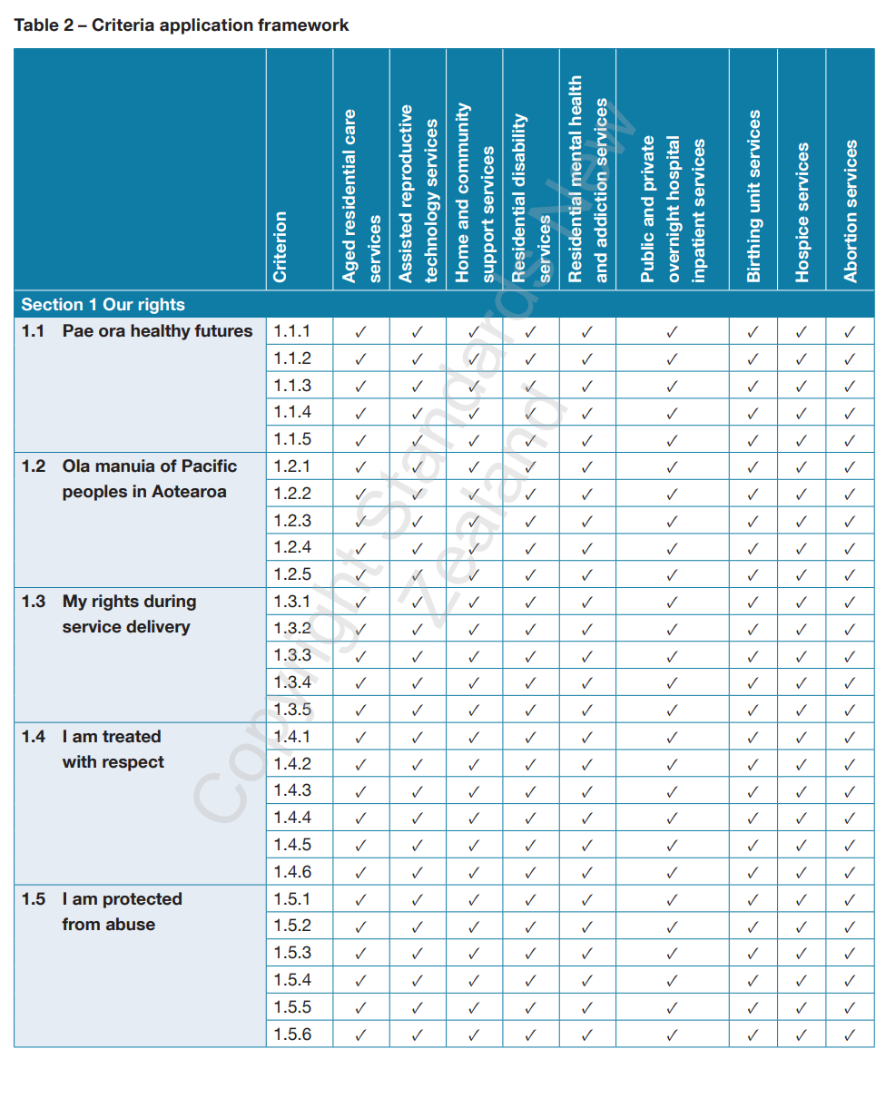

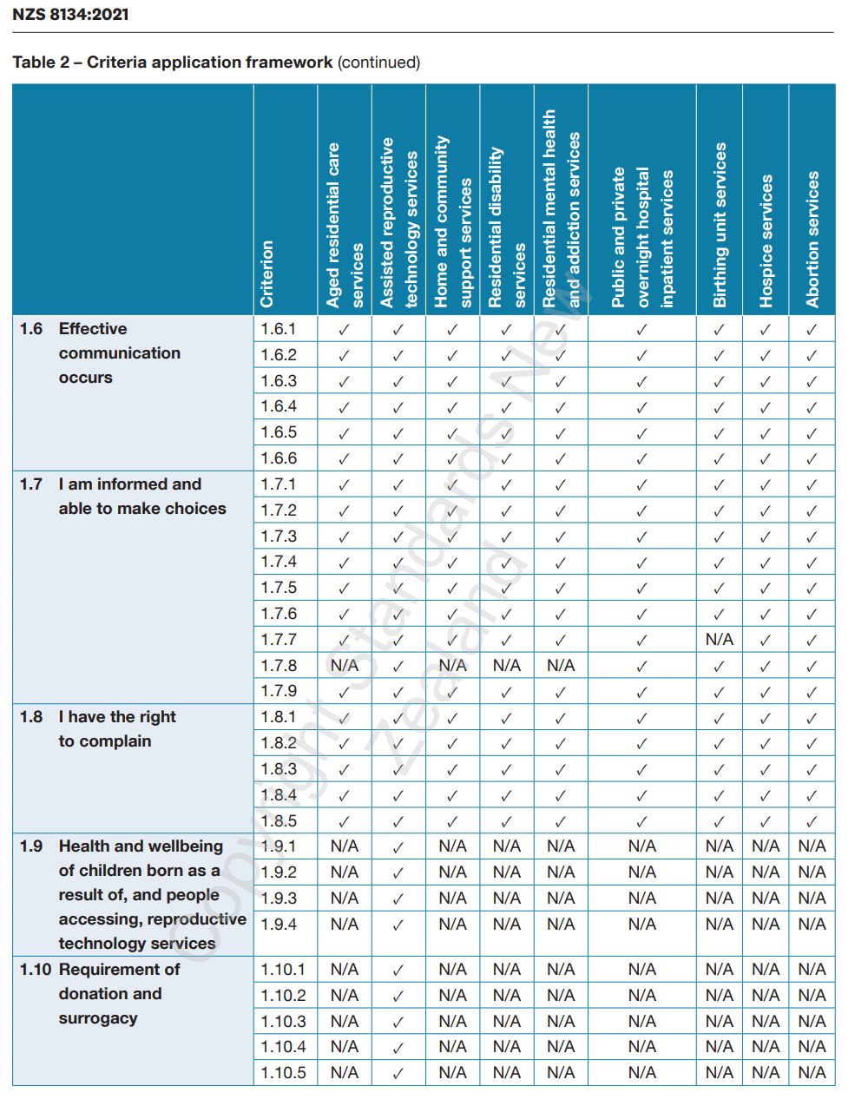

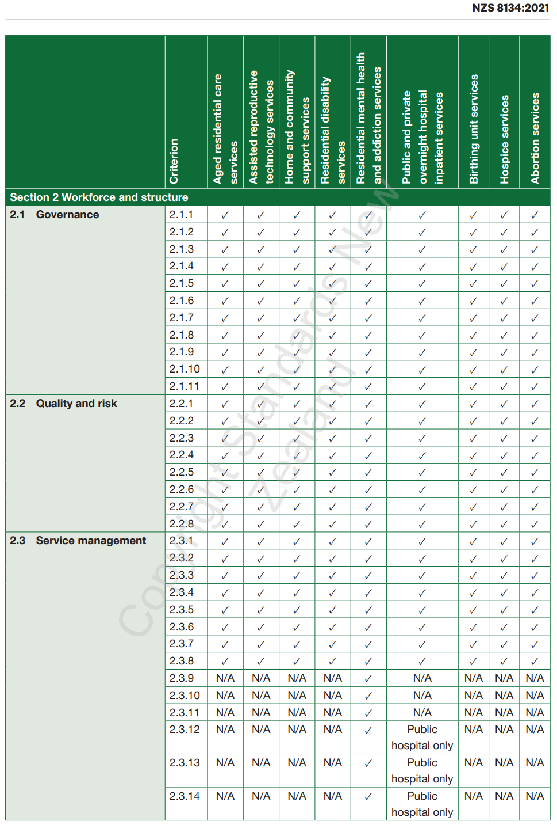

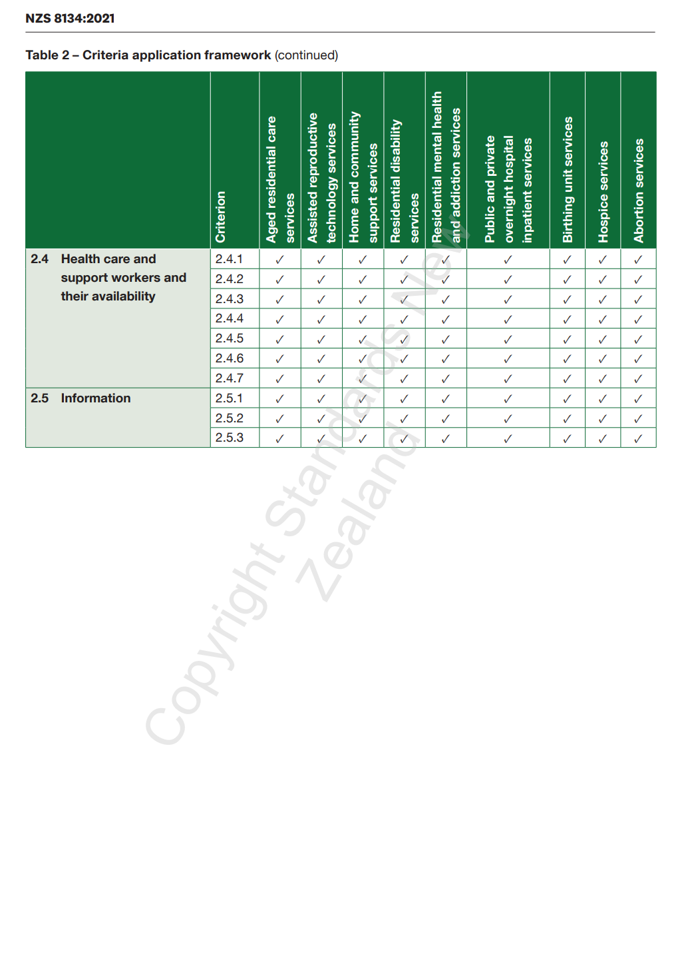

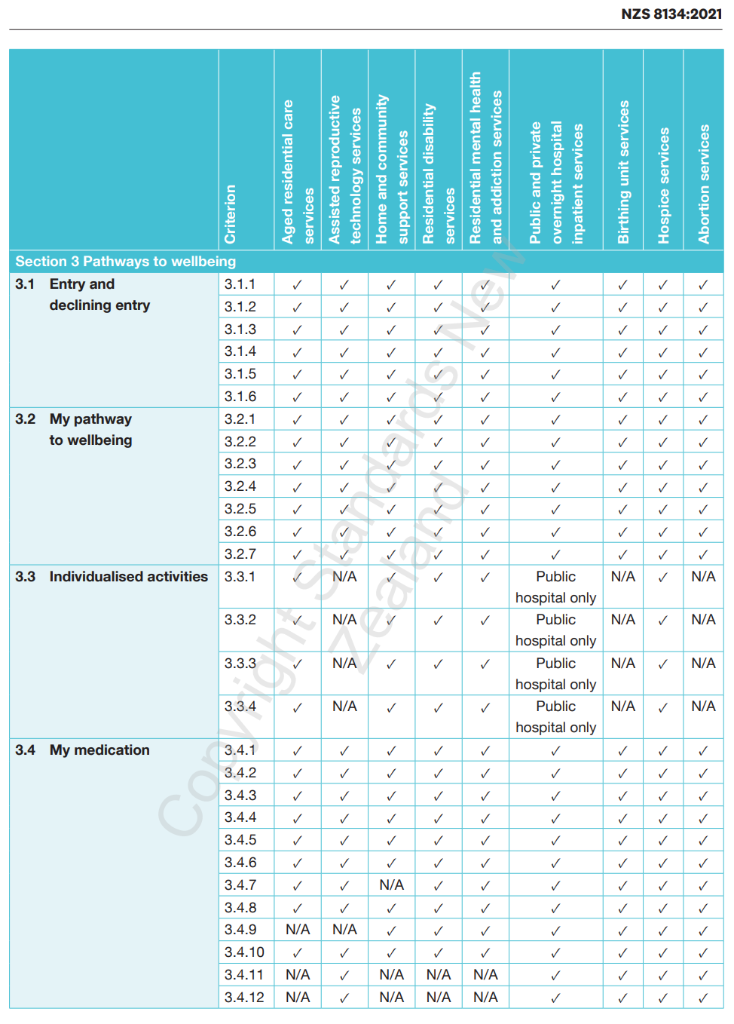

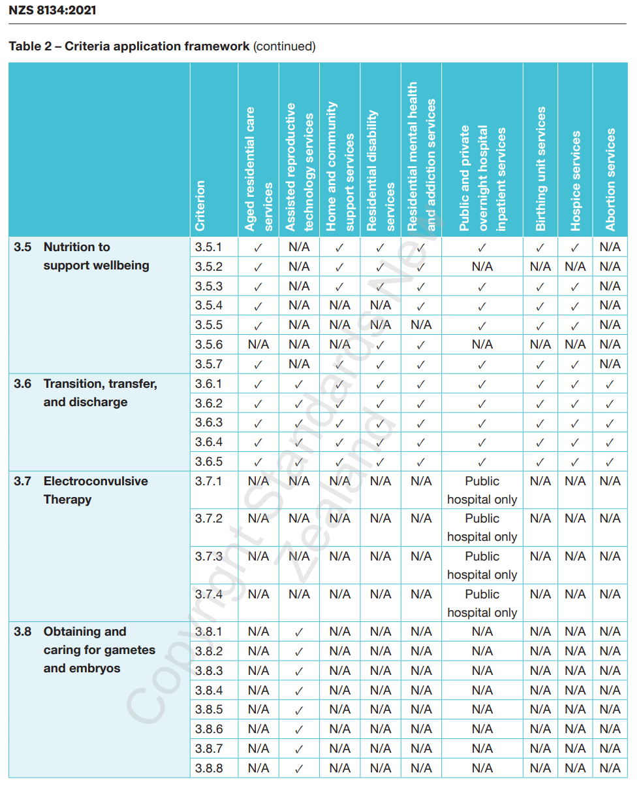

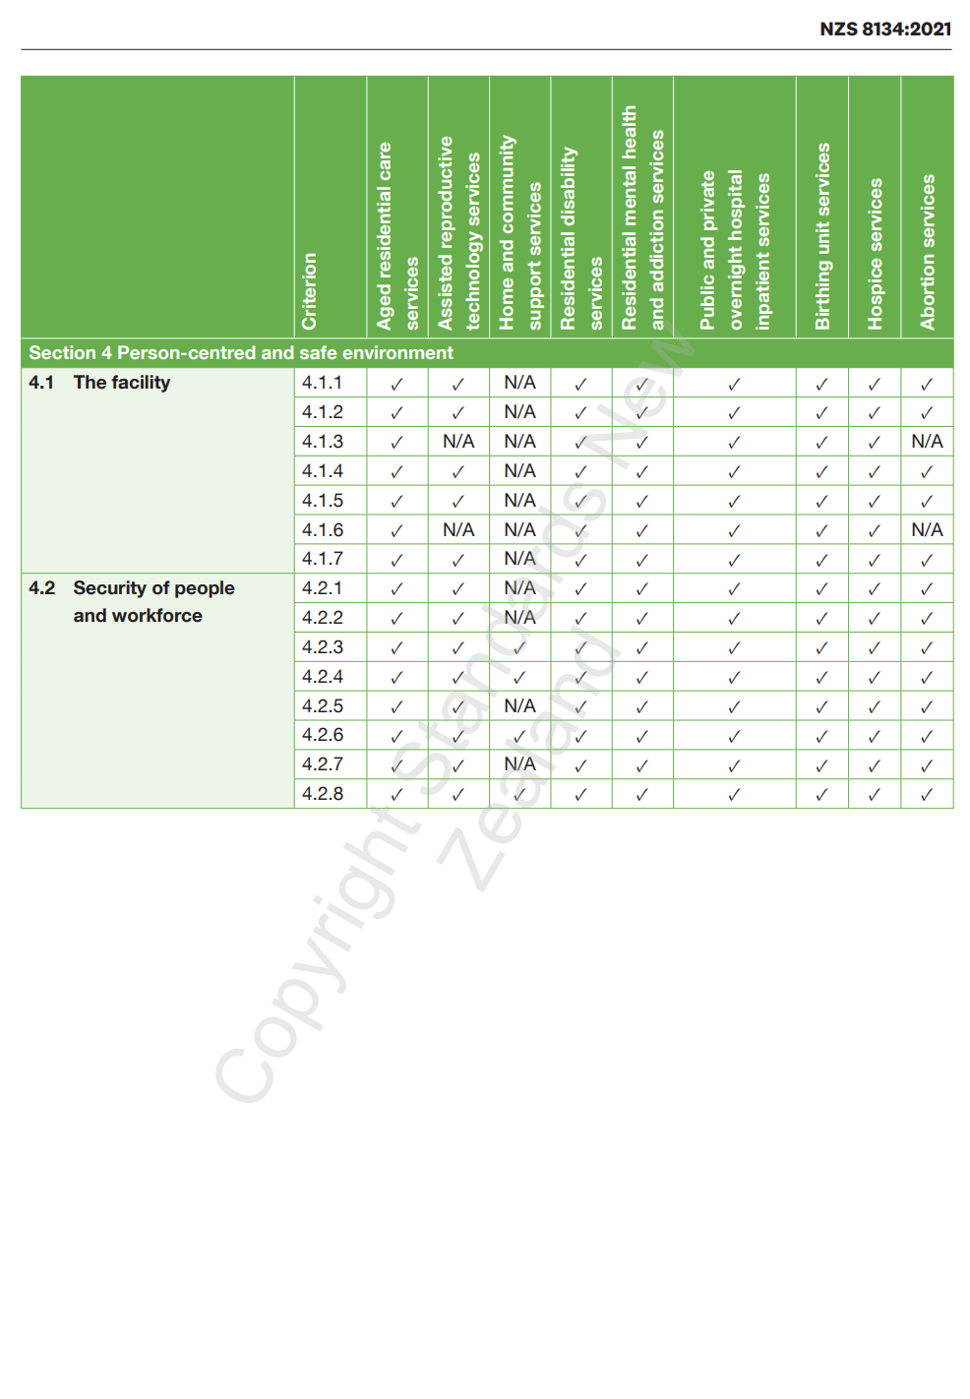

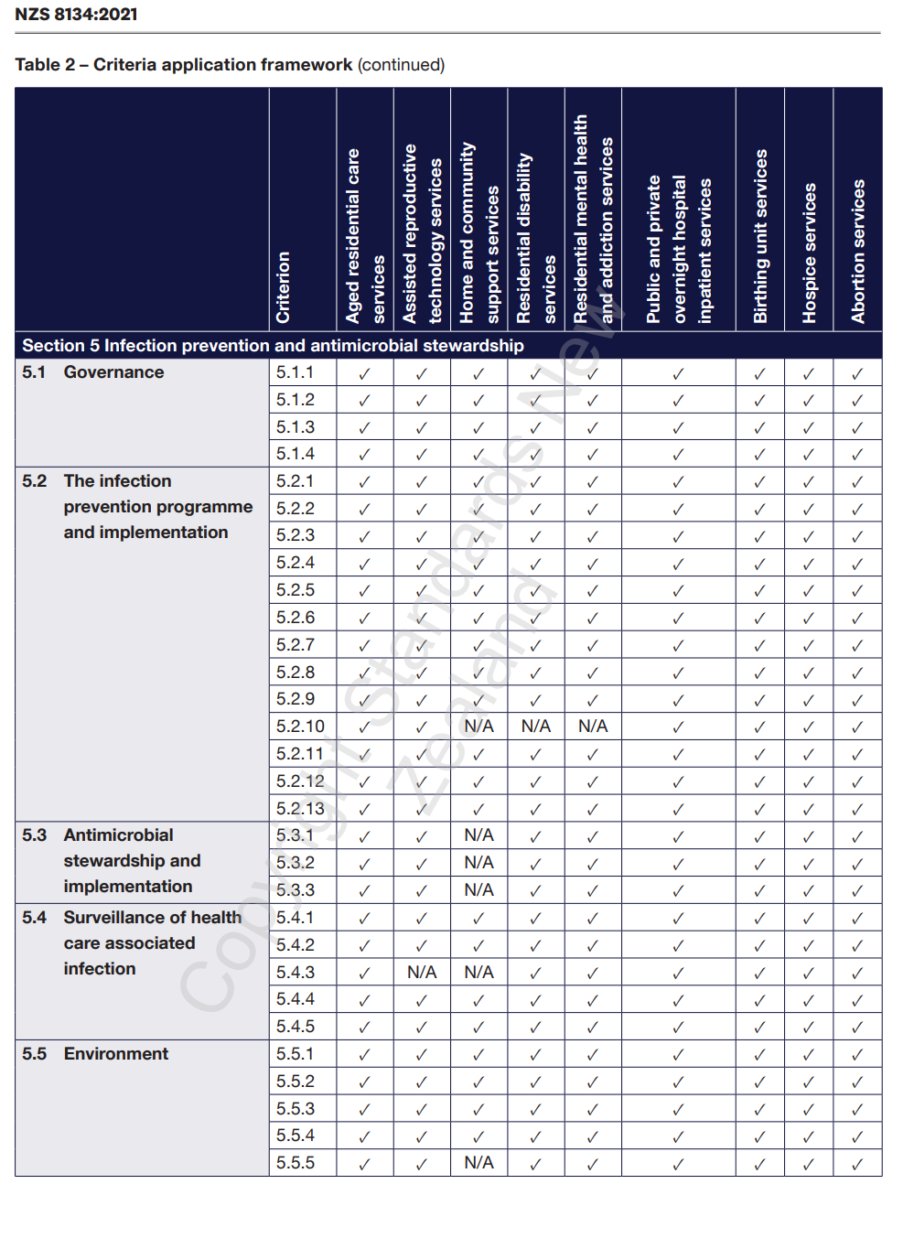
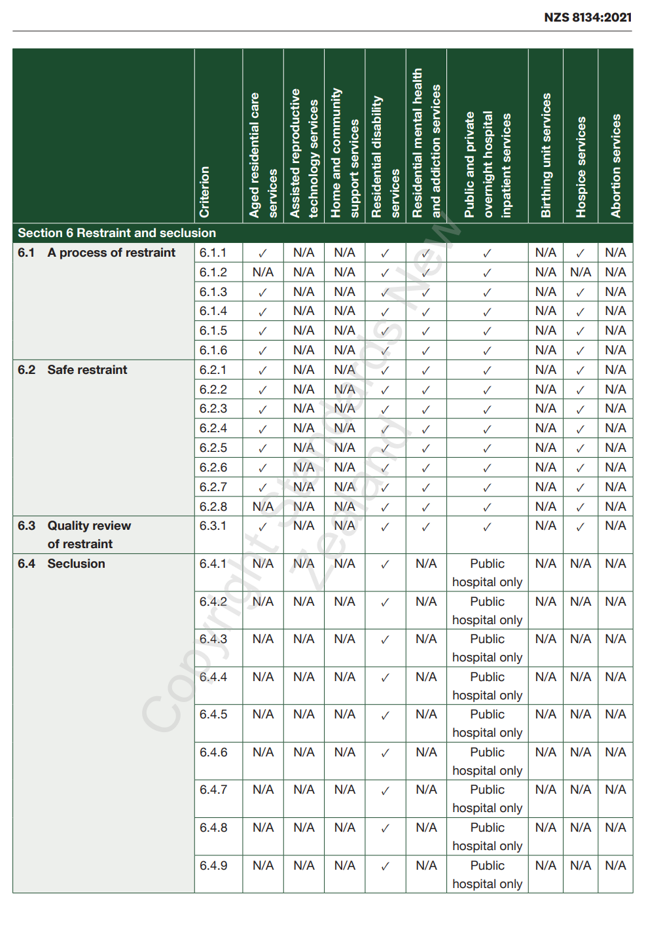

- : Surveillance audits
Note:
- home and community support services have not been included in this table, as they currently have a separate handbook
- abortion services have not been included in this table as they currently do not undergo surveillance audits

Surveillance audit criteria services summary
 | Criterion | Aged residential care services | Assisted reproductive technology services | Residential disability services | Residential mental health and addiction services | Public and private overnight hospital inpatient services | Birthing unit services | Hospice services
1.1 Pae ora healthy futures | 1.1.1 | ✓ | ✓ | ✓ | ✓ | ✓ | ✓ | ✓
1.2 Ola manuia of Pacific peoples in Aotearoa | 1.2.1 | ✓ | ✓ | ✓ | ✓ | ✓ | ✓ | ✓
1.3 My rights during service delivery | 1.3.1 | ✓ | ✓ | ✓ | ✓ | ✓ | ✓ | ✓
1.5 I am protected from abuse | 1.5.1 | ✓ | ✓ | ✓ | ✓ | ✓ | ✓ | ✓
 | 1.5.3 | ✓ | ✓ | ✓ | ✓ | ✓ | ✓ | ✓
 | 1.5.4 | ✓ | ✓ | ✓ | ✓ | ✓ | ✓ | ✓
1.7 I am informed and able to make choices | 1.7.5 | ✓ | ✓ | ✓ | ✓ | ✓ | ✓ | ✓
1.8 I have the right to complain | 1.8.2 | ✓ | ✓ | ✓ | ✓ | ✓ | ✓ | ✓
 | 1.8.3 | ✓ | ✓ | ✓ | ✓ | ✓ | ✓ | ✓
 | 1.8.4 | ✓ | ✓ | ✓ | ✓ | ✓ | ✓ | ✓
 | 1.8.5 | ✓ | ✓ | ✓ | ✓ | ✓ | ✓ | ✓
1.9 Health and wellbeing of children born as a result of, and people accessing, reproductive technology services | 1.9.1 | N/A | ✓ | N/A | N/A | N/A | N/A | N/A
2.1 Governance | 2.1.1 | ✓ | ✓ | ✓ | ✓ | ✓ | ✓ | ✓
 | 2.1.2 | ✓ | ✓ | ✓ | ✓ | ✓ | ✓ | ✓
 | 2.1.4 | ✓ | ✓ | ✓ | ✓ | ✓ | ✓ | ✓
 | 2.1.5 | ✓ | ✓ | ✓ | ✓ | ✓ | ✓ | ✓
 | 2.1.7 | ✓ | ✓ | ✓ | ✓ | ✓ | ✓ | ✓
 | 2.1.11 | ✓ | ✓ | ✓ | ✓ | ✓ | ✓ | ✓
2.2 Quality and risk | 2.2.2 | ✓ | ✓ | ✓ | ✓ | ✓ | ✓ | ✓
 | 2.2.3 | ✓ | ✓ | ✓ | ✓ | ✓ | ✓ | ✓
 | 2.2.4 | ✓ | ✓ | ✓ | ✓ | ✓ | ✓ | ✓
 | 2.2.5 | ✓ | ✓ | ✓ | ✓ | ✓ | ✓ | ✓
 | 2.2.6 | ✓ | ✓ | ✓ | ✓ | ✓ | ✓ | ✓
2.3 Service management | 2.3.1 | ✓ | ✓ | ✓ | ✓ | ✓ | ✓ | ✓
 | 2.3.2 | ✓ | ✓ | ✓ | ✓ | ✓ | ✓ | ✓
 | 2.3.3 | ✓ | ✓ | ✓ | ✓ | ✓ | ✓ | ✓
 | 2.3.4 | ✓ | ✓ | ✓ | ✓ | ✓ | ✓ | ✓
 | 2.3.9 | N/A | N/A | N/A | ✓ | N/A | N/A | N/A
 | 2.3.12 | N/A | N/A | N/A | ✓ | N/A | N/A | N/A
2.4 Health care and support workers and their availability | 2.4.3 | ✓ | ✓ | ✓ | ✓ | ✓ | ✓ | ✓
 | 2.4.4 | ✓ | ✓ | ✓ | ✓ | ✓ | ✓ | ✓
 | 2.4.5 | ✓ | ✓ | ✓ | ✓ | ✓ | ✓ | ✓
3.2 My pathway to wellbeing | 3.2.1 | ✓ | ✓ | ✓ | ✓ | ✓ | ✓ | ✓
 | 3.2.3 | ✓ | ✓ | ✓ | ✓ | ✓ | ✓ | ✓
 | 3.2.4 | ✓ | ✓ | ✓ | ✓ | ✓ | ✓ | ✓
 | 3.2.5 | ✓ | ✓ | ✓ | ✓ | ✓ | ✓ | ✓
3.4 My medication | 3.4.1 | ✓ | ✓ | ✓ | ✓ | ✓ | ✓ | ✓
 | 3.4.3 | ✓ | ✓ | ✓ | ✓ | ✓ | ✓ | ✓
 | 3.4.4 | ✓ | ✓ | ✓ | ✓ | ✓ | ✓ | ✓
 | 3.4.6 | ✓ | ✓ | ✓ | ✓ | ✓ | ✓ | ✓
 | 3.4.7 | ✓ | ✓ | ✓ | ✓ | ✓ | ✓ | ✓
 | 3.4.11 | N/A | ✓ | N/A | N/A | ✓ | ✓ | ✓
 | 3.4.12 | N/A | ✓ | N/A | N/A | ✓ | ✓ | ✓
3.5 Nutrition to support wellbeing | 3.5.1 | ✓ | N/A | ✓ | ✓ | ✓ | ✓ | ✓
 | 3.5.5 | ✓ | N/A | N/A | N/A | ✓ | ✓ | ✓
3.6 Transition, transfer, and discharge | 3.6.4 | ✓ | ✓ | ✓ | ✓ | ✓ | ✓ | ✓
3.8 Obtaining and caring for gametes and embryos | 3.8.1 | N/A | ✓ | N/A | N/A | N/A | N/A | N/A
 | 3.8.2 | N/A | ✓ | N/A | N/A | N/A | N/A | N/A
4.1 The facility | 4.1.1 | ✓ | ✓ | ✓ | ✓ | ✓ | ✓ | ✓
4.2 Security of people and workforce | 4.2.1 | ✓ | ✓ | ✓ | ✓ | ✓ | ✓ | ✓
5.2 The infection prevention programme and implementation | 5.2.2 | ✓ | ✓ | ✓ | ✓ | ✓ | ✓ | ✓
 | 5.2.6 | ✓ | ✓ | ✓ | ✓ | ✓ | ✓ | ✓
5.4 Surveillance of health care associated infection | 5.4.1 | ✓ | ✓ | ✓ | ✓ | ✓ | ✓ | ✓
 | 5.4.2 | ✓ | ✓ | ✓ | ✓ | ✓ | ✓ | ✓
 | 5.4.3 | ✓ | N/A | ✓ | ✓ | ✓ | ✓ | ✓
 | 5.4.4 | ✓ | ✓ | ✓ | ✓ | ✓ | ✓ | ✓
6.1 A process of restraint | 6.1.1 | ✓ | N/A | ✓ | ✓ | ✓ | N/A | ✓
 | 6.1.6 | ✓ | N/A | ✓ | ✓ | ✓ | N/A | ✓
6.4 Seclusion | 6.4.1 | N/A | N/A | N/A | N/A | Public hospitals only | N/A | N/A
TOTAL CRITERIA | 84 | 51 | 51 | 50 | 52 | 54 | 51 | 53

- : Provisional audit – the interview with the prospective provider
Whenever a facility or services changes ownership, auditors undertake a provisional audit. Through this process they establish:
- how well prepared the prospective provider is to provide a health and disability service
- has an understanding of the needs of the different certified service types at the facility including certified residential disability services
- the extent to which the existing provider conformed to requirements before the service changed ownership.

The prospective provider has an understanding of the ARRC agreement, including in relation to the ARRC manager (D17). This includes D 17.3 d (i) ARRC and D 17.5 a – ARHSS Agreements – the Manager is required to hold a current qualification that is relevant to management and health care for older adults.

A necessary part of this process is to interview the prospective provider (or contact person). If this person is not present for the full audit,then an off-site interview is acceptable. During the interview, the auditor shall determine whether the prospective provider meets all of the following Ngā Paerewa subsections/criterion.
- The prospective provider knows and understands the consumer rights that it shall adhere to (Ngā Paerewa subsection 1.3 – My rights during service delivery).
- The prospective provider has an established organisational structure (governance and management) and a predetermined lead-in time. It has identified any changes to key personnel (involving governance, organisational and financial management, clinical management and team leader level) that will occur after taking ownership of the service, and has confirmed management and registered nurse full-time equivalent staff (FTE) (Ngā Paerewa subsection 2.1 – Governance, Ngā Paerewa subsection 2.3 Service management: criterion 2.3.1).
- The prospective provider has developed a transition plan with timelines, if required, allowing timeframe for implementation (Ngā Paerewa subsection 2.1 – Governance).
- The prospective provider has notified the relevant funder of the proposed purchase.
- Where it is planning changes within the service that may affect the service’s capacity to meet the requirements of Ngā Paerewa, the prospective provider is aware of the issues and taking steps to ensure it will continue to meet those requirements.
- Any plans for environmental changes to the service comply with legal requirements (Ngā Paerewa subsection 4.1 The facility).
- There are no legislative compliance issues (for example, concerning health and safety, employment, local body) that could affect the service (Ngā Paerewa subsection 2.2 – Quality and risk – adverse event reporting).
- The prospective provider will produce an annual quality plan and has established quality management systems including schedules for internal audit, changes and continuity (Ngā Paerewa subsection 2.2 – Quality and risk).
- The prospective provider has a policy regarding staff skill mix, including contractual obligations and acuity of consumers within the service (Ngā Paerewa subsection 2.3 – Service management).
- The prospective provider has established plans for service management, such as determining who will cover when rostered staff are absent and managing staff changes (Ngā Paerewa subsection 2.1 – Governance and Ngā Paerewa subsection 2.3 – Service management).
- Where it is changing existing operational (management and clinical) policies or procedures, the prospective provider has ensured the changes will meet the requirements of the Health and Disability Services Standards (Ngā Paerewa subsection 2.2 – Quality and risk).
- Where the provisional audit includes rest home – including dementia, and/or psychogeriatric services the prospective owner is versed with their responsibilities in respect of restraint minimisation and safe practice (Ngā Paerewa subsection 6.1 – A process of restraint). This also includes E4.5 f ARRC and D17.11 (i-ii) ARHSS agreements timeframe to complete unit standards.

The provisional audit report shall include evidence of the prospective provider’s preparedness against each of the above criterion.

- : Role description – lead auditor, public hospital audits
- Introduction
The lead auditor requires a thorough understanding of the relationship between Ngā Paerewa, public hospital systems, services and outcomes and how risk is managed in a complex environment.

The lead auditor has expert skills in identifying potential risk points and facilitates effective, constructive and collegial communication with the audit team and public hospital leadership.

The lead auditor provides leadership and direction of the audit team and is responsible for applying systems analysis skills and inductive reasoning skills to determine the degree of conformity with Ngā Paerewa and the functionality of care delivery systems across the public hospital.

The lead auditor also undertakes audit activities as set out in the audit schedule.

This description outlines specific requirements for lead auditors working within public hospitals that are in addition to those outlined in the Designated Auditing Agency Handbook.
- Functions
There is one allocated lead auditor for each public hospital audit. The role is not a shared role as other members of the audit team shall be senior auditors and/or technical experts or technical expert assessors who require minimal supervision. Note that a lead auditor for public hospitals is not required for public hospital partial provisional audits.

The lead auditor for public hospitals is approved for public hospital audits by the Ministry.

Note: The following list of functions is not exhaustive but is aimed to assist the lead auditor/team leader to better understand their role in relationship to public hospital audits.

- Working with the audit team
Ensures auditors and technical experts or technical expert assessors:
- are conversant with results from stage one of the audit
- work collaboratively to collect audit evidence
- undertake all tasks and activities in accordance with the audit schedule
- flag any emerging issues with the lead auditor at the earliest opportunity.
- Stage one of the audit
- Is responsible for requesting and analysing self-assessment report and associated data. Note the analysis cannot be delegated to administration or support staff.
- Is responsible for disseminating relevant information to the audit team from stage one. Note: If the lead auditor allocates any analysis of the self-assessment to members of the audit team, the lead auditor shall ensure their own analysis takes into consideration the relevance of the whole in addition to that of the parts.
- Stage two of the audit
- Actively uses information and knowledge gained from stage one to verify findings from the self-assessment using a sampling methodology.
- Tests systems through the audit process that have been identified as high-risk areas.
- Determines the extent to which evidence is indicative of system-wide non-conformities.
- Engages auditees and the audit team in interactive dialogues in order to identify the nature of issues and their relevance to Ngā Paerewa.
- Qualifications and experience
Holds a lead auditor qualification and health professional qualification with a current annual practising certificate or holds a lead auditor qualification and health management or business management postgraduate degree, and in addition has:
- Application approved by HealthCERT to audit in a public hospital Lead Auditor role following submission of the following evidence:
- completion of four public hospital certification audits in a trainee public hospital Lead Auditor capacity (training log)
- witnessed assessment report completed at the fourth public hospital audit in a trainee capacity verifying competent as a public hospital Lead Auditor
- a CV outlining experience, knowledge and skills verifying applicant meets requirements of the position
- professional development log
- at least four years’ quality auditor experience
- proven ability and at least two years’ experience working in a lead auditor role across a number of health or disability support services or where this is not met, at the discretion of HealthCERT approval on a case-by-case basis
- proven experience in supervising and managing a team of audit professionals ranging in size from 8 to 16 people
- previous experience working in a public hospital in a fourth tier or higher management position within the last six years or has previous experience working across complex health systems – in addition to any audit activities (as determined and approved by the Ministry) within in the last six years demonstrated current knowledge of public hospital systems and processes.

- : Role description – technical expert assessor, public hospital audits
- Introduction
Technical expert assessors have a vital role as part of the audit team for certification audits. The effectiveness and credibility of the audit process is highly reliant on the competence, professionalism and integrity of health professionals who have specialist relevant and current knowledge of public hospital systems and current practice in delivery of services.
- Functions
- Provides advice to qualified quality auditors based on their specific knowledge and expertise.
- Conducts an assessment of technical competence of service delivery within specific clinical settings using tracer methodology (individual and systems).
- Provides information to quality auditors who can then use this information to form part of the audit evidence required to objectively determine the extent to which Ngā Paerewa subsections and associated criteria have been fulfilled.
- Has clinical expertise in the area in which they will be acting as a technical expert/assessor.
- Stage one of the audit
- Receives the results of stage one via a briefing prior to the on-site audit.
- Stage two of the audit
- Accompanies the auditor on a tour of the ward or department.
- Discusses observations from the tour of the ward or department with the auditor.
- Provides advice to the auditor on request.
- In completing individual tracers:
- assists in identifying a suitable patient for tracer through discussion with nurse in charge
- ensures verbal consent has been obtained for individual tracers
- begins the tracer in the ward in which the patient resides
- reviews care processes by reviewing records, interviews and observations. One of the records reviewed is the clinical file (hard copy and electronic), including progress notes, consent forms, procedure records, laboratory records, observation records, medication records (ideally done with a staff member familiar with the patient concerned)
- determines what other wards and departments need to be visited in response to the review of the clinical file and ensures this information is communicated to the auditor who will schedule onward appointments
- alerts the auditor to any concerns found through reviewing the notes
- interviews a selection of staff currently providing care (in the ward) with a focus on care delivery
- interviews the patient (and/or family), which may be in conjunction with a consumer auditor
- makes observations in the ward (eg, handover, patient movements)
- as they identify issues, reports findings to the auditor to allow the auditor to respond to these
- may undertake some interviews together with the auditor
- moves to clinical areas where the patient was before the current ward/department
- interviews staff in relation to the systems and processes, using the patient as an example
- focuses on risk points such as handovers between services
- continues to move progressively back in time to the point of admission (but does not need to go to outpatient services, radiology or laboratory services unless an issue was identified, or the nature of the procedure requires a review of the process)
- takes field notes that they then provide to the auditor at the completion of the tracer
- when the tracer is completed, talks with the auditor to discuss findings.
- Qualifications and experience
- Holds a health professional qualification with a current annual practising certificate.
- Is a current employee of a public hospital working in a senior leadership position with a clinically active role (equivalent middle management or above).
- Has participated in clinical audit, quality improvement initiatives, service reviews or other equivalent activities.
- Attributes
- Possesses sound judgement and analytical skills.
- Has knowledge of quality management principles.
- Is able to obtain and assess information objectively.
- Has good time management skills.
- Is able to work under pressure.
- Has effective interviewing skills.
- Training
Technical expert assessors will successfully complete a Ministry of Health training programme to ensure that they have a basic understanding of the Ngā Paerewa Health and Disability Services Standard and the audit process and can competently assess service delivery within their specialty area using tracer methodology.
- Conflict of interest
Technical expert assessors shall be free from any conflict of interest. As such, they cannot be current employees of the public hospital being audited or provide expert advice to that public hospital.

Note: Technical expert assessors complete a workbook which they then provide to the quality auditors along with verbal handover or advice at the end of the audit. However, they are not required to contribute to the writing of the audit report.

- : Role description – quality auditor, public hospital audits
- Introduction
Quality auditors have a vital role as part of the audit team for certification audits. The effectiveness and credibility of the audit process rely heavily on the competence, professionalism and integrity of quality auditors who can work alongside technical expert assessors.

Quality auditors need a thorough understanding of the relationship between the Ngā Paerewa Health and Disability Services Standard, public hospital systems, services and outcomes and how risk is managed in a complex environment.

General requirements of auditors in relation to the principles and code of conduct they shall follow are outlined in Sections 3 and 5. This description outlines additional, specific requirements.
- Functions
Note: The following list of functions is not exhaustive but is aimed to assist auditors in better understanding their role in relationship to the technical expert assessor.
- Working with technical expert assessors
- Receives advice from and technical expert assessors and synthesises this information to objectively determine the extent to which Ngā Paerewa subsections and associated criteria have been fulfilled.
- Helps to select a consumer suitable for the tracer. Note the selection process should be undertaken in the clinical area following the tour of this area.
- Supports technical expert assessors to assess the technical competence of service delivery within specific clinical settings, using tracer methodology.
- Ensures technical expert assessors complete the tracer process including sampling and interviewing across clinical areas relevant to the consumer selected for the tracer.
- Ensures technical expert assessors keep to time allocated.
- Facilitates discussions with the technical expert assessor to tease out issues, determining their relevance to Ngā Paerewa and where additional information or focus is required.
- Receives completed workbooks and takes a verbal handover from and technical expert assessors, ensuring they have gathered all the information auditors need to use as part of audit evidence and to write the audit report. Note that once technical expert assessors have left the on-site audit, they may not be available for further comment or advice and do not directly contribute to the writing of the audit report.
- Stage one of the audit
- Is conversant with the results from stage one of the audit process.
- Stage two of the audit
- Leads introductions in clinical areas outlining the activities and time expectations of being in the clinical area for both the auditor and t technical expert assessor.
- Jointly undertakes a short tour of the clinical area with the technical expert assessor and public hospital staff member to observe interactions between staff and patients, other staff, the availability and location of equipment, respect for privacy and confidentiality of information and general risk management (eg, standard precautions in place, isolation, use of equipment). Note: The tour should not take an inspection approach.
- Ensures that the manager or person in charge has asked for verbal consent from the consumer chosen as the tracer.
- Facilitates meetings and interviews with the technical expert.
- Takes notes at all meetings and interviews, where the auditor and technical expert assessor are present.
- Asks any additional questions at meetings and interviews following the questions the technical expert assessor asks (eg, orientation programme, ongoing training, annual competencies).
- Works alongside the technical expert assessor to undertake incidental sampling and additional sampling to validate findings of the technical expert assessor from the tracer review and assist in determining the nature of non-conformities (isolated anomaly, specific to the clinical area, service specific, or across the public hospital).
- Undertakes medication file audits in addition to the tracer sample.
- Undertakes an audit of a sample of informed consent (including surgical or procedural consents, for example, resuscitation status).
- Follows up on risk areas that the technical expert assessor identified, to determine the extent to which risks are systemic across the public hospital.
- Undertakes additional interviewing as indicated to validate findings or determine conformity with a Ngā Paerewa subsection not directly captured through the tracer process. Note: This may or may not be done in conjunction with the or technical expert assessor.
- Undertakes informal interviews with consumers of services. Note: The r technical expert assessor will conduct a formal interview with the consumer who has consented to be part of the tracer process and that interview does not need to include the auditor.
- Follows up on and reviews any policies or procedures in response to findings that are inconsistent with the findings from stage one of the audit (including the public hospital self-assessment).
- Reviews quality data that are from the ward or clinical area and are not otherwise reviewed in stage one of the audit.
- Reviews the roster of the ward or clinical area.
- Observes a partial handover between shifts. Note: The auditor is likely to do this in conjunction with the technical expert assessor
- Before leaving a clinical area, thanks the manager or person in charge of the service, providing them with a short debrief of findings (both positive and negative). Where there are negative findings, manages this information sensitively and does not present it as a definitive finding, given further information will be collected across other service areas which may or may not be relevant to the findings in a specific clinical area.
- Completes own field notes.
- Undertakes a critical appraisal of information collected and determines the sufficiency of evidence and how the evaluation of this evidence will be reflected in the audit report, ensuring that it is applicable to the public hospital at the level of clinical area, service, facility or the public hospital as a whole.
- Completes audit reporting as directed by the lead auditor.
- Qualifications and experience
- Application approved by HealthCERT to audit in a public hospital Quality Auditor role following submission of the following evidence:
- completion of four public hospital audits in a trainee capacity (training log)
- witnessed assessment report completed at the fourth public hospital audit in a trainee capacity verifying competent as a public hospital Quality Auditor
- a CV outlining experience, knowledge and skills verifying applicant meets requirements of the position
- professional development log
- Holds an audit qualification and health professional qualification with a current annual practising certificate as outlined in the Designated Auditing Agency Handbook.
- Has at least two years’ quality auditor experience and is qualified as a quality auditor or where this is not met, at the discretion of HealthCERT approval on a case-by-case basis
- Has previous experience working in a public hospital and current knowledge of public hospital systems and processes.

- : Guidance for auditing residential disability services
When auditing residential disability services against Ngā Paerewa, the audit team shall consider the philosophy of these services within the context of the audit.

Note that HealthCERT accepts the following interpretations of Ngā Paerewa.
1.1.2 Consumer rights during service delivery: The Code of Rights and Advocacy Services information should be readily available in a public place (for example, lounge bookshelf), and not publicly displayed on walls.
1.1.9 Communication: Staff may or may not wear name badges. Where they do not wear name badges, other methods of staff identification should be identified during audit.
1.1.10 Informed consent: Policies should reflect the provider’s process around managing advance directives within the residential disability setting.
1.3.12 Medicines management: The audit team shall witness medication administration as part of the audit process.
1.4.2 Code of compliance/building warrant of fitness (BWOF): Where the property is exempt from needing a BWOF as defined in the Building Act 2004, the audit report should expressly identify this exemption. It is expected that appropriate maintenance processes will be evident.
1.4.3 Hot water temperatures: Refer to local body bylaws to ensure hot water temperatures meet requirements. Evidence shall reflect the mechanisms in place to monitor and maintain an acceptable water temperature in sanitary fittings.
1.4.3 Toilets and showers have clear distinguishable identification: As the house is the consumer’s home, it is acceptable to rate any aspect of this standard as not applicable.
1.4.7 Approved evacuation plan: Where there is no requirement for an approved plan under the Fire Safety and Evacuation of Buildings Regulations 2006, it is expected the provider will have a documented procedure in place, with evidence that evacuations are practised at regular intervals.

- Infection prevention and control auditing guidance
The following points offer general guidance.
- In a small service, a ‘committee’ can be one person assigned to be responsible for activities that a committee would usually undertake in a larger setting.
- In a large service with multiple sites, a committee can be a central committee that is responsible for multiple sites.
- The level of detail within an infection prevention and control programme should be tailored to the size, scope, complexity and risk. Auditors shall take this requirement into full consideration when completing their audit. For example, residential disability homes should comply with food safety tips as published by the New Zealand Food Safety Authority for ‘food safety at home’ and should monitor fridge temperatures, rather than complying with the food safety requirements for a commercial kitchen.

- : Audit Framework
The information in Appendix 8 is a copy of Audit Framework on pages 14–17 from NZS 8134:2008.

Copyright in NZS 8134:2021 is owned by the Crown and administered by the New Zealand Standards Executive. Reproduced with permission from Standards New Zealand, on behalf of New Zealand Standards Executive, under copyright licence LN001437.

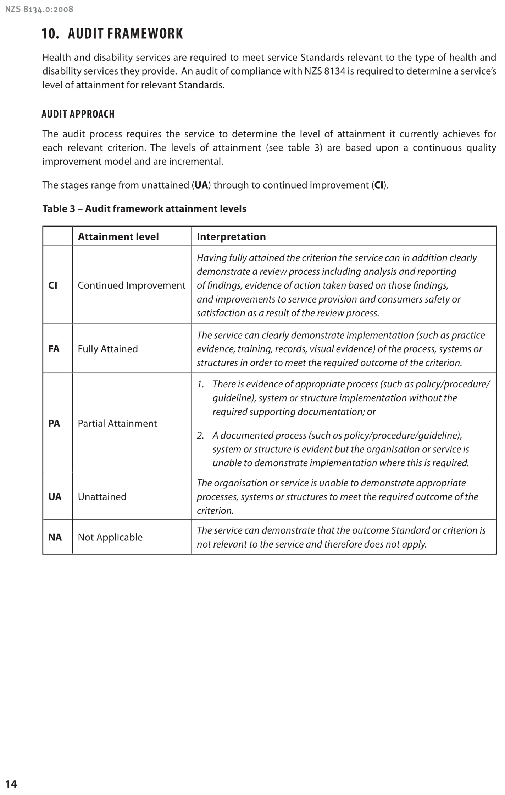

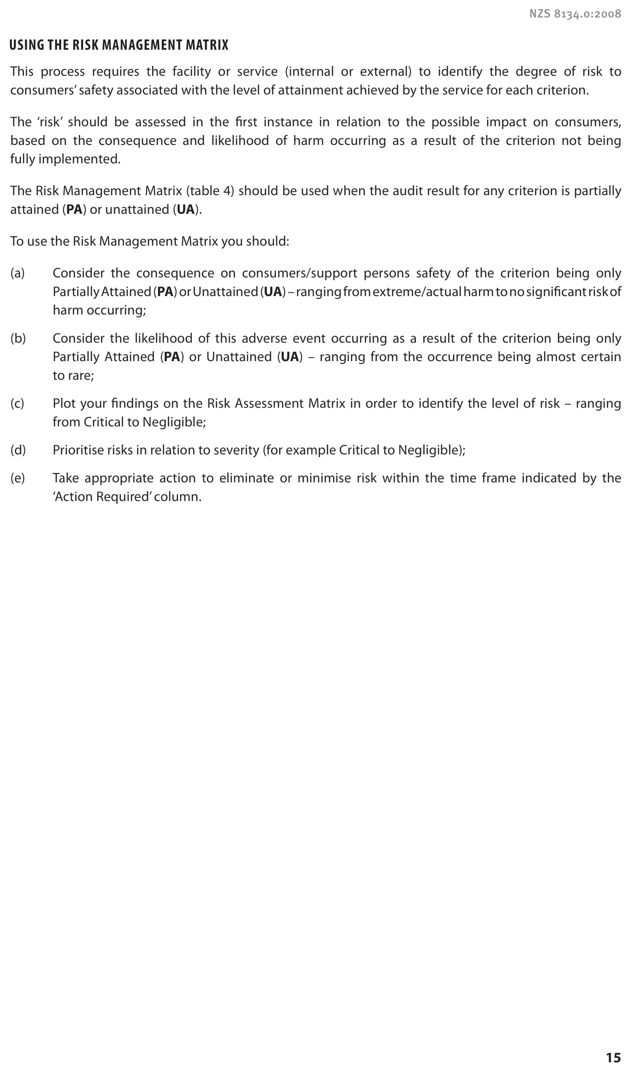

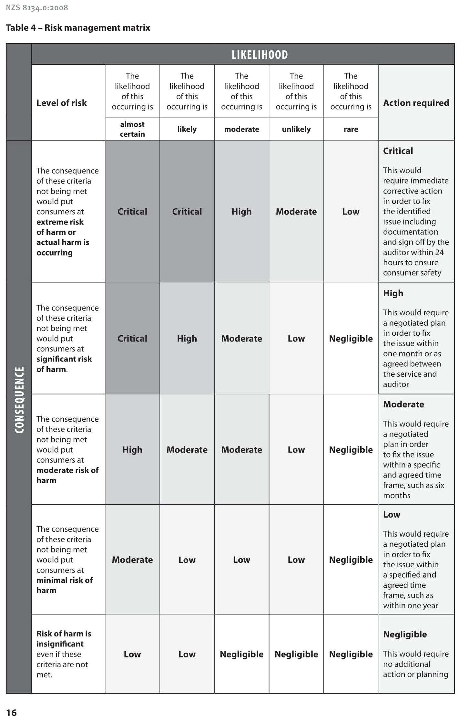

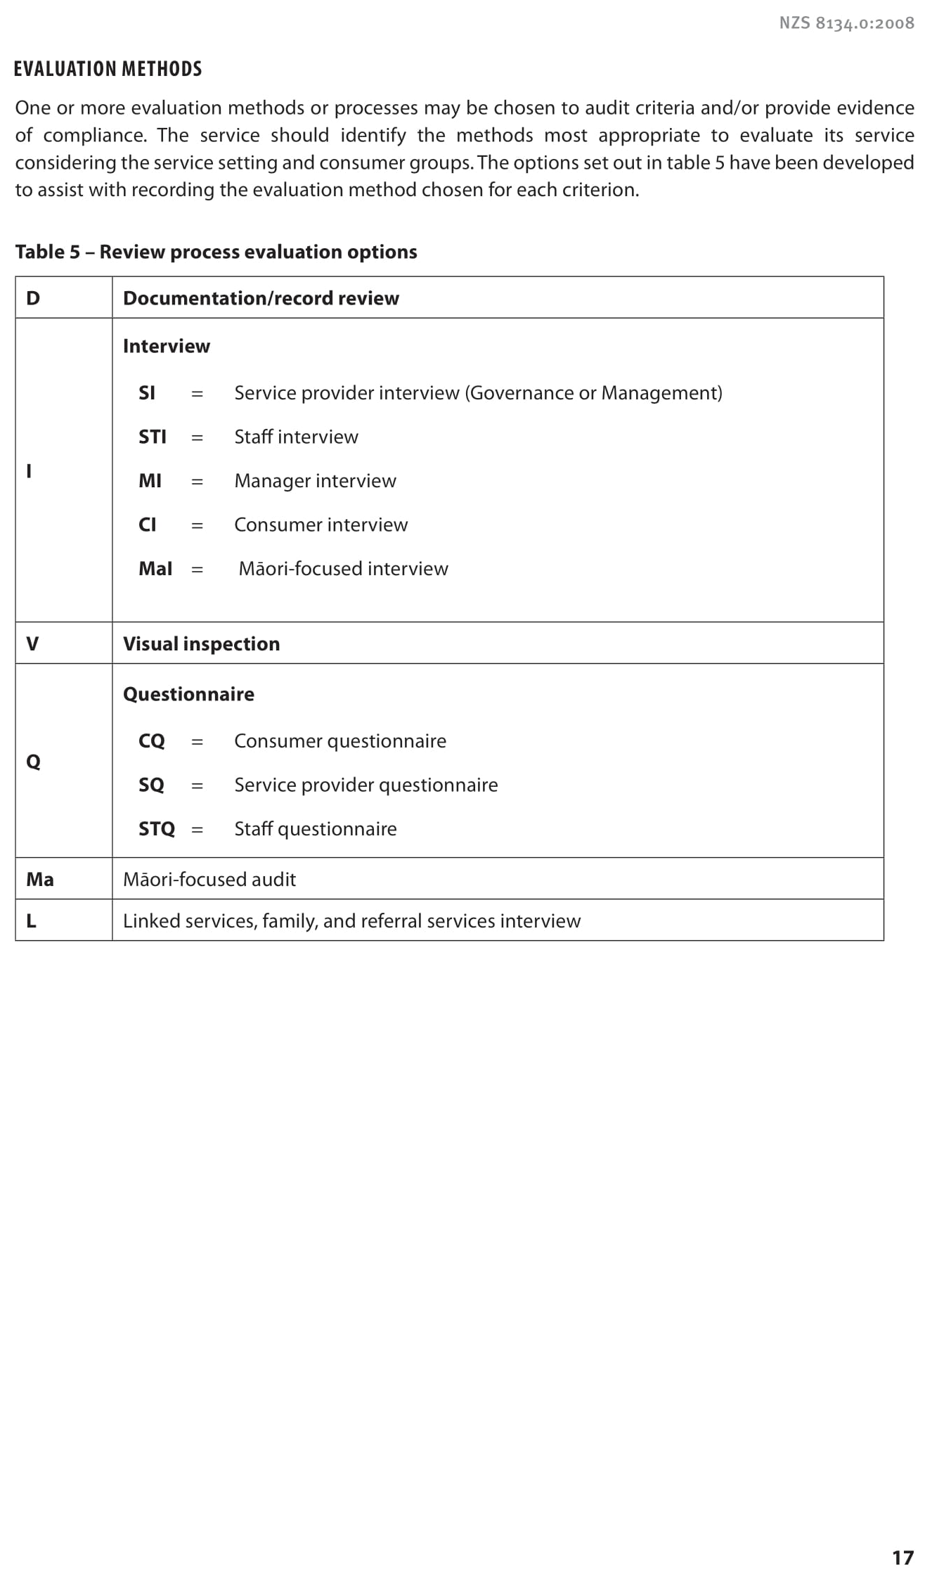

Assessments against NZQA standards must be undertaken by an NZQA provider of auditor training that has a health and disability focus.
Those health professionals who are auditors regulated through the Health Practitioners Competence Assurance Act 2003 also need to meet the requirements of professional development to maintain their annual practising certificates, which may be in addition to or part of this eight-hour requirement.
This can be a surveillance audit or a certification audit.
These can be submitted to the Ministry electronically.
Multi-site sampling is not applicable to aged residential care services.
‘Consulting services’ include, but are not limited to, designing, implementing or maintaining a quality or management system (for example, preparation of manuals or procedures; undertaking a gap analysis; conducting internal audits; providing specific advice, instruction or solutions towards the development and implementation of a quality or management system; or participating in the decision-making system regarding such matters).
Legal entity.
This requirement also applies to any separate organisation established by the DAA or its directors for the purpose of training or education.
See public hospital-specific audit processes in section 15 for sampling requirements in public hospitals.
However, staff may be interviewed in pairs or with a support person. Where staff are interviewed together, they should be of the same level (for example, both caregivers or both registered nurses, neither at the managerial level).
The DAA is responsible for developing questions unless otherwise notified by the Ministry.
Note: for provisional audits the relevant public hospital portfolio manager should be notified at least 10 working days prior to audit (refer section 8).
ORA is also known as Care Suites, Licence to Occupy (LTO) and Rent to Occupy (RTO).
A telephone interview is acceptable if the GP is not be at the facility on the day(s) of the audit. Note that if the GP declines to be interviewed, this must be recorded in the audit report and shall not affect the level of attainment awarded for any criterion.
Certification and surveillance audits. This requirement does not apply to disability services.
www.hqsc.govt.nz/our-programmes/reducing-harm-from-falls/
This subsection is only audited if there have been any low risk building changes since the previous audit.
Interest in respect of employment means current employment or any position held up to two years previously.
Department of Building and Housing: Determination 2006/92.

