2021 COVID-19 Māori Health Protection Plan
December 2022 Monitoring Report
2022

Citation: Ministry of Health. 2023. 2021 COVID-19 Māori Health Protection Plan December 2022 Monitoring Report. Wellington: Ministry of Health.
Published in March 2023 by the Ministry of Health
PO Box 5013, Wellington 6140, New Zealand
ISBN 978-1-991075-10-9 (online)
HP 8725
This document is available at health.govt.nz
This work is licensed under the Creative Commons Attribution 4.0 International licence. In essence, you are free to: share ie, copy and redistribute the material in any medium or format; adapt ie, remix, transform and build upon the material. You must give appropriate credit, provide a link to the licence and indicate if changes were made.

Ngā mihi | Acknowledgements
Whakangaro atu ana te makiu tāngata ki te rua kōiwi o Ranginui. Nā te mata kārehu rātou i tanu, tēnei te mata o te pene te hahū ake anō hei whakamahu i te mamae e kaikikini nei. Kei ngā mate tāruru nui o te tau, koutou i riro atu i te ringa o te Mate Kowheori, haere atu koutou, hoatu ki te pūtahitanga o Rehua, ki te whare whakamoeariki. Kei aku pōkaitara, haere, oki atu e. Ko rātou te pito mate ki a rātou, ko tātou te pito ora ki a tātou.

Kia rere anō a mihi ki ngā uaua parāoa nā koutou tēnei pūrongo i tutuki ai, tae atu rā ki a koutou e kōrerohia ana ki roto. Me pēhea e kore ai e rere te kupu monoa, te kupu whakamiramira, te kupu kauanuanu ki a koutou e ngā kahu pītongatonga. Nā koutou te iwi Māori i tiaki, i whakahaumaru, i manaaki hoki, ahakoa ngā piere nuku o te wā o te Mate Kowheori. Mei kore ake koutou katoa kua kore e ea ngā tini kaupapa kei roto i tēnei pūrongo, nā reira tēnā koutou katoa.

We wish first to acknowledge those who have passed away in the past few years due to COVID-19. Our thoughts and condolences are with the whānau and friends who are still grieving. While we look towards a future beyond the pandemic, we realise the mamae many are experiencing will endure. Kia kaha, kia māia, kia manawanui.

We also wish to thank everyone who has contributed to the development of this report, including those whose efforts are described within. A report like this is not possible without the contribution of multiple organisations, iwi partners, Māori community groups and providers. Thank you all for your commitment to the protection and safety of whānau Māori. We look forward to continuing to work with you on our journey towards pae ora, healthy futures.

Ihirangi | Contents
Ngā mihi | Acknowledgements iii
He whakarāpopoto | Executive summary 1
Kōrero whakataki | Introduction 3
Te Tiriti and Whakamaua: Māori Health Action Plan 2020–2025 continue to guide our response 3
Te Mahere Whakahaumaru Māori e whakatinanahia ana | The Māori Protection Plan in action 5
Enabler 1: Target and localise information and education for whanau 5
Enabler 2: Increase integrated outreach health and social services for and with Māori 7
Ngā tatauranga matua | Key statistics 12
Health impact of COVID-19 on Māori 12
Te anga whakamua | Moving forward 20
Key learnings from monitoring the Māori Protection Plan 20
Where we are heading 23
Ngā āpitihanga | Appendices 25
Appendix 1: COVID-19 Māori Health Protection Plan Monitoring Framework 26
Appendix 2: Cases and mortality 27
Appendix 3: Vaccinations 32
Appendix 4: Funding to Māori providers 36
Appendix 5: Wider health system measures 43

List of Figures
Figure 1: Whakapapa of the Monitoring Report to the COVID-19 Māori Health Protection Plan 4
Figure 2: Care in the Community services 11
Figure 3: Cumulative case rate per 1,000 people by ethnicity, 17 August 2021 to 1 November 2022 13
Figure 4: Cumulative COVID-19 hospitalisation rate per 100,000 people by ethnicity at date of hospitalisation, 17 August 2021 to 1 November 2022 14
Figure 5: Cumulative rate of deaths within 28 days and deaths attributable to COVID-19 by ethnicity, 17 January 2021 to 1 November 2022 15
Figure 6: Vaccination status of Māori COVID-19 cases, 17 August 2021 to 1 November 2022 16
Figure 7: Vaccination status of Māori COVID-19 hospitalisations, 17 August 2021 to 1 November 2022 17
Figure 8: Second dose booster uptake per 100 adults aged 50 years and over by ethnicity, 21 February 2021 to 1 November 2022 18
Figure 9: Cumulative case rate per 100,000 people by age group and ethnicity, 17 August 2021 to 1 November 2022 28
Figure 10: Cumulative hospitalisation rate per 100,000 people by age group and ethnicity, 17 August 2021 to 1 November 2022 28
Figure 11: Cumulative deaths within 28 days of being reported as a case rate per 100,000 people by age group and ethnicity, 17 August 2021 to 1 November 2022 29
Figure 12: Cumulative deaths attributable to COVID-19 rate per 100,000 people by age group and ethnicity, 17 August 2021 to 1 November 2022 29
Figure 13: Cumulative COVID-19 case rate per 1,000 people by ethnicity and district, 17 August 2021 to 1 November 2022 30
Figure 14: Cumulative COVID-19 hospitalisation rate per 1,000 people by ethnicity and district, 17 August 2021 to 1 November 2022 31
Figure 15: First dose COVID-19 vaccination uptake per 100 people aged 12 years and over by ethnicity, 21 February 2021 to 1 November 2022 33
Figure 16: Second dose COVID-19 vaccination uptake per 100 people aged 12 years and over by ethnicity, 21 February 2021 to 1 November 2022 34
Figure 17: Paediatric first dose uptake per 100 children aged 5 to 11 years by ethnicity, 21 February 2021 to 1 November 2022 34
Figure 18: Booster uptake per 100 people aged 16 years and above by ethnicity, 21 February 2021 to 1 November 2022 35
Figure 19: Number of primary care services that Māori health providers delivered with Omicron response funding, February to July 2022 37
Figure 20: Number of vaccinations that Māori health providers delivered with Omicron response 38
Figure 21: Number of staff supported through Omicron funding to Māori health providers, February to July 2022 38
Figure 22: Number of health services that Māori health providers delivered with Delta response funding, September 2021 to February 2022 40
Figure 23: Number of whānau support items provided through the Delta response funding, September 2021 to February 2022 41
Figure 24: Number of staff supported through the Delta response funding, September 2021 to February 2022 42
Figure 25: Completed vaccinations for Māori pēpi and tamariki at 18 and 24 months by quarter, 2016 to 2022 43
Figure 26: Cumulative influenza vaccination uptake for Māori aged 65 years and over by week, 2018 to 2022 44
Figure 27: Ambulatory sensitive hospitalisation rate per 10,000 people aged 0–4 years by quarter and ethnicity, 2016 to 2022 45
Figure 28: Percentage of first specialist appointments missed by ethnicity and quarter, 2016 to 2022 46
Figure 29: Age-standardised emergency department attendances by ethnicity and month, 2019 to 2022 47

He whakarāpopoto | Executive summary
The December 2022 Māori COVID-19 Monitoring Report provides an overview of progress made against the 2021 COVID-19 Māori Health Protection Plan (the Māori Protection Plan) between May and November 2022.

Since the publication of the first Monitoring Report in May 2022, Aotearoa New Zealand experienced a wave of COVID-19 and other illnesses over the winter. Then, as the winter outbreak eased, the COVID-19 Protection Framework (the traffic light system) ended.

Progress continued to be made against the priorities outlined in the Māori Protection Plan. This included:
- increasing communications tailored for and with Māori
- increasing funding for targeted outreach services; providing funding for whānau-centred vaccination services
- distributing more personal protective equipment, rapid antigen tests and masks
- supporting whānau through the Care in the Community programme.

Achieving equity for Māori has progressed in some areas. For example, the equity gap in hospitalisations between Māori and non-Māori, non-Pacific peoples has halved since April. (Since 1 April, when Māori were 3 times as likely to have been hospitalised with COVID-19 compared to non-Māori, non-Pacific peoples, the gap has decreased to 1.48 times more likely to have been hospitalised as at 1 November 2022.)

In other areas, inequities for Māori remain. Inequities remain in COVID-19 hospitalisation rates, deaths and COVID-19 vaccination uptake, particularly among Māori aged 60 to 69 years. Monitoring of wider health system performance under the Māori Protection Plan also indicates that COVID-19 has exacerbated health inequities for Māori in areas such as childhood immunisation rates.

Monitoring of the Māori Protection Plan has affirmed the value of Māori community-led solutions and putting equity at the centre of the Māori COVID-19 response. Work done under the Māori Protection Plan has also highlighted the importance of data, research, monitoring and knowledge sharing to improve responsiveness and ensure accountability to Māori.

Moving forward, work is continuing to place Aotearoa New Zealand in a good position to prepare for, respond to and recover from future waves of COVID-19. Monitoring of COVID-19 will continue, alongside monitoring of overall performance of the health system, including its performance in improving Māori health outcomes.

More information

For the latest updates and information on the COVID-19 response, please go to: covid19.govt.nz

Kōrero whakataki | Introduction
The COVID-19 Māori Health Protection Plan (the Māori Protection Plan) was published in December 2021 to respond to the changing COVID-19 landscape as the Delta variant emerged. The Māori Protection Plan has continued to guide policy, planning and action for Māori health under the COVID-19 Protection Framework (the traffic light system) and the evolving context of the Omicron variant.

The Māori Protection Plan includes a monitoring framework to inform the response as it continues to develop, contributing to the wider effort to address equitable outcomes for Māori. Under the framework, progress against the Māori Protection Plan is tracked and the results are reported in two monitoring reports. The first Monitoring Report, published in May 2022 (the May Monitoring Report) outlined progress between December 2021 and April 2022. This second Monitoring Report (the December Monitoring Report) outlines the progress made between May and November 2022.
It provides an overview of Māori infection rates, hospitalisations, deaths and vaccination coverage in relation to COVID-19, along with broader health system performance.

Modelling and planning for future outbreaks is continuing, reflecting global evidence and modelling that indicates the number of COVID-19 cases will continue to fluctuate. Some focus areas are to maintain the legacy of community resilience built through the COVID-19 response, embed COVID-19 vaccination into the broader immunisation system, and continue to build and share data, research and knowledge on the Māori COVID-19 response.

Te Tiriti and Whakamaua: Māori Health Action Plan 2020–2025 continue to guide our response
Manatū Hauora has set out the health and disability system’s commitment to, and expression of, Te Tiriti o Waitangi (Te Tiriti) in Whakamaua: Māori Health Action Plan 2020–2025 (Whakamaua). Whakamaua includes relevant COVID-19 actions to keep Te Tiriti and Māori health equity at the centre of the COVID-19 Māori health response.

Manatū Hauora’s approach strongly aligns with the findings of the Waitangi Tribunal’s Haumaru: The COVID-19 Priority Report. That report recommends the Crown do more to support and resource Māori providers, whānau, hapū, iwi and hapori Māori to drive responses with, and for, their communities. It also highlights the need to improve data collection and monitoring, as a way of strengthening the pandemic response.

The Māori Protection Plan has guided the Māori COVID-19 response, focusing on supporting mana motuhake (Māori authority over their wellbeing) and effective kaitiakitanga (stewardship) of the system. It sets out the objectives and actions for the health and disability system, with the overarching goal of preventing and mitigating the impacts of COVID-19 on the health and wellbeing of whānau, hapū, iwi and hapori Māori.

The purpose of the May and December 2022 monitoring reports is to outline the progress being made against the Māori Protection Plan’s drivers, enablers and actions, and assess the health impact of COVID-19 on Māori.

Figure 1 gives an overview of the strategic COVID-19 Māori health response plans and monitoring reports, including this Monitoring Report, from Manatū Hauora –the Ministry of Health (the Ministry).

Figure 1: Whakapapa of the Monitoring Report to the COVID-19 Māori Health Protection Plan
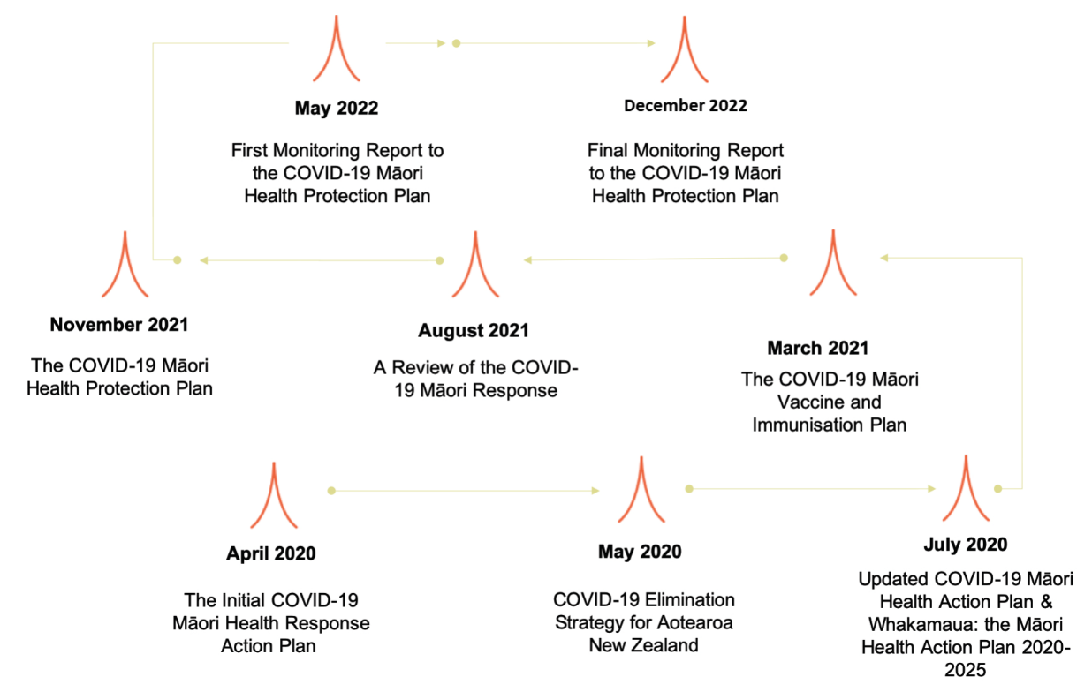

Te Mahere Whakahaumaru Māori e whakatinanahia ana | The Māori Protection Plan in action
The COVID-19 Māori Health Protection Plan provides a platform for a range of work that is already under way. It has the following 2 key drivers.

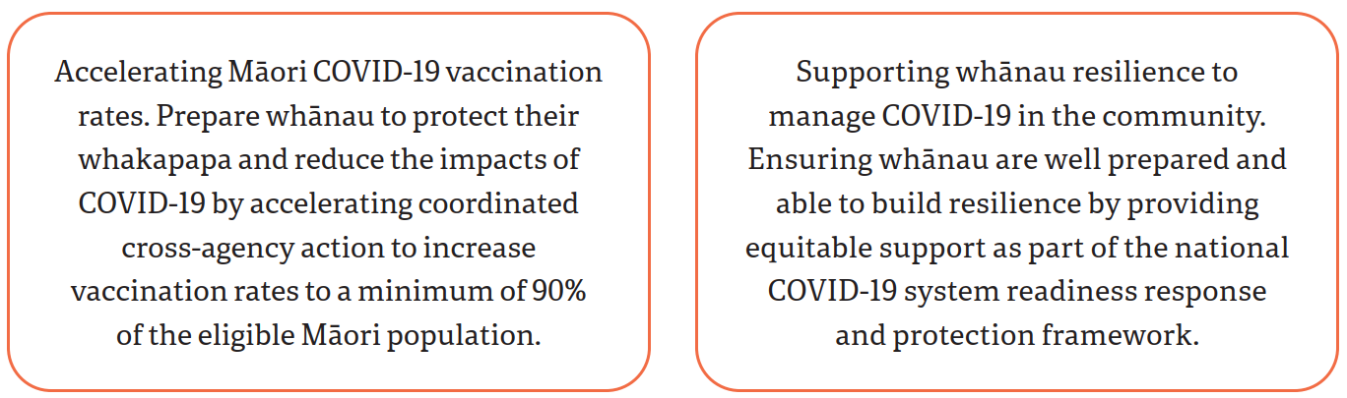

The Māori Protection Plan details actions that support the goals. Actions are grouped under two enablers: targeting information and increasing targeted health services for Māori that are easier to access. Underpinning these enablers are evidence and feedback from iwi and Māori providers about what works. Here we provide an update on actions taken under each enabler.

Enabler 1: Target and localise information and education for whanau
This enabler is about getting information out to whānau that is accessible, locally tailored, accurate and evidence based. Actions taken for this purpose have focused on understanding public health requirements, how COVID-19 is going to be managed in the community, supporting vaccination uptake, and addressing vaccination misinformation and hesitancy.

Whānau information and education campaigns and initiatives
Over 2021 and 2022, $3.09 million has been invested in two campaigns – Ngāti Rangatahi (an iwi- led initiative) and Karawhiua (led by Te Puni Kōkiri) – with the aim of lifting Māori COVID-19 vaccination rates. The campaigns are based on the understanding that it is essential to partner with iwi Māori and to resource Māori providers, communities and organisations to deliver communications in order to reach whānau Māori and empower them with information.

In both campaigns, Māori health providers supported the campaign strategy and roll-out.

Another initiative aiming to combat vaccination misinformation and disinformation was the Ngahere Communities campaign. It saw $300,000 invested in podcasts and a web series focused on directing Māori communities towards accurate sources of information on COVID-19 vaccination for children. In addition, Manatū Hauora provided secretariat support to the New Zealand Māori Council so that it could engage with Māori community leaders and collaborate with a range of agencies to address misinformation.

Alongside these specific campaigns, the Department of the Prime Minister and Cabinet has delivered targeted communications for Māori in collaboration with Māori creatives and communications experts. The Iwi Communications Collective network and channels such as iwi radio have delivered the messaging.

Evidence from research, social media monitoring and reporting from Māori providers indicates that working in partnership to deliver ‘by Māori for Māori’ communications and engagement has been effective in reaching Māori. Ngāti Rangatahi and Karawhiua, in particular, have had success in reaching Māori communities and are brands with high levels of trust and buy-in among Māori.

Another success from crafting communications content in a way that resonates with Māori is that the messaging has reached broader groups in Aotearoa as well. Social media monitoring showed that Māori-targeted content, with its characteristics of humour, plain language, transparency and visibility of trusted voices, resonated with many New Zealanders.

Mai i te Manatū
Mai i te Manatū, Manatū Hauora’s Māori COVID-19 response update pānui, was a major communications channel. It used the voice of Deputy Director-General of Health John Whaanga.

Mai i te Manatū began as a daily update of COVID-19 case numbers and important announcements early in the pandemic. As time went on, the pānui grew to include whānau-specific guidance on changes to the COVID-19 requirements, to share resources and content that whānau and providers could use, and to acknowledge the work of providers and staff across the Māori health sector.

The impact and reach of Mai i te Manatū grew over time. Over 900 editions of Mai i te Manatū were sent to 1,293 subscribers representing Māori providers, iwi, peak bodies and kaimahi hauora across Aotearoa. Māori media outlets also shared the pānui as part of their own daily update releases.

Mai i te Manatū ended in December 2022. The Ministry has now added a dedicated section for COVID-19 to its monthly Māori health pānui, Kia Tina.

Enabler 2: Increase integrated outreach health and social services for and with Māori
This enabler focuses on investment in outreach services during the COVID-19 response to deliver joined-up health and social services. It aims to reduce the inequitable impacts of COVID-19 on Māori by:
- empowering and resourcing local communities to rapidly coordinate their responses to COVID-19 outbreaks
- enabling Māori providers to offer timely and tailored health and social support to whānau while they are ill with and recovering from COVID-19.

Funding for Māori providers through the Delta and Omicron responses
Resourcing the Māori health sector and wider Māori communities has continued to be an essential part of the COVID-19 response for Māori. A total of $283.6 million has been invested in the COVID-19 Māori health response, including $36 million to Māori health providers to support the Delta outbreak response, and $29.6 million for the Omicron response. This is the biggest investment in Māori health services in over 20 years.

Māori health providers have provided integrated care and support to whānau to reach more Māori who did not have access to vaccinations against COVID-19 and other diseases. Reports from Māori providers showed that between February and July 2022, Omicron response funding has delivered:
- 81,400 COVID-19 vaccinations
- 7,790 other vaccinations
- 505,000 health consultations
- 166,500 whānau wrap-around support engagements.

Māori health providers have also used this funding to support their workforces, including by hiring additional vaccinators and supporting kaimahi wellbeing through a period of high demand for health services over the winter of 2022. See Appendix 4 for more information on how providers have used this funding.

Immunisation data indicates that Māori providers funded through the Delta and Omicron responses delivered more than double the doses of the COVID-19 vaccine to Māori compared with sites without targeted Māori funding between September 2021 and August 2022. Provider reports give qualitative evidence of a further benefit: the contact with services for COVID-19 vaccinations through this funding often prompted other health interventions with whānau as well.

‘Surprisingly many of the Māori whānau and other pockets of vaccinations given [to whānau] via referrals from other Māori organizations have been first time influenza vaccinations as they have either never heard of it, didn’t realize you should get it annually, or couldn’t ever be bothered paying for it, so we have helped to make whānau aware of it – not only this year but also moving forward.’ – Funded Māori provider

In reflecting on what supported them to reach their communities, providers identified an enabler was Manatū Hauora’s agile, flexible and high-trust commissioning approaches to distributing Māori-related COVID-19 funds.

National Immunisation Programme
The National Immunisation Programme has continued to make available complementary funding. The aim of this funding is to lift Māori uptake of vaccinations, particularly booster and paediatric vaccinations.

Vaccination events and initiatives
In May 2022, Māori providers received $6.35 million in outreach immunisation funding to expand their current COVID-19 vaccination services and deliver the full range of nationally approved immunisations. Particular targets for this funding and support have been communities where vaccination rates are lower than national rates, including Ōpōtiki, Kawerau, Murupara, Flaxmere, Wairoa, Tūrangi, Kaitī, Kaitāia and Kaikohe. Kaumātua, tamariki and rural communities have been other priorities.

Evidence from Māori influenza and measles programme evaluations has continued to inform the approach to vaccination initiatives. It confirms the value of investing in holistic approaches to immunisation and flexible, high-trust commissioning. COVID vaccination events have focused on whānau wellbeing, offering the opportunity for whānau to be vaccinated together and, in some cases, receive other health services at the same time. These community-led events have been held at times and locations convenient and comfortable for whānau, such as weekend or evening clinics on marae. Examples include the ‘Street Chat, Kai and Kōrero’, ‘Whānau Ora community day’ at Manurewa Marae, and Ta Hā Oranga’s ‘Whānau day’ at the Wellsford Community Centre.

Numerous experiences from vaccination events demonstrate the value of holistic approaches. For example, many whānau who attended the events were then vaccinated for COVID-19 or registered with a health practitioner for the first time. Providers have also reported that, while the numbers of vaccinations delivered at some events might be relatively small on a national scale, the vaccinations they delivered have been significant in the context of small, rural communities, or in communities with a high degree of vaccine hesitancy.

In addition, since May 2022, $2 million has been invested in the roll-out of Mā te Kōrero Ka Eke. This national programme takes a kaupapa Māori approach to improving uptake of COVID-19 vaccination for tamariki and their whānau, alongside other immunisations and health services. Mā te Kōrero Ka Eke is the first hauora programme to be delivered in kura kaupapa, kōhanga reo and wānanga. Examples of the programme’s initiatives to date include delivering holistic health services at kapa haka events and kōhanga reo anniversary celebrations.

While inequities remain in COVID-19 vaccination rates, Māori providers report success in reaching whānau that the system has historically failed to reach. Reasons that they give for this success are strong relationships, a larger workforce, improved supply, logistics and communications, and improved approaches to funding community initiatives.

Data sharing to support vaccination efforts
Alongside vaccination initiatives, Manatū Hauora entered into data sharing arrangements with providers, making it easier for them to deliver vaccination services. Data sharing agreements are now in place with 10 Māori providers, 16 iwi and five Māori commissioning agencies.
Reporting on these arrangements in September 2022 indicated that data sharing has given Māori providers insights into the needs of their communities, and supported them to target vaccination to where it is most needed. For example, a Māori provider that could use shared data went on to provide 21% of all COVID-19 vaccinations to Māori in the North Island.

Testing and supply
Since the last Monitoring Report, efforts have continued to ensure enough COVID-19 tests, personal protective equipment and antiviral medications are available.
Between February and June 2022, $20 million was committed to equity-specific testing and supply activity. Work focused on partnering with community providers to deliver fast, practical solutions that address equity in testing, mask distribution and access to anti-viral medications. These initiatives targeted Māori and others, including those in transitional housing and those with disabilities.

As part of this funding, nine million masks and 12 million rapid antigen tests were distributed to community partners, and 120 iwi Māori providers were given access to the Personal Protective Equipment (PPE) Portal. Free antiviral medication was also made available across the country for people in eligible groups who test positive for COVID-19, have symptoms or are household contacts. To be eligible for this programme, Māori or Pacific peoples must be aged over 50 years or have a high risk of severe illness from COVID-19.

According to evidence from PPE hubs and evaluative case studies, all of this work has supported providers to receive tests and supplies in a more timely and efficient way. Evaluative case studies indicate that critical steps in achieving equity are to take a pragmatic, community-centric approach, build trust with communities and communicate regularly.

Care in the Community
The Care in the Community programme involves a nationally resourced, regionally coordinated and locally led approach to support whānau who are isolating at home with COVID-19. This approach is based on the understanding that local providers know their communities best, and that welfare and wellbeing support should be tailored to respond to individual and whānau needs. Care in the Community brings together government agencies, providers and communities to provide easy access to services for whānau –there is no ‘wrong door’ preventing this access.

Because they are locally led, hubs differ in the way they were established, how they operate and the services they provide. However, across the programme there are five key service models for assessing and delivering care. These models are summarised in Figure 2, including a focus on manaaki, meeting clinical needs, whānau-centred care, keeping whānau safe and leaving whānau better off.

Figure 2: Care in the Community services
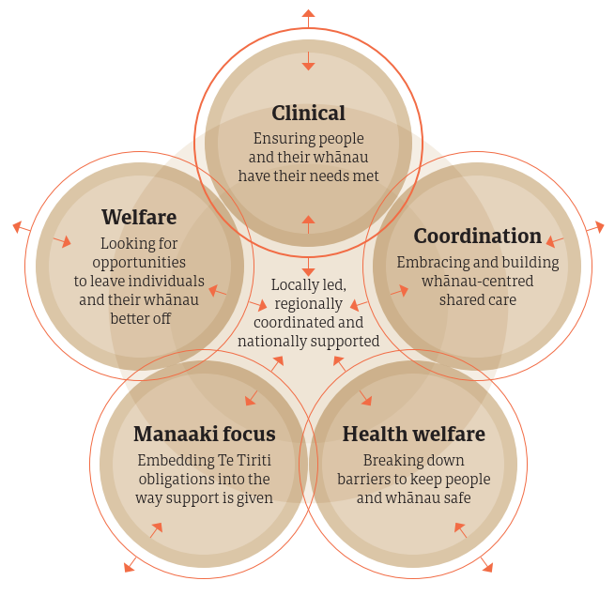

In all, 53 hubs have been operating in 2022, with total funding for the Care in the Community programme of $595 million. The majority of these hubs are integrated with kaupapa Māori services, and many are Māori- or iwi-led services. Between December 2021 and September 2022, Care in the Community hubs supported 1.75 million people isolating with COVID-19, of whom 263,680 were Māori. Hubs have delivered clinical assessments to 214,714 Māori with COVID-19, made 9,680 welfare referral requests for Māori with COVID-19 and supported 767 requests from whānau Māori for alternative isolation accommodation.

Real-time evaluation of and reporting from the hubs shows that the Care in the Community model has had a positive impact on Māori communities. Care in the Community has made it possible for people to ask for and receive support, and for whānau to isolate safely. For whānau it has also reduced their stress and worry about coping with the impact of COVID-19 on their health, income and wellbeing, and linked whānau to other supports and services, which will have ongoing benefits.

Ngā tatauranga matua | Key statistics

Health impact of COVID-19 on Māori
This section provides updated statistics on the overall impact of COVID-19 on Māori since the beginning of the Delta outbreak in August 2021. Because the Ministry has not differentiated between cases when collecting data, these statistics cover both the Delta and Omicron variants. For more detailed data and insights, see Appendix 2 and Appendix 3.

COVID-19 infection rates for Māori
Figure 3 shows the rate of COVID-19 infections for Māori compared with non-Māori non-Pacific peoples since August 2021.

Since the beginning of the Delta outbreak (17 August 2021), more than 272,400 Māori have contracted COVID-19, with 133,100 of those cases occurring since 1 April 2022. Over the current reporting period, the number of daily cases for Māori has not reached the peak of 5,315 on 7 March 2022, which the May 2022 Monitoring Report noted. Since 1 April 2022, the number of daily reported cases for Māori has fluctuated between 58 (on 24 September 2022 and 1 October 2022) and 2,894 (on 4 April 2022).

Figure 3: Cumulative case rate per 1,000 people by ethnicity, 17 August 2021 to 1 November 2022
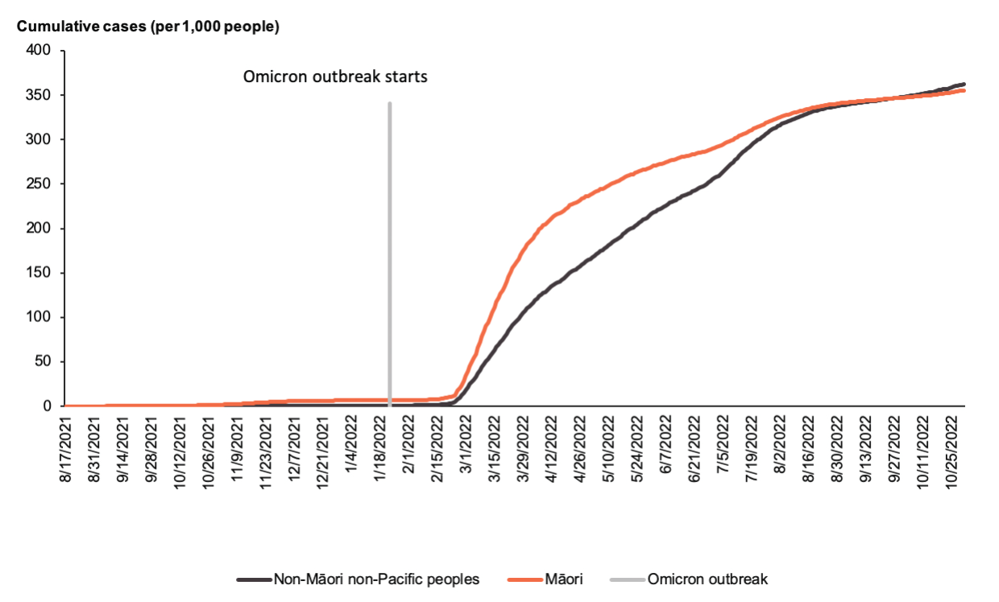

The increase in the crude rate of cumulative COVID-19 cases over time for Māori has decreased slowly over time while the non-Māori non-Pacific rate has increased steadily (Figure 3). As a result, the equity gap for reported cases has decreased from a peak in December 2021, when Māori were nearly 10 times more likely to have contracted COVID-19 than non-Māori non-Pacific peoples, to the extent that in August 2022 where the difference between the rates for Māori (339.5 cases per 100,000) and non-Māori non-Pacific peoples (338.0 cases per 100,000) were about the same.

Now no equity gap in cumulative case rates is evident between Māori and non-Māori non-Pacific peoples (355.32 cumulative cases per 1,000 Māori compared with 362.8 cumulative cases per 1,000 non-Māori non-Pacific peoples from the start of the Delta outbreak to 1 November 2022). However, feedback from Māori health providers suggests that at least part of the reason for this decrease in reported COVID-19 cases for Māori, and the resulting decrease in the equity gap, is due to under- reporting of Māori who have tested positive.

COVID-19 related hospitalisations
Since the beginning of the Delta outbreak, more than 1,190 Māori have been hospitalised due to COVID-19, at a rate of 155.2 COVID-19 related hospitalisations per 100,000 Māori. Around two-fifths (43.6% or 519 of the 1,190 hospitalisations) occurred since the May Monitoring Report (data to 1 April 2022).

Despite this increase, the equity gap between Māori and non-Māori non-Pacific peoples has halved since April (Figure 4). At that time, Māori were more than three times as likely to have been hospitalised with COVID-19 compared with non-Māori non-Pacific peoples. In contrast, as of 1
November 2022 Māori were 1.48 times more likely to have been hospitalised with COVID-19. See the ‘COVID-19 by age groups’ section in Appendix 2 for data on age-specific equity gaps for this period.

Figure 4: Cumulative COVID-19 hospitalisation rate per 100,000 people by ethnicity at date of hospitalisation, 17 August 2021 to 1 November 2022
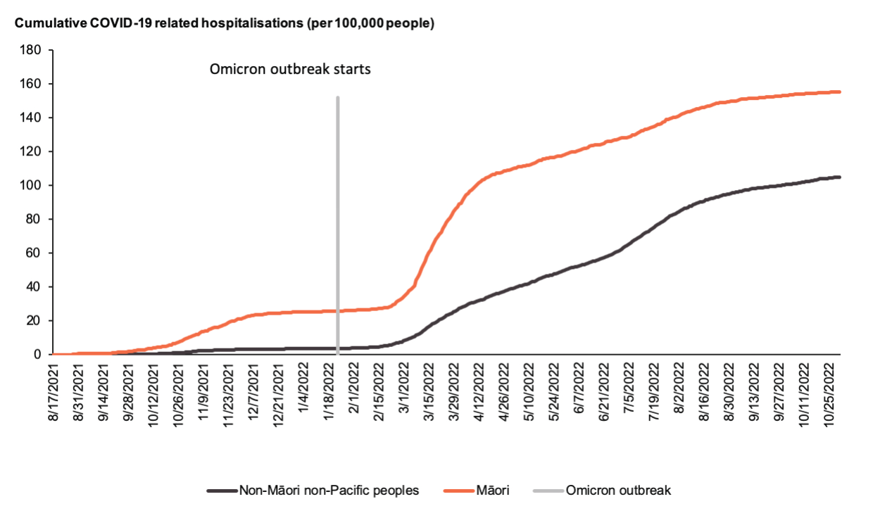

COVID-19 related mortality
Since the beginning of the Delta outbreak, 310 Māori have died within 28 days of being reported as a COVID-19 case and 183 Māori have died with COVID-19 as an attributable cause (Figure 5). Most of these deaths occurred over the 2022 winter; more than four-fifths occurred since the week ending 3 April 2022 (amounting to 80.0% of Māori who died within 28 days of being reported as a COVID-19 case and 76.0% of Māori who died with COVID-19 as an attributable cause).

Figure 5: Cumulative rate of deaths within 28 days and deaths attributable to COVID-19 by ethnicity, 17 January 2021 to 1 November 2022
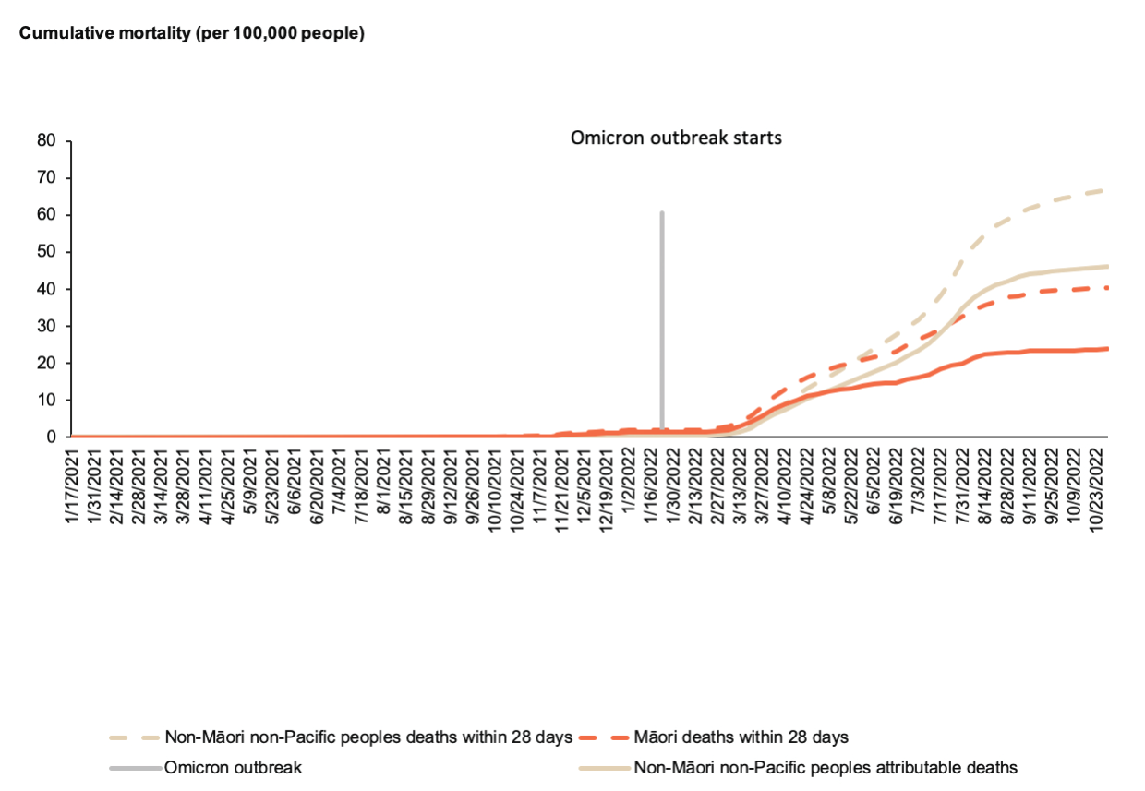

COVID-19 health outcomes by age
Māori have a younger population compared with non-Māori non-Pacific peoples. For this reason, breaking down the statistics reported above by age highlights how much age impacts these outcomes. Since the Delta outbreak, Māori have been less likely to contract COVID-19 in all age groups except for 30–39 years, 60–69 years and 70 years and above. In contrast, Māori in all age groups have been more likely to be hospitalised with COVID-19, die within 28 days of being reported as a case, or die with COVID-19 as an attributable cause.

The inequities in poorer health outcomes related to COVID-19 are particularly evident among those aged 60–69 years. In this age group, Māori were three times more likely to experience a COVID-19 related hospitalisation, over 3 times more likely to die within 28 days of being reported as a case and 3.5 times more likely to have a COVID-19 attributable death compared with non- Māori non-Pacific peoples of the same age. See Appendix 2 for more data on the health impact of COVID-19 on Māori by age.

Vaccination status of COVID-19 cases and of people hospitalised
Figure 6 shows the vaccination status of Māori COVID-19 cases between 17 August 2021 and 1 November 2022. Similarly, Figure 7 shows the vaccination status of Māori hospitalised with COVID-19 during the same period.
Around two-fifths of Māori COVID-19 cases were fully vaccinated (40.2%), which is slightly lower than the percentage reported as at 1 April 2022 (47.7% of Māori had received at least 2 doses when reported as a case), but is still higher than the 10% reported in the 20 December 2021 COVID-19 Māori health protection plan. The decrease in the percentage of fully vaccinated Māori cases is likely due to the increase in the number of cases who had received a booster (32.1% of Māori cases had ‘booster received’ as their vaccination status compared with 20.9% in the May Monitoring Report).

The data also highlights the importance of vaccination status in protecting people from further complications. Unvaccinated Māori with COVID-19 were nearly 3 times more likely to be hospitalised with COVID-19 (at 3,671 hospitalisations per 100,000), compared with Māori cases that were booster vaccinated (at 1,237 hospitalisations per 100,000).

Figure 6: Vaccination status of Māori COVID-19 cases, 17 August 2021 to 1 November 2022
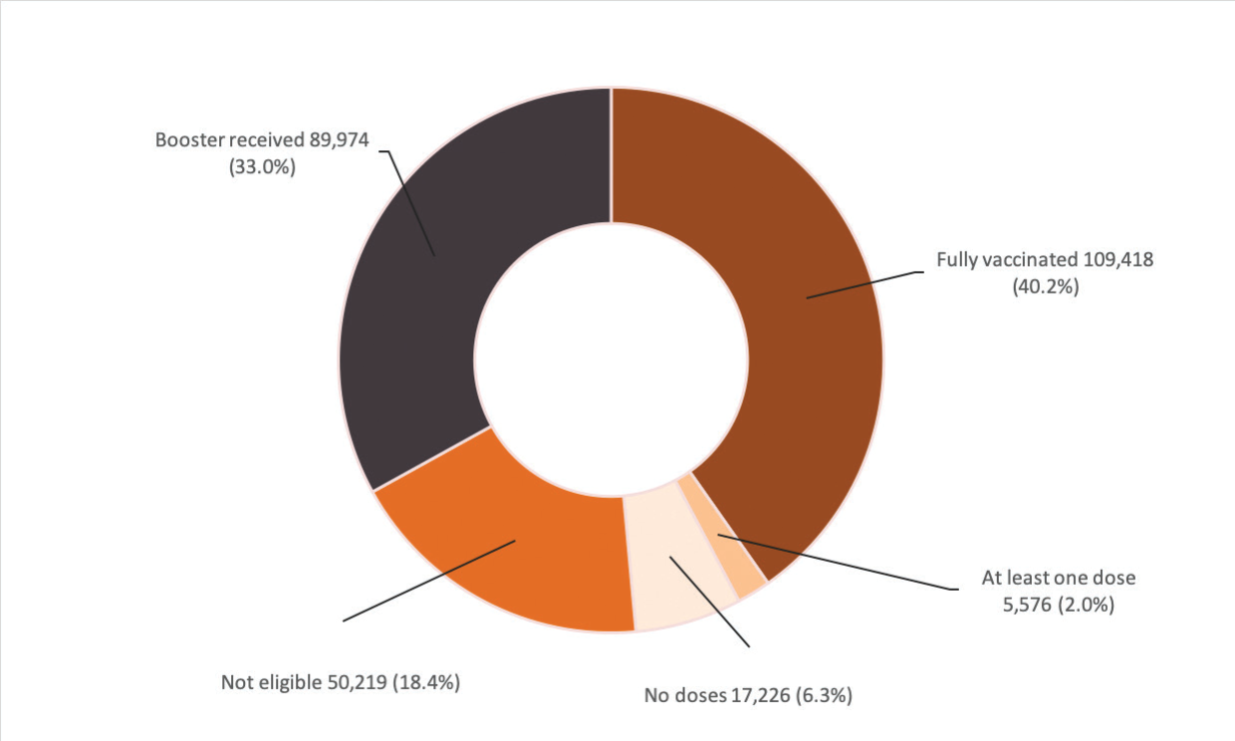

Figure 7: Vaccination status of Māori COVID-19 hospitalisations, 17 August 2021 to 1 November 2022
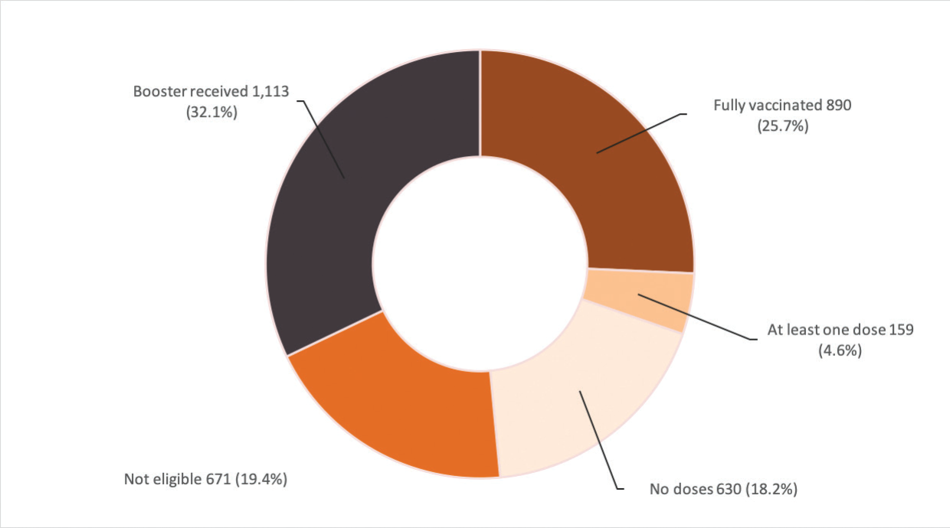

Vaccination rates
Since the May Monitoring Report, the COVID-19 vaccination uptake rate for first and second doses has not changed much: only another 850 Māori have received a second dose. In other areas, rates have increased more noticeably. Another 17,335 Māori have received the first booster dose and 46,100 have received the second booster dose. In addition, 1,385 Māori tamariki have received a first dose of the COVID-19 vaccine.

In June 2022 a second booster dose was made available for Māori aged 50 years and over and non- Māori non-Pacific peoples aged 65 years and over who had already received a first booster dose. The eligibility age for a second booster dose for Māori was lowered again in November 2022 to 40 years and over. The uptake of the first booster has heavily impacted the uptake of the second booster dose, as the same equity gap from the start of the first booster roll-out is evident six months later for the second booster dose (Figure 8).

Inequities in vaccination rates are also evident in booster uptake by age. Māori aged 50 years and over were less likely to have received a second booster (25%) compared to non-Māori non- Pacific peoples of the same age group (34%). See Appendix 3 for more details on the first, second, paediatric and booster doses uptake over time.

Figure 8: Second dose booster uptake per 100 adults aged 50 years and over by ethnicity, 21 February 2021 to 1 November 2022
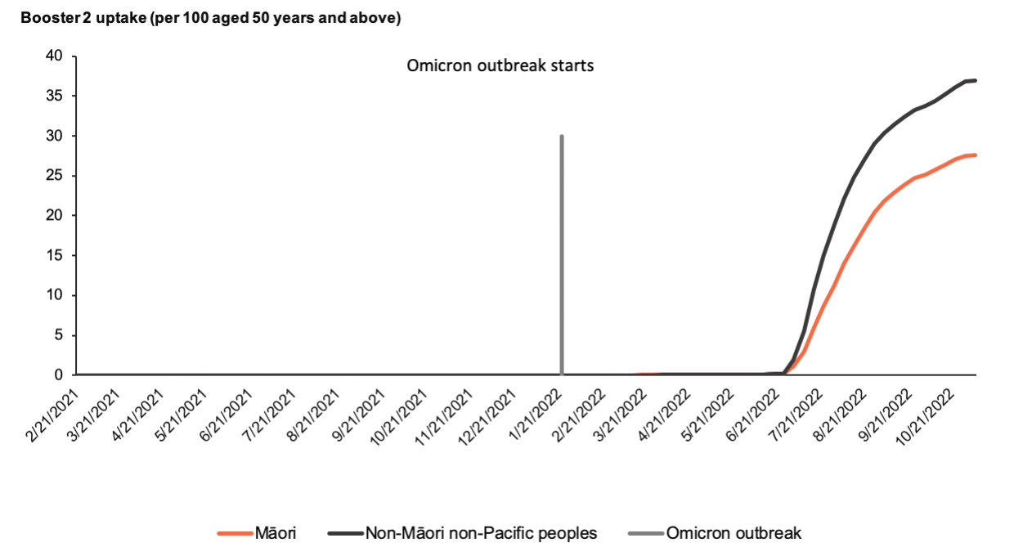

Tāngata whaikaha Māori
Data continues to be collected throughout the COVID-19 response, allowing us to build our understanding of the impact of COVID-19 on tāngata whaikaha Māori (disabled Māori). Between late 2020 and April 2022, tāngata whaikaha Māori were slightly more likely to have received one or more doses of the COVID-19 vaccine (89.2%) compared with other Māori (82.7%). Tāngata whaikaha Māori were also more likely to be aware of Māori health providers in their area (63%) compared with those not identifying as disabled (54%) and were more likely to go to a Māori health provider for primary health care (46% compared with 30% of other Māori).

However, compared with Māori not identifying as disabled, tāngata whaikaha Māori were more likely to report finding it hard or very hard to access and understand information about COVID-19. They were likewise more likely to report concerns about access to digital information, information overload and lack of time to process information.

Further insights into the experiences of tāngata whaikaha Māori during the Omicron outbreak identified barriers and challenges related to receiving COVID-19 tests, PPE, safely isolating with COVID-19, and disruption to Disability Support Services.

Further work is under way to develop data on COVID-19 experiences and outcomes for tāngata whaikaha Māori. The initial focus is on mortality and hospitalisation data for Disability Support Services users.

Other winter illnesses and wider health system performance
Rates of other respiratory illnesses, particularly influenza, were higher for Māori over the winter of 2022 than in previous years. While 2022 saw the highest proportion of Māori aged 65 years and over vaccinated for influenza (67.1%), the peak monthly rate of influenza-related public hospitalisations (18.7 influenza-related hospitalisations per 10,000 Māori in June 2022) was nearly three times the next largest peak over the past five years (6.8 influenza-related hospitalisations per 10,000 Māori in June 2019).

COVID-19 has affected the wider health system. For example, lockdowns and outbreaks have delayed services in areas like screening and elective surgery. The data also indicates that COVID-19 has exacerbated health inequities for Māori in some areas. For example, Māori childhood immunisation uptake was already declining from 2016, but it has declined more sharply since 2020. See Appendix 5 for an overview of key indicators of wider health system performance for Māori.

Te anga whakamua | Moving forward
Since the release of the May Monitoring Report, Aotearoa New Zealand has enacted the Pae Ora (Healthy Futures) Act 2022 (the Pae Ora Act) and moved to a new health and disability system. The Pae Ora Act requires the Crown to continue to meet Te Tiriti o Waitangi obligations, including by fostering effective Māori–Crown partnerships and achieving equity for Māori.

With the retirement of the Protection Framework, Aotearoa New Zealand has turned a page on our COVID-19 response. Over the next 12 to 18 months, services and supports for COVID-19 will be transitioned into business-as-usual health care services. This approach is intended to provide greater flexibility and certainty, and reduce the impact of COVID-19 measures on whānau, communities, businesses and our health care system.

As we transition to business as usual, it will be important to build on and embed the promising gains achieved through community-led responses to the COVID-19 pandemic. This section uses the data and insights gathered over the last 12 months to identify some key learnings from the Māori Protection Plan and how these learnings can guide future action.

Key learnings from monitoring the Māori Protection Plan
Over the last 12 months, more and better information on the Māori COVID-19 response has become available, providing insights and opportunities for improvement. Our growing evidence base has included:
- evaluations and reviews of effective approaches
- Māori-specific and kaupapa Māori research identifying improvements for Māori
- provider reports on needs, challenges and successes
- social media monitoring, and insights into ways of engaging and communicating that whānau prefer
- engagement with the Māori health and disability sector, iwi, communities and other government organisations, has improved collaboration and coordinated action.

Monitoring of the Māori Protection Plan has highlighted how, through focusing on equity and doing things differently, providers have supported Māori to prepare for and manage COVID-19.

Māori community-led solutions work
Several innovations help to explain why more Māori have received COVID-19 support. These include having services that are delivered by Māori providers; communications by Māori, for Māori and to Māori; and working in a partnership of iwi, providers, communities and government to deliver testing and supply PPE.

Care in the Community has received significant positive feedback, especially for delivering wrap-around support to whānau. With more efficient, flexible, high-trust contracting and commissioning, Māori providers have been able to more effectively innovate, mobilise rapidly and build trust with whānau in ways the system has traditionally failed to do.

‘We have worked extremely hard over the last 2 years and felt that we have made a meaningful contribution – health services, RATS distribution, food parcels, medication, mental health support, d[octo]rs and nursing service[s]
and advocacy and much more.’
– Māori health provider

It will be important to continue to strengthen whānau-centred services delivered by Māori providers, and services through Care in the Community, which are demonstrating new and better ways of organising health care. These improvements include taking a wellbeing approach, expanding access to primary care, and embedding collaboration across government agencies to deliver holistic services.

COVID-19 has put pressure on communities, their providers who serve them and the health system
While Māori community-led solutions have reached Māori, providers have reported that COVID-19 has increased the pressure on them.

‘The organisation is currently the welfare hub, a RATs distribution centre, Va[ccine] clinics, Supervised RA[T]s, and a clinic with increasing numbers of positive cases each day and a Hub lead across the sector, facilitating twice weekly forums. Our approach working from a cross-sector perspective in HUBs as well as across the region, appears to be working really well, but it is really hard, in particular for Iwi Hauora Organisations. We have chosen to lead out all of these initiatives, but they also come at a cost as the work feels like it is 24/7.’ – Māori health provider

A common theme in Māori provider reporting, particularly over the winter of 2022, is that having adequate resources and support is critical to support staff and kaimahi experiencing high workloads and fatigue. It will be important to continue to support the resilience of Māori providers and enable them to sustain their workforces to deliver community health services over the longer term.

Achieving equity is complex and requires enough time along with focused effort
Actions under the Māori Protection Plan have provided examples of how to put equity into practice and what we need to do to achieve equity for Māori. Case studies, evaluations and provider reports from Care in the Community, testing and supply, COVID-19 vaccination efforts and Māori COVID-19 communications have highlighted the importance of:
- Māori leadership at all levels
- putting equity at the centre of decision-making
- enabling providers to build relationships with communities
- enabling communities to lead responses
- collaboration across agencies.

‘Our success hinges on direct, critical relationships within the health system … To have people that respect and relate to your situation has relieved our burdens significantly. We don’t expect every problem to be instantly solved, but we do appreciate being heard, authentic efforts being made, and feeling like we have champions in the system sharing the burden with us.’ – Community leader

Opportunities for continuous improvement
International best-practice ‘learn-and-improve’ approaches underpin the World Health Organization’s epidemic and pandemic response in the Western Pacific region.

Over the last 12 months, monitoring, reporting, research and data sharing under the Māori Protection Plan have contributed to the evolving Māori COVID-19 response. An example is a survey of Māori health providers, established in response to the Omicron outbreak. The aim of the survey was to gain insights into challenges and innovations during the outbreak and providers’ perspectives on current health measures. The information collected through the survey was used to target Omicron response funding to Māori providers.

Another example is a study of Māori attitudes towards vaccination. It found several interconnected barriers to Māori getting vaccinated against COVID-19, including fear of adverse reactions,misconceptions and difficulty finding the right information. Recommendations from this research informed communications and engagement with Māori on vaccine hesitancy.

In recent months, Aotearoa New Zealand’s 2022 ‘winter COVID-19 wave’ highlighted the importance of continuing to monitor the current situation, and to model and plan for managing the impact of further COVID-19 outbreaks on Māori. It also pointed to the need to plan for future epidemics or pandemics.

Where we are heading

The COVID-19 landscape continues to evolve
Global evidence and Aotearoa New Zealand modelling indicate that we are likely to experience a consistent base level of COVID-19 cases throughout 2023, along with several surges.

Alongside this, widespread transmission of COVID-19 in Aotearoa New Zealand has resulted in rising numbers of New Zealanders experiencing post-COVID conditions (commonly known as long COVID). These conditions had affected an estimated 50,000 New Zealanders as at October 2022. Long COVID has a range of symptoms such as fatigue, shortness of breath and impacts on cognitive function, which occur 3 months from the initial COVID-19 infection and may fluctuate or relapse over time.

While data is still emerging, it is likely that Māori will be disproportionately affected by long COVID. This is because of inequities in vaccination rates and in the incidence of severe illness requiring hospitalisation, both of which are associated with a higher likelihood of developing long COVID. It will be important for the health system to continue to build our knowledge base around long COVID to address the effects and continue with efforts to prevent COVID-19 infections (and therefore long COVID).

Next steps
Work is under way to place Aotearoa New Zealand in a good position to prepare for, respond to and recover from future waves of COVID-19. Part of this work involves a focus on maintaining the momentum of system changes, and the legacy of community-led services built through the Māori COVID-19 response.

Aotearoa New Zealand is continuing to plan and prepare for potential changes in the COVID-19 situation. The Variants of Concern Strategic Framework was launched in June 2022 to prepare for the emergence of any new COVID-19 variants. It considers different future scenarios and our preparedness for responding to new variants.

In an immunisation context, COVID-19 vaccination is being embedded into the broader vaccination system. Vaccination activity will focus on all parts of the health system working together with iwi and community groups to deliver solutions. The National Immunisation Programme will also continue to support Māori health providers and the Māori vaccinator workforce, including supporting new vaccinator roles.

Work continues to share research and evaluation information related to the Māori COVID-19 response. Upcoming work includes better capturing data and insights from community vaccination events, research into the ongoing impacts of COVID-19 and future pandemic responses, and using further learnings from real-time evaluation of the Care in the Community welfare response.

Data collection and monitoring of the impact of COVID-19 will continue, alongside monitoring of overall health system performance in improving Māori health outcomes. Work is also under way to improve data for tangata whaikaha Māori, expand iwi affiliation data sharing and support Māori data sovereignty.

Ngā āpitihanga | Appendices
Appendix 1: COVID-19 Māori Health Protection Plan Monitoring Framework
Appendix 2: Cases and mortality
Appendix 3: Vaccinations
Appendix 4: Funding to Māori providers
Appendix 5: Wider health system measures

Appendix 1: COVID-19 Māori Health Protection Plan Monitoring Framework
Monitoring component | Sources and type of data | Why this is important?
Surveillance | Ethnicity and geography data across:  - confirmed and probable cases  - testing – positive and negative  - close contact tracing  - economic and social support for people  - hospitalisations for COVID-19 specifically  - influenza vaccination access coverage | To maintain close oversight of the impact of COVID-19 on Māori communities  To inform internal strategy and planning of the COVID-19 Māori Health Response
Monitoring of system performance | Ethnicity and geography data across the use of inpatient and outpatient services, including:  - ambulatory sensitive hospitalisations  - attendances at emergency departments  - use of outpatient services  - missed appointment rates for outpatient services  - use of community care services (eg, pharmaceuticals, childhood immunisations)  - psychosocial insights | To maintain oversight of potential impact of COVID-19 on Māori access to services
Māori- specific COVID-19 actions | Insights from contracts, including outcomes and outputs  - Qualitative insights from Māori communities and Māori health and disability service providers | To track the progress and impact of investment  To enable accountability to the Ministry for delivering on COVID-19 response actions
COVID-19 immunisation | Ethnicity, age and geography data across:  - number of COVID-19 immunisations delivered  - proportion of the population who has completed the first and second doses of the vaccine | To track the progress of the immunisation rollout for the Māori population

Appendix 2: Cases and mortality

Health impact of COVID-19 on Māori
This appendix provides further statistics on the overall impact of COVID-19 on Māori since the beginning of the Delta outbreak (17 August 2021). Because the Ministry has not differentiated between cases when collecting data, these statistics cover both Delta and Omicron variants.
Since the last set of data was published in the May Monitoring Report (data up to 1 April 2022), an additional 133,100 Māori have had COVID-19. Among them, 519 Māori have been hospitalised with COVID-19, 248 Māori have died within 28 days of being reported as a case and 139 Māori deaths have been attributable to COVID-19.

COVID-19 by age group
Māori have a younger population compared to non-Māori non-Pacific peoples, as such, disaggregating the earlier statistics by age highlights how age impacts these outcomes. Since the Delta outbreak, Māori were less likely to contract COVID-19 in all age groups except for 30 to 39 years, 60 to 69 years and 70 years and above age groups. In contrast, Māori were more likely to be hospitalised with COVID-19, die within 28 days of being reported as a case, or experience COVID-19 attributable mortality in all age groups.
The inequities in the poorer health outcomes related to COVID-19 are particularly evident in the 60 to 69 years age group, where Māori were three times more likely to experience a COVID-19 related hospitalisation, more than three times more likely to die within 28 days of being reported as a case, and three-and-a-half times more likely to have a COVID-19 attributable death when compared to non-Māori non-Pacific of the same age.

Figure 9: Cumulative case rate per 100,000 people by age group and ethnicity, 17 August 2021 to 1 November 2022
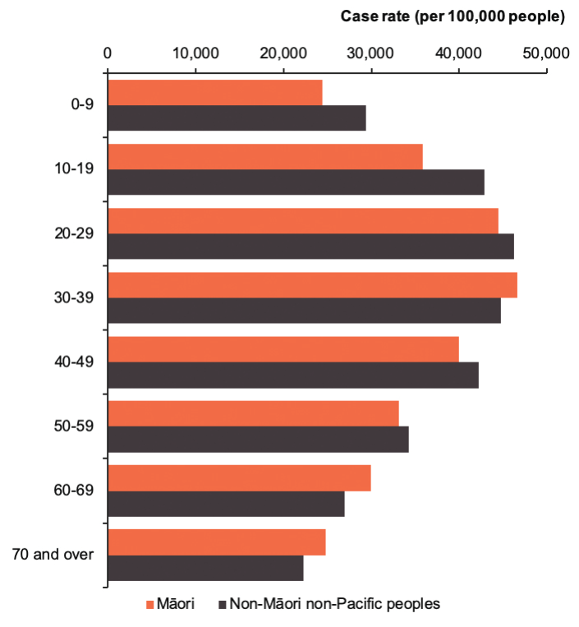
Figure 10: Cumulative hospitalisation rate per 100,000 people by age group and ethnicity, 17 August 2021 to 1 November 2022
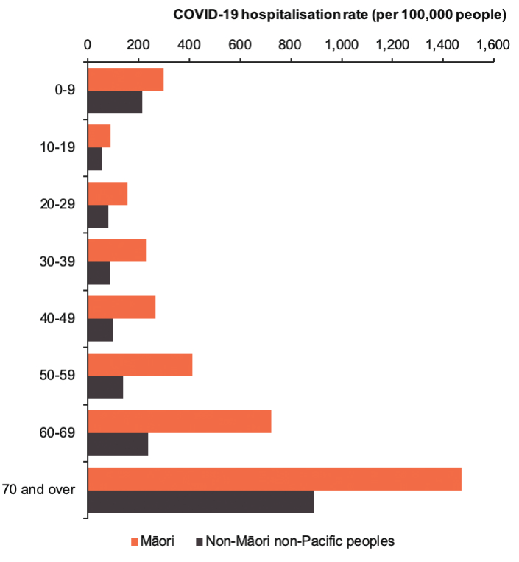

Figure 11: Cumulative deaths within 28 days of being reported as a case rate per 100,000 people by age group and ethnicity, 17 August 2021 to 1 November 2022
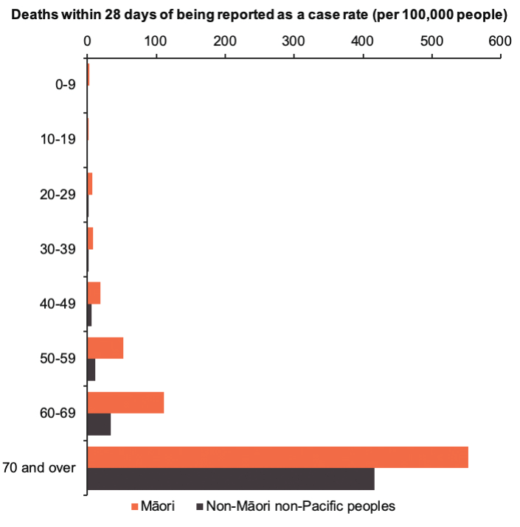

Figure 12: Cumulative deaths attributable to COVID-19 rate per 100,000 people by age group and ethnicity, 17 August 2021 to 1 November 2022
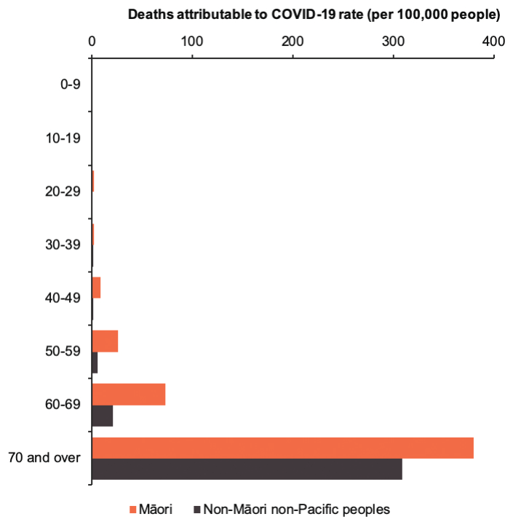

COVID-19 cases and hospitalisations by ethnicity and district

COVID-19 cases by ethnicity and district
The cumulative rate of cases per 1,000 people by district between the start of the Delta outbreak and 1 November 2022 shows all districts have slight equity gaps (Figure 13). The Northland district has the largest equity gap: Māori (at 328.5 COVID-19 cases per 1,000) were 18.0% more likely to have contracted COVID-19 over this period than non-Māori non-Pacific peoples (at 278.3 COVID-19 cases per 1,000). More than half (13) of the 18 districts had an equity gap of less than 10% between Māori and non-Māori non-Pacific cases. Of these districts, Lakes had no equity gap, meaning Māori and non-Māori non-Pacific peoples were about likely to have contracted COVID-19 over this time.

Figure 13: Cumulative COVID-19 case rate per 1,000 people by ethnicity and district, 17 August 2021 to 1 November 2022
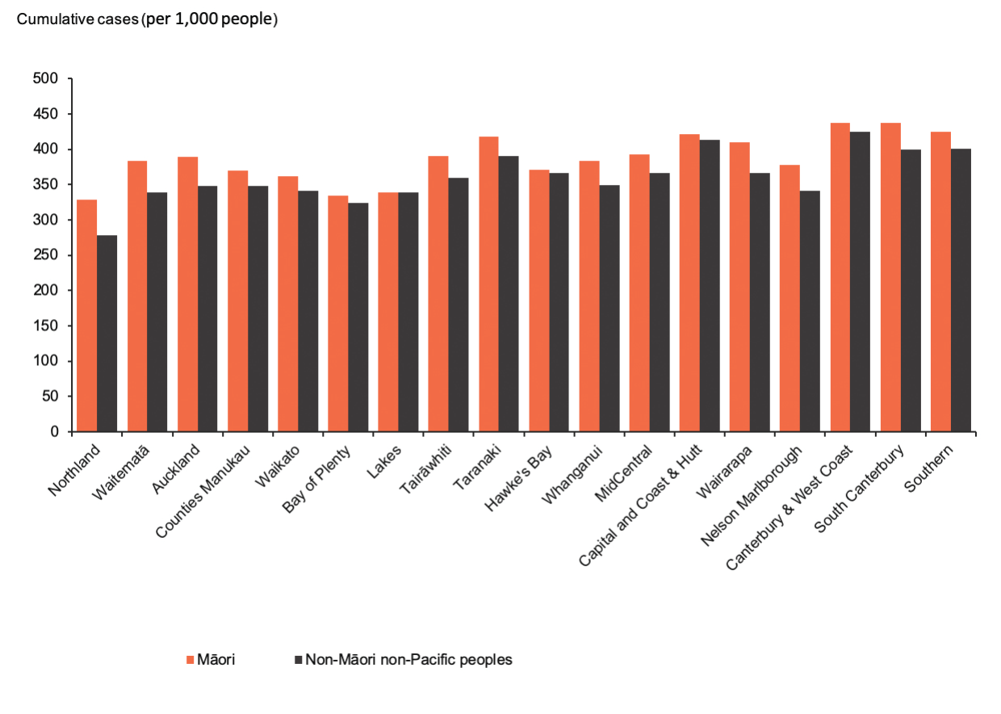

COVID-19 related hospitalisations by ethnicity and district
The cumulative rate of COVID-19 related hospitalisations per 100,000 people since the start of the Delta outbreak highlights how Māori across Aotearoa experience inequitable outcomes related to COVID-19 (Figure 14). The Auckland district has the largest equity gap: Māori (at 936.1 COVID-19 related hospitalisations per 100,000) are twice as likely to have experienced a COVID-19 related hospitalisation compared with non-Māori non-Pacific peoples (at 443.3 COVID-19 related hospitalisations per 100,000) over this period.

Māori had lower COVID-19 related hospitalisation rates in 5 districts over this period. In Tairāwhiti, Whanganui, MidCentral, Wairarapa and South Canterbury, Māori were around 20% less likely to have experienced a COVID-19 related hospitalisation than non-Māori non-Pacific peoples.

Figure 14: Cumulative COVID-19 hospitalisation rate per 1,000 people by ethnicity and district, 17 August 2021 to 1 November 2022
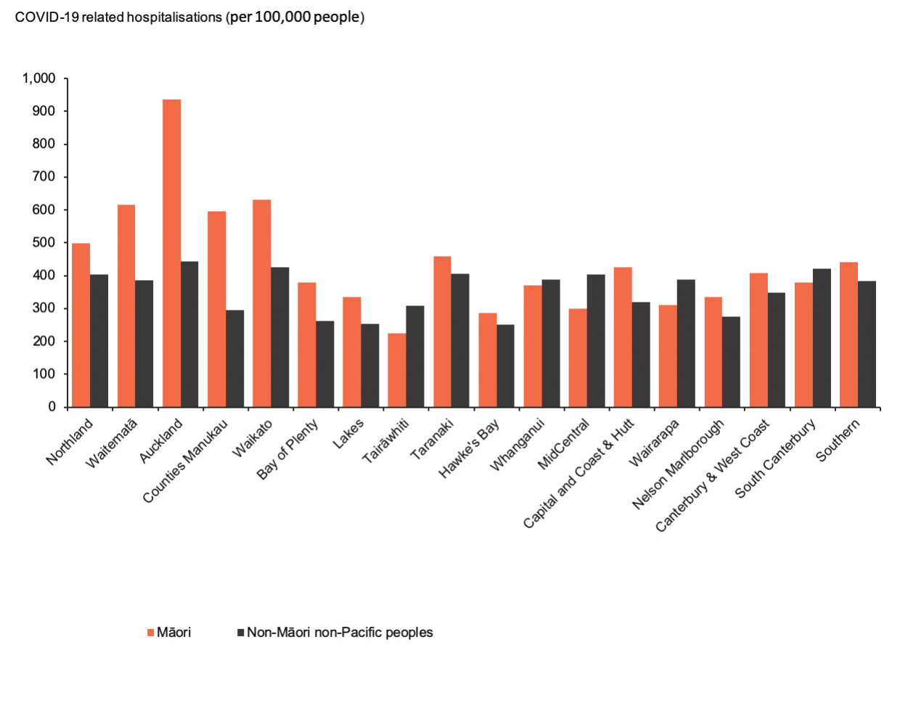

Appendix 3: Vaccinations

Change in population denominator and the impact of vaccination rates
Manatū Hauora commissioned Stats NZ to do an independent peer review of the Health Service User (HSU) data set, which is used to calculate COVID-19 vaccination rates. The review considered the methodology of the HSU data set and whether it was the best source for vaccine reporting. The purpose of the review was to contribute to the continuous improvement of future data sets used to report on vaccination rates. The review confirmed that the HSU data set is an appropriate way to measure vaccination coverage.

Te Whatu Ora – Health New Zealand started using the updated HSU 2021 data set from 8 August 2022 to calculate COVID-19 coverage. This replaces the 2020 HSU data set.

The data set will be updated every 6 months, each time the latest version is released. In this way, the most accurate information on vaccination coverage will continue to be provided.

Because the 2021 HSU update contains a larger number of eligible New Zealanders (creating a larger denominator), the proportion of people vaccinated has decreased. However, the actual number of people who have received the vaccine has increased. This increase is particularly evident for Māori. The latest update shows an additional 36,500 Māori aged 12 years and over have now been vaccinated.

For more information, see Manatū Hauora’s website.

Vaccination rates over time to 1 November 2022
Since the May Monitoring Report, the COVID-19 vaccination uptake rate for first and second doses has not changed much: only another 850 Māori have received a second dose. An additional 17,335 Māori have received the first booster dose, 46,100 Māori have received the second booster dose and 1,385 Māori tamariki have received a first dose of the COVID-19 vaccine.

Figure 15 shows the first dose uptake for the COVID-19 vaccine for people aged 12 and over by ethnicity over time. Figure 16 shows the same for the second dose. Both figures highlight a delay in vaccine uptake for Māori compared with non-Māori non-Pacific peoples, a trend that also appears in reports of the results of the booster uptake campaign. Despite this delay, work by iwi and Māori providers has seen a considerable decrease in the equity gap for the first and second doses. At 1 November 2022, 87% of eligible Māori had received at least one dose of the vaccine and 84% had received at least 2 doses.

The percentage of Māori who have received a booster vaccination has increased by 7% (3 percentage points) to 46% of eligible Māori since the May Monitoring Report (Figure 18). The increase is noteworthy because the eligible population also expanded in this period to include those aged 16 and 17 years (rather than those aged 18 years and over under the previous criteria). This change in eligibility did not impact the equity gap in uptake between Māori and non-Māori non-Pacific peoples. Among Māori aged 16 years and over, 46% received a booster dose, making them around 33% less likely to have received one than non-Māori non-Pacific peoples of the same age, of whom 69% had received a first dose booster as at 1 November 2022.

The paediatric first dose uptake shows a similar pattern with a 4% (1 percentage point) increase in Māori tamariki vaccinated between May and 1 November 2022 (Figure 17). The equity gap stayed reasonably constant as 32% of Māori aged 5 to 11 years had received a first dose vaccination, making them nearly 45% less likely to have had one than non-Māori non-Pacific children in this age group, for whom the vaccination rate was 59%.

Figure 15: First dose COVID-19 vaccination uptake per 100 people aged 12 years and over by ethnicity, 21 February 2021 to 1 November 2022
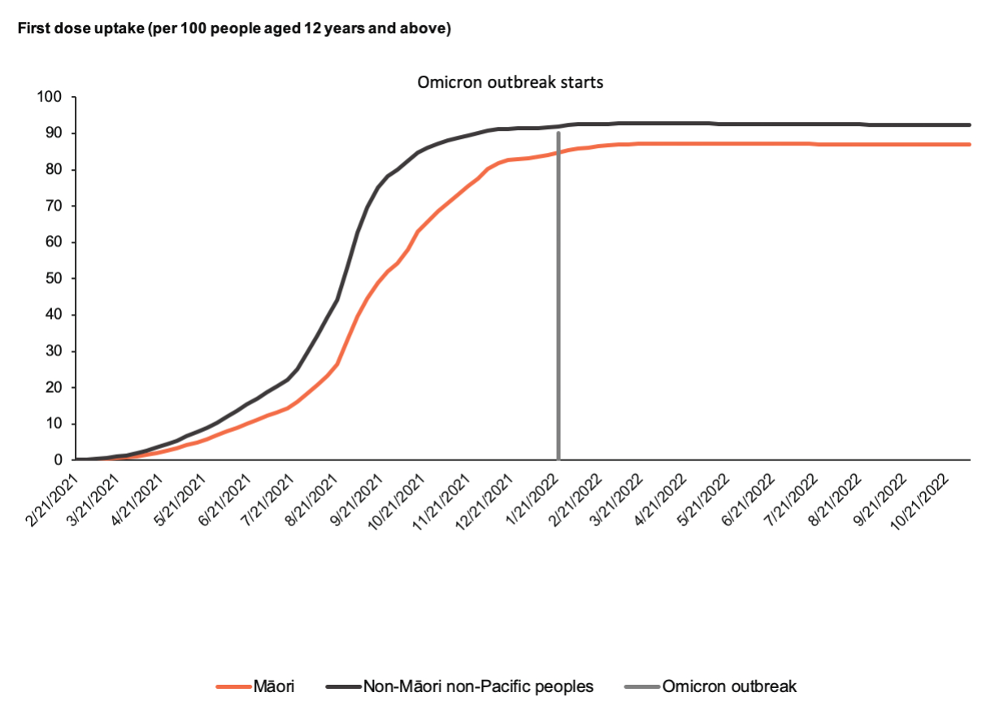

Figure 16: Second dose COVID-19 vaccination uptake per 100 people aged 12 years and over by ethnicity, 21 February 2021 to 1 November 2022
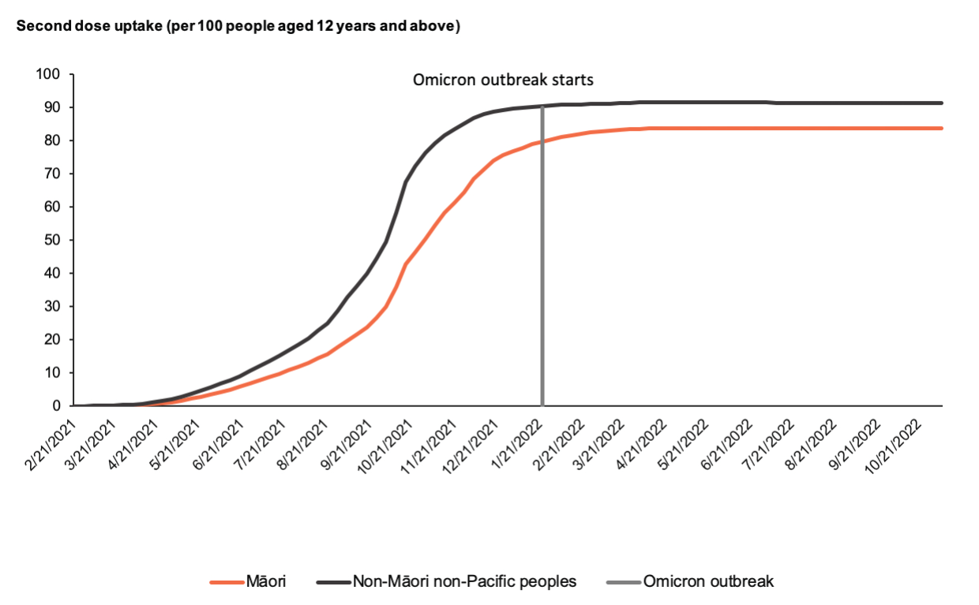
Figure 17: Paediatric first dose uptake per 100 children aged 5 to 11 years by ethnicity, 21 February 2021 to 1 November 2022
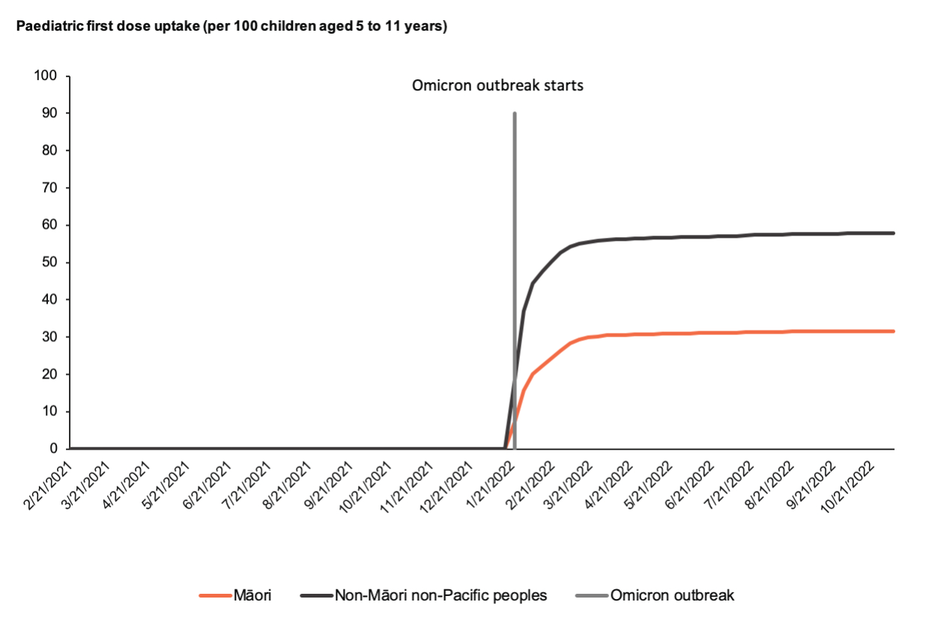

Figure 18: Booster uptake per 100 people aged 16 years and above by ethnicity, 21 February 2021 to 1 November 2022
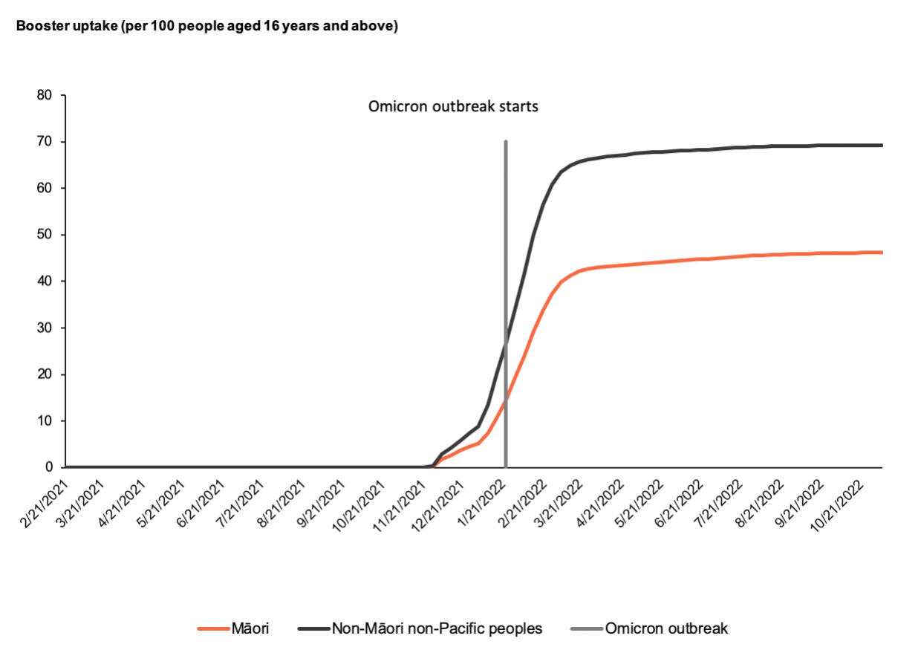

Appendix 4: Funding to Māori providers

Funding for Māori providers through the Omicron response
In addition to the $36 million distributed to 180 Māori health providers in response to the Delta outbreak, $29.6 million was distributed to 102 Māori health providers over February 2022 in response to the Omicron outbreak.

Drawing on information from the COVID-19 Māori provider feedback survey, this funding targeted the areas that Māori providers identified as of most concern. Specifically, it went towards supporting staff and addressing barriers for Māori to access health services – particularly the cost of prescriptions, vaccinations and primary care consultations.

Manatū Hauora’s priorities were to fund providers who supported tangata whaikaha Māori, and provided mental health services and Kaupapa Māori services, in line with the Ministry’s overall priorities in the COVID-19 response. Of the 102 Māori providers, 28 held Disability Support Services contracts with the Ministry and a further 18 used the Omicron funding to support access to services for tangata whaikaha, including general practitioner (GP) consultations, prescriptions and COVID-19 vaccinations.

Vaccination against COVID-19 remained a focus during the Omicron response, alongside complementary vaccinations such as against influenza, prioritising those who are more at risk of severe illness from COVID-19. In total, around 14,400 COVID-19 paediatric (ages 5–11 years) vaccinations and around 167,000 COVID-19 vaccinations for those aged 12 years and over were delivered. Around 27,070 influenza vaccines, 1,750 measles, mumps and rubella (MMR) vaccines and 38,970 other childhood immunisations were delivered as part of the COVID-19 response in this phase (Figure 20).

Figure 19: Number of primary care services that Māori health providers delivered with Omicron response funding, February to July 2022
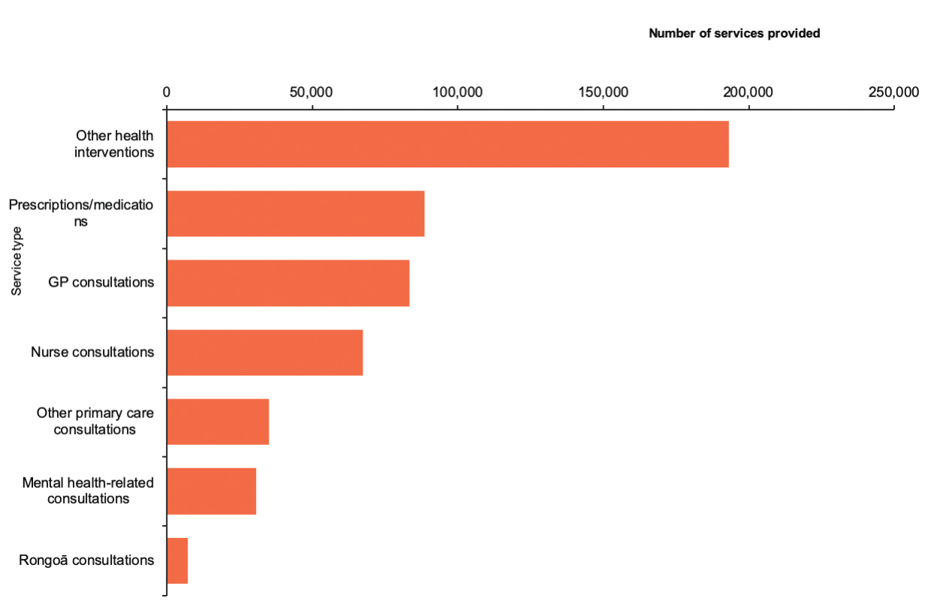

Between February and July 2022, Māori health providers delivered over 505,000 health consultations, including around 83,000 general practitioner consultations, 67,000 nurse consultations, 30,000 mental health consultations and 88,000 prescriptions (Figure 19). Many consultations were provided for free or at low cost to support access. This included removing co-payments for prescriptions, medications and a range of health consultations for whānau as appropriate.

In total, over 166,500 whānau wrap-around support engagements were delivered as part of the Omicron response. These engagements included over 103,960 wellbeing check-ins, supporting around 20,800 whānau with travel to access health services, and helping about 41,800 whānau to navigate health services or referring them to other services.

Many providers offered extended hours in the evenings and weekends, as well as continuing to offer online and telephone consultations. Acknowledging not all whānau had enrolled with a general practice, some providers expanded their low-cost consultation fees to include non- enrolled whānau and provided free consultations to those aged under 18 years.

Figure 20: Number of vaccinations that Māori health providers delivered with Omicron response
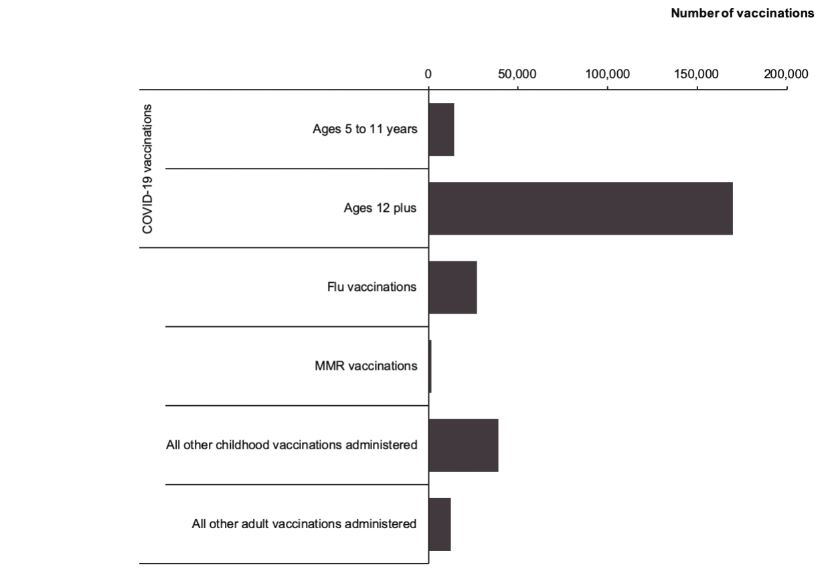

Figure 21: Number of staff supported through Omicron funding to Māori health providers, February to July 2022
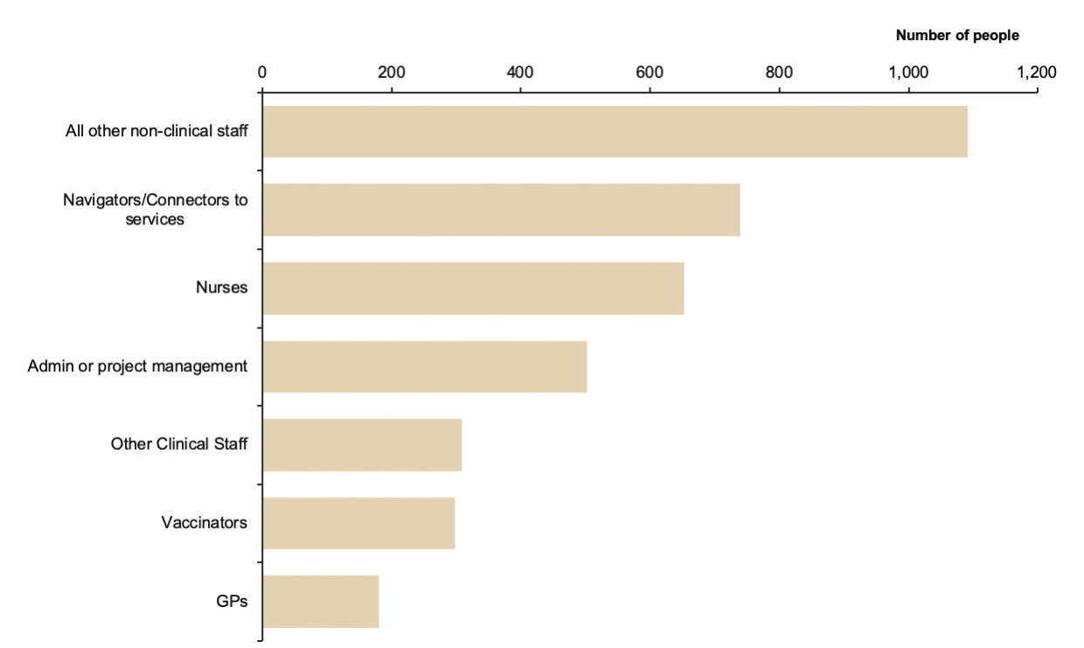

Support to Māori providers throughout the COVID-19 Delta outbreak
In September 2021, the COVID-19 Ministerial Group approved a $36 million package to support the Delta outbreak response for Māori. The Māori COVID-19 Delta outbreak response supported over 180 Māori health and community providers across a range of services. This included:
- provider and whānau support funding totalling over $25.9 million for 157 Māori health and community providers such as primary care organisations, mental health and addictions service providers, disability services providers, rongoā practitioners, and iwi, wahine-focused and rangatahi-focused providers
- targeted psychosocial funding of $2.9 million for 15 kaupapa Māori mental wellbeing initiatives focused on rangatahi, 8 kaupapa Māori mental health and community providers and a national multimedia psychosocial campaign.

Some providers were funded as part of a consortium, which meant that only 133 of the 180 Māori providers noted above were required to report back on their use of their Delta support funding.

The figures given in this section are an update to the reporting published in the May Monitoring Report and include complete responses.

COVID-19 related services to support whānau
Figure 22 shows the number and types of services delivered to whānau from Māori providers, with support from the Delta response funding.

The largest number of services provided related to delivering COVID-19 vaccinations (52 providers offered services in this category), with more than 835,000 vaccinations given with help from the Delta response funding. Support for services that were not specifically related to COVID-19 included subsidising more than 190,000 GP consultations or addressing other barriers, such as transport. In addition, funding went to nearly 60,000 consultations for mental health services.

Figure 22: Number of health services that Māori health providers delivered with Delta response funding, September 2021 to February 2022
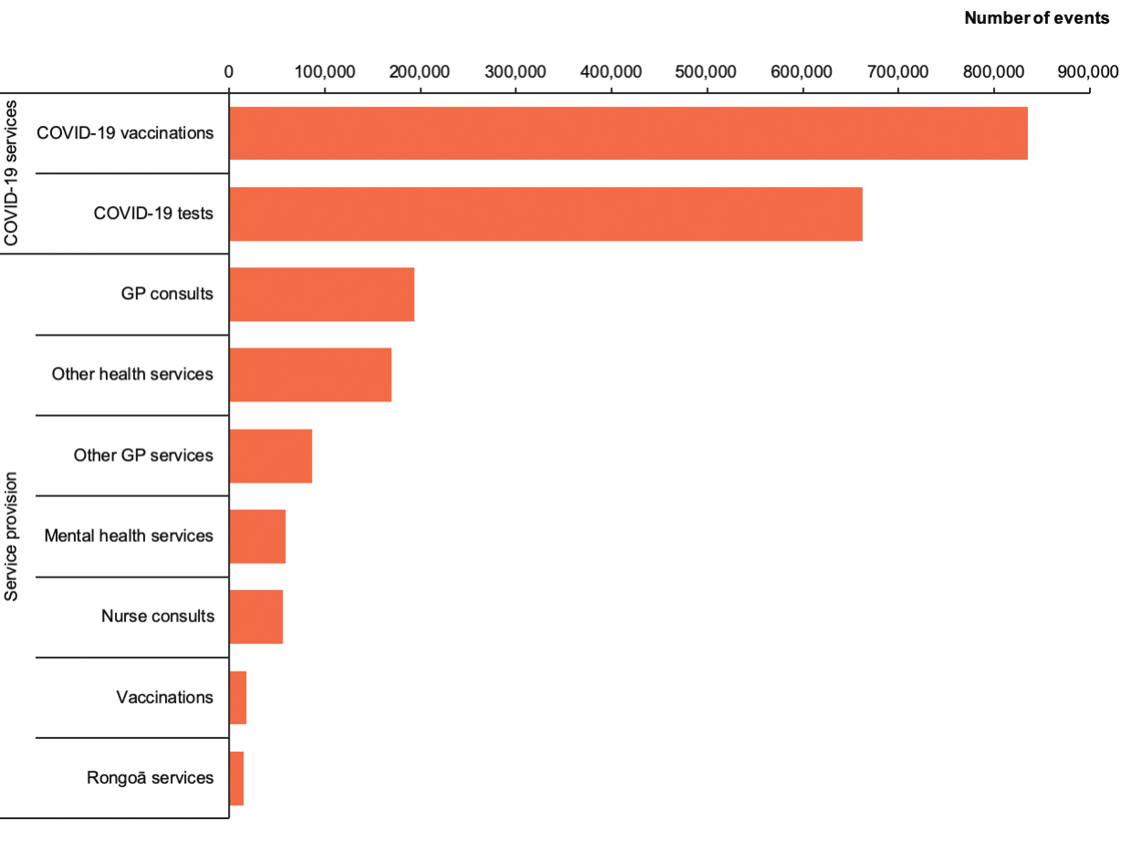

Whānau support services
Figure 23 shows the number of whānau support services delivered with help from the Delta response funding. The majority of providers (86) used the funding to distribute more than 140,000 hygiene packages, making this the most frequently provided service to whānau from this funding. Providers also used this funding to supply more than 100,000 kai packages and nearly 50,000 rongoā packages to whānau. These packages supported the holistic health and wellbeing of whānau through offering supplies and resources that responded to broader health needs.

Figure 23: Number of whānau support items provided through the Delta response funding, September 2021 to February 2022
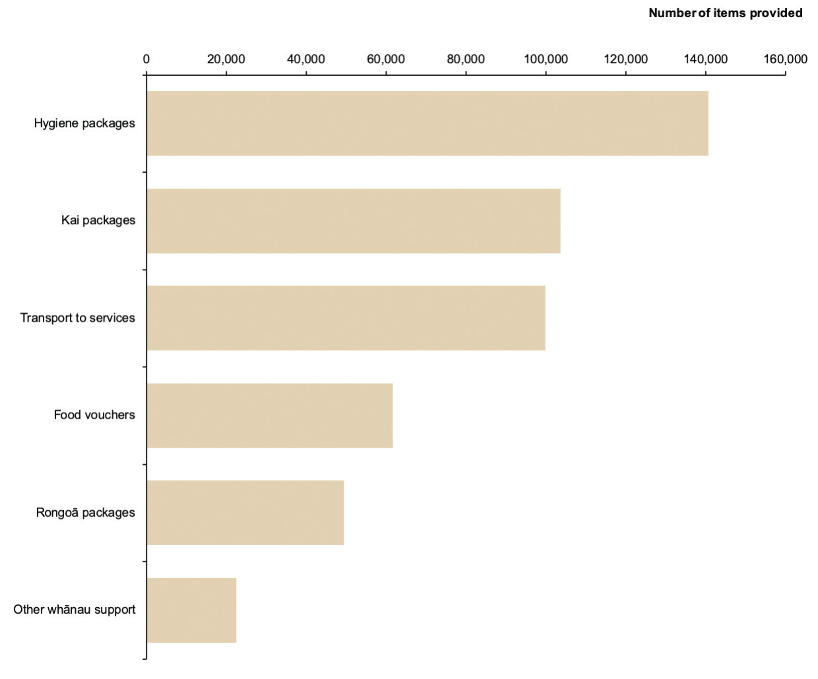

Support for staff
Figure 24 shows the number of staff in different roles who received support through the Delta response funding. Such support may have included overtime pay, koha and wellbeing packs for staff, and funding for surge capacity. The majority of providers (74) used the funding to support more than 5,100 kaiāwhina. More than 450 nurses and more than 270 rangatahi in support roles also received support through this funding.

Figure 24: Number of staff supported through the Delta response funding, September 2021 to February 2022
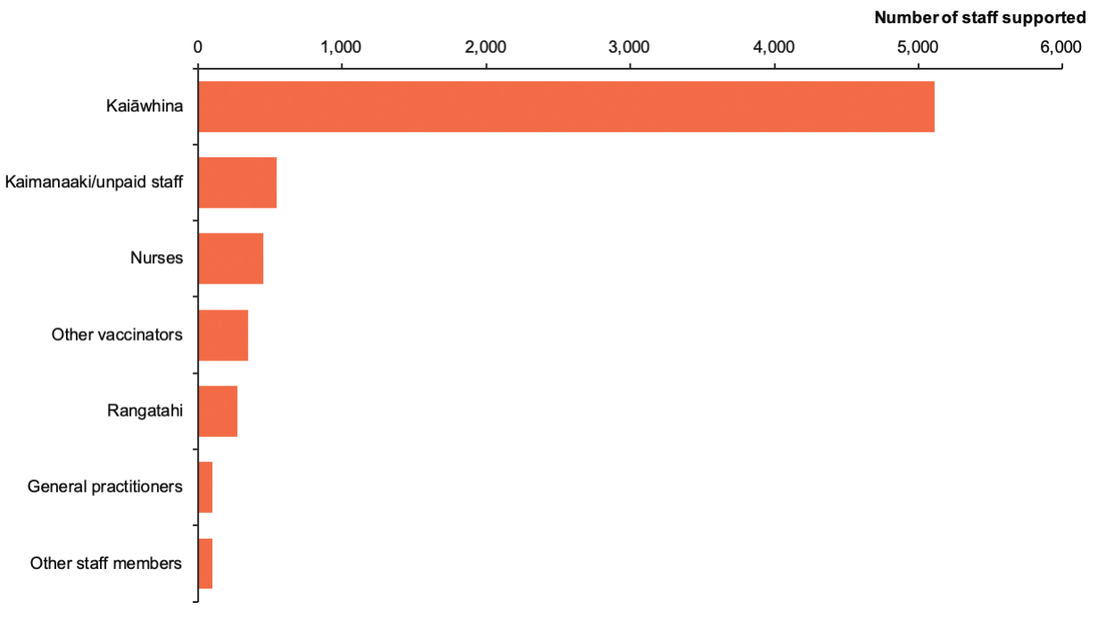

Appendix 5: Wider health system measures

Childhood immunisation uptake
Figure 25 shows the proportion of Māori pēpi that have completed their childhood vaccinations at 18 months and 24 months each quarter from 2016 to 2022. For more detail on the childhood vaccination scheme, see Manatū Hauora’s website.

Māori childhood immunisation uptake has declined since 2016 for both the 18-month and 24-month immunisation milestones. A particularly noticeable decrease in completed vaccinations occurred over 2020. For Māori pēpi aged 18 months, completed vaccinations decreased from 73.4% in the first quarter of 2020 to 53.3% in the first quarter of 2021. Similarly, for Māori tamariki aged 24 months, the rate fell from 86.4% in the first quarter of 2020 to 78.6% in the first quarter of 2021.

As at quarter 3 in 2022, Māori pēpi aged 18 months (of whom 43.6% had completed their vaccinations) were 43% less likely to have completed their vaccinations at this milestone than non-Māori, non-Pacific babies of the same age (of whom 76.5% had completed their vaccinations).

In the same quarter, Māori tamariki aged 24 months (of whom 67.3% had completed their vaccinations) were 24% less likely to have completed their vaccinations at this milestone than non- Māori, non-Pacific children of the same age (of whom 88.4% had completed their vaccinations).

Figure 25: Completed vaccinations for Māori pēpi and tamariki at 18 and 24 months by quarter, 2016 to 2022
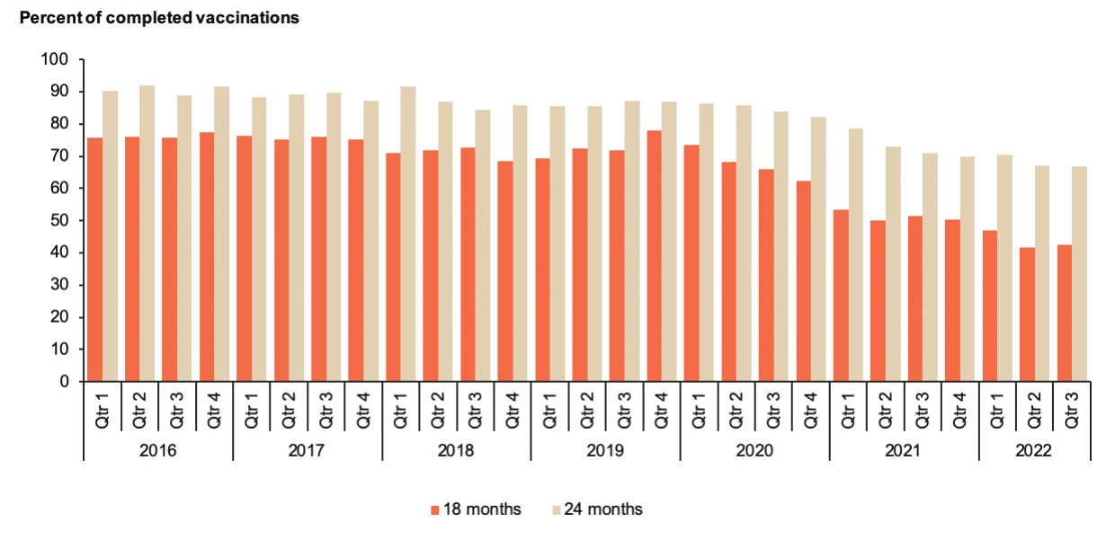

Influenza vaccination uptake for Māori aged 65 years and over
Figure 26 shows influenza vaccine uptake rates for Māori aged 65 years and over between 2018 and 2022, as at 9 October 2022. It shows that 67.2% of Māori in this age group received an influenza vaccine in 2022, making them 32% more likely to have received it than Māori in the same age group in 2021 (50.8%) and 19% more likely than Māori in the same age group in 2020 (56.4%).

This highlights the influence of the continued targeted immunisation programmes since the beginning of the COVID-19 outbreak.

Figure 26: Cumulative influenza vaccination uptake for Māori aged 65 years and over by week, 2018 to 2022
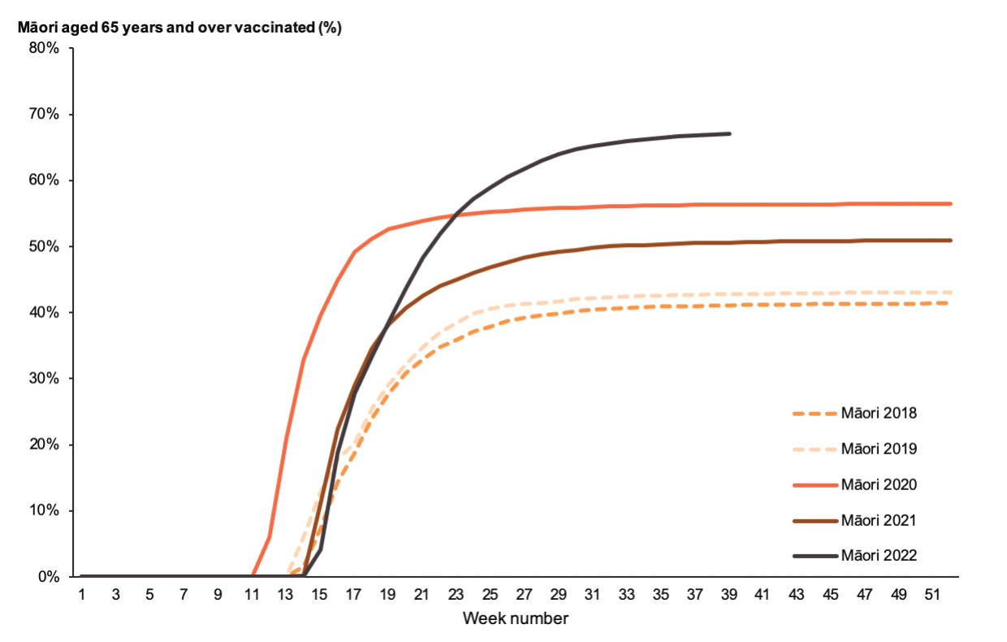

Ambulatory sensitive hospitalisations over time
Ambulatory sensitive hospitalisations (ASH) are admissions to hospitals that could potentially be reduced through primary health care interventions. This is a key multi-morbidity measure of how well the primary health care system is working for young Māori tamariki.

In the latest quarter (between 1 July and 1 October 2022), Māori tamariki aged 0–4 years (with 167.2 ASH events per 10,000 tamariki) were 1.29 times (29%) more likely to experience an ASH than non-Māori, non-Pacific children in the same age group (with 129.1 ASH events per 10,000 children). This equity gap is the second smallest compared with the same quarter in the previous 7 years.

The ASH rates in quarters 2 and 3 in 2020 remain the lowest for all ethnic groups because the first COVID-19 lockdown reduced access to hospital services. The rate of ASH events per 10,000 Māori tamariki was 81.1 in quarter 2 of 2020 and 137.5 in quarter 3 of 2020 (Figure 27).
Figure 27: Ambulatory sensitive hospitalisation rate per 10,000 people aged 0–4 years by quarter and ethnicity, 2016 to 2022
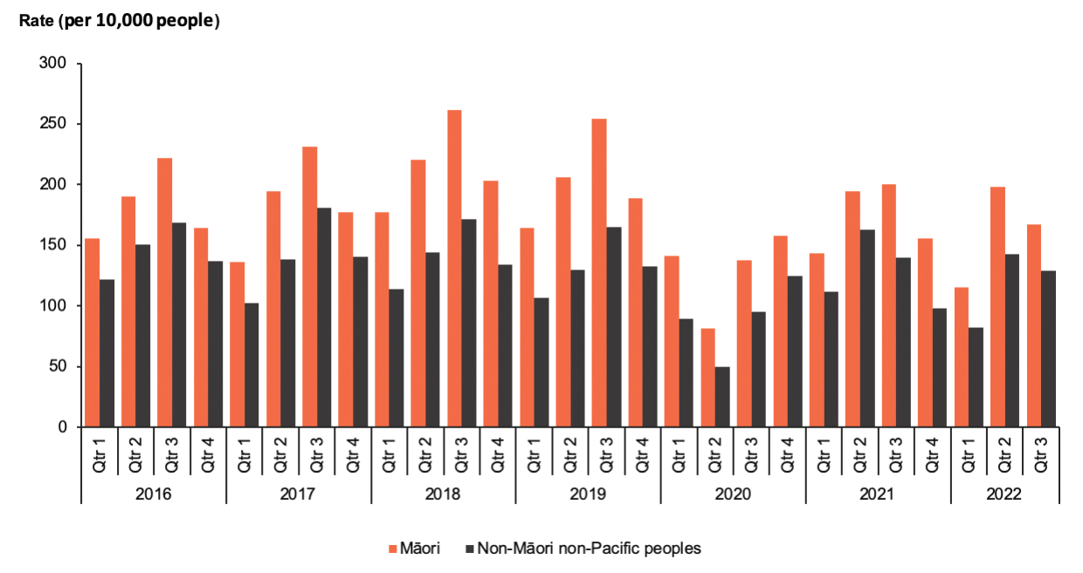

Missed appointments for first specialist assessments over time
Outpatient services that are safe and appropriate for Māori patients and their whānau are essential to improving health outcomes for Māori. This measure places responsibility on health providers to offer services at times, in settings and in ways that build trust and work for Māori.

In the latest quarter (between 1 July and 1 October 2022), Māori missed 12.6% of first specialist appointments, which made them over 3 times (215%) more likely to do so than non-Māori, non- Pacific peoples (of whom 4.0% missed these appointments) (Figure 28).

This is the smallest equity gap when compared with the same quarter across the previous 7 years. For Māori, the highest proportion of missed appointments (14.1%) occurred in the surgical specialist group.

Figure 28: Percentage of first specialist appointments missed by ethnicity and quarter, 2016 to 2022
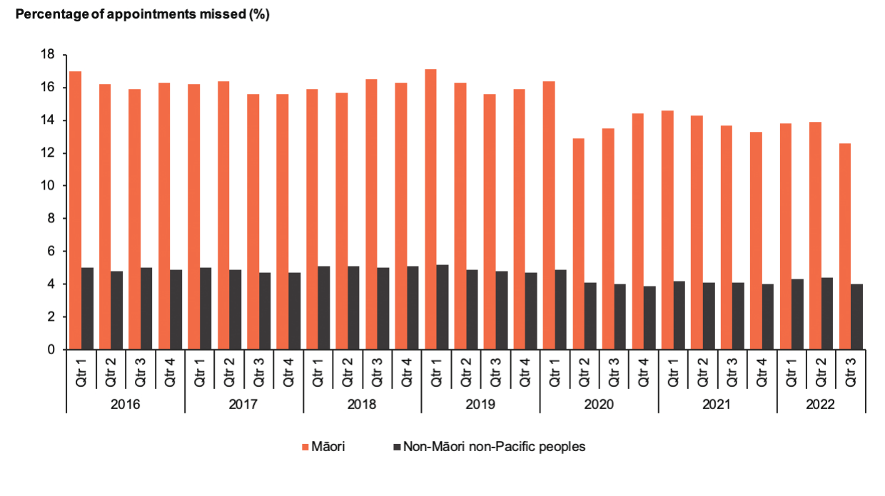

Emergency department use over time
In New Zealand, emergency departments (EDs) provide care and treatment for patients with serious injuries or illness, either real or perceived. This includes resuscitating and stabilising critically unwell or injured patients who often require admission to hospital. An ED will conduct sufficient workup of a patient (eg, physical examination, laboratory tests, X-rays) to decide whether the patient should be discharged or admitted to the hospital. The vast majority of EDs are open 24 hours a day, 7 days a week. They are publicly funded, although some facilities may charge for GP-level care at an ED.

Figure 29 shows the monthly age-standardised rate of emergency department attendances per 1,000 people by ethnicity between 2019 and 2022.

Over August 2022, Māori made 25.2 ED attendances per 1,000 Māori. This made them nearly one-and-a-half times (43.2%) more likely to attend an ED than non-Māori, non-Pacific peoples (who made 17.6 ED attendances per 1,000 non-Māori, non-Pacific peoples) after adjusting for age.

ED attendances decreased markedly across all ethnic groups during the first lockdown, from 25 March 2020 (with the move from Level 3 to Level 4) to 27 April 2020 (with the move from Level 4 to Level 3). A similar decrease occurred in the August Delta lockdown (17 August to 31 August 2021) for Māori, along with a smaller decrease for non-Māori, non-Pacific peoples.

Figure 29: Age-standardised emergency department attendances by ethnicity and month, 2019 to 2022
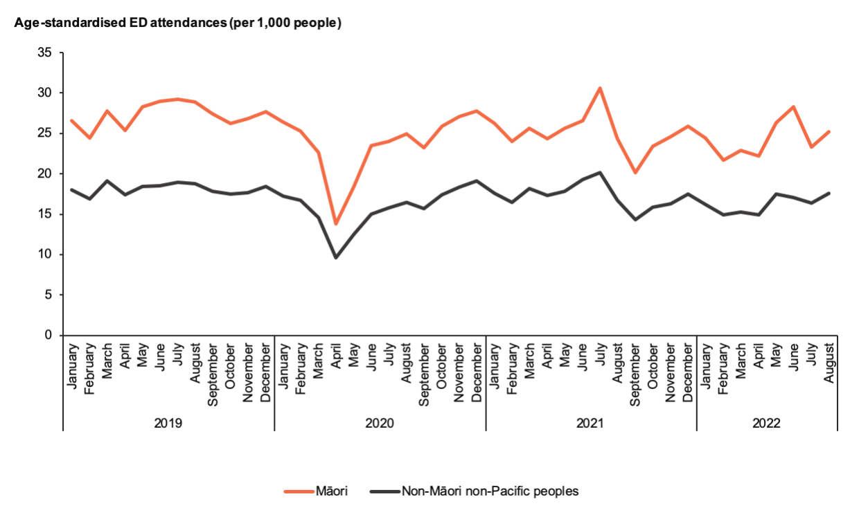

Research throughout the COVID-19 response found that Māori were more likely to listen to whānau members, leaders in their community, and health professionals than government. They were also more likely to engage with campaigns and events that had no obvious links with government.
In total, 167 vaccination sites associated with Māori providers, including mobile units, marae and central hubs, received funding through the Delta and Omicron responses. The other 2,020 sites were not associated with Māori providers.
Episurv, ESR and National Contact Tracing System, Ministry of Health, 17 August 2021 to 1 November 2022.
Māori provider COVID-19 feedback fortnightly survey, Ministry of Health, August 2022
Some deaths within 28 days of being reported as a COVID-19 case may also be reported as deaths with COVID-19 as an attributable cause. For this reason, it is not possible to add together the 2 categories to work out the total number of COVID-19 related deaths.
Episurv, ESR and National Contact Tracing System, Ministry of Health, 2022; COVID-19 Immunisation Register, Ministry of Health, 2022.
7 Tangata whaikaha are as at March 2022. Data sourced from Social Welfare Agency. 2022. Updated analysis: COVID-19 vaccine uptake by disabled people. URL: swa.govt.nz/publications/reports (accessed 26 January 2023).
Horizon survey, 2021.
How’s it going for the disability community survey, 2020.
Baker G, King P. 2022. Inquiry into the Support of Disabled People and Whānau during Omicron. Wellington: Te Kāhui Tika Tangata Human Rights Commission.
After adjusting for age. Source: Numerator from the National Minimum Dataset, Ministry of Health 2022, and denominator from Health Service Utilisation, Ministry of Health.
The Ministry’s preference is for the neutral term ‘missed appointment’ rather than ‘did not attend’, which places sole responsibility on the service user.
The specific psychosocial survey has ended. However, this data will now be collected as part of the wider New Zealand Health Survey.
Deaths within 28 days of being reported as a case and deaths attributable to COVID-19 are not mutually exclusive, therefore these categories do not sum to the total number of deaths related to COVID-19.
Māori provider COVID-19 feedback fortnightly survey, Ministry of Health, March 2022.
New Zealand Immunisation Schedule. URL: health.govt.nz/our-work/preventative-health-wellness/immunisation/new-zealand-immunisation-schedule (accessed 30 January 2023).
Age-standardised rates are standardised to the 2001 Census Māori population.

