PRMS Corrective Action Monitoring (CAM) management process

Overview of the CAM management process
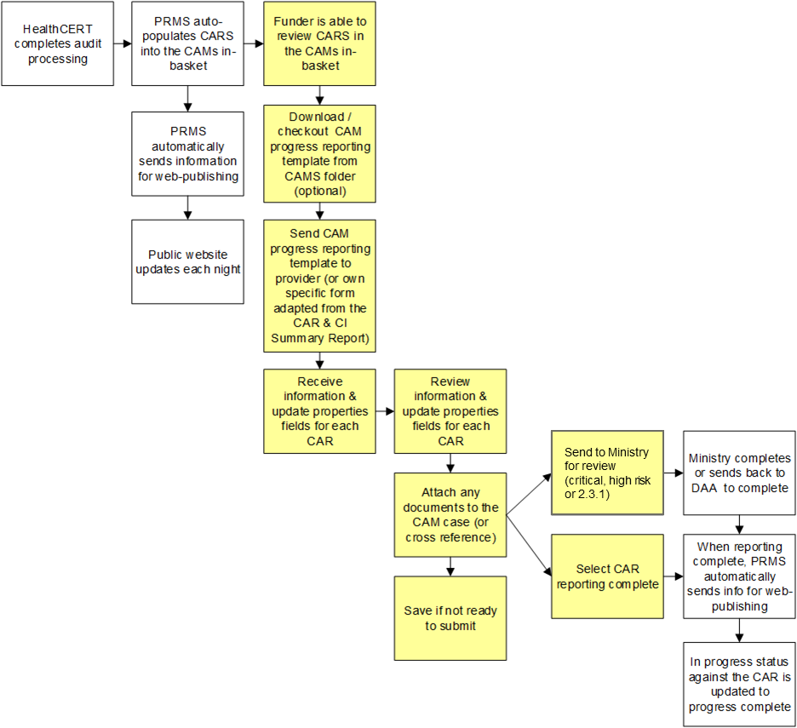

CAM Management:
- Click on the CAM case from the CAM in-basket.
- Scroll down the middle properties column to find the heading ‘Corrective Action Assessment’ and click on the arrow to expand and show the fields which you need to complete. The fields are:
  - Provider Actions, enter in briefly what actions the provider has taken. If you are attaching a progress report from the provider to the file, you can say refer to attached document. If you want to add a document follow the adding a document quick reference guide
  - Assessment of Actions, enter in briefly what your assessment of these actions is (ie, the assessment based on your review). If you are attaching a document that includes the funders assessment of actions, you can state what the status is (eg, satisfactory) and refer to the attached document
  - Revised Attainment Rating, this defaults to “please select a value”. Make sure you choose either the current attainment rating (as awarded at the audit) or a new rating that reflects the status of the corrective action (e.g. now PA low). Make sure you do not say FA (fully attained) unless this has been fully verified and you are prepared to stand by this
  - Report Date Received, put in the date the report from the provider was received (don’t worry about the time)
  - Report Date Completed, put the date the funder finished reviewing the provider’s response (don’t worry about the time, this is the date you reviewed the info).
- If you have not completed the reporting into the PRMS push the save button and the close button at the top right hand side of the screen AND if you need to give the provider more time, then change the report due date field and push the save button and then the close button.
- If you have completed the reporting into the PRMS you need to either push the corrective action reporting complete button (top right hand side of the screen) or the send to Ministry for review (anything high or critical risk or 2.3.1).

Other helpful info:
- CAMs can be sorted by facility or due date by clicking on the corresponding header in the in-basket.
- Hover your mouse over the description field in the in-basket for each CAM and it should show you the criterion number if it is not visible (or you can expand the column to see more of the name).
- The comments character limit in the provider actions and assessment actions is 500 characters. If you want to add a lot of information you are better to add a document.
- If you have one document that refers to several CARs you can up-load it to the first of these CAM cases and then refer to the document in the properties fields of the other CAM cases (eg, refer attached document against criterion XXX).
- From the CAM case you can:
  - review the certificate and schedule by following the link to regulatory instrument (right hand side of the screen)
  - review the audit report by following the link to the audit – which is the title of the DAA that completed the case (right hand side of the screen)
  - download CAM progress report specific to that corrective action. To download open the CAMs document folder (left hand side of the screen) and select the document, right click and then view and download (save as) to your own computer.

