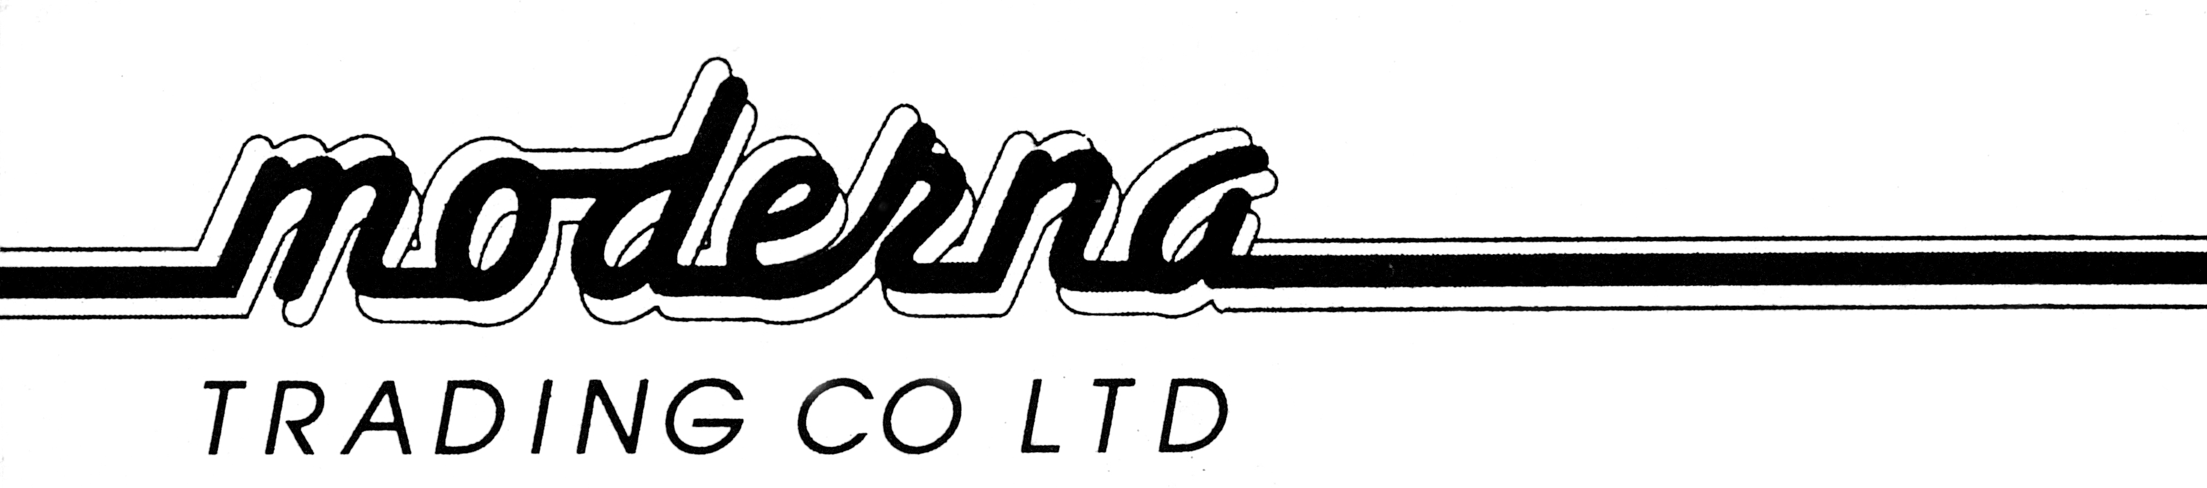

PH+644 568 4101
FAX+644 568 4102
2 Gough Street
P O Box 30 684
LOWER HUTT
TOBACCO RETURNS 1ST JAN 2020-31ST DEC 2020

SOLD WEIGHT RETAIL

SNUFF

453 TINS .95 KG $9.95/TIN

BLUNTS

JUICY/KINGPIN 25’S BOX 1700 BOXES 2.41 KG $4.50/PKT

SHISHA PIPE TOBACCO

AL-FAKHER 217 PKT 0.045KG 16.95/PKT

David Wyllie
General Manager
Moderna Trading Co Ltd

