**ANNUAL REPORT   
OF THE MENTAL HEALTH**

**REVIEW TRIBUNAL**

**1 JULY 2018**

**TO 30 JUNE 2019**

**Contents**

**Abbreviations used in this report 3**

**Message from the Convener 4**

**About the Tribunal 5**

**Membership of the Tribunal 8**

**Appointments to give opinions pursuant to ss 59 and 60 of the Act 10**

**The review process 11**

**An overview of applications at a glance 15**

**Applications received by DHB 16**

**An overview of applications involving Māori patients ______17**

**Timeliness 18**

**Publication of Decisions 19**

**Relationship with the Director of Mental Health and the Ministry of Health ______20**

**Secretariat** **20**

**Professional Development**  **21**

**Website** **21**

**What’s next for 2019-2020**  **21**

**Conclusion**  **22**

**Appendix 1 - Tribunal members 24**

**Appendix 2 - A breakdown of applications 27**

**Appendix 3 – A comparison over time (with previous four annual reports) ____ ______33**

**Abbreviations used**

**in this report**

Application Application for Review

DAMHS Director of Area Mental Health Services

DHB District Health Board

Director Director of Mental Health (for New Zealand)

DI District Inspector of Mental Health

CTO Compulsory Treatment Order

MOH Ministry of Health

RC Responsible Clinician

Tribunal Mental Health Review Tribunal

The Act Mental Health (Compulsory Assessment and Treatment) Act 1992

**Message from the Convener**

The Tribunal is pleased to present its annual report for the year to 30 June 2019.

The Tribunal helps to support and protect the rights and interests engaged when people are treated compulsorily under the Mental Health (Compulsory Assessment and Treatment) Act 1992.

It mainly does so in two ways. First, by hearing applications for a review of whether a patient ought to remain subject to the Act. Secondly, by investigating complaints of a breach of patient rights, if the patient is dissatisfied with the outcome of an investigation by a District Inspector.

In this report we use the word *"patient"*, because that is the word used in the Act. We recognise that characterising a person as a *"patient"* reflects only one aspect of their life.

The year has seen a continued focus on the timeliness of hearing reviews and the importance of good reports and supporting evidence from health professionals to inform decisions. The Tribunal welcomed new deputy members and a new Secretariat, the first change in Secretariat in over 25 years.

More broadly, the Government released *He Ara Oranga: Report of the Government Inquiry into Mental Health and Addiction*. This helped give voice to people affected by mental health issues, addiction and suicide. It identifies the need for major changes to mental health and addiction services, including changes to the Act. The report is available at:

<https://www.mentalhealth.inquiry.govt.nz/assets/Summary-reports/He-Ara-Oranga.pdf>

Some of the themes contained in *He Ara Oranga* are the catalyst for patients to seek a review, because of frustration and so as to try to make progress in addressing them. Examples include concern that powers under the Act are exercised without proper respect for cultural identity and beliefs; being treated in a more restrictive environment than necessary if there were better inpatient resources and more community facilities; and narrowly focused treatment which does not take proper account of many contributors to wellbeing.

Health professionals sometimes support those concerns in their evidence to us.

We anticipate that our workload will continue at current levels or increase. *The Office of the Director of Mental Health and Addiction Services Annual Report 2017* identified that a record number of people accessed specialist mental health and addiction services, reflective of factors which include international trends, population growth and increasingly open discussion of mental health issues. A flow on effect on the Tribunal's work seems likely.

**About the Tribunal**

The Tribunal was established by the Act in 1992. The Act enables the compulsory psychiatric assessment and treatment of people who have a mental disorder. It is intended to define and better protect their rights than preceding legislation.

**The members of the Tribunal reflect the diverse nature of our society. We convene in Tribunals of three, comprising a lawyer, a psychiatrist and a community member, to hear cases throughout New Zealand, in the locality where the patient lives.**

Some people welcome support under the Act. Others consider it to be a significant and unwanted intrusion into their lives. We endeavour to consider all of the views put forward in reviews, by patients, their family and whanau and health professionals, and to strike the balance required by the Act.

This remains a challenging task. We recognise that our functions and decisions directly affect the rights and interests of patients treated under the Act, and often impact on their friends, family and whanau and the community.

**The functions of the Tribunal**

The functions of the Tribunal are to:

on application or of its own motion, review the condition of patients who are subject to ordinary compulsory treatment orders, special patient orders and restricted patient orders, pursuant to ss79 to 81 of the Act. Reviews are for the purposes of assessing whether in the Tribunal’s opinion a patient ought to be released from compulsory treatment or from special patient or restricted patient status;[1]

* to investigate complaints of breaches of specific patient rights. That occurs when a patient or complainant is not satisfied with the outcome of the investigation of a complaint by a District Inspector of Mental Health[2] or an Official Visitor pursuant to s75 of the Act;[3]
* report to the Director pursuant to s102 of the Act on any matter relating to the exercise or performance of its powers and functions;
* appoint psychiatrists who assess:
  + whether treatment is in the interests of a patient who does not consent to that treatment, pursuant to s59 of the Act;
  + whether electro-convulsive treatment is in the interests of a patient who does not consent to that treatment, pursuant to s60 of the Act; and
  + whether brain surgery is appropriate, if the Tribunal is first satisfied that the patient has given free and informed consent to surgery, pursuant to s61 of the Act. The Tribunal is not aware of this provision having been used.

Many patients accept compulsory treatment or the outcome of a District Inspector’s complaint investigation and neither they, nor others in their interests, make an application for review to the Tribunal. Consequently, the Tribunal reviews only a small proportion of patients receiving compulsory treatment. The issue on review is summarised below.

***Ordinary Patients***

For ordinary patients who are subject to compulsory treatment orders the issue for the Tribunal is whether the patient is fit to be released from compulsory status. That requires that the patient no longer be *”mentally disordered”*.[4] To be *“mentally disordered”* a patient must have a continuous or intermittent abnormal state of mind of such a degree that it poses a serious danger to the health or safety of the patient or others or seriously diminishes the capacity of the patient to self-care. If the Tribunal considers the patient is no longer mentally disordered, he or she is released from compulsory treatment. Otherwise, the patient remains subject to compulsion.

***Special Patients***

Some special patients receive compulsory treatment because they were found unfit to stand trial. The Tribunal must express an opinion as to whether the patient remains unfit to stand trial and whether he or she should continue to be detained as a special patient. Depending on the outcome and whether the Attorney-General is the applicant, the opinion may be provided to the Attorney-General to enable a decision to be made for the purpose of s31 of the Criminal Procedure (Mentally Impaired Persons) Act 2003.

Other special patients receive compulsory treatment because they were acquitted on account of insanity. The Tribunal must express an opinion as to whether the patient’s condition still requires that he or she should be detained as a special patient. Depending on the outcome and whether the Minister of Health is the applicant, the opinion may be provided to the Minister of Health to enable a decision to be made for the purpose of s33 of the Criminal Procedure (Mentally Impaired Persons) Act 2003.

***Restricted Patients***

Restricted patients have been declared so because they present special difficulties due to the danger they pose to others. The Tribunal must express an opinion as to whether the patient is mentally disordered. If not, then the patient is released from compulsory treatment upon the direction of the Director of Mental Health. If the Tribunal considers the patient is mentally disordered but no longer needs to be a restricted patient, the matter is referred to the Minster of Health, who after consultation with the Attorney-General, will decide whether restricted patient status should continue.

***Right of Appeal***

Section 83 of the Act provides a right of appeal where the Tribunal considers that a patient is not fit to be released from compulsory status. It is mainly to be exercised by the patient or certain classes of people acting in his or her interests.

The psychiatrist responsible for the patient’s care does not have a right of appeal. In practice, he or she can make a fresh assessment for the purpose of compulsory treatment if a patient who has been discharged later becomes sufficiently unwell.

**The powers of the Tribunal**

The Act confers on the Tribunal a range of powers in order to enable it to discharge its functions.

Pursuant to s104(3) of the Act these include the same powers and authority to summons witnesses and to receive evidence conferred upon Commissions of Inquiry by the [Commissions of Inquiry Act 1908](http://www.legislation.govt.nz/act/public/1992/0046/latest/link.aspx?id=DLM139130). The provisions of that Act apply (except for [sections 11](http://www.legislation.govt.nz/act/public/1992/0046/latest/link.aspx?id=DLM139172#DLM139172) and [12](http://www.legislation.govt.nz/act/public/1992/0046/latest/link.aspx?id=DLM139174#DLM139174) which relate to costs).

The Tribunal prefers to operate in a cooperative manner, without resorting to formal use of such powers.

**Membership of the Tribunal**

Every review is heard by a Tribunal comprising three members, comprising a lawyer, a psychiatrist and a community member, although additional members may be co-opted by the Tribunal for a particular hearing.

The members are appointed by the Minister of Health. The membership is reviewed every three years. The appointment end date for current members is 26 September 2021, but their appointments continue until a successor is appointed.[5]

The Tribunal seeks to ensure a fair allocation of work, to help ensure diversity in the hearing of cases and to help ensure all members can retain their expertise.

The members who held office during the report year are listed below. More full information about them is contained in Appendix 1.

**Tribunal members**

Mr A J F Wilding QC (Convener)[6]

Dr N R Judson, psychiatrist

Ms P Tangitu, community member

**Deputy lawyer members**

Ms M J Duggan

Mr N J Dunlop

Mr R A Newberry

Ms R F von Keisenberg

**Deputy psychiatrist members**

Dr Ben Beaglehole

Dr J Cavney

Dr C Dudek-Hodge

Dr H Elder

Dr M Honeyman

Professor G Mellsop

Dr S Nightingale

Dr P Renison

Dr S Schmidt

**Deputy community members**

Mrs F Diver

Ms A Lucas

Mrs K Rose

**Co-opted Members**

Section 103 of the Act enables, and in some cases requires, if requested by the patient, the Tribunal to co-opt:

* any person whose specialised knowledge or expertise would be of assistance to the Tribunal in dealing with the case;
* any person whose ethnic identity is the same as the patient’s where no member of the Tribunal has that ethnic identity; or
* any person of the same gender as the patient, where no member of the Tribunal is of that gender.

This power was exercised in several review hearings during the reporting year. The Tribunal is grateful to the co-opted members who made themselves available.

The Tribunal is currently considering the availability of co-opting members and the process for co-opting them, aspects which likely have not been reviewed for many years.

**Appointments to give opinions pursuant to ss   
59 and 60 of the Act**

The Tribunal is required to consider applications for the appointment of psychiatrists who assess:

* + whether treatment is in the interests of a patient who does not consent to that treatment, pursuant to s59 of the Act;
  + whether electro-convulsive treatment is in the interests of a patient who does not consent to that treatment, pursuant to s60 of the Act;
  + whether brain surgery is appropriate, if the Tribunal is first satisfied that the patient has given free and informed consent to surgery, pursuant to s61 of the Act.

The process of appointment has been the subject of consideration by the Tribunal. As part of that, the Tribunal has identified that there is no mechanism for the Tribunal to know whether appointments, which are not stated to have an end date, are still appropriate, some years later. It intends to liaise with the Ministry regarding the best process and appointment terms.

This reporting period 22 psychiatrists were appointed by the Tribunal to give opinions regarding whether the proposed treatment of patients without consent (including electro-convulsive treatment) is in their interests.

No applications were received to give opinions regarding whether brain surgery is appropriate. The Tribunal is not aware of this provision having been used before.

**The review process**

The review process is determined by the Tribunal hearing each particular case. The sequence is:

**The approach taken by the Tribunal**

The Tribunal tends to conduct hearings without undue formality. But because the process is quasi-judicial and the determination affects important rights and interests, a degree of formality is necessary.

Formality is also inherent in the process outlined in Schedule 1 of the Act, which contains provisions regarding the conduct of reviews.

The process is partly-inquisitorial. The Tribunal tends to lead much of the questioning. It prefers to do so in a way which helps rather than undermines the therapeutic relationship between the patient and health professional, but not at the risk of relevant aspects not being addressed.

There are rights of audience and cross-examination.

Tension is sometimes apparent, reflective of the context. Health practitioners are contending that a patient ought to be subject to compulsory treatment, when the patient objects to current and future compulsory treatment.

The Tribunal benefits from patients giving candid accounts of, at times, intensely personal matters, involving their background, family and whānau, health, current circumstances and aspirations.

**An effort is made to provide applicants with constructive and positive comments**.

The Tribunal sometimes makes broader observations, reflecting concerns about the patient's care. It sometimes does so with supporting evidence from health practitioners, who work within a constrained system. Health practitioners are to be commended for their frankness.

**Who attends the hearings?**

The hearings are not public.

Those attending are usually:

* the applicant, who may be excused if need be;
* the applicant’s lawyer;
* the responsible clinician, who is a psychiatrist;
* the keyworker, who is usually a psychiatric nurse who is familiar with the patient.

Others who might attend include:

* a support person or advocate for the patient;
* family members or friends of the applicant;
* a social worker;
* a psychologist;
* an occupational therapist;
* a cultural advisor;
* other medical and nursing staff;
* a district inspector.

**How hearings are conducted**

The hearing format tends to be similar regardless of whether the patient is an ordinary patient subject to a compulsory treatment order, a special patient or a restricted patient.

In advance, the Tribunal receives written reports from health professionals and sometimes written material from the applicant or his or her lawyer or advocate.

The hearing commences with the Tribunal introducing itself. It clarifies who is present and, where appropriate, whether there is any objection by the patient to any particular person being present.

An opening submission or statement is called for from the applicant or his or her lawyer. Following that, evidence is heard.

Usually the first witness is the patient or the responsible clinician, being the clinician responsible for the care and treatment of the patient.

Evidence can be required on oath, but this would be unusual.

Each witness is questioned by the Tribunal. The applicant or lawyer for the applicant is then invited to ask questions of that witness. It would be rare for a health professional to question other witnesses.

At the conclusion of the evidence, closing submissions are invited, more usually from the applicant or his or her lawyer.

Those present are then asked to leave the room to enable the Tribunal to deliberate. If possible, a decision is given shortly after, on the same day.

Sometimes written submissions are sought or an adjournment is necessary, for example to enable further medical evidence to be obtained. Where fresh evidence is received, an opportunity to comment upon it is given to the extent consistent with natural justice.

Following the hearing the Tribunal issues a written decision, or written reasons for a decision if the decision was announced orally.

**Ethnic and cultural identity and language**

The Tribunal seeks to recognise the ethnic and cultural identity and beliefs of the patient and his or her family and whanau.

It also recognises the issues which can arise where English is not the language or first language of the patient.

When applying for reviews applicants are asked whether they wish to have the Tribunal include a person of the same ethnic identity as the patient. If so that is arranged, including by co-opting a member where necessary.

It also asks whether an interpreter is sought and if so arranges that.

Hearings may be opened or closed by a karakia, blessing or waiata where a patient wishes.

**Where do hearings take place?**

If the applicant is being treated in hospital the hearing usually takes place at the hospital. If the applicant lives in the community, the hearing usually takes place at the outpatient clinic which the applicant attends.

Some hearings take place by video conference. Where that occurs, the format described above is followed as much as possible. Whether videoconferencing is used is a matter of judgment, exercised consistently with natural justice. On rare occasions, a hearing could be conducted by telephone conference, but this is undesirable.

**Applications by category of patient**

Of the total applications received during the reporting year:

* 93 were in respect of patients under a community treatment order;
* 45 were in respect of patients under an inpatient treatment order;
* 8 were in respect of special patients;
* 1 was by a restricted patient.

**An overview of applications at a glance**

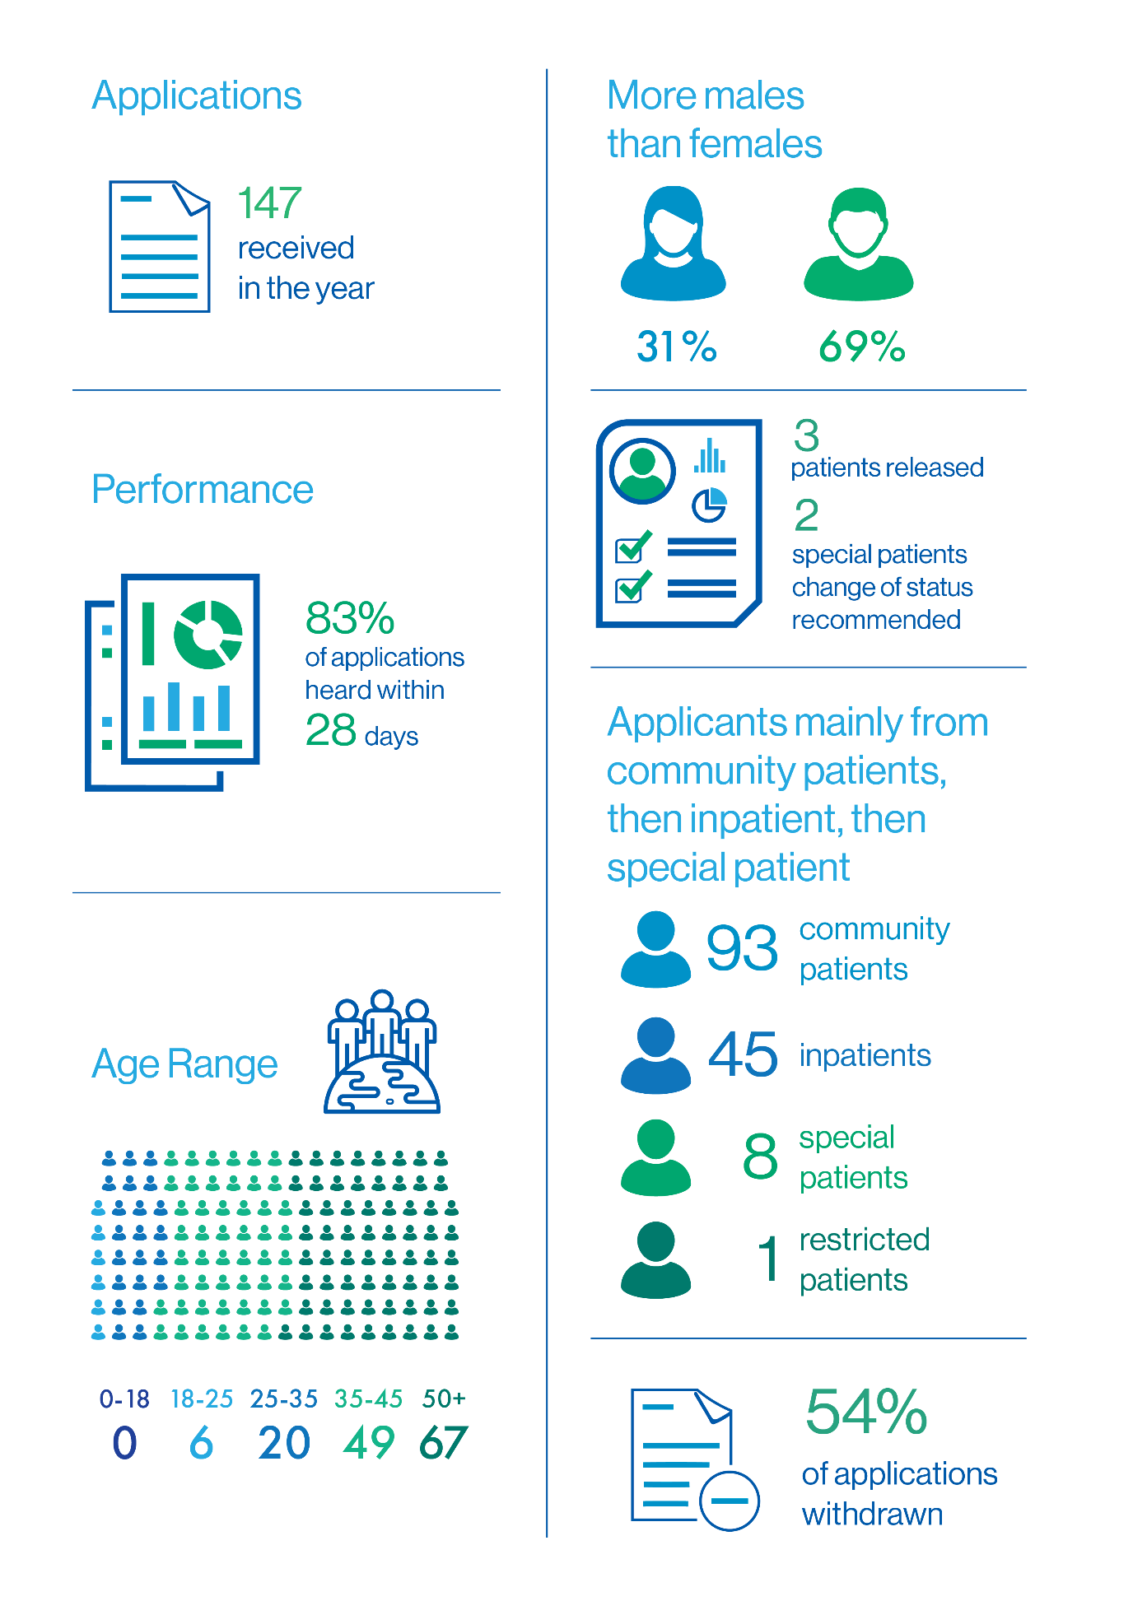

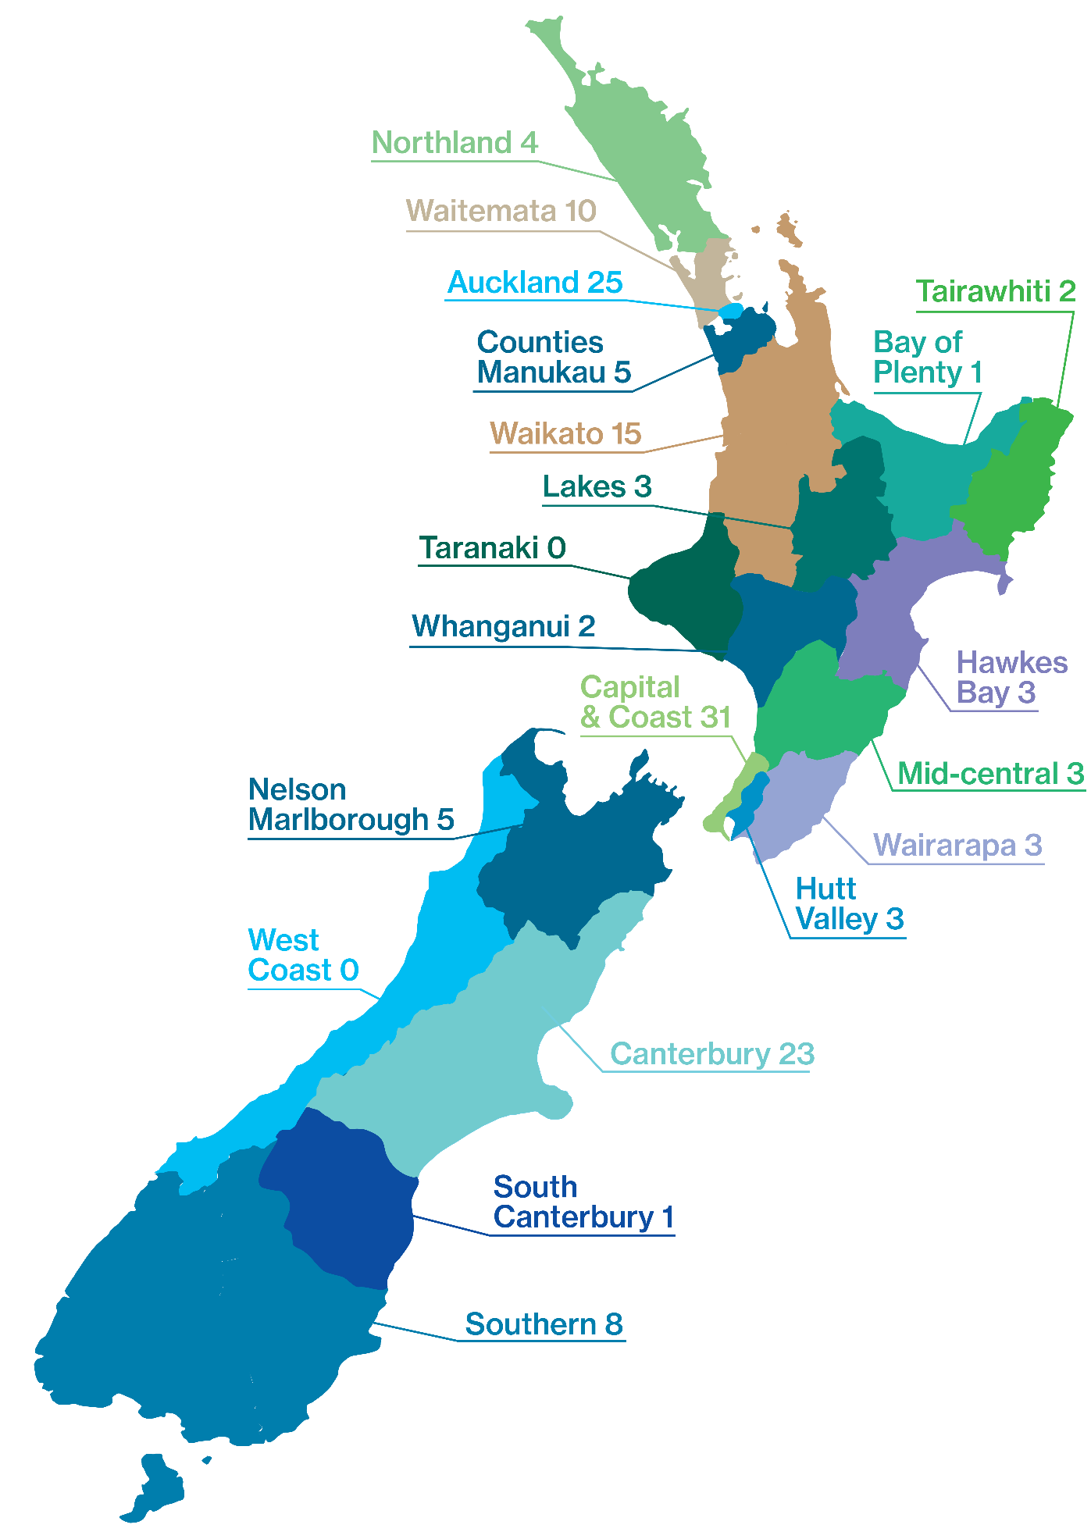**Applications received by DHB**

Further detail illustrating the breakdown of applications is contained in **Appendix 2.**

**An overview of applications involving Māori patients**

Reducing the disparity in mental health outcomes for Māori is a priority for the Ministry of Health and DHBs. Māori make up approximately 15 percent of the New Zealand population and 25 percent of all mental health service users.

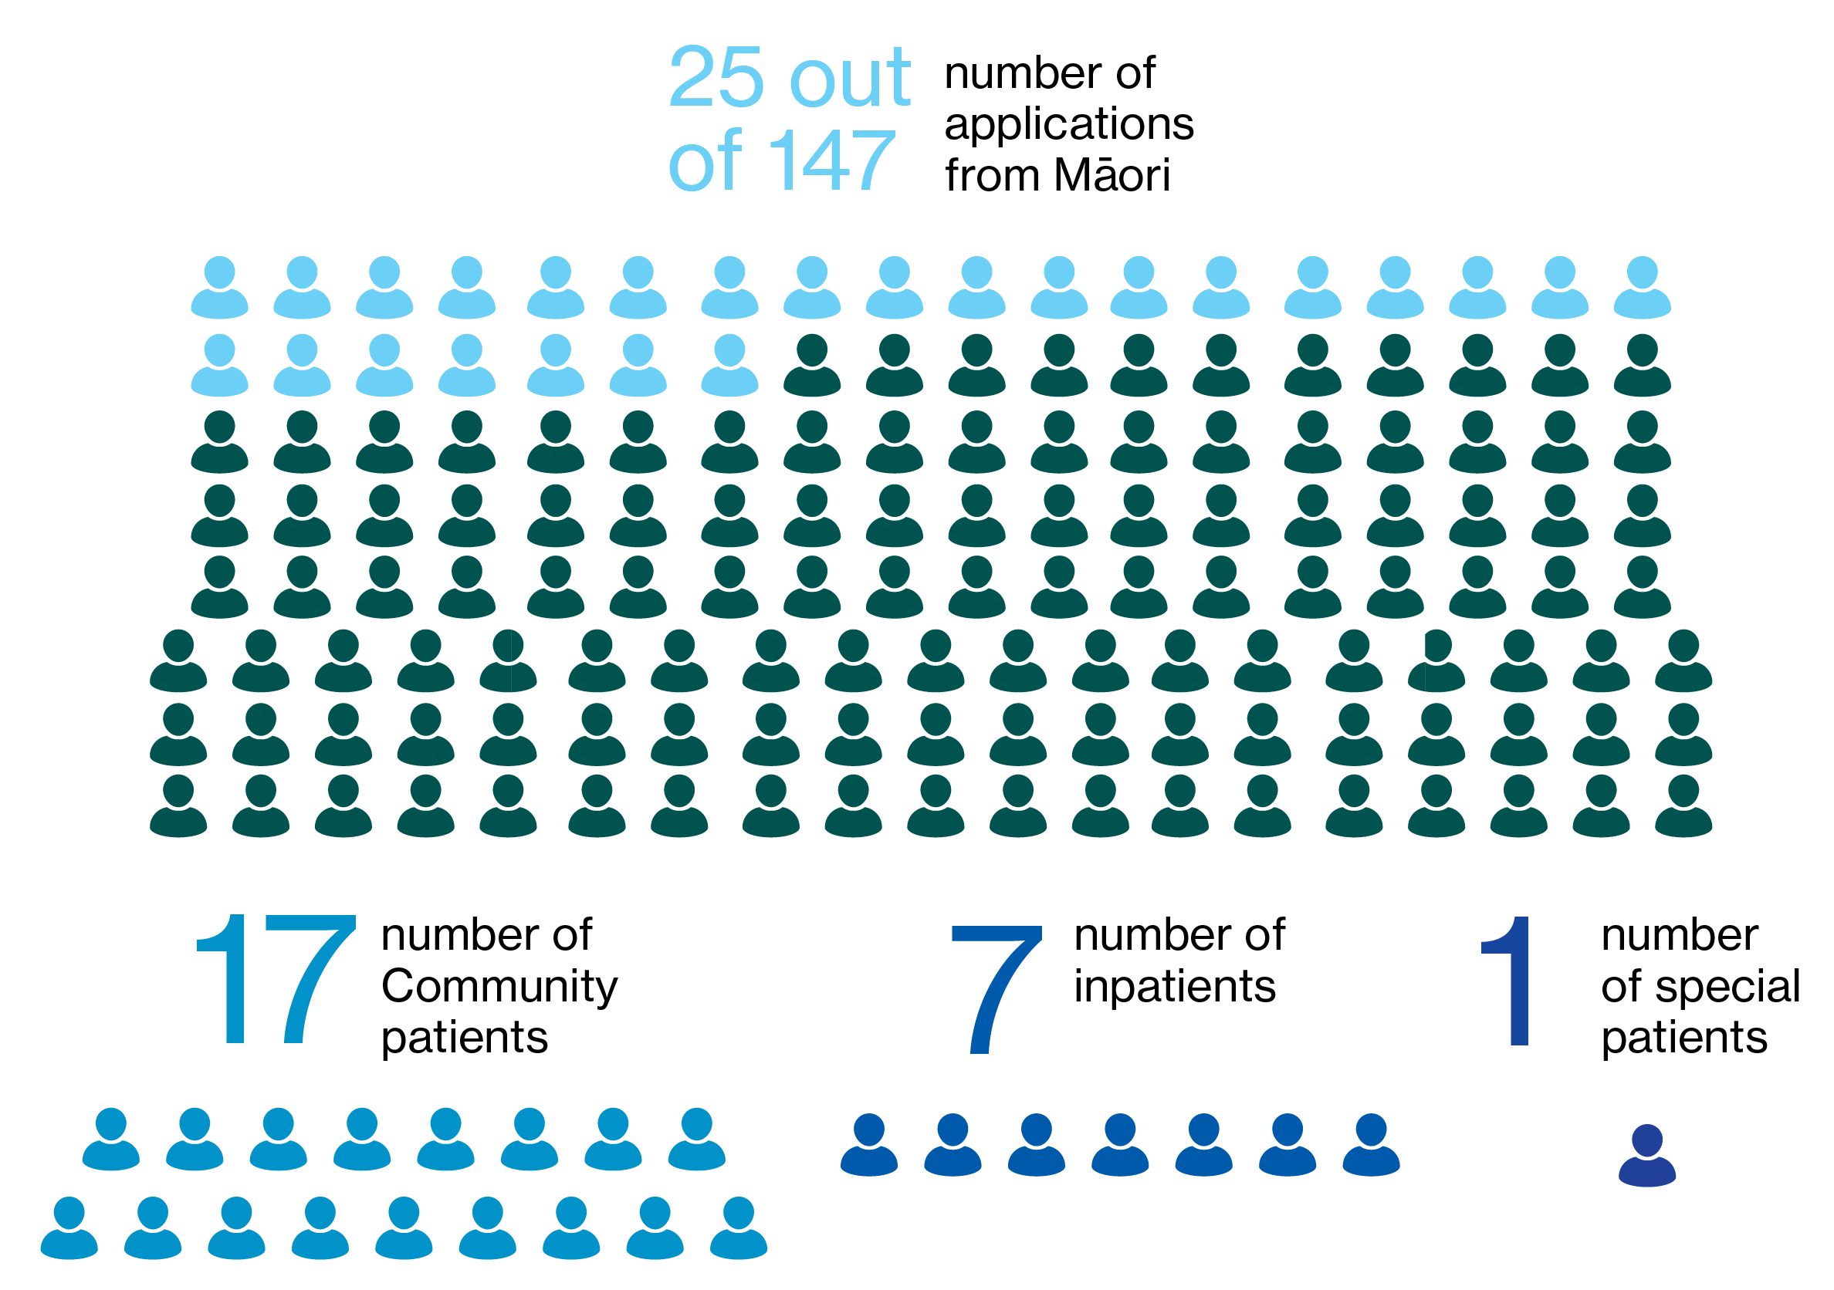



Further detail illustrating the breakdown is contained in **Appendix 2.**

**Timeliness**

An ongoing focus for the Tribunal is the timely hearing of applications for review. By 2016 under 30% of applications heard were heard within 28 days, being the statutory timeframe, inclusive of a 7 day extension, for the commencement of a hearing. Most reviews are heard in less than a day.

Addressing delay became a focus, with timeliness improved significantly for each year compared to prior to 2016. This year 83% of cases were heard within 28 days.

This has been possible because of the efforts of the Secretariat and because of the generally excellent support and cooperation received by patients, lawyers and health professionals.

From 2019, the Tribunal commenced issuing notices regarding the hearing process and who has to do what, following applications being received.

This, in conjunction with revised guidelines issued in 2018 for responsible clinicians when writing reports, appears to have resulted in more timely and full reports from many clinicians, with the benefit that brings to the patient and Tribunal processes.

There are still circumstances in which cases which are heard outside of 28 days, and will continue to be, the reasons for which include:

* patients sometimes seeking deferral in order to have a lawyer of their choice or to obtain a second opinion or a grant of legal aid. In some cases, applications are be withdrawn until all information is to hand;
* responsible clinicians or lawyers being unavailable, for example overseas or in a hearing, and the Tribunal and patient or his or her lawyer agree it is preferable that a hearing be delayed;
* scheduling difficulties. Difficulty is inherent in trying to coordinate dates suitable to patients, their lawyers, health professionals and the Tribunal;
* travel factors, being the availability of flights and cancellations due to poor weather conditions. Hearings tend to involve at least two if not three members travelling from different cities.

Sometimes the interests of time have had to give way to the interest in the Tribunal gathering sufficient good quality information to enable it to make a properly informed decision.

Some interruption occurred during the time of the changeover in Secretariat, a significant exercise for the former and current Secretariat, Ministry and Tribunal. This was an isolated cause of delay.

Regrettably, there were a number of cases in which scheduling of telephone conferences and hearings was difficult when it ought not to have been, for example:

* because a District Health Board was initially not willing to make a venue available on a particular day;
* because a health practitioner had other (unclear) commitments and the DAMHS did not ensure someone was available to attend a telephone conference; or

* because a health professional failed to file a relevant report.

The Tribunal is concerned about such circumstances. It seeks to accommodate parties to a review but will impose timeframes and use formal powers where necessary, in order to avoid the patient's right to a timely and informed hearing being undermined.

It is intended to draw to the attention of the Director certain cases in which there is inappropriate delay, either by way of direction in particular cases or by way of report pursuant to s102(2) of the Act.

**Publication of Decisions**

Clause 7 of Schedule 1 of the Act provides that Tribunal proceedings are not open to the public. Clause 8 allows for the publication of reports of proceedings with the leave of the Tribunal and in publications of a bona fide professional or technical nature.

Decisions of the Tribunal are rarely made public. This reflects the interest of the patient, and often others, for example victims and family, in privacy. Decisions are highly fact specific and anonymisation may not prevent identification.

Those receiving compulsory treatment under the Act likely assume that the usual privacy and confidentiality requirements attaching to medical matters will apply. They are vulnerable and may not be well placed to address issues of publication.

Patients, their families and clinicians who provide private information during the course of Tribunal hearings may be alarmed if decisions find their way on to the worldwide web. Publishers of professional and technical journals now publish journals online.

Weighing against those is the public interest in being informed of the workings of the Tribunal.

In April 2010 the Tribunal and the Ministry agreed on guidelines intended to ensure that the relevant interests in privacy and in making information public are balanced and that appropriate cases are identified for publication. The protection provided by these guidelines is essentially three-fold:

* only a selection of cases identified by the Tribunal is sent to publishers, by the Ministry;
* those cases will be anonymised, by the Tribunal and then the Minsitry; and
* they will be sent only to three established professional and responsible publishers, namely Brookers (Thomson Reuters), LexisNexis and the New Zealand Legal Information Institute.

As at the date of this report 49 cases can be found on line on the New Zealand Legal Information Institute website: <http://www.nzlii.org/nz/cases/NZMHRT/>.

**Relationship with the Director of Mental Health and the Ministry of Health**

The Tribunal is an independent statutory body, supported by its own Secretariat. Decisions reflect its independent view.

More broadly, its role involves liaison with the Director and Deputy of Mental Health, Dr Crawshaw and Dr Soosay, and the Ministry of Health.

The Tribunal enjoys a constructive relationship with Dr Crawshaw and Dr Soosay. That relationship involves support of the work of the Tribunal outside of the context of specific cases and consideration of issues which can adversely impact on the functioning of the Tribunal.

The Ministry of Health administers the Act. The Tribunal also enjoys a constructive relationship with it, in respect of training, administrative, personnel and funding issues.

The Tribunal extends its thanks to Dr Crawshaw, Dr Soosay and the team at the Ministry for their support during the year.

**Secretariat**

Public policy firm *Allen + Clarke* is contracted by the Ministry to be the Tribunal’s Secretariat and commenced its role in November 2018.

It supports the work of the Tribunal, which includes managing the flow of information between parties and the Tribunal, organising Tribunal pre-hearing conferences and hearings, supporting the Tribunal to give effect to its statutory requirements under the Act, and quarterly and six-monthly reporting to the Ministry on Tribunal activities.

The transition from the former Secretariat to *Allen + Clarke* has involved significant effort. With that behind it, the Tribunal and Secretariat can turn their attention to other matters which warrant attention. Some of these are referred to under the heading *What’s next for 2019-2020.*

The Tribunal is grateful for the hard work of *Allen + Clarke* and the team ofMs Harrison, Ms Slater, Ms Clark and Ms Tuifao, during the transition and subsequently.

**Professional Development**

The lawyer and psychiatrist members of the Tribunal are qualified in their respective professions. The community members possess a diverse range of skills and experiences. All members have considerable experience in their respective areas of expertise prior to appointment.

The Tribunal welcomed three new appointees this year. New members are provided with training and attend hearings in an observer capacity before commencing to sit.

Members maintain their own professional development and attend a Tribunal plenary at least once, sometimes twice, a year.

**Website**

The Tribunal has a website, within the Ministry’s website: <http://www.health.govt.nz/new-zealand-health-system/key-health-sector-organisations-and-people/mental-health-review-tribunal>.

The website contains relevant information, including Policy and Practice notes and Guidelines.

**What’s next for 2019-2020**

The Tribunal will continue its focus on seeking to provide patients with meaningful and effective reviews within the statutory timeframe.

It will also:

* reflect on the approach it takes to decisions, including whether a consistent and appropriate standard is being applied over time and between each of the variously composed Tribunals;
* reflect on how best to ensure that prime facie legitimate patient concerns, including those captured by *He Ara Oranga*, are drawn to the attention of appropriate people;
* seek to better address circumstances where there is avoidable delay which is not supported by the patient and, as part of that, draw circumstances to the attention of the Director in appropriate cases;
* review the process for co-opting members for specific hearings and the pool of available people, aspects which have not been reviewed for many years;
* continue to review the process for approval of psychiatrists under ss59 to 61, including whether appointments ought to be for a limited term and how the Tribunal will be informed of any adverse circumstances which may impact on whether approval should remain.

It would welcome the opportunity to have input into work related to its role and the Act resulting from *He Ara Oranga.*

**Conclusion**

The work of the Tribunal involves intensely personal issues for patients, their families and whanau and those involved in their care and support.

The competing arguments for why continued compulsory treatment is or is not required are challenging.

The Tribunal has reviewed many ordinary patient and special patient applications and, unusually, a restricted patient application. It hopes that its work has helped protect:

* the rights of those who are mentally disordered to be treated under the Act;
* the rights of those who are not mentally disordered to be discharged from the Act; and
* the special interests that arise in the case of special and restricted patients.

With the completion of the transition of a new Secretariat, and significant progress having been made over the past three years in addressing the delay in hearing applications, the Tribunal seeks to focus on the areas identified under the heading *What's next for 2019-2020.*

_________________________________

A.J.F. Wilding QC

(Convener)

_________________________________

Ms P. Tangitu

(Community member)

________________________________

Dr N.R. Judson

(Psychiatrist member)

**Appendix 1 – Tribunal members**

**Mr A J F Wilding QC** (Tribunal Convener)

James is a barrister based in Christchurch. His work includes inquiries and medico-legal issues. He was a District Inspector of Mental Health from 1999 until to 2011.

**Dr N R Judson**

Nick is a psychiatrist based for the last 20 years in Wellington. In the past he worked in Dunedin and then as Deputy Director of Mental Health. His interests are in forensic psychiatry and intellectual disability.

**Ms P Tangitu**

Phyllis hails from the Iwi of Ngati Pikiao, Ngati Ranginui and Ngati Awa. She has a background in education and health and has worked in the Mental Health and Addictions and Māori Health sector for 31 years.  Phyllis has whanau members who have experienced mental ill-health and continues to advocate for recognition of Māori world views.  She is employed by Lakes DHB as General Manager Māori Health, where she has worked for 30 years.

**Deputy Members**

The Minster of Health also appoints deputy members of the Tribunal. During the report year, the deputy members of the Tribunal were:

Deputy lawyer members:

**Ms M J Duggan**

Michelle is lawyer based in Nelson who specialises in family law and mental health issues. She is the former chair of the Family Law Section of the New Zealand Law Society.

**Mr N J Dunlop**

Nigel is a Nelson based barrister and mediator. He has been a member of the Tribunal since 1992 and for many years was the convener. Nigel additionally sits on appeal and complaint bodies in the areas of censorship, retirement villages, real estate and physiotherapy.

**Mr R A Newberry**

Robb is a barrister based in Wellington.  Prior to becoming a deputy lawyer member of the Tribunal, he was a District Inspector of Mental Health from 1993 until 2008.  He also practices in other jurisdictions, such as the Protection of Personal and Property Rights Act 1988 and Intellectual Disability (Compulsory Care and Rehabilitation) Act 2003.

**Ms R F von Keisenberg**

Robyn is a family law barrister with over 30 years’ experience in a broad range of areas including issues under Mental Health (Compulsory Assessment and Treatment) Act 1992 and the Protection of Personal and Property Rights Act 1988. Robyn is a senior counsel appointed in proceedings under that Act and in proceedings involving the care of children. She has served on and convened a number of Law Society committees.

Deputy psychiatrist members:

**Dr Ben Beaglehole**

Ben is a Christchurch based psychiatrist.  He is the clinical head of the Anxiety Disorders Service based at Hillmorton Hospital.  Ben is also a Senior Lecturer for the University of Otago.  He teaches medical students and researches mood disasters and mental health outcomes following disasters.

**Dr J Cavney**

James is a forensic psychiatrist based in Auckland. He is a lead clinician, Kaupapa Māori and Pacific Services, Mason Clinic.

**Dr C Dudek-Hodge**

Christine Dudek trained as doctor in Germany and The Netherlands. She gained her PhD in Germany and went on to complete her vocational training as a psychiatrist at the Academic Medical Centre in Amsterdam, The Netherlands. Christine relocated with her family to Christchurch in 2012 and has since worked as a general adult psychiatrist for the CDHB.

**Dr H Elder, MNZM**

Ngāti Kurī, Te Aupouri, Te Rarawa, Ngāpuhi. Hinemoa is a psychiatrist, who works in a range of settings including CFU, Starship Hospital, and as a court report writer for the Family and District Courts and Kōti Rangtahi, and under the Intellectual Disability (Compulsory Care and Rehabilitation) Act 2003. She specialises in the neuropsychiatry of traumatic brain injury and is a researcher in that field and in the field of dementia. She is the Māori strategic leader at Brain Research NZ.

**Dr M Honeyman, QSO**

Margaret is a psychiatrist based in Auckland and who is semi-retired but still undertakes clinical work. She works mainly in adult psychiatry. A large part of her career has been in leadership and management roles, including as Clinical Director and DAMHS in DHB settings and as Chief Psychiatrist in South Australia. She has thus been involved in the application of mental health legislation from a number of different perspectives.

**Professor G Mellsop, CNZM**

Graham is a psychiatrist who has spent most of his working life contributing to adult mental health services, medical education and research. He has been a Professor of Psychiatry since 1982, first at the University of Otago and now at the University of Auckland (Waikato Clinical Campus), with a few years at the Universities of Queensland and Melbourne in between.

**Dr S Nightingale**

Sue is a psychiatrist who has worked in Christchurch for many years. She is currently the Chief Medical Officer for the Canterbury District Health Board but was previously Chief of Psychiatry and DAMHS from 2010 to 2016. She has a strong interest in health law, completing a Masters in Bioethics and Health Law in addition to her medical qualifications.

**Dr P Renison**

Peri is a psychiatrist who works clinically in adult general psychiatry.  She is Chief of Psychiatry for the Canterbury District Health Board and Director of Area Mental Health Services for Canterbury.

**Dr S Schmidt**

Sigi Schmidt moved to NZ in 1999 after completing his psychiatric training at the University of Cape Town in South Africa. He has worked in a range of services since that time. These include Adult General Psychiatric Services (both inpatient and outpatient settings), Rehabilitation, Early Intervention in Psychosis and Rural Psychiatry.  He is working for the CDHB as Clinical Director of Adult Community Psychiatric Services in Christchurch.

Deputy community members:

**Mrs F Diver, QSM**

Francis is a community member based in Otago. She is Ngai Tahu and works closely with the Māori community. She founded the Te Ao Huri whānau group and has held leadership roles with charities and local government initiatives. She has a close focus on mental health.

**Ms A Lucas**

Albany is a researcher at the University of Otago, working in the areas of mental health and Big Data. She has a law degree and a Master’s in Bioethics and Health Law. Albany is of Kiribati and Dutch descent.

**Mrs K Rose**

Kay has a background in nursing and has owned and operated a Nursing Bureau and a Recruitment Placement business. She was a Justice of the Peace from 1980 until 2012 having exercised jurisdiction in the District Courts in Auckland. She has an extensive background in commerce and voluntary services.

**Appendix 2 -   
A breakdown   
of applications**

This part provides information on applications received from 1 July 2018 – 30 June 2019.

**Figure 1: Applications received 1 July 2018 – 30 June 2019 by gender**

The number of applications received from male patients was 101 and the number from female patients was 46. There was an increase in applications from male patients from last year, but the number of female patients remained the same.

**Figure 2: Applications received 1 July 2018 – 30 June 2019 by age range**

This is the first year we have reported on application by age range. Most of the applications received were from people over the age of 36 years, with those aged over 50 years being the largest segment.

**Figure 3: Applications received 1 July 2018 – 30 June 2019 by DHB location**

The majority of applications were received from the main city centres across New Zealand. The Auckland region gave rise to the largest number of applications.

**Figure 4: Applications received 1 July 2018 – 30 June 2019 by type of order**

The largest number of applications received was from patients on community treatment orders. Of 147 applications, 90 were from patients on community treatment orders.

**Figure 5: Applications received 1 July 2018 – 30 June 2019 by hearing status**

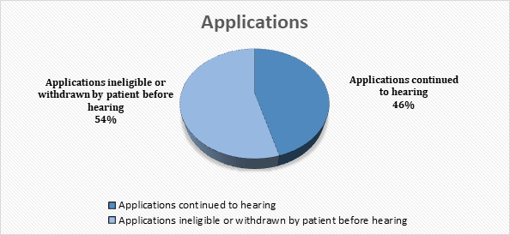

Just over half of all applications received during the year were withdrawn. A patient can withdraw an application at any stage during the review process.

**Table 1: Applications received 1 July 2018 - 30 June 2019 percentage withdrawn**

|  |  |  |  |
| --- | --- | --- | --- |
| Year | Applications | Applications ineligible or withdrawn by patient | Percentage |
| 1 July 2018 – 30 June 2019 | 147 | 80 | 54% |

**Figure 6: Applications received 1 July 2018 – 30 June 2019 by decision outcome**

Most decisions that were received during the year resulted in patients remaining on their orders. Three patients were released from the Act during the year. The Tribunal recommended that two special patients be released from that status. There was no recommendation for change of the status of the single restricted patient applicant.

**Table 2: Applications received 1 July 2018 - 30 June 2019 decision outcome by percentage**

|  |  |  |  |  |  |  |  |
| --- | --- | --- | --- | --- | --- | --- | --- |
| Year | Number of cases determined | Remained on order | % | Released from order | % | Recommendation for a change in special patient status | % |
| 1 July 2018 – 30 June 2019 | 67 | 64 | 93% | 3 | 4% | 2 | 3% |

**Figure 7: Applications received 1 July 2018 – 30 June 2019 by ethnicity**

The largest ethnic group to apply to the Tribunal was New Zealand European. The graph does not fully reflect the ethnicity of all applicants because patients are not required to identify their ethnicity and some did not do so.

**Table 3: Applications received 1 July 2018 - 30 June 2019 by ethnicity**

|  |  |  |
| --- | --- | --- |
| Ethnicity | Number | Percentage |
| African | 2 | 1% |
| Asian | 7 | 5% |
| NZ European | 69 | 47% |
| Māori | 25 | 17% |
| Pacific Island | 8 | 5% |
| Other | 34 | 24% |
| Unknown | 2 | 1% |
| Total | 147 | 100% |

**Appendix 3 –   
A comparison over time (previous four Annual Reports)**

This part provides a comparison from the last four annual reports.

**Figure 8: Applications received by gender compared to the last four annual reports**

The number of applications received from male patients was 101 and the number from female patients was 46. There was an increase in applications from male patients from last year, however the number of applications from female patients remained the same. Since 2014, over 60% of the applications have been from males.

**Figure 9: Applications received by DHB compared to the last four annual reports**

The major cities continue to be the locations where a large proportion of applications are received from. The Auckland region (including Auckland, Waitemata and Counties Manukau DHBs) continues to be the highest.

**Figure 10: Applications status compared to the last four annual reports**

**Table 4: Applications withdrawn or ineligible compared to the last four annual reports**

|  |  |  |  |
| --- | --- | --- | --- |
| Year | Application | Withdrawn or Ineligible | Percentage |
| 1 July 2013 – 30 June 2014 | 157 | 74 | 47.% |
| 1 July 2014 – 30 June 2015 | 156 | 77 | 49% |
| 1 July 2016 – 30 June 2017 | 139 | 70 | 50% |
| 1 July 2017 – 30 June 2018 | 131 | 57 | 43% |
| 1 July 2018 – 30 June 2019 | 147 | 80 | 54% |

This year there was an increase in the number of applications withdrawn or ineligible.

In some cases withdrawal has occurred because, following making the application, there has been substantive discussion between the patient and responsible clinician resulting in the resolution of the issues of concern to the patient, and then the withdrawal of the application by the patient or the discharge of the patient by the responsible clinician.

**Figure 11: Decision outcome compared to the last four annual reports**

This is the first year that the number of recommendations for discharge from special patient status are reported, therefore we do not include data for previous years. There was no recommendation of a change in restricted patient status for the single applicant.

**Table 5: Decision outcome by percentage compared to the last four annual reports**

|  |  |  |  |  |  |  |  |
| --- | --- | --- | --- | --- | --- | --- | --- |
| Year | Number of cases determined | Remained on order | % | Released from order | % | Discharge from special patient status recommended | % |
| 1 July 2013 – 30 June 2014 | 80 | 72 | 90% | 8 | 10% | - | - |
| 1 July 2014 – 30 June 2015 | 62 | 57 | 92% | 5 | 8% | - | - |
| 1 July 2016 – 30 June 2017 | 69 | 63 | 91.3% | 6 | 8.7% | - | - |
| 1 July 2017 – 30 June 2018 | 63 | 58 | 92% | 5 | 8% | - | - |
| 1 July 2018 – 30 June 2019 | 67 | 64 | 93% | 3 | 4% | 2 | 3% |

This year saw a reduction in the number of patients who the Tribunal discharged from compulsory status. That does not take account the number of patients who were discharged by responsible clinicians following an application being made.

There were six special patient hearings. Two resulted in recommendations to the Ministry of Health that the patient be discharged from special patient status. There was no recommendation of a change in restricted patient status for the single applicant.

This is the first year that the number of recommendations for discharge from special patient status are reported, therefore we do not include data for previous years.

**Figure 12: Applications by ethnicity compared to the last four annual reports**

**Table 6: Number of applications received by ethnicity compared to the last four annual reports**

|  |  |  |  |  |  |
| --- | --- | --- | --- | --- | --- |
| Ethnicity | 1 July 2018 – 30 June 2019 | 1 July 2017 – 30 June 2018 | 1 July 2016 – 30 June 2017 | 1 July 2014 – 30 June 2015 | 1 July 2013 – 30 June 2014 |
| African | 2 | 6 | - | - |  |
| Asian | 7 | 5 | 3 | 6 | 7 |
| NZ European | 69 | 68 | 81 | 93 | 74 |
| Māori | 25 | 18 | 26 | 31 | 31 |
| Pacific Island | 8 | 7 | 8 | 5 | 9 |
| Other | 34 | 5 | 10 | 2 | 7 |
| Unknown | 2 | 22 | 11 | 19 | 29 |
| Total | 147 | 131 | 139 | 156 | 157 |

New Zealand European continues to be the largest ethnic group applying to the Tribunal. This has been consistent over the last four annual reports.

1. Decisions regarding the release of special patients or restricted patients are generally for the relevant Minister or Attorney-General.
2. District Inspectors are lawyers who are appointed under the Act to help safeguard the rights of patients.
3. There are no Official Visitors in New Zealand.
4. *Waitemata Health v the Attorney-General* [2001] NZFLR 1122.
5. Section 106 of the Act.
6. Pursuant to s107 of the Act the three members of the Tribunal appointed Mr Wilding as convener, with effect from 22 July 2016.