# ANNUAL REPORT

**OF**

**MENTAL HEALTH REVIEW TRIBUNAL**

**1 JULY 2014 TO 30 JUNE 2015**

**Mental Health Review Tribunal, P O Box 10 407, The Terrace, Wellington**

**Phone: (04) 499 0431, Fax: (04) 499 0662**

**http://www.health.govt.nz/new-zealand-health-system/key-health-sector-organisations-and-people/mental-health-review-tribunal**

## CONTENTS

**Page**

1. **Introduction 3**
2. **The Role of the Tribunal 3**
3. **Membership 5**
4. **The Typical Hearing 8**
5. **Secretariat 11**
6. **Relationship with Ministry of Health 11**
7. **Professional Development 12**
8. **Statistics 14**
9. **Publication of Decisions 29**
10. **Website 30**

**11. Conclusion 31**

### ANNUAL REPORT OF MENTAL HEALTH REVIEW TRIBUNAL

**1 JULY 2014 TO 30 JUNE 2015 (“THE REPORT YEAR”)**

# 1. Introduction

The Mental Health (Compulsory Assessment and Treatment) Act came into force on 1 November 1992. At that time, the Minister of Health appointed two Tribunals, a Northern Mental Health Review Tribunal and a Southern Mental Health Review Tribunal. As from 1 July 2002, those two Tribunals were unified and so from that date there has been the one Mental Health Review Tribunal.

# 2. The Role of the Tribunal

The functions which the Tribunal performs are as follows:

* reviews under s79 the condition of patients who are subject to compulsory treatment orders;
* reviews under s80 the condition of patients who are subject to special patient orders;
* reviews under s81 the condition of patients who are subject to restricted patient orders;
* investigates complaints under s75;
* appoints the psychiatrists who determine under s59 whether treatment is in the interests of patients who do not consent to that treatment;
* appoints the psychiatrists who determine under s60 whether electro-convulsive treatment is in the interests of a patient;
* considers brain surgery cases under s61 and appoints psychiatrists to give opinions in that regard.

It should be noted that the Tribunal does not review the condition of all compulsory, special and restricted patients in New Zealand but only a small proportion of them. Similarly, it investigates only a small proportion of s75 complaints, being those where the complainant is not satisfied with the outcome of the complaint to the District Inspector.

In the case of ordinary patients, the Tribunal’s role is to determine whether or not the patient is fit to be released from compulsory status. That determination is synonymous with the consideration of whether the patient remains mentally disordered. If the patient remains mentally disordered, he or she is thereby not fit to be released. If the patient is no longer mentally disordered he or she is thereby fit to be released. Section 83 provides a right of appeal to the District Court against Tribunal decisions in some cases. Patients have a right of appeal but responsible clinicians do not.

In the case of persons made special patients as a result of being unfit to stand trial, the Tribunal’s role is to express an opinion as to whether or not they remain unfit to stand trial and whether or not they should continue to be subject to the order of detention as a special patient.

In the case of persons made special patients as a result of being acquitted on account of insanity, the role of the Tribunal is to express an opinion as to whether or not the patient’s condition still requires that he or she should be subject to the order of detention as a special patient.

In the case of ordinary patients, the Tribunal’s decision is determinative. In the case of special patients the Tribunal’s decision is in the nature of a recommendation, being an opinion given to either the Attorney General (in the case of the unfit to stand trial special patients) or the Minister of Health (in the case of the insanity special patients).

# Membership

S101(2) of the Act provides that :

*“Every Review Tribunal shall comprise three persons appointed by the Minister, of whom 1 shall be a barrister or solicitor, and 1 shall be a psychiatrist.”*

The three persons so appointed by the Minister to hold office during the report year were:

Mr N J Dunlop of Auckland, barrister

Dr N R Judson of Wellington, psychiatrist, and

Ms P Tangitu of Rotorua, general manager, health

S107 provides that the three members of the Review Tribunal shall from time to time elect one of their numbers to be the Convener of the Tribunal. Mr N J Dunlop has been the elected Convenor from July 2002 until the end of the report year.

S105 provides that the Minister shall from time to time appoint persons to be deputy members of the Tribunal. S105 (2) provides that the deputies of the lawyer member of the Tribunal must also be lawyers and the deputies of the psychiatrist member of the Tribunal must also be psychiatrists.

During the report year, the deputy lawyer members of the Tribunal were:

Mr P J R Comber of Levin, barrister

Ms M J Duggan of Nelson, solicitor

Mr T J Gilbert of Wellington, solicitor

Ms R F von Keisenberg of Auckland, barrister

Mr R A Newberry of Wellington, barrister.

During the report year, the deputy psychiatrist members of the Tribunal were as follows:

Dr J Cavney of Auckland

Dr H Elder of Auckland

Dr M Fisher of Auckland

Dr M Honeyman of Auckland

Professor G Mellsop of Hamilton

Dr S Nightingale of Christchurch

Dr K C Pillai of Auckland

During the report year, the two deputy community members of the Tribunal were:

Mrs K T Rose of Auckland

Mr A C Spelman of Auckland

At the end of the report year therefore, the membership of the Tribunal comprised:

Lawyers 6

Psychiatrists 8

Community members 3

Total 17

The appointment end date for all members and deputy members of the Tribunal is 14 September 2015.

The number of cases heard by Tribunal members and deputy members over the report year is set out in the following table. The figures do not necessarily reflect members’ availability. The location of applicants, the dates on which cases can be heard, and the fact that some cases set down for hearing do not proceed, all affect the figures below.

|  |  |  |
| --- | --- | --- |
| **Legal Members** | **Hearings** | **%** |
| Nigel Dunlop | 22 | 32.4 |
| Phil Comber | 6 | 8.8 |
| Rob Newberry | 10 | 14.7 |
| Tom Gilbert | 10 | 14.7 |
| Michelle Duggan | 8 | 11.8 |
| Robyn Von Keisenberg | 12 | 17.6 |
| **Total** | **68** | **100** |
| **Community Members** |  |  |
| Phyllis Tangitu | 22 | 32.4 |
| Anthony Spelman | 20 | 29.4 |
| Kathleen Rose | 26 | 38.2 |
| **Total** | **68** | **100** |
| **Psychiatrist Members** |  |  |
| Dr Nicholas Judson | 20 | 29.4 |
| Dr Krishna Pillai | 6 | 8.8 |
| Professor Graham Mellsop | 8 | 11.8 |
| Dr Susan Nightingale | 8 | 11.8 |
| Dr Mark Fisher | 7 | 10.3 |
| Dr James Cavney | 5 | 7.3 |
| Dr Hinemoa Elder | 3 | 4.4 |
| Dr Margaret Honeyman | 11 | 16.2 |
| **Total** | **68** | **100** |

From time to time, other members are co-opted to the Tribunal for the purposes of a particular case. Section 103 of the Act enables (or in some cases requires, if requested by the patient) the Tribunal to co-opt:

1. Any person whose specialised knowledge or expertise would be of assistance to the Tribunal in dealing with the case; or
2. Any person whose ethnic identity is the same as the patient’s where no member of the Tribunal has that ethnic identity; or
3. Any person of the same gender as the patient, where no member of the Tribunal is of that gender.

During the report year, there were no co-options to the Tribunal.

# 4. The Typical Hearing

About one week prior to each hearing, a brief telephone conference takes place between the lawyer member of the Tribunal, the lawyer for the applicant and the responsible clinician. Such conferences are designed to smooth the process and achieve greater effectiveness and efficiency.

If the applicant is a hospital inpatient the hearing takes place at the hospital. If the applicant resides in the community, the hearing takes place at the outpatient clinic which the applicant attends.

The typical duration of hearings is about 2 hours.

Usually, those in attendance are:

* the applicant
* the applicant’s lawyer
* the responsible clinician (usually a psychiatrist)
* the keyworker (most often a psychiatric nurse).

Others who might be in attendance include:

* a social worker
* a psychologist
* a cultural advisor
* family members or friends of the applicant
* other medical and nursing staff
* a district inspector.

The hearings are held in private. The three Tribunal members sit at a table facing all those attending the hearing. The hearing is presided over by the lawyer member of the Tribunal. Of the two remaining members, one is a psychiatrist and one a community member. Sometimes as previously mentioned there is a fourth member of the Tribunal, co-opted for special purposes, usually for reasons of ethnicity. An interpreter is occasionally used by the Tribunal not just in relation to applicants but also family members.

Legal aid is freely available to applicants for hearings and so applicants are only legally unrepresented should they decline representation.

Prior to the commencement of the hearing, the psychiatrist member of the Tribunal briefly examines the patient pursuant to clause 1 of the First Schedule of the Act, primarily to ascertain whether or not the hearing process will occasion difficulties to either the patient or Tribunal.

The hearing commences with the Tribunal introducing itself and establishing the identity of those present. Opening submissions are then heard from the applicant’s lawyer. Following that, evidence is heard from those who wish to contribute. Usually, the first witness is either the applicant or the responsible clinician. Evidence is not given on oath, nor is it recorded except in notes taken by Tribunal members.

The process is an inquisitorial rather than an adversarial one. Each witness is questioned in turn by each Tribunal member. The lawyer for the applicant is then invited to ask questions of that witness.

At the conclusion of the evidence, closing submissions are invited from the applicant’s lawyer. Those present are then asked to leave the room to enable the Tribunal to deliberate. The deliberation usually takes about 5 minutes after which the attendees are invited back into the room and the Tribunal’s decision announced.

In the great majority of cases, the Tribunal’s decision is contrary to that sought by the applicant and so an effort is made to provide the applicant with constructive and positive comment by way of support and encouragement. Tribunal members seek to conduct hearings in such a way as to enhance rather than damage therapeutic relationships. On the other hand, the process is quasi-judicial, involving the determination of the rights and interests of not only the applicants but other persons as well. Therefore, the process necessarily involves a degree of formality.

Following the hearing, the lawyer member of the Tribunal prepares a full written Decision recording the Tribunal’s findings of fact, decision and reasons for the decision. Typically, the length of that document is 5 – 10 pages. The applicant and responsible clinician receive a copy of these documents, hopefully not more than 3 - 4 weeks following the hearing.

In some cases, there may be marked departures from the typical hearing described above.

The typical format applies regardless of whether the patient is an ordinary patient subject to a compulsory treatment order or is a special patient.

A few hearings take place by video conference. Where that occurs, the typical format just described is followed as much as possible. Videoconferencing is used to avoid the disproportionate time and expense which may otherwise result from Tribunal members travelling from various parts of New Zealand to a hearing or hearings. The Tribunal members hearing the case are gathered together in one venue, and all other participants in another venue. Usually videoconferencing occurs when there are no more than two hearings in one centre on the one day. Whether videoconferencing is used is however a matter of judgement, having regard to the overriding goal that all hearings are fair and effective, and perceived to be so.

On rare occasions, substantive hearings are conducted by telephone conference.

# 5. Secretariat

The Wellington law firm of D’Ath Partners is contracted by the Ministry of Health to be the Tribunal’s secretariat.

The secretariat is kept busy processing applications and setting up the hearings. The latter involves liaising with Tribunal members, hospitals, responsible clinicians and lawyers and making the travel arrangements for Tribunal members.

The Tribunal’s Secretary is Mrs Susan D’Ath. She has been assisted throughout the year by her husband and legal partner Mr Andrew D’Ath. They were ably supported during the report year by a law student, Tom Wheeler.

The Tribunal is grateful for the efficiency with which the Secretariat attends to the never-ending minutiae of work.

# 6. Relationship with Ministry of Health

The Ministry administers the Mental Health (Compulsory Assessment and Treatment) Act under which the Tribunal is established and by which it operates. There is therefore a close relationship between the Tribunal and the Ministry, particularly with regard to personnel and funding issues.

Importantly, both the Ministry and the Tribunal share the common function of serving the interests of mental health in New Zealand. It is essential therefore that the Ministry and Tribunal liaise with regard to relevant legal and medical issues. This occurs. The Ministry has the advantage of overview. The Tribunal has the advantage of meeting first-hand with clinicians and patients and their families at a wide range of psychiatric institutions throughout the country.

The Tribunal enjoys an amicable and constructive relationship with the Ministry. The contact between the two occurs primarily between the Convener and the Director of Mental Health, Dr John Crawshaw.

The Tribunal extends its thanks to Dr Crawshaw for his support, together with members of his team including Emma Quealey, Sarah Webster and Helen Wong. Thanks also are due to Anna Pethig and Allan Potter, who were the Ministry staff instrumental in establishing the Tribunal’s website. The website is referred to in section 10 of this report.

# 7. Professional Development

The lawyer and psychiatrist members of the Tribunal are qualified in their respective professions. The community members of the Tribunal possess a diverse range of skills. All Tribunal members already have very considerable experience in their respective areas of expertise prior to appointment. Thus, the training required of Tribunal members upon appointment is quite limited, particularly as the Tribunal always sits as a panel of three comprising a lawyer, psychiatrist and community member. Thus, both legal and medical expertise is part of each panel together with the diverse skills, experience and insights of the community members.

The Tribunal however recognises the need for an induction process for new members and ongoing professional development for all members. That process will now be enhanced by the Tribunal’s new website. See section 10 below.

As well as maintaining their own personal professional development, Tribunal members share relevant information and viewpoints with one another on an ongoing basis throughout the year. Thus for example, important Tribunal decisions are circulated to all members and interesting and helpful articles likewise circulated.

The pivotal feature of the Tribunal’s ongoing professional development is its plenary meetings. These are held twice a year in Wellington and last for about a day.

Since the Northern and Southern Tribunals were combined, many plenary meetings of the Tribunal have been held, the latest being on 22 June 2015.

Prior to each plenary, Tribunal members determine topics which will be of assistance. Presentations on these topics are made by Tribunal members or invited guests. Topical issues are discussed. These presentations prove to be valuable, drawing as they do upon the considerable experience and expertise of both members and non-members of the Tribunal.

# 8. Statistics

Applications received during the report year

**Section 79 applications**

Deemed ineligible: 20

Withdrew during report year: 54

Held over to subsequent year: 13

Heard during report year: 58

Total 145

# Section 80 applications

Deemed ineligible: 0

Withdrew during report year: 2

Held over to subsequent year: 1

Heard during report year: 6

Total 9

# Section 81 applications

Deemed ineligible: 0

Withdrew during report year: 1

Held over to subsequent year: 0

Heard during report year: 0

Total 1

# Section 75 applications

Deemed ineligible: 0

Withdrew during report year: 0

Held over to subsequent year: 1

Heard during report year: 0

Total 1

**Grand Total** **156**

# Summary of applications received

Deemed ineligible: 20

Withdrew during report year: 57

Held over to subsequent year: 15

Heard during report year: 64

**Grand Total** **156**

Cases deemed ineligible during the report year

**Section 79 applications**

Applications from previous year: 0

Applications from report year: 20

Total 20

# Section 80 applications

Applications from previous year: 0

Applications from report year: 0

Total 0

# Section 81 applications

Applications from previous year: 0

Applications from report year: 0

Total 0

# Section 75 applications

Applications from previous year: 0

Applications from report year: 0

Total 0

**Grand Total** **20**

# Summary of ineligibility

Applications from previous year: 0

Applications from report year: 20

**Grand Total** **20**

Cases withdrawn during the report year

**Section 79 applications**

Applications from previous year: 0

Applications from report year: 54

Total 54

# Section 80 applications

Applications from previous year: 0

Applications from report year: 2

Total 2

# Section 81 applications

Applications from previous year: 0

Applications from report year: 1

Total 1

# Section 75 applications

Applications from previous year: 0

Applications from report year: 0

Total 0

**Grand Total** **57**

**Summary of withdrawals**

Applications from previous year: 0

Applications from report year: 57

**Grand Total** **57**

A comparison of the number of applications of all descriptions received during the report year and subsequently withdrawn or deemed in eligible during the report year.

|  |  |  |  |
| --- | --- | --- | --- |
| Year | Applications | Withdrawn or Ineligible | % |
| 8 March 1993 to 30 June 1993 | 138 | 27 | 19.6 |
| 1 July 1993 to 30 June 1994 | 164 | 44 | 26.8 |
| 1 July 1994 to 30 June 1995 | 118 | 40 | 33.9 |
| 1 July 1995 to 30 June 1996 | 155 | 36 | 23.2 |
| 1 July 1996 to 30 June 1997 | 165 | 51 | 30.9 |
| 1 July 1997 to 30 June 1998 | 211 | 89 | 42.2 |
| 1 July 1998 to 30 June 1999 | 178 | 61 | 34.3 |
| 1 July 1999 to 30 June 2000 | 175 | 76 | 43.4 |
| 1 July 2000 to 30 June 2001 | 184 | 85 | 46.2 |
| 1 July 2001 to 30 June 2002 | 159 | 72 | 45.3 |
| 1 July 2002 to 30 June 2003 | 174 | 68 | 39.1 |
| 1 July 2003 to 30 June 2004 | 155 | 62 | 40 |
| 1 July 2004 to 30 June 2005 | 133 | 60 | 45.1 |
| 1 July 2005 to 30 June 2006 | 154 | 63 | 40.9 |
| 1 July 2006 to 30 June 2007 | 134 | 57 | 42.6 |
| 1 July 2007 to 30 June 2008 | 226 | 94 | 41.6 |
| 1 July 2008 to 30 June 2009 | 161 | 69 | 42.9 |
| 1 July 2009 to 30 June 2010 | 146 | 51 | 34.9 |
| 1 July 2010 to 30 June 2011 | 144 | 65 | 45.1 |
| 1 July 2011 to 30 June 2012 | 174 | 78 | 44.8% |
| 1 July 2012 to 30 June 2013 | 207 | 91 | 44.0% |
| 1 July 2013 to 30 June 2014 | 157 | 74 | 47.1% |
| **1 July 2014 to 30 June 2015** | **156** | **77** | **49.4%** |
| **Total** | **3768** | **1490** | **39.5%** |

The bar graph below illustrates the above table.

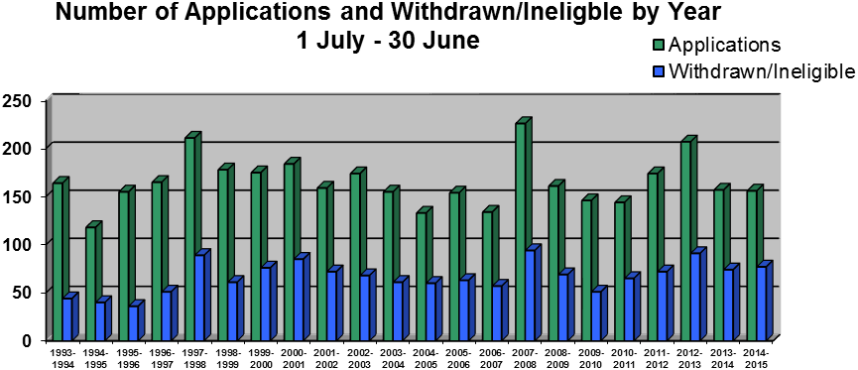

**Breakdown Between Categories**

The following pie graph illustrates what proportions of special patients, inpatients and community treatment patients make up all applications received (including s75 complaints):

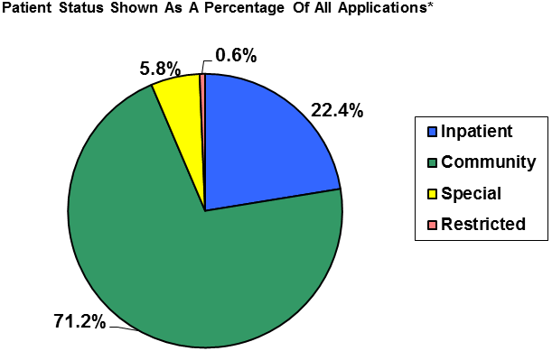

The actual figures were:

Community Patients 111

Inpatients 35

Special Patients 9

Restricted Patients 1

**Total** **156**

**Gender**

Over the report year, the number of applications of all descriptions received from male patients was 93 and the number from female patients was 63 as illustrated in the following pie graph*:

**Percentage of Applications by Sex**

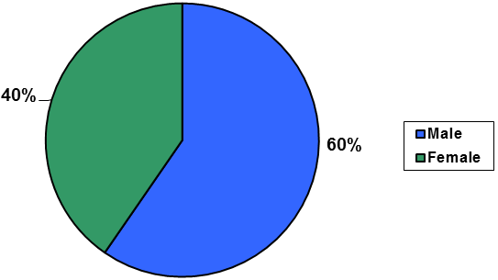

*NB: Some patients of both sexes applied more than once

**By comparison, 2013 census data supplied by Statistics New Zealand indicates that for the age range 20-69 years inclusive (in which nearly all the applicants fall) the total population breakdown was 48.69% males and 51.31% females.**

The gender breakdown of inpatient applicants, community treatment applicants and special patients was as follows:

|  |  |
| --- | --- |
| **Applications by patients subject to community treatment orders** | |
| ***Gender*** | **Number** |
| Male | 69 |
| Female | 42 |
| **Applications by patients subject to inpatient treatment orders** | |
| Male | 15 |
| Female | 20 |
| Applications by patients subject to special treatment orders | |
| Male | 8 |
| Female | 1 |
| **Applications by patients subject to restricted orders** | |
| Male | 1 |
| Female | 0 |
| **Total** | **156** |

These figures are illustrated in the following four pie graphs:

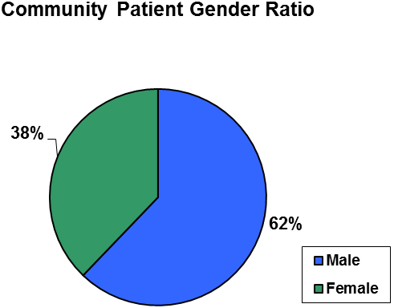

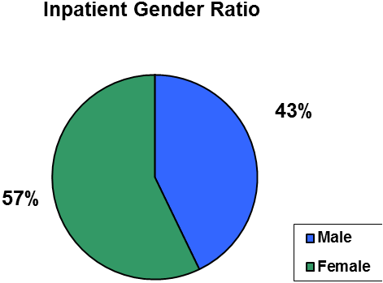

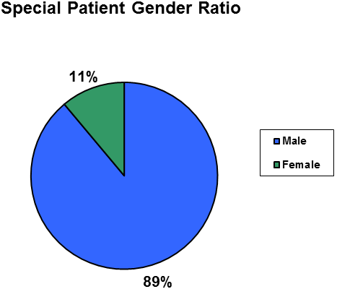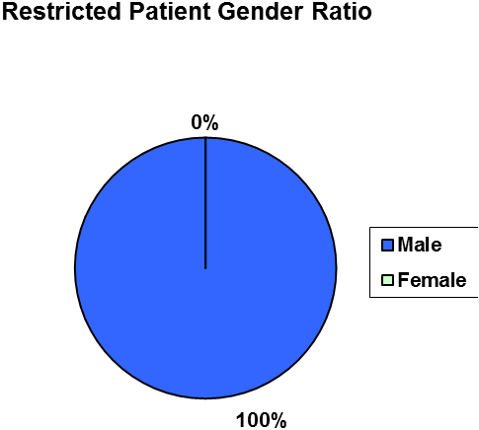

**Ethnicity**

Of the 156 applications received, 137 (88%) presented an identifiable ethnicity through their applications. The 137 applicants for whom data has been recorded have been broken down in the following table. The percentages will not necessarily reflect the actual ethnic breakdown over the year because the data is incomplete. The comparative figures in the final column are derived from Statistics New Zealand figures as per the 2013 census for the age 20 – 69 (inclusive) population range into which nearly all applicants fall.

|  |  |  |  |
| --- | --- | --- | --- |
| Ethnicity | Number | Percentage % | Population Comparison |
| European/Pakeha | 93 | 68% | 67% |
| Maori | 31 | 23% | 13% |
| Pacific Island | 5 | 4% | 7% |
| Asian | 6 | 4% | 11% |
| Other | 2 | 1% | 2% |
| **Total** | **137** | **100%** | **100%** |

These figures are illustrated in the following pie graph:



**Hearings held during the report year**

**Section 79 applications**

From previous year: 4

From report year: 58

Total 62

**Section 80 applications**

From previous year: 0

From report year: 6

Total 6

**Section 81 applications**

From previous year: 0

From report year: 0

Total 0

**Section 75 applications**

From previous year: 0

From report year: 0

Total 0

**Grand Total** **68**

**Summary of hearings held**

From previous year: 4

From report year: 64

**Grand Total** 68

**Numbers Found Fit to be Released**

Of the 62 s79 applications determined by the Tribunal during the report year the Tribunal certified 5 (8%) were fit to be released from compulsory status and 57 (92%) not fit to be released from compulsory status. The equivalent figures since the Northern and Southern Tribunals merged are as follows:

|  |  |  |  |  |  |
| --- | --- | --- | --- | --- | --- |
| Year | No. Of Cases Determined | Remain On  Order | % | Released From Order | % |
| 2002-2003 | 96 | 93 | 96.9 | 3 | 3.1 |
| 2003-2004 | 79 | 72 | 91 | 7 | 8.9 |
| 2004-2005 | 69 | 65 | 94.2 | 4 | 5.8 |
| 2005-2006 | 90 | 85 | 94.4 | 5 | 5.6 |
| 2006-2007 | 68 | 64 | 94.3 | 4 | 5.7 |
| 2007-2008 | 94 | 87 | 92.6 | 7 | 7.4 |
| 2008-2009 | 95 | 88 | 93 | 7 | 7 |
| 2009-2010 | 76 | 75 | 99 | 1 | 1 |
| 2010-2011 | 72 | 70 | 97.3 | 2 | 2.7 |
| 2011-2012 | 80 | 76 | 95 | 4 | 5 |
| 2012-2013 | 102 | 97 | 95.1 | 5 | 4.9 |
| 2013-2014 | 80 | 72 | 90 | 8 | 10 |
| **2014-2015** | **62** | **57** | **92** | **5** | **8** |
| **Total** | **1063** | **1001** | **94.2** | **62** | **5.8** |
|  |  |  |  |  |  |

**Special Patients**

Recommendations for a change in status were made in 2 of the 6 hearings held during the report year. The equivalent figures since the Act came into force are:

|  |  |  |  |  |  |
| --- | --- | --- | --- | --- | --- |
| Year | No. Of Cases | Special Patient Status Should Continue | % | Special Patient Status Should Not Continue | % |
| 1993 | 6 | 6 | 100 | 0 | 0 |
| 1993-1994 | 9 | 7 | 78 | 2 | 22 |
| 1994-1995 | 7 | 6 | 86 | 1 | 14 |
| 1995-1996 | 14 | 12 | 86 | 2 | 14 |
| 1996-1997 | 6 | 5 | 83 | 1 | 17 |
| 1997-1998 | 5 | 4 | 80 | 1 | 20 |
| 1998-1999 | 10 | 10 | 100 | 0 | 0 |
| 1999-2000 | 4 | 3 | 75 | 1 | 25 |
| 2000-2001 | 6 | 6 | 100 | 0 | 0 |
| 2001-2002 | 7 | 6 | 86 | 1 | 14 |
| 2002-2003 | 9 | 6 | 67 | 3 | 33 |
| 2003-2004 | 11 | 6 | 55 | 5 | 45 |
| 2004-2005 | 4 | 4 | 100 | 0 | 0 |
| 2005-2006 | 2 | 1 | 50 | 1 | 50 |
| 2006-2007 | 2 | 2 | 100 | 0 | 0 |
| 2007-2008 | 8 | 7 | 87.5 | 1 | 12.5 |
| 2008-2009 | 5 | 5 | 100 | 0 | 0 |
| 2009-2010 | 1 | 1 | 100 | 0 | 0 |
| 2010-2011 | 6 | 4 | 67 | 2 | 22 |
| 2011-2012 | 6 | 6 | 100 | 0 | 0 |
| 2012-2013 | 6 | 4 | 66.6 | 2 | 33.3 |
| **2013-2014** | **9** | **6** | **66.6** | **3** | **33.3** |
| **2014-2015** | **6** | **4** | **66.6** | **2** | **33.3** |
| **Total** | **149** | **121** | **81.2** | **28** | **18.8** |

**Geographics**

The district health boards from which applications were received over the past year together with the number of applications and the number of withdrawals prior to determination are shown in the following chart.

|  |  |  |  |  |  |  |
| --- | --- | --- | --- | --- | --- | --- |
|  | ***Report Year Applications*** | | | | ***Previous Year Applications*** | |
| Location | No. of Apps. | Heard | W/D and Ineligible | Carried over to 14/15 | Heard | W/D and Ineligible |
| ***Northland*** | 4 | 2 | 1 | 1 | 0 | 0 |
| ***Waitemata*** | 25 | 11 | 12 | 2 | 1 | 0 |
| ***Auckland*** | 33 | 11 | 20 | 2 | 0 | 0 |
| ***Counties Manukau*** | 5 | 1 | 3 | 1 | 1 | 0 |
| ***Waikato*** | 9 | 2 | 7 | 0 | 0 | 0 |
| ***Bay of Plenty*** | 8 | 5 | 3 | 0 | 0 | 0 |
| ***Lakes*** | 6 | 0 | 4 | 2 | 0 | 0 |
| ***Tairawhiti*** | 0 | 0 | 0 | 0 | 0 | 0 |
| ***Taranaki*** | 0 | 0 | 0 | 0 | 0 | 0 |
| ***Hawkes Bay*** | 6 | 6 | 0 | 0 | 0 | 0 |
| ***Whanganui*** | 1 | 0 | 1 | 0 | 0 | 0 |
| ***MidCentral*** | 2 | 1 | 1 | 0 | 0 | 0 |
| ***Wairarapa*** | 0 | 0 | 0 | 0 | 0 | 0 |
| ***Hutt Valley*** | 6 | 1 | 5 | 0 | 1 | 0 |
| ***Capital & Coast*** | 19 | 8 | 8 | 3 | 0 | 0 |
| ***Nelson Marlboro*** | 2 | 0 | 1 | 1 | 0 | 0 |
| ***West Coast*** | 0 | 0 | 0 | 0 | 0 | 0 |
| ***Canterbury*** | 19 | 10 | 7 | 2 | 0 | 0 |
| ***South Canterbury*** | 0 | 0 | 0 | 0 | 0 | 0 |
| ***Southern*** | 11 | 6 | 4 | 1 | 1 | 0 |
| **Grand Total** | **156** | **64** | **77** | **15** | **4** | **0** |

##### **Video Conferences and Telephone Conferences**

The pie graph illustrates the proportion of hearings (of all descriptions) heard by way of video conference during the report year. Of the 68 hearings, 2 were held by video conference and none by teleconference.

**Proportion of Hearings By Way of Video or Teleconference**

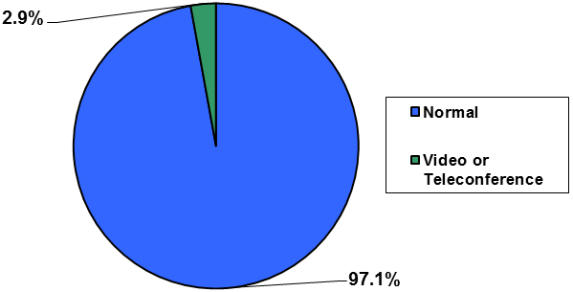

Record keeping in relation to video conferencing commenced in the 2002/2003 year.

The comparative figures are as follows:

|  |  |  |
| --- | --- | --- |
| *Year* | *Number of video-conferences and telephone conferences* | **Proportion to total number of hearings** |
| 2002/2003 | 5 | 5% |
| 2003/2004 | 10 | 11% |
| 2004/2005 | 3 | 4.2% |
| 2005/2006 | 4 | 3.6% |
| 2006/2007 | 6 | 8.6% |
| 2007/2008 | 2 | 1.9% |
| 2008/2009 | 3 | 3% |
| 2009/2010 | 4 | 5.5% |
| 2010/2011 | 2 | 2.5% |
| 2011/2012 | 1 | 1.2% |
| 2012/2013 | 2 | 2.6% |
| 2013/2014 | 0 | 0% |
| 2014/2015 | 2 | 2.9 |

##### **Appointments Pursuant to ss 59 and 60**

During the last year a total of 17 clinicians were appointed by the Tribunal as psychiatrists appointed to give opinions that proposed treatment of patients contrary to their consent (including in relation to electro-convulsive) is in their interests.

# 9. Publication of Decisions

There are two competing principles in relation to the publication of Tribunal decisions: the right of the public to be informed as to the workings of the Tribunal on the one hand and on the other hand, the need for privacy to be respected and protected.

The Mental Health Review Tribunal conducts its hearings at the place where applicants are treated. This means that hearings are conducted in a medical milieu, usually a hospital or community mental health centre. In such a setting, participants may incorrectly surmise that the usual privacy and confidentiality which attends medical matters will pertain with respect to Tribunal hearings. That is not the correct position. Although clause 7 of Schedule 1 of the Mental Health (Compulsory Assessment and Treatment) Act provides that Tribunal proceedings are not open to the public, clause 8 allows for the publication of reports of proceedings with the leave of the Tribunal and/or in publications of a bona fide professional or technical nature.

Patients and their families and clinicians, when providing private and personal information during the course of tribunal hearings may rightly be alarmed that reports of those hearings might find their way on to the worldwide web. Publishers of professional and technical journals are now publishing those journals on line.

In April 2010 the Tribunal and the Ministry of Health agreed on guidelines intended to ensure that the two competing principles referred to above are properly balanced and that appropriate cases are identified for publication.

The protection provided by these guidelines is essentially three-fold:

1. Only a selection of cases will be sent to publishers.
2. Those cases will be carefully anonymised.
3. They will be sent only to three established professional and responsible publishers, namely Brookers (Thomson Reuters), LexisNexis and the New Zealand Legal Information Institute.

The Tribunal’s intention is that important and helpful cases are made available to these publishers that will enable the work of the Tribunal to be better understood, and assist the public at large with its understanding of mental health law and practice.

As at the date of this report forty-two cases can be found on line on the New Zealand Legal Information Institute website: [www.nzlii.org/nz/cases/NZMHRT/](http://www.nzlii.org/nz/cases/NZMHRT/)

These cases can now be accessed through the Tribunal’s website. The website also provides a brief précis each case and an index listing the issues involved.

# Website

The Tribunal now has a dedicated website, within the Ministry’s website: <http://www.health.govt.nz/new-zealand-health-system/key-health-sector-organisations-and-people/mental-health-review-tribunal>

The website went live on 13 August 2015. Its purpose is to provide information about the Tribunal and to lend assistance to those who are involved in its work.

# Conclusion

The report year saw a good deal of time devoted to establishing the Tribunal’s website. Amongst other things, this involved a comprehensive review and rewrite of the Tribunal’s policies, some of which had unaltered since 2002. These Practice and Policy Guidelines, as they are now called, are all available on the website. Until the website went live in August 2015, none of these documents was available to the public. Also made available to the public for the first time through the website was the Tribunal’s index and précis of each cases.

There is thus full information available without cost to the world at large as to who comprises the Tribunal, what is does, how it does it, and why it makes the decisions that it does.

---------------------------

**N J Dunlop**

**Convener**

**Mental Health Review Tribunal**

---------------------------

**Date**