Important Messages for the Implementation of the Substance Addiction (Compulsory Assessment and Treatment) Act
Reporting Requirements for Tracking Health Service Utilisation

Prepared for: DHB Funding and Planning, Treatment Services
Intended Audience: Data Analysts, PRIMHD Site Coorodinators, NCAMP

Introduction
Legislation to allow for someone to be assessed and treated under compulsion for their substance abuse issues has been around for over fifty years.
The existing legislation has been thoroughly upgraded and new legislation is to commence on 21 February 2018.
Like the previous legislation the new Substance Addiction (Compulsory Assessment and Treatment Act) 2017 is reserved as a last resort and for the most severe forms of addiction.
Compulsory assessment and treatment is intended to:
- protect the person from harm; and
- allow a comprehensive assessment of their addiction; and
- stabilise their health (including medically managed withdrawal); and
- protect and enhance their mana and dignity and restore their capacity to make informed decisions; and
- facilitate continued medical treatment and care on a voluntary basis; and
- provide an opportunity to engage in voluntary addiction treatment.

What data is required to be collected?
The data that will be required to be collected represents the activities to cover the continuum of service engagement from first contact with an authorised officer through to eventual discharge. Even then, it would be useful to show a person’s service utilisation before application of the Act, and for up to twelve months post-discharge.
The following information is specifically required by section 119 of the SACAT Act.
Data required to comply with the Act (s119) | Explanation
Number of people detained | Compulsory status (‘detention’) starts at when a compulsory treatment certificate is issued
Length of detention | Period between section 23 and release from compulsory status
Compulsory treatment orders made | Information is also collected by Justice
Compulsory treatment orders extended | Information is also collected by Justice
The number of people discharged (and where) – release from compulsory status | How many people are released from status prior to the end of the compulsory treatment period?  Where do they go on release/discharge from a treatment centre?

Codes for Reporting Legal Status
Existing codes for the Alcoholism and Drug Addiction Act will be retired from February 2018.

New legal status (LS) codes to be available from early 2018 are:

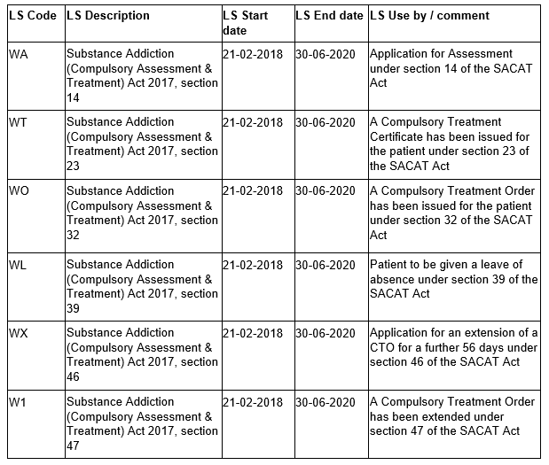

Note – there is no separate LS code for discharge from the Act – it will be critical for services to include a “close-off” date under “WO” or “WX” when the person is discharged.

Other data that may be required
The next table shows examples of the kinds of questions we will need to answer in respect to the operation of the Act, and present as part of our review of the Act as specified in section 120.
There are different ways of getting this information – some through analysis of the data collected above, through PRIMHD, and some in respect of reports such as those provided by district inspectors (particularly with regard to monitoring patients’ rights).
Data required to monitor the use of the Act | Explanation
Number of applications for assessments | We need to know the number of applications for assessment
Number of repeat applications for assessment (by individual, DHB, age, ethnicity) | We need to know how many people are subject to more than one application for assessment within a defined period (probably 12 months)
Number of repeat compulsory treatment certificates issued | We will want to know how many people are placed under the Act more than once in a defined period
Medical certificate OR authorised officer’s memorandum | We will want to know the numbers and means
Children or young people assessed by an approved specialist with expertise in child/adolescent psych. | We want to show compliance with in the Act
Detention in treatment centre | We want to show how many people accepted into the treatment centre, and in how many cases does the treatment centre refuse to accept the patient
Orders made in respect of a child or young person | Need to know how many children and young people are subject to the Act
Leave of absence (start & end) | How many people / how long /what for?
Review of patient | Are responsible clinicians complying with the requirements for ‘regular review’ Note: we will also ask district inspectors to monitor this section
Plan for future care and treatment | We will want to know if there are plans, and may review the content of such plans as part of the wider evaluation
Transitional / savings provisions | How many people are transferred from the ADA Act to the SACAT Act  Note: this information will be collected as a ‘one off’ – probably manual reporting

Code Sets
We will continue using the existing team type and activity type codes to describe the treatment provider and services provided.

Team type would be 03 = AOD. However, as part of a general health assessment, other groups of services or people who are sources of mental health and addiction referrals may also be relevant.

Typically the applicable activity type codes will be:

T16 - substance abuse withdrawal management/detoxification occupied bed nights (medical)

T20 - substance abuse residential service occupied bed nights

T02, T03, T04 - inpatient bed nights (intensive, acute, sub-acute).

T20 – susbtance3 abuse residential services occupied bed nights

T32 – contact with family/whanau, consumer not present

T36 - contact with family/whanau, tangata whaioria/consumer present

T39 – integrated Māori and clinical interventions

T42 – individual treatment attendances; family/whanau not present.

For Further Information
To find out more, you can:
- Contact the Ministry of Health about the application of PRIMHD codes
- Go on-line to the Ministry of Health to see various guidelines – http://www.health.govt.nz/sacat
- Contact your local District Health Board addiction treatment service and ask to speak to someone about the Act by phoning: number.

