Horizon Research
Reconnecting New Zealand to the World
28 August – 1 September 2021

Prepared for:
Behavioural Insights
Science and Insights Group
COVID-19 Directorate
Ministry of Health

Contents

EXECUTIVE SUMMARY 1
REPORT 4
1. Delta variant 4
Level of concern 4
Level of risk 5
2. Re-opening borders 6
2.1 Time to re-open 6
2.2 Factors to consider 7
2.3 Percentage of people in New Zealand who should be vaccinated before re-opening 11
2.4 Would two doses of the COVID-19 vaccine be enough to make it safe to open the border? 12
2.5 Booster vaccinations 14
3. Public health behaviours 16
3.1 Prior to lockdown 16
3.2 Safety behaviours if the border were open 17
3.3 Motivations 18
3.4 Key concerns about COVID-19 becoming established in the community 19
3.5 Effect on confidence in opening the border if the provision of COVID-19-related services had limited capacity or suffered performance delays. 22
4. Entering New Zealand 23
4.1 Entering New Zealand – a phased approach 23
4.2 Isolation 27
5. Tracing and signing in 28
6. Mandatory testing and vaccination 29
6.1 Mandatory Testing 29
6.2 Mandatory vaccination 31
7. Government approach to the pandemic 33
7.1 Decisions for Reconnecting to the World 33
7.2 Protecting the most at-risk 34
7.3 Treaty of Waitangi 35
8. Pandemic impact on health and wellbeing 37
8.1 Personal impact 37
8.2 Reasons for feeling that way 39
8.3 Health experiences 41
8.4 Alcohol 43
APPENDIX 1 - SAMPLE 46
APPENDIX 2 – TABLES ATTACHED 48
APPENDIX 3 – VERBATIMS ATTACHED 48

EXECUTIVE SUMMARY
These results are from an online survey of 1,321 New Zealand respondents aged 18 years of age or over. The survey was conducted between 28 August and 1 September, 2021.

The sample is weighted on age, gender, employment status, ethnicity, household income and education to match the 18+ population at the most recent census.

KEY FINDINGS

Re-opening borders
- Sixty per cent of respondents think the country should re-open to the world by the end of 2022, if not earlier.
- While a majority of New Zealanders are prepared to reconnect with the world, that comes with the proviso that it is safely and cautiously implemented.

- The ability to keep New Zealanders safe is rated the most important factor that decision makers should take into consideration in making decisions about reopening the borders (66% of all respondents). This is followed by the percentage of people vaccinated (53%, which is important to those under 65 years of age) and the capacity and capability of the health system (53%).

- High vaccination rates are sought. Only 26% of respondents are comfortable with a nationwide vaccination rate of 70% of the whole population (including children under 12 years of age) before the borders are opened. When the vaccination rate reaches 80% of the whole population, 47% would support the borders being open. When the vaccination rate reaches 90%, the support for the borders being open rises to 75%.

Public Health behaviours
- If the border were opened, some health protection practices would increase. For example, 27% of respondents reported wearing masks before the current lockdown and intention to wear a mask rises to 43% or 52% depending on the risk rating of the countries the border was open to. Getting a test if symptomatic doubles, from 31% before, to 64% or 69% with open borders.

- Doing the best for their own individual health (68%) and the health of their families (68%) are the main motivations for protecting against COVID-19.

- Key concerns if COVID-19 became established in the community are Illness/death of a loved one (63%), health system capacity (61%), and continuing lockdowns (60%).

- 4 out of 10 respondents indicated they would have reduced confidence in reopening the borders if any of the COVID-19-related services –infection testing, vaccination and contact tracing – experienced limited capacity or delays.

Phased reopening plan
- The overall support for a phased reopening totals 66%, with 26% opposing it.

- Overall support levels for the components of the phased reopening plan are:
  - The plan to change to an individual, risk-based approach: 66%.
  - Quarantine-free travel being introduced for vaccinated travellers who have been in low-risk countries: 64%.
  - Self-isolation arrangements for some vaccinated New Zealanders who have been in medium-risk countries: 63%.
  - 14 days in MIQ for all unvaccinated travellers: 80%.
  - 14 days in MIQ for vaccinated travellers who have been in high risk or very high-risk countries: 81%.

Tracing and signing in
- There is strong support for mandatory signing in when entering places or using a range of services: 80%+ for all places measured except “Smaller retail premises” (78%) and Office premises (77%).

Mandatory testing and vaccination
There are high levels of general public support for mandatory testing and mandatory vaccination for four key groups:
Group | % support for mandatory testing | % support for mandatory vaccination
Border workers | 91% | 87%
Maritime/port workers | 90% | 86%
Frontline workers | 91% | 86%
Essential workers | 88% | 83%

Government approach to the pandemic
- At total of 73% feel the government is making the right decisions as New Zealand looks to reconnect to the world, but the average strength of that support is mid-range.
- Similarly, 76% feel the Government has adequately protected the health of the people most at risk from COVID-19 in the past year.
- 64% of Māori overall felt that the Government has upheld the principles of Te Tiriti o Waitangi in the way it has managed COVID-19. 19% felt it had not upheld these principals, while 17% were unsure.

Pandemic impact on health and wellbeing
- It is likely that younger people are having a much harder time with the pandemic, and specifically this lockdown.
- Overall, 45% of all respondents said the pandemic has negatively affected their personal health and wellbeing. This is estimated at 1,764,600 people 18+.
- 31% found it to be “Neither positive nor negative” (an estimated 1,237,200 people 18+).
- 23% found it positive to some degree (an estimated 927,900 people).
- 1% (39,700 people) were unsure.

- A third of respondents (34%, an estimated 1,364,100 adults) reported feeling anxious in the past four weeks. Almost the same proportion said they felt tired for “no good reason” (Just over 32%, around 1,284,800 adults), and others had problems:
  - Maintaining a healthy lifestyle (26%, around 1,027,000 adults).
  - Feeling depressed (25%, around 979,500 adults).
  - Feelings of loneliness (also25%, around 979,500 adults).
- 32% (around 1,268,900 adults) said they had felt none of these feelings or attitudes, suggesting that over two-thirds have experienced some of these in the past four weeks.
- 17% (an estimated 666,200 people 18+) said they had experienced “Challenging domestic, family or emotional situations”. This experience is likely to include domestic, family and sexual violence and emotional abuse.
- 13% (an estimated 531,400 people 18+) said they had experienced difficulties with managing their current health conditions. This is likely to include problems managing mental health conditions.

- Among those drinking, there does not appear to have been a large increase in alcohol consumption: about half of those who drink say they’re drinking the same , and those who say their alcohol consumption has changed are roughly balanced (17% less, an estimated 622,600 adults, and 14% more, an estimated 602,700 adults). The volume of consumption was not measured.
- 13% of respondents (an estimated 499,600 people) expressed some concern about the amount of alcohol someone else in their household was drinking.

REPORT

Delta variant

Level of concern
69% of respondents say the emergence of the Delta strain has heightened their concern about the COVID-19 pandemic. Only 4% are less concerned and 3% were not sure.
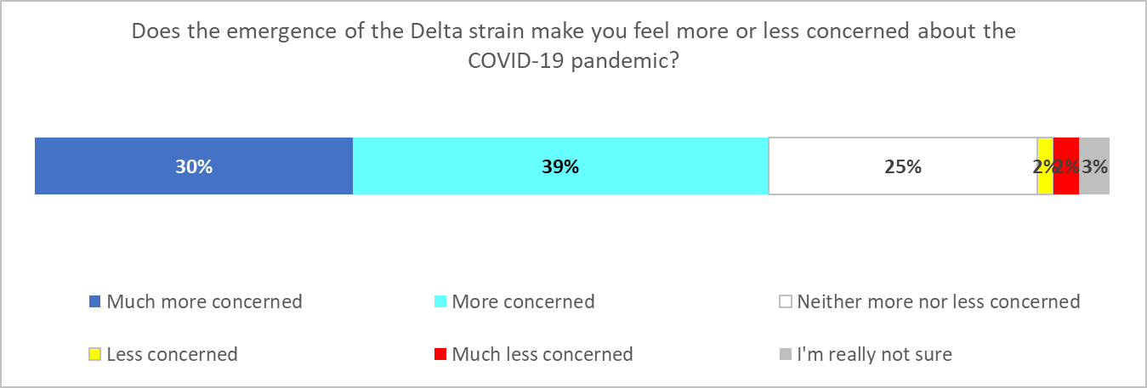
This does not vary a lot by age, although there are indications that those 75 years and older are less concerned (57%).
Females are more concerned (76% versus 60% for males) as well as Asians (75%) and Indians (89%). It seems to be a little lower for Māori (64%).

Does the emergence of the Delta strain make you feel more or less concerned about the COVID-19 pandemic? | AGE GROUP
 | 18-24 years | 25-34 years | 35-44 years | 45-54 years | 55-64 years | 65-74 years | 75 years or over
More or much more | 69% | 73% | 71% | 69% | 68% | 65% | 57%

Does the emergence of the Delta strain make you feel more or less concerned about the COVID-19 pandemic? | GENDER*
 | Male | Female
More or much more | 60% | 76%
* Results for “Gender Diverse” not shown owing to small base (n=2)

Does the emergence of the Delta strain make you feel more or less concerned about the COVID-19 pandemic? | ETHNIC GROUP
 | Asian | Indian | Māori | NZ European/ Pākehā | Other European | Pasifika | Other
More or much more | 75% | 89% | 64% | 68% | 66% | 69% | 46%

Level of risk
The emergence of more infectious strains has made respondents feel more at risk.
The highest increase in perceived risk was to families (48%) and the community (48%) followed by personal risk (38%). 18% felt no higher personal risk and 11% felt no higher risk to their families.
Overall, more females think the emergence of more infectious strains put their families at risk than males (53% versus 44%).
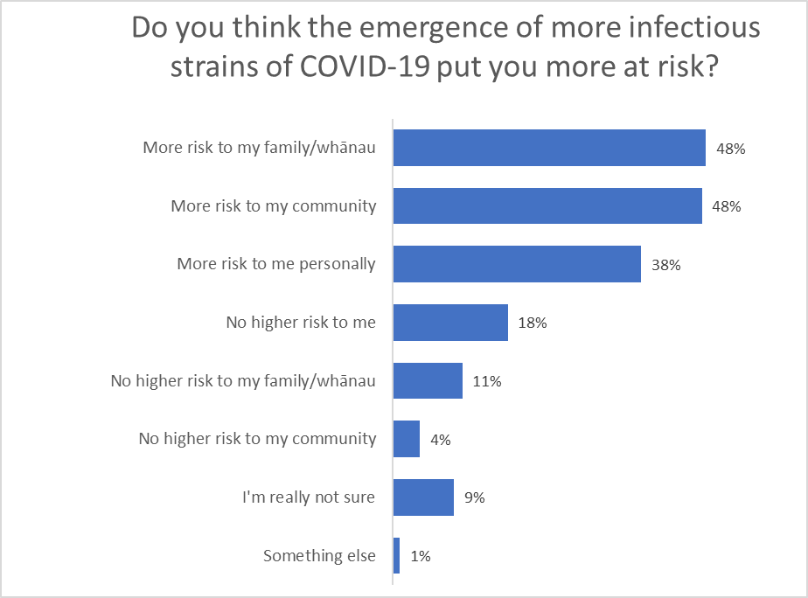

Re-opening borders

2.1 Time to re-open
Sixty per cent of respondents think the country should re-open to the world by at least the end of 2022. Among those, 18% feel it should open in 2021.

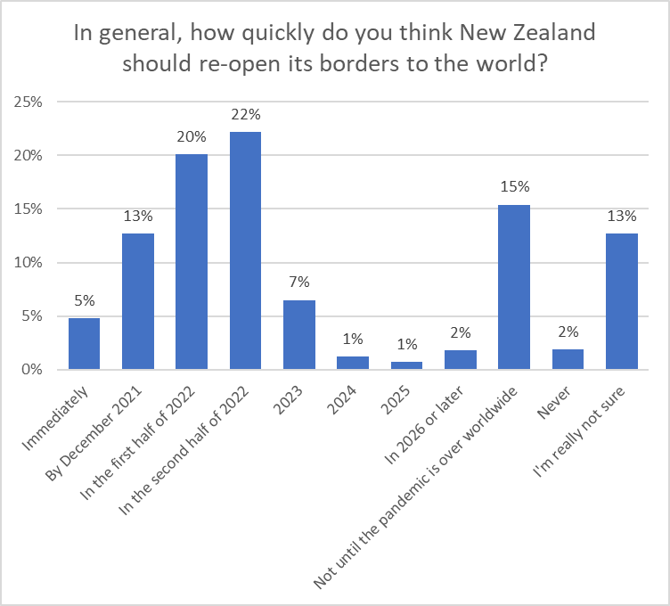

This is higher than average among younger and older people (72% under 25, 68% 65 years of age and over) – indicating they want to open sooner – and less by those aged 25 to 54 (51%).
It is higher for males (64%) and correspondingly lower for females (56%).
It is also higher for Asians (69%) and lower for Māori and Pasifika (54% and 48%) indicating they would prefer a slightly longer “closed” period.

2.2 Factors to consider
Respondents were asked which of a list of factors should be taken into account when reopening the borders.
The ability to keep New Zealanders safe is rated the most important (66%), followed by the percentage of people vaccinated (53%) and the capacity and capability of the health system (53%).
Overall, it seems a majority of New Zealanders are prepared to reconnect with the world, provided it were safely and cautiously implemented. Re-opening for business travel, to allow immigration, sports teams and “freedom of travel” have least importance.

There was an apparent relationship (but only a moderate correlation) between the top 3 considerations. To illustrate this, and looking at just the top 3 considerations:
- The 66% who said “The ability to keep New Zealanders safe” selected an average of 7.9 of 22 options. The most important other considerations selected by these people were:
  - The capacity and capability of the New Zealand health system (67% of the 66%).
  - The percentage of New Zealanders who have been vaccinated (65% of the 66%).
- The 53% who said “The percentage of New Zealanders vaccinated) selected 8.9 options, on average. The three most important other considerations to them were:
  - The ability to keep New Zealanders safe (81% of the 53%).
  - The capacity and capability of the New Zealand health system (72% of the 53%).
  - The capacity of the New Zealand contract tracing system (63% of the 53%).
- The 53% who said “The capacity and capability of the New Zealand health system” also selected an average of 8.9 options. The three most important to them were:
  - The ability to keep New Zealanders safe (84% of the 53%).
  - The percentage of New Zealanders who have been vaccinated (72% of the 53%).
  - The capacity of the New Zealand contract tracing system (66% of the 53%).

Reconnecting/re-uniting families (45%), allowing more New Zealand citizens and permanent residents to return (42%), the capacity of the New Zealand contract tracing system (41%), jobs for New Zealanders (41%) and allowing skilled workers to come to New Zealand (41%) were middle- to higher-ranking factors.
Males seem to be slightly more focused on economic and business factors, and females on more social ones.

“The ability to keep New Zealanders safe” is consistently in the top 3 considerations for all ethnic groups, and is the top-ranking consideration for all but Asian and “other” ethnicity respondents.

ETHNIC GROUP
Asian | Indian | Māori | NZ European/ Pākehā | Other European | Pasifika | Other
Allowing more New Zealand citizens and permanent residents to return (52%) | The ability to keep New Zealanders safe (57%) | The ability to keep New Zealanders safe (67%) | The ability to keep New Zealanders safe (68%) | The ability to keep New Zealanders safe (78%) | The ability to keep New Zealanders safe (65%) | Jobs for New Zealanders (52%)
The percentage of New Zealanders who have been vaccinated (52%) | Jobs for New Zealanders (49%) | Reconnecting/re-uniting families (47%) | The capacity and capability of the New Zealand health system (58%) | The percentage of New Zealanders who have been vaccinated (65%) | Allowing more New Zealand citizens and permanent residents to return (43%) | The ability to keep New Zealanders safe (43%)
The ability to keep New Zealanders safe (51%) | The percentage of New Zealanders who have been vaccinated (37%) | Allowing more New Zealand citizens and permanent residents to return (47%) | The percentage of New Zealanders who have been vaccinated (56%) | The capacity and capability of the New Zealand health system (64%) | Jobs for New Zealanders (38%) | Allowing skilled workers to come to New Zealand (40%)

Note that “The ability to keep New Zealanders safe” is the top consideration for all age groups. “The percentage of New Zealanders who have been vaccinated is a top 3 consideration for all age groups up to 64 years.

AGE GROUP
18-24  years | 25-34  years | 35-44  years | 45-54  years | 55-64  years | 65-74  years | 75 years or over
The ability to keep New Zealanders safe (45%) | The ability to keep New Zealanders safe (57%) | The ability to keep New Zealanders safe (66%) | The ability to keep New Zealanders safe (67%) | The ability to keep New Zealanders safe (82%) | The ability to keep New Zealanders safe (75%) | The ability to keep New Zealanders safe (79%)
The capacity and capability of the New Zealand health system (38%) | The percentage of New Zealanders who have been vaccinated (51%) | The percentage of New Zealanders who have been vaccinated (44%) | The percentage of New Zealanders who have been vaccinated (62%) | The capacity and capability of the New Zealand health system (67%) | The capacity and capability of the New Zealand health system (74%) | The capacity and capability of the New Zealand health system (70%)
The percentage of New Zealanders who have been vaccinated (37%) | Reconnecting/re-uniting families (47%) | The capacity and capability of the New Zealand health system (41%) | The capacity and capability of the New Zealand health system (54%) | The percentage of New Zealanders who have been vaccinated (61%) | Allowing skilled workers to come to New Zealand (69%) | The capacity of the New Zealand contract tracing system (65%)

2.3 Percentage of people in New Zealand who should be vaccinated before re-opening
Only 26% of respondents were comfortable with a nationwide vaccination rate of 70% before the borders are opened (the orange circle in the chart below). When the vaccination rate reaches 80%, 47% would support the borders being open (the blue circle.) When the vaccination reaches 90%, the support for the borders being open rises to 75% (the green circle.)
(Note that two per cent said “don’t know”, which is why the cumulative line only reaches 98%).

There does not seem to be any significant difference between genders.
Asian respondents would be comfortable with a lower vaccination rate (40% supportive of re-opening at a 70% rate, compared to the 26% overall). Pasifika are less supportive, and even at 90% vaccination rate only 59% want the border re-opened.
Younger people (under 35) were more supportive of opening with a lower vaccination rate than the 18+ population overall.

Support for the borders opening when vaccination rate for the whole population reaches: | AGE GROUP
 | 18-24 years | 25-34 years | 35-44 years | 45-54 years | 55-64 years | 65-74 years | 75 years or over
70% | 42% | 37% | 26% | 24% | 18% | 14% | 13%
80% | 59% | 55% | 41% | 52% | 36% | 44% | 42%
90% | 82% | 82% | 63% | 77% | 71% | 74% | 85%

Support for the borders opening when vaccination rate for the whole population reaches: | GENDER*
 | Male | Female
70% | 27% | 26%
80% | 49% | 45%
90% | 77% | 73%
* Results for “Gender Diverse” not shown owing to small base (n=2)

Support for the borders opening when vaccination rate for the whole population reaches: | ETHNIC GROUP
 | Asian | Indian | Māori | NZ European/ Pākehā | Other European | Pasifika | Other
70% | 40% | 23% | 32% | 24% | 22% | 20% | 38%
80% | 63% | 51% | 45% | 46% | 42% | 36% | 56%
90% | 82% | 71% | 70% | 76% | 78% | 59% | 89%

2.4 Would two doses of the COVID-19 vaccine be enough to make it safe to open the border?
Respondents were asked if they considered having two doses of the COVID-19 vaccine sufficient to re-open the border to more countries for quarantine-free travel.
Respondents were split between answering “Yes” or “Definitely” (39%,) and “No” or “Definitely not” (34%). 22% were unsure. 6% felt that the border should be opened now regardless of whether people were vaccinated or not.

More males answered “Yes” or “Definitely” (45%) than females (34%). Younger people were also likely to feel that two-doses would be sufficient to allow quarantine-free travel (53% under the age of 25).

The following table indicates the demographic groups whose answers were 5% more or less than the overall result.
Think having two doses of the COVID-19 vaccine is enough to make it safe to open the border to more countries for quarantine-free travel? | %
Asian | 58% ↑
Aged 18-24 | 53% ↑
Household income over $100,000 pa | 47% ↑
People who identify as disabled | 46% ↑
Males | 45% ↑
Total | 39%
Females | 34%↓
People with long-term health impairments | 34%↓
Aged 35-54 | 32% ↓
Household income under $50,000 pa | 31% ↓
Māori | 27% ↓
Results for sample sizes of n=50 or more

2.5 Booster vaccinations
Respondents were presented with a set of questions regarding COVID-19 booster doses.
The first of these questions asked if respondents thought that a third dose should be offered to those who are immunocompromised and at additional risk of being infected with COVID-19, to make it safer to open the border to more countries for quarantine-free travel.
Just over two-thirds of respondents believe a third dose should be offered (34% “Yes, definitely”, 30% “Yes”). 14% believe a third dose should not be offered (“Definitely not” 5%, “No” 9%). 23% were not sure.
Both males and females almost equally think a third dose should definitely be offered.
There was a difference by age, with older people more in favour of the idea (55-64 years 70%, 65-74 years 80% and 75 years or over 74%).
59% of Māori respondents were in favour of providing a third dose, with Pasifika slightly lower (57%).

Additionally, respondents were asked if there was an annual vaccine to continue protection, how likely would they be to get it each year.
75% of respondents overall said they were likely to get an annual vaccine (“Definitely” 40%. “Most likely” 18%, “Likely” 17%).
18% were unlikely to get an annual booster and 8% were not sure.
Both males and females are in favour of an annual vaccine.

In general, the likelihood to get a booster was in line with vaccination intentions: 81% of those who were not yet vaccinated but were likely to get a vaccine, and 91% of those who were already vaccinated, said they were also likely to get a booster.
However, 4% of those who were already vaccinated and 8% of those who were not yet vaccinated but were likely to do so, said they were unlikely to get a booster.

Public health behaviours

3.1 Prior to lockdown
Most respondents seem to have been practising some health behaviours before the current lockdown. It is possible that there could be a small amount of exaggeration but looking at the “currently vaccinated” figure and comparing it to actual vaccination rate, there is probably not a substantial amount.

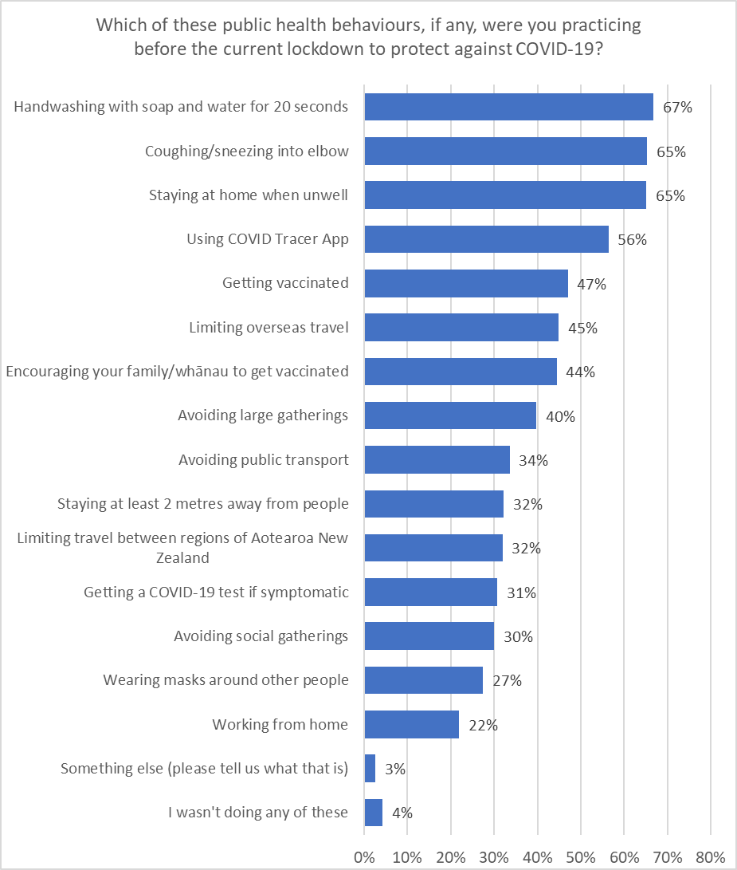
Females are taking more precautions from the list shown, averaging 6.9, on average, to men at 5.8. The number also increases by age, especially for those over 65 who practice 7.4; for respondents under 35 the average number of protective behaviours is 5.8.
Asians on average practice more protective behaviours than average (8.2) but Māori fewer (5.6).

3.2 Safety behaviours if the border were open
If the border were opened, some health safety practices would increase.
- Mask-wearing around other people was 27% prior to the current lockdown and is likely to rise to 43% or 52% depending on what countries the border was open to.
- Handwashing doesn’t seem to change a lot.
- Coughing or sneezing into your elbow increases a little, as does using the tracer app, but if symptomatic, with the borders open the intention to get a COVID-19 test doubles from 31% to 64% or 69% (depending on level of risk of the countries in question).
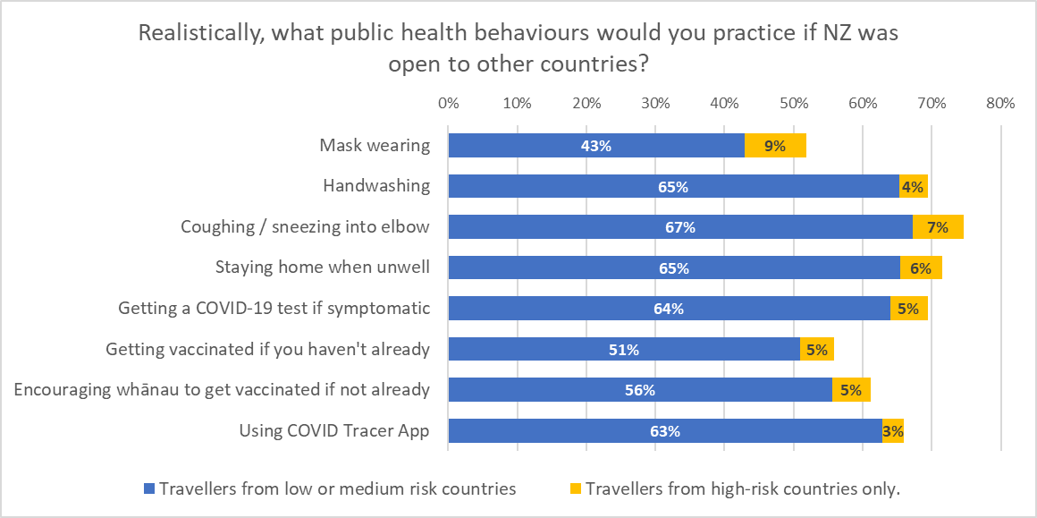
Females and older respondents would generally take more precautions, which mirrors the results for their current behaviour.

Once vaccinated, there is a group of respondents who will stop taking health precautions, from 8% not encouraging their family to get vaccinated, to 15% who would stop wearing masks.
Most respondents (81%) would still practice all the precautions listed below. Only 4% would stop practicing three or more.
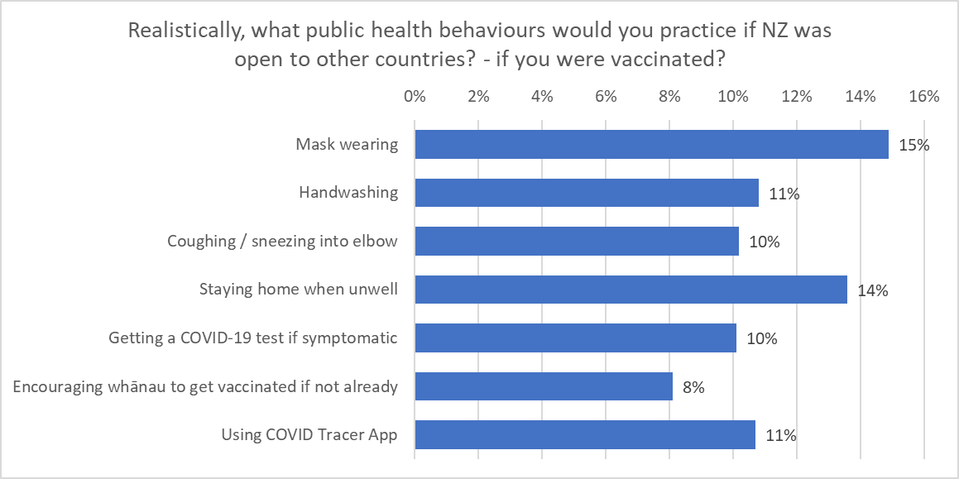
This does not vary largely between age groups, genders and ethnic groups.
Those that are unlikely to get vaccinated are less likely to take precautions. For example, 5% would wear masks after being vaccinated compared with 15% for the total population). They are also more likely to say they do not wear them anyway (30% compared to 10% of the total.)

3.3 Motivations
Respondents were presented with a list of factors and asked which, if any, would motivate them to behave in ways to protect themselves or others from COVID-19.
Doing the best for individual health (68%) and the health of their families (68%) are the main motivations for protecting against COVID-19. Reducing the chances of another lockdown (63%) and getting ‘back to normal’ (63%) also rate highly.

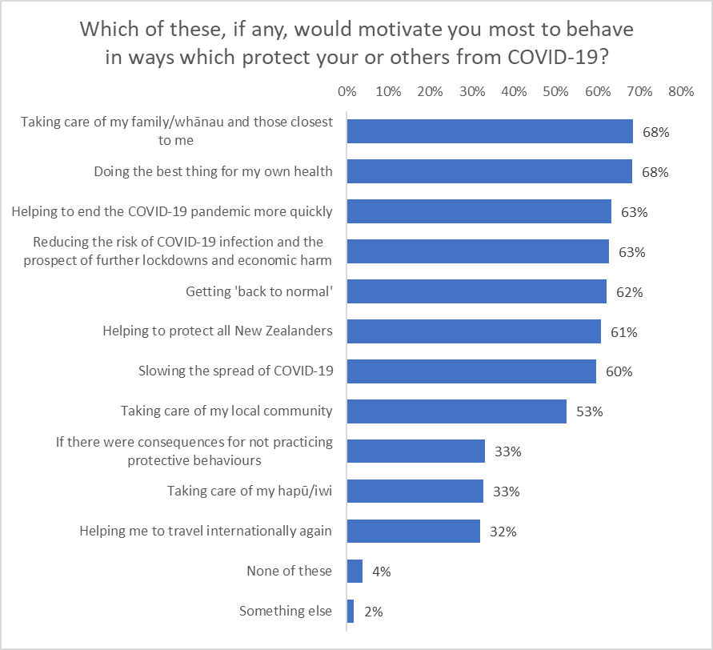
Slowing the spread of COVID-19 (60%) and taking care of the community (53%) closely follow.
In general, females appear to be more motivated by these factors than males, particularly by personal and family health and avoiding another lockdown. Males were significantly less likely than average to be motivated by:
- Slowing the spread of COVID-19.
- Consequences (e.g., fines, arrest, prosecution, jail) for not practicing protective behaviours .
- Taking care of my family/whānau and those closest to them.
- Taking care of their local community.
- Helping reduce the risk of COVID-19 infection and the prospect of further lockdowns and economic harm.
- Helping to end the COVID-19 pandemic more quickly.
There is no significant difference by ethnic group. All ethnic groups have a strong focus on personal and family health.

3.4 Key concerns about COVID-19 becoming established in the community
All respondents were shown a list of concerns about COVID-19 and asked which, if any, would cause them concern if COVID-19 were to become established in the community
As shown in the following chart, Illness/death of a loved one (63%), health system capacity (61%), and continuing lockdowns (60%) were the top concerns followed by the ongoing effects of COVID-19 (58%) and spreading COVID-19 to others (57%).
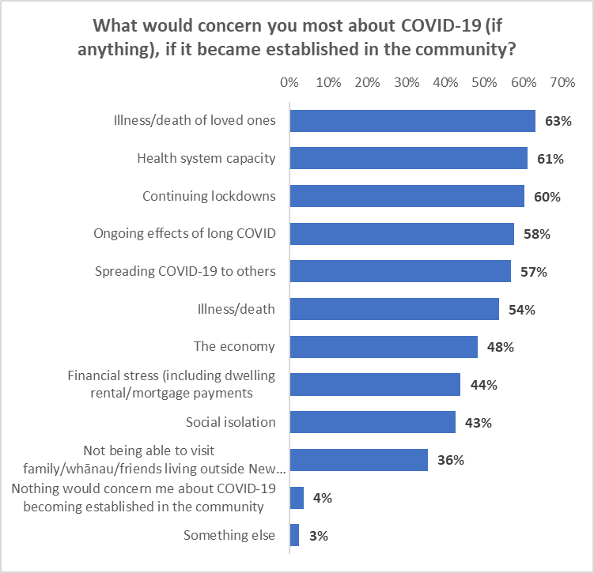

The estimated number of adults who share each of the concerns is shown in the following table.
Concern | % | Estimated no. 18+
Illness/death of loved ones | 63% | 2,502,200
Health system capacity | 61% | 2,418,900
Continuing lockdowns | 60% | 2,387,200
Ongoing effects of long COVID | 58% | 2,284,100
Spreading COVID-19 to others | 57% | 2,252,300
Illness/death | 54% | 2,133,400
The economy | 48% | 1,911,300
Financial stress (including dwelling rental/mortgage payments | 44% | 1,740,800
Social isolation | 43% | 1,689,300
Not being able to visit family/whānau/friends living outside New Zealand | 36% | 1,407,700
Nothing would concern me about COVID-19 becoming established in the community | 4% | 146,700
Something else | 3% | 103,100

There are different concerns across the ethnic groups:
ETHNIC GROUP
Asian | Indian | Māori | NZ European/ Pākehā | Other European | Pasifika | Other
Continuing lockdowns (68%) | Spreading COVID-19 to others (46%) | Illness/death of loved ones (50%) | Illness/death of loved ones (50%) | Illness/death of loved ones (50%) | Spreading COVID-19 to others (46%) | Continuing lockdowns (68%)
The economy (56%) | Ongoing effects of long COVID (48%) | Health system capacity (45%) | Health system capacity (45%) | Spreading COVID-19 to others (46%) | Continuing lockdowns (68%) | Social isolation (46%)
Financial stress (including dwelling rental/mortgage payments (53%) | Financial stress (including dwelling rental/mortgage payments (53%) | Ongoing effects of long COVID (48%) | Continuing lockdowns (68%) | Health system capacity (45%) | Illness/death (43%) | Ongoing effects of long COVID (48%)

There are also differences by age group. Health system capacity is a top three concern for all age groups except 18–24-year-olds.
AGE GROUP
18-24  years | 25-34  years | 35-44  years | 45-54  years | 55-64  years | 65-74  years | 75 years or over
Continuing lockdowns (68%) | Illness/death of loved ones (53%) | Illness/death of loved ones (53%) | Illness/death of loved ones (53%) | Health system capacity (35%) | Health system capacity (35%) | Health system capacity (35%)
The economy (56%) | Health system capacity (35%) | Health system capacity (35%) | Illness/death (36%) | Continuing lockdowns (63%) | Ongoing effects of long COVID (42%) | Continuing lockdowns (63%)
Financial stress (including dwelling rental/mortgage payments (53%) | Continuing lockdowns (63%) | Ongoing effects of long COVID (42%) | Health system capacity (35%) | Illness/death of loved ones (53%) | Illness/death of loved ones (53%) | Illness/death of loved ones (53%)

3.5 Effect on confidence in opening the border if the provision of COVID-19-related services had limited capacity or suffered performance delays.
As shown in the following chart, 4 out of 10 respondents consistently indicated they would have reduced confidence if any of the COVID-19-related services –infection testing, vaccination and contact tracing – experienced limited capacity or delays.
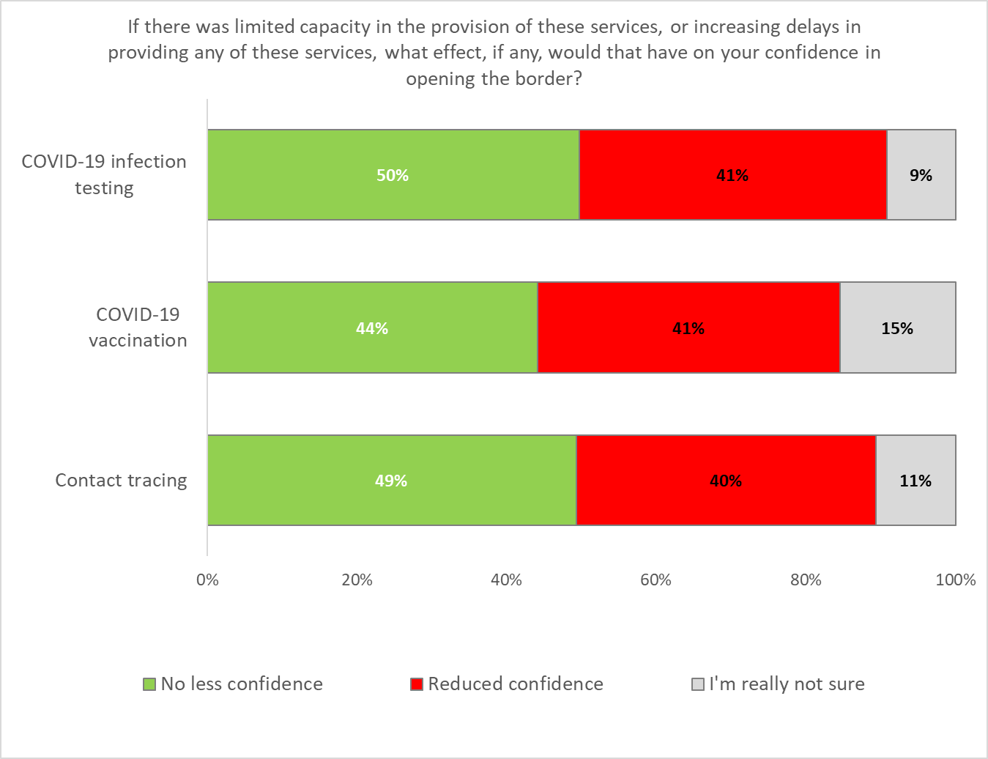
This reduced confidence is generally higher among females, older people, people who don’t identify as disabled and those already vaccinated.
Taking infection testing as an example:
Reduction in confidence with reduced or delayed
COVID-19 infection testing
Aged 45 and over | 49% ↑
Females | 47% ↑
Don’t identify as disabled | 43% ↑
Total | 41%
Males | 36%↓
Aged 25 to 34 | 31% ↓
Identify as disabled | 29% ↓
Pasifika | 27% ↓
Asian | 26% ↓
Unlikely to get vaccinated | 25% ↓
Aged 18 to 24 | 23% ↓
Results for sample sizes of n=50 or more

Full table results accompany this report.

Entering New Zealand

4.1 Entering New Zealand – a phased approach
Respondents were told:
“An expert group has recommended a phased opening of Aotearoa New Zealand’s borders once the COVID-19 vaccination programme has been fully rolled out.
The Government has announced that it will use the second half of 2021 to vaccinate as many New Zealanders as possible while it prepares and tests the safety of having three “Pathways” to allow people to enter Aotearoa New Zealand in 2022. This will involve allowing quarantine-free entry to vaccinated travellers from low-risk countries from early 2022 while those from medium- and high-risk countries will have to go through a combination of quarantine measures ranging from self-isolation to spending 14 days in quarantine. The phased reopening is looking to introduce:
- A Low-Risk pathway allowing quarantine free entry for vaccinated travellers who have been in low-risk countries.
- A Medium-Risk pathway allowing a combination of self-isolation and/or reduced time in managed isolation for vaccinated travellers who have been in medium-risk countries.
- A High-Risk pathway continuing a full 14 days in managed isolation and testing for unvaccinated travellers and any traveller, including vaccinated travellers, who have been in high-risk countries.”

They were initially asked how strongly they supported or opposed this overall approach to a phased reopening.
66% overall supported the phased approach, with 26% opposing and 8% unsure.
Male respondents (68%) were slightly more supportive of the pashed approach than females (64%). By age group, the largest level of opposition came from those aged 35-64 years.
Overall levels of support for a phased opening are generally higher among younger respondents (78% under the age of 25) and older people (79% over the age of 64) which mirrors the length of time those groups think it should take to re-open; sooner rather than later.

Support for the phased approach to reopening the borders | AGE GROUP
 | 18-24 years | 25-34 years | 35-44 years | 45-54 years | 55-64 years | 65-74 years | 75 years or over
Total Support | 78% | 61% | 54% | 57% | 65% | 73% | 90%
Total Oppose | 13% | 23% | 37% | 32% | 31% | 26% | 8%

Māori and NZ European/Pākehā respondents were the least supportive of the approach.
Support for the phased approach to reopening the borders | ETHNIC GROUP
 | Asian | Indian | Māori | NZ European/ Pākehā | Other European | Pasifika | Other
Total Support | 78% | 61% | 54% | 57% | 65% | 73% | 90%
Total Oppose | 13% | 23% | 37% | 32% | 31% | 26% | 8%

All respondents were then told:
“The individual risk-based approach requires new systems to be set up. The Government has said that it will use the remainder of 2021 to prepare for the operation of borders under this system, including:
- Ongoing development of a traveller health declaration system.
- Investigating new testing technology for rapid testing on arrival at airports and reliable pre-departure testing.
- Piloting self-isolation arrangements for some New Zealanders.
- Strengthening other public health measures such as contact tracing”.

They were asked, assuming the plan was to proceed, how strongly they would support or oppose each of the following:
- The plan to change to an individual, risk-based approach.
- Quarantine-free travel being introduced for vaccinated travellers who have been in low-risk countries.
- Self-isolation arrangements for some vaccinated New Zealanders who have been in medium-risk countries.
- 14 days in MIQ for all unvaccinated travellers.
- 14 days in MIQ for vaccinated travellers who have been in high risk or very high-risk countries.
The results are shown in the following chart, with the initial, overall question, shown as a comparison.
Consistent with the overall theme of “The ability to keep New Zealanders safe”, support is highest for MIQ for unvaccinated travellers (79%) and also for vaccinated travellers, if they have been in high-risk countries (81%).
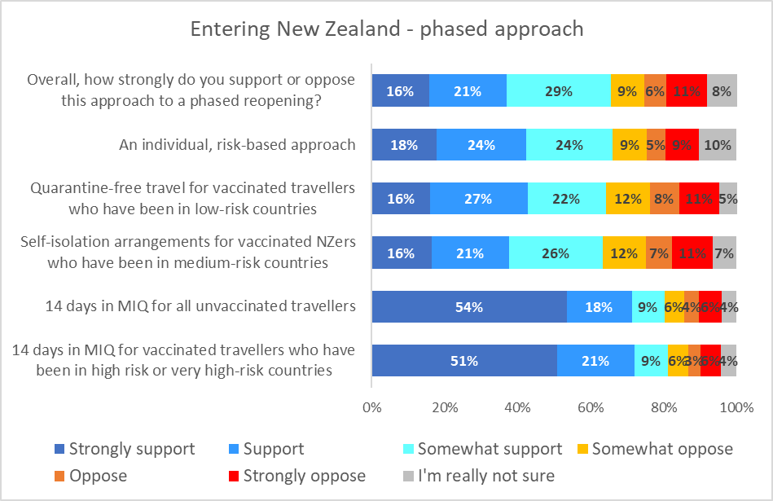

Overall levels of support for a phased opening are generally higher among younger respondents (78% under the age of 25) and older people (79% over the age of 64) which mirrors the length of time those groups think it should take to re-open; sooner rather than later.
Support for “self-isolation arrangements for some vaccinated New Zealanders who have been in medium-risk countries” was highest among 18–24-year-olds.
Support for components of the phased approach plan | AGE GROUP
 | 18-24 years | 25-34 years | 35-44 years | 45-54 years | 55-64 years | 65-74 years | 75 years or over
Overall support | 78% | 61% | 54% | 57% | 65% | 73% | 90%
The plan to change to an individual, risk-based approach. | 68% | 65% | 61% | 59% | 67% | 73% | 80%
Quarantine-free travel being introduced for vaccinated travellers who have been in low-risk countries. | 66% | 66% | 60% | 59% | 60% | 67% | 88%
Self-isolation arrangements for some vaccinated New Zealanders who have been in medium-risk countries. | 79% | 61% | 59% | 53% | 60% | 65% | 76%
14 days in MIQ for all unvaccinated travellers. | 77% | 78% | 77% | 73% | 85% | 91% | 88%
14 days in MIQ for vaccinated travellers who have been in high risk or very high-risk countries. | 80% | 78% | 78% | 73% | 86% | 92% | 87%

Males are also slightly more likely to support a phased re-opening (68% versus 64% for females) but this is not statistically significant.
Note that:
- Support is generally higher for Asian respondents across all components of the plan.
- Support is generally lower than average among Māori for the plan to change to an individual, risk-based approach, quarantine-free travel being introduced for vaccinated travellers who have been in low-risk countries and self-isolation arrangements for some vaccinated New Zealanders who have been in medium-risk countries.

Support for components of the phased approach plan | ETHNIC GROUP
 | Asian | Indian | Māori | NZ Euro-pean/ Pākehā | Other Euro-pean | Pasifika | Other
Overall support | 78% | 61% | 54% | 57% | 65% | 73% | 90%
The plan to change to an individual, risk-based approach. | 74% | 78% | 57% | 66% | 70% | 50% | 61%
Quarantine-free travel being introduced for vaccinated travellers who have been in low-risk countries. | 69% | 61% | 54% | 65% | 77% | 57% | 74%
Self-isolation arrangements for some vaccinated New Zealanders who have been in medium-risk countries. | 69% | 77% | 56% | 64% | 68% | 55% | 31%
14 days in MIQ for all unvaccinated travellers. | 84% | 86% | 75% | 82% | 91% | 61% | 79%
14 days in MIQ for vaccinated travellers who have been in high risk or very high-risk countries. | 77% | 88% | 77% | 83% | 87% | 76% | 78%

The following table indicates the demographic groups whose answers were 5% more or less than the overall result.

Overall support for a phased re-opening
Aged 75 and over | 90% ↑
Age 18 to 24 | 78% ↑
Asian | 77% ↑
Employed | 68% ↑
Males | 68% ↑
Total | 66%
Females | 64%↓
People with long-term health impairments | 58%↓
Aged 35-54 | 56% ↓
Māori | 54% ↓
Household income under $20,000 pa | 53% ↓
Results for sample sizes of n=50 or more

4.2 Isolation
The majority of respondents (56%) think that any returnees or travellers required to isolate should do it in a government-managed hotel facility (MIQ).
An additional 21% think this should be another type of government facility, which means a total of 77% of respondents believe the government should be involved in providing managed isolation to some degree.

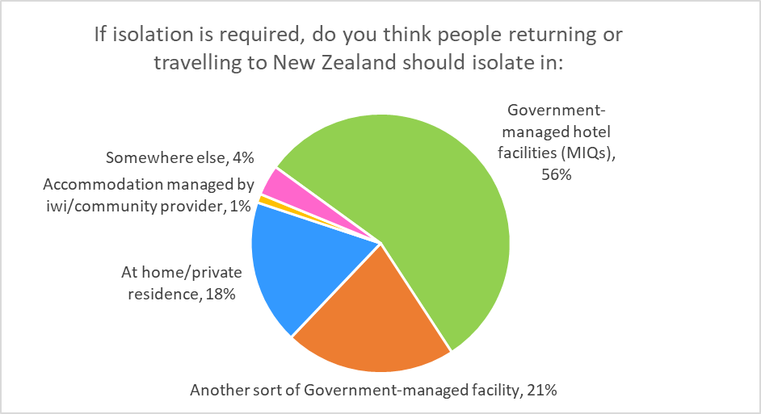
Eighteen per cent think they should isolate in a home or private residence, and the remaining 5% say an iwi or community provider or “somewhere else”.
These figures do not appear vary significantly by age, gender or ethnicity.

Tracing and signing in
There is strong support for mandatory signing in when entering places or using a range of services.
Most respondents (at least 56%) think it should “definitely” be mandatory to sign-in or use the COVID-19 tracer app when entering places or using a range of services. 56% support this for entering offices, 65% for hotels or motels. When “probably” is added to the “definitely”, this goes up to 77% for offices and 84% for gyms.
Support for mandatory signing in (whether manually or via the tracer app) is therefore in the high-seventies to mid-eighties.
D% who think that signing in should definitely or probably be mandatory
84%
83%
82%
82%
82%
82%
82%
82%
81%
81%
78%
77%
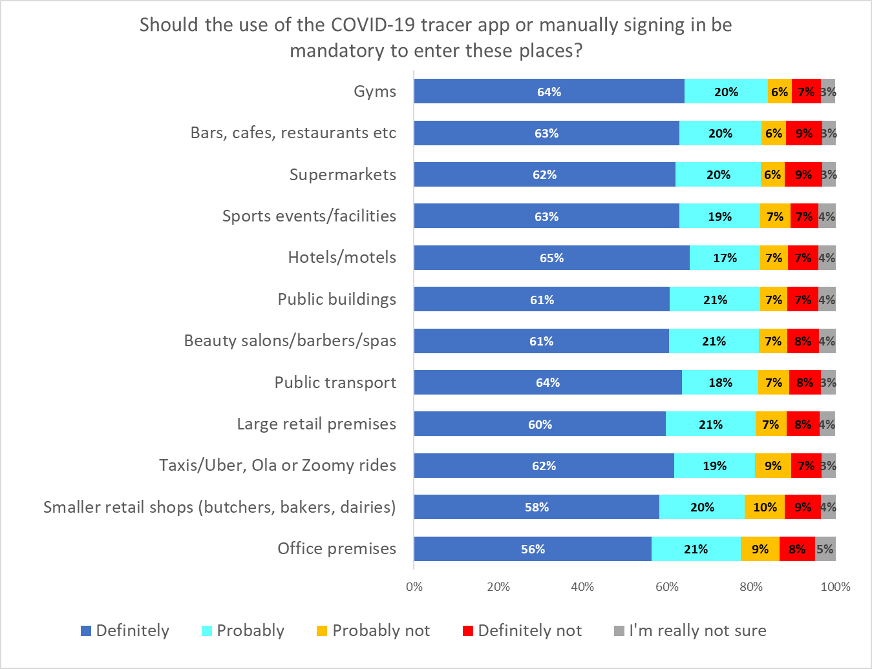

This indicates a high level of support for signing in when entering indoor venues.

Taking supermarkets as an example, the definitely sign-in percentage is higher for females (68% compared to 56% for males) as well as older people (72% over the age of 64).
Mandatory signing in to supermarkets – definitely support
Aged 65 and over | 72% ↑
Asian | 71% ↑
Indian | 71% ↑
Females | 68% ↑
Total | 62%
Males | 56%↓

Mandatory testing and vaccination
Support for mandatory testing and mandatory vaccination was measured for four key groups:
- Border workers.
- Maritime/port workers.
- Frontline workers.
- Essential workers.

6.1 Mandatory Testing
Support is very high for all groups. Overall support reaches 91% for border workers, 91% for frontline workers, 90% for maritime/ port workers and 88% for essential workers.
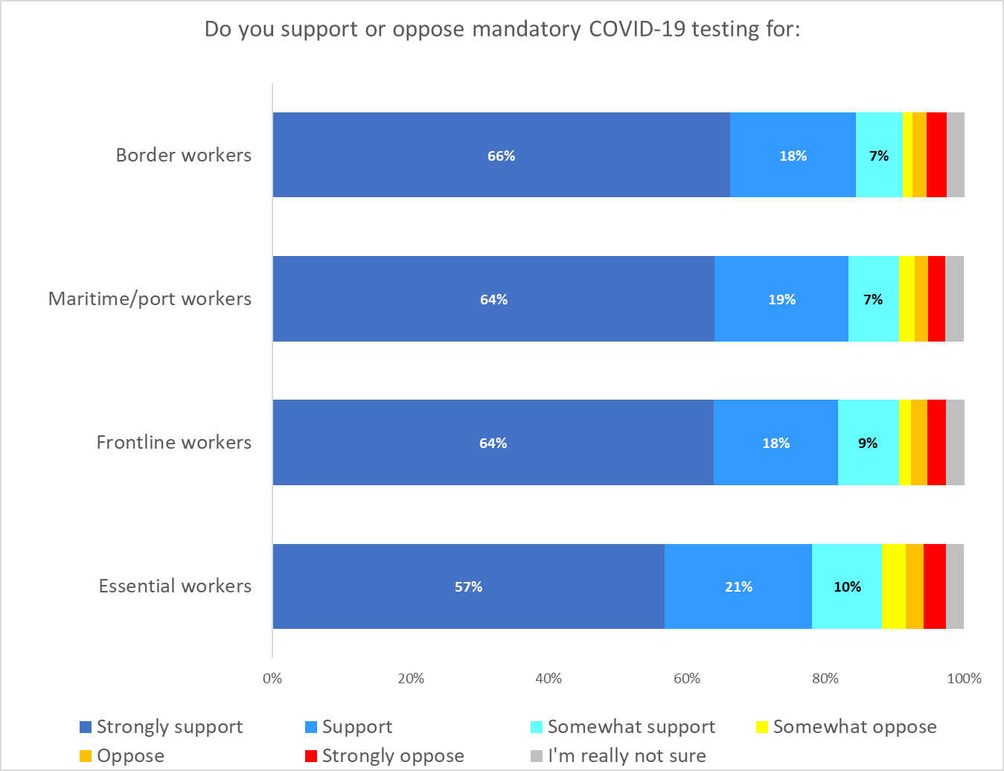

Strong support is generally higher among older people, and decreases with age.
There is little difference by gender. By ethnicity, Asians are more strongly supportive of testing for each of the four groups.

Those unlikely to get vaccinated themselves are much less supportive of the idea.
Strongly support mandatory testing for border workers
Identify as disabled | 80%↑
Aged 55 years and over | 79%↑
Asian | 79%↑
Long-term health impairments | 73% ↑
Total | 66%
Indian | 61%↓
Household income under $30,000 pa | 60%↓
Aged under 35 years | 52%↓
Those unlikely to get vaccinated | 27%↓

Strongly support mandatory testing for maritime / port workers
Asian | 79%↑
Aged 55 years and over | 76%↑
Identify as disabled | 73%↑
Total | 64%
Aged under 35 years | 50%↓
Household income under $20,000 pa | 48%↓
Those unlikely to get vaccinated | 24%↓

Strongly support mandatory testing for frontline workers
Aged 55 years and over | 77%↑
Identify as disabled | 76%↑
Asian | 72%↑
Total | 64%
Household income under $20,000 pa | 54%↓
Aged under 35 years | 49%↓
Those unlikely to get vaccinated | 26%↓

Strongly support mandatory testing for essential workers
Aged 55 years and over | 68%↑
Identify as disabled | 65%↑
Asian | 65%↑
Total | 57%
Household income under $30,000 pa | 51%↓
Aged under 35 years | 43%↓
Those unlikely to get vaccinated | 15%↓

6.2 Mandatory vaccination
Support for mandatory vaccination for the same four groups is marginally less than mandatory testing, but still strong.
Overall, 87% support mandatory vaccination of borders workers, 86% for maritime/port and frontline workers and 83% for essential workers.
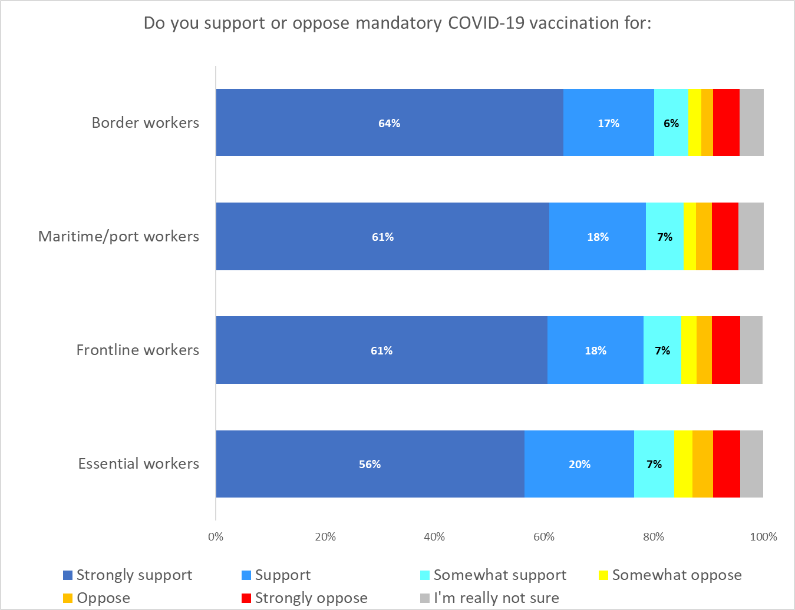

The level of strong support for mandatory vaccination is similar to mandatory testing: higher for older people, and lower for younger people.

There doesn’t appear to be much difference by gender, but Asian respondents were generally more supportive of vaccinations (as they were of testing).

Strongly support mandatory vaccinations for border workers
Aged 55 years and over | 78%↑
Identify as disabled | 72%↑
Asian | 71%↑
Long-term health impairments | 70% ↑
Total | 64%
Household income under $30,000 pa | 58%↓
Aged under 35 years | 52%↓
Those unlikely to get vaccinated | 17%↓

Strongly support mandatory vaccinations for maritime / port workers
Aged 55 years and over | 76%↑
Asian | 74%↑
Identify as disabled | 68%↑
Long-term health impairments | 66% ↑
Total | 61%
Household income under $30,000 pa | 53%↓
Aged under 35 years | 48%↓
Those unlikely to get vaccinated | 16%↓

Strongly support mandatory vaccinations for frontline workers
Aged 55 years and over | 75%↑
Asian | 68%↑
Long-term health impairments | 66% ↑
Total | 61%
Household income under $30,000 pa | 54%↓
Aged under 35 years | 48%↓
Those unlikely to get vaccinated | 14%↓

Strongly support mandatory vaccinations for essential workers
Aged 55 years and over | 68%↑
Asian | 66%↑
Identify as disabled | 64%↑
Long-term health impairments | 62% ↑
Total | 56%
Household income under $20,000 pa | 47%↓
Aged under 35 years | 46%↓
Those unlikely to get vaccinated | 14%↓

Government approach to the pandemic

7.1 Decisions for Reconnecting to the World
73% of respondents think the government is making the right decisions around reconnecting to the world. 20% think they are making wrong decisions, with 7% unsure.
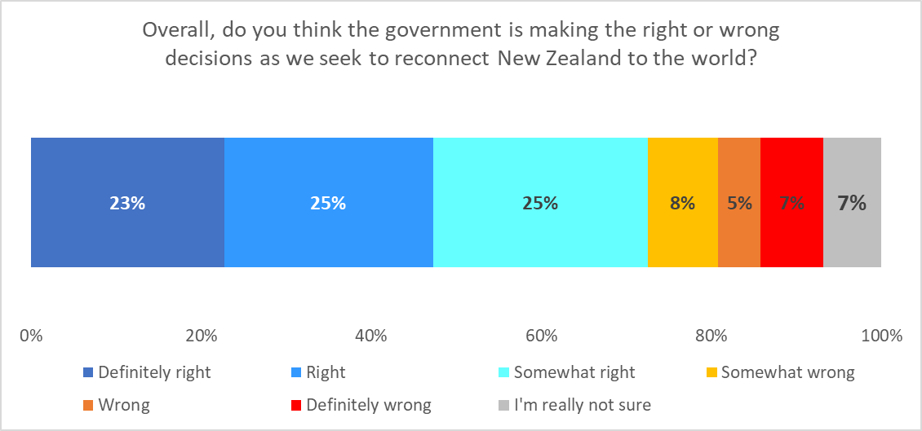

Support is slightly higher among younger people (under 35) at 77%. It is also higher among Asian and Indian respondents.
Overall government approach (definitely right, right, somewhat right)
Asian | 89%↑
Indian | 82%↑
Aged under 35 years | 77% ↑
Total | 73%
Long-term health impairments | 68%↓
Those unlikely to get vaccinated | 34%↓

7.2 Protecting the most at-risk
76% think the Government adequately protected the health of those most at risk from COVID-19 in the past year (“Somewhat” to “Definitely”). 20% did not think that, and 3% were not sure

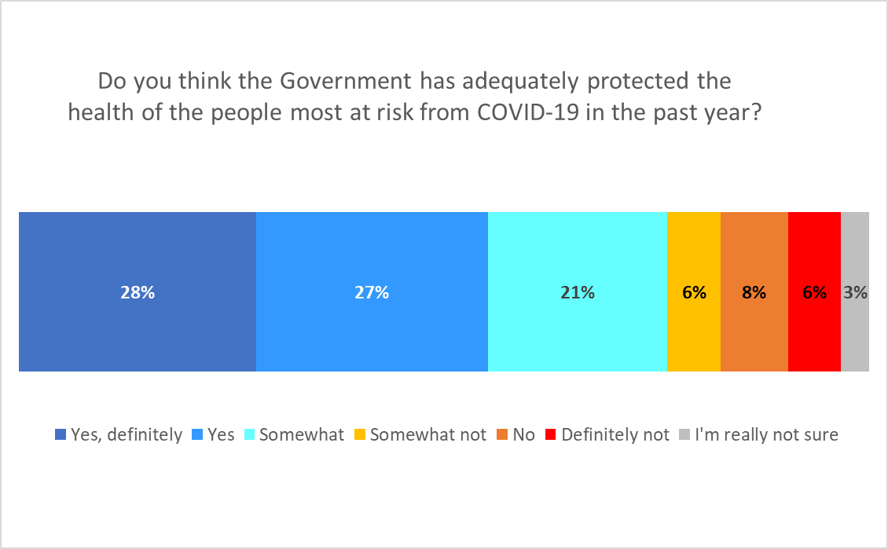

Agreement that the Government has provided an adequate level of protection is higher among young people (83% under the age of 35), and also with Asian respondents (88%).
There is no difference by gender.
Government has adequately protected the health of those most at risk (definitely, yes and somewhat)
Asian | 88%↑
Aged under 35 years | 83% ↑
Total | 76%
Household income under $20,000 pa | 68%↓
Those unlikely to get vaccinated | 55%↓

7.3 Treaty of Waitangi
64% of Māori felt that the Government has upheld the principles of Te Tiriti o Waitangi in the way it has managed COVID-19. 19% felt it had not upheld these principals, while 17% were unsure.
Indications are that Māori who are in the following groups are more likely to feel that the Government has upheld the principles of Te Tiriti o Waitangi in the way it has managed COVID-19i:
- 55 years or over.
- In paid employment.
- Living in Waikato, the Gisborne/Hawkes Bay region, the Whanganui/Manawatu/ Palmerston North/Ruapehu/Horowhenua region and the Wellington Urban areas.
- Those who have already been vaccinated and those who are likely to get the COVID-19 vaccine.

By contrast, the following groups of Māori were more likely than average to feel that the Government has not upheld the principles of Te Tiriti o Waitangi in the way it has managed COVID-19i:
- Māori under 55, especially those aged 45-54 years.
- Those in professional or senior Government official roles, Māori who are business proprietors/self-employed, students or currently unemployed.
- Māori in Northland (although the percentage of Māori in Northland who feel that the Government has upheld the principles of the Treaty is not below average, only 2% of Māori respondents in Northland were unsure).
- Those who are unlikely get a COVID-19 vaccine.

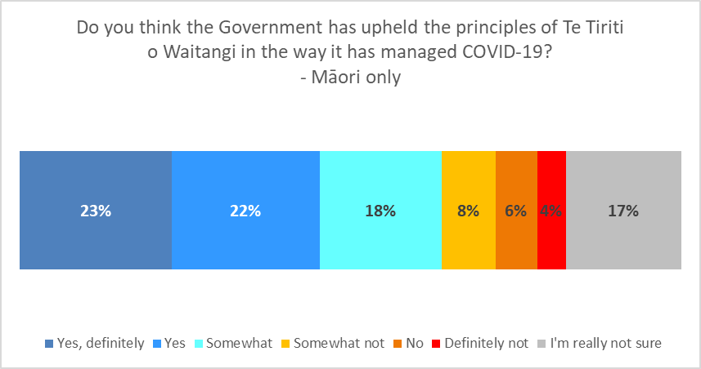

For the whole sample, 30% were unsure if the government had upheld the principles of Te Tiriti o Waitangi.
The overall level of positive responses (57%) is just a little higher than overall support once these “unsure” responses are removed. That is, the level of support of those who gave an answer that was not “I’m really not sure” was 82%.

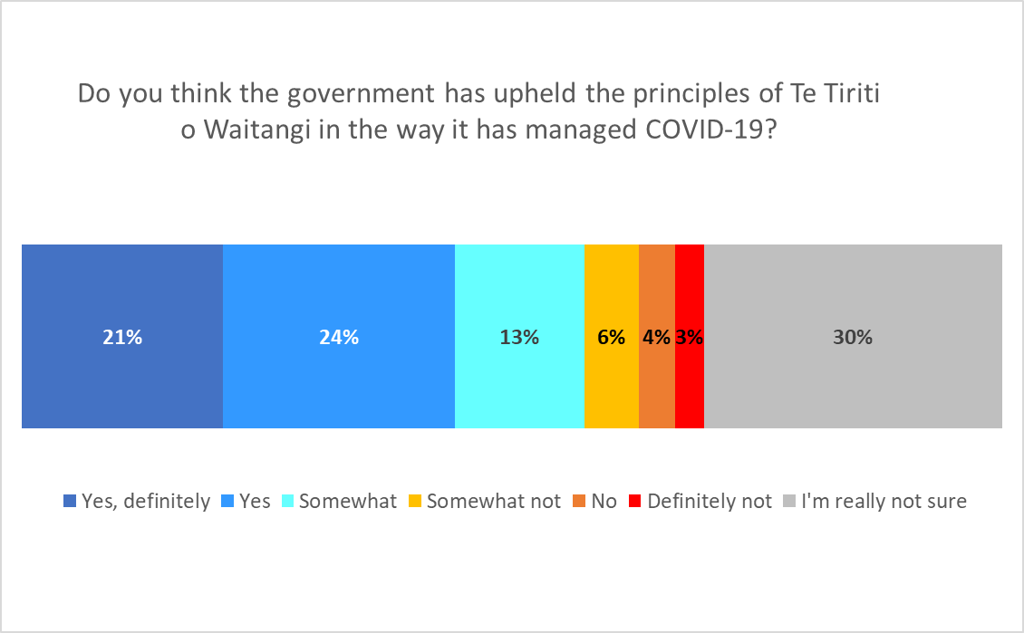
Again, with the “unsure” responses removed, this level of support is higher among younger people (18 to 34 years of age) and older people (55 years and over).
Māori also have a higher level of surety (only 17% being unsure.)

Government has upheld the principles of Te Tiriti o Waitangi with COVID-19? (“Definitely”, “Yes” and “Somewhat”)
Asian | 77%↑
Aged over 74 years | 68% ↑
Māori | 64% ↑
Aged under 25 years | 63% ↑
Total | 57%
Those unlikely to get vaccinated | 33%↓

Pandemic impact on health and wellbeing

8.1 Personal impact
Overall, 45% of all respondents said the pandemic has negatively affected their personal health and wellbeing. This is estimated at 1,764,600 people 18+.
31% found it to be “Neither positive nor negative” (an estimated 1,237,200 people 18+) and 23% found it positive to some degree (an estimated 927,900 people). 1% (39,700 people) were unsure.

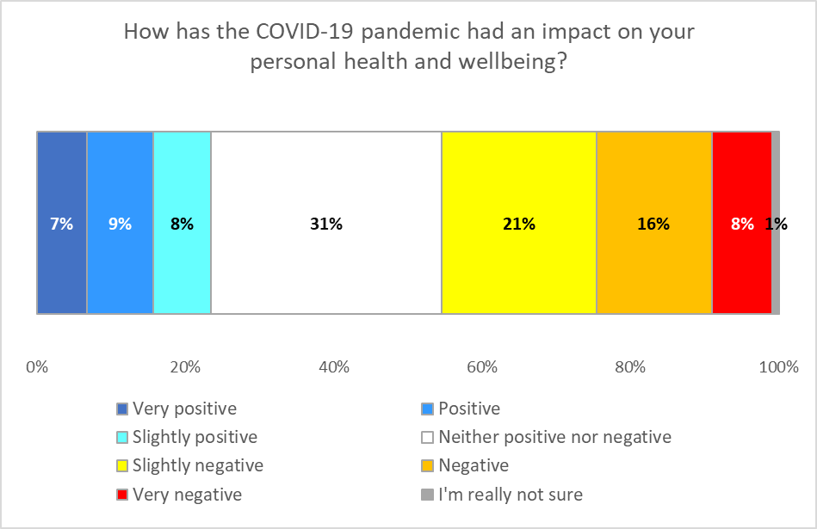

Negative impacts were higher among younger people, with 59% of those under 25 saying the pandemic had impacted their personal health and wellbeing negatively to some degree.
Impact of pandemic on personal health and wellbeing. | AGE GROUP
 | 18-24 years | 25-34 years | 35-44 years | 45-54 years | 55-64 years | 65-74 years | 75 years or over
Total Negative impact | 59% | 43% | 48% | 38% | 41% | 38% | 42%
Neither a positive nor a negative impact | 21% | 30% | 28% | 39% | 32% | 36% | 42%
Total negative impact | 20% | 25% | 23% | 22% | 27% | 27% | 17%
Unsure | 1% | 3% | 1% | 2% | 1% | 0% | 0%

The impact was marginally higher with females (47% versus 42% for males).
By ethnicity, the highest negative impact for the main ethnic groups was on NZ European/ Pākehā respondents (although indications are that the “Other” ethnic group may have had experienced a greater negative impact).

Impact of pandemic on personal health and wellbeing. | ETHNIC GROUP
 | Asian | Indian | Māori | NZ Euro-pean/ Pākehā | Other Euro-pean | Pasifika | Other
Total Negative impact | 49% | 47% | 35% | 47% | 43% | 44% | 56%
Neither a positive nor a negative impact | 26% | 12% | 29% | 33% | 32% | 22% | 29%
Total positive impact | 25% | 41% | 36% | 19% | 25% | 34% | 15%
Unsure | 0% | 0% | 1% | 1% | 0% | 0% | 0%

Key groups with greater or lower levels of impact in comparison with the overall result were:
COVID-19 impact on personal health and well-being (all NEGATIVES combined)
Aged under 25 years | 59% ↑
Those unlikely to get vaccinated | 57% ↑
Asian | 49% ↑
Not employed | 48% ↑
Female | 47% ↑
Total | 45%
Male | 42%↓
Already vaccinated | 40%↓
Māori | 35%↓

8.2 Reasons for feeling that way
Respondents were asked to say in their own words why they had answered that way. The following is a selection of typical comments (note that some have been edited slightly for readability).
Positive
“A quieter life helped me reduce stress levels. I also enjoyed the birds singing and less cars on the road." - Female, 25-34 years
“A small break from studies has been helpful for mental health and I have found other ways of staying stimulated." - Male, 18-24 years
“Because I have our whanau with us in our bubble and I am confident our government's approach is working for us and we will see our extended whanau shortly when the restrictions ease, I believe. And, I can still work from home." - Male, 45-54 years
“Due to lockdown, I realised that my multiple sclerosis was a lot better when the stress of my job was [detracting] from my life. I finally listened to my doctors and gave up working." - Female, 45-54 years
"Given me a chance to reflect on what life means." - Male, 45-54 years
"Life is simpler during lockdown, and everybody is more kind/caring. At the start of the pandemic, carbon emissions reduced significantly, showing that if everybody treats it like an emergency, we can effectively reduce those as well." - Male, 25-34 years
"The government has acted decisively once it became aware that Delta was in the community. It did take me by surprise but otherwise they did the right thing and in doing so made me feel really safe and reassured." - Female, 55-64 years
"Taking better care of my health to increase immunity and being conscious of other people being unwell." - Female, 45-54 years
Neutral or mixed
"I’m an essential worker so nothing has really changed except more work which keeps me on track." - Female, 65-74 years
"Hasn't affected us in any major way. Still working but from home while spending time together that we otherwise wouldn't be able to do." - Female, 25-34 years
"Hasn't concerned me yet." - Male, 45-54 years
“I have been able to carry on with life much the same." - Female, 65-74 years
“I have been actively managing my health for some years now, and COVID has not changed anything. Nor has it impacted my mental health." - Male, 65-74 years
“I know it's had a lot of mental impact on others but I don't feel that." - Female, 25-34 years
"Life is just the same." - Male, 75 years or over
"Not noticed any chance. Was a bit miserable after the vaccination but hey small price to pay." - Male, 45-54 years
"The COVID 19 pandemic didn't have any effects on my health and well-being." - Male, 18-24 years
"The lockdown hasn't really affected too much." - Male, 55-64 years
Negative
“Anxiety has increased, feelings of depression more often." - Female, 45-54 years
"Feel more lonely, isolated. My household has lost a major career and the only salary we had due to COVID. We were also forced to move out of Auckland due to COVID." - Female, 25-34 years
"Financial stress and isolation-based anxiety." - Male, 18-24 years
"Financial stress and uncertainty. Damage to my children's educations. Separation from immediate family." - Female, 45-54 years
"Has prevented me from going to social events, has stressed my partner who has to balance working from home and looking after our toddler while I go to work as an essential worker. Has just had a slight negative impact on myself and partners mental health and our ability to provide a good upbringing for our child, filled with new experiences and family." - Male, 25-34 years
"Higher levels of anxiety when there are outbreaks." - Female, 65-74 years
“I am bored and lonely due to lockdowns, get headaches due to change in sleeping patterns, am not eating healthy food because I am scared to visit supermarket for shopping." - Female, 25-34 years
“I am inclined to depression, and lockdowns have increased this." - Male, 55-64 years
“I am older, and my social isolation has been amplified." - Male, 65-74 years
“I have severe depression and anxiety so forced isolation makes those symptoms more noticeable, isolation is typically the trigger that sets off and indicates my depression is bad, so when it's forced like this it sets off the depression." - Female, 18-24 years
"Jobs have been lost; government has increased the minimum wages requirements at the wrong time; inflation is a huge concern for many middle-income families, causing anxiety." - Female, 35-44 years
"Lockdowns don't help with mental health and introduce stress to people unduly." - Male, 35-44 years
"Mental stress has been through the roof, along with financial stress & the lack of a workable plan for protecting NZ first, then getting back to life with the rest of the world." - Male, 25-34 years
"The isolation from my family is very hard, sometimes I cry because I miss them. We have a very tightknit family and I worry for my 86-year-old mother who is stubborn and lives alone." - Female, 55-64 years
"There are too many negatives to list. It's been negative for my physical health, psychological health, career and business, export earnings, our daughter and family." - Female, 55-64 years
"This time around the government is completely liable for the outbreak through poor MIQ facilities That with the pathetic vaccine roll out. I have been disillusioned and lack real motivation to do stuff." - Male, 55-64 years

8.3 Health experiences
Respondents were shown a list of feelings and situations and asked to say which ones they had experienced, if any, during the past four weeks.
A third of respondents (34%, an estimated 1,364,100 adults) reported feeling anxious in the past four weeks. Almost the same proportion said they felt tired for “no good reason” (just over 32%, around 1,284,800 adults), and others had problems:
- Maintaining a healthy lifestyle (26%, around 1,027,000 adults).
- Feeling depressed (25%, around 979,500 adults).
- Feelings of loneliness (also 25%, around 979,500 adults).
32% (around 1,268,900 adults) said they had felt none of these feelings or attitudes, suggesting that over two-thirds have experienced some of these in the past four weeks.

Note that 17% (an estimated 666,200 people 18+) said they had experienced “Challenging domestic, family or emotional situations”. This experience is likely to include domestic, family and sexual violence and emotional abuse.
13% (an estimated 531,400 people 18+) said they had experience difficulties with managing their current health conditions. This is likely to include problems managing mental health conditions.

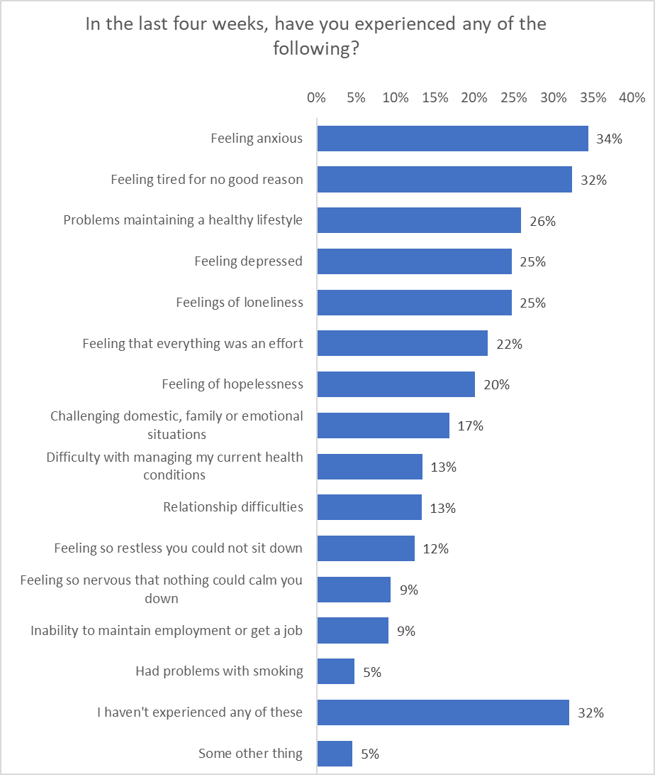
Estimated number of people 18+

1,364,100
1,284,800
1,027,000
979,500
979,500
860,500
797,000
666,200
531,400
527,400
491,700
372,700
360,900
190,300
1,268,900
178,400
Overall, the average number of experiences for each respondent was 2.7. This is higher for younger people (4.4 for those under 25), 3.7 for those 25 to 34 years of age and much lower for older people at 1.5 for those 65 years or older.
This suggests that younger people are having a much harder time with the pandemic, and specifically this lockdown. Full demographic tables detailing the responses are appended to this report.

8.4 Alcohol
This question was designed to determine whether respondents are drinking more or less alcohol since the spread of COVID-19 in Aotearoa New Zealand.
37% of respondents (an estimated 1,411,700 adults) said they did not drink alcohol.
Among those drinking, there does not appear to have been a large increase in alcohol consumption: about half of those who drink say they’re drinking the same , and those who say their alcohol consumption has changed are roughly balanced (17% less, an estimated 622,600 adults, and 14% more, an estimated 602,700 adults). The volume of consumption was not measured.

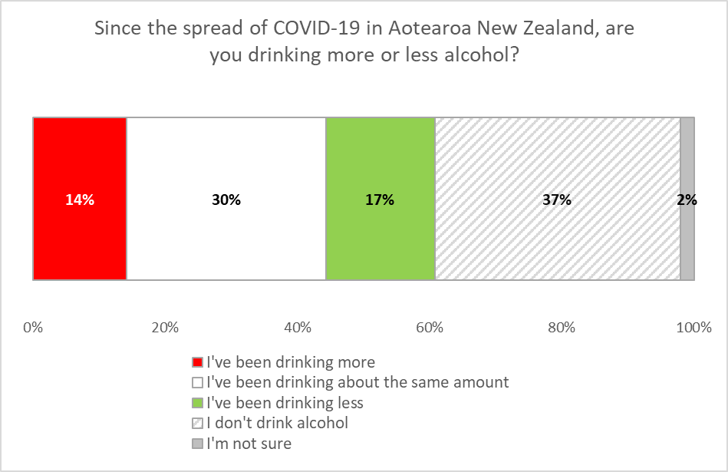

Increase in alcohol consumption is slightly higher among people under 35 years of age (18%) and it trends lower as age increases. This may be related to the higher negative impact the pandemic has had on younger people, although given the correlation between increased alcohol consumption and negative impacts on health and well-being is only weak (0.11), it seems unlikely.

There did not appear to be a difference by gender. Asian respondents were much less likely to report drinking more (6%).
Since spread of COVID-19, are you drinking more?
(“Yes”)
Household income $100,000 pa or more | 22% ↑
People who identify as disabled | 20% ↑
Aged under 35 | 18% ↑
Total | 14%
Unlikely to get vaccinated | 9%↓
Asian | 6%↓

Respondents who had indicated they had been drinking more were asked why they thought that was. The top two reasons for increased consumption include increased stress (22%, an estimated 135,000 adults) and boredom (20%, an estimated 120,500 adults).

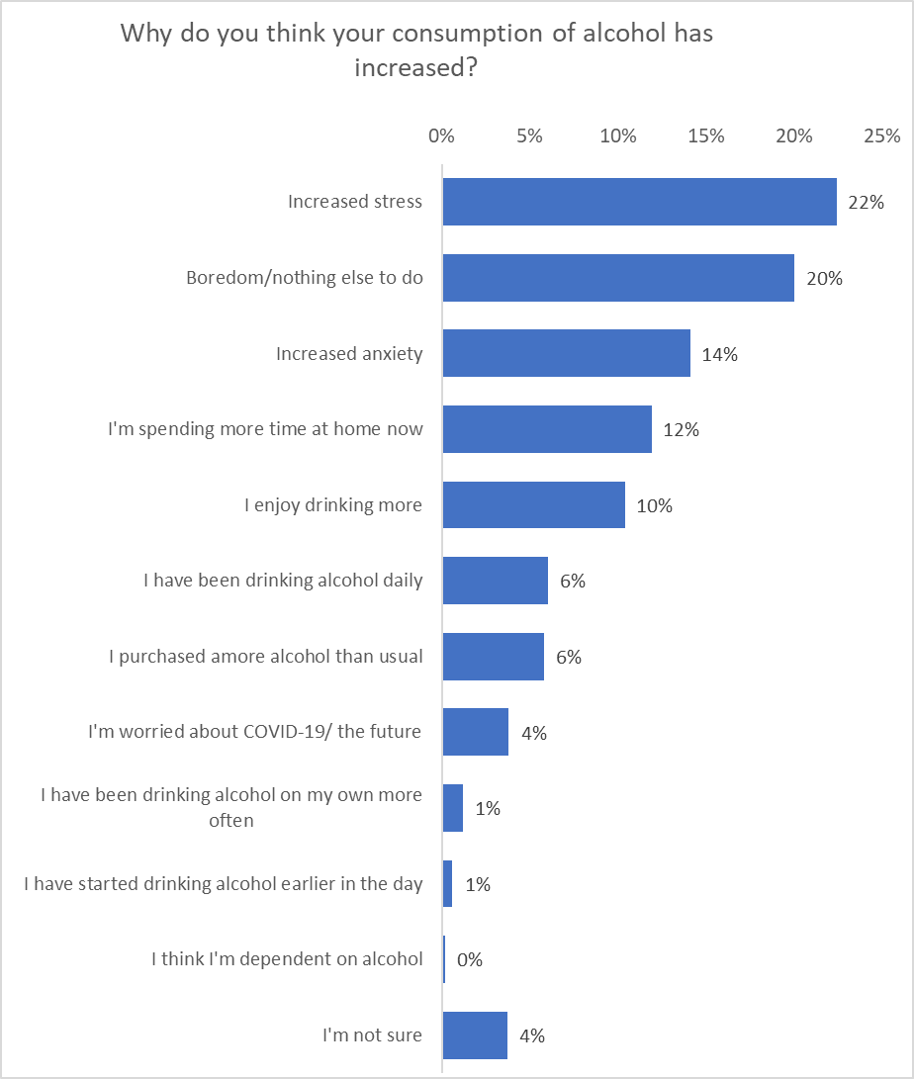
All respondents were asked if they were concerned about the amount of alcohol someone else in their household was drinking. 13% of respondents (an estimated 499,600 people) expressed some concern.

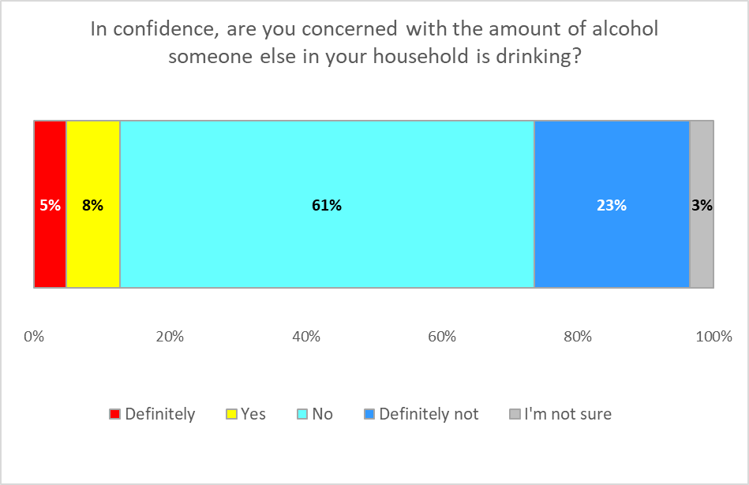

Concern was lower among older people (4% over the age of 64), but higher among those 18 to 24 years (21%).
There is no discernible difference by gender, although there are indications that there is higher concern among Asian and Indian respondents.

Concern about household drinking?
(“Definitely” and ”Yes”)
People who identify as disabled | 22% ↑
Indian | 22% ↑
Aged under 25 years | 21% ↑
Asian | 19% ↑
Total | 13%
Unlikely to get vaccinated | 7%↓
Aged 65 and over | 4%↓

Note: Respondents were offered a list of professional organisations if they, or someone they knew, needed help.

APPENDIX 1 - SAMPLE
These results are from an online survey of 1,321 New Zealand respondents aged 18 years of age or over.
The survey was conducted between 28 August and 1 September, 2021.
The sample is weighted on age, gender, employment status, ethnicity, household income and highest education to match the 18+ population at the most recent census.
At a 95% confidence level, the survey has a maximum margin of error of ±2.7% overall (this occurs when the result is 50%).
Sub-sample respondent counts and margins of error are shown below.

 | All respondents
 | Count | Sub-sample margin of error
TOTAL | 1,321 | ±2.7%
GENDER
Male | 663 | ±3.8%
Female | 656 | ±3.8%
Gender Diverse | 2 | ±69.3%
AGE GROUP
18-24 years | 127 | ±8.7%
25-34 years | 237 | ±6.4%
35-44 years | 270 | ±6%
45-54 years | 196 | ±7%
55-64 years | 226 | ±6.5%
65-74 years | 178 | ±7.3%
75 years or over | 87 | ±10.5%
IMPAIRMENT, LONG-TERM HEALTH CONDITIONS OR DISABLED
Impairment or long-term health conditions | 454 | ±4.6%
Identify as disabled | 124 | ±8.8%

 | All respondents
 | Count | Sub-sample margin of error
AREA TYPE
Large city | 749 | ±3.6%
Regional City | 189 | ±7.1%
Regional town | 228 | ±6.5%
Rural, but not remote | 131 | ±8.6%
Rural and remote | 24 | ±20%
ETHNIC GROUP
Asian | 104 | ±9.6%
Indian | 47 | ±14.3%
Māori | 220 | ±6.6%
NZ European/ Pākehā | 925 | ±3.2%
Other European | 136 | ±8.4%
Pasifika | 55 | ±13.2%
Other | 34 | ±16.8%
REGION
Northland | 28 | ±18.5%
Auckland | 436 | ±4.7%
Waikato | 116 | ±9.1%
Bay of Plenty | 82 | ±10.8%
Taranaki | 19 | ±22.5%
Gisborne/Hawkes' Bay | 52 | ±13.6%
Wairarapa | 11 | ±29.5%
Whanganui/ Manawatu/ Palmerston North/ Rangitikei/ Ruapehu/ Horo-whenua | 80 | ±11%
Wellington (Urban Areas) | 180 | ±7.3%
Nelson/ Tasman/ Marl-borough | 46 | ±14.4%
Canterbury | 183 | ±7.2%
West Coast | 9 | ±32.7%
Otago | 59 | ±12.8%
Southland | 20 | ±21.9%

Contact
For more information about this survey, please contact:

Grant McInman, telephone 021 076 2040, email gmcinman@horizonresearch.co.nz.
Andrew Stevenson, telephone 021 464 307 email andrew.stevenson@horizonresearch.co.nz
Graeme Colman, telephone 021 84 85 76, email gcolman@horizonresearch.co.nz.

APPENDIX 2 – TABLES ATTACHED

APPENDIX 3 – VERBATIMS ATTACHED

(30% + 2%) / 63%
The apparent discrepancy with the figures on the chart is due to rounding.
Note that this is not in line with results for self-reported pre-lockdown COVID-19 app use.
This adds to 100%, but the apparent discrepancy is due to rounding.
Small sub-samples.
The difference between this figure and those on the chart is due to rounding.
(21% + 24% + 13%) / 70%.
This is partly because they are less unsure. Their total “no” is also higher than the rest of the population.
There was a small base of respondents in the “Other” ethnic group (n=33).
(30% + 2%) / 63%

