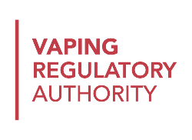
HARP GUIDANCE – RegWorks v5 to v6 Upgrade
Vaping Release 2.4.2 – 1 August 2022
The HARP system is being updated over the weekend of 29 to 31 July to support product notification renewals, and to move the HARP Vaping system onto a new server based on a new version of the RegWorks product.
As a result, retailers and notifiers will not be able to log into HARP from 7pm on Friday 29 July to 8am on Monday 1 August. The new RegWorks product brings a few changes to the HARP user interface, and adds the ability to renew product notifications:
Function | Old – RegWorks v5 | New – RegWorks v6
New Web Address  HARP for Vaping has a new server with a new URL. The old URL may still be used for other HARP systems | https://harp.health.nz | https://vaping.harp.health.nz
Save  Submissions can now be saved part way through | N/A | 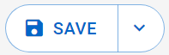
Save & finish later  After saving a submission as Draft, you can go back and finish it later from your My Submissions dashboard | N/A | 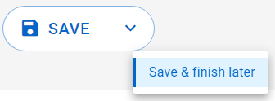
Dashboard Actions  On your My Submissions dashboard, actions are now accessed by clicking the ellipses (…) | 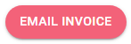 | 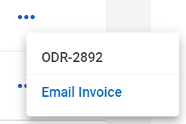
Open Record  To open a record from your My Submissions dashboard, you now need to click on the code rather than anywhere on the row | click anywhere on the row | only click on the Code
Submission Actions  When making a Submission, additional actions may now be accessed by clicking the down arrow (∨) | 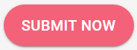 | 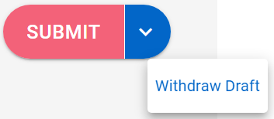
Product Notification Renewal  Product Notifications can now be renewed up to two months before they are due to expire  (see step-by-step guidance overleaf) | N/A | - Select New Submission, VRA Applications, Product Notification Renewal  - Select which Business’s notifications you want to renew and submit the Product Notification Renewal  - On the new PNREN record on your My Notifier Applications dashboard, choose which Product Notifications you want to renew  - Generate, Submit and Pay for the renewal Order, and your product notifications will be extended by 12 months from the current expiry date

Product Notification Renewals – Step-by-Step Guide
1. Create a New Submission – VRA Applications – Product Notification Renewal
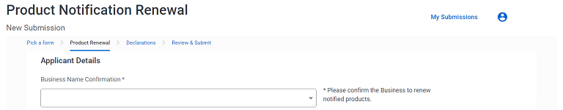
2. Choose the correct business from the Business Name Confirmation drop-down:

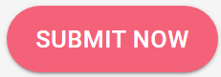
3. Review & Submit the Product Notification Renewal request
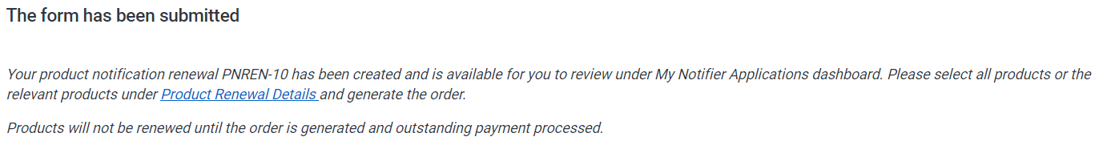
4. Follow the link in the confirmation message or open the new PNREN record from your My Notifier Applications dashboard:

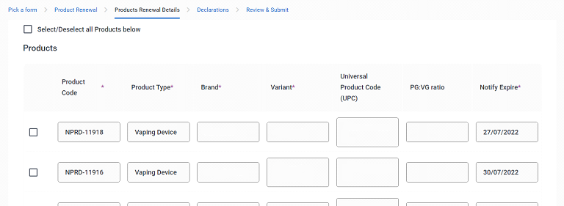
5. Select the Products that you want to renew from the Product list on the Products Renewal Details tab:

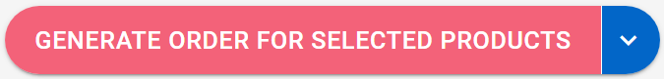
6. Generate Order for selected products
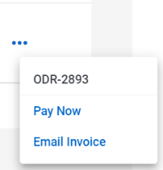
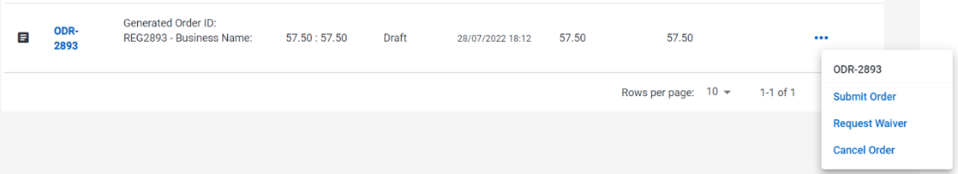
7. Submit Order, and either Pay Now or Email Invoice and pay offline:

8. Repeat steps for other businesses and/or products as needed – any products not renewed will expire
Notifiers are no longer permitted to sell products whose Notification has expired, but Retailers have 3 months to sell through or return their existing stock
If you need to change the flavour, PG:VG ratio, ingredients or components for a product then you should withdraw the current Product Notification and create a new one rather than renewing the current one
Changes to nicotine strength or container size can be done through the normal Request Amendment process

