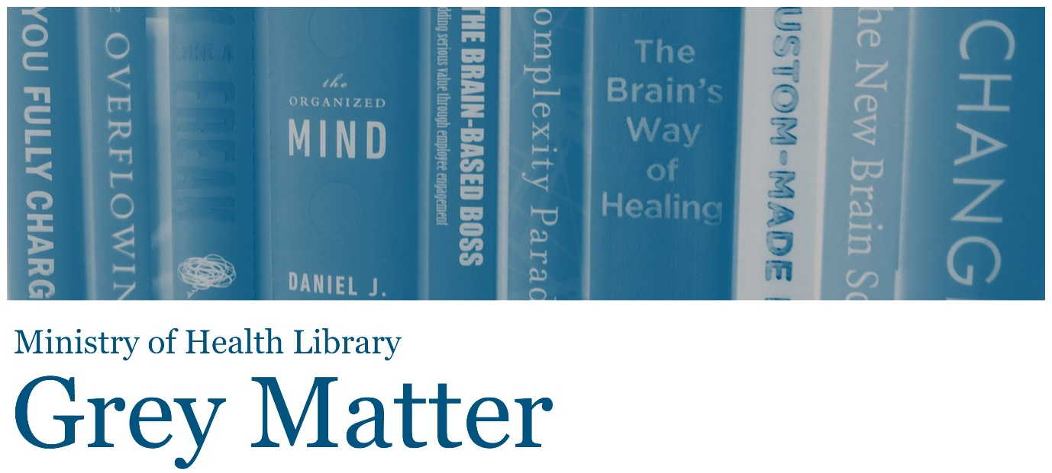

A Collection of Recent NGO, Think Tank, and International Government Reports
Issue 42, 2017, February
Welcome to Grey Matter, the Ministry of Health Library’s Grey Literature Bulletin. In each issue, we provide access to a selection of the most recent NGO, Think Tank, and International Government reports that are relevant to the health context. The goal of this newsletter is to facilitate access to material that may be more difficult to locate (in contrast to journal articles and the news media). Information is arranged by topic, allowing readers to quickly hone in on their key areas of interest. Email library@moh.govt.nz to subscribe.
Click on any of the bulleted points below to go to a section of interest.

Nutrition, Physical Activity, & Obesity
Health Information & Research
Health Systems, Costs, & Reform
Public Health
End of Life Care
Inequalities
Drug Use
Health of Older People
Social Care

Nutrition, Physical Activity, & Obesity

Nutrition Across the Lifespan for Healthy Aging: Proceedings of a Workshop—in Brief
“On September 13-14, 2016, the National Academies of Sciences, Engineering, and Medicine's Food Forum convened a workshop in Washington, DC, to (1) examine trends and patterns in aging and factors related to healthy aging in the United States with a focus on nutrition; (2) examine how nutrition can sustain and promote healthy aging, not only in late adulthood, but beginning in pregnancy and early childhood and extending throughout the lifespan; (3) highlight the role of nutrition in the aging process at various stages in life; (4) discuss changes in organ systems over the lifespan, including the skeletal, muscular, and cardiovascular systems, and changes that occur with age related to cognitive, brain, and mental health; diet-related sensory preferences; oral health; and the microbiome; and (5) explore opportunities to move forward in promoting healthy aging in the United States.” Source: National Academy Press

Driving Action and Progress on Obesity Prevention and Treatment: Proceedings of a Workshop—in Brief
“The Roundtable on Obesity Solutions of the Health and Medicine Division of the National Academies of Sciences, Engineering, and Medicine held a workshop in Washington, DC, on September 27, 2016, titled "Driving Action and Progress on Obesity Prevention and Treatment." The workshop was designed to (1) review the progress that has been made in obesity prevention and treatment; (2) identify some of the levers that can drive significant future progress; and (3) discuss how gaps in the field can be filled. This Proceedings of a Workshop-in Brief highlights key points made during the presentations and discussions and is not intended to provide a comprehensive summary of information shared during the workshop.” Source: National Academies Press
Back to top

Health Information & Research

Governing with Collective Intelligence
“This paper provides an introduction to collective intelligence in government. It aims to be useful and relevant to governments of countries at very different levels of development. It highlights the ways in which governments are better understanding the world around them, drawing on ideas and expertise from their citizens, and encouraging greater scrutiny of their actions.” Source: Nesta

My data, my care: How better use of data improves health and wellbeing
“This report uses real life case studies to show why data is so critical for good healthcare and the tangible benefits which can be gained from its use. However, as well as showing the good which can come from data use, it also illustrates that the healthcare system is currently not set up to share data as a matter of course. Our case studies demonstrate the huge potential that better use of healthcare data can unlock, but also that this is currently being achieved in spite of the system, rather than because of it.” Source: Richmond Group

Metrics That Matter for Population Health Action: Workshop Summary
“In times of rapid change and constrained resources, measures that are important, focused, and reliable are vital. However there is an overabundance of measures available for evaluating various aspects of population health and previous efforts to simplify existing sets to meet the needs of all decision makers have been unsuccessful. The National Academies of Sciences, Engineering, and Medicine convened a workshop to explore the status and uses of measures and measurement in the work of improving population health. Participants explored existing and emerging population health metric sets and characteristics of metrics necessary for stakeholder action across multiple sectors. This report summarizes the presentations and discussions from the workshop.” Source: National Academies Press
Back to top

Health Systems, Costs, & Reform

Tackling wasteful spending on health
“This report systematically reviews strategies put in place by countries to limit ineffective spending and waste. On the clinical front, preventable errors and low-value care are discussed. The operational waste discussion reviews strategies to obtain lower prices for medical goods and to better target the use of expensive inputs. Finally, the report reviews countries experiences in containing administrative costs and integrity violations in health.” Source: OECD *you may need to interlibrary loan a copy from your local library

Better value in the NHS: The role of changes in clinical practice
“The report looks at trends in NHS productivity in three areas – generic prescribing, length of stay and day case surgery – in which the NHS has made significant and sustained gains in productivity over a number of years, allowing more (and often better) care to be delivered within the same budget. It then outlines a number of areas where the NHS has opportunities to improve value in the future, focusing in particular on changes in clinical practice.” Source: King’s Fund

Swimming together or sinking alone: health, care and the art of systems leadership
“This report is based on interviews with senior leaders in health and local government on what is really happening as managers grapple with the Sustainability and Transformation Plan (STP) process. The report will help leaders understand the values, culture and skills they need to survive and thrive as the NHS tries to change from organisations working in silos to local health and care networks focussed on the needs of patients.” Source: Institute of Healthcare Management

New Health Technologies: Managing Access, Value and Sustainability
“This report discusses the need for an integrated and cyclical approach to managing health technology in order to mitigate clinical and financial risks, and ensure acceptable value for money. The analysis considers how health systems and policy makers should adapt in terms of development, assessment and uptake of health technologies.” Source: OECD *you may need to interlibrary loan a copy from your local library

Defining social investment, Kiwi-style
“This working paper aims to answer three questions: what is the social investment approach (and what is it not), how should it be applied and where would it be most productively applied?” Source: New Zealand Institute for Economic Research

Designing a high-performing health care system for patients with complex needs: ten recommendations for policymakers
“The [working] group’s purpose was to outline the prerequisites of a high-performing health care system for “high-need, high-cost” patients and to identify promising international innovations in health care delivery for meeting needs of these patients. Drawing on international experience, quantitative and qualitative evidence, and its members’ collective expertise in policy and program design, implementation, and evaluation, the international working group sought to articulate the principles that underpin high performance for this complex population in health systems around the world.” Source: Commonwealth Fund

Choosing Wisely in Australia
“The Choosing Wisely in Australia 2016 Report offers some key insights into the drivers of unnecessary healthcare and details the success of the campaign since it launched in Australia last year.” Source: Choosing Wisely Australia

Fast discovery: The imperative for high velocity learning by everyone, about everything, all of the time
“In this thought paper, Steven Spear explores the gaps between the ‘theoretical limit’ (ie what could be achieved) and what organisations actually achieve in terms of taking the innate potential of the people they employ and the technology they use. He argues that much time is used unproductively and examines how this can be addressed. The paper draws on examples from a range of industries, from aluminium production to car manufacturing, to look at what separates the best performers from the rest. It argues that, if speed and excellence is the standard, with slowness and imperfection unacceptable, then learning is the only way to close the gap.” Source: Health Foundation

Use of Behavioural Insights in Consumer Policy
“This report examines how behavioural insights have been used by governments and other public policy organisations to develop and implement consumer policy initiatives, primarily through the use of experiments and surveys. Behavioural insights have informed enforcement actions, new regulations, consumer empowerment initiatives and consumer education. Behavioural insights provide grounds and justification on why governments need to take actions and, helping identify how the impact of behavioural biases on consumer choice can be mitigated, for example through effective labelling and information disclosures. The report also identifies challenges to applying behavioural insights to consumer policy, relating to the conduct and interpretation of behavioural experiments as well as organisational and stakeholder issues.” Source: OECD
Back to top

Public Health

Antimicrobial resistance: Policy Insights
“Policy options to support the development of new treatments can be divided into two broad categories. Upstream interventions target the early phases which are the most uncertain part of developing any medical technology. Interventions are designed to shift the risk on the funding body and encourage enterprise participation. Downstream mechanisms aim to boost the reward at the end of the development process and facilitate the market entry of drugs. These levers reduce the risk to sponsors (because they only reward successful research) but they may inflate the size of the intervention because companies would need strong incentives to invest on an uncertain return far in the future.” Source: OECD

The Economics of Tobacco and Tobacco Control
“This monograph, a collaboration between the National Cancer Institute and the World Health Organization, examines the current research and evidence base surrounding the economics of tobacco control—including tobacco use, tobacco growing, manufacturing and trade, tobacco product taxes and prices, and tobacco control policies and other interventions to reduce tobacco use and its consequences. This information can help direct future research and inform tobacco prevention and control programs and policies in countries around the world.” Source: National Cancer Institute and the WHO

Community Violence as a Population Health Issue: Proceedings of a Workshop
“On June 16, 2016, the Roundtable on Population Health Improvement held a workshop at the Lutheran Church of the Good Shepherd in Brooklyn, New York, to explore the influence of trauma and violence on communities. The workshop highlighted examples of community-based organizations using trauma-informed approaches to treat violence and build safe and healthy communities. Presentations showcased examples that can serve as models in different sectors and communities and shared lessons learned. This publication summarizes the presentation and discussion of the event.” Source: National Academies Press
Back to top

End of Life Care

Improving end-of-life care in Australia
“The intention of this brief is firstly to raise awareness of the issues surrounding EOL (end-of-life) care and to provide recommendations on what can be done to facilitate discussions on these issues among consumers and all sectors of the health system. We also provide recommendations on improving EOL care and care services.” Source: Deeble Institute
Back to top

Inequalities

Communities in Action: Pathways to Health Equity
“Only part of an individual’s health status depends on his or her behavior and choice; community-wide problems like poverty, unemployment, poor education, inadequate housing, poor public transportation, interpersonal violence, and decaying neighborhoods also contribute to health inequities, as well as the historic and ongoing interplay of structures, policies, and norms that shape lives. When these factors are not optimal in a community, it does not mean they are intractable: such inequities can be mitigated by social policies that can shape health in powerful ways. This report focuses on what communities can do to promote health equity, what actions are needed by the many and varied stakeholders that are part of communities or support them, as well as the root causes and structural barriers that need to be overcome.” Source: National Academies Press

Child Poverty Monitor: Technical Report 2016
“The Child Poverty Monitor and this Technical Report provide data on a set of indicators that assess aspects of child poverty in New Zealand and their implications for child wellbeing. In it are data on income and non-income measures of poverty, including measures that reflect increasing levels of severity. Other data include indicators related to health, living conditions, education, and a selection of economic measures used to assess how well we are doing as a nation that are relevant to the wellbeing of children and their families.” Source: New Zealand Child and Youth Epidemiology Service
Back to top

Drug Use

The Health Effects of Cannabis and Cannabinoids: The Current State of Evidence and Recommendations for Research
“The Health Effects of Cannabis and Cannabinoids provides a comprehensive review of scientific evidence related to the health effects and potential therapeutic benefits of cannabis. This report provides a research agenda—outlining gaps in current knowledge and opportunities for providing additional insight into these issues—that summarizes and prioritizes pressing research needs.” Source: National Academies Press

Readiness to change drug use and help-seeking intentions of police detainees: findings from the DUMA program
“The analysis revealed those detainees most in need of drug treatment were also those most ready to change their drug use. The findings serve as a reminder of the need and desire for interventions for drug abuse among the police detainee population, and have implications for the development of intervention strategies aimed at reducing drug use among offender populations.” Source: Australian Institute of Criminology
Back to top

Health of Older People

Policy briefing: music, singing and wellbeing in adults with diagnosed conditions or dementia
“Drawing on the available evidence, this briefing examines what music and singing interventions work to improve wellbeing of adults living with diagnosed conditions or dementia. While there is ample evidence looking at the impact of music and singing on clinical outcomes such as pain management, coping with hospitalisation, coping with symptoms and managing symptoms of dementia, this new evidence focuses on wellbeing for those living with diagnosed conditions or dementia. Specifically, it focuses on self-reported measures of quality of life; life satisfaction; and anxiety or depression.” Source: What Works Centre for Wellbeing

Systematic review: music, singing and wellbeing for adults living with dementia
“A systematic review of the subjective, self-reported wellbeing outcomes of music and singing in adults living with dementia. The review encompasses data from 249 participants in quantitative and qualitative studies from Australia, Canada, Finland, France, and the United Kingdom. It encompasses interventions focusing upon singing or listening to music. Three key domains of wellbeing are reported: quality of life, depression and anxiety.” Source: What Works Centre for Wellbeing

What is truth? An inquiry about truth and lying in dementia care
“Carers often have challenging decisions to make when a person is living with different realities and beliefs - something that increases as the dementia accelerates. Should they agree or contradict? What should they say? This report looks to provide guidance in these situations.” Source: Mental Health Foundation (UK)

Staying put: developing dementia-friendly care and support for people with a learning disability
“This paper explores how best to develop support, services and treatments for the growing number of people with a learning disability and dementia.” Source: Voluntary Organisations Disability Group (UK)
Back to top

Social Care

Building the right home
“The document covers the key housing principles in Transforming Care, to increase housing options and achieve reductions in inpatient capacity. It explains different models of settled accommodation through supported living and the provision short-term accommodation in the community. It then looks at developing the housing market for the Transforming Care, including negotiate with housing providers and agreeing key terms such as rent levels.” Source: NHS

The need to scale up rehabilitation
"Throughout the life course, persons with health conditions that cause limitations in functioning can benefit from rehabilitation. The need for rehabilitation continues to grow worldwide, especially in low- and middle income countries. The demand for rehabilitation services already exceeds availability, leaving a large unmet need." Source: WHO
Back to top
The information available on or through this newsletter does not represent Ministry of Health policy. It is intended to provide general information to the health sector and the public, and is not intended to address specific circumstances of any particular individual or entity.

