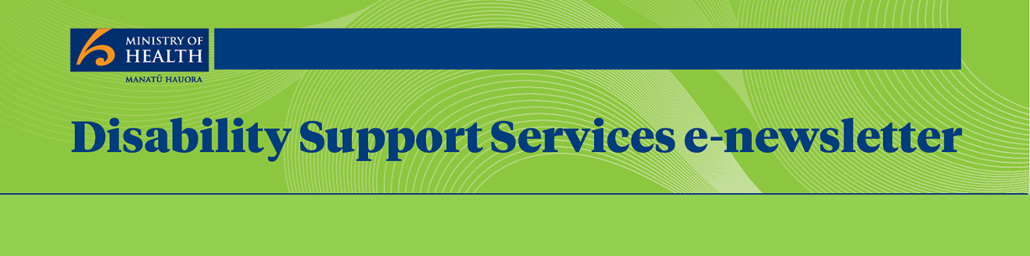
ISSN 2253-1386
No. 58 August 2015

 | From Toni Atkinson  Group Manager  Disability Support Services | 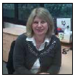 | Contents
Page 2
Enabling Good Lives
Page 4
DSS News
Te Ao Mārama (the world of light)
Page 6
Upcoming Events
Page 7
DSS Project Updates
Disability Support Services (DSS) are now well into the new financial year and we are busy planning our activity for the coming year with a work plan of 55 development activities. Examples of these include next steps for the New Model demonstration and developing the current year’s action plan for Whāia te ao Mārama. The development activities range across all areas of our work, with a focus on ensuring the delivery of effective services to our clients.

We expect the new streamlined contracts will give providers some flexibility in the way they deliver services, with their focus on outcomes for disabled people. The new contracts should also help the Ministry to better monitor and support the quality of service delivery by our providers.

This continuing emphasis on quality will inform all of our work activities over the coming year, including developing tools DSS can use to better manage its contracting functions. These tools will allow the DSS team to spend more time on relationship-building with the sector as we continue to test new and better ways of supporting people with a disability.

I look forward to the development activities over the coming year and your feedback on what is working well and how we can all do better.

Enabling Good Lives

Christchurch
The Ministry and the Enabling Good Lives (EGL) Christchurch team are currently preparing a procurement process for Flexible Disability Support.

Flexible Disability Support contracts enable a disabled person to work with a provider who will provide flexible support that meets their disability related needs.

A provider with a Flexible Disability Support contract can offer a combination of:
a. administering direct fundholding (for some or all of the support that people buy directly) – similar to Individualised Funding hosting services
b. facilitated buying – where a provider purchases support on behalf of the person
c. delivering flexible support – where the provider delivers support as directed by the person.

Flexible Disability Supports will suit people who do not want to have all of the responsibility of standard hosted services (for example being an employer) but wish to be able to have the flexibility to work with the provider of their choice, and to be supported in the way they choose.

The Ministry plans to purchase Flexible Disability Supports via a criteria-based contracting process in the Christchurch area. Christchurch disability support providers are likely to be sent an application pack with more detailed information in the near future.

Waikato
The Enabling Good Lives Waikato demonstration is into its second month.

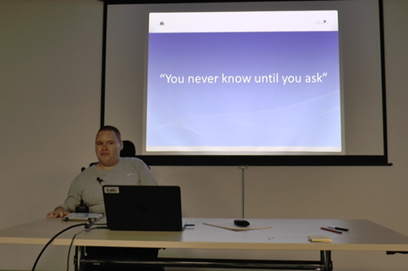
In early July we contacted disabled people, family and whānau who expressed interest in Enabling Good Lives Waikato. Our Tūhono/Connectors have been busy meeting with participants to help them plan their good life. We are already able to see the positive impact that Enabling Good Lives could have on an individual’s life.

Enabling Good Lives Waikato is working with people who live in the Waikato District Health Board area, from Northern Coromandel to close to Mt Ruapehu in the south and from Raglan on the west coast to Waihi on the east.

The recent Enabling Good Lives Waikato Disabled Person’s Forum included a presentation by student journalist Mike Pulman. Mike is seen as a positive disabled leader within the community and actively promotes the principles of Enabling Good Lives. Mike shared with an 80-strong audience information about his life including his determination for independence, work experience in the Waikato sporting arena and the struggles he has faced.

For more information:
www.enablinggoodlives.co.nz

Contact Loren Corbett 029 2014780
or email enabling_good_lives_waikato@msd.govt.nz

DSS News

We are pleased to welcome Amerika Wilson to DSS. Amerika will be working with us four days a week until November assisting on a project to work with and support disabled people and their families/whānau/aiga in the Auckland region.

Amerika is currently employed as a Service Manager at Spectrum Care Trust Board and has more than 20 years’ experience supporting people with disabilities and helping them achieve their goals – from living more independently and participating in their local communities or cultural groups to reconnecting with family and friends following deinstitutionalisation.

Amerika is also on the Faiva Ora National Leadership Group, which enables Pacific peoples with disabilities to have a group representing their views at the highest levels in New Zealand.

We would like to acknowledge the support from Spectrum Care Trust Board as we take on this project.

Te Ao Mārama
(the world of light)

Kia ora koutou. In this section we share stories of how our service providers are responding to the needs of Māori with disabilities and their whānau. The aim is to promote and foster culturally integrated practice and culturally responsive services within our sector.

Mauri ora (be well).

Contact: Inia Eruera, Senior Advisor Māori, 04 816 3659

NorthAble Disability Services
Tēnā koutou katoa. I am proud to share with you some information about our service at NorthAble, which is based in Whangarei, Mid-Far North and Kaipara districts. Fifty-five percent of our clients identify themselves as Māori. Accordingly, Māori representation is reflected at the Board level and throughout the organisation.

NorthAble is Northland’s primary Disability Resource Centre and has been serving local communities since June 1990.

The NorthAble Māori Cultural Advisor has been with the organisation for 11 years and inducts all new staff to familiarise them with local protocols, including basic marae etiquette. Waiata practice is held each week for an hour and this brings the organisation together to re-energise with waiata and karakia.

NorthAble is able to refer clients to a Navigation Service which is able to match an independent navigator who could access supports across agencies to assist all families/whānau to regain their independence. Here is a link: https://www.youtube.com/watch?v=nnNtVjFdC-s

We are supported by kaumātua and kuia who uphold ‘te tikanga ō Ngāpuhi’ for our organisation. They are involved when welcoming new staff, and any manuhiri/visitors, by guiding us through pōwhiri, mihi whakatau, karakia and waiata.

NorthAble works with a number of Tai Tokerau iwi service providers in the provision of information and delivery of services for whānau. These relationships have been built over 25 years, based on trust and goodwill and provider recognition of how accessible NorthAble and its staff are to Māori and other cultures. We are happy to share information with any other providers interested in better responding to the needs of Māori with disabilities and their whānau. Please contact us on ph: 09 430 0988 or northable@northable.org.nz

Noho ora mai (Be well)
Noel Matthews, CEO
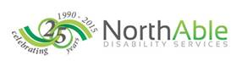

Upcoming Events

ImagineBetter Assemblies
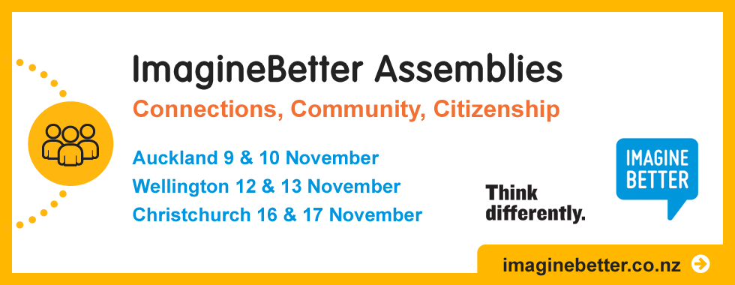

ImagineBetter is introducing a fresh approach to its annual conference this year.
Two-day assemblies, with a new group-discussion format, will be held in Auckland on 9 and 10 November; in Wellington on 12 and 13 November; and Christchurch on
16 and 17 November.

Participants will explore the theme: Connections, Community, Citizenship: How can we increase our community connections and gain the most value from them?

Presenting partners Margaret Wheatley, Jeder Institute and Future by Design will introduce group-discussion tools that will enable participants to find new ways to increase their networks and benefit from them.

Find out more and register at www.imaginebetter.co.nz

DSS Project Updates

Quality Review – Putting People First
The following progress has been made with implementation of Putting People First (PPF) recommendations during June and July.

People who are non-verbal must be involved in decision-making about their lives. The updated Service Specifications for Residential Service Providers now require providers to:
- ensure that a personal plan is developed, where the process is led by the person (or, where approved by the person, their family/whānau/guardian/advocate) with support provided to ensure the person is listened to and the planning experience is positive and relevant
- ensure the Primary Support Worker communicates effectively with the person, using communication means known and understood by the person, and also supports the person to communicate with others as needed.

In addition, providers must ensure support is given to non-verbal people and their whānau to access support to have their voices heard and listened to. The updated service specifications also require providers to:
- understand a person’s means of communication to engage and effectively interact with each person they support (this may include, where required, learning and using tools such as Makaton, sign language or use of technology)
- support the person to make him/herself understood – create an open environment where people and their whānau/guardian/advocate feel their feedback (both positive and negative) about the service is welcomed by the provider and used to improve outcomes for the person
- ensure people and their whānau are aware of and know how to access the provider’s complaints process
- ensure people have access and support to independent advocacy services – people are informed they have the right to an advocate or support person to help them express their wishes (especially those who are non-verbal), and have the support of the provider to access support of their choice.

Other PPF highlights in June and July include:
- the second of the three DSS interns to date has now gained employment. He credits his time in DSS as helping him to build up the confidence to apply for the job
- DSS staff attended the launch of a DVD on people’s rights when using a health and disability service in New Zealand. The video was the result of a joint project between the Health and Disability Commissioner and People First and describes people’s rights in an easy to understand format. The video is available to view here: http://www.peoplefirst.org.nz/people-first-members-steal-the-show-in-latest-hdc-film/
- Work is progressing on a guideline for the prevention and management of abuse in DSS funded services. Keeping Safe Feeling Safe and the Ministry are jointly hosting an interagency forum in August to discuss safeguarding for disabled people. Other participants at the forum will include the Human Rights Commission, Office of the Health and Disability Commissioner, New Zealand Police, Ministry of Justice, Ministry of Social Development and Disabled People’s Organisations. The purpose of the forum is to commit to ongoing interagency collaboration in the safeguarding of disabled people.
Contact: Pam MacNeill, Quality Improvement Lead, 04 816 2178

New Model – Enhanced Individualised Funding
There are about 340 people using Enhanced Individualised Funding (EIF) in the Western and Eastern Bay of Plenty Region.
An evaluation report on EIF in the Bay of Plenty demonstration will be available on the Ministry of Health website soon (www.health.govt.nz).
As a result of some of the findings so far, the Ministry is reviewing the application of the Purchasing Guidelines for the New Model for Supporting Disabled People (the Guidelines).
The Ministry is aware that there is a lack of clarity and consistency in the way the Guidelines are applied. This means it can be difficult for some people to determine what can be covered by Ministry funding. The review of the Guidelines will look at how to make the Guidelines clearer.
In mid-July 2015 the Ministry sent a letter to all people using EIF and Choice in Community Living (CiCL) to advise them that the Ministry is reviewing the Guidelines. The Ministry will work with disabled people and their families over the next few months to refine and reshape the Guidelines.
This review of these Guidelines does not affect the Guidelines that are used within the EGL Demonstrations in Christchurch and Waikato.
Contact: Murray Penman, Development Manager, 09 580 9084

New Model – Local Area Coordination
The two Local Area Coordination (LAC) trials through Needs Assessment and Service Coordination Services (NASCs) in Hutt and Central Otago/Southland have now been under way for a year. At the end of that year there were over 400 people working with a Coordinator in those two sites and through the ongoing LAC work in Bay of Plenty and the Lakes district. Thirty-three percent of these people are Māori and nearly 50 percent are people with a learning/intellectual impairment.

For some, their contact with an LAC would be for information or initial assistance, for others they would have a longer working relationship where they are supported to think about their lives and plan for their future within their particular community. Each of the sites is also involved in community building in different ways with the aim of supporting those communities to include and value the contribution of disabled people in all aspects of community life.

An evaluation report on LAC in the Bay of Plenty demonstration is due on the Ministry of Health website soon.

Contact: Jenny Moor, Development Manager, 09 580 9070

Behaviour Support Services Improvement Project
The Behaviour Support Service is now implemented through the country and feedback about the new service has been very positive. The referral rate to the service is high, so support service provider Explore is spending the next six months looking at referral rates and how best to configure their teams to respond. The quality measures that will be used for the service, and how it will be evaluated, are being refined over the next few months.

Contact: Gordon Sinclair, Development Manager, 04 816 3696

Residential Pricing Model Implementation
DSS is finalising a nationally consistent pricing model for all DSS-funded residential services. The first step in implementation will be to move all residential funding packages to one of 30 new price points from 1 December 2015. Prior to the new residential outcome agreements beginning on that date, providers will be supplied with funding information on each of their clients. These agreements will incorporate the updated community residential service specifications and meet the new streamlined contract framework requirements.

Contact: Lee Henley, Manager, Community Living Team, 04 816 2119
Viv Ruth, Contract Relationship Manager, Community Living Team, 03 9742304

Pacific Development

Implementation of Faiva Ora 2014–2016 – Le Va Work Plan
2015–2016
In July, the Ministry approved Le Va’s annual work plan 2015-2016 for implementation. This plan outlines key activities Le Va will undertake to deliver on the outcomes of the Faiva Ora plan.

Working with disability stakeholders, Le Va will implement the Engaging Pasifika disability cultural workshops, profile the Pasifika disability church resources to Pasifika church communities and promote the use of the new organisational guidelines to disability support providers working with Pasifika disabled people and their families.

Contact: Feala Afoa, Development Manager, 09 580 9053

Disability Workforce Development

Kaiāwhina Workforce Action Plan
During April and May 2015, Careerforce undertook a stakeholder engagement survey to obtain feedback on the draft five-year Kaiawhina action plan from workers in the disability, aged care, mental health, public health and general health sectors, consumers and service providers.. Their feedback supported the direction and approach outlined in the action plan. Implementation of this plan is due to start by September 2015. The plan aims to address workforce development and long-term sustainability across seven domains: Access, Career Development, Workforce Recognition, Consumer Focus, Quality and Safety, Workforce Intelligence and Sustainability.

ASD support workforce training needs and barriers
Since April 2014, people with Autism Spectrum Disorder (ASD) have been eligible to have their disability support needs assessed through the Ministry-funded NASC organisations. This means disability workers need to be equipped with the necessary skills to provide quality supports that are responsive to the specific needs of people with ASD. To address this, the Ministry is working with Te Pou to collect information from workers and disability services to gain a better understanding of the training needs and barriers for those who support people with ASD. This work is due to start this month and conclude in December 2015.

Contact: Feala Afoa, Development Manager, 09 580 9053

New Streamlined Contracting Framework and DSS Service Specifications Update
During April, workshops were held to provide advice on the final draft versions of the new Ministry of Health Outcome Agreement which will apply to all disability support services provided to disabled people in the future. The workshops also provided advice on the updated service specifications and performance measures relating to the following services: Community Residential; Children’s Residential; Supported Living; Facility-Based Respite; Home and Community Support; Foster Care; Contract Board; Day Programmes; Younger Persons in Aged Care; Regional Intellectual Disability Supported Accommodation Services.

Workshop attendees represented service providers, people using disability support services, carers and family members.

The final draft documents were then made available on the Ministry’s website for consultation over a period of eight weeks. Consultation has now closed and 35 responses were received.

The documents will be finalised in August, for implementation from:
- 1 October 2015 for Day Programmes
- 1 November 2015 for Home and Community Support Services, and
- 1 December 2015 for the remaining services listed above.

The Ministry thanks all of the disabled people, Disabled People’s Organisations, service providers, carers and family members who took the time to attend workshops and provide feedback to inform its work. This input will help ensure the Outcome Agreements and service specifications are fit for purpose and that services are centred on disabled people, and supporting them to live a good life.

Contact: Barbara Crawford, Manager Strategy and Contracting, 04 816 4384

Contact Disability Support Services
Email: disability@moh.govt.nz Phone: 0800 DSD MOH (0800 373 664)
Web: www.health.govt.nz/disability
To be added to the email list for this newsletter, send an email to: disability@moh.govt.nz
If you do not wish to receive these newsletters, please email: disability@moh.govt.nz with ‘unsubscribe to newsletter’ in the subject line.

