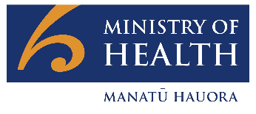
COVID-19 Science Updates
CSU | 23 July 2021
1. Increased transmission of Delta variant: higher viral load and shorter incubation period
It is in the nature of viruses to mutate. Some of these mutations will result in an adaptive change in function such as transmissability, or the ability to evade previously effective treatments and vaccines. Changes to the way the virus behaves may have a significant effect on the way the disease is controlled or treated. The Delta variant of SARS-CoV2 is now the most dominant variant in many parts of the world. It is helpful, however, to understand which characteristics of the virus are changing so that control measures can be effectively adjusted.
Researchers in Guangdong, China and the University of Oxford (link) have reported that the Delta variant of SARS-CoV-2 (B.1.617.2, first identified in India) is associated with substantially increased viral loads and shorter incubation periods compared to an ancestral variant (denoted “19A/19B”). Viral load refers to the number of infectious particles within an individual and typically correlates to disease severity and outcome. However, other risk factors, such as immune deficiency or pre-existing respiratory conditions (e.g. severe asthma) are also relevant. The incubation period refers to the time between the initial exposure and the onset of disease symptoms.
- The study aim was to assess the serial interval (the time between successive cases in a chain of transmission) and the viral load in a cluster which was epidemiologically or genetically linked to a single case between 21 May and 18 June 2021. These results were compared to a similar dataset from a cluster in 2020 of a previous variant.
- The cohort comprised 167 cases of the Delta variant, of whom 62 were known close contacts of previous cases. These close contacts were quarantined as soon as they were identified as a close contact (before testing positive), and had daily oropharyngeal swab PCR tests. This enabled researchers to gather data on each individual’s course of infection, specifically from the likely exposure day through to first positive PCR test.
- The assessment of viral load was based on the Ct values, which represents the number of PCR cycles required to detect the nucleic acid sequence under investigation. Samples with a higher initial viral load will reach the detection threshold after fewer PCR cycles and therefore have a lower Ct value. As the Ct value is based on a log scale, a decrease in the Ct value of one (1) represents twice the amount of nucleic acid (from viral RNA fragments) in the original sample while a decrease of three (3) represents an increase of nucleic acid of 8 times.
- For cases identified in quarantine (after close contact) in 2020 (N=63, non-Delta cases), the average cycle threshold (Ct) value was 34.3 on the first day of detection, compared to 24.0 for Delta cases identified in quarantine (N=62). The authors report that this corresponds to Delta cases having 1260 times greater viral load on the first day of detection, compared to cases from the 2020 wave in Guangdong. See Figure 2.
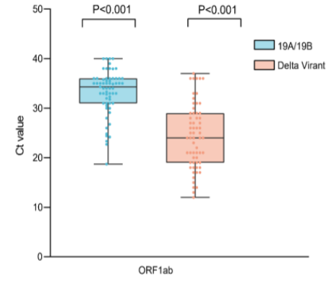
Figure 1. Cycle threshold value for cases in 2020 wave in Guangdong province (the 19A/19B variant, in blue) and cases of the Delta variant from the wave in May-June 2021 (in orange).
- It was possible to calculate the serial interval from the data available for 34 cases occuring during the Delta cluster and for 29 cases occuring during the 2020 outbreak. It was estimated that the median time from exposure to first positive PCR was 6 days for the 2020 pandemic data (see Figure 3 green bar chart), and 4 days in the 2021 (Delta) infections (see Figure 3, orange bar chart).
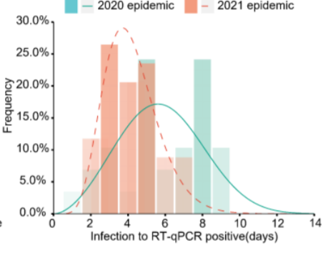
Figure 2. The incubation time from estimated exposure based on contact tracing data, and day of first positive PCR test. Close contacts were quarantined and tested daily
Comment: Infections associated with the Delta variant appears to have over 1000 times higher viral load and a significantly shorter period of time to from exposure to first positive test (4 days vs 6 days) than previous variants. The report of increased viral load for Delta is consistent with a national surveillance data from Public Health England (link) published on 25 June 2021. The strength of this study is that the likely day of exposure could be ascertained via contact tracing, and that the individuals were subsequently isolated/quarantined (all individuals subsequently tested positive) and sampled daily through the course of their infection. For this study, the observed increased viral load is not an artifact of the time the testing was undertaken during the course of the infection, which may be true when individuals are not tested daily.
The increased viral load helps to explain the increased transmissibility observed for the Delta variant, and each infected case is likely to infect, on average, more of their contacts than for previous variants (R₀ ~ 6 for Delta as opposed to ~2.5 for the ancestral variants). Additionally, the infected contacts of cases will themselves become infectious earlier resulting in a shortened window for contact tracers to identify and isolate them before they become infectious in the community. Very rapid contact tracing will therefore be even more important for controlling the Delta variant than for previous variants. This has been highlighted as an issue by the Chief Science Advisor for New South Wales, Kerry Chant, who has said that “contact tracers are having difficulty getting ahead of transmission chains” (Link here).
The impact of the Delta variant on the current elimination strategy in Aotearoa New Zealand will be complex and results from an interplay between the effects of increased transmissibility and shorter incubation periods. As part of a continual refinement of the elimination strategy, a number of additional measures have been implemented over the past 12 months, such as pre-departure testing, day 0/1 testing in managed isolation, and cohorting of returnees. Based on an empirical assessment of what this study tells us about the increased transmissibility of the Delta variant, these are appropriate methods for addressing a shorter incubation period and the wider introduction of mask-wearing in both managed isolation and public transport will help to address the risk from higher viral loads. Ongoing review of the elimination strategy in the context of new variants continues.
2. Mask-wearing and HEPA filters reduce exposure to aerosols able to carry SARS-CoV-2
Virus particles remaining suspended in tiny exhaled droplets, referred to as “aerosols” are likely responsible for several kinds of transmission events, including super-spreading events and transmission in managed isolation and quarantine facilities (MIQF). This mode of transmission is of particular interest as we accept that contacts may not always be in the same room at the same time, as was initially thought for COVID-19. Reducing the risk of airborne transmission can be achieved by reducing the spread of virus from an infected person, decreasing the viral load in the air, and reducing the risk of someone inhaling infectious particles.
A study published by the US CDC in the Morbidity and Mortality Weekly Report (MMWR) on 09 July 2021 (link) investigated the effectiveness of portable High Efficiency Particulate Air (HEPA) filters and mask-wearing (three-ply cotton cloth face masks with ear loops) at reducing aerosol particles capable of carrying pathogens, both in circulating air and from behind the mask. Combined, these measures reduced the concentration of potentially infectious particles that could be inhaled by 90%. While the link between reducing circulating aerosols and clinical outcomes is not fully established, epidemiological observations from areas of high transmission (e.g. enclosed spaces) suggest that such measures are likely to reduce the risk of infection.
- The objective was to evaluate the effect that HEPA filtration and/or mask-wearing have on the concentration of airborne particles capable of carrying pathogens.
- The study used breathing simulators, which were models of the human upper respiratory tract, to generate and receive the aerosols. The experiment modelled the setting of a conference room with one meeting “participant” infected with COVID-19 exhaling infectious aerosols (the source), plus a “conference presenter” and two other participants exposed to these aerosols (receivers – who would typically be referred to as “close contacts” in a real-world setting).
- The two HEPA filters were used in four different locations and compared to a control of a room with no air cleaning devices.
- The concentration of 0.3 micrometre to 3 micrometre aerosol particles were measured at the mouth of each receiver. This particle size was chosen as it is small enough to remain airborne, but large enough to carry pathogens – although there is still debate on these estimates.
- For the masked participants, particle counters collected air samples from inside the masks, as a proxy for the amount of aerosol being inhaled.
- Compared to no masking and no air cleaning, HEPA filtration alone decreased the exposure to simulated airborne particles by 50-65% (depending on their location in the room) and masking alone reduced exposure by 72%.
- The combination of HEPA filtration and masking reduced the concentration of aerosols by 90%.
- Many other factors will be important to estimate transmission risk in a real-world situation, such as the amount of virus in the aerosol particles, how long the virus survives in air, individual susceptibility to infection (including vaccination status), airflow patterns in real-world settings, and movement of people around a room.
Comment: The MMWR study found that universal masking and portable HEPA air cleaners can each significantly reduce exposure to simulated aerosols in indoor environments and by up to 90% in combination. Portable air filtration, especially when existing ventilation systems are insufficient, is a plausible way to help remove airborne particles from a room. The experiment was conducted in a 52m² conference room and the air cleaners were set to achieve a combined 5.2 air changes per hour, which would be characteristic settings for an air-conditioned, moderate-sized conference room.
Currently, the risk of airborne infection within managed isolation in Aotearoa New Zealand is mitigated using several interventions, including masking of returnees and the use of HEPA filters in high-risk shared spaces. This study suggests that such measures may be effective at reducing the risk of infection within MIQ. Research is underway within managed quarantine facilities in New Zealand to assess the ability of HEPA filters to decrease the viral load of SARS-CoV-2 in the rooms of returnees infected with COVID-19.

