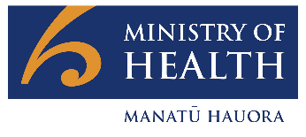
COVID-19 Science Updates
CSU | 03 August 2021
1. Summary of key information from recent weekly Variants of Concern Updates
The Science and Technical Advisory team within the COVID-19 Directorate of the Ministry produces a weekly review of evidence on Variants of Concern (VOC) and Variants Under Investigation (VUI) in the weekly Variants of Concern Update. All updates are publicly available on the COVID-19 Science News (link) webpage on the Ministry of Health website.
Summary of key information from the recent updates:
- The ongoing active global pandemic gives the virus opportunities to replicate and mutate: while there is an active pandemic globally, the opportunity for the emergence of new variants exists.
- Variants of concern (VOC) are variants that pose a greater threat to peoples’ health and management of the pandemic, due to increased transmissibility, causing more severe disease, and/or ability to evade immune responses or vaccines. Variants with preliminary evidence suggesting that they may become a VOC, are initially designated a Variant Under Investigation (VUI) while they are being evaluated.
- In the previous six weeks there has been a continuous increase in the global spread of the Delta (B.1.617.2) variant, which has a transmission advantage over other variants. A notable exception is some South American countries (Peru, Chile) where the VUI Lambda (C.37) has overtaken other circulating lineages, including Alpha (B.1.1.7) and Gamma (P.1) as the dominant variant.
- The Delta variant with the added mutation K417N is known informally as “Delta plus”. Mutation K417N is potentially associated with immune escape. Public Health England (PHE) has reported a very small number of cases with “Delta plus” as of 23 July. Of note, data on this variant is generally not collected separately but included along with Delta.
- WHO expect Delta to continue to displace other variants and to become the dominant VOC worldwide in the coming months.
- In Aotearoa New Zealand, Delta is the predominant VOC identified in cases at our border in recent weeks.
What do we know about Delta?
Transmissibility
- Epidemiological evidence from secondary attack rates, household transmission studies, and growth rate modelling all support increased transmissibility.
- The basic reproductive number R₀ for Delta is estimated to be at least 5.5-6.5, meaning that on average each person transmits Delta to another 5-6 people.
- An outbreak study in Guandong China indicated that Delta is associated with very high viral loads – 1000 times higher on the first PCR positive test compared with the previously dominant variant in that region -- and a shorter median incubation time of 4 days, compared to approximately 6 days for the prior variant.
Severity of Disease
- PHE data estimated that Delta is associated with 2.3 times the risk of hospitalisation compared to Alpha. Fortunately, PHE data indicate that the case fatality rate for Delta remains low (0.2%). Data reported for risk of death with Alpha varies: PHE’s most recent case fatality rate for Alpha is approximately 1.8%, noting that this data is based on the wave from December 2020.
Vaccine effectiveness (VE)
- The Pfizer vaccine is effective against symptomatic Delta infection when two doses are given: PHE reported 33% protection after one dose, 88% protection after two doses against symptomatic infection. Similar results have been reported in Denmark and Canada. In contrast, Israel’s Ministry of Health reported a vaccine effectiveness against symptomatic disease of 64%. This result was reported in a press release, but the difference may be due to a methodological differences that do not fully account for the confounding in the observational data.
- The AstraZeneca vaccine is less effective against symptomatic Delta infection when two doses are given compared to Pfizer but still provides protection: Public Health England reported 30% protection after one dose, 67% protection after two doses against symptomatic Delta infection.
- A separate analysis from Public Health England (but typical of other estimates) showed two doses of the Pfizer vaccine offered 96% protection against hospitalisation due to the Delta variant. The AstraZeneca vaccine provided 92% protection against hospitalisation due to the Delta variant in the same Public Health England analysis.
Horizon scanning
- Recent data from England shows infection rates in healthcare workers are increasing. The cause is unclear but contributing factors may include one or more of: waning immunity for AstraZeneca and/or Pfizer vaccines; immune escape properties of variants; increasing prevalence of COVID-19 in England due to Delta. Further updates will continue to report on this as data emerges.
Comment:
The predominant variant of SARS-CoV-2 is Delta and looking ahead it is prudent to plan for outbreaks assuming Delta will be the variant responsible. Delta has increased transmissibility compared to the previously dominant Alpha variant. It also appears to have higher viral loads, a shorter incubation period, and shows some degree of immune escape (even though mRNA vaccines appear to largely maintain their effectiveness against symptomatic disease) compared to previous variants. The shorter incubation period has implications for the contact tracing timelines and the speed with which public health measures.

2. Guillan Barré Syndrome after COVID-19 Vaccination
Events of Guillain-Barré syndrome (GBS) have been observed after vaccination with AstraZeneca and Johnson and Johnson (J&J)/Janssen COVID-19 vaccines internationally. On 13 July 2021, the US Food and Drug Administration (FDA) added a warning regarding GBS for the J&J vaccine. The European Medicines Agency (EMA) added a similar warning to the AstraZeneca vaccine and is continuing to assess GBS with regard to the J&J vaccine, as of 14 July 2021. GBS is a rare autoimmune neurological disorder affecting the peripheral nervous system.
- GBS can range from a very mild case with brief weakness to complete paralysis and death. Most people recover from even the most severe cases of GBS but some may be left with residual weakness. The most common precipitating cause is a respiratory or gastrointestinal viral infection.
- The background risk of GBS increases with age from a rate of approximately 0.9 per 100,000 person-years for 18 – 29 year-olds, to 2.3 per 100,000 person-years for those 65 years and over (link and Table 1)
- The US CDC’s Advisory Committee on Immunization Practice (ACIP) analysed 100 preliminary reports, reported to the VAERS (Vaccine Adverse Event Reporting System) up to 30 June 2021. During the data collection period, approximately 12.2 million doses of the J&J vaccine were administered in the US, for a crude rate of 8.1 per million doses (link). Of these 100 cases, 95% were serious, 61% occurred in males, and there was one death attributed to GBS. When stratified by age, the risk was significantly elevated for those over the age of 30: people aged 30-39 had approximately 4 times the risk of GBS post-vaccination with the J&J vaccine; people aged 40-49 and 50-64 years had approximately 7 times the risk of GBS (see Table 1)
Table 1 Background rates, expected numbers of cases and observed numbers of cases of GBS by age (ACIP)
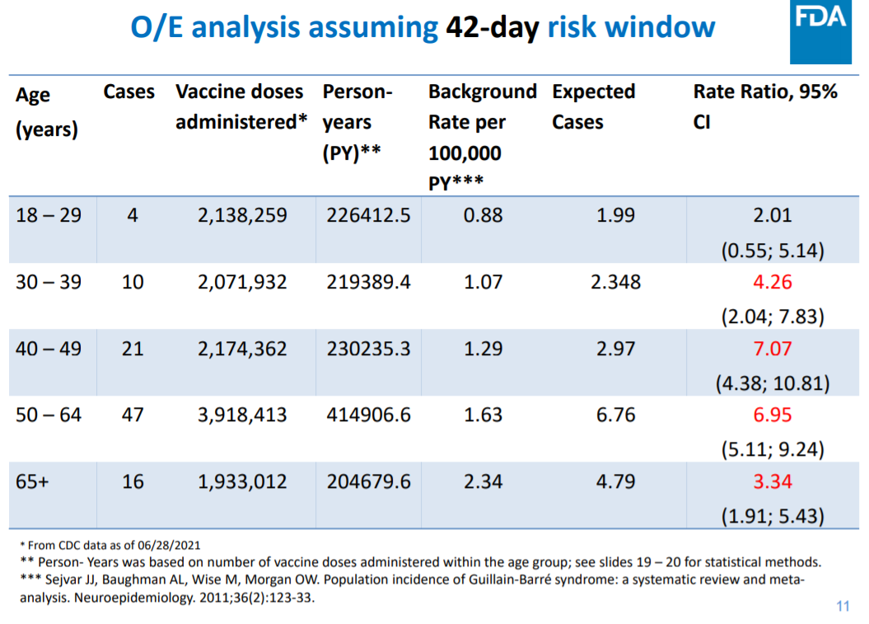
- The rate of GBS in those receiving the Pfizer or Moderna mRNA vaccines was approximately 8 times lower than the rate for Janssen (see Table 2).
Table 2 Crude reporting rates of GBS for mRNA vaccines and Janssen vaccine in the US (ACIP)
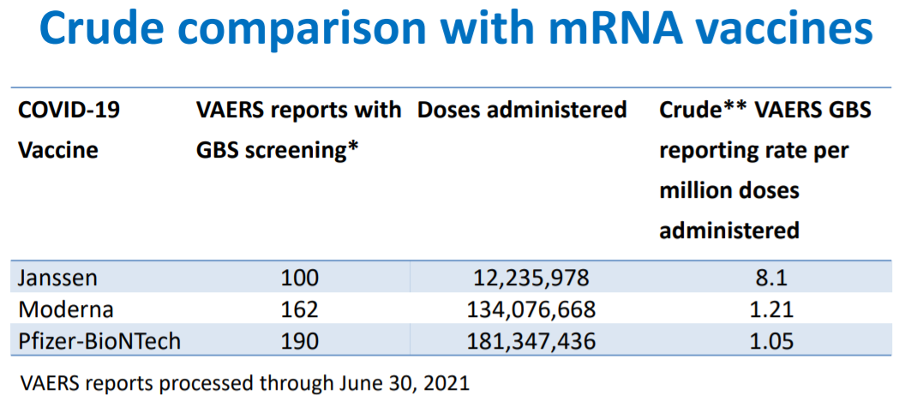
- The EMA’s Pharmacovigilance Risk Assessment Committee (PRAC) reviewed 227 reported cases of GBS through 27 June 2021, after administration of the AstraZeneca vaccine (link). Approximately 51.4 million doses of AstraZeneca vaccine had been administered through 20 June, for an approximate rate of 4.4 per million doses.
- As of 27 June 2021, 15 cases of GBS after vaccination with the J&J COVID-19 vaccine were reported from the EU/EEA to the Eudravigilance database (link). Approximately 7 million doses were administered in the EU/EEA in a similar period, through 20 June 2021, which corresponds to a crude rate of 2.1 per million doses.
- The WHO released a statement (link) regarding the risk of GBS after COVID-19 vaccination on 25th July 2021, which is consistent with comments made by the US and EU agencies. The WHO recommend that individuals receiving the Janssen or AstraZeneca COVID-19 vaccine are made aware of the possible association with GBS, but that there is no evidence that GBS is associated with mRNA vaccines.
Comment:There is some previous evidence to suggest that influenza vaccination is linked to GBS. For example, researchers found that over the 2010-2011 influenza season in Italy, there was a 2-fold relative increase in the risk of GBS for vaccinated compared to unvaccinated individuals (link). However, an association has not been reported for other vaccination programs. It is possible that because the enormous size of the COVID-19 vaccination, which has no precedent, and the increased safety monitoring associated with COVID-19, researchers are able to identify associations between vaccination and extremely rare events. Interestingly, the pathophysiology of GBS is based on the development of auto-antibodies (against the myelin sheath of the peripheral nervous system), which is similar to the proposed mechanism for the vaccine induced thrombocytopaenic thrombosis (VITT), observed after vaccination using adenoviral vector vaccines; VITT is associated with platelet-activating antibodies against platelet factor 4 (PF4). However, it is important to keep in mind that the risk of these potential complications from the vaccine is tiny compared to the benefits of vaccination in preventing disease and death from COVID-19.

