Changes to the  Mental Health Act | October 2023

On 29 October 2021, Parliament made some changes to the Mental Health (Compulsory Assessment and Treatment) Act 1992 (commonly called the Mental Health Act).
These changes will strengthen the rights of people placed under the Mental Health Act.
The changes are part of the work Manatū Hauora (the Ministry of Health) is doing to improve the care and treatment people get under the Mental Health Act.

What the changes mean for you

Using phone or video
The staff at your mental health service can now use a video link in some situations. For example, when a staff member is arranging a review or assessment of you, under section 76 of the Mental Health Act. A judge can also use a video link at the court hearing, if you agree for them to do so.

No more ‘indefinite orders’

Reviewing your condition
Your responsible clinician must review your condition with you at certain times to check whether you still need to be under a compulsory treatment order.
The first review must happen 3 months after you were first listed under the order. Any review after that first one must happen within 6 months each time.
Before this change was made to the Mental Health Act, your responsible clinician could apply to the courts to extend your first order for 6 months. Then when it came time for the next review, they could extend the order for an unfixed time. This means your compulsory treatment order could just keep going without any review.

Extending your compulsory treatment order
From 30 October 2023, after the first 12-month extension of your compulsory treatment order,
your responsible clinician must reapply every year to the courts if they think you still need to be under an order.

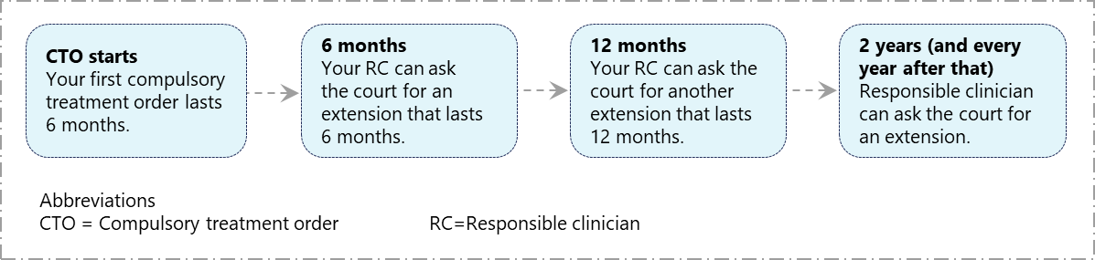

If you do not want to go to the court hearing and you want to stay on your order
If you don’t want to go to the court hearing about extending your compulsory treatment order and you want the judge to consider the extension without you:
- You must talk with a lawyer and give your permission in writing for the judge to consider the extension without you.
- Your responsible clinician needs to check that nobody else wants to talk to the judge about your extension application.
- The judge must agree that you don’t need to attend the hearing.
You should also let your responsible clinician know if you want to go or not.
If the judge does not agree with your wish not to go to the hearing, they can ask you to go to the hearing, and you must go.

Dates for reviewing your treatment order
If you are on an indefinite treatment order, your mental health team should review you and your order within 14 days of the day when your original compulsory treatment order was made. The last day of the 14 days is called the ‘expiry date’.
For example, if your compulsory treatment order was made on 30 June 2022, then your expiry date each year is 30 June. In this example, your responsible clinician should review you and your order any day from 16 June, which is 14 days before the expiry.
If your responsible clinician thinks you still need compulsory treatment, they will apply to the court for a 12-month extension. This may or may not need a court hearing, depending on what is agreed in court.

A judge must decide whether to extend your order or not within 2 months after the date that your responsible clinician applied for the extension.
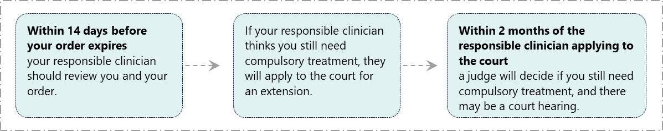

October 2023
HP 8859

