Annual sterilisation notification reporting
The Contraception Sterilisation, and Abortion (Information Collection) Regulations 2021 (the Regulations) set out the new annual reporting requirements for sterilisation providers.

These regulations came into effect on 24 September 2021 to enable the Director-General of Health (as required by the amended CSA Act 1977) to review and report on whether there is timely and equitable access to sterilisation services.

Under Section 5 of the Regulations, all sterilisation service providers are required to send the Ministry of Health an annual report for all services provided within the preceding year ending 31 December for which they had overall responsibility, by 31 March the following year. For example, the annual report for 2021 must cover services performed between 1 January 2021 and 31 December 2021 and is due to the Ministry on 31 March 2022.

The reporting process
Ideally the person completing the annual report notification should be someone with oversight of the services, such as the service or clinic manager, but it can be any staff member from the service who has access to service information. Providers are required to send the Ministry their completed annual report for the year by 31 March the following year.

The Ministry sends all sterilisation providers the annual report template. If your service doesn’t have a copy of the template, please email ster@health.govt.nz to request one.

Please email the completed report to ster@health.govt.nz.

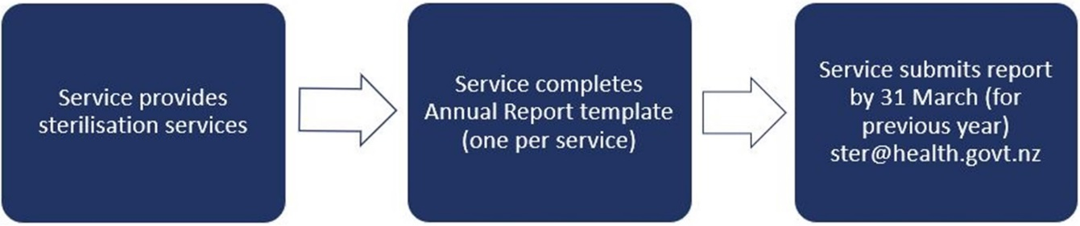

The new regulations came into effect on 24 September 2021 and so we recognise that the data captured by your service for 2021 may not be complete. Please provide what information you can for 2021 and note the period the data covers.

In order to prepare for the 2022 report (due by 31 March 2023), please remember to start capturing the required data from the start of the year.

