Summary of COVID-19 Disease Indicators
For the reporting period 23 October to 5 November 2020
Report date: 09/11/2020
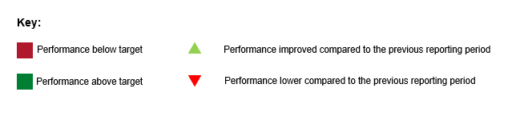

Summary of community cases
Number of cases for this reporting period and cumulative number of cases since 11 August 2020.
Reporting period | Cumulative
3 | 193

This reporting period involves three community cases and 14 associated contacts. During this period most metrics reach 100% within the target timeframe as one case, related to the Maritime cluster, had been a close contact and was already in isolation. In addition, close contacts of the two MIQ health workers related to the Russian mariners cluster were quickly identified and isolated.

System level indicators
These indicators provide a view of the end-to-end collective actions of the wider health system response (indicators are prefixed with an S#).

S001 - Time from exposure to contact isolation / quarantine
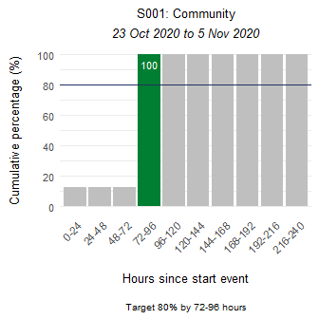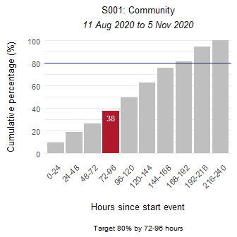

S002 - Time from case first symptom to contact isolation / quarantine
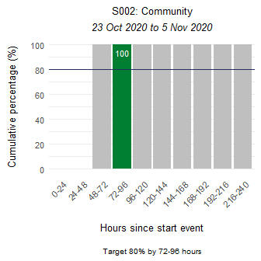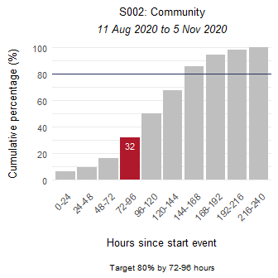

S003 - Time from test sample taken to close contact isolation / quarantine
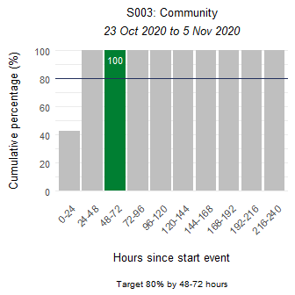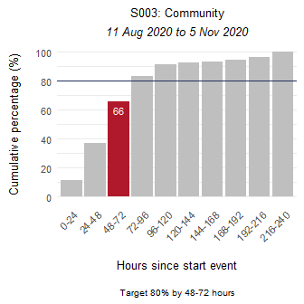

S005 - Proportion of close contacts with confirmed or suspected COVID-19 at the time of tracing
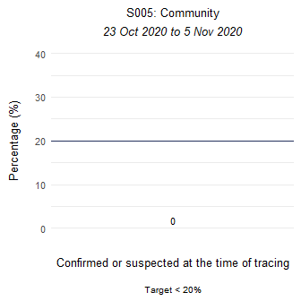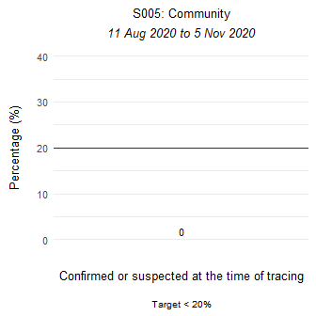

Community-level indicator
This indicator focuses on community behaviours and the impact of communication, education and societal attitudes (indicator is prefixed with a C#). The time period measured is from the symptom onset date as recorded in EpiSurv to the date/time the laboratory received the sample. The time between a sample taken and the receipt date/time of the sample at the laboratory, including transport time, will affect this indicator.

C001 - Time from first symptom to test sample taken for positive cases
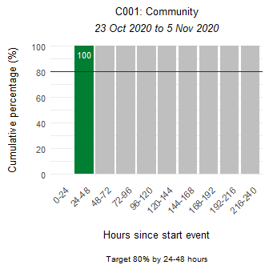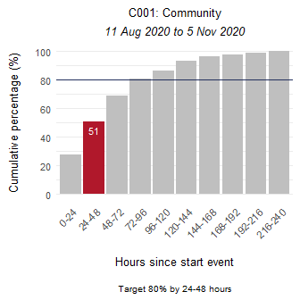

Laboratory sector indicator
This indicator provides insight into the effectiveness of testing facilities and programmes (indicator is prefixed with an L#). The time period measured is from the time the laboratory received the sample to notification of a positive result in EpiSurv.

L001 - Time from test sample taken to notification of positive result
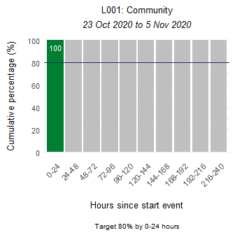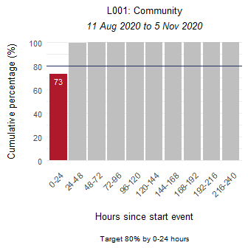

Public health sector indicators
These indicators provide a national overview of contact tracing as well as case and close contact management by public health units (PHUs) and the National Investigation and Tracing Centre (indicators are prefixed with a P#).

P001 - Time from notification to case interview
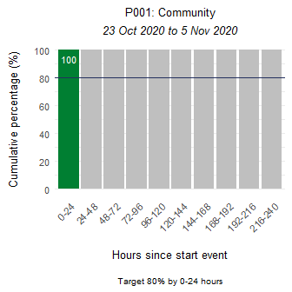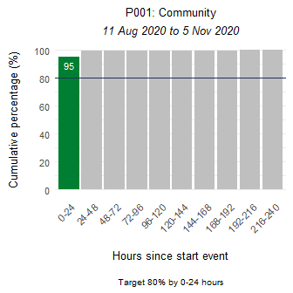

P002 - Time from case notification to isolation / quarantine of contact
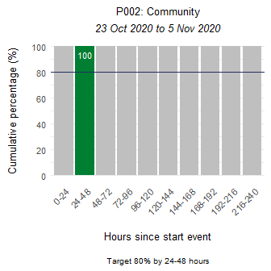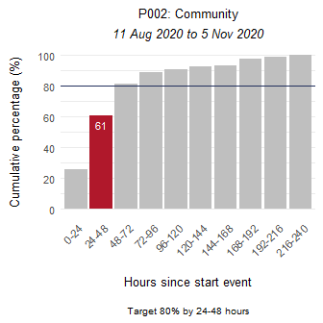

P003 - Time from close contact identification to isolated / quarantined
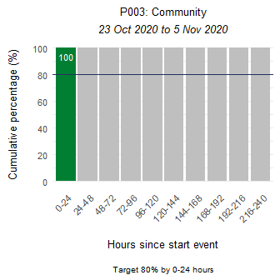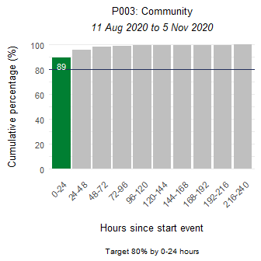

P004 - Proportion of contacts traced in 48 hours
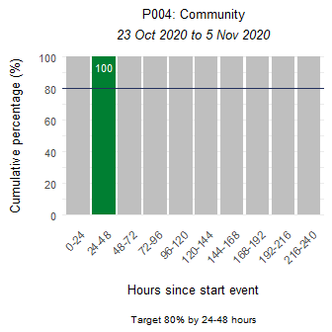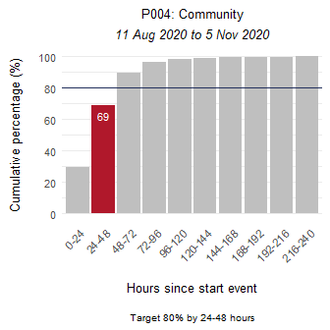

Appendix: Summary of MIQ border and international indicators
This section presents the indicators for Border Managed Isolation and Quarantine (MIQ) and International cases. Indicators S001, S002, and C001 are affected by the inclusion of border cases in MIQ, as returnees’ exposure is arbitrarily set to the day of arrival in New Zealand. They are placed into MIQ upon arrival and are tested if symptomatic or on approximately day 3 and day 12. Therefore, cases in MIQ will make the performance of these indicators appear low.

Summary of MIQ border and international cases
Number of cases for this reporting period and cumulative number of cases since 11 August 2020.
Reporting period | Cumulative
57 | 208

S001 - Time from exposure to contact isolation / quarantine
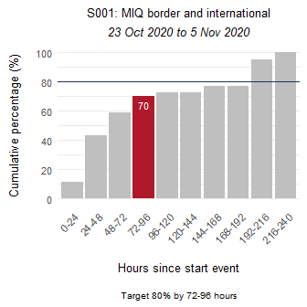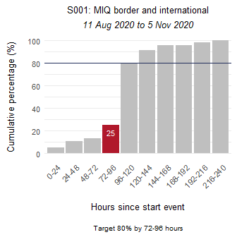

S002 - Time from case first symptom to contact isolation / quarantine
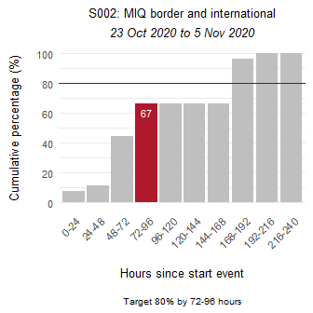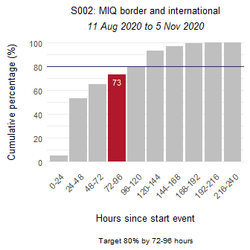

S003 - Time from test sample taken to close contact isolation / quarantine
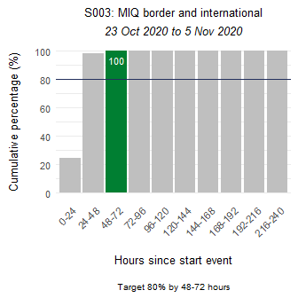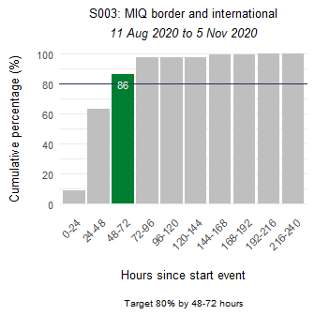

S005 - Proportion of close contacts with confirmed or suspected COVID-19 at the time of tracing
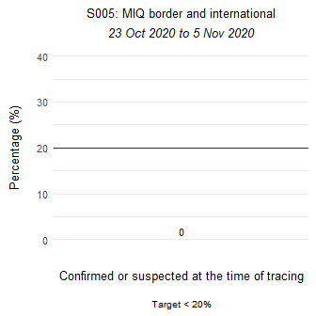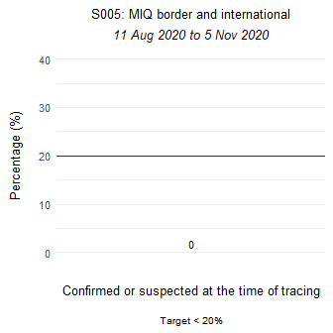

C001 - Time from first symptom to test sample taken for positive cases
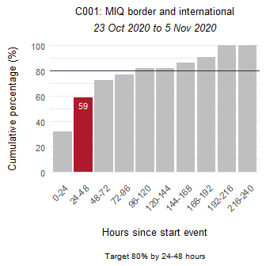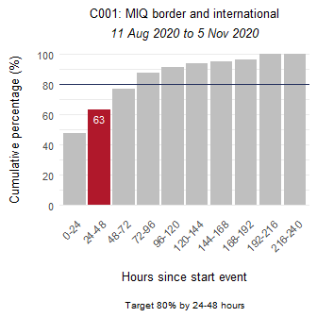

L001 - Time from test sample taken to notification of positive result
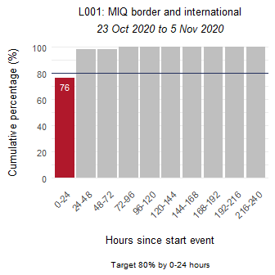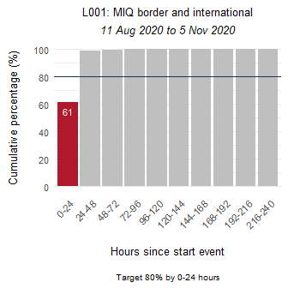

P001 - Time from notification to case interview
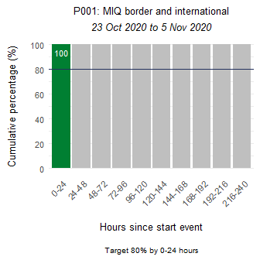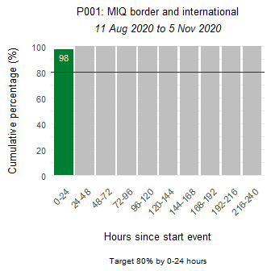

P002 - Time from case notification to isolation / quarantine of contact
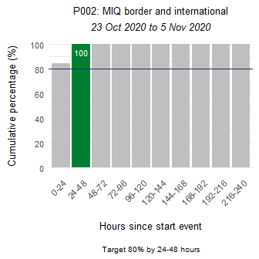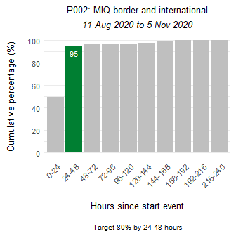

P003 - Time from close contact identification to isolated / quarantined
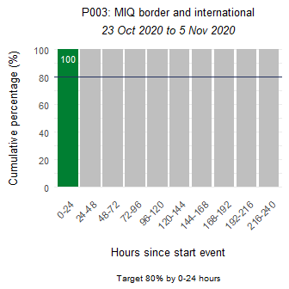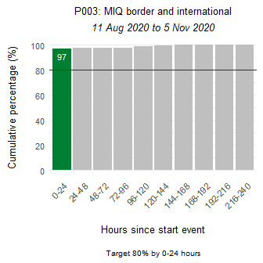

P004 - Proportion of contacts traced in 48 hours
