Summary of COVID-19 Disease Indicators
For the reporting period 9 October to 22 October 2020
Report date: 27/10/2020
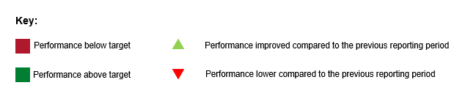

Summary of community cases
Number of cases for this reporting period and cumulative number of cases since 11 August 2020.
Reporting period | Cumulative
3 | 190
The metrics for the community and laboratory level COVID-19 Disease Indicators (C001, L001) are impacted by the low number of cases during this period.

System level indicators
These indicators provide a view of the end-to-end collective actions of the wider health system response (indicators are prefixed with an S#). For this reporting period the metric for the system-level COVID-19 Disease Indicator S001 is low due to the time between the exposure events and notification of cases (part of the Maritime cluster) taking four days. As a result, once the close contacts had been identified, the time to reach the target had already elapsed.

S001 - Time from exposure to contact isolation / quarantine
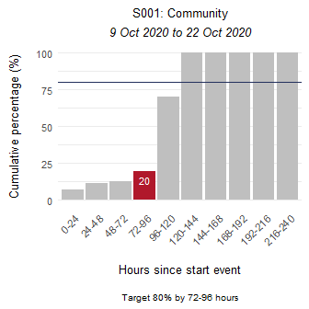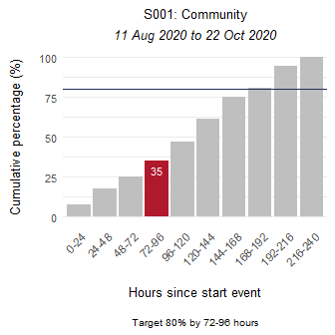

S002 - Time from case first symptom to contact isolation / quarantine
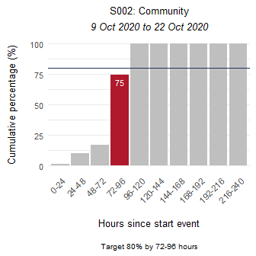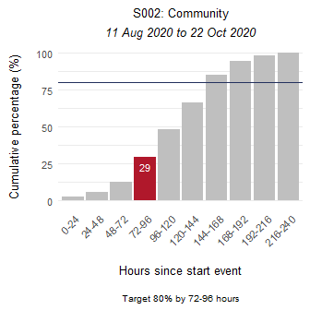

S003 - Time from test sample taken to close contact isolation / quarantine
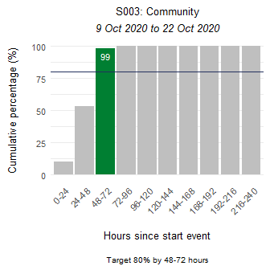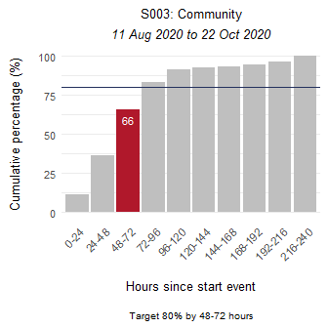

S005 - Proportion of close contacts with confirmed or suspected COVID-19 at the time of tracing
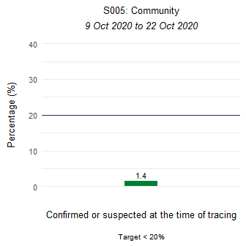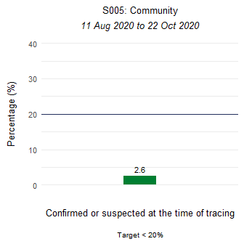

Community-level indicator
This indicator focuses on community behaviours and the impact of communication, education and societal attitudes (indicator is prefixed with a C#). The time period measured is from the symptom onset date as recorded in EpiSurv to the date/time the laboratory received the sample. The time between a sample taken and the receipt date/time of the sample at the laboratory, including transport time, will affect this indicator. In this reporting period 100 percent of test samples were taken at hour 53.

C001 - Time from first symptom to test sample taken for positive cases
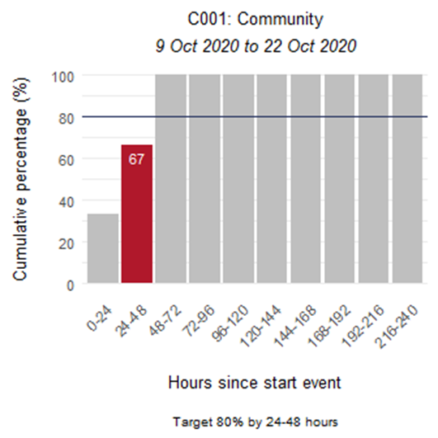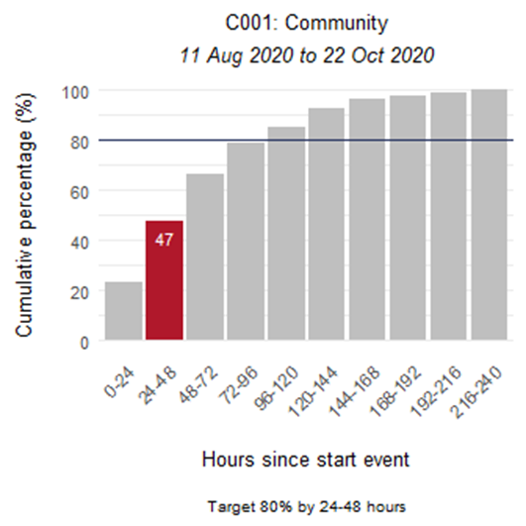

Laboratory sector indicator
This indicator provides insight into the effectiveness of testing facilities and programmes (indicator is prefixed with an L#). The time period measured is from the time the laboratory received the sample to notification of a positive result in EpiSurv. In this reporting period 100 percent of positive results were notified at hour 32.

L001 - Time from test sample taken to notification of positive result
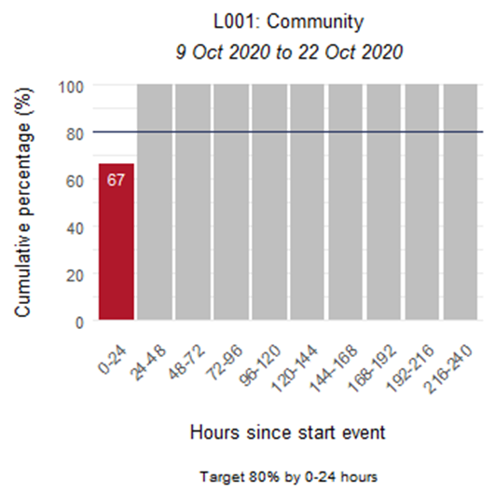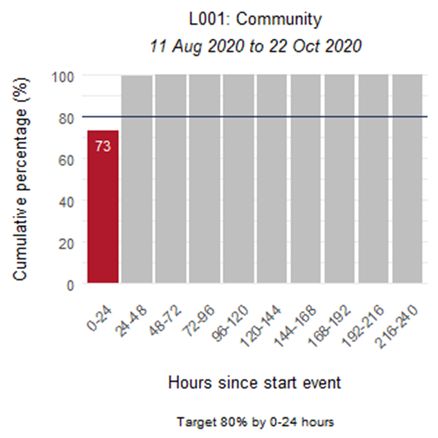

Public health sector indicators
These indicators provide a national overview of contact tracing as well as case and close contact management by public health units (PHUs) and the National Investigation and Tracing Centre (indicators are prefixed with a P#). Public health indicators for this reporting period show that contacts were quickly isolated once identified.

P001 - Time from notification to case interview
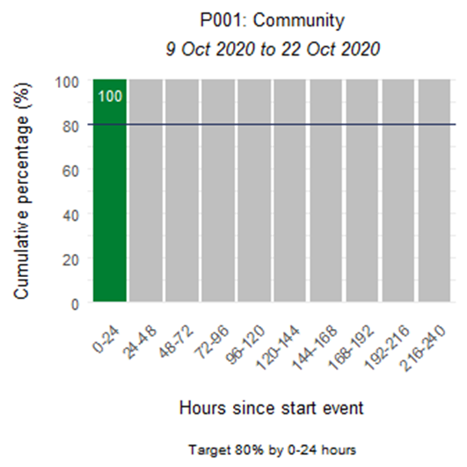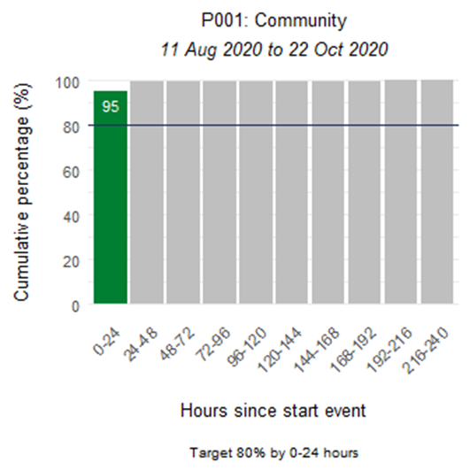

P002 - Time from case notification to isolation / quarantine of contact
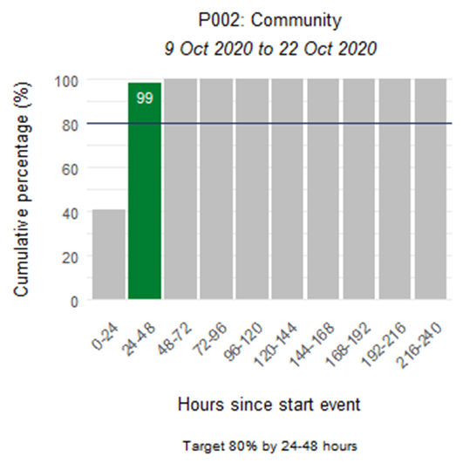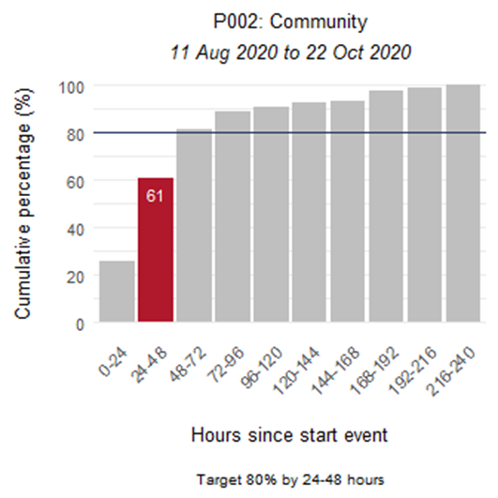

P003 - Time from close contact identification to isolated / quarantined
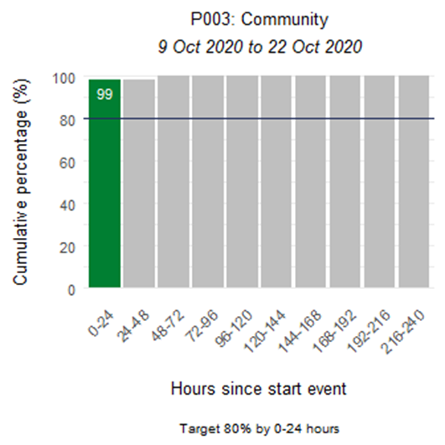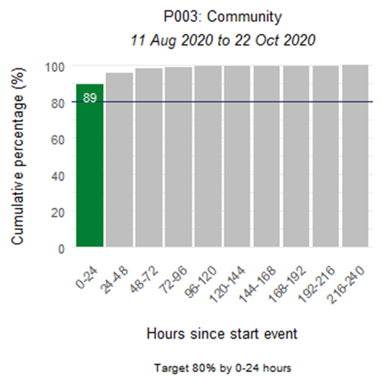

P004 - Proportion of contacts traced in 48 hours
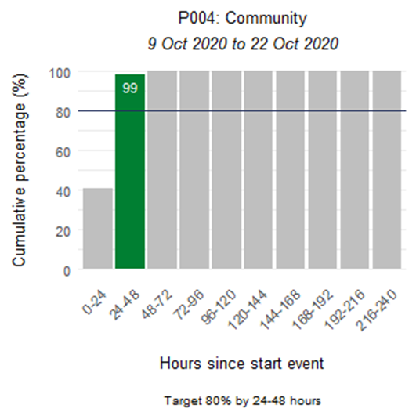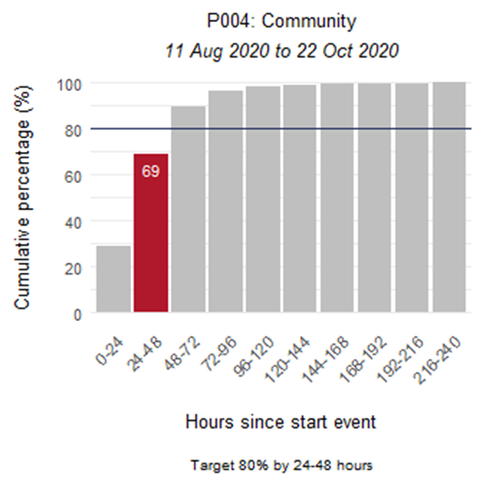

Appendix: Summary of MIQ border and international indicators
This section presents the indicators for Border Managed Isolation and Quarantine (MIQ) and International cases. Indicators S001, S002, and C001 are affected by the inclusion of border cases in MIQ, as returnees’ exposure is arbitrarily set to the day of arrival in New Zealand. They are placed into MIQ upon arrival and are tested if symptomatic or on approximately day 3 and day 12. Therefore, cases in MIQ will make the performance of these indicators appear low.

Summary of MIQ border and international cases
Number of cases for this reporting period and cumulative number of cases since 11 August 2020.
Reporting period | Cumulative
46 | 151

S001 - Time from exposure to contact isolation / quarantine
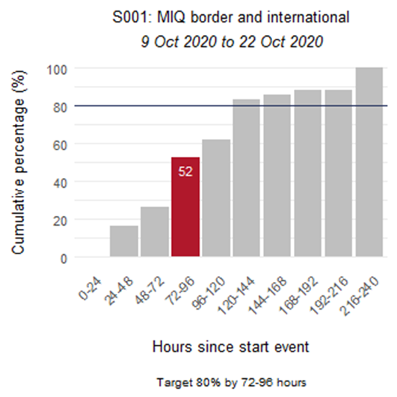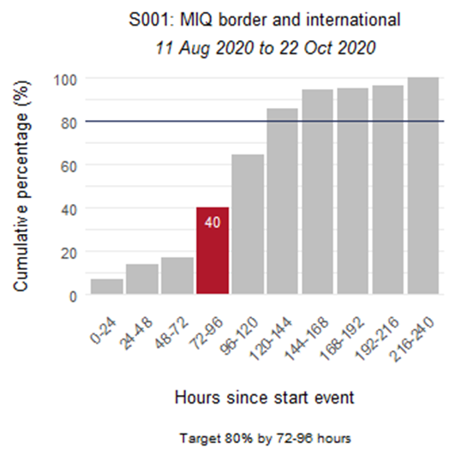

S002 - Time from case first symptom to contact isolation / quarantine
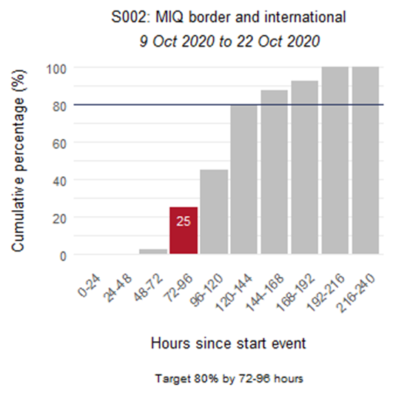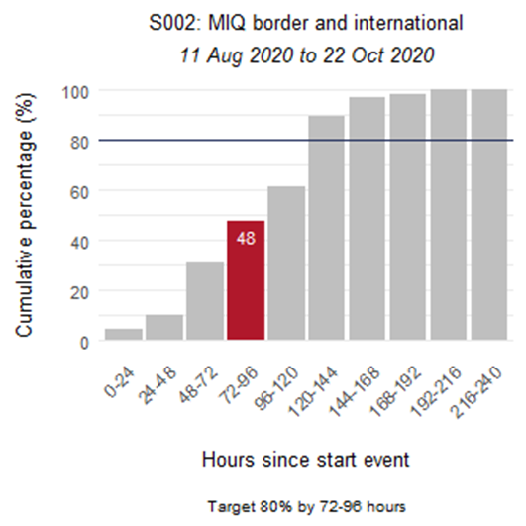

S003 - Time from test sample taken to close contact isolation / quarantine
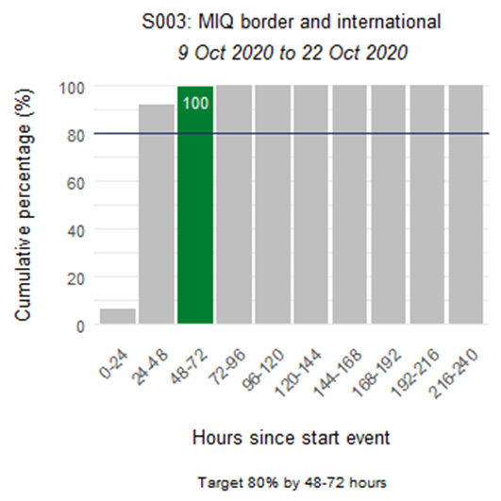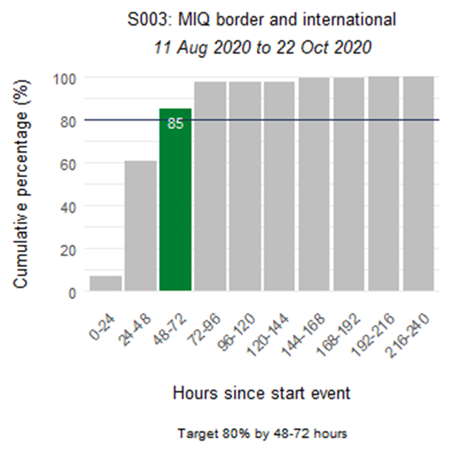

S005 - Proportion of close contacts with confirmed or suspected COVID-19 at the time of tracing
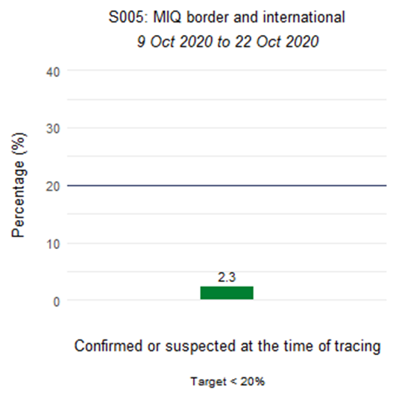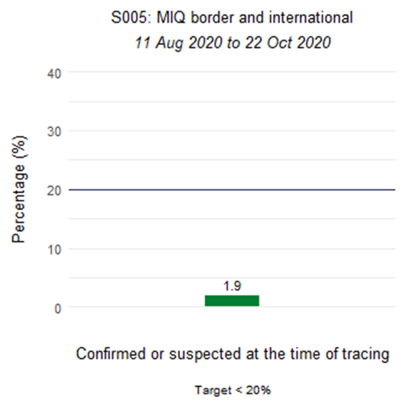

C001 - Time from first symptom to test sample taken for positive cases
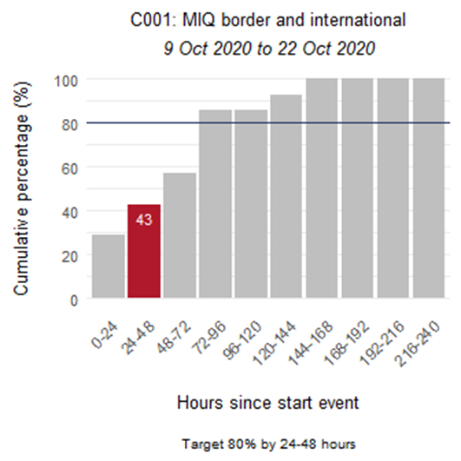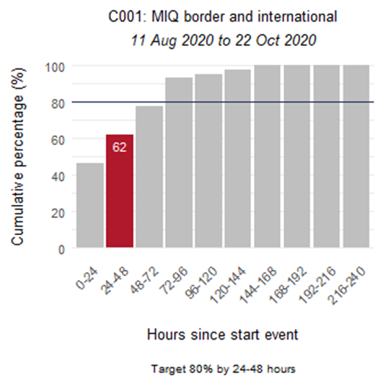

L001 - Time from test sample taken to notification of positive result
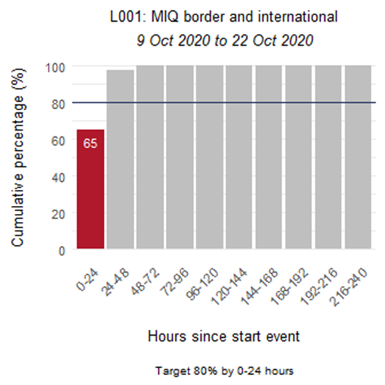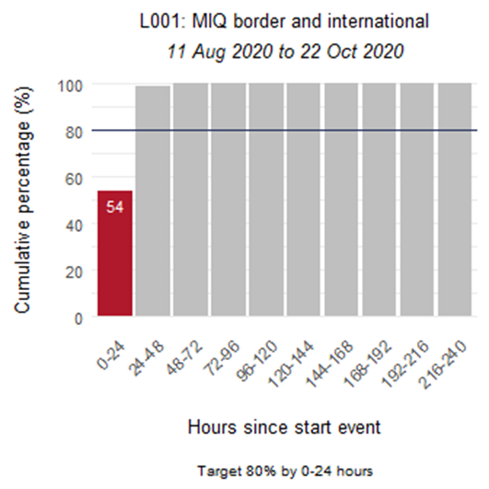

P001 - Time from notification to case interview
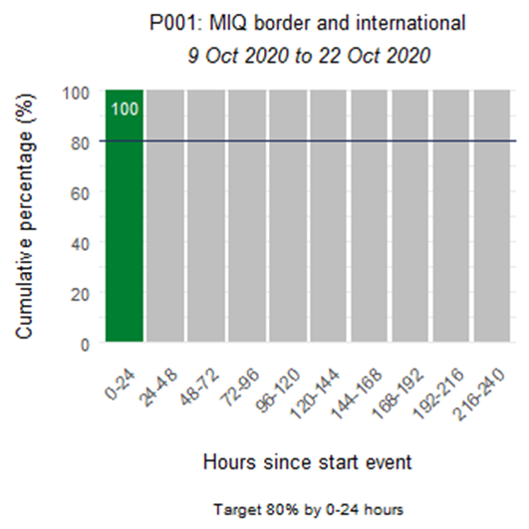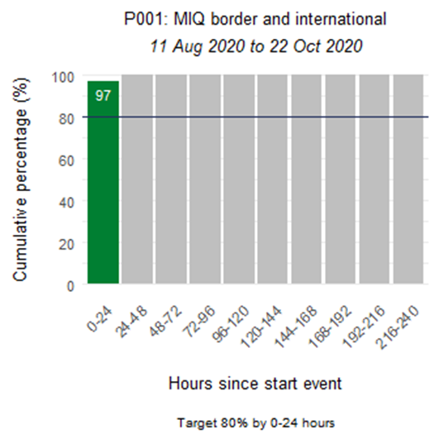

P002 - Time from case notification to isolation / quarantine of contact
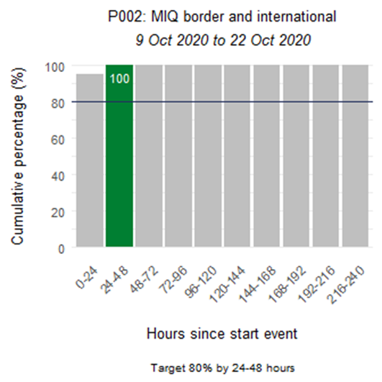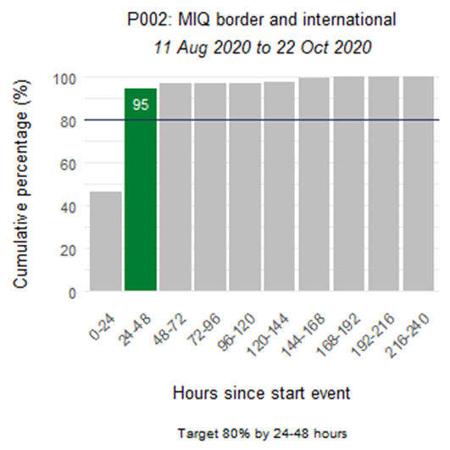

P003 - Time from close contact identification to isolated / quarantined
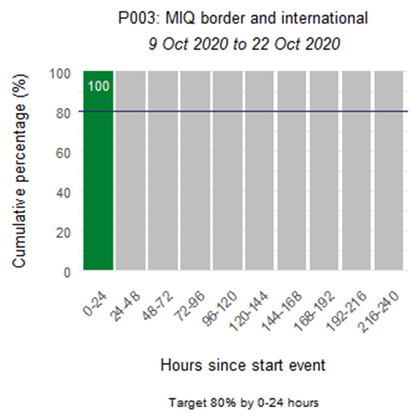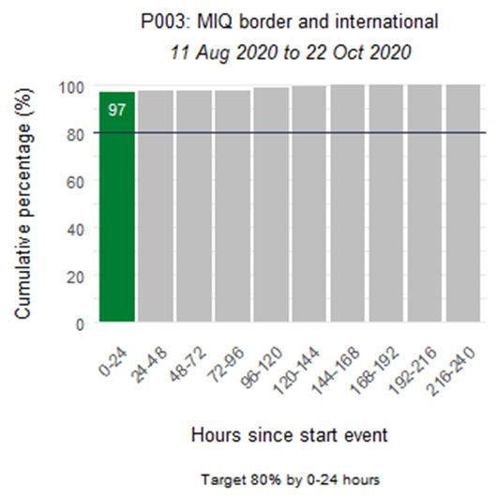

P004 - Proportion of contacts traced in 48 hours
