Summary of COVID-19 Disease Indicators for 4 September 2020 to 10 September 2020
Report date: 30/09/2020
This summary report presents performance against the COVID-19 Disease Indicators between 4 September 2020 to 10 September 2020.

Key:
Performance improved compared to the previous reporting period
Performance below target
Performance lower compared to the previous reporting period
Performance above target

System-level indicators
These indicators provide a view of the end-to-end collective actions of the wider health system response (indicators are prefixed with an S#).

The metrics for the system-level COVID-19 Disease Indicators (S001, S002) are primarily low due to the delayed identification of two exposure events (linked to the Mount Roskill Evangelical Fellowship group) and subsequent delayed identification of close contacts. As a result, a number of close contacts were not able to be contacted within the target timeframes.
S001 - Time from exposure to contact isolation / quarantine
Target: 80% within 96 hours
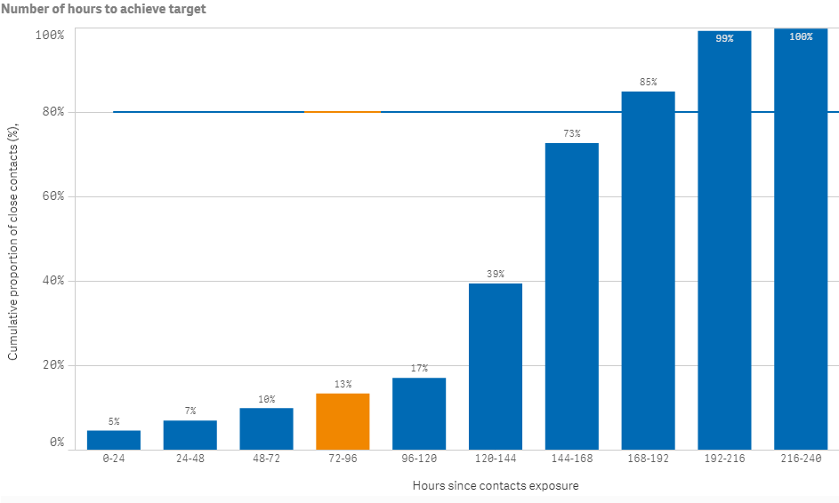
S002 - Time from case first symptom to contact isolation / quarantine
Indicator S002 is affected by the inclusion of cases in MIQ as returnees’ exposure is arbitrarily set to the day of arrival in New Zealand. They are placed into MIQ upon arrival and are tested if symptomatic or on approximately day 3 and day 12. Therefore, cases in MIQ can make the performance of this indicator appear low.
Target: 80% within 96 hours

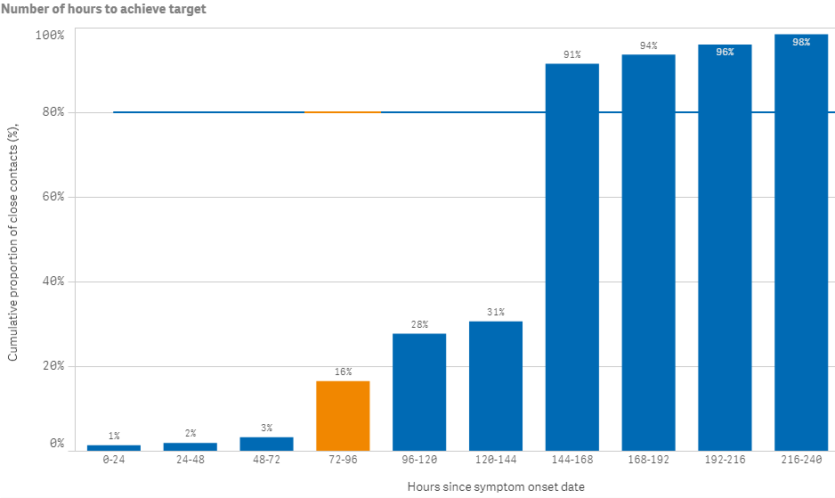
S003 - Time from test sample taken to close contact isolation / quarantine
Target: 80% within 72 hours
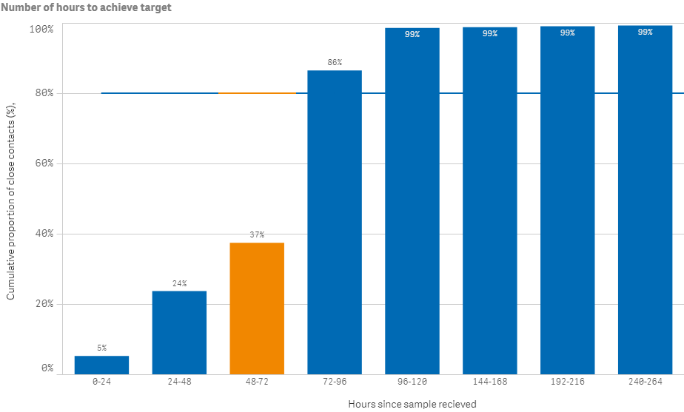
S005 - Proportion of close contacts with confirmed or suspected COVID-19 at the time of tracing
Target: less than 20%
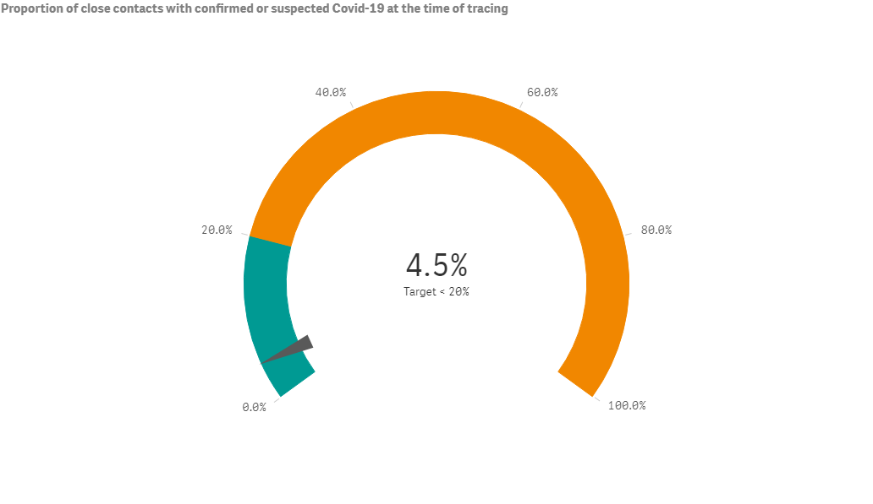

Community-level indicator
C001 - Time from first symptom to test sample taken for positive cases
This indicator focuses on community behaviours and the impact of communication, education and societal attitudes (indicator is prefixed with a C#). The time period measured is from the symptom onset date as recorded in EpiSurv to the date/time the laboratory received the sample. The time between a sample taken and the receipt date/time of the sample at the laboratory, including transport time, will affect this indicator. Indicator C001 is also affected by the inclusion of cases in MIQ as returnees are placed into MIQ upon arrival and are tested if symptomatic or on approximately day 3 and day 12. Therefore, cases in MIQ can make the performance of this indicator appear low.

Target: 80% within 48 hours
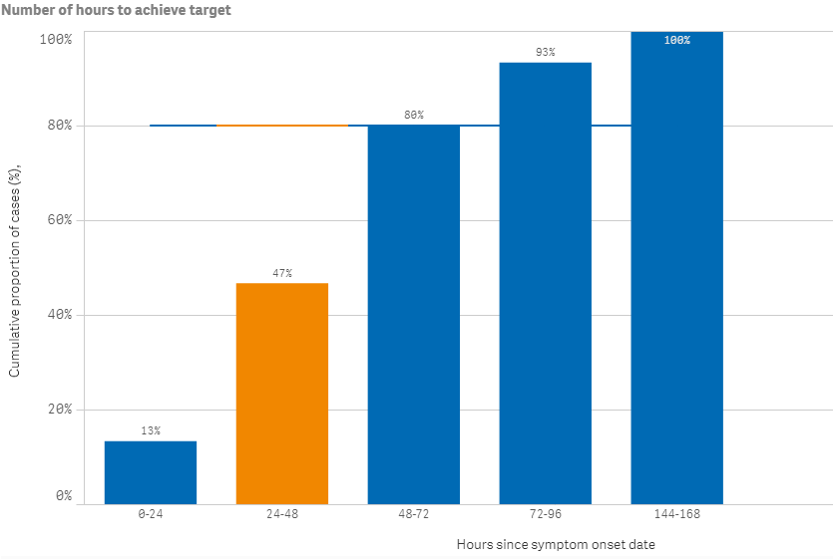

Laboratory sector indicator
This indicator provides insight into the effectiveness of testing facilities and programmes (indicator is prefixed with an L#). The time period measured is from the time the laboratory received the sample to notification of a positive result in EpiSurv. In this reporting period, over 80 percent of positive results were notified at hour 37 and 100 percent reached by hour 39.

L001 - Time from test sample taken to notification of positive result
Target: 80% within 24 hours
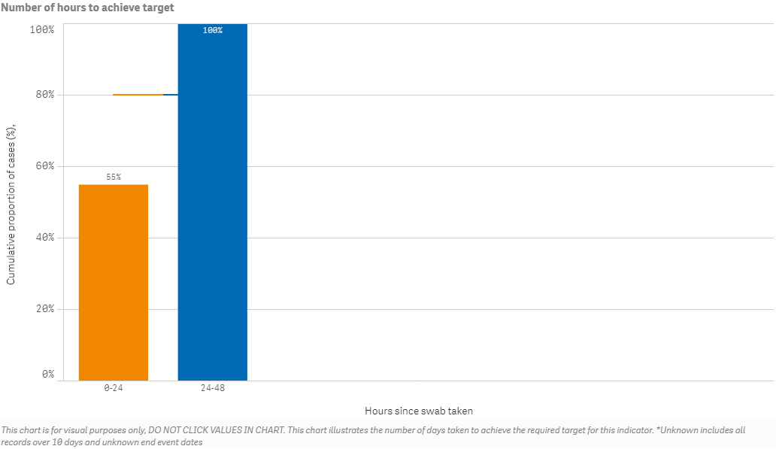

Public health sector indicators

These indicators provide a national overview of contact tracing as well as case and close contact management by public health units (PHUs) and the National Investigation and Tracing Centre (indicators are prefixed with a P#). For this reporting period, performance for all public health sector indicators (P001, P002, P003, P004) are above the set targets.
P001 - Time from notification to case interview
Target: 80% within 24 hours
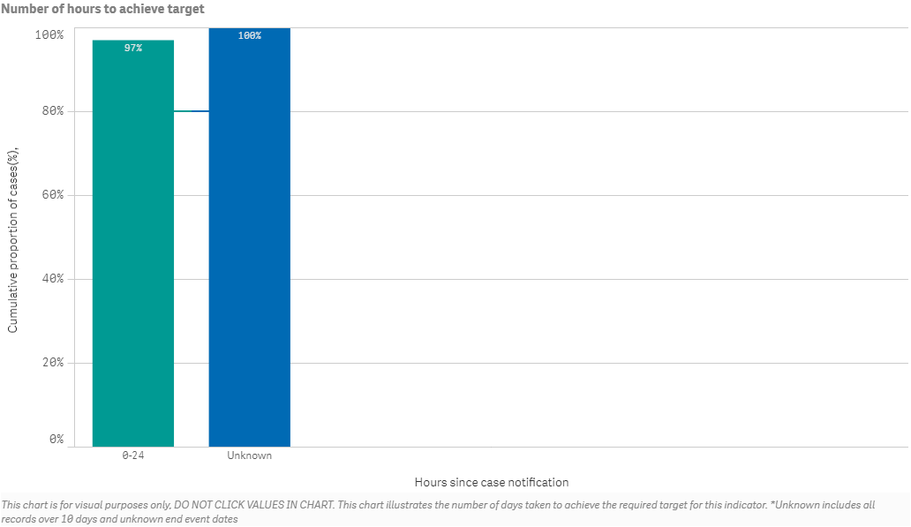

P002 - Time from case notification to isolation / quarantine of contact
Target: 80% within 48 hours
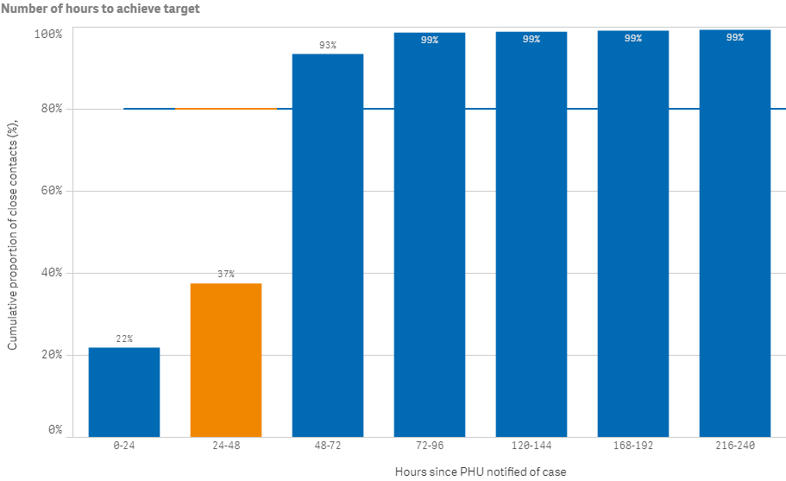

P003 - Time from close contact identification to isolated / quarantined
Target: 80% within 24 hours 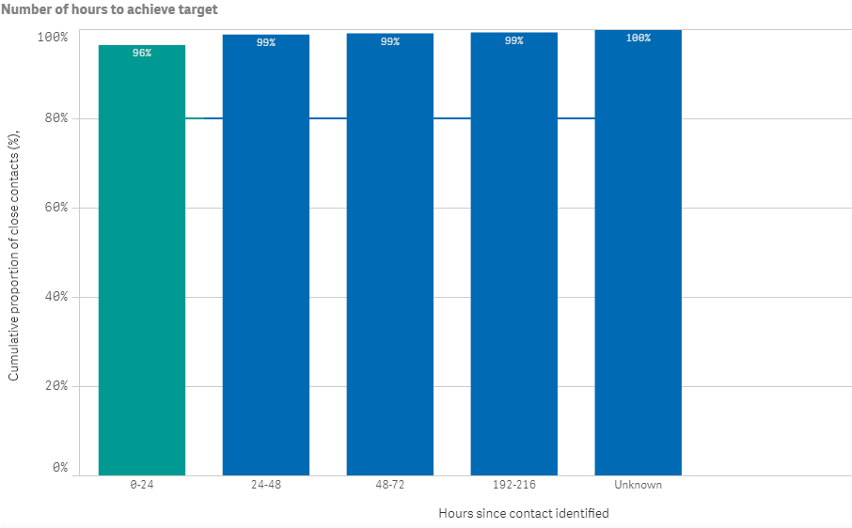

P004 - Proportion of contacts traced in 48 hours
Target: 80% within 48 hours
