Summary of COVID-19 Disease Indicators for 28 August 2020 to 3 September 2020
Report date: 08/09/2020
This summary report presents performance against the COVID-19 Disease Indicators between 28 August 2020 to 3 September 2020.

Key:
Performance improved compared to the previous reporting period
Performance below target
Performance lower compared to the previous reporting period
Performance above target

System-level indicators
These indicators provide a view of the end-to-end collective actions of the wider health system response (indicators are prefixed with an S#).
S001 - Time from exposure to contact isolation / quarantine
Target: 80% within 96 hours

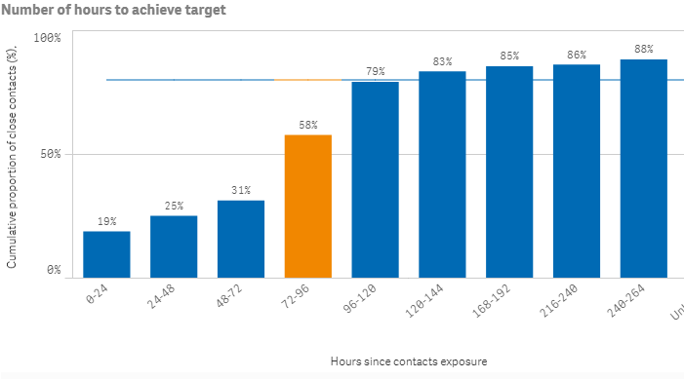

S002 - Time from case first symptom to contact isolation / quarantine
Indicator S002 is affected by the inclusion of cases in MIQ as returnees’ exposure is arbitrarily set to the day of arrival in New Zealand. They are placed into MIQ upon arrival and are tested if symptomatic or on approximately day 3 and day 12. Therefore, cases in MIQ can make the performance of this indicator appear low.
Target: 80% within 96 hours

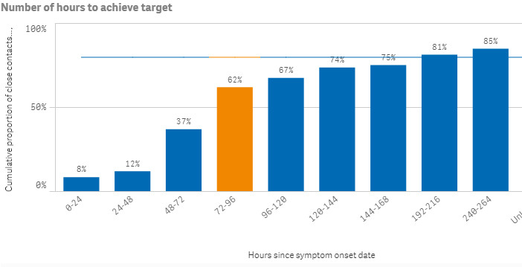

S003 - Time from test sample taken to close contact isolation / quarantine
Target: 80% within 72 hours

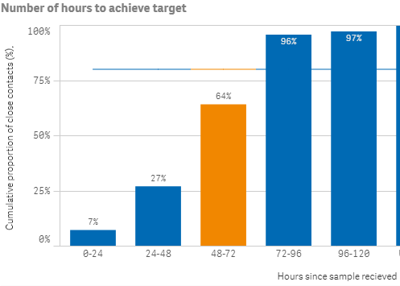
S005 - Proportion of close contacts with confirmed or suspected COVID-19 at the time of tracing
Target: less than 20%
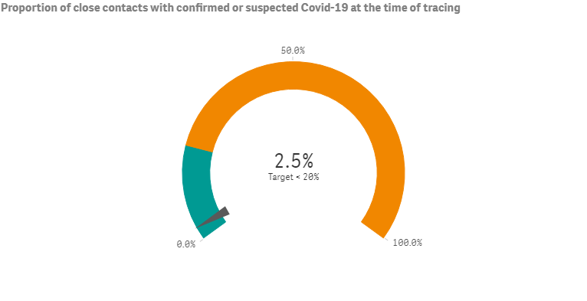
Community-level indicator
C001 - Time from first symptom to test sample taken for positive cases
This indicator focuses on community behaviours and the impact of communication, education and societal attitudes (indicator is prefixed with a C#). The time period measured is from the symptom onset date as recorded in EpiSurv to the date/time the laboratory received the sample. The time between a sample taken and the receipt date/time of the sample at the laboratory, including transport time, will affect this indicator. Indicator C001 is also affected by the inclusion of cases in MIQ as returnees are placed into MIQ upon arrival and are tested if symptomatic or on approximately day 3 and day 12. Therefore, cases in MIQ can make the performance of this indicator appear low.

Target: 80% within 48 hours

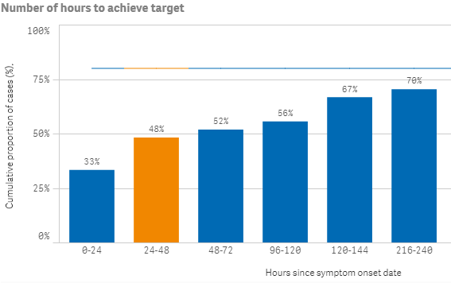
Laboratory sector indicator
This indicator provides insight into the effectiveness of testing facilities and programmes (indicator is prefixed with an L#). The time period measured is from the time the laboratory received the sample to notification of a positive result in EpiSurv. There was a substantial increase in the number of tests during this reporting period compared to the previous reporting period (21 August 2020 to 27 August 2020). In this reporting period, over 80 percent of positive results were notified at hour 38.
L001 - Time from test sample taken to notification of positive result
Target: 80% within 24 hours
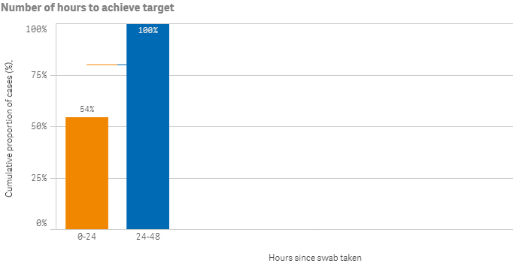
Public health sector indicators

These indicators provide a national overview of contact tracing as well as case and close contact management by public health units (PHUs) and the National Investigation and Tracing Centre (indicators are prefixed with a P#).
P001 - Time from notification to case interview
Target: 80% within 24 hours

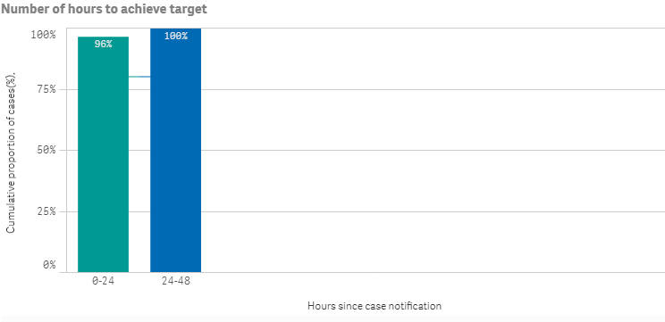

P002 - Time from case notification to isolation / quarantine of contact
Target: 80% within 48 hours
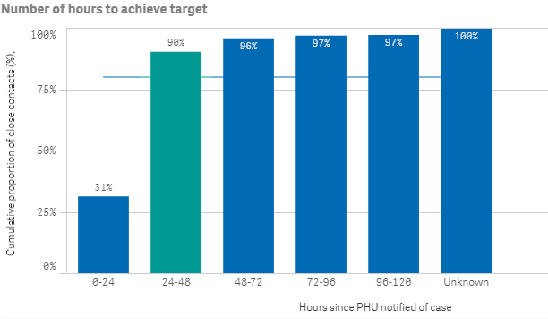
P003 - Time from close contact identification to isolated / quarantined
Target: 80% within 24 hours
Hours since contact identified

P004 - Proportion of contacts traced in 48 hours
Target: 80% within 48 hours
