Summary of COVID-19 Disease Indicators for 21 August 2020 to 27 August 2020
Report date: 30/09/2020
This summary report presents performance against the COVID-19 Disease Indicators between 21 August 2020 to 27 August 2020.

Key:
Performance against target (S001, S002, S003, C001, L001, P002, P003)

System-level indicators
These indicators provide a view of the end-to-end collective actions of the wider health system response (indicators are prefixed with an S#).

The metrics for Indicators S001 and S002 are low mainly due to a particular exposure event and resulting sub-cluster during this period. Around 400 people were identified as close contacts through exposure to a case that was identified via a source attribution investigation. In this instance, the Case was not identified until more than 14 days after the exposure event. After 14 days from an exposure, the need to isolate close contacts has passed as this is the full incubation period, therefore close contacts were not isolated. Despite impacting metrics this delayed case identification and subsequent delayed close contact communication demonstrates that an effective trace back process occurred, leading to successful source identification.

In addition, a significant number of people have not been contacted due to a delay in obtaining phone numbers during this reporting period. This impacts on the metrics for indicators S001, S002, S003, P002, P003.

Indicators S001 and S002 are also affected by the inclusion of cases in MIQ as returnees’ exposure is arbitrarily set to the day of arrival in New Zealand. They are placed into MIQ upon arrival and are tested if symptomatic or on approximately day 3 and day 12. Therefore, cases in MIQ will make the performance of these indicators appear low.
S001 - Time from exposure to contact isolation / quarantine
Target – 80% within 96 hours
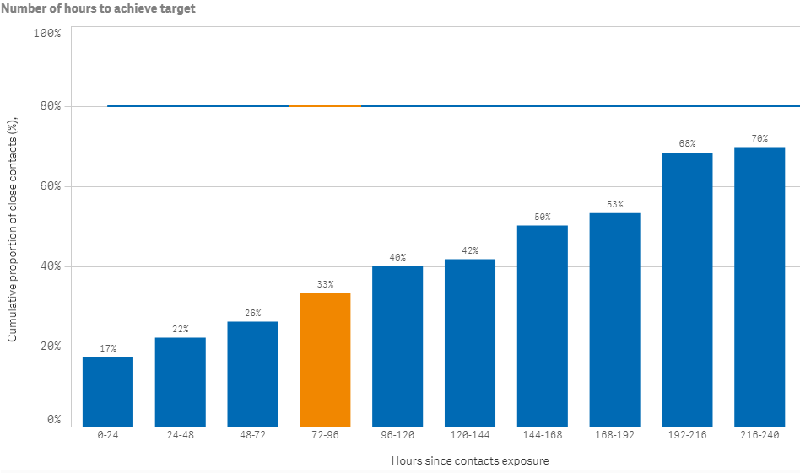
S002 - Time from case first symptom to contact isolation / quarantine
Target – 80% within 96 hours
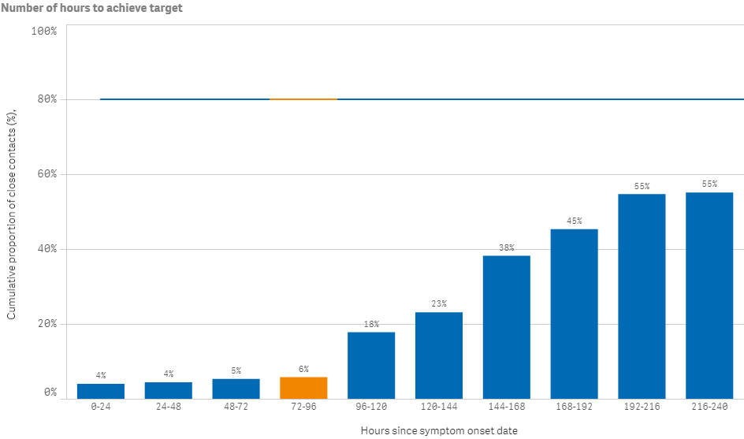
S003 - Time from test sample taken to close contact isolation / quarantine
Target – 80% within 72 hours
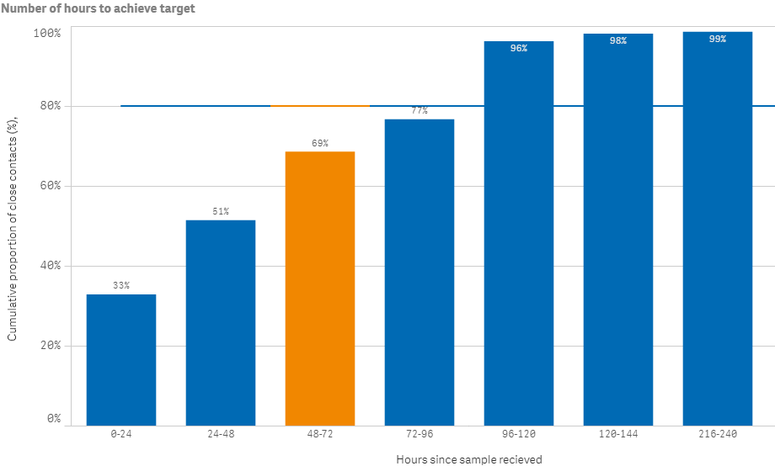
S005 - Proportion of close contacts with confirmed or suspected COVID-19 at the time of tracing
Target – less than 20%
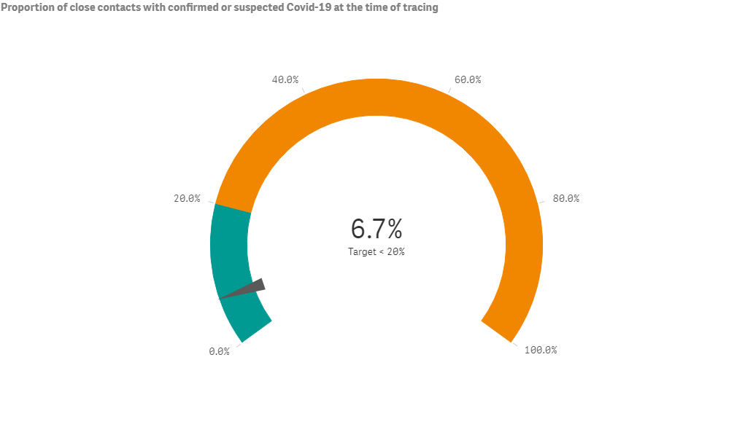
Community-level indicator
This indicator focuses on community behaviours and the impact of communication, education and societal attitudes (indicator is prefixed with a C#). Indicator C001 is affected by the inclusion of cases in MIQ as returnees’ exposure is arbitrarily set to the day of arrival in New Zealand. They are placed into MIQ upon arrival and are tested if symptomatic or on approximately day 3 and day 12. Therefore, cases in MIQ will make the performance of these indicators appear low.

C001 - Time from first symptom to test sample taken for positive cases
Target - 80% within 48 hours
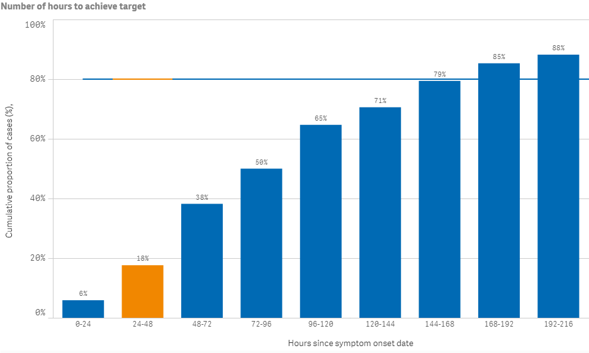

Laboratory sector indicator
This indicator provides insight into the effectiveness of testing facilities and programmes (indicator is prefixed with an L#). The time period measured is from the time the laboratory received the sample to notification of a positive result.
L001 - Time from test sample taken to notification of positive result
Target - 80% within 24 hours
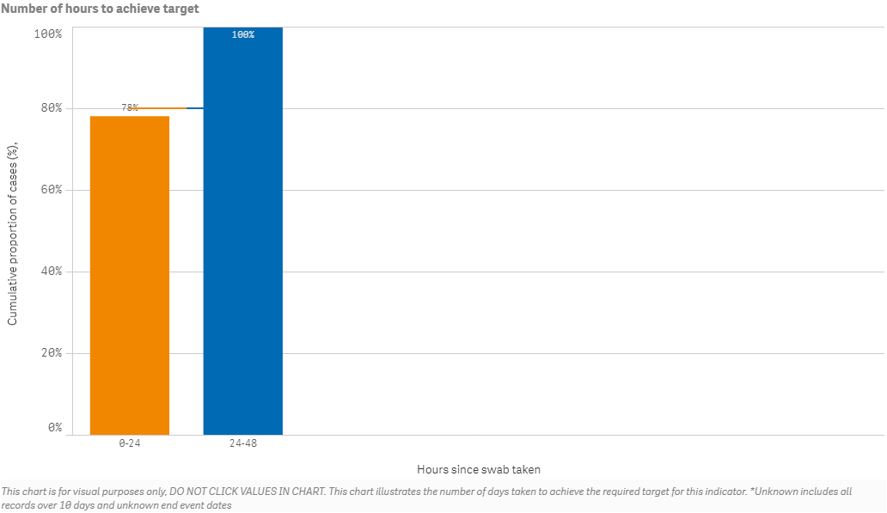

Public health sector indicators

These indicators provide a national overview of contact tracing as well as case and close contact management by public health units (PHUs) and the National Investigation and Tracing Centre (indicators are prefixed with a P#).

Performance for indicator P002 (Time from case notification to isolation/quarantine of contact) is lower (53%) than the target of 80% for this period. This is partially due to the addition of new close contacts to exposure events after the 48-hour period since case notification. This can happen for several reasons, including a case recalling further details following the original case interview or the time it takes to prepare a list of close contacts (e.g. a list of people who visited a workplace, or attended a church service). However, the contact tracing performance reported by indicator P004, which only includes close contacts of exposure events which were entered in the National Contact Tracing Solution within 48 hours of case notification. For this period, 76% of the close contacts were identified and contacted within 48 hours of case notification.
P001 - Time from notification to case interview
Target - 80% within 24 hours
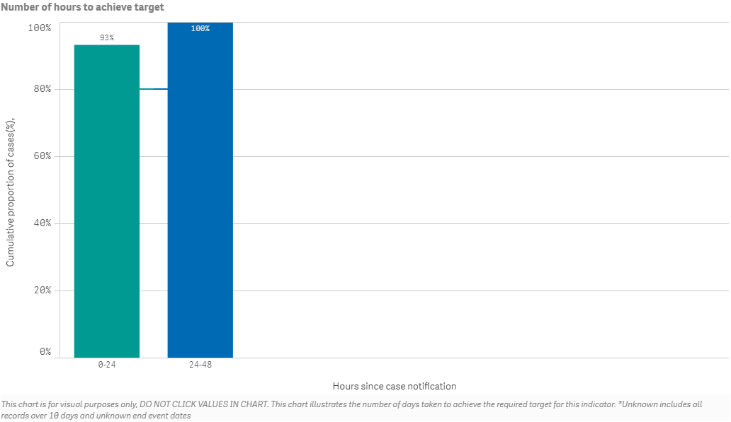

P002 - Time from case notification to isolation / quarantine of contact
Target – 80% within 48 hours
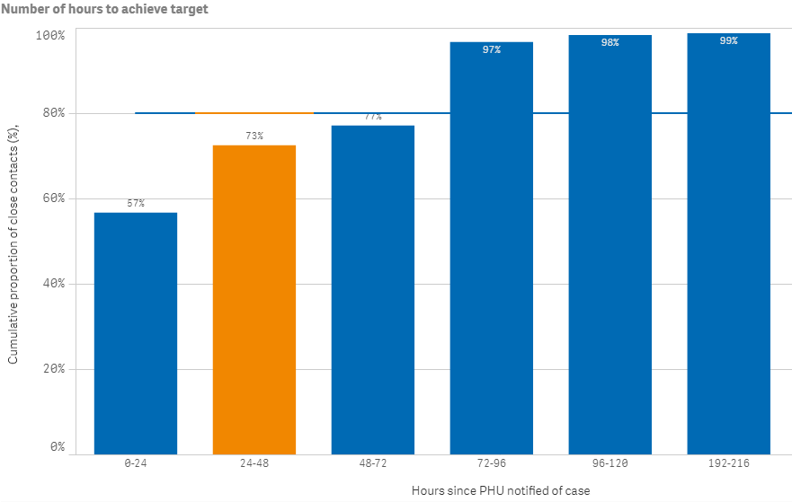
P003 - Time from close contact identification to isolated / quarantined
Target – 80% within 24 hours
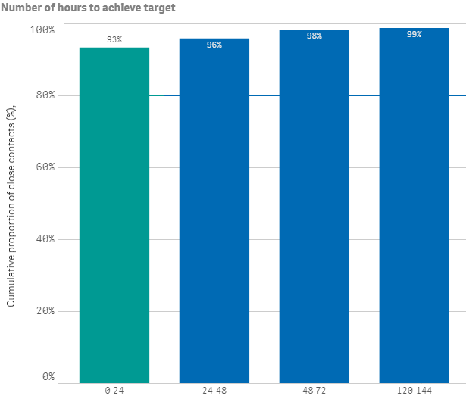
Hours since contact identified

P004 - Proportion of contacts traced in 48 hours
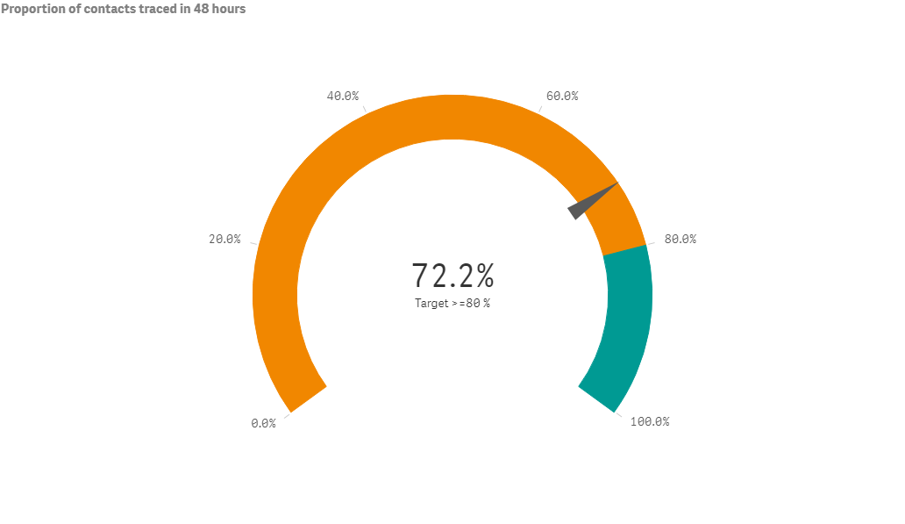
Target – 80% within 48 hours

