National Indicator Summaries for August 11 to August 21 2020
Report date: 30/09/2020
These provisional Covid-19 Disease Indicators provide an end-to-end view of the public health response to COVID-19. This report covers the period from 11 August, the notification of the first community case in the current outbreak, to 21 August 2020. It includes both community cases and cases in Managed Isolation and Quarantine (MIQ) and includes close contacts only.

The indicators have been grouped by focus area.
- System-level indicators: provide a view of the end-to-end collective actions of the wider health system response (indicators prefixed with an S#).
- Community-level indicators: focus on community behaviours and the impacts of communication, education and societal attitudes (indicator prefixed with a C#).
- Laboratory sector indicators: provide insights into the effectiveness of testing facilities and programmes (indicators prefixed with an L#).
- Public health sector indicators: provides a national overview on contact tracing and case and close contact management by Public Health Units (PHUs) and the National Investigation and Tracing Centre (indicators prefixed with a P#).

Points of interest:
- The indicators that include a date of symptom onset (S002 and C001) are significantly skewed by several of the initial community cases who appear in this indicator but were diagnosed in mid-August, many days after the onset of symptoms.
- Performance for indicator P002 (Time from case notification to isolation/quarantine of contact) is lower (60%) than the target of 80% for this period. This is largely due to the addition of new close contacts to exposure events after the 48-hour period since case notification. This can happen for several reasons, including a case recalling further details following the original case interview or the time it takes to prepare a list of close contacts (e.g. a list of people who visited a workplace). However, the contact tracing performance reported by indicator P004, only includes close contacts of exposure events which were entered in the National Contact Tracing Solution within 48 hours of case notification. For this period, 74% of the close contacts were identified and contacted within 48 hours of case notification.
- The system (S#) and community (C#) indicators are less relevant for cases in MIQ as new arrivals are placed into MIQ upon arrival and are tested if symptomatic or around day 3 and day 12. As the cases are already in isolation/quarantine, the time from exposure event (S001) to quarantine of contact, or symptom onset (S002 and C001) to testing or quarantine of contact is not very informative. Additionally, these two indicators - which have a target of 80% reached within 96 hours - will always appear low given that the first test is done on day 3.
S001 - Time from exposure to contact isolation / quarantine
Target – 80% within 96 hours

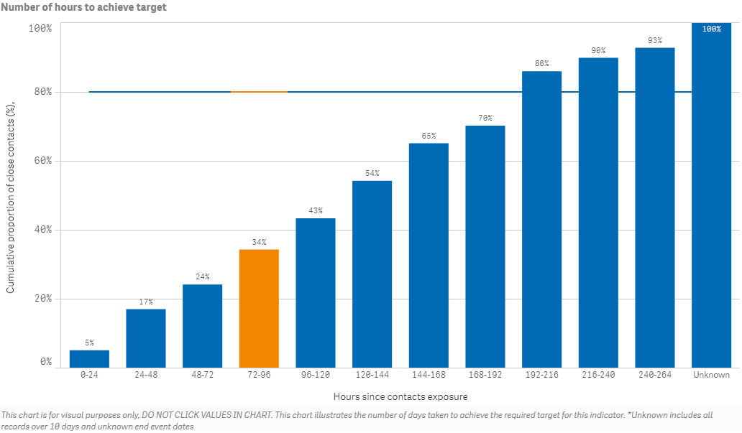
S002 - Time from case first symptom to contact isolation / quarantine
Target – 80% within 96 hours

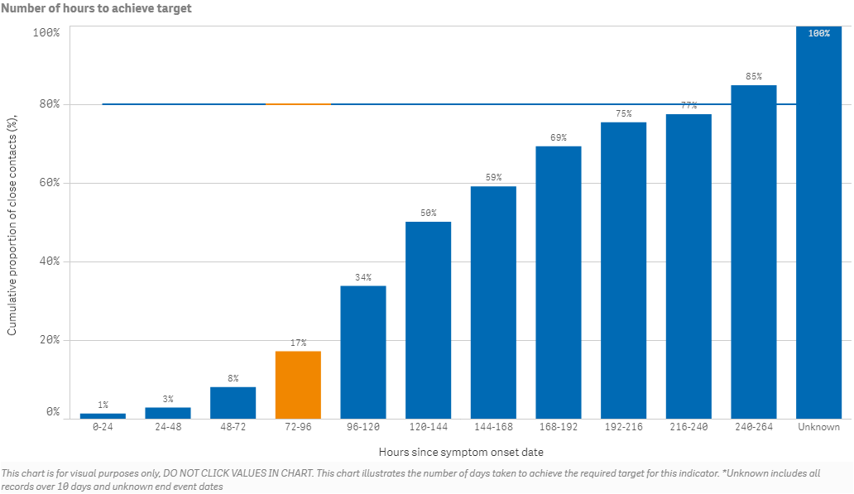
S003 - Time from test sample taken to close contact isolation / quarantine
Target – 80% within 72 hours
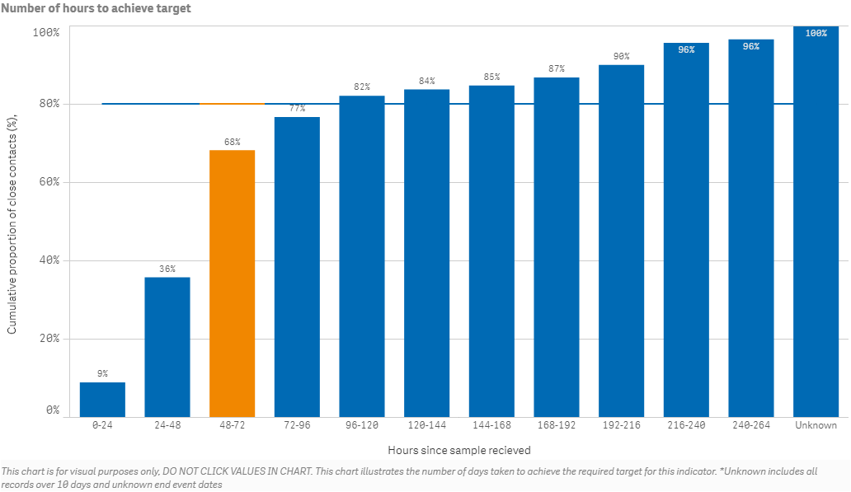
C001 - Time from first symptom to test sample taken for positive cases
Target - 80% within 48 hours
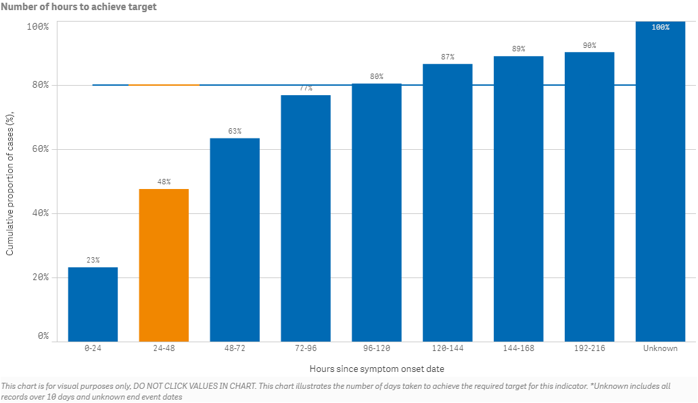
L001 - Time from test sample taken to notification of positive result
Target - 80% within 24 hours
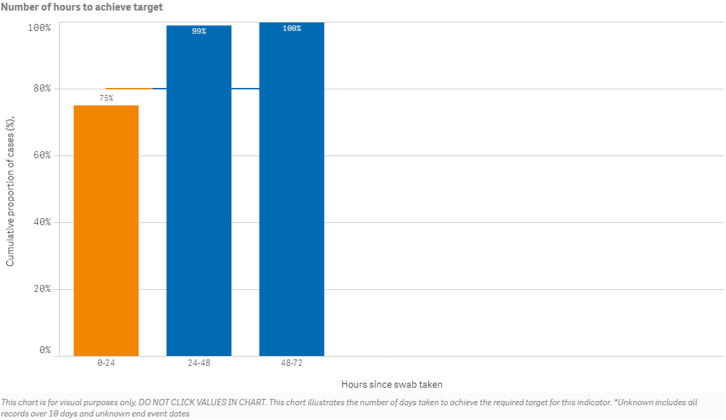

P001 - Time from notification to case interview
Target - 80% within 24 hours
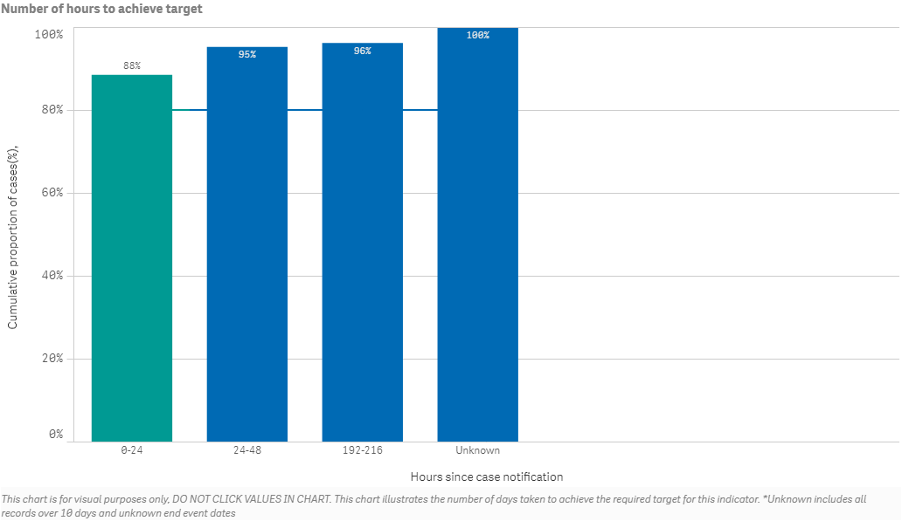
P002 - Time from case notification to isolation / quarantine of contact
Target – 80% within 48 hours
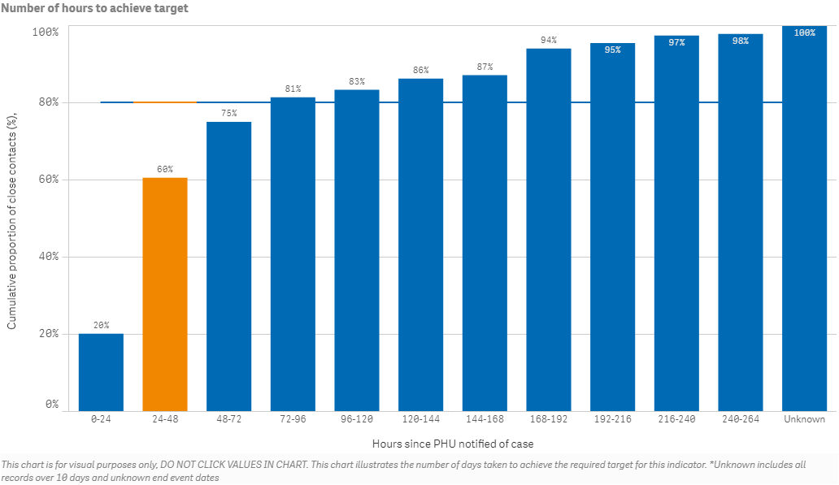
P003 - Time from close contact identification to isolated / quarantined
Target – 80% within 24 hours
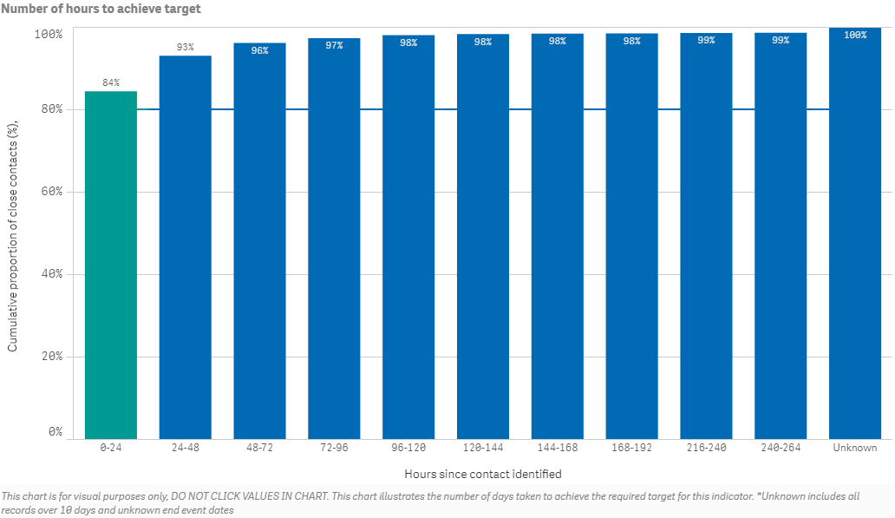
P004 - Proportion of contacts traced in 48 hours
Target – 80% within 48 hours
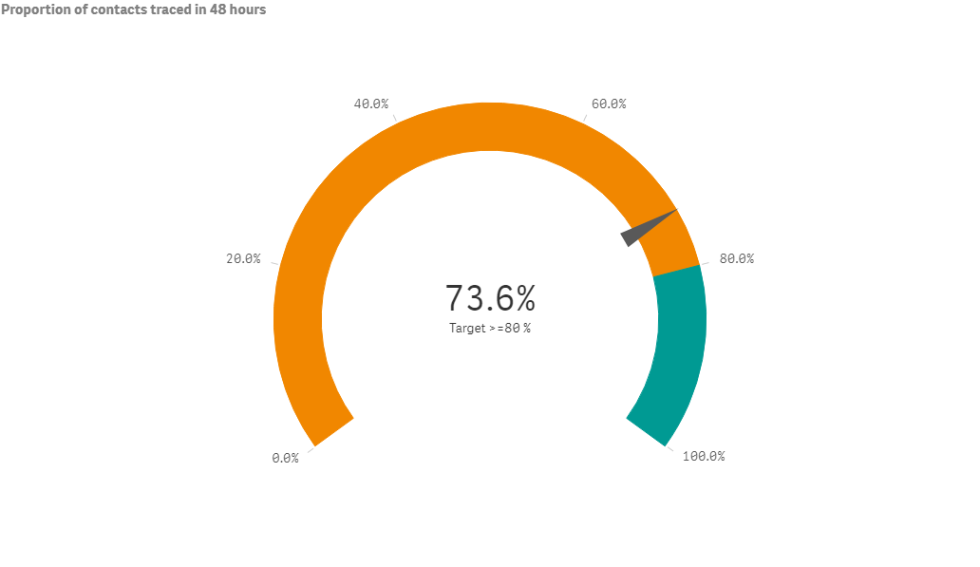
S005 - Proportion of close contacts with confirmed or suspected COVID-19 at the time of tracing
Target – less than 20%
