Assisted Dying Service – Ngā Ratonga Mate Whakaahuru
Registrar (assisted dying) Annual Report to the Minister of Health – June 2026

Citation: Ministry of Health. 2026. Assisted Dying Service – Ngā Ratonga Mate Whakaahuru: Registrar (assisted dying) Annual Report to the Minister of Health – June 2026. Wellington: Ministry of Health
Published in June 2026 by the Ministry of Health
PO Box 5013, Wellington 6140, New Zealand
ISBN 978-1-991324-90-0 (print)
ISBN 978-1-991324-91-7 (online)
HP 9178

This document is available at health.govt.nz
 | This work is licensed under the Creative Commons Attribution 4.0 International licence. In essence, you are free to: share ie, copy and redistribute the material in any medium or format; adapt ie, remix, transform and build upon the material. You must give appropriate credit, provide a link to the licence and indicate if changes were made.

Contents
Introduction 1
About this report 1
End of Life Choice Act 2019 1
Roles and groups 3
Registrar (assisted dying) 3
The Support and Consultation for End of Life in New Zealand Group 3
End of Life Review Committee 4
Assisted Dying Secretariat 4
The Office of the Registrar 4
Health New Zealand 4
The assisted dying process 5
Reporting and service activity 7
Key facts 8
Overview of assisted dying applications 9
Timeframes for eligibility 10
Demographic details of applicants 11
Application outcomes 14
Assessments completed during the reporting period 14
Applications not progressed to an assisted death 16
Assisted deaths 18
Locations of assisted deaths 18
Method of administration 19
The assisted dying workforce 20
Practitioners on the SCENZ Group lists 20
Feedback, complaints and queries 22
Feedback 22
Complaints 22
Queries 25

List of figures
Figure 1: The assisted dying application process 6
Figure 2: Number of applications and assisted deaths from April to March reporting periods, 2022–2026 9
Figure 3: Number of new applications by diagnosis, 1 April 2025 – 31 March 2026 13
Figure 4: Number of new applications by the applicant’s region of domicile, 1 April 2025 – 31 March 2026 13
Figure 5: Number of assisted deaths by location, 1 April 2025 – 31 March 2026 19

List of tables
Table 1: Summary of demographic data of people making new applications for assisted dying services, 1 April 2025 – 31 March 2026 12
Table 2: Assessment outcomes, 1 April 2025 – 31 March 2026 15
Table 3: Reasons for decisions that applicants are ineligible at AMP and IMP assessments, 1 April 2025 – 31 March 2026 * 16
Table 4: Application outcomes where applicant did not have an assisted death (excluding cases where AMP or IMP assessment found them to be ineligible), 1 April 2025 – 31 March 2026 17
Table 5: Number of health practitioners on the SCENZ Group lists across Health New Zealand regions, as at 14 May 2026 21
Table 6: Complaints that the Ministry of Health and Registrar received about assisted dying services and actions taken, 1 April 2025 – 31 March 2026 23
Table 7: Complaints that the Health and Disability Commissioner received about assisted dying services and actions taken, 1 April 2025 – 31 March 2026 24

Introduction

About this report
The Ministry of Health – Manatū Hauora is responsible for administering the End of Life Choice Act 2019 (the Act).

The Registrar (assisted dying) (the Registrar) must report on the assisted dying service under section 27(7) of the Act.

Reporting is due to the Minister of Health by 30 June each year and must cover the following matters for the year:
- the total number of deaths that occurred under the Act
- the number of deaths that occurred through each method of administering assisted dying medication
- the number of complaints received about breaches of the Act and how the Registrar dealt with those complaints
- any other matter relating to the operation of the Act that the Registrar thinks it is appropriate to report on.

This report covers the period from 1 April 2025 to 31 March 2026. For copies of previous reports, please visit the publications page on assisted dying regulation and reporting on the Ministry of Health’s website.

End of Life Choice Act 2019
The Act came into force on 7 November 2021. It gives a person with a terminal illness the option to request medication to end their life. The Act outlines the legal framework for assisted dying, including eligibility criteria and some key safeguards.

To be eligible for an assisted death, a person must be:
- aged 18 years or over
- a citizen or permanent resident of Aotearoa New Zealand
- suffering from a terminal illness that is likely to end their life within six months
- in an advanced state of irreversible decline in physical capability
- experiencing unbearable suffering that cannot be relieved in a manner the person considers tolerable
- competent to make an informed decision about assisted dying.

The person with a terminal illness must be the one who initiates the request to have an assisted death. A health practitioner is not permitted to raise this option with a patient unprompted.

To read the full Act, please visit the End of Life Choice Act 2019 on the New Zealand Legislation website.

New national regulatory IT platform for assisted dying
In November 2025, a new national regulatory information technology (IT) platform was introduced to support the delivery, monitoring, regulation and reporting of assisted dying services in New Zealand. It is used to manage key parts of the assisted dying process, from initial requests through to final reporting and review. Benefits of the new system have included:
- a more effective regulatory approach – by providing oversight and improving access to timely, up-to-date information
- greater efficiency – by reducing the amount of manual handling of data, and providing clearer processes for submitting data
- higher-quality data and insights – by improving the quality of information available for reporting and analysis.

Roles and groups
The Act establishes the framework for the oversight and delivery of assisted dying services in New Zealand. Key statutory roles and groups, supported by the Ministry’s Regulatory Assurance team and the Office of the Registrar work to ensure the service operates in line with legislative requirements.

Registrar (assisted dying)
The Registrar (assisted dying) is a statutory role under the Act and must be a Ministry employee who is nominated by the Director-General of Health. The Registrar’s responsibilities under the Act include:
- reviewing the assisted dying forms that health practitioners complete to ensure compliance with the Act before an assisted death takes place
- establishing and maintaining a register of approved forms for the assisted dying process and consulting the Privacy Commissioner as required under the Act
- receiving and managing complaints and referring them to the Health and Disability Commissioner (HDC), New Zealand Police and/or other appropriate authorities
- taking any action as directed by the End of Life Review Committee.

The Registrar must also perform any other functions that the Act requires of them.

The Support and Consultation for End of Life in New Zealand Group
The Support and Consultation for End of Life in New Zealand Group (the SCENZ Group) is a statutory body under the Act. The Director-General of Health appoints its members.

Section 25 of the Act sets out the role of the SCENZ Group. It requires the group to:
- maintain a list of health professionals willing to provide assisted dying services in New Zealand
- be responsible for the clinical guidelines for administering medication for an assisted death and the standard of care for assisted dying in New Zealand.

For more information on the SCENZ Group, including details of its current members, go to the SCENZ Group webpage, health.govt.nz/regulation-legislation/assisted-dying/statutory-roles-and-groups/scenz-group, on the Ministry’s website.

End of Life Review Committee
The End of Life Review Committee (the Committee) is responsible for considering all assisted death reports the Registrar receives under section 21(3) of the Act.

The assisted death report is a mandatory report that the attending medical practitioner (AMP) or attending nurse practitioner (ANP) completes after each assisted death provided in New Zealand.

The Committee is responsible for reviewing whether the information contained within each assisted death report shows satisfactory compliance with section 21(2) of the Act. The Committee may make recommendations for the Registrar to follow up on any information contained within the assisted death report, if it considers that the report does not show satisfactory compliance with the requirements of the Act.

The Registrar has not received any recommendations from the Committee on compliance matters for the period of this report.

For more information about the Committee (including its current members), go to the End of Life Review Committee webpage on the Ministry’s website.

Assisted Dying Secretariat
The Assisted Dying Secretariat is part of the Regulatory Assurance team in the Ministry’s Regulatory Services – Te Pou Tāhū Group. The Secretariat supports the SCENZ Group, the Committee and the Office of the Registrar.

The Regulatory Assurance team regulates and monitors the service to ensure it complies with the Act. The Registrar works closely with the team.

The Office of the Registrar
The Office of the Registrar supports the Registrar. The Office includes the Deputy Registrar and members of the Regulatory Assurance team who hold the relevant knowledge and technical skills to support the Registrar.

Health New Zealand
Health New Zealand – Te Whatu Ora (Health New Zealand) is responsible for operational aspects of health care in New Zealand, including the delivery of assisted dying services. For this reason, this report does not include general information on the operational functions of assisted dying services, such as training, clinical support, service provision and data collection.

The assisted dying process
Figure 1 summarises the process that an eligible person needs to go through to have an assisted death in New Zealand. The Act sets out the full process, which includes multiple safeguards and checks throughout. The only people who can have an assisted death are those who:
- meet the criteria to be eligible under the Act
- are competent to make an informed decision
- are free of pressure from other people.

An eligible person can stop the assisted dying process at any time, including on their chosen date of assisted death before the medication is administered. The process will also stop if a person is no longer competent to make an informed decision, or if it is suspected that they are under pressure from others, or if their situation changes and they are no longer eligible.

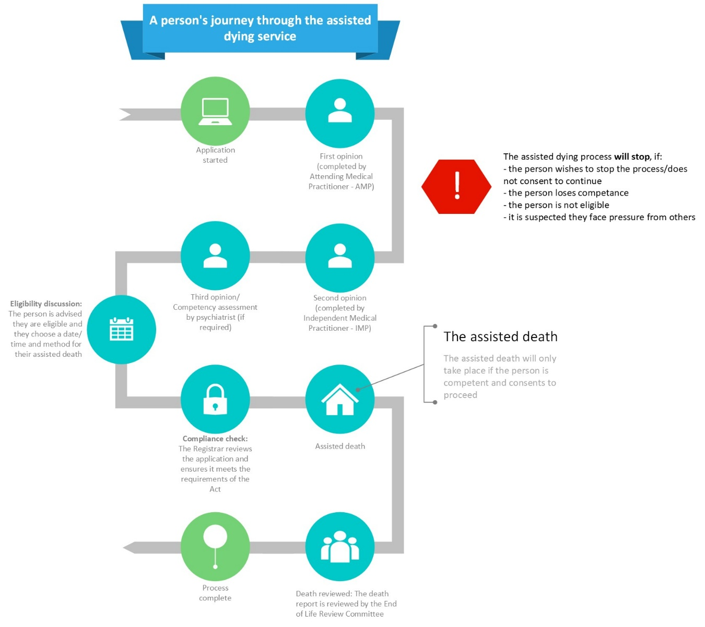
Figure 1: The assisted dying application process

For more information about the process, please visit the End of Life Choice Act 2019 on the New Zealand Legislation website or the assisted dying webpage on the Health New Zealand website.

Reporting and service activity
The Ministry, through Health New Zealand, collects data about assisted dying services as part of its regulation and monitoring role. Collecting this information helps us to understand who is accessing services and how services are provided, enabling us to report on information about assisted dying, as required by the Act. Data can provide insight into how individuals, their whānau and health practitioners experience assisted dying services. These insights support continuous service improvement and help achieve better outcomes for applicants and their whānau.

The level of detail that we can currently report is limited due to the need to protect the confidentiality of individuals accessing assisted dying services, while numbers remain low.

The Ministry of Health has worked in collaboration with Health New Zealand to consolidate and review the data informing this report. Due to the introduction of a new national regulatory IT platform during the current reporting period, and then the migration of data from the previous platform over time the Ministry will continue to review and ratify this information.

Key facts
- In the year from 1 April 2025 and 31 March 2026, 1,289 applications were active (made up of 1,164 new applications plus 125 ongoing from the previous year). This is a 13% increase in active applications compared with last year.
- 306 applications ended because the person died during the process (from their underlying illness or condition) – about 24% of the total of 1,289 active applications.
- 42 people withdrew (rescinded) their application – about 3% of the total active applications.
- 486 people had an assisted death – about 38% of the total active applications.
- Of the total number of assisted deaths during the year, 94.4% occurred through injection by the AMP. This was also the most common method in previous years.
- The number of assisted deaths between 1 April 2025 and 31 March 2026 represents 1.29% of all deaths in New Zealand over that time.

Overview of assisted dying applications
The data in this section summarises individuals’ interactions with the assisted dying service during the year from 1 April 2025 to 31 March 2026.

Between 1 April 2025 and 31 March 2026, there were 1,164 new formal applications for assisted dying (Figure 2). This report also contains information on 125 applications that were ongoing at the end of last year’s report (for the 2024/25 year). Because of this, a total of 1,289 applications were active during this 2025/26 reporting period. The result reflects an increase in active applications of 13% from the previous reporting period, when a total of 1,137 of applications were active.

Figure 2: Number of applications and assisted deaths from April to March reporting periods, 2022–2026

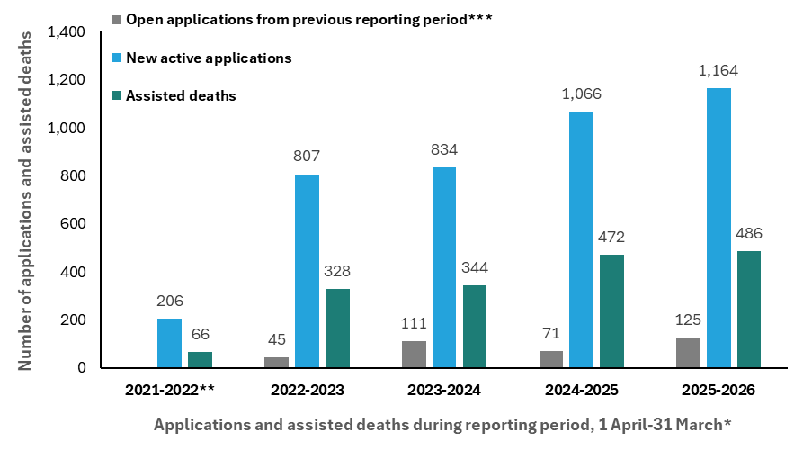
Notes:
* Reporting period covers 1 April to 31 March the following year
** Data relating to 2021-2022 includes new applications and assisted deaths following the Act coming into effect 7 November 2021, thereby reflecting a partial year reporting.
*** ‘Open applications’ refers to open applications submitted during the prior to the reporting period

As of 31 March 2026, there were 135 individuals still in the process of being assessed or are in preparation for assisted dying, and 486 people had an assisted death. The remaining applications had not progressed to an assisted death for one of the following reasons:
- the application was found to not comply with the Act
- the application stopped due to process reasons
- the applicant withdrew their application
- the applicant died during the process, or was found to be ineligible or not competent to give consent before the AMP assessed them
- the applicant was found to be ineligible or not competent to give consent at or following assessment
- the applicant died as a result of their underlying conditions following assessment.

As part of the assisted dying process, the AMP must ensure the person understands all their choices for end-of-life care. As a result, on some occasions a person’s request for assisted dying led to them to explore alternative care or services, such as optimising palliative care or additional social or wrap-around supports. Some of these people then withdrew (rescinded) their application for assisted dying.

The principal clinical advisors within Health New Zealand work with other health services, such as people’s general practitioners, to help coordinate the care or support of those people. In some cases, following further consultation, some people chose to withdraw their application for assisted dying as they felt this was no longer their preferred option. For some people, just knowing they have options available that are within their control is comfort enough.

Timeframes for eligibility
Assisted dying services are person-centred. The time taken from applying for the service through to confirmation of eligibility by the AMP, and then to an assisted death, varies. It depends on each applicant’s personal situation, the choices they make and the progression of their terminal illness.

The process from when a person first applies through to the decision on whether they are eligible can take up to six weeks. In 2025/26, for those found to be eligible for the service following assessment, the average time between the person formally applying and getting notification from the AMP that they were eligible was 15 days. After the AMP notifies a person that they are eligible, the Registrar must review the application to ensure it complies with the Act before the assisted death can take place.

People requesting the option of assisted dying are nearing the end of their life. This may mean they feel a sense of urgency to move through the process. However, the processes and steps that must be followed under the Act ensure services are delivered safely and with high quality. For this reason, it is important to follow these processes carefully and not to rush them.

Demographic details of applicants
Following health sector standards and protocols, the Ministry collects information about the demographic details of people who apply for the assisted dying service. These details include their gender and ethnicity.

Of the 1,164 new applications received over the 2025/26 year:
- 81% of applicants identified as New Zealand European/Pākehā
- 5% identified as Māori
- 48% identified as female/wāhine
- 80% were aged 65 years or older
- 80% were receiving palliative care when they applied
- 63% had a diagnosis of cancer.

Table 1 summarises the demographic data of people making new applications for assisted dying services in 2025/26. Figure 3 focuses specifically on the diagnosis of the people who applied.

Table 1: Summary of demographic data of people making new applications for assisted dying services, 1 April 2025 – 31 March 2026
Demographic characteristic (N = 1,164) |  |  | Number of people³ | % of applications
Ethnic group¹ | Māori |  | 57 | 4.90
Ethnic group¹ | Pacific peoples |  | 9 | 0.77
Ethnic group¹ | New Zealand European/Pākehā |  | 944 | 81.10
Ethnic group¹ | Asian |  | 29 | 2.49
Ethnic group¹ | Other |  | 154 | 13.23
Ethnic group¹ | Not stated |  | 0 | 0
Sex | Female/wāhine |  | 553 | 47.51
Sex | Male/tāne |  | 611 | 52.49
Sex | Gender diverse |  | 0 | 0
Age group | 18–44 years |  | 26 | 2.23
Age group | 45–64 years |  | 203 | 17.44
Age group | 65–84 years |  | 713 | 61.25
Age group | 85+ years |  | 222 | 19.07
Diagnosis² | Cancer |  | 739 | 63.49
Diagnosis² | Neurological condition |  | 97 | 8.33
Diagnosis² | Chronic respiratory disease |  | 93 | 7.99
Diagnosis² | Cardiovascular condition |  | 56 | 4.81
Diagnosis² | Other organ failure |  | 31 | 2.66
Diagnosis² | Multiple co-morbidities |  | 71 | 6.10
Diagnosis² | Not known⁴ |  | 135 | 11.60
Receiving palliative care at time of application? | Yes |  | 926 | 79.55
Receiving palliative care at time of application? | No |  | 238 | 20.45
Reported a disability at time of application? | Yes |  | 76 | 6.53
Reported a disability at time of application? | No |  | 1,088 | 93.47
Notes:
- This data is based on total ethnicity. This means that individuals reporting more than one ethnicity are included within each category they identify with. In the current report, individuals identifying as ‘European’ have been included within the ‘Other’ category, rather than being categorised as New Zealand European/Pākehā.
- This data is based on total diagnosis. This means that individuals presenting with more than one diagnosis are included within each diagnostic category that applies to them.
- Repeat applications are included as unique instances. This means that, in cases where an individual has submitted more than one application during this period, their information appears as a separate applicant in the demographic data each time.
- A diagnosis of ‘not known’ was recorded for individuals who had applied but had not yet completed their first assessment with their AMP, as well as for those who withdrew their application before assessment, died before their assessment was completed, were found not eligible or not competent before their AMP assessed them, or were ineligible because they did not have a terminal illness.

Figure 3: Number of new applications by diagnosis, 1 April 2025 – 31 March 2026
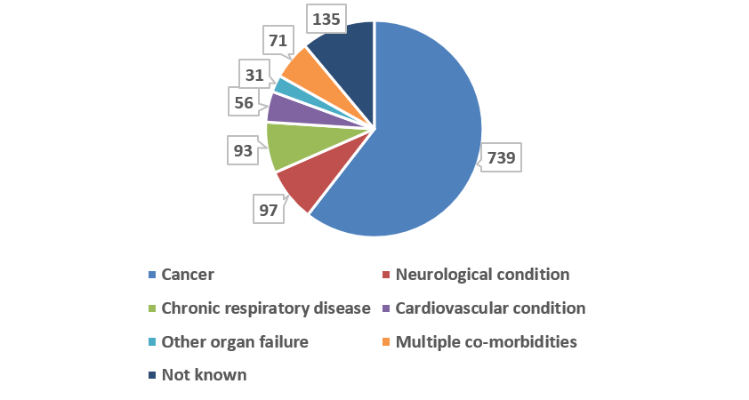

Figure 4 shows the distribution of new assisted dying applications by the applicant’s region of domicile for the reporting period. Applications were received from all regions, with the highest number recorded in the Northern region (338), followed by Midland (307) and Southern (294), while the Central region recorded the lowest number of applications (225).

Figure 4: Number of new applications by the applicant’s region of domicile, 1 April 2025 – 31 March 2026

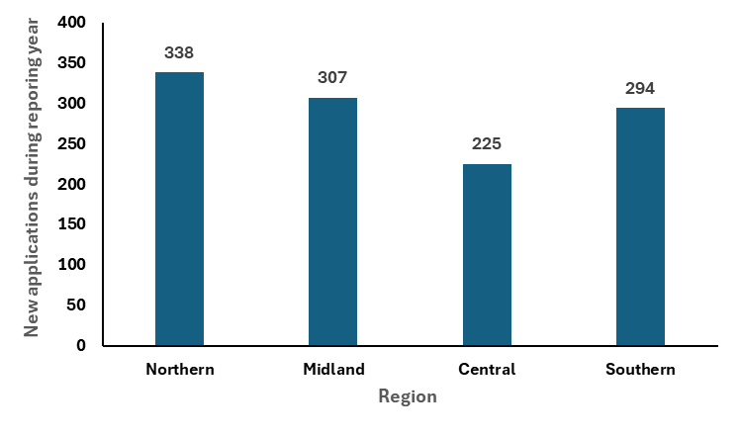

Application outcomes

Assessments completed during the reporting period
After a person submits an application, an AMP makes an initial assessment. The AMP reviews the person’s eligibility against the strict criteria outlined in the Act. An independent medical practitioner (IMP) then provides an independent second assessment.

During the reporting period, AMPs assessed 1,106 applications, representing an increase of 8% compared with the previous year’s reporting period (1,027 applications). During the same period, IMPs assessed 832 applications, which was an increase of 3% compared with the previous year (804 applications). The percentage of applications AMPs found to be eligible (84%) was consistent with the trend observed in the three previous years, when the percentages of eligible applications were 85% in 2024/25, 86% in 2023/24 and 82% in 2022/23.

The percentage of applications IMPs found to be eligible (95%) was also comparable with the three previous years: 95% in 2024/25, 97% in 2023/24 and 99% in 2022/23. We note that this figure has remained above 90% across all reporting periods.

Applicants may be found ineligible at the AMP or IMP assessment for a variety of reasons. Applicants may also be found to be not competent to give consent at any time during their application process, including at each of these assessments. Table 2 presents more information on ineligibility and ‘not competent’ outcomes for the current period.

If both the AMP and IMP assess an applicant as eligible, the AMP then meets with the applicant for another discussion about eligibility and about the assisted dying process itself. At this time, some eligible applicants may be found not competent or ineligible to continue. However, as in the previous reporting period, 99% (or more) of applicants considered to be eligible at both AMP and IMP initial assessments were also found to be eligible at this stage.
Table 2: Assessment outcomes, 1 April 2025 – 31 March 2026
 | Outcome of assessment | Number of assessments
AMP assessments  (N = 1,106) | Eligible | 929
AMP assessments  (N = 1,106) | Ineligible | 165
 | Not competent at assessment | 12
IMP assessments  (N = 832) | Eligible | 793
IMP assessments  (N = 832) | Ineligible | 17
 | Not competent at assessment | 22
Eligibility discussion following assessment  (N = 769) | Eligible | 769
Eligibility discussion following assessment  (N = 769) | Ineligible | 0

An AMP or an IMP may request an assessment from a psychiatrist who is on the SCENZ Group list of psychiatrists as to whether a particular applicant is competent to make an informed decision about assisted dying. Psychiatrists provide an independent, expert assessment of a person’s decision-making capacity. They are able to identify whether any impairment is temporary or linked to a more complex mental health condition. Their assessment helps to establish whether a person seeking assisted dying can actually make an informed choice. Their role supports both the protection of vulnerable individuals and respect for personal autonomy.

In the current period, psychiatrists completed 16 assessments. As a result, one individual was determined not to be competent to make an informed decision about assisted dying and their application stopped.

Only people who are competent can continue through the assisted dying process.

For more information about the process for assisted dying and the roles of the practitioners in the service, visit the Health New Zealand website at healthnz.govt.nz and search for ‘assisted dying services’.

Ineligibility summaries
As Table 2 shows, not all applications made to the service in the reporting period led to an assisted death, as some individuals were found ineligible. Reasons for ineligibility vary: they may relate to an applicant’s age, status as a New Zealand citizen/resident or considerations relating to their health and physical decline. For more information about the eligibility criteria, visit Health New Zealand's assisted dying webpage at healthnz.govt.nz/health-topics/conditions-treatments/death-and-dying/assisted-dying.

Table 3 summarises the reasons why AMPs and IMPs decided applicants in 2025/26 were ineligible at each stage of assessment. An applicant may be found eligible at the AMP assessment stage but then ineligible at the IMP assessment stage for a number of reasons. These include but are not limited to a change in personal circumstances impacting eligibility and/or a change in prognosis.

Table 3: Reasons for decisions that applicants are ineligible at AMP and IMP assessments, 1 April 2025 – 31 March 2026 *
Reason(s) for ineligibility** | Ineligible at AMP assessment (165) | Ineligible at IMP assessment (17)
Not a New Zealand citizen or permanent resident | 7 (4.2%) | 0 (0.0%)
Not aged 18 years or over | 0 (0.0%) | 0 (0.0%)
Not experiencing unbearable suffering that cannot be relieved in a manner the person considers tolerable | 65 (39.4%) | 6 (35.3%)
Not in an advanced state of irreversible physical decline | 69 (41.8%) | 8 (47.1%)
Not suffering from a terminal illness that is likely to end their life within six months | 140 (84.8%) | 12 (70.6%)
Notes:
* This table does not include cases where an applicant was found not competent at AMP or IMP assessment.
** This data presents total reasons for ineligibility. Individuals found to be ineligible based on more than one criterion are included separately for each observed reason.

Applications not progressed to an assisted death
Table 4 summarises reasons why an applicant did not have an assisted death. It excludes information on applications found to be ineligible at the AMP or IMP assessments (for that information, see Table 3). Additionally, this table includes applications that were still open at the end of this reporting period, meaning that their outcome was not yet known.

Several reasons can explain why an individual may not continue their application to an assisted death. These include that the person:
- is found ineligible following a previous eligible outcome or becomes unable to make an informed decision or give their consent
- withdraws their application
- dies of an underlying condition or terminal illness at any point during the application process or before their scheduled assisted death.

In addition, where it is suspected that an applicant is experiencing pressure or coercion, the Act requires that the application be stopped. However, no such cases were identified in this reporting period.

Compliance reviews are a key safeguard under the Act. Given the complexity of AMP and IMP assessments, a thorough review – including of any supporting documentation - is required to determine whether an application meets legislative requirements. A compliance review may find an application does not comply with the Act. An assisted death cannot proceed unless the Registrar confirms compliance.
The number of people dying from their underlying terminal illness during the assessment process indicates how close to the end of life some applicants are, rather than reflecting significant delays in accessing services.

Table 4: Application outcomes where applicant did not have an assisted death (excluding cases where AMP or IMP assessment found them to be ineligible), 1 April 2025 – 31 March 2026
 | Outcome type | Number of applications
Closed application outcomes not continuing to AMP assessment
 | Died in process, found not competent or found not eligible before AMP assessment, or did not consent to proceed with their application | 60
Further application outcomes not progressing to assisted death during this reporting period
 | Died in process | 306
 | Lost competence | 17
 | Lost eligibility | 14
 | Decided to withdraw | 42
 | Application stopped for process reasons | 4
 | Registrar (assisted dying) found application was not compliant with the Act at compliance review | 6
 | Application still open at the time of this reporting period | 135

Assisted deaths
Between 1 April 2025 and 31 March 2026, a total of 486 people had an assisted death. This number represents 38% of all active applications during this reporting period. The percentage has decreased slightly from the previous year, when 42% of active applications resulted in an assisted death.

The number of assisted deaths between 1 April 2025 and 31 March 2026 represents 1.29% of all deaths in New Zealand over that time.

People having an assisted death work with their AMP to ensure the experience is personal to them and their whānau and fits with their wishes. Some people choose to include cultural or spiritual practices, such as karakia or prayer, before or while the assisted dying medication is administered; others choose to play music that is significant to them. People also choose who they would like to be present during the process, which may include whānau, friends and pets, and where their death will occur.

Health practitioners are encouraged to discuss these choices with people so that the service provided is responsive to their cultural, spiritual and social needs. Health New Zealand’s health practitioner training includes resources provided to support these conversations.

With consent from the person seeking an assisted death, AMPs may bring a support person with them when they administer the medication.

Locations of assisted deaths
As in previous years, most assisted deaths in 2025/26 took place in people’s homes or another private residence.

As Figure 5 shows, by location, of the total number of assisted deaths that took place in 2025/26:
- 69.8% took place at a private residence or another private property
- 19.5% took place in an aged care facility
- 7.2% took place at a hospital
- 3.5% took place in a hospice facility.

Figure 5: Number of assisted deaths by location, 1 April 2025 – 31 March 2026
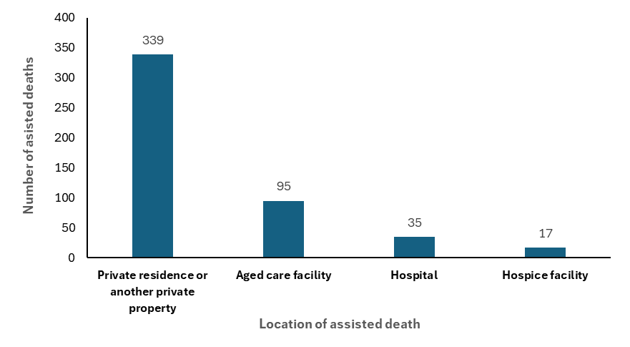

Method of administration
Under the Act, there are four options for the method of administering the assisted dying medication. The AMP provides the person with advice on each option, and the person then selects their preferred option.

On the day of the assisted death, the AMP confirms whether the person wishes to proceed and the method they have chosen. The way that the person’s disease has progressed may mean that it is no longer possible to use the method they initially chose. If this is the case, with the person’s consent, a backup method will be used instead. It is also possible that the person simply changes their mind about following through with assisted dying at this point.

For the 486 assisted deaths that took place between 1 April 2025 and 31 March 2026:
- 25 people chose ingestion, triggered by the person
- one person chose intravenous delivery, triggered by the person
- one person chose ingestion through a tube, triggered by the AMP or ANP
- 459 people chose injection, administered by the AMP/ANP.

Each medication method has a standard administration protocol to ensure consistent, safe and high-quality services. The details of the protocol are only provided to the health practitioners involved in the assisted dying service.

As of 31 March 2026, no major complications related to the administration of the medication have arisen, and all deaths have occurred within expected timeframes.

The assisted dying workforce
The assisted dying workforce is essential to the delivery of assisted dying services in New Zealand. The workforce consists of health practitioners providing services to their own patients or in the role of replacement AMP, IMP, ANP or psychiatrist on the SCENZ Group lists.

Any health practitioner may conscientiously object to providing assisted dying services under the Act. However, all practitioners must be aware of and understand important legal obligations under the Act.

Health New Zealand provides training and guidance on assisted dying (including on how to respond when a person raises assisted dying) for all health practitioners.

Practitioners on the SCENZ Group lists
Under the Act, one of the responsibilities of the SCENZ Group is to maintain lists of health professionals who are willing to deliver assisted dying services. This workforce is critical to ensuring people can access assisted dying, particularly where their usual health practitioner does not provide the service or where they do not feel comfortable to raise the subject with this health practitioner.

When a person asks for an assisted death, the service seeks a practitioner located as close to that person as possible. If a practitioner is not available in the person’s area, an approved practitioner will travel to the person’s location. Practitioners may come from anywhere in New Zealand.

Audio-visual consultations may also be used, where appropriate.

Table 5 summarises the number of practitioners on the SCENZ Group lists in each Health New Zealand region. This includes health practitioners available to perform the AMP, IMP, ANP and psychiatrist roles exclusively, as well as those available to provide services as either an AMP or an IMP. It does not include the number of practitioners who have not applied to be on the SCENZ lists but who are providing services to their own patients.

Following the introduction of the new regulatory IT platform and as part of their ongoing maintenance, the SCENZ Group lists were revised and practitioners who were no longer willing or able to provide services were removed. Some practitioners who were on the list have never provided the service for a variety of reasons or have not provided the service for a considerable time. This may be due to retirement, work pressures in other employment, moving overseas or another undisclosed reason. As a result of the revision, fewer practitioners are on the lists than last year. However, the number of practitioners actively involved in the service has remained stable. We continue to receive applications from practitioners to join the lists for providing assisted dying services.

Table 5: Number of health practitioners on the SCENZ Group lists across Health New Zealand regions, as at 14 May 2026
Region | AMP | IMP | AMP and IMP | ANP | Psychiatrist
Northern | 2 | 5 | 16 | 2 | 1
Midland | 1 | 6 | 16 | 4 | 0
Central | 4 | 0 | 16 | 1 | 0
Southern | 2 | 3 | 28 | 5 | 2
No district indicated | 0 | 1 | 6 | 0 | 0
Total (121) | 9 | 15 | 82 | 12 | 3

For health practitioners who are interested in providing assisted dying services and would like to register on an assisted dying practitioner list, information is available at health.govt.nz/regulation-legislation/assisted-dying/resources-for-health-professionals/register-for-an-assisted-dying-practitioner-list on the Ministry’s website.

Feedback, complaints and queries

Feedback
Feedback is critical to improving the quality, safety and equity of assisted dying services. The Ministry remains committed to receiving feedback to support these improvements.

We actively encourage individuals and their families and whānau to share their experience with the assisted dying service across a number of formats. For more information about how to give feedback and how to make a complaint about assisted dying services, visit health.govt.nz/regulation-legislation/assisted-dying/give-feedback-or-make-a-complaint on the Ministry’s website.

We are aware of the sensitive nature of this topic. For this reason, upholding the emotional wellbeing and the privacy of anyone who shares their feedback is a priority.

Complaints
The Registrar and the Secretariat keep a central record of all complaints related to the Act. The Registrar also receives details of complaints about the service made to the HDC, authorities such as professional bodies and councils, and the New Zealand Police under section 28 of the Act. Health New Zealand notifies the Registrar of operational complaints.

The Nursing Council of New Zealand, the Medical Council of New Zealand and the New Zealand Police did not receive any complaints in relation to assisted dying services under the Act during the current reporting period.

The tables that follow contain a summary of all complaints that the Registrar and the Secretariat within the Ministry of Health (Table 6) and the HDC (Table 7) received between 1 April 2025 and 31 March 2026.

Table 6: Complaints that the Ministry of Health and Registrar received about assisted dying services and actions taken, 1 April 2025 – 31 March 2026
Date received | Complainant | Referred by another agency? | Description of complaint | Action(s) taken
April 2025 | Facility | No | Concerns about the competence of a person having an assisted death within the facility | Registrar reviewed application and confirmed compliance with the Act; complaint closed
November 2025 | The End of Life Choice Review Committee (the Committee) | No | Concerns that an assisted dying practitioner had provided incomplete death report forms. | Registrar spoke with the practitioner and reminded them of their obligations under the Act and the practitioner promptly completed the incomplete forms; complaint closed

Table 7: Complaints that the Health and Disability Commissioner received about assisted dying services and actions taken, 1 April 2025 – 31 March 2026
Date received | Referred by another agency? | Description of complaint | Action(s) taken
September 2025 | No | The complainant raised a range of issues around the management of a family member’s cancer diagnosis and care, and also noted concerns about the lack of support for bereaved families in relation to assisted dying | HDC referred the concerns raised about a gap in support for families to Health New Zealand and the Ministry of Health  Issues related to cancer care were referred to the Advocacy Service to facilitate resolution  Complaint closed – referred to Advocacy Service  Complaint re-opened February 2026 (see February 2026 below)
September 2025 | No | The complainant raised concerns about not being eligible to receive assisted dying services | Closed – no further action
October 2025 | No | This complainant primarily focused on issues with the consumer’s pain management. However, they also raised a concern that a counsellor had raised assisted dying options with them | Ongoing at the time of this report
February 2026 | No | HDC re-opened complaint after resolution not reached with assistance from Advocacy Service  The complainant’s unresolved concerns primarily relate to the management of a family member’s cancer diagnosis and care. She also noted her concerns about the lack of support for bereaved families in relation to assisted dying | Ongoing at the time of this report

Queries
There is ongoing public interest in assisted dying, beyond people accessing or providing the service. The Ministry is committed to being open and transparent about matters of public interest and routinely publishes responses to Official Information Act 1982 requests on its website. For updates, visit health.govt.nz/information-releases on the Ministry’s website and search for ‘assisted dying’.

For advice to media on reporting on assisted dying, see health.govt.nz/regulation-legislation/assisted-dying/advice-for-media-reporting-on-assisted-dying on the Ministry’s website.

