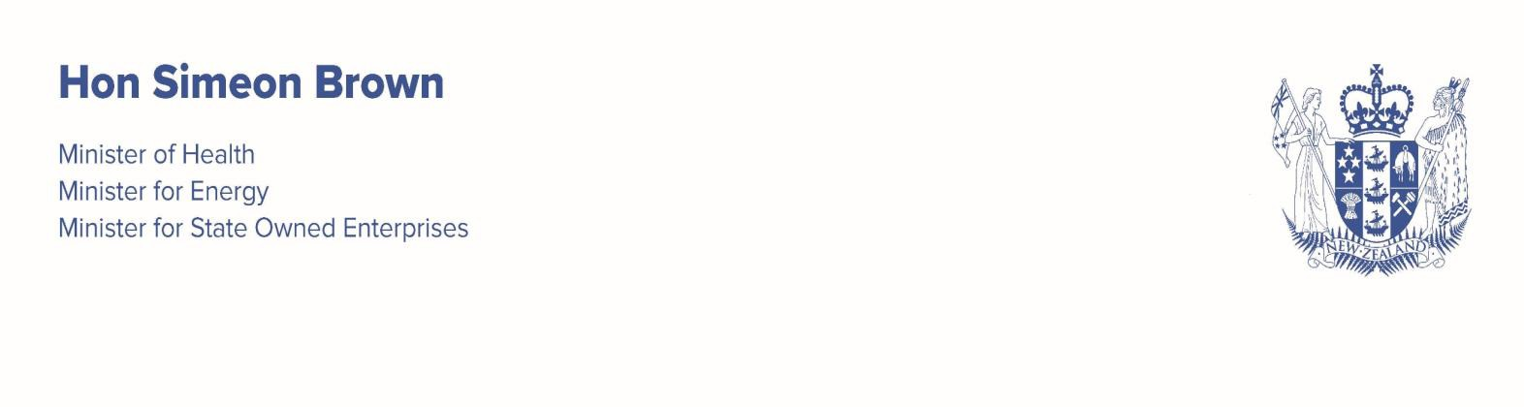


Roger Jarrold Chair
New Zealand Blood and Organ Service
s 9(2)(a)

Dear Roger

I am writing to set out my expectations and priorities for 2026/27. As you are aware, this Government is committed to improving health outcomes by providing New Zealanders with timely access to high-quality services, delivered by a financially sustainable health system. I want the health system focused on putting patients first in every decision.

My key areas of focus continue to be:
- getting Health New Zealand (Health NZ) back to basics;
- delivering all health targets, including driving shorter stays in emergency departments and getting on top of the elective surgery backlog;
- enabling faster access to primary care;
- delivering a long-term health infrastructure programme; and
- streamlining accountability mechanisms, statutory and regulatory settings to drive performance.
I know that you and the New Zealand Blood and Organ Service (NZBOS) will support me in ensuring that these areas of focus are strongly positioned in NZBOS’s work programme, particularly where you interface with Health NZ.

My overarching expectation is that NZBOS is relentless in its pursuit of the delivery of more and better health services for New Zealanders. In doing so, I expect NZBOS to put patient and consumer need at the heart of every decision it makes and to prioritise its services based on clinical need, not race.

Our system must deliver the best mix of outputs and services possible within current budgets, with a focus on optimising productivity and efficiency. I expect individual Crown entities to measure and demonstrate how they are delivering value for money. Each Crown entity must play its part for the system to perform as a whole. Where possible and useful, individual Crown entities need to partner with others to find synergies and efficiencies which will help achieve this aim.

I expect the NZBOS to continue to provide high-quality services while managing your costs carefully to ensure the prices charged to Health NZ are efficient. Your efforts here should include any ongoing work to address the recommendations of the Deloitte review of financial forecasting in April 2025.
I expect NZBOS to focus on:

- Supporting health delivery: NZBOS must continue to develop and document where necessary the relationship with Health NZ including aspects like clinical demand, pricing and capital. I want to reinforce my expectation that future pricing for blood products is agreed with Health NZ, supported by the Ministry of Health, through a transparent process. You will need to consider any options for managing financial risk in partnership with Health NZ, for instance through inventory management.
- System capability and partnerships: I encourage you to partner with Primary Health Organisations, non-government organisations and the community sector, and private providers to maximise delivery for New Zealanders, with an unrelenting focus on improving outcomes and achieving results.
- Managing clinical demand: I am pleased that you have agreed your first service level agreement with Health NZ. The two parties should continue to develop the document by incorporating joint work on managing clinical demand, sharing information and any other areas which would provide mutual benefit. I am aware that work is progressing on the National Blood Management group involving both NZBOS and Health NZ clinicians. I expect to see continued progress on that work, with results built into the service level agreement.
- Deceased organ donation: I expect an increase in deceased organ donation following the recent review by the Health Select Committee. I expect you to lead work with the Ministry and Health NZ to develop a roadmap for increasing New Zealand’s organ donation rates, and therefore transplantation, in line with the 2017 strategy. That work should involve engagement with key relevant stakeholders including patient advocates. I will be passing the same expectations to Health NZ to work with you on this matter. I expect to see regular reporting on progress.
- Plasma self-sufficiency: Thank you for your efforts to date in supporting the review of the current approach to plasma self-sufficiency. The Ministry is planning further work to inform a decision on the optimal target for self-sufficiency and I ask you to continue to work collaboratively with the Ministry. This will enable robust planning in relation to plasma-derived products from domestically collected plasma to be undertaken for the 2027/28 year onwards. In the meantime, I expect you to plan capital and operational investments to maintain the current level of self -sufficiency, which I understand is in in the range 70 to 75 percent.
- Reflecting my expectations in your accountability documents: My overarching expectation remains that all health entities are relentless in the pursuit of the delivery of better outcomes and value for New Zealanders. My expectations should form the basis for the development of your accountability documents for the coming financial year. As you prioritise your work programme, please advise me early to discuss any proposed trade-offs that would impact on the full delivery of any of my expectations. Please ensure regular progress updates are provided through your performance reports. I expect you to ensure timely responses continue to be provided to information requests made by the Ministry, as your monitoring agency. I expect you to advise me and the Ministry early if you have any concerns about progress.

It is three years since the NZBOS last prepared a Statement of Intent (SOI) and the Crown Entities Act 2004 would normally require a refreshed SOI for the period beginning 1 July 2026. I note that there is a significant level of change and uncertainty, particularly the further work required on self-sufficiency, which would affect the quality of an SOI produced now.
Pursuant to section 139B of the Crown Entities Act 2024, I therefore approve an extension of one year, until 1 July 2027, for the production of a new SOI. I expect that the SOI reflects

any significant changes resulting from decisions on self-sufficiency or other drivers such as your financial transformation programme.

I would like to take this opportunity to thank you for your work to date, and I look forward to continuing our collaborative efforts to improve health outcomes for all New Zealanders.
Please provide a draft of your Statement of Performance Expectations for 2026/27 to your contact at the Ministry by 30 April 2026.
Yours sincerely
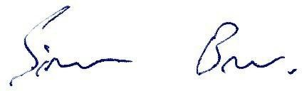

Hon Simeon Brown

Minister of Health
Cc Audrey Sonerson, Director-General, Ministry of Health Audrey.Sonerson@health.govt.nz
Sam Cliffe, Chief Executive, NZBOS Sam.Cliffe@nzblood.co.nz

