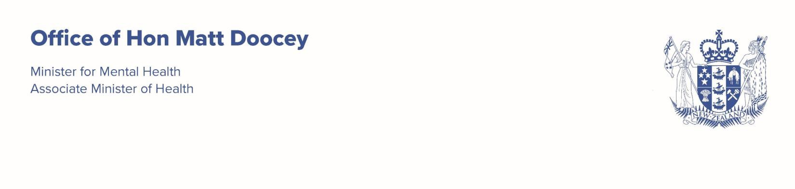


23 March 2026

Mr Hayden Wano Chair
Mental Health and Wellbeing Commission
s 9(2)(a)

Dear Hayden
I am writing to set out my expectations for the Mental Health and Wellbeing Commission | Te Hiringa Mahara (the Commission) for 2026/27. As this letter builds on and does not replace my previous letters of expectations to you, please ensure all my expectations are appropriately reflected in your planning documents for 2026/27.
The Government remains committed to improving health outcomes by providing New Zealanders with timely access with patients at its centre. This means our system must deliver the best mix of outputs and services possible within current budgets, with a focus on optimising productivity and efficiency. I want to thank the Commission for the work it has undertaken to support my portfolio priorities of delivering faster access to mental health support, more frontline workers, and a better crisis response. This work helps build a foundation for the Commission to have a more targeted work programme in 2026/27.
To continue to achieve progress, there is a need for all agencies to work together. The Commission’s work programme should support and not duplicate the work of the Ministry of Health, Health New Zealand and other agencies. While the Commission’s foundational work has brought together key system performance metrics into a cohesive picture, I expect the Commission to prioritise its efforts towards adding new insights on factors that affect people’s mental health and wellbeing, and system performance. The Commission’s work should include actionable recommendations, which can be used to inform policy and operational work where possible.
It would be helpful for the Commission to add insights to areas such as enhancing productivity across the system, value for money of mental health and addiction investment, or whether the current spread of investment aligns with population needs, with recommendations for improvement.
The Commission should look to include deep dives in its 2026/27 work programme to better understand the underlying drivers for the trends being seen from a system performance and outcomes perspective. I understand you are taking this approach to understand the access patterns for young people, which I support and would encourage consideration of other life course stages. I am also interested in seeing what good looks like from evidence informed and lived experience perspectives. Potential focus areas could include best practice and practical steps towards eliminating seclusion.

The Commission has a unique statutory role which allows it to engage with, and assess the impacts of agencies outside of the health system who contribute to mental health and wellbeing outcomes. The Commission should consider strengthening its focus on the interface with other sectors, such as housing, welfare and education with mental health, addiction and wellbeing outcomes, to strengthen a whole-of-government approach.
The Commission has already committed to leading the national risk conversation. I would also like to see you undertake work to build on your previous crisis response report of 2025.
In relation to the Commission’s role in monitoring suicide prevention, rather than monitoring the Suicide Prevention Action Plan (which will be undertaken by the Ministry of Health), I would ask the Commission to focus on impacts for population groups experiencing higher needs or levels of risk, or on cross-government contributions to suicide prevention where the Suicide Prevention Office only has an influencing role.
s 9(2)(ba)(i)
During 2026 a review of the Commission will commence as required under the Mental Health and Wellbeing Commission Act 2020. The Ministry will be liaising with the Commission regarding the review once I have agreed the terms of reference for the review. I am intending that the review will include comparisons to Australian mental health commission models (at national and state level) to inform decision about the shape, form, design and structure of the Commission.
Under the Crown Entities Act 2004, the Commission is due to provide me with a draft Statement of Performance Expectations (SPE) for 2026/27 by 30 April 2026. As the Commission is now a mature entity, I would like you to develop performance measures which demonstrates how the Commission is contributing to improved and equitable mental health and wellbeing outcomes. The Commission should show good stewardship of public resources, and that you can clearly measure and demonstrate how you are delivering value for money. I ask you provide a draft of your SPE to your contact at the Ministry by 30 April 2026, who will be providing feedback on my behalf.

Yours sincerely

Hon Matt Doocey

Minister for Mental Health
cc Hon Simeon Brown, Minister of Health
Audrey Sonerson, Director-General of Health, Ministry of Health, audrey.sonerson@health.govt.nz
Karen Orsborn, Chief Executive, Mental Health and Wellbeing Commission, karen.orsborn@mhwc.govt.nz

