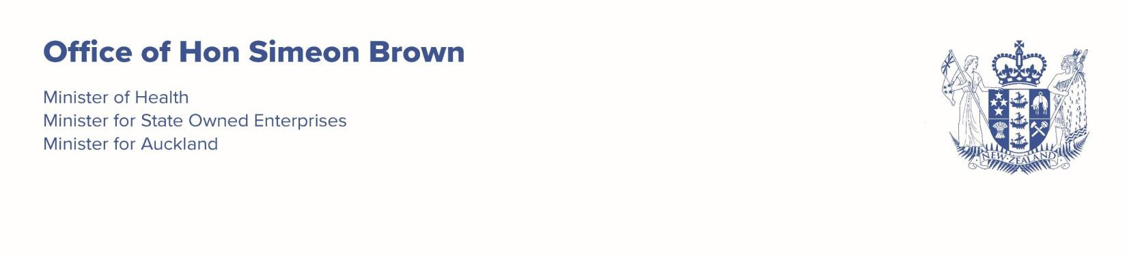


31 March 2026

Professor Lester Levy Board Chair
Health New Zealand
s 9(2)(a)

Dear Lester
Deceased Organ Donation and Transplantation

As you are aware concerns have been expressed about the rate of deceased organ donation and therefore transplantation in New Zealand, and the amount of progress made towards delivery of the 2017 Strategy ‘Increasing Deceased Organ Donation and Transplantation’.

It is clear that that while the directions set out in the 2017 Strategy are sound, it is not an implementation plan. While some progress has been made on aspects of the Strategy further progress is needed on the visibility of donation intent and strengthening support for. hospital-based donation to increase the overall numbers of organ donations.

Progress on support for hospital- based donation is critically dependent on Health NZ working with the New Zealand Blood and Organ Service (NZBOS). Potential organ donors can only be found in intensive care units in Health NZ hospitals and Health NZ clinical teams must make referrals, harvest organs and undertake transplant procedures.

I note Health NZ’s appearance at the Health Select Committee in December to discuss organ donation alongside representatives of the NZBOS and the Ministry of Health. I understand that all three agencies have met subsequently to discuss organ donation.

We have an opportunity to improve health outcomes through collaborative efforts to increase the numbers of deceased organ donations. I am aware that resourcing is constrained for all agencies in the system and that deceased organ donation is one of many priorities competing for health resources. However, it is an important priority which will improve patient outcomes and could release resources over time, for example through the reduction of the need for dialysis.

I therefore expect you to work closely with the NZBOS and the Ministry to develop a roadmap for the improvement of deceased organ donation and therefore transplant services.
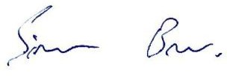
I look forward to observing your progress on this issue. Yours sincerely

Hon Simeon Brown
Minister of Health

