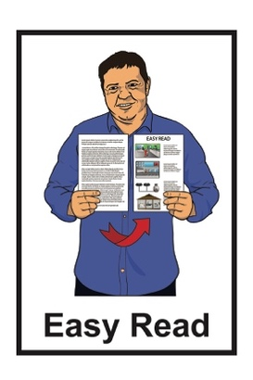


Part 2: Have your say on the Draft Mental Health and Wellbeing Strategy 2026 – 2036
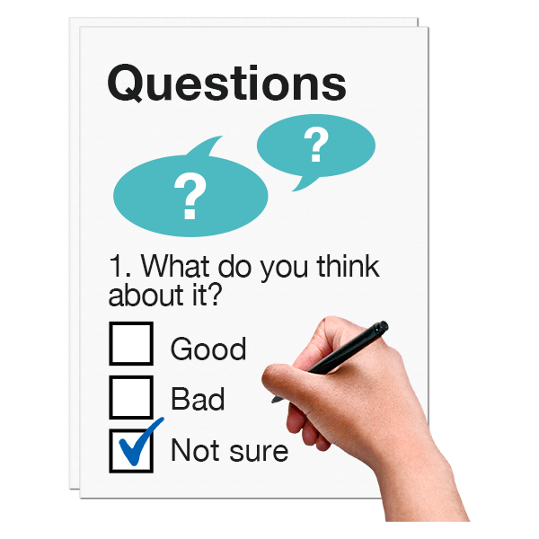

Published: May 2026

Before you start


This information may upset some people when they are reading it.

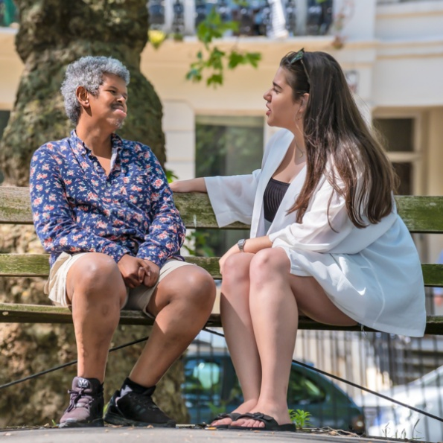
If you are upset after reading this document you can talk to your:
whānau / family
friends.

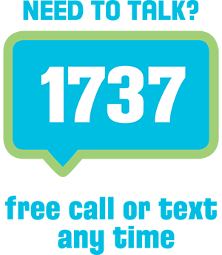
You can also contact Need to Talk by:
calling 1737
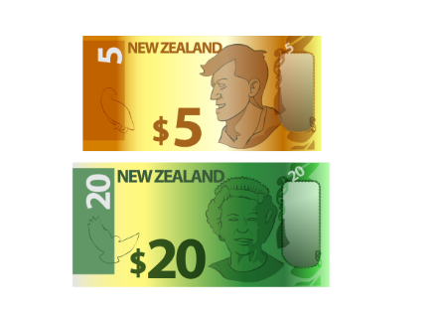

texting 1737.

It does not cost any money to call / text 1737.
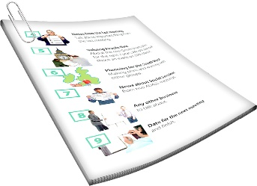
This is a long document.

It can be hard for some people to read a document this long.
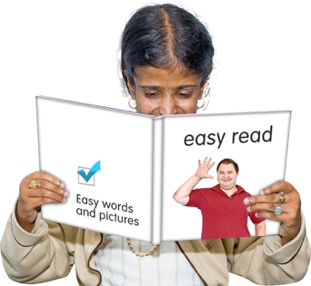

Some things you can do to make it easier are:
read it a few pages at a time
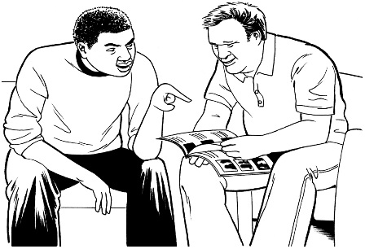
set aside some quiet time to look at it
have someone read it with you to support you to understand it.

What you will find in here

Page number:
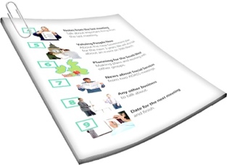

About this Easy Read 4

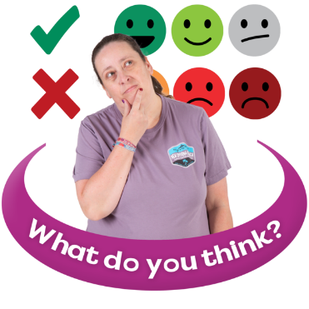
Why it is important to
get your feedback 12
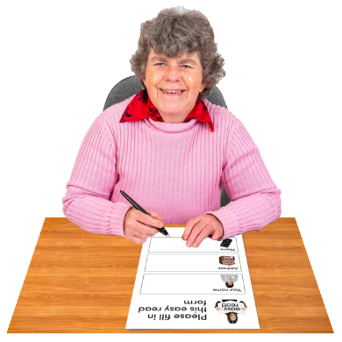

How to have your say 16


Questions 20

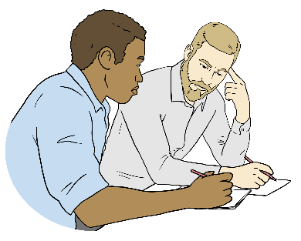
What will happen next 38

About this Easy Read


This Easy Read tells you how you can have your say on the draft Mental Health and Wellbeing Strategy 2026 – 2036.


Draft means that this is the first version of the strategy.

There will be changes before the strategy is finished.

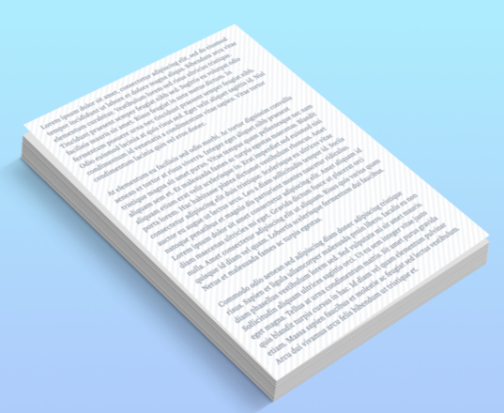
When you see the words the draft strategy in this Easy Read they mean the draft Mental Health and Wellbeing Strategy 2026 – 2036.

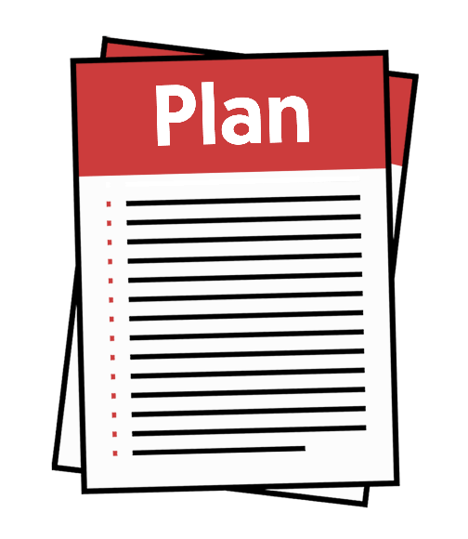
The Mental Health and Wellbeing Strategy will tell the Government what it needs to do to support New Zealanders to have better mental health and wellbeing over the next 10 years.


Mental health and wellbeing
means things like:
feeling good about yourself
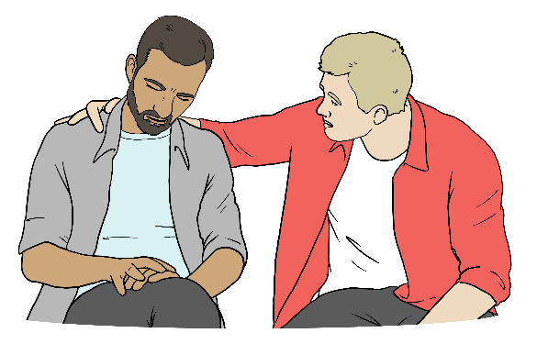
feeling safe
having people in your life who:
- support you
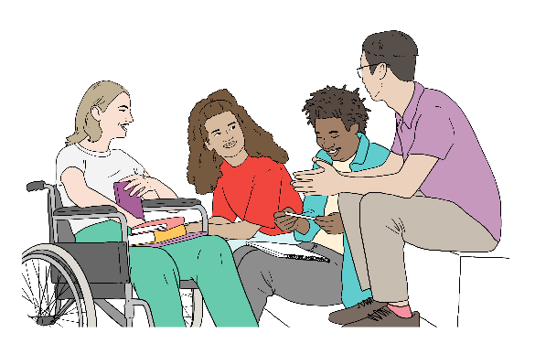
- you trust
- you like spending time with
knowing your life is important.

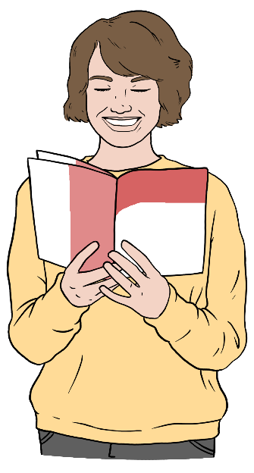
When you see the words the strategy in this Easy Read it means the finished Mental Health and Wellbeing Strategy 2026 – 2036.



This document is Part 2 of 2 consultation documents to find out what you think about the draft strategy.


Here consultation is when we find out what people think about the draft strategy.


Part 1 tells you about:

the main ideas in the draft strategy
the 4 priority areas where things can be changed to make mental health services better
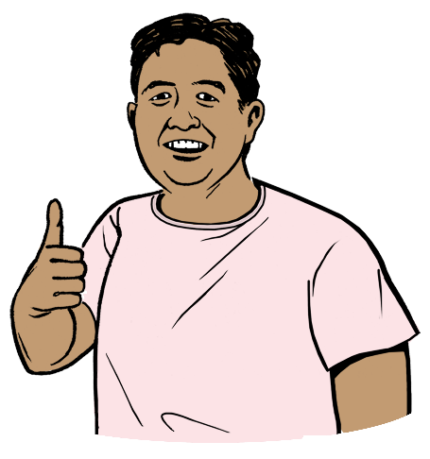
what the future could look like if following the strategy works.
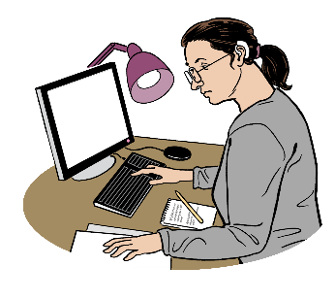
A priority area is a main area where work needs to be done.


The future is time that has not yet happened.

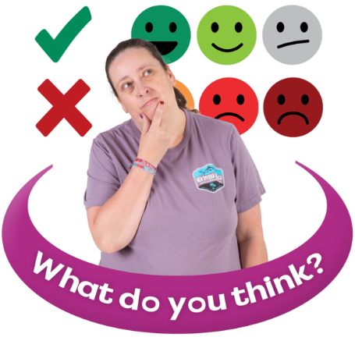
Part 2 tells you how to give us your feedback.


You should read Part 1 first to support you to give us your feedback.

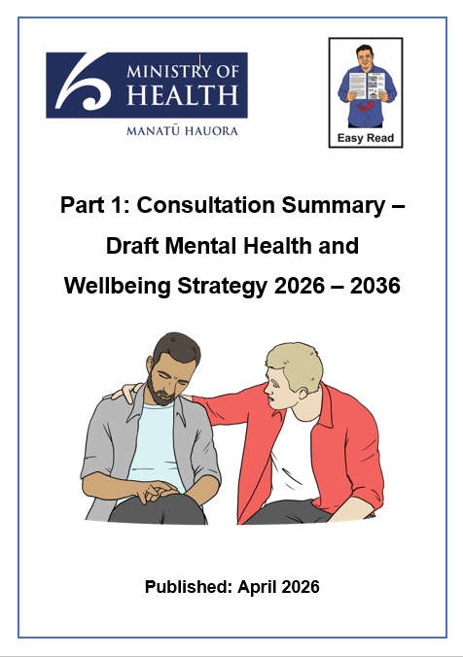
You can read the Easy Read Part 1: Consultation Summary – Draft Mental Health and Wellbeing Strategy 2026 – 2036 at this website:

https://tinyurl.com/38tjk4rv

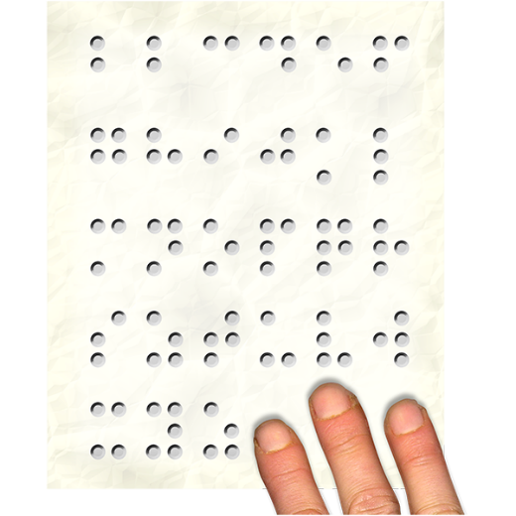
Information about the draft strategy is also in alternate formats like:
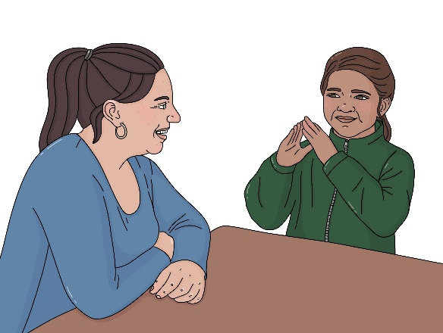
Braille
New Zealand Sign Language.


To view the alternate formats go to our website at:

https://tinyurl.com/38tjk4rv

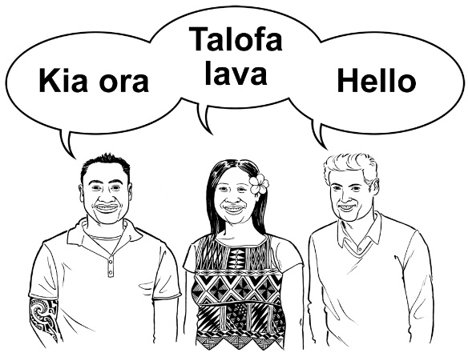
Information about the draft strategy is also in different languages at this website:

https://tinyurl.com/38tjk4rv


You can find the full draft strategy on this website:

https://tinyurl.com/38tjk4rv
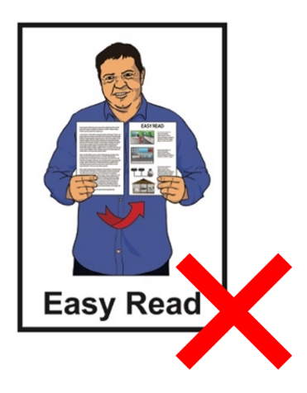

The full draft strategy is not in Easy Read.


The Ministry of Health – Manatū Hauora wrote the draft strategy.

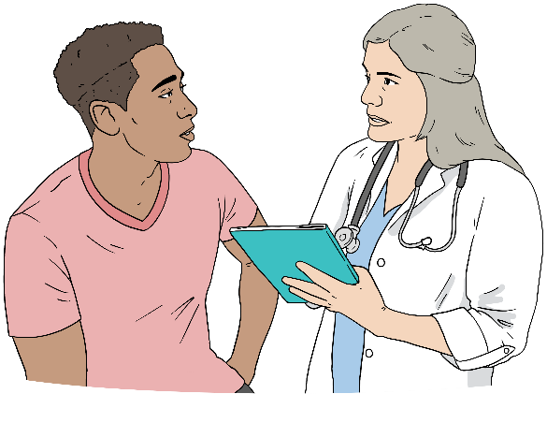
The Ministry of Health – Manatū Hauora is the part of the
Government in charge of making sure everyone in Aotearoa New Zealand can be healthy.

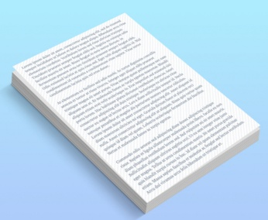
When you see the words we / us
/ our it means the Ministry of Health – Manatū Hauora.

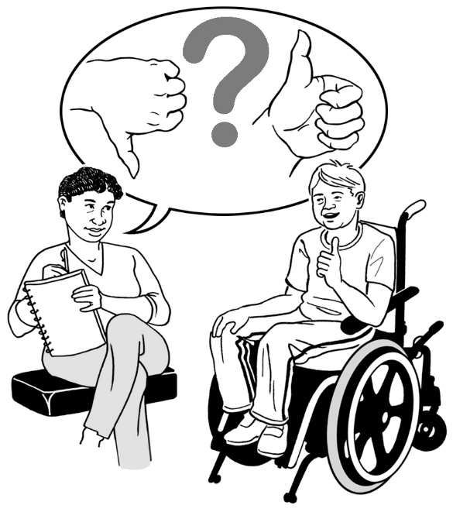
We want to hear your feedback about the draft strategy.

Here feedback means telling us what you think about the draft strategy.


We want to hear what you think about:
the draft strategy
what we need to do to make the things in the draft strategy happen.


We want to hear from lots of different people to make sure the strategy will work for everyone.

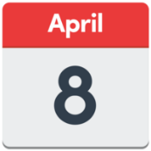
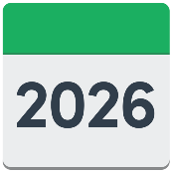
You can have your say from:
8 April 2026
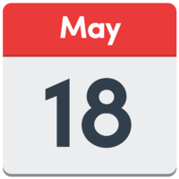
to
18 May 2026.


Go to pages 16 to 19 to find out how to give us your feedback.

Why it is important to get your feedback

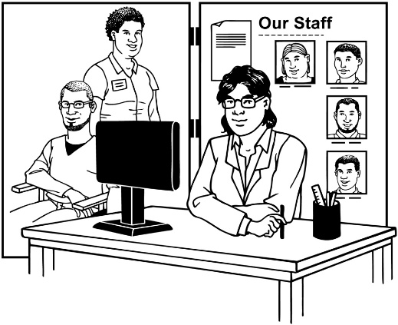
The strategy will affect:
people who use mental health and addiction:

- services
- supports
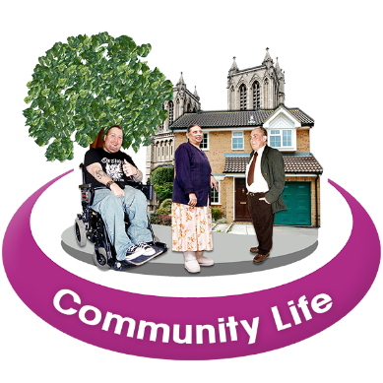
supporters of people using these services like their whānau / families
communities.


Addiction means not being able to stop doing something even if you:
want to stop
will get hurt if you do not stop.


The draft strategy is based on what people have told us is important.

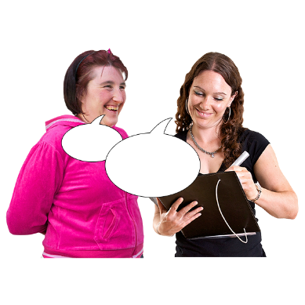
Your feedback will support us to understand what:
matters most to people
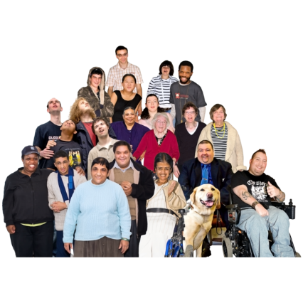
is working well
can be made better
are the first things to do to make the biggest differences.



Finding these things out will support us to make the:
Strategy
- final strategy
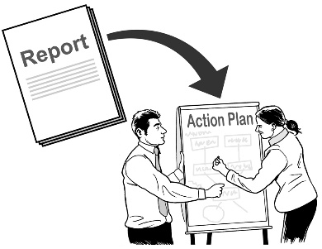
first 3 year implementation plan
/ plan that will make things happen.
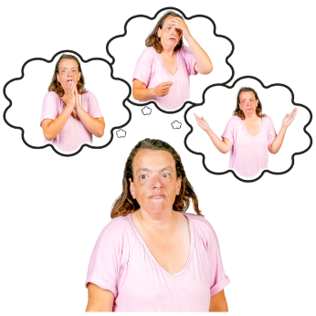
We want to hear from:
people with lived / living experience of mental health and addiction challenges
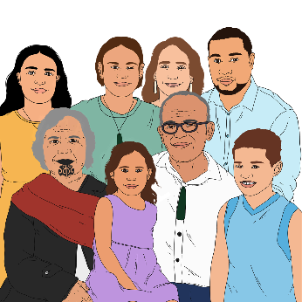
whānau / families of people with mental health and addiction challenges

health workers
social service workers
community workers

community groups
organisations
anyone with an interest in making mental health and wellbeing better for people like reducing:
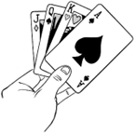
- substance use related harm
- gambling related harm.

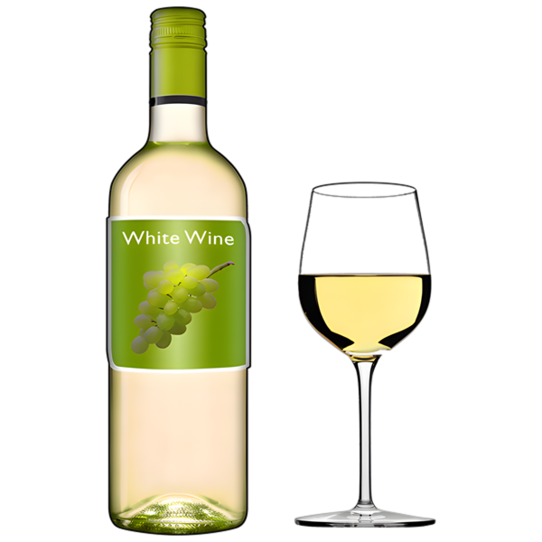
Here substance use means having problems with:
drinking alcohol
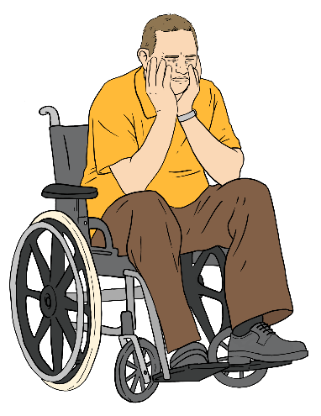
taking drugs.

Substance use can become an addiction.


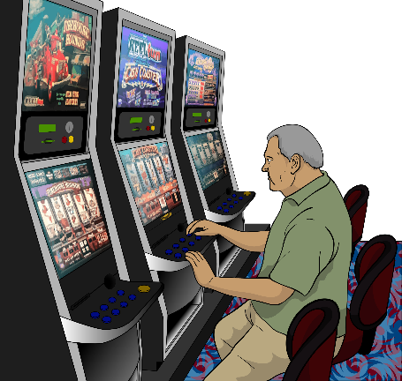
Gambling is spending money on things like:
playing the pokie machines
betting on horse races

playing games at the casino.

Gambling can become an addiction.

How to have your say
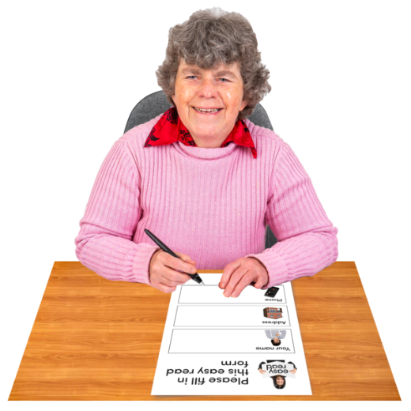


We want you to give us feedback in the way that works for you.

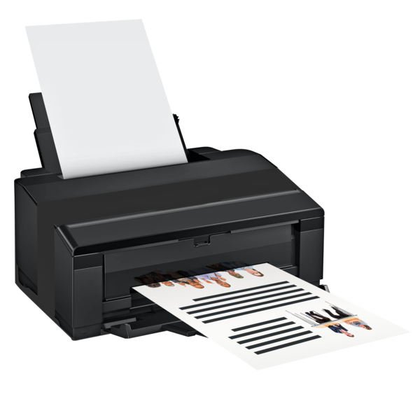
You can give us feedback by answering the questions in this document then:
printing off a copy
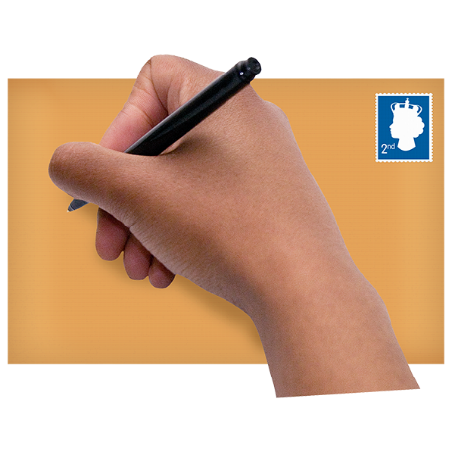
sending your feedback to us at:

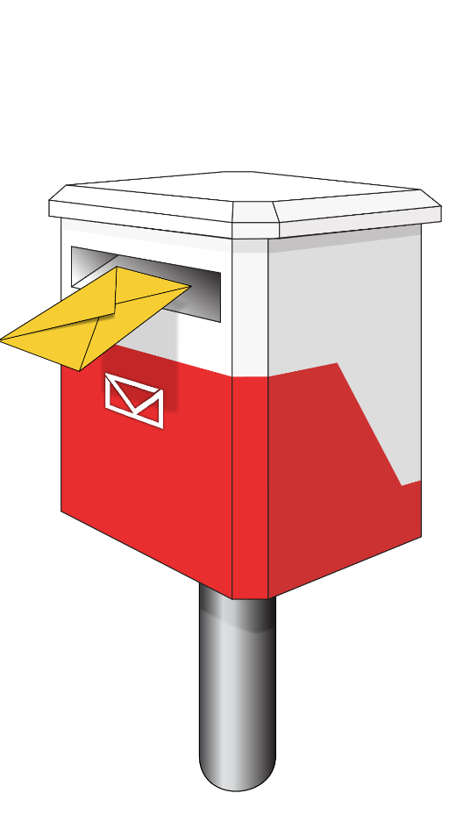
Mental Health and Wellbeing Strategy Consultation

PO Box 5013

Wellington 6140


The questions are on
pages 20 to 37.

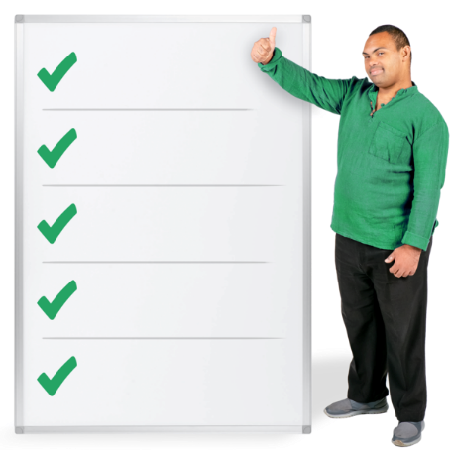
There are also other ways to have your say.

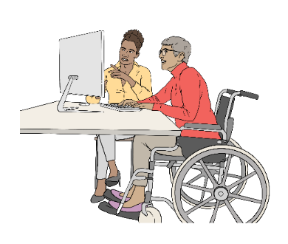
You can read information online at this website then tell us what you think:
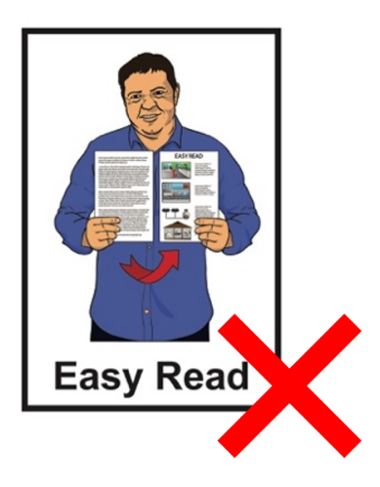
https://consult.health.govt.nz

This website is not in Easy Read.


You can take part in information sessions / meetings for different community groups.

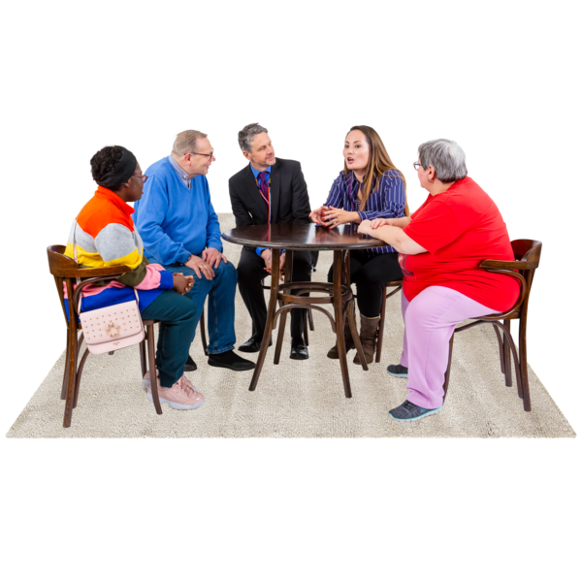
You can also have your say by taking part in community discussions.
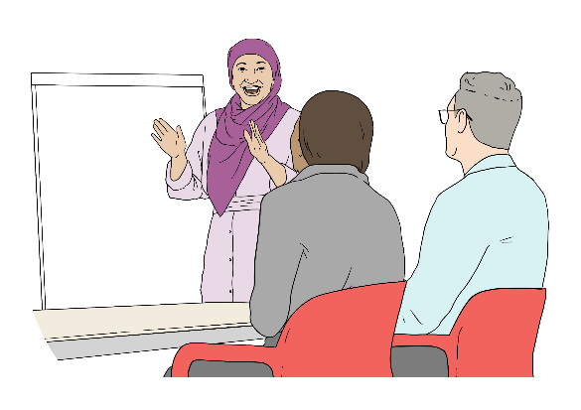
There is a community toolkit that supports you to:
run your own meetings
give your feedback as a group.


There is information about how you can send us feedback at this website:

https://health.govt.nz/mhws-consultation

This website is not in Easy Read.

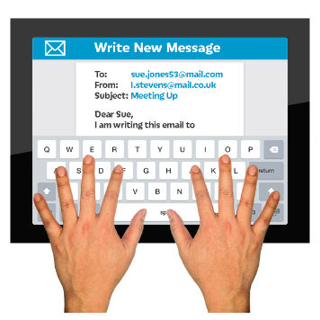
You can also email our team if you:
want to have your say another way
are having problems with having your say.


You can email us at:

mhasp.engagement@health.govt.nz

Questions

There are 9 questions.

You do not have to answer all the questions if you do not want to.
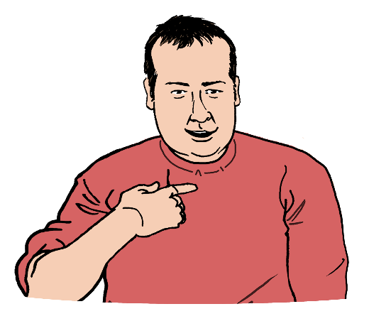

Your answers should be about:
- your own experiences
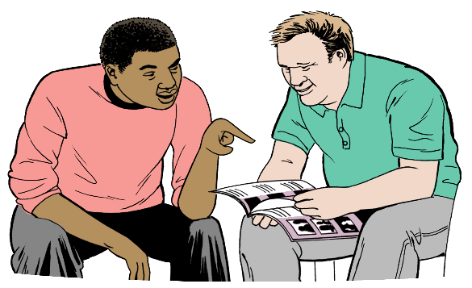
- experiences of people you support
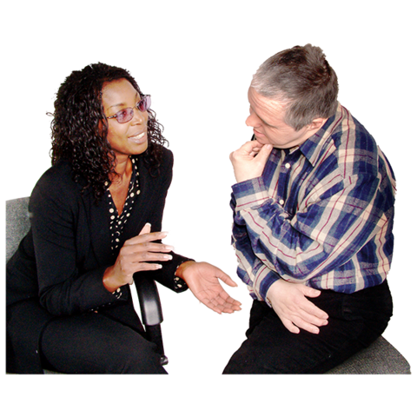
- what you see happening in your community.

You can tell us anything you want to say about the draft strategy.


Question 1

Think about your experiences with:
mental health support
addiction support.

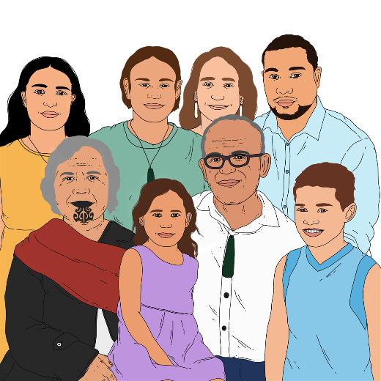
Think about:
people needing the support
whānau / families.


What do you think stops people getting the support they need?
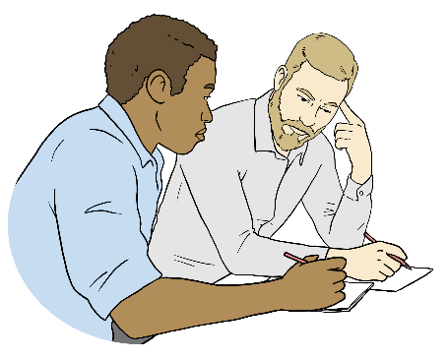
Please put your answer for
Question 1 in the box.

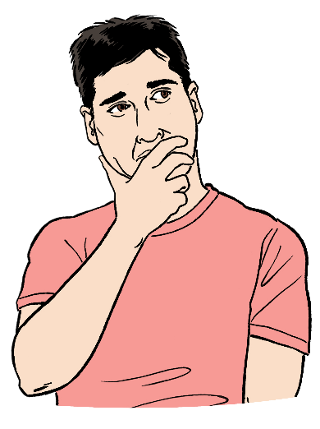
Question 2

Think about your own experiences.

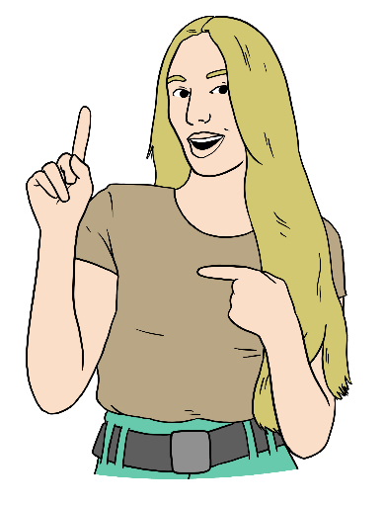
What do you think supports people or
their families the most to:
stay mentally well
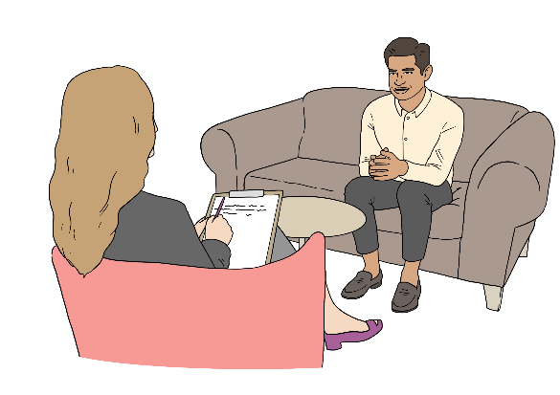
get the support they need for their:
- mental health problems
- addiction problems?
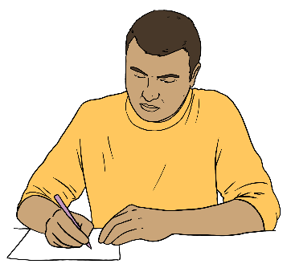

Please put your answer in the box.
Here is more space to put your answer if you need it.

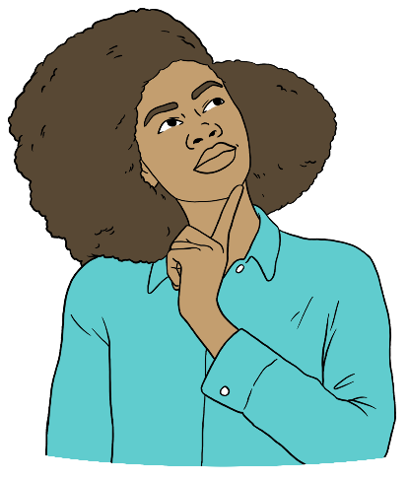
Question 3

What parts of the strategy do you think feel the most:
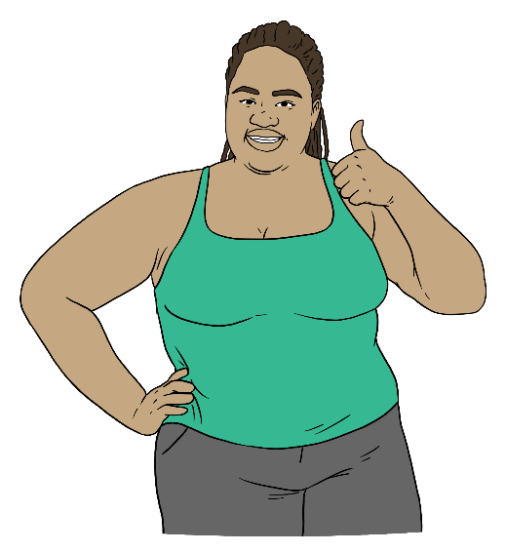
right to you
important to you?

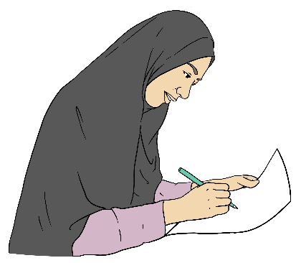
Tell us why you think this.

Please put your answer in the box.

Here is more space to put your answer if you need it.


Question 4

What changes would make the strategy work better for:
people using the mental health and addiction services
whānau / families?

Tell us why you think this.
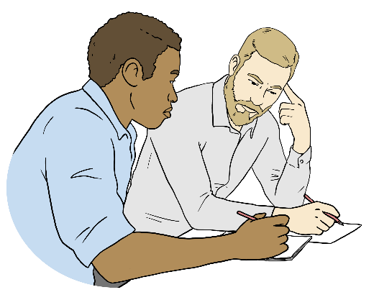

Please put your answer in the box.

Here is more space to put your answer if you need it.

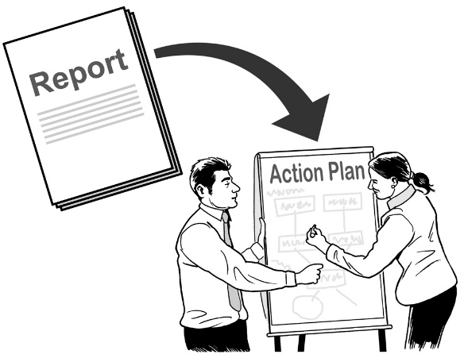
Question 5

The strategy will have an action plan to say what needs to be done to make things in the strategy happen.

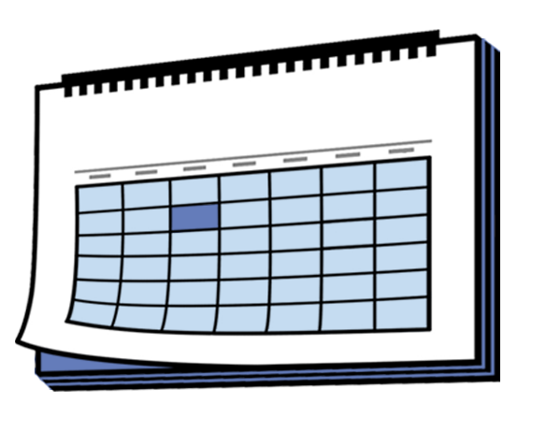
The first action plan will be for
3 years.


This action plan will focus on the things that can make the biggest difference for the mental health and wellbeing of New Zealanders.

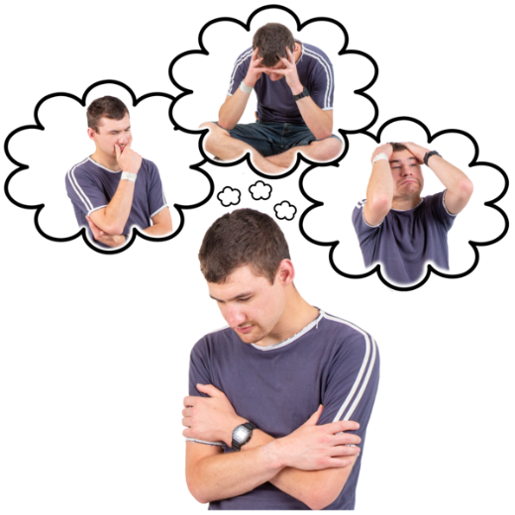
Think about what will make the biggest difference to:
the mental health and wellbeing of people
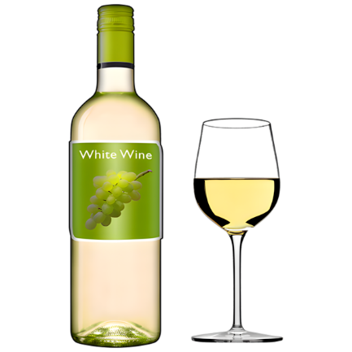
reducing:
- substance use harm
- gambling harm.

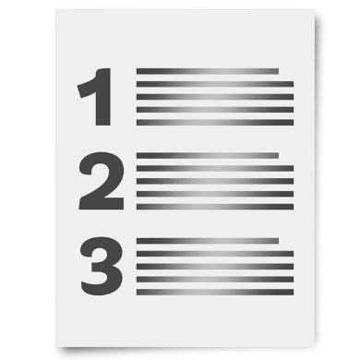
What do you think are the most important things to have in this plan?

Tell us why you think this.

Please put your answer in the box.
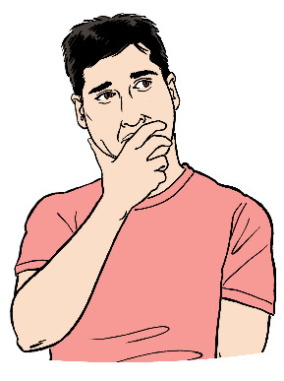
Here is more space to put your answer if you need it.


Question 6

Think of 1 thing we could do to make the biggest difference in the next 3 years.

Please put your answer in the box.


Question 7

We might need to stop doing some things so that we can do:

new things
better things.


What do you think we should:
stop doing
do less of?

Please put your answer in the box.

Here is more space to put your answer if you need it.

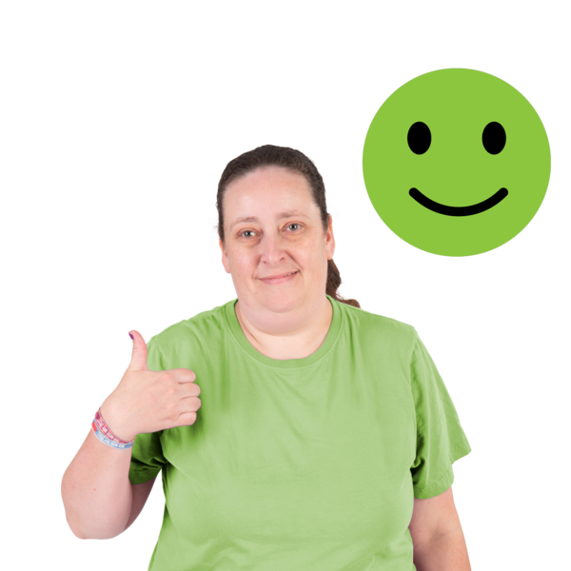
Question 8

We want to make sure the things we do make life better for people.

What things can we use to tell us if the strategy is working well?

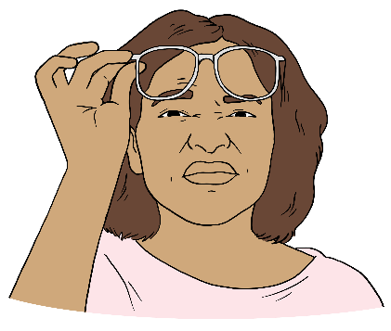
Think about what you would like to:
see

hear
feel.

Please put your answer to Question 8 in the box.

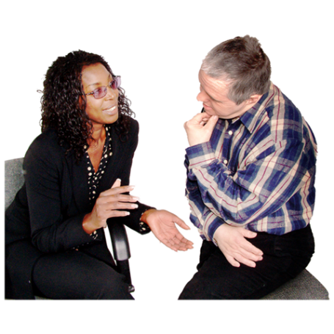
Question 9

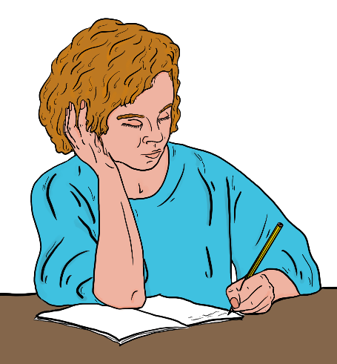
Is there anything else you want to say about the strategy?

Please put your answer in the box.

What will happen next?

After 18 May 2026 we will:
look at all the feedback we get
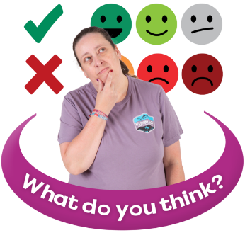
make a summary of the:
- feedback
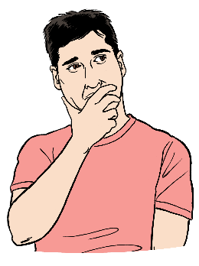
- changes to make the strategy better
think how to make the final strategy better
make the final strategy.


We will share information about:
the final strategy
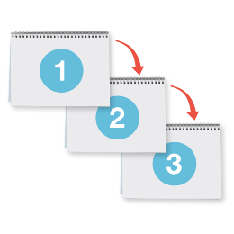
next steps.

We will share this information on our website at:
https://health.govt.nz/mhws-consultation


This information has been written by the Ministry of Health – Manatū Hauora.

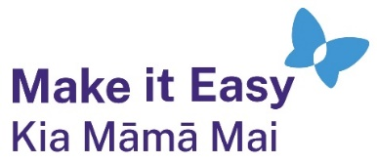
It has been translated into Easy Read by the Make it Easy Kia Māmā Mai service of People First New Zealand Ngā Tāngata Tuatahi.

The ideas in this document are not the ideas of People First New Zealand Ngā Tāngata Tuatahi.

All images used in this Easy Read document are subject to copyright rules and cannot be used without permission.


Make it Easy uses images from:


- Photosymbols

- Change Images


- Huriana Kopeke-Te Aho

- SGC Image Works

- T Wood


- Studio Rebeko

- Inga Kramer.

