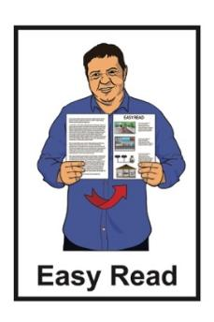


Part 1: Consultation Summary –
Draft Mental Health and Wellbeing Strategy 2026 – 2036
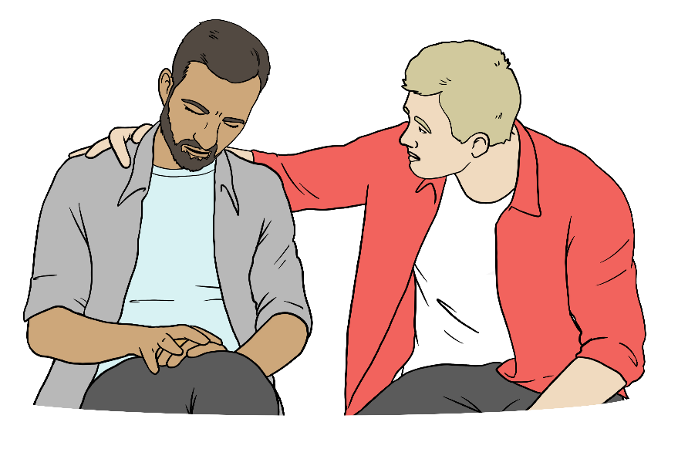

Published: May 2026

Before you start


This information may upset some people when they are reading it.


If you are upset after reading this document you can talk to your:
whānau / family
friends.

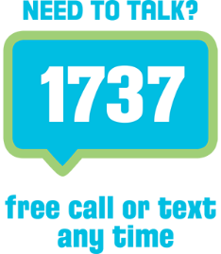
You can also contact Need to Talk by:
calling 1737


texting 1737.

It does not cost any money to call / text 1737.
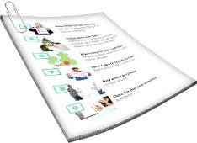
This is a long document.

It can be hard for some people to read a document this long.
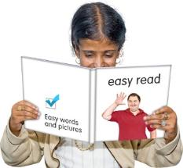

Some things you can do to make it easier are:
read it a few pages at a time
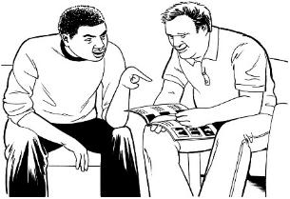
set aside some quiet time to look at it
have someone read it with you to support you to understand it.

What you will find in here

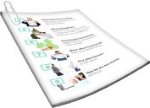
Page number:

About this Easy Read 5
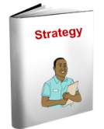

About the Mental Health
and Wellbeing Strategy 14

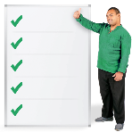
The 4 priority areas 18


Priority 1: Prevention and
early intervention 19

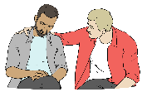
Priority 2: Access to supports
and services 28
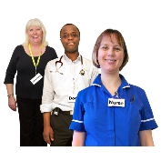

Priority 3: Workforce 33

Page number:

Priority 4: Effectiveness 41
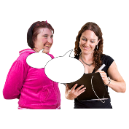

How to have your say 51

About this Easy Read


This Easy Read is a summary of the draft Mental Health and Wellbeing Strategy 2026 – 2036.


Here a summary:
is shorter than the full strategy
tells you the main ideas.


Draft means that this is the first version of the strategy.

There will be changes before the strategy is finished.

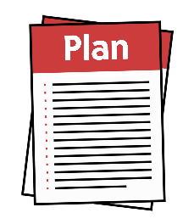
The Mental Health and Wellbeing Strategy will tell the Government what it needs to do to support New Zealanders to have better mental health and wellbeing over the next 10 years.


Mental health and wellbeing
means things like:
feeling good about yourself
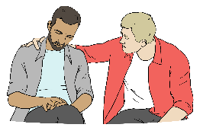
feeling safe
having people in your life who:
- support you
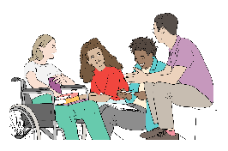
- you trust
- you like spending time with
knowing your life is important.


We call the draft Mental Health and Wellbeing Strategy 2026 – 2036 the draft strategy in this Easy Read.


The Ministry of Health – Manatū Hauora wrote this draft strategy.

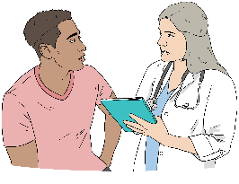
The Ministry of Health – Manatū Hauora is the part of the
Government in charge of making sure everyone in Aotearoa New Zealand can be healthy.

When you see the words
we / us / our it means the Ministry of Health.

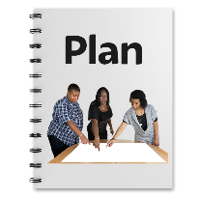
Our draft strategy is a 10 year plan saying how the health system will work to support people to:

feel mentally well
not be hurt so much by:
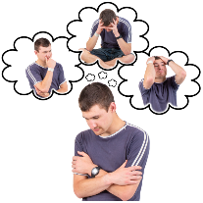
- mental distress
- addiction
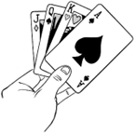
- substance use
- gambling.


Addiction means not being able to stop doing something even if you:
want to stop
will get hurt if you do not stop.



Here substance use means having problems with:
drinking alcohol
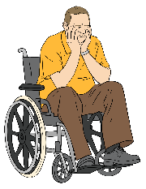
taking drugs.

Substance use can become an addiction.


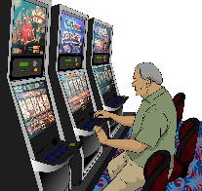
Gambling is spending money on things like:

playing the pokie machines
betting on horse races

playing games at the casino.

Gambling can become an addiction.

We want to hear your feedback about the draft strategy.
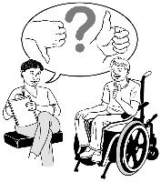
Here feedback means telling us what you think about the draft strategy.


We will use your feedback to decide what should be in the finished strategy.


This Easy Read will support you to:
understand what is in the draft strategy
give feedback about it.



This document is Part 1 of 2 consultation documents to find out what you think about the draft strategy.


Here consultation is when we find out from people what they think about the draft strategy.


Part 1 tells you about:

the main ideas in the draft strategy
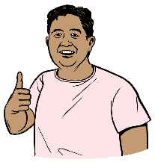
the 4 priority areas where things can be changed to make mental health services better
what the future could look like if following the strategy works.

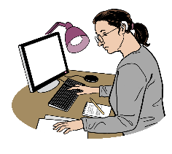
A priority area is a main area where work needs to be done.


The future is time that has not yet happened.

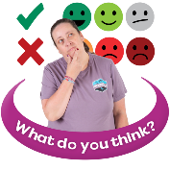
We are getting feedback on this strategy from:
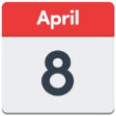
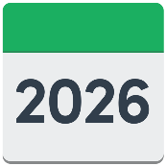
8 April 2026
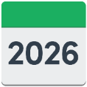

to
18 May 2026.

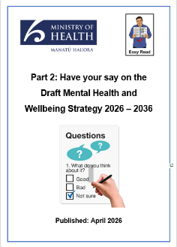
Part 2: Have your say on the Draft Mental Health and Wellbeing Strategy 2026 – 2036 tells you where you can give us your feedback.


You can read Part 2 when you have finished reading Part 1.


You can read Part 2 at this website:

https://tinyurl.com/38tjk4rv

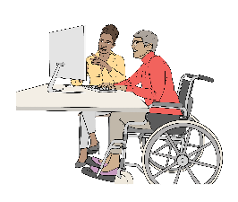
You can find the full draft strategy on this website:

https://tinyurl.com/38tjk4rv
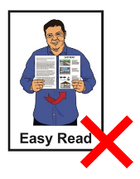

The full draft strategy is not in Easy Read.

About the Mental Health and Wellbeing Strategy

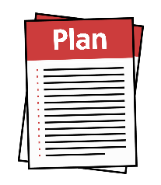
The Mental Health and Wellbeing Strategy is part of a set of strategies that will guide the health system to:

plan what health services are needed
invest / put money into health services
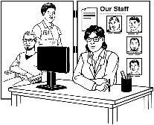
deliver / give services
work to support people to also have good physycal health.

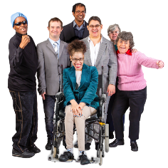
The vision for this strategy is that
all New Zealanders are supported in the ways they need to:
thrive

experience positive / good mental health and wellbeing
have good physical health.


Here vision means the main things the Government wants to make happen.


Here thrive is for people to have the support they need to be able to live their best life.


The finished strategy:
looks at how well the health system is working now

says what:
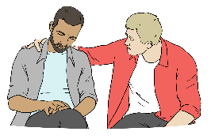
- changes might happen in the future
- hard things we may face in the future
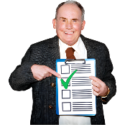
says what needs to change to get better outcomes / results.

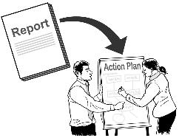
An implementation plan will say the steps we will take to do this work.


Here implementation plan means the steps to take to get the work set out in the strategy done.


The health system cannot do this work alone.

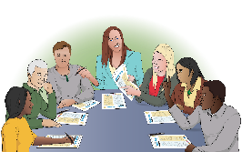
Many groups need to work together like:
other government agencies
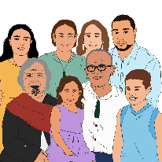
whānau / families
iwi / tribes
Māori partners

community groups
voluntary groups
businesses / workplaces.


Here voluntary means you are not getting paid money to do something.

Working together will support mental health and wellbeing to be better for everyone.

The 4 priority areas

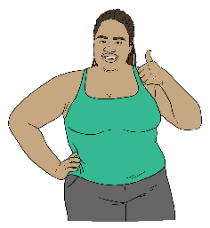
Working in the 4 priority areas will make the biggest difference for the mental health and wellbeing of
New Zealanders.

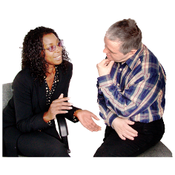
We tell you about each of these 4 priorities on the next pages.

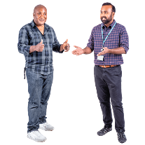
For each priority area the summary tells you:
why it is important
what the future could look like if this work is done
strategic actions / the main work to be done.

Priority 1: Prevention and early intervention


Prevention means stopping people from having a hard time with their mental health and wellbeing.


Early intervention means
supporting people as soon as they start having a hard time with their mental health and wellbeing.
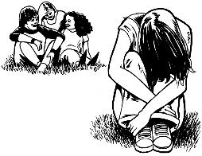

Early intervention can stop problems from getting worse.

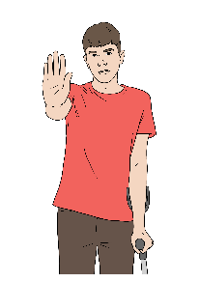
This priority is about helping people earlier to:
- prevent problems
- stop problems from getting worse.

Priority 1 focuses on:
supporting mental wellbeing
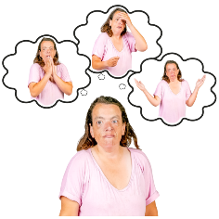
reducing the bad effects of:
- mental distress
- addiction
- substance use
- gambling
working with other places to support people to stay:
- safe
- well.

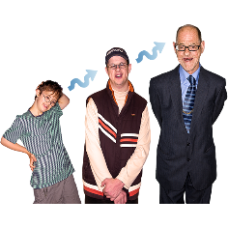
It is very important to support people:
early in life
during important parts of life.

What the future will look like

We want the future to be where:
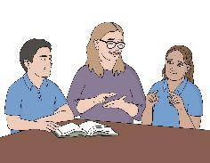
mental wellbeing is supported in everyday places like:
- schools
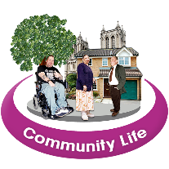
- workplaces
- communities
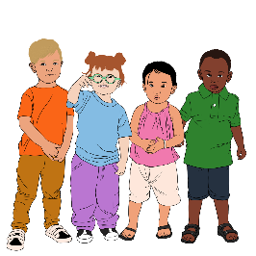
people can get early intervention when they need it like for:
- children
- young people.
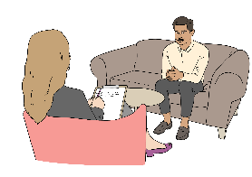
We also want the future to be where:
everyone has the ability to:
- look after their own mental wellbeing
- support others with their mental wellbeing
the health system works with other services to make things better for people like their:
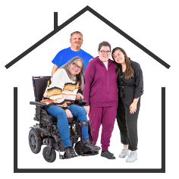
- social conditions like having a safe place to live
- environmental conditions like having a healthy
house / place to live in
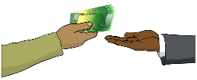
- financial conditions like having the money to get the support they need.


It is important that the culture of a person is thought about when they are being supported in the health system in the future.

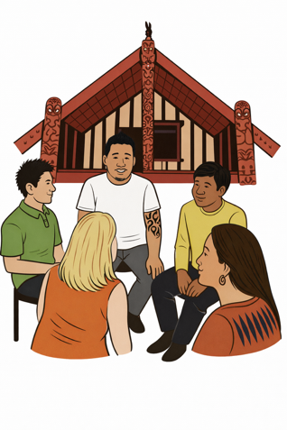
Culture is a way of:
thinking that a group shares
doing things as a group.
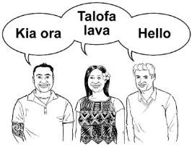

There are many different cultures in
Aotearoa New Zealand like:
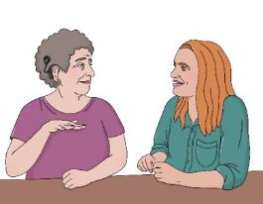
Māori culture
Deaf culture.


Strategic actions
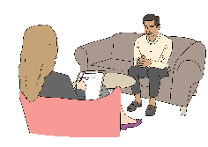
- Make strong programmes that:
support wellbeing
make people understand things better like about:

- mental health
- addiction
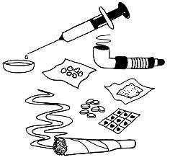
- gambling
- harm caused by substance use.


This work will focus on communities needing the most support.
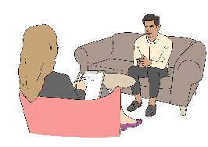
- Make it easier for people to get support when problems first start with:
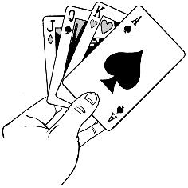
mental health
substance use
gambling.
- Use programmes made with good evidence to:
prevent / stop suicide
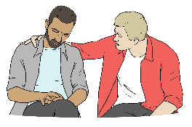
support people after a suicide
reduce harm from:

- drugs
- alcohol
- gambling.

Here evidence is information that has been proven / shown to be correct.
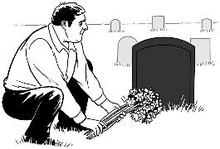

Suicide is what we call it when a person ends their own life.

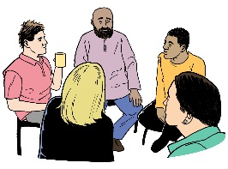
- Have more support for people with mental health and addiction problems like some:
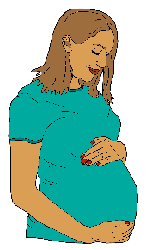
pregnant people
parents of young children
whānau / families.
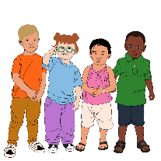
- Make ways for people to find the right support for:
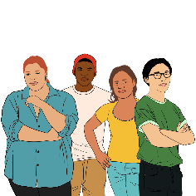
children
young people.
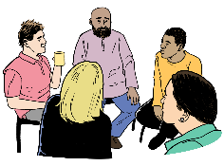
- Make sure people are supported when they:

are using mental health and addiction services
stop using mental health and addiction services.

This support can be about people getting:

the housing they need
employment / a job.

Priority 2: Access to
supports and services


This priority is about making sure services:
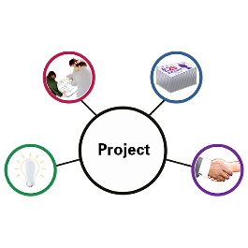
are easier to access / get
are better connected to each other
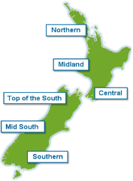
work for people as soon as they need them
work in the same way around the country.

What the future will look like

People can get the right support when they need it.

Support is joined up to meet the needs of people:
for different services
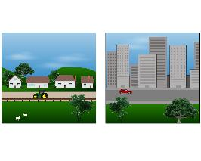
at different parts of life
no matter where they live.
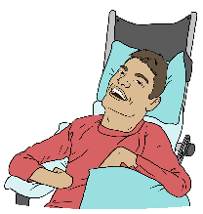

People with many different needs get support when they need it.

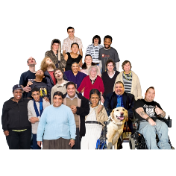
Communities get the support that:
is right for them
means they can look after their own mental wellbeing.


Strategic actions
- Make more ways to support people in the community so they get the services they need.

- Make more ways for people to use digital / online tools to support their:
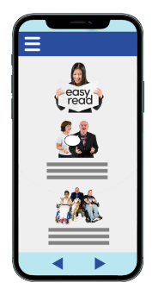
mental health
problems with addictions.

A digital / online tool can be something like telehealth.



Telehealth is a way to get healthcare services online using your:

phone
computer.

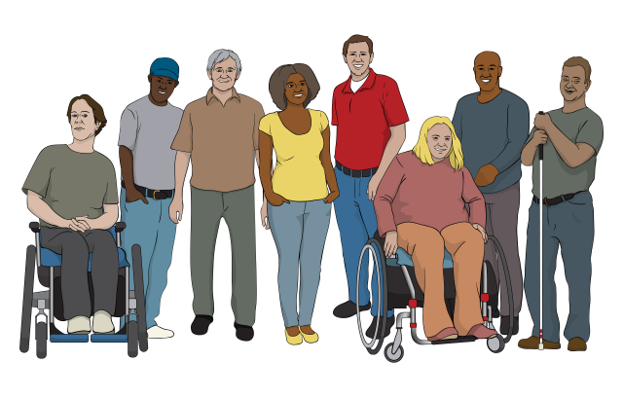
- Provide services that:
are safe
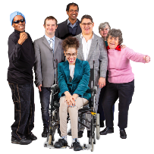

are trauma informed
are accessible / can be used by everyone
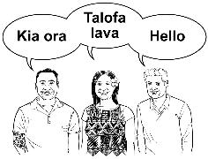
work for different cultures
work for people with different needs.


Trauma is the way someone may respond after something very bad has happened.


Trauma informed means doing something in a way that:
understands what trauma is
is safe.
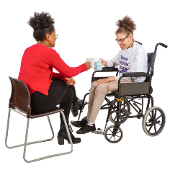
Make sure people are well supported when they move between different services to support their mental wellbeing.


- Work together to make good ways to support people by:
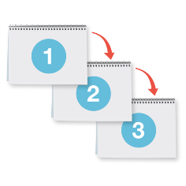
having clear ways of doing things
keeping on making services better
making sure everyone in the country has access to the services they need.

Priority 3: Workforce

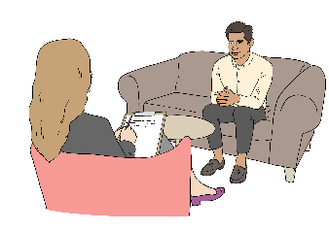
Here workforce means all the people who work to support other people with their mental health and wellbeing.

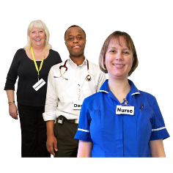
This priority is about having enough skilled people in the workforce to provide:
mental health support
addiction support.


It focuses on making sure workers:

feel valued like feeling you are important
feel they are good at their job
are able to do their jobs well.

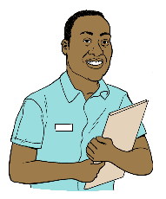
What the future will look like

We want the workforce to be made up of people:

from different cultures
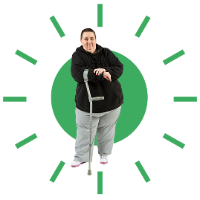
with the skills they need
who put the people they are supporting at the centre of their work.
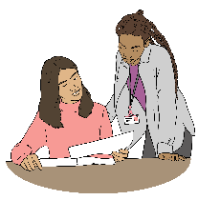

There are more roles / jobs for:
peers
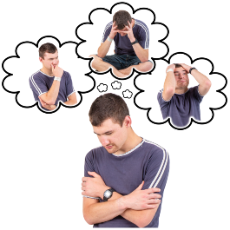
people who:
- live with mental health challenges
- have had mental health challenges.

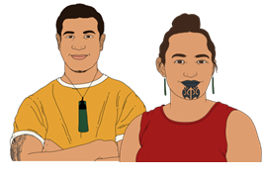
Here a peer is a person who comes from the same community as you.

We want workers to be supported to stay:

well
safe.

This means people will want to:

do the jobs
stay in the jobs.
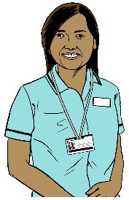

That way the mental health system can meet the growing / changing needs of people.


We want people to get support from teams that can work together to care for their:
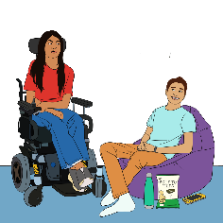
mental health needs
physical needs
social needs.

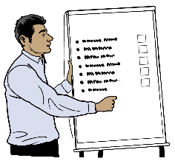
Strategic actions
- Grow the workforce by having:

chances to do more training
ways for workers to do well in their jobs
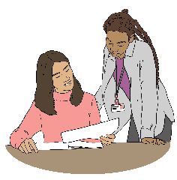
internships
student placements.


An internship is when somebody works at a place to get job experience.

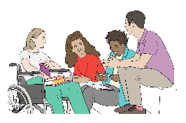
Student placements are where students can learn while they are doing the job.

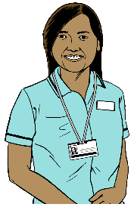
- Make roles / jobs that support people with different health problems so workers can use all their skills.
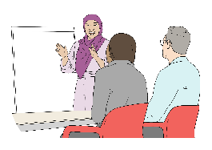
- Train the workforce to:
give better quality care

have the right skills to care for people in the right way
work in different ways to support people

do things in a safe way that works for the culture of each person.
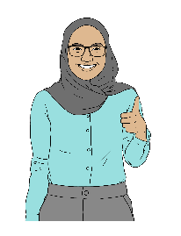
- Make sure mental health and addiction services are good places to work.
Doing this will make more people want to:

- work in these services
- stay working in these services.

- Have a diverse workforce like having people who are from:
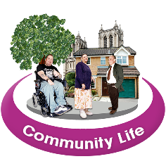
- different cultures
- the communities the services are working for.

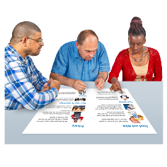
- Do better for the:

consumer workforce
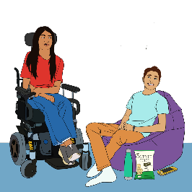
- peer support workforce
- lived experience workforce.
This will let them be a bigger part of the mental health system.
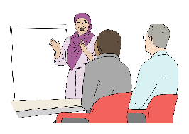
- Support the workforce to get the skills they need to be able to:
- understand what services a person needs
- get people the services they need.

Priority 4: Effectiveness


Here effectiveness means that mental health and wellbeing support works well.

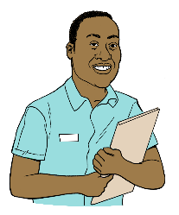
This priority is about making mental health and addiction services better like:

the quality of care
keeping people safe.


Priority 4 focuses on care that:
people can trust

respects the rights of people
is guided by people with lived experience
keeps improving / getting better.

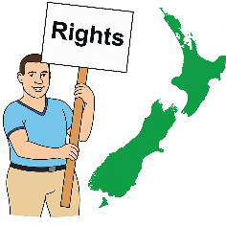
Rights are things that the law says every person should:
have
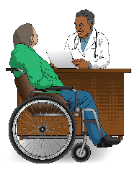
be able to do.

Rights can be something like getting the healthcare you need.


A law is a rule made by the Government that everyone must follow.

What the future will look like

We want people to see the mental health and addiction system as:
safe to use

effective
welcoming
respecting their rights.


We want more of the decisions in the mental health and addiction system being made by people who are:
people with lived / living experience
peers.

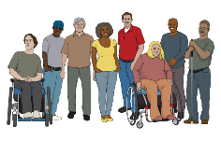
We want the experience of these people to be valued.

We want to see places working together in the system to learn from things like:
evidence
research
experiences.


We want to see a system that can change when:
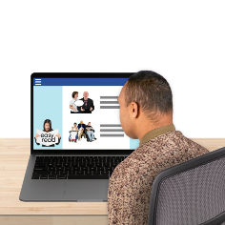
the needs of people change
technology changes.

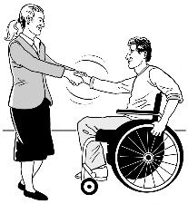
Strategic actions
- Build strong systems to:

support people with lived experience to have jobs as leaders in the system
include people when putting together / providing support services like:
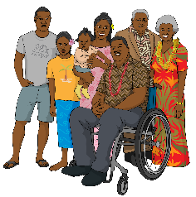
- whānau / families
- communities where people are getting the services.
- Find ways to stop the discrimination of people with mental health and addiction challenges / problems.

Here discrimination is when people are treated unfairly because of things like their:
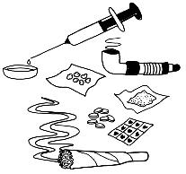
mental health problems
addiction problems.
- Get better quality
data / information to find out:
what is working
where changes are needed.
- Use data / information to find out where support is needed around the country.
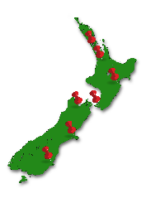

This will support the health system to put money in the right places to make services better.
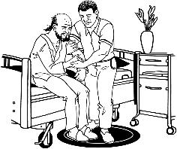
- Make compulsory care better by:
not using it as much

making sure people are not in compulsory care for very long
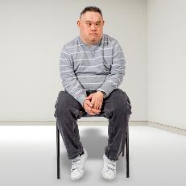
working to stop the use of:
- seclusion
- restraint.

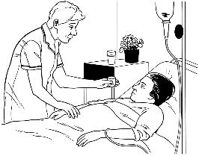
Compulsory care is when someone is made to go to a place like a hospital when they have a mental health or addiction problem.

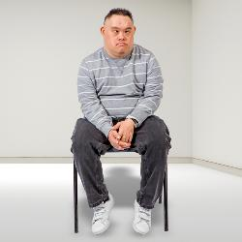
Seclusion is when mental health workers put someone in a room on their own.

It is usually used to stop people from getting hurt.

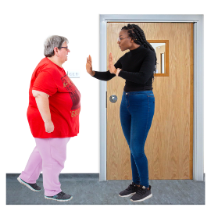
Restraint is when mental health workers stop someone from moving for example by:
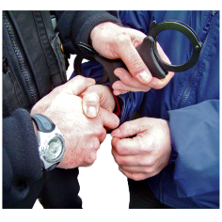
holding them on the ground
putting them in handcuffs.


Restraint can be used to stop someone from hurting:
themselves
other people.

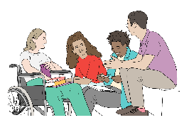
- Support health service providers to work for the needs in their community.
This can be done by doing things like finding:

ways to fund / pay for services in partnerships with other places
better ways to check results / see how things turn out.


- Make the facilities / places where people go for their mental health and addiction care:
safer to use
better quality.


- Make better ways for the mental health system to get new information.

This will support the workforce to respond to / look after people better.

How to have your say

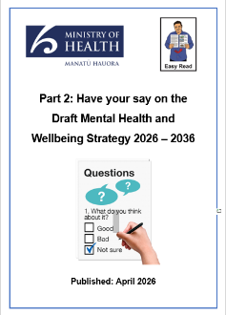

We want to hear what you think about the draft Mental Health and Wellbeing Strategy.

Your feedback will support us to:
make the final strategy
guide the actions that will happen after the strategy comes out.


You can tell us what you think in
Part 2: Have your say on the Draft Mental Health and Wellbeing Strategy 2026 – 2036 at this website:

https://tinyurl.com/38tjk4rv

We need to get your feedback by
18 May 2026.


This information has been written by the Ministry of Health – Manatū Hauora.

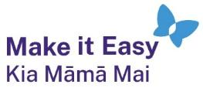
It has been translated into Easy Read by the Make it Easy Kia Māmā Mai service of People First New Zealand Ngā Tāngata Tuatahi.

The ideas in this document are not the ideas of People First New Zealand Ngā Tāngata Tuatahi.

All images used in this Easy Read document are subject to copyright rules and cannot be used without permission.


Make it Easy uses images from:

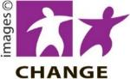
- Photosymbols

- Change Images


- Huriana Kopeke-Te Aho

- SGC Image Works

- T Wood


- Studio Rebeko

- Inga Kramer.

