Greenhouse Gas Emissions for the 2024/25 Financial Year
Report and inventory

Acknowledgements
Prepared by: Manager Property and Facilities
Approved by: Group Manager Risk & Resilience
The Group Manager Risk & Resilience in the Corporate Services Directorate is responsible for this report. For any inquiries on the GHG emissions report and inventory, please email sustainability@health.govt.nz.
Verification status: Reasonable for all categories.
Citation: Ministry of Health. 2025. Greenhouse Gas Emissions for the 2024/25 Financial Year: Report and inventory. Wellington: Ministry of Health.
Published in April 2025 by the Ministry of Health
PO Box 5013, Wellington 6140, New Zealand
ISBN 978-1-991324-82-5 (online)
HP 9167


This document is available at health.govt.nz
 | This work is licensed under the Creative Commons Attribution 4.0 International licence. In essence, you are free to: share ie, copy and redistribute the material in any medium or format; adapt ie, remix, transform and build upon the material. You must give appropriate credit, provide a link to the licence and indicate if changes were made.

Contents
Introduction 1
Our commitment 2
Statement of intent 2
Organisation description 3
Base year selection 3
Organisational and operational boundaries included for this reporting period 4
Operational boundaries excluded from the inventory 6
GHG emissions sources included 7
GHG emissions sources excluded 9
Data collection and uncertainties 11
Greenhouse gas emissions report summary 13
Calculations and results 13
Variances from base year 15
Conclusion 16
Reduction plan 16
Appendix A: The Ministry of Health Greenhouse Gas Emissions Inventory 17
Appendix B: The Ministry of Health 2024/25 Audit Certification 18

List of Figures
Figure 1: Organisational boundaries 5
Figure 2: Summary of GHG emissions sources included in the
inventory by category 8
Figure 3: GHG emissions by category, 2024/25 14
Figure 4: GHG emissions by source, 2024/25 14
List of Tables
Table 1: Brief description of properties included in Ministry of Health
operational boundaries 5
Table 2: Brief description of properties excluded from operational boundaries 6
Table 3: Brief description of properties excluded from operational boundaries 9
Table 4: Details of GHG emissions sources included 11
Table 5: GHG emissions summary, 2024/25 13
Table 6: Emissions variances in 2024/25 compared with base year 15

Introduction
This document provides the financial year 2024/25 (1 July 2024 to 30 June 2025) report and inventory for the greenhouse gas (GHG) emissions of the Ministry of Health – Manatū Hauora (the Ministry).

The inventory has been prepared in accordance with the requirements of:
- the Carbon Neutral Government Programme
- the GHG Protocol
- International Standard ISO 14064-1:2018 and with guidance from:
- the Ministry for the Environment – Manatū mō te Taiao
- the Ministry of Business, Innovation and Employment – Hīkana Whakatutuki.

The inventory report (Appendix A) and any GHG assertions are verified by a
third-party verifier. Once verified, the assurance statement is attached to this report and inventory (Appendix B).

Our commitment
This GHG emissions inventory forms part of the Ministry’s commitment to measure and manage our emissions in support of the Carbon Neutral Government Programme.

The data reported in this inventory guides our sustainability work programme and will inform our Emissions Reduction Plan 2025/26.

Statement of intent
The Ministry’s initial aims for our Carbon Neutral work programme were to:
- be carbon neutral by 2025
- measure, manage, verify and report on our emissions each year
- reduce our emissions and implement an Emissions Reduction Plan by the end of 2025 with a 1.5°C target reduction pathway
- optimise our vehicle fleet to electric vehicles or hybrids where practicable
- build or lease energy-efficient buildings with NABERSNZ ratings of no less than 4 stars (or for new builds, 5 stars) for government office accommodation over 2,000 m²
- offset remaining emissions where it is impractical to reduce them.

Having reached the end of 2025, the Ministry is waiting for guidance from the Ministry for the Environment regarding advice for the offsetting of remaining emissions.

Organisation description
As kaitiaki of the health and disability system, the Ministry has a stewardship role and responsibility to sustain, nurture, grow and develop the system. It steers improvements that help New Zealanders live longer, healthier and more independent lives.

The Ministry funds an array of national services (including disability support services and public health services) and provides clinical and sector leadership.

The Ministry ensures that the health and disability system is delivering on the Government’s priorities, and that health sector organisations are well governed and soundly managed from a financial perspective.

To do this, the Ministry:
- advises the government
- funds, monitors and drives the performance improvements of health sector Crown entities, including Health New Zealand – Te Whatu Ora (Health NZ)
- supports the planning and accountability functions of health sector Crown entities, including Health NZ
- regulates the sector and ensures it is meeting legislative requirements.

The Ministry is made up of directorates and business units, each with its own functions and areas of responsibility.

The property portfolio under the operational control of the Ministry operates across New Zealand from Auckland through to Christchurch in various property types.

Base year selection
In determining the base year, the Ministry of Health has consulted with the Ministry for the Environment and other government agencies and agreed that due to the variabilities that the COVID-19 pandemic presented, the base year should fall before March 2020. For this reason, the base year for the Ministry’s GHG emissions reports is 1 March 2019 to 29 February 2020.

Where it was impractical to source data for the base-year period, data from an alternative time period (as close to the base year as possible) was sourced to best represent ‘business as usual’ for those specific emissions sources as noted in the inventory.

Organisational and operational boundaries included for this reporting period
‘Organisational boundaries’ refer to the legal composition of an organisation and determine whether the Ministry has direct control over the sources of its emissions.

The organisational boundaries at the time of the base year (1 March 2019 to 29 February 2020) were set with reference to the methodology described in the GHG Protocol standard.

The GHG Protocol allows for two approaches to consolidate GHG emissions: the equity share (financial) approach and the control (operational) approach. For the purposes of the Ministry’s reporting, the control approach has been used to account for emissions.

For the purposes of carbon emissions reporting to the Carbon Neutral Government Programme, it has been agreed that Cancer Control Agency – Te Aho o Te Kahu (CCA) is included in the Ministry’s organisational boundaries.

Figure 1 represents the structure of the operational boundaries defined in the GHG emissions inventory, which includes all owned and leased properties directly under the operational control of the Ministry, or co-located premises where noted. Table 1 briefly describes those properties.
Figure 1: Operational boundaries

National Office
Wellington (including CCA)
National
Laboratory Christchurch
Ministry of
Health operational boundaries
Regional
Office Auckland
CCA
Palmerston North
National
Storage Facility

Note: CCA = Cancer Control Agency – Te Aho o Te Kahu.

Table 1: Brief description of properties included in Ministry of Health
operational boundaries
Property | Address | Description
National Office | Wellington | The National office is an approx. 15,500sqm office building in the fringe Wellington CBD. The Ministry holds the lease and currently is responsible for all carbon reporting and carbon inventory. Note this site includes other agencies with a significant area utilised by Health NZ.
Regional Office | Auckland | Regional Ministry office
National Laboratory | Christchurch | Former National Radiation Laboratory building (currently unoccupied)
CCA Office | Palmerston North | Small office in Palmerston North in a larger complex.
National Storage Facility | Manawatū | National storage facility

Operational boundaries excluded from the inventory
Table 2 describes the properties that have been leased recently or have produced no emissions (within the financial year 2024/25). They are not relevant to the base year from which this report and GHG emissions inventory are consolidated. For transparency, this table provides an overview of the current state of the property portfolio and indicates the potential to include these properties in future GHG reports and inventories.

Some properties (for example, co-located tenancies) do not sit under the operational control of the Ministry. However, if it is possible to source the emissions data of these properties, future GHG emissions reports will note the relevant portion of their emissions outputs in line with their associated categories. If this is not achievable, each lead agency will report its emissions inclusive of its co-located tenants.
Table 2: Brief description of properties excluded from operational boundaries
Property | Address | Description
Hamilton | 16 Clarence Street | Cancer Control Agency – Te Aho o Te Kahu:  Not under operational control; however, the agency agreement sits with the Ministry. Due to the small number of staff (4–5), this site has been excluded from this report.
Christchurch | 32 Oxford Terrace | Cancer Control Agency – Te Aho o Te Kahu: Not under operational control and has no influence over the operation of this building. Due to the small number of staff (4–5), this site has been excluded from the inventory.
Christchurch | 48 Hereford St | Small number of staff remained in an area which was previously leased by Health NZ. The Ministry then took on a short-term lease from January 2025–30 June 2025.

GHG emissions sources included
The GHG emissions sources included in this inventory were identified with reference to the methodology described in the GHG Protocol and International Standard ISO 14064-1:2018.

The emissions sources are also referenced in the Ministry for the Environment’s Measuring Emissions: 2025 Detailed Guide. This guide specifies the various types of
emissions the organisation would typically report on, depending on what type of organisation it is and its operational functions.

As adapted from the GHG Protocol, the emissions were classified under the following categories:
- direct GHG emissions (Category 1): emissions from sources that the agency owns or controls
- indirect GHG emissions from imported energy (Category 2): emissions from the generation of electricity, heat and steam that the agency purchases and consumes
- indirect GHG emissions from transportation (Category 3): emissions that occur as a consequence of the agency’s activities but from transportation sources that the agency does not own or control
- indirect GHG emissions from products an organisation uses (Category 4): emissions that occur as a consequence of the agency’s activities but from product sources that the agency does not own or control.

Figure 2 lists the actual emissions sources relevant to the Ministry’s operational boundaries that have been identified and included in the GHG emissions inventory under each of the above categories.
Figure 2: Summary of GHG emissions sources included in the inventory by category
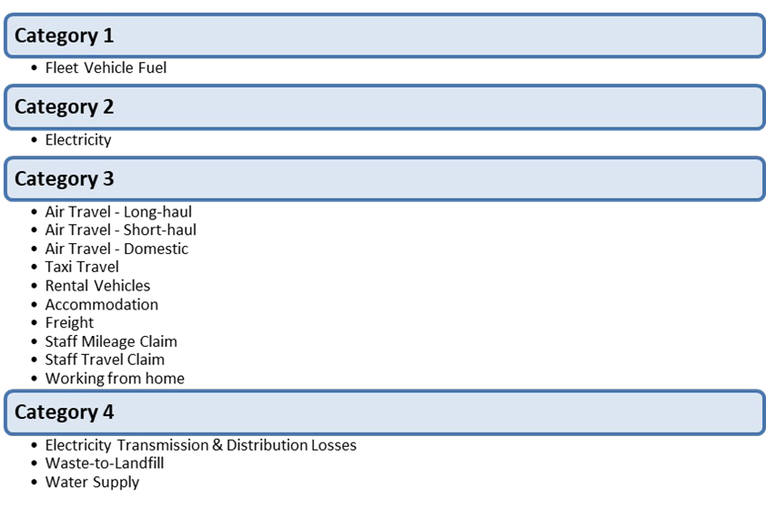

GHG emissions sources excluded
Table 3 identifies the emissions sources for the financial year 1 July 2024 to 30 June 2025 that have been excluded from the operational boundaries.

Where a property is considered to be outside of the Ministry’s operational control, the emissions sources may be de minimis (too trivial or minor to be worth considering) and will be reported as an exclusion. For example, this applies to the small co-located tenancies shown in table 2.

Various factors may be involved in the decision to exclude an emissions source relevant to the Ministry’s organisational boundaries for the 2024/25 year. These include but are not limited to:
- the type of lease agreement in place
- the practicality of sourcing the emissions
- total occupied space
- the number of full-time equivalent staff (FTE) in the premises
- an emissions source that is less than 1% of the total emissions within that source and not greater than 5% of the total emissions.

Table 3: Emissions sources excluded
Property | Address | Reason | Source
Categories 2  and 4 | 32 Oxford Terrace, Christchurch | Cancer Control Agency – Te Aho o Te Kahu: Not under operational control and has no influence over the operation of this building. The number of staff at this site is low (4–5) and this site forms part of Health NZ emissions inventory. | Electricity Waste to landfill Water supply Wastewater
Categories 2  and 4 | 16 Clarence St, Hamilton | Cancer Control Agency – Te Aho o Te Kahu: Not under operational control and has no influence over the operation of this building. The number of staff at this site is low (4–5) and this site forms part of Health NZ emissions inventory. | Electricity Waste to landfill Water supply Wastewater
Categories 2  and 4 | 48 Hereford St Christchurch | Emissions from July 2024 to December 2024 were under the operational control of Health NZ. From January 2025 to June 2025 building lease sat with Ministry of Education. | Electricity Waste to landfill Water supply Wastewater
Category 4 | All sites | Data for the base year had been sourced for the largest building and extrapolated on a square-metre basis for all other sites and was found to be de minimis. | Water supply
Category 4 | All sites | As water supply was found to be de minimis, wastewater has also been considered de minimis. | Wastewater

Data collection and uncertainties
Table 4 provides an overview and an explanation of any uncertainties or assumptions. The calculation methodology has been used to quantify the emissions inventory based on emissions source activity data, multiplied by the emissions factors. For further detail on how the data was sourced, see the GHG emissions inventory (Appendix A). All emissions factors have been sourced from Ministry for the Environment guidance, specifically through the Ministry for the Environment’s 2025 Emission Factors Workbook, an Excel document accessed through Measuring Emissions: A guide for organisations: 2025 detailed guide.

Table 4: Details of GHG emissions sources included

Business unit | Activity | Category | Data source | Data unit | Uncertainty / Assumption (description)
All | Fleet fuel | Category 1 | Fuel card monthly summary and monthly fuel invoices | Litre | The Fleet card summary is cross-checked with fuel card invoices for accuracy and completeness. As a result, the amount of uncertainty is limited.
All | Purchased electricity | Category 2 | Smart Power report | kWh | Smart Power receives, verifies and pays all energy bills on behalf of the Ministry, using a strong internal quality-assurance process. As a result, the amount of uncertainty is limited.
All | Electricity transmission and distribution losses | Category 4 | As above | kWh | As above
All | Air travel | Category 3 | Tandem, reconciliation reports | Passenger km (pkm) | Tandem reconciles and processes all of the Ministry’s invoices for flights, accommodation and rental cars and can only charge back against an approved booking. Therefore, all data would have been approved in the report. As a result, the amount of uncertainty is limited.
All | Accommodation | Category 3 | Tandem, reconciliation reports | Room/night
All | Rental vehicles | Category 3 | Tandem, reconciliation reports | km

Business unit | Activity | Category | Data source | Data unit | Uncertainty / Assumption (description)
All | Taxi travel | Category 3 | Taxi charge summary report | km | It is assumed the report is complete and accurate. Kilometres are used for consistency across the inventory, and default emissions factors are used. The amount of uncertainty is moderate.
All | Freight | Category 3 | CourierPost emissions report | Tonne-km (tkm) and other | It is assumed the report is complete and accurate, especially because Toitū audited and certified CourierPost’s calculation. As a result, the amount of uncertainty is limited.
All | Freight | Category 3 | Kiwi Express | km | It is assumed the report is complete and accurate. Kiwi Express could not provide accurate weight of vehicles used but provided accurate type of vehicle used and kilometres travelled. Therefore, the road freight emissions factors for light vehicles has been used. As a result, the amount of uncertainty is moderate.
All | Working from home | Category 3 | Attendance record from security record for Wellington office and FTE reports. Assumptions provided by the Ministry | Employee per day | As the Ministry has no formal ways to measure the number of employees working from home per day, the amount of uncertainty is reasonable.
All | Use of private car (for work related purposes) | Category 3 | Staff expenses financial report | km | Estimated assumption is based on national vehicle ownership data to determine the split between petrol (91%) and diesel (9%) for light passenger vehicles. Inland Revenue conversion rate from dollars to kilometres was used. Default emissions factors were used. As a result, the amount of uncertainty is moderate.
All | Air travel | Category 3 | Staff expenses financial report | pkm | A number of assumptions have to be made as the expenses claim report was not detailed enough. As a result, the amount of uncertainty is reasonable.
All | Taxi | Category 3 | Staff expenses financial report | $
All | Accommodation | Category 3 | Staff expenses financial report | Room/night
All | Waste to landfill | Category 4 | Waste Management customer sales transaction report | kg | It is assumed the report is complete and accurate, especially because Toitū audited Waste Management’s process. Emissions factors with gas recovery have been used because waste in all Ministry’s sites includes landfill with gas recovery. As a result, the amount of uncertainty is limited.

Greenhouse gas emissions report summary
Table 5 shows the Ministry’s total emissions for the period 1 July 2024 to 30 June 2025. For a complete and quantified breakdown of this information, see the GHG emissions inventory (Appendix A).

Table 5: GHG emissions summary, 2024/25
Category | CO₂ | CH₄ | N₂O | HFCs | PFCs | SF₆ | Total t CO₂-e
Category 1: Direct | 2.14 | 0.03 | 0.07 | 0.00 | 0.00 | 0.00 | 2.238
Category 2: Direct | 112.79 | 3.14 | 0.22 | 0.00 | 0.00 | 0.00 | 116.145
Category 3: Indirect | 457.00 | 1.59 | 2.19 | 0.00 | 0.00 | 0.00 | 460.780
Category 4: Indirect | 8.67 | 28.87 | 0.02 | 0.00 | 0.00 | 0.00 | 37.555
Total | 580.608 | 33.624 | 2.485 | 0.00 | 0.00 | 0.00 | 616.717
Note: CO₂ = carbon dioxide; CH₄ = methane; N₂O = nitrous oxide; HFCs = hydrofluorocarbons;
PFCs = perfluorocarbons; SF₆ = sulphur hexafluoride; t CO₂-e = metric tonnes of carbon dioxide equivalent.

Calculations and results
Figure 3 provides the total of the Ministry’s emissions in each of the four emissions categories.

Figure 3: GHG emissions by category, 2024/25
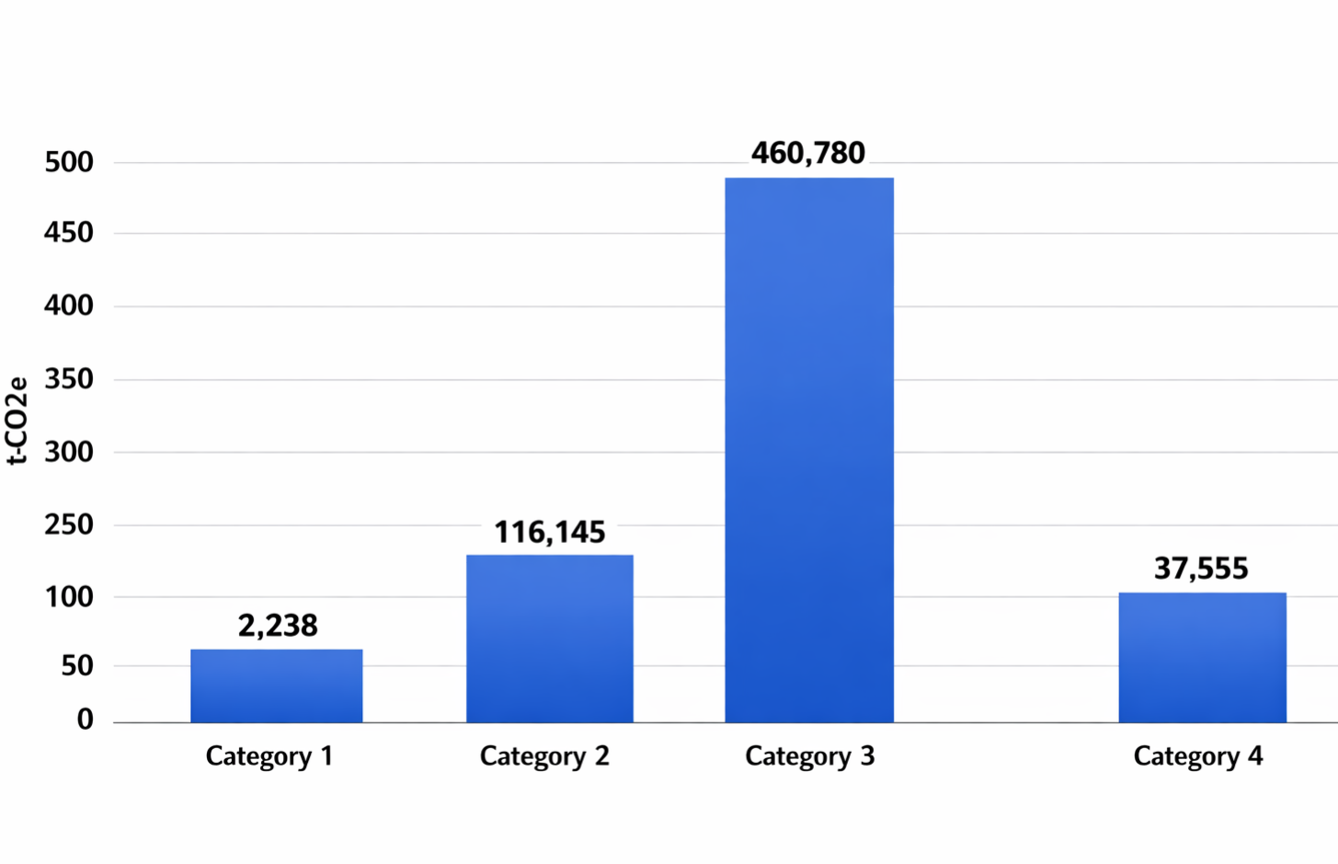

Note: t CO₂-e = metric tonnes of carbon dioxide equivalent.

Figure 4 provides the total of the Ministry’s emissions for each source.
Figure 4: GHG emissions by source, 2024/25
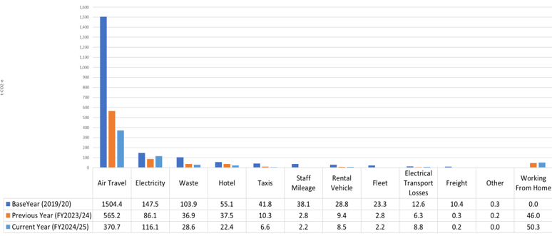

Note: FY = financial year; t CO2-e = metric tonnes of carbon dioxide equivalent.

Variances from base year
This report concludes that, for the financial year 1 July 2024 to 30 June 2025, the Ministry’s highest emissions source is air travel.

Table 6 shows how the Ministry’s total emissions for the 2024/25 financial year differ from the base-year emissions. Air travel contributed the highest amount of emissions.

Table 6: Emissions variances in 2024/25 compared with base year
Emissions source | 2024/25 emissions (t CO2-e) | Emissions variance from base year  (t CO2-e) | % variance from base year
Working from home | 50.3 | +50.3 | 100%
Freight | 0.2 | -10.2 | -98%
Fleet | 2.2 | -21.1 | -90%
Electricity transmission and distribution losses | 8.8 | -3.8 | -30%
Rental vehicles | 8.5 | -20.3 | -71%
Taxis | 6.6 | -35.3 | -84%
Use of private cars | 2.2 | -35.9 | -94%
Waste to landfill | 28.6 | -75.3 | -72%
Accommodation | 22.4 | -32.7 | -59%
Electricity | 116.1 | -31.3 | -21%
Air travel | 370.7 | -1133.7 | -75%
Total | 616.7 | -1349.5 | -69%

Conclusion
It was evident from earlier emissions inventories that air travel and associated emission factors had a significant influence on overall emissions from the Ministry. The implementation of specific travel guidance and business rules, along with ongoing changes and familiarity with technology, has allowed people to interact without travel. These changes have led to a sustained reduction in travel-related carbon emissions.

The Ministry is pleased to have reached and surpassed our 2025 carbon emissions reduction target. Having reached the end of 2025, we are waiting for guidance from the Ministry for the Environment on the offsetting of remaining emissions.

Having successfully met our 2025 carbon emissions reduction target, we now propose further initiatives, as outlined in the plan below, to support achieving a similar outcome by 2030.

Reduction plan
As this report provides a framework for the Ministry to measure, verify and report on our emissions every year, we are continuing to operate a reduction plan with an ongoing 1.5°C target reduction pathway.

Some of the planned initiatives are to:
- continue to improve internal processes to produce accurate and complete reporting
- investigate the potential for reducing emissions from electrical sources, by purchasing and operating higher-efficiency electricity devices
- further investigate self-generation of electricity through solar panels at sites and on buildings (where possible)
- conduct a study on the waste-to-landfill process to maximise recycling.

Appendix A: The Ministry of Health Greenhouse Gas Emissions Inventory
See attached.

Appendix B: The Ministry of Health 2024/25 Audit Certification
See attached.

New Zealand Government. 2020. Public sector to be carbon neutral by 2025. Releases. URL: www.beehive.govt.nz/release/public-sector-be-carbon-neutral-2025 (accessed 07 August 2025). Greenhouse Gas Protocol. About us. URL: ghgprotocol.org/about-us (accessed 08 August 2025).
Greenhouse Gas Protocol. About us. URL: ghgprotocol.org/about-us (accessed 08 August 2025).
International Organization for Standardization. 2018. ISO 14064-1:2018: Greenhouse Gases – Part 1: Specification with guidance at the organization level for quantification and reporting of greenhouse gas emissions and removals. URL: www.iso.org/standard/66453.html (accessed 08 August 2025).
In line with the Government’s policy for reducing emissions – see New Zealand Government Procurement (nd) Reducing government fleet emissions. URL: www.procurement.govt.nz/guides/broader-outcomes/reducing-emissions-and-waste/reducing-government-fleet-emissions/ (accessed 08 August 2025).
National Australian Build Environment Rating System New Zealand – NABERSNZ: https://www.nabersnz.govt.nz/about-nabersnz/background/
Greenhouse Gas Protocol (nd) The Public Sector GHG Accounting and Reporting Standard, Provisional draft. URL: ghgprotocol.org/sites/default/files/standards_supporting/provisional-draft.pdf (accessed 08 August 2025).
Ministry for the Environment. 2025. 2025 Emission Factors Workbook. Accessed through Measuring Emissions: URL: https://environment.govt.nz/assets/publications/Measuring-Emissions-Guide-2025/EmissionFactors_Workbook_2025_2.xlsx
Ministry for the Environment. 2025. 2025 Emission Factors Workbook. Accessed through Measuring Emissions: A guide for organisations: 2025 detailed guide. URL: https://environment.govt.nz/publications/measuring-emissions-guide-2025/ – accessed on 08 August 2025.

