Action Plan to Prevent and Reduce Substance Harm 2026 – 2029

Citation: Ministry of Health. 2026. Action Plan to Prevent and Reduce Substance Harm 2026 – 2029. Wellington: Ministry of Health.
Published in March 2026 by the Ministry of Health
PO Box 5013, Wellington 6140, New Zealand
ISBN 978-1-991324-78-8 (online)
HP 9072
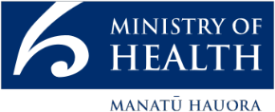
This document is available at health.govt.nz
 | This work is licensed under the Creative Commons Attribution 4.0 International licence. In essence, you are free to: share ie, copy and redistribute the material in any medium or format; adapt ie, remix, transform and build upon the material. You must give appropriate credit, provide a link to the licence and indicate if changes were made.

Foreword from Minister for Mental Health
The Government’s mental health and addiction plan is delivering faster access to addiction support, more frontline workers, and a better crisis response.

The Government is investing more each year to prevent and reduce substance-related harm and strengthen the services that people rely on to combat the harm caused by addiction.

The first alcohol levy increase since 2009 has been used to deliver the new approach to FASD with activities to help prevent FASD, improve diagnosis and support, and strengthen services for affected families.

Substance harm has devastating consequences for individuals, families, and communities. Methamphetamine in particular continues to destroy lives and tear families apart. That is why the Government has resourced a new comprehensive action plan to combat meth harm, to grow the number of services and strengthen support for those affected.

We know we can’t wait until someone is in active addiction to act. Early intervention is critical. That is why we have expanded early intervention services in communities and rolled out Screening and Brief Intervention Practitioners across seven hospitals. These roles help ensure that people using meth, alcohol, or other drugs are identified early within the health system and connected with the right support they need. We have also launched a nationwide campaign aimed at preventing people from starting methamphetamine use and ensuring that those who need help know where to find it.

We are expanding pregnancy and parenting support services for women and families affected by addiction, establishing a community-based peer follow-up service for people leaving emergency departments after substance-related presentations, and investing in community-based mutual aid services for individuals and families.

This plan also strengthens the frontline workforce that supports people experiencing substance-related harm. We are growing the number of frontline practitioners,
creating earn-as-you-learn opportunities for new practitioners, and providing training to upskill the workforce in responding to methamphetamine harm.

Our frontline workforce does incredible work, often under challenging circumstances.
We are backing them so they can continue supporting New Zealanders experiencing substance-related harm.

We are already seeing progress. Wait times are decreasing, the frontline workforce has grown by more than 11 percent since we came into Government, and vacancy rates have fallen significantly. Vacancies among drug and alcohol counsellors have dropped from more than 14 percent in September 2023 to 5.5 percent in September 2025.
This has meant more people have been able to be seen quicker, with the latest results from December 2025 showing 75.9% of people are accessing specialist addiction services within 3 weeks.

We continue this momentum by setting out the health response to substance-related harm for the next three years. Informed by people with lived experience, community leaders, practitioners and researchers. It provides a clear and accountable roadmap to improve the system so we can ultimately ensure better outcomes for all New Zealanders.

The sector has long called for the actions within this plan, and I am pleased to be able to deliver.

Hon Matt Doocey
Minister for Mental Health

Contents
Foreword from Minister for Mental Health iii
Scope and purpose 1
Why do we need an action plan for substance-related harm? 2
Roadmap of actions 3
Increasing the focus on prevention and early intervention 3
Improving access to services 5
Growing the workforce 7
Increasing the effectiveness of the system 9
References 10
Appendix 1: Summary of stakeholder engagement feedback 12
Appendix 2: What we know about substance-related harm in New Zealand 16

List of Figures
Figure 1: Key population groups with moderate or high risk of problematic substance use (2021/22 to 2022/23) 17
Figure 2: Self-reported illicit substance use in past 12-months 19
Figure 3: National Drugs in Wastewater Testing Quarter 3, 2025 estimated consumption volume 20
Figure 4: Proportion of New Zealanders who report using alcohol and/or illicit substances in the past 12 months (2024/25) 21
Figure 5: Proportion of New Zealanders who report using alcohol and/or illicit substances in the past 12 months (2024/25), by age category 21
Figure 6: Proportion of New Zealanders who report using alcohol and/or illicit substances in the past 12 months (2024/25), by gender category 22
Figure 7: Rate of service users accessing specialist alcohol and other drug treatment services per 1,000 population, by age group and region of domicile, 2024 23
Figure 8: Rate of people accessing specialist alcohol and other drug treatment services per 1,000 population, by ethnic group and calendar year, 2019 – 2024 23
List of Tables
Table 1: Experiences of substance harm by population groups in New Zealand 18

Scope and purpose
Substance harm refers to the negative health, social, and economic impacts associated with the use of alcohol and other substances. Drivers of substance-related harm are influenced by a range of individual and social factors, many of which are outside the influence of the health system, such as employment and engagement with education. However, the health system plays a critical role in prevention, treatment, and recovery.

The health system is already taking meaningful steps to address these challenges. The Fetal Alcohol Spectrum Disorder (FASD) Action Plan 2025–2028 outlines targeted health-led activities to prevent and reduce fetal alcohol spectrum disorder. This work is supported by annual Alcohol Levy investment decisions, which fund wider alcohol-harm prevention efforts across the country. In addition, 2025 saw the development of a dedicated health system response to rising methamphetamine-related harm, following a sharp and concerning increase in methamphetamine consumption. Together, these initiatives form a strong foundation for a more comprehensive response.

This Action Plan (the Plan) builds on that foundation. It sets out the overarching health system response for the next three years, bringing together the actions initiated in 2025 with a suite of new commitments. This Plan provides a clear, system-wide roadmap for preventing and reducing substance-related harm, ensuring that efforts across health entities are aligned, coordinated, and grounded in shared priorities.

This Plan also sits within a broader strategic landscape. It will sit underneath the overarching strategic framework and vision that will be set through the Mental Health and Wellbeing Strategy and also sits alongside other dedicated strategies and action plans, ensuring coherence across the wider system.

Importantly, the Plan has been informed by engagement with a wide range of perspectives, including people with lived experience (including families and whānau), Māori service providers, NGO providers, addiction treatment practitioners, harm-reduction and specialist services and organisations representing population groups that experience disproportionate risks of harm from substance use. A summary of their feedback is provided in Appendix 1.

The Plan commits to specific actions to address pressing concerns and challenges within the health system relating to substance harm. Noting the opportunity for further actions to be considered as part of the development of the Mental Health and Wellbeing Strategy.
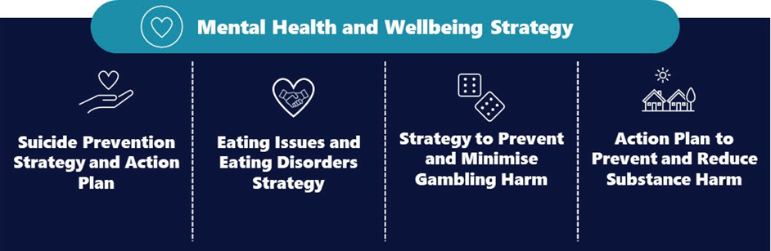

Why do we need an action plan for substance-related harm?
Substance harms can be acute, such as injury or overdose, or long term, including chronic disease, cancer, and cognitive decline. Harms can affect both the person using the substance, as well as those around them, and can contribute to issues such as family violence, homelessness, and economic insecurity. Around one in four New Zealanders use substances in a way that increases their risk of experiencing harm.

New Zealand’s drug landscape has changed significantly over time, with a wider range
of illicit substances now available than ever before. Historically, the types of substances people used reflected the difficulty of importing into New Zealand. However, the infiltration of transnational organised crime has expanded the range of illicit substances available nationwide, and lowered their cost.

At the same time, the digitisation of the illicit drug market combined with the rise of new synthetic substances has made high risk substances more accessible while also increasing uncertainty about their contents and effects. Many of these emerging substances are so new we know very little about them, leaving gaps in knowledge about how to prevent or treat related harms. This has resulted in a highly unpredictable drug market that is contributing to rising rates of overdose and other serious health impacts. At the same time, use of high potency, dependence forming substances such as methamphetamine and cocaine has also climbed sharply. These trends are intertwined with broader social and health inequities, including housing instability, low income and coexisting mental or physical health conditions.

Measuring substance-related harm is challenging because of its wide-reaching personal, family and community impacts. New Zealand’s Drug Harm Index provides a way to estimate the economic and social costs of illicit substance-related harm, noting the real costs are likely higher. Using this measure, the estimated costs are significant and growing. In 2023, social harms from illicit substances were estimated at $1 .941 billion, up $37 million since 2020. This increase reflects the growing presence of more harmful substances, including powdered heroin and G-type substances, alongside a more volatile illicit drug market.

Alcohol remains the most widely used and socially accepted substance in New
Zealand, and the most harmful overall across economic, health, and social domains.
The risk of harm is particularly high at key developmental stages, including during pregnancy and for children and young people.

More information and data about substance- related harm in New Zealand is included in Appendix 2.

Roadmap of actions
New Zealand offers a range of health services and supports for people experiencing, or at risk of experiencing, substance-related harms. This includes services focused on preventing and reducing the risk of harm such as school- based education programmes, needle exchange programmes, and free drug checking services, as well as specialist community and residential treatment services.

The Plan sets out the key actions the health system will undertake to strengthen New Zealand’s health response to the increasing substance-related harm experienced by individuals, families and communities across the four priority areas of the mental health portfolio:
- prevention and early intervention
- access to treatment services
- growing the addiction workforce
- improving the effectiveness of the system

Increasing the focus on prevention and early intervention
There are several underlying drivers of substance-related harm that can lead to the development of problematic substance use or addiction. These include factors such as trauma impacts, social disconnection, unstable housing or income, and broader factors that place some communities or population groups at higher risk than others. While the health system cannot address all these drivers alone, the health system does have a critical role in delivering prevention and early intervention, including harm reduction services and supports.

Currently, the health system uses the following interventions for the prevention and early intervention of substance related harms:
- Health promotion and education initiatives to help delay uptake of legal and illicit substances, shape healthier decision-making, and reduce risky patterns of use.
- Harm reduction services to educate people on the risks of different substances and how to prevent and reduce the potential for experiencing substance- related hams.
- Drug early warning system to monitor data and intelligence on substance use and harm incident trends as well as the New Zealand illicit drug market to enable public notifications and alerts when a high risk of harm is identified.
- Routine screening and brief interventions across primary care, emergency departments, antenatal services, youth services, and other frontline settings to allow early identification and timely support.

To strengthen and build on New Zealand’s prevention and early intervention services, the health system will focus on implementing the following actions:

Current Actions:  Increasing the focus on prevention and early intervention | 2026/27 | 2027/28 | 2028/29
- Expand the secondary school-based programme Tūturu into Northland, Gisborne, and Rotorua
- Increase alcohol and other drug screening, brief interventions, and referrals to treatment (SBIRT) in primary, community and hospital-based settings
- Enhance early intervention and peer support services in communities impacted by increased methamphetamine consumption
- Develop and implement alcohol screening, brief intervention, and treatment programme including support for the healthcare and social service workforces to deliver these interventions
- Deliver nationwide FASD prevention campaign and activations to raise awareness and support community solutions to address the impacts of alcohol use and FASD | 
- Year on year investment on prevention activities to reduce alcohol harm funded by the alcohol levy
- Deliver a national four-year methamphetamine demand reduction campaign | 

New Actions:  Increasing the focus on prevention and early intervention | 2026/27 | 2027/28 | 2028/29
- Establish a community-based peer support post-discharge follow-up service for substance harm-related emergency department presentations or hospitalization events
- Undertake a joint exercise between the Ministry of Health, Health NZ and the National Drug Intelligence Bureau to test national emergency response preparedness for a potential mass drug harm event, to identify and address areas where our response needs improvement | 
- Investing in technology to ensure continued accuracy and performance of drug checking services
- Improve access to overdose reversal medications, training and information on how to prevent, recognise and respond to overdose
→ In progress ✓ Operational or completed

Improving access to services
People often engage with addiction treatment services only after experiencing some level of harm. While prevention and early intervention remain crucial, ensuring that individuals and their families can access effective treatment when they are ready, and in a way that meets their needs, is essential for reducing further harm and supporting long-term recovery. Timely, flexible, and culturally appropriate treatment can prevent escalation, interrupt cycles of crisis, and reduce the wider social and economic costs associated with alcohol and other substance harms.

In 2024/25, the health system spent approximately $248 million on addiction treatment services. Despite this investment, access to addiction treatment varies across New Zealand. This means some services are effectively inaccessible or require extensive travel, time away from work or caregiving responsibilities and significant personal cost. Even where services exist nationally there can be wide variation with respect to wait times and referral acceptance criteria. This makes the system hard to navigate and creates access barriers, delaying treatment for people in need.

To increase access to services for people experiencing addiction and/or substance- related harms, and their families and whānau, the health system will focus on implementing the following actions:

Current Actions: Increasing access to services | 2026/27 | 2027/28 | 2028/29
- Provide community support for whānau and families living with FASD through grant funding for whānau, hauora Māori partners and community organisations to develop and test FASD interventions, including training for caregivers, mentoring programmes and school-based approaches
- Establish FASD navigators and case workers within communities to support individuals and families with wrap- around care, to develop plans and navigate social services
- Establish pathways to mental health and addiction services for people presenting with known or possible FASD and ensure services are FASD-aware and informed
- Establish a targeted community-based assessment, diagnosis and early intervention behavioural and learning development support programme for children and young people with FASD and possible FASD
- Deliver and evaluate early neurodevelopment assessment and support pilot (NASP) that brings together existing Pregnancy and Parenting Services and Child Development Services in Northland, Hawke’s Bay and Tairāwhiti, aiming to enhance and integrate service pathways to holistically support tamariki and whānau at risk of the impacts of FASD
- Invest in regions experiencing increased methamphetamine consumption to boost intensive treatment services
- Establish community-led peer support and activities to ensure individuals with FASD are connected within a community, build life skills and receive support to achieve their goals

Current Actions: Increasing access to services | 2026/27 | 2027/28 | 2028/29
- Invest in community-based mutual aid and peer-led services for individuals, and for families experiencing substance related harms
- Analyse addiction investment across the continuum of care by geographic area, service and provider type, populations served and effectiveness to identify and prioritise investment to address unwarranted variation
- Expand the Pregnancy and Parenting Service to support women and whānau with addiction
- Explore options to improve access to medication assisted therapies such as opioid substitution treatment
→ In progress ✓ Operational or completed

Growing the workforce
A well supported, skilled and culturally safe addiction workforce is fundamental to an effective mental health and addiction system. This workforce should span a diverse range of clinical and nonclinical roles including practitioners, counsellors, peer support workers, nurses, doctors, psychologists, among others; who collectively respond to the multifaceted needs of people experiencing addiction and substance-related harm.

However, access to addiction treatment services is increasingly constrained by
significant workforce shortages. Recruitment and retention challenges, particularly the loss of early to midcareer practitioners at a rate faster than they can be replaced, are placing pressure on service capacity across the country.

To support the growth of the addiction workforce with respect to number of practitioners, as well as the development of key skills and expertise, the health system will focus on implementing the following actions:

Current Actions: Growing the addiction workforce | 2026/27 | 2027/28 | 2028/29
- Invest to enable training of new addiction practitioners and peer support workers, and opportunities to upskill existing practitioners to work with people experiencing addiction
- Deliver community-led FASD programme with the Māori Coalition for Te Iho Tātai-ā-Rongo (FASD) in communities identified with high needs, including regional wānanga, whānau and peer support networks, and Te Whare ō Oro neurodiversity training
- Support capacity building for individuals with FASD and opportunities to be the next generation of FASD lived- experience support workers, champions and leaders
- Develop and implement FASD training and workforce programme, to: 1) increase diagnostic capability to support early identification and intervention; 2) expand a health and allied workforce that is better equipped to understand and support FASD (micro-credential training); 3) increase knowledge within the non-clinical workforce and communities to identify individuals with possible FASD and refer them to services; and 4) increase awareness of alcohol harm prior to conception and during pregnancy

Current Actions: Growing the addiction workforce | 2026/27 | 2027/28 | 2028/29
- Update the framework and training resources which support health professionals working with coexisting substance use and mental health challenges and support uptake across mental health and addiction services
- Support the workforce to grow expertise and skills through the development of guidelines, training, and resources with an initial focus on:
- Responding to stimulant use
- Family inclusive practice
- Supporting disabled people engaged with addiction services
→ In progress ✓ Operational or completed

Increasing the effectiveness of the system
A well-functioning addiction treatment system requires clear and consistent service design, coherent leadership to provide direction and advocate for the sector, strong data and performance monitoring, and regulatory and legislative settings that enable
the delivery of evidence-based, person- centred services.

To improve the effectiveness of the addiction system the New Zealand Health system will focus on implementing the following actions:

Current Actions: Increasing the effectiveness of the system | 2026/27 | 2027/28 | 2028/29
- Progress Māori FASD priorities (WAI 2624) in collaboration with a Māori representative body to address the disproportionate impact of FASD on Māori – including whānau-centred and kaupapa Māori responses to FASD – and guide implementation and monitoring of the FASD Action Plan
- Produce FASD prevalence and return-on investment data that focuses on the extent, challenge and impact FASD presents in New Zealand and among different populations
- Establish national or regional FASD platforms for individuals, families, clinicians, researchers and government to work together to improve diagnosis, treatment and prevention

New Actions: Increasing the effectiveness of the system | 2026/27 | 2027/28 | 2028/29
- Establish a pathway for routine engagement between government and addiction sector and people with lived experience to inform strategy, policy, and system and service design, including the model of care, at a national level
- Separate monitoring of substance-related service data from mental health data and increasing frequency of substance- specific monitoring reports
- Measure and report on the effectiveness of alcohol levy spending, use the annual report to determine the most strategic use of the levy to prevent and reduce alcohol harm
- Review and assess whether regulatory and legislative settings are fit-for-purpose
- Refresh and articulate a clear model of care for addiction services in New Zealand across the continuum, supported by population needs analysis (including children and youth), clinical service planning and consistent operating models, with clarity of national, regional or local delivery
→ In progress ✓ Operational or completed

References
Bowman, J., Indig, D., Gear, C., & Wilhelm, K. (2016). Comorbid substance use disorders and mental health disorders among New Zealand prisoners. Department of Corrections.
Connor, J., Kydd, R., Shield, K., & Rehm, J. (2015). The burden of disease and injury attributable to alcohol in New Zealanders under 80 years of age: Marked disparities by ethnicity and sex. The New Zealand Medical Journal, 128(1409), 15–28.
Crossin, R., Cleland, L., Beautrais, A., Witt, K., & Boden, J.M. (2022). Acute alcohol use and suicide deaths: An analysis of New Zealand coronial data from 2007–2020. New Zealand Medical Journal,135(1558), 65–78.
Crossin, R., Cleland, L., Wilkins, C., Rychert, M., Adamson, S., Potiki, T., Pomerleau, A. C., MacDonald, B., Faletanoai, D., Hutton, F., Noller, G., Lambie, I., Sheridan, J. L., George, J., Mercier, K., Maynard, K., Leonard, L., Walsh, P., Ponton, R…& Boden, J. (2023). The New Zealand drug harms ranking study: A multi-criteria decision analysis. Journal of Psychopharmacology, 37(9), 891–903.
Dapaanz. (2023). A closer look: The addiction workforce in Aotearoa New Zealand.
Gordon, L. (2018). ‘My daughter is a drug addict’: Grandparents caring for the children of addicted parents. Kōtuitui: New Zealand Journal of Social Sciences Online, 13(1), 39–54. https://doi.org/10.1080/117708 3X.2017.1413664
Jackson, S.C., Chubb, L.A., & de Haan, I. (2023). A scoping review of Aotearoa New Zealand women’s experiences of substance use, alcohol and drug services. Aotearoa New Zealand Social Work, 35(3), 58–75.
Lees, B., Mewton, L., Jacobus, J., Valadez, E.A., Stapinski, L.A., Teesson, M., Tapert, S.F., & Squeglia, L.M. (2020). Association of prenatal alcohol exposure with psychological, behavioral, and neurodevelopmental outcomes in children from the Adolescent Brain Cognitive Development Study. The American Journal of Psychiatry, 177(11). https://doi.org/10.1176/appi.ajp.2020.20010086
Ministry of Health. (2025). New Zealand Health Survey 2023/2024.
National Drug Intelligence Bureau. (2024). The New Zealand Illicit Drug Harm Index 2023: Research report. Ministry of Health.
National Drug Intelligence Bureau (NDIB). (2025, September). New Zealand Drugs in Wastewater Programme Overview Quarter Three: July – September 2025. New Zealand Police. https://www.police.govt.nz/sites/default/files/publications/wastewater-results-quarter-3-2025.pdf
National Drug Intelligence Bureau (NDIB). (2025, August 11). Thinking of using GBL, GHB or 1,4- BD?
National Drug Intelligence Bureau (NDIB). (2025, December 15). Alerts & notifications. Retrieved December 15 from: https://www.highalert.org.nz/alerts-and-notifications
New Zealand Drug Foundation. (2025). Drug overdoses in Aotearoa: 2025 annual report.
Nosa, V., Faletanoai, D., Po’e-Tofaeono, A., & Newcombe, D. (2022). A perspective on Illicit drug use for Pacific people living in New Zealand. The Journal of Pacific Research, 21(10), 693–696. https://doi.org/10.26635/phd.2022.149
NZIER. (2024). Costs of alcohol harms in New Zealand: Updating the evidence with recent research. A report for the Ministry of Health.
Oranga Tamariki. (2020). Methamphetamine and care: What we know to date July 2020.
Surace, A., Riordan, B. C., & Winter, T. (2019). Do New Zealand sexual minorities engage in more hazardous drinking than non-sexual minorities? Drug and Alcohol Review, 38(5), 519–522. https:/doi.org/10.1111/dar.12940
van der Sanden, R., Wilkins, C., Romeo, J.S., Rychert, M., & Barratt, M.J. (2021). Predictors of using social media to purchase drugs in New Zealand: Findings from a large-scale online survey. International Journal of Drug Policy, 98,103430. https://doi.org/10.1016/j.drugpo.2021.103430
Veale, J., Byrne, J., Tan, K., Guy, S., Yee, A., Nopera, T., & Bentham, R. (2019). Counting ourselves: The health and wellbeing of trans and non- binary people in Aotearoa New Zealand. Transgender Health Research Lab, University of Waikato.
Wikaire, E., & Doherty, T. H. (2023). Cannabis and methamphetamine in New Zealand: A Kaupapa Maori literature review. New Zealand Medical Journal, 136(1584), 73–83.
Wilkins, C., van der Sanden, R., Rychert, M., Romeo, J. S., & Graydon-Guy, T. (2024). New Zealand Drug Trends Survey: 2024 report. Massey University.
Whare Tukutuku. (2024). Whakangungu Rākau: Māori alcohol and other drug workforce action plan 2024–2029. Te Rau Ora.
World Health Organization. (2024). Global status report on alcohol and health and treatment of substance use disorders.
Zhou, Q., Song, L., Chen, J., Wang, Q., Shen, H., Zhang, S., & Li, X. (2021). Association of preconception paternal alcohol consumption with increased fetal birth defect risk. JAMA Pediatrics, 175(7), 742–743. https://doi.org/10.1001/jamapediatrics.2021.0291

Appendix 1: Summary of stakeholder engagement feedback
The Ministry of Health undertook engagement with a wide range of stakeholders across the addiction sector in October – November 2025 to inform the development of the Action Plan to Prevent and Reduce Substance Harm.

Engagement sessions were set up as small group discussions where attendees were asked to consider priorities for the addiction sector and identify gaps in the current
health response to substance-related harm. The Ministry of Health met with over 100 stakeholders representing different parts of the sector. The invitations to attend engagement sessions were sent to key leaders and frontline professionals to ensure balanced views were heard. A summary of key themes and stakeholder feedback is outlined below.

The relationship between social determinants and substance- related harm

Stakeholders noted that actions to address substance-related harm must have a cross-government agency focus to make a meaningful impact. There was concern that a health-only focused action plan would have limited impact on reducing substance- related harms. Stakeholders emphasised wider social determinants such as income, housing security and employment are external drivers of substance-related harm and cannot be ignored or left unaddressed.

There are rapidly growing trends that the current system is not prepared for

Stakeholders also expressed increasing concerns about the rapid evolution of substances available on the illicit drug market, and the increasing ease with which people can access these substances through the internet and social media. New Zealand’s drug checking services have an important role to support rapid and real time intelligence about the substances circulating and the harms they may cause. The value of this information in preventing further harm by warning the general public was highlighted by many stakeholders, with calls to expand the service.

Stakeholders identified a need to strengthen and expand the existing services and supports. In particular, stakeholders noted that access to the overdose reversal medication naloxone is limited in New Zealand compared to international jurisdictions, and follow-up services for people following an emergency department presentation or hospitalisation for a substance harm event are only available for people ready to enter into treatment.

Substance-related harm affects different population groups inequitably

Communities and population groups who already experience disproportionately inequitable social outcomes such as Māori, people in the justice system, Pacific peoples, disabled people and people living in high deprivation areas also have an increased risk of inequitable outcomes if substance- related harm occurs. Stakeholders agreed that there is a need for services that are responsive to people at different life stages to prevent harm from occurring. Initiatives that focus on supporting groups that experience inequitable outcomes would mitigate wider harms being experienced.

Stakeholders reflected concerns that certain population groups feel invisible and underserved in the current system. For example, whānau and families are often the first port of call and most available resources are only operational during daytime hours for people experiencing substance harm. There is a lack of investment and support for whānau and families to navigate the system to get help for their loved ones and themselves. Stakeholders felt that equipping families with information and skills to manage substance- related harms would have a long-term impact and benefit to improve outcomes for communities and social networks.

Our current legislative settings are not working well with a harm- reduction approach

During the engagement sessions, stakeholders agreed that the current New Zealand legislative and regulatory settings play a role in contributing to substance- related harms. This was a key recurring theme in almost all of the stakeholder engagement sessions, with strong feedback about reporting back in a free and frank manner on these views.

Stakeholders described people experiencing multi-faceted harms from criminalisation and stigmatisation of substance use. Stakeholders are concerned that the current settings are contributing to harm and creating additional stigma and barriers to people getting help and feeling comfortable to seek support.

There are multiple gaps in the current health system response to address substance-related harms

Stakeholders identified a perceived gap in cohesive, central, independent leadership to advocate for and unite the addiction sector. The lack of coordinated leadership has created gaps and disagreements in our understanding of the current models of care, prioritisation of service delivery and future planning from an independent viewpoint which is unanimously supported by the sector. Stakeholders noted that the current leadership groups for addiction are under resourced to fully focus on their work or lack the breadth and depth of perspectives from across the sector.

Stakeholders asked to see a system where addiction has been well integrated within the wider mental health and addiction response, with collective leadership from the government and non-government organisations to ensure the investment and
policy approaches to addiction are the same as those being applied to mental health.

Stakeholders felt that the combined approach to addressing mental health and addiction has allowed mental health to overshadow and silo the addiction sector despite the increasingly complex demands and broad impact of substance-related harms. Stakeholders provided examples of mental health services declining patients if they present with addiction issues and will make abstinence a pre-requisite to receiving mental health services. This perpetuates the stigma associated with using substances and creates difficulty for individuals and the addiction sector workforce to navigate the system as they are shifted between non- addiction services.

People are struggling to access services

Stakeholders reinforced a common theme that has come through multiple engagements and discussions which is that addiction services are under extreme pressure, and this is resulting in access barriers for people seeking treatment. There are multiple factors contributing to this issue including the fact that some specialist services are not available in all regions, a lack of a clear model of care and variation in operating models across services, and as described in more detail below, workforce pressures and constraints. Stakeholders also noted that peer-led mutual aid services can help fill some gaps and ease pressures on specialist services, however these services need more investment.

There are long-standing workforce issues that need to be addressed immediately

During engagement, many stakeholders repeatedly highlighted long-standing workforce issues. Several leaders voiced their concerns with vacancies not being filled due to a lack of appropriately trained staff and recruitment prioritisation decision rules in Health NZ. Stakeholders expressed frustration that there are more experienced practitioners leaving than being replaced and this made it difficult to provide high-quality services where the workforce is not at risk of burning out. They emphasised that investment is urgently needed to strengthen the current workforce, and to make addiction treatment an attractive and supported career pathway for new graduates and mid-career professionals.

Stakeholders also noted that people experiencing substance-related harms often interact with a wide range of health professionals in different settings and there is a gap in the knowledge of addressing substance harm among health professionals who do not specialise in addiction. A specific concern raised by stakeholders was the lack of succession planning for specialised medical addiction doctors. The current workforce is limited and aging, with no overt planning for retirement or burnout. There is a risk the system will become unbalanced without specialist medical expertise made available and accessible to the wider addiction workforce.

We need to support people in lived experience roles to ensure sustainability of meaningful change

Stakeholders were concerned that people with lived experience of substance use and substance related harms are not sufficiently represented in decision-making, design or delivery. There was frustration expressed in how current lived experience roles are prevented from making meaningful change due to the structure of the system. Stakeholders emphasised the key role of people with lived and living experience in successfully developing and implementing initiatives in services and the system.
Stakeholders felt that lived experience advisors/peers needed to be matched to the communities they are serving/representing, and to upskill clinicians to be able to work collaboratively with people with lived and living experience. People said that embedded consumer and whānau advisors were critical for helping to change culture, attitudes and practice and wanted greater investment in these roles throughout the sector as there were only a few across the system currently and current roles are being stretched beyond their capacity. Stakeholders recommended investing in improved pathways into the workforce and ongoing support are needed for peers, including mechanisms to reduce barriers to training, and keep themselves safe.

Families and whānau need immediate support and are invisible in the current system

A significant gap raised during stakeholder engagement is a severe lack of services specifically for families and whānau of people experiencing addiction and/or substance- related harm. Families and whānau often shoulder a substantial emotional, social, and financial cost due to their loved one’s substance use. They also play a vital role in supporting recovery— particularly as most people experiencing issues with substances do not seek help from treatment services. Strengthening support for families and whānau is essential to creating a more holistic and sustainable response to preventing and reducing substance-related harms. Community peer-led services that have families supporting families can be leveraged to fill this gap, but these services need resourcing.

There is poor and fragmented data collection and monitoring across the addiction system and this is hindering progress

Many stakeholders raised the concern that there is a lack of quality data regarding the substance related harms experienced in New Zealand, and the performance of addiction services.

The gap in data and information has led to difficulties in accurately reviewing and monitoring the current state of service efficacy and delivery across the country. This means there is difficulty in monitoring the performance of the system overall and being able to quickly understand and respond to new trends and harms that are being experienced.

Appendix 2: What we know about substance-related harm in New Zealand
This appendix provides some high-level information about substance- related harm in New Zealand, including the factors that influence harm, population groups that experience a disproportionate burden of harm, data regarding the use of illicit substances and alcohol, and data regarding the use of services to support recovery from harms.

What influences substance- related harm
Substance-related harm is driven and influenced by a range of individual and social factors, including employment and income security, housing stability, experiences of trauma and exposure to family and sexual violence, social isolation, and engagement with education. While the health system plays a critical role in prevention, treatment, and recovery, many of these drivers sit beyond its direct control.

While many people use substances without experiencing significant problems, others may experience harm over time, or experience adverse effects early, including on first use. When harm does occur, it often extends beyond the individual to affect family, communities, and wider society.

The level of risk and harm is influenced by several factors:
- The substance itself. Alcohol, methamphetamine, synthetic cannabinoids, and opioids are ranked as the most harmful substances in New Zealand.
- Individual factors. An individual’s experience using particular substances, their tolerance and previous withdrawal history, and overall physical health all contribute to their personal risk of experiencing substance-related harm.
- Patterns of use. Frequency and amount of use, potency, different routes of administration, and use during certain life stages can increase the likelihood of harm.
- Wider social factors. Income and employment, housing, engagement in education, family and community norms, and societal responses to substance use all shape substance related risks and harms.
- Access and availability. The digitisation of the illicit drug market has made substances easier to obtain, including for naïve or first-time users, increasing the potential for exposure to more harmful substances.

Key statistics about who bears the burden of substance-related harm in New Zealand
Substance-related harm is widespread but unevenly distributed in New Zealand. The New Zealand Health Survey 2021/22 and 2022/23 found that 27 percent of people are at moderate or high risk of problematic substance use, including both alcohol and illicit substances. These rates were higher for Māori and Pacific compared with Asian and European/Other people, people with disabilities versus non-disabled people, and people from neighbourhoods with the highest deprivation index versus the lowest.
Figure 1: Key population groups with moderate or high risk of problematic substance use (2021/22 to 2022/23)
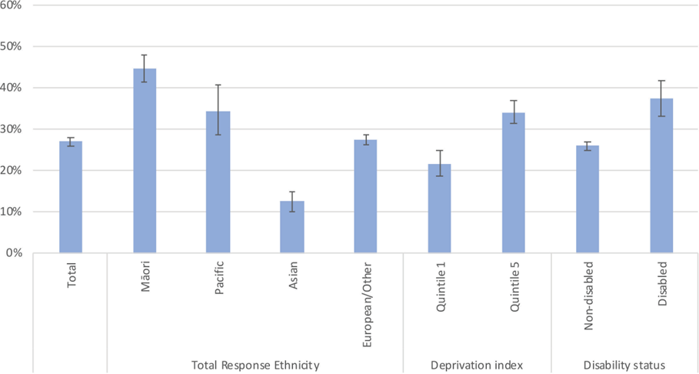

Note: Error bars indicate 95% confidence intervals. Total response measure of ethnicity means people who reported more than one ethnic group are counted once in each group reported. More detailed data about the inequitable burden of harms for different population groups is included in the table below.

Table 1: Experiences of substance harm by population groups in New Zealand
Māori | Māori experience significantly more harm from alcohol and other substances, with around one in five (19%) at risk from alcohol harms, and nearly one in four (23%) at risk from illicit substance harms, rates substantially higher than other ethnic groups. Māori have a fatal overdose rate that is two times higher than that of non-Māori, especially where opioids are involved.
People in the Justice system | Many people in the Justice system have a substance use disorder. In prison settings, most people have a substance use disorder in their lifetime (87%). Lifetime prevalence of stimulant dependence in prisons was the highest of all drug types (23%).
Pacific people | One in three Pacific people (35%) have moderate or high-risk substance use compared to 28% Europeans (one in four). Young Pacific people show increasing use of cannabis, methamphetamine, and synthetic cannabinoids.
Young people (15 – 24 years) | Young people (15-24 years) are particularly vulnerable to substance harms, with one in ten (10%) at moderate or high risk of problematic alcohol use, and almost twice that many - nearly one in five (18%) at moderate or high risk of problematic illicit substance use.
Families affected by substance harm | About 2% of women who gave birth in 2023 received treatment for substance use during pregnancy or the first year post-partum. Foetal Alcohol Spectrum Disorder (FASD) affects an estimated 1.3–3.9% of the general population, with Māori experiencing higher FASD rates (1.7– 6.3%). 44% of grandparents are raising grandchildren due to parental substance-related harms.  In 2020, methamphetamine was identified as a contributing factor in almost half of all Oranga Tamariki care placements. Children exposed to caregiver substance use can experience ongoing harm, neglect, instability, and increased risk of intergenerational trauma.
People in high deprivation areas | Living in high deprivation is associated with increased substance harm. One in seven people (14%) living in the most deprived areas are at moderate or high risk of problematic use of alcohol. Similarly, 15% of people in the most deprived areas are at moderate or high risk of problematic use of illicit substances. People from the most deprived areas are 2.1 times more likely than people from the least deprived areas to have used an amphetamine-type stimulant in the last 12 months.
Disabled people, people who experience mental health conditions, and people who are neurodivergent | Disabled people, people with mental health conditions and people who are neurodivergent experience disproportionate harms. One in five disabled people (20%) are at moderate or high risk of problematic use of illicit substances.  The rates of co-existing mental health and addiction issues are high. Approximately 70% of people who access addiction services, and approximately 50% of mental health service users have a co- occurring disorder.  Although there are no large-scale, population-based studies for people who are neurodivergent in New Zealand, smaller studies and service reports consistently note increased rates of co-occurring substance use and neurodevelopmental conditions among clients in addiction treatment settings.
Rainbow communities | People in the LGBTQI+ community continue to face disproportionate substance-related harm. Research shows lesbian, gay, and bisexual adults are nearly twice as likely as heterosexual females, and slightly more likely than heterosexual males, to report hazardous drinking patterns. For trans and non-binary people, substance use is closely linked to elevated psychological distress, self-injury, and suicide attempts.
Asian people | While statistically, Asian people generally do not show higher rates of substance harm, for those who do experience substance related harm, their experiences of stigma, language barriers, and limited culturally responsive services can contribute to additional harm.  These factors can delay help seeking by Asian people who experience substance-related harm.

Key statistics and information about substance use in New Zealand
The New Zealand Health Survey indicates that overall, the prevalence of self-reported use of illicit substances by adults aged 15+ has not changed significantly over the past five years, with cannabis consistently showing as the most prevalent illicit substance people report using.
Figure 2: Self-reported illicit substance use in past 12-months
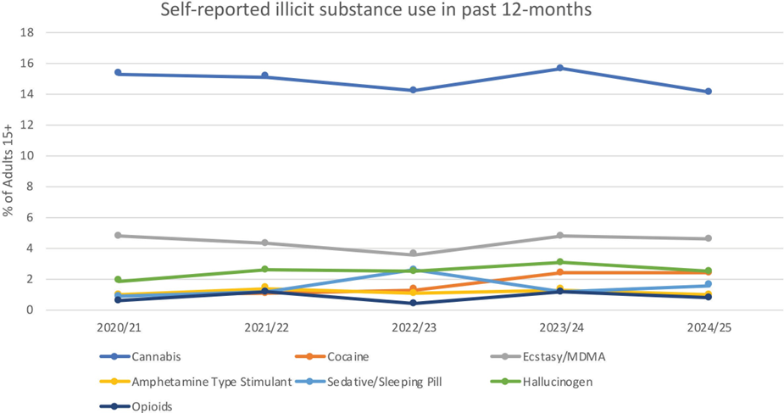
Source: New Zealand Health Survey

However, while the number of people reporting illicit substance use is generally low, New Zealand wastewater testing shows that the volume of certain substances, in particular methamphetamine and cocaine, has increased over the previous year.

Figure 3: National Drugs in Wastewater Testing Quarter 3, 2025 estimated consumption volume
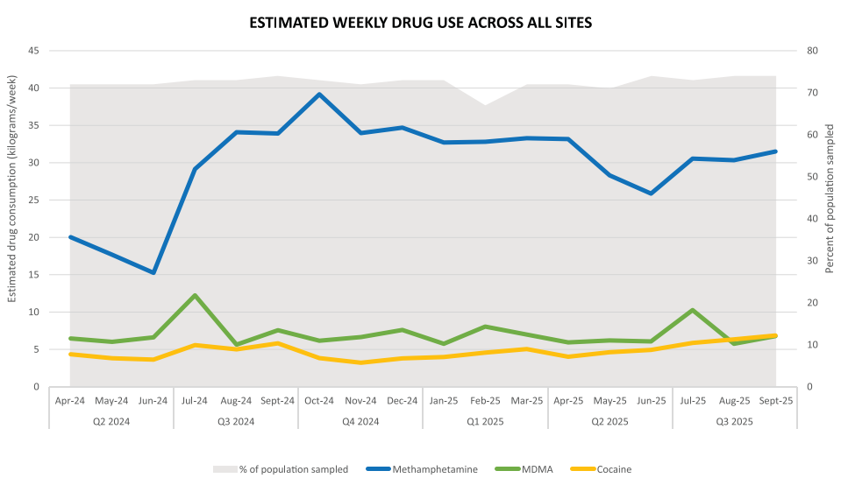
Source: National Drugs in Wastewater Testing Programme – Quarter 3, 2025

The risk of harm from illicit substances can be significantly increased when combined with alcohol. To better understand the consumption of alcohol and illicit substances, a bespoke analysis of New Zealand Health Survey 2024/25 data was undertaken. People aged 15 and over were categorised into one of four groups based on whether they had used alcohol or illicit substances at least once in the past 12 months:
- used both alcohol and illicit drugs
- only used alcohol
- only used illicit substances
- used neither alcohol nor illicit substances.

Please note this analysis provides a high-level view of consumption, and does not represent frequency or quantity of consumption, and use does not equate to harm.

Overall, around 75 percent of people aged 15 and over report drinking alcohol at least once in the past year, with slightly under 20 percent using illicit substances in the same time period. Most people who use illicit substances also use alcohol (see Figure 4).

Figure 4: Proportion of New Zealanders who report using alcohol and/or illicit substances in the past 12 months (2024/25)
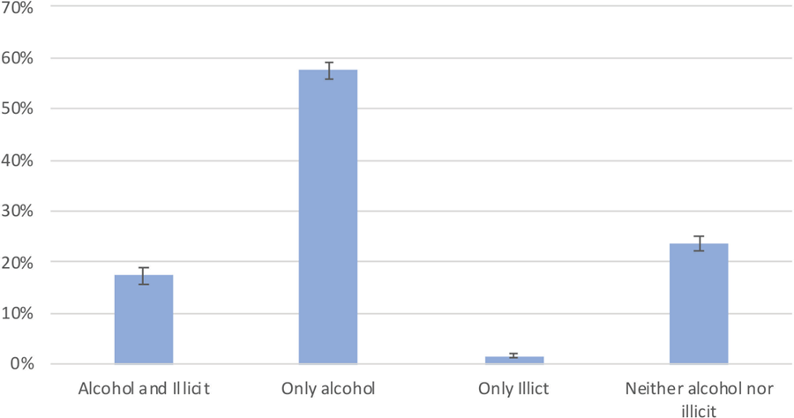
Note: Columns sum to 100% so an increase in one consumption category must be matched by decreases in one or more other categories; Error bars indicate 95% confidence intervals.

When analysing more detailed breakdowns of consumption, illicit substance use tends to decrease with age; as people age, people are more likely to use just alcohol rather than alcohol and illicit substances (Figure 5). Men are also more likely to report using illicit substances than women, but the reported rates of using only alcohol are similar (Figure 6).
Figure 5: Proportion of New Zealanders who report using alcohol and/or illicit substances in the past 12 months (2024/25), by age category

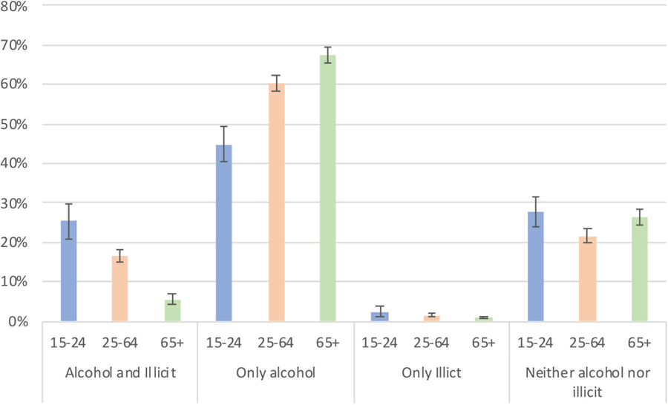
Note: within an age category columns sum to 100% so an increase in one consumption category must be matched by decreases in one or more other categories; Error bars indicate 95% confidence intervals.
Figure 6: Proportion of New Zealanders who report using alcohol and/or illicit substances in the past 12 months (2024/25), by gender category
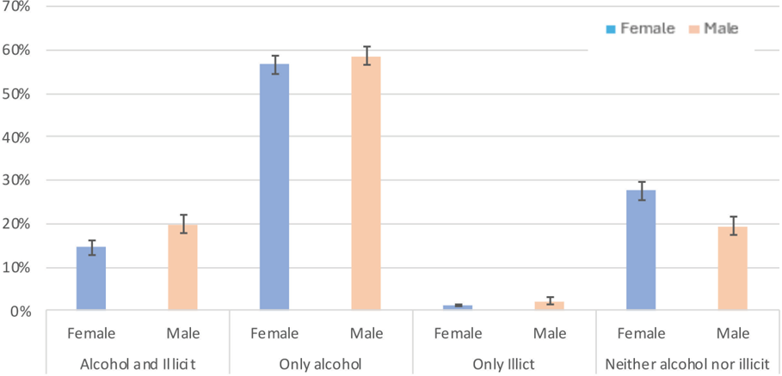

Note: Note that within a gender category the columns sum to 100% so an increase in one consumption category must be matched by decreases in one or more other categories; Error bars indicate 95% confidence intervals.

Key statistics and data about addiction service utilisation in New Zealand
There are a range of services within the health system that are available to meet people’s needs, these include:
- community based treatment programmes
- residential treatment programmes
- specialist pregnancy and parenting support services
- opioid substitution treatment
- managed withdrawal services

In 2024/25, the health system spent approximately $248 million on specialist alcohol and other drug (AOD) treatment services. 48,500 people accessed AOD treatment services in New Zealand over this same period, with 76.1 percent of referrals for addiction services seen within 3 weeks compared to 83.8 percent for mental health services.

The majority of AOD services are provided in a community-based setting. AOD services are accessed most frequently by those aged 25–64 years, followed by those aged under 25 years, as shown in Figure 7. This reflects the types of services that we have available for people, however we have heard throughout engagement from stakeholders that further work needs to be done to support those under 25 years old.

Figure 7: Rate of service users accessing specialist alcohol and other drug treatment services per 1,000 population, by age group and region of domicile, 2024
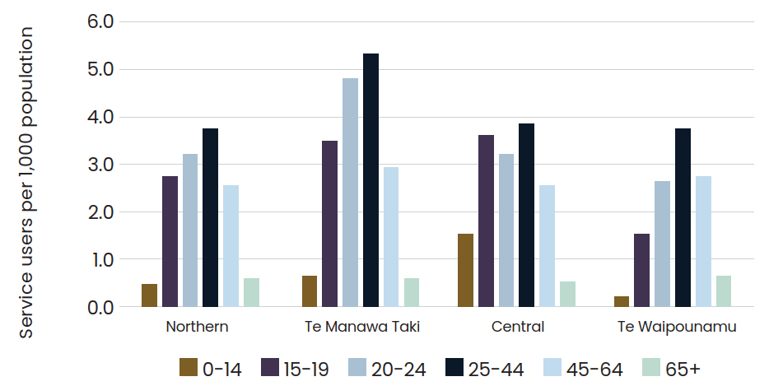
Source: Sapere calculation using activity data from PRIMHD and population denominators from the 2024 annual update of district level population estimates and projections customised for Health New Zealand - Te Whatu Ora by Stats NZ.

Figure 8 shows that Māori were more than twice as likely to access AOD services than other ethnic groups. This reinforces the feedback received during the engagement period that kaupapa Māori services are an important part of the system and requires ongoing investment. The system also needs to ensure the workforce is skilled in cultural safety and kaupapa Māori approaches to meet the needs of people accessing services the most.
Figure 8: Rate of people accessing specialist alcohol and other drug treatment services per 1,000 population, by ethnic group and calendar year, 2019 – 2024
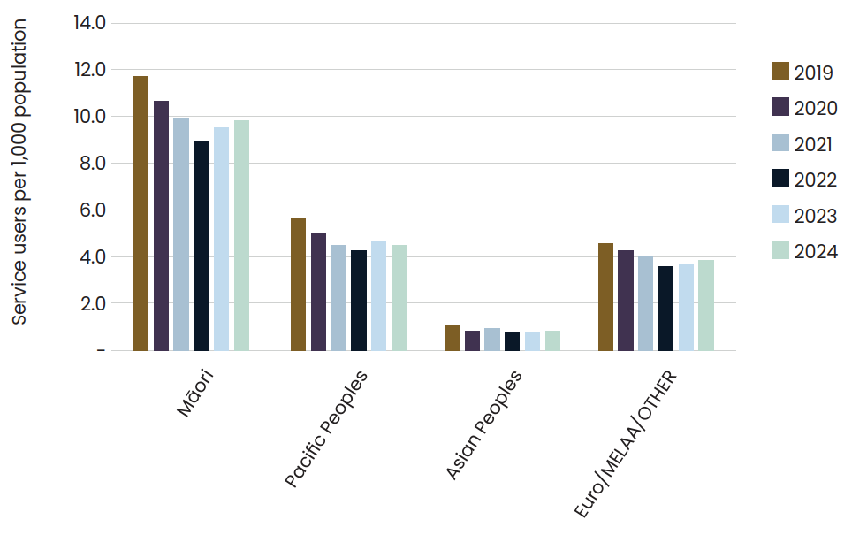
Source: Sapere calculation using activity data from PRIMHD and population denominators from the 2024 annual update of district level population estimates and projections customised for Health New Zealand - Te Whatu Ora by Stats NZ.

For more details on how these groups are defined please see the New Zealand Health Survey Mental Health and Problematic Substance Use Data Explorer
For detailed information on confidence intervals please see the Methodology Report 2024/25: New Zealand Health Survey

