Office of the Director of Mental Health and Addiction Services
Regulatory Report
1 July 2023 to 30 June 2024

Citation: Ministry of Health. 2026. Office of the Director of Mental Health and Addiction Services: Regulatory Report 1 July 2023 to 30 June 2024. Wellington: Ministry of Health.
Published in March 2026 by the Ministry of Health
PO Box 5013, Wellington 6140, New Zealand
ISBN 978-1-991324-77-1 (online)
HP 9162

This document is available at health.govt.nz
 | This work is licensed under the Creative Commons Attribution 4.0 International licence. In essence, you are free to: share ie, copy and redistribute the material in any medium or format; adapt ie, remix, transform and build upon the material. You must give appropriate credit, provide a link to the licence and indicate if changes were made.

Foreword
This regulatory report contains collated data on the use of compulsory assessment and treatment legislation in Aotearoa New Zealand under the Mental Health (Compulsory Assessment and Treatment) Act 1992 (the Mental Health Act) for the financial year from 1 July 2023 to 30 June 2024. The report also contains data on related activities under the Intellectual Disability (Compulsory Care and Rehabilitation) Act 2003 (the Intellectual Disability Care Act) and the Misuse of Drugs Act 1975. For more information about the Acts, see Mental health and addiction on the Ministry of Health – Manatū Hauora website.

I want to acknowledge that the mental health, intellectual disability and addiction workforce in New Zealand continues to demonstrate passion, professionalism and care in working with people who are experiencing significant vulnerability. I truly thank everyone for this. The demand for mental health, intellectual disability, and addiction services remains high, placing increased pressure on our workforce. We know improvements are needed to reduce this pressure, and we are working closely with our colleagues in Health New Zealand – Te Whatu Ora (Health New Zealand) to provide sustainable solutions.

As the Director of Mental Health and Addiction, I am responsible for the general administration of the relevant compulsory assessment, care and treatment legislation under the direction of the Minister of Health, the Minister for Mental Health and the Director-General of Health. My functions and powers under the Acts listed above, as well as under the Substance Addiction (Compulsory Assessment and Treatment) Act 2017 (the Substance Addiction Act), allow the Ministry of Health to provide guidance to and oversight of mental health, addiction and intellectual disability services. It is my role to make sure that when people are under compulsory care or treatment in New Zealand, they are well cared for, their rights are upheld and the services providing care or treatment follow all legislative requirements. When needed, I intervene to ensure this is what people experience.

Since 2005, the Office of the Director of Mental Health and Addiction Services has been reporting each year on the use of compulsory assessment and treatment legislation in New Zealand. The main purpose of this report is to present information that helps to measure the quality of compulsory care that our mental health, intellectual disability and addiction services provide. We monitor these services to assure both ourselves and the public that people undergoing compulsory assessment, care and treatment under the relevant legislation are receiving high-quality care.

Whanaketia – Through pain and trauma, from darkness to light, released by the Royal Commission into Abuse in Care on 24 July 2024, has highlighted how important it is to carefully monitor the use of compulsory care under the relevant legislation. It further draws attention to the experiences of people receiving mental health, intellectual disability and addiction care through the state and the impact that care can have on them. It is fundamental that we ensure that what happened then never happens again to people in care.

Overall the data in this report show rates of use of compulsory assessment and treatment remained steady in 2023/24, compared with previous years. The total number of people who have been secluded and the total hours people spend in seclusion have decreased from 2022/23, which are positive trends. We remain committed to working with Health New Zealand and the Health Quality & Safety Commission – Te Tāhū Hauora (Health Quality & Safety Commission) to reduce seclusion over time and eventually eliminate it. In April 2023, my office published the Guidelines for Reducing and Eliminating Seclusion and Restraint under the Mental Health Act.

Work has continued on repealing and replacing the current Mental Health Act, as recommended in He Ara Oranga: Report of the Government Inquiry into Mental Health and Addiction. On 17 April 2025, the Health Committee reported back to the House of Representatives on the Mental Health Bill. For updates on this work, see Repealing and replacing the Mental Health Act on the Ministry’s website. My office continues to be involved in developing the Bill, and we are looking forward to supporting legislation that promotes a recovery and wellbeing approach to care.

I acknowledge that the release of this report has been delayed again, for two main reasons. First, the data is complex. Second, some regulatory data are still reported to the Ministry via manual processes, which creates further time lag for receipt and quality assurance processes. I continue to encourage services to follow the Programme for the Integration of Mental Health Data (PRIMHD) standards so data is more consistent and can be used to better inform services and practice.

To get a full picture of mental health and addiction services in New Zealand, including service use outside of compulsory legislation, I recommend you read this report together with updates on the Health New Zealand website, in particular the Mental health and addiction monitoring, reporting and data page. The Ministry of Health’s Annual Report includes information on the use of the Substance Addiction Act, and Te Hiringa Mahara – Mental Health and Wellbeing Commission publishes monitoring reports on the mental health and addiction system, available on its website.

My office has close working relationships with Health New Zealand and the Ministry of Social Development to ensure tāngata whaiora (people seeking health) and tāngata whaikaha (people with disabilities) receive a consistent level of high-quality care. While this report highlights areas where the sector has made improvements, sustained focus and efforts on improving the experiences of tāngata whaiora, tāngata whaikaha and their whānau need to continue.

Noho ora mai

Dr John Crawshaw
Director of Mental Health and Addiction
Contents
Foreword iii
Context 1
The Mental Health Act process 2
Court applications in 2023/24 2
Compulsory assessment and treatment in 2023/24 2
Comparing compulsory assessment and treatment among districts 5
Use of the Mental Health Act 9
Compulsory assessment 10
Compulsory treatment orders 10
Length of time people are subject to compulsory treatment orders 14
Family and whānau consultation under the Mental Health Act 15
Seclusion 18
Seclusion in New Zealand mental health services 20
Use of seclusion by district 24
Seclusion and ethnicity 27
Seclusion in forensic units 30
People with intellectual disabilities cared for in an intellectual disability forensic service 31
Special and restricted patients 33
Extended forensic care special patients 34
Short-term forensic care special patients 34
Gender, age and ethnicity of special patients 36
Decisions about leave and change of legal status for special and restricted patients 37
Mental health and addiction adverse event reporting 39
Deaths reported to the Director of Mental Health 40
Section 95 inquiries and section 99 inspections 40
Electroconvulsive therapy 42
Number of people receiving ECT 42
ECT by region 43
Age and gender of people receiving ECT 46
Ethnicity of people treated with ECT 46
Consent to ECT treatment 47
Drug and substance harm reduction 48
Opioid substitution treatment 48
Drug-checking licensing scheme 54
Substance Addiction (Compulsory Assessment and Treatment) Act 2017 58
Land Transport Act 1998 58
Appendix 1: The Mental Health Act process 59
Compulsory assessment 59
Compulsory treatment 59
Appendix 2: Additional statistics – Ministry of Justice 60
Appendix 3: Individuals who experienced prolonged and/or frequent periods of seclusion 62

List of Figures
Figure 1: Applications and outcomes for compulsory treatment orders and extensions, 2009/10 to 2023/24 4
Figure 2: Number of granted compulsory treatment orders and extensions, community and inpatient, 2009/10 to 2023/24 4
Figure 3: Average number of people on a given day subject to a community treatment order (section 29) per 100,000 population, by district, 1 July 2023 to 30 June 2024 6
Figure 4: Average number of people on a given day subject to an inpatient treatment order (section 30) per 100,000 population, by district, 1 July 2023 to 30 June 2024 7
Figure 5: Rate of people subject to compulsory treatment order applications (including extensions) per 100,000 population, by age group, 2009/10 to 2023/24 8
Figure 6: Rate of people subject to compulsory treatment order applications (including extensions) per 100,000 population, by gender, 2009/10 to 2023/24 8
Figure 7: Rate ratio of Māori to non-Māori subject to a community treatment order (section 29) under the Mental Health Act per 100,000 population, by district, 1 July 2023 to 30 June 2024 11
Figure 8: Rate ratio of Māori to non-Māori subject to an inpatient treatment order (section 30) under the Mental Health Act per 100,000 population, by district, 1 July 2023 to 30 June 2024 12
Figure 9: Age-standardised rates of people subject to community (section 29) and inpatient (section 30) treatment orders under the Mental Health Act, by gender and ethnicity, 1 July 2023 to 30 June 2024 13
Figure 10: Total time spent subject to a community treatment order (section 29) under the Mental Health Act in the last three years, by ethnicity, for those with a current order in the year 1 July 2023 to 30 June 2024 14
Figure 11: Total time spent subject to an inpatient treatment order (section 30) under the Mental Health Act in the last three years, by ethnicity, for those with a current order in the year 1 July 2023 to 30 June 2024 14
Figure 12: Average percentage of successful family and whānau consultation for particular assessment or treatment events nationally, sections 10, 12, 14 and 76–78, 1 July 2023 to 30 June 2024 15
Figure 13: Average percentage of successful family and whānau consultation across all assessment and treatment events, by district, 1 July 2023 to 30 June 2024 16
Figure 14: Reasons for not consulting families and whānau, 1 July 2023 to 30 June 2024 17
Figure 15: Number of people secluded in adult inpatient services nationally, 2007 to 2023/24 19
Figure 16: Number of seclusion hours in adult inpatient services nationally, 2007 to 2023/24 19
Figure 17: Number of people secluded across all inpatient services (adult, forensic, intellectual disability and youth), by age group, 1 July 2023 to 30 June 2024 21
Figure 18: Rate of people secluded across all inpatient services (adult, forensic, intellectual disability and youth) per 100,000 population, by age group, 1 July 2023 to 30 June 2024 21
Figure 19: Percentage of seclusion events across all inpatient services (adult, forensic, intellectual disability and youth), by length of event, 1 July 2023 to 30 June 2024 22
Figure 20: Percentage of seclusion events across all inpatient services (adult, forensic, intellectual disability and youth), by ethnicity and length of event, 1 July 2023 to 30 June 2024 22
Figure 21: Number and percentage of seclusion events across all inpatient services (adult, forensic, intellectual disability and youth), by length of event, 1 July 2023 to 30 June 2024 23
Figure 22: Number of seclusion events across all inpatient services (adult, forensic, intellectual disability and youth) that are less than 24 hours, by length of event, 1 July 2023 to 30 June 2024 23
Figure 23: Number of people secluded in adult inpatient services per 100,000 population, by district, 1 July 2023 to 30 June 2024 24
Figure 24: Number of seclusion events in adult inpatient services per 100,000 population, by district, 1 July 2023 to 30 June 2024 26
Figure 25: Number of people secluded in adult inpatient services, by ethnicity and year, from 1 July 2020 to 30 June 2024 27
Figure 26: Seclusion indicators for adult inpatient services, by ethnicity, 1 July 2023 to 30 June 2024 28
Figure 27: Percentage of people secluded in adult inpatient services, by ethnicity and gender, 1 July 2023 to 30 June 2024 28
Figure 28: Number of Māori and non-Māori secluded in adult inpatient services, 2007 to 2023/24 29
Figure 29: Seclusion indicators for forensic mental health services, by ethnicity, 1 July 2023 to 30 June 2024 31
Figure 30: Total number of special patients, by regional service, 1 July 2023 to 30 June 2024 34
Figure 31: Percentage of court orders given for extended and short-term forensic care, by regional service, 1 July 2023 to 30 June 2024 35
Figure 32: Number of special patients, by gender, 1 July 2023 to 30 June 2024 36
Figure 33: Total number of special patients, by age group, 1 July 2023 to 30 June 2024 36
Figure 34: Percentage (and number) of special patients, by ethnicity and special patient type, 1 July 2023 to 30 June 2024 37
Figure 35: Number of ECT patients, 2010 to 2023/24 42
Figure 36: Rate of ECT patients per 100,000 population, 2010 to 2023/24 43
Figure 37: Rate of people per 100,000 population treated with ECT, by district of domicile, 1 July 2023 to 30 June 2024 44
Figure 38: Rate of ECT treatments per 100,000 population, by district of domicile, 1 July 2023 to 30 June 2024 45
Figure 39: Rate of people treated with ECT per 100,000 population, by district of domicile, 1 July 2023 to 30 June 2024 45
Figure 40: Number of people treated with ECT, by age group and gender, 1 July 2023 to 30 June 2024 46
Figure 41: Percentage of people receiving opioid substitution therapy from specialist services and general practitioners, by district, 1 July 2023 to 30 June 2024 50
Figure 42: Number of people receiving opioid substitution therapy from a specialist service, general practitioner or prison service, 2009/10 to 2023/24 50
Figure 43: Number of people prescribed suboxone, 2009/10 to 2023/24 51
Figure 44: Number of opioid substitution treatment clients, by age group, 2009/10 to 2023/24 52
Figure 45: Percentage of exits from opioid substitution treatment programmes, by reason (voluntary, involuntary or death), 2009/10 to 2023/24 53
Figure 46: Drug-checking harm reduction advice and samples tested by quarter, 1 July 2023 to 30 June 2024 55
Figure 47: Breakdown of drug types at drug checking, as presumed by client on presentation, 1 July 2023 to 30 June 2024 56
Figure 48: Percentage of testing consistency with presumed substance, 1 July 2023 to 30 June 2024 57

List of Tables
Table 1: Average number of people each month required to undergo assessment under section 11, 13 or 15 of the Mental Health Act per 100,000 population, by district, 1 July 2023 to 30 June 2024 5
Table 2: Average number of people on a given day subject to a compulsory treatment order under section 29, 30 or 31 of the Mental Health Act per 100,000 population, by district, 1 July 2023 to 30 June 2024 6
Table 3: Percentage of mental health service users, by ethnicity, 1 July 2023 to 30 June 2024 9
Table 4: Number and rate of people required to undergo assessment under section 11, 13 or 15 of the Mental Health Act, by ethnicity 1 July 2023 to 30 June 2024 10
Table 5: Number and rate of people subject to a compulsory treatment order under section 29 or 30 of the Mental Health Act, by ethnicity, 1 July 2023 to 30 June 2024 10
Table 6: Age-standardised rates of people subject to community (section 29) and inpatient (section 30) CTOs under the Mental Health Act, by gender and ethnicity, 1 July 2023 to 30 June 2024 12
Table 7: Rate ratio of age-standardised rates of people subject to community (section 29) and inpatient (section 30) treatment orders under the Mental Health Act, by gender and ethnicity, 1 July 2023 to 30 June 2024 13
Table 8: Percentage of admissions to adult inpatient services with seclusion recorded during admission, by district, 1 July 2023 to 30 June 2024 25
Table 9: Seclusion indicators for forensic mental health services, by regional service, 1 July 2023 to 30 June 2024 30
Table 10: Seclusion indicators for people with intellectual disabilities, nationally, by Act, 1 July 2023 to 30 June 2024 32
Table 11: Length of seclusion for people with intellectual disabilities, nationally, by Act, 1 July 2023 to 30 June 2024 32
Table 12: Seclusion indicators for Māori and non-Māori with intellectual disabilities, nationally, by Act, 1 July 2023 to 30 June 2024 32
Table 13: Total number of special patients, by type and service, 1 July 2023 to 30 June 2024 35
Table 14: Number of applications for granting section 50A long leave, revoking that leave and reclassifying legal status that the Minister of Health received for special and restricted patients, 1 July 2023 to 30 June 2024 38
Table 15: Outcomes of reportable death notifications under section 132 of the Mental Health Act, 1 July 2023 to 30 June 2024 40
Table 16: Number of section 95 inquiries completed and section 99 inspections reports received or completed by the Director, 2013/14 to 2023/24 41
Table 17: ECT indicators, by region of domicile, 1 July 2023 to 30 June 2024 44
Table 18: Number of people treated with ECT and rate per 100,000 population, by ethnicity, 1 July 2023 to 30 June 2024 46
Table 19: ECT administered under second opinion without consent, by region of service, 1 July 2023 to 30 June 2024 47
Table A1: Applications for compulsory treatment orders or extensions, 2009/10 to 2023/24 60
Table A2: Types of compulsory treatment orders made on granted applications, 2009/10 to 2023/24 61
Table A3: Seclusion indicators excluding and including individuals who experienced prolonged periods of seclusion, 1 July 2023 to 30 June 2024 63

Context
The following summarises the use of the Mental Health (Compulsory Assessment and Treatment) Act 1992 (Mental Health Act) in the financial year from 1 July 2023 to 30 June 2024. It provides a broad overview of how compulsory mental health legislation is operating in Aotearoa New Zealand.
- 11,495 people (6.5% of specialist mental health and addiction service users) were subject to the Mental Health Act.
- Out of all people using specialist mental health and addiction services, 93.5% engaged voluntarily rather than under compulsion.
- About 5,883 people were subject to either compulsory assessment or compulsory treatment under the Mental Health Act on the last day of the 2023/24 year.
- Males were more likely to be subject to the Mental Health Act than females.
- Across the different age groups, people aged 25–34 years were the most likely to be subject to compulsory treatment, and people aged under 14 or 65 years and over were the least likely.
- Māori were more likely to be assessed or treated under the Mental Health Act than Pacific peoples and other ethnicities.
- Most people subject to compulsory treatment are based in the community (approximately 75% in 2023/24).

The Mental Health Act process

Court applications in 2023/24
In the 2023/24 financial year, clinicians made 7,397 applications for compulsory treatment orders (CTOs) or extensions of CTOs under the Mental Health Act. This is an increase from 6,332 applications in the previous year. The increase appears to be due to the legislative change at 29 November 2023 which meant that CTOs could not continue indefinitely. As a result, clinicians now must apply to the courts for extensions of CTOs.

Of the 7,397 applications, the courts granted 6,725 (90.9%). Appendix 1 sets out the Mental Health Act process and Appendix 2 presents a time series of data on CTO applications.

A total of 1,280 applications were filed for a judge’s review of the patient’s condition under section 16 of the Mental Health Act. Of this total, judges issued an order to release a person from their CTO in 41 cases (3.2%) and confirmed that the order would continue in 571 applications (44.6%). Among the remaining applications, 628 were withdrawn and 40 had another outcome.

Compulsory assessment and treatment in 2023/24
On the last day of the 2023/24 financial year, a total of 5,883 people were subject to either compulsory assessment or compulsory treatment under the Mental Health Act.

On average within each month, the assessment provisions applied as follows.
Section 11 | 740 people were subject to an initial assessment | 14 people per 100,000 population
Section 13 | 877 people were subject to a second period of assessment | 16 people per 100,000 population
Section 15 | 593 people were subject to an application for a CTO | 11 people per 100,000 population
Sources: PRIMHD data (extracted 10 June 2025) and manual data for Health New Zealand Counties Manukau and Waikato.

This data is relatively steady compared with the previous financial year.

In New Zealand, on an average day in the 2023/24 financial year, the treatment provisions of the Mental Health Act were applied as follows.

Section 29 | 4,797 people were subject to a community treatment order | 90 people per 100,000 population
Section 30 | 807 people were subject to an inpatient treatment order | 15 people per 100,000 population
Section 31 | 251 people were on temporary leave from an inpatient unit | 5 people per 100,000 population
Sources: PRIMHD data (extracted 10 June 2025) and manual data for Health New Zealand Bay of Plenty, Capital & Coast, Hawke’s Bay, MidCentral, Southern, Tairāwhiti, Waikato and Waitematā.

The number of people subject to a community treatment order in 2023/24 decreased slightly from 91 to 90 people per 100,000 people in the general population. There was also a slight decrease for those subject to section 30 (15 per 100,000 compared with 17 per 100,000 in 2022/23). The rate of people subject to section 31 in 2023/24 was the same as in the previous year.

Figure 1 shows the number of CTOs and extensions that clinicians have applied for and courts have granted since 2009/10. It also shows the number of applications dismissed or withdrawn.

Figure 1: Applications and outcomes for compulsory treatment orders and extensions, 2009/10 to 2023/24
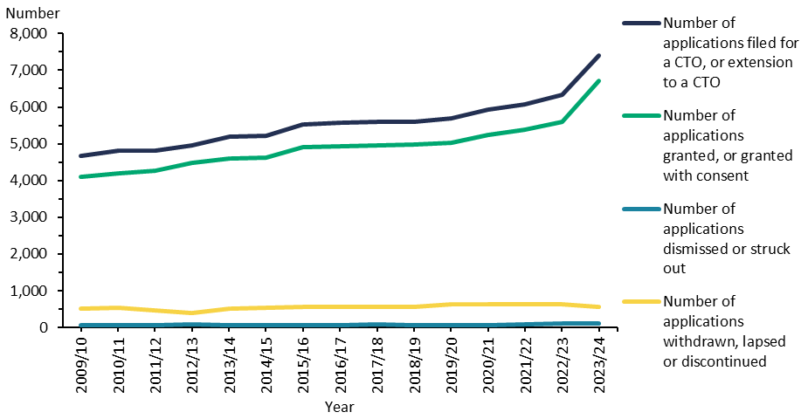
Notes: This figure is based on data entered into the Ministry of Justice’s CMS, which is a live operational database. Figures are subject to minor changes at any time.
Source: Ministry of Justice Integrated Sector Intelligence System data (extracted 2 December 2025).

Figure 2 shows the number of applications for community and inpatient treatment orders that courts have granted since 2009/10.

Figure 2: Number of granted compulsory treatment orders and extensions, community and inpatient, 2009/10 to 2023/24
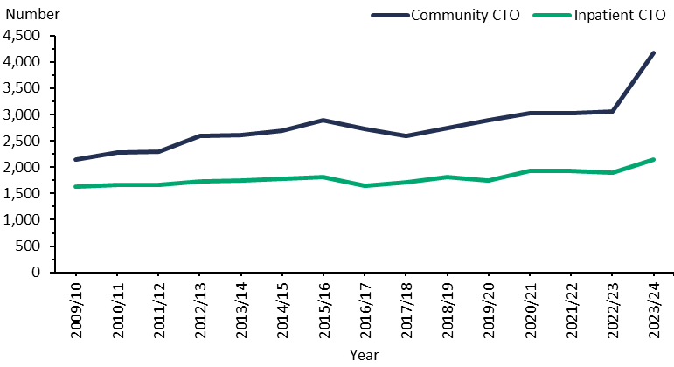
Notes: This figure is based on data entered into the CMS, which is a live operational database. Figures are subject to minor changes at any time.
Source: Ministry of Justice Integrated Sector Intelligence System data (extracted 2 December 2025).

Comparing compulsory assessment and treatment among districts
Table 1 shows the average number of people per month in 2023/24 who were required to undergo assessment under the Mental Health Act in each district. Table 2 shows the average number of people subject to a CTO on a given day in the same period in each district.

The following figures present the average number of people subject to a CTO on a given day, focusing specifically on either community treatment orders (Figure 3) or inpatient treatment orders (Figure 4).

Table 1: Average number of people each month required to undergo assessment under section 11, 13 or 15 of the Mental Health Act per 100,000 population, by district, 1 July 2023 to 30 June 2024
District | s 11 | s 13 | s 15 |  | District | s 11 | s 13 | s 15
Auckland | 16 | 18 | 15 |  | Northland | 15 | 19 | 14
Bay of Plenty | 14 | 16 | 8 |  | South Canterbury | 6 | 7 | 5
Canterbury | 12 | 13 | 9 |  | Southern | 11 | 9 | 6
Capital & Coast | 14 | 22 | 15 |  | Tairāwhiti | 25 | 11 | 8
Counties Manukau | 10 | 13 | 10 |  | Taranaki | 16 | 15 | 8
Hawke’s Bay | 30 | 47 | 20 |  | Waikato | 24 | 24 | 14
Hutt Valley | 16 | 17 | 11 |  | Wairarapa | 7 | 3 | 6
Lakes | 10 | 9 | 9 |  | Waitematā | 12 | 15 | 12
MidCentral | 19 | 25 | 19 |  | West Coast | 8 | 7 | 4
Nelson Marlborough | 8 | 10 | 8 |  | Whanganui | 13 | 17 | 11
 |  |  |  |  | National average | 14 | 16 | 11
Note: As these figures are averages, some services may have higher volumes under section 13 than under section 11.
Sources: PRIMHD data (extracted 10 June 2025) and manual data for Health New Zealand Counties Manukau and Waikato.

Table 2: Average number of people on a given day subject to a compulsory treatment order under section 29, 30 or 31 of the Mental Health Act per 100,000 population, by district, 1 July 2023 to 30 June 2024
District | s 29 | s 30 | s 31 |  | District | s 29 | s 30 | s 31
Auckland | 86 | 9 | 2 |  | Northland | 147 | 13 | 2
Bay of Plenty | 61 | 22 | 7 |  | South Canterbury | 78 | 4 | 3
Canterbury | 76 | 15 | 7 |  | Southern | 48 | 9 | 2
Capital & Coast | 151 | 37 | 6 |  | Tairāwhiti | 57 | 6 | 8
Counties Manukau | 56 | 14 | 1 |  | Taranaki | 102 | 3 | 1
Hawke’s Bay | 205 | 29 | 19 |  | Waikato | 156 | 31 | 14
Hutt Valley | 74 | 11 | 2 |  | Wairarapa | 72 | 6 | 2
Lakes | 78 | 10 | 4 |  | Waitematā | 80 | 9 | 1
MidCentral | 130 | 15 | 4 |  | West Coast | 65 | 3 | 3
Nelson Marlborough | 63 | 10 | 4 |  | Whanganui | 124 | 21 | 5
 |  |  |  |  | National average | 90 | 15 | 5
Note: ‘On a given day’ is the average of the last day of each month.
Sources: PRIMHD data (extracted 10 June 2025) and manual data for Health New Zealand Bay of Plenty, Capital & Coast, Hawke’s Bay, MidCentral, Southern, Tairāwhiti, Waitematā and Waikato.

Figure 3: Average number of people on a given day subject to a community treatment order (section 29) per 100,000 population, by district, 1 July 2023 to 30 June 2024
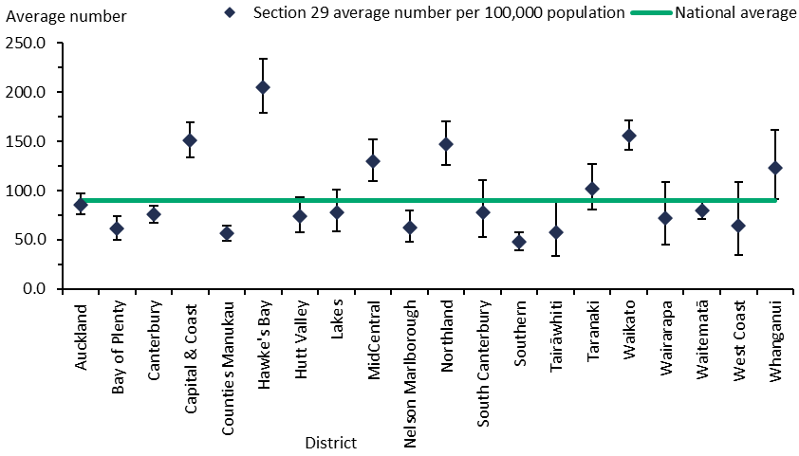
Notes: ‘On a given day’ is the average of the last day of each month. In this figure, the confidence intervals (for 99% confidence, shown as vertical lines through the blue diamond markers) can help with interpreting the data. Where a district’s confidence interval crosses the national average, that means its rate was not different from the average at a statistically significant level.
Sources: PRIMHD data (extracted 10 June 2025) and manual data for Health New Zealand Bay of Plenty, Capital & Coast, Hawke’s Bay, MidCentral, Southern, Tairāwhiti and Waikato.

Figure 4: Average number of people on a given day subject to an inpatient treatment order (section 30) per 100,000 population, by district, 1 July 2023 to 30 June 2024
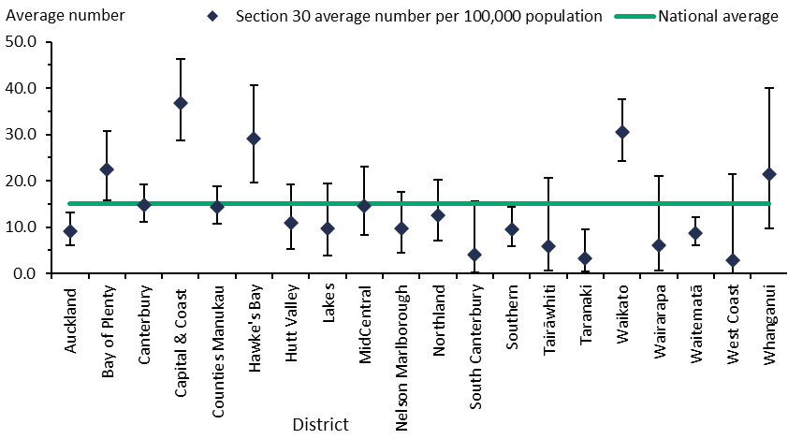
Notes: ‘On a given day’ is the average of the last day of each month. In this figure, the confidence intervals (for 99% confidence, shown as vertical lines through the blue diamond markers) can help with interpreting the data. Where a district’s confidence interval crosses the national average, that means its rate was not different from the average at a statistically significant level.
Sources: PRIMHD data (extracted 10 June 2025) and manual data for Health New Zealand Bay of Plenty, Capital & Coast, Hawke’s Bay, MidCentral, Waikato and Waitematā.

Compulsory treatment by age and gender
Among people aged 15 years and over, those aged 25–34 years were most likely to be subject to a CTO application (239.4 people per 100,000 population). People aged 65 years or over were the least likely (79.5 per 100,000) (Figure 5). Overall, 137.5 people per 100,000 people in the general population were subject to an application.

Figure 5: Rate of people subject to compulsory treatment order applications (including extensions) per 100,000 population, by age group, 2009/10 to 2023/24
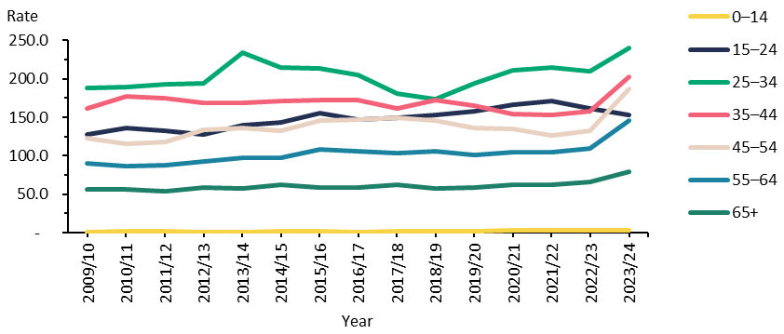
Notes: This figure is based on data entered into the CMS, which is a live operational database. Figures are subject to minor changes at any time.
Source: Ministry of Justice Integrated Sector Intelligence System data (extracted 2 December 2025).

Males were more likely to be subject to a CTO application (151.0 per 100,000 population) than females (104.3 per 100,000), as Figure 6 shows.

Figure 6: Rate of people subject to compulsory treatment order applications (including extensions) per 100,000 population, by gender, 2009/10 to 2023/24
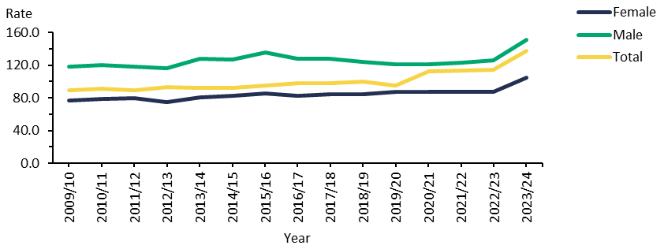
Notes: Due to the design of the system, this figure represents only two gender categories. The CMS includes an ‘other’ category; however, this group is too small to appear here.
Source: Ministry of Justice Integrated Sector Intelligence System data (extracted 2 December 2025).

Use of the Mental Health Act
This section presents statistics on people receiving care under the Mental Health Act. This information underlines the need for mental health services to take actions to address the disparity in outcomes for different ethnicities in New Zealand. The following summarises data on the use of the Mental Health Act from 1 July 2023 to 30 June 2024.
- 5.8% of Māori accessed specialist mental health and addiction services, compared with 2.8% of non-Māori.
- Māori were 1.9 times more likely than Pacific peoples and 2.3 times more likely than other ethnicities to be subject to a community CTO (section 29).
- Māori were 1.6 times more likely than Pacific peoples and 2.1 times more likely than other ethnicities to be subject to an inpatient CTO (section 30).
- Of all population groups, Māori men were the most likely to be subject to CTOs. However, on average, Māori, Pacific peoples and other ethnicities remained on CTOs for a similar length of time.
- Among service users, 28.8% of Māori, 26.1% of Pacific peoples, 28.5% of Asians and 27.1% of other ethnicities were aged under 20 years.
- Among people who were under a community CTO, 47% of Māori and 48% of Pacific peoples were living in the most socioeconomically deprived areas (quintile 5), compared with 26% of non-Māori, non-Pacific peoples.

Table 3 shows the percentage of Māori, Pacific peoples, Asians and other ethnicities in the general population and in the population of mental health service users.

Table 3: Percentage of mental health service users, by ethnicity, 1 July 2023 to 30 June 2024
Ethnic group | Percentage of New Zealand population | Percentage of all mental health service users
Māori | 17% | 30.1%
Pacific peoples | 7% | 6%
Asian | 20% | 6.1%
Other | 56% | 57.8%
Source: PRIMHD data (extracted 10 June 2025)

Compulsory assessment
In the 2023/24 financial year, Māori were more likely to undergo compulsory assessment than other ethnicities. Table 4 shows the number of people subject to compulsory mental health assessment on a national level by ethnicity and the rate per 100,000 people in the general population.

Table 4: Number and rate of people required to undergo assessment under section 11, 13 or 15 of the Mental Health Act, by ethnicity 1 July 2023 to 30 June 2024
Ethnic group | Section 11 |  | Section 13 |  | Section 15
Ethnic group | Number | Rate | Number | Rate | Number | Rate
Māori | 2,212 | 242.6 | 2,022 | 221.8 | 1,465 | 160.7
Pacific peoples | 439 | 115.6 | 428 | 112.7 | 351 | 92.5
Asian | 457 | 43.7 | 412 | 39.4 | 281 | 26.8
Other | 2,973 | 99.0 | 2,626 | 87.4 | 1,801 | 60.0
All | 6,081 | 113.9 | 5,488 | 102.7 | 3,898 | 73.0
Sources: PRIMHD data (extracted 10 June 2025) and manual data from Health New Zealand Counties Manukau, and Waikato.

Compulsory treatment orders
Table 5 shows that Māori were more likely to be subject to community and inpatient treatment orders than other ethnic groups. These figures represent the number of people who were subject to a CTO during the 2023/24 financial year, rather than the number of CTOs issued for the year.

Table 5: Number and rate of people subject to a compulsory treatment order under section 29 or 30 of the Mental Health Act, by ethnicity, 1 July 2023 to 30 June 2024
Ethnic group | Section 29 |  | Section 30
Ethnic group | Number | Rate | Number | Rate
Māori | 2,928 | 321.1 | 918 | 100.7
Pacific peoples | 614 | 168.1 | 234 | 63.0
Asian | 454 | 43.4 | 151 | 14.4
Other | 3,177 | 105.8 | 1,146 | 38.2
All | 7,173 | 134.3 | 2,449 | 45.9
Sources: PRIMHD data (extracted 10 June 2025) and manual data from Health New Zealand Bay of Plenty, Capital & Coast, Hawke’s Bay, MidCentral, Southern, Tairāwhiti, Waikato and Waitematā.

The following figures show the rate ratio of Māori to non-Māori subject to community treatment orders (Figure 7) and inpatient treatment orders (Figure 8) per 100,000 people in the general population for each Health New Zealand district. Table 6 and Figure 9 then present the age-standardised rates for both community and inpatient treatment orders by ethnicity and gender. Table 7 presents the age-standardised rate ratios.

It is difficult to interpret the range of rates because the proportions of different ethnic groups within a population vary greatly across districts, so it is hard to define a standard rate ratio for a given population or district. However, to help with comparing rates, each figure includes a line of ‘no difference’ to indicate where Māori and non-Māori would be subject to CTOs at the same rate (ie, a 1:1 ratio). Therefore, the further a ratio is away from the ‘no difference’ line, the more disparity there is.

The great variation between districts, as the figures show, emphasises the need for in-depth, area-specific knowledge to understand why these differences occur and how to address them at a local level.

Figure 7: Rate ratio of Māori to non-Māori subject to a community treatment order (section 29) under the Mental Health Act per 100,000 population, by district, 1 July 2023 to 30 June 2024
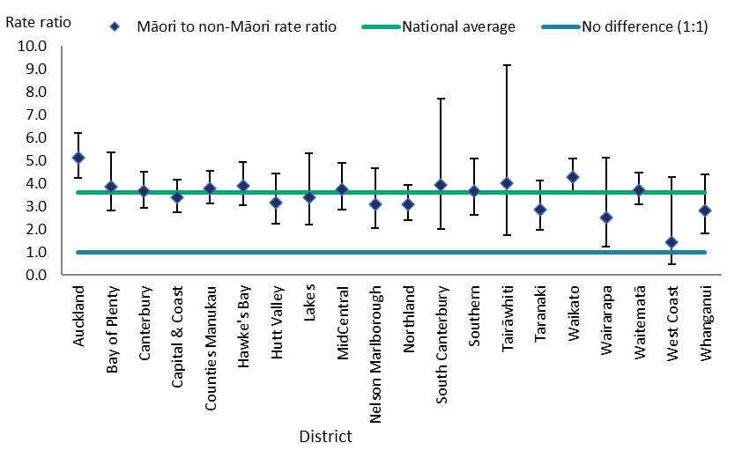
Notes: In this figure, confidence intervals (for 99% confidence, shown as vertical lines through the blue diamond markers) can help with interpreting the data. Where a district’s confidence interval crosses the national average, that means its rate per 100,000 is not different from the average at a statistically significant level. These are age-standardised rates.
Source: PRIMHD data (extracted 10 June 2025).

Figure 8: Rate ratio of Māori to non-Māori subject to an inpatient treatment order (section 30) under the Mental Health Act per 100,000 population, by district, 1 July 2023 to 30 June 2024
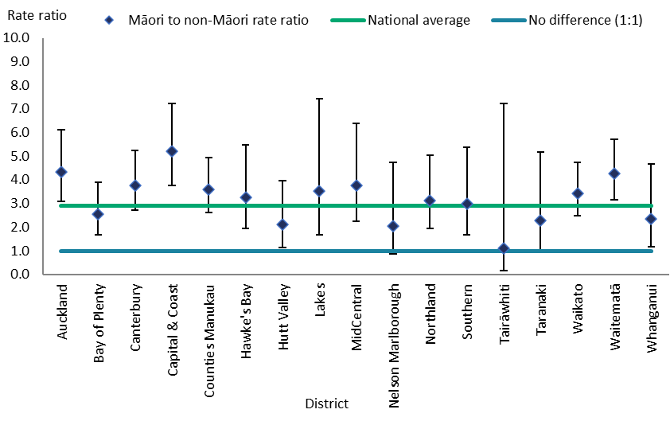
Notes: In this figure, the confidence intervals (for 99% confidence, shown as vertical lines through the blue diamond markers) can help with interpreting the data. If a district’s confidence interval crosses the national average, that means its rate per 100,000 is not different from the average at a statistically significant level. These are age-standardised rates. Health New Zealand Wairarapa has no inpatient service. As Health New Zealand South Canterbury and West Coast have small populations, their rates were very volatile and error bars of the resulting calculations were large. This figure does not include the data for Health New Zealand South Canterbury and West Coast to avoid skewing the overall results.
Source: PRIMHD data (extracted 10 June 2025).

Table 6: Age-standardised rates of people subject to community (section 29) and inpatient (section 30) CTOs under the Mental Health Act, by gender and ethnicity, 1 July 2023 to 30 June 2024
Ethnic group | Community CTO |  | Inpatient CTO
Ethnic group | Male | Female | Male | Female
Māori | 422.3 | 259.1 | 120.0 | 90.8
Pacific peoples | 218.2 | 111.3 | 83.7 | 39.9
Asian | 44.5 | 41.2 | 15.0 | 13.9
Other ethnicities | 133.8 | 71.9 | 41.4 | 28.5
Notes: Rates per 100,000 are age standardised. ‘Other ethnicities’ are all ethnicities excluding Māori, Pacific peoples and Asian groups.
Source: PRIMHD data (extracted 10 June 2025).

Figure 9: Age-standardised rates of people subject to community (section 29) and inpatient (section 30) treatment orders under the Mental Health Act, by gender and ethnicity, 1 July 2023 to 30 June 2024
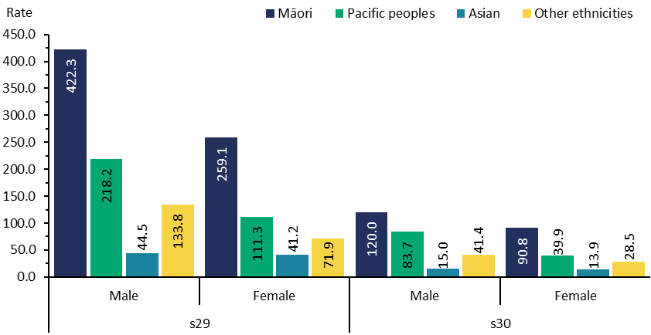
Note: Rates per 100,000 are age standardised.
Source: PRIMHD data (extracted 10 June 2025).

Table 7: Rate ratio of age-standardised rates of people subject to community (section 29) and inpatient (section 30) treatment orders under the Mental Health Act, by gender and ethnicity, 1 July 2023 to 30 June 2024
Ethnic group | Community CTO |  | Inpatient CTO
Ethnic group | Male | Female | Male | Female
Māori to Pacific peoples rate ratio | 1.9:1.0 | 2.3:1.0 | 1.4: .0 | 2.3:1.0
Māori to Asian rate ratio | 9.5:1.0 | 6.3: .0 | 8.0: .0 | 6.5:1.0
Māori to Other ethnicities rate ratio | 3.2:1.0 | 3.6:1.0 | 2.9: .0 | 3.2:10.
Pacific peoples to Other ethnicities rate ratio | 1.6:1.0 | 1.5:1.0 | 2.0: .0 | 1.4:1.0
Pacific peoples to Asian rate ratio | 4.9:1.0 | 2.7:1.0 | 5.6:1.0 | 2.9:1.0
Asian to Other ethnicities rate ratio | 0.3:1.0 | 0.6:1.0 | 0.4:1.0 | 0.5:1.0
Notes: Rates per 100,000 are age standardised. ‘Other ethnicities’ are all ethnicities excluding Māori, Pacific peoples and Asian groups.
Source: PRIMHD data (extracted 10 June 2025).

Length of time people are subject to compulsory treatment orders
On average, Māori, Pacific peoples and other ethnicities remain on CTOs for a similar amount of time. Figure 10 and Figure 11 show the percentage of Māori, Pacific peoples and other ethnicities who had spent less than a year, one to two years or more than two years subject to a community or inpatient CTO in the last three years.

Figure 10: Total time spent subject to a community treatment order (section 29) under the Mental Health Act in the last three years, by ethnicity, for those with a current order in the year 1 July 2023 to 30 June 2024
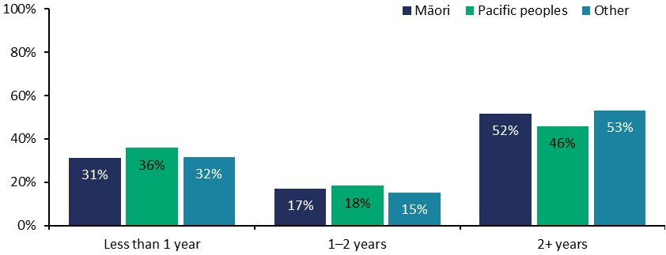
Notes: The data refers to people with treatment orders that were current at any point in 2023/24 and shows the total time they were subject to the order in the period from 1 July 2021 to 30 June 2024. Some orders current in this period will have started before 1 July 2021. For some people with orders starting in the most recent two years, the total time is not yet known as the orders are still current.
Source: PRIMHD data (extracted 10 June 2025).

Figure 11: Total time spent subject to an inpatient treatment order (section 30) under the Mental Health Act in the last three years, by ethnicity, for those with a current order in the year 1 July 2023 to 30 June 2024
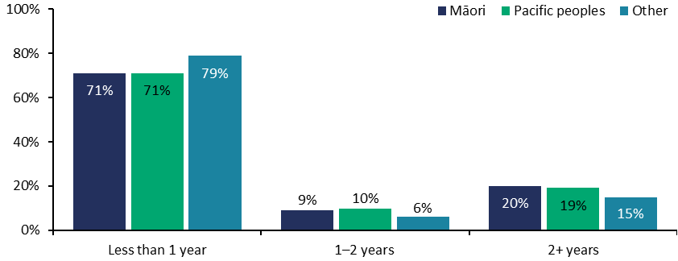
Notes: The data refers to people with treatment orders that were current at any point in 2023/24 and shows their total time subject to the order in the period from 1 July 2021 to 30 June 2024. Some orders current in this period will have started before 1 July 2021. For some people with orders starting in the most recent two years, the total time is not yet known as the orders are still current.
Source: PRIMHD data (10 June 2025).

Family and whānau consultation under the Mental Health Act
Section 7A of the Mental Health Act requires clinicians to consult family and whānau of a person undergoing compulsory assessment or treatment, unless service providers and clinicians consider this consultation is not reasonably practicable or not in the interests of the person being assessed or receiving the treatment. Clinicians are encouraged to consider that the term ‘whānau’ could include any set of relationships a patient or proposed patient recognises as their closest connections, without limiting them to blood ties.

The following summarises the consultation data from 1 July 2023 to 30 June 2024.
- On average nationally, clinicians consulted families and whānau about Mental Health Act assessment or treatment events 72.3% of the time.
- Of all the steps in the Mental Health Act treatment process, clinicians were most likely to consult family and whānau at section 14, when a person is issued with a certificate of final assessment.
- The most common reason families and whānau were not consulted was that it was considered to be not reasonably practicable in the particular circumstance.

Figure 12 shows the percentage of cases in which consultation with families and whānau occurred at each of four points in the assessment and treatment process.

Figure 12: Average percentage of successful family and whānau consultation for particular assessment or treatment events nationally, sections 10, 12, 14 and 76–78, 1 July 2023 to 30 June 2024
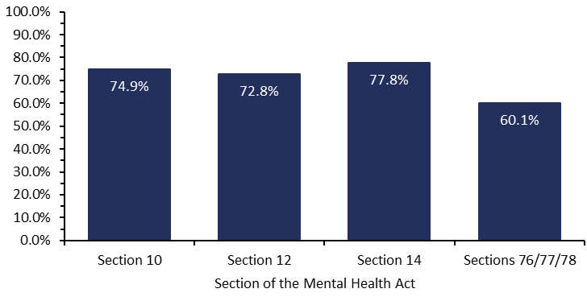
Note: Data is missing for Health New Zealand Whanganui for 1 January 2024 – 31 March 2024.
Source: Office of the Director of Mental Health and Addiction Services records.

On average nationally during this financial year, consultation was successful with family and whānau in 72.3% of events across the assessment and treatment stages. Counties Manukau had the highest rate of consultation at 94.5% and Northland had the lowest at 55.8% (Figure 13).

Figure 14 shows that, where no consultation with families and whānau occurred, by far the most common reason (in 85.3% of cases) was that service providers and clinicians considered consultation was not reasonably practicable in the particular circumstance. This could be due to the time of day or the urgency of the situation.

In 10.8% of cases, consultation was considered to be not in the interests of the person being assessed or receiving the treatment. This decision can be made at the person’s request, if their responsible clinician considers it appropriate. The responsible clinician must justify these decisions, and the Director of Area Mental Health Services must review the reasoning.

Figure 13: Average percentage of successful family and whānau consultation across all assessment and treatment events, by district, 1 July 2023 to 30 June 2024
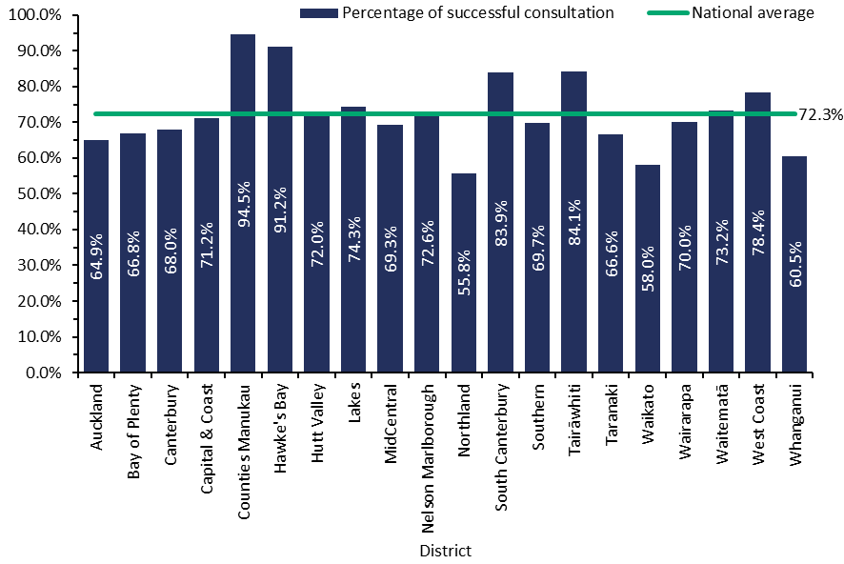
Note: Data is missing for Health New Zealand Whanganui for 1 January 2024 – 31 March 2024.
Source: Office of the Director of Mental Health and Addiction Services records.

Figure 14: Reasons for not consulting families and whānau, 1 July 2023 to 30 June 2024
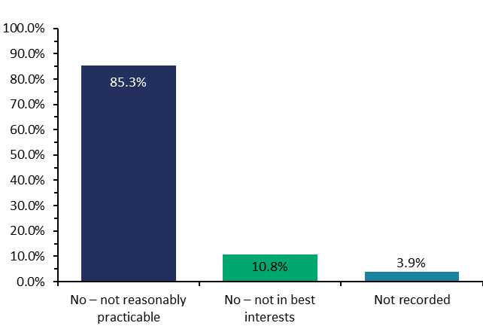
Notes: Data is missing for Health New Zealand MidCentral for the periods 1 July 2023 – 31 December 2023, and for Whanganui for 1 January 2024 – 31 March 2024.
Source: Office of the Director of Mental Health and Addiction Services records.

Additional consultation and examination data
In October 2023, the quarterly reporting template for Directors of Area Mental Health Services was amended to include data on the use of audio-visual links under section 6A of the Mental Health Act.

Section 6A was added into the Act as a result of the Mental Health (Compulsory Assessment and Treatment) Amendment Act 2021. It recognises that there may be reasons why it is not always practicable for an examination to take place face to face, such as when the person is living in a rural area.

The reporting of this data gives the Director insight into the use of audio-visual technologies. It is important to only use these technologies in situations where their use is not detrimental to the patient and their care.

Section 6A data will be included in next year’s regulatory report.

Seclusion
In New Zealand, seclusion can only lawfully occur under the Mental Health Act or the Intellectual Disability (Compulsory Care and Rehabilitation) Act 2003 (the IDCCR Act).

Ngā Paerewa Health and Disability Services Standard defines ‘seclusion’ as a situation where a service user is ‘placed alone in a room or area, at any time and for any duration, from which they cannot freely exit’.

The analysis of data on the use of seclusion during 2023/24 showed that eight individuals experienced prolonged and/or frequent periods of seclusion. This raises significant issues around trauma, dignity and human rights, and the impact these experiences have on people and their recovery. There must be a clear focus on identifying and addressing the factors that sit behind these experiences in order to ensure the safety and dignity of people in the care system.

The Office of the Director of Mental Health is undertaking deeper analysis of the circumstances and factors that led to these prolonged or frequent periods of seclusion and the interventions in place to address them. The Office will work with Health New Zealand on this initiative.

It is important to note that the data for these individuals is included in Appendix 3 for transparency and consistency with previous reports. The intention is to include this information in this section in future reports.

The following summarises adult inpatient services data from 1 July 2023 to 30 June 2024.
- The total number of people who experienced seclusion while receiving mental health treatment in an adult inpatient service decreased by 48% since 2009 (Figure 15) and by 20% compared with 2022/23.
- In contrast, the number of Māori who have been secluded has decreased by 18% since 2009. However, it decreased by 20% compared with 2022/23.
- Since 2009, the total number of hours spent in seclusion has decreased by 73% (Figure 16). Compared with 2022/23, the total number of hours spent in seclusion has decreased by 24%.
- Of all seclusion events, 70% lasted for less than 24 hours and 16% lasted for longer than 48 hours.
- Males were more than twice as likely as females to be secluded.
- People aged 25–34 years were more likely than other age groups to be secluded.
- Māori were more likely than non-Māori to be secluded. They also had more seclusion events, on average, and had longer periods of seclusion.
- On average, adult inpatient units had 4.8 seclusion events for every 1,000 bed nights.
- Of the 10,324 admissions to adult inpatient units, 665 (6.4%) had seclusion recorded at some point during the patient’s stay.

Figure 15: Number of people secluded in adult inpatient services nationally, 2007 to 2023/24
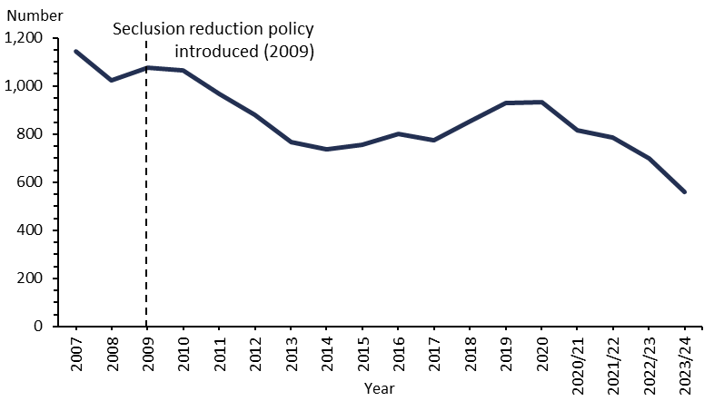
Notes: The data excludes forensic inpatient services and regional intellectual disability secure services. All years before 2020/21 are calendar years.
Sources: PRIMHD data (extracted 10 June 2025) and manual data from Health New Zealand Canterbury, Southern, Waikato and Waitematā.

Figure 16: Number of seclusion hours in adult inpatient services nationally, 2007 to 2023/24
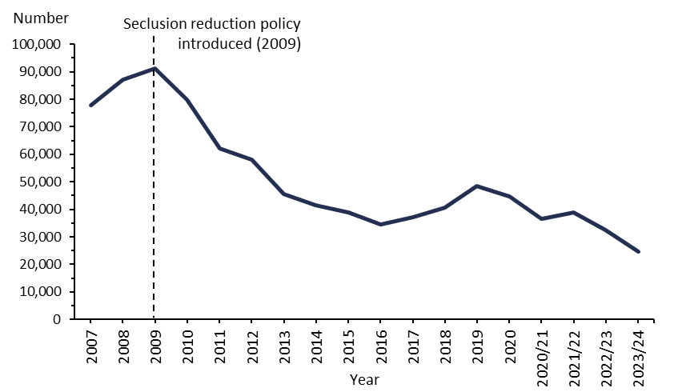
Notes: The data excludes forensic inpatient services and regional intellectual disability secure services. All years before 2020/21 are calendar years.
Sources: PRIMHD data (extracted 10 June 2025) and manual data from Health New Zealand Canterbury, Southern, Waikato and Waitematā.

Seclusion in New Zealand mental health services
In the 2023/24 financial year, New Zealand adult mental health services (excluding forensic and other regional rehabilitation services) accommodated 7,042 people for a total of 220,898 bed nights. Of these, 561 people (8%) were secluded at some stage during the reporting period. Māori were more likely to be secluded than other groups, making up 55% of all adults secluded. For context, Māori make up 17% of the general population.

Many were secluded more than once (on average, 1.9 times). For this reason, the number of seclusion events in adult inpatient services (1,050) was higher than the number of people secluded. The 2024 seclusion guidelines help to explain this trend in that they encourage services to support patients to exit seclusion rather than secluding them for a longer single session. If a transition out of seclusion is not successful, a patient may be secluded again, with the result that they could have several seclusion events.

There were 4.8 seclusion events per 1,000 bed nights on average in adult inpatient units. This means that nationally and on average, for every 1,000 bed nights a person spent in an inpatient unit, they would have 4.8 seclusion events.

Across all inpatient services, including forensic, intellectual disability and youth services, 755 people experienced at least one seclusion event. Of those people, 69% were male and 31% were female.

As Figure 17 and Figure 18 show, the most common age group for those secluded was 30–34 years. A total of 67 young people (aged 19 years and under) experienced 225 seclusion events across mental health and intellectual disability services during the year. Figure 18 presents the age group seclusion data as rates per 100,000 population to more clearly demonstrate the differences between them.

Figure 17: Number of people secluded across all inpatient services (adult, forensic, intellectual disability and youth), by age group, 1 July 2023 to 30 June 2024
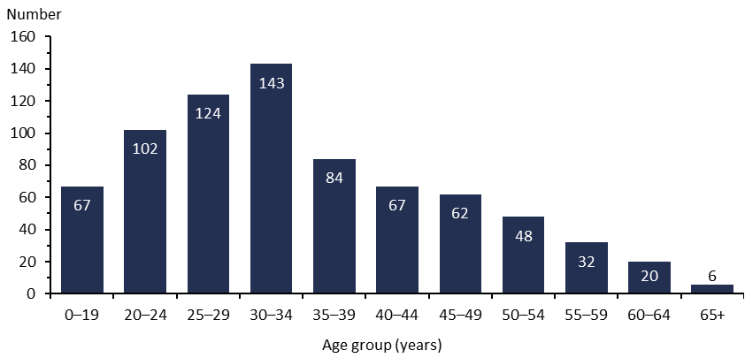
Note: The data includes patients treated in regional intellectual disability secure services, but excludes the eight individuals who had experienced prolonged and/or frequent periods of seclusion.
Sources: PRIMHD data (extracted 10 June 2025) and manual data from Health New Zealand Canterbury, Southern, Waikato and Waitematā.

Figure 18: Rate of people secluded across all inpatient services (adult, forensic, intellectual disability and youth) per 100,000 population, by age group, 1 July 2023 to 30 June 2024
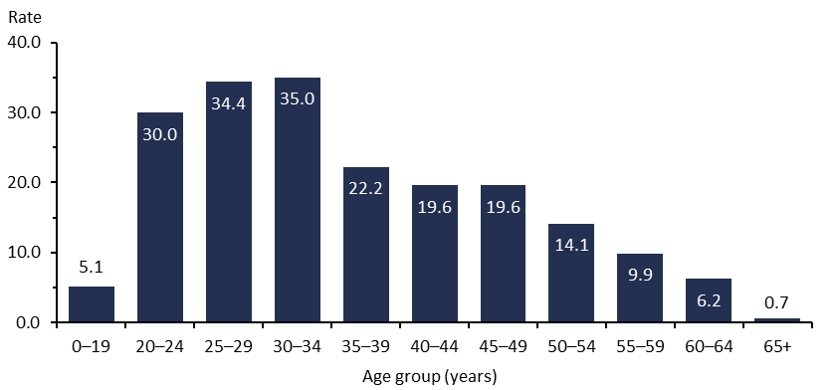
Note: The data includes patients treated in regional intellectual disability secure services, but excludes the eight individuals who had experienced prolonged and/or frequent periods of seclusion.
Sources: PRIMHD data (extracted 10 June 2025) and manual data from Health New Zealand Canterbury, Southern, Waikato and Waitematā.

Figure 19 presents the percentage of seclusion events across all inpatient services by the length of the event in hours. Nearly half of seclusion events lasted for less than 12 hours and about 70% of events lasted for less than 24 hours.

Figure 20 provides the number of events by length and ethnicity, which shows some variation in duration between ethnic groups. Figure 21 shows the number and percentage of events by their length.

Figure 19: Percentage of seclusion events across all inpatient services (adult, forensic, intellectual disability and youth), by length of event, 1 July 2023 to 30 June 2024
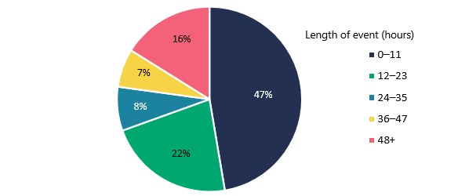
Notes: The data includes patients treated in regional intellectual disability secure services, but excludes the eight individuals who had experienced prolonged and/or frequent periods of seclusion.
Sources: PRIMHD data (extracted 10 June 2025) and manual data from Health New Zealand Canterbury, Southern, Waikato and Waitematā.

Figure 20: Percentage of seclusion events across all inpatient services (adult, forensic, intellectual disability and youth), by ethnicity and length of event, 1 July 2023 to 30 June 2024
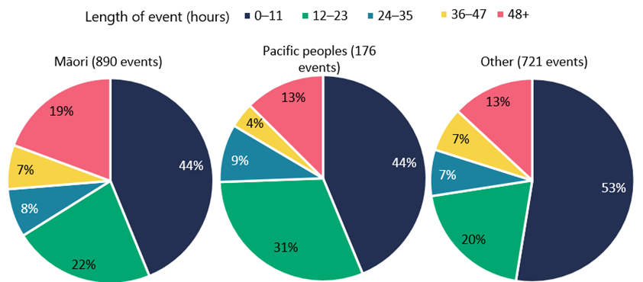
Notes: The data includes patients treated in regional intellectual disability secure services, but excludes the eight individuals who had experienced prolonged and/or frequent periods of seclusion.
Sources: PRIMHD data (extracted 10 June 2025) and manual data from Health New Zealand Canterbury, Southern, Waikato and Waitematā.

Figure 21: Number and percentage of seclusion events across all inpatient services (adult, forensic, intellectual disability and youth), by length of event, 1 July 2023 to 30 June 2024
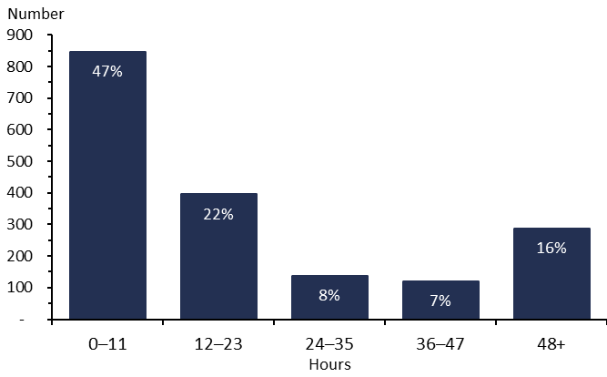
Notes: The data includes patients treated in regional intellectual disability secure services, but excludes the eight individuals who had experienced prolonged and/or frequent periods of seclusion.
Sources: PRIMHD data (extracted 10 June 2025) and manual data from Health New Zealand Canterbury, Southern, Waikato and Waitematā.

Figure 22 gives an hourly breakdown of the distribution of seclusion events that lasted for less than 24 hours. This shows a high proportion of these events last for less than six hours.

Figure 22: Number of seclusion events across all inpatient services (adult, forensic, intellectual disability and youth) that are less than 24 hours, by length of event, 1 July 2023 to 30 June 2024
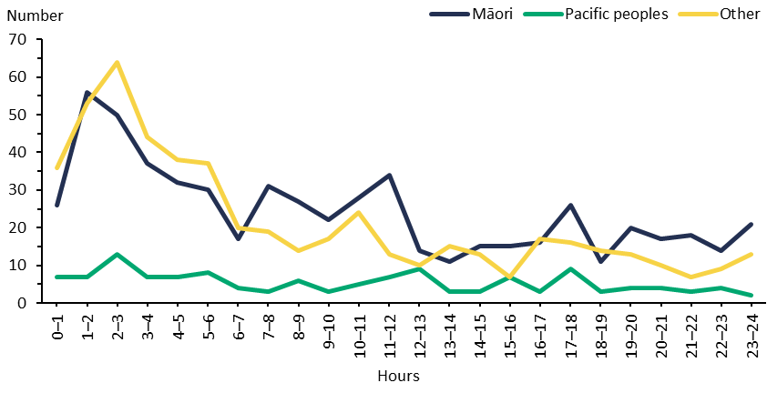
Notes: The data includes patients treated in regional intellectual disability secure services, but excludes the eight individuals who had experienced prolonged and/or frequent periods of seclusion.
Sources: PRIMHD data (extracted 10 June 2025) and manual data from Health New Zealand Canterbury, Southern, Waikato and Waitematā.

Use of seclusion by district
All Health New Zealand districts except for Wairarapa (which has no mental health inpatient service) used seclusion in the 2023/24 financial year.

At the national level in 2023/24, the average number of people secluded in adult inpatient services was 17.9 per 100,000 people in the general population. Figure 23 shows how individual districts compare with this national average.

Figure 23: Number of people secluded in adult inpatient services per 100,000 population, by district, 1 July 2023 to 30 June 2024
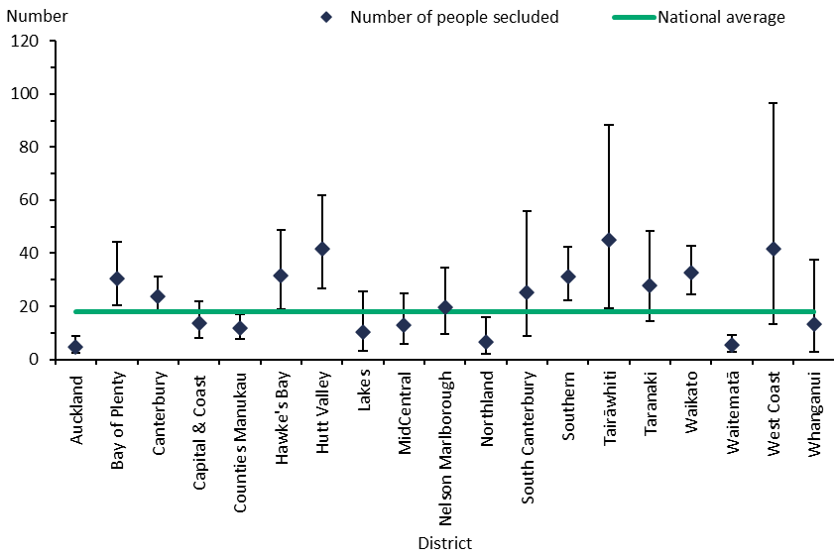
Notes: In this figure, the confidence intervals (for 99% confidence, shown as vertical lines through the blue diamond markers) can help with interpreting the data. Where a service’s confidence interval crosses the national average, that means its rate was not different from the average at a statistically significant level. The data excludes forensic inpatient services and regional intellectual disability secure services. Wairarapa had no inpatient unit, so is not shown in this figure.
Sources: PRIMHD data (extracted 10 June 2025) and manual data from Health New Zealand Canterbury, Southern, Waikato and Waitematā.

Table 8 shows the seclusion rate for each district as a percentage of patients admitted to adult inpatient services who experienced seclusion during their admission.

Table 8: Percentage of admissions to adult inpatient services with seclusion recorded during admission, by district, 1 July 2023 to 30 June 2024
District | Percentage |  | District | Percentage
Auckland | 2.3% |  | Northland | 1.3%
Bay of Plenty | 10.5% |  | South Canterbury | 4.1%
Canterbury | 8.0% |  | Southern | 10.4%
Capital & Coast | 5.6% |  | Tairāwhiti | 10.6%
Counties Manukau | 7.2% |  | Taranaki | 3.7%
Hawke’s Bay | 8.5% |  | Waikato | 9.5%
Hutt Valley | 10.8% |  | Waitematā | 2.3%
Lakes | 4.1% |  | West Coast | 10.7%
MidCentral | 3.0% |  | Whanganui | 3.2%
Nelson Marlborough | 7.7% |  | National average | 6.4%

Notes: The data excludes forensic inpatient services, regional intellectual disability secure services, and Wairarapa as it had no inpatient service. Some services may have low admission rates, with the result that they have a higher percentage of admissions with seclusion recorded than other services.
Sources: PRIMHD data (extracted 10 June 2025) and manual data from Health New Zealand Canterbury, Southern, Waikato and Waitematā.

Nationally, the average number of seclusion events was 33.6 per 100,000 people in the general population, down from 38.4 in the 2022/23 financial year. Figure 24 breaks this rate down by Health New Zealand district.

The average length of a seclusion event was 23.4 hours, a decrease from 27.5 hours in the previous year.

Figure 24: Number of seclusion events in adult inpatient services per 100,000 population, by district, 1 July 2023 to 30 June 2024
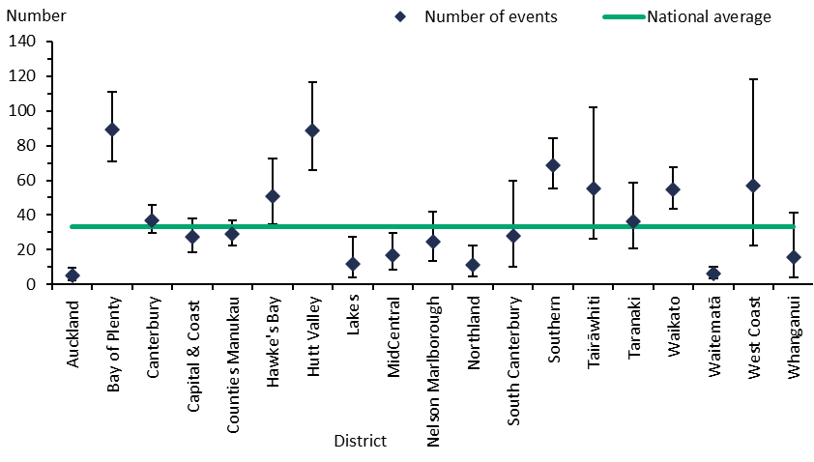
Notes: In this figure, the confidence intervals (for 99% confidence, shown as vertical lines through the blue diamond markers) can help with interpreting the data. Where a service’s confidence interval crosses the national average, that means its rate was not different from the average at a statistically significant level. The data excludes forensic inpatient services and regional intellectual disability secure services. Wairarapa had no inpatient unit, so is not shown in this figure.
Sources: PRIMHD data (extracted 10 June 2025) and manual data from Health New Zealand Canterbury, Southern, Waikato and Waitematā.

Seclusion and ethnicity
The rate of seclusion for Māori in adult inpatient services was 62.8 people per 100,000 people in the general population. Māori were 6.6 times more likely to be secluded than non-Māori, who had a rate of 9.6 people per 100,000.

Figure 25 shows the number of people secluded by ethnicity over four financial years, from 2020/21 to 2023/24.

Figure 25: Number of people secluded in adult inpatient services, by ethnicity and year, from 1 July 2020 to 30 June 2024
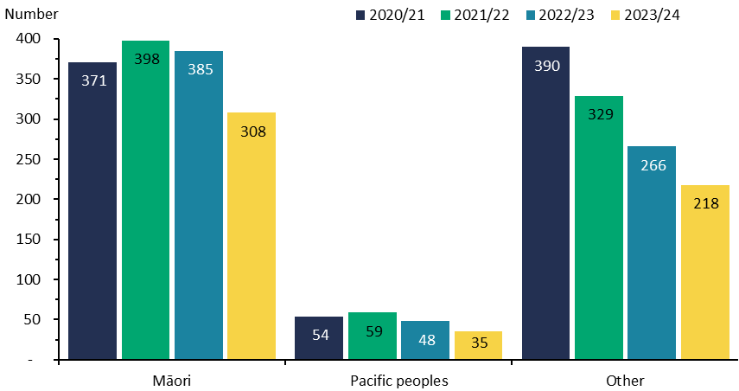
Notes: The data excludes forensic services and regional intellectual disability secure services.
Sources: PRIMHD data (extracted 10 June 2025) and manual data from Health New Zealand Canterbury, Southern, Waikato and Waitematā.

Along with other seclusion indicators, Figure 26 shows seclusion rates for Māori, Pacific peoples and other ethnicities in 2023/24. Māori were secluded at a rate of 62.8 people per 100,000 people in the general population, Pacific peoples at a rate of 15.7 people per 100,000 and other ethnicities at a rate of 9.0 people per 100,000.

Figure 27 shows the percentage of people secluded in adult inpatient services by ethnicity and gender.

Figure 26: Seclusion indicators for adult inpatient services, by ethnicity, 1 July 2023 to 30 June 2024
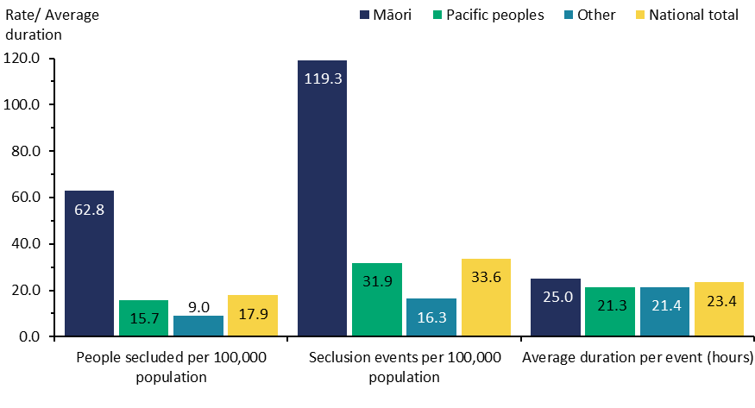
Note: The data excludes forensic services and regional intellectual disability secure services.
Sources: PRIMHD data (extracted 10 June 2025) and manual data for Health New Zealand Canterbury, Southern, Waikato and Waitematā.

Figure 27: Percentage of people secluded in adult inpatient services, by ethnicity and gender, 1 July 2023 to 30 June 2024
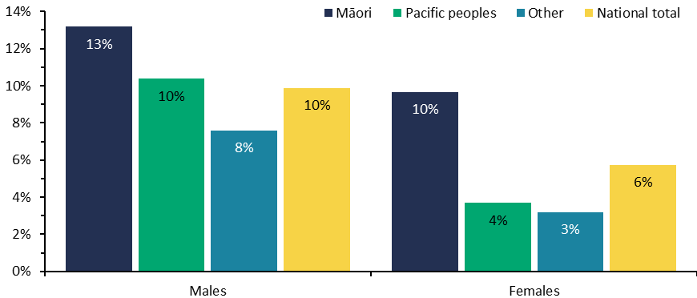
Note: The data excludes forensic services and regional intellectual disability secure services.
Sources: PRIMHD data (extracted 10 June 2025) and manual data for Health New Zealand Canterbury, Southern, Waikato and Waitematā.

Figure 28 shows the number of Māori and non-Māori aged 20–64 years who were secluded in adult inpatient services from the 2007 calendar year to the 2023/24 financial year. Nationally since 2009 (when the seclusion reduction policies were introduced), the number of people secluded has decreased by 48%. In contrast, the number of Māori secluded has decreased by 18% over the same period.

Figure 28: Number of Māori and non-Māori secluded in adult inpatient services, 2007 to 2023/24
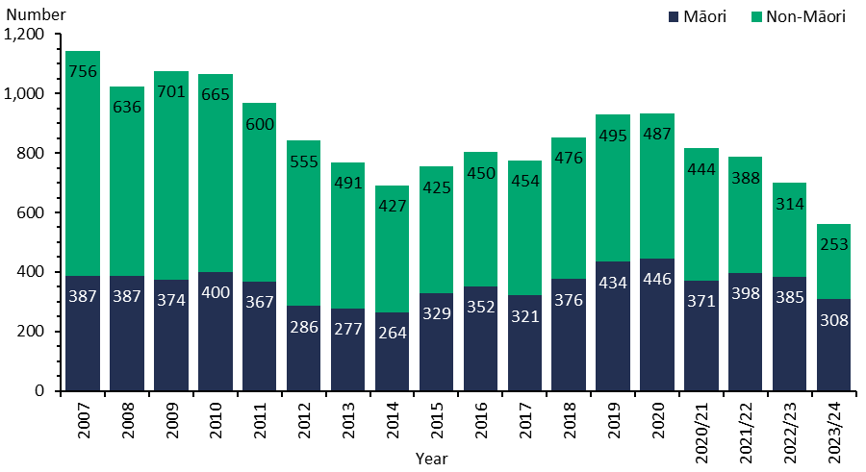
Notes: The data excludes forensic services and regional intellectual disability secure services. All years before 2020/21 are calendar years. The numbers of Māori and non-Māori secluded in the 2009 year have been corrected in this chart. In previous reports, the figures for 2009 were incorrectly reported as 270 Māori and 805 non-Māori.
Sources: PRIMHD data (extracted 10 June 2025) and manual data for Health New Zealand Canterbury, Southern, Waikato and Waitematā.

Seclusion in forensic units
Five regional forensic mental health services provide specialist inpatient forensic care.
- Auckland Regional Forensic Psychiatry Service operates from Health New Zealand Waitematā and covers the Auckland, Counties Manukau, Northland and Waitematā districts.
- Midland Regional Forensic Psychiatric Service operates from Health New Zealand Waikato and covers the Bay of Plenty, Lakes, Tairāwhiti, Taranaki and Waikato districts.
- Central Regional Forensic Mental Health Service operates from Health New Zealand Capital, Coast and Hutt Valley and covers the Capital & Coast, Hawke’s Bay, Hutt Valley, MidCentral, Wairarapa and Whanganui districts.
- Canterbury Regional Forensic Mental Health Service operates from Health New Zealand Canterbury and covers the Canterbury, Nelson Marlborough, South Canterbury and West Coast districts.
- Southern Regional Forensic Mental Health Service operates from and covers the Southern district.

These services provide mental health treatment in a secure setting for prisoners with mental disorders and for people defined as a special or restricted patient. Some services have more beds than others, which may be a reason contributing to their higher levels of seclusion use.

Table 9 presents seclusion indicators for each regional service that provides forensic mental health services. Broadening the focus to the national level, Figure 29 breaks down the number of people secluded and number of events by ethnicity. These indicators cannot be compared with adult inpatient service indicators because they have a different client base.

Table 9: Seclusion indicators for forensic mental health services, by regional service, 1 July 2023 to 30 June 2024
Regional service | Number of people secluded | Number of events | Total hours | Average duration per event (hours)
Auckland | 53 | 136 | 8,820 | 64.9
Canterbury | 26 | 93 | 5,494 | 59.1
Central | 5 | 6 | 130 | 21.7
Midland | 21 | 64 | 1,928 | 30.1
Southern | 9 | 16 | 506 | 31.6
Nationally | 114 | 315 | 16,878 | 53.6
Notes: This data is for forensic mental health service users aged 20–64 years. It excludes the three individuals who had experienced prolonged and/or frequent periods of seclusion in forensic services.
Sources: PRIMHD data (extracted 10 June 2025) and manual data for Health New Zealand Canterbury, Southern, Waikato and Waitematā.

Figure 29: Seclusion indicators for forensic mental health services, by ethnicity, 1 July 2023 to 30 June 2024
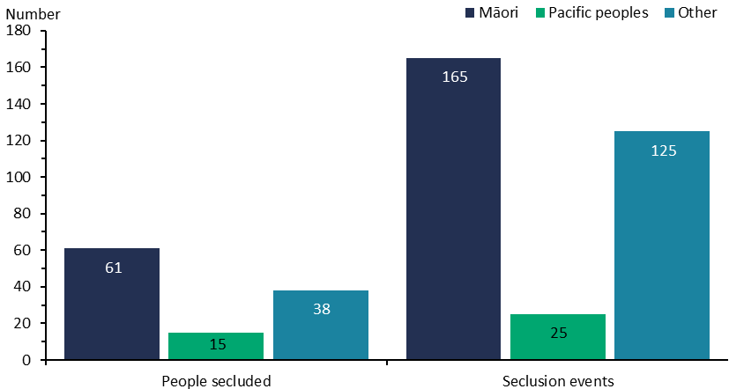
Notes: This data is for forensic mental health service users aged 20–64 years. It excludes the three individuals who had experienced prolonged and/or frequent periods of seclusion in forensic services.
Sources: PRIMHD data (extracted 10 June 2025) and manual data for Health New Zealand Canterbury, Southern, Waikato and Waitematā.

People with intellectual disabilities cared for in an intellectual disability forensic service
The five regional forensic mental health services listed in the section above also provide forensic intellectual disability services for people with an intellectual disability under the IDCCR Act, as care recipients or special care recipients. Individuals become subject to the IDCCR Act when they are convicted of criminal offending and compulsory care is ordered rather than a prison sentence. A small number of individuals in forensic intellectual disability services are under the Mental Health Act.

The seclusion data presented in Table 10: Seclusion indicators for people with intellectual disabilities, nationally, by Act, 1 July 2023 to 30 June 2024 through Table 12 for people with intellectual disabilities is for individuals with a legal status under the IDCCR Act or the Mental Health Act. People receiving care under these Acts can only be secluded in hospital-level secure services that meet specific requirements.

Data in this section is presented on a national level to protect individuals’ privacy. Similarly, the seclusion indicators for Māori and non-Māori with intellectual disabilities are presented per 100,000 people in the general population (Table 12), rather than as raw figures.
Table 10: Seclusion indicators for people with intellectual disabilities, nationally, by Act, 1 July 2023 to 30 June 2024
Act | Number of people secluded | Number of events | Median number of events | Average number of events per person
IDCCR Act | 18 | 177 | 7.0 | 9.8
Mental Health Act | 7 | 86 | 3.0 | 12.3
Note: The data excludes the five individuals who had experienced prolonged and/or frequent periods of seclusion in intellectual disability services.
Sources: PRIMHD data (extracted 10 June 2025) and manual data for Health New Zealand Canterbury, Southern, Waikato and Waitematā.

Table 11: Length of seclusion for people with intellectual disabilities, nationally, by Act, 1 July 2023 to 30 June 2024
Act | Total seclusion hours | Median length of seclusion events (hours:minutes) | Average length of seclusion events (hours:minutes)
IDCCR Act | 8,982.8 | 10:48 | 50:45
Mental Health Act | 7,028.6 | 16:9 | 81:44
Note: The data excludes the five individuals who had experienced prolonged and/or frequent periods of seclusion in intellectual disability services.
Sources: PRIMHD data (extracted 10 June 2025) and manual data for Health New Zealand Canterbury, Southern, Waikato and Waitematā.

Table 12: Seclusion indicators for Māori and non-Māori with intellectual disabilities, nationally, by Act, 1 July 2023 to 30 June 2024
Act | Ethnicity | People secluded per 100,000 population | Seclusion events per 100,000 population | Average number of events per person
IDCCR Act | Māori | 0.5 | 2.5 | 4.6
IDCCR Act | Non-Māori | 0.3 | 3.5 | 11.8
Mental Health Act | Māori | 0.2 | 3.1 | 14.0
Mental Health Act | Non-Māori | 0.1 | 1.3 | 11.6
Note: The data excludes the five individuals who had experienced prolonged and/or frequent periods of seclusion in intellectual disability services.
Sources: PRIMHD data (extracted 10 June 2025) and manual data for Health New Zealand Canterbury, Southern, Waikato and Waitematā.

Special and restricted patients
Under New Zealand law, people who have been charged with committing crimes while severe mental illness was influencing their judgement may be treated in a secure mental health facility instead of going to prison. These people are given ‘special patient’ status.

Special patients include:
- people charged with, or convicted of, a criminal offence and remanded to a hospital for a psychiatric report
- remanded or sentenced prisoners transferred from prison to a hospital
- defendants found not guilty by reason of insanity or who have a finding of act proven but not criminally responsible on account of insanity
- defendants who are unfit to stand trial
- people who have been convicted of a criminal offence and are both sentenced to a term of imprisonment and placed under a CTO.

Restricted patients are people detained in forensic mental health services by court order because they pose a danger to others. They have not necessarily been charged with or convicted of a crime. They may have also been transferred from prison or previously had a special patient status that changed when their sentence ended.

Special and restricted patients can be detained in the five regional forensic mental health services (see the Seclusion in forensic units section).

The national total of 473 special patients is lower than the sum of special patients by regional service. This is because some special patients may have transferred across services during the year.

Figure 30 presents the total number of special patients in the care of each regional forensic mental health service.

Special and restricted patients may be detained for either extended or short-term care. The following discussion details the data on these variations.

Figure 30: Total number of special patients, by regional service, 1 July 2023 to 30 June 2024
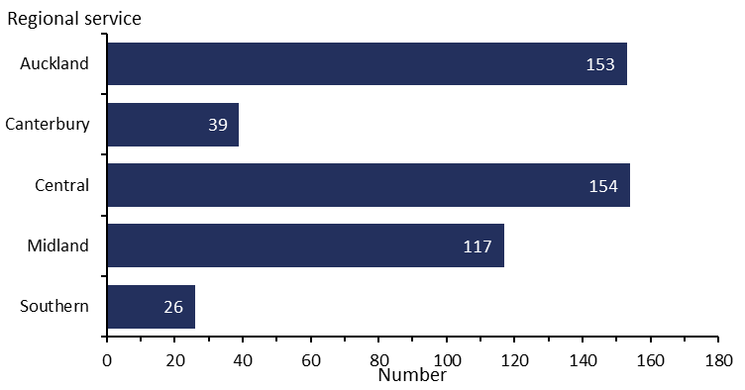
Sources: PRIMHD data (extracted 10 June 2025) and manual data for Health New Zealand Capital & Coast and Waikato.

Extended forensic care special patients
Extended forensic care (EFC) patients include special patients who have been found not guilty by reason of insanity or unfit to stand trial under section 24(2)(a) of the Criminal Procedure (Mentally Impaired Persons) Act 2003. Restricted patients under section 55 of the Mental Health Act are also supported in extended forensic care facilities.

From 1 July 2023 to 30 June 2024, New Zealand had 186 EFC special patients.

Short-term forensic care special patients
Short-term forensic care (SFC) patients include people transferred from prison to a forensic mental health service. When a person has been sentenced to a term of imprisonment, any Mental Health Act status that they may have had previously no longer applies. Remand prisoners may remain on a current CTO, but it is unlawful to enforce compulsory treatment in the prison environment. However, a court may make a ‘hybrid order’ under section 34(1)(a)(i) of the Criminal Procedure (Mentally Impaired Persons) Act 2003, sentencing an offender to a term of imprisonment while also ordering their detention in hospital as a special patient.

From 1 July 2023 to 30 June 2024, New Zealand had a total of 308 SFC special patients.

Table 13 shows the number of these patients in the care of each regional forensic mental health service. Figure 31 shows the percentage of court orders given for SFC and EFC legal status in each of these services.

Table 13: Total number of special patients, by type and service, 1 July 2023 to 30 June 2024
Regional service | EFC special patients | SFC special patients | Total special patients
Auckland | 58 | 103 | 153
Canterbury | 18 | 21 | 39
Central | 72 | 89 | 154
Midland | 37 | 85 | 117
Southern | 9 | 17 | 26
Nationally | 186 | 308 | 473
Notes: Special patients who receive treatment with more than one service are counted in each one, which is why the sum of patients in the five services is higher than the national total. A patient may be represented under both the EFC and SFC categories in this table. Court orders for a small number of special patients directed them to receive treatment outside a regional forensic service. This data is excluded to protect patient confidentiality.
Sources: PRIMHD data (extracted 10 June 2025) and manual data for Health New Zealand Capital & Coast and Waikato.

Figure 31: Percentage of court orders given for extended and short-term forensic care, by regional service, 1 July 2023 to 30 June 2024
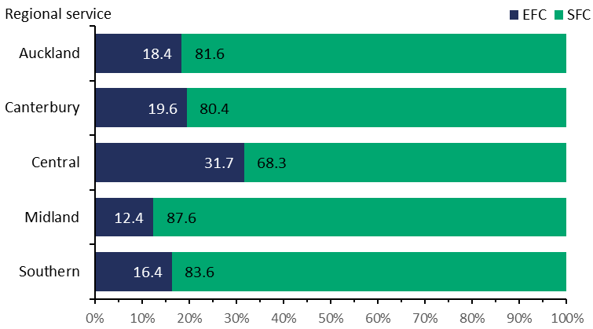
Notes: Unlike previous data in this section, this figure is based on a count of court orders rather than the number of special patients. A single special patient may have many court orders in the year, which could include both EFC and SFC, but each special patient’s legal status is counted in only one category at any one time. Please use caution when comparing the counts of court orders for legal status with the counts of people with either EFC or SFC legal status.
Sources: PRIMHD data (extracted 10 June 2025) and manual data for Health New Zealand Capital & Coast and Waikato.

Gender, age and ethnicity of special patients
Special patients were over six times more likely to be male (86.0%) than female (14.0%) (demonstrated as numbers in Figure 32). The most common age group for special patients in 2023/24 was 30–34 years (Figure 33).

Figure 32: Number of special patients, by gender, 1 July 2023 to 30 June 2024
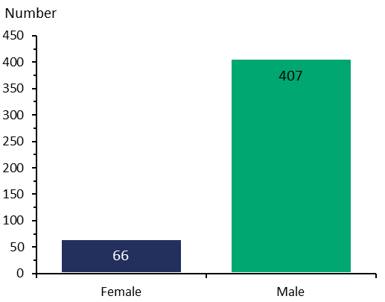
Sources: PRIMHD data (extracted 10 June 2025) and manual data for Health New Zealand Capital & Coast and Waikato.

Figure 33: Total number of special patients, by age group, 1 July 2023 to 30 June 2024
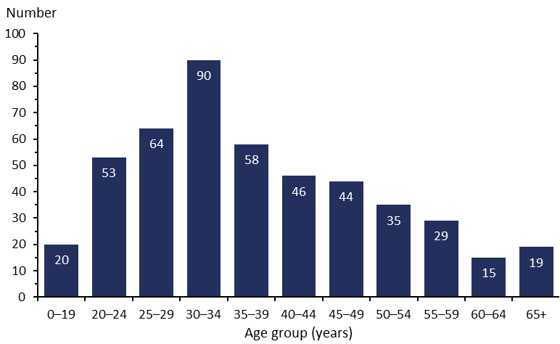
Sources: PRIMHD data (extracted 10 June 2025) and manual data for Health New Zealand Capital & Coast and Waikato.

Among people subject to a special patient order, most (52.4%) were Māori (Figure 34). Māori represented the highest proportion of both EFC (44.1%) and SFC (57.8%) special patients.

Figure 34: Percentage (and number) of special patients, by ethnicity and special patient type, 1 July 2023 to 30 June 2024
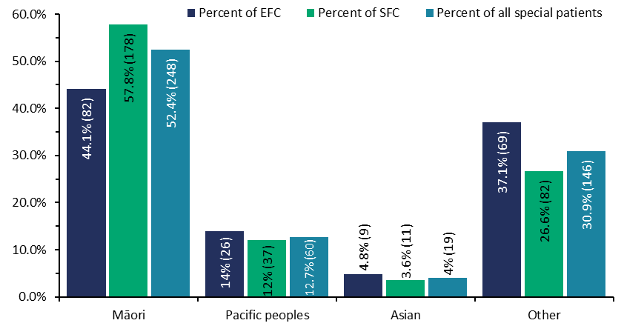
Notes: A single patient may be represented under both the EFC and SFC categories in this figure. Numbers in brackets are the number of special patients.
Sources: PRIMHD data (extracted 10 June 2025) and manual data for Health New Zealand Capital & Coast and Waikato.

Decisions about leave and change of legal status for special and restricted patients
The Director of Mental Health (the Director) has a central role in managing special patients and restricted patients throughout the continuum of care. The Director must be notified when special and restricted patients are admitted, discharged or transferred, and when certain incidents involving these people occur (section 43 of the Mental Health Act). The Director may authorise the transfer of patients between hospitals and districts under section 49 of the Mental Health Act or grant leave for any period no longer than seven days for certain special and restricted patients (section 52A).

Under section 50A of the Mental Health Act, the Minister of Health can grant periods of leave for longer than seven days to certain categories of special patients. The Director briefs the Minister of Health when requests for this type of leave are made. If the Minister grants the first application under section 50A, it is usually for a period of six months. Further applications for ministerial leave for a period of 12 months are possible.

Where a special patient has been acquitted by reason of insanity, or the criminal act is proven but they are not criminally responsible on account of insanity, they may be considered for a change of legal status if it is determined that their detention as a special patient is no longer necessary to safeguard their own or the public’s interests. This change in legal status will usually occur after the person has been living successfully in the community on ministerial long leave for several years. Forensic services apply to the Director for this change. After careful consideration, the Director makes a recommendation for the Minister of Health’s decision about a person’s legal status.

On some occasions, a special patient who was found unfit to stand trial may be certified by their responsible clinician to still be unfit to stand trial but no longer require detention as a special patient. An application is then made under section 31(3) of the Criminal Procedure (Mentally Impaired Persons) Act 2003 to the Minister of Health and the Attorney-General to consider reclassifying the person as a patient subject to a regular CTO or be fully discharged from compulsory treatment.

Table 14 shows the number of applications for granting section 50A long leave, revoking that leave and reclassifying a person’s legal status that the Office of the Director of Mental Health and Addiction Services processed through to the Minister of Health in 2023/24.

Table 14: Number of applications for granting section 50A long leave, revoking that leave and reclassifying legal status that the Minister of Health received for special and restricted patients, 1 July 2023 to 30 June 2024
Type of request | Number completed
Initial ministerial section 50A leave applications approved | 4
Initial ministerial section 50A leave applications not approved | 0
Ministerial section 50A leave revocations (initial and further) | 3
Further ministerial section 50A leave applications approved | 21
Further ministerial section 50A applications not approved | 0
Change of legal status applications approved | 3
Change of legal status applications not approved | 1
Total applications completed | 32
Notes: This table does not include applications that were withdrawn before the Minister of Health received them and applications for adjustments to be made to section 50A leave conditions for a special patient.
Source: Office of the Director of Mental Health and Addiction Services records.

Mental health and addiction adverse event reporting
New Zealand has two major national reporting mechanisms for adverse events relating to mental health.
- Health New Zealand districts notify the Director of Mental Health of the death of any person or special patient under the Mental Health Act.
- Districts report all adverse events rated Severity Assessment Code (SAC) 1 or 2 to the Health Quality & Safety Commission in line with the National Adverse Events Reporting Policy. At the time the data reported here was collected, mental health services not funded by districts were encouraged but not required to report adverse events to the Health Quality & Safety Commission.

Public reporting of adverse events began in 2006. Since then, the number of reported adverse events has increased each year.

To provide timely access to adverse events data on mental health and addiction services, the Health Quality & Safety Commission publishes the national quarterly dashboard online. In publishing providers’ reported adverse events, it aims to make harm visible and transparent.

Event totals displayed in the dashboards fluctuate because later reviews may change the SAC rating of some events to more accurately reflect their level of severity. That, in turn, changes a provider’s obligation to report or not.

The Health Quality & Safety Commission welcomes increases in reporting rates, because it believes they represent more thorough and consistent reporting of the events that have always been a part of the system, rather than showing that rates of adverse events are actually worsening. This stronger reporting culture can create real opportunities for improvement across the system.

Deaths reported to the Director of Mental Health
Section 132 of the Mental Health Act requires services to notify the Director within 14 days of the death of any patient or special patient under the Mental Health Act. This includes identifying the apparent cause of death.

In New Zealand, a coroner determines a cause of death after completing their inquiry. Only deaths that the coroner decides are ‘intentionally self-inflicted’ will receive a final verdict of suicide. The coronial inquiry is unlikely to occur within a year of a death. When a death appears to be self-inflicted, but the coroner has not yet made a ruling, it is called a ‘suspected suicide’. For more information and data, see the suicide data web tool on Health New Zealand’s website: tewhatuora.govt.nz/for-health-professionals/data-and-statistics/suicide/data-web-tool.

In 2023/24, the Director received 47 death notifications relating to people under the Mental Health Act (Table 15). Of these, 13 related to people who were reported to have died by suspected suicide. The remaining 34 reportedly died by other means, including natural causes and illnesses unrelated to their mental health status.

Table 15: Outcomes of reportable death notifications under section 132 of the Mental Health Act, 1 July 2023 to 30 June 2024
Reportable death outcome | Number of deaths
Suspected suicide | 13
Other deaths | 34
All reportable deaths | 47
Source: Office of the Director of Mental Health and Addiction Services records.

Section 95 inquiries and section 99 inspections
Occasionally the Director will require a district inspector to carry out an inquiry under section 95 of the Mental Health Act or the Director will undertake an inspection themselves under section 99. Inquiries and inspections generally focus on systemic issues across one or more mental health services. As a result of either an inquiry or an inspection, typically a district inspector or the Director makes specific recommendations about the mental health services and/or their system.

Following an inquiry under section 95 of the Mental Health Act, the Director considers the recommendations and acts on any that have implications for the Ministry of Health or the wider mental health sector. The Director later audits the specific district’s implementation of the recommendations.

Following an inquiry under section 99 of the Mental Health Act, the Director will make specific recommendations to district mental health services and will monitor their implementation.

The inquiry process is complete when the Director considers that the district concerned and, if appropriate, the Ministry and all other districts have satisfactorily implemented the recommendations.

No section 95 inquiries or section 99 inspections were completed in the 2023/24 financial year. Table 16 shows the number of completed section 95 inquiry reports the Director received and the number of section 99 reports the Director received or completed between 1 July 2013 and 30 June 2024.

The Director initiated a section 99 inspection on 6 July 2022, following a serious incident in late June 2022 and in the context of concerns about the Canterbury – Waitaha adult inpatient service and associated mental health services.

Table 16: Number of section 95 inquiries completed and section 99 inspections reports received or completed by the Director, 2013/14 to 2023/24
2013/14 | 2014/15 | 2015/14 | 2016/17 | 2017/18 | 2018/19 | 2019/20 | 2020/21 | 2021/22 | 2022/23 | 2023/24
0 | 1 | 2 | 0 | 0 | 0 | 0 | 0 | 0 | 0 | 0
Source: Office of the Director of Mental Health and Addiction Services records.

Electroconvulsive therapy
Electroconvulsive therapy (ECT) is a therapeutic procedure that delivers a brief pulse of electricity to a person’s brain to generate a seizure while they are under anaesthesia. ECT can be an effective treatment for depression, mania, catatonia and other serious neuropsychiatric conditions. It can happen only if the person receiving it consents or in carefully defined circumstances without their consent.

The following summarises ECT data from 1 July 2023 to 30 June 2024.
- 294 people received ECT (5.5 people per 100,000 population).
- Services administered a total of 3,531 treatments of ECT.
- ECT patients received an average of 12.0 ECT treatments each over the year.
- Females (62.2%) were more likely to receive ECT than males (37.4%).
- Older people were more likely to receive ECT. Those aged over 50 years made up 68.0% of ECT patients.
- For every 100,000 specialist service users, 166.2 received ECT.

Number of people receiving ECT
Around 200 to 300 people receive ECT treatment each year. This number has remained relatively stable since 2010 (Figure 35). Figure 36 shows the rate of people per 100,000 population receiving ECT.

Figure 35: Number of ECT patients, 2010 to 2023/24
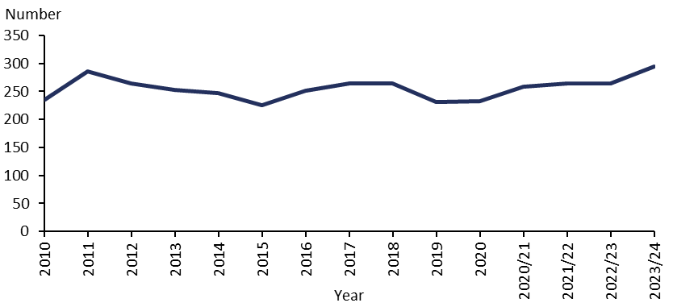
Note: in the 2022/23 Regulatory Report we incorrectly labelled the equivalent graph (Figure 38) as showing the rate per 100,000 population. The caption should have stated that the figure showed the number of ECT patients.
Sources: 2023/24 PRIMHD data (extracted 10 June 2025) and manual data for Health New Zealand Capital & Coast, Hawke’s Bay, Southern and Waikato. All years before 2020/21 are calendar years.
Figure 36: Rate of ECT patients per 100,000 population, 2010 to 2023/24
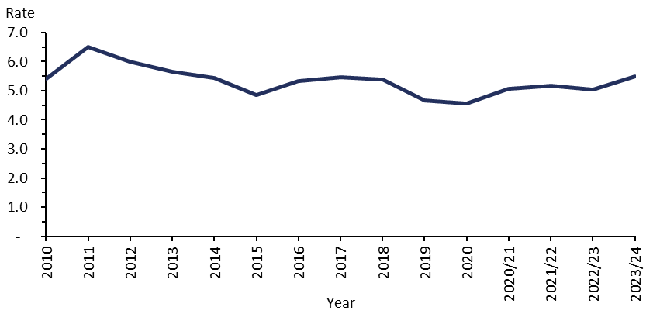
Sources: 2023/24 PRIMHD data (extracted 10 June 2025) and manual data for Health New Zealand Capital & Coast, Hawke’s Bay, Southern and Waikato. All years before 2020/21 are calendar years.

ECT by region
The number and rate of ECT treatments vary regionally (Table 17 and Figure 37, Figure 38 and Figure 39). Several factors help to explain these variations.
- Districts with smaller populations are more vulnerable to variations between years (based on the needs of the population at any given time).
- People receiving ECT treatment to maintain the improvement in their mental health will typically receive more treatments in a year than those treated with an acute course.
- People in some districts have fewer barriers to accessing ECT services than those in other districts. Some districts have no ECT facilities.

It is important to keep these factors in mind when interpreting the following information.

As in the 2022/23 Regulatory Report, this data is reported regionally to protect the privacy of individuals. These regions are:
- Northern – covering Health New Zealand Northland, Waitematā, Auckland and Counties Manukau
- Midland – covering Health New Zealand Waikato, Bay of Plenty, Tairāwhiti, Lakes and Taranaki
- Central – covering Health New Zealand Whanganui, Hawke’s Bay, MidCentral, Wairarapa, and Capital, Coast and Hutt Valley
- South Island – covering Health New Zealand Nelson Marlborough, West Coast, Canterbury, South Canterbury and Southern.

Table 17: ECT indicators, by region of domicile, 1 July 2023 to 30 June 2024
Region of domicile | Number of people treated with ECT | Number of treatments | Mean number of treatments per person (range)
Northern | 77 | 785 | 10 (1–43)
Midland | 81 | 851 | 11 (1–55)
Central | 58 | 856 | 15 (1–48)
South Island | 79 | 1,039 | 13 (1–62)
Nationally | 294 | 3,531 | 12 (1–62)
Note: The distinct total of people is 294; however, the sum is 295 as one person was counted in two regions.
Sources: PRIMHD data (extracted 10 June 2025) and manual data for Health New Zealand Capital & Coast, Hawke’s Bay, Southern and Waikato.

Figure 37: Rate of people per 100,000 population treated with ECT, by district of domicile, 1 July 2023 to 30 June 2024
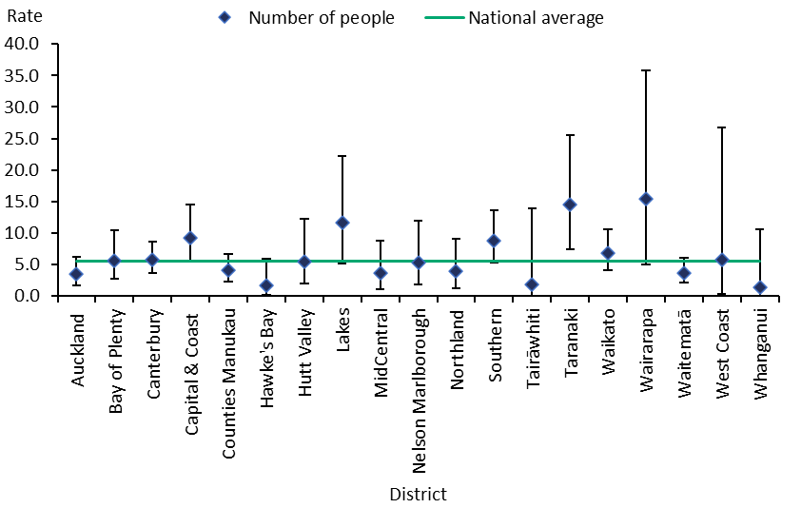
Note: In this figure, the confidence intervals (for 99% confidence, shown as vertical lines through the blue diamond markers) can help with interpreting the data. Where a service’s confidence interval crosses the national average, that means its rate was not different from the average at a statistically significant level. No one living in South Canterbury received ECT treatment in the period, so this district is not included in the figure.
Sources: PRIMHD data (extracted 10 June 2025) and manual data for Health New Zealand Capital & Coast, Hawke’s Bay, Southern and Waikato.

Figure 38: Rate of ECT treatments per 100,000 population, by district of domicile, 1 July 2023 to 30 June 2024
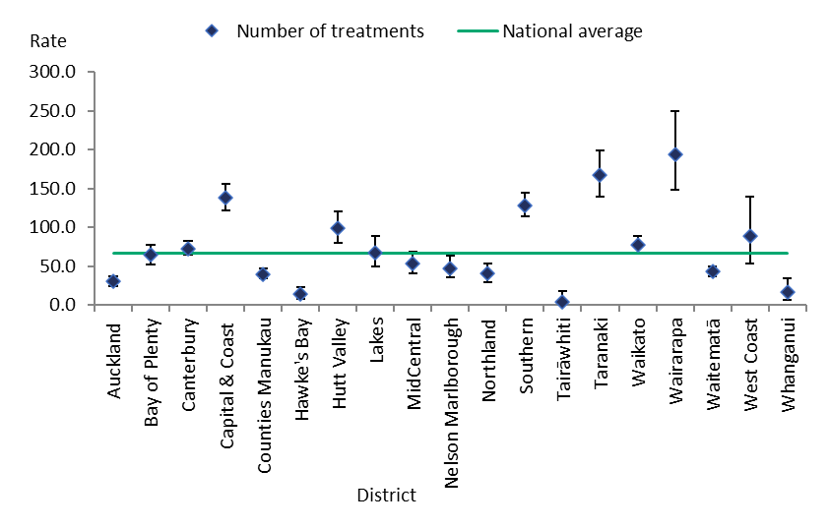
Note: In this figure, the confidence intervals (for 99% confidence, shown as vertical lines through the blue diamond markers) can help with interpreting the data. Where a service’s confidence interval crosses the national average, that means its rate was not different from the average at a statistically significant level. No one living in South Canterbury received ECT treatment in the period, so this district is not included in the figure.
Sources: PRIMHD data (extracted 10 June 2025) and manual data for Health New Zealand Capital & Coast, Hawke’s Bay, Southern and Waikato.

Figure 39: Rate of people treated with ECT per 100,000 population, by district of domicile, 1 July 2023 to 30 June 2024
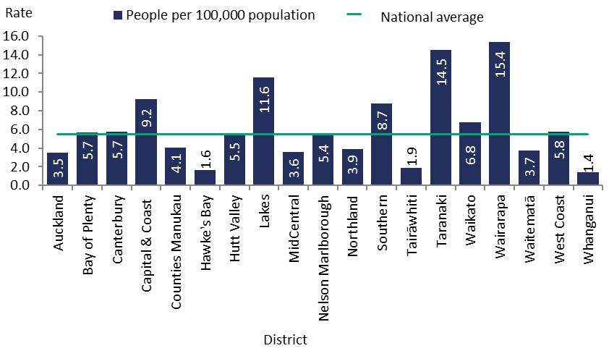
Note: No one living in South Canterbury received ECT treatment in the period, so this district is not included in the figure. National average rate is 5.5 people per 100,000 population.
Sources: PRIMHD data (extracted 10 June 2025) and manual data for Health New Zealand Capital & Coast, Hawke’s Bay, Southern and Waikato.

Age and gender of people receiving ECT
In the 2023/24 financial year, women were more likely to receive ECT than men. Older people were more likely to receive ECT than other age groups, with those aged over 50 years making up 68% of ECT patients. Figure 40 breaks down the number of people treated with ECT by age group and gender.

Figure 40: Number of people treated with ECT, by age group and gender, 1 July 2023 to 30 June 2024
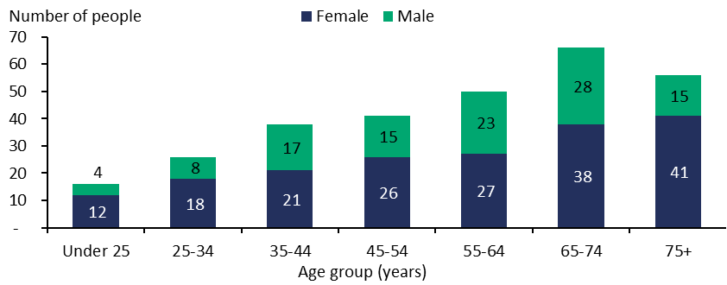
Note: Everyone receiving ECT was under 90.
Sources: PRIMHD data (extracted 10 June 2025) and manual data for Health New Zealand Capital & Coast, Hawke’s Bay, Southern and Waikato.

Ethnicity of people treated with ECT
Table 18 indicates that Asian, Māori and Pacific peoples were less likely to receive ECT than people of other ethnicities, such as New Zealand Europeans. However, the numbers involved are so small that it is not statistically appropriate to compare the percentage of people receiving ECT in each ethnic group with that group’s proportion of the total population.

Table 18: Number of people treated with ECT and rate per 100,000 population, by ethnicity, 1 July 2023 to 30 June 2024
Ethnicity | Number | Rate per 100,000
Māori | 26 | 2.9
Pacific peoples | 9 | 2.4
Asian | 21 | 2.0
Other | 238 | 7.9
All | 294 | 5.5
Sources: PRIMHD data (extracted 10 June 2025) and manual data for Health New Zealand Capital & Coast, Hawke’s Bay, Southern and Waikato.

Consent to ECT treatment
Under the Mental Health Act, a person can be treated with ECT if they consent in writing or if an independent psychiatrist appointed by the Mental Health Review Tribunal considers this treatment to be in the person’s interests. An independent psychiatrist cannot be the patient’s responsible clinician or part of the patient’s clinical team.

In 2023/24, a total of 1,085 ECT treatments were administered to 105 people who did not have capacity to consent. One person had capacity to consent but refused to consent, and was administered 12 treatments of ECT after an independent psychiatrist provided a second opinion.

Table 19 shows the number of treatments administered without consent during this period. Please note the numbers per region may not add up to the national total, as some individuals may have received ECT under multiple services or their capacity to consent may have fluctuated.

Table 19: ECT administered under second opinion without consent, by region of service, 1 July 2023 to 30 June 2024
Region of service | Second opinion where patient did not have the capacity to consent |  | Second opinion where patient had the capacity but refused to consent
Region of service | Number of people given ECT | Number of treatments administered | Number of people given ECT | Number of treatments administered
Northern | 46 | 444 | 0 | 0
Midland | 19 | 141 | 0 | 0
Central | 11 | 139 | 0 | 0
South Island | 29 | 361 | 1 | 12
Nationally | 105 | 1,085 | 1 | 12
Notes: The data in this table cannot be reliably compared with the data in Table 17 as it relates to the Health New Zealand region of service rather than region of domicile.
Source: Manual data from districts.

Drug and substance harm reduction

Opioid substitution treatment
The Director, acting under delegated authority from the Minister of Health, designates specialist services and lead clinicians to provide treatment with controlled drugs to people who are dependent on them, under section 24A(7)(b) of the Misuse of Drugs Act 1975. These services are also subject to an audit every three years, using the Specialist Opioid Substitution Treatment Service Audit and Review Tool.

Opioid dependence is a complex, relapsing condition requiring a model of treatment and care much like any other chronic health problem. Opioid substitution treatment (OST) helps people who have an opioid dependence to access treatment, including substitution therapy, which provides them with the opportunity to recover their health and wellbeing.

Specialist OST services are specified by the Minister of Health under section 24A of the Misuse of Drugs Act 1975 and notified in the New Zealand Gazette.

OST services in New Zealand are expected to provide a standardised approach that puts the person, family and whānau at the heart of treatment, recovery, wellbeing and citizenship. To help services take this approach, the New Zealand Practice Guidelines for Opioid Substitution Treatment provide clinical and procedural guidance for specialist services and primary health care providers who deliver OST. These guidelines were updated in October 2025, with an increased emphasis on people’s rights and empowering them towards recovery.

The following summarises OST data from 1 July 2023 to 30 June 2024.
- 5,444 people received OST.
- Of these people, 74.8% were New Zealand European, 18.3% were Māori, 1.4% were Pacific peoples and 5.5% were of other ethnicities.
- 70.7% of clients receiving OST were over 45 years of age.
- 25.6% of people receiving OST were receiving treatment from a general practitioner in a shared-care arrangement.

Service providers
New Zealand has three types of OST service providers.

Specialist services: Specialist OST services are the entry point for nearly all people needing treatment with controlled drugs. These services comprehensively assess the needs of clients, provide them with specialist interventions and stabilise them. This approach creates a pathway to plan for recovery, make referrals for co-existing health needs and social support, and eventually transfer treatment to a primary health provider or withdraw the client from treatment altogether.

In 2023/24, 73.3% of OST clients received treatment from specialist services.

Primary health: Specialist addiction services work alongside primary health care to share delivery of OST services. This approach allows specialist services to focus on clients who have the highest need and normalises the treatment process.

In 2023/24, 25.6% of OST clients received this treatment from their general practitioner (GP).

The Ministry and Health New Zealand’s target for service provision is to split it 50:50 between primary and specialist health care services.

Ara Poutama – Department of Corrections (Ara Poutama): When a person receiving OST goes to prison, Ara Poutama ensures that the person continues to receive OST services, including psychosocial support and treatment from specialist services.

In 2023/24, 1% of OST clients received this treatment from Ara Poutama. Service providers and Ara Poutama work together to initiate OST as appropriate for people who are imprisoned.

Figure 41 presents the percentage of people receiving OST from specialist services and GPs in each Health New Zealand district in 2023/24. Figure 42 shows the number of people receiving OST from these providers from 2009/10 to 2023/24, based on January to June six-monthly reports from OST providers.

Figure 41: Percentage of people receiving opioid substitution therapy from specialist services and general practitioners, by district, 1 July 2023 to 30 June 2024
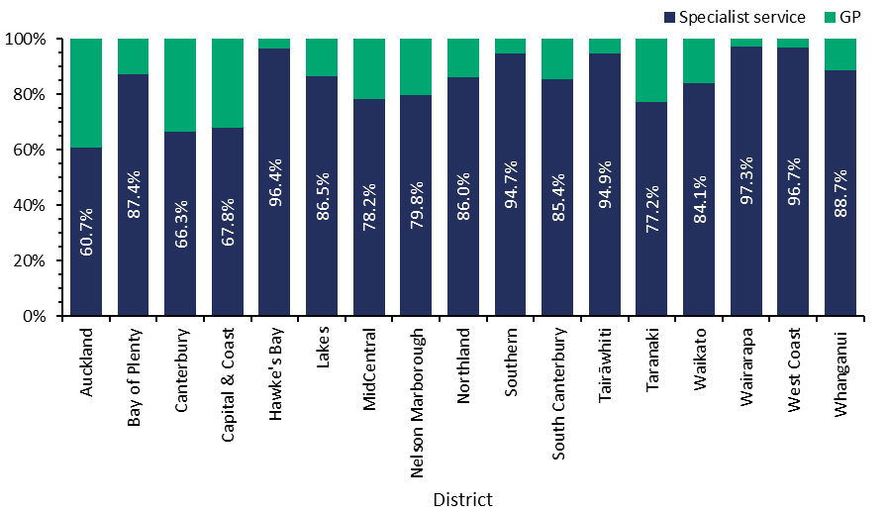
Notes: ‘Auckland’ includes Auckland, Counties Manukau and Waitematā districts. ‘Capital & Coast’ includes Capital & Coast and Hutt Valley districts. ‘Canterbury’ includes one GP service operating in Christchurch.
Source: Data provided by OST services in January to June six-monthly reports.

Figure 42: Number of people receiving opioid substitution therapy from a specialist service, general practitioner or prison service, 2009/10 to 2023/24
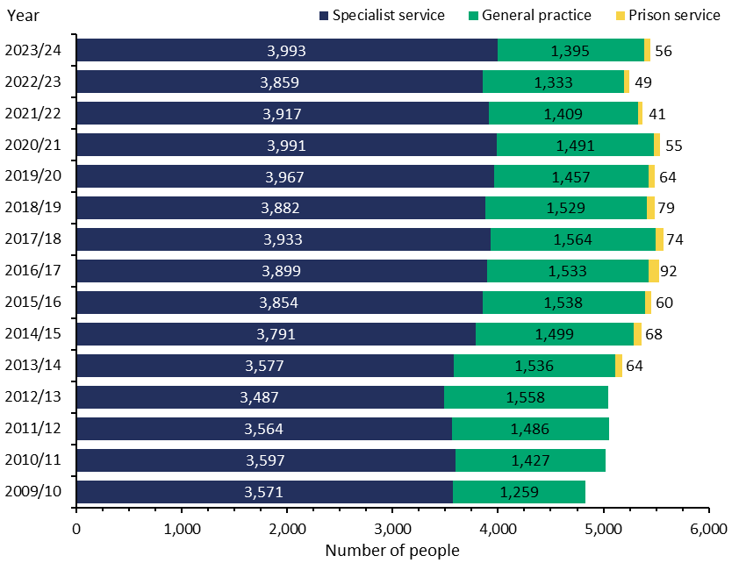
Note: Data for clients seen in prison collected from July 2013.
Source: Data provided by OST services in January to June six-monthly reports.

Prescribing opioid treatments
A treatment that replaces addictive substances like opioids with prescribed drugs is called pharmacotherapy. The purpose of this treatment is to stabilise the opioid user’s health and reduce harms from drug use, such as the risk of overdose, blood-borne virus transmission and substance-related criminal activity.

The two types of pharmacotherapy are:
- maintenance therapy – using opioid substitutes to remain on a stable dose
- detox – using opioid substitutes to gradually withdraw from the substitute so the client can be free of all opioid substances.

Methadone has historically been the main OST available. Clients need a daily dose, which in turn makes it necessary to limit prescribing and dispensing.

In 2012, the Pharmaceutical Management Agency Ltd (Pharmac) began funding a buprenorphine-naloxone (suboxone) combination for OST. Suboxone can be administered in cumulative doses that last several days, which reduces the risk of drug diversion and offers clients more normality in their lives. Figure 43 presents the number of people prescribed suboxone from 2009/10 to 2023/24.

In 2023/24, 24.3% of OST clients were prescribed suboxone.

Figure 43: Number of people prescribed suboxone, 2009/10 to 2023/24
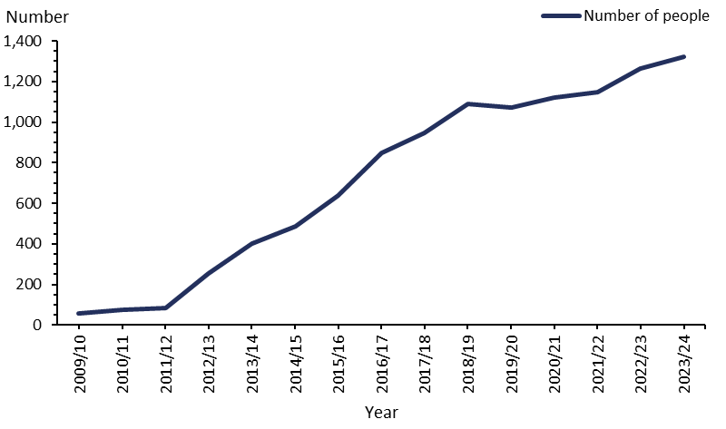
Source: Data provided by OST services in January to June six-monthly reports.

The ageing population of OST clients
OST clients are an ageing population. Figure 44 shows how the number of clients in older age groups has been increasing from 2009/10. Those aged 45–59 years are the most likely of any age group to be receiving OST.

In 2023/24, the majority of clients (70.7%) were aged over 45 years. Treating an ageing population brings with it more health complications.

Figure 44: Number of opioid substitution treatment clients, by age group, 2009/10 to 2023/24
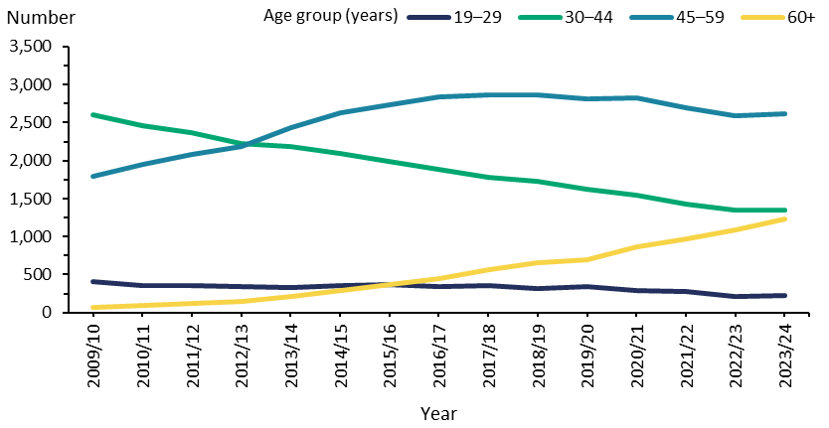
Source: Data provided by OST services in January to June six-monthly reports.

Exit from OST
A total of 374 people receiving OST exited the service in 2023/24. The following summarises the OST exit data for this group.
- Of those who exited OST, 272 (73%) voluntarily withdrew.
- There were 10 involuntary withdrawals (3% of all exits). Involuntary withdrawals can occur where a client’s behaviour puts their own safety or the safety of others at risk.
- Of the people who had been receiving OST, 92 passed away. A small proportion of these people died of a suspected overdose. In these cases, the Ministry requires services to conduct an incident review and report it to the medical officer of health. The remaining deaths had a range of other causes, such as cancer or cardiovascular disease.

Figure 45 gives an overview of the reasons for exit from treatment (voluntary, involuntary or death) from 2009/10 to 2023/24.

Figure 45: Percentage of exits from opioid substitution treatment programmes, by reason (voluntary, involuntary or death), 2009/10 to 2023/24
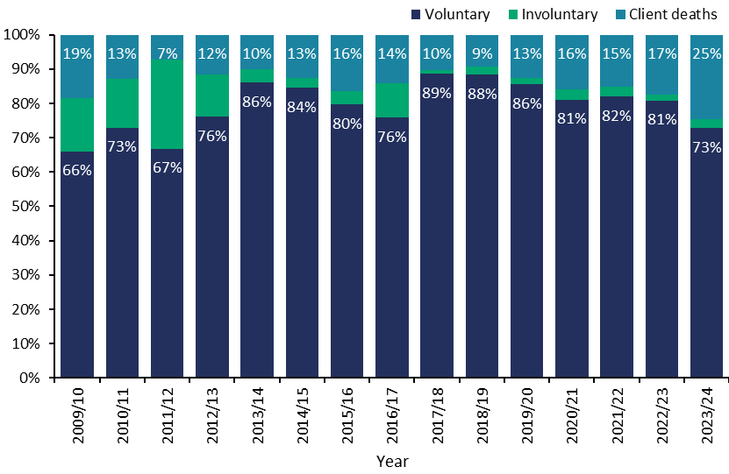
Source: Data provided by OST services in six-monthly reports.

Drug-checking licensing scheme
Drug checking was legalised in New Zealand through amendments made to the Misuse of Drugs Act 1975 in November 2021. Drug checking is regulated under the Misuse of Drugs Act 1975, Psychoactive Substances Act 2013 and Medicines Act 1981, along with the relevant regulations under those Acts.

New Zealand was the first country globally to legislate a fully legal, licensed drug-checking scheme. At least 27 other countries operate some type of drug-checking service scheme, either within legislation or in a legislative ‘grey area’ where the scheme is not fully legalised or legislated for.

Drug-checking services aim to reduce drug harm and risk by helping people make informed decisions about drug use. They do not promote illicit drug use or claim that illicit drug use is safe. Licensed drug-checking providers conduct scientific tests on unknown substances (which may be illicit drugs) and interpret results to establish their likely identity and composition. The providers then give mandatory harm reduction information to any person who provides a sample.

In the 2023/24 financial year, four existing entities retained their drug-checking licences. The fifth existing provider surrendered its licence on 1 December 2023, because it was disestablished. A new provider was granted approval from 9 October 2023. Due to the date of licensing, no data for this provider exists for the July–September 2023 quarter.

The licensed providers for 2023/24 are:
- KnowYourStuffNZ, licensed on 10 October 2022
- New Zealand Institute for Public Health and Forensic Science (PHF Science, formerly ESR), licensed on 17 October 2022
- NZ Drug Foundation, licensed on 31 October 2022
- Needle Exchange Services Trust, licensed on 5 December 2022 and surrendered on 1 December 2023
- the University of Auckland, School of Pharmacy, licensed on 15 May 2023
- Drug Injecting Services Canterbury, licensed on 9 October 2023.

Drug-checking test results provide critical information to the National Drug Intelligence Bureau, which is a joint operation between the Ministry of Health, Health New Zealand, Customs, and Police. This system alerts health professionals and the public to especially dangerous drugs circulating in New Zealand.

The National Drug Intelligence Bureau works closely with licensed drug-checking providers to share information and provide harm reduction messaging to the public through their early warning system, High Alert. Data from licensed drug-checking services directly feeds into this early warning system. Drug-checking services played a direct role in 77.7% (seven of nine) of the High Alert notifications released during 2023/24.

The Ministry of Health receives quarterly reporting from all licensed drug-checking providers. A total of 453 drug-checking events and clinics were held during 2023/24, which includes festivals and other events, static clinics, pop-up clinics, mobile clinics and continuous services. At these drug-checking events and clinics, 9,458 samples were presented for drug-checking.

Drug-checking service providers must also provide harm reduction advice to anyone who receives test results for a particular drug. This must be specific to the person, their circumstances and the drug identified. In 2023/24, 11,947 people received harm reduction advice.

Figure 46 presents the number of samples tested and number of clients given harm reduction advice for each quarter in 2023/24. These numbers differ because they depend on the number of clients or samples that are presented at a given time (eg, one harm reduction client presenting three samples to test; or one sample presented by two clients who are both given harm reduction advice on the one sample tested).

Figure 46: Drug-checking harm reduction advice and samples tested by quarter, 1 July 2023 to 30 June 2024
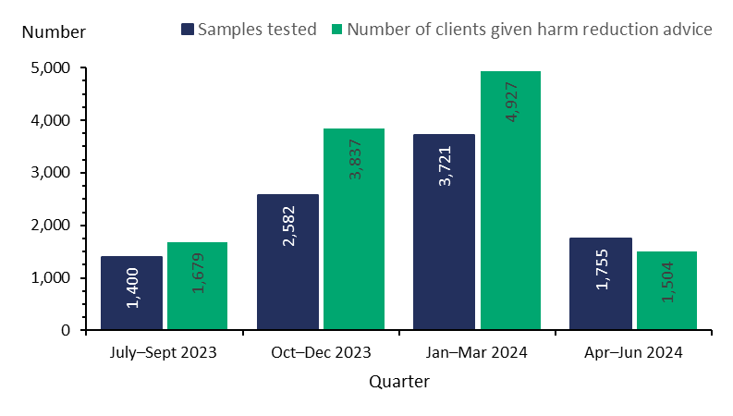
Source: Data submitted in quarterly reporting by field-based drug-checking providers.

The data in Figure 46 excludes testing undertaken by the New Zealand Institute for Public Health and Forensic Science (PHF Science, previously ESR), which is the approved laboratory for further testing and analysis of substances. A substance presented for initial drug checking may be sent for further analysis to PHF Science to determine its composition if the substance remains unknown following field drug checking, if it presents as a novel (new) substance, or as a substance linked to high-risk and/or harm events. PHF Science tested 144 substances for the purpose of further analysis of drug-checking samples during 2023/24.

It also excludes data from the University of Auckland, School of Pharmacy, which is licensed to provide drug checking under the Research Project service model. In 2023/24, two projects have been active under this licence – one on psychedelic mushrooms and the other on microdosing LSD. The University of Auckland tested a total of 26 samples in this period and had harm reduction conversations with 12 clients. Due to the nature of these clinics under the research model, often only one client comes to the clinic at a time, bringing multiple samples.

Drug-checking providers also report to the National Drug Intelligence Bureau, which analyses drug-checking trends. The top five presumed drug types (ie, what the person thought the drug was before testing) presented for testing in 2023/24 were:
- MDMA (59.3%)
- ketamine (11.5%)
- cocaine (7.4%)
- methamphetamine (5.8%)
- LSD (5.7%).

These presumed substances accounted for 93% of all drugs presented for drug checking, with the additional 7% being an assortment of less commonly presented substances. Out of all substances presented for testing, 9.5% were presumed unknown. Figure 47 shows the number of each type of presumed substance presented.

Figure 47: Breakdown of drug types at drug checking, as presumed by client on presentation, 1 July 2023 to 30 June 2024
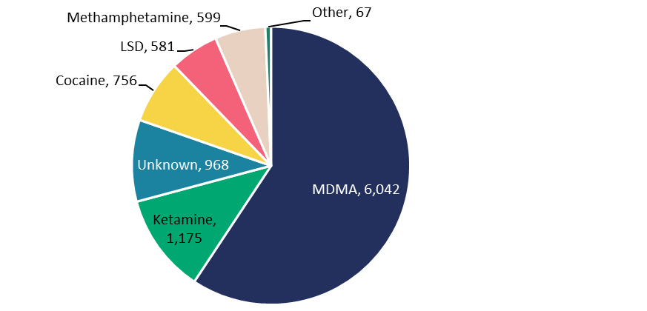
Source: Data submitted to the National Drug Intelligence Bureau in post-clinic reporting. This excludes data from PHF Science and University of Auckland. All data for this period is provisional and subject to change. Finalised data is reflected in quarterly reports provided by PHF Science and drug-checking providers to the Ministry of Health.

The National Drug Intelligence Bureau reported that in 2023/24, 88.7% of substances presented for drug checking were found to be consistent with what the client presumed (see Figure 48).

Figure 48: Percentage of testing consistency with presumed substance, 1 July 2023 to 30 June 2024
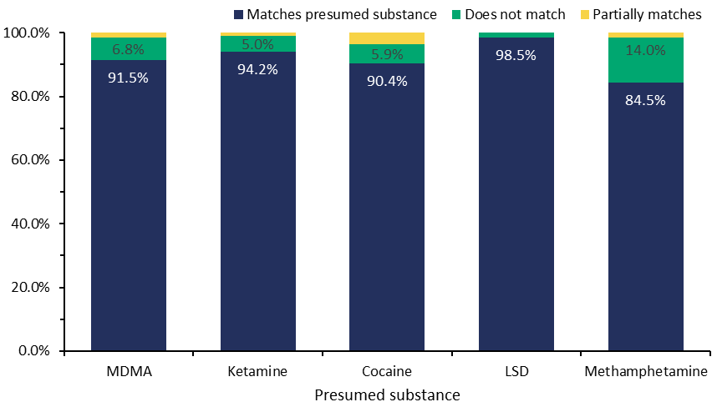
Source: Data submitted to the National Drug Intelligence Bureau in post-clinic reporting. This excludes data from PHF Science and University of Auckland. All data for this period is provisional and subject to change. Finalised data is reflected in quarterly reports provided by PHF Science and drug-checking providers to the Ministry of Health.

Whether or not the sample presented is consistent with the presumed drug, drug-checking providers always have a harm reduction conversation with the client. This conversation aims to inform the client of risks relating to the substance, allowing them to make more informed decisions about safety and risk associated with drug use.

The Drug Checking Licensing Scheme also received funding from the Ministry of Health’s Research and Evaluation Fund to conduct an evaluation of the Drug and Substance Checking Legislation within the 2023/24 financial year. This study aims to evaluate the effectiveness, challenges and opportunities of current drug-checking legislation. The evaluation will finish in 2026 with a final report publishing the findings. Future regulatory reports will publish information on the study’s implementation and progress.

Substance Addiction (Compulsory Assessment and Treatment) Act 2017
The Substance Addiction (Compulsory Assessment and Treatment) Act 2017 (Substance Addiction Act) is designed to help people who have a severe substance addiction and impaired capacity to make decisions about engaging in treatment. This legislation is better equipped than the Act it replaced to protect the human rights and cultural needs of patients and their families and whānau. It also places greater emphasis on enhancing mana and following a health-based approach.

Section 119 of the Substance Addiction Act requires the Ministry to publish certain information in its annual report, such as the number of people who received compulsory treatment. The 2023/24 annual report, which includes the Substance Addiction Act data for the 2023/24 financial year, is available on the Ministry’s website.

Land Transport Act 1998
In 2023/24, the Office of the Director of Mental Health and Addiction Services continued to work with Waka Kotahi New Zealand Transport Agency (Waka Kotahi), the Ministry of Transport and the Drug and Alcohol Practitioners’ Association Aotearoa New Zealand to monitor the reinstatement of drivers disqualified for offences involving alcohol or drugs. It also worked with the agencies to approve assessment centres under section 65A of the Land Transport Act 1998.

Where people have committed repeat driving offences involving drugs or alcohol, section 65A requires them to be indefinitely disqualified from having a driver licence and to undergo assessment. To determine if a person can have their licence reinstated, an approved assessment centre considers their ability to manage their substance use or addictive behaviours. The assessment centre sends a copy of its report to Waka Kotahi, which decides whether to reinstate the person’s licence.

The Director-General of Health makes the decision on whether to approve an assessment centre. Establishments and individuals applying to be an approved assessment centre must demonstrate that they are competent in assessing alcohol and other drug problems and are a registered and experienced alcohol and drug practitioner or employ such practitioners.

Appendix 1: The Mental Health Act process
The compulsory assessment and treatment process begins with a referral and an initial assessment. If the health assessor believes a person fits the Mental Health Act’s criteria, the person will become subject to the Mental Health Act and receive further assessment from there.

Compulsory assessment
Application for assessment (section 8A)
Compulsory assessment can take place in either a community or a hospital setting. There are two periods of compulsory assessment, during which a person’s clinician may release them from assessment at any time.
First period of assessment (section 11, up to 5 days)
Second period of assessment (section 13, up to 14 days)

During the assessment period, a person is obliged to receive treatment that their responsible clinician prescribes. The first period (section 11 of the Mental Health Act) lasts for up to 5 days. The second period (section 13 of the Mental Health Act) can last up to 14 days.
Application to the court for a CTO (section 14(4), within second period)

Following the first two assessment periods, a person’s responsible clinician can make an application to the courts under section 14(4) of the Mental Health Act to place the person under a CTO.
No CTO issued by courts
Community or inpatient treatment order made (section 29 or 30)

At any time during the compulsory assessment process, the person (or someone on their behalf) can request that the courts review their condition to determine whether it is appropriate that they continue to be assessed. Based on information presented to them, a judge will decide whether the assessment should continue or not.

Compulsory treatment
There are two types of CTOs: community treatment orders (section 29 of the Mental Health Act) and inpatient treatment orders (section 30 of the Mental Health Act). A person’s responsible clinician can convert an inpatient treatment order to a community treatment order at any time. A responsible clinician can also grant leave in the community for up to three months to a person who is under an inpatient treatment order (section 31 of the Mental Health Act).

Appendix 2: Additional statistics – Ministry of Justice
Table A1 presents data on applications for a CTO from 2009/10 to 2023/24. Table A2 shows the types of orders granted over the same period.

Table A1: Applications for compulsory treatment orders or extensions, 2009/10 to 2023/24
Financial year | Number of applications for a CTO, or extension to a CTO | Number of applications granted or granted with consent | Number of applications dismissed or struck out | Number of applications withdrawn, lapsed or discontinued | Number of applications transferred to the High Court
2009/10 | 4,679 | 4,100 | 72 | 507 | 0
2010/11 | 4,804 | 4,198 | 63 | 542 | 1
2011/12 | 4,816 | 4,272 | 69 | 475 | 0
2012/13 | 4,952 | 4,480 | 75 | 397 | 0
2013/14 | 5,185 | 4,610 | 53 | 522 | 0
2014/15 | 5,210 | 4,629 | 55 | 526 | 0
2015/16 | 5,529 | 4,918 | 51 | 560 | 0
2016/17 | 5,563 | 4,927 | 73 | 563 | 0
2017/18 | 5,599 | 4,959 | 74 | 566 | 0
2018/19 | 5,607 | 4,972 | 64 | 571 | 0
2019/20 | 5,695 | 5,021 | 52 | 622 | 0
2020/21 | 5,932 | 5,244 | 62 | 626 | 0
2021/22 | 6,082 | 5,376 | 75 | 631 | 0
2022/23 | 6,332 | 5,606 | 105 | 621 | 0
2023/24 | 7,397 | 6,725 | 101 | 571 | 0
Notes: The table presents applications that had been processed at the time of data extraction on 2 December 2025. The year is determined by the final outcome date. The CMS is a live operational database, which means figures are subject to minor changes at any time.
Source: Ministry of Justice Integrated Sector Intelligence System, which uses data entered into the CMS (extracted 2 December 2025).

Table A2: Types of compulsory treatment orders made on granted applications, 2009/10 to 2023/24
Financial year | Number of granted applications for orders | Number of community CTOs (or extensions) | Number of inpatient CTOs (or extensions) | Number of orders recorded as both community and inpatient CTOs (or extensions) | Other order (not further defined in data set) | Number of applications where type of order was not recorded
2009/10 | 4,100 | 2,147 | 1,628 | 116 | 6 | 203
2010/11 | 4,198 | 2,281 | 1,668 | 97 | 10 | 142
2011/12 | 4,272 | 2,296 | 1,661 | 100 | 8 | 207
2012/13 | 4,480 | 2,591 | 1,729 | 64 | 0 | 96
2013/14 | 4,610 | 2,615 | 1,753 | 92 | 2 | 148
2014/15 | 4,629 | 2,687 | 1,779 | 88 | 0 | 75
2015/16 | 4,918 | 2,895 | 1,817 | 66 | 4 | 136
2016/17 | 4,927 | 2,721 | 1,654 | 82 | 2 | 468
2017/18 | 4,959 | 2,591 | 1,708 | 54 | 4 | 602
2018/19 | 4,972 | 2,743 | 1,813 | 52 | 1 | 363
2019/20 | 5,021 | 2,892 | 1,739 | 77 | 0 | 313
2020/21 | 5,244 | 3,033 | 1,932 | 54 | 3 | 222
2021/22 | 5,376 | 3,028 | 1,932 | 92 | 2 | 322
2022/23 | 5,606 | 3,063 | 1,899 | 59 | 1 | 584
2023/24 | 6,725 | 4,164 | 2,141 | 87 | 1 | 332
Notes: The table presents applications that had been processed at the time of data extraction on 2 December 2025. The year is determined by the date the application was granted. When more than one type of order is shown, it is likely to be because new orders are linked to a previous application in the CMS. The CMS is a live operational database, which means figures are subject to minor changes at any time.
Source: Ministry of Justice Integrated Sector Intelligence System, which uses data entered into the CMS (extracted 2 December 2025).

Appendix 3: Individuals who experienced prolonged and/or frequent periods of seclusion
The Office of the Director of Mental Health and Addiction Services has commissioned a specific piece of work to examine the factors surrounding the eight individuals who experienced prolonged and/or frequent periods of seclusion.

The eight individuals are at three Health New Zealand regional facilities. The facilities are in the categories of regional intellectual disability or regional forensic units. The eight individuals are each subject to one of three Acts: the Mental Health Act, the IDCCR Act or the Criminal Procedure (Mentally Impaired Persons) Act 2003.

Further information, including on individual treatment plans, will be sought from the relevant service providers to explore and review each case. In particular, this work will focus on gaining:
- confirmation of the accuracy of reported seclusion data
- assurance that these individuals have safeguards in place to protect their rights
- assurance that services are meeting the expected standards for seclusion
- assurance that services are taking active measures to reduce and eliminate seclusion, both on an individual and a service basis
- the reasons for the extended seclusion hours
- details of service and organisational barriers to reducing and eliminating seclusion.

After receiving the information, the Director will ensure it is reviewed and will consider recommendations for action by the service providers and any areas that require escalation to other agencies.

Table A3 presents some of the seclusion data both with and without the individuals who experienced prolonged periods of seclusion.

Table A3: Seclusion indicators excluding and including individuals who experienced prolonged periods of seclusion, 1 July 2023 to 30 June 2024
Seclusion measure | Excluding 8 individuals who experienced prolonged periods of seclusion | Including 8 individuals who experienced prolonged periods of seclusion
Overall mental health inpatient services (adult, forensic, intellectual disability and youth)
Number of people secluded in all services | 755 | 763
Number of hours of seclusion in all services | 59,876 | 105,407
Number of seclusion events in all services | 1,787 | 2,772
Percentage of seclusion events lasting under 24 hours | 70% | 73%
Percentage of seclusion events lasting over 48 hours | 16% | 16%
Adult inpatient services
Number of people secluded | 561 | 561
Number of hours of seclusion | 24,610 | 24,610
Number of seclusion events | 1,050 | 1,050
Number of seclusion events per person | 1.9 | 1.9
Number of seclusion events per 1,000 bed nights | 4.8 | 4.8
Number of people secluded per 100,000 population | 17.9 | 17.9
Number of seclusion events per 100,000 population | 33.6 | 33.6
Average duration per seclusion event | 23.4 hours | 23.4 hours
Decrease in people secluded since 2009 | 48% | 48%
Decrease in hours spent in seclusion since 2009 | 73% | 73%
Decrease in hours spent in seclusion since 2022/23 | 24% | 24%
Forensic services
Number of people secluded | 114 | 117
Number of hours of seclusion | 16,878 | 28,387
Number of seclusion events | 315 | 386
Intellectual disability services
Number of people secluded | 22 | 27
Number of hours of seclusion | 15,652 | 49,674
Number of seclusion events | 229 | 1,143
Sources: PRIMHD data (extracted 10 June 2025) and manual data for Health New Zealand Canterbury, Southern, Waikato and Waitematā.

Royal Commission of Inquiry into Abuse in Care. 2024. Whanaketia: Through pain and trauma, from darkness to light. URL: abuseincare.org.nz/reports/whanaketia (accessed 9 February 2026).
Ministry of Health. 2023. Guidelines for Reducing and Eliminating Seclusion and Restraint under the Mental Health (Compulsory Assessment and Treatment) Act 1992. Wellington: Ministry of Health.
Government Inquiry into Mental Health and Addiction. 2018. He Ara Oranga: Report of the Government Inquiry into Mental Health and Addiction. URL: mentalhealth.inquiry.govt.nz/inquiry-report/he-ara-oranga (accessed 14 January 2026).
Health Committee Mental Health Bill Final Report. 2025. URL: selectcommittees.parliament.nz/v/SelectCommitteeReport/87973bb4-1764-44d5-775e-08dd7d2d2e15?lang=en (accessed 14 January 2026).
Sources: Programme for the Integration of Mental Health Data (PRIMHD) data (extracted 10 June 2025) and manual data for Health New Zealand Bay of Plenty, Capital & Coast, Counties Manukau, Hawke’s Bay, MidCentral, Southern, Tairāwhiti, Waikato and Waitematā.
Mental Health Act, sections 11, 13, 15(1), 15(2), 29, 30 and 31.
‘Other ethnicities’ includes all ethnicities except for Māori and Pacific peoples.
This is calculated differently from the last report. This figure uses raw figures and is a calculation of the number of people under section 29 over the total number of people under section 29 and 30. The last report calculated this using the average per month.
Other outcomes include that the application was struck out, lapsed, discontinued or stayed.
Source: Ministry of Justice’s case management system (CMS) data (extracted 2 December 2025).
Sources: PRIMHD data (extracted 10 June 2025) and manual data for Health New Zealand Bay of Plenty, Capital & Coast, Counties Manukau, Hawke’s Bay, MidCentral, Southern, Tairāwhiti, Waikato and Waitematā.
‘On an average day’ is the average of the last day of each month.
Sources: PRIMHD data (extracted 10 June 2025) and manual data from Health New Zealand Bay of Plenty, Capital & Coast, Counties Manukau, Hawke’s Bay, MidCentral, Southern, Tairāwhiti, Waikato and Waitematā.
These ratios are based on the age-standardised rates of the Māori, Pacific peoples and other ethnic groups.
Deprivation quintiles are ranked 1 to 5, where 1 represents areas with the least deprived scores and 5 the areas with the most deprived scores.
In this report, we are now identifying data relating to Asian ethnic groups where it is possible to separate it from within the ‘Other’ category. However, this information is not available for all data tables and figures.
Standards New Zealand. 2021. Ngā Paerewa Health and Disability Services Standard. Wellington: Standards New Zealand.
‘Adult inpatient service’ means an inpatient mental health service for those aged 18 years and older. It does not include those in older people’s mental health services.
Sources: PRIMHD data (extracted 10 June 2025) and manual data from Health New Zealand Canterbury, Southern, Waikato and Waitematā.
We compare with 2009 because in that year, seclusion reduction policies were introduced in New Zealand as part of the Health and Disability Services Standard 2008.
Data in this section excludes forensic, intellectual disability and youth services unless specified otherwise. Bed nights are measured by team types that use seclusion. This may differ from denominator figures used in other entities’ seclusion reporting. This data cannot be compared with years before 2017, when bed nights were measured by acute and sub-acute bed nights. Sources: PRIMHD data (extracted 10 June 2025) and manual data from Health New Zealand Canterbury, Southern, Waikato and Waitematā.
If people in Wairarapa required admission to mental health inpatient services, they were transported to either Health New Zealand Hutt Valley or MidCentral. Any seclusion statistics for them are included in the service where they received treatment.
‘Act proven but not criminally responsible on account of insanity’ is a finding that was introduced by the Rights for Victims of Insane Offenders Act 2021 to replace ‘not guilty by reason of insanity’.
The Health Quality & Safety Commission defines an adverse event as an event that results in harm or has the potential to result in harm to a consumer.
A Severity Assessment Code is a numerical rating of how severe an adverse event is, which in turn indicates what level of reporting and investigation is needed for that event.
See the National Adverse Events Reporting Policy on the Health Quality & Safety Commission’s website at: https://www.hqsc.govt.nz/resources/resource-library/national-adverse-event-policy-2023/.
The report was published on 12 August 2025. See Section 99 inspection of Canterbury Mental Health Services on the Ministry’s website for further information. This will be included in the annual report for the financial year 2025/26.
In addition, in April 2025, the Director requested a district inspector begin a section 95 inquiry in relation to the misidentification of a patient in Waikato. For more information, see Section 95 inquiry into the treatment of a patient at Waikato Hospital on the Ministry’s website.
Sources: PRIMHD data (extracted 10 June 2025) and manual data for Health New Zealand Capital & Coast, Hawke’s Bay, Southern and Waikato.
The Mental Health Review Tribunal is an independent body that the Minister of Health appoints under the Mental Health Act. For more information, see the Mental Health Review Tribunal webpage on the Ministry’s website at: health.govt.nz/about-us/new-zealands-health-system/health-system-roles-and-organisations/health-committees-and-boards/mental-health-review-tribunal (accessed 14 January 2026).
For more information, see Ministry of Health. 2014. Specialist Opioid Substitution Treatment (OST) Service Audit and Review Tool. URL: health.govt.nz/publications/specialist-opioid-substitution-treatment-ost-service-audit-and-review-tool (accessed 21 November 2025).
Ministry of Health. 2025. New Zealand Practice Guidelines for Opioid Substitution Treatment 2025. URL: health.govt.nz/publications/new-zealand-practice-guidelines-for-opioid-substitution-treatment-2025 (accessed 21 November 2025).
Source: Data provided by OST services in six-monthly reports. These six-monthly reports do not collect data by National Health Index numbers. Instead, the national total is a sum of the district figures, so it may double-count people who received services from more than one district.

