Māori Years of Life Lost: Estimates from the Global Burden of Disease Study, 2021

Ngā Tau i Ngaro mō te Oranga o Ngāi Māori: He Whakatau Tata nō te Rangahau mō te Taumahatanga Tahumaero ā-Ao, 2021

Citation: Ministry of Health. 2025. Māori Years of Life Lost: Estimates from the Global Burden of Disease Study, 2021. Wellington: Ministry of Health.
Published in December 2025 by the Ministry of Health
PO Box 5013, Wellington 6140, New Zealand
ISBN 978-1-991324-67-2 (online)
HP 9151

This document is available at health.govt.nz
 | This work is licensed under the Creative Commons Attribution 4.0 International licence. In essence, you are free to: share ie, copy and redistribute the material in any medium or format; adapt ie, remix, transform and build upon the material. You must give appropriate credit, provide a link to the licence and indicate if changes were made.

Karakia
Whakarongo ake au ki te tangi a te manu nei,
Tui, tui, tuituia
Tuia ngā whakaaro, tuia ngā kōrero,
Tuia ngā maharatanga o te hunga kua riro ki tua o te ārai.
Kia tau te mauri, kia tau te wairua,
Hei arahi i a tātou ki te pae ora, ki te ao mārama.
Whakakotahihia ngā ngākau, kia ū, kia mau,
Hei oranga mō ngā uri whakatipu.
Haumi ē, hui ē, tāiki ē!

I listen to the call of the bird,
Bind, bind, let us be bound together.
Bind together our thoughts, bind together our words,
Bind together the memories of those who have passed beyond the veil.
Let the life force settle, let the spirit be at peace,
To guide us toward healthy futures, toward the world of light.
Unite our hearts, steadfast and strong,
For the wellbeing of generations to come.
Join, gather, it is done!

Foreword
This report, Māori Years of Life Lost: Estimates from the Global Burden of Disease Study, 2021, represents a significant milestone. This is the first time the Global Burden of Disease framework has been applied to Māori, and to any Indigenous population, globally. It provides a clear picture of premature mortality and the health inequities that persist for Māori in New Zealand.
While life expectancy for Māori has increased, and there have been improvements over time in key health statistics, the data finds Māori have roughly twice the rate of early death compared to non-Māori. Non-communicable diseases accounted for most of this, with cancers contributing 29% and cardiovascular diseases 22%. Beyond non-communicable diseases, injuries, including self-harm, accounted for 17% of years of life lost prematurely compared to 9% for non-Māori.
These differences highlight the importance of delivering the basics of health care well across New Zealand. Ensuring all populations receive the care they need is a priority for the health system and critical for improving health outcomes for Māori.
These figures are not just numbers; they represent lives shortened, whānau disrupted and communities carrying the weight of early loss – each number is a person, a whānau, and a story. We acknowledge with deep respect those whose lives are represented in these statistics. We also acknowledge those who shared their knowledge, experiences and expertise to shape this report. Your voices ensure that these findings are not just data points, but insights grounded in lived reality.
The whakataukī ’He oranga ngākau, he pikinga waiora’ – A healthy heart leads to a fulfilling life – captures the aspiration behind this work. It reminds us that wellbeing begins within and radiates outward, strengthening whānau, hapū and iwi. Let this report be a catalyst for change so that future generations of Māori may live longer, healthier and more fulfilling lives.

Ngā mihi
John Whaanga
Deputy Director-General, Māori Health

He wāhinga kōrero
He whakatutukinga whakahirahira te pūrongo nei, Ngā Tau i Ngaro mō te Oranga o Ngāi Māori: He Whakatau Tata nō te Rangahau mō te Taumahatanga Tahumaero ā-Ao, 2021. Koinei te wā tuatahi i whakahāngaitia te pou tarāwaho Taumahatanga Tahumaero ā-Ao, ki ngāi Māori, waihoki he tuatahitanga mō tētahi taupori Iwi Taketake puta noa i te ao. Kei roto he whakaahua mārama o te mate kokoti tau me ngā tautika-kore ā-hauora e pā tonu ana ki ngāi Māori i Aotearoa nei.
Ahakoa kua piki te wāora mō ngāi Māori, ā, nāwai rā kua pai ake hoki ngā tauanga hauora matua, ko te kitenga i roto i ngā raraunga ka tata huarua te matenga tōmua o ngāi Māori ina whakatairitea ki tauiwi. Nā ngā tahumaero whakawhiti kore te take mō te nuinga o tēnei āhuatanga. Ko te wāhi ki ngā mate pukupuku e 29 ōrau, ko te wāhi ki ngā tahumaero ia-manawa 22 ōrau. I tua atu i ngā tahumaero whakawhiti kore, nā ngā wharanga, tae atu ki te whakakino whaiaro, te 17 ōrau o ngā tau oranga i ngaro tōmua ina whakatairitea ki te 9 ōrau o tauiwi.
Nā runga anō i ēnei rerekētanga he mea nui kia pai te whakarato i ngā āhuatanga waiwai o te ratonga hauora puta noa i Aotearoa. He kaupapa whakaarotau mō te pūnaha hauora te whakatūturu e whiwhi ai ngā taupori katoa ki te tiaki e hiahiatia ana, ā, he waiwai kia whakapai ake i ngā putanga hauora mō ngāi Māori.
Ehara ēnei whika i te nama noa iho; e tohu ana i ngā oranga i whakapotohia, ngā whānau i whakatōhenehenetia me ngā hapori e kawe ana i te taumahatanga o te ngaromanga tōmua – kei tēnā nama, kei tēnā nama he tangata, he whānau, he kōrero anō hoki. E mihi ana mātou ki te hunga e whakaatuhia ana ō rātou ao i roto i ēnei tauanga i runga i te whakaute hōhonu. E mihi ana hoki mātou ki te hunga i homai ō rātou mātauranga, wheako, mātanga hoki hei tārai i te pūrongo nei. Nā ō koutou reo i whakatūturu he māramatanga i puta mai i te ao wheako ēnei kitenga, ehara i te ira raraunga noa iho.
E hopu ana te whakataukī ‘He oranga ngākau, he pikinga waiora’ i te tino wawata o te mahi nei. He mea hei whakamaumahara i a tātou ka tīmata te oranga ki roto o te tangata, ā, ka whakawhiti atu ki waho, e whakapakari ana i ngā whānau, ngā hapū me ngā iwi. Kia noho te pūrongo nei hei tūāpapa mō te panonitanga kia roa ake te wāora, kia kounga te hauora, ā, kia whakatūtatakihia ngā ao o ngā whakatipuranga Māori haere ake nei.

Ngā mihi
John Whaanga
Deputy Director-General, Te Pou Hauora Māori

Contents
Karakia iii
Foreword iv
He wāhinga kōrero v
Executive summary – Whakarāpopototanga matua 1
The leading causes of years of life lost for Māori 1
Introduction – Kupu whakataki 3
The Global Burden of Disease study 3
Positioning and use of the estimates – Te ara whakamahi i ngā whakatau tata mō te Rangahau Taumahatanga Tahumaero ā-Ao mō te Māori 5
Worldviews and determinants of health 5
Māori data governance 6
Other considerations 6
Methodology – Tikanga mahi 8
Estimates and modelling 8
Years of life lost as a measure of premature death 8
Data sources 8
Data classifications 9
Age standardisation 11
Numerators and denominators 11
Uncertainty intervals 12
Data updates and methodology changes 12
Premature death in New Zealand – Mate kokoti tau i Aotearoa 13
Top conditions contributing to premature death for Māori 17
Premature death for Māori across life stages 18
Leading contributors to years of life lost for Māori – Ngā take matua mō te ngaromanga o ngā tau oranga o ngāi Māori 24
Cancers 24
Ischaemic heart disease 32
Self-harm 35
Chronic obstructive pulmonary disease 38
Chronic kidney disease 41
Stroke 44
Diabetes 47
Discussion of main findings – He matapaki i ngā kitenga matua 50
Cancer 50
Cardiovascular diseases 50
Self-harm 51
Chronic obstructive pulmonary disease 51
Diabetes and chronic kidney disease 51
Implications of these findings 52
Appendix 1 – Tāpiritanga 1 53
Appendix 2 – Tāpiritanga 2 54
References – Ngā tohutoro 56

List of Figures
Figure 1: Examples of GBD cause levels 1–4 10
Figure 2: All causes: Māori and non-Māori age-standardised years of life lost, 1996–2021 13
Figure 3: All causes: Māori/non-Māori age-standardised years of life lost rate ratio, 1996–2021 14
Figure 4: All causes: tāne and wāhine Māori age-standardised years of life lost rates, 1996–2021 14
Figure 5: Proportion of years of life lost by level 1 and 2 disease categories for Māori, 2021 15
Figure 6: Ten leading contributors to years of life lost (proportion %) for tāne and wāhine Māori, 2021 16
Figure 7: Māori and non-Māori age-standardised years of life lost rates by ten leading level 2 causes, 2021 17
Figure 8: Māori/non-Māori years of life lost age-standardised rate ratios for 10 leading level 2 causes, 2021 18
Figure 9: Proportion of years of life lost for Māori and non-Māori by age group, 2021 19
Figure 10: Number of years of life lost for Māori, by life stage, 2021 19
Figure 11: Rate of years of life lost per 100,000 for Māori and non-Māori by age group, 2021 20
Figure 12: Relative contribution of the top six conditions to years of life lost, by life stage (0–24 years), 2021 21
Figure 13: Relative contribution of the top six conditions to years of life lost, by life stage (25+ years), 2021 22
Figure 14: Five leading contributors to years of life lost for pakeke Māori aged 25–64 years, number of years of life lost by age group and gender, 2021 23
Figure 15: Māori and non-Māori age-standardised years of life lost rates for the 15 leading cancer types, 2021 25
Figure 16: Māori/non-Māori age-standardised years of life lost rate ratios for the 15 leading cancer types, 2021 26
Figure 17: All cancer: tāne and wāhine Māori, age-specific years of life lost rates, 2021 26
Figure 18: Top 10 leading cancers contributing to years of life lost from cancer for tāne and wāhine Māori, 2021 27
Figure 19: Lung cancer: Māori and non-Māori age-standardised years of life lost rates, 1996–2021 28
Figure 20: Lung cancer: Māori/non-Māori age-standardised years of life lost rate ratios, 1996–2021 28
Figure 21: Lung cancer: tāne and wāhine Māori age-standardised years of life lost rates, 1996–2021 29
Figure 22: Lung cancer: Māori and non-Māori years of life lost rates, by age group, 2021 29
Figure 23: Lung cancer: tāne and wāhine Māori years of life lost rates by age group, 2021 30
Figure 24: Breast cancer: Māori and non-Māori wāhine age-standardised years of life lost rates, 1996–2021 30
Figure 25: Breast cancer: Māori/non-Māori wāhine age-standardised years of life lost rate ratios, 1996–2021 31
Figure 26: Breast cancer: Māori and non-Māori years of life lost rates by age group, 2021 31
Figure 27: Ischaemic heart disease: Māori and non-Māori age-standardised years of life lost rates, 1996–2021 32
Figure 28: Ischaemic heart disease: Māori/non-Māori age-standardised years of life lost rate ratios, 1996–2021 33
Figure 29: Ischaemic heart disease: Māori tāne and wāhine age-standardised years of life lost rates, 1996–2021 33
Figure 30: Ischaemic heart disease: Māori and non-Māori years of life lost rates by age group, 2021 34
Figure 31: Ischaemic heart disease: Māori tāne and wāhine years of life lost rates by age group, 2021 35
Figure 32: Self-harm: Māori and non-Māori age-standardised years of life lost rates, 1996–2021 35
Figure 33: Self-harm: Māori/non-Māori age-standardised years of life lost rate ratios, 1996–2021 36
Figure 34: Self-harm: tāne and wāhine Māori age-standardised years of life lost rates, 1996–2021 36
Figure 35: Self-harm: Māori and non-Māori years of life lost rates by age group, 2021 37
Figure 36: Self-harm: tāne and wāhine Māori years of life lost rates by age group, 2021 37
Figure 37: Chronic obstructive pulmonary disease: Māori and non-Māori age-standardised years of life lost rates, 1996–2021 38
Figure 38: Chronic obstructive pulmonary disease: Māori/non-Māori age-standardised years of life lost rate ratios, 1996–2021 39
Figure 39: Chronic obstructive pulmonary disease: tāne and wāhine Māori age-standardised years of life lost rates, 1996–2021 39
Figure 40: Chronic obstructive pulmonary disease: Māori and non-Māori years of life lost rates by age group, 2021 40
Figure 41: Chronic obstructive pulmonary disease: tāne and wāhine Māori years of life lost rates by age group, 2021 40
Figure 42: Chronic kidney disease: Māori and non-Māori age-standardised years of life lost rates, 1996–2021 41
Figure 43: Chronic kidney disease: Māori/non-Māori age-standardised years of life lost rate ratios, 1996–2021 42
Figure 44: Chronic kidney disease: Māori and non-Māori years of life lost rates by age group, 2021 42
Figure 45: Chronic kidney disease: tāne and wāhine Māori age-standardised years of life lost rates, 1996–2021 43
Figure 46: Chronic kidney disease: tāne and wāhine Māori years of life lost rates by age group, 2021 43
Figure 47: Stroke: Māori and non-Māori age-standardised years of life lost rates, 1996–2021 44
Figure 48: Stroke: Māori/non-Māori age-standardised years of life lost rate ratios, 1996–2021 45
Figure 49: Stroke: Māori and non-Māori years of life lost rates by age group, 2021 45
Figure 50: Stroke: tāne and wāhine Māori age-standardised years of life lost rates, 1996–2021 46
Figure 51: Stroke: tāne and wāhine Māori years of life lost rates by age group, 2021 46
Figure 52: Diabetes: Māori and non-Māori age-standardised years of life lost rates, 1996–2021 47
Figure 53: Diabetes: Māori/non-Māori age-standardised years of life lost rate ratios, 1996–2021 48
Figure 54: Diabetes: tāne and wāhine Māori age-standardised years of life lost rates, 1996–2021 48
Figure 55: Diabetes: Māori and non-Māori years of life lost rates by age group, 2021 49
Figure 56: Diabetes: tāne and wāhine Māori years of life lost age-standardised rates by gender and age group, 2021 49
Figure S1: IHME estimated New Zealand population for Māori and non-Māori, 2020 55

List of Tables
Table S1: Risk factors included in the Global Burden of Disease study at levels 2 and 3 53
Table S2: Differences between the Stats NZ Māori population and the IHME Māori population 54

Executive summary – Whakarāpopototanga matua
This report presents findings from the Global Burden of Disease (GBD) Study 2021, focusing on years of life lost (YLL) for Māori in Aotearoa New Zealand. It highlights the leading causes of premature death for Māori and significant health disparities between the Māori and non-Māori populations.
The GBD estimates that in 2021 a total of 123,685 years of Māori life were lost prematurely. Over the last two decades, Māori had around twice the YLL rate of non-Māori. Non-communicable diseases accounted for 78% of YLL for Māori, cancers (29%) and cardiovascular diseases (22%) being the leading contributors. Injuries, including self-harm, made up 17% of YLL.

The leading causes of years of life lost for Māori

Cancer
Māori had higher YLL rates for nearly all cancer types; liver, lung and cervical cancers showed the greatest inequities.
Lung cancer was the leading cancer contributing to YLL for Māori, with a large equity gap (an age-standardised rate 3.3 times higher) between Māori and non-Māori.
Lung cancer was the leading contributor of YLL for wāhine Māori, contributing 11% of total YLL and the third leading cause for tāne Māori, contributing 7%.
Breast cancer was the fourth leading cause of YLL for Māori; the age-standardised rate was 1.5 times higher than that of non-Māori.

Ischaemic heart disease and stroke
Ischaemic heart disease (IHD) was the top cause of premature death for tāne Māori, contributing 15% of YLL, and the second leading cause for wāhine Māori, contributing 8% of YLL.
Stroke was the fourth leading cause of premature death for kaumātua Māori aged 65+ years and affected wāhine Māori more than tāne Māori (making up 5% and 3% of YLL respectively).

Self-harm
Self-harm as a cause of death was the third overall contributor of YLL for Māori, and the leading cause of YLL among rangatahi (those aged 15–24 years) and pakeke aged 25–44 years, which highlights urgent mental health needs.

Other major long-term conditions
While chronic kidney disease (CKD), chronic obstructive pulmonary disease (COPD) and diabetes contributed less to total YLL for Māori compared to the leading causes of YLL (cancer, IHD, stroke and self-harm), YLL rates for these conditions showed the greatest disparity when comparing Māori to non-Māori.
Māori experienced twice the rate of YLL from COPD compared to non-Māori. COPD had a greater impact on wāhine Māori: it was the third leading cause of YLL and contributed 7% of the total YLL for wāhine Māori.
Chronic kidney disease and diabetes rates were over four times higher for Māori than they were for non-Māori. When combined, diabetes and CKD contributed 7% to overall YLL for Māori.

The GBD study provides insights into some of the health challenges faced by Māori. This report concludes that Māori continue to experience a disproportionate burden of premature death. The information presented can be used alongside other evidence to support targeted policies and effective health interventions for Māori.

Introduction – Kupu whakataki
The Global Burden of Disease (GBD) study provides a framework for comparing estimates of health loss between countries, over time and by age and sex. The 2021 cycle of the GBD for Aotearoa New Zealand was the first time the GBD study had provided estimates of health loss for Māori. The GBD measures total health loss as the combination of early death (mortality) and living with disease or injury (morbidity).

Early death is measured as years of life lost (YLL) and living with disease or injury is measured as years lived with disability (YLD) (IHME 2025). YLL is a measure that shows the impact of early death within a population, highlighting the diseases and injuries that lead to untimely deaths.

This report focuses on early death. However, it is critical to consider this information alongside non-fatal health loss and the impact of this on quality of life. Fatal outcomes alone do not represent the full picture of health loss. Estimates for early death (YLL), living with disease or injury (YLD) and the combined metric disability-adjusted life years (DALY) are available on the Institute of Health Metrics and Evaluation (IHME)’s website (GBD 2021 Results tool).

This report aims to:
- highlight the leading causes of premature death for Māori
- add to the existing evidence on Māori health inequities to inform evidence-based decision making and thereby support pae ora (healthy futures) for Māori.

The Global Burden of Disease study
The GBD study is the largest and most comprehensive effort to quantify health loss globally. The study provides a comprehensive picture of health loss across 204 countries and territories. It covers 371 diseases and injuries and 88 risk factors, using a standard methodology and a wide range of morbidity and mortality data sources.

The study began in 1990 when it was commissioned by the World Bank and established at the World Health Organization (WHO). It is currently funded by the Gates Foundation (previously Bill and Melinda Gates Foundation) and coordinated by the IHME, based in the state of Washington, USA. Information on the study’s history can be found on the IHME website (IHME 2025).

Governments, policy makers, clinicians and researchers use the GBD study to find out about the causes of health loss and trends over time, which helps them improve health systems and address inequities. With each GBD release, the whole time series back to 1990 is re-estimated, to make sure all estimates in the release are up-to-date and comparable.

Release of the full set of Māori/non-Māori Global Burden of Disease estimates
The IHME released the full set of GBD 2021 estimates for Māori in December 2025. Further information on the background and the estimates released can be found on the Ministry of Health Statistics and research page (Ministry of Health 2025). The estimates are available here: GBD 2021 Compare tool.

Previous total population health loss estimates
The IHME regularly releases estimates for the total national population. These are available in the GBD Compare tool.

The report Longer, Healthier Lives: New Zealand’s Health 1990–2017 (Ministry of Health 2020) provides a summary of total population estimates; it uses the 2017 GBD data.

Positioning and use of the estimates – Te ara whakamahi i ngā whakatau tata mō te Rangahau Taumahatanga Tahumaero ā-Ao mō te Māori

Worldviews and determinants of health
It is best practice for health researchers to carefully consider the values and goals of specific communities when conducting health research with indigenous communities (Bergeron et al 2021). The GBD study applies a western biomedical model that prioritises biological and individual factors over the holistic, relational and culturally embedded ways of knowing that are central to te ao Māori (the Māori worldview). This approach does not align with kaupapa Māori methods that are Māori-led and place the needs and aspirations of Māori front and centre (Simmonds et al 2015).

While it is important to acknowledge differing worldviews, it is still valuable to point out health inequities so that they can be addressed. The Māori GBD estimates presented in this report should be understood alongside existing information on the enduring health inequities Māori experience, and with consideration of the determinants of health. Below, we provide guidance on how the data can be used in a culturally safe way to inform health outcomes for Māori.

The use and interpretation of data supplied by the GBD study should adopt a strengths-based approach, which firmly rejects 'victim-blame' or 'cultural-deficit' interpretations. It is crucial to understand that identifying inequities between Māori and non-Māori does not imply Māori failure or shortcomings (Curtis 2016). A kaupapa Māori perspective highlights racism, privilege and power imbalances as fundamental drivers of ethnic inequities in health for Māori when compared to non-Māori (Curtis et al 2023).

Wider determinants, such as social and economic factors, experiences of discrimination and the ongoing impacts of colonisation, are crucial considerations in the context of Māori health. A useful model for understanding the determinants of health, and for using and interpreting the Māori GBD estimates, is the Te Kupenga Hauora model (Curtis et al 2023). This model emphasises the importance of a holistic approach to Māori health by incorporating cultural, social and environmental factors. It advocates for the protection, promotion and improvement of Māori health to achieve equity in health outcomes and build towards pae ora (healthy futures) for Māori. To best understand and interpret equity-focused analyses, we should consider western biomedical approaches to health research along with the wider aspects of Māori health.

Māori data governance
The GBD study uses a standardised international methodology that enables comparisons between countries and globally but does not fully align with Māori data governance principles. Māori data governance refers to the ‘processes, practices, standards and policies that enable Māori, as collectives and as individuals, to have control over Māori data’ (Kukutai et al 2023).

The application of the Māori data governance model ‘enables Māori to make decisions about how, when and why Māori data is defined and classified, collected, stored, accessed, analysed, used and shared’ (Kukutai et al 2023). The IHME stores and analyses GBD estimates overseas without Māori involvement, which limits our ability to apply the Māori data governance model to these estimates. Considering these limitations, we sought advice on how to present the Māori GBD estimates through engagement with the Māori Monitoring Group and other Māori health experts.

Members of the Māori Monitoring Group provided advice on this report to make sure the potential benefits for Māori were of top consideration. We set up an engagement process with experts to ensure the respectful use and interpretation of the data. Our engagement with Māori and non-Māori health stakeholders (including public health experts and physicians) was to ensure that we verified the current state of Māori health against the available data and framed and shared it in a culturally appropriate way that aimed to protect and benefit Māori.

Other considerations

Ethnicity data quality
We sourced ethnicity information for causes of death from the registry of deaths held by the Department of Internal Affairs. The New Zealand Census-Mortality Study has showed, by linking death registrations and census records, that there were substantial undercounts of Māori mortality in the 1980s and 1990s. In 1995, the death registration form was modified to link ethnicity as closely as possible to the census question. Research found that using the ‘total ethnicity’ definition has meant that there has been little or no under-reporting of Māori ethnicity in the death registry since 1996 (Ajwani et al 2003; Tan et al 2010).

Comparing Māori to non-Māori
IHME have provided GBD estimates for Māori and non-Māori. Prioritised ethnicity is used in health data; this categorises a person into a single ethnic group based on the Health Information Standards Organisation Ethnicity Data Protocols (Health New Zealand 2017). As prioritised ethnicity prioritises Māori first, an individual who identifies with multiple ethnicities, including Māori, is categorised as Māori.

This ethnic breakdown gives us the opportunity to look at Māori-specific estimates and compare them against non-Māori. Using non-Māori as a comparator for health outcomes can mask disparities by masking differences in the non-Māori group. For example, Pacific peoples often have similar health outcomes to Māori, which are often different to health outcomes for people in the Asian or European/Other ethnic groups.

Methodology – Tikanga mahi

Estimates and modelling
The GBD data comprises estimates that are calculated using statistical modelling. In some cases, assumptions are made based on the data available. These assumptions often represent non-population-specific realities and may not reflect the experiences or realities of Māori.

The strength of the GBD project is that it produces cause-specific estimates of diseases, injuries and risk factors. The quality of these estimates relies on the quality and coverage of the data. Statistical modelling techniques account for gaps in the data, but there is still a level of uncertainty that varies for each disease, injury and risk factor, and consequently for the various measures (described below).

Years of life lost as a measure of premature death
‘Years of life lost’ is the number of years of life lost due to premature mortality (early death). It is calculated by subtracting the age at death from the longest possible life expectancy for a person at that age. This is done for each cause of death, to provide an understanding of the impact specific diseases and injuries have on premature mortality in a population. The life expectancy measure used is at the global level, to allow comparisons between countries. It is constructed using the lowest observed age-specific mortality rates across all locations with a population of more than 5 million.

Data sources

Mortality data sources
We sourced mortality data from the Mortality Collection managed by Health New Zealand and combined with the registry of deaths held by the Department of Internal Affairs. Ethnicity information is sourced from the ‘Notification of Death for Registration’ form, which is filled out by a person’s next of kin and is the official source of information for the registry of deaths. Stats NZ investigated the accuracy of ethnic information from this source and compared it to ethnic information from the 2018 Census, they found that the deaths registry had the highest level of agreement out of all data sources assessed at 94.5% for level 1 ethnicity (Dixon et al 2024).

Population data sources
The IHME applies a population modelling approach to produce globally consistent population estimates. This approach is based on the cohort-component projection method, outlined by Wheldon et al (2013).

To estimate Māori and non-Māori populations, IHME relied on the estimated resident population data produced by Stats NZ following each census. They used Population and Housing Census data for census years from 1951 to 2018, along with population estimates for 2013. Additional modelling was undertaken to ensure consistency in definitions and to adjust for undercounts of Māori as well as for non-census years.

Data classifications

Classification of causes of death
The IHME covers 294 causes of death, organised into four levels. Level 1 is the broadest category, and an increasing amount of detail is provided at each level. This report discusses results at levels 1–3. Figure 1 shows a diagrammatic representation of the causes of health loss hierarchies, with examples. For a more complete list of causes within the GBD, see supplementary table S2 in Naghavi et al (2024).

Figure 1: Examples of GBD cause levels 1–4
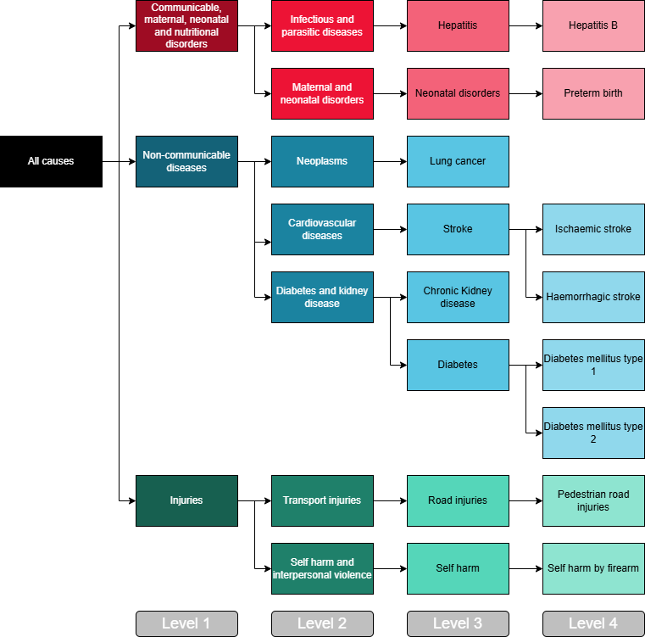

Redistribution of codes
The IHME redistributes some of the causes of death recorded in the Mortality Collection, because several of the causes recorded in that collection cannot be an underlying cause of death, due to their lack of specificity. An example is hypertension, which is redistributed to more specific causes such as chronic ischaemic heart diseases (IHD) or stroke. This results in differences between IHME estimates and the Mortality Collection data from New Zealand.

Ethnicity classification
The Ministry of Health considers ethnicity to be the group or groups that people identify with or feel they belong to. Ethnicity is a measure of cultural affiliation, as opposed to race, ancestry, nationality or citizenship. Ethnicity is self-perceived, and people can belong to more than one ethnic group (Health New Zealand 2017).

Age standardisation
The risk of developing chronic diseases such as heart disease or cancer increases with age. This is important to consider when comparing disease rates between population groups with different age structures. The Māori population has a younger age structure than the non-Māori population, so comparing observed (or crude) disease rates between those populations can mask differences between them.

Age standardisation is a method used to account for the differences in age-structure between populations. It adjusts crude rates to a standard population with a specific age structure. The standard population the IHME uses to age-standardise the estimates allows comparisons across all countries and jurisdictions that participate in the GBD study, the method for which Schumacher et al describe in the supplementary appendix to their 2024 paper (Schumacher et al 2024).

We advise caution when comparing age-standardised rates in this report with those in publications that use a different standard population, since the underlying age structures will likely be different. This includes the Mortality data web tool (Health New Zealand 2025a), which uses the WHO World Standard Population, and publications such as Tatau Kahukura: Māori Health Chart Book (Ministry of Health 2024a), which use the 2001 Māori census population, as recommended in the Position Paper on Māori Health Analytics – Age standardisation (Ministry of Health 2018). For example, calculating mortality rates with the Māori population age structure will lead to low age-standardised mortality rates, whereas using a standard population with an older age structure will lead to high age-standardised mortality rates, due to the strong association between age and mortality.

Most rates in this report from the GBD 2021 study are expressed as an age-standardised rate per 100,000 people, standardised to the age structure of the IHME global population. This report presents age-specific data as crude rates, calculated using the number of events divided by the population in a particular age interval. In this case, we advise caution when comparing Māori with non-Māori results. Crude rates accurately portray a situation in each population but make comparisons difficult because they do not consider the different age distributions in each of the populations.

Numerators and denominators

Numerator-denominator bias
Accurate calculation of rates depends on numerators being drawn from the same population as denominators. The IHME sources the numerator data from the registry of deaths (Māori and non-Māori) and the denominator from the estimated resident population.

The New Zealand Census Mortality and CancerTrends Study has showed, by linking death registrations and census records, that there were substantial undercounts of Māori mortality in the 1980s and 1990s. In 1995, the death registration form was modified to link ethnicity as closely as possible to the census question. Research found that using the ‘total ethnicity’ definition has meant that there has been little or no numerator-denominator bias in the calculation of mortality rates (Ajwani et al 2003; Tan et al 2010).

The mortality rates calculated by the IHME and reported here are based on IHME population estimates, which differ from Stats NZ’s estimates. The discrepancies between the two figures are small (~2–3%) for the most recent year of comparison but larger (~5–9%) for earlier years (see Appendix Table S2). These discrepancies were mainly concentrated in the very young and very old age groups. The IHME estimates of the Māori population are generally slightly larger than Stats NZ’s estimates. The IHME does not account for changes in the ethnic group a person identifies with; nor does it account for differing ethnic rates of migration.

Rate difference and rate ratio
Rate difference is an absolute measure of inequity that shows the difference in health indicators between two population subgroups. It provides a picture of the absolute difference or size of the disparity (Schlotheuber and Hosseinpoor 2022).

Rate ratio is a relative measure of inequity calculated by dividing the population rate of a health indicator for one population subgroup by the population rate in the comparator group (Schlotheuber and Hosseinpoor 2022).

Generally, higher rate differences and higher rate ratios show higher levels of inequity. However, lower values may still be problematic from an equity perspective where there are barriers in access to care and/or undercounting of a population group.

Uncertainty intervals
The GBD data comprises estimates and involves some degree of modelling. Every GBD estimate is associated with a specific uncertainty interval to reflect the strength of the estimate. This is the range of values that is likely to include the correct estimate. A wider interval indicates less robust estimates; Māori estimates have wider intervals because the population size is smaller.

Data updates and methodology changes
The GBD study releases new estimates periodically with refined and improved methodology. With each release, the entire time series back to 1990 is re-estimated to ensure the estimates are up-to-date and comparable. Therefore, comparisons of GBD estimates must not be compared to previous releases.

Premature death in New Zealand – Mate kokoti tau i Aotearoa
This section highlights the burden of premature death experienced by Māori and the leading contributing causes at time of death.

Premature deaths are deaths that happen before a certain age or deaths that occur before the average expected age of death for a particular population. This report presents premature death measured by YLL (for more information see the Methodology section of this report).

In 2021, Māori lost a total of 123,685 years of life due to premature death. The Māori age-standardised YLL rate was double that of non-Māori (15,660 per 100,000 Māori, compared to 7,860 per 100,000 non-Māori).

Figure 2 compares age-standardised YLL rates for Māori and non-Māori from 1996 to 2021. While both Māori and non-Māori YLL rates decreased over this time, an equity gap remained.

Figure 2: All causes: Māori and non-Māori age-standardised years of life lost, 1996–2021
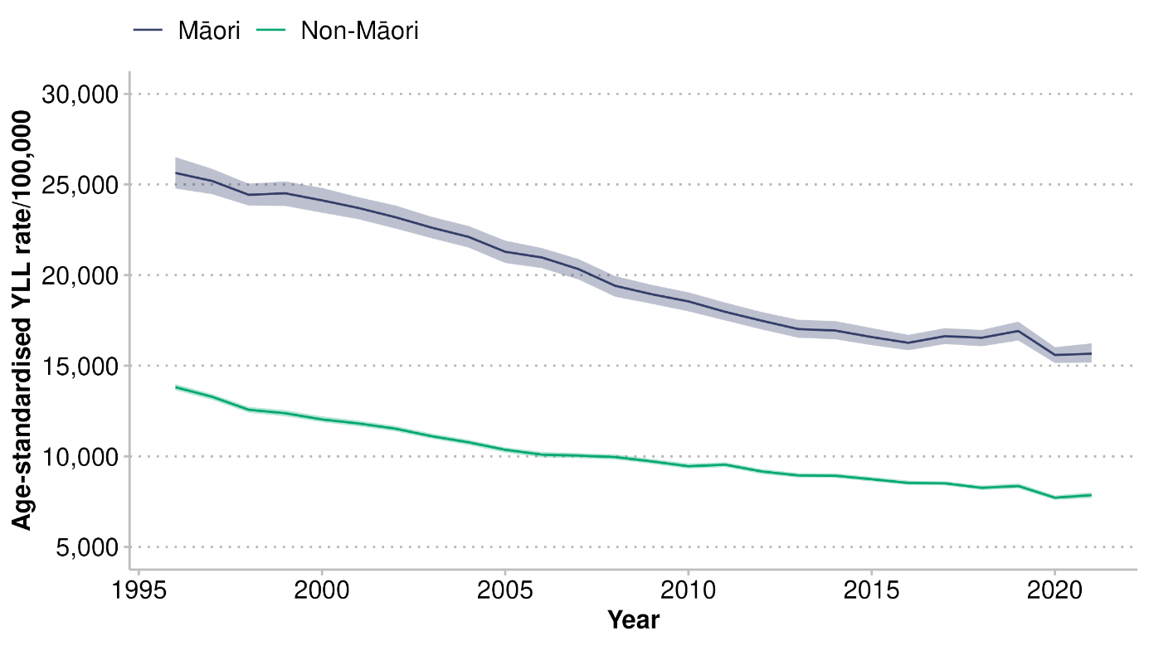
Note: the shaded areas indicate 95% uncertainty intervals

The rate ratio (calculated by dividing the rate of a health indicator for one population subgroup by the rate of a comparator group) shows that Māori consistently experienced around twice the rate of YLL compared to non-Māori during this period (Figure 3).

Figure 3: All causes: Māori/non-Māori age-standardised years of life lost rate ratio, 1996–2021
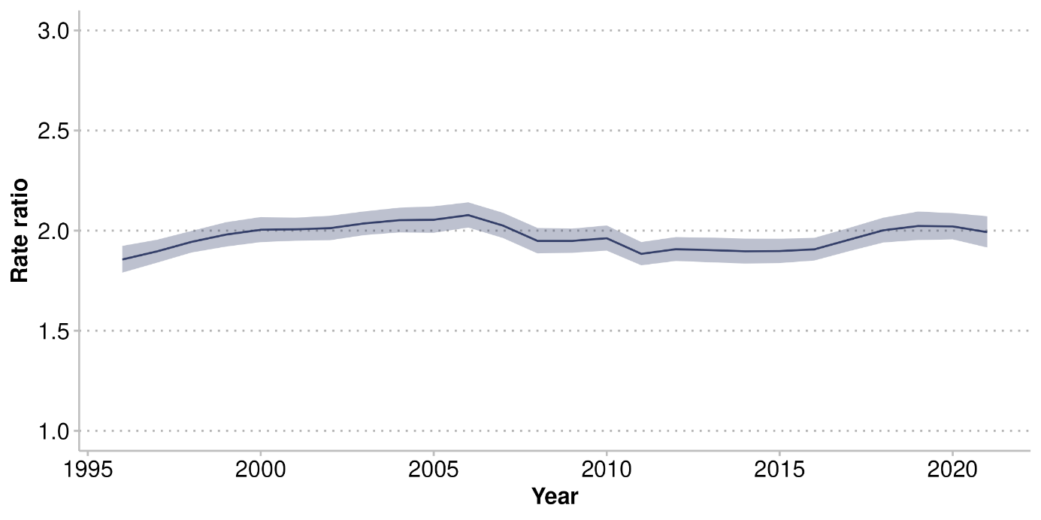
Note: the shaded area indicates 95% uncertainty interval

The gap in YLL rates between Māori and non-Māori is partially driven by high YLL rates for tāne Māori (Figure 4). This gap is narrowing over time.

Figure 4: All causes: tāne and wāhine Māori age-standardised years of life lost rates, 1996–2021
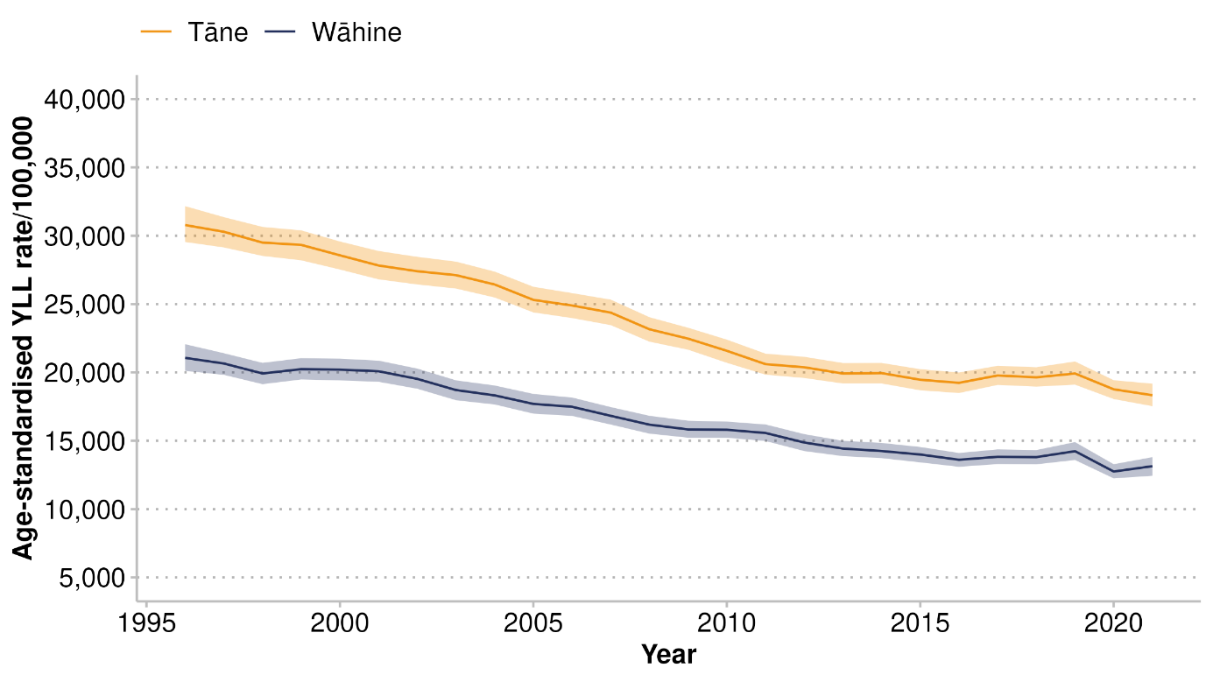
Note: the shaded areas indicate 95% uncertainty intervals

The GBD study splits YLL estimates into three major (level 1) categories: non-communicable diseases, injuries, and a combined group of communicable, maternal, neonatal and nutritional diseases. These categories are broken down into more detailed conditions in level 2. Figure 5 shows the disease categories that made the biggest contribution to YLL for Māori in 2021. Non-communicable diseases made up the majority (78%). Within non-communicable diseases, cancer contributed the most (29%), followed by cardiovascular disease (22%); together, these conditions contributed to more than half of YLL for Māori.

Figure 5: Proportion of years of life lost by level 1 and 2 disease categories for Māori, 2021
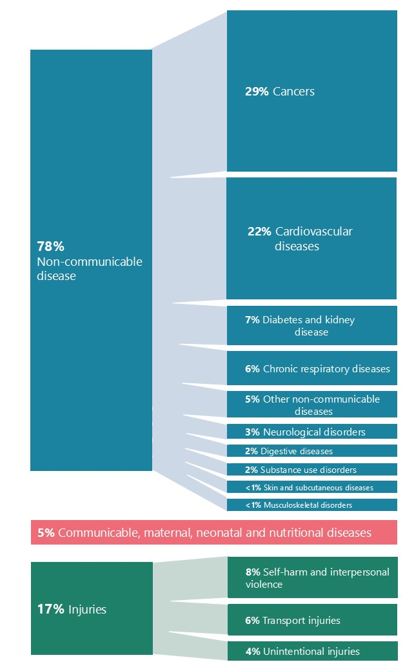
In 2021, the top 10 causes of premature death made up 54% of total YLL for Māori. Ischaemic heart disease was the leading cause of premature death for tāne Māori (15% of YLL), and lung cancer was the leading cause of premature death for wāhine Māori (11% of YLL; see Figure 6).

In addition, a significant percentage of YLL for tāne Māori was also due to injuries such as self-harm (8% of total YLL) and road injuries (6%). Among wāhine Māori, IHD was a major contributor to premature death (8%), followed by COPD (7%) and breast cancer (6%).

Figure 6: Ten leading contributors to years of life lost (proportion %) for tāne and wāhine Māori, 2021
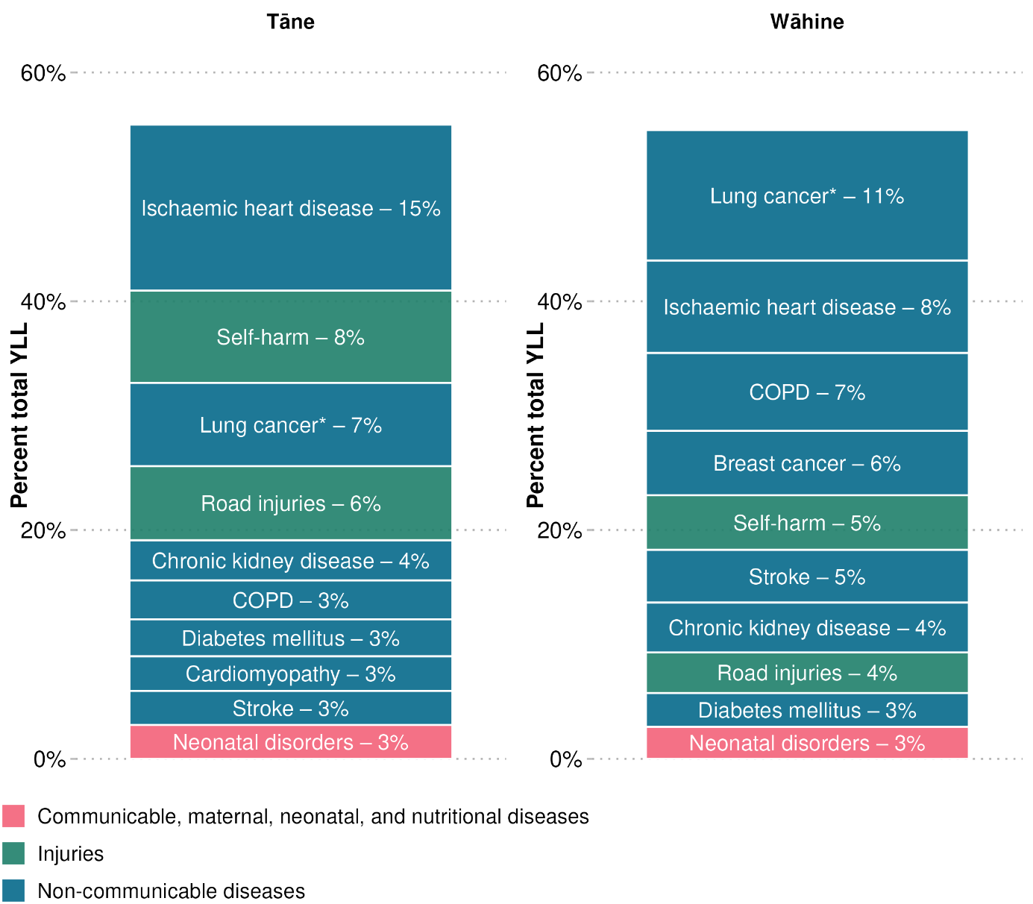
Note:
* Lung cancer includes bronchus, tracheal and lung cancers

Top conditions contributing to premature death for Māori
Māori experience a greater burden from premature death across a broad range of conditions. This section explores the equity gap between Māori and non-Māori in the context of YLL and discusses the conditions that contribute the most to this gap. The Ministry of Health defines equity as follows: ‘in New Zealand, people have differences in health that are not only avoidable but unfair and unjust. Equity recognises different people with different levels of advantage require different approaches and resources to get equitable health outcomes’ (Health New Zealand 2017).

Figure 7 shows age-standardised rates for level 2 causes of YLL for Māori and non-Māori in 2021. Cardiovascular diseases and cancers were associated with the highest age-standardised YLL rates for Māori. When compared to rates for non-Māori, they were also associated with the greatest absolute difference: 2,020 per 100,000 for cardiovascular diseases and 1,941 per 100,000 for cancers. The YLL rates for these two conditions were about twice as high for Māori as they were for non-Māori.

Figure 7: Māori and non-Māori age-standardised years of life lost rates by ten leading level 2 causes, 2021
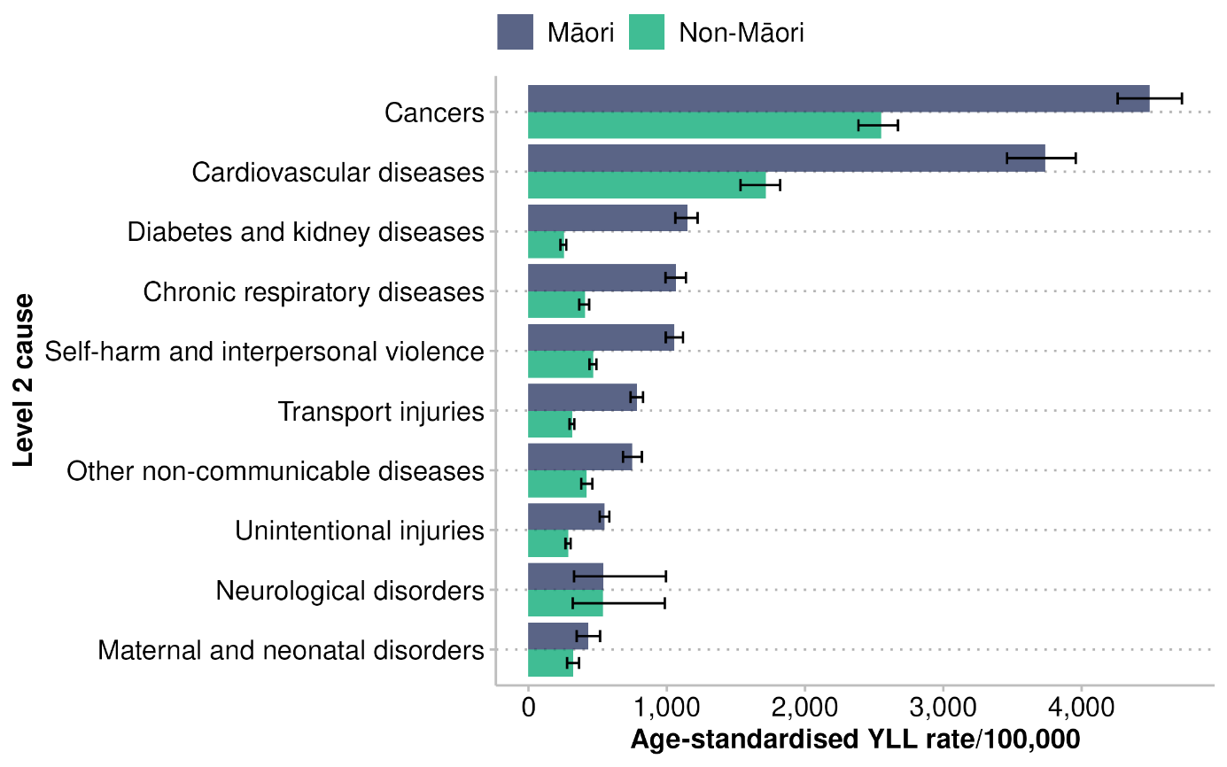
Note: the bars indicate 95% uncertainty intervals

In 2021, the level 2 causes of YLL with the greatest equity gaps (measured by rate ratios) were diabetes and kidney disease, and chronic respiratory diseases (Figure 8). Age-standardised YLL rates for diabetes and kidney diseases were more than four times higher, and chronic respiratory diseases nearly three times higher, for Māori compared to non-Māori.

Figure 8: Māori/non-Māori years of life lost age-standardised rate ratios for 10 leading level 2 causes, 2021
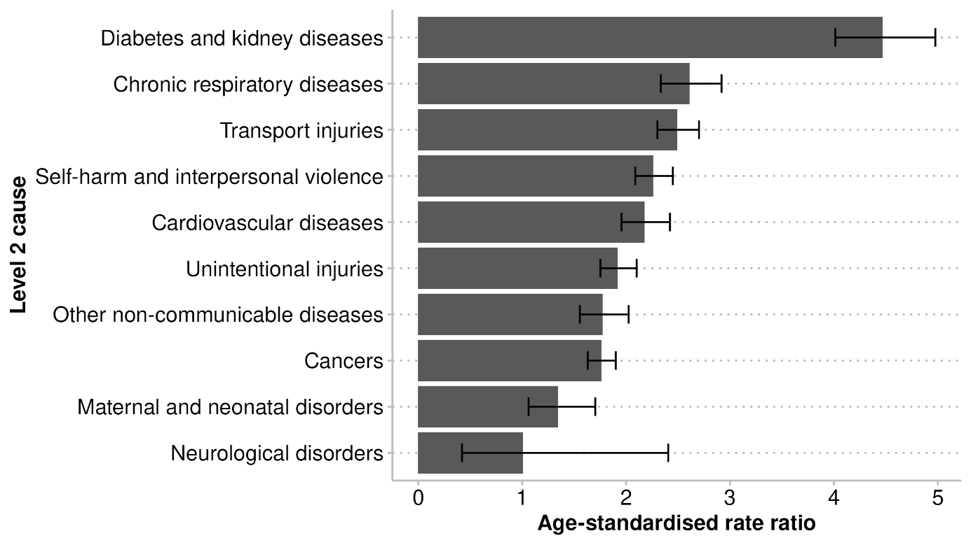
Note: the bars indicate 95% uncertainty intervals

Premature death for Māori across life stages
This section describes major causes of premature death across age groups for Māori. Māori have a younger age structure than non-Māori and experience poorer health outcomes at younger ages (Sheridan et al 2024; Stats NZ 2022). Causes of early death change across life stages: self-harm and road injuries contribute more in the younger age groups, whereas non-communicable diseases such as IHD, lung cancer and COPD are more significant in older age groups.

A greater proportion of YLL occurs earlier in life for Māori compared to non-Māori (Figure 9). For example, 8% of the total number of YLL occurred in Māori aged under five years, compared to 3% for non-Māori. The five-year age group with the highest proportion of YLL was younger for Māori, peaking at 60–64 years, compared to 75–79 years for non-Māori. The lower proportion of YLL in the 70+ age groups shows that a higher rate of deaths occurs earlier for Māori compared to non-Māori.
Figure 9: Proportion of years of life lost for Māori and non-Māori by age group, 2021
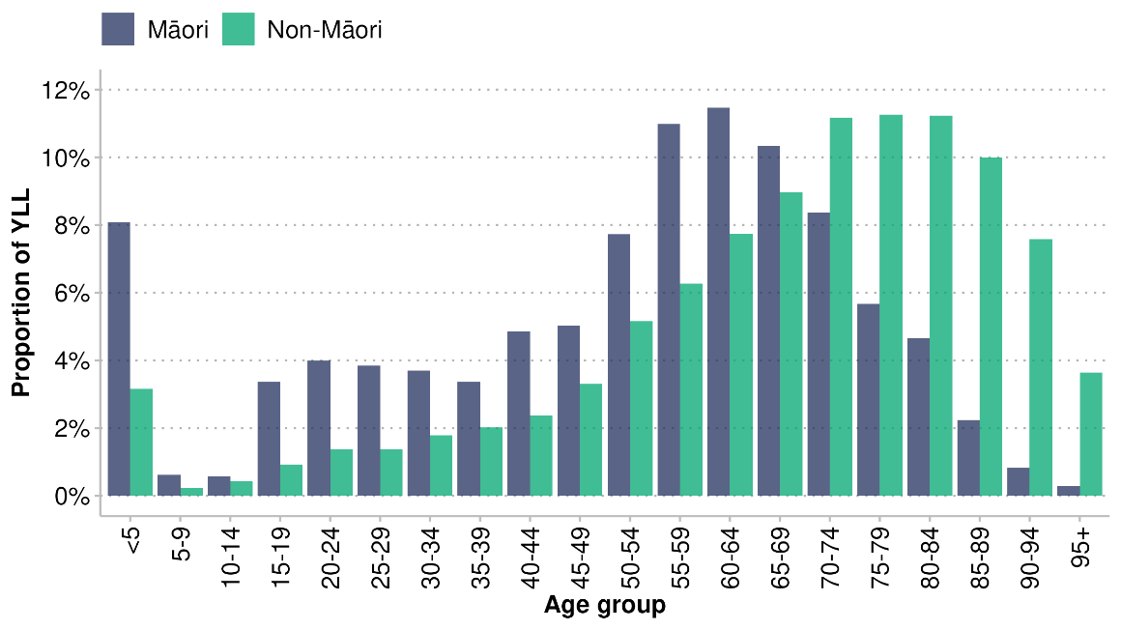

When only looking at the Māori population across life stages, the number of YLLs shows the same trends evident in Figure 9: the lowest number in the 5–14-year age group and the highest in the 45–64-year age group (Figure 10).

Figure 10: Number of years of life lost for Māori, by life stage, 2021
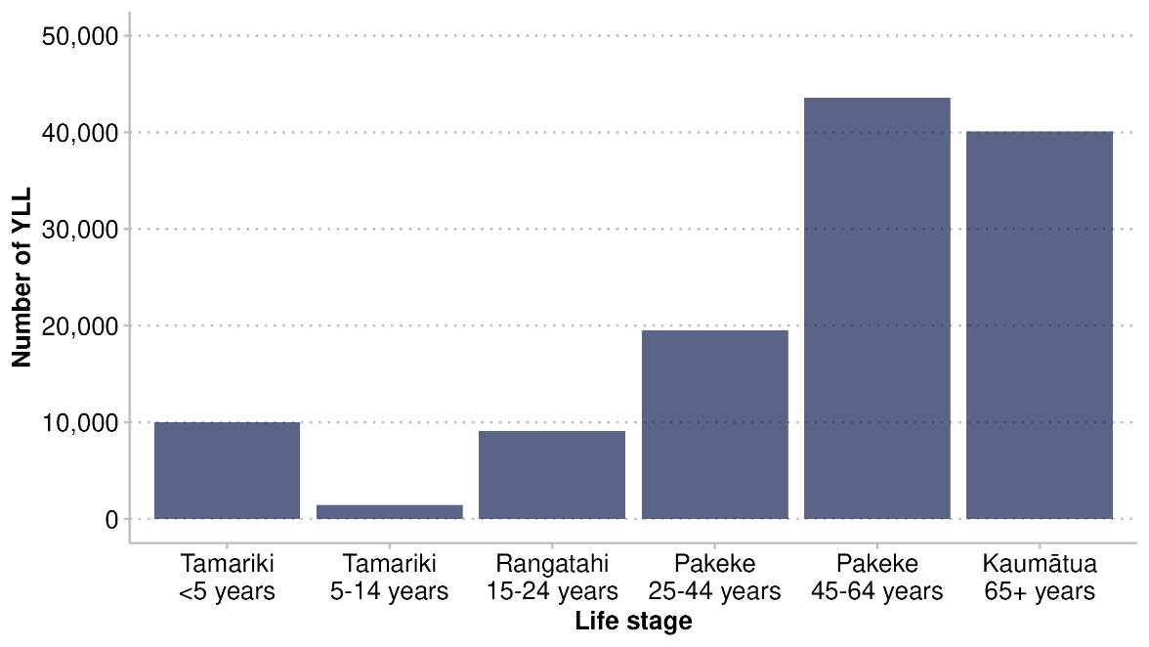

There was a drop in the proportion and number of YLL for older age groups, likely caused by small Māori population sizes in those age groups (see Appendix 2, Figure S1). Adjusting for population size, the YLL rate increases as age increases, but Māori still have a higher rate of YLL at younger ages than non-Māori (Figure 11).

Figure 11: Rate of years of life lost per 100,000 for Māori and non-Māori by age group, 2021
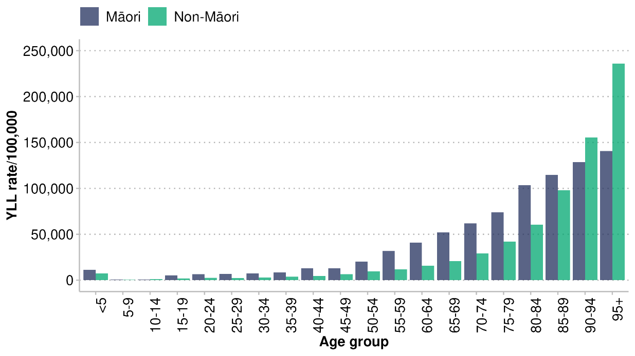

Figures 12 and 13 present the five leading causes of YLL across different life stages for Māori in 2021. For tamariki Māori under five years, neonatal disorders contributed the largest proportion of YLL (36%), with a total number of 3,572 YLL. In this age group, congenital birth defects accounted for 17% and sudden unexpected death in infancy (SUDI) accounted for 10%.

There was a low number of deaths contributing to YLL in the 5–14-year-old age group in 2021; therefore, data in this group should be interpreted with caution.

In 2021, self-harm was the leading contributor to YLL for both rangatahi Māori aged 15–24 years and pakeke Māori aged 25–44 years, followed by road injuries. Self-harm accounted for 34% of premature death for rangatahi and 19% for pakeke aged 25–44 years. Road injuries accounted for 26% of premature death for rangatahi and 12% for pakeke aged 25–44 years. Ischaemic heart disease and lung cancer were the top two contributors to YLL for pakeke aged 45–64 years (at 16% and 13% respectively) and kaumātua aged 65 years and over (at 16% and 12% respectively).
Figure 12: Relative contribution of the top six conditions to years of life lost, by life stage (0–24 years), 2021
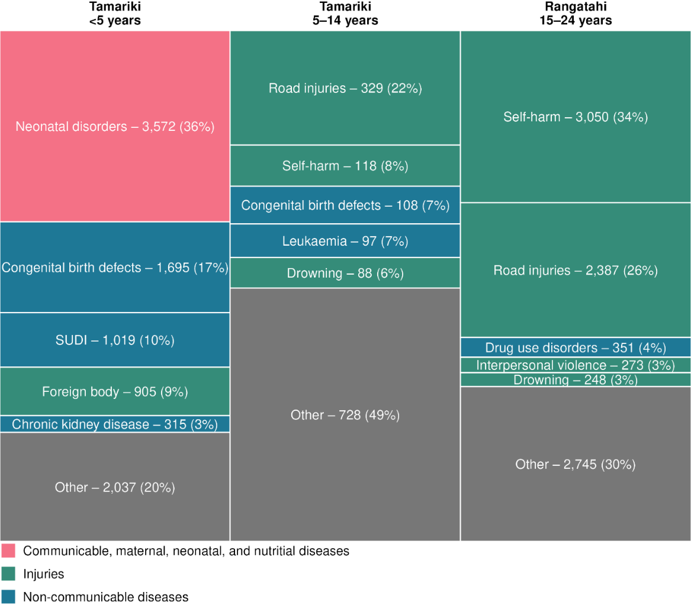

Figure 13: Relative contribution of the top six conditions to years of life lost, by life stage (25+ years), 2021
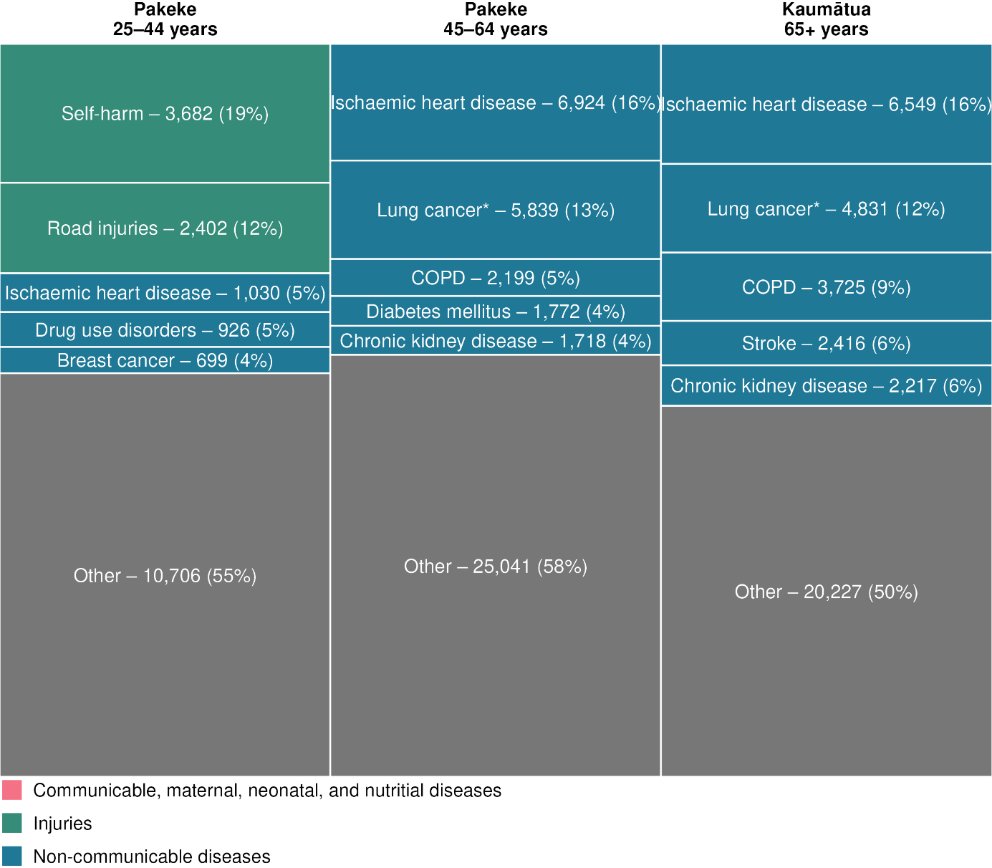
Note:
*Lung cancer includes bronchus, tracheal and lung cancers

In 2021, in pakeke age groups, there were gender differences in conditions contributing to YLL. There were no noticeable gender differences in YLL contributors for tamariki (aged under 15 years) or kaumātua (aged 65 years and above).

Figure 14 shows the five leading contributors to YLL in pakeke aged 25–64 years. Self-harm was the leading cause of premature death for both tāne and wāhine Māori aged 25–44 years. Self-harm was also the leading cause of premature death for non-Māori males, whereas breast cancer was the leading cause for non-Māori females. In the 45–64-year age group, the leading cause of premature death for tāne Māori was IHD; for wāhine Māori in this age group, the leading cause was lung cancer. The leading causes of death were the same for non-Māori males in the equivalent age group, but breast cancer was still the leading cause for non-Māori females.

Figure 14: Five leading contributors to years of life lost for pakeke Māori aged 25–64 years, number of years of life lost by age group and gender, 2021
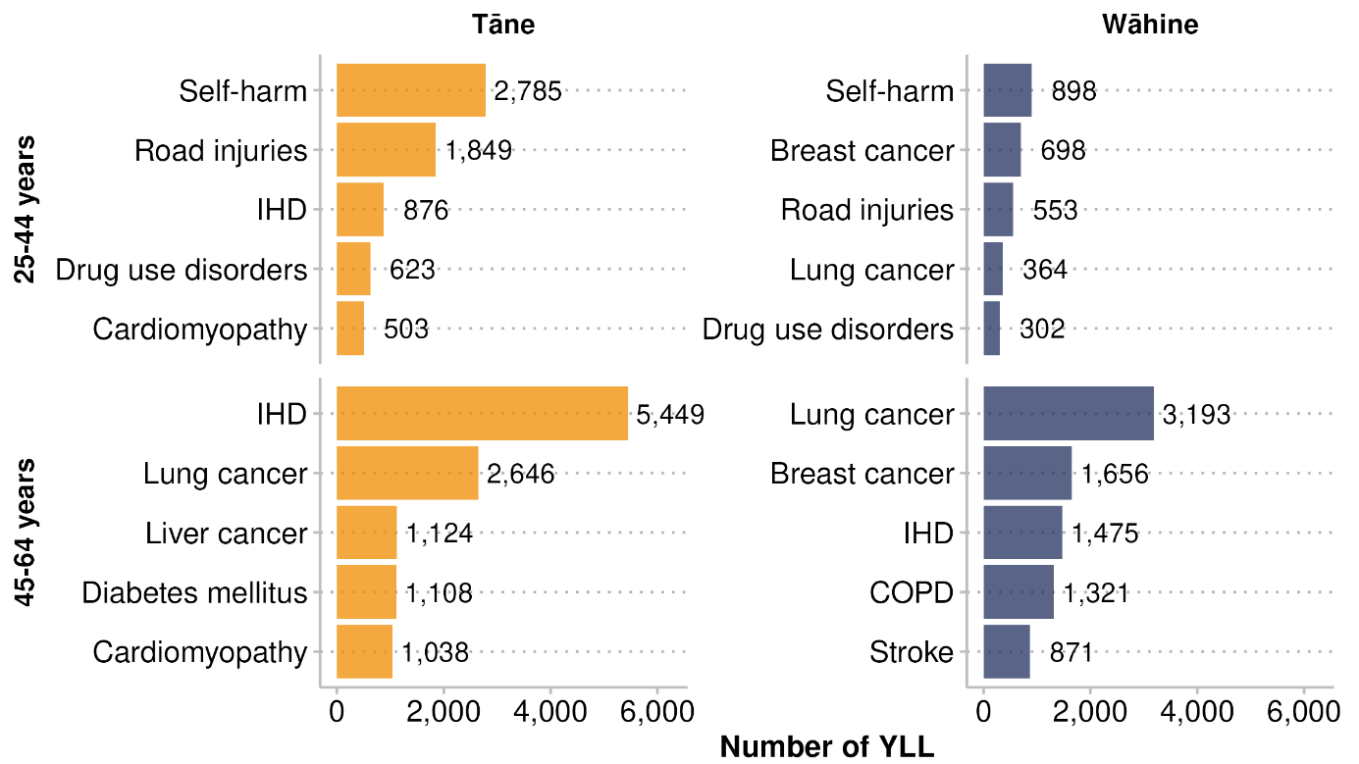

Leading contributors to years of life lost for Māori – Ngā take matua mō te ngaromanga o ngā tau oranga o ngāi Māori
This section provides a more detailed breakdown (by level 3 causes) of the leading conditions that contribute to premature death for Māori, including lung cancer, breast cancer, IHD, self-harm, COPD, stroke, CKD and diabetes.

Cancers
Cancer is the second leading cause of death for all New Zealanders (the leading cause is cardiovascular diseases) and the leading cause for Māori (Health New Zealand 2025b). The GBD results show that, in 2021, Māori experienced higher rates of YLL from cancer than non-Māori, with an age-standardised rate of 4,455 YLL per 100,000 for Māori from all cancers, compared to 2,527 YLL per 100,000 for non-Māori.

Figure 15 shows the 15 cancers with the highest YLL age-standardised rates. Lung cancer was the leading cause of premature death for Māori and non-Māori in 2021. The YLL rates for cancer were higher among Māori than among non-Māori for all types of cancers except for brain and central nervous system cancers.
Figure 15: Māori and non-Māori age-standardised years of life lost rates for the 15 leading cancer types, 2021
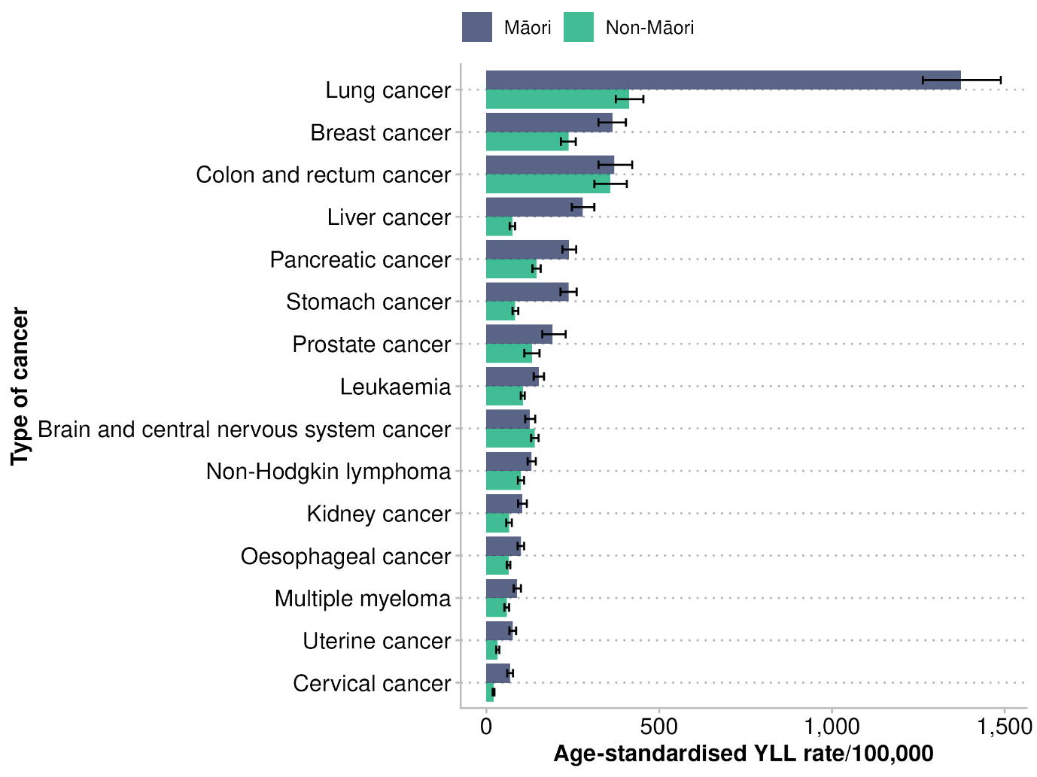
Note: the bars indicate 95% uncertainty intervals

Māori experienced a higher rate of YLL from multiple cancer types in 2021 (see Figure 16). The greatest equity gaps for Māori were seen in the context of liver, lung and cervical cancers; Māori age-standardised YLL rates were over three times higher than rates for non-Māori. Māori experienced over twice the rate of YLL from stomach cancer and uterine cancer than non-Māori.

Figure 16: Māori/non-Māori age-standardised years of life lost rate ratios for the 15 leading cancer types, 2021
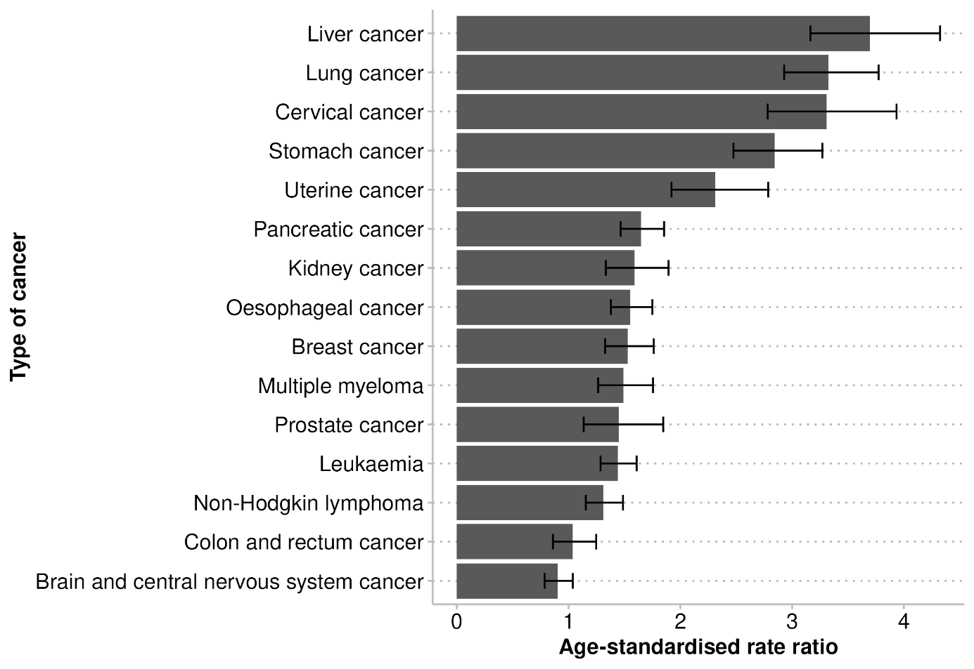
Note: the bars indicate 95% uncertainty intervals

Figure 17 shows the distribution of YLL from cancer by age for tāne and wāhine Māori in 2021. Tāne Māori generally had higher YLL rates than wāhine Māori. The age distribution was similar for cancer among tāne and wāhine Māori; peak life loss due to early death occurred in the older age groups.

Figure 17: All cancer: tāne and wāhine Māori, age-specific years of life lost rates, 2021
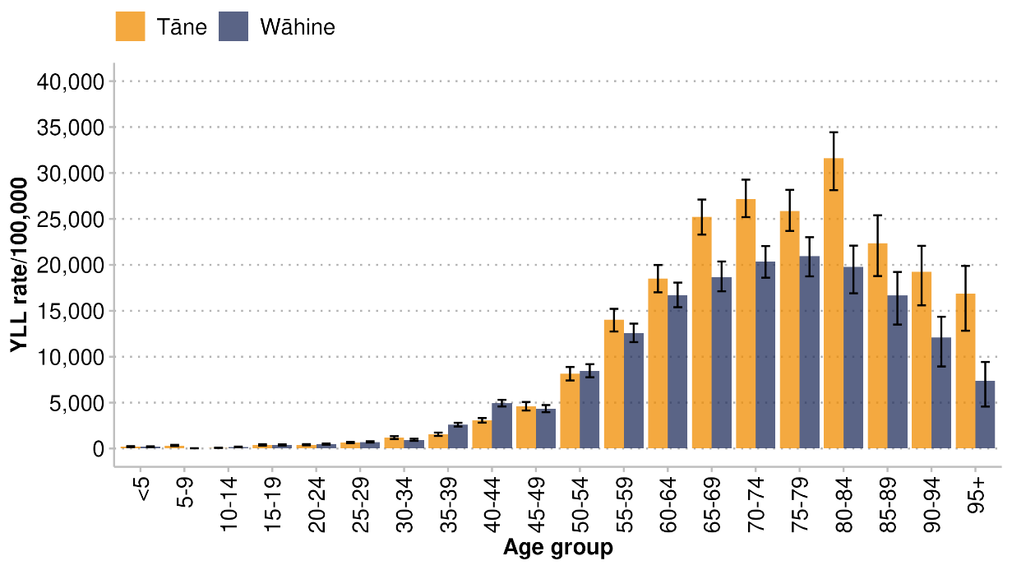
Note: the bars indicate 95% uncertainty intervals

Figure 18 shows the proportion of YLL from different types of cancers among tāne and wāhine Māori. Lung cancer was the leading cancer contributing to YLL for both tāne and wāhine Māori (at 28% and 34% respectively). The second leading cause was breast cancer for wāhine Māori (contributing 17% of cancer-related YLL), and liver cancer for tāne Māori (contributing 10%). The third leading cancer contributor for both genders was colorectal cancer (9.6% for tāne Māori and 7% for wāhine Māori).

Figure 18: Top 10 leading cancers contributing to years of life lost from cancer for tāne and wāhine Māori, 2021
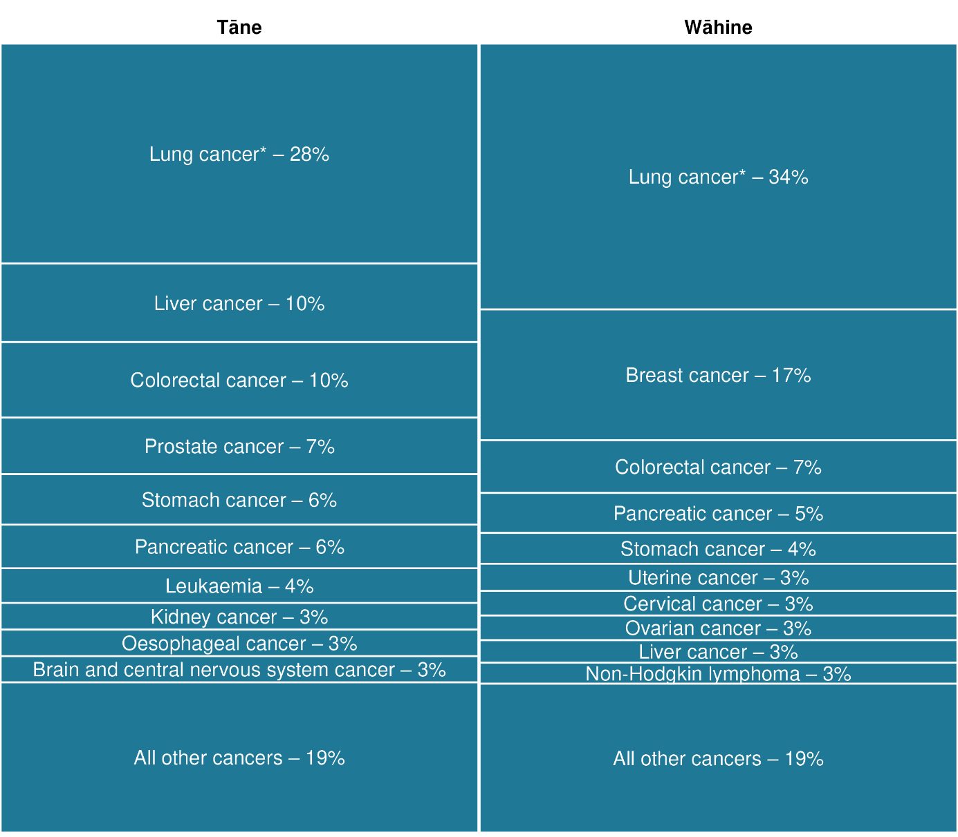
Note: *Lung cancer includes bronchus, tracheal and lung cancers

Lung cancer
In this report, ‘lung cancer’ refers to cancers of the trachea, bronchus and lung. Lung cancer is often diagnosed at advanced stages, when treatment options are limited, as early lung cancer often does not cause significant symptoms. The YLL rates of lung cancer are decreasing for Māori, but the rates are still consistently higher among Māori than non-Māori (Figure 19).
Figure 19: Lung cancer: Māori and non-Māori age-standardised years of life lost rates, 1996–2021
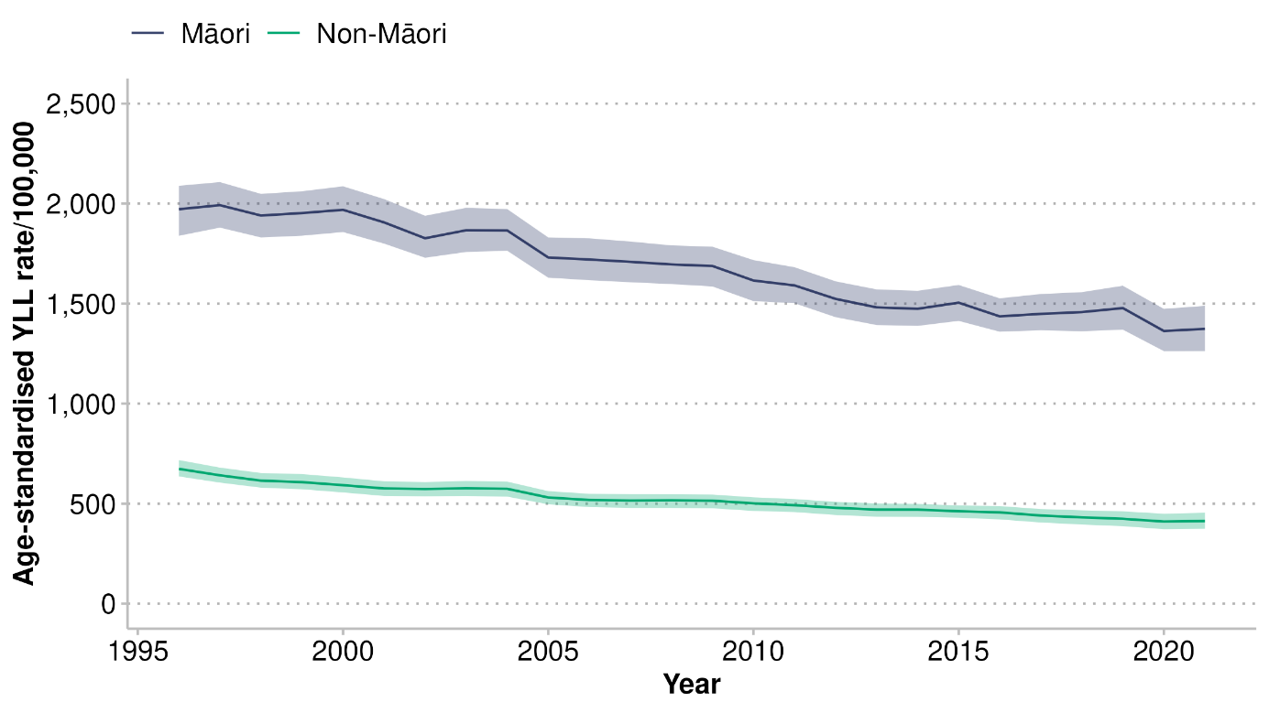
Note: the shaded areas indicate 95% uncertainty intervals

The Māori YLL rate from lung cancer was three times higher than that for non-Māori (Figure 20). This ratio remained steady, except for a small jump in 2019.

Figure 20: Lung cancer: Māori/non-Māori age-standardised years of life lost rate ratios, 1996–2021
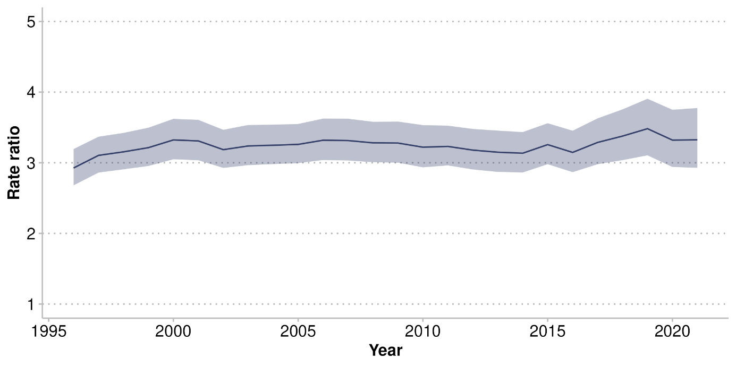
Note: the shaded area indicates 95% uncertainty interval

Tāne and wāhine Māori age-standardised YLL rates for lung cancer decreased between 1996 and 2021 (see Figure 21). The YLL rates for lung cancer declined more rapidly for tāne Māori than they did for wāhine Māori. Tāne had higher YLL rates than wāhine Māori until about 2008, when the rates became similar. The decrease in wāhine Māori YLL rates mostly occurred over the decade prior to 2021.

Figure 21: Lung cancer: tāne and wāhine Māori age-standardised years of life lost rates, 1996–2021
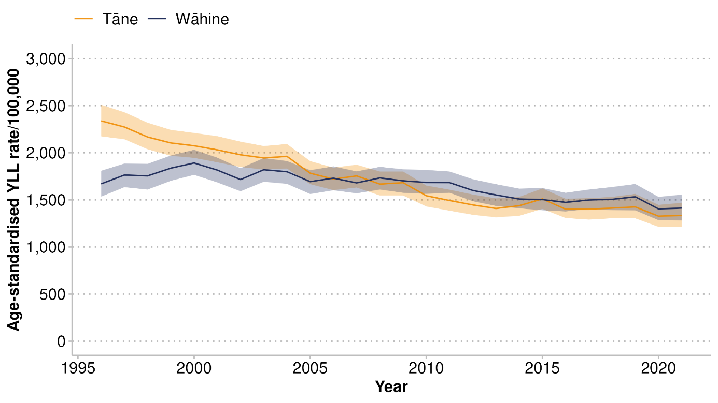
Note: the shaded areas indicate 95% uncertainty intervals

There was a gradual decline in this rate in the years prior to 2021 among most age groups, but there were still large equity gaps when comparing Māori to non-Māori in 2021, particularly for those aged between 50 and 84 years (Figure 22).

Figure 22: Lung cancer: Māori and non-Māori years of life lost rates, by age group, 2021
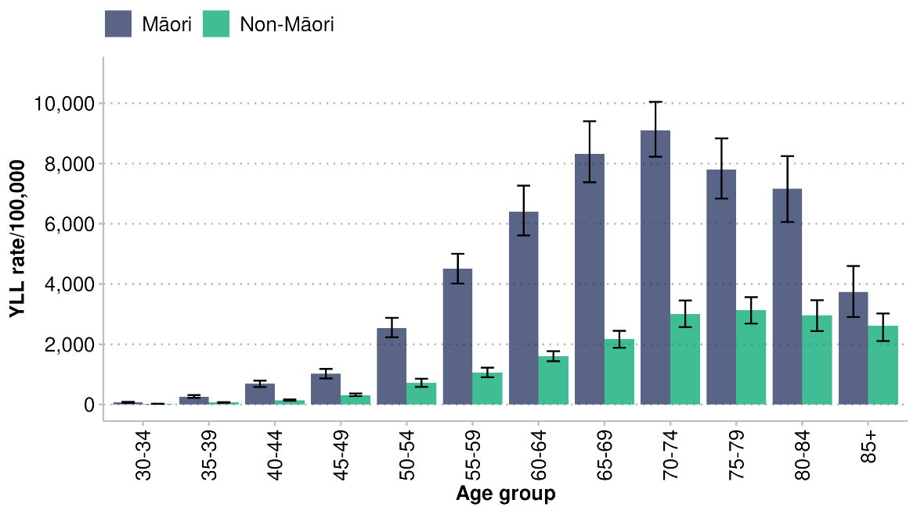
Note: the bars indicate 95% uncertainty intervals

The lung cancer YLL rates for tāne and wāhine Māori Figure 21 shows appear again in more detail in Figure 23, by age group. There were small differences between rates for tāne and wāhine in 2021 that were not always consistent across age groups. Lung cancer YLL rates peaked in the 70–74-year age group for both tāne and wāhine

Figure 23: Lung cancer: tāne and wāhine Māori years of life lost rates by age group, 2021
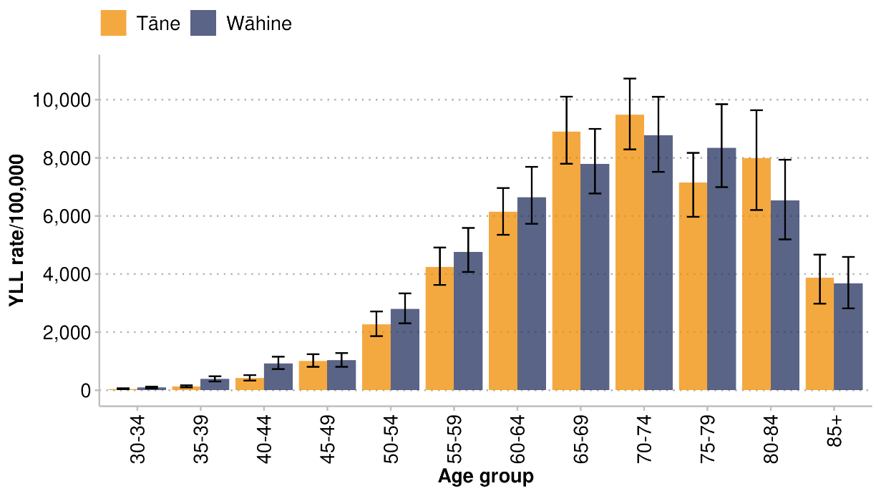
Note: the bars indicate 95% uncertainty intervals

Breast cancer
Breast cancer was the second highest cancer contributor, and the fourth highest overall contributor to YLL for wāhine Māori, contributing to 6% of overall YLL for wāhine Māori in 2021. The age-standardised breast cancer YLL rate was higher for Māori than it was for non-Māori (see Figure 24), but the gap was smaller for this cancer than for lung cancer. The gap between the breast cancer YLL rates for Māori and non-Māori remained consistent from 1996 to 2021: the rate ratio remained generally about 1.5, with small fluctuations (Figure 25). This means the equity gap did not get smaller.

Figure 24: Breast cancer: Māori and non-Māori wāhine age-standardised years of life lost rates, 1996–2021
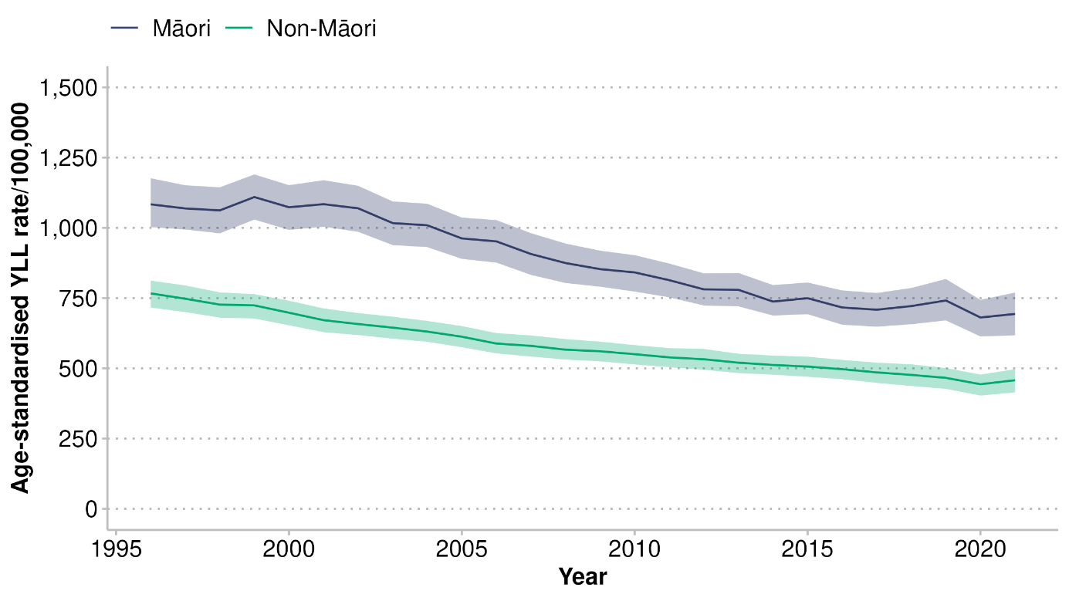
Note: the shaded areas indicate 95% uncertainty intervals
Figure 25: Breast cancer: Māori/non-Māori wāhine age-standardised years of life lost rate ratios, 1996–2021
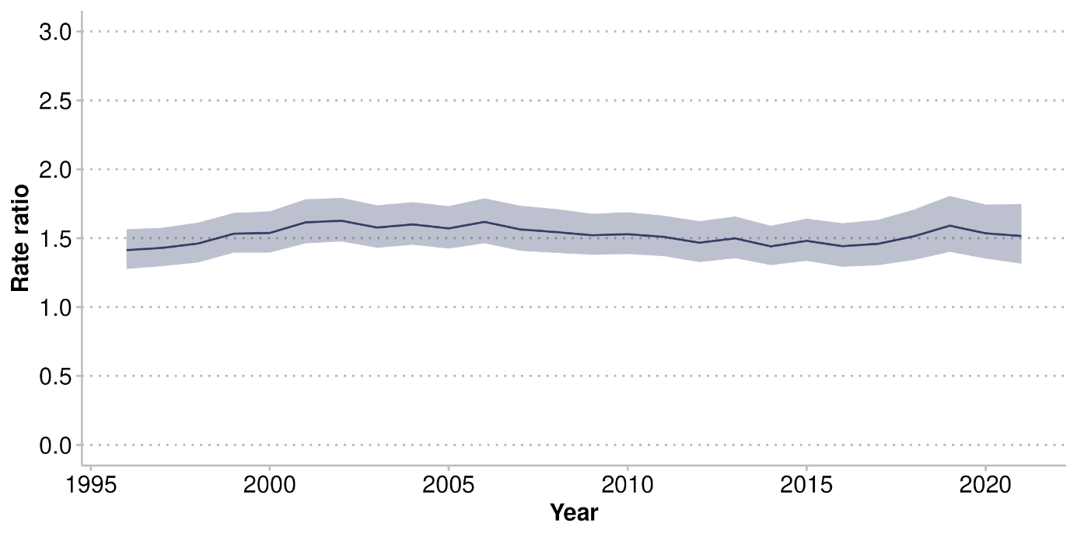
Note: the shaded area indicates 95% uncertainty interval

Greater disparities in the breast cancer YLL rate between Māori and non-Māori were seen in specific age groups; for example, the Māori YLL rate in the 40–44-year age group was about double the non-Māori rate (see Figure 26). Overall, the Māori YLL rate for breast cancer was higher in every age group, except for those aged 85+ years.

Figure 26: Breast cancer: Māori and non-Māori years of life lost rates by age group, 2021
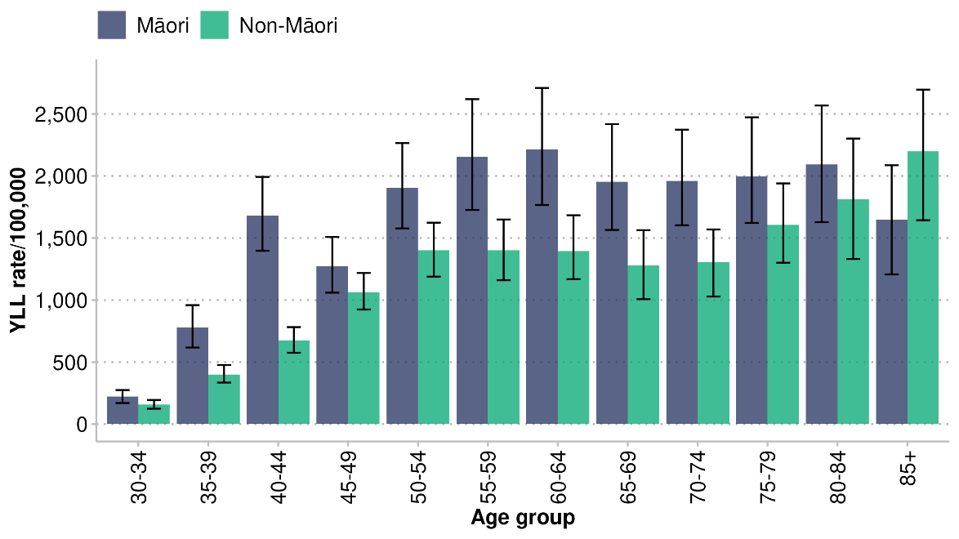
Note: the bars indicate 95% uncertainty intervals

Ischaemic heart disease
Ischaemic heart disease, also called coronary artery disease, is a cardiovascular condition in which there is a reduced supply of oxygen to the heart due to reduced blood supply. The reduced blood supply is caused by a build-up of fatty material (plaque) along the walls of the blood vessels supplying the heart, which narrows and stiffens these blood vessels (Heart Foundation 2024). In 2021, IHD was the leading cause of premature death for tāne Māori and the second leading cause for wāhine Māori (see Figure 6). In total, IHD contributed 12% of total YLL for Māori.

Figure 27 shows the trend in age-standardised YLL rates for IHD among Māori and non-Māori from 1996 to 2021, and Figure 28 shows the respective rate ratios between Māori and non-Māori. There was a declining trend in premature death from IHD for both Māori and non-Māori over the years reported on. However, rates for Māori were consistently around twice as high as rates for non-Māori.

Figure 27: Ischaemic heart disease: Māori and non-Māori age-standardised years of life lost rates, 1996–2021
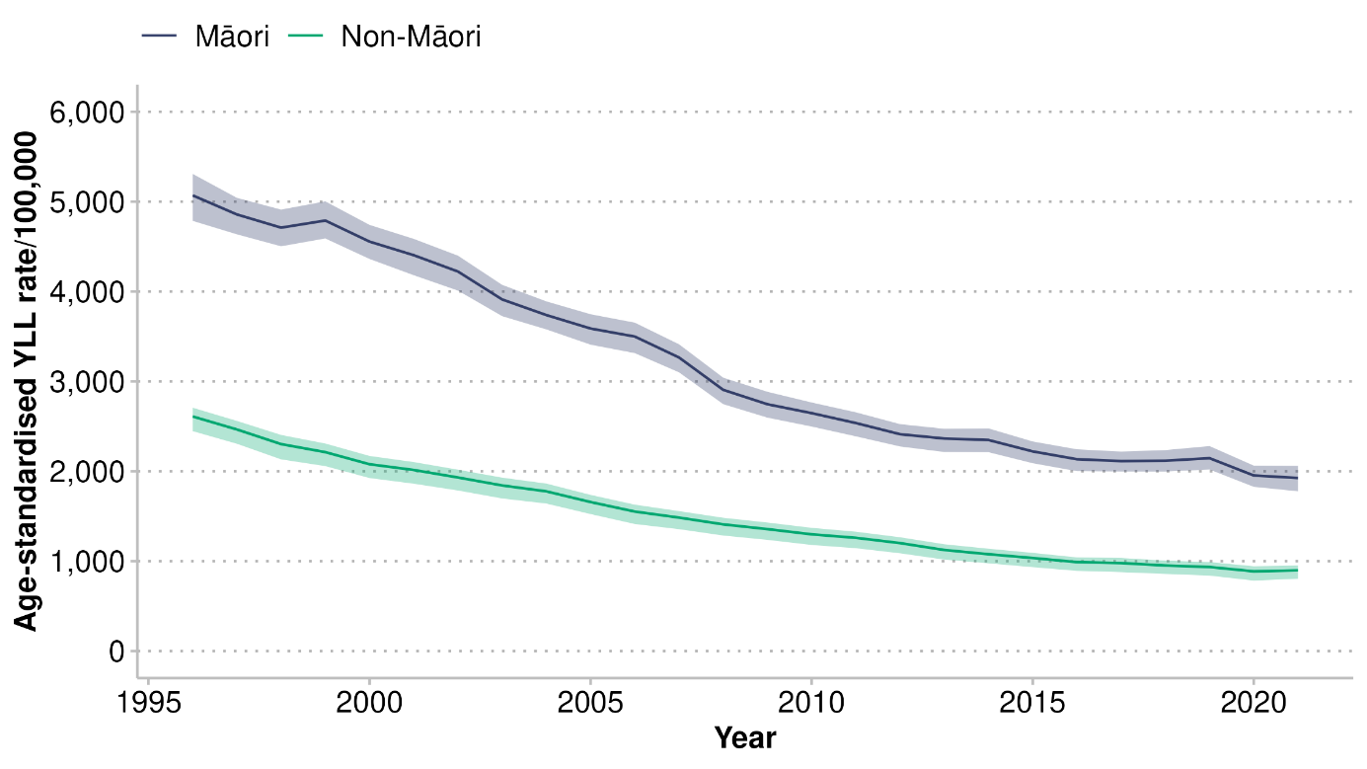
Note: the shaded areas indicate 95% uncertainty intervals

Figure 28: Ischaemic heart disease: Māori/non-Māori age-standardised years of life lost rate ratios, 1996–2021
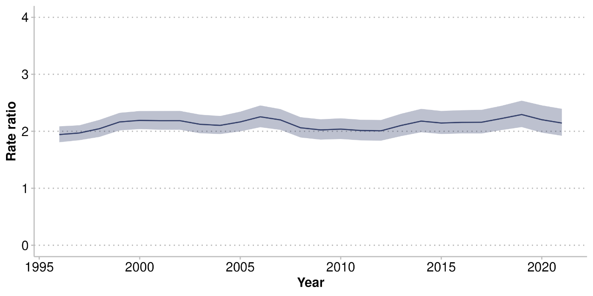
Note: the shaded area indicates 95% uncertainty interval

In addition to differences between Māori and non-Māori, there are differences in rates of IHD-related YLL between tāne and wāhine Māori. Tāne Māori experience a higher rate of premature death from IHD compared to wāhine Māori (see Figure 29). There was a decline in YLL rates for both tāne and wāhine Māori over the years to 2021. However, this decline slowed down over the last decade, especially for tāne Māori. The gap between tāne and wāhine Māori lessened over time, but tāne Māori continued to experience a higher rate of YLL from IHD than wāhine Māori, with a rate ratio 2.4 times higher than that of tāne Māori in 2021.

Figure 29: Ischaemic heart disease: Māori tāne and wāhine age-standardised years of life lost rates, 1996–2021
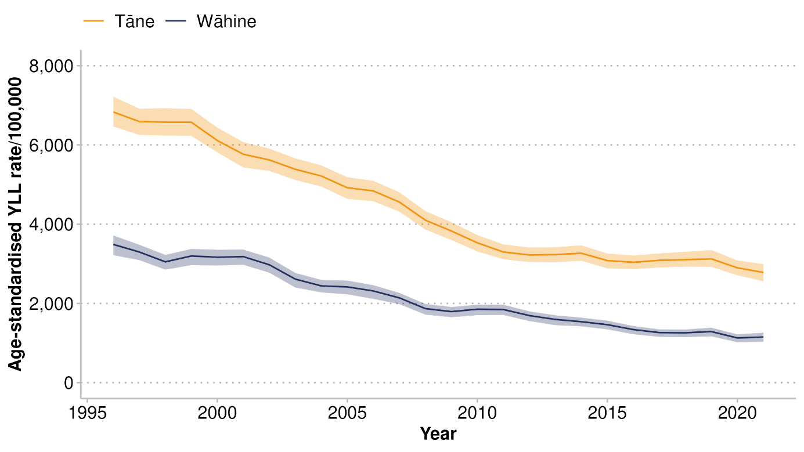
Note: the shaded areas indicate 95% uncertainty intervals

Figure 30 shows YLL age-specific rates per 100,000 people for IHD in 2021, by age group, for Māori and non-Māori. Rates of IHD increased with age for both Māori and non-Māori. Māori experienced an earlier increase and higher rates of YLL at every age group up to age 80–84 years compared to non-Māori. The higher non-Māori rate in the 85 and over age category shows that non-Māori were living longer with IHD or developing the disease at an older age, resulting in a higher number of deaths for non-Māori compared to Māori in that age category.

Figure 30: Ischaemic heart disease: Māori and non-Māori years of life lost rates by age group, 2021
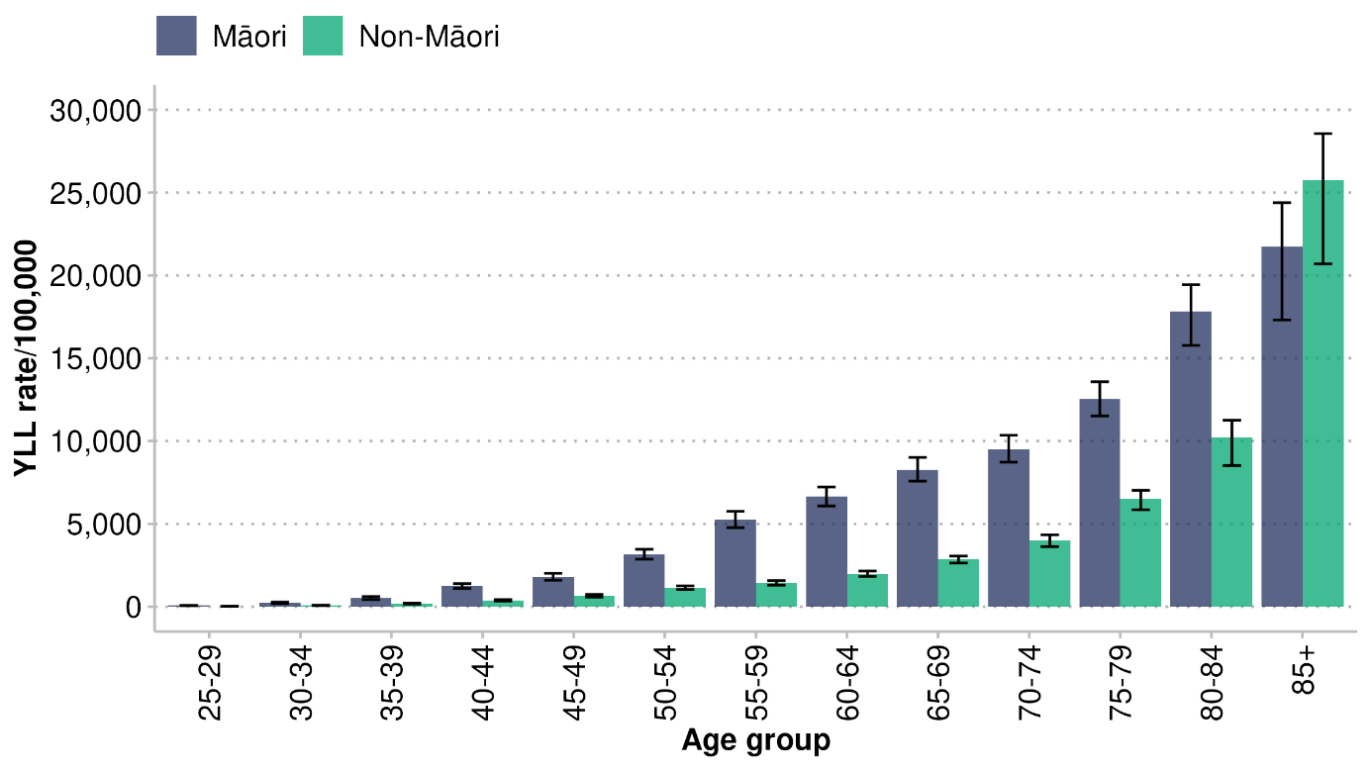
Note: the bars indicate 95% uncertainty intervals

In 2021, YLL rates for IHD differed by gender. Tāne Māori experienced a higher burden of premature death compared to wāhine Māori (see Figure 31). Rates for both tāne and wāhine Māori gradually increased with age; rates for tāne Māori increased at an earlier age.

Figure 31: Ischaemic heart disease: Māori tāne and wāhine years of life lost rates by age group, 2021
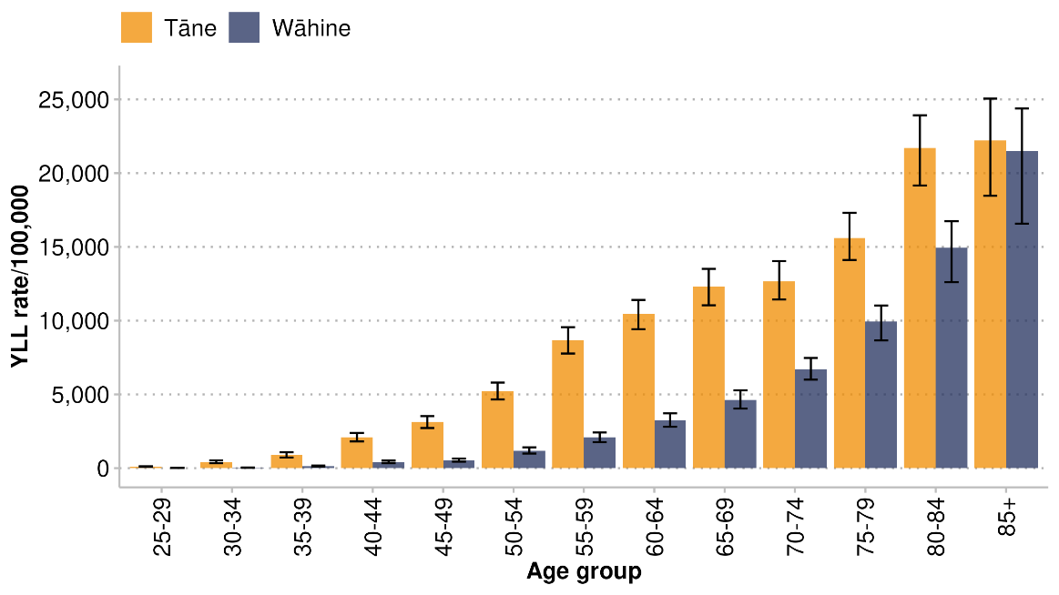
Note: the bars indicate 95% uncertainty intervals

Self-harm
Self-harm refers to deliberate bodily damage inflicted on oneself that results in death or injury (Global Health Metrics 2020); it includes suicide. For the purposes of this report, ‘suicide’ refers to YLL resulting from self-harm. Self-harm rates were higher for Māori than non-Māori, and the gap increased in the years to 2021, as the non-Māori rate decreased but the Māori rate remained high (see Figure 32).

Figure 32: Self-harm: Māori and non-Māori age-standardised years of life lost rates, 1996–2021
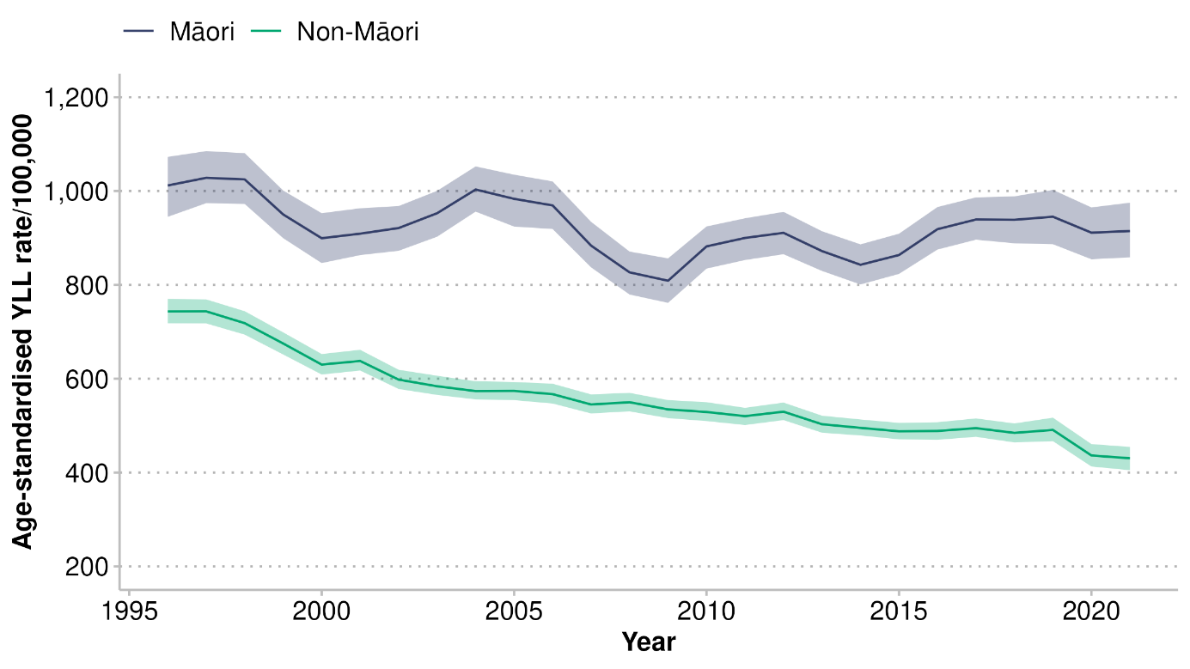
Note: the shaded areas indicate 95% uncertainty intervals
Figure 33 clearly shows the difference between the non-Māori and Māori rates increasing.

Figure 33: Self-harm: Māori/non-Māori age-standardised years of life lost rate ratios, 1996–2021
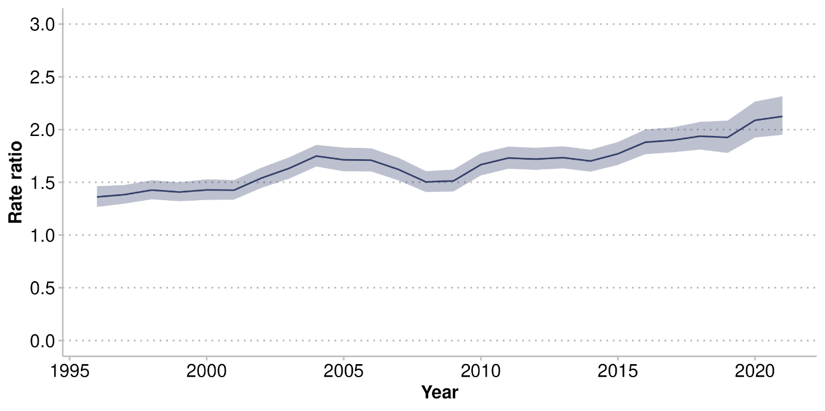
Note: the shaded area indicates 95% uncertainty interval

Self-harm was the second leading cause of YLL for tāne Māori and the fifth leading cause for wāhine Māori (see Figure 6). Figure 34 shows the trend in YLL rates for self-harm between 1996 and 2021 for tāne and wāhine Māori. In 2021, tāne Māori experienced more than twice the burden of premature death from self-harm (an age-standardised rate of 1,267 per 100,000) than wāhine Māori (a rate of 564 per 100,000). The self-harm rate for wāhine Māori slowly increased over the decade to 2021.

Figure 34: Self-harm: tāne and wāhine Māori age-standardised years of life lost rates, 1996–2021
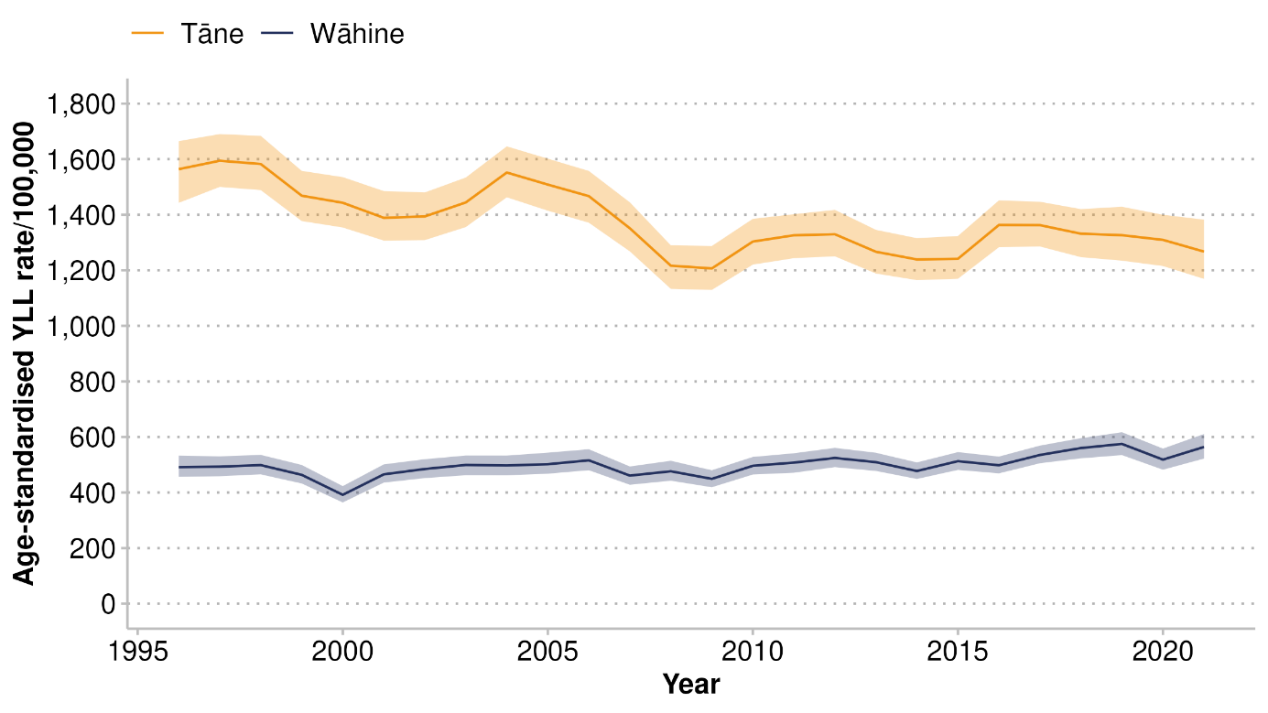
Note: the shaded areas indicate 95% uncertainty intervals

Figure 35 shows the YLL rates for self-harm by age group in 2021. These rates were highest among younger age groups for both Māori and non-Māori. The YLL rates for self-harm were consistently higher for Māori compared to non-Māori across all age groups between 15 and 80 years, with the greatest inequity seen for rangatahi aged 15-24 years and pakeke aged 25-44 years.

Figure 35: Self-harm: Māori and non-Māori years of life lost rates by age group, 2021
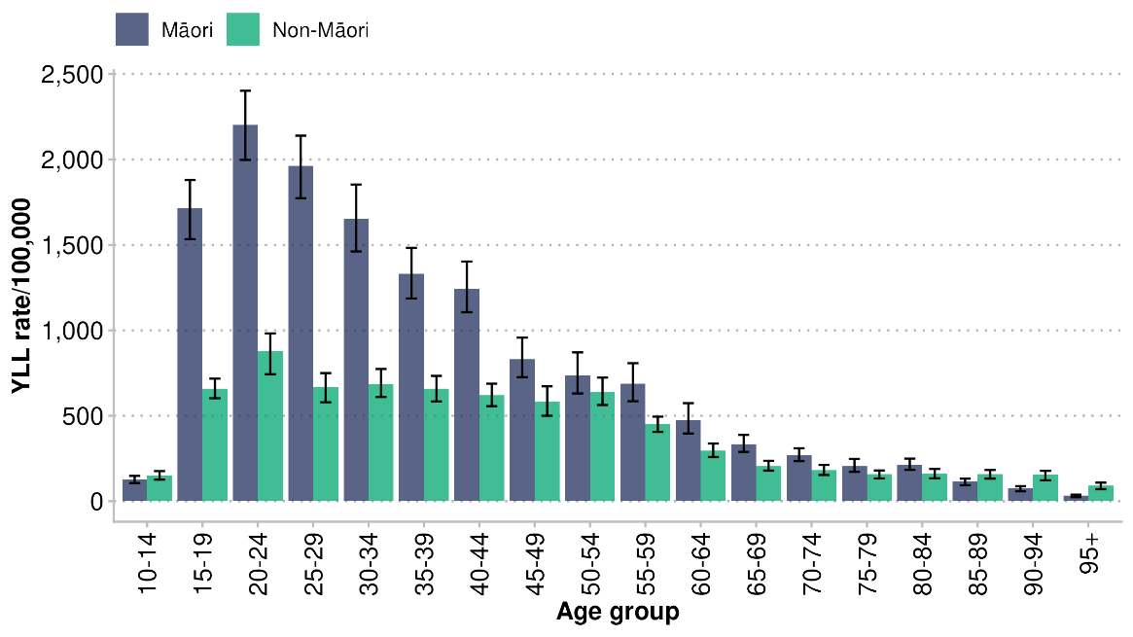
Note: the bars indicate 95% uncertainty intervals

Figure 36 shows YLL rates for self-harm by age for tāne and wāhine Māori in 2021. For wāhine Māori, there was a peak between 15 and 24 years. Among tāne Māori, those aged between 20 and 34 years were most affected. The fatal burden from self-harm was greater among tāne Māori than among wāhine Māori.

Figure 36: Self-harm: tāne and wāhine Māori years of life lost rates by age group, 2021
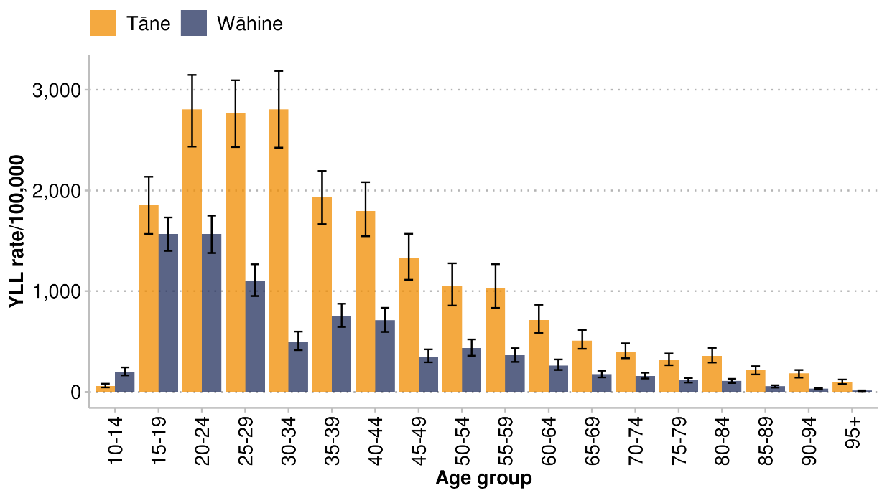
Note: the bars indicate 95% uncertainty intervals

Chronic obstructive pulmonary disease
Chronic obstructive pulmonary disease is a progressive lung disease causing reduced airflow and difficulty breathing. Parts of the lung can become damaged or blocked by phlegm, or the airways can become inflamed (WHO 2024). Overall, rates of COPD reduced between 1996 and 2021 (see Figure 37), but COPD was still the third leading cause of early death for wāhine Māori (7%) and the sixth leading cause for tāne Māori in 2021, contributing 3% of early deaths.

Rates of YLL reduced for both Māori and non-Māori during this time (see Figure 37). However, a persistent equity gap remained: Māori experienced nearly three times the rate of YLL from COPD than non-Māori did (the age-standardised rates were 841 YLL per 100,000 for Māori, compared to 309 YLL per 100,000 for non-Māori in 2021; see Figure 38).

Figure 37: Chronic obstructive pulmonary disease: Māori and non-Māori age-standardised years of life lost rates, 1996–2021
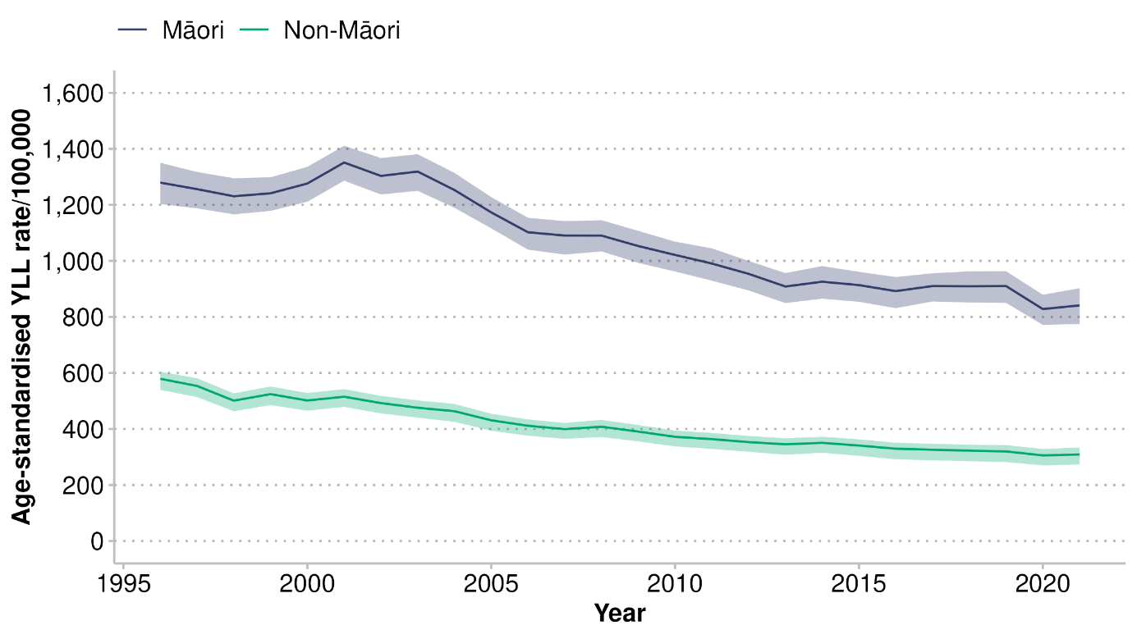
Note: the shaded areas indicate 95% uncertainty intervals

Figure 38: Chronic obstructive pulmonary disease: Māori/non-Māori age-standardised years of life lost rate ratios, 1996–2021
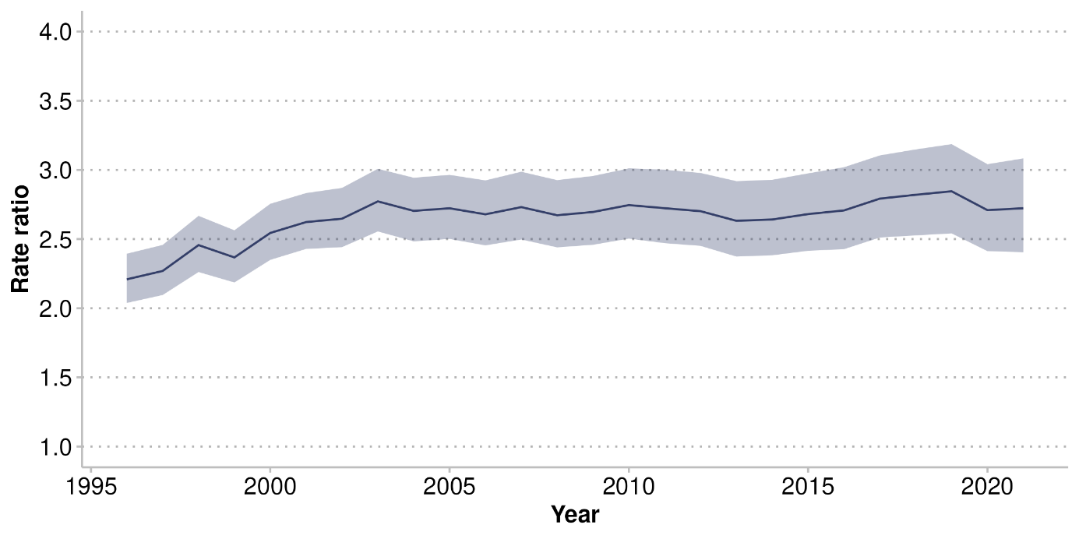
Note: the shaded area indicates 95% uncertainty interval

Figure 39 shows the trend in age standardised YLL rates for COPD in tāne and wāhine Māori from 1996 to 2021. These rates increased between 1998 and 2001 for both tāne and wāhine Māori. Thereafter, a declining trend was observed among tāne Māori. The trend declined overall among wāhine Māori, but plateaued from around 2013 onwards.

Figure 39: Chronic obstructive pulmonary disease: tāne and wāhine Māori age-standardised years of life lost rates, 1996–2021
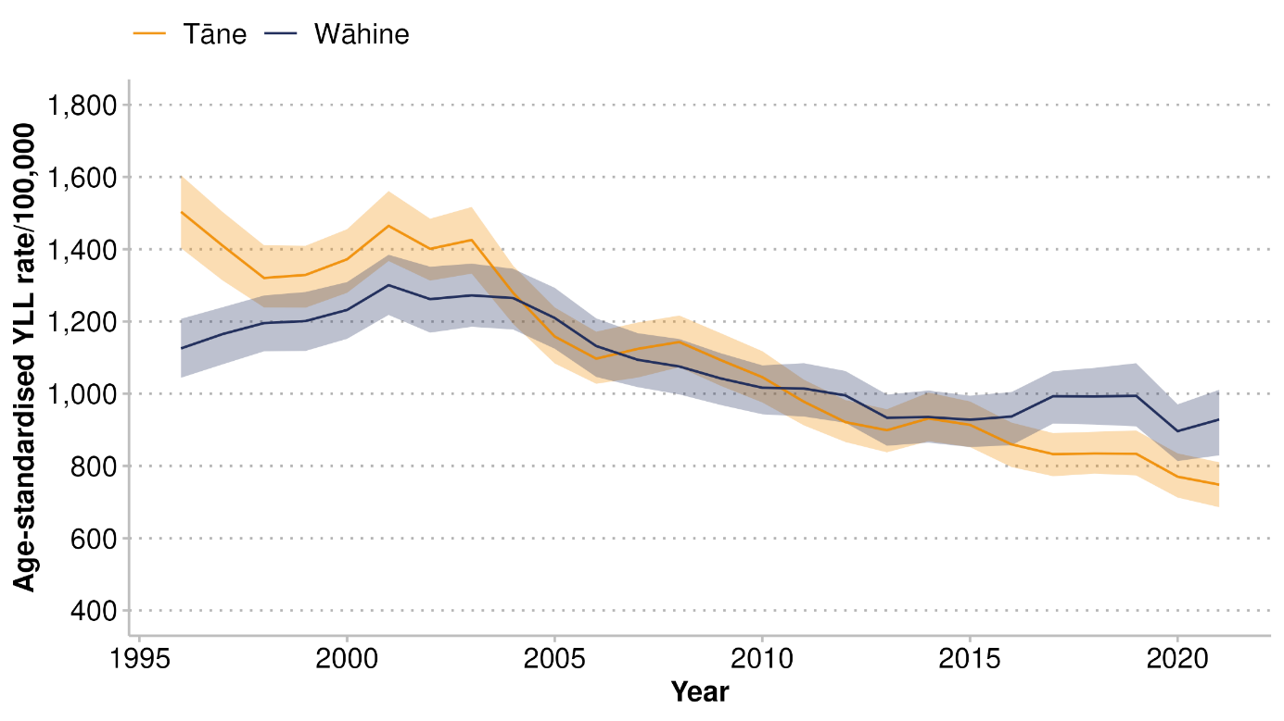
Note: the shaded areas indicate 95% uncertainty intervals

Figure 40 shows the trends in YLL rates for COPD for Māori and non-Māori by age group in 2021. There was a gap between Māori and non-Māori rates in most age groups; rates were more than double for Māori for those aged 50–84 years.
Figure 40: Chronic obstructive pulmonary disease: Māori and non-Māori years of life lost rates by age group, 2021
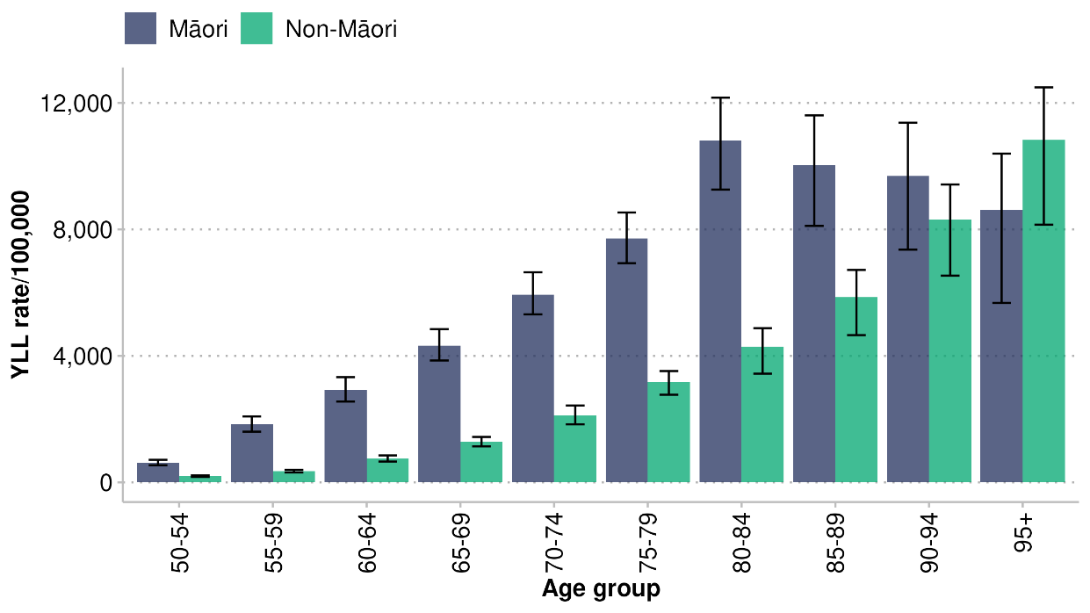
Note: the bars indicate 95% uncertainty intervals

The YLL rates for Māori with COPD varied little by gender, except in the 95+ year age group, where tāne had higher rates (see Figure 41).

Figure 41: Chronic obstructive pulmonary disease: tāne and wāhine Māori years of life lost rates by age group, 2021
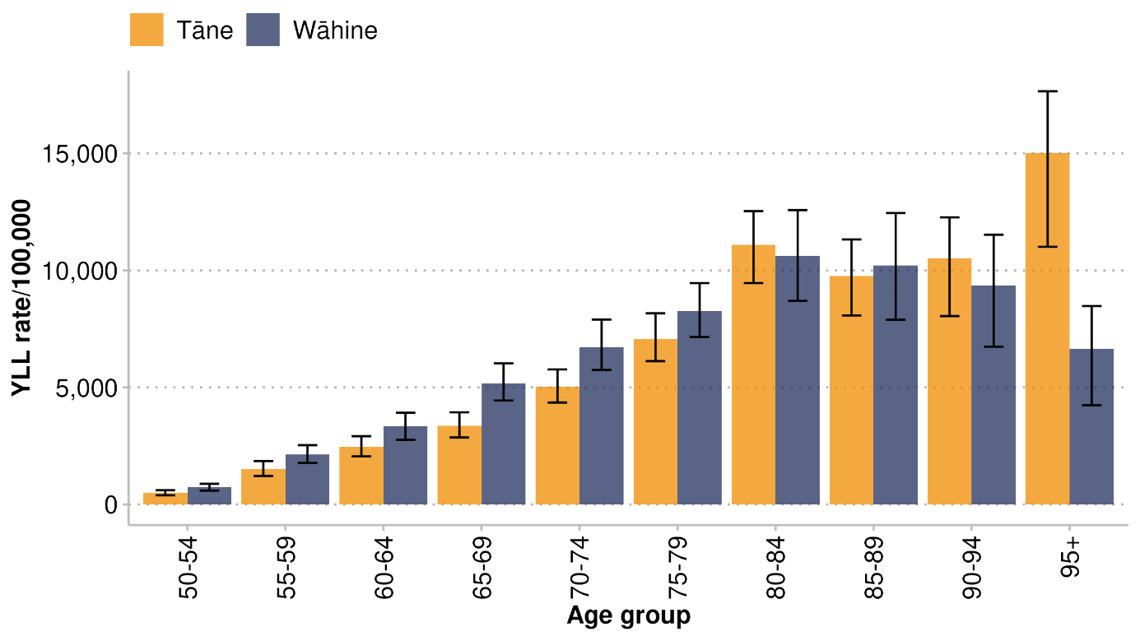
Note: the bars indicate 95% uncertainty intervals

Chronic kidney disease
Chronic kidney disease, also called chronic kidney failure, is a condition in which the kidneys are not working properly and are unlikely to get better; the disease affects how the kidneys filter blood, and results in a gradual loss of kidney function (Health New Zealand 2024). Having CKD is a risk factor for developing high blood pressure and cardiovascular disease.

There was a significant increase in YLL due to CKD in 2000 for both tāne and wāhine Māori, and a sharp decrease in 2016. These sharp fluctuations are likely due to changes in coding practices between CKD and diabetes when the International Classification of Diseases (ICD) coding system transitioned from ICD9 to ICD10 in 1999 and when mortality coding rules based on the ICD Australian Modification (ICD10-AM) changed to WHO mortality coding standards in 2016 (Health New Zealand 2025a).

The YLL rates for non-Māori with CKD did not change much between 1996 and 2021, but the rates for Māori increased by 17% over that time (see Figure 42).

Figure 42: Chronic kidney disease: Māori and non-Māori age-standardised years of life lost rates, 1996–2021
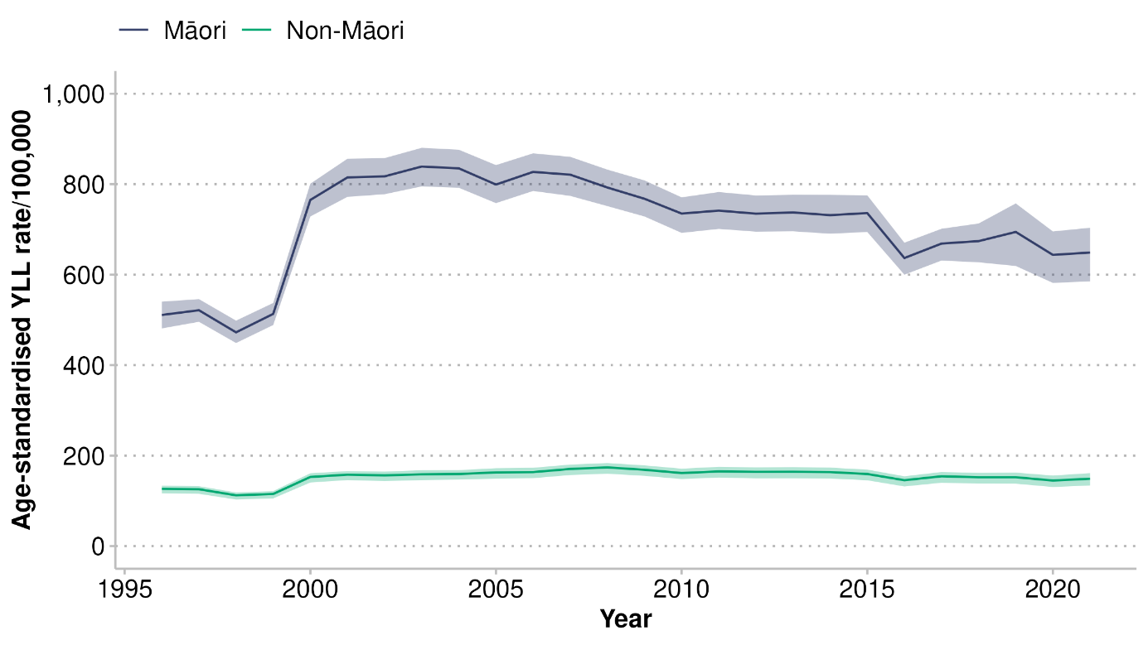
Note: the shaded areas indicate 95% uncertainty intervals

The rate ratio for Māori with CKD was consistently at least four times that of non-Māori in the years to 2021 (see Figure 43), peaking between 2000 and 2006. There was a gradual decline after that peak, between 2006 and 2021.
Figure 43: Chronic kidney disease: Māori/non-Māori age-standardised years of life lost rate ratios, 1996–2021
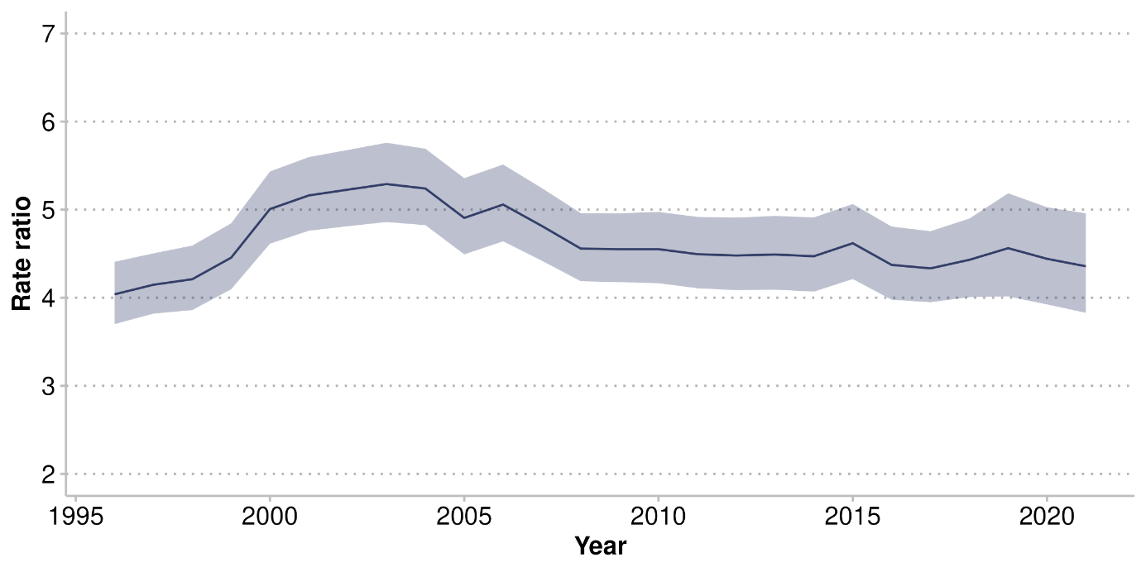
Note: the shaded area indicates 95% uncertainty interval

Figure 44 shows YLL rates for CKD by age group for Māori and non-Māori in 2021. Rates were consistently higher among Māori compared to non-Māori.

Figure 44: Chronic kidney disease: Māori and non-Māori years of life lost rates by age group, 2021
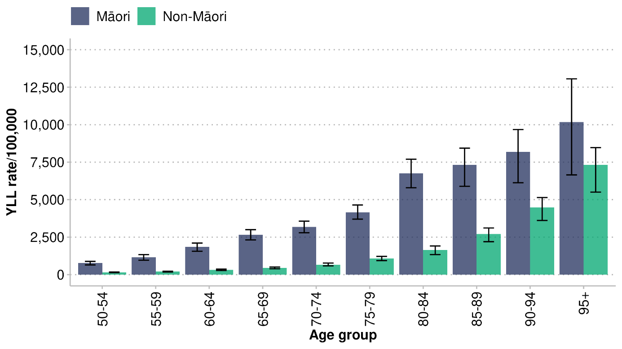
Note: the bars indicate 95% uncertainty intervals

Tāne Māori consistently experienced higher age-standardised rates of YLL from CKD than wāhine Māori between 1996 and 2021, but that disparity decreased over the last few years before 2021 (see Figure 45).
Figure 45: Chronic kidney disease: tāne and wāhine Māori age-standardised years of life lost rates, 1996–2021
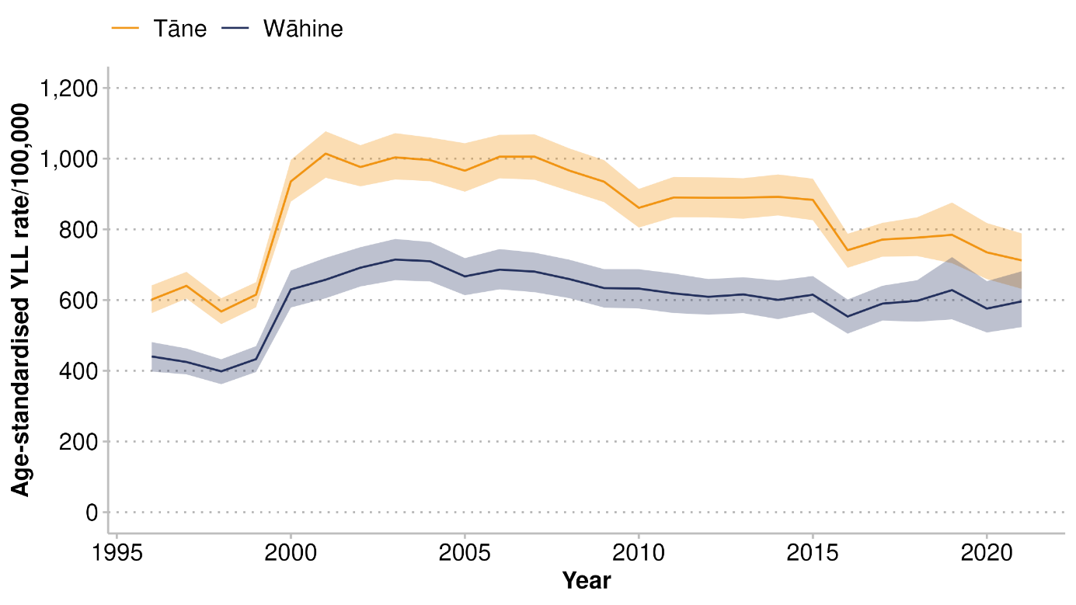
Note: the shaded areas indicate 95% uncertainty intervals

Figure 46 shows YLL rates for CKD by age for tāne and wāhine Māori in 2021. Rates of CKD increase with age for both tāne and wāhine Māori. Tāne have higher YLL rates, particularly in the older age groups, however the uncertainty intervals demonstrate that this is not statistically significant.

Figure 46: Chronic kidney disease: tāne and wāhine Māori years of life lost rates by age group, 2021
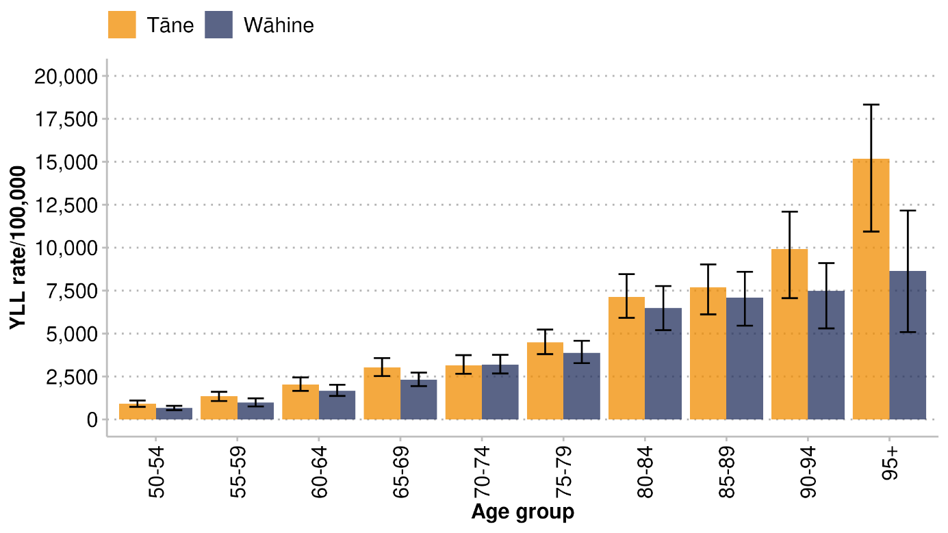
Note: the bars indicate 95% uncertainty intervals

Stroke
A stroke is sudden loss of brain function due to interruption of blood flow or when a blood vessel bursts and damages brain cells. Stroke is caused by either a blockage (usually a blood clot) that restricts the flow of blood to part of the brain, or when a blood vessel bursts and damages brain cells (Stroke Foundation of New Zealand 2025). In 2021, stroke was the sixth leading cause for premature death among wāhine Māori and the ninth for tāne Māori. For all Māori, it accounted for 4% of total YLL.

Figure 47 compares age-standardised YLL rates for stroke for Māori and non-Māori between 1996 and 2021. During this time, there was a declining trend in premature death due to stroke, particularly among Māori. However, this downward trend slowed down over the decade to 2021, and the equity gap persisted. Māori consistently had YLL rates for stroke that were over 1.5 times greater than the rates for non-Māori (see Figure 48).

Figure 47: Stroke: Māori and non-Māori age-standardised years of life lost rates, 1996–2021
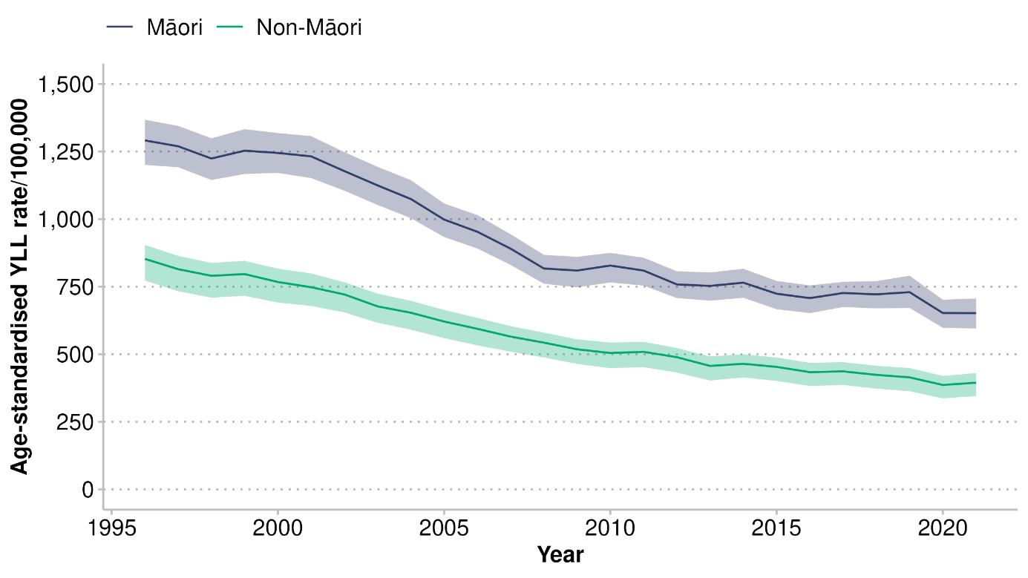
Note: the shaded areas indicate 95% uncertainty intervals
Figure 48: Stroke: Māori/non-Māori age-standardised years of life lost rate ratios, 1996–2021
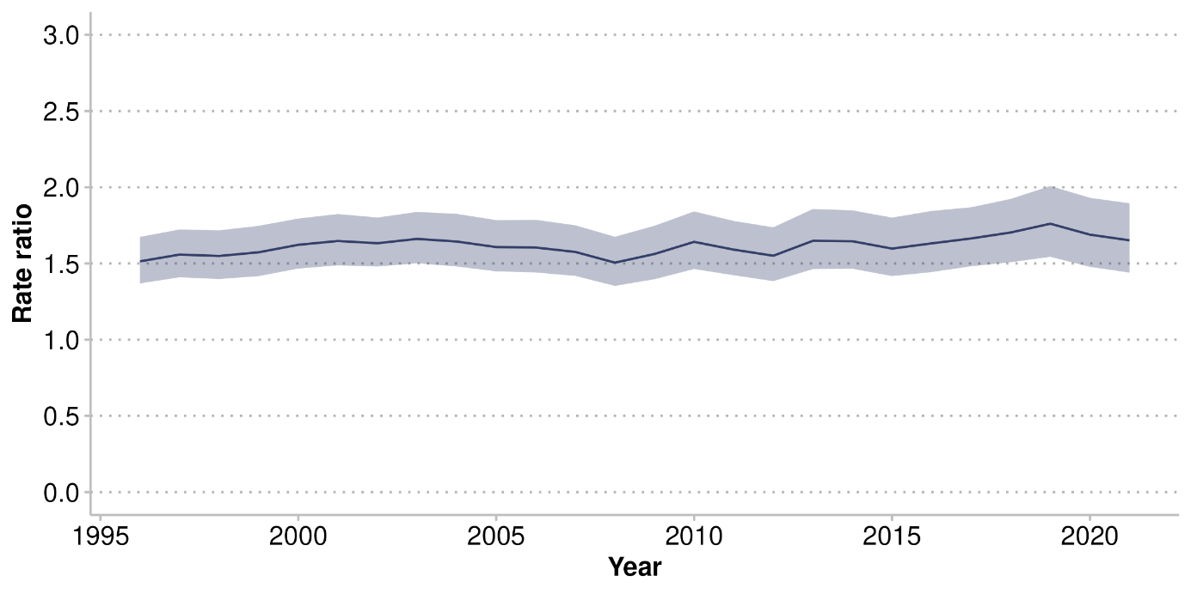
Note: the shaded area indicates 95% uncertainty interval

Figure 49 shows YLL rates for stroke by age group for Māori and non-Māori in 2021. Māori had higher rates of premature death due to stroke than non-Māori for every age group under 90.

Figure 49: Stroke: Māori and non-Māori years of life lost rates by age group, 2021
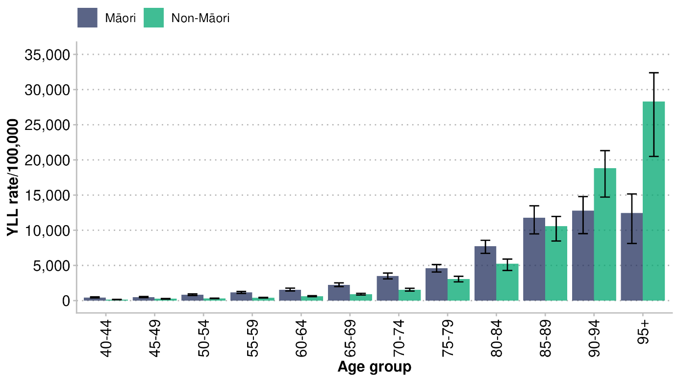
Note: the bars indicate 95% uncertainty intervals

There has been little difference in age-standardised YLL rates for stroke between tāne Māori and wāhine Māori over the past two decades (see Figure 50).

Figure 50: Stroke: tāne and wāhine Māori age-standardised years of life lost rates, 1996–2021
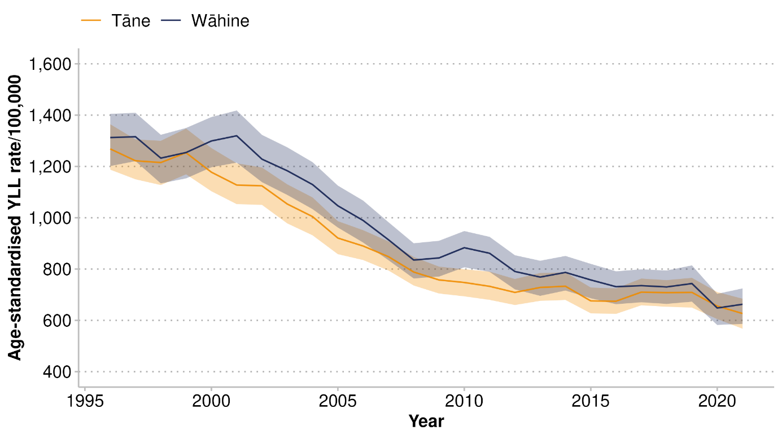
Note: the shaded areas indicate 95% uncertainty intervals

Figure 51 shows age-specific YLL rates for stroke for tāne and wāhine Māori in 2021. Rates were slightly higher for tāne Māori in the younger age groups to 74 years. After that age, rates were higher for wāhine Māori. Overall, Māori aged 80 years and over experienced stroke at the highest rates.

Figure 51: Stroke: tāne and wāhine Māori years of life lost rates by age group, 2021
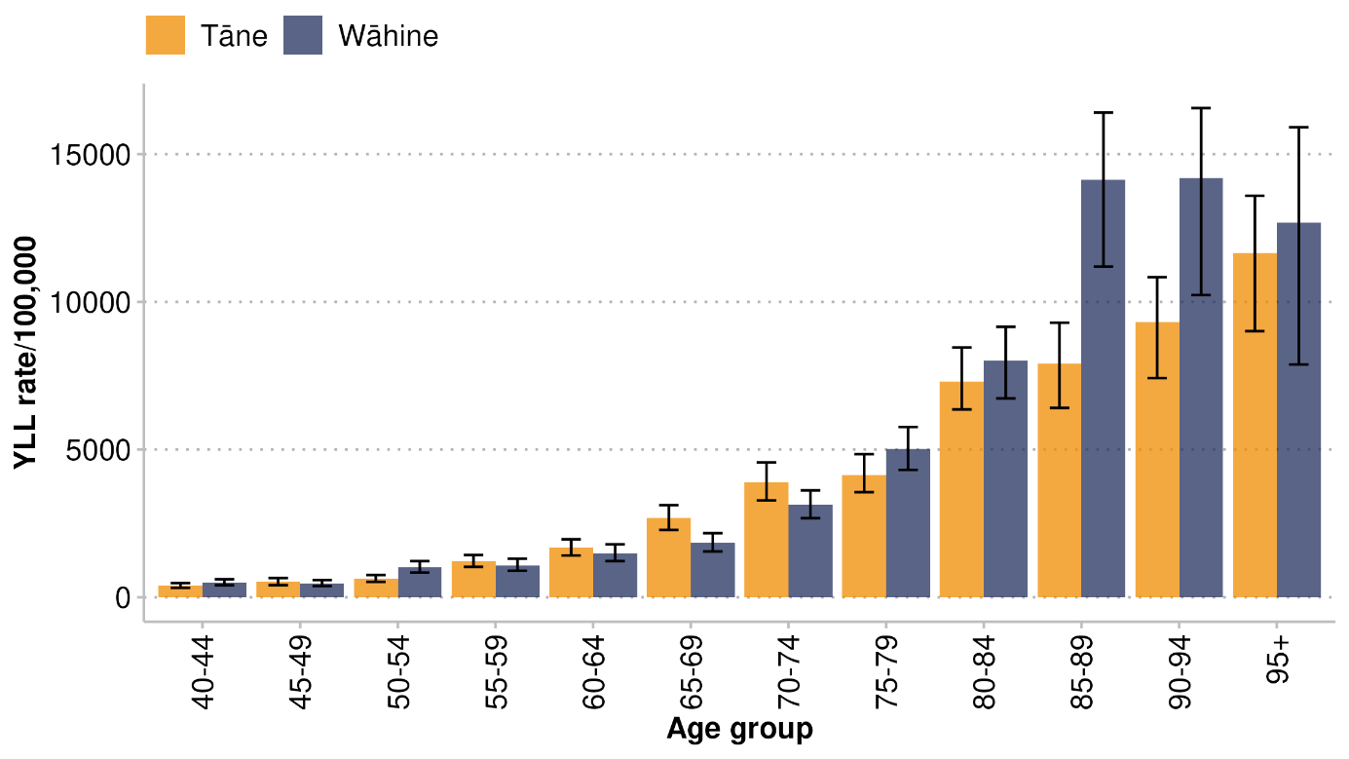
Note: the bars indicate 95% uncertainty intervals

Diabetes
Diabetes is a chronic disease in which the body is not able to produce enough insulin, or to use the insulin it produces, causing high levels of glucose in the blood (hyperglycaemia). Over time, hyperglycaemia can cause damage to the body and failure of various organs and tissues (Heart Foundation 2025). Diabetes was the seventh leading cause of early death for tāne Māori and the ninth leading cause for wāhine Māori in 2021.

Figure 52 shows age-standardised YLL rates for diabetes for Māori and non-Māori between 1996 and 2021. The Māori rates declined steadily after 1996 and levelled out from 2012 to 2021. In 2021, an equity gap remained; Māori rates were five times higher than those for non-Māori (see Figure 53).

Figure 52: Diabetes: Māori and non-Māori age-standardised years of life lost rates, 1996–2021
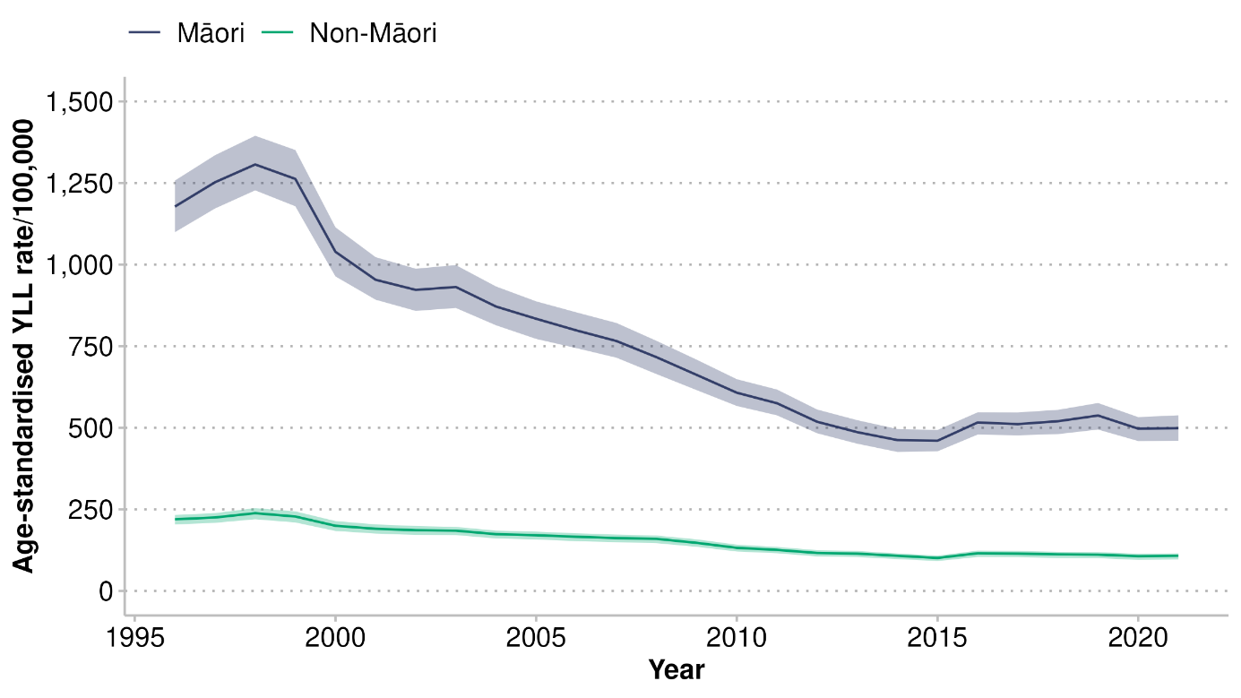
Note: the shaded areas indicate 95% uncertainty intervals
Figure 53: Diabetes: Māori/non-Māori age-standardised years of life lost rate ratios, 1996–2021
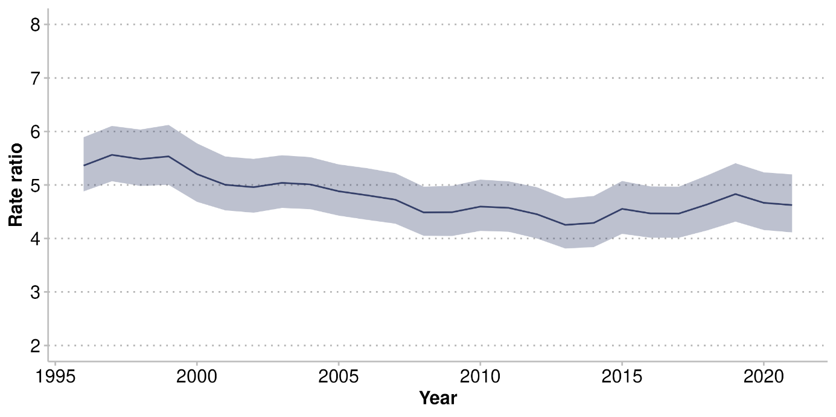
Note: the shaded area indicates 95% uncertainty interval

Figure 54 shows the trend in age-standardised YLL rates for diabetes for tāne and wāhine Māori from 1996 to 2021. The rates declined steadily between 1998 and 2015 among both tāne and wāhine Māori. In 2016 there was a sharp increase in diabetes rates, especially among tāne Māori. Thereafter, rates remained stable, at around 600 per 100,000 for tāne Māori and 400 per 100,000 for wāhine Māori. Tāne Māori consistently have higher rates of premature death from diabetes compared to wāhine Māori.

Figure 54: Diabetes: tāne and wāhine Māori age-standardised years of life lost rates, 1996–2021
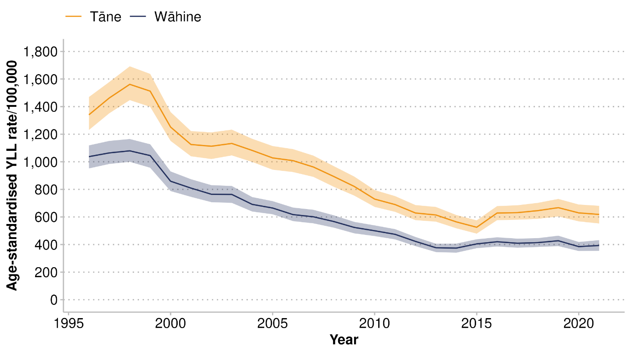
Note: the shaded areas indicate 95% uncertainty intervals

Figure 55 shows the YLL rates for diabetes by age group for Māori and non-Māori in 2021. Māori had higher rates of premature death due to diabetes than non-Māori for every age group. Māori in the 80–84-year age group had the highest YLL rate.

Figure 55: Diabetes: Māori and non-Māori years of life lost rates by age group, 2021
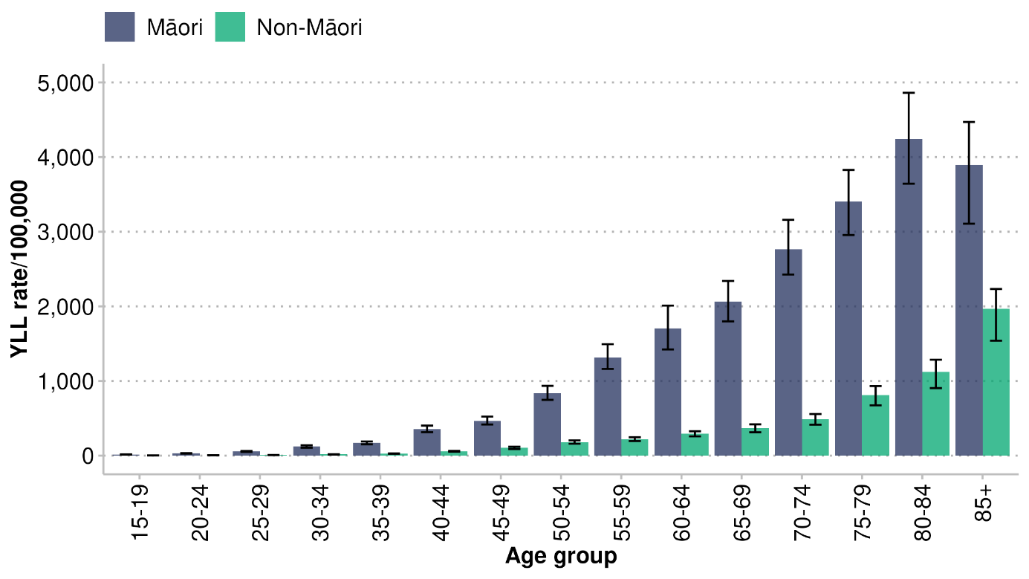
Note: the bars indicate 95% uncertainty intervals

In 2021, YLL rates for diabetes differed by gender. Tāne Māori experienced a higher burden of premature death than wāhine Māori (see Figure 56). Rates for both tāne and wāhine gradually increased with age, with tāne diabetes rates beginning at an earlier age and demonstrating a steeper increase.

Figure 56: Diabetes: tāne and wāhine Māori years of life lost age-standardised rates by gender and age group, 2021
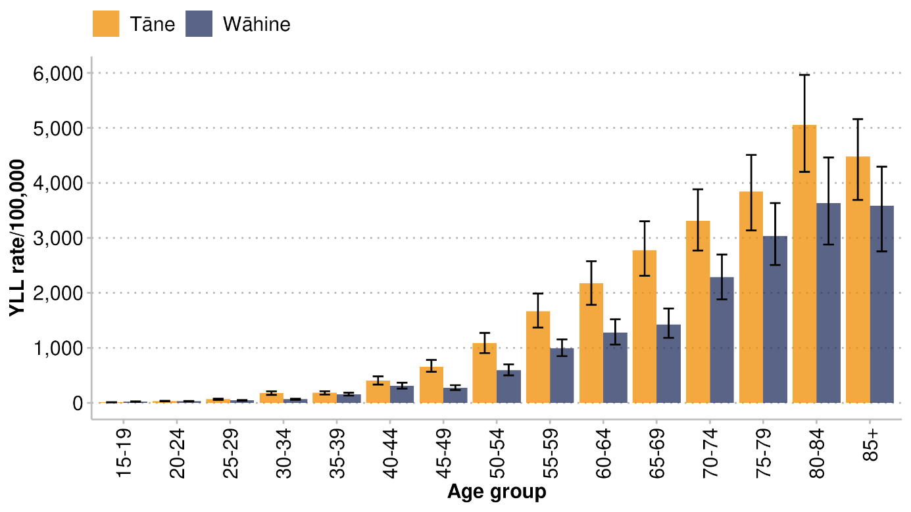
Note: the bars indicate 95% uncertainty intervals

Discussion of main findings – He matapaki i ngā kitenga matua
Over the past 25 years, age-standardised rates of YLL have reduced for both Māori and non-Māori. Despite this, Māori consistently experience a rate nearly twice as high as that of non-Māori. The GBD estimates that a total of 123,685 years of Māori life were lost prematurely in 2021. Non-communicable diseases contributed the most to these early deaths for Māori (78%), followed by injuries (17%) such as self-harm. Over 50% of premature death for Māori was caused by cancers (29%) and cardiovascular diseases (22%).

Broken down into specific conditions, the leading causes of YLL for Māori were IHD, lung cancer, self-harm and COPD. Across the lifespan, the leading cause of premature death changed. Among tamariki aged under five years, neonatal conditions were the leading causes. Self-harm was the leading cause for rangatahi aged 15–24 years and pakeke aged 25–44 years. For pakeke aged 45–64 and kaumātua aged 65+ years, it was long-term conditions, including IHD, lung cancer and COPD.

Cancer
Cancers made up 29% of YLL for Māori. Lung cancer was the leading cancer contributor, accounting for about a third of YLL among all cancer types. Lung cancer was the leading cause for premature death for wāhine Māori and the third leading cause for tāne Māori. In addition to lung cancer, the cancer types showing the greatest equity gaps were liver and cervical cancers, with YLL age-standardised rates three times higher for Māori than for non-Māori.

The inequities between Māori and non-Māori in cancer outcomes are well known and enduring. Wāhine Māori are 3.8 times as likely to die from lung cancer, 2.2 times as likely to die from cervical cancer and 1.5 times as likely to die from breast cancer as non-Māori women (Health New Zealand 2025b). Tāne Māori are 2.8 times as likely to die from liver cancer and 2.3 times as likely to die from lung cancer as non-Māori men (Health New Zealand 2025b). Not only do Māori have higher rates of YLLs for cancer; they also die at younger ages.

Cardiovascular diseases
Cardiovascular diseases make up 22% of all YLL for Māori. The biggest contributor is IHD (12%), which makes up just over half of cardiovascular disease YLL for Māori. The second biggest contributor is stroke (4%), which is the fourth leading cause of premature death for kaumātua Māori aged 65 and over years. Ischaemic heart disease is the leading cause of premature death for tāne Māori (15%) and the second leading cause for wāhine Māori (8%). In contrast, wāhine Māori are more affected by stroke (5%) than tāne Māori (3%). We know that Māori have higher death rates from cardiovascular diseases: Māori are 1.8 times as likely to die from IHD as non-Māori. This trend in the context of IHD and stroke is present across all age groups up to the age of 85, which contributes to lower life expectancy for Māori.

Self-harm
In this report, we refer to self-harm as a cause of death. Self-harm is the third overall contributor to YLL for Māori, and the leading cause of YLL for rangatahi Māori and pakeke Māori aged 25–44 years. Māori have experienced enduring health inequity relating to self-harm and suicide. Rangatahi Māori experienced a 1.3 times higher rate of self-harm-related hospitalisations and a 1.7 higher rate of suicide in 2021 compared to non-Māori (Hauora Māori Advisory Committee 2025). The data in this report adds to the existing evidence by showing that Māori experience a greater burden of YLL from self-harm compared to non-Māori and that self-harm is a major contributor to Māori dying younger.

Chronic obstructive pulmonary disease
Māori are twice as likely to have COPD compared to European/Other populations and Pacific peoples and more likely to be diagnosed at an earlier age than non-Māori (Health Quality & Safety Commission 2024). Māori with COPD are more likely to be hospitalised because of their COPD, more likely to have a repeat hospitalisation for COPD in the same year and more likely to be diagnosed at an earlier age (Health Quality & Safety Commission 2024). These inequities mean that Māori are more likely to die from COPD at younger ages. The GBD 2021 study shows that COPD is the fifth leading cause of premature death for Māori, who have 2.7 times the non-Māori rate of YLL.

Diabetes and chronic kidney disease
Māori have lower prevalence rates of diabetes compared to Pacific and Indian populations. However, they have twice the rate of diabetes compared to the European/Other population (Health New Zealand 2025c). Despite having lower prevalence rates compared to Pacific and Indian peoples, Māori experience a 3.6 times higher rate of deaths from diabetes than non-Māori (Health New Zealand 2025b).

People with diabetes are more likely to develop CKD. Māori also experience a higher rate of diabetes complications, including hospitalisations due to kidney failure and lower-limb amputations. Māori with diabetes are 3.1 times as likely to be hospitalised for kidney failure and 2.4 times as likely to be hospitalised for a limb amputation compared as non-Māori, non-Pacific peoples (Ministry of Health 2024b).

Higher rates of diabetes-related deaths and diabetes-related complications for Māori contribute to higher rates of YLL due to diabetes and CKD among Māori. This report contributes further evidence of these known inequities.

Implications of these findings
This GBD release is the first time that the international GBD framework has been applied to Māori, and to any indigenous population worldwide. Consideration of the wider determinants of health relevant to Māori in New Zealand is necessary when interpreting and using the information provided in this report. This includes social, economic and cultural contexts; experiences of discrimination; and the ongoing impacts of colonisation. Despite limitations in the use of the GBD methodology for an indigenous population, this report provides useful information on some of the areas we must address for Māori to achieve health equity.

This report highlights areas of health inequity for Māori. Based on the findings in this report, the biggest contributors to premature death for Māori are:
- cancers (particularly lung cancer)
- cardiovascular diseases (including ischaemic heart disease and stroke)
- self-harm
- diabetes and chronic kidney disease.

Whilst this report focuses on how to use and interpret YLL estimates for Māori, attention should also be given to insights related to morbidity (YLD) and total health loss (DALY), ensuring a more complete perspective of health loss is explored. Estimates of morbidity and total health loss are available as part of the full set of GBD 2021 estimates for Māori. Insights from this report add to existing literature about major causes of premature death and inequities in health outcomes for Māori. These insights may be used alongside information on morbidity and service utilisation (ie prevention) as supporting evidence for targeted policies and effective health interventions for Māori, acknowledging the limitations and assumptions built into the analysis and interpretation of the GBD estimates. Addressing the areas of health inequity identified in this report has the potential to make a meaningful contribution to Māori health outcomes and achieve progress towards pae ora (healthy futures) for Māori.

Appendix 1 – Tāpiritanga 1
Table S1: Risk factors included in the Global Burden of Disease study at levels 2 and 3
Environmental / occupational risks | Modifiable behavioural* risks | Metabolic risks
Unsafe water, sanitation and handwashing  - Unsafe water source, unsafe sanitation, no access to handwashing facility | Child and maternal malnutrition  - Suboptimal breastfeeding, child growth failure, low birth weight and short gestation, iron deficiency, vitamin A deficiency, zinc deficiency | High fasting plasma glucose
Air pollution  - Particulate matter pollution, ambient ozone pollution, nitrogen dioxide pollution | Tobacco  - Smoking, chewing tobacco, second-hand smoke | High LDL cholesterol
Non-optimal temperature  - High temperature, low temperature | High alcohol use | High systolic blood pressure
Other environmental risks  - Residential radon, lead exposure | Drug use | High body-mass index
Occupational risks  - Occupational carcinogens | Dietary risks  - Diet low in fruits, vegetables, legumes, whole grains, nuts and seeds, milk, fibre, calcium, seafood omega-3 fatty acids, omega-6 polyunsaturated fatty acids  - Diet high in red meat, processed meat, sugar-sweetened beverages, trans fatty acids, sodium | Low bone mineral density
 | Intimate partner violence | Kidney dysfunction
 | Childhood sexual abuse and bullying
 | Unsafe sex
 | Low physical activity
Source: Supplement to Brauer et al, 2024.
* GBD methodology uses the term ‘behavioural risks’ to describe the risk factors under modifiable behaviour risk factors.

Appendix 2 – Tāpiritanga 2
Table S2: Differences between the Stats NZ Māori population and the IHME Māori population
Age | Stats NZ Māori Population  (Infoshare 16 November 2023) |  |  | IHME Māori Population  (IHME October 2023) |  |  | Percentage difference
 | 2010 | 2015 | 2020 | 2010 | 2015 | 2020 | % | % | %
0–4 | 89,700 | 85,820 | 85,100 | 81,493 | 79,729 | 87,002 | -9% | -7% | 2%
5–9 | 74,840 | 87,830 | 87,940 | 72,521 | 83,893 | 90,595 | -3% | -4% | 3%
10–14 | 72,840 | 76,210 | 89,070 | 70,705 | 74,119 | 90,070 | -3% | -3% | 1%
15–19 | 71,400 | 72,510 | 78,160 | 68,565 | 69,676 | 79,210 | -4% | -4% | 1%
20–24 | 61,560 | 68,790 | 71,770 | 58,480 | 63,014 | 73,843 | -5% | -8% | 3%
25–29 | 46,200 | 57,080 | 67,980 | 45,162 | 54,153 | 69,846 | -2% | -5% | 3%
30–34 | 44,020 | 45,690 | 58,280 | 42,066 | 44,227 | 59,092 | -4% | -3% | 1%
35–39 | 45,880 | 43,920 | 47,220 | 44,067 | 42,614 | 47,833 | -4% | -3% | 1%
40–44 | 43,270 | 46,610 | 45,250 | 41,594 | 45,470 | 45,938 | -4% | -2% | 2%
45–49 | 41,240 | 43,940 | 47,980 | 41,039 | 43,451 | 48,904 | 0% | -1% | 2%
50–54 | 33,390 | 41,500 | 45,050 | 33,466 | 41,885 | 45,306 | 0% | 1% | 1%
55–59 | 24,970 | 32,970 | 42,060 | 25,314 | 33,569 | 42,410 | 1% | 2% | 1%
60–64 | 18,660 | 24,360 | 32,780 | 18,659 | 24,623 | 32,648 | 0% | 1% | 0%
65–69 | 12,720 | 17,470 | 23,220 | 12,758 | 17,462 | 23,307 | 0% | 0% | 0%
70–74 | 9,210 | 11,170 | 15,510 | 9,090 | 11,146 | 15,433 | -1% | 0% | 0%
75–79 | 5,370 | 7,320 | 9,110 | 5,362 | 7,302 | 9,132 | 0% | 0% | 0%
80–84 | 2,790 | 3,770 | 5,210 | 2,731 | 3,761 | 5,174 | -2% | 0% | -1%
85–89 | 1,020 | 1,570 | 2,230 | 984 | 1543 | 2,264 | -4% | -2% | 2%
90 plus | 390 | 590 | 950 | 335 | 516 | 906 | -14% | -12% | -5%

Figure S1: IHME estimated New Zealand population for Māori and non-Māori, 2020
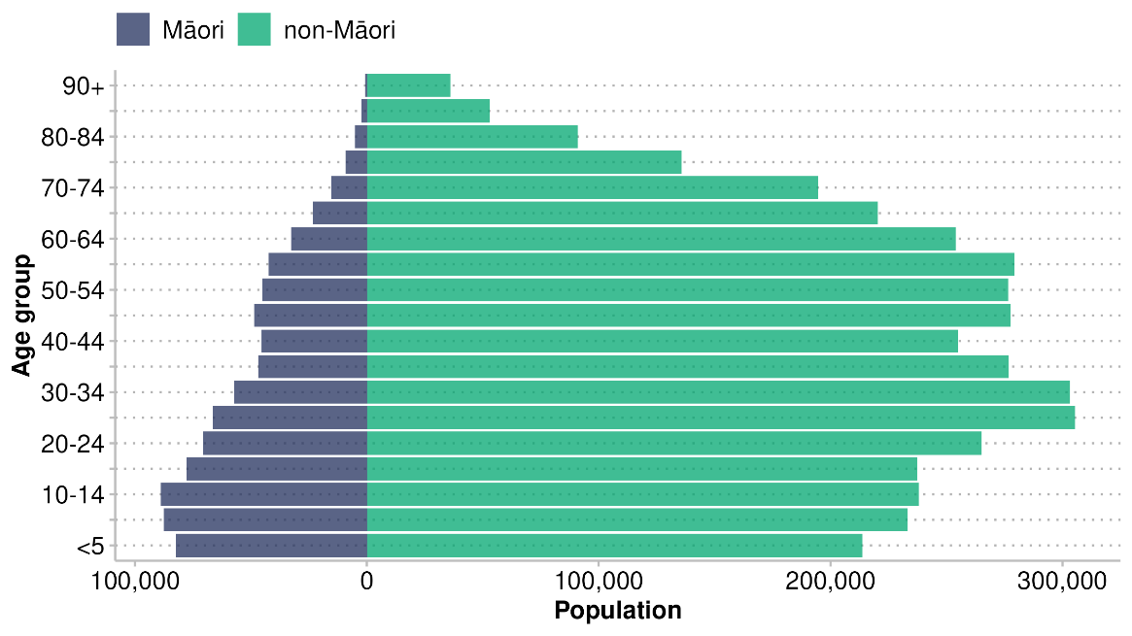

References – Ngā tohutoro
Ajwani S, Blakely T, Robson B, et al. 2003. Unlocking the numerator-denominator bias III: adjustment ratios by ethnicity for 1981–1999 mortality data. The New Zealand Census-Mortality Study. The New Zealand Medical Journal (Online) 116(1175): U456.
Bergeron DA, Tremblay MC, Dogba MJ, et al. 2021. The use of realist approaches for health research in Indigenous communities. AlterNative 17(1): 106–10.
Brauer M, Roth GA, Aravkin AK, et al. 2024. Global burden and strength of evidence for 88 risk factors in 204 countries and 811 subnational locations, 1990–2021: a systematic analysis for the Global Burden of Disease Study 2021. Lancet 403: 2162–203.
Curtis E. 2016. Indigenous positioning in health research: The importance of Kaupapa Māori theory-informed practice. AlterNative 12(4): 396–410.
Curtis E, Jones R, Willing E, et al. 2023. Indigenous adaptation of a model for understanding the determinants of ethnic health inequities. Discover Social Science and Health 3(10): 10.
Dixon R, Batts T, Diener H. 2024. Reviewing the quality of ethnicity data from administrative sources: Comparison with the census. URL: stats.govt.nz/research/reviewing-the-quality-of-ethnicity-data-from-administrative-sources-comparison-with-the-census (accessed 11 November 2025).
Global Health Metrics. 2020. Communicable, maternal, neonatal, and nutritional diseases—Level 1 cause. The Lancet 396: S2–S3.
Hauora Māori Advisory Committee. 2025. Rangatahi experience stronger mental health resilience. URL: health.govt.nz/system/files/2025-07/priority-4-key-insights–june-2025.pdf (accessed 11 November 2025).
Health New Zealand. 2017. HISO 10001:2017 Ethnicity Data Protocols. Wellington, New Zealand: Ministry of Health.
Health New Zealand. 2024. Chronic kidney disease. URL: info.health.nz/conditions-treatments/bladder-kidney-and-urinary-system/chronic-kidney-disease (accessed 11 November 2025).
Health New Zealand. 2025a. “About Classification.” Data and Statistics – NZ Health Statistics. Accessed December 1, 2025. URL: tewhatuora.govt.nz/for-health-professionals/data-and-statistics/nz-health-statistics/classification/about
Health New Zealand. 2025b. Mortality web tool. URL: tewhatuora.shinyapps.io/mortality-web-tool (accessed 11 November 2025).
Health New Zealand. 2025c. Virtual Diabetes Register web tool. URL: tewhatuora.shinyapps.io/virtual-diabetes-register-web-tool (accessed 12 November 2025).
Health Quality & Safety Commission. 2024. Chronic Obstructive Pulmonary Disease in people aged 45 and over. URL: hqsc.govt.nz/our-data/atlas-of-healthcare-variation/chronic-obstructive-pulmonary-disease (accessed 12 November 2025).
Heart Foundation. 2024. Coronary artery disease. URL: heartfoundation.org.nz/your-heart/heart-conditions/coronary-artery-disease (accessed 12 November 2025).
Heart Foundation. 2025. Managing diabetes. URL: heartfoundation.org.nz/wellbeing/managing-risk/managing-diabetes (accessed 12 November 2025).
IHME. 2025. GBD History. URL: healthdata.org/research-analysis/about-gbd (accessed 12 November 2025).
Kukutai T, Campbell-Kamariera K, Mead A, et al. 2023. Māori Data Governance Model. URL: kahuiraraunga.io/maoridatagovernance (accessed 12 November 2025).
Ministry of Health. 2018. Position Paper on Māori Health Analytics – Age standardisation. URL: health.govt.nz/system/files/2018-11/position-paper-maori-health-analytics-age-standardisation-nov18_0.pdf (accessed 11 November 2025).
Ministry of Health. 2020. Longer, Healthier Lives: New Zealand’s Health 1990–2017. Wellington: Ministry of Health.
Ministry of Health. 2024a. Tatau Kahukura: Māori Health Chart Book 2024 (4th edition). Wellington: Ministry of Health.
Ministry of Health. 2024b. Whakamaua: 2020–2025. URL: minhealthnz.shinyapps.io/WhakamauaDashboard (accessed 12 November 2025).
Ministry of Health. 2025. Global Burden of Disease Māori Estimates Estimates. URL: health.govt.nz/statistics-research/research/global-burden-of-disease-study/maori-years-of-life-lost-estimates (accessed 12 December 2025).
Naghavi M, Ong KL, Aali A, et al. 2024. Global burden of 288 causes of death and life expectancy decomposition in 204 countries and territories and 811 subnational locations, 1990–2021: a systematic analysis for the Global Burden of Disease Study 2021. The Lancet 403(10440): 2100–32.
Schlotheuber A, Hosseinpoor AR. 2022. Summary measures of health inequality: A review of existing measures and their application. International Journal of Environmental Research and Public Health 19(6): 3697.
Schumacher AE, Kyu HH, Aali A, et al. 2024. Global age-sex-specific mortality, life expectancy, and population estimates in 204 countries and territories and 811 subnational locations, 1950–2021, and the impact of the COVID-19 pandemic: a comprehensive demographic analysis for the Global Burden of Disease Study 2021. The Lancet 403(10440): 1989–2056.
Sheridan N, Jansen RM, Harwood M, et al. 2024. Hauora Māori – Māori health: a right to equal outcomes in primary care. International Journal for Equity in Health 23(1): 42.
Simmonds S, Robson B, Cram F, et al. 2015. Kaupapa Māori epidemiology. In L Pihama, S-J Tiakiwai, K Southey (ed), Kaupapa Rangahau: A Reader: A collection of readings from the Kaupapa Rangahau Workshop Series (pp. 125–30). Hamilton: Te Kotahi Research Institute.
Stats NZ. 2022. National ethnic population projections: 2018(base)–2043 (update). URL: stats.govt.nz/information-releases/national-ethnic-population-projections-2018base2043-update (accessed 12 November 2025).
Stroke Foundation of New Zealand. 2025. What Is a Stroke? URL: stroke.org.nz/understanding-stroke/what-is-a-stroke (accessed 17 November 2025).
Tan L, Blakely T, Atkinson J. 2010. Ethnic counts on mortality and census data 2001–06: New Zealand census-mortality study update. New Zealand Medical Journal 123(1320): 37–44.
Wheldon MC, Raftery AE, Clark SJ, et al. 2013. Reconstructing past populations with uncertainty from fragmentary data. Journal of the American Statistical Association 108(501): 96–110.
WHO. 2024. Chronic Obstructive Pulmonary Disease (COPD). URL: who.int/news-room/fact-sheets/detail/chronic-obstructive-pulmonary-disease-(copd) (accessed 12 November 2025).

The descriptions are based on groupings from the relevant International Classification of Diseases (ICD 10th edition) codes.
Communicable, maternal, neonatal and nutritional diseases are combined into a level 1 category in the GBD study due to shared characteristics including their increased prevalence in low- to middle-income countries, their being preventable and treatable through public health interventions, and overlaps and interactions between the conditions (Global Health Metrics 2020).

