Abortion Services Aotearoa New Zealand

Ratonga Whakatahe i Aotearoa
Annual Report – Pūrongo ā-Tau
2025

Citation: Ministry of Health. 2025. Abortion Services Aotearoa New Zealand: Annual Report. Wellington: Ministry of Health.
Published in November 2025 by the Ministry of Health
PO Box 5013, Wellington 6140, New Zealand
ISBN 978-1-991324-65-8 (online)
HP 9148

This document is available at health.govt.nz
 | This work is licensed under the Creative Commons Attribution 4.0 International licence. In essence, you are free to: share ie, copy and redistribute the material in any medium or format; adapt ie, remix, transform and build upon the material. You must give appropriate credit, provide a link to the licence and indicate if changes were made.

Contents
Introduction – Kupu arataki 1
Key facts – Ngā meka matua 1
Section 1. General abortion statistics – Wāhanga 1. Ngā tatauranga whakatahe ahuwhānui 3
Section 2. Types of abortion procedures – Wāhanga 2. Ngā tukanga whakatahe 12
Section 3. Geographical access to abortion – Wāhanga 3. Te āheinga ā-matawhenua ki te whakatahe 18
Section 4. Early medical abortion access – Wāhanga 4. Te āheinga atu ki te whakatahe tōmua mō tētahi take hauora 26
Section 5. Abortion counselling – Wāhanga 5. Tohuora whakatahe 30
Section 6. Abortion and access to contraception – Wāhanga 6. Te āheinga ki te whakatahe me ngā ārai hapūtanga 31
Section 7. Complications at time of abortion – Wāhanga 7. Ngā uauatanga i pūrongotia i te wā o te whakatahe 33
Notes on ethnicity classifications used in this report – Ngā kōrero mō te whakarōpūtanga mātāwaka i whakamahia i tēnei pūrongo 35
General data notes – Ngā kōrero raraunga ahuwhānui 36
Key terms – Ngā kupu matua 37

List of Figures
Figure 1–1: Number of abortion procedures by year, 2012–2024 4
Figure 1–2: Number of abortion procedures per 1,000 females aged 15–44 years (general abortion rate), 2012–2024 5
Figure 1–3: Number of abortion procedures per 1,000 known pregnancies (abortion ratio), 2012–2024 5
Figure 1–4: Rate of abortion procedures by age group, 2012–2024 6
Figure 1–5: Number of abortion procedures by total ethnicity, 2020–2024 7
Figure 1–6: Percentage of abortion procedures by prioritised ethnicity, 2024 7
Figure 1–7: Rate of abortion procedures per 1,000 females aged 15–44 years (general abortion rate) by prioritised ethnicity, 2011–2024 8
Figure 1–8: Percentage and number of abortion procedures by age group and total ethnicity, 2024 9
Figure 1–9: Average gestation in weeks at time of abortion procedure by total ethnicity, 2021–2024 10
Figure 1–10: Number of abortion procedures by level of socioeconomic deprivation, 2024 10
Figure 1–11: Average gestation at time of abortion by level of socioeconomic deprivation, 2024 11
Figure 2–1: Number of abortion procedures by procedure type, 2017–2024 13
Figure 2–2: Percentage of abortions by gestation in weeks and procedure type, 2024 14
Figure 2–3: Number and percentage of abortion procedures by type and prioritised ethnicity, 2022–2024 15
Figure 2–4: Rate of abortion procedures by procedure type and district of domicile, 2024 15
Figure 3–1: Geospatial analysis – patient drive time in minutes to services by facility in the North Island and South Island, 2024 21
Figure 3–2: Average drive time in minutes to nearest in-person abortion provider by prioritised ethnicity and GCH rural-urban index, 2024 23
Figure 3–3: Average drive time in minutes to nearest in-person abortion provider by level of socioeconomic deprivation and GCH rural-urban index, 2024 23
Figure 3–4: Percentage of patients travelling to other districts for abortion procedures by district of domicile, 2024 24
Figure 3–5: Average gestation in days by district of domicile, 2024 24
Figure 4–1: Percentage of early medical abortions by channel of service provision and age group, 2024 28
Figure 4–2: Percentage of early medical abortions by channel of service provision and prioritised ethnicity, 2024 29

List of Tables
Table 1–1: Number of abortion procedures by age group, 2012–2024 6
Table 1–2: Number of abortion procedures by prioritised ethnicity, 2011–2024 8
Table 1–3: Number of abortion procedures by age group and prioritised ethnicity, 2024 9
Table 2–1: Number of abortion procedures by gestation in weeks and procedure type, 2024 14
Table 2–2: Number of abortion procedures by procedure type and district of domicile, 2024 16
Table 2–3: Number of abortion procedures by district of service, 2020–2024 17
Table 3–1: Average drive time in minutes to nearest in-person abortion provider by prioritised ethnicity, 2024 23
Table 3–2: Number of abortions by gestation in weeks and percentage occurring outside of district of domicile, by procedure type, 2024 25
Table 4–1: Number and percentage of total EMAs accessed by channel of service provision, 2022–2024 28
Table 4–2: Number and percentage of early medical abortions by channel of service provision and age group, 2024 28
Table 4–3: Number and percentage of early medical abortions by channel of service provision and prioritised ethnicity, 2024 29
Table 4–4: Number and percentage of early medical abortions by channel of service provision, across rural and urban groups, 2024 29
Table 6–1: Number and percentage of people receiving contraception, by contraception category and abortion procedure type, 2024 32
Table 6–2: Number and percentage of people receiving contraception, by contraception category and prioritised ethnicity, 2024 32
Table 7–1: Number and percentage of complications at the time of abortion by type of complication, 2024 34
Table 7–2: Number of complications at the time of abortion by procedure type, 2024 34

Introduction –
Kupu arataki
This is the fifth annual report on abortion services that the Ministry of Health – Manatū Hauora has published. The Contraception, Sterilisation, and Abortion Act 1977 requires the Director-General of Health to collect, collate, analyse, and publish information about the provision of abortion services, as well as about the provision of counselling in relation to these services. This report relates to data on abortion services provided in the 2024 calendar year.

Some minor changes have been made to the information presented in this report compared with previous years. These changes aim to focus on timely and equitable access to services based on the ethnicity, socioeconomic area (decile), district and age of those using abortion services. The changes align with the Ministry’s responsibility to regulate and monitor abortion health services, and with our findings from the recent Review of Certain Matters under the Contraception, Sterilisation, and Abortion Act 1977.

Key facts – Ngā meka matua
- In total, there were 17,785 abortion procedures reported in 2024. This represents a 9.3% increase compared with 2023 (total abortions in 2023: 16,277).
- In 2024, the majority of both surgical (62%) and medical (97%) abortions were provided at 10 weeks’ gestation or fewer. This reflects 86% of abortions overall.
- The general rate of early medical abortions (EMAs), at 67% of all abortions, has increased from earlier years. The proportion of EMAs increased by 5% while surgical abortions decreased by 5% from 2023.
- Continuing the pattern observed in recent years, average gestation at the time of abortion decreased across all ethnic groups in 2024.
- Across all ethnic groups, the percentage of surgical abortions decreased, and the percentage of EMAs increased, compared with 2023.
- Those living in more socioeconomically deprived deciles accessed abortion services at a greater rate compared with those living in the least deprived deciles.
- Those living within the most socioeconomically deprived decile (decile 10) accessed abortion services at a later average gestation than those living in the least deprived decile (decile 1). However, the difference in gestation between these groups decreased from 7 days in 2022 to 4.9 days in 2024.
- The number of locally based, in-person abortion services available increased in 2024. As a result, average drive time to access in-person services decreased.
- Demographic factors affected drive time to an in-person abortion provider. These included the ethnicity and socioeconomic decile of the person accessing an abortion, as well as whether they lived in an urban or rural area.
- The use of in-person services to access EMA has remained stable since the introduction of the DECIDE national telehealth abortion service.
- Telehealth provides an accessible channel of service provision for EMA, improving the availability of medical abortion at early gestations.
- Those living in rural communities relied more heavily on telehealth services than those living in urban centres.
- Those accessing a surgical abortion (especially at more than 10 weeks’ gestation) are more likely to have to travel out of their district for abortion care.

General abortion statistics – Wāhanga 1. Ngā tatauranga whakatahe ahuwhānui
The number of abortions performed in 2024 (17,785) was 9% higher than the number performed in 2023 (16,277) (Figure 1–1). The abortion rate (16.6 abortions per 1,000 females aged 15–44 years) (Figure 1–2) and ratio of abortions (232 per 1,000 known pregnancies) (Figure 1–3) were higher in 2024 compared with 2023.

Across most age groups, the number of abortion procedures (Table 1–1) and rate of abortions per 1,000 females (Figure 1–4) increased in 2024, compared with 2023.

The number of abortion procedures increased across all ethnic groups in 2024 compared with 2023 (Figure 1–5).

A summary by prioritised ethnicity (Figure 1–6) shows that Māori accessed approximately a quarter (27%) of all abortion procedures in 2024, while Pacific peoples accessed 9%, Asian people 22% and the European/other group close to half (42%). These proportions have been generally consistent over the last decade (Table 1–2).

The rate of abortion procedures (per 1,000 females aged 15–44 years) within each prioritised ethnic group has fluctuated over time (Figure 1–7). Relatively consistently, however, Māori and Pacific peoples have typically accessed abortion services at a greater rate than non-Māori, non-Pacific peoples.

As in prior years, Māori and Pacific peoples on average accessed abortion services at younger ages than other ethnic groups. Measured across total ethnicity, 71% of Māori and Pacific peoples accessing abortion service were under 30 years of age, compared with 62% of the European/other group and 38% of the Asian group (Figure 1–8). These figures are similar when comparing age groups by prioritised ethnicity (Table 1–3). The mean age for Māori accessing abortion services in 2024 was 26.1 years. This was comparable with the mean age for Pacific peoples, at 26.7 years. Overall, Asian groups accessed abortions at later ages, with a mean age of 31.1 years. Finally, the European/other ethnic group accessed abortion services at a mean age of 28.0 years.

Gestation is an important indicator of access to services; having an abortion procedure at an earlier gestation at the time of abortion signals that the person faced fewer barriers to accessing the service. Consistent with prior years, length of gestation decreased in 2024 compared with 2023 for all ethnic groups (Figure 1–9). Additionally, length of gestation was more similar across ethnic groups as compared to prior years. However, on average, Māori and Pacific peoples continue to access abortion procedures at later gestations compared with the non-Māori, non-Pacific groups, suggesting continued barriers to equitable access.

Socioeconomic deprivation remains a key indicator for differences in rate of abortion access. Those living in more socioeconomically deprived deciles tended to access abortion services at a greater rate than those living in the least deprived deciles (Figure 1–10). Additionally, as in prior years, those living in the most deprived deciles accessed abortion services at a later average gestation compared with those living in the least deprived deciles (Figure 1–11). However, average gestation decreased across all deciles in 2024, compared with 2023. Additionally, the difference in gestation between those living in the most deprived decile (decile 10) and those living in the least deprived decile (decile 1) decreased from 7 days in 2022 to 4.9 days in 2024.

Figure 1–1: Number of abortion procedures by year, 2012–2024
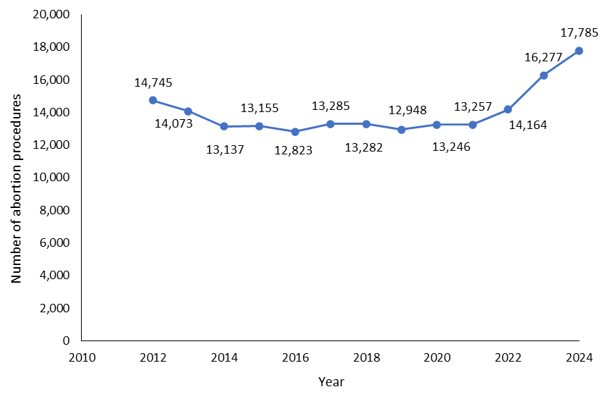

Figure 1–2: Number of abortion procedures per 1,000 females aged 15–44 years (general abortion rate), 2012–2024
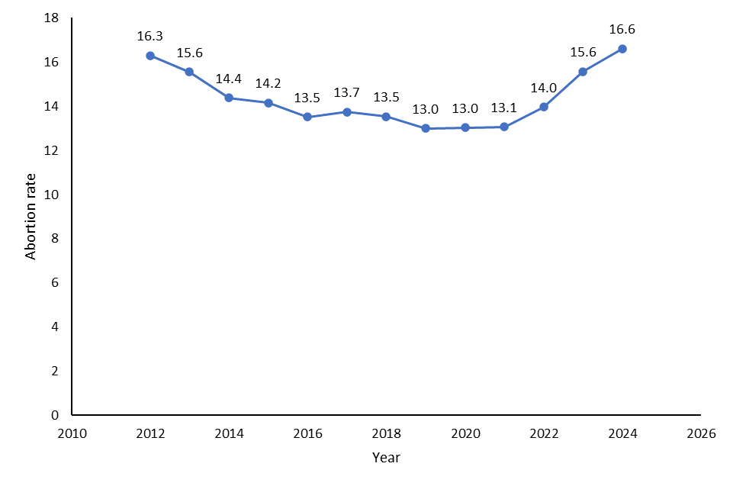
Figure 1–3: Number of abortion procedures per 1,000 known pregnancies (abortion ratio), 2012–2024
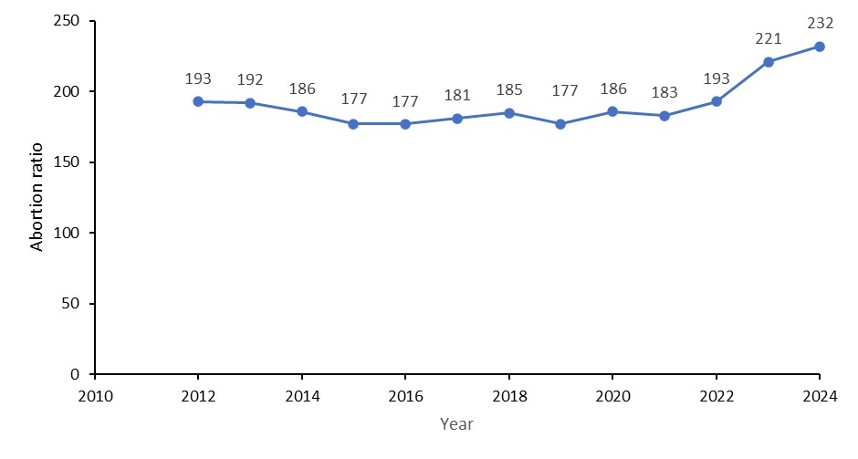

Table 1–1: Number of abortion procedures by age group, 2012–2024
Age (years) | 2012 | 2013 | 2014 | 2015 | 2016 | 2017 | 2018 | 2019 | 2020 | 2021 | 2022 | 2023 | 2024
Under 15 | 51 | 48 | 57 | 32 | 27 | 30 | 22 | 23 | 26 | 30 | 26 | 37 | 48
15–19 | 2,489 | 2,096 | 1,758 | 1,635 | 1,451 | 1,414 | 1,289 | 1,219 | 1,227 | 1,232 | 1,490 | 1,811 | 1,801
20–24 | 4,560 | 4,386 | 4,024 | 3,777 | 3,537 | 3,599 | 3,334 | 3,191 | 3,204 | 3,303 | 3,599 | 4,076 | 4,372
25–29 | 3,240 | 3,174 | 3,075 | 3,256 | 3,368 | 3,632 | 3,598 | 3,397 | 3,488 | 3,339 | 3,537 | 3,989 | 4,236
30–34 | 2,248 | 2,237 | 2,172 | 2,309 | 2,343 | 2,419 | 2,650 | 2,686 | 2,795 | 2,829 | 2,951 | 3,477 | 3,865
35–39 | 1,506 | 1,451 | 1,384 | 1,483 | 1,443 | 1,562 | 1,679 | 1,720 | 1,784 | 1,792 | 1,886 | 2,084 | 2,507
40–44 | 590 | 637 | 611 | 598 | 602 | 584 | 660 | 642 | 649 | 681 | 624 | 739 | 892
45+ | 61 | 44 | 56 | 65 | 52 | 45 | 50 | 70 | 70 | 51 | 51 | 64 | 64

Figure 1–4: Rate of abortion procedures by age group, 2012–2024
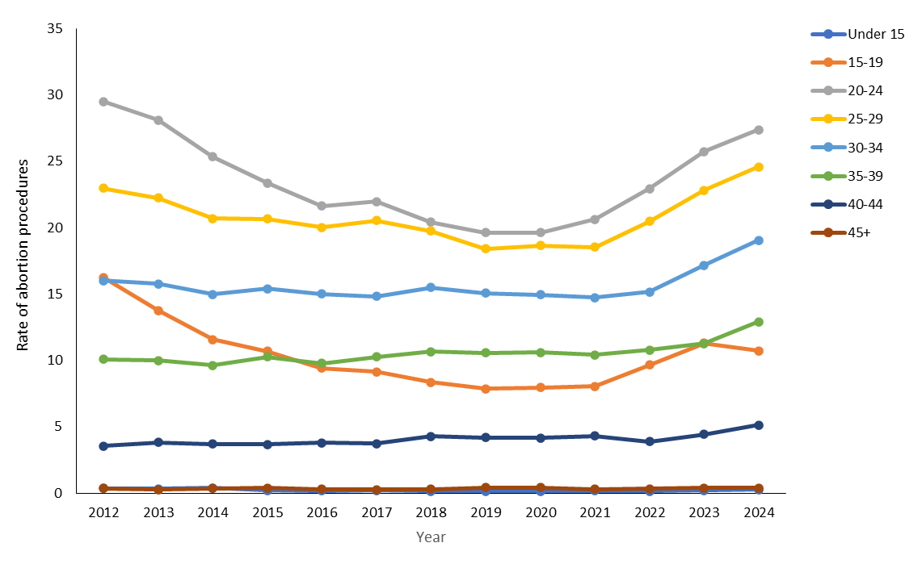
Figure 1–5: Number of abortion procedures by total ethnicity, 2020–2024
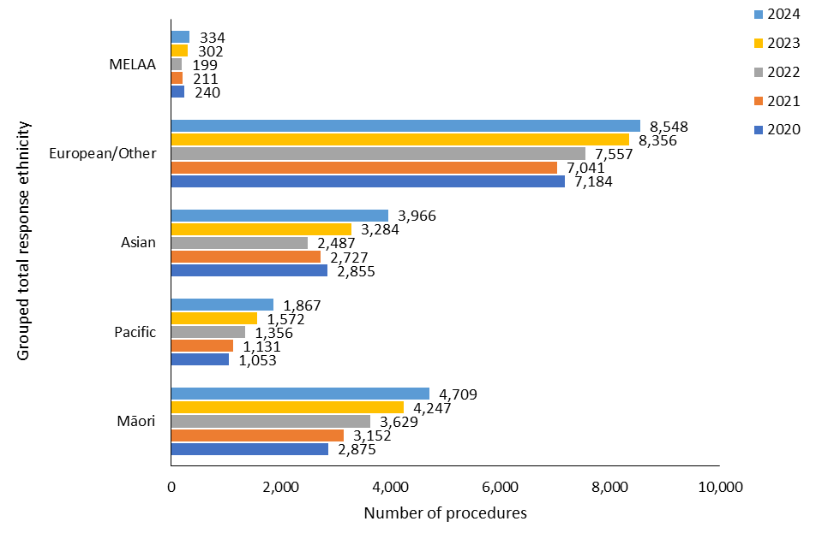
Note: MELAA = Middle Eastern, Latin American and African.
In 5 cases, ethnicity data was not reported and so these have been omitted.

Figure 1–6: Percentage of abortion procedures by prioritised ethnicity, 2024
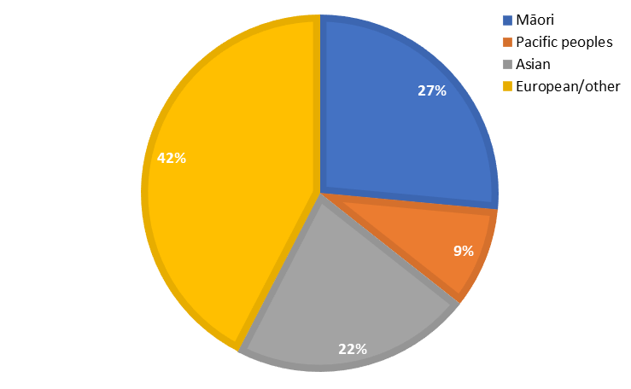
Note: In 5 cases, ethnicity data was not reported and so these have been omitted.

Table 1–2: Number of abortion procedures by prioritised ethnicity, 2011–2024
Ethnicity | 2011 | 2012 | 2013 | 2014 | 2015 | 2016 | 2017 | 2018 | 2019 | 2020 | 2021 | 2022 | 2023 | 2024
Māori | 3,855 | 3,595 | 3,455 | 3,012 | 3,074 | 2,895 | 3,107 | 2,979 | 2,999 | 2,875 | 3,152 | 3,629 | 4,247 | 4,709
Pacific peoples | 1,846 | 1,776 | 1,510 | 1,354 | 1,304 | 1,231 | 1,210 | 1,188 | 1,101 | 945 | 1,011 | 1,223 | 1,410 | 1,627
Asian | 2,517 | 2,368 | 2,303 | 2,258 | 2,286 | 2,484 | 2,528 | 2,710 | 2,715 | 2,798 | 2,685 | 2,459 | 3,228 | 3,903
European/other | 7,620 | 6,955 | 6,771 | 6,477 | 6,428 | 6,175 | 6,366 | 6,379 | 6,071 | 6,587 | 6,397 | 6,838 | 7,386 | 7,541
Note: In 5 cases, ethnicity data was not reported and so these have been omitted.

Figure 1–7: Rate of abortion procedures per 1,000 females aged 15–44 years (general abortion rate) by prioritised ethnicity, 2011–2024
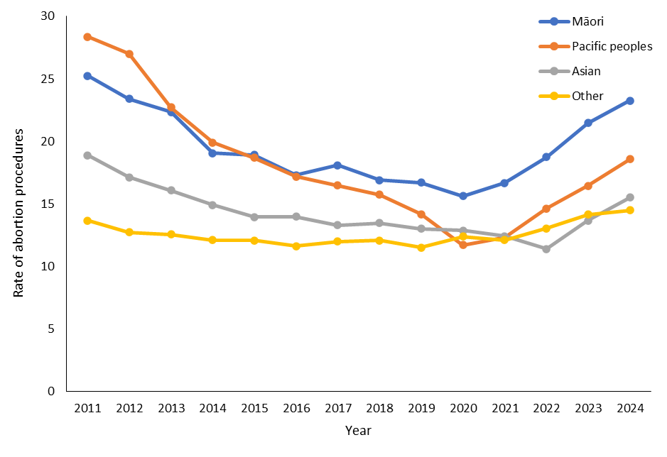
Note: In 5 cases, ethnicity data was not reported and so these have been omitted.

Figure 1–8: Percentage and number of abortion procedures by age group and total ethnicity, 2024
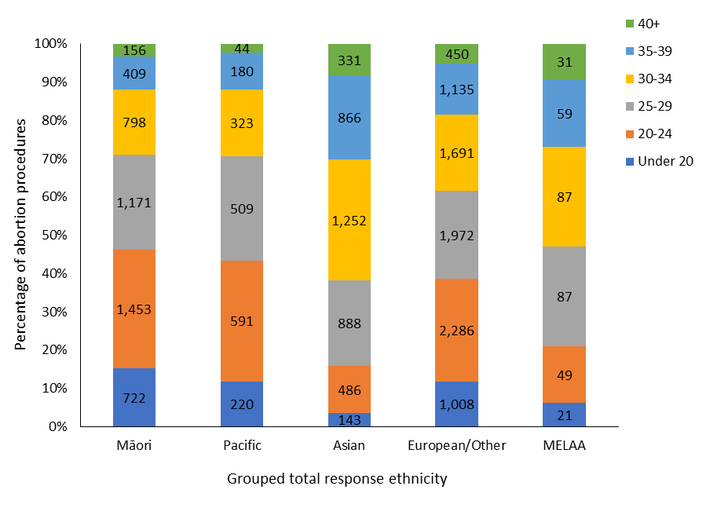
Note: MELAA = Middle Eastern, Latin American and African.
In 5 cases, ethnicity data was not reported and so these have been omitted.

Table 1–3: Number of abortion procedures by age group and prioritised ethnicity, 2024
Age group (years) | Māori | Pacific | Asian | European/other
Under 20 | 722 | 176 | 132 | 819
20–24 | 1,453 | 507 | 468 | 1,943
25–29 | 1,171 | 452 | 869 | 1,743
30–34 | 798 | 289 | 1,244 | 1,531
35–39 | 409 | 161 | 862 | 1,075
40+ | 156 | 42 | 328 | 430
Total | 4,709 | 1,627 | 3,903 | 7,541
Note: In 5 cases, ethnicity data was not reported and so these have been omitted.

Figure 1–9: Average gestation in weeks at time of abortion procedure by total ethnicity, 2021–2024
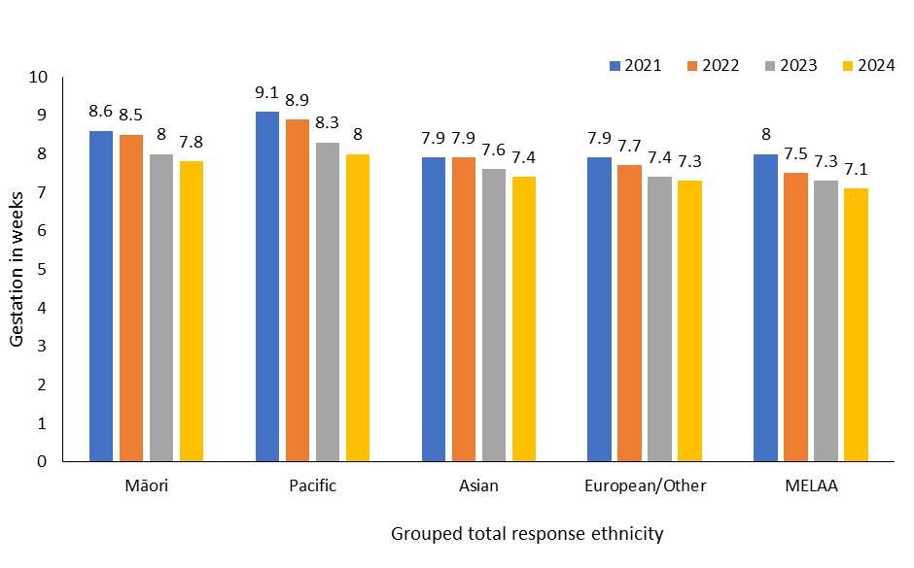
Note: MELAA = Middle Eastern, Latin American and African.
Cases (5) where ethnicity data was not reported have been excluded.

Figure 1–10: Number of abortion procedures by level of socioeconomic deprivation, 2024
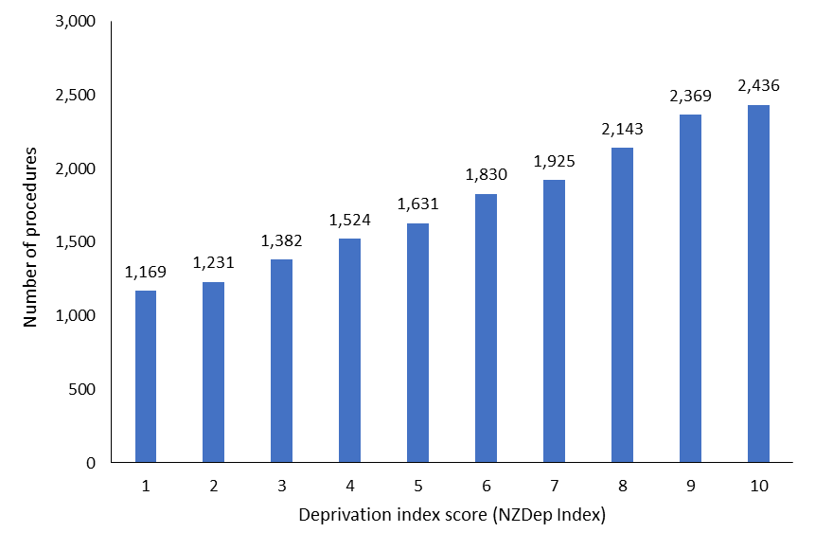
Figure 1–11: Average gestation at time of abortion by level of socioeconomic deprivation, 2024
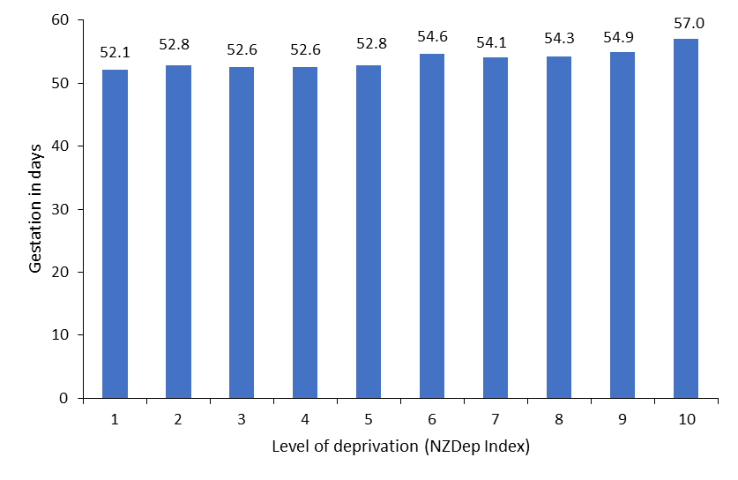

Types of abortion procedures – Wāhanga 2. Ngā tukanga whakatahe
Consistent with the prior two years, early medical abortion (EMA) procedures in 2024 represented the majority of abortion procedures accessed throughout Aotearoa New Zealand (Figure 2–1). Notably, compared to 2023, the proportion of EMAs increased by 5%, and the proportion of surgical abortions decreased by 5%.

In total, of all abortion procedures performed in 2024, 66.9% (11,892) were EMAs, compared with 61.9% (10,080) in 2023 and 50.6% (7,171) in 2022. In total, in 2024, 31.0% (5,507) of abortion procedures were surgical, compared with 36.1% (5,875) in 2023 and 47.8% (6,764) in 2022. Abortions occurring at over 10 weeks’ gestation accounted for just 2.2% of all abortions. This proportion has remained fairly consistent since 2017.

The majority of both surgical (62%) and medical (97%) abortions – together representing 86% of abortions overall – were provided at 10 weeks’ gestation or earlier. From 11 to 20 weeks’ gestation, a higher number of abortions were provided surgically rather than medically. As observed in both 2022 and 2023, less than 1% of all abortions occurred at greater than 20 weeks’ gestation (Figure 2–2 and Table 2–1).

Māori accessing abortion services were more likely than non-Māori, non-Pacific peoples to access surgical rather than medical abortions. Specifically, in 2024, 36% of Māori accessing an abortion had a surgical procedure (Figure 2–3). This rate was comparable with the rate among Pacific peoples (35%), and higher than the rate for both Asian (28%) and European/other (29%) populations. Notably, as observed in the prior year, across all ethnic groups the percentage of surgical abortions decreased, and the percentage of EMAs increased. Finally, differences across ethnic groups in the rate of EMA access have decreased over the last three years to the extent that, as of 2024, EMAs reflect approximately two-thirds of abortion access, regardless of ethnicity.

Based on district of domicile, the rate of abortion service access ranged from 12 to 22 per 1,000 females aged 15–44 years (Figure 2–4). Note that in regions or districts with small populations, the rate of abortion may appear high despite low overall number of abortion access. This effect is evident in Tairāwhiti and Wairarapa (Figure 2–4 and Table 2–2).

Across all districts of domicile, people accessed more EMAs than surgical abortions (Table 2–2). This is a noteworthy increase in the rate of EMA access across districts of domicile compared with 2022, when surgical abortion was accessed at a greater rate within 9 of the 20 districts.

Comparing the number of procedures by district of service across 2023 and 2024 shows that regionally provided abortion services decreased overall within 10 districts. The largest service decrease occurred in Auckland and the largest service increase occurred in Canterbury (Table 2–3). The observed decreases may be attributed to the growth in access to the national telehealth EMA service delivered by DECIDE. Specifically, in 2024, this service provided 5,419 (30%) of all abortions.

Taken together, these changes demonstrate that, on average, the number and rate of EMA service provision has increased while surgical abortions have decreased in number and rate, both nationally and within most districts in New Zealand. Sections 3 and 4 give further details on regional outcomes and on provision of EMA (through both telehealth and in-person services).

Figure 2–1: Number of abortion procedures by procedure type, 2017–2024
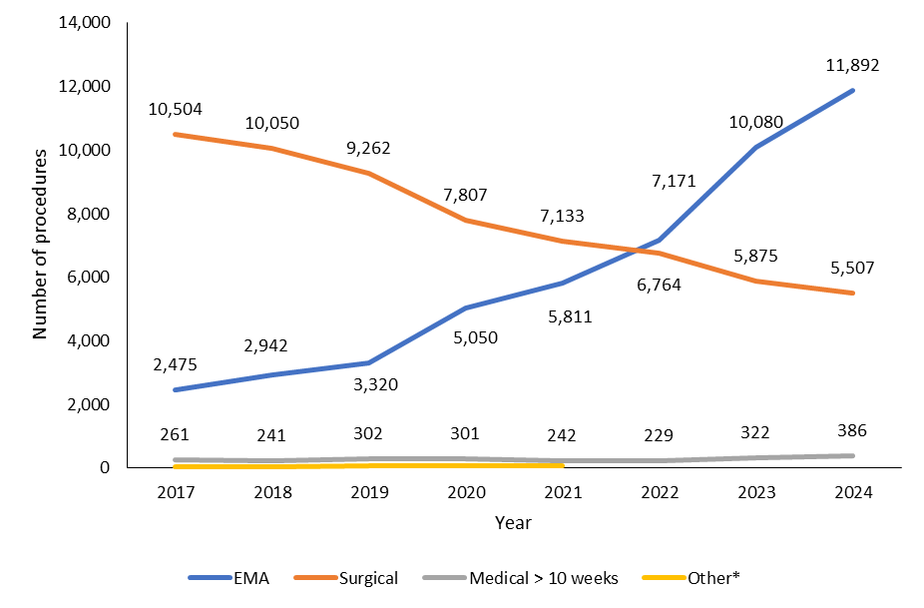
Note: * ‘Other’ abortion types (2017–2021) include failed abortion, a secondary abortion following a failed abortion and reports where a procedure type was missing.

Figure 2–2: Percentage of abortions by gestation in weeks and procedure type, 2024
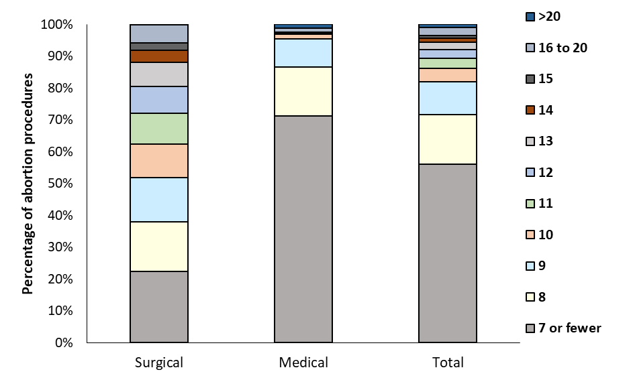
Table 2–1: Number of abortion procedures by gestation in weeks and procedure type, 2024
Gestation (weeks) | Surgical | Medical | Total
7 or fewer | 1,230 | 8,753 | 9,983
8 | 863 | 1,886 | 2,749
9 | 763 | 1,073 | 1,836
10 | 575 | 180 | 755
11 | 536 | 20 | 556
12 | 470 | S | 476
13 | 409 | 11 | 420
14 | 214 | 29 | 243
15 | 130 | 29 | 159
16 | 94 | 31 | 125
17 | 97 | 31 | 128
18 | 60 | 24 | 84
19 | 39 | 31 | 70
20 | 16 | 21 | 37
Over 20 | 11 | 153 | 164
Total | 5,507 | 12,278 | 17,785
Note: ‘S’ indicates suppressed information; this applies to instances with fewer than 10 cases and is to protect the privacy of natural people.

Figure 2–3: Number and percentage of abortion procedures by type and prioritised ethnicity, 2022–2024
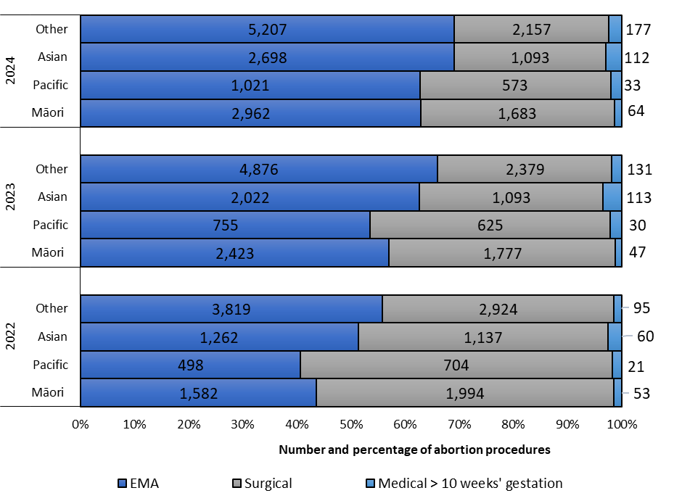
Note: Due to non-reporting of ethnicity data, 5 cases from 2024, 6 cases from 2023 and 15 cases from 2022 have been omitted.

Figure 2–4: Rate of abortion procedures by procedure type and district of domicile, 2024
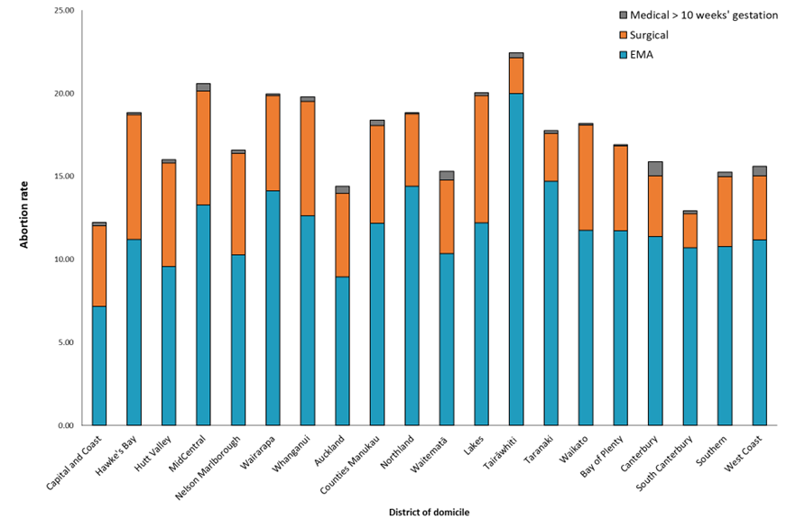
Table 2–2: Number of abortion procedures by procedure type and district of domicile, 2024
District of domicile | EMA | Surgical | Medical >10 weeks
Capital and Coast | 538 | 364 | 16
Hawke's Bay | 369 | 247 | S
Hutt Valley | 319 | 208 | S
MidCentral | 488 | 253 | 16
Nelson Marlborough | 278 | 165 | S
Wairarapa | 116 | 47 | S
Whanganui | 148 | 81 | S
Auckland | 1,092 | 614 | 54
Counties Manukau | 1,661 | 806 | 42
Northland | 477 | 144 | S
Waitematā | 1,451 | 618 | 75
Lakes | 274 | 172 | S
Tairāwhiti | 197 | 21 | S
Taranaki | 338 | 66 | S
Waikato | 1,078 | 583 | S
Bay of Plenty | 588 | 257 | S
Canterbury | 1,413 | 457 | 105
South Canterbury | 116 | 22 | S
Southern | 804 | 312 | 22
West Coast | 58 | 20 | S
Not reported | 89 | 50 | S
Total | 11,892 | 5,507 | 386
Note: This table excludes instances with a missing code of domicile. ‘S’ indicates suppressed information; this applies to instances with fewer than 10 cases and is to protect the privacy of natural people.

Table 2–3: Number of abortion procedures by district of service, 2020–2024
District | 2020 | 2021 | 2022 | 2023 | 2024
Auckland | 4,656 | 4,597 | 4,702 | 4,389 | 4,056
Canterbury | 1,612 | 1,470 | 1,515 | 1,312 | 1569
Capital and Coast | 1,259 | 1,297 | 1,345 | 1,118 | 960
Waikato | 997 | 989 | 975 | 709 | 679
Southern | 987 | 969 | 857 | 898 | 859
MidCentral | 902 | 932 | 1,038 | 1,164 | 1,371
Lakes | 794 | 802 | 775 | 649 | 581
Northland | 413 | 480 | 503 | 351 | 424
Hawke’s Bay | 420 | 446 | 459 | 432 | 431
Nelson Marlborough | 328 | 364 | 329 | 303 | 317
Bay of Plenty | 246 | 305 | 373 | 315 | 255
Taranaki | 304 | 283 | 327 | 249 | 228
Tairāwhiti | 172 | 167 | 213 | 223 | 205
South Canterbury | 55 | 57 | 110 | 95 | 100
Counties Manukau | 53 | 53 | 30 | 43 | 105
Waitematā | 45 | 40 | 80 | 113 | 205
West Coast | S | S | 17 | 19 | 14
Note: Regional data for abortions excludes abortions accessed through the DECIDE national telehealth service: 515 from the year 2022; 3,889 from the year 2023; 5,419 from the year 2024. This table excludes abortion procedures in Hutt Valley district (2020–2024) and West Coast district (2020 and 2021) due to very low numbers.

Geographical access to abortion – Wāhanga 3. Te āheinga ā-matawhenua ki te whakatahe
The number of locally based, in-person abortion services available increased in 2024 compared with 2023. Figure 3–1 shows patients’ average drive times to the nearest abortion provider across New Zealand. Most providers are located in urban areas. Reflecting the population density around these areas, the majority of females aged 15–44 years live within a 30-minute drive from an in-person abortion provider (Table 3–1).

While average drive times to locations providing in-person EMAs and (in many cases) surgical abortions reported here are one measure of equity of access, these summaries do not reflect all details needed to assess equity. For instance, individual providers may differ in their wait times or may have limited capacity in terms of the number of patients they can see. Additionally, drive times do not take account of how providers may differ in the variety or availability of services they offer at different gestational thresholds. For example, an individual’s nearest abortion provider may be within a 30-minute drive time but offer only EMAs. In such circumstances, a person seeking an abortion at over 10 weeks’ gestation may need to travel further to access the abortion services they need.

Different demographic and regional characteristics may also have an impact on average drive times. For example, 93% of Asian and Pacific females aged 15–44 years live within a 30-minute drive from an in-person abortion provider. However, this proportion decreases to 75% for Māori and 79% for European/other groups.

Individuals in rural communities will typically have to drive longer distances than those in urban communities to access in-person health services. Similarly, the level of socioeconomic deprivation of the area where they are living may make it more or less likely that they will live close to abortion providers.

To consider how living in rural areas affects drive time, we applied the Geographical Classification for Health (GCH), which was developed by the University of Otago to monitor rural–urban variables in relation to health outcomes in New Zealand. The GCH includes two urban categories (Urban 1 and Urban 2) and three rural categories (Rural 1 to Rural 3). Urban categories are based on population size (with Urban 1 as the category with the larger population), and rural categories are based on drive time to urban areas (with Rural 1 as the category with the shortest drive time). To view a map of these classification areas, visit rhrn.nz/gch/maps.

Figure 3–2 shows the average drive time (in minutes) to the nearest in-person abortion provider based on both prioritised ethnicity and GCH rural-urban classification index, among females aged 15–44 years. Due to the low numbers of individuals living in Rural 3 areas, we merged Rural 2 and Rural 3 categories for the purposes of this report (calling the new category ‘Rural 2/3’).

As expected, those living in urban centres (Urban 1 and Urban 2) had shorter drive times to access providers than those in rural areas. Average drive time for urban individuals was reasonably consistent at 10–15 minutes across prioritised ethnic groups.

Those living in rural areas (Rural 1 and Rural 2/3) had much longer drive times. In Rural 1 areas, individuals on average lived a 43- to 47-minute drive time to the nearest abortion provider. Those living in Rural 2/3 areas on average had to drive an hour to reach an abortion provider. However, due to the greater availability of locations providing abortion services, the average drive time for those living in the most rural areas has decreased compared with earlier years. This decreasing trend is consistent across all ethnic groups.

Figure 3–3 shows the average drive time (in minutes) to the nearest in-person abortion provider based on both level of socioeconomic deprivation and GCH rural-urban urban index, among females aged 15–44 years. We again note that these drive times are averages for people living within each given category. Additionally, interpreting these drive times as an average measure of geographical access does not account for other factors that may affect an individual’s access, for instance whether they have reasonable access to a car or have the time or opportunity to travel. These factors may be most impactful on those living within lower socioeconomic deciles.

On average, individuals in Urban 1 and Urban 2 areas lived a 12- to 16-minute drive away from an in-person service. This trend is consistent with the prior years’ reporting and is not affected by level of socioeconomic deprivation.

For those living in Rural 1 areas, the average drive time to an in-person service was 42 to 49 minutes. While these averages are slightly higher than in 2023, the increase is not substantive. Additionally, this average was not impacted by level of socioeconomic deprivation.

Finally, on average, individuals in very rural areas (Rural 2/3) lived on average a 40- to 64-minute drive away from an in-person abortion provider. Their level of socioeconomic deprivation affected this average. Those living in the least socioeconomically deprived deciles had the shortest relative drive time to an in-person service: 40 minutes for those in decile 1 and 53 minutes for those in decile 2. However, while there was a marked increase in average drive time when comparing decile 1 to decile 3 (at 60 minutes), average drive time was fairly consistent across deciles 3 through 10, at 60 to 64 minutes.

Access to local in-person abortion services varies across New Zealand regions and districts: people living in certain areas may need to travel outside of their district for in-person abortion services (Figure 3–4). Notably, all those seeking abortion services who live in Whanganui or Wairarapa needed to travel out of their district of domicile to access in-person services. In Waitematā, Counties Manukau, and Hutt Valley, 92–98% of those seeking abortion services travelled out of their district for in-person services. This trend is consistent with 2023.

In contrast, across 12 districts of domicile, fewer than 10% of individuals accessing abortion services had to travel to a different district. Additionally, average gestation at the time of abortion has remained low across all districts of domicile, ranging from 50 to 59 days’ gestation (Figure 3–5).

However, regional variations are most likely to impact access to surgical abortions. Based on Table 2–1 data, 82% of abortions at later than nine weeks’ gestation in 2024 were performed surgically. This presents an additional burden, particularly in rural communities, for those who may not live near a hospital or community specialist that is able to provide a surgical abortion. In 2024, 40% of individuals accessing a surgical abortion had to travel out of their district of domicile for service, compared with 29% of those accessing a medical abortion (Table 3–2). The percentage of those who have to travel out of their district for access to a surgical abortion increases as gestation increases.

Notably, these figures are unlikely to account for the full burden of travelling for an abortion. People accessing abortion services may face additional barriers related to travelling when they would otherwise elect to have a surgical abortion, or an abortion at more than 10 weeks’ gestation. For instance, people with cognitive or physical disabilities may be disadvantaged in accessing timely and affordable transport, particularly if they live rurally or depend on caregivers’ support for arranging travel.

Figure 3–1: Geospatial analysis – patient drive time in minutes to services by facility in the North Island and South Island, 2024
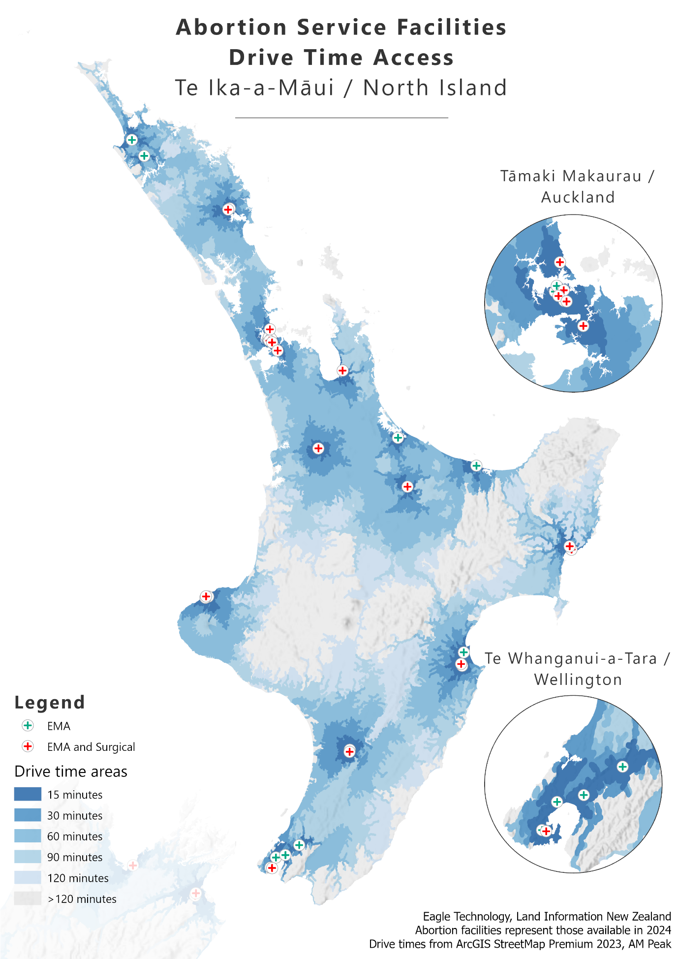
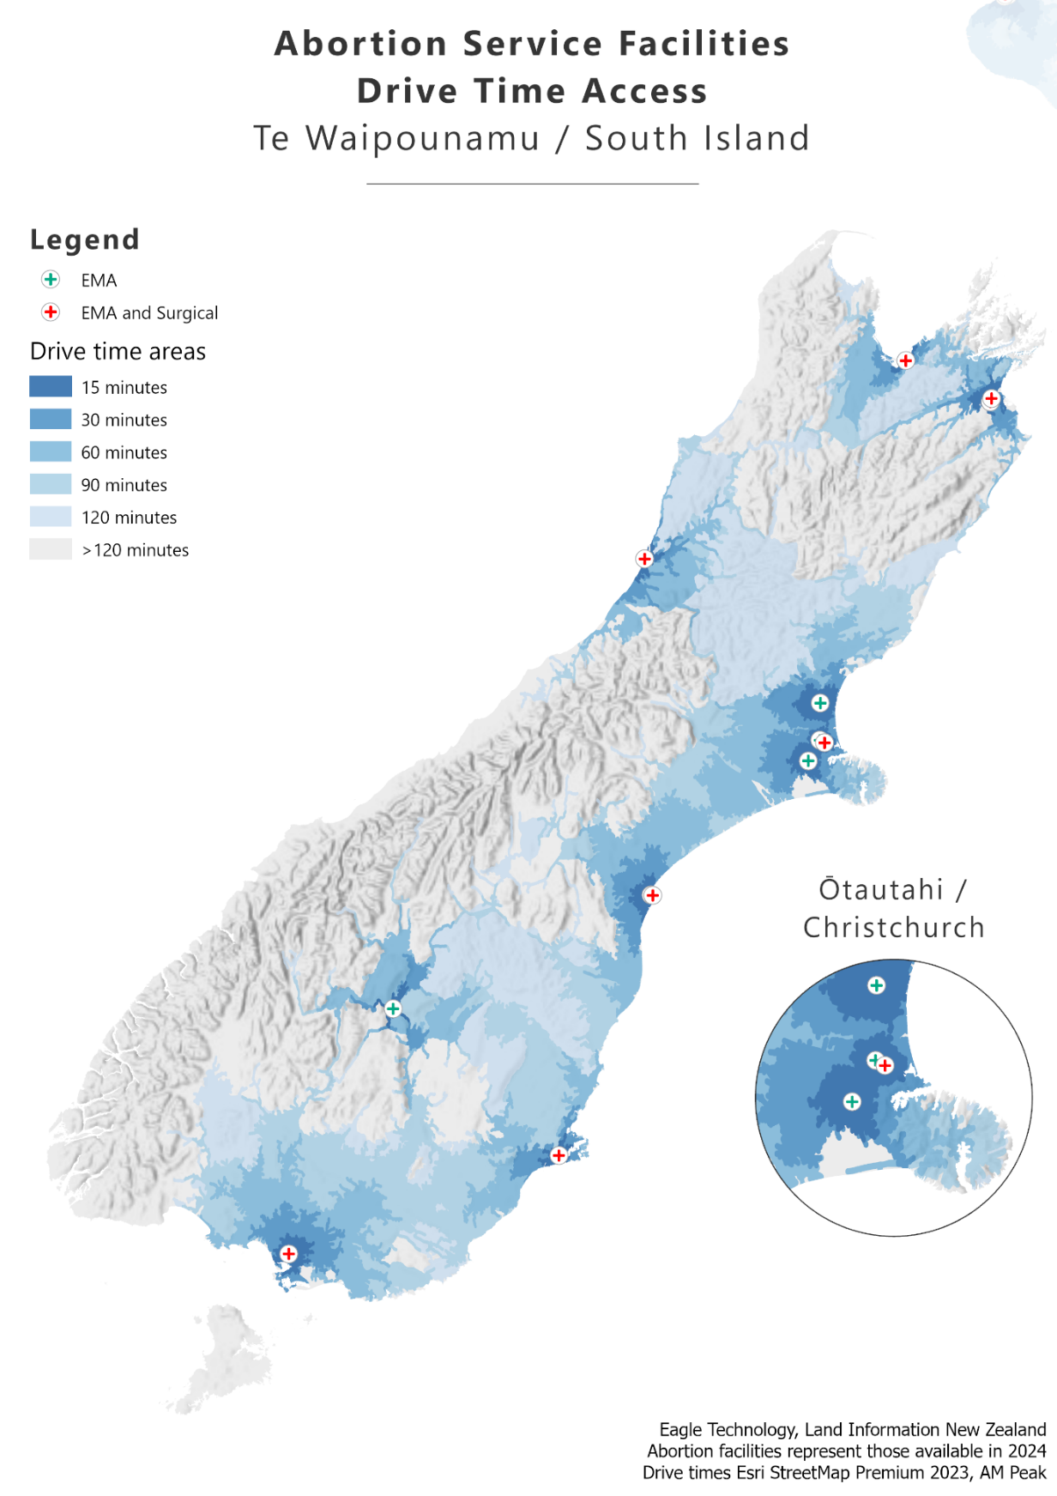

Table 3–1: Average drive time in minutes to nearest in-person abortion provider by prioritised ethnicity, 2024
Drive time (minutes) | Māori | Pacific | Asian | European/other
Up to 30 | 75.2% | 93.0% | 92.9% | 78.7%
31–60 | 18.0% | 5.9% | 5.7% | 16.5%
61–90 | 5.1% | 0.9% | 1.1% | 3.7%
Over 90 | 1.8% | 0.2% | 0.2% | 1.1%
Average drive time (minutes) | 22.6 | 15.4 | 14.9 | 20.7

Figure 3–2: Average drive time in minutes to nearest in-person abortion provider by prioritised ethnicity and GCH rural-urban index, 2024
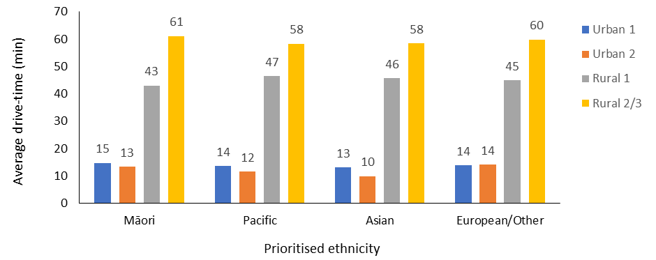

Figure 3–3: Average drive time in minutes to nearest in-person abortion provider by level of socioeconomic deprivation and GCH rural-urban index, 2024
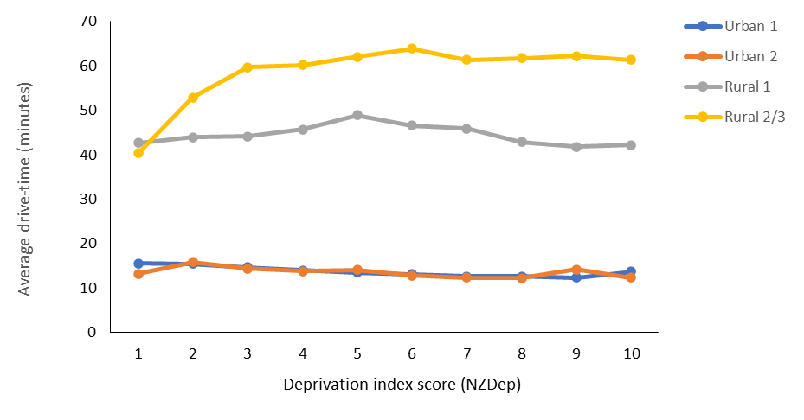

Figure 3–4: Percentage of patients travelling to other districts for abortion procedures by district of domicile, 2024
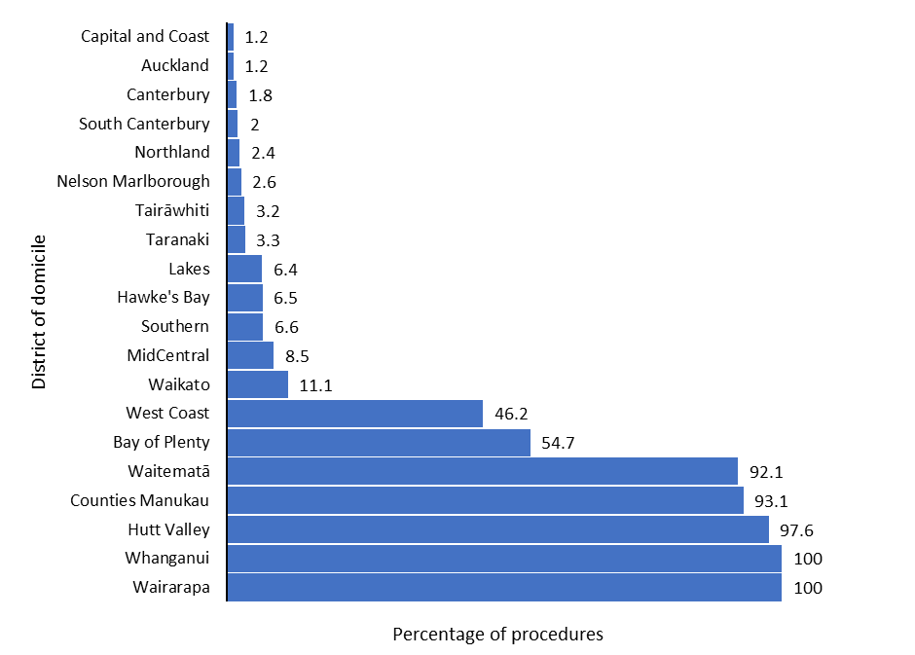
Note: Total values exclude individuals accessing EMA through the DECIDE national telehealth service. This figure also excludes those records that were missing information on a patient’s district of domicile.

Figure 3–5: Average gestation in days by district of domicile, 2024
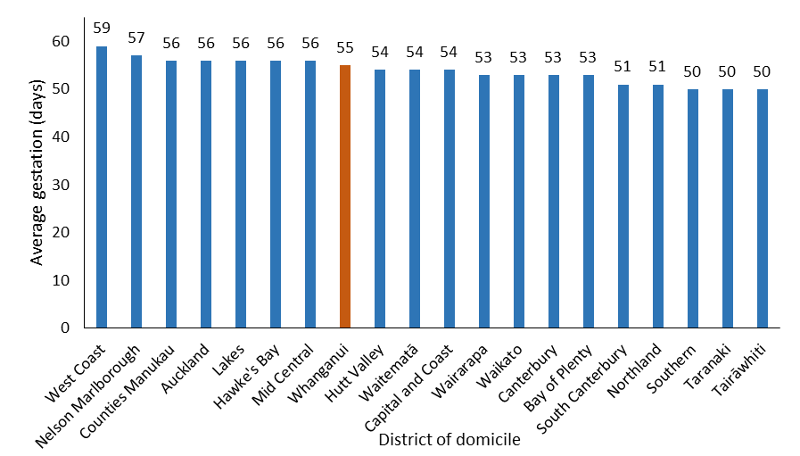
Note: Red in this figure indicates that the district had no local in-person, first-trimester abortion services in 2024; blue indicates that it did have such services.
Table 3–2: Number of abortions by gestation in weeks and percentage occurring outside of district of domicile, by procedure type, 2024
Gestation (weeks) | Medical abortion |  | Surgical abortion
 | Total | % travelling outside district of domicile | Total | % travelling outside district of domicile
0–5 | 422 | 23.2% | 65 | 23.1%
>5–10 | 3,658 | 31.9% | 3,366 | 37.3%
>10–15 | 95 | 9.5% | 1,759 | 39.4%
>15–20 | 138 | 10.9% | 306 | 67.0%
>20 | 153 | 15.7% | 11 | 81.8%
Note: Total values exclude individuals accessing EMA through national or regional telehealth. This table also excludes those records that were missing information on district of domicile.

Early medical abortion access – Wāhanga 4. Te āheinga atu ki te whakatahe tōmua mō tētahi take hauora
In 2024, EMAs represented 66.9% of all abortion procedures, an increase of 5% in the rate of EMA provision as compared to 2023 (61.9%), and an increase of 29% since abortion law reform occurred under the Abortion Legislation Act 2020 (38.1%).

This increase is reflective of improved accessibility to abortions, and to EMAs in particular. As Section 3 reports, a greater number of provider locations were available in 2024 than in 2023. This continues a year-on-year trend since the abortion law reform of 2020, which in turn has reduced the average drive time to in-person services.

Additionally, some regionally based providers offer EMAs through telehealth services, providing an accessible option for people seeking an EMA. From 1 November 2022, EMAs also became available through the national telehealth service, DECIDE. This service includes consultation, abortion counselling (if requested) and provision of abortion medications and aftercare (including contraception post-abortion) for those who meet all clinical requirements. This service complements in-person and regional telehealth abortion services.

Telehealth services increase both availability and access to EMAs, and we are seeing demand for these services. For instance, over 2,000 EMAs were accessed through regionally provided telehealth services within each year from 2022 through 2024. Additionally, there has been a noted increase in access in EMA services provided by DECIDE in 2024 (5,419), as compared to what was observed in 2023, DECIDE’s first full year of service provision (3,889).

Notably, access to in-person EMA services remains high, at approximately 4,000 cases in both 2023 and 2024. This is a slight decrease from 2022, which saw about 4,500 cases of in-person EMAs (Table 4–1). This demonstrates continued demand for access to local, in-person EMA care.

As in 2023, the current results demonstrate that demand exists for in-person services, as well as for both regional and national telehealth services. Here we report on a more detailed investigation into trends in accessing these different forms of service, based on the key demographic characteristics of age, ethnicity and whether people live in an urban or rural area.

Table 4–2 gives a detailed breakdown of EMA access across age brackets and channel of EMA service provision. In terms of age, 71.7% of all EMA services were accessed by individuals aged 20–34 years, with 9.4% accessed by those under 20 years of age. Finally, 18.9% of EMA services were accessed by individuals aged 35 or above. As with 2023, Figure 4–1 shows that age does not appear have a notable impact on channel of EMA service provision. That is, the rate of EMA access for each age group is generally consistent across in-person, regional telehealth and national telehealth services.

Table 4–3 provides a detailed breakdown of access to the different channels of EMA services among prioritised ethnic groups in 2024. It shows that Māori accessed 24.9% of all EMAs, Pacific peoples accessed 8.6%, Asian people accessed 22.7% and the European/other group accessed 43.8%.

Figure 4–2 demonstrates that each ethnic group relied on all three channels of EMA service provision, but groups differed in which channels they used more. These differences may reflect demographic and regional variation in service availability or preference. For example, the European/other group accessed a greater proportion of both national and regional telehealth services than in-person services. In comparison, Māori tended to access national telehealth and in-person services at comparable rates, and regional telehealth to a lesser extent. For the Asian population, the rate of access to regional telehealth and in-person services was similar, but this group was less likely to access national telehealth. Finally, Pacific peoples accessed each of the three channels of service at comparable rates.

As Section 3 outlines, those living in rural areas, on average, have a longer drive time to in-person abortion services than individuals living in urban centres. Notably, while only 15% of all females aged 15–44 years were living in rural areas in 2024, individuals in this age group who lived in rural communities accessed 19.7% of all EMA telehealth services but only 13.9% of in-person services (Table 4–4). These results mirror findings from 2023, further demonstrating that those living in rural communities relied more heavily on telehealth services (both regional and national) than those living in urban centres.

Table 4–1: Number and percentage of total EMAs accessed by channel of service provision, 2022–2024
 | National telehealth  (DECIDE) |  | Regional telehealth |  | In person |  | Total
Year | Number | % | Number | % | Number | % | Number
2022 | 515 | 7.2% | 2,093 | 29.2% | 4,563 | 63.6% | 7,171
2023 | 3,889 | 38.6% | 2,216 | 22.0% | 3,975 | 39.4% | 10,080
2024 | 5,419 | 45.6% | 2,393 | 20.1% | 4,080 | 34.3% | 11,892
Note: From 1 November 2022, DECIDE has offered national telehealth services. Regional providers offer regional telehealth services.

Table 4–2: Number and percentage of early medical abortions by channel of service provision and age group, 2024
 | National telehealth  (DECIDE) |  | Regional telehealth |  | In person |  | Total
Age (years) | Number | % | Number | % | Number | % | Number | %
Under 20 | 490 | 9.0 | 198 | 8.3 | 425 | 10.4 | 1,113 | 9.4
20–24 | 1360 | 25.1 | 584 | 24.4 | 1,005 | 24.6 | 2,949 | 24.8
25–29 | 1,321 | 24.4 | 608 | 25.4 | 1,003 | 24.6 | 2,932 | 24.7
30–34 | 1,221 | 22.5 | 542 | 22.6 | 886 | 21.7 | 2,649 | 22.3
35–39 | 727 | 13.4 | 350 | 14.6 | 543 | 13.3 | 1,620 | 13.6
40+ | 300 | 5.5 | 111 | 4.6 | 218 | 5.3 | 629 | 5.3
Total | 5,419 |  | 2,393 |  | 4,080 |  | 11,892

Figure 4–1: Percentage of early medical abortions by channel of service provision and age group, 2024
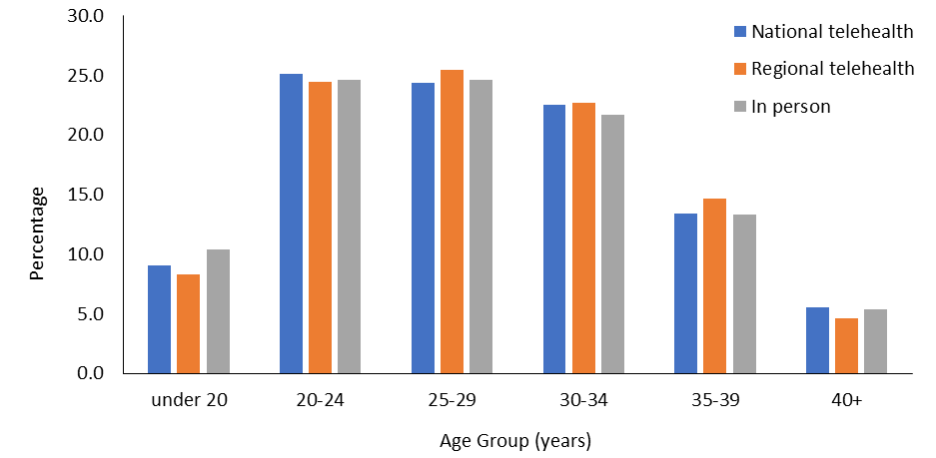

Table 4–3: Number and percentage of early medical abortions by channel of service provision and prioritised ethnicity, 2024
 | National telehealth (DECIDE) |  | Regional telehealth |  | In person |  | Total
Ethnicity | Number | % | Number | % | Number | % | Number | %
Māori | 1,433 | 26.4 | 448 | 18.7 | 1,081 | 26.5 | 2,962 | 24.9
Pacific | 463 | 8.5 | 217 | 9.1 | 314 | 8.4 | 1,021 | 8.6
Asian | 872 | 16.1 | 686 | 28.7 | 1,140 | 28.0 | 2,698 | 22.7
European/  other | 2,650 | 48.9 | 1,042 | 43.5 | 1,515 | 37.2 | 5,207 | 43.8
Total | 5,418 |  | 2,393 |  | 4,077 |  | 11,888*
Note: * In 4 cases, ethnicity data was not reported and so these have been omitted.

Figure 4–2: Percentage of early medical abortions by channel of service provision and prioritised ethnicity, 2024
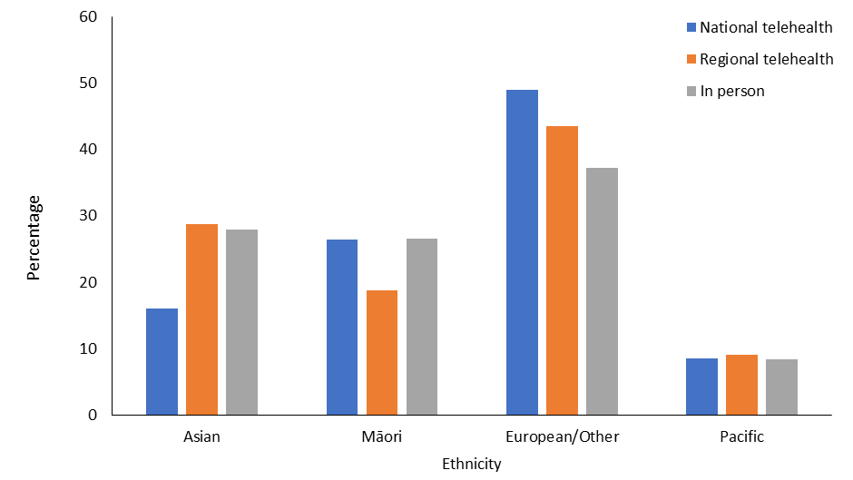

Table 4–4: Number and percentage of early medical abortions by channel of service provision, across rural and urban groups, 2024
 | National telehealth (DECIDE) |  | Regional telehealth |  | In person |  | Total
Urban/rural (GCH) | Number | % | Number | % | Number | % | Number | %
Urban¹ | 4,385 | 81.0 | 1,836 | 78.7 | 3,493 | 86.1 | 4,385 | 81.0
Rural² | 1,026 | 19.0 | 497 | 21.3 | 566 | 13.9 | 1,026 | 19.0
Total | 5,411 |  | 2,333 |  | 4,059 |  | 11,803³
Note: ¹ ‘Urban’ includes GCH categories ‘Urban 1’ and ‘Urban 2’. ² ‘Rural’ includes GCH categories ‘Rural 1’, ‘Rural 2’ and ‘Rural 3’. ³ 89 cases could not be classified according to the GCH and so have been omitted.

Abortion counselling – Wāhanga 5. Tohuora whakatahe
The Ministry is responsible for developing and monitoring standards relating to abortion counselling. In 2022, the standard for abortion counselling was published and the Ministry continues to monitor access to, and the availability of, abortion counselling.

The Act states that abortion counselling is not mandatory for a person accessing abortion services. However, health providers must advise those seeking an abortion about the availability of counselling services. The Standard for Abortion Counselling in Aotearoa New Zealand (2022) outlines the purpose and scope of abortion counselling in New Zealand.

Abortion counsellors should support people to explore their emotions, thoughts, and feelings in relation to their abortion. As the Standard explains, abortion counselling provides therapeutic support to people who are considering having, or have had, an abortion. The Standard is grounded in Te Tiriti o Waitangi and health equity practice and sets out what the Ministry expects of those delivering abortion-related counselling.

The Ministry continues to work with providers within its regulatory role to monitor abortion counselling services.

Abortion and access to contraception – Wāhanga 6. Te āheinga ki te whakatahe me ngā ārai hapūtanga
In accordance with the Contraception, Sterilisation, and Abortion (Information Collection) Regulations 2021, the Ministry collects data on contraception provided at the time of an abortion procedure. Providers also have the option to report instances in which an individual had booked, or has been referred for, a post-abortion follow-up contraception appointment. In addition to the circumstances captured through this data collection, a person may already have access to contraception, or may choose to go to their own general practitioner or another provider outside of the scope of this report. The abortion reporting procedures that this report draws on do not capture that data.

This section summarises data on contraception provided at the time of an abortion procedure.

Long-acting reversible contraception (LARC) is highly effective at preventing pregnancy and lasts for extended periods, while being easily reversible. Examples of LARC are the intra-uterine system (IUS), contraceptive injections (Depo-Provera) and subdermal implant contraceptive devices.

Analysis shows that 10.1% of those who had an EMA in 2024 were provided with LARC at the time of the abortion, compared with 52.9% of those receiving a surgical abortion (Table 6–1). The reason for the large difference between these reported figures may be that certain LARC devices can only be provided under specific conditions. For instance, insertion of an IUS into the uterus cannot occur at the time of an EMA procedure and so requires a follow-up appointment. In contrast, an IUS can be provided at the time of a first-trimester surgical abortion.

Other forms of contraception, such as condoms or hormonal contraceptive pills, are more frequently accessed overall (45.9%), and among those accessing EMA services. In 2024, 53.6% of those who had an EMA, and 31.6% of those accessing surgical abortions, were provided with some of these other forms of contraception at the time of the abortion (Table 6–1).

When accessing contraceptive services at the time of abortion, all ethnic groups were most likely to access short-term (rather than long-acting) forms of contraception, such as condoms or oral contraceptive pills. However, Māori and Pacific peoples had a higher rate of accessing LARC, compared with Asian and European/other populations (Table 6–2).

Table 6–1: Number and percentage of people receiving contraception, by contraception category and abortion procedure type, 2024
Contraception provided | EMA (%) | Surgical (%) | Medical > 10 weeks' gestation (%) | Total (%)
LARC | 1,202 (10.1) | 2,912 (52.9) | 63 (16.3) | 4,177 (23.5)
Other | 6,379 (53.6) | 1,742 (31.6) | 50 (13.0) | 8,171 (45.9)
Booked/referred | 738 (6.2) | 149 (2.7) | 94 (24.4) | 981 (5.5)
None | 3,573 (30.0) | 704 (12.8) | 179 (46.4) | 4,456 (25.1)
Total | 10,080 | 5,875 | 322 | 17,785
Note: Individuals may access multiple forms of contraception. The category ‘LARC’ refers to individuals who accessed LARC, regardless of whether additional contraceptives were provided. The category ‘Other’ includes individuals accessing only other contraception, excluding LARC.

Table 6–2: Number and percentage of people receiving contraception, by contraception category and prioritised ethnicity, 2024
Contraception provided | Māori (%) | Pacific (%) | Asian (%) | European/  other (%) | Total (%)
LARC | 1,457 (30.9) | 539 (33.1) | 685 (17.6) | 1,496 (19.8) | 4,177 (23.5)
Other | 1,992 (42.3) | 669 (41.1) | 2,100 (53.8) | 3,406 (45.2) | 8,167 (45.9)
Booked/referred | 246 (5.2) | 82 (5.0) | 211 (5.4) | 442 (5.9) | 981 (5.5)
None | 1,014 (21.5) | 337 (20.7) | 907 (23.2) | 2,197 (29.1) | 4,455 (25.1)
Total | 4,709 | 1,627 | 3,903 | 7541 | 17,780
Note: Individuals may access multiple forms of contraception. The category ‘LARC’ refers to individuals who accessed LARC, regardless of whether additional contraceptives were provided. The category ‘Other’ includes individuals accessing only other contraception, excluding LARC.

Complications at time of abortion – Wāhanga 7. Ngā uauatanga i pūrongotia i te wā o te whakatahe
In 2024, abortion service providers reported that 389 abortion procedures were associated with a complication at the time of the abortion (2.2% of all abortion procedures). As in earlier years, the majority (97.8%) of abortions were not associated with any complication (Table 7–1). The most commonly observed complication following an abortion was the presence of retained placenta/products, requiring follow-up treatment.

By type of abortion procedure, 303 (2.6%) EMAs, 39 (0.7%) surgical procedures and 47 (12.2%) medical abortions at greater than 10 weeks’ gestation were associated with a complication. The most commonly reported complications were retained placenta/products and the presence of an infection following a medical abortion (Table 7–2). In a small proportion of cases (11, or 0.06%), the person accessing abortion services did not engage with requests for follow-up appointments after termination of pregnancy. In each of these 11 cases, the person had accessed EMA services and either did not attend a booked follow-up appointment or could not be contacted to confirm follow-up.

Table 7–1: Number and percentage of complications at the time of abortion by type of complication, 2024
Complication type | Number | %
None | 17,385 | 97.8
Retained placenta/products | 179 | 1.0
Infection | 117 | 0.7
Haemorrhage | 35 | 0.2
Retained placenta/products and infection | 19 | 0.1
Haemorrhage and retained placenta/products | 15 | 0.1
Failed abortion | 8 | <0.1
Pain | 6 | <0.1
Perforation of uterus | 6 | <0.1
Reaction to medication – eg, drowsiness, nausea, dizziness | 4 | <0.1
Total | 17,774 | 100.0
Person did not engage with follow-up after the procedure | 11

Table 7–2: Number of complications at the time of abortion by procedure type, 2024
Complication type | EMA | Surgical | Medical (>10 weeks) | Total
None | 11,578 | 5,468 | 339 | 17,385
Retained placenta/products | 133 | 22 | 24 | 179
Infection | 110 | 4 | 3 | 117
Haemorrhage | 19 | 4 | 12 | 35
Retained placenta/products and infection | 18 | 1 | 0 | 19
Haemorrhage and retained placenta/products | 6 | 1 | 8 | 15
Failed abortion | 8 | 0 | 0 | 8
Pain | 5 | 1 | 0 | 6
Perforation of uterus | 2 | 4 | 0 | 6
Reaction to medication – eg, drowsiness, nausea, dizziness | 2 | 2 | 0 | 4
Total reported | 11,881 | 5,507 | 386 | 17,774
Person did not engage with follow-up after the procedure | 11 | 0 | 0 | 11

Notes on ethnicity classifications used in this report – Ngā kōrero mō te whakarōpūtanga mātāwaka i whakamahia i tēnei pūrongo

Prioritised ethnicity
Data collection that uses prioritised ethnicity allocates each person to a single ethnic group in priority order, as follows: Māori, Pacific, Asian and European/other. For example, if a person’s recorded ethnicities include both Māori and New Zealand European, this person is classified as Māori.

Total response ethnicity
Data collection that uses total response ethnicity reports each person within all groups they have identified with. This report uses the following ethnicity categories: Māori; Pacific peoples; Asian; Middle Eastern, Latin American and African (MELAA); and European/other. A person belonging to more than one ethnic group is counted once in each group. For example, a person of Samoan, Tongan and German ethnicity would be counted once in the category of Pacific peoples and once in the category of European/other.

General data notes – Ngā kōrero raraunga ahuwhānui
Data in this report comes from abortion notification reporting. The statistics presented are for the 2024 calendar year, along with some data from previous years for comparison and to show trends.

The general abortion rate is the number of abortions per 1,000 of the mean estimated population of females aged 15–44 years. The mean estimated population of females aged 15–44 years comes from the Stats NZ estimated resident population for the mean year ended 31 December 2024. This information was downloaded from the Stats NZ Infoshare website in July 2025.

Drive time estimates used the total female population aged 15–44 years from the Health Service User population data set 2024. This is a count of the number of people who used health services between 1 January and 31 December 2024. It was used as the denominator because Stats NZ does not produce population estimates at this granular level, and the Health Service User set can be used to calculate population estimates by small area units, age and sex.

We used the New Zealand Index of Deprivation to determine the socioeconomic deprivation decile linked to each abortion procedure. This index is applied using the meshblock data of each person accessing the service.

The abortion statistics in this report represent all abortion procedures that were reported to the Ministry as occurring in the 2024 calendar year, where the Ministry received this information by 1 August 2025.

Key terms – Ngā kupu matua
Term | Meaning
Decile | Each decile represents approximately 10% of areas in New Zealand. ‘Decile 1’ is a label for the 10% of areas in New Zealand with the lowest level of socioeconomic deprivation on the New Zealand Index of Deprivation. ‘Decile 10’ is a label for the 10% of areas with the highest level of deprivation on the New Zealand Index of Deprivation.
District | Health New Zealand – Te Whatu Ora districts are generally the same as those of the 20 former district health boards. Each district is part of one of Health New Zealand’s four regional divisions, ensuring continuity of services in the health system. In July 2022, the Hutt Valley and Capital and Coast districts became incorporated as the Capital, Coast and Hutt Valley district, and so now this district differs from the original reporting structure. However, this report provides results based on the original structure to maintain consistency in reporting.
District of domicile | The district where a person has a fixed or legal address or permanent residence.
District of service | The district where a person accessed an abortion service. This may be the same as the district of domicile, or it may be another district if the person travelled outside of the district for the abortion.
Early medical abortion (EMA) | This report classifies all medical abortion reported at up to and including 10 weeks’ gestation as EMA.
Geographical Classification for Health (GCH) | A system of classification developed by the University of Otago to monitor rural-urban variables in health outcomes in New Zealand. The GCH includes two urban categories (Urban 1 and Urban 2) and three rural categories (Rural 1 to Rural 3). Urban categories are based on population size, and rural categories are based on drive time to urban areas.
Long-acting reversible contraception (LARC) | This form of contraception is highly effective at preventing pregnancy and will last for several years. Additionally, this form of contraception is easily reversible – if a person wants to get pregnant or stop using it, it can be removed at any time. Examples include the intra-uterine system and subdermal implants.
Meshblock | A defined geographic area that is the smallest geographic unit for which Stats NZ reports statistical data, represented by a seven-digit code. In this report, meshblock is based on a health care user’s address at the time of service provision. Providing this data has been collected in abortion notification reporting since 24 September 2021.
New Zealand Index of Deprivation | A measure that calculates an area’s level of socioeconomic deprivation based on the following Census variables for the population living in that area: lack of internet access; receiving a means-tested benefit; income below an income threshold; aged 18–64 years and unemployed; aged 18–64 years and without any qualifications; people not living in their own home; people under 65 years living in single-parent families; people living in households below a bedroom occupancy threshold; and people with no access to a car.

Health New Zealand – Te Whatu Ora districts are generally the same as those of the 20 former district health boards. Each district is part of one of Health New Zealand’s - Te Whatu Ora’s four regional divisions, ensuring continuity of services in the health system. In July 2022, the Hutt Valley and Capital and Coast districts became incorporated as the Capital, Coast and Hutt Valley district, and so now this district differs from the original reporting structure. However, this report provides results based on the original structure to maintain consistency in reporting.
Ministry of Health. 2025. Review of Certain Matters under the Contraception, Sterilisation, and Abortion Act 1977. Wellington: Ministry of Health.
This report uses the term ‘female’ when referring to self-reported population-level trends retrieved from national databases.
For an explanation of prioritised and total ethnicity, see ‘Notes on ethnicity classifications used in this report’.
Ministry of Health. 2022. Standard for Abortion Counselling in Aotearoa New Zealand. Wellington: Ministry of Health.

