Compliance Guide for Dental Radiology including Dental Cone Beam CT
ORS G4
2025

Revision history
Updated | Details
December 2021 | Compliance Guide for Dental Radiology including Dental Cone Beam CT: ORS G4 published.
October 2025 | Compliance Guide for Dental Radiology including Dental Cone Beam CT: ORS G4 revised.

Citation: Ministry of Health. 2025. Compliance Guide for Dental Radiology including Dental Cone Beam CT: ORS G4. Wellington: Ministry of Health.
Published in October 2025 by the Ministry of Health
PO Box 5013, Wellington 6140, New Zealand
ISBN 978-1-991324-58-0 (online)
HP 9143

This document is available at health.govt.nz
 | This work is licensed under the Creative Commons Attribution 4.0 International licence. In essence, you are free to: share ie, copy and redistribute the material in any medium or format; adapt ie, remix, transform and build upon the material. You must give appropriate credit, provide a link to the licence and indicate if changes were made.

Contents
Introduction 1
1 Licensing 2
Source licence for the facility 2
Use licences 2
2 Exemptions from the use licence requirement 3
Users authorised by regulations 3
Use under the direct supervision of an authorised person 4
Use under the written instructions of an authorised person 4
3 Facilities 5
Risk assessment 5
Ability to observe and communicate with the patient during the X-ray 5
Room shielding (for CBCT dental X-ray units) 6
Controlled areas 6
Room warning signs (for CBCT dental X-ray units) 7
4 X-ray equipment 8
Buying, selling or disposing of dental X-ray units 8
Quality assurance 8
Optimisation of protection and safety 10
X-ray unit’s periodic performance testing 11
Maintenance log 12
Inventory of X-ray units 12
Handheld intra-oral X-ray units 13
5 Other common issues 14
Justification 14
Management system 14
Informed consent and risk communication 14
Radiation safety officer 15
Individual and workplace dose monitoring 15
Properly process films (for film systems) 15
No holding of the image receptor or tube head during exposures 15
Use of lead aprons (for traditional dental X-ray units) 15
Use of thyroid shields (for traditional dental X-ray units) 16
Appendices 17
Appendix 1: Example risk assessment for a typical CBCT dental X-ray unit 17
Appendix 2: Example risk assessment for a traditional dental facility 20
Appendix 3: Example radiation safety officer appointment letter 22
Appendix 4: Assessment of typical patient doses from traditional dental X-ray units and comparison against DRLs 23
Appendix 5: Guidance on management systems 27
Appendix 6: Guidance on patient doses 30
Appendix 7: Guidance on intra-oral dental unit optimisation 32
Appendix 8: Warning signs 38

List of Figures
Figure 1: Floor plan 19
Figure 2: Intra-oral set-up 24
Figure 3: Panoramic set-up 25
Figure 4: Typical radiation doses associated with some techniques or activities 31
Figure 5: Relative X-ray beam areas 34
Figure 6: Effect of FSD 35
Figure 7: Pregnancy notice 38
Figure 8: Radiation warning sign 39

Introduction
This compliance guide is advisory only. It has been written to provide some information for holders of source licences, dental practitioners, manufacturers/suppliers, service engineers and medical physics experts on the activities associated with radiological equipment used for intra-oral, panoramic and cephalometric dental procedures (traditional dental X-ray units) and for cone beam computed tomography dental procedures (CBCT dental X-ray units). It gives practical guidance on some of the more common compliance issues that dental facilities face in meeting the requirements of radiation protection legislation – the Code of Practice for Dental Radiology: ORS C4 (ORS C4) (for traditional dental X-ray units) and the Code of Practice for Diagnostic and Interventional Radiology: ORS C1 (ORS C1) (for CBCT dental X-ray units).

This compliance guide was issued by the Director for Radiation Safety (the Director) at the Office of Radiation Safety (ORS) on 17 December 2021, and revised in 2025.

Licensing

Source licence for the facility
(section 13 of the Radiation Safety Act 2016)

All dental facilities that have X-ray units, whether in use or in storage, must have a current source licence | The person responsible at all times for the management and control of each radiation source must hold a source licence issued under section 13 of the Radiation Safety Act 2016 (the Act) to protect people and protect the environment from the harmful effects of ionising radiation. Refer to the ORS website: health.govt.nz/regulation-legislation/radiation/managing-entities-of-radiation-sources.  CBCT dental X-ray units are not covered by the standard dental diagnosis source licence. In this case, contact ORS to upgrade the source licence to a higher category that also includes this practice.

Use licences
(section 21 of the Act)

X-ray servicing engineer, medical physics expert (for CBCT dental X-ray units), and related roles | Section 21 of the Act requires a natural person to hold a use licence to use radiation sources. Training requirements in the relevant codes of practice issued under the Act set out the basic level of radiation safety knowledge an applicant must demonstrate to be granted a licence.  Because dentists are usually authorised by the Radiation Safety Regulations 2016 (the Regulations) (see Section 2), it is usually only the X-ray service engineer and medical physics expert that will need a use licence. A technician setting up a digital detector and software must have a use licence if they need to operate the X-ray unit for quality assurance purposes. Refer to the ORS website: health.govt.nz/regulation-legislation/radiation/using-an-ionising-radiation-source  The holder of a source licence is responsible for ensuring all such persons have an appropriate use licence before allowing them to use the X-ray units under the source licence (refer to clause 4 of the code ORS C4 for traditional dental X-ray units; and clause 9 of the code ORS C1 for CBCT dental X-ray units).

Exemptions from the use licence requirement

Users authorised by regulations
(section 21(6) of the Act and Schedule 3 of the Regulations)

Health practitioners registered with the Dental Council in the appropriate scope of practice and holding a current practising certificate | Schedule 3 of the Regulations exempts certain health practitioners from the use licence requirement if they meet the criteria of their scope when using a radiation source for activities set out in Schedule 3.  For example, a dentist with the general dental practice scope of practice is, according to Schedule 3, authorised to use irradiating apparatus for dental diagnostic purposes. Similarly, a dental therapist with the scope of practice of dental therapy practice (with no exclusion in taking radiographs) is, according to Schedule 3, authorised to use irradiating apparatus for taking periapical and bitewing radiographs for dental diagnostic purposes. In general, if the scope of practice does not exclude extra-oral radiography then use of CBCT equipment is also authorised as long as the exposure is justified.  In all cases, the use that is authorised through Schedule 3 of the Regulations is restricted only to radiation practices that fall within the vocational scopes of practice for which the authorised person is currently registered by the Dental Council.  The holder of a source licence needs to maintain an up-to-date list of all the authorised users including proof such as the expiry date that their annual practising certificates are current (refer to clause 4 of the code ORS C4 for traditional dental X-ray units; and clause 9 of the code ORS C1 for CBCT dental X-ray units).

Use under the direct supervision of an authorised person
(section 21(4) of the Act)

Dental assistants | Direct supervision requires the dentist or authorised person (as described by Schedule 3 of the Regulations) to be physically present and able to intervene. Usually this is just done for hygiene purposes so that the gloved dentist does not themselves have to touch the exposure switch. For example, to save time, a dentist might have the dental assistant set up the patient for a panoramic X-ray, and then the dentist would come in, check the set-up and ask the dental assistant to make the exposure while the dentist stands next to them.

Use under the written instructions of an authorised person
(section 21(4) of the Act)

Registrars under training towards an appropriate scope of practice | Dental radiology is not considered to be sufficiently mechanical or procedural in nature for written instructions to be appropriate. The only exception to this is during the later stages of registrar training where they can operate under a combination of direct supervision and written instructions of an authorised user.

Facilities

Risk assessment
(clause 1(b) of the code ORS C4 for traditional dental X-ray units; clause 4 of the code ORS C1 for CBCT dental X-ray units)

For traditional and CBCT dental X-ray units | A risk assessment is required for both traditional and CBCT dental X-ray units and must be updated following any changes to the dental X-ray units or room that may affect radiation safety (refer to clause 1(b) of the code ORS C4 for traditional dental X-ray units and clause 4 of the code ORS C1).  The purpose of the risk assessment is to assess exposure risks to workers and members of the public from the CBCT dental X-ray unit. It aims to: identify specific safety measures that may be required such as shielding and monitoring; identify potential incidents before they occur; and assess the provisions for protection and safety to reduce the likelihood of incidents happening.  For example risk assessments, refer to Appendix 1 and 2.

Ability to observe and communicate with the patient during the X-ray
(clause 2(a)(iii) of the code ORS C4 for traditional dental X-ray units; clause 5(a) of the code ORS C1 for CBCT dental X-ray units)

For traditional and CBCT dental X-ray units | The operator must be able to observe the patient for any unintended movement so that the operator can abort the X-ray if necessary (refer to clause 2(a)(iii) of the code ORS C4 for traditional dental X-ray units and clause 5(a) of the code ORS C1 for CBCT dental X-ray units).  For example, the operator might put a mirror in the corner of the surgery so that they can observe the patient from the operator position outside the room.

Room shielding (for CBCT dental X-ray units)
(clause 5(b)–(c) of the code ORS C1)

For CBCT dental X-ray units | A CBCT dental X-ray unit is not a drop-in replacement for an existing panoramic unit. The much higher dose rate means that CBCT dental X-ray units will usually require a dedicated room with shielded walls. The medical physics expert will need to specify the shielding required.  The adequacy of the shielding must be formally verified and documented by the medical physics expert (refer to clause 5(b)–(c) of the code ORS C1).  A shielding plan may be required in support of an application for a source licence that includes CBCT dental X-ray units (refer to section 10 of the Radiation Safety Act 2016).

Controlled areas
(clauses 15 and 1(a)(vii) of the code ORS C4 for traditional dental X-ray units; clauses 4 and 5 of the code ORS C1 for CBCT dental X-ray units)

For traditional dental X-ray units | A controlled area of at least a 2-metre radius around the patient’s head and the X-ray tube must be established for each X-ray procedure. Access to the controlled area must be restricted so that no person can enter the controlled area during the procedure.  If the operator is unable to observe all entrances to the controlled areas, for example for X-ray units in shared spaces, then warning signs and physical barriers (such as locked doors and chained-off areas) should be used to prevent access to the controlled area.  Where these additional controls are needed, they must be recorded as written local rules (refer to clauses 15 and 1(a)(vii) of the code ORS C4).
For CBCT dental X-ray units | The entire CBCT dental X-ray room is usually considered the controlled area for these units. This decision will be informed by the risk assessment, with which the medical physics expert can help (refer to clauses 4 and 5 of the code ORS C1).

Room warning signs (for CBCT dental X-ray units)
(clause 5(e) of the code ORS C1)

For CBCT dental X-ray units | Prominently displayed radiation warning signs are required at the entrance to the controlled area of the CBCT dental X-ray room. CBCT dental X-ray units also require notices asking patients to notify staff if they are or may be pregnant (refer to clause 5(e) of the code ORS C1). Appendix 8 contains a suitable radiation warning sign and a notice advising pregnant patients to notify the dentist or assistant.

X-ray equipment

Buying, selling or disposing of dental X-ray units
(section 31 of the Act)

Buyers’ and sellers’ obligations | Any facility that has management or control of an X-ray unit must make sure it has an appropriate source licence (see Section 1). The X-ray unit must be registered with the Office of Radiation Safety before it is used.  ORS must also be notified when there is any change in the location, possession or disposal of the X-ray unit.  To access forms to register an X-ray unit or to notify a change of a radiation source, refer to the ORS website:  health.govt.nz/regulation-legislation/radiation/buysell-importexport-radiation-sources/buy-or-sell-radiation-sources  When disposing of an X-ray unit, the holder of a source licence must render it permanently inoperable before disposal. This typically involves puncturing the X-ray tube, wrecking the controls and removing any X-ray signage from it. It is also good practice to send pictures and protocols of disposal to ORS when notifying ORS of the disposal. Refer to the ORS website:  health.govt.nz/regulation-legislation/radiation/managing-entities-of-radiation-sources/register-radiation-sources

Quality assurance
(Appendix 1, Part 2 of the code ORS C4 for traditional dental X-ray units; clauses 1(a)(vi) and 20 of the code ORS C1 for CBCT dental X-ray units)

For traditional dental X-ray units | It is required that intensifying screens, digital receptors, and cassettes are monitored by regular quality assurance checks and in-house preventative maintenance at the frequency recommended by the manufacturer. Quality assurance checks should include regular checks for any signs of damage on the receptor. Images should also be visually checked for the presence of artefacts or blemishes.  Associated protective and ancillary equipment such as film processors and CR plate scanners are also expected to be regularly serviced and maintained. Refer to the manufacturer for an appropriate servicing frequency for their equipment and recommended preventative maintenance, such as screen cleaning. Typically servicing should be performed at least yearly, and in-house preventative maintenance every few months.  (Refer to Appendix 1, Part 2 of ORS C4.)
For CBCT dental X-ray units | Ongoing oversight and involvement by a medical physics expert is required in ensuring that the requirements for quality assurance of CBCT dental X-ray units are met (refer to clause 1(a)(vi) of the code ORS C1).  A quality assurance programme must be established that ensures performance is adequate and doses are optimised.  The quality programme must be documented in writing and comprise:  - regular image quality checks carried out by the user  - regular servicing by a service engineer  - regular testing carried out by a medical physics expert  - regular review of patient doses, including comparison with diagnostic reference levels  - regular reviews of the quality assurance programme, including the results of quality assurance checks  - protocols and frequencies for each of the above checks and tests  - records of when the tests were performed and the results.  The user manuals for most CBCT dental X-ray units include the recommended quality assurance from the manufacturer. These typically include annual preventative maintenance checks performed by a servicing engineer, regular quality assurance checks including image quality checks, constancy tests or calibrations using a phantom attachment and visual inspections of the unit to check for signs of wear and other damage. These checks can be performed by the holder of a source licence, the service engineer or the medical physics expert depending on the equipment and frequency required.  The medical physics expert can give advice on what quality assurance checks should be performed and how often. As a starting point, the medical physics expert tests should be performed every three years; however, this can be varied by the medical physics expert on a case-by-case basis.  The review of the quality assurance programme would normally be conducted at least annually, and this can be done remotely by the medical physics expert where digital records are kept.  Records of documents provided by the medical physics expert, including the review of the quality assurance programme and correspondence from the medical physics expert, should be retained as evidence of ongoing medical physics expert involvement.  The quality assurance programme must be approved by the medical physics expert as a way of demonstrating their ongoing involvement. Any corrective or preventive actions recommended by the medical physics expert must be carried out as soon as practicable.

Optimisation of protection and safety
(clauses 1e, 3(b), 14(e) and Appendix 1, Part 2 of the code ORS C4 for traditional dental X-ray units; clauses 1c and 22(c) of the code ORS C1 for CBCT dental X-ray units)

For traditional dental X-ray units | Exposures for patients must be optimised by:  - selecting radiological equipment that is fit for its purpose, the most appropriate available and designed for its purpose  - correctly identifying the patient and the procedure  - strictly limiting patient exposure to the area of clinical interest by collimating the beam and, for intra-oral radiography, by positioning the end of the cone as closely as possible to the patient’s skin, and shielding radiosensitive organs that may be exposed when appropriate  - minimising the need for repeat procedures  - adopting equipment settings and features for the procedure that the holder of a source licence has set or, if the holder of a source licence has set no such requirements, applying settings and features that keep the dose to the patient as low as reasonably achievable to get the desired diagnostic information for which the procedure was undertaken  - optimised processing and displaying of images.  - Using a digital image receptor, or fast film speed, such as E or F speed film. D speed film is not considered acceptable. (Refer to clause 14 and Appendix 1, Part 2 of the code ORS C4.)  Comparison of typical patient doses to diagnostic reference levels (DRLs) is an important step in checking patient doses have been optimised. The X-ray service engineer must include this in their periodic compliance testing of the traditional dental X-ray units (see ‘X-ray unit’s periodic performance testing’ below), and the source licence holder needs to check that this has been done. For guidance on how these comparisons should be performed and the DRL values to compare against, refer to Appendix 4.  Some factors in optimising patient doses for intra-oral X-ray units are discussed in Appendix 7. A service engineer can also give further advice on this.
For CBCT dental X-ray units | Exposures for patients must be optimised by:  - using appropriate radiological equipment  - adopting techniques and parameters to deliver a medical exposure that is the minimum necessary to fulfil the clinical purpose of the radiological procedure, considering relevant norms of acceptable image quality and relevant diagnostic reference levels.  (Refer to clause 25(a) of the code ORS C1.)  CBCT dental X-ray unit exposures should be limited to the area of clinical interest only. The whole field of view (FOV) needs to be reported on and some areas may warrant involvement of a radiologist. Wherever possible, preference should be given to using low-dose protocols.  Comparison of typical patient doses to DRLs is an important step in checking that patient doses are optimised.  The medical physics expert must include this in their periodic compliance testing of the CBCT dental X-ray unit, and the source licence holder needs to check that this has been done (see ‘X-ray unit’s periodic testing’ below). For a list of medical physics experts, refer to the ORS website:  health.govt.nz/regulation-legislation/radiation/consultants-and-service-providers

X-ray unit’s periodic performance testing
(clauses 3(a) and (b), and 19 of the code ORS C4 for traditional dental X-ray units; clauses 1(a)(vi) and 6(a) and (b) of the code ORS C1 for CBCT dental X-ray units)

For traditional dental X-ray units | Performance testing of the X-ray units by the X-ray service engineer against the code ORS C4 requirements needs to be done at commissioning, after repairs and at least every three years.  The X-ray service engineer must include comparisons of patient doses to DRLs in their periodic compliance testing of the traditional dental X-ray units (see ‘X-ray unit’s periodic performance testing’ below), and the source licence holder needs to check that this has been done.  The X-ray service engineer must provide a full written report for these tests (refer to clause 19(g) of the code ORS C4). ORS does not hold a list of X-ray service engineers.
For CBCT dental X-ray units | CBCT dental X-ray units must have ongoing oversight and involvement by a medical physics expert in ensuring that the requirements for medical imaging, calibration, dosimetry of patients, quality assurance and the commissioning and acceptance of radiological equipment. The medical physics expert will be able to give advice on everything that needs to be done and at what frequencies, including their own visits. Typically, the medical physics expert will do commissioning compliance testing, then each year will review the yearly compliance testing done by the service engineer and the results of any other quality control tests that have been performed since the last review. The medical physics expert will also need to come in and do their own testing at least every three years, and also whenever there are any changes to the CBCT dental X-ray equipment or CBCT dental X-ray room that may have an effect on radiation protection and safety.  The facility design, dose monitoring programme and quality assurance programme must be formally approved by a medical physics expert (including any subsequent changes to these) and the medical physics expert must have continuing oversight and involvement.

Maintenance log
(clause 3(c) of the code ORS C4 for traditional dental X-ray units; clause 6(g) of the code ORS C1 for CBCT dental X-ray units)

Keep a maintenance log | It is required to keep a maintenance and fault log, past service reports and so on (refer to clause 3(c) of the code ORS C4 for traditional dental X-ray units and clause 6(g) of the code ORS C1 for CBCT dental X-ray units).

Inventory of X-ray units
(clause 3(d) of the code ORS C4 for traditional dental X-ray units; clause 6(f) of the code ORS C1 for CBCT dental X-ray units)

Keep an inventory of all X-ray units | It is required to keep an inventory of all X-ray units. This needs to include make, model, serial number and location. Updates to this inventory must be communicated with ORS via email to orsenquiries@health.govt.nz (refer to clause 3(d) of the code ORS C4 for traditional dental X-ray units and clause 6(f) of the code ORS C1 for CBCT dental X-ray units).

Handheld intra-oral X-ray units
(clauses 2(a), 3,(e), 5(c) and 15(f) of the code ORS C4)

For handheld traditional dental intra-oral X-ray units | Handheld portable radiological equipment can be used only if it is impractical or medically unacceptable to transfer patients to a fixed or mobile unit (refer to clause 5(c) of the code ORS C4).  Where a general dental facility has only a handheld intra-oral X-ray unit, it must be used with a stand and trigger cord so that it can be used effectively as a fixed intra-oral X-ray unit and the operator can maintain the required minimum 2-metre distance from the unit (refer to clause 2(a) of the code ORS C4).  Where it is impractical or medically unacceptable to transfer patients to a fixed or mobile unit, such as in a hospital operating theatre or intensive care unit, or for forensic use in the field, a handheld unit may be used without the stand and trigger cord. The operator, and anyone else within 2 metres of the unit, must wear appropriate shielding (refer to clause 15(f) of the code ORS C4).  When not in use, handheld X-ray equipment should also be stored securely, for example in a locked office or cupboard, to prevent unauthorised access or loss (refer to clause 3(e) of the code ORS C4).

Other common issues
Justification | Before starting a radiological procedure, the dental practitioner must justify the medical exposure, in consultation with the referring practitioner as appropriate. Justification is particularly important for paediatric or possibly pregnant patients. Consider:  - the appropriateness of the request  - the urgency of the radiological procedure  - the characteristics of the medical exposure  - the characteristics of the individual patient  - relevant information from the patient’s previous radiological procedures and clinical history  - relevant national or international referral guidelines.  (Refer to clause 10 of the code ORS C4 and clause 24 of the code ORS C1.)  Alternative modalities should be considered to get required information for a lower dose. For example, if the additional information obtained for a given patient through taking a higher-dose CBCT dental X-ray image rather than a lower-dose panoramic image would not be expected to change the course of treatment for this patient, then this extra dose would not be justified.  Justification in the case of programmes of medical research are instead assessed by an ethics committee and health screening programmes are justified by the Ministry of Health in conjunction with appropriate professional bodies.
Management system | A management system for radiation protection and safety is required and must be kept up to date (refer to clause 1(a) of the codes ORS C4 and ORS C1). For a guidance checklist of common issues that need to be considered in a management system, refer to Appendix 5.
Informed consent and risk communication | For each radiological procedure, the patient or the patient’s legal representative must be informed of the expected diagnostic benefits as well as the risks (refer to clauses 6(b)(iii) and 12(b) of ORS C4 and clause 23(c) of the code ORS C1).  A graded approach should be applied as to how much information is required to be given to the patient. For example, the amount of information needed to be supplied for a low-dose bitewing X-ray procedure does not need to be as detailed as for a higher-dose CBCT dental X-ray procedure. Dental bitewing X-rays are typically equal to a couple of days of natural background radiation. Panoramic X-rays are similar to the amount of background radiation received over a couple of weeks, and CBCT dental X-ray exposures are typically equal to a couple of months of natural background radiation.  For guidance on patient doses, refer to Appendix 6.
Radiation safety officer | A radiation safety officer (RSO) must be appointed to oversee the application of regulatory requirements for occupational and public radiation protection and safety (refer to clause 1(c) of the code ORS C4 and clause 1(a)(iv) of the code ORS C1). The RSO is to be appointed by way of a formal letter of appointment, which has been counter-signed to indicate acceptance and an understanding of the duties.  This RSO role has training requirements associated with it (refer to Appendix 1 of the code ORS C1). Usually therefore a dentist, as the authorised user, takes on this role.  For an example radiation safety officer appointment letter, refer to Appendix 3.
Individual and workplace dose monitoring | For traditional X-ray units, dose monitoring is not usually required. Dose monitoring may need to be considered, however, for situations involving a very high number of X-rays or workers who need to be inside the 2-metre controlled area and are not adequately shielded by a barrier.  For CBCT dental X-ray units, individual dose monitoring is required for any workers who need to be inside the controlled area during exposures and could receive a dose higher than an investigation level (refer to clause 13(a) of the code ORS C1).  Workplace monitoring is required to verify doses to workers outside of the controlled area for CBCT dental X-ray units. This can be done by dose surveys performed by a medical physics expert or the use of dosimetry badges in surrounding occupied areas. Dose surveys must be performed before the CBCT dental X-ray unit is used clinically and again when circumstances change such as after construction or renovation, changes or upgrades to X-ray equipment or the introduction of new techniques, after major servicing and after a significant increase in workload (refer to clauses 5(c) and 13(b) of the code ORS C1).
Properly process films (for film systems) | For manual processing, it is required that a time/temperature chart, thermometer and timer are used when processing films (refer to clause 2(a)(iv) of the code ORS C4).
No holding of the image receptor or tube head during exposures | Holding of the image receptor or tube head during exposures is not allowed (refer to clause 15(e) of the code ORS C4). If the tube head is not stable, the tube head arm joints must be tightened. Image receptor holders must be used rather than manually holding the image receptor.
Use of lead aprons (for traditional dental X-ray units) | A lead apron is required for any procedure involving a comforter/ carer holding a patient. The comforter/carer must wear the lead apron, and no part of the comforter/carer can be exposed to the primary beam (refer to clause 13 of the code ORS C4).  Protective equipment such as a lead apron must also be used if a worker must be within two metres from the patient and is not shielded by a barrier (such as when using a handheld X-ray unit). (Refer to clause 15(f) of the code ORS C4.)  In other situations (such as with pregnant patients), the use of a lead apron is left to the judgement of the dental practitioner.  Use of lead aprons for patients is not recommended for panoramic procedures as they may obstruct the image.
Use of thyroid shields (for traditional dental X-ray units) | Use of thyroid shields on patients for intra-oral dental imaging is left to the judgement of the dental practitioner. However, as long as the primary beam is more than 2 centimetres away from the thyroid, a thyroid shield does not make a significant difference to the thyroid dose. Use of thyroid shields for patients is not recommended for panoramic procedures as they may obstruct the image.

Appendices

Appendix 1: Example risk assessment for a typical CBCT dental X-ray unit

Purpose and scope
The holder of a source licence must conduct, document and keep up to date a risk assessment to:
- identify the ways in which occupational, public, and medical exposures could be incurred
- determine the expected likelihood and magnitudes of exposures in normal operation and, to the extent reasonable and practicable, assess potential exposures including the possibility of unintended or accidental medical exposures
- assess the adequacy of provisions for protection and safety in respect of siting, design and operation.

Example
This example risk assessment is for a dedicated shielded CBCT dental X-ray room next to the reception area and public waiting area with a single doorway, and no other occupied areas above or below. The examples given are for illustrative purposes only and are not a comprehensive list of all possible exposures that could occur at a specific dental facility.

The CBCT dental X-ray unit in this example uses a setting of 120 kVp, 5 mA, for a typical scan. The dose rate at 1 metre from the unit is 0.3 mSv per hour. A typical scan time is 8.9 seconds. Typical patient effective dose for a large field of view is 0.4 mSv.

The shielding required to ensure dose rate outside controlled area remains below a public dose constraint on 0.3 mSv per year at 20 scans per week is 1 mm lead equivalent as per medical physics expert shielding design.

Hazard and person at risk | Likelihood and magnitude of exposure with protection and safety measures in place | Provisions for protection and safety
Exposure to operator during routine use | - Likelihood: high  - Magnitude: low, less than 2 mSv per year or 10 percent of the dose limit | - Not reasonably foreseeable that operators could receive significant doses in excess of 2 mSv per year (10 percent of the dose limit) and workers excluded from controlled area during exposure, so no individual monitoring warranted  - Workplace monitoring to verify adequate CBCT dental X-ray room shielding:  - after construction or renovation, and before CBCT dental X-ray unit is used clinically  - after changes or upgrades to X-ray equipment or the introduction of new techniques  - after an increase in workload beyond 20 scans per week  - after major servicing  - Operator positioned behind room shielding
Exposure to workers in surrounding occupied areas and public in the waiting area | - Likelihood: high  - Magnitude: low, less than 0.3 mSv per year | - CBCT dental X-ray room shielded and shielding verified  - Workplace monitoring as above, and dose badge placed on wall by reception area to continuously monitor that doses remain negligible
Exposure to patient | - Likelihood: high  - Magnitude: low, 0.4 mSv for large field of view | - Each radiological procedure is justified by the dental practitioner  - Quality assurance programme approved by medical physics expert  - Yearly performance testing  - Optimised protocols including standardising on use of low-dose mode as default and paediatric modes for all children  - Patient dose comparison performed by medical physics expert  - Able to see patient using mirror in the corner of the room  - Dental practitioner appropriately trained on using the CBCT dental X-ray unit, and assessing its images, including refresher training every three years  - Radiologist consulted as necessary to ensure entire field of view is reported on
Member of the public or workers walking into the CBCT dental X-ray room during an exposure | - Likelihood: low  - Magnitude: low, less than 0.3 mSv per hour at 1 metre from the patient  - Less than 1 mSv per year | - CBCT dental X-ray room designated a controlled area whenever equipment is switched on  - Warning signs  - Operator positioned outside entranceway able to monitor access
X-ray unit malfunction | - Likelihood: low  - Magnitude: medium, less than 20 mSv effective dose | - Operator able to terminate exposure immediately  - Quality assurance programme  - Regular performance testing  - Exposure lights on X-ray unit visible plus audible exposure warning

Figure 1: Floor plan
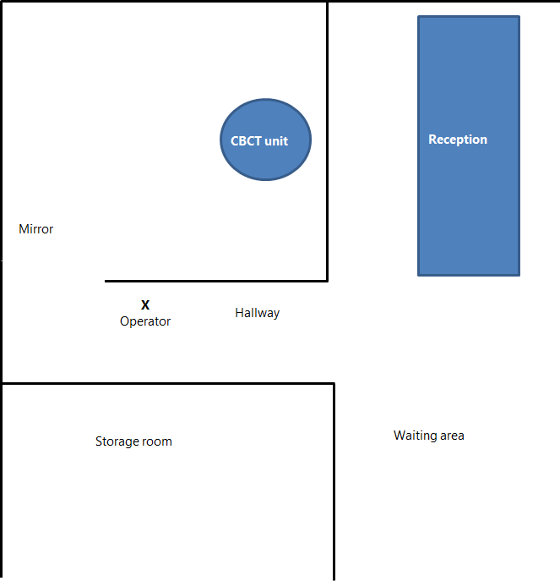

Appendix 2: Example risk assessment for a traditional dental facility

Purpose and scope
The holder of a source licence must conduct, document and keep up to date a risk assessment for the purpose of ensuring the adequacy of the protection and safety provisions.

Example
This example risk assessment is for a dental facility with several surgeries each with an intra-oral x-ray unit attached to a wall, and also has a panoramic x-ray unit in an alcove off the main passageway. The examples given are for illustrative purposes only and are not a comprehensive list of all possible exposures that could occur at a specific dental facility.

Hazard and person at risk | Likelihood and magnitude of exposure with protection and safety measures in place | Provisions for protection and safety
Exposure to operator during routine use | Likelihood: high  Magnitude: low | - Typical patient doses are assessed against appropriate diagnostic reference levels by the service technicians to ensure that doses are not excessive.  - Everyone positioned outside of 2m radius of X-ray unit or behind shielding equivalent to at least 18mm gypsum plasterboard when X-ray unit is in use  - Operator suitably trained  - No holding allowed by anyone of the X-ray tube head and/or image receptor  - Fast image receptor type in use  - The panoramic x-ray unit has 2mm lead primary barrier built into it behind the image receptor
Exposure to workers in surrounding occupied areas and public in the waiting area | Likelihood: high  Magnitude: low | - All such areas are much greater than 2m from the X-ray units and/or are behind shielding equivalent to at least 18mm gypsum plasterboard.  - Operator will not take a panoramic x-ray if there is anyone else in the main passageway, and if anyone approaches during the x-ray exposure will warn them to stop or will terminate the x-ray.
Exposure to patient | Likelihood: high  Magnitude: low | - Each radiological procedure is justified by the dental practitioner  - Quality assurance programme of the x-ray equipment, including three yearly performance testing by a service technician  - X-ray unit factors are adjusted for patients based on size  - Typical patient doses are assessed against appropriate diagnostic reference levels by the service technicians to ensure that doses are not excessive.  - Operator is able to see and communicate with the patient during the whole x-ray exposure. In some of the surgeries a mirror has been positioned in the corner of the room to allow this.  - Operator suitably trained  - Area of interest properly collimated  - X-ray tube head positioned as close as possible to patient for intra-oral x-rays.
Member of the public or workers walking into the controlled area during an exposure. | Likelihood: low  Magnitude: low | - Operator has a clear view of the surgery entranceway when intra-oral X-ray unit is in use.  - Operator has a clear view of the main passageway in both directions when the panoramic X-ray unit in use  - Deadman type exposure switch to stop X-rays immediately if required.
X-ray unit malfunction | Likelihood: low  Magnitude: medium | - Operator able to terminate exposure immediately  - Quality assurance programme of the x-ray equipment, including three yearly performance testing by a service technician  - Exposure lights on X-ray unit visible to the operator, plus there is an audible exposure warning
Member of public/worker in controlled area | Likelihood: low  Magnitude: low | - If patient support needed, preferred to have caregiver in room, rather than staff member  - Lead apron provided to any persons other than patient that needs to be within 2m of the X-ray when in use

Appendix 3: Example radiation safety officer appointment letter
29 December 2024

AB Dental Clinic Ltd
113 Main Street
BERTSVILLE

Dear Dr Alan J Smith

AB Dental Clinic Ltd appoints you to the role of radiation safety officer, as required by the radiation safety legislation, for our dental X-ray facility at AB Dental Clinic – Bertsville.

Kind regards

A Jones

Alice Jones
General Manger
Date: 29 December 2024

I accept this role:

A J Smith

Alan J Smith
Dentist
Date: 29 December 2024

Appendix 4: Assessment of typical patient doses from traditional dental X-ray units and comparison against DRLs

Purpose and scope
Comparison of typical patient doses with diagnostic reference levels (DRLs) is an important step in optimising medical exposures. This procedure sets out how to measure patient doses on intra-oral, panoramic and cephalometric dental X-ray systems, and how to compare them with DRLs. This procedure as an illustrative example is specific to a RaySafe Xi kV/dose meter system; for guidance on other brands of dose meters, please consult the manufacturer’s website.

In the case of cephalometric and CBCT dental X-ray units, New Zealand data does not currently exist so DRLs are suggested from Public Health England UK.

Assessment of patient doses against DRLs must be checked during compliance testing performed by the service engineer, and included in the test report provided.

Intra-oral systems
Patient dose on intra-oral dental X-ray units can be measured using a RaySafe Xi with an R/F sensor. The instrument measures the skin entrance surface exposure (ESE) to the patient’s face in mGy.

Sensor set-up and placement
- For best accuracy, centre the R/F high sensor perpendicular to the anode-cathode axis of the tube, at the end of the positioning cone plus the standoff distance from the patient’s face that the dentist may use for hygiene reasons, as shown in the photo.  - Set the sensor to R/F high.  - Trig delay – normally 0 ms, but can be increased to exclude a pre-pulse from the measurement.  - kVp delay – use to extend the kVp window past the filament pre-heat on units with slow rising output. Recommend 150 ms unless the exposure time is shorter, in which case reduce it to less than the exposure time minus the trig delay.  - Calc delay – not needed for dental, leave on 0 ms.  - Dose unit – Gy.  - kVp mode – kV/kVp. | Figure 2: Intra-oral set-up  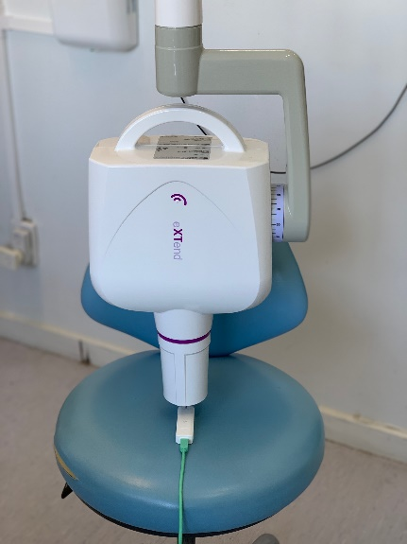

Taking the measurement
Set the exposure parameters (kVp, time, mA) to those most commonly used for a bitewing of an average adult (or for mandibular molar periapical if the dentist does not take bitewings). Take the exposure.

Comparison with diagnostic reference levels
Compare the ESE measurement in mGy to the values in the table below, taking into account the image receptor type and sensitivity.

Adult bitewing DRLs mGy
Image receptor | 60 kVp | 70 kVp
E or F speed film | 2.2 | 1.7
Digital systems | 1.4 | 1.2
Source: Unpublished New Zealand survey, 2017.

If the measurement exceeds the relevant DRL, further dose optimisation should be considered while maintaining diagnostic quality. In most cases this is easily achieved by lowering the exposure time; however, some systems allow the user to adjust the kVp upwards, allowing the mAs to drop. Additional factors such as computer display quality and ambient lighting should also be considered. In any case the image quality still needs to be diagnostically acceptable. With film-based systems, a high ESE can mean that the film is not being processed optimally and may need adjustment to ensure an appropriate film density.

Panoramic systems
The dose area product (DAP) of typical patient exposures from panoramic systems can be measured using a RaySafe Xi with either a CT sensor or an R/F sensor.

Sensor set-up and placement
The R/F sensor must be precisely aligned in the beam and this can be time consuming to set up. By far the most efficient method of measuring the DAP is to use a CT sensor.

RaySafe Xi with CT sensor  - Align the CT sensor perpendicular to the beam slit, with the beam positioned approximately in the centre as shown in Figure 3, and secure to the detector with tape, taking care to ensure the cord will not get snagged when the tube head rotates.  - Turn the unit on and expose the sensor; acquisition is automatic.  - The dose length product is displayed in mGy.cm.  - Multiply the dose length product by the image height in cm to convert to DAP in mGy.cm² for direct comparison with the DRL. | Figure 3: Panoramic set-up  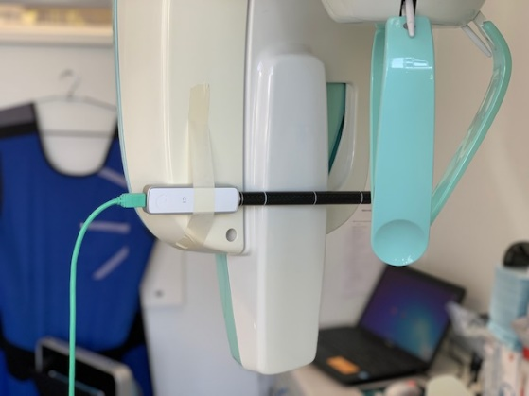

RaySafe Xi with R/F sensor alternative method
      - The receptor slit must be located on the unit. If this is not marked, it can be located using radiochromic film (or a strip of intensifying screen).
      - Place the R/F sensor so that the active detector area is completely intercepted by the X-ray beam.
      - Set the sensor to R/F high.
      - Take the exposure.
      - The dose is displayed in mGy; this needs to be multiplied by the slit width at the detector and image height (both in cm) to convert to DAP in mGy.cm² for direct comparison with the DRL.

Comparison with diagnostic reference levels
Compare the panoramic DAP measurement in mGy.cm² with the values in the table below.

Panoramic DRLs mGy.cm²
Adult panoramic | 93
Child panoramic | 67
Sources: Hart D, Hillier MC, Wall PC. 2007. Doses to Patients from Radiographic and Fluoroscopic X-ray Imaging Procedures in the UK – 2005 Review. Health Protection Agency. Hart D, Hillier MC, Shrimpton PC. 2010. Doses to Patients from Radiographic and Fluoroscopic X-ray Imaging Procedures in the UK – 2010 Review. Health Protection Agency.

Cephalometric systems
The dose area product (DAP) of typical patient exposures from cephalometric systems can be measured using a RaySafe Xi with an R/F sensor.

Sensor set-up and placement
- Place the R/F sensor so that the active detector area is completely intercepted by the X-ray beam.
- Set the sensor to R/F high.
- Take the exposure.
- The dose is displayed in mGy; this needs to be multiplied by the image width and image height (both in cm) at the detector to convert to DAP in mGy.cm² for direct comparison with the DRL.

Comparison with diagnostic reference levels
A DRL for cephalometric images was proposed in the UK of 35 mGy.cm².

CBCT dental X-ray units
A DRL for CBCT dental X-ray units was proposed in the UK of 265 mGy.cm² for imaging prior to the placement of maxillary molar implant. This assumes a field of view of approximately 5 cm × 5 cm or smaller. Therefore, for CBCT dental X-ray units that use a larger field of view, the DAP result should be normalised down to a field of view of 5 cm × 5 cm.

Appendix 5: Guidance on management systems

Purpose and scope
The holder of a source licence must establish a management system to enhance protection and safety that includes:
- effectively integrating protection and safety into the overall management system of the organisation
- making a commitment to protection and safety from the highest level of management at the facility, including by providing all required resources
- promoting continuous improvement and a safety culture
- delegating the planning and delivery of medical exposures to a dental practitioner
- delegating other tasks as appropriate, whether to radiation safety officers or other suitably qualified people
- consulting with and engaging the services of experts and other interested parties as necessary
- maintaining and enforcing local rules as appropriate.

Also, in the case of CBCT dental X-ray units, that management system must include:
- appointing a radiation safety officer to oversee the application of regulatory requirements for occupational and public radiation protection and safety
- ensuring that requirements for medical imaging, calibration, dosimetry of patients, quality assurance and the commissioning and acceptance of radiological equipment are fulfilled by, or under the oversight of, or with the documented advice of a medical physics expert whose degree of involvement is determined by the complexity of the radiological procedures and the associated radiation risks.

Guidance checklist of common issues
This checklist identifies some of the common issues that may need to be considered in the management system.

 | Item | Yes / No
Responsibilities and authorisations | Source licence
Responsibilities and authorisations | All workers taking X-rays have current annual practising certificates with appropriate scope of practice
Responsibilities and authorisations | X-ray service engineer licensed
Responsibilities and authorisations | Letter of appointment of radiation safety officer signed
Responsibilities and authorisations | Medical physicist licensed (for CBCT dental X-ray units)
X-ray unit inventory | Records of make, model, serial number and location for each X-ray unit
X-ray unit inventory | Compliance reports for each X-ray unit within previous three years from servicing engineer, including comparison of patient doses to DRLs (for traditional X-ray units)
X-ray unit inventory | Maintenance log
X-ray unit inventory | Commissioning compliance test report from medical physics expert (for CBCT dental X-ray units)
X-ray unit inventory | Medical physics expert shielding report verifying that room shielding is adequate (for CBCT dental X-ray units)
X-ray unit inventory | Compliance reports for each CBCT dental X-ray unit within previous three years from medical physics expert, including comparison of patient doses to DRLs (for CBCT dental X-ray units)
Radiation safety training | Requirements and records up to date such as copies of annual practising certificates and regular refresher training in using equipment and interpreting images
Local rules for radiation use | Rules for use of X-ray units at the facility reviewed and up to date, for example, operator position, controlling access to controlled areas
Local rules for radiation use | Justification protocols reviewed and up to date
Local rules for radiation use | Optimised exposure settings for each X-ray unit
Quality assurance programme | Quality assurance programme approved by the medical physics expert, including any changes (for CBCT dental X-ray units)
Quality assurance programme | Quality assurance check results and compliance reports reviewed by medical physics expert (for CBCT dental X-ray units)
Quality assurance programme | All quality assurance checks performed on time and records retained
Quality assurance programme | Risk assessment completed and up to date
Emergency procedures | Procedures on what needs to be done to ensure radiation safety in the case of an emergency, such as fire or earthquake, reviewed and up to date
Incidents and accidents | Procedures for investigating incidents and records of any incidents reviewed and up to date
Individual and workplace monitoring | Policy of who and where needs to be monitored reviewed and up to date and monitoring records up to date

Appendix 6: Guidance on patient doses
Effective dose is a term that is useful for describing the dose to the patient, as it allows for both the amount of the body irradiated and the radio sensitivities of the organs involved. It converts the actual dose distribution in the body (and its ensuing harm – that is, cancer and hereditary effects) into an equivalent uniform whole-body dose that would cause the same level of harm. It is measured by:
- the sievert (Sv)
- thousandths of a sievert (mSv)
- millionths of a sievert (μSv).

Skin entrance surface dose is a measure of the dose arriving at the patient but does not give a very good indication of doses to organs or to a person.

The effective dose from natural background radiation, to which everyone is exposed, is about 2,000 μSv per year.

The effective dose to the patient for one bitewing image taken at 60–70 kV is about 5 μSv. For panoramic X-ray images, the doses are about 25 μSv. For CBCT dental X-ray images, the doses are about 400 μSv. These can be compared with the annual dose from natural background radiation.

The dose to a fetus from a pair of bitewing images is equivalent to several hours of background radiation, or less than 1 percent of the natural background radiation received by the fetus during the nine months in utero.

There are no limits on the number of dental radiographs that can be taken. Before taking an exposure, the dentist needs to justify that there is sufficient clinical need for it.

The lifetime risk from radiation, of fatal and non-fatal cancer and severe hereditary effects, is currently estimated to be about 5.7 percent per sievert, according to the International Commission on Radiological Protection (ICRP). For a pair of bitewing images, the lifetime risk of harm is less than one in a million. This is about the same as smoking 1.4 cigarettes or flying about 1,000 km in a commercial airliner.

Figure 4: Typical radiation doses associated with some techniques or activities
* For complex examinations such as CT or barium enema exams, entrance surface dose is not meaningful.

Appendix 7: Guidance on intra-oral dental unit optimisation

Purpose and scope
This is a discussion of some of the many factors that affect the relationship between image quality and dose – namely, the effect of the peak kilovoltage of the X-ray tube; collimation; focus to skin distance; image receptor type; and the exposure time in intra-oral dental radiography.

Kilovoltage (kVp)

Defining the kVp
Kilovoltage (kVp) is the voltage that is used to accelerate electrons from the filament in the X-ray tube so that they hit the anode with sufficient energy to produce X-rays. The higher the kVp, the higher the average energy of the X-rays produced, making the X-ray beam more penetrating. And the higher the kVp, the more X-rays are produced for a given current and exposure time.

In the early days of intra-oral dental radiography, the kVp of the dental units was around 45 kVp. Since then, the value of the kVp used has increased slowly so that most units now operate in the range of 60–70 kVp.

How kVp influences dose
The production of the image requires a certain number of X-rays to have passed through the patient and to then interact with the image receptor. Higher-energy X-rays have a greater likelihood of reaching the image receptor, which in turn means that fewer X-rays are needed to be incident on the patient in the first instance. In other words, the skin entrance surface dose is higher for a low kVp technique than it is for a higher kVp technique.

To illustrate, the following table gives representative doses for a bitewing radiograph performed with a 200 mm positioning device at two different kVps for two types of image receptor. Note that these are the doses required to produce similar images.

Adult bitewing skin entrance surface exposure (mGy)
Image receptor | 60 kVp | 70 kVp
E or F speed film | 2.2 | 1.7
Digital systems | 1.4 | 1.2

How kVp influences image quality
The above table seems to suggest that continuing to increase the kVp would result in even further dose reduction. While this would be true, it would come at a cost – namely, in image quality. In particular, the contrast of the image is likely to become compromised: the high kVp beam produces a ‘flatter’ image where contrast is being suppressed because higher-energy X-rays are less suited to distinguishing any differences that might be in the tissues being radiographed.

The need for a compromise
The whole purpose of the X-ray examination is to obtain a diagnostically useful image. A kVp the is too high may give a very low dose, but if the image is not of sufficient quality then the dose is wasted. Conversely, a kVp that is too low may result in image quality beyond what is needed coupled with an unnecessarily high dose. A compromise is needed.

The kVp that is the best compromise
The kVp of the typical intra-oral X-ray unit is fixed by the manufacturer – having selected an X-ray unit, then the kVp cannot usually be adjusted. Currently the minimum kVp allowed to be used for intra-oral radiography in New Zealand is 60 kVp. Studies suggest that the use of a kVp in the range of 60–70 provides the best compromise, ensuring adequate image quality for an acceptably low dose.

Choosing an intra-oral X-ray unit with an operating kVp of 60–70 kVp, all other technique factors (apart from exposure time) being constant, will be the first step to ensuring that patients are not receiving more radiation than is necessary.

Collimation
When it comes to X-raying patients, the radiation protection equivalent of real estate’s ‘location, location, location’ is ‘collimation, collimation, collimation’. So why is restricting the X-ray beam to just the region of interest so important?

First, the larger the volume of tissue irradiated, the larger the effective dose to the patient. In particular, a larger than necessary beam may include particularly radiosensitive organs or tissues (such as the thyroid in the case of dental X-rays), whereas tight collimation would have excluded such organs.

Second, the larger the volume of tissue irradiated, the more scatter that is produced. Some of this increased scatter will reach the image receptor, leading to decreased image contrast. Furthermore, the increased scatter means that occupational doses will also increase, all other factors being equal.

Restricting the X-ray beam to just the region of the body that needs to be imaged results in better image quality, lower patient doses and lower occupational dose.

Collimation in dental X-rays
With medical X-ray units, the size of the X-ray beam is varied to suit the task by means of an adjustable light beam diaphragm. However, with dental X-ray units, the beam size is generally fixed. For intra-oral dental units, it is required that the X-ray beam at the tip of the positioning device has a diameter that does not exceed 6 cm.

Figure 5: Relative X-ray beam areas

Figure 5 illustrates relative X-ray beam areas for three situations: the positioning device is placed 20 mm from the patient’s skin (red area and inwards); the positioning device is placed against the patient’s skin (yellow area and inwards); and rectangular collimation is used (blue area and inwards). The relative patient effective doses would be approximately 120 percent, 100 percent and 50 percent respectively. Thus, the dose saving with rectangular collimation is significant.

To summarise, tight collimation results in lower patient doses, lower occupational doses and improved image quality compared with poor collimation. Dentists are encouraged to use rectangular collimation for intra-oral radiography, to further limit the X-ray beam dimensions.

Focus-to-skin distance (FSD)
Anyone who has worked with a variety of intra-oral dental X-ray units will have noticed that the length of the X-ray collimator ‘cones’ varies. These differences in ‘cones’ result in different focus-to-skin distances – typically in the range of 200–300 mm in New Zealand. Some dentists who have worked overseas will even have used units with a focus-to-skin distance of up to 400 mm.

Why focus-to-skin distances differ
Short FSDs were used on early dental X-ray units because these units were operated at low kVps (as low as 45 kVp in some cases) and hence the radiation output was low. The problem was to get enough radiation to produce diagnostic films for an acceptably short exposure time. This problem was compounded at the time by the availability of only relatively slow X-ray film. The solution was to reduce the distance from the focus to the skin, typically to 100 mm.

Since those early days, the operating kVp of dental units has steadily increased, with most new units in New Zealand now operating in the range of 65–70 kVp. Also advances in image receptor technology have resulted in image receptors that are much faster than the early films, requiring significantly less radiation to produce an image. These factors have allowed the use of much longer focus-to-skin distances.

The effects of different focus-to-skin distances
Figure 6: Effect of FSD
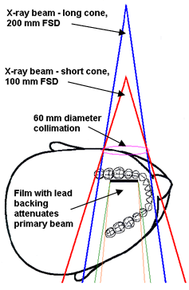

The FSD affects both the patient dose and image quality. The first effect is illustrated in Figure 6. With a short FSD, the volume of the patient’s head irradiated is significantly larger than for a long FSD. For the example of 100 mm (no longer permitted) and 200 mm FSDs, both with 60 mm collimation at the patient’s skin, the short FSD results in an increase in the irradiated volume of about 70 percent. An added factor with the larger volume being irradiated for the short FSD technique is that, for some projections, the primary beam may now include particular radiosensitive tissues or organs, such as the thyroid.

Another consequence of the need for an increased skin entrance surface dose for the short FSD technique is that more scatter is being produced. This scatter, due to the more divergent beam described above, may lead to higher occupational exposures.

To summarise, a longer FSD will result in lower patient doses; however an FSD that is too long may be too unwieldly to use and make more retakes necessary. An FSD of 200–300 mm gives a reasonable compromise.

Image receptor type
The first dental radiographs were taken only a few weeks after Roentgen announced his discovery of X-rays. These first radiographs used silver halide emulsions to form the image in much the same way as film today but, rather than the sub-second exposure times of today, required exposure times as long as 25 minutes! Since then, technological advances have occurred at irregular intervals – including the use of emulsion on both sides of the film base, the development of more sensitive emulsions and advances in the shape and size of the crystals in the emulsion, and now digital imaging systems are becoming the norm.

If the dose that would have been used in the early 1900s with the advent of double emulsions is assigned an arbitrary value of 100 units, then by the time D speed film was widely available in the 1950s the relative dose was 8 units. Current F speed film and digital image receptors require about 3 units.

When changing from D speed to F speed film and digital image receptors, the technique factors for an exposure will change. On many X-ray units, this is a simple matter of selecting an exposure time of about one-half of that used with D speed film. However, for X-ray units with anatomical selection, an internal adjustment is likely to be required, necessitating the presence of the X-ray service technician.

In summary, the fastest image receptor available should be selected to allow shorter exposure times, which leads to lower patient doses. Digital image receptors are the fastest type of image receptor available and can require less than half the dose of D speed films, which are no longer considered acceptable

For digital image receptors, appropriate displaying of images must be considered. Monitors for viewing digital images should be placed to avoid light from doorways and windows, which can create glare or reflections, reducing the visibility of the displayed image. Monitors should be kept clean from dust and checked for artifacts such as dead pixels, to ensure images are not obscured.

The monitor chosen should be capable of displaying high-quality images at a relevant resolution and contrast. For specific monitor performance requirements of CBCT dental X-ray units, refer to the monitors and hardcopy devices section in Appendix 2 of ORS C1.

Exposure time

Effect of changing the time
Intra-oral X-ray units in New Zealand have very few ‘knobs’ or settings that can be changed. The kVp is fixed in most units, as is the mA (tube current), but the exposure time can be varied either directly by selecting the value of the time required or indirectly by selecting the icon or icons (for example, tooth symbol, patient size) required. Changing the time simply changes the number of X-rays being produced – for example, doubling the exposure time doubles the number of X-rays.

An acceptable exposure time
As a starting premise, exposure times should be as short as possible. The main reason for this is to minimise the chance of patient movement during the exposure as any motion will result in loss of sharpness in the image. The maximum allowed exposure time is 1 second, but under normal circumstances exposure times for all types of intra-oral radiography should be able to be much less than this. Digital systems may be able to use exposures that are as low as 0.1 seconds. The actual value will obviously depend on the interplay of the factors discussed above. As a starting point for a new or changed X-ray system, the X-ray unit’s owner’s manual and film or digital receptor manufacturer should give guidelines for exposure times. The service engineer will be able to help refine exposure times further.

Appendix 8: Warning signs

Purpose and scope
Below are a suitable wall notice for querying if a patient may be pregnant, which is to be placed inside a CBCT dental X-ray room (Figure 7), and a radiation warning sign for the entrances to a CBCT dental X-ray room (Figure 8).

Figure 7: Pregnancy notice
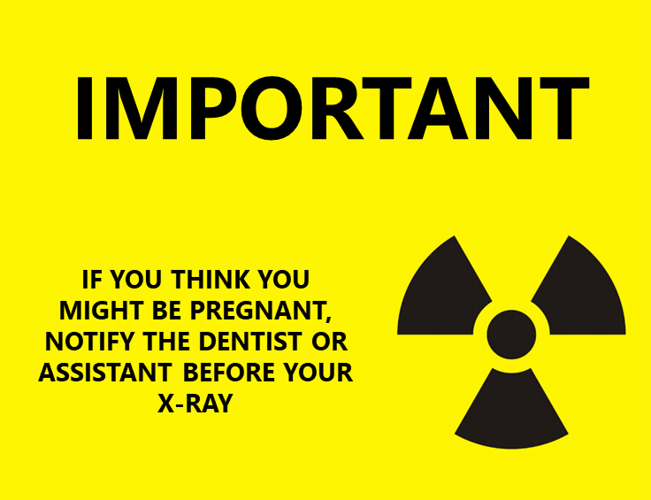

Figure 8: Radiation warning sign
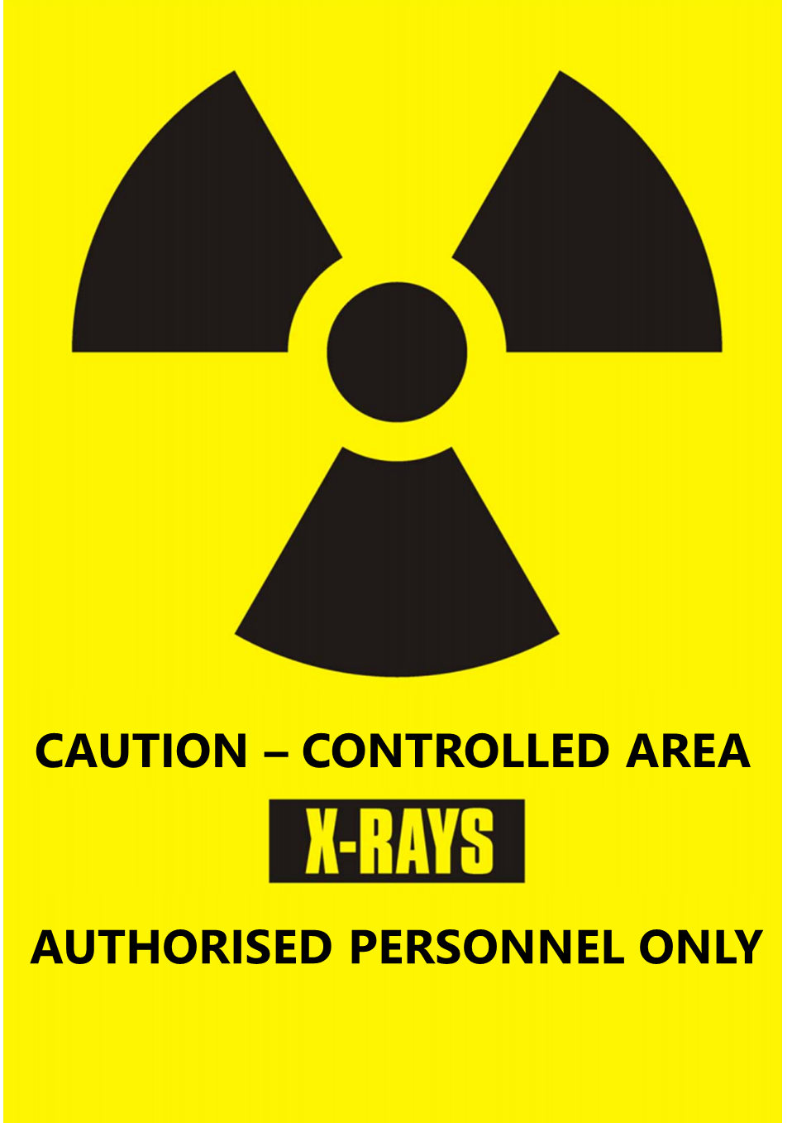

Khong P-L, Ringertz V, Donoghue D, et al. 2013. ICRP Publication 121: Radiological protection in paediatric diagnostic and interventional radiology. Annals of the ICRP 42(2).
European Commission. 2004. Radiation Protection 136: European guidelines on radiation protection in dental radiology. The safe use of radiographs in dental practice. Luxembourg: Office for Official Publications of the European Communities.
To ensure accuracy of the measurement, it is important to ask the dentist what standoff distance they typically use, to record this, and to use the same distance when positioning the sensor to measure ESE. The standoff distance must be as short as is practicable; if the standoff distance is more than 1 centimetre, the dentist should be advised to reduce this in order to ensure the dose is optimised.
The fastest film speed should be used where possible, and at least E or F speed film.
If the X-ray system displays a DAP, this measurement can also be used to check the accuracy of this displayed value.
Holroyd JR, Smith JRH, Edyvean S. 2020. Dose to Patients from Dental Radiographic X-ray Imaging Procedures in the UK – 2017 Review. London: Public Health England.
Holroyd et al (2020), above note 6.

