Requirements for conformity assessment bodies that conduct certification audits of providers holding contracts with Health New Zealand , Ministry of Social Development - Disability Support Services – and/or the Accident Compensation Corporation to provide home and community support services.

Home and Community Support Services Conformity Assessment Bodies: Auditing Requirements
Ngā Paerewa Health and Disability Services Standard: NZS 8134:2021
Acknowledgments
This is the second edition of the Home and Community Support Services Conformity Assessment Bodies: Auditing Requirements. It is adapted from the previous handbook for the home and community support sector, NZS 8158:2012, which was first published in October 2012 and revised in May 2017 and July 2023.
The Ministry of Health – Manatū Hauora partnered with Health New Zealand – Te Whatu Ora, Ministry of Social Development - Disability Support Services – and the Accident Compensation Corporation to write and review this handbook.
Citation: Ministry of Health. 2025. Home and Community Support Services Conformity
Assessment Bodies: Auditing Requirements: Ngā paerewa Health and disability services
standard NZS 8134:2021. Wellington: Ministry of Health.
Published in October 2025 by the
Ministry of Health
PO Box 5013, Wellington 6140, New Zealand
ISBN 978-1-991324-56-6 (online)
HP 9142
This document is available at
health.govt.nz

This document is available at
Auditing Requirements: Ngā paerewa Health and disability services standard NZS 8134:2021 Ministry of Health

Preface
Home and community support services (HCSS) providers that hold a contract with Health New Zealand – Te Whatu Ora, Ministry of Social Development -Disability Support Services – and/or the Accident Compensation Corporation must be certified against Ngā paerewa Health and disability services NZS 8134:2021 (Ngā Paerewa). This document guides the certification auditing scheme.

In 2015, an HCSS oversight committee was formed to support the ongoing development of this certification scheme. It is made up of funder representatives and representatives from HealthCERT within the Ministry of Health – Manatū Hauora. One of the key changes the Oversight Committee made in 2016 was to make it easier to process HCSS audit reports through an electronic database – the Provider Regulation and Monitoring System (PRMS). Using the PRMS will make it possible to identify national trends in audit outcomes across HCSS providers with a view to developing quality improvement initiatives with the sector.

This is a revision of the 2012 document Auditing Requirements: Home and Community Support Sector Standard NZS 8158. It is designed to assist conformity assessment bodies conduct certification audits of HCSS service providers. The audit requirements for certification are set out in Ngā Paerewa. The specific focus of this document is to facilitate consistent delivery of certified HCSS across Aotearoa.

The Oversight Committee will determine and agree any changes to the auditing requirements in consultation with stakeholders, and will be responsible for amending this document.

In 2021, the Ministry of Health reviewed the potential to regulate HCSSs under the Health and Disability Services (Safety) Act 2001. Following consultation with stakeholders and extensive review, it was decided not to regulate HCSSs but instead to strengthen the mechanisms for quality assurance within the existing certification scheme. The Ministry of Health intends to review the possibility of regulation in the future.

Contents
Preface iv
1 Introduction 1
1.1 Oversight Committee 1
1.2 Independent Assessment Committee 1
1.3 HealthCERT 2
2. Conformity assessment bodies 3
2.1 Approved conformity assessment bodies 3
2.2 Responsibilities of a conformity assessment body 4
2.3 Audit teams 5
2.4 Auditor days on site 6
2.5 Sampling methods 7
2.6 Reporting requirements 8
2.7 Audit costs 9
2.8 Provider regulation and monitoring system 10
3. Audit 11
3.1 Attainment level 14
3.2 Evaluation methods 14
3.3 Risk management 14
4. Certification 17
4.1 Certification period 17
4.2 Certification conditions 17
4.3 Certification document 17
4.4 Monitoring 18
4.5 Additional sites 18
4.6 Sale of a certified organisation 19
4.7 Audits of lead suppliers and subcontractors 19
References 20
Appendix 1: Process of certification for the home and community support sector 21
Appendix 2: Square root table 22

1 Introduction
This document sets out what conformity assessment bodies (CABs) that audit and certify providers of home and community support services (HCSSs) must do to audit and certify these providers against Ngā paerewa Health and disability services standard NZS 8134:2021 (Ngā Paerewa). It also outlines the roles of other stakeholders operating within the certification scheme, including the Oversight Committee, the Independent Assessment Committee (IAC: section 1.2 outlines the role of this body) and HealthCERT.

1.1 Oversight Committee
The Oversight Committee was established in 2015. It is primarily made up of representatives from the Ministry of Health and HCSS funders (ie, Health New Zealand, Disability Support Services and the Accident Compensation Corporation).

The committee provides oversight and direction to the HCSS certification scheme, to improve sector outcomes. It identifies national trends based on audit reports and processes audit reports processed through an electronic database, the PRMS. Over time, PRMS data will build a national picture of the main areas of non-conformity across HCSSs. This information will give us the opportunity to work with the sector on key areas for improvement.

From an operational perspective, the Oversight Committee:
- meets with CABs on an annual basis
- meets with the IAC on an annual basis
- provides advice to the IAC where required
- seeks expertise from CABs or providers as issues arise.
- holds contact lists for HCSS funders and makes them available to CABs
- receives HCSS auditing schedules from CABs and shares them with HCSS funders. It is up to funders to confirm whether CABs wish to request that specific sites or providers be included in their auditing sampling.

The Oversight Committee is not responsible for CABs’ operational activities.

See Appendix 1 for a flowchart of the process involved in certifying HCSS providers.

1.2 Independent Assessment Committee
The role of the IAC is to conduct an independent review of each audit report and decide whether to endorse the decision to award certification, noting that CABs are responsible for final certification decisions (in line with ISO/IEC 17021-1: Conformity assessment – requirements for bodies providing audit and certification of management systems (ISO/IEC 17021-1)).

The IAC is made up of funder representatives. Each funder nominates at least one representative to participate as a member (one for each Health New Zealand region). To be a member of the IAC, the nominated representative must understand Ngā Paerewa and the certification process relevant to this scheme. The IAC follows terms of reference that the Oversight Committee reviews each year.

If the IAC has an issue about the quality of audit documentation or process, it can raise this with the relevant representative from the Ministry of Health (HealthCERT), and the issue can be escalated to the Oversight Committee. HealthCERT will facilitate the process as part of its administrative function of the Oversight Committee.

1.3 HealthCERT
The Oversight Committee has agreed that HealthCERT will coordinate and administer the HCSS audit framework on behalf of funders. HealthCERT’s role is to:
- maintain a central repository and collation point for audit reports, audit summaries and progress reports for corrective actions
- manage audit report workflow using the PRMS
- manage and maintain the web page for publishing audit summaries once this process has been developed and approved. Audit summaries will only be published if they meet the Ministry of Health’s publication standards
- channel communications between each CAB and the IAC as they review certification audit reports
- undertake other administrative functions as agreed by the Oversight Committee, including the receipt and dissemination of auditing schedules from CABs to funders and the maintenance of the HCSS funder list to be made available to CABs.

2. Conformity assessment bodies
The requirements set out in this document apply to audits of HCSS providers that hold contracts with Health New Zealand, Disability Support Services and/or the Accident Compensation Corporation. These contracts require HCSS providers to demonstrate through certification that they are complying with Ngā Paerewa.

In addition to the contractual requirement for HCSS providers to hold certification, a funder may undertake or commission other audit and monitoring activities within the terms and conditions of its contract with a provider.

If a CAB meets the requirements in this document, funders can be assured that it follows a robust and consistent process when undertaking audits and providing audit reports that lead to the certification of HCSS providers.

Once an approved CAB audits and certifies a HCSS provider, that provider meets the certification requirements in its funder contract. Providers may become certified against standards by non-approved CABs, but those providers will not meet certification requirements in funder contracts.

The requirements in this document supplement:
- ISO/IEC 17021-1
- ISO 19011: Guidelines for auditing management systems.
Except where otherwise stated, all elements of ISO/IEC 17021-1 apply.

Additional documents that apply to these requirements are:
- Ngā Paerewa
- ISO/IEC 17000: Conformity assessment – Vocabulary and general principles.

2.1 Approved conformity assessment bodies
A CAB may audit against Ngā Paerewa if it:
- meets the requirements in this document
- complies with the following International Accreditation Forum (IAF) documents:
- ISO 19011: Guidelines for auditing management systems
- IAF MD1: IAF Mandatory Document for the Audit and Certification of a Management System Operated by a Multi-Site Organization
- IAF MD2: International Accreditation Forum Mandatory Document for the Transfer of Accredited Certification of Management Systems
- IAF MD5: International Accreditation Forum Mandatory Document for Duration of Quality Management Systems and Environmental Management Systems Audits
- is a designated auditing agency as authorised under the Health and Disability Services (Safety) Act 2001
- holds third-party accreditation with either the Joint Accreditation System of Australia and New Zealand or the International Society for Quality in Health Care (ISQua) for Ngā Paerewa, and meets all costs associated with this accreditation. If a CAB is ISQua accredited, it must also demonstrate that, as a minimum:
- it reports progress annually to ISQua
- ISQua conducts a two-yearly surveillance audit of it.

A CAB that meets the criteria listed above is an ‘approved CAB’.

If a funder asks for a copy of a CAB’s third-party accreditation certificate, the CAB must provide it. CABs must work to the auditing principles and code of ethics outlined in the Designated Auditing Agency Handbook (Ministry of Health 2023).

2.2 Responsibilities of a conformity assessment body
As a CAB, you are responsible for:
- meeting the requirements outlined in ISO/IEC 17021-1
- coordinating audit activities with the provider such as:
- ensuring the provider’s certification can continue where the provider achieves compliance
- planning the audit
- conducting the audit
- writing the audit report
- establishing that the provider’s certification status is consistent with this document, ISO 19011 and ISO/IEC 17021-1
- contacting the funders before an on-site audit (as part of sampling plan and audit planning) to seek feedback about issues and concerns
- Giving the provider a copy of any funder feedback seven days before the audit
- submitting the audit report to HealthCERT, which will engage no fewer than two IAC members to review the audit report
- providing a draft of the audit report that covers any specific additional contractual requirements that the funder has paid you to audit
- submitting an electronic audit report using a specified template into the PRMS
- notifying funders in writing as soon as practicable (ideally at the time of audit, but within 24 hours of completion of the audit) where the audit identifies critical or high risks; and/or notifying funders where a cumulative number of corrective actions delay the awarding of certification. For national providers, all funders must be informed of critical or high risks irrespective of whether the audited site was in their region
- monitoring the provider throughout the certification period in line with surveillance requirements and any progress reporting that is required as a result of the audit
- notifying funders if the provider’s progress against corrective actions is inadequate and submitting a record of progress monitoring into the PRMS
- providing the Oversight Committee with an annual audit schedule, commencing 29 January each year, and an update of this schedule on a quarterly basis.

2.3 Audit teams
The audit team must follow the principles of auditing set out in:
- ISO/IEC 17021-1
- the Designated Auditing Agency Handbook (Ministry of Health 2023).

The members of the audit team must be competent in areas appropriate to the service they are auditing. The team must have enough auditors to complete the audit against all relevant criteria in the standards.

The audit team must include a:
- team leader (or lead auditor) who is familiar with person-centred, restorative HCSS models of care
- clinical/technical expert in the delivery of HCSS who has:
- a qualification in nursing or allied health services and current annual practising certificate, or a rehabilitation qualification and/or home care auditing experience
- experience in medication management (within an HCSS setting)
- consumer auditor when this is a contractual requirement.

Auditors have developed sufficient knowledge and skills in quality management if they have achieved as a minimum:
- a recognised auditing qualification (eg, New Zealand Qualifications Authority unit standard 8086 and
- two years’ work experience in the health and disability sector, unless they are a consumer auditor.

Clinical/technical experts must have at least two years’ work experience in HCSS or related fields, or have experience in auditing home care services.

The team leader and clinical/technical expert may be the same person and fulfil the roles and responsibilities of both if they meet the criteria for both roles.
A consumer auditor may be a qualified auditor or a person who has been trained in auditing principles (but is not necessarily qualified as an auditor) and is a person with a disability and lived experience of receiving residential services or HCSS or a family member of such a person. Where a consumer auditor is qualified as an auditor, they may take on audit functions in addition to their consumer role as outlined in the Designated Auditing Agency Handbook.

If a team of two or more is performing an audit, each team member does not have to meet all the competency criteria for the area of activity involved. However, the team as a whole must meet all the competency criteria.

The requirements for audit team competency apply to all types of audits.

A team leader can conduct a surveillance audit if they are experienced in auditing home care services and, as a minimum, have access to the CAB’s clinical/technical advisor. In this case, a consumer auditor need not be involved.

As a CAB, you must have procedures for establishing the ongoing competence of your auditors, including auditors in the roles of team leader, clinical/technical expert and consumer auditors. There must also be a process for reviewing the performance of each auditor at least once a year; for example, through periodically observing each auditor’s performance on site. Base the frequency of such observations on the need you identify from all monitoring information available.

2.4 Auditor days on site
The time the certification audit should take depends on the size, nature and complexity of the organisation you are auditing. Calculate the time required on site to satisfactorily complete the audit with the following in mind:
- 50 percent of your time will likely be spent on preparing for the audit (stage 1) and completing the audit report (all audits).
- For a certification audit, two auditors should be on site for:
- 1.5 days (or equivalent), for a single-site provider.
- 0.5 days for each additional site audited, for multi-site provider.
- For a surveillance audit, one auditor should be on site for:
- one day (or equivalent), for a single-site provider
- 0.5 days, for each additional site audited for a multi-site provider.

2.5 Sampling methods
The following sampling requirements apply to consumer record reviews and interviews, and sampling of multiple sites.

Minimum sample size – consumer record reviews
You should review consumer records as part of the on-site audit. Ideally, the records you review will be those of the consumers you interview.

Decide on the minimum sample of consumer record reviews using the square root rule, as follows.
- Certification audit consumer record sample = 0.6 times the square root of the number of current consumers receiving HCSSs (rounded to a whole number). Exception: If a service has fewer than 10 consumers, review a minimum of three records. For multi-site providers with more than 2,500 consumers, review a minimum of five records at each site, ensuring a total sample size of at least 30.
- Surveillance audit consumer record sample = 0.3 times the square root of the number of current consumers receiving HCSSs (rounded to a whole number). Exception: If a service has fewer than 50 consumers, review a minimum of three records. For multi-site providers with more than 2,500 consumers, review a minimum of five records at each site, ensuring a total sample size of at least 30.

Stratify sampling so it is representative of:
- current consumers receiving HCSSs (stratified to complex, non-complex, short term, long term and so on)
- service agreements between the provider and its funders.

Increase the sample size if you identify non-conformity with the standard.

Minimum sample size – consumer interviews
The number of consumers you should interview as part of the audit process depends on the size, nature, complexity, internal quality monitoring of consumer satisfaction and funding arrangements of the provider you are auditing. Decide on the minimum sample using the same 0.6 x square root rule for certification and surveillance audits as set out for consumer records above. Include whānau in the minimum sampling requirements for consumer interviews, as outlined in the Designated Auditing Agency Handbook (Ministry of Health 2023).

Conduct face-to-face interviews with consumers as part of the sample for certification audits. In addition, you may conduct telephone interviews or surveys.

Increase the sample size for face-to-face consumer interviews if you identify non-conformity.

Minimum sample size – multiple sites
Decide on the minimum sample for multi-site reviews using this square root rule:
- certification audit site sample = square root of the number of sites
- surveillance audit site sample = 0.6 times the square root of the number of sites.

We expect that you will rotate the sites you audit within a three-year period (initial certification audit, surveillance audit and next certification audit) so that you audit the maximum possible number of individual sites the multi-site provider operates.

Funders may ask you to include or exclude their region or a particular regional site in your sampling plan for any audit. These requests must be provided within five days of requesting funder feedback, to enable audit planning.

2.6 Reporting requirements

Evidence
You may use your own audit tools and workbooks to audit against Ngā Paerewa. As part of the process of collecting audit evidence, consider using standardised assessment and outcome tools consistent with the service delivery aspects of Ngā Paerewa, as required under a provider’s contract with its funder.

Audit reports
For all audit reports, the following guidelines apply.
- Use the prescribed template to complete the report.
- The writer must be the audit team leader for all audits, including verification visits.
- Include:
- the reporting requirements outlined in ISO/IEC 17021-1
- the level of compliance against each criterion for each outcome in the standard as set out in the auditing requirements for each type of audit
- an executive summary for each standard, stating whether the provider achieved attained, partially attained or unattained for each criterion, and identifying criteria that were not met
- details of non-conformities, with supporting evidence
- where criteria have not been achieved, corrective actions that are specific, measurable and relevant, with a timeframe
- the areas covered by the audit (eg, services provided and locations, satellite services, departments, processes, number and types of interviews conducted) and observations made, both positive (eg, noteworthy features) and negative (eg, opportunities for improvement)
- opportunities for improvement where criteria have been fully attained and the auditors have noted further actions that the provider could take to maintain continuous improvement.
- Make sure the report reflects the findings of the audit.
- Present the report in word-processed format.
- Follow the Audit Report Writing Guide (Ministry of Health 2014).

Allow funders to review and comment on the draft audit report where it relates to any specific additional contractual elements, before you finalise the audit report. Allow funders seven working days to come back to you with comments.

Submit final audit reports electronically into the PRMS and copy them to funders. Submit a final report no later than eight weeks following the on-site audit, unless you identified further actions the provider needs to take before you can award certification.

The Ministry of Health intends to publish audit summaries on its website. Audit summaries must meet the Ministry of Health’s publication standards, and the provider must agree with the final audit summary before submitting the report into the PRMS. You must have a process for dealing with situations where you and a provider cannot agree on the audit summary.

2.7 Audit costs
Funders are not liable for the cost of certification audit services.

If a funder asks you to include additional criteria in an audit specific to a service agreement that it holds with a provider, the funder will negotiate appropriate payment for this with you before the audit starts. This payment is likely to be a set price based on a time requirement the funders and you have already worked out and agreed on.

If a funder asks you to include a particular site within the sample for the audit, you must include this without increasing the cost of the audit, unless you cannot accommodate the additional site within the sampling equation (see ‘Minimum sample size – multiple sites’ in Section 2.5).

2.8 Provider regulation and monitoring system
You must:
- access the PRMS via a connection to the New Zealand health network, Connected Health
- securely manage user-specific log-ins and passwords for the PRMS
- use the PRMS to download provider-specific audit reporting templates to complete audits
- use the PRMS to upload completed audit reports
- complete the prescribed form in the PRMS that maintains an up-to-date register of auditors who undertake audits on your behalf. An auditor must not undertake an audit on your behalf if you have not entered them onto the auditor register
- ensure the lead auditor/team leader and a peer reviewer have reviewed all audit reports before you submit them to the PRMS. The peer review process must include:
- proofreading the report
- ensuring the report is factual and accurate
- ensuring the audit activities conducted were technically adequate and properly documented
- ensure the report follows the guidelines set out in the Audit Report Writing Guide (Ministry of Health 2014).

3. Audit
The three types of audits of HCSS providers are:
- certification audit
- verification audit
- surveillance audit.
- Provisional audit

For each audit, you must undertake the activities listed in Table 1.

Table 1: Audit activity required by audit type
Type of audit | Description of audit | Audit activity required | Result
Certification audit | An audit of an organisation providing HCSS seeking certification against Ngā Paerewa | Conduct a first-stage audit, considering any revised or new policies and procedures against Ngā Paerewa.  Conduct a second stage on-site audit against Ngā Paerewa. | Conformity assessment body issues three-year certificate
Verification audit | Adding an additional premise into an existing certificate  Adding an additional scope of practice  Changing premises or making significant changes to premises | The provider shall notify the CAB prior to the establishment of the new site.  A risk-based approach should be taken.  If a surveillance or certification audit is scheduled within the next six months, the following process applies:  - The provider warrants that governance, systems, processes, policies and procedures are substantially the same as the current service and provides the following information:  - management changes/adaptations for the move  - management of the logistics of the move  - adjustments to policies and procedures  - planned process flow for the service delivery.  At the next surveillance or certification audit (conducted within the next six months), the new site/s will be included in the sample and the governance information previously provided will be verified.  If a surveillance or certification audit is not planned within the next six months, a verification audit should be conducted. The verification audit should include all HCSS Ngā Paerewa subsections/criteria in scope. | New site added to existing certificate. Dates do not change
Surveillance audit | An audit of an HCSS near the midpoint date of its certification period – the surveillance audit occurs in the window two months either side of this date | Conduct an on-site audit of:  - non-conformities identified at the certification audit  - changes that have occurred since the certification audit  - the following Nga Paerewa subsections/criteria  1.3 My Rights during service delivery  - 1.3.1  - 1.3.2  - 1.3.3  - 1.3.4  - 1.3.5  1.5 I am protected from abuse  - 1.5.1  - 1.5.2  - 1.5.3  - 1.5.4  1.8 I have the right to complain  - 1.8.1  - 1.8.2  - 1.8.3  - 1.8.4  - 1.8.5  2.1 Governance  - 2.1.1  - 2.1.2  - 2.1.3  - 2.1.4  2.2 Quality and risk  - 2.2.2  - 2.2.4  - 2.2.6  2.3 Service management  - 2.3.1  - 2.3.2  - 2.3.3  - 2.3.4  2.4 Healthcare and support workers and their availability  - 2.4.2  - 2.4.3  - 2.4.4  3.1 Entry and declining service  - 3.1.2  - 3.1.3  3.2 My pathway to wellbeing  - 3.2.1  - 3.2.2  - 3.2.6  - 3.2.7  4.2 Security of people and workforce  - 4.2.3  - 4.2.6  5.2 The infection prevention programme and implementation  - 5.2.3  - 5.2.6 | certification monitoring
Provisional audit | An audit of a new ‘start-up’ provider (prior to services being provided to clients) or an existing private provider seeking a public funded contract | Conduct a full certification audit against as much of the standard as possible. A substantial amount will be rated as ‘not audited’, particularly ‘My pathway to wellbeing’.  Award certification for one year, and impose a condition of certification that a full certification audit be conducted within 12 months of services being provided. If the full certification audit confirms that the standards are substantially complied with, certification can then be confirmed – the original certification dates and requirements for surveillance and corrective action reporting will remain in place. | Full certification awarded, provisional upon a full certification audit within 12 months of commencing service delivery

3.1 Attainment level
As part of the audit process, you must decide on the level of attainment the provider achieves for each relevant criterion. The levels of attainment are based on a continuous quality improvement model, so are incremental (see Table 2).

Table 2: Meaning of the attainment levels
Attainment level |  | What it means
CI | Continuous improvement | The service has attained the criterion and demonstrates a review process, including:  - analysing and reporting findings  - demonstrating evidence that it has acted based on those findings  - improving service provision and consumers’ safety or satisfaction as a result of the review process
FA | Fully attained | The service demonstrates implementation (eg, practice evidence, training, records or visual evidence) of the process, systems or structures it has in place to meet the required outcome
PA | Partially attained | There is evidence that the service has implemented an appropriate process (eg, a policy, procedure or guideline), system or structure without having the required supporting documentation  Or  A documented process (eg, a policy, procedure or guideline), system or structure is evident, but the organisation or service cannot demonstrate that it has implemented it
UA | Unattained | The organisation or service cannot demonstrate appropriate processes, systems or structures to meet the required outcome
NA | Not applicable | The criterion does not apply to the service

In your audit report, record the lowest attainment level finding for each of the criteria and outcomes you are reporting on.

3.2 Evaluation methods
Auditors record evaluation methods used in their field notes. They triangulate audit evidence where possible.

3.3 Risk management
Identify the degree of risk to consumers’ safety associated with the level of attainment the provider achieves for each criterion. Audit the ‘risk’ in relation to its possible impact on the consumer, based on the consequence and likelihood of harm occurring if the provider does not fully attain the criterion. Use the risk management matrix (Figure 1 below) when the audit result for any criterion is partially attained or unattained.

To use the risk management matrix, undertake the following process.
- Consider what consequences for consumer safety might follow from the provider achieving ‘partially attained’ or ‘unattained’ for a criterion, within a range from extreme/actual harm to negligible risk of harm occurring.
- Consider how likely it is that this adverse event will occur due to the provider achieving ‘partially attained’ or ‘unattained’ for a criterion, within a range from being almost certain to occur to rare.
- Plot the findings on the risk assessment matrix to identify the level of risk, which may range from critical to negligible, and prioritise risks in relation to severity (eg, critical to negligible).
- Approve the appropriate action the provider must take to eliminate or minimise risk within the timeframe in the ‘action required’ section (Figure 1). Note that timeframes are set based on full resolution of the requirement, which may include a systems change or staff training programme. State anything requiring urgent attention in your report, and specify a longer timeframe the provider needs to make sustainable change, if appropriate.

Risk management matrix The Risk Management Matrix (table 4) should be used when the audit result for any criterion is partially attained (PA) or unattained (UA).
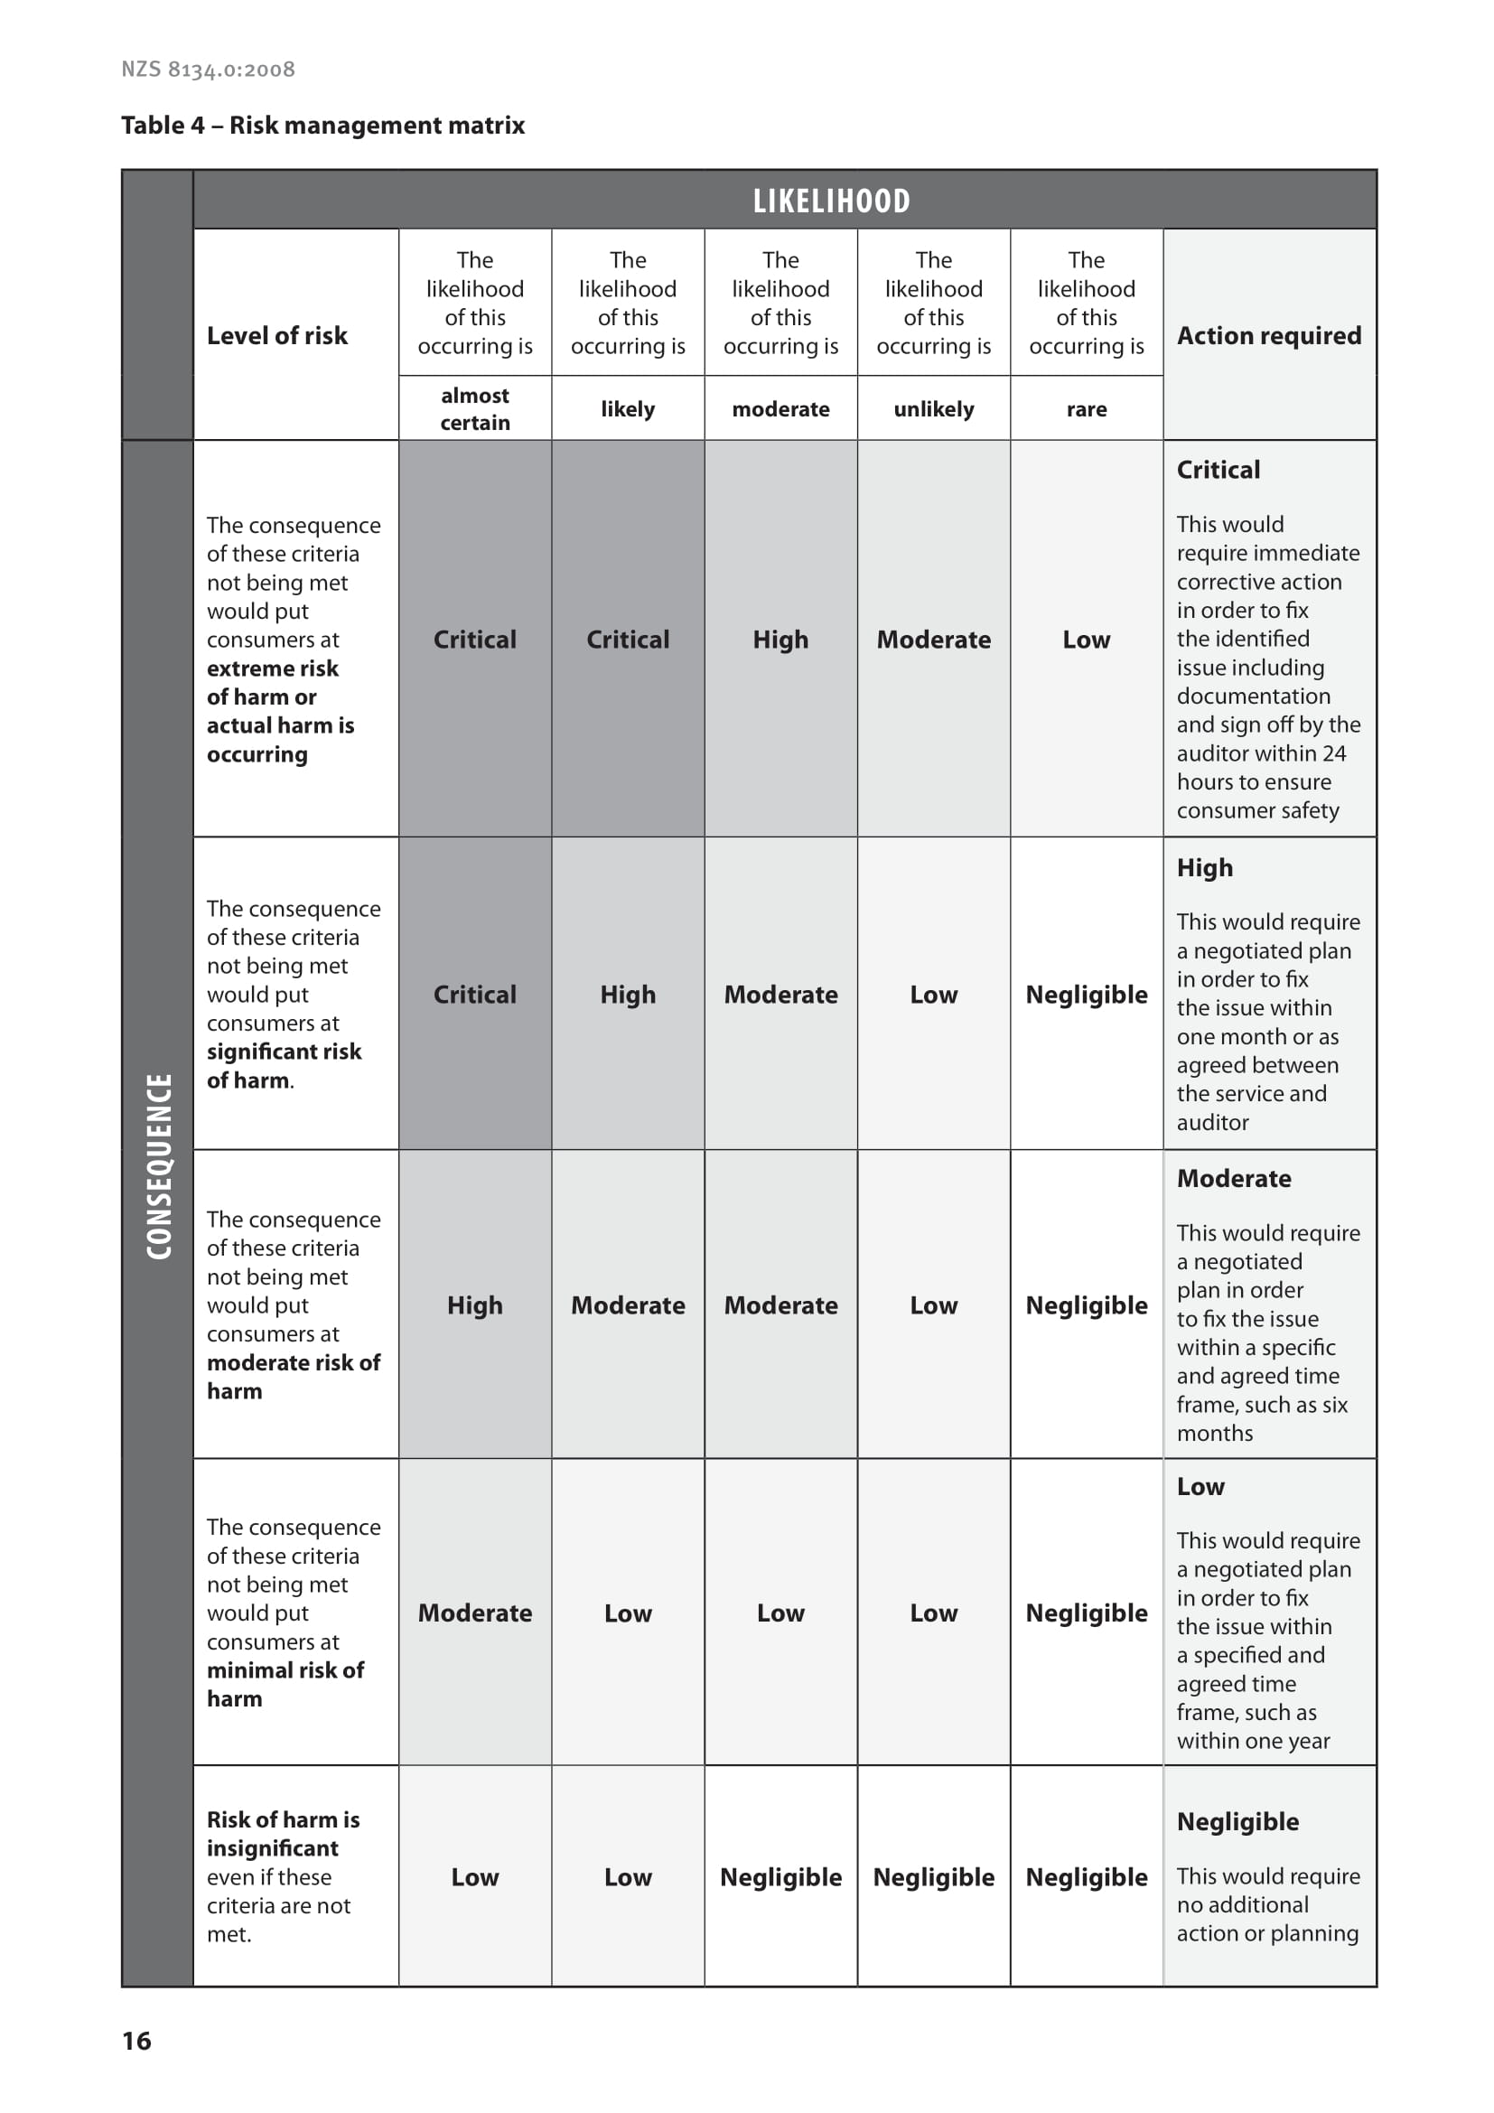

4. Certification
Follow a two-stage certification decision process, as follows.
- A team leader experienced in auditing HCSS conducts a systematic peer review of the audit report. The peer review includes associated audit evidence (that is, field notes, workbooks or tools) where a report is ambiguous. The peer reviewer must be independent of the original audit. After the peer reviewer has completed the peer review, the CAB recommends either certification or delaying certification pending completion of corrective action requirements.
- An IAC made up of two funder representatives conducts an independent review of the audit report and decides whether to endorse the decision to award certification. The IAC has seven working days to respond to and provide feedback on the audit report.

If the audit finds a critical risk or a recurring high-risk, the auditing agency should immediately contact the funder(s) and seek an agreement about certification.

You must decide on certification and notify the provider of your decision within eight weeks of completing the audit. You must specify an appeal process consistent with ISO/IEC 17021-1

4.1 Certification period
The certification period is three years from the date of the certification decision. A provider must undergo at least one on-site surveillance audit near the midpoint date of its certification period to maintain its certification. Findings are actioned in line with the risk management matrix (see Figure 1 in Section 3.3). This surveillance audit can be scheduled two months either side of the midpoint.

If a provider has a ‘critical’ or residual high level of risk and certification proceeds, you may, in liaison with the funder, require additional surveillance activities. This may include on-site visits or yearly surveillance audits.

4.2 Certification conditions
With each certificate you issue, include conditions of certification based on risks that the audit has identified. These conditions may include requirements for the provider to make written progress reports of corrective actions or for you to verify corrective actions on site and to conduct an annual surveillance audit or other progress monitoring.

4.3 Certification document
Notify the provider of your audit report and give it a copy of the report and a certification document that includes the information ISO/IEC 17021-1 requires.

Keep an up-to-date record of all the provider’s sites that have met the certification requirements. You must date certification documents from the date of your formal decision to award certification.

4.4 Monitoring
Monitor the HCSS provider during the period of certification to ensure it:
- has addressed any non-conformity that you identified at the time of the certification or surveillance audit
- is maintaining its systems and processes.

Implement procedures to ensure that the provider takes corrective action in line with the risk management matrix (see Figure 1 in Section 3.3). These procedures may include requiring a written progress report from the provider or making an on-site verification visit.

If the provider does not correct a particular non-conformity in the timeframe agreed at the audit, and to be consistent with the risk management matrix, you:
- may suspend certification
- must notify the funders before any such suspension
- Must notify the Oversight Committee of any suspensions of certification.

Make your monitoring reports available to funders. Funders may work with you in monitoring requirements that result from audits.

4.5 Additional sites
When a provider plans to add another satellite (eg, a regional site) to an existing service that holds certification, they must apply to you to complete a verification audit within six months of establishing the additional site. You must issue certification to match the expiry of the current certificate that the provider holds.

The provider must notify you before adding the new site and confirm in writing that its governance, systems, processes, policies and procedures are substantially the same as those in the current service.

4.6 Sale of a certified organisation
The current provider owns the certification. If a new organisation buys a certified organisation, it may keep that certification for a maximum of six months (unless the certification period expires before this date). The buyer organisation shall have a CAB complete a certification audit within six months of taking possession.

You may withdraw or suspend certification where it has been transferred with the sale of an organisation if the systems and processes for operational management or quality and risk management differ substantially from those in the certified organisation. Before doing this, however, you must liaise with the relevant funders of the new organisation.

4.7 Audits of lead suppliers and subcontractors
In an audit of a lead supplier of HCSSs, consider how that supplier manages quality and risk management systems, its organisational management and how consistently it delivers services across its subcontractors.

In auditing a lead supplier against Ngā Paerewa, establish whether that supplier:
- has a process for subcontractor organisations to implement policies and procedures that are consistent with the lead supplier’s policies and procedures
- collects high-quality monitoring information from its contractors and subcontractors and has a mechanism for regularly communicating issues with its contractors and subcontractors.

Subcontractor organisations must be certified against Ngā Paerewa and demonstrate how they share information with a lead supplier. If a lead supplier is a supply chain management organisation providing services in the capacity of a lead supplier, it needs to be certified against Ngā Paerewa.

References
IAF. 2007a. IAF Mandatory Document for the Certification of Multiple Sites Based on Sampling. Issue 1, Version 2. IAF MD1:2007. Quebec: International Accreditation Forum.
IAF. 2007b. IAF Mandatory Document for the Transfer of Accredited Certification of Management Systems. Issue 1. IAF MD2:2007. Quebec: International Accreditation Forum.
IAF. 2015. IAF Mandatory Document for Duration of QMS and EMS Audits. Issue 3. IAF MD5:2015. Quebec: International Accreditation Forum.
ISO. 2003. Guidelines for Auditing Management Systems. ISO 19011:2011. Geneva: International Organization for Standardization.
ISO. 2004. Conformity Assessment: Vocabulary and general principles. ISO/IEC 17000:2004. Geneva: International Organization for Standardization.
ISO. 2011. Conformity Assessment: Requirements for bodies providing audit and certification of management systems. ISO/IEC 17021-1:2015. Geneva: International Organization for Standardization.
Ministry of Health. 2014. Audit Report Writing Guide: A guide for writing audit reports to the Ministry of Health. Wellington: Ministry of Health.
Ministry of Health. 2023. Designated Auditing Agency Handbook: Manatū Hauora (Ministry of Health) Auditor Handbook. Wellington: Ministry of Health.
Standards New Zealand. 2012. Home and Community Support Sector Standard. NZS 8158:2012. Wellington: Standards New Zealand.
Standards New Zealand. 2021. Ngā Paerewa Health and Disability Services Standard. NZS 8134:2021. Wellington: Standards New Zealand.

Appendix 1: Process of certification for the home and community support sector
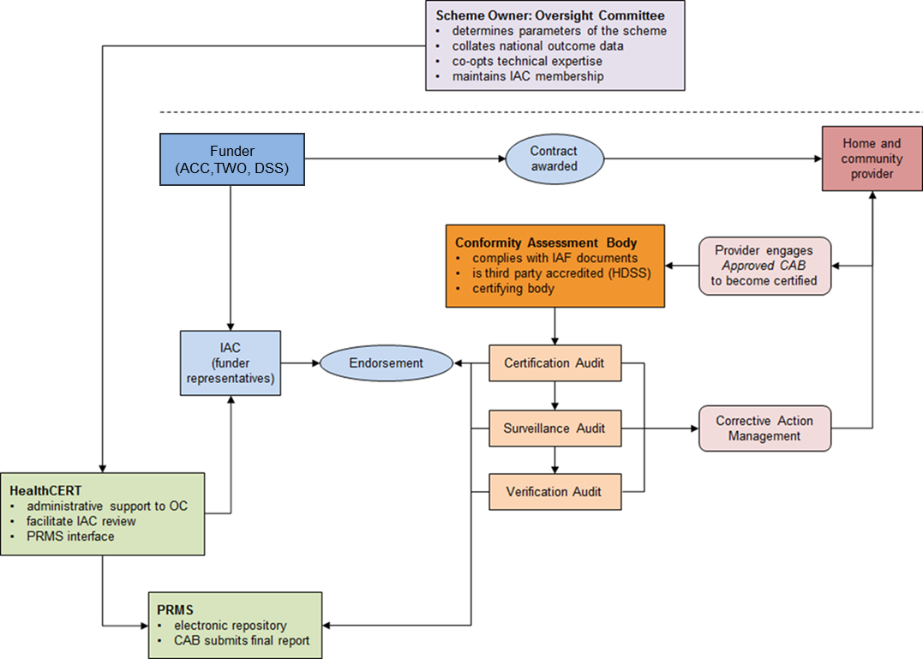

Key:
ACC Accident Compensation Corporation
DSS Disability Support Services
TWO Te Whatu Ora – Health New Zealand
OC Oversight Committee

Appendix 2: Square root table
Use this guide to check you have followed the square root rule correctly. Note: round up numbers with decimal points to the next whole number.

Number of home and community support service clients currently receiving support | Square root calculation of sample size
 | 0.6 times the square root  Certification | 0.3 times the square root  Surveillance
10 | 3  (minimum requirement;  square root rule does not apply) | 3  (minimum requirement;  square root rule does not apply)
20 | 3 | 3  (minimum requirement;  square root rule does not apply)
30 | 4 | 3  (minimum requirement;  square root rule does not apply)
40 | 4 | 3  (minimum requirement;  square root rule does not apply)
50 | 5 | 3
100 | 6 | 3
150 | 8 | 4
200 | 9 | 5
250 | 10 | 5
300 | 11 | 6
350 | 12 | 6
400 | 12 | 6
450 | 13 | 7
500 | 14 | 7
750 | 17 | 9
1,000 | 19 | 10
1,250 | 20 | 11
1,500 | 20 | 12
1,750 | 20 | 13
2,000 | 20 | 14
2,500+ (multi-site) | minimum of five records at each site ensuring a total sample size of at least 30 | minimum of five records at each site ensuring a total sample size of at least 30

A certification scheme defines the process and criteria for deciding whether a service meets specific criteria.
HealthCERT regulates overnight health services in line with the Health and Disability Services (Safety) Act 2001.
Certification, Surveillance, Verification and Provisional audits
See Appendix 2 for an example of sampling based on the square root rule.
Notification to the Oversight committee can be made to HealthCERT via the certification email inbox: certification@health.govt.nz
A lead supplier holds a service agreement with a funder. The lead supplier may, if its service agreement allows, subcontract services to an independent party where that independent party has a contractual arrangement with the lead supplier (and not with the funder directly).

