New Zealand

Eating Issues and Eating Disorders Strategy

Citation: Ministry of Health. 2025. New Zealand Eating Issues and Eating Disorders Strategy. Wellington: Ministry of Health.
Published in September 2025 by the Ministry of Health
PO Box 5013, Wellington 6140, New Zealand
ISBN 978-1-991324-50-4 (print)
ISBN 978-1-991324-51-1 (online)
HP 9139

This document is available at health.govt.nz
 | This work is licensed under the Creative Commons Attribution 4.0 International licence. In essence, you are free to: share ie, copy and redistribute the material in any medium or format; adapt ie, remix, transform and build upon the material. You must give appropriate credit, provide a link to the licence and indicate if changes were made.

Foreword
I am pleased to deliver the refreshed New Zealand Eating Issues and Eating Disorders Strategy.

Eating disorders are serious and often life- threatening conditions that have the potential to cause real harm to individuals and their families.

There is clear evidence that we are experiencing an increase in the number of people who are battling an eating disorder. This is a worrying trend that is reflected internationally. It increases demand for treatment and puts additional pressure on our mental health and addiction services.

I welcome the opportunity to deliver a refreshed strategic approach to eating disorders in New Zealand. Our previous strategy was published over 16 years ago and no longer meets the needs of our communities.

Our current eating disorders services are doing great work across the country. This Strategy outlines a pathway towards supports that are available early and services with
the capacity and capability to respond to growing demand.

My vision is for a full continuum of treatment and support, aligned with my four priorities to:
- strengthen the focus on prevention and early intervention
- increase access to services for eating disorders across the continuum, including by involving and supporting families, whānau and carers
- improve the effectiveness of supports and the use of data on eating disorders
- grow and develop our specialist health and eating disorders workforces, so that they are trained to confidently understand and respond effectively to eating issues and eating disorders.

Work is underway to grow and utilise the peer support workforce, which includes professionals with lived experience who can help people within the health system. We will build on this and focus our efforts on where they can have the most impact. This will include improving our understanding of the drivers behind eating disorders through better monitoring and data collection.

To support the implementation of the Strategy, Health New Zealand is increasing investment in the eating disorders continuum by over $4 million each year. This will bring the total investment in eating disorders services to over $23 million per year.

This new funding package includes ongoing investment to:
- roll out peer support to all regional eating disorders services
- create sustainable, community-based support for families, whānau and carers
- increase the capacity of specialist eating disorders services
- expand prevention and early intervention support.

A number of individuals and organisations have contributed to the development of this Strategy. They include people with lived experience, Eating Disorders Association of New Zealand, Eating Disorders Carer Support New Zealand, Te Tira Wānanga Māuiui Kai Executive (expert Māori rōpū), the national Eating Disorders and Eating Issues Advisory Group, and frontline services and clinicians providing expert eating disorders care.

I want to acknowledge that this Strategy is a first step towards refreshing New Zealand’s strategic approach to eating issues and eating disorders. It provides a clear roadmap for how we can improve outcomes for New Zealanders and their families.

Hon Matt Doocey
Minister for Mental Health and Associate Minister of Health

Contents
Foreword iii
Overview and actions 1
Purpose and vision 1
What is out of scope 2
Issues to address and desired outcomes 2
Roadmap of initial actions and further opportunities 4
Supporting information 6
Impact of eating disorders 6
Strategic context and principles 6
Defining eating issues and eating disorders 7
Experiences of eating disorders 8
Data on prevalence, incidence and hospital admissions 10
Feedback received through targeted engagement on eating disorders 12
Current state of eating disorders services in New Zealand 13
References 16

List of Figures
Figure 1: Number of publicly funded eating disorder inpatient discharges, 2016–2024 10
Figure 2: Number of referrals to eating disorders teams and percentage of declined referrals by referral end year, 2016–2024 11

List of Tables
Table 1: Experiences of population groups within New Zealand 9

Overview and actions

Purpose and vision
The purpose of the Eating Issues and Eating Disorders Strategy (the Strategy) is to provide the strategic approach for New Zealand to move towards a full continuum of eating disorders care. The system should be resourced to reflect national and local population needs, as well as being responsive to cultural and contextual differences. A full continuum of care includes prevention and public health promotion initiatives, earlier intervention and increased availability of community supports, timely access to effective eating disorders treatment, and a range of support options for families, whānau and carers.

Additionally, this Strategy:
- sets out our understanding of eating disorders in New Zealand and provides a clear picture of the current problems experienced by: people and their families, whānau and carers; our health and wider workforces; and the eating disorders system
- analyses evidence, feedback and data to provide insights and direction on the key focus areas for eating disorders and how they align with Government priorities
- describes the current state of activities and investment related to eating disorders, which helps identify the gaps and what is needed to shift us closer to our desired outcomes
- includes an action-oriented roadmap that outlines an initial set of actions towards these outcomes across the first 6–18 months as well as potential opportunities that can be progressed over the next five years.

The successful implementation of this Strategy will move New Zealand towards our vision where:
- People and their families, whānau and carers are able to access treatment and supports that respond to their unique needs and contexts. They are fully included in their own recovery and that of their family and whānau.
- Specialist eating disorders workforces, health workforces and other relevant workforces are trained to confidently understand and respond effectively to eating issues and eating disorders.
- An eating disorders system of care covers the full continuum of treatment and support, spanning early intervention through to specialist community and inpatient services. This includes prevention and public health promotion initiatives to minimise and prevent the risk factors associated with developing eating issues and eating disorders.

What is out of scope
While strongly informed by New Zealand’s eating disorders services and workforces, this Strategy is not an operational policy document. It does not include:
- an operational service plan to commission and deliver eating disorders services and different workforce roles
- clinical guidelines on the effective clinical treatment modalities and approaches for assessing and treating eating disorders
- a review of the current operational settings for eating disorders through the hub-and- spokes model of regional eating disorders services.

Health New Zealand – Te Whatu Ora (Health New Zealand) provides operational policy, including for commissioning and delivering eating disorders services. For this reason, the Ministry of Health – Manatū Hauora will work in partnership with Health New Zealand to refresh and implement our strategic approach for eating disorders.

Issues to address and desired outcomes
The following intervention logic outlines problems related to the current approach to eating disorders care. These include the need for a greater focus on prevention; increasing demand and pressure on services; limited family, whānau and carer involvement and support; the need for ongoing workforce training; and issues with the collection and monitoring of data. The initial list of potential actions that follows highlights the focus areas that will contribute to achieving the outcomes we are seeking.

We developed this view based on an analysis of the available evidence and data, along with feedback through targeted engagement. While not exhaustive, it highlights the areas of high priority and alignment with Government priorities.
Current problem | Intervention | Desired outcome
There is a need for a greater focus on the prevention of eating disorders across all relevant agencies and sectors | Support prevention initiatives that address the risk and protective factors associated with eating disorders  Work with relevant agencies and sectors on collaborative initiatives to prevent eating disorders and to improve the responsiveness of existing initiatives | Agencies work together to minimise and prevent the risk factors that contribute to eating disorders, and protective factors are promoted
Demand for eating disorders services is increasing due to the rising prevalence of eating issues and disorders, unmet need and existing service pressures | Build a full continuum of care across early intervention, community support, and specialist treatment and inpatient services  Support regional specialist eating disorders services and additional inpatient capacity that correspond to needs | A full continuum of care is available, meaning that people receive eating disorders support earlier, and specialist treatment is available at the right level when they need it
Families, whānau and carers are not fully involved in family members’ treatment and receive little extra support | Support family, whānau and carer organisations to provide guidance, support and resources  Develop and implement guidelines and expectations for family, whānau and carer involvement | Families, whānau and carers are involved in the care of family members and receive appropriate support
Specialist eating disorders workforces and wider workforces need ongoing relevant training to respond to and treat eating disorders | Provide specialised training based on current best- practice evidence for treating eating disorders  Provide eating disorders training for workforces interacting with children and young people to upskill in early intervention and screening | Specialist eating disorders services, health workforces and other relevant workforces are trained to confidently understand and respond to eating disorders
New Zealand prevalence data is limited and known gaps exist in our understanding of the services people access for eating disorders treatment | Investigate ways of better understanding prevalence for children and young people in particular  Undertake a system mapping exercise as a step towards improving data collection on eating disorders services | New Zealand has up-to- date data on the prevalence of eating disorders, and a clearer understanding of the services provided to people experiencing an eating disorder

Roadmap of initial actions and further opportunities
 | Government priorities
 | Prevention and early intervention  Strengthen focus on prevention and early intervention | Access  Increase access to services for eating disorders
Eating disorders focus area | Prevent eating disorders and intervene earlier for people experiencing eating issues | Increase access to support and treatment for people experiencing eating disorders and their families, whānau and carers
Initial action areas  (short term) | - Update Children and Young People’s Dietary Guidelines (3–17 years) based on best available evidence and include sensitivities to eating disorders  - Adapt existing eating disorders safe principles to the New Zealand context  - Support a cross-sector approach to social media to protect the safety and wellbeing of young people | - Complete the rollout of Budget 2022 investment for regional eating disorders services and review its effectiveness  - Review availability and role of inpatient beds for children, young people and adults with eating disorders  - Explore the role of community supports specific to eating disorders  - Review availability and use of eating disorders liaison clinician roles across the country
Future opportunities  (medium to long term) | - Provide school-based programmes for media literacy and body image  - Explore the role of food insecurity programmes as protective factors  - Improve availability of early intervention for eating, drinking and swallowing support for children  - Work across sectors to design wellbeing initiatives that reflect what we know about preventing eating disorders  - Develop and launch a public health campaign to address stigma and misunderstandings | - Increase the capacity and capability of regional specialist eating disorders services  - Develop Kaupapa Māori services and interventions based on local and population needs  - Sustainably support community organisations that are supporting families, whānau and carers  - Provide for the mental health, financial and relationship needs of families, whānau and carers  - Increase availability of community supports  - Explore availability and use of digital treatment options

 | Government priorities
 | Effectiveness  Improve the effectiveness of supports and the use of data on eating disorders | Workforce  Grow and develop the eating disorders workforce
Eating disorders focus area | Improve understanding of and support for priority populations and under- served conditions | Provide opportunities for specialist eating disorders services, health workforces and other relevant workforces
Initial action areas  (short term) | - Map the current eating disorders system to understand the continuum of care and gaps and identify resources to reflect local population needs  - Provide high-quality resources and guidance for under-served conditions, for example, binge eating disorder and avoidant/restrictive food intake disorder (ARFID)  - Ensure national eating disorders leadership is representative of the eating disorders sector | - Introduce new peer support roles in eating disorders services and explore how organisations and training opportunities support these new roles  - Expand opportunities for specialist workforce training  - Develop and deliver train-the-trainer training for ARFID  - Develop cultural competencies for working with high-needs groups, including Māori and Pacific peoples
Future opportunities  (medium to long term) | - Review the current level and availability of eating disorders services to support the unique needs of population groups  - Include eating disorders within the child and youth mental health and addiction prevalence survey  - Enhance the connection between eating disorders treatment services and general medical inpatient services  - Support research opportunities in eating disorders  - Review regional variation in referral pathways and models of care for ARFID | - Increase the availability of and access to workforce development specific to ARFID  - Deliver ongoing training for general practitioners, primary care professionals, allied health and mental health professionals (including health improvement practitioners)  - Provide evidence-based psychological therapies training for eating disorders followed by ongoing professional supervision  - Provide training for workforces in settings outside health, including education

Supporting information

Impact of eating disorders
Eating issues and eating disorders – ngā māuiui kai are complex and diverse conditions that can have serious and far- reaching effects on the lives of people experiencing them, as well as on their family and whānau (Cleland et al 2023).

Eating disorders can have significant impacts on someone’s physiological and psychological health and wellbeing, their relationships with family, whānau and friends, and their day-to-day education and employment.

In serious cases, eating disorders can be life threatening. They are associated with higher mortality rates than other mental health challenges due to a high incidence of physiological complications and an increased risk of self-harm and suicidal behaviours (Crow et al 2009).

International evidence estimates high economic and social costs are associated with eating disorders. For example, one study calculated these costs to be $66.9 billion in Australia in 2023 (Butterfly Foundation 2024).

Strategic context and principles
This Strategy is part of the strategic context in the wider health system, which includes the Government Policy Statement on Health 2024–2027 (Minister of Health 2024). This Strategy aligns with the following principles.
- People with lived experience are included at all levels across national leadership, workforce development, and eating disorders service delivery.
- Evidence-informed interventions and initiatives are grounded in the best evidence currently available to ensure high-quality treatment approaches.
- Person- and family-centred care is available for all New Zealanders, and includes tailored treatment to address the range of factors and needs of different population groups.
- Services and models of care are culturally responsive and safe.
- The health system is committed to upholding the rights of patients, families and whānau.
- Trauma-informed treatment and support recognises co-occurring conditions and the need for ongoing recovery and relapse prevention.

Defining eating issues and eating disorders
This Strategy uses definitions of eating issues and eating disorders that acknowledge
that people’s experiences exist across a continuum of severity and acuity and that people may experience highly distressing eating issues. While some eating issues may not meet the full criteria for an acute eating disorder diagnosis, a person still requires support through early intervention and prevention-focused supports in order to reduce the likelihood of them developing an acute eating disorder.

It is important to provide specialist treatment and support for people experiencing an eating disorder and their family and whānau in order to restore positive health and social outcomes. This Strategy affirms that recovery from eating issues and eating disorders is achievable with timely treatment and support, while recognising that recovery is not always linear or a final destination. People may experience ongoing changes in their relationship with food but can still live well.

This Strategy also uses the mātauranga Māori conceptualisation of ngā māuiui kai. Ngā māuiui kai is to be out of balance or out of sorts in relation to food and to eating (Fraser et al 2024). Ngā māuiui kai is an inclusive definition that acknowledges New Zealand’s unique experiences and cultural contexts regarding eating disorders for both Māori and for all New Zealanders. It also deepens our understanding of eating disorders to incorporate the range of factors that contribute to eating disorders and acknowledges the relationships that people have with each other and with their environments.

People may experience a range of eating disorders across a continuum of severity regarding different symptoms and behaviours. Disorders include, but are not limited to:
- anorexia nervosa – māuiui whakatiki, associated with restrictive eating behaviours
- bulimia nervosa – pukuruaki, associated with purging behaviours
- binge eating disorder – māuiui kaihoro, associated with lack of control related to overeating
- avoidant/restrictive food intake disorder – karo kai, associated with food avoidance.

Eating disorders can often co-occur with other conditions including anxiety disorders, major depressive disorder, obsessive- compulsive disorder and autism.

Experiences of eating disorders
Research evidence shows that eating disorders affect all population groups in New Zealand, including people of all body types, genders, ages, levels of socioeconomic status and cultural backgrounds.

There are observed differences in experiences of eating disorders between population groups (see Table 1) as well as differences within the same population groups. These findings reflect the intersecting nature of many people’s experiences, environments and contexts.

Contributing factors
Many factors can contribute to the development of eating disorders, including:
- genetics
- family, whānau and intergenerational influences
- personality characteristics
- individual differences
- experiences of trauma and stress
- sensory sensitivities
- a need for routine or for sameness
- body image concerns
- poverty and socioeconomic drivers
- food insecurity
- use of social media
- challenging relationships
- cultural norms associated with thinness and muscularity
- availability of weight-loss drugs
- cultural views and behaviours towards food.

Table 1: Experiences of population groups within New Zealand
Māori | Māori experience a greater rate of eating disorders and other co-occurring mental health conditions than non-Māori and can face greater barriers to accessing support for eating disorders. Māori and their whānau also report that treatment can privilege non-Māori perspectives of eating disorders, which contributes to a lack of cultural understanding and lack of access to appropriate services and practices that understand Māori experiences of eating disorders (Baxter et al 2006; Clark et al 2023; Fraser et al 2024; Lacey et al 2020).
Young people | A large proportion of people experiencing eating disorders in New Zealand and internationally are younger people. Research shows that eating disorders are emerging at younger ages and are becoming more common among young people (López-Gil et al 2023).
Asian people | People from Asian communities are at greater risk of some types of eating disorders. Influences include combinations of cultural norms, acculturative stress, mental health stigma and body image concerns (Chan et al 2010; Wales et al 2017).
LGBTQ+ | LGBTQ+ populations experience a higher prevalence of eating disorders and disordered eating behaviours compared with their heterosexual and gender- binary peers (Nagata et al 2020; Parker and Harriger 2020).
Pacific peoples | Pacific communities experience different types of eating disorders due to cultural body ideals that differ from mainstream western norms. Services should consider different presentations for eating disorders within Pacific communities (McCabe et al 2011).
Neuro- divergent people | Neurodivergent people experience a higher risk of eating disorders with unique challenges influenced by sensory processing differences, executive function challenges, social communication difficulties, and unique interests (Cobbaert et al 2024; Herle et al 2025).
Men and boys | Men and boys often experience underdiagnosis, undertreatment, and the impacts of misconceptions that eating disorders only affect certain genders. Social pressures and body ideals can contribute to body dissatisfaction in men and can promote disordered eating (Hansson and Schmidt 2025).
Older adults | Eating disorders are often associated with life stage and transitions including pregnancy, relationship issues, illness and retirement. There is an increased risk for women in part related to the menopause transition (Baker et al 2019).
Rural and remote residents | There are limited specialist eating disorders services available, particularly for people living in rural and remote areas outside of urban centres. This means some people may have to relocate away from support networks  to access specialist care, and regions differ in how much appropriate community care is available for people when they return home.
Refugees and migrants | Refugee and migrant experiences include body image dissatisfaction, acculturative stress, and pressures associated with the adoption of new or different cultural standards and eating habits (Tempia Valenta et al 2024).

Data on prevalence, incidence and hospital admissions
- Global lifetime prevalence for eating disorders is 8.4% for women and 2.2% for men. The total combined international prevalence for eating disorders increased from 3.5% to 7.8% between 2000 and 2018 (Galmiche et al 2019).
- Prevalence data for eating disorders in New Zealand is outdated. The available data shows a lifetime prevalence of 1.7% for the population overall, and 3.1% for Māori (Oakley Browne et al 2006).
- It is highly likely that the prevalence of eating disorders in New Zealand is similar to the current prevalence being reported internationally. This is reflected indirectly in local data showing service use is increasing over time, services are reporting being at capacity, waiting lists and wait times are longer, and the number of declined referrals has increased.
- Based on up-to-date international prevalence data, around 400,000 New Zealanders may experience an eating disorder in their lifetime (approximately 7.5% of the population).

Publicly funded eating disorder inpatient discharges
Figure 1 presents data on the number of publicly funded discharges of inpatients with eating disorders each year from 2016 to 2024.
- This data includes medical and paediatric inpatient admissions, and the small number of beds specifically for eating disorders inpatients. Most people will access general medical inpatient beds for stabilisation.
- Inpatient data shows an increasing trend over time, with a spike in 2020 during the COVID-19 pandemic due to limited support options available outside of inpatient services.
Figure 1: Number of publicly funded eating disorder inpatient discharges, 2016–2024
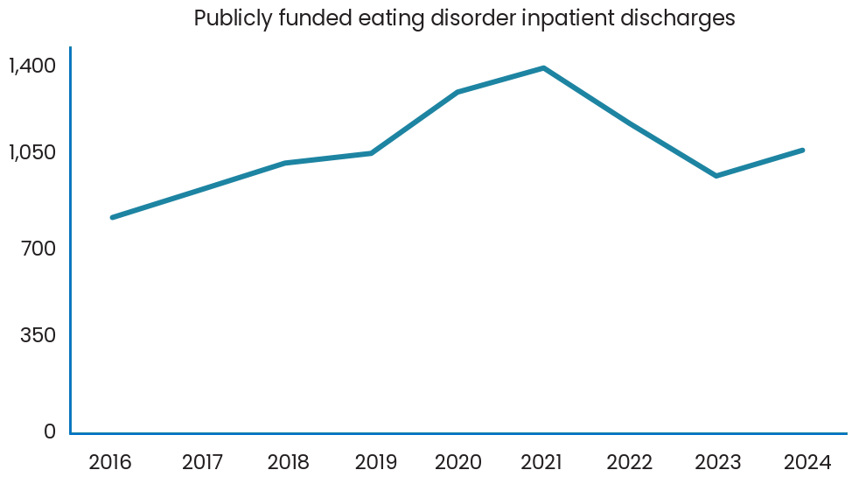

Referrals to eating disorder teams
Figure 2 presents data on the number referrals to eating disorders teams (dedicated eating disorder services in either a community or residential setting) and the percentage of declined referrals each year from 2016 to 2024.
- The data shows the total number of referrals by the year a person was discharged from an eating disorder service (referral end year). It is obtained through the Programme for the Integration of Mental Health Data (PRIMHD) national data collection.
- Approximately 1,800–2,000 people access publicly funded eating disorders services each year. Of those, roughly three-quarters are young people aged 0–24 years.
- The percentage of declined referrals can signal unmet need for eating disorders support, as this shows people who may not meet the criteria for specialist eating disorders services.
- Specialist services are often at capacity and focus on people with the highest needs; this has flow-on effects for inpatient treatment services.
Figure 2: Number of referrals to eating disorders teams and percentage of declined referrals by referral end year, 2016–2024
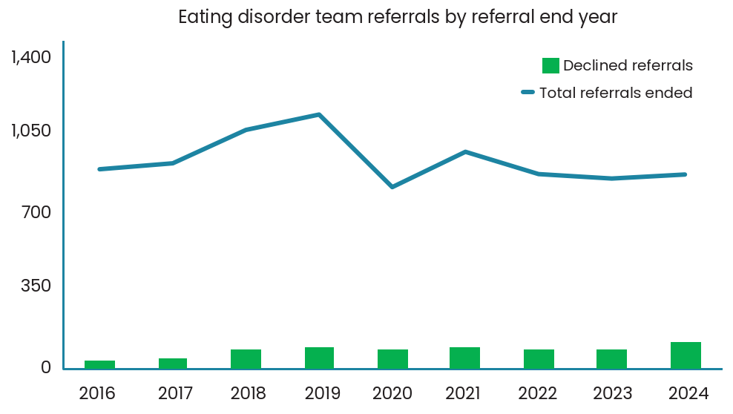

Feedback received through targeted engagement on eating disorders
Targeted engagement on eating disorders from the start of May through to July 2025 drew the following feedback.

Key themes
- Demand is increasing, particularly among younger age groups, and resources have not kept pace. Limited community options and increasing thresholds and waitlists for access to services mean many people either turn to private services or have their health deteriorate before they can get help.
- While a focus on supporting people with anorexia is important given its high mortality rate, New Zealand’s approach needs to be inclusive of disordered eating more broadly and able to respond effectively to people with eating disorders such as ARFID and binge eating disorder.
- Support for eating disorders is best provided using a full continuum of care for eating disorders across prevention, primary health care, early intervention and community services, and specialist and inpatient services for people with the highest needs. A multidisciplinary approach to support holistic care is required.
- Including a prevention focus is important. It means considering the contexts that can prevent eating disorders – for example, media literacy within schools, opportunities for screening people earlier, supporting safety around the use of social media, and nutrition and physical activity guidelines.
- Updated prevalence data for eating disorders in New Zealand is needed, as are improvements across service use data including on how primary mental health services are meeting the needs of people with eating disorders and their family and whānau, and the use of inpatient beds across the country.

Key consultations
The following feedback came from key groups consulted.

Specialist clinical services (regional specialist and inpatient)
- Increasing demand pressures are stretching services and workforces, requiring an increase in the capacity of regional eating disorders services.
- There are very few specialists around the country and care is being provided by people with varying levels of knowledge and expertise about eating disorders. High demand for services makes it difficult for people to take the time needed for training, supervising and supporting colleagues.
- Inpatient beds available for treating eating disorders (primarily anorexia nervosa) and acute refeeding are delivered ad hoc across the country. A review of inpatient beds is needed.
- Specialist and inpatient clinical workforces need more opportunities for ongoing training in best-practice and other evidence-based treatments.

Lived experience of eating disorders including as family, whānau and carers
- People who access services, and their family and whānau, can feel like they are excluded from decision making and have limited choice and control.
- There are limited lived experience and peer workforces that are funded and that have appropriate support structures. Yet these roles can be a highly valued part of a team that supports recovery.
- Increased support is needed for organisations and networks that support lived experience, family, whānau and carers.
- Family, whānau and carers have a critical role and need to be involved in treatment for eating disorders. They also require their own support, including mental health support and assistance with financial and relationship stressors.
- Consumer, peer support and lived experience roles should be supported by training and development and a professional network or organisation to ensure safety and sustainability.
- There is a need for national guidelines for working with priority groups and under- served conditions, including for managing binge eating disorder and ARFID.

Te Tira Wānanga Māuiui Kai Executive (expert Māori rōpū)
- There is a need for a broad or widely encompassing definition that goes beyond eating disorder diagnoses. The rōpū suggests using ngā māuiui kai.
- There is a need to explore what the gaps are in eating disorders services for Māori and other groups with higher and/ or unique needs, including culturally responsive services and supports.

Current state of eating disorders services in New Zealand
Development of eating disorders is influenced by social, environmental and cultural
factors, which highlights that a cross-sector approach to preventing eating disorders is essential. Many workforces play a role in the prevention and early identification of eating disorders. These include a range of health professionals across primary and specialist settings, people working in a number of different government agencies and people working within education settings.

New Zealand currently uses a hub-and- spokes model to provide specialist eating disorders services. The Regional Eating Disorders Services, located in Auckland, Hamilton, Wellington and Christchurch, are the ‘hub’. These services deliver specialised assessment and treatment for people with moderate to severe eating disorders and provide clinical advice, training and supervision to services and areas. Eating disorders liaison clinicians play a key role in contributing to the ‘spokes’. They work in
partnership with the district specialist mental health and addiction services, providing local expertise and linking those services to the hubs.

The following are other services available that play a critical role in providing eating disorders care.
- Private providers and health professionals are available across the country. They provide specialist treatment options outside of the publicly funded health system.
- General practice and other primary-level services (eg, Access and Choice providers) provide early intervention and primary care for eating issues. They also provide ongoing treatment and monitoring for patients known to the regional specialist services.
- Residential and hospital-based services in Auckland and Wellington provide specialist inpatient treatment. Christchurch delivers a mixed-purpose inpatient unit, which includes a perinatal mental health inpatient unit.
- Paediatric and general medical inpatient settings provide medical refeeding treatment and other treatment where physiological compromise occurs. These are located in the main centres of New Zealand – including in Auckland, Hamilton, Wellington, Lower Hutt, Dunedin and Christchurch.
- Infant, Child and Adolescent Mental Health Services have a significant role in the community treatment of many young people with an eating disorder, particularly those who live outside of main centres.
- Community and volunteer organisations, such as the Eating Disorders Association of New Zealand and Eating Disorders Carer Support New Zealand, provide peer connection, educational resources, training opportunities, and other supports for families, whānau and carers.
- Whāraurau, the child and adolescent mental health workforce development centre, delivers eating disorders workforce development initiatives for eating disorders services, health professionals and other workforces.

International benchmarking
Early international benchmarking gives us an indication of how New Zealand compares with other jurisdictions in the provision of specialist treatment for eating disorders. Based on available data:
- New Zealand spends $305,000 per 100,000 population
- Australia spends $577,000 per 100,000 population
- the United Kingdom spends $533,000 per 100,000 population.

Note that these figures compare available funding data for specialist residential and community treatment eating disorders services. This excludes inpatient data, primary care data, and funding for research and evaluation.

This analysis is included as an approximate measure and will reflect broader local contextual factors and wider landscapes of services and supports. It should not be relied on exclusively for funding decisions.

Investment in regional eating disorders services in New Zealand
Budget 2009 provided $4.7 million in 2009/10 and $6.5 million in 2010/11 and ongoing to establish our current eating disorders services and workforces. Budget 2022 then invested ongoing funding of $1.5 million per year to increase the capacity of regional eating disorders services.

In the 2023/24 financial year, Health New Zealand invested a total of just over $19 million in regional eating disorders services.

This Strategy is supported by the allocation of an additional approximately $4 million per year towards eating disorders services and supports, including support for families, whānau and carers.

References
Baker JH, Eisenlohr-Moul T, Wu Y-K, et al. 2019. Ovarian hormones influence eating disorder symptom variability during the menopause transition: a pilot study. Eating Behavior 35: 101337.
Baxter J, Kani Kingi T, Tapsell R, et al. 2006. Prevalence of mental disorders among Māori in Te Rau Hinengaro: the New Zealand Mental Health Survey. Australian and New Zealand Journal of Psychiatry 40(10): 914–23. DOI: 10.1080/j.1440-1614.2006.01911.x (accessed 22 August 2025).
Butterfly Foundation. 2024. Paying the Price, Second Edition: The economic and social impact of eating disorders in Australia. URL: butterfly.org.au/who-we-are/research-policy-publications/payingtheprice2024/ (accessed 22 August 2025).
Chan CK, Ku Y, Owens RG. 2010. Perfectionism and eating disturbances in Korean immigrants: moderating effects of acculturation and ethnic identity. Asian Journal of Social Psychology 13(4): 293–302.
Clark MTR, Manuel J, Lacey C, et al. 2023. Reimagining eating disorder spaces: a qualitative study exploring Māori experiences of accessing treatment for eating disorders in Aotearoa New Zealand. Journal of Eating Disorders 11(22). DOI: 10.1186/s40337-023-00748-5 (accessed 22 August 2025).
Cleland L, Kennedy HL, Pettie MA, et al. 2023. Eating disorders, disordered eating, and body image research in New Zealand: a scoping review. Journal of Eating Disorders 11(7). DOI: 10.1186/s40337-022-00728-1 (accessed 26 August 2025).
Cobbaert L, Millichamp AR, Elwyn R, et al. 2024. Neurodivergence, intersectionality, and eating disorders: a lived experience-led narrative review. Journal of Eating Disorders 12(187). DOI: 10.1186/s40337-024-01126-5 (accessed 22 August 2025).
Crow SJ, Peterson CB, Swanson SA, et al. 2009. Increased mortality in bulimia nervosa and other eating disorders. American Journal of Psychiatry 166(12): 1342–6. DOI: 10.1176/appi.ajp.2009.09020247 (accessed 22 August 2025).
Fraser G, Clark MTR, Rose BM, et al. 2024. Ngā Māuiui Kai: creating Indigenous Māori terms for eating disorders in Aotearoa New Zealand. Journal of Eating Disorders 12(1): art 205. DOI: 10.1186/s40337-024-01179-6 (accessed 22 August 2025).
Galmiche M, Déchelotte P, Lambert G, et al. 2019. Prevalence of eating disorders over the 2000–2018 period: a systematic literature review. The American Journal of Clinical Nutrition 109(5): 1402–13. DOI: 10.1093/ajcn/nqy342 (accessed 22 August 2025).
Hansson E, Schmidt M. 2025. Measuring disordered eating in adolescent boys: a systematic literature review. Eating Disorders 1–21. DOI: 10.1080/10640266.2024.2433325 (accessed 22 August 2025).
Herle M, Leno VC, Mandy W. 2025. Recommendations for advancing understanding of eating disorders in neurodivergent people: a commentary on Inal-Kaleli et al. 2024 and Nimbley et al. 2024. International Journal of Eating Disorders 58(4): 677–9. DOI: 10.1002/eat.24380 (accessed 22 August 2025).
Lacey C, Clark M, Manuel J, et al. 2020. Is there systemic bias for Māori with eating disorders? A need for greater awareness in the healthcare system. New Zealand Medical Journal 133(1514): 71–6.
López-Gil JF, García-Hermoso A, Smith L, et al. 2023. Global proportion of disordered eating in children and adolescents: a systematic review and meta-analysis. JAMA Pediatrics 177(4): 363–72. DOI: 10.1001/ jamapediatrics.2022.5848 (accessed 22 August 2025).
McCabe MP, Mavoa H, Ricciardelli LA, et al. 2011. Socio-cultural agents and their impact on body image and body change strategies among adolescents in Fiji, Tonga, Tongans in New Zealand and Australia. Obesity Review 12(Suppl 2): 61–7. DOI: 10.1111/j.1467-789X.2011.00922.x (accessed 22 August 2025).
Minister of Health. 2024. Government Policy Statement on Health 2024–2027. Wellington: Ministry of Health. URL: health.govt.nz/publications/government-policy-statement-on-health-2024-2027 (accessed 22 August 2025).
Nagata JM, Ganson KT, Austin SB. 2020. Emerging trends in eating disorders among sexual and gender minorities. Current Opinion in Psychiatry 33(6): 562–7. DOI: 10.1097/YCO.0000000000000645 (accessed 22 August 2025).
Oakley Browne MA, Wells JE, Scott KM (eds). 2006. Te Rau Hinengaro: The New Zealand Mental Health Survey. Wellington: Ministry of Health.
Parker LL, Harriger JA. 2020. Eating disorders and disordered eating behaviors in the LGBT population: a review of the literature. Journal of Eating Disorders 8: art 51. DOI: 10.1186/s40337-020-00327-y (accessed 22 August 2025).
Valenta ST, Innella V, Bonazzoli F, et al. 2024. Eating across borders: a scoping review of eating disorders and body image dissatisfaction in migrant populations. International Review of Psychiatry 37(3–4): 353–67. DOI: 10.1080/09540261.2024.2384725 (accessed 22 August 2025).
Wales J, Brewin N, Raghavan R, et al. 2017. Exploring barriers to South Asian help-seeking for eating disorders. Mental Health Review 22(1): 40–50.

