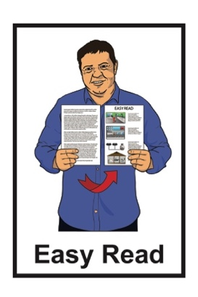


Summary:
Suicide Prevention
Action Plan 2025 to 2029
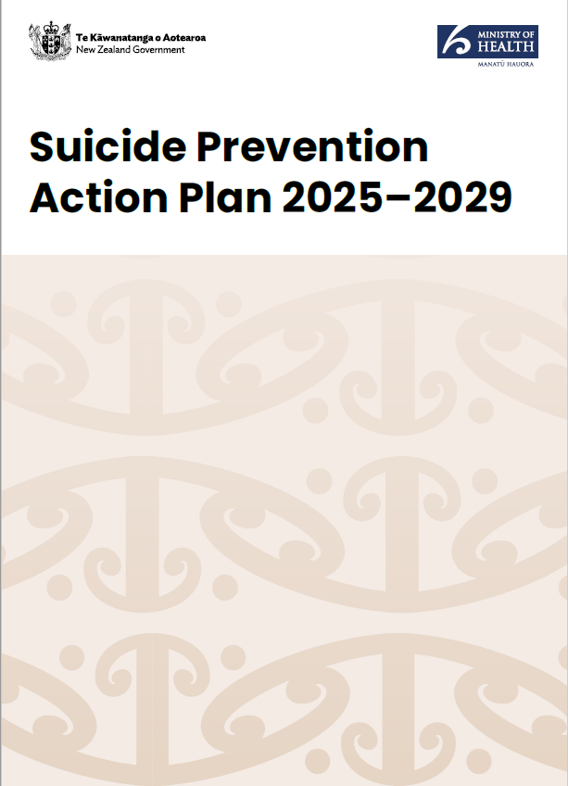
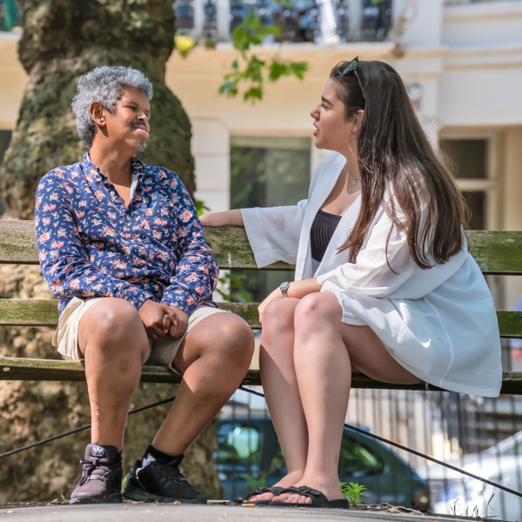

Published: August 2025

Before you start


This information may upset some people when they are reading it.

If you are upset after reading this document you can talk to your:
whānau / family
friends.

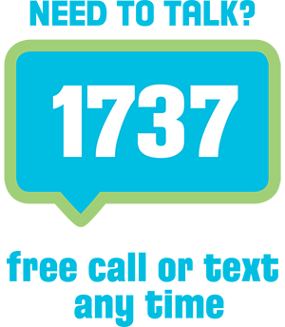
You can also contact Need to Talk by:
calling 1737


texting 1737

It does not cost any money to call / text 1737.

What is in this document

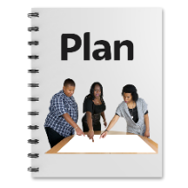
Page number:

What this document is about 3


Focus areas 10
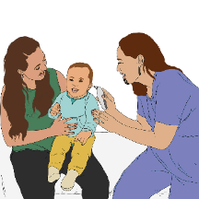

Focus area 1 – Access to
support 11


Focus area 2 – Support
the workforce 17

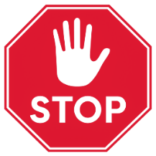
Focus area 3 – Prevent suicide 25

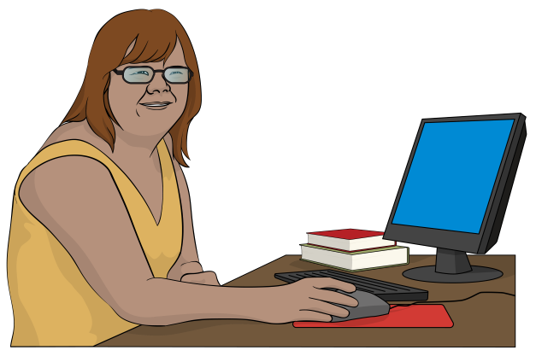
Focus area 4 – Understand
suicide 32

More information 38

What this document is about

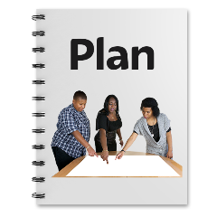
This Easy Read is about the plans the Government has made to prevent suicide.

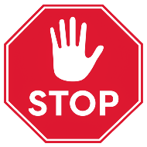
Prevent means to try to stop something from happening.

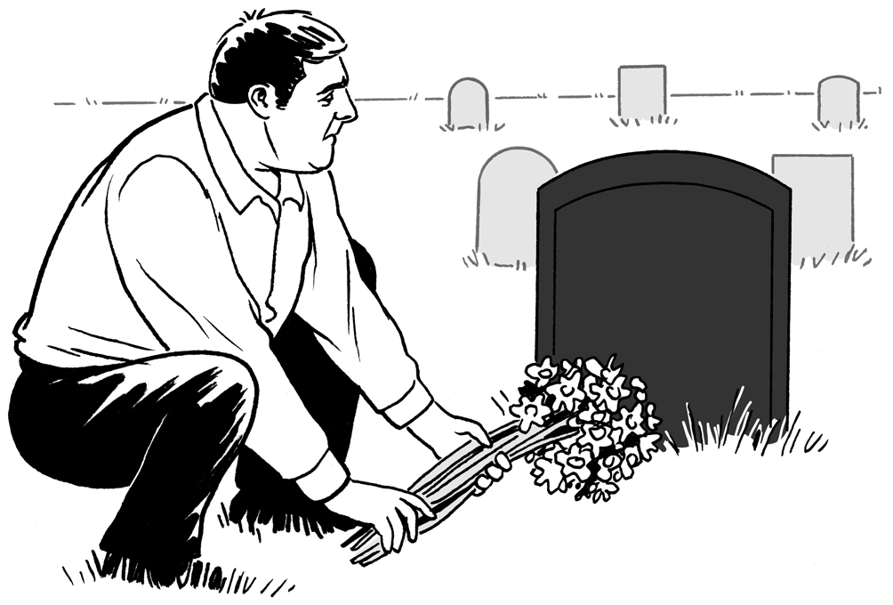
Suicide is what we call it when a person ends their own life.

This Easy Read is a summary of the Suicide Prevention Action Plan
2025 – 2029.

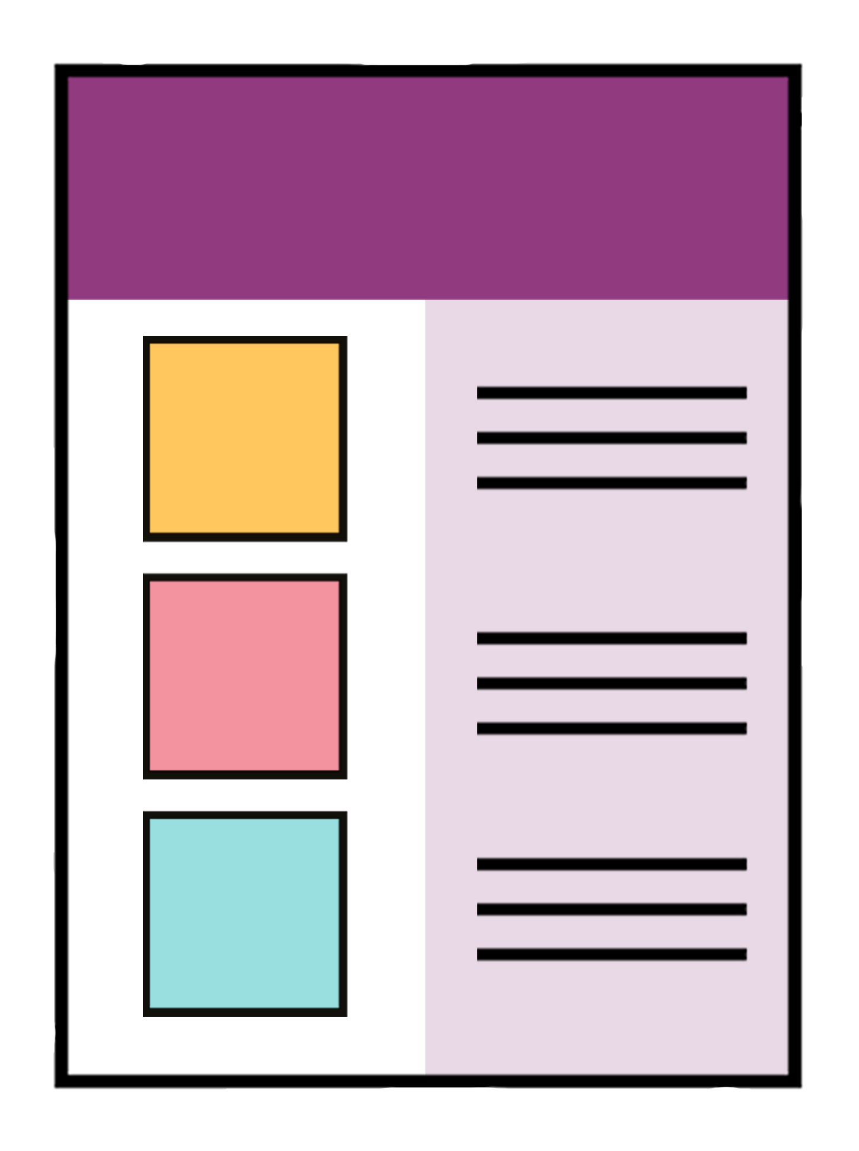
A summary:
is shorter than the full plan
gives the main information.

You can find the full Suicide Prevention Action Plan
2025 – 2029 at:

https://tinyurl.com/3s298sxc

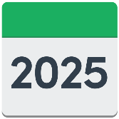
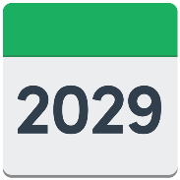
The Suicide Prevention Action Plan
2025 to 2029 explains what the Government will do from 2025 to 2029.


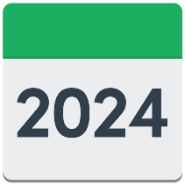
It carries on with the work that was done in the Government plan from 2019 to 2024.


This plan is about what things the Government can do to make sure:

there are no gaps in services
people can get support when they need it.

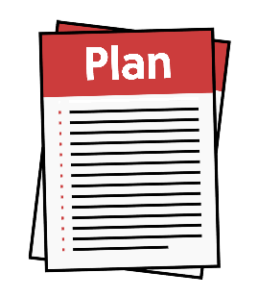
The Ministry of Health – Suicide Prevention Office made the plan.

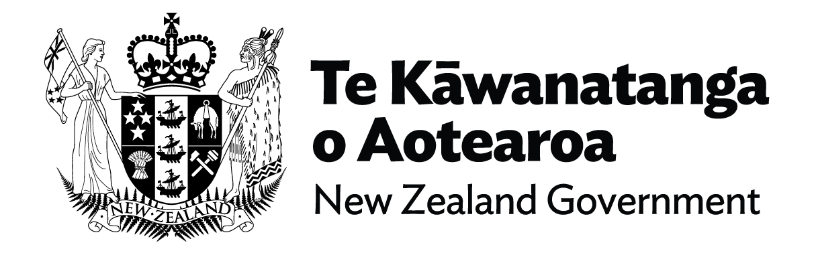
In this document we means the government / government agencies.

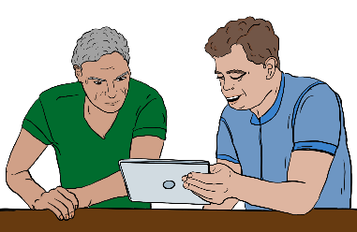
To write the plan we used information from things:
we already knew about suicide
people told us in the past
people told us in late 2024.


We thank all the people who took the time to talk to us.

This plan focuses on what we will do to prevent suicide.


We have other plans for mental health services in New Zealand to:
make the services better
support people more quickly.

Mental health services support people when their mental health is not strong.

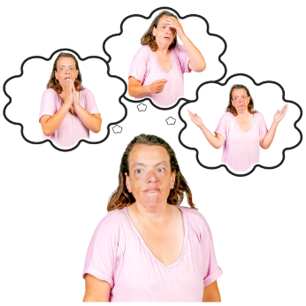
Mental health is health to do with:
your mind
how you are feeling.


When mental health is not strong people can have conditions like:
depression
anxiety
schizophrenia.


We will change the things we pay for so that 1 dollar in every 4 dollars we spend in mental health and addiction goes to:
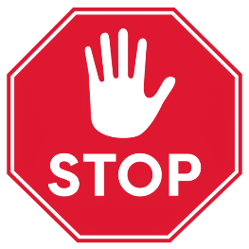
prevention / stopping problems before they happen
supporting people earlier.

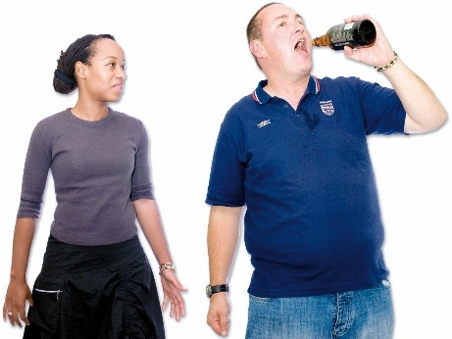
Addiction is when someone finds it hard to stop doing something that harms them like:
drinking alcohol

taking drugs
spending money on gambling like pokie machines.


We are working on a new Mental Health and Wellbeing Strategy.


A wellbeing strategy is a plan to make sure that people:
can live a good life
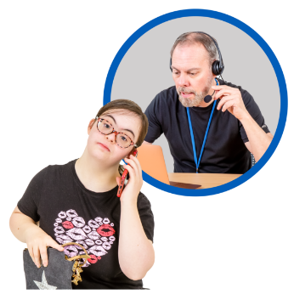
feel good about themselves
get support when they need it.

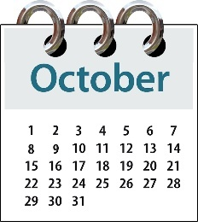
The Mental Health and Wellbeing Strategy should be ready by October 2025.

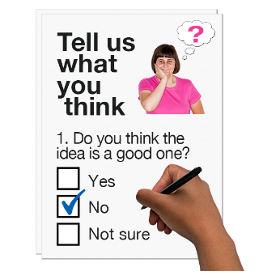
We will use some of the feedback people gave us to write that strategy.

Focus areas
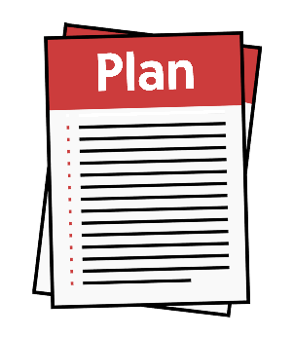

The Suicide Prevention Action Plan 2025 – 2029 has 4 areas to focus on.
Focus is looking really closely to make sure something happens.

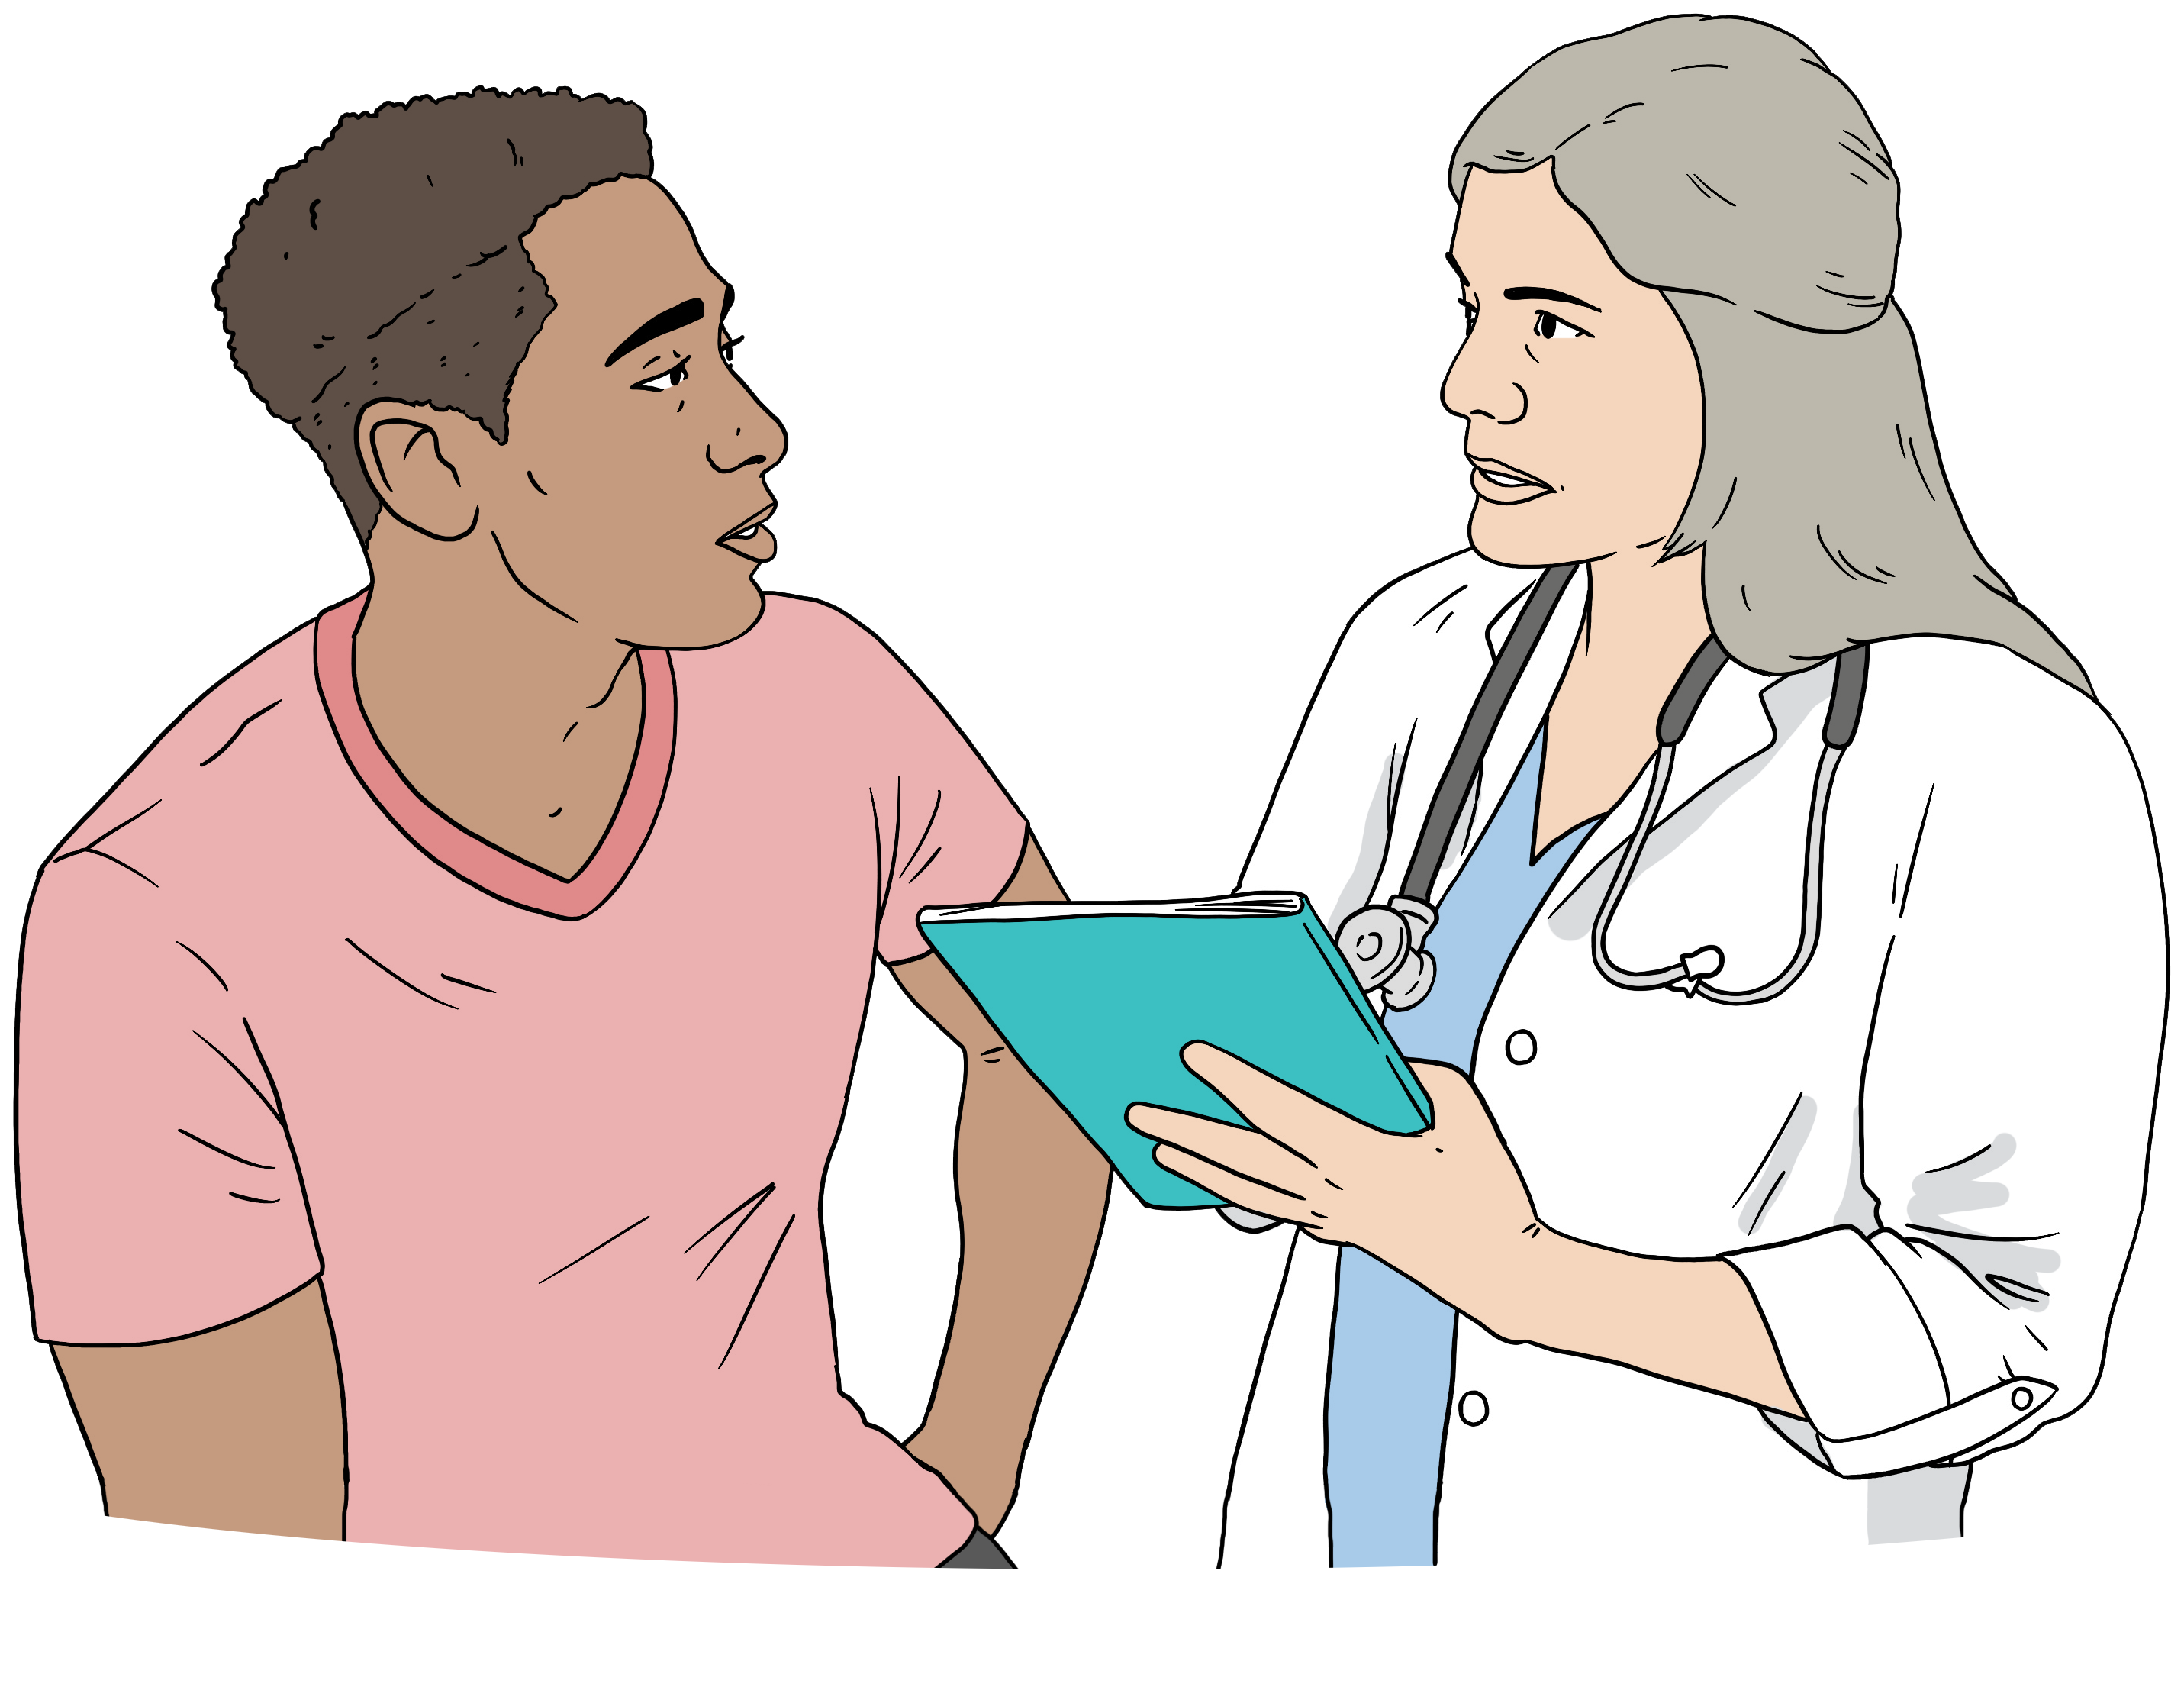
The plan has things to do in each of the 4 focus areas for:
health services like Health New Zealand

other parts of the government like the Ministry of Education.


On pages 11 to 35 we will explain what the services and agencies will do to make sure the 4 focus areas happen.

Focus area 1 – Access to support

The Government wants to make it easier to get support:
to prevent / stop suicide
for other people after someone they know has died by suicide.

Health services will do 5 things to make it easier to get support.


- By 31 December 2025 Health New Zealand will set up a fund to prevent suicide in groups with specific needs like:
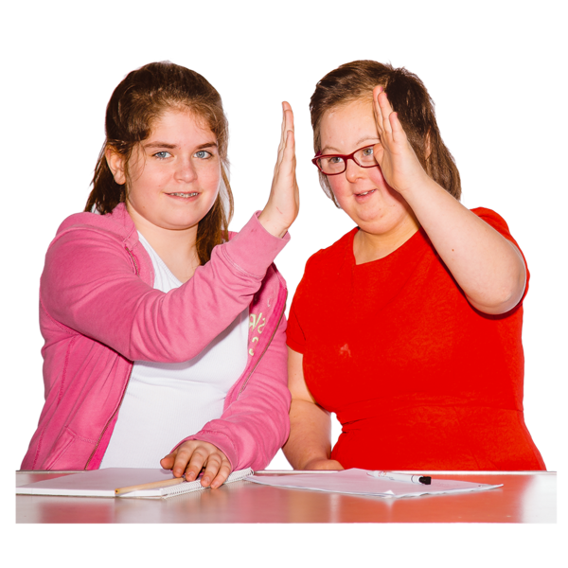
people who have just had babies
people who live in rural areas
young people.
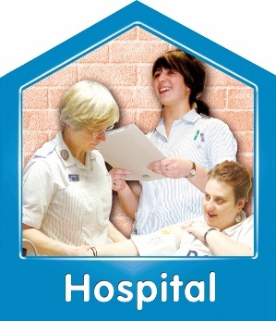
- Health New Zealand will also set up peer support workers in 8 hospital emergency departments by 31 October 2025 for people who come in with:
mental health needs
addiction needs.


Peer support means someone to talk to who has been through the same things as you.

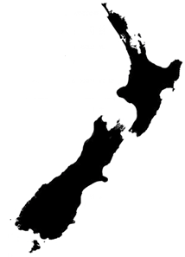
- Health New Zealand will set up services in 6 regions by 30 June 2026 to support people in a crisis.


Crisis is when something bad happens that can make you feel you are not in control of your life.

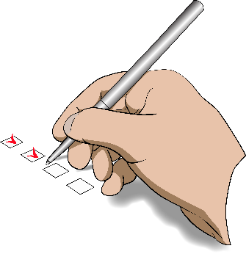
- Health New Zealand will check the 6 new crisis services are working well by 30 June 2028.

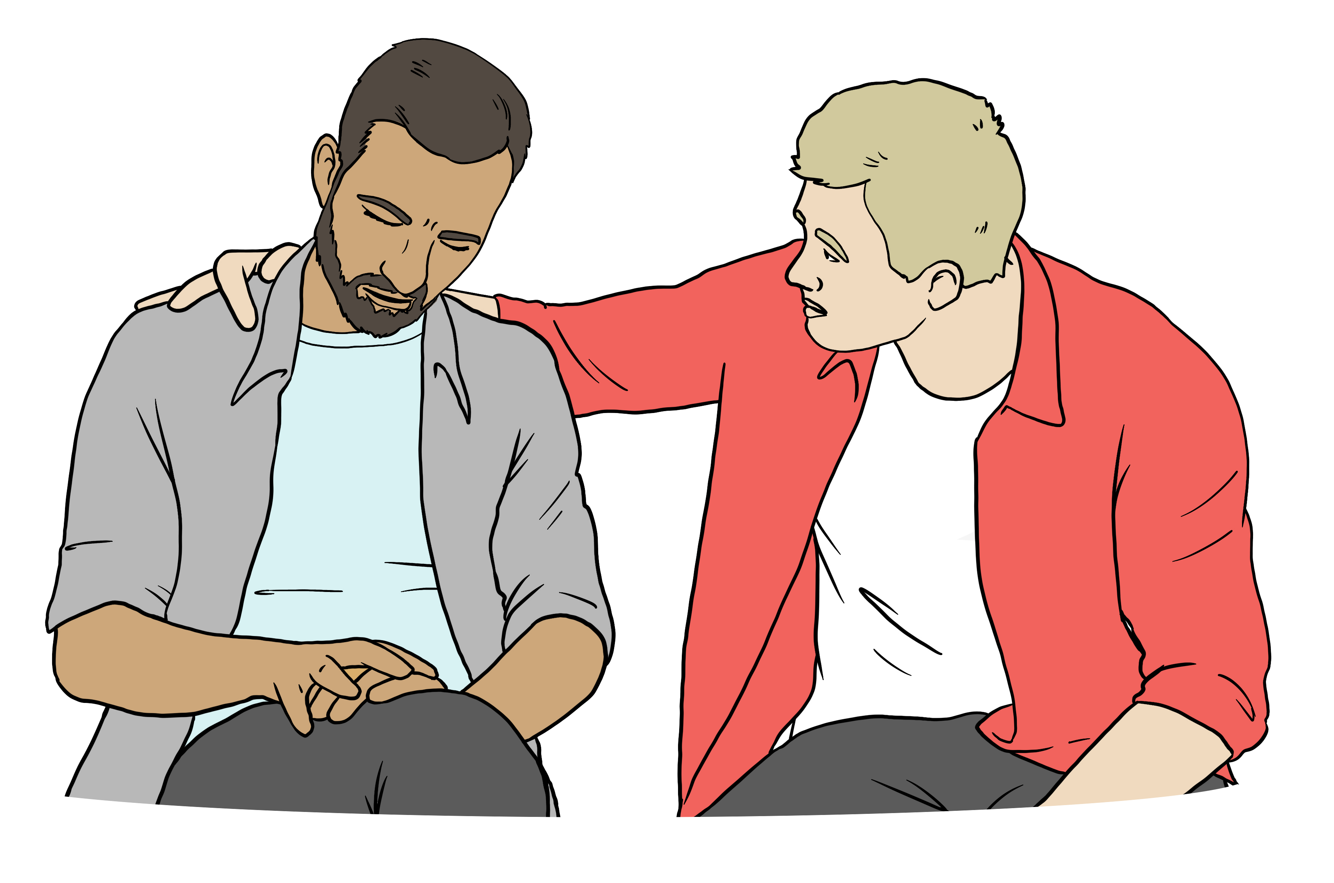
- Health New Zealand will also make suicide bereavement support services better by 31 December 2028.

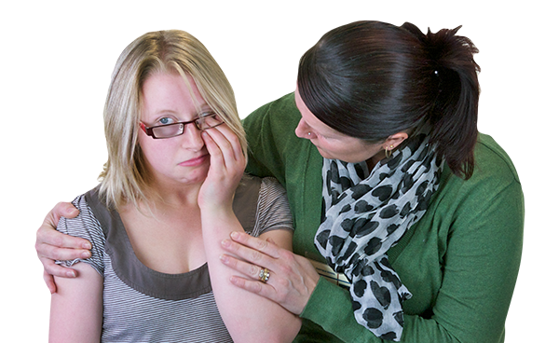
Suicide bereavement support services are services for people who know someone who died by suicide.


Other parts of government will do 4 things to make it easier to get support.

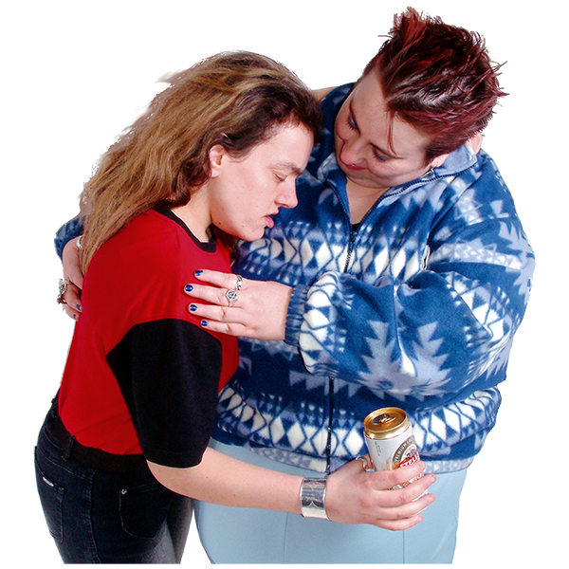
- By 31 July 2025 the Ministry of Social Development / MSD will make sure that their Heartlands website has easy to find information about:
mental health
addiction.


- By 31 December 2025 the Department of Corrections will update their action plan on:
suicide prevention

what to do after suicide.

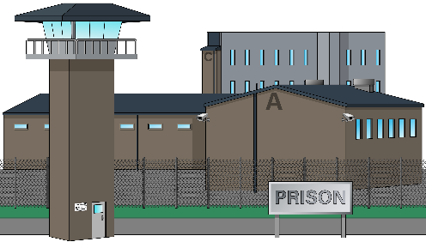
The Department of Corrections is the part of the government that looks after things like prisons.

- New Zealand Police have already updated the plan for what happens when someone they are dealing with says they are thinking about suicide.



- The Ministry for Primary Industries will make sure that they share suicide prevention information with the groups they work with like:
farmers
forestry workers.

Focus area 2 – Support the workforce


The Government wants to make sure the people like social workers who work with people who may be thinking about suicide have good training.

Health services will do 4 things to support the people who work in suicide prevention.

- By 31 December 2025 Health New Zealand will make sure that more people can get training in stopping suicide like:
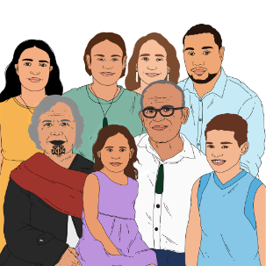
people who work in health
whānau / families
communities.

- By 30 June 2026 Health New Zealand will make sure that key people who work for them in suicide prevention roles work in similar ways.


Health New Zealand will make:
information for when people start working in this area
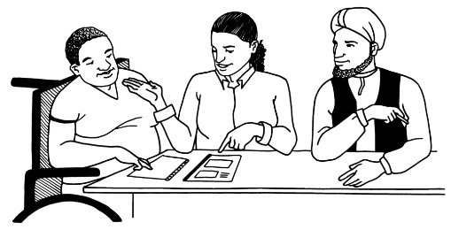
better supports for workers to be supported properly.


The workers include people who:
organise support to prevent / stop suicide
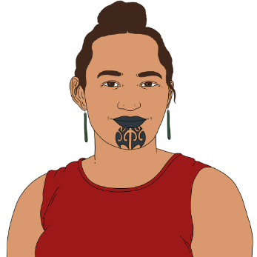
organise support for people who know someone who has died by suicide
work in Kia Piki Te Ora / Māori Suicide Prevention roles.

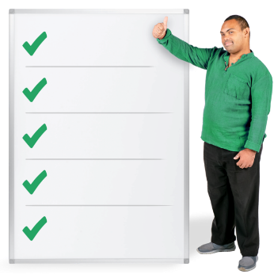
- By 30 June 2026 the Suicide Prevention Office will publish a document that says what skills are useful for people working to prevent / stop suicide.

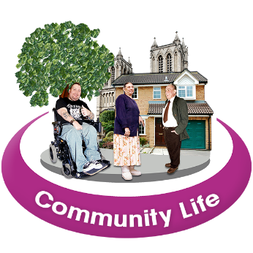
This document will be for:
community groups
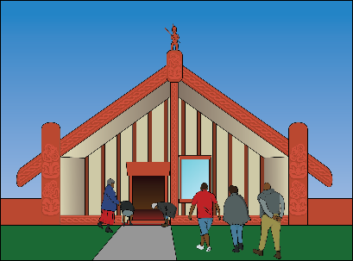
marae
schools
whānau / families.


- By 30 June 2028 the Suicide Prevention Office will write a guide for people who work in health services so they can work out:

who might be at risk of suicide / ending their own life

how to support people who feel like they might want to die by suicide.

Other parts of the government will do 3 things to support people who work in suicide prevention.


- By 30 June 2026 Oranga Tamariki will rewrite the suicide prevention guides for people who work with young people like:
social workers
carers.

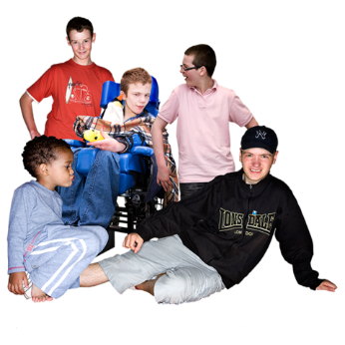
Oranga Tamariki is the part of the government that looks after children who might need more support.

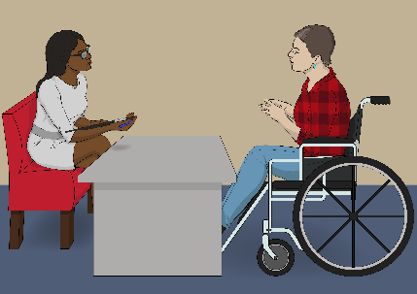
- By 30 June 2027 the Ministry of Social Development will make sure that staff know about the training so they can spot which clients feel like they might want to end their life.


- By 30 June 2028 the Ministry of Social Development will work on suicide prevention with 37 Elder Abuse Response Services who support older people who are:
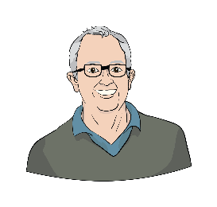
European / Pākehā
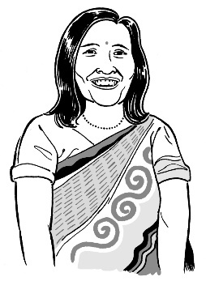
Māori
Pacific
South East Asian.

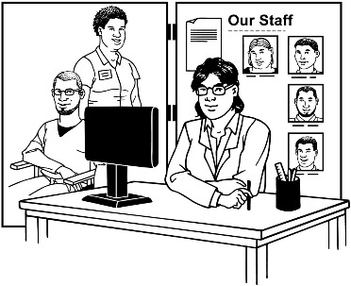
Elder Abuse Response Services work with older people who might:
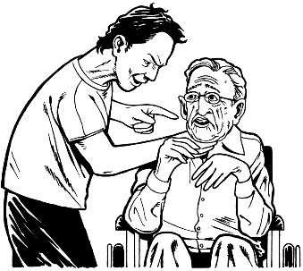
be hurt by other people
not be looked after properly
have their money stolen.

Focus area 3 – Prevent suicide

The Government wants to focus on:
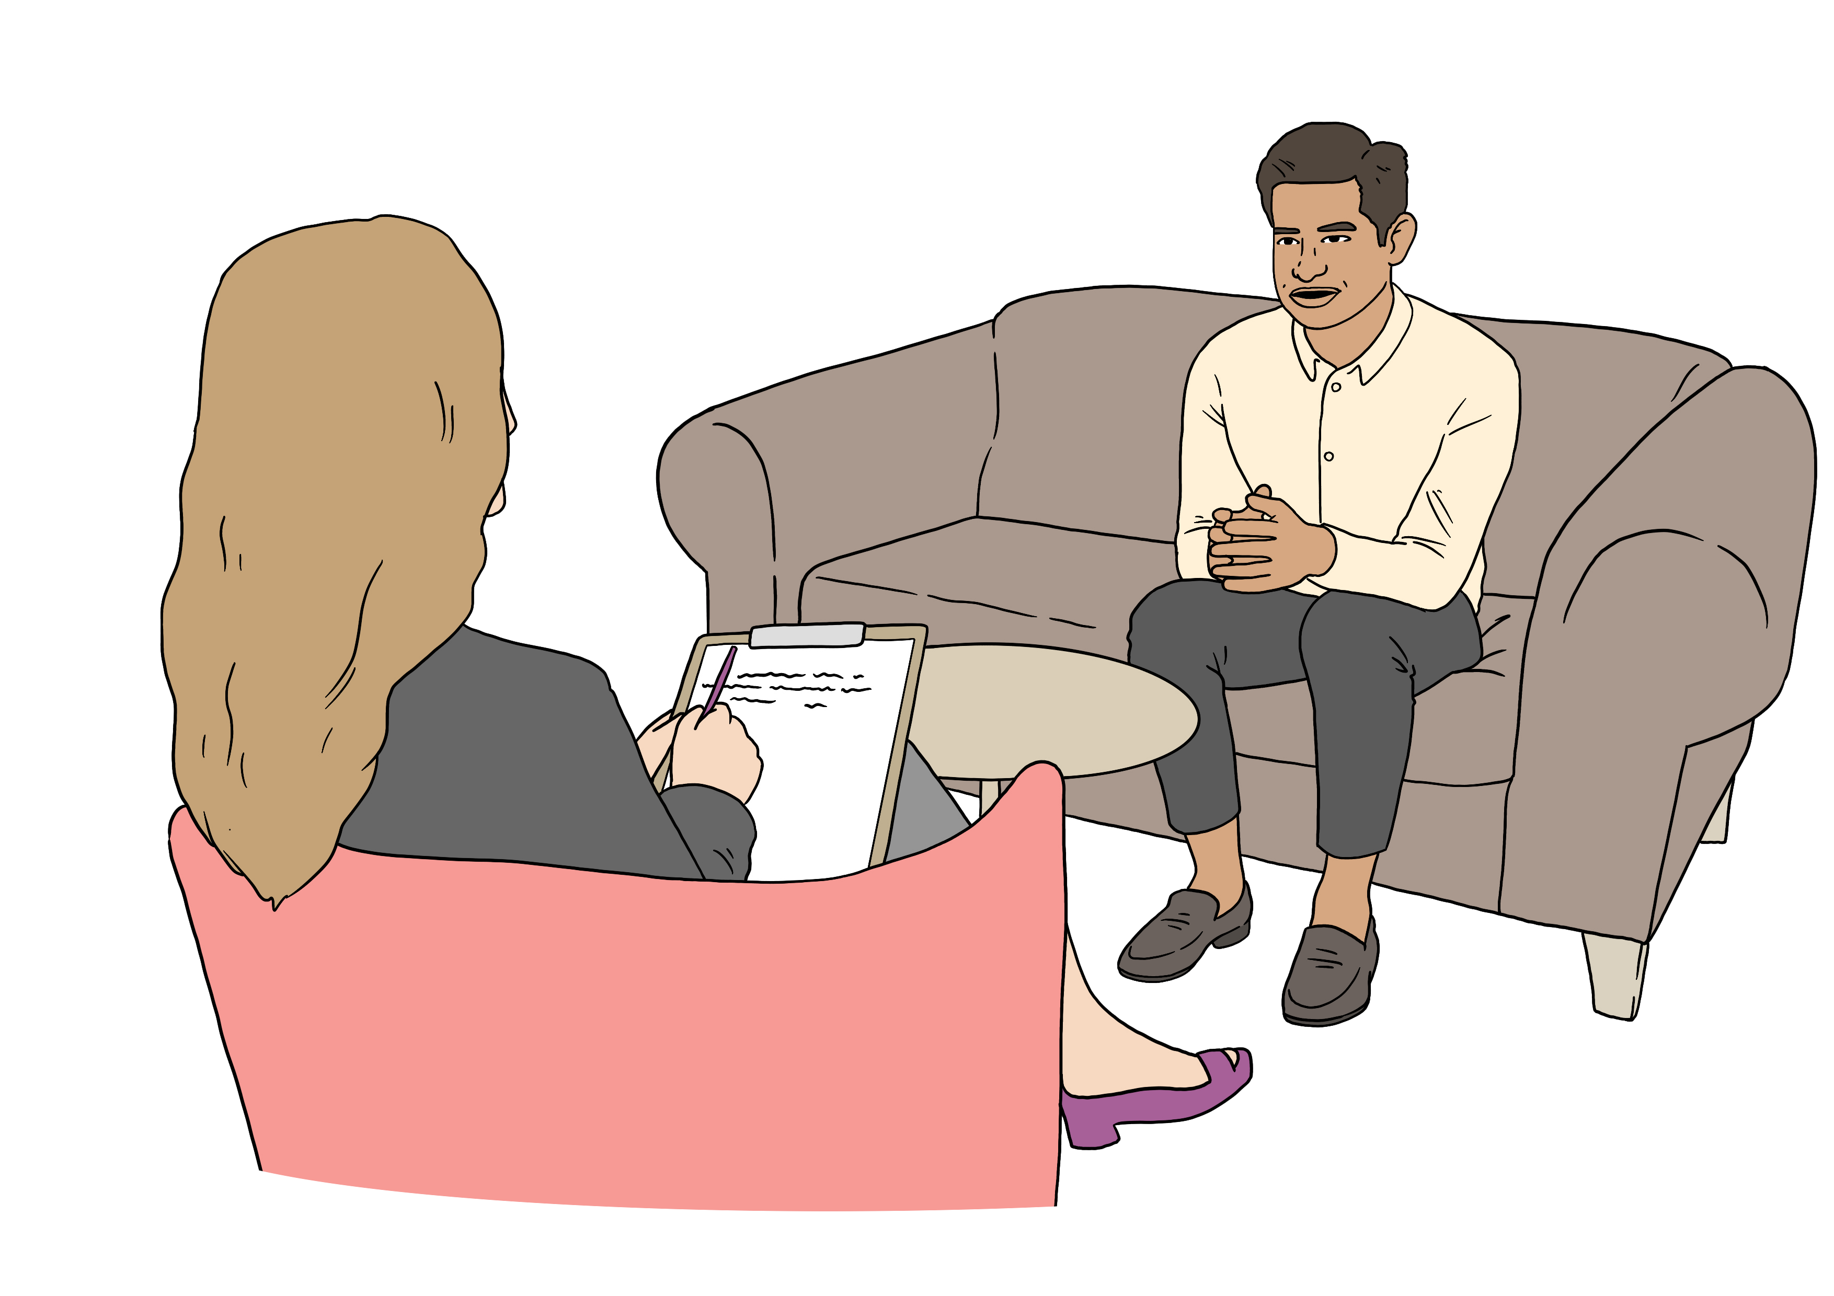
preventing suicide / stopping people from ending their own lives
early intervention / supporting people as soon as they need it.

Health services want to make sure that there is more support for:
children
young people.

Health services will do 6 things to stop suicide.

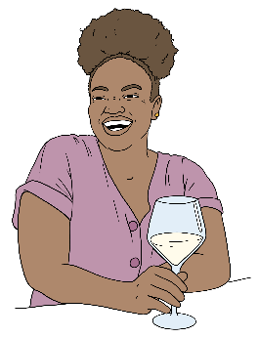
- From 1 July 2025 Health New Zealand will start making a programme to:
identify people who are drinking too much alcohol
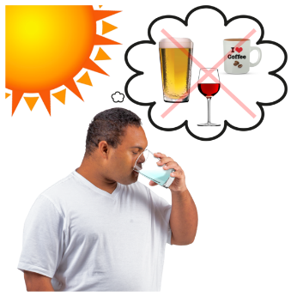
support people to drink less alcohol
put money into community activites that make alcohol seem less usual.

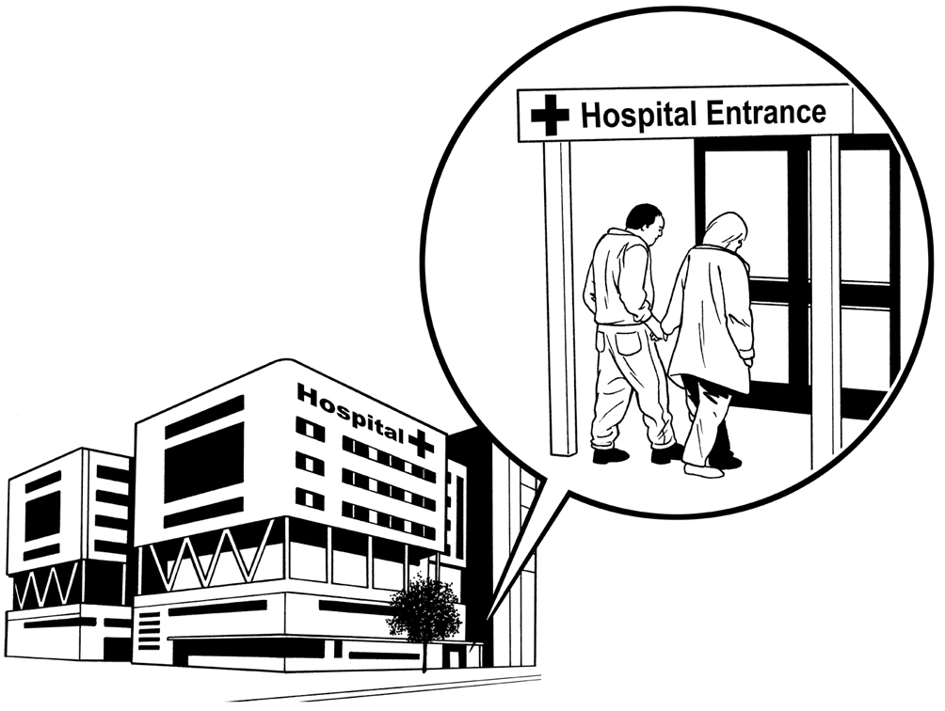
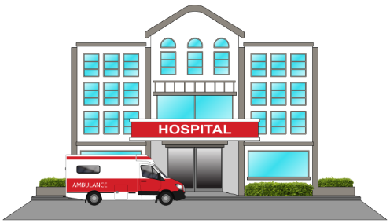
- From 1 July 2025 Health New Zealand will work to make services safer by taking away things people could use to hurt themselves in:
mental health services
addiction services.


- By 31 July 2025 Health New Zealand will start a new campaign to promote wellbeing for:
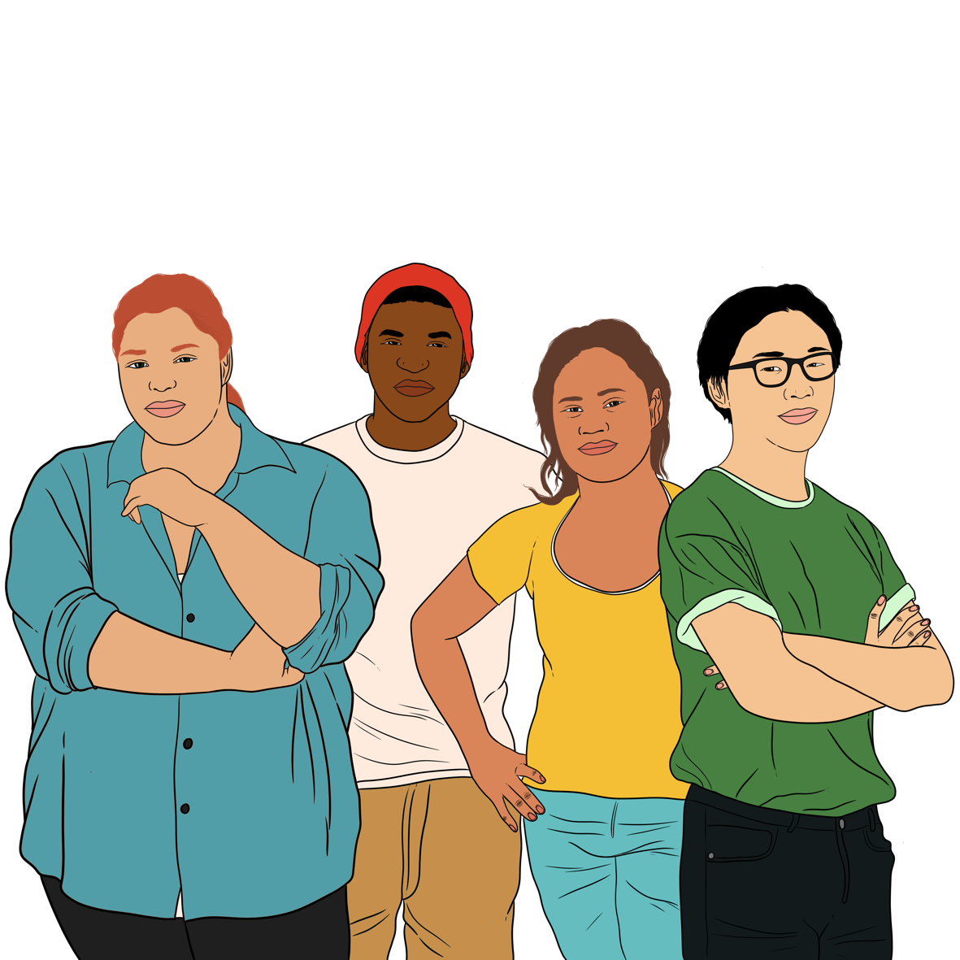
young people
other groups that need it.

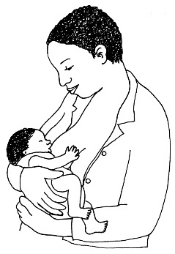
- By 31 October 2025 the Ministry of Health will start working across government agencies on how to better support mental health for people who have just had a baby.

- By June 2026 Health New Zealand will work with communities to find out where to put money into 2 regions to make services better for young people.
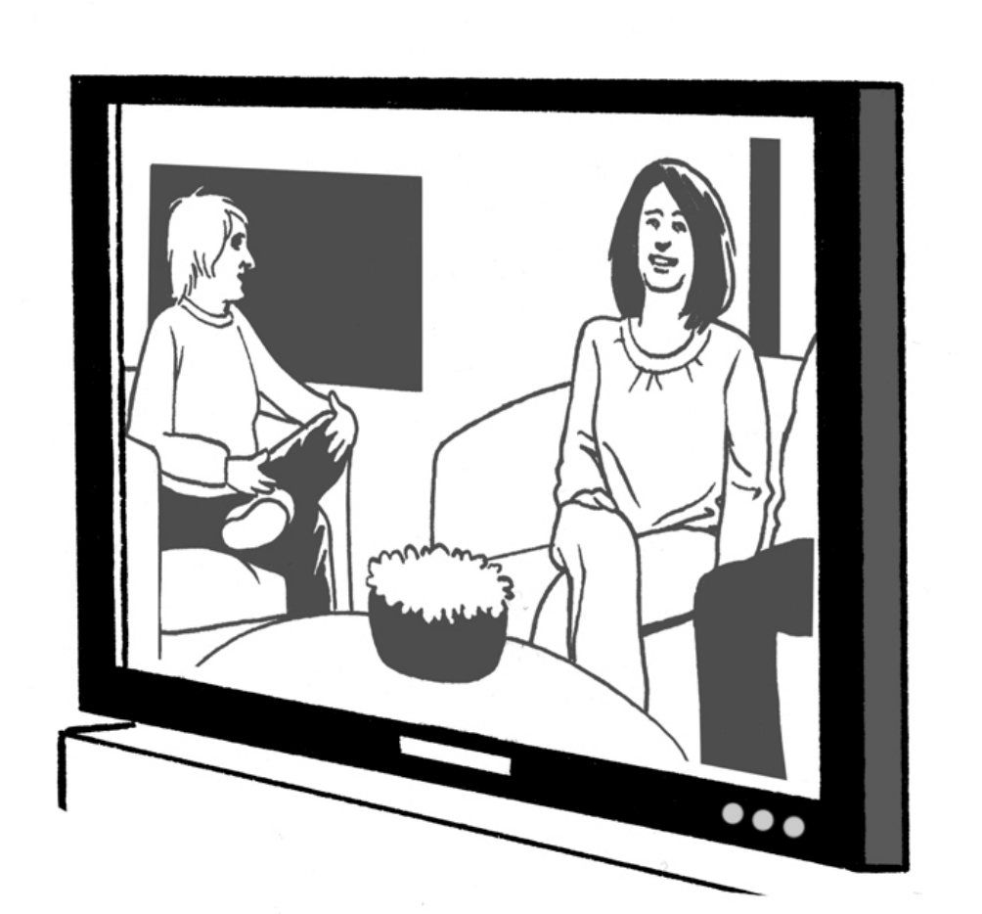

- By 31 December 2026 Health New Zealand will make new information to support how the media tells people about suicide including:
on television
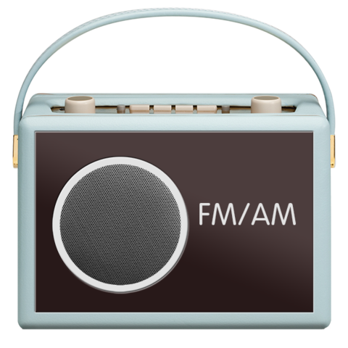
in newspapers
on the radio.
Other parts of the government will do 4 things to stop suicide.


- By September 2025 the Ministry of Social Development will use its digital noticeboard so that staff can know how to talk to people who are in distress.


Distress is when someone feels:
very upset

badly hurt
as if they are in danger.

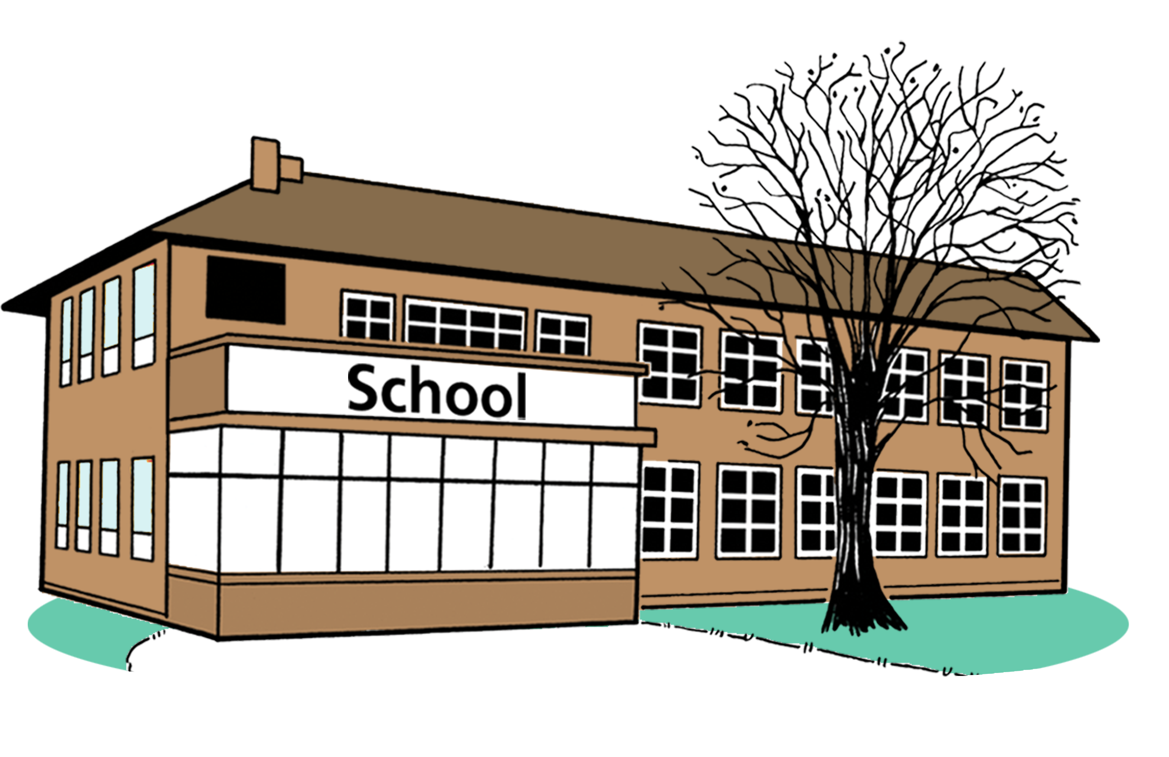
- By 31 December 2027 the Ministry of Education will give more support to schools when students:
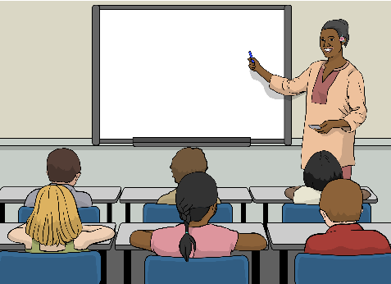
harm themselves
die by suicide.
The Ministry of Education is part of the government that looks after learning like in schools.

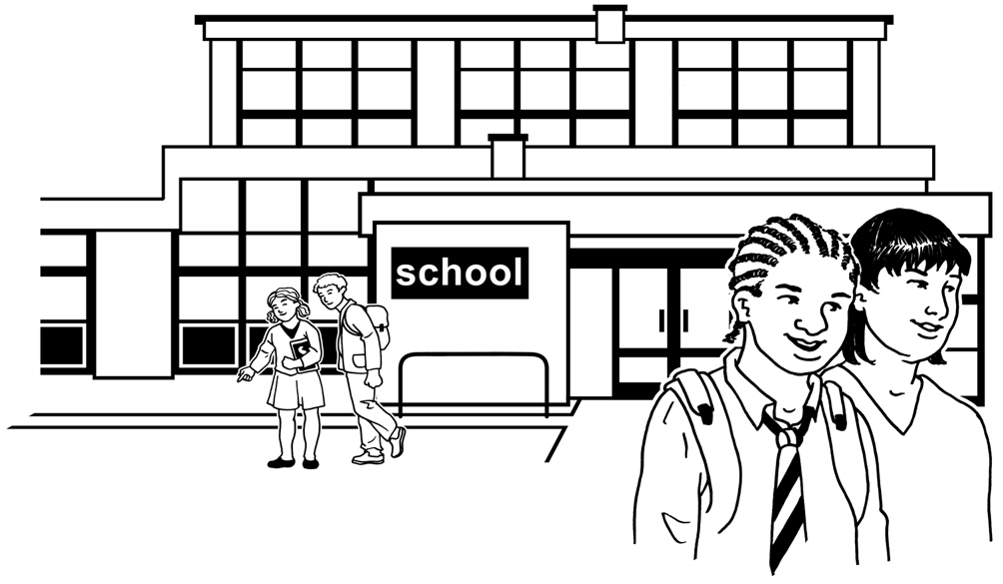
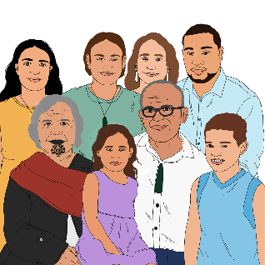
- The Ministry of Education will also support schools by giving them resources to talk about suicide in the right way with:
staff
whānau / families.

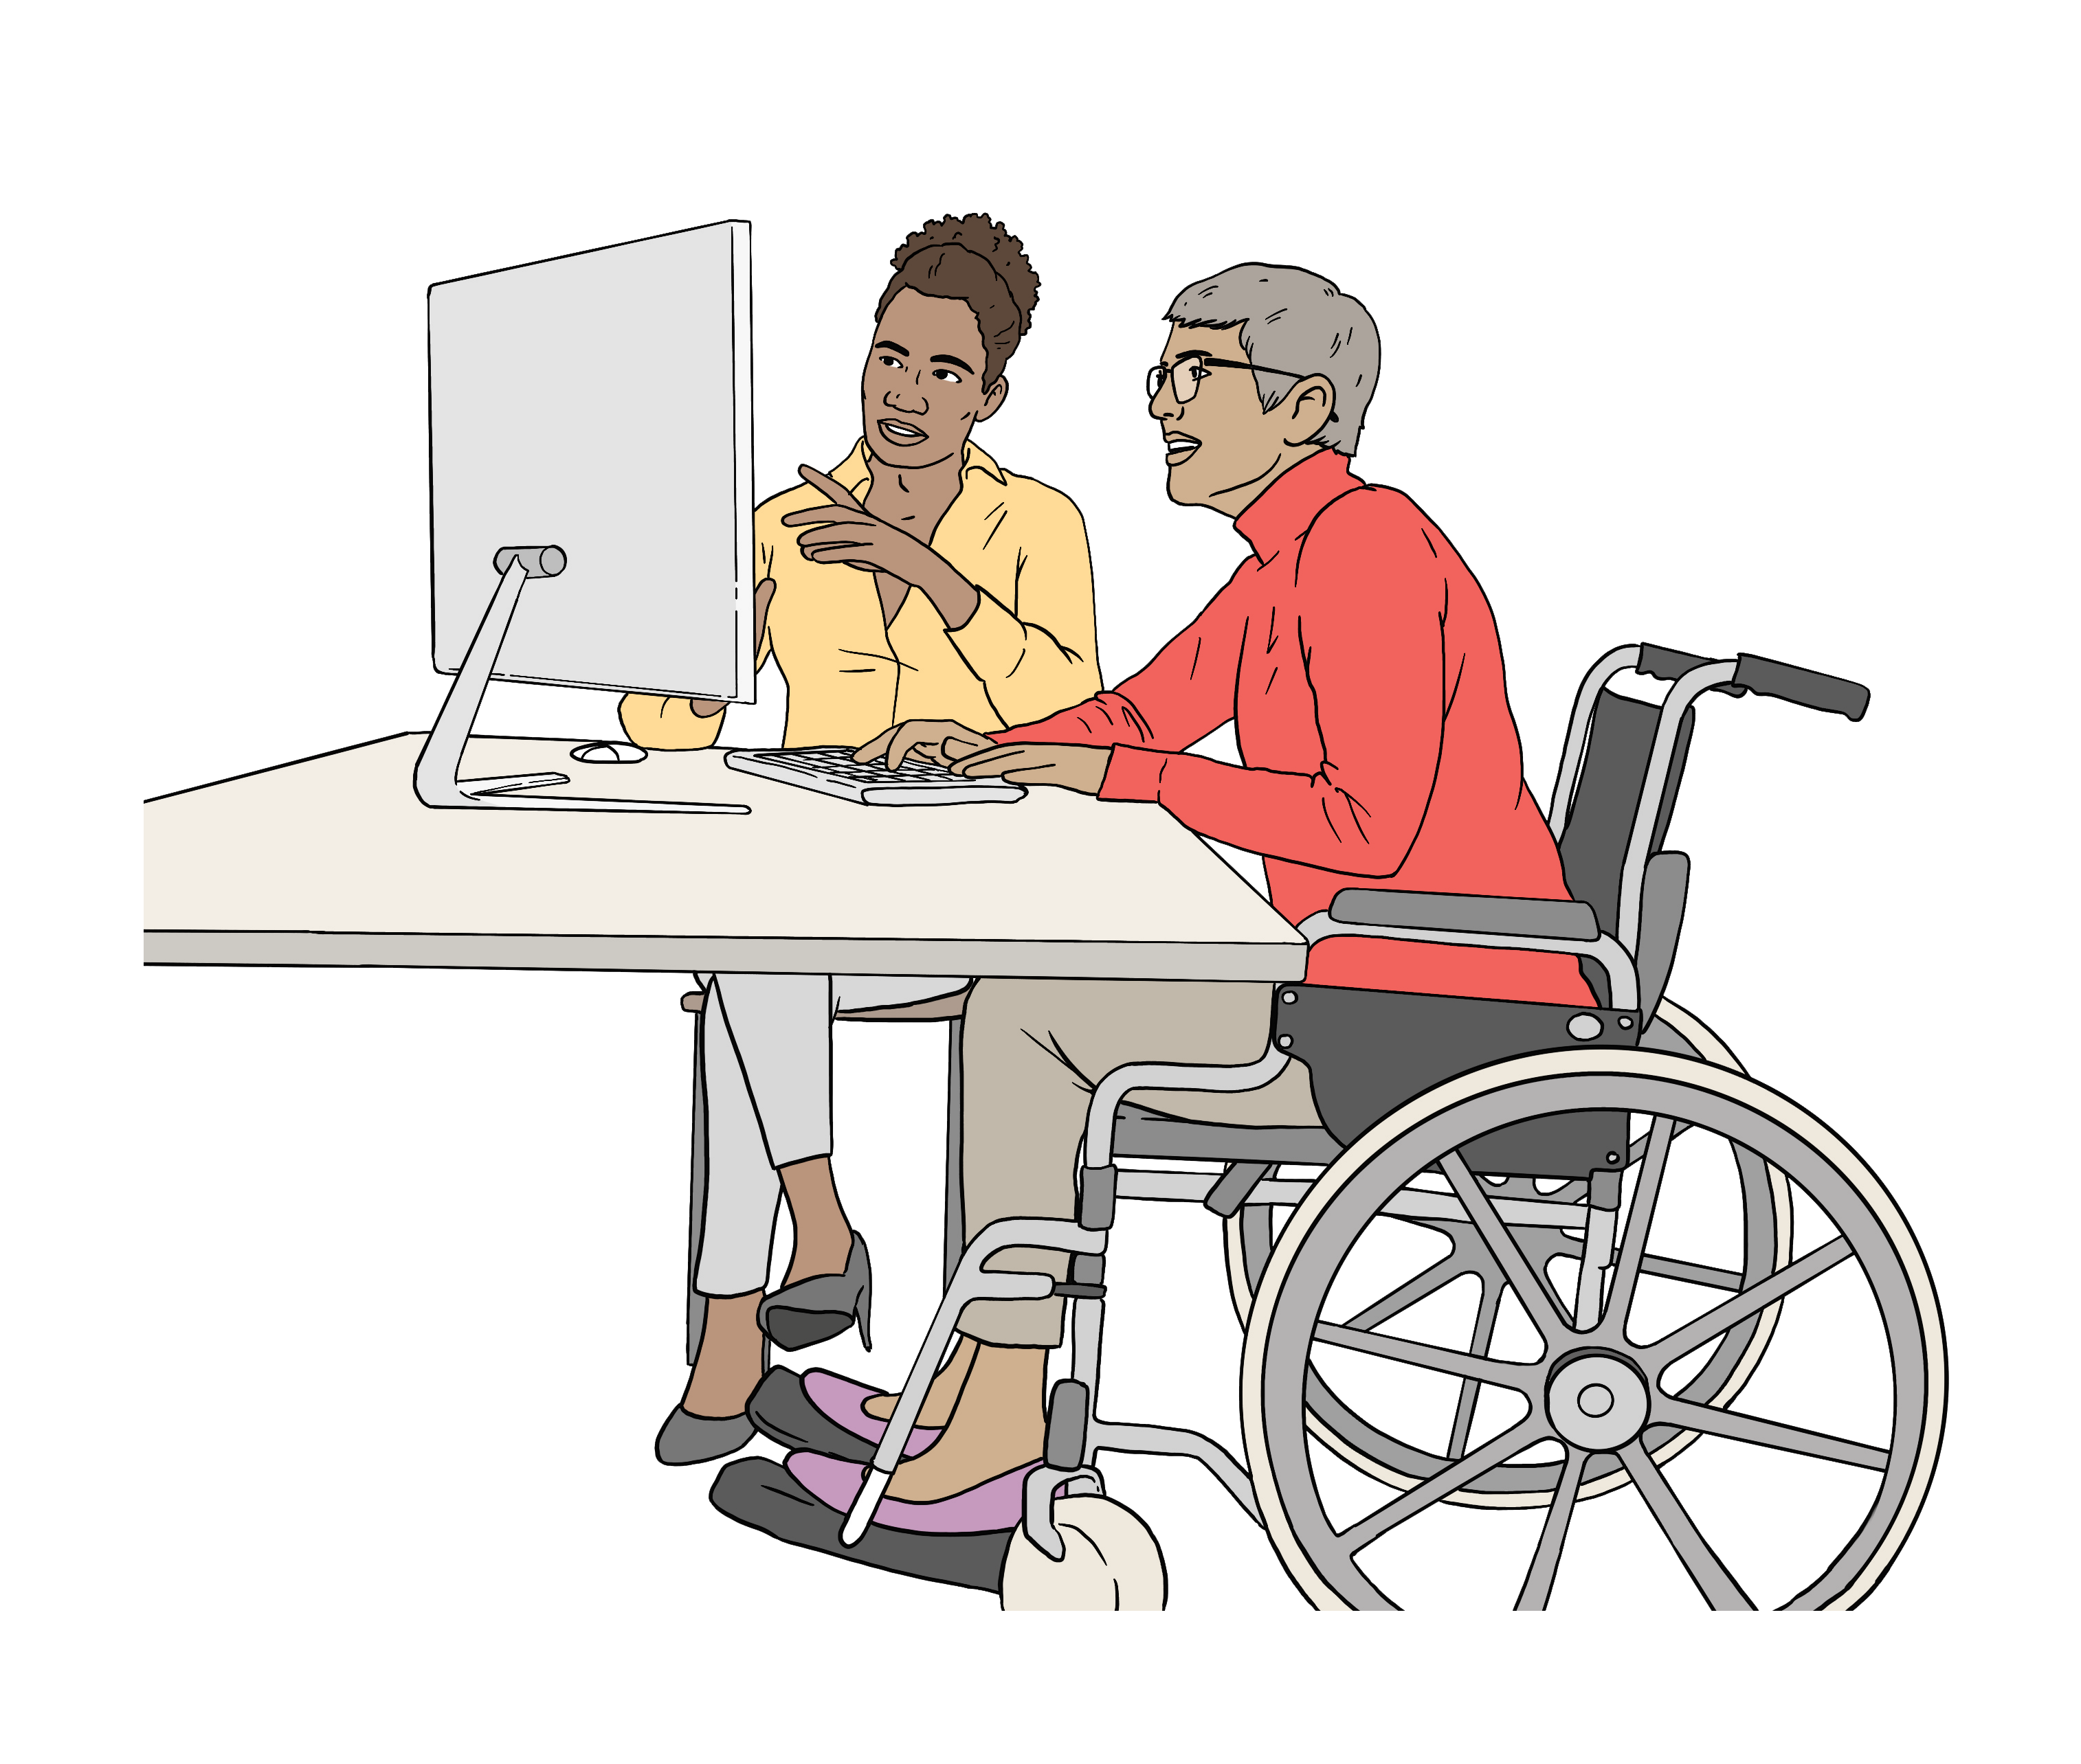
- By 30 June 2028 the Office for Seniors will make sure that information about mental health is better for older people.

Focus area 4 – Understand suicide


The Government wants to get better at understanding suicide.

The reason for this is to put in place better ways of stopping suicide.

Health services will do 6 things to better understand suicide.

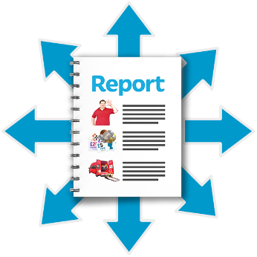
- By 30 September 2025 the Suicide Prevention Office will set up a group to check how well the things they do are working.

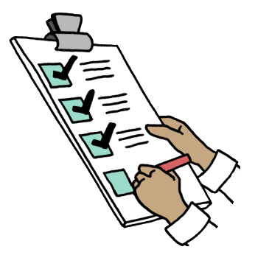
- By 30 June 2026 Health New Zealand will:
check how well the money we spent on suicide prevention services is being used

think about what we might change using information from the He Arotake suicide review.

He Arotake is a report that looked at ways of stopping Māori suicide.


- By 30 June 2026 the Suicide Prevention Office will check the system of suicide supports to find:

gaps / things that are missing
things we can do better.

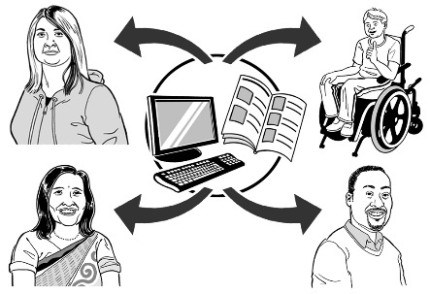
- By 30 June 2027 the Suicide Prevention Office will look for ways to share information better to make sure:

information is collected in the same way by everyone
we share information across services in a way that works.

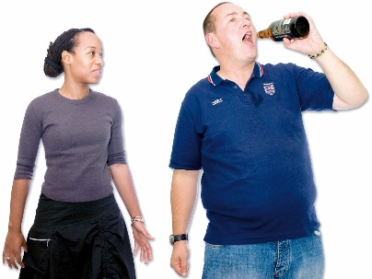
- By June 2028 the Suicide Prevention Office will work with Health New Zealand look for better ways to:
find out the harm alcohol causes
count how many suicides were because of alcohol.

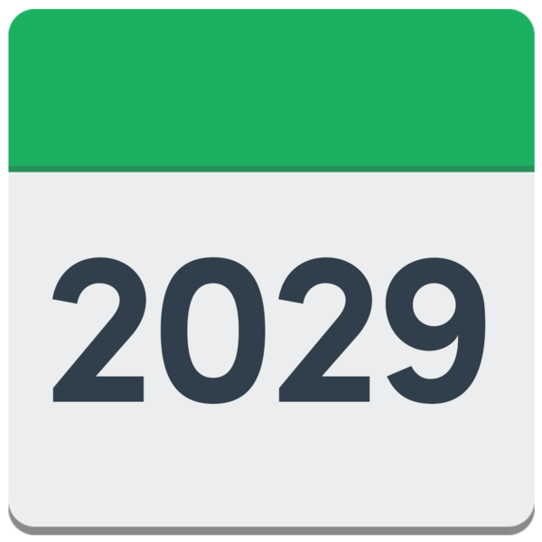
- By 30 June 2029 the Suicide Prevention Office will:
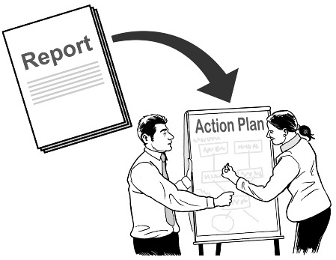
check how well this action plan is working
use that information to make future plans.

Other parts of the government will do 2 things to better understand suicide.

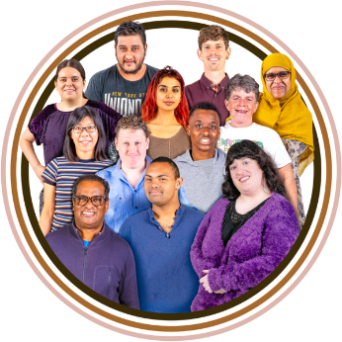
- By 31 December 2025 the Ministry for Ethnic Communities will check how they understand the experience of young people from MELAA communities with:
mental health
harming themselves
suicide.


MELAA communities means people from:
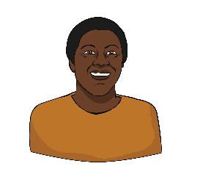
the Middle East
Latin America
Africa.
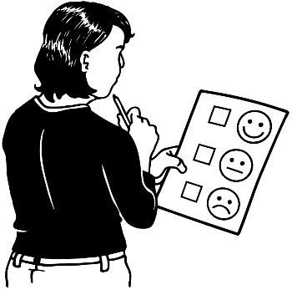
- By 30 June 2027 Veterans’ Affairs New Zealand will find ways of collecting better information about the experience veterans have of:
mental health
harming themselves
suicide.

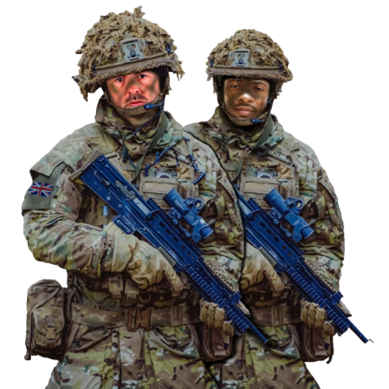
Veterans are people who have been in the armed services like:
the navy
the army
the airforce.

More information

You can find the full Suicide Prevention Action Plan
2025 – 2029 at:

https://tinyurl.com/3s298sxc

The full Suicide Prevention Action Plan 2025 – 2029 is not in
Easy Read.


You can contact the Ministry of Health on:

Phone: 0800 400 569

Email: info@health.govt.nz

This information has been written by the Ministry of Health – Suicide Prevention Office.

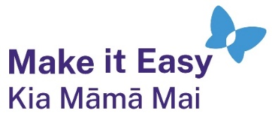
It has been translated into Easy Read by the Make it Easy Kia Māmā Mai service of People First New Zealand Ngā Tāngata Tuatahi.
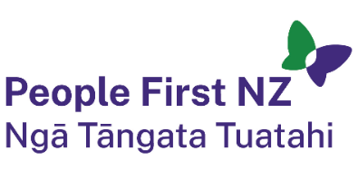
The ideas in this document are not the ideas of People First New Zealand Ngā Tāngata Tuatahi.

All images used in this Easy Read document are subject to copyright rules and cannot be used without permission.


Make it Easy uses images from:

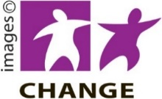
- Photosymbols

- Change Images


- Huriana Kopeke-Te Aho

- SGC Image Works

- T Wood


- Studio Rebeko

- Inga Kramer.

