Consultation on Amendments to the Specified Prescription Medicines List for Designated Pharmacist Prescribers

Acknowledgements
The Ministry of Health engaged with several key stakeholders when developing this consultation in partnership with the Pharmacy Council of New Zealand – Te Pou Whakamana Kaimatū o Aotearoa.
Citation: Ministry of Health. 2025. Consultation on Amendments to the Specified Prescription Medicines List for Designated Pharmacist Prescribers. Wellington: Ministry of Health.
Published in September 2025 by the Ministry of Health
PO Box 5013, Wellington 6140, New Zealand
HP 9140

This document is available at health.govt.nz
 | This work is licensed under the Creative Commons Attribution 4.0 International licence. In essence, you are free to: share ie, copy and redistribute the material in any medium or format; adapt ie, remix, transform and build upon the material. You must give appropriate credit, provide a link to the licence and indicate if changes were made.

Contents
Purpose 1
Background 2
Requirements for designated pharmacist prescribers 3
Additional information 5
The proposed additions to the medicines list 6
The proposed deletions from the medicines list 8
Appendix: Safeguards for designated pharmacist prescribing practise (Pharmacy Council) 9

Consultation on amendments to the specified prescription medicines list for designated pharmacist prescribers under the Medicines (Designated Pharmacist—Prescribers) Regulations 2013

Purpose
The Ministry of Health – Manatū Hauora (the Ministry) invites submissions on proposed amendments to the specified prescription medicines list for designated pharmacist prescribers (pharmacist prescribers).

The Ministry, on behalf of the Director-General of Health, must consult with those people or organisations that may be affected by a change to the schedules before making a legal change by Gazette notice.

This submission will allow you to provide feedback on the proposed medicines, or to propose medicines that have not been referenced.

- You can view the proposed medicines list within this document.

Please submit your feedback on the proposed amendments by 17 October 2025.

Note that specific questions you may have about the proposed prescription medicines for pharmacist prescribers should be directed to the Pharmacy Council.

Background
Pharmacist prescribers have met specific requirements and are registered in an additional scope of practice by the Pharmacy Council. They work in collaborative multidisciplinary health care teams and only prescribe medicines within their specific area of practice. Additional information on requirements and practice context is provided below.

The current list of 1,722 prescription medicines has been in effect since the Medicines (Designated Pharmacist—Prescribers) Regulations passed into legislation in June 2013 (updated 8 October 2021 and 27 May 2022). Since then, additional medicines have become available in New Zealand, to which wider access would benefit patients. The list needs to be amended to reflect these additional medicines.

Following work with pharmacist prescribers and the Ministry, the Pharmacy Council recommends that 21 prescription medicines, and vaccines as a class, should be added to the specified prescription medicines list for pharmacist prescribers under the Medicines (Designated Pharmacist—Prescribers) Regulations 2013. Two medicines are recommended to be removed.

Requirements for designated pharmacist prescribers
The Medicines (Designated Pharmacist Prescribers) Regulations 2013 and Misuse of Drugs Regulations 1977 permit pharmacist prescribers to prescribe specified prescription medicines.

Pharmacy Council sets the Pharmacist Prescriber scope of practice and the required qualifications to enter the scope. These are published in a Gazette notice. The prescribing activities of pharmacist prescribers are therefore tightly regulated via the Medicines Act 1981, the Misuse of Drugs Act 1975, and the Health Practitioners Competence Assurance Act 2003.

Pharmacy Council also sets expected levels of competence and requirements for entry into the Pharmacist Prescriber scope of practice. Requirements include:
- holding an annual practising certificate in the Pharmacist scope of practice
- having at least two years of recent and appropriate post-registration experience working in a collaborative patient-facing health care team environment relevant to the area of practice in which they plan to prescribe
- holding a qualification prescribed by the Pharmacy Council for entry into the Pharmacist Prescriber scope (eg, a postgraduate certiﬁcate in prescribing)
- the course content must include clinical reasoning and decision-making, physical assessment and diagnostic skills, the 'mechanics' of prescribing, pharmacoeconomic considerations, and completion of a practicum with a medical practitioner or nurse practitioner
- the practicum must demonstrate knowledge to safely prescribe speciﬁed prescription medicines and knowledge of the regulatory framework for prescribing
- submission of a practice plan which is endorsed by the clinical lead of their collaborative health care team
- review of practice and submission of a new or modiﬁed practice plan if the prescriber amends or expands their deﬁned area or practice or changes the collaborative team in which they work
- a declaration that their current practice meets relevant standards from the Competence Standards for the Pharmacy Profession, and all the Pharmacist Prescriber Competence Standards.

Of the 4,463 practising pharmacists in New Zealand, there are 99 registered pharmacist prescribers (at 31 March 2025). Of these, the majority are working in general practice (66%) and secondary care (33%) settings. There has been an increase in the number of pharmacist prescribers from previous year (73 in March 2024). While the numbers of pharmacist prescribers remain reasonably small, they continue to increase.

Pharmacist prescribers prescribe from a specified prescription medicines list gazetted by the Director-General of Health. There are 1,722 medicines on the pharmacist prescriber list.

Pharmacist prescribers are required to prescribe as part of a collaborative and multidisciplinary health care team. Additional information is provided in the Appendix.

The pharmacist prescriber must only prescribe within the limits of their professional expertise, competence, and ethical codes of practice. They are responsible and accountable for the prescribing decisions they make and the care they provide. A pharmacist prescriber may only prescribe a medicine if:
- they possess the appropriate knowledge and competence (both clinical and cultural)
- the condition and medicine lie within their specified clinical area of practice
- the clinical lead of the collaborative team is satisfied that pharmacist prescribing of the medicine is safe, aligns with legal and workplace protocols, and is in the best interests of the patient.

Additional information on pharmacist prescribers including requirements to enter the scope of practice and competence standards can be found on the Pharmacy Council website.

Additional information
- The existing pharmacist prescribers’ specified prescription medicines list is available on the New Zealand Gazette: Speciﬁed Prescription Medicines for Designated Pharmacist Prescribers, 30 May 2022.
- The controlled drugs (eg, morphine, tramadol and zopiclone) the pharmacist prescribers can prescribe are listed under the Misuse of Drugs Regulations 1977, Schedule 1B, Controlled drugs that designated prescriber pharmacists may prescribe. A review of the scheduled controlled drugs that pharmacist prescribers can prescribe is outside of the scope for this consultation.
- Pharmacist prescribers can prescribe non-prescription medicines, including pharmacist only (restricted), pharmacy-only, and general sales medicines. Hence, these medicines have not been considered under this consultation.
- Combination products (eg, triamcinolone + neomycin + gramicidin + nystatin) must have all their individual chemical ingredients (active pharmaceutical ingredient) listed (if these are prescription medicines) before being available to the pharmacist prescriber.
- Some medicines, while not currently available in New Zealand, have been suggested to future proof the list in anticipation that they may be introduced into New Zealand in the near future.
- Not all of the medicines proposed are currently Medsafe approved. Current legislation does not authorise pharmacist prescribers to prescribe unapproved products, therefore these proposals are forward-looking to avoid barriers accessing important medicines which may become available in New Zealand.
- When gazetted, the chemical name as in the Medicines Regulation 1984 (Schedule 1) will be used. This means that the spelling may differ to that used in the NZ Formulary and/or on medicine labelling (eg, ‘bendrofluazide’ and ‘lignocaine’ (the old British approved names (BAN) used in the Medicines Regulations) versus ‘bendroflumethiazide’ and ‘lidocaine’ (the recognised international non-proprietary name (rINN) used in the NZ Formulary and on product labelling).
- Some medicines may be indicated for multiple uses. For example, haloperidol may be used as an antipsychotic or in palliative care for the management of nausea and vomiting. The gazetted list generally does not specify a specific indication. Pharmacist prescribers must be aware of all medicines that are on their gazetted list and through agreement with their collaborative team and/or clinical lead decide which medicines are appropriate to be prescribed within the pharmacist prescriber’s area of practice, irrespective of the medicine being listed.
- Inclusion of a medicine on the gazetted specified prescription medicines list for pharmacist prescribers does not give a pharmacist prescriber automatic approval to prescribe the medicine. At all times, the pharmacist prescriber must operate within legislative frameworks (eg, the Medicines Act and regulations; including not prescribing unapproved medicines), funding restrictions (if applicable), within the prescriber’s area of practice, experience and competence, and within the collaborative team and the limits set by the prescriber’s mentor.

The proposed additions to the medicines list
Broad therapeutic group | Proposed additional medicine | Rationale
Anaesthesia
Drugs for opioid or benzodiazepine antagonism | Nalmefene | Treatment of opioid overdose
Volatile liquid anaesthetics | Methoxyﬂurane | For the short-term relief of moderate to severe pain after injury or during some short medical procedures
Cardiovascular
Cardiovascular system | Mavacamten | Future proofing; to treat obstructive hypertrophic cardiomyopathy
Antiplatelet drugs | Selexipag | Antithrombotic agent for use in hospital settings
Lipid-regulating medicines | Alirocumab  Inclisiran | Future proofing the list in anticipation that they may be introduced / funded into New Zealand in the near future
Central nervous system
Dopaminergic drugs used in Parkinson's disease | Foscarbidopa  Foslevodopa | Treatment of Parkinson’s disease
Hypnotics | Lemborexant | Insomnia characterised by difficulties with sleep onset and/or sleep maintenance
Other nervous system drugs | Patisiran | Treatment of treat polyneuropathy of hereditary transthyretin-mediated amyloidosis
Prophylaxis of migraine | Atogepant | For migraine prophylaxis
Endocrine system
Diabetes mellitus | Tirzepatide | Future prooﬁng for new antidiabetic dual glucose-dependent insulinotropic polypeptide (GIP) and glucagon-like peptide-1 (GLP-1) receptor agonist. Dual GIP/GLP-1 agonists tirzepatide
Immunological products and vaccines
Immunological products and vaccines | Vaccines as a class | Future prooﬁng the speciﬁed list for new vaccines that are approved for use in New Zealand against variety of infectious disease/ pandemic/ outbreaks, for example, mpox vaccine (orthopoxvirus vaccine)  This will bring the following vaccines into the pharmacist prescribers medicines list.  - Dengue virus vaccines  - Ebola vaccines  - Enterovirus 71 vaccines  - Mpox vaccines  - Respiratory syncytial virus vaccines  - Smallpox vaccine  Exclusion: Yellow fever vaccine unless meet WHO requirements
Infections
HIV infection | Lenacapavir | Treatment of HIV infection
Musculoskeletal and joint diseases
Enzymes | Hyaluronidase | To improve the absorption and dispersion of parenterally (eg, subcutaneous or intramuscular) administered fluids, medicines, and contrast agents
Nutrition and blood
Drugs used in metabolic disorders | Trientine | Treatment of Wilson’s disease
Renal anaemias | Daprodustat  Roxadustat | Proposal for hospital-based pharmacist prescribers working in renal services; to prescribe antianaemic preparations
Respiratory system
Mucolytics and others | Elexacaftor  Tezacaftor | Proposal from hospital-based pharmacist prescribers working in respiratory services; Trikafta (ivacaftor, tezacaftor and elexacaftor) for inpatients.  Noting that ivacaftor is already included on the gazetted list
Skin
Acne | Clascoterone | Treatment of acne
Psoriasis | Deucravacitinib | Treatment of psoriasis

The proposed deletions from the medicines list
Therapeutic group | Proposed additional medicine | Rationale
Malignant disease and immunosuppression
Other immunomodulating drugs | Lenalidomide  Pomalidomide | Medical practitioners can only prescribe these medicines:  - Provisional Consent to the Distribution of New Medicines - 2024-go2115- New Zealand Gazette  - https://gazette.govt.nz/notice/id/2023-go5784  It is therefore inappropriate for these medicines to be included in the designated pharmacist prescriber specified prescription medicines list. It is proposed that they are removed from the medicines list.

Appendix: Safeguards for designated pharmacist prescribing practise (Pharmacy Council)
Safeguards for pharmacist prescribing practice are outlined more fully in the main document. In summary, pharmacist prescribers must hold postgraduate qualifications, work in a collaborative team environment, are not the primary diagnostician and must prescribe within the limits of their professional expertise and competence. See Figure 1.

Figure 1: Safeguards for designated pharmacist prescribing practise (Pharmacy Council)
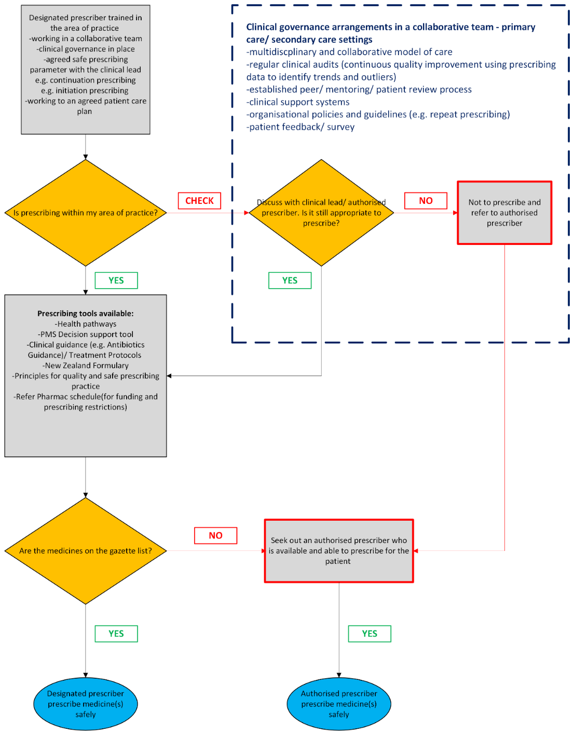

Pharmacy Council is the regulator for the pharmacy profession (including designated pharmacist prescribers) in Aotearoa New Zealand and is mandated by the Health Practitioners Competence Assurance Act 2003.
Refer to guidance on pages 13 & 14 of the ‘Competence Standards for Aotearoa New Zealand Pharmacist Prescribers’
View the ‘Competence Standards for Aotearoa New Zealand Pharmacy Profession 2023’ and the ‘Competence Standards for Aotearoa New Zealand Pharmacist Prescribers’ at https://pharmacycouncil.org.nz/pharmacist/competence-standards/.
Pharmacist practising on 31 March 2025 (including pharmacist prescribers)
Survey of pharmacist prescribers between 19 Feb and 4 March 2024 with a response rate of 82.4%.
Based on the New Zealand Formulary (NZF) v158 – 01 Aug 2025. Available from www.nzf.org.nz. Please note that the therapeutic group is not gazetted, only the chemical name.

